**Silicon Uptake and Distribution Under Rice–Maize Cropping System: Effects on Soil Availability and Crop Productivity**

**ABSTRACT**

Silicon (Si) is a beneficial element in soil for crop growth and survival. Incorporating silicon into modern crop management practices offers a promising pathway to balance increased agricultural output with ecological sustainability, a critical goal in addressing global food security challenges. The role of Si in plant health is principally providing resistance against different biotic and abiotic stresses. Si is supposed to increase the yield in *Poaceae* crops like rice, wheat etc. The present study has been conducted to find the role of Si on rice yield, its uptake characteristics and its distribution in different soil depths. Five soil treatments of Si (0 to 125 kg Si ha-1) and two foliar sprays (0.5% and 1% Si) with a control treatment has been selected for the experiment, conducted in the farm area of Uttar Banga Krishi Viswavidyalaya. Soil samples collected from different soil depths and crop growth stages showed distribution of Si in soil. Application of Si in higher dose has resulted in higher maize yields with respect to control treatment. Higher yields have been achieved with increasing Si application in the soil, as well as, in the foliar sprays although the difference is not found to be significantly different. In comparison to the control (S1), Si application @125 kg ha-1 (S6) has resulted in 11.19% yield increase in rice. With increasing soil depths, the available pool of Si is found to increase and highest availability is found in the 30-45 cm soil depth. Higher dissolution results in higher Si availability in panicle initiation stage. Higher uptake has been observed with increasing Si application rate, although non-significantly yield increased in rice suggesting no direct impact of Si in increasing yield. The present study can be can be helpful to find effects of Si on rice production under stressed conditions.

Keywords: Silicon, rice, yield, crop growth stage, soil depths, availability

1. **INTRODUCTION:**

Rice (*Oryza sativa*) is the most consumed staple food for most of the population of the world (Ashraf et al., 2018 a;b;c). For majority of the global population, it is the principle staple food in terms of both source of carbohydrates and other essential nutrients, protein and vitamins specially for the south-east Asian countries like India, China, Bangladesh, Indonesia (Song et al., 2014). With the continuous growing population, the need for the increase in the production to feed the world population has become a massive concern for recent time. It is essential to improve the nutrient options to increase the overall productivity in rice and subsequent reduction of the nutrient losses from the soil (Thind et al., 2012). In this respect application of silicon (Si) comes to be a promising aspect. In terms of abundance in soil, it is found as the second most dominant element (around 27.8%) in the earth’s crust. Despite being highly abundant in the soil, it is not considered as essential element for plants, but for its numerous beneficial importance to crop’s physiology, biochemical reactions and having a great impact in the yield, it is regarded as a beneficial element. Research on silicon in plants started over a century ago; nevertheless, its importance and advantageous impacts on crop production were not acknowledged until the early 20th century (Ma and Yamaji, 2006). The first study of Si in rice crop was done by Onodera (1917) in a journal of agronomy where he extensively studied blast of rice and found higher concentration of Si in rice not affected by blast than those of the infected ones. Si is having a diverse dimension of helpful impacts on plants in terms of reduction of the transpiration rate (de Oliveira et al., 2019) increasing resistance against diseases, insects, and abiotic stresses like salt stress, draught stress, heat stress, heavy metals toxicity, lodging etc. (Chaiwong et al., 2021; Ming et al., 2012; Wang et al., 2017). Studies revealed that upon application of Si fertilizer, there is a reduction in the lodging index by 13% in rice with significant rise in yield (Kim et al., 2012) and significant rise in the number of spikelets and percent filled grains (Lavinsky et al., 2016; Ma et al., 1989). But even with high dominance in the soil, the availability of Si in soil is very poor (Tayade et al., 2022; Tubana et al., 2016).

Different crops have different capacity to absorb Si from soil. Among all, those belonging to the family *Poaceae* like rice are more efficient accumulator of Si (Cuong et al., 2017; Ma and Yamaji, 2006). In soil Si is mostly available to crops in the form of mono and poly-silicic acids. Rice can accumulate Si from soil several times higher than that of the primary nutrients (nitrogen, phosphorus and potassium) and it is essential for better growth and higher productivity of rice (Schaller et al., 2021; Savant et al., 1997). Keeping these things in view, the present study has been conducted to find the effect of different doses of Si on rice and maize growth and yield attributes and the distribution of available pool of Si in different depths of soil.

1. **MATERIALS AND METHODS:**
   1. **Description of the Study area and Experimental Design**

The present study has been conducted under the Terai agro-climatic region of West Bengal in the farm area of Uttar Banga Krishi Viswavidyalaya which is situated in the Cooch Behar district of West Bengal. The area is having an elevation of 43m above mean sea level (AMSL) and the soil is acidic in nature with sandy-loam type of soil texture. The area is having mean annual rainfall of around 330 cm, the majority of which is received in the months of June to September (table 1). Seasonal variations exist in this area and the mean low and high temperatures varied between 20.4oc to 31.4oc in summer and between 11.5oc to 20.4oc in winter (table 1).

The initial status of soil suggests that the soil of this region is mostly of sandy-loam texture. The soils are poor in terms of available nitrogen and potassium content, although high status in available phosphorus content. In 0-15 cm soil depth, the initial status of the soil suggests that the available nitrogen content has been found 80.92 kg/ha, the available phosphorus content was found 32.48 kg/ha and the available potassium content was 59.75 kg /ha. In 15-30 cm soil these values have been found as 28.28 kg/ha, 18.14 kg/ha and 23.83 kg/ha respectively. The nutrient contents in soil are less in the lower soil depths. The organic carbon content in the soil found to be 0.96%, 0.23%, 0.19% in the 0-15 cm, 15-30 cm and 30-45 cm soil depths respectively. The available Si content in the different soil depths have been measured as 6.40, 5.87, and 4.47 mg kg-1 in the 0-15, 15-30 and 30-45 cm soil depths respectively.

Table 1: Agroclimatic Data of the experimental site (AgERA5 Climate data)

|  |  |  |  |  |  |  |
| --- | --- | --- | --- | --- | --- | --- |
| Month | Precipitation  (mm/m) | Minimum Temperature  (℃) | Maximum temperature  (℃) | Mean Temperature  (℃) | Relative Humidity  (%) | Potential Evapotranspiration  (mm/m) |
| January | 17 | 11.5 | 22.3 | 16.9 | 57.1 | 67 |
| February | 65 | 11.9 | 21.9 | 16.9 | 55.4 | 76 |
| March | 14 | 17.3 | 30.9 | 24.1 | 48.4 | 133 |
| April | 224 | 20.4 | 28.8 | 24.6 | 68.5 | 112 |
| May | 422 | 22.2 | 30.3 | 26.3 | 68.6 | 130 |
| June | 1,224 | 24.7 | 29.4 | 27.1 | 81.4 | 88 |
| July | 313 | 26.1 | 31.4 | 28.8 | 77.8 | 111 |
| August | 352 | 25.9 | 31.4 | 28.7 | 77.8 | 109 |
| September | 414 | 24.4 | 30.4 | 27.4 | 79.4 | 88 |
| October | 258 | 20.4 | 29.4 | 24.9 | 68.8 | 93 |
| November | 0 | 15.6 | 27.3 | 21.4 | 55.5 | 81 |
| December | 1 | 14.0 | 24.6 | 19.3 | 54.3 | 68 |
| Total | **3,305** |  |  |  |  | 1157 |

The present experiment has been conducted in a rice-maize cropping system in the year 2022. The experiment was conducted with rice variety MTU-1153 which is a hybrid rice variety, grown in kharif (rainy) season under transplanted condition and maize variety selected was DKC-9081, a hybrid maize variety grown in rabi (winter) season. The experiment was conducted with five different doses of soil application of silicon and two different doses of Si foliar application along with one treatment of no Si application in both the crops. Recommended dose of straight fertilizers (RDF) was applied to each and every treatment @160:60:80 kg N:P2O5:K2O ha-1 for maize and 100:50:60 kg N:P2O5:K2O ha-1 for rice crop. Graded doses of Si @ 0, 25, 50, 75, 100 and 125 kg ha-1 were applied and denoted as S1, S2, S3, S4, S5, and S6 respectively and two foliar sprays of 0.5% and 1% Si were applied and were represented by S7 and S8 respectively. Experiment was conducted in randomized block design (RBD) with three replications and each plot size of 3m x 4m area. The nitrogen was supplied through urea, phosphorus through single super phosphate, and potassium through muriate of potash. The full dose of phosphorus and potassium were supplied as basal dose just before sowing of the crop. The nitrogen was supplied in three split doses; half as basal dose, 1/4th at active tillering stage (40 DAS) and rest 1/4th at panicle initiation stage (70 DAS). The application of Si was made through calcium silicate for soil application and through potassium silicate for foliar spray.

* 1. **Collection of the Samples:**

For rice crop, soil samples were collected at three different stages i.e. active tillering (stage 1), panicle initiation (stage 2) and after harvest (stage 3) stages. Each soil sampling was done at three different soil depths i.e. 0-15 cm (D1), 15-30 cm (D2) and 30-45 cm (D3). Soil samples were collected with the help of dutch auger (for active tillering and panicle initiation stage) and tube auger (for harvest stage) for each of the three depths. For each of the soil depths in each individual treatment plots, soil samples have been collected from two random spots in each treatment that were later composited together accordingly. All the soil samples were air-dried, ground and passed through 2 mm sieve for the analytical purpose. Plant samples were collected after harvesting of the crop. The straw and grains of the harvested produce were separated and were oven-dried on constant weight basis. For plant sample collection, plants were harvested at ground level from 1 m2 area of each of the plots and at two random points. For maize crop, the plant samples have collected after harvesting. The maize crops were harvested at 2m line and the cobbs were separated from each plant. The oven-dried plant samples were finely ground and stored for future analysis.

* 1. **Growth parameters, yield attributing characters and biomass yield calculation:**

Several growth and yield attributing characters like plant height, number of tillers/plant, panicle length, 1000 grain weight (for rice) and plant height, number of cob per plant, number of rows per cob, cob weight, grain yield and seed index (for maize) have been recorded. Also, total number of grains per panicles, number of filled grains and percent filled grains have been calculated for rice crop. Biomass yield for both grain and straw has been recorded on oven-dry weight basis.

* 1. **Soil analysis methods:**

The available silicon present in the soil was measured by following the molybdenum-blue colorimetric method given by Korndörfer et al. (2001). Soil samples of known weight were shaken with 0.01 (M) CaCl2 solution in 1:10 ratio for one hour which is followed by filtration with Whatman 42 filter paper. 10 ml of the filtrate is transferred to 50 ml volumetric flask and added 1 ml of 7.5% ammonium molybdate solution. After ten minutes 6 ml of 10% tartaric acid and 1ml of reducing agent ANSA (1-amino-2napthol-4-sulfonic acid) were added and respective absorbances were measured after 30 minutes in UV-Visible spectrophotometer at 650 mµ wavelength. Standard curve was developed by preparing 0.5, 1, 2 and 4 ppm standard Si solutions from 1000 ppm stock solution.

* 1. **Statistical Analysis:**

The analysis of variance (ANOVA) was carried out for different treatments. The significant differences in different parameters have been calculated using Duncan Multiple Range Test (DMRT) as according to the ANOVA results at 0.05 level of significance. The descriptive statistics of the plant as well as the soil data were carried out using Windows based software R studio (version 2024.12.1+563).

1. **RESULTS AND DISCUSSION:**
   1. **Effects of different Si doses on maize growth and yield attributes**

Differences have been found in different growth and yield characteristics of maize under different Si treatments (table 2) but in all cases these differences are statistically not significant (p < 0.05). Plant height among all the treatments varied between 107.13 to 116.20 cm and has been found highest in S1 and lowest in S4. The number of grain rows/cob in all the treatments varied between 15.10 to 16.53. On average basis, the higher number of rows has been found in S2 (16.53) than all the other treatments (table 2). As compared to S2 the number of rows/cob has been found lower by 2.8%, 2.42%, 1.57%, 4.84%, 6.04%, 4.84% and 8.65% in S1, S3, S4, S5, S6, S7 and S8 respectively. Differences in the cob length and weight of cobs were also found. The grain yield was found, among the different treatments to be highest in the treatment S6 (4.70 t ha-1) and lowest in S1 (3.17 t ha-1). In comparison with S1, the grain yield of the other treatments increased by 0.63%, 9.46%, 27.76%, 37.85%, 48.26%, 27.76% and 31.86% in S2, S3, S4, S5, S6, S7 and S8 respectively.

Table 2: Effects of different Si treatments on maize growth and Yield characteristics

|  |  |  |  |  |  |  |  |
| --- | --- | --- | --- | --- | --- | --- | --- |
| **Treatments** | **Plant Height (cm)** | **No. of Cob/plant** | **Rows/cob** | **Grains/row** | **Cob length (cm)** | **Grain Yield (t ha-1)** | **Seed index (g)** |
| **S1** | 116.20 | 2.13 | 16.07 | 41.07 | 19.3 | 3.17 | 42.03 |
| **S2** | 109.20 | 2.13 | 16.53 | 43.73 | 21.3 | 3.19 | 41.60 |
| **S3** | 110.07 | 2.20 | 16.13 | 44.73 | 20.9 | 3.47 | 41.77 |
| **S4** | 107.13 | 2.00 | 16.27 | 45.73 | 20.5 | 4.05 | 37.77 |
| **S5** | 108.67 | 2.00 | 15.73 | 45.13 | 20.3 | 4.37 | 37.43 |
| **S6** | 115.87 | 2.07 | 15.53 | 45.00 | 20.7 | 4.70 | 40.50 |
| **S7** | 108.13 | 2.00 | 15.73 | 42.02 | 19.6 | 4.05 | 40.20 |
| **S8** | 108.73 | 1.87 | 15.10 | 43.73 | 19.7 | 4.18 | 42.93 |
| **S.D.** | 5.63 | 0.22 | 0.62 | 2.70 | 1.03 | 0.56 | 2.71 |
| **S.Em.** | 1.15 | 0.05 | 0.13 | 0.55 | 0.21 | 2.83 | 0.55 |
| **C.D. (p<0.05)** | NS | NS | NS | NS | NS | NS | NS |

* 1. **Effects of different Si doses on rice growth and yield attributes**

No significant impact of Si on the plant height, panicle length, no. of tillers per plant and no. of panicles per m2 have been found. Results have shown that different Si does not have any significant impact on the gran and straw yield of rice (table 3). The data shows that with increasing Si dose, the yield of rice increases. As compared to the control treatment, (S1) all the other treatments have shown an increase in the straw yield also. Highest grain yield has been achieved from the S6 treatment that shown a yield increase by 11.19% as compared to the S1 treatment. Among the foliar treatments, S8 has shown an increase in the grain yield by 8.81% as compared to the S1 treatment.

Table 3: Effects of different Si treatments on Rice growth and yield attributes

|  |  |  |  |  |  |  |  |
| --- | --- | --- | --- | --- | --- | --- | --- |
| **Treatments** | **Plant height (cm)** | **Panicle Length (cm)** | **No. of tillers plant-1** | **No. of panicles m-2** | **Grain Yield (t ha-1)** | **Straw Yield (t ha-1)** | **Harvest Index** |
| **S1** | 113.40 | 25.61 | 9.27 | 124.20 | 4.20 | 4.92 | 46.25 |
| **S2** | 112.53 | 25.89 | 10.73 | 122.40 | 4.34 | 5.15 | 45.60 |
| **S3** | 117.56 | 26.07 | 11.00 | 122.40 | 4.45 | 5.30 | 44.34 |
| **S4** | 112.95 | 26.21 | 11.00 | 136.80 | 4.48 | 5.00 | 47.41 |
| **S5** | 112.83 | 26.30 | 10.47 | 126.00 | 4.49 | 5.24 | 46.42 |
| **S6** | 108.73 | 26.77 | 11.73 | 140.40 | 4.67 | 6.11 | 43.30 |
| **S7** | 113.20 | 24.99 | 10.27 | 127.80 | 4.39 | 4.92 | 47.26 |
| **S8** | 108.41 | 26.31 | 11.20 | 126.00 | 4.57 | 5.33 | 46.51 |
| **S.D.** | 4.73 | 0.72 | 1.41 | 6.61 | 1.06 | 1.29 | 2.74 |
| **S.Em.** | 0.96 | 0.15 | 0.29 | 1.35 | 0.22 | 0.26 | 0.56 |
| **C.D. (p<0.05)** | NS | NS | NS | NS | NS | NS | NS |

Significant differences have been found in the total silicon concentration in rice straw and grain. With increasing Si dose in the soil, an increase in the total Si content has been found in both rice grain and straw (fig.1). Among the different treatments, the total Si content varied between as low as 0.36% in S1 to as high as 0.60% in S6 in grain and between 0.38% (S1) and 0.63 (S6) in straw. The uptake characteristics suggest that with increasing Si application rate, there is increase in the uptake of Si uptake by rice straw and grain (fig. 2).

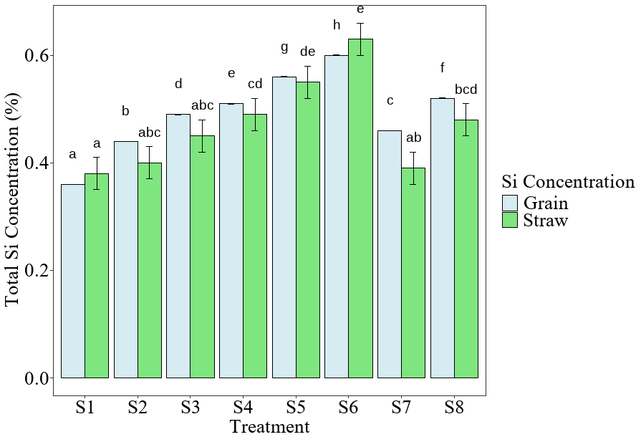

**Fig. 1: Total Si concentration in rice straw and grain**

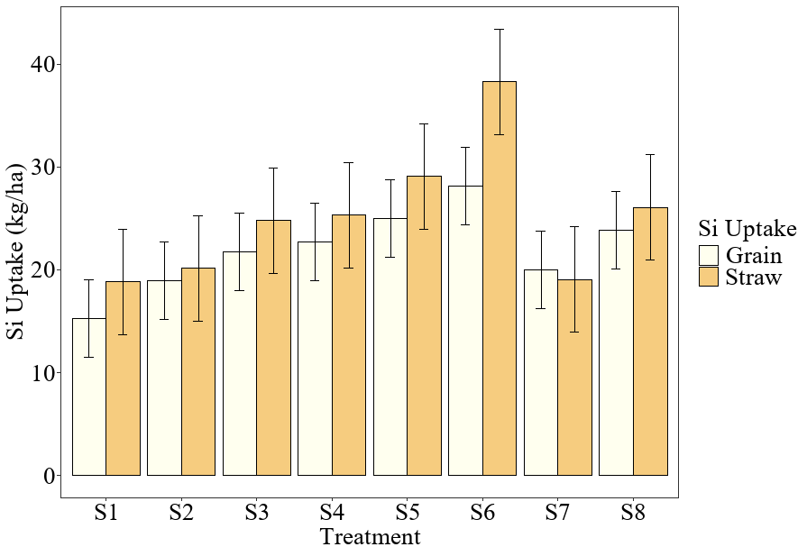

**Fig. 2: Si uptake by rice straw and grain**

Silicon can enhance the overall crop yield when it is applied recommended dose of straight fertilizers. Our study resulted that, both the maize and rice crop can show increased yield when Si is applied in elevated doses. Although the results of Pati et al. (2016) and Gong et al. (2003) showed that with increasing Si doses, there are significant increase in the plant height, number tillers per plant, panicle length, test weight and grain yield.

The results found in the research by Widjajanto and Purbajanti (2021) are in compliance with our findings where they have also shown that increasing Si dose does not have any significant increase in the yield as compared to the control treatment. The study by Li et al. (2020) also suggests the same observations. Several studies (Ma and Yamaji, 2006) have shown that under non-stress or well-managed conditions, Si application has limited or no statistically significant effect on rice grain yield. The primary reason is that rice already has a high capacity for Si uptake and may not be Si-deficient in well-balanced soils. The higher yield as compared to the control treatments might be due higher resistance from insect attacks as Si increases the sharpness of the leaves and the grains. Being a high Si accumulator, increasing Si content in the soil has resulted in higher Si uptake in rice straw and grain.

* 1. **Available Si content under different treatments**

The changes in the available Si content in different soil depths and crop growth stages have been shown in table 4. It is found that among the different treatments, the available Si content have been increasing with increasing Si application rate. In 0-15 cm soil depths, the Si availability has been found to decrease with progressing crop growth stage. This is due to higher crop uptake and nutrient removal from soil with progressing crop growth stage.

Considering the overall effect of crop growth stages on Si availability shows that, panicle initiation stage (stage 2) has resulted in higher available Si in soil followed by active tillering stage (stage 1) and lowest in the harvest stage (stage 3) (fig. 3). Also, when finding the effect of soil depth on Si availability, it is found no significant differences occurred among different soil depths. Although, higher Si availability has been found in 30-45 cm soil depth (D3), followed by 15-30 cm soil depth (D2) and lower values in 0-15 cm (D1) soil depth (fig. 4).

The higher Si availability in the panicle initiation stage is due to higher dissolution from the amorphous form of Si present in the soil. The higher availability of the moisture present in soil during this stage triggers the dissolution process (Yang et al., 2020). In PI stage, the reducing soil condition is dominant. This anaerobic soil condition increases the solubility of the amorphous and poorly crystalline silicate minerals, thus boosting the amount of dissolved Si content in the form of monosilicic acids. According to Du et al. (2023), unlike the early growth stage (active tillering stage), where a dense root competition and rapid vegetative growth may deplete available Si from soil, Pi stage represents a shift from vegetative stage to reproductive growth stage. This shift can result in moderate but targeted uptake of Si from soil and subsequent higher Si reserve in the soil.

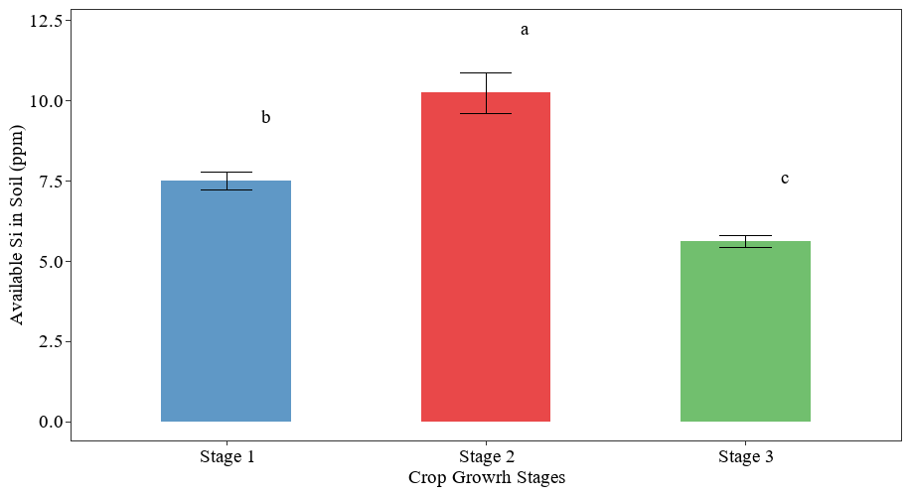

**Fig 3: Changes in available Si content in soil (ppm) under different growth stages of rice soil**

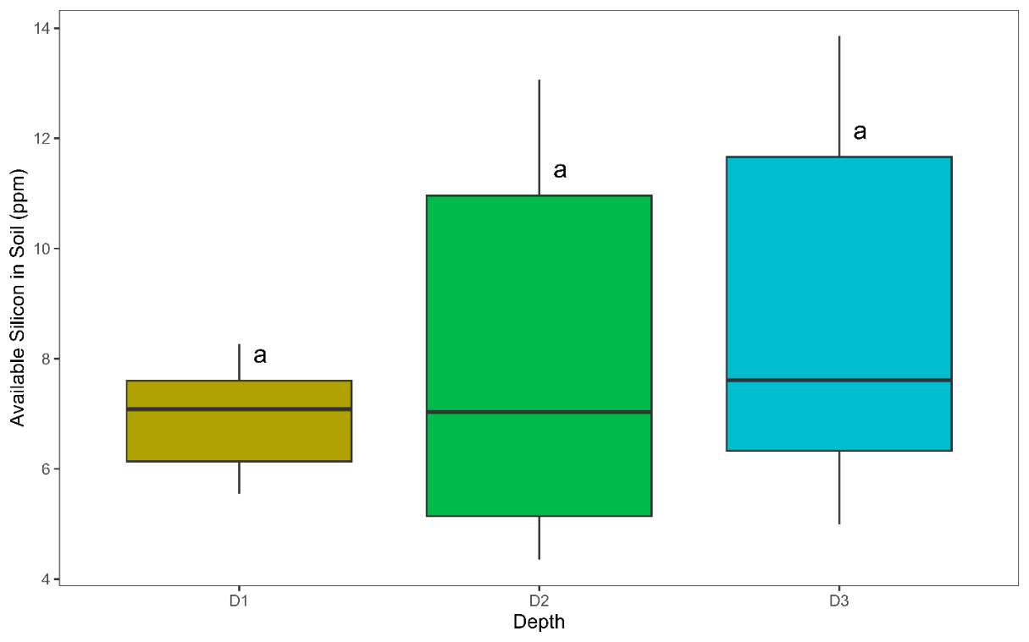

**Fig. 4: Distribution of available Si in soil under different soil depths of rice soil**

Table 4: Changes in available Si content in soil under different crop growth stages and soil depths of rice crop

|  |  |  |  |  |  |  |  |  |  |
| --- | --- | --- | --- | --- | --- | --- | --- | --- | --- |
| **Treatments** | **Available Si Content in Soil (ppm)** | | | | | | | | |
| **D1** | | | **D2** | | | **D3** | | |
| **Stage 1** | **Stage 2** | **Stage 3** | **Stage 1** | **Stage 2** | **Stage 3** | **Stage 1** | **Stage 2** | **Stage 3** |
| **S1** | 7.17a | 6.03a | 5.55a | 5.52a | 10.17a | 4.35a | 6.37a | 9.12a | 4.99a |
| **S2** | 7.81b | 6.47b | 5.85b | 5.88b | 11.23b | 4.41b | 6.89b | 12.02b | 5.34b |
| **S3** | 7.63c | 6.76c | 5.67d | 6.71c | 11.66c | 4.58c | 8.33c | 12.02b | 6.22d |
| **S4** | 7.90d | 7.02cd | 5.98c | 7.35d | 12.10d | 5.11d | 10.59d | 12.54bc | 5.96c |
| **S5** | 8.09e | 7.14d | 6.59e | 7.63f | 12.89e | 5.11e | 8.88e | 12.81c | 6.31e |
| **S6** | 8.27f | 7.52e | 7.20f | 7.72e | 13.07f | 5.23f | 6.51f | 13.86d | 6.75f |
| **S.D.** | 0.37 | 0.52 | 0.60 | 0.87 | 1.02 | 0.37 | 1.55 | 1.50 | 0.61 |
| **S.Em.** | 0.09 | 0.12 | 0.14 | 0.21 | 0.24 | 0.09 | 0.37 | 0.35 | 0.14 |
| **C.D. (p<0.05)** | 0.01 | 0.36 | 0.01 | 0.01 | 0.00 | 0.00 | 0.32 | 0.65 | 0.01 |
| Different letters in same column corresponds to significant differences according to DMRT test (at p≤ 0.05) | | | | | | | | | |

1. **Conclusion:**

Silicon plays great role in the plant biology and helps in increasing yield. The effects can be found in both the maize and rice plants. But the increasing response is not significantly higher as compared to the plants that are grown without any external Si application, although greater uptake occurs with higher doses. The increased sharpness of the leaves, enhanced by the external Si application, causes lesser insect pests to attack the plants, that contributes to the higher yields. Silicon having very less solubility in soil, the water availability is needed for the higher dissolution of the fertilizer in soil and this may be achieved when there is higher rainfall and/or sufficient source of irrigation as obtained in the panicle initiation stage when grown as a kharif crop. Also, the higher dissolution of the amorphous silicon in the deeper layer can cause an increased Si availability in the lower soil depths.

**AKNOWLEDGEMENT:**

We would like to express our sincere gratitude to all the authors who have contributed in the research paper. Their collective expertise, dedication, and hard work have significantly enhanced the quality and validity of this study. Also, we express our deepest gratitude to DST-GoI for supporting the research work with the INSPIRE Fellowship which has helped a lot for executing the whole work including field experiment and laboratory analysis.

**COMPETING INTERESTS:** The authors declare that there is no conflict of interests.

Authors’ Contributions:

The work has been carried out in collaboration of all the authors. Author SS wrote and prepared the original draft of the manuscript, performed the laboratory experiment, and did statistical analysis. Author AKS conceptualized the study, wrote the protocol, and did data curation. Author JDS performed laboratory analysis and manuscript formatting. Author SP performed laboratory analysis. Author PA performed statistical analysis. All authors read and approved the final manuscript.

**Disclaimer (Artificial intelligence)**

Author(s) hereby declare that NO generative AI technologies such as Large Language Models (ChatGPT, COPILOT, etc.) and text-to-image generators have been used during the writing or editing of this manuscript.

**REFERENCES:**

Ashraf, U., Mo, Z., & Tang, X. (2018a). Direct-seeded versus transplanted rice in Asia: climatic effects, relative performance, and constraints—a comparative outlook. In *Agronomic Rice Practices and Postharvest Processing* (pp. 51-100). Apple Academic Press.

Ashraf, U., Hussain, S., Akbar, N., Anjum, S. A., Hassan, W., & Tang, X. (2018b). Water management regimes alter Pb uptake and translocation in fragrant rice. *Ecotoxicology and Environmental Safety*, *149*, 128-134. <https://doi.org/10.1016/j.ecoenv.2017.11.033>

Ashraf, U., Hussain, S., Sher A., Abrar, M., Khan, I., Anjum, S.A. (2018c) Planting geometry and herbicides for weed control in rice: implications and challenges. In: Tadele Z (ed) Grasses as Food and Feed. IntechOpen. pp 111–133. <https://doi.org/10.5772/intechopen.79579>

Chaiwong, N., Rerkasem, B., Pusadee, T., & Prom‐u‐thai, C. (2021). Silicon application improves caryopsis development and yield in rice. *Journal of the Science of Food and Agriculture*, *101*(1), 220-228. <https://doi.org/10.1002/jsfa.10634>

Cuong, T. X., Ullah, H., Datta, A., & Hanh, T. C. (2017). Effects of silicon-based fertilizer on growth, yield and nutrient uptake of rice in tropical zone of Vietnam. *Rice Science*, *24*(5), 283-290. <https://doi.org/10.1016/j.rsci.2017.06.002>

de Oliveira, R. L. L., de Mello Prado, R., Felisberto, G., Checchio, M. V., & Gratão, P. L. (2019). Silicon mitigates manganese deficiency stress by regulating the physiology and activity of antioxidant enzymes in sorghum plants. *Journal of Soil Science and Plant Nutrition*, *19*, 524-534. <https://doi.org/10.1007/s42729-019-00051-w>

Du, S., Wang, X., Zhou, Z., Zhang, T., & Ding, C. (2023). Kinetic characteristics of and critical stages for mercury accumulation in rice (Oryza sativa L.). *Ecotoxicology and Environmental Safety*, *258*, 114968. <https://doi.org/10.1016/j.ecoenv.2023.114968>

Gong, H. J., Chen, K. M., Chen, G. C., Wang, S. M., & Zhang, C. L. (2003). Effects of silicon on growth of wheat under drought. *Journal of plant nutrition*, *26*(5), 1055-1063. <https://doi.org/10.1081/PLN-120020075>

Kim, Y. H., Khan, A. L., Shinwari, Z. K., Kim, D. H., Waqas, M. U. H. A. M. M. A. D., Kamran, M. U. H. A. M. M. A. D., & Lee, I. J. (2012). Silicon treatment to rice (Oryza sativa L. cv.‘Gopumbyeo’) plants during different growth periods and its effects on growth and grain yield. *Pak. J. Bot*, *44*(3), 891-897.

Korndörfer, G. H., Snyder, G. H., Ulloa, M., Powell, G., & Datnoff, L. E. (2001). Calibration of soil and plant silicon analysis for rice production. *Journal of Plant Nutrition*, *24*(7), 1071-1084. <https://doi.org/10.1081/PLN-100103804>

Lavinsky, A. O., Detmann, K. C., Reis, J. V., Ávila, R. T., Sanglard, M. L., Pereira, L. F., ... & DaMatta, F. M. (2016). Silicon improves rice grain yield and photosynthesis specifically when supplied during the reproductive growth stage. *Journal of plant physiology*, *206*, 125-132. <https://doi.org/10.1016/j.jplph.2016.09.010>

Li, N., Feng, A., Liu, N., Jiang, Z., & Wei, S. (2020). Silicon application improved the yield and nutritional quality while reduced cadmium concentration in rice. *Environmental Science and Pollution Research*, *27*(16), 20370-20379. <https://doi.org/10.1007/s11356-020-08357-4>

Ma, J. F., & Yamaji, N. (2006). Silicon uptake and accumulation in higher plants. *Trends in plant science*, *11*(8), 392-397.

Ma, J., Nishimura, K., & Takahashi, E. (1989). Effect of silicon on the growth of rice plant at different growth stages. *Soil Science and Plant Nutrition*, *35*(3), 347-356. <https://doi.org/10.1080/00380768.1989.10434768>

Ming, D. F., Pei, Z. F., Naeem, M. S., Gong, H. J., & Zhou, W. J. (2012). Silicon alleviates PEG‐induced water‐deficit stress in upland rice seedlings by enhancing osmotic adjustment. *Journal of Agronomy and Crop Science*, *198*(1), 14-26. <https://doi.org/10.1111/j.1439-037X.2011.00486.x>

Onodera, I. (1917). Chemical studies on rice blast (1). *J. Sci. Agric. Soc.*, *180*, 606-617.

Pati, S., Pal, B., Badole, S., Hazra, G. C., & Mandal, B. (2016). Effect of silicon fertilization on growth, yield, and nutrient uptake of rice. *Communications in soil science and plant analysis*, *47*(3), 284-290. <https://doi.org/10.1080/00103624.2015.1122797>

Savant NK, Datnoff LE, Snyder GH (1997) Depletion of plant-available silicon in soils: a possible cause of declining rice yields. Commun Soil Sci Plant Anal 28:1245–1252. <https://doi.org/10.1080/00103629709369870>

Schaller, J., Puppe, D., Kaczorek, D., Ellerbrock, R., & Sommer, M. (2021). Silicon cycling in soils revisited. *Plants*, *10*(2), 295. <https://doi.org/10.3390/plants10020295>

Song, Z., Wang, H., Strong, P. J., & Shan, S. (2014). Increase of available soil silicon by Si-rich manure for sustainable rice production. *Agronomy for sustainable development*, *34*, 813-819. <https://doi.org/10.1007/s13593-013-0202-5>

Tayade, R., Ghimire, A., Khan, W., Lay, L., Attipoe, J. Q., & Kim, Y. (2022). Silicon as a smart fertilizer for sustainability and crop improvement. *Biomolecules*, *12*(8), 1027. <https://doi.org/10.3390/biom12081027>

Thind, H. S., Sharma, S., Vashistha, M., & Singh, G. (2012). Land application of rice husk ash, bagasse ash and coal fly ash: Effects on crop productivity and nutrient uptake in rice–wheat system on an alkaline loamy sand. *Field Crops Research*, *135*, 137-144. <https://doi.org/10.1016/j.fcr.2012.07.012>

Tubana, B. S., Babu, T., & Datnoff, L. E. (2016). A review of silicon in soils and plants and its role in US agriculture: history and future perspectives. *Soil science*, *181*(9/10), 393-411.

Wang, M., Gao, L., Dong, S., Sun, Y., Shen, Q., & Guo, S. (2017). Role of silicon on plant–pathogen interactions. *Frontiers in plant science*, *8*, 701. <https://doi.org/10.3389/fpls.2017.00701>

Widjajanto, D. W., & Purbajanti, E. D. (2021). Effect of silicate fertilizer on the growth and yield of two local Indonesian varieties of rice (Oryza sativa L.). *Indian Journal of Agricultural Research*, *55*(4), 463-467. <http://dx.doi.org/10.18805/IJARe.A-559>

Yang, X., Song, Z., Yu, C., & Ding, F. (2020). Quantification of different silicon fractions in broadleaf and conifer forests of northern China and consequent implications for biogeochemical Si cycling. *Geoderma*, *361*, 114036. <https://doi.org/10.1016/j.geoderma.2019.114036>