Impact of Chelated Iron and Zinc Application Methods on Soil Properties and Micronutrient Availability During Rice Growth Stages
Abstract
Zn and Fe are the most limiting nutrients for plant development and metabolism. This study evaluated the impact of Fe and Zn supplementation alternate methods such as biopriming, nutripriming, foliar and basal application. A randomized block design with 10 treatments under a rice system including RDF alone (T10), and combinations of iron (Fe) or zinc (Zn) or both applied through basal application, bio-priming, nutripriming, and foliar spray: T1–Fe (basal + foliar), T2–Fe (bio-priming + nutripriming), T3–Fe (basal + bio-priming + nutripriming), T4–Zn (basal + foliar), T5–Zn (bio-priming + nutripriming), T6–Zn (basal + bio-priming + nutripriming), T7–Fe+Zn (basal + foliar), T8–Fe+Zn (bio-priming + nutripriming), and T9–Fe+Zn (basal + bio-priming + nutripriming).This study evaluated the influence of different iron (Fe) and zinc (Zn) management strategies on soil chemical properties and the availability of DTPA-extractable Fe and Zn at critical growth stages of rice under a rice-based cropping system. Treatments involved sole and combined applications of Fe and Zn via basal, foliar, biopriming, and nutripriming methods. Soil chemical properties, including pH, electrical conductivity (ECe), oxidizable carbon, cation exchange capacity (CEC), and macronutrients (N, P, K), showed no statistically significant variation across treatments, although numerical differences were observed. The combined application of Fe and Zn (T9: basal + nutripriming + biopriming) consistently resulted in the highest DTPA-Fe and Zn concentrations across tillering, flowering, and post-harvest stages. DTPA-Fe ranged from 20.46 to 29.99 mg kg⁻¹ at tillering, while DTPA-Zn ranged from 0.77 to 1.47 mg kg⁻¹. A general declining trend was observed for both nutrients as the crop progressed. Results affirm that integrated micronutrient application enhances soil Fe and Zn bioavailability, demonstrating the potential of agronomic biofortification strategies to address micronutrient deficiencies in rice-based systems.

Keywords: Chelated fertilizer, Fe, Zn and Rice crop.

1. Introduction
Rice (Oryza sativa L.) is a staple food for more than half of the global population, particularly in developing countries across Asia and Africa. However, despite its high caloric contribution, rice is inherently poor in essential micronutrients such as iron (Fe) and zinc (Zn), contributing to widespread deficiencies in human diets. In India, rice is the principal kharif season crop, with estimated production and demand reaching 107.08 and 118.43 million tonnes respectively during 2020–21 (Ministry of Agriculture and Farmers Welfare, 2021). Alongside cereals, pulses such as lentils (Lens culinaris Medik.) are vital in fulfilling protein and micronutrient requirements in low-income regions, where these staple foods may provide up to 55% of dietary energy.
Iron is the third most limiting nutrient for plant growth due to its poor solubility in aerobic soils where it predominantly exists in the oxidized ferric (Fe³⁺) form (Zuo and Zhang, 2011). Zinc, an essential micronutrient, functions as a structural and catalytic co-factor in numerous enzymes, including superoxide dismutase (SOD), which plays a critical role in detoxifying reactive oxygen species (ROS) like superoxide radicals and hydrogen peroxide (Cakmak and Tansley, 2000). Furthermore, Zn is vital for membrane integrity, protein synthesis, and the biosynthesis of growth hormones such as auxins and gibberellins. Zn uniquely regulates all six classes of enzymes: oxidoreductases, transferases, hydrolases, lyases, isomerases, and ligases. Importantly, Fe and Zn share complex interactions in the rhizosphere and within plant metabolic pathways. Zn deficiency can upregulate Fe uptake, sometimes leading to toxic accumulation (Narwal and Malik, 2011), while Fe application can mitigate Zn-induced stress, and vice versa (Fontes and Cox, 1998).Globally, over two billion individuals suffer from micronutrient malnutrition, particularly Fe and Zn deficiencies, a condition often termed “hidden hunger” (WHO; Godecke et al., 2018). In 2018 alone, an estimated 821 million people were reported to be undernourished (UN, 2018). In India, Zn deficiency is widespread, affecting approximately 47% of soils, while Fe deficiency is observed in about 13% (Singh, 2009). Studies have confirmed that nearly half of the soils tested in India and globally are deficient in plant-available Zn (Reza et al., 2017; Shukla et al., 2017, 2018; Manyevere et al., 2017). Despite abundant total Fe and Zn in the Earth's crust, their availability to plants remains limited due to their presence in insoluble forms. Agronomic biofortification particularly through soil and foliar application of micronutrients—is a promising, scalable approach to enhance grain Fe and Zn concentrations (Bouis & Saltzman 2020). However, the use efficiency of applied micronutrients remains low (2–5%). Chelated forms of Fe and Zn, such as EDDHA-Fe and EDTA-Zn, offer improved solubility and translocation by protecting the nutrient from soil fixation and facilitating root and foliar absorption. Considering this background, the present investigation was undertaken to enhance Fe and Zn bioavailability in soil and plants through a low-input, targeted application strategy. The outcomes of this study aim to support agronomic biofortification efforts, particularly in the rice crop, thereby contributing to the improvement of grain nutritional quality and alleviation of micronutrient malnutrition in resource-limited settings

2. Material and Methods
2.1 Experimental site:
Field experiments were conducted at the experimental farm of Bihar Agricultural University, Sabour, Bhagalpur (Bihar) in a Rice crop during the consecutive Kharif seasons of 2021-2022.
2.2 Experimental details:
A field experiment was conducted on alluvial soil using a randomized block design (RBD) with 10 treatments and 3 replications, involving rice (var. Rajendra Sweta, RDF: 120:60:40 NPK) where iron (Fe-EDDHA, 6% Fe) and zinc (Zn-EDTA, 12% Zn) were applied through nutripriming (2.5 g/kg seed), bio-priming with FeSB and ZnSB (@ 5 mL/kg seed), soil application (5 kg/ha each), and foliar spray (0.1% solution, 2 sprays).
2.3 Treatment structure for the field experiment
The experiment comprised ten treatments under a rice system including RDF alone (T10), and combinations of iron (Fe) or zinc (Zn) or both applied through basal application, bio-priming, nutripriming, and foliar spray: T1–Fe (basal + foliar), T2–Fe (bio-priming + nutripriming), T3–Fe (basal + bio-priming + nutripriming), T4–Zn (basal + foliar), T5–Zn (bio-priming + nutripriming), T6–Zn (basal + bio-priming + nutripriming), T7–Fe+Zn (basal + foliar), T8–Fe+Zn (bio-priming + nutripriming), and T9–Fe+Zn (basal + bio-priming + nutripriming).
2.4 Experimental Site Description
2.4.1) Location and Site
Bhagalpur situated 52.73m above mean sea level and comes under the Agro-climatic Zone IIIA's middle Gangetic plain region. It lies under 87°19' E longitude and 25°50' N latitude.
2.4.2) Weather and Climate
The experimental site experiences a subtropical climate with hot-arid summers followed by cold and somewhat precipitous winters. Based on observations taken at the meteorological observatory of the Bihar Agricultural University, Sabour, the meteorological data collected during the experimentation period 28 May 2021 to 17 November 2021 of the Kharif. The weather remained normal during the whole farming season. During the crop period, from June to the first week of November 2021, the relative humidity varied from 88.7 to 94.1 % at 7:00 AM and 63.5 to 77.1 % at 2:00 PM, respectively. The highest average rainfall (mm) was recorded on 13th June, 20th June and 20th October, while September and November observed minimum to no rainfall.
2.4.3) Soils
The soils in the study region belong to the taxonomic order "Inceptisols" and come under the subgroup "Typic Ustifluvents". According to genetic characterization, the Ganga River recently deposited deep, medium to coarse-textured soils ranging from white to light grey in hue. Rocks including granite, amphibolites, schists, quartzites, and gneiss are responsible for forming these soils.
2.4.4) Soil Sampling
Soil samples (at 0-15 cm depth) were collected from the experimental field before the initiation of the experiment, at different growth stages and after the harvest of each crop. The collected soil samples were air dried in shade, and passed through a 2mm sieve after grinding in a wooden mortar and pestle. The preliminary evaluation indicated that the soil in the experimental field was alkaline in reaction (7.87), was low in nitrogen (179.54 kgha⁻¹), medium in organic carbon (4.92g kg⁻¹) and medium K (187.36 kgha⁻¹), and had a medium availability of phosphorus (19.99 kgha⁻¹).
2.4.5) Chemical properties of experimental soil
Soil pH and electrical conductivity (EC) were measured using a glass electrode pH and EC meter, respectively (Jackson, 1973), organic carbon was estimated by the wet digestion method (Walkley and Black, 1934), available nitrogen by the alkaline permanganate method (Subbiah and Asija, 1956), available phosphorus by the 0.5 M NaHCO₃ (pH 8.5) method (Olsen et al., 1954), available potassium using 1N ammonium acetate (pH 7.0) (Black, 1965), cation exchange capacity by neutral normal NH₄OAc extraction (Jackson, 1973), DTPA-extractable Fe and Zn by atomic absorption spectrophotometer (Lindsay and Norvell, 1978)..

2.5) Field preparation and Sowing:
Rice variety 'Rajendra Sweta' was grown using transplanted seedlings raised in a nursery (sown on July 1, 2021) and manually puddled plots (3×4 m²), with transplanting at 25×10 cm spacing after 26 days, and harvested on November 18, 2021, following standard agronomic practices and a seed rate of 35 kg ha⁻¹.
2.6) Fertilizer Application
Fertilizers were applied to the research plots as per the experimental design, with half the recommended dose of urea and the full doses of P₂O₅ and K₂O applied basally at the time of rice transplanting, while the remaining nitrogen was top-dressed in two equal splits at the first and second irrigations.
2.7) Statistical analysis
The experimental data obtained after analysis of soil and plant samples were statistically analyzed using standard analysis of variance (ANOVA) as described by Gomez and Gomez (1984) to determine the comparative effect of different treatments. Critical difference (CD) at a 5 % probability level and p values were used to examine the differences among treatment means. Data were also subjected to analysis of correlation (Gomez and Gomez, 1984) through the requisite statistical computations to predict the cause and effect of the relationship of various treatments on the soil and plant parameters. SPSS (v 23.0) statistical package was used to analyse data.
3.) Result:

3.1) Effect of Fe and Zn Management Approaches on Soil Chemical Properties
Apart from the primary objectives of this research, the influence of different Fe and Zn management strategies was assessed on key soil chemical parameters namely, pH, electrical conductivity (ECe), oxidizable carbon, cation exchange capacity (CEC), and available macronutrients (N, P, K) under rice systems. The data presented in Tables.1 and summarize the treatment-wise impact on these soil parameters for rice crop. Statistical analysis indicated that none of the treatments caused significant variations in soil pH, ECe, oxidizable carbon, CEC, or available N, P, and K content. However, numerical differences were observed across treatments.
Under rice, pH ranged from 7.62 (T₂: Zn applied via nutripriming and biopriming) to 7.79 (T₁₀: RDF). ECe varied between 0.24 dS m⁻¹ (T₁₀: RDF) and 0.29 dS m⁻¹ (T₉: combined Fe and Zn applied as basal + nutripriming + biopriming). Oxidizable carbon content ranged from 5.00 g kg⁻¹ (T₂) to 5.23 g kg⁻¹ (T₉). CEC values were lowest in T₇ (19.35 cmol(p⁺) kg⁻¹) and highest in T₉ (21.49 cmol(p⁺) kg⁻¹). Available nitrogen content varied from 162.37 kg ha⁻¹ (T₆: Zn basal + nutripriming + biopriming) to 181.40 kg ha⁻¹ (T₈: Fe + Zn via nutripriming and biopriming). Available phosphorus ranged from 18.50 kg ha⁻¹ (T₁₀: RDF) to 19.40 kg ha⁻¹ (T₃: Fe basal + nutripriming + biopriming). Available potassium content ranged from 176.36 kg ha⁻¹ (T₈) to 185.52 kg ha⁻¹ (T₃).

Table 1: Treatment effect on important chemical properties of soil after harvesting of rice crop
Rice After Harvest
 | Treatment | pH | ECe  (dS m⁻¹) | Oxidisable  organic carbon (g kg⁻¹) | CEC  (cmol (p+)g kg⁻¹) | Available  nitrogen (kg ha⁻¹) | Available  P₂O₅ (kg ha⁻¹) | Available  K₂O (kg ha⁻¹)
T₁ | Fe basal and foliar | 7.74 | 0.26 | 5.12 | 19.42 | 174.46 | 18.91 | 179.42
T₂ | Fe Np+Bp | 7.62 | 0.25 | 5.00 | 20.64 | 177.22 | 18.89 | 177.99
T₃ | Fe basal+ Np+Bp | 7.63 | 0.29 | 5.22 | 21.39 | 170.04 | 19.40 | 185.52
T₄ | Zn basal+ Foliar | 7.62 | 0.27 | 5.11 | 20.93 | 176.65 | 18.91 | 184.21
T₅ | ZnNp+Bp | 7.75 | 0.26 | 5.02 | 20.46 | 169.81 | 18.70 | 180.44
T₆ | Zn Basal+Np+Bp | 7.77 | 0.32 | 5.15 | 21.23 | 162.37 | 19.28 | 181.16
T₇ | Fe+Zn+ Basal and Foliar | 7.72 | 0.28 | 5.21 | 19.35 | 171.06 | 18.90 | 180.11
T₈ | Fe+Zn Np+Bp | 7.71 | 0.27 | 5.09 | 20.00 | 181.40 | 18.56 | 176.36
T₉ | Fe+Zn+ Basal+Np+Bp | 7.65 | 0.29 | 5.23 | 21.49 | 177.88 | 19.25 | 181.67
T₁₀ | RDF | 7.79 | 0.24 | 5.01 | 20.09 | 170.99 | 18.50 | 177.43
SEm(±) |  | 0.1 | 0.02 | 0.10 | 0.79 | 5.72 | 0.54 | 3.67
CD (5 %) |  | NS | NS | NS | NS | NS | NS | NS

3.2) Effect of Different Treatments on DTPA-Extractable Iron and Zinc in Soil at Different Growth Stages of Rice crop
The study investigated the effect of various Fe and Zn nutrient management strategies on DTPA-extractable Fe and Zn concentrations in soil at three critical growth stages of rice (tillering, flowering, and post-harvest). Treatments included sole and combined applications of Fe and Zn through basal, foliar, nutripriming, and biopriming methods. The results, summarized in Figure 1 and 2, showed statistically significant variation among treatments.

3.2.1) Effect on DTPA-Extractable Iron (Fe)
Across all stages, DTPA-Fe content decreased progressively from tillering to harvest. At the tillering stage, Fe concentrations ranged from 20.46 mg kg⁻¹ (T10: RDF) to 29.99 mg kg⁻¹ (T9: Fe+Zn basal + Bp+Np). T3 (28.50 mg kg⁻¹: Fe basal + Bp+Np) was statistically at par with T9. Sole Zn applications generally reduced DTPA-Fe levels. At the flowering stage, the lowest Fe content was again noted under RDF (T10: 19.00 mg kg⁻¹), while T9 (24.08 mg kg⁻¹) recorded the highest, with T3, T7, and T8 statistically at par. Post-harvest, Fe levels continued to decline, with T10 registering the lowest (13.78 mg kg⁻¹) and T9 the highest (20.05 mg kg⁻¹). Treatments T3 (19.99 mg kg⁻¹) and T7 (19.04 mg kg⁻¹) were statistically similar to T9, highlighting the sustained benefit of combined and enhanced application methods.

3.2.2) Effect on DTPA-Extractable Zinc (Zn)
A similar declining trend in DTPA-Zn was observed over the crop stages. At tillering, Zn values ranged from 0.77 mg kg⁻¹ (T10: RDF) to 1.47 mg kg⁻¹ (T9: Fe+Zn basal + Bp+Np). Treatments T4, T6, and T7 were statistically at par with T9. At the flowering stage, Zn levels dropped slightly, with the lowest in T10 (0.72 mg kg⁻¹) and the highest in T9 (1.11 mg kg⁻¹). T7 (0.93 mg kg⁻¹) and T8 (0.83 mg kg⁻¹) showed comparable effectiveness.
Post-harvest, DTPA-Zn levels declined further, with a minimum of 0.54 mg kg⁻¹ in T10 and a maximum of 0.90 mg kg⁻¹ in T9. Treatments T4 (0.71), T5 (0.65), T6 (0.73), T7 (0.76), and T8 (0.68) were statistically similar to T9.
Overall, the combined application of Fe and Zn through basal, biopriming, and nutripriming (T9) consistently resulted in the highest availability of DTPA-extractable Fe and Zn across all rice growth stages, highlighting the efficacy of integrated nutrient management approaches.

FIG 1. Treatment effect on extractable DTPA Fe at different growth stage of rice crop
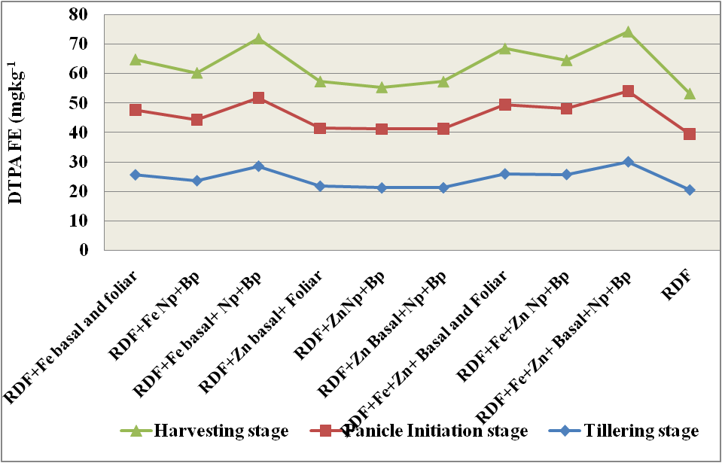
Treatment effect on extractable DTPA Fe at different growth stage of rice crop
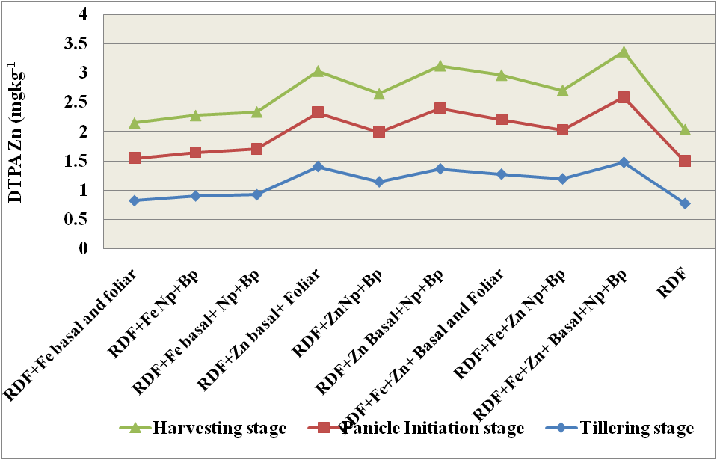
Treatment effect on extractable DTPA Zn at different growth stage of rice crop

FIG 2. Treatment effect on extractable DTPA Zn at different growth stage of rice crop

4.) Discussion:
4.1) Effect of different treatments on critical physicochemical properties of soils under Rice-Lentil cropping
The relationship between plant traits, soil characteristics, and the interactions between plant roots and surrounding soil microbes determines the availability of nutrients in the rhizosphere (Dotaniya and Meena, 2015). Although modest changes were noted among treatments, the major chemical characteristics, such as pH, EC, OC, Available Nitrogen, Phosphorus, and Potassium, were not significantly affected by the varied sources of Fe and Zn or their respective application methods since every treatment received fertilizers as per the recommended dose. Treatments that constituted bacterial biopriming resulted in slightly lower soil pH. Microbial incorporations are responsible for the slight acidity of the rhizospheric soil as well as the transformation, transportation, and solubilization of metals inside the plant parts. pH decrease is caused by the microorganisms' production of CO₂, which raises pCO₂ and eventually becomes carbonic acid. Fe compounds have limited solubility in soils. Our findings demonstrated that a slight pH fall was noted in the treatment involving simultaneous applications of Fe and Zn with biopriming. The cation exchange capacity (CEC) of the soil, pH, and solubility of the mineral itself—which is primarily controlled by adsorption to mineral surfaces, complex formation with organic matter, and precipitate formation-restrict the accessibility of soil Zn for uptake by crop plants (Smolders and Mertens, 2013; Fan et al. 2016a; Fan et al. 2016b). A slight increase in organic carbon was also observed for the treatments where biopriming was done, which could be because of comparatively higher root biomass and greater microbial activity. When Fe and Zn were combined with microbial inoculations, the N content was higher than in the other treatments in the post-harvest soil of rice. On the other hand, the post-harvest soil under lentil had higher nitrogen content than that of rice. This might be because the roots of the lentil crop fixed some N. The morpho-physiological characteristics of rice, such as its fibrous root system that explores more surface area for metal absorption, are expected (Sebastian and Prasad, 2014). Higher N values occur from developing a rhizosphere, facilitated by the developed rooting zone and allows for the natural release of organic acids and root exudates. The priming-mediated treatments naturally have better root proliferation exploring more rhizospheric soil, releases of organics acids and solubilisation of nutrients responsible for higher availability for both the crop (Mahmoud, 2023). A similar trend was also observed with P and potassium content in the post-harvest soil. These observations were recorded even if the effect of treatments was statistically non-significant.
4.2) Effect of treatments on DTPA extractable Fe and Zn in soil under rice and lentil cropping
A higher value of initial DTPA-Fe and Zn in soil was observed because soil taken before crop sowing which is fallow means no standing crop. Rhizospheric roots interfere with nutrient availability; it causes acidification of the rhizospheric zone which triggers more availability of nutrients that ultimately get more uptake by the root of plants. High pH value and a low organic matter concentration, reason for which can retards the Fe and Zn fixation ability of soil and reduce the bioavailability of Fe and Zn, thus inhibiting Fe and Zn uptake in plant roots (Alloway. 2008; Nandy, 2023). To tackle these issues, chelated form of Fe and Zn sources was used; having slow release and lower ability for complex formation. In our study, Fe and Zn application induced significant availability of Fe and Zn concentration in soil at each growth stage; and the treatments having combined applications of Fe and Zn as basal report to be highest concentrations in soil (Cakmak 2017) (Figure 1 and 2). The treatments having combined applications of Fe and Zn improved Fe and Zn absorption and accumulation in rice crops grown support the availability of specific nutrients in the rhizospheric zone. The result of DTPA extracted Fe and Zn presented in the previous chapter report to be significant differences at different critical growth stage but there was no significant differences among the treatments having sole or combined applications of particular nutrients. The result is similar to the finding of Li et al. (2007). With the advancement of the crop growth stage, the decline of DTPA extractable Fe and Zn for both crops was observed. Talukdar et al. (2009) found a substantial correlation between organic carbon and DTPA extractable Zn and Fe in surface soils of different series. These findings explain how complexing agents produced by organic matter increase the availability of these minerals in soil. No correlation was found between soil pH, and DTPA extractable Zn and Fe reported by Pati and Mukhopadhya (2011). This suggests that the aforementioned soil features do not affect the distributions of cationic micronutrients accessible within this soil series. According to Azarmi et al. (2011) the effects of treatments involving microorganisms applied through priming, such as Fe and Zn solubilizers, play a role in root proliferations, developed root systems, and the production of various organic acids in the rhizosphere, such as fumaric acids, citric acids, and gluconic acids. Alternatively, slight pH reductions lead to boost solubility and mobilizations of the insoluble compounds, which increases the accessibility of micronutrients for plant uptake. A study by Dhaliwal et al. (2021) revealed no correlation between DTPA-Zn and total zinc, confirming the widespread occurrence of zinc shortage without reference to total zinc levels in soils.
5.) Conclusion:
Treatments involving bacterial biopriming resulted in slightly lower soil pH, which is caused by the production of CO₂ by microorganisms. A slight increase in organic carbon was observed in treatments involving nutripriming and biopriming, possibly due to higher root biomass and microbial activity. The study results showed that Fe and Zn application induced significant availability of Fe and Zn concentration in soil at each growth stage, with the highest concentrations in soil for treatments with basal application and priming for respective nutrients. The inoculation of microorganisms through biopriming helps in the solubilization and transformation of nutrients in rhizospheric soil, making them available in soil solutions. The proportion of Fe and Zn readily available in soil was highest for treatments having combined applications of Fe and Zn along with priming was done. Priming and basal treatments led to higher Fe and Zn content values, with better root proliferation, organic acid release, and nutrient solubilization being the leading causes of increased crop and nutrient availability. The complex relationships between microbes and plants affect the availability of micronutrients in the rhizosphere. The use of endophytes helps improve soil Fe and Zn availability to crop plants.

Disclaimer (Artificial intelligence)
Option 1:
Author(s) hereby declare that NO generative AI technologies such as Large Language Models (ChatGPT, COPILOT, etc.) and text-to-image generators have been used during the writing or editing of this manuscript.
Option 2:
Author(s) hereby declare that generative AI technologies such as Large Language Models, etc. have been used during the writing or editing of manuscripts. This explanation will include the name, version, model, and source of the generative AI technology and as well as all input prompts provided to the generative AI technology
Details of the AI usage are given below:
1.
2.
3.

References:

Alloway BJ., (2008). Zinc in Soils and Crop Nutrition. Second Edi. International Zinc Association
Azarmi R, Hajieghrari B, Giglou A (2011) Effect of Trichoderma isolates on tomato seedling growth response and nutrient uptake. African journal of Biotechnology, 10(31): 5850-5855.
Black CA (1965) Methods of Soil Analysis Parts 12 American Society of Agronomy1nc Publisher Madisson Wisconsin USA 1-1378.
Bouis, H.E. & Saltzman, A. (2020). Improving nutrition through biofortification: A review of evidence from HarvestPlus. Global Food Security, 25, 100347.
Cakmak, I. (2000). Tansley Review No. 111 Possible roles of zinc in protecting plant cells from damage by reactive oxygen species. The New Phytologist, 146(2), 185-205.
Cakmak, I., Kalayci, M., Kaya, Y., et al. (2017). Agronomic biofortification of cereals with zinc: a review. European Journal of Soil Science, 68(1), 57–64.
Dhaliwal SS, Sharma V, Shukla AK,Verma V, Sandhu PS, Behera SK,Hossain A (2021) Interactive effects of foliar application of zinc iron and nitrogen on productivity and nutritional quality of Indian mustard (Brassica juncea L). Agronomy, 11(11): 2333.
Dotaniya, M. L., & Meena, V. D. (2015). Rhizosphere effect on nutrient availability in soil and its uptake by plants: a review. Proceedings of the National Academy of Sciences, India Section B: Biological Sciences, 85, 1-12.
Fontes RLF, Cox FRS (1998) Zinc toxicity in soybean grown at high iron concentration in nutrient solution.J Plant Nutr ,21 : 1723–1730.
G¨odecke T, Stein AJ, Qaim M (2018) The global burden of chronic and hidden hunger Trends and determinants. Glob Food Sec, 17: 21–29
Gomez KA, Gomez AA (1984) Statistical Procedures for Agricultural Research. IRRI, Loss Banos, Manila.
Jackson ML (1967) Soil chemical analysis. Prentice Hall of India Pvt Ltd New Delhi pp, 134–144.
Li JXY,ang XE, He ZL, Jilani G Sun CY, Chen S M (2007) Fractionation of lead in paddy soils and its bioavailability to rice plants. Geoderma, 141: 174–180.
Lindsay WL, Norvell WA (1978) Development of a DTPA soil test for zinc iron manganese and copper. Soil SciSoc Am J, 42(3):421– 428.
Mahmoud Soltani, S., Hossieni Chaleshtori, M., Tajaddodi Talab, K., Shokri Vahed, H., & Shakoori Katigari, M. (2023). Rice growth improvement, bio-fortification, and mitigation of macronutrient requirements through foliar application of zinc and iron-glycine chelate and zinc sulfate. Journal of Plant Nutrition, 46(8), 1777-1786. https://www.tandfonline.com/doi/abs/10.1080/01904167.2022.2099894
Manyevere A,Muchaonyerwa P,Mnkeni PN, Dhau I (2017) Spatial variability of selected soil micronutrients under smallholder crop production in Zanyokwe Eastern Cape South Africa. S Afr J Plant Soil, 34(5):339– 349
Nandy, P., Das, S. K., & Tarafdar, J. C. (2023). Effect of integrated nutrient management and foliar spray of zinc in nanoform on rice crop nutrition, productivity and soil chemical and biological properties in inceptisols. Journal of Soil Science and Plant Nutrition, 23(1), 540-555. https://link.springer.com/article/10.1007/s42729-022-01064-8
Narwal RP, Malik RS (2011) Interaction of Zn with other nutrients. Indian J Fert, 7(10) :140–150.
Olsen S, Cole C, Watanabe F, Dean L (1954) Estimation of available phosphorus in soils by extraction with sodium bicarbonate. USDA Circular Nr 939, US Government Print Office, Washington, D.C
Pati R,Mukhopadhya D (2011) Distribution of cationic micronutrients in some acid soils West Bengal. Journal of the Indian Society of Soil Science,59:125-33.
Reza SK, Nayak DC, Mukhopadhyay S, Chattopadhyay T, Singh SK (2017) Characterizing spatial variability of soil properties in alluvial soils of India using geostatistics and geographical information system. Arch Agron Soil Sci 63(11):1489-1498.
Sebastian A, Prasad MNV, 2014 Cadmium minimization in rice A review Agron Sustain Dev 34: 155–173.
Shukla AK, Sinha NK, Tiwari PK, Prakash C, Behera SK, Lenka NK, Singh VK, Dwivedi BS, Majumdar K, Kumar A, Srivastava PC, Pachauri SP, Meena MC, Lakaria BL, Siddiqui S (2017) Spatial distribution and management zones for sulfur and micronutrients in Shiwalik Himalayan region of India. Land Degrad Dev 28(3): 959-969.
Shukla AK, Sinha NK, Tiwari PK, Prakash C, Behera SK, Surendra Babu P, Patnaik MC, Somasundaram J, Singh P, Dwivedi BS, Datta SP (2018) Evaluation of spatial distribution and regional zone delineation for micronutrients in a semiarid Deccan Plateau Region of India. Land Degrad Dev, 29(8):2449-2459
Subbiah BV, Asija GL (1956) A rapid procedure for the estimation of available nitrogen in soils. Current Science 25: 254-260
Talukdar D. (2012). Total flavonoids, phenolics, tannins andantioxidant activity in seeds of lentil and grass pea.International Journal of Phytomedicine, 4: 537-542
Walkley A Black I (1934) An examination of Degtjareff method for determining soil organic matter and a proposed modification of the chromic acid in soil analysis. Exp Soil Sci ,79:459–465.
Zuo Y, Zhang F (2011) Soil and crop management strategies to prevent iron deficiency in crops Plant Soil 339: 83-95.

