Comparative analysis of pollen viability and germination efficiency among guava genotypes

ABSTRACT
A study was conducted at the Fruit Science Laboratory, College of Horticulture, Junagadh Agricultural University, Junagadh, during the years 2023-24 and 2024-25 to assess pollen viability and in vitro germination in five guava genotypes. The experiment was laid out in a Randomized Block Design (RBD) comprising five treatments with three replications each. Pollen viability an essential parameter in plant breeding for evaluating the functional capacity of male gametes was examined using both the 2% acetocarmine staining technique and in vitro pollen germination methods. The results showed that among the tested guava genotypes, L-49 recorded the highest pollen viability (96.23%), followed by Allahabad Safeda (94.86%) and Lalit (92.99%). In contrast, the highest pollen germination was observed in Lalit (92.23%), followed by Allahabad Safeda (91.59%) and L-49 (87.99%) in the pooled analysis. Based on the findings, L-49 was the best genotype in terms of pollen viability, while Lalit showed the highest germination rate, indicating its superior reproductive potential under in vitro conditions.
Keywords: Guava, Genotypes, Viability and Germination

- INTRODUCTION
Guava (Psidium guajava L.) is an important fruit of the tropical and subtropical regions of the world. The genus Psidium belongs to the family Myrtaceae and has a basic chromosome number of x=11. All cultivars of Indian guava belong to a single species, Psidium guajava L. Hayes (1953) reported that the genus contains about 150 species, though only a few have been studied in detail. Bailey (1919) noted that the two species, P. pyriferum and P. pomiferum, mentioned by Linnaeus, are merely variations with pear shaped and round shaped fruits, respectively. Subsequently, other species were recognized and documented. The wild species of guava hold considerable importance in breeding programs.
Guava occupies an important place in horticultural wealth of our nation. Guava is popularly known as the “Apple of tropics” due to its high nutritional value and year round availability at moderate prices. It is one of the most referred to and legendary fruits, known for its hardiness and prolific bearing nature. This fruit has been domesticated across India and is sold in local markets, even at the village level, at an affordable price. Hence, guava is often called the “Poor man’s apple” (Sahoo et al., 2017). It is the fifth most important fruit crop in terms of production, following banana, mango, citrus and papaya.
Currently, the major guava producing countries are India, China, Thailand, Mexico, Indonesia, Pakistan, Brazil, Egypt, Bangladesh and Nigeria (Anon., 2018). India is the leading producer of guava in the world. It is estimated that guava area about 310 Mha and production of about 4469 MT in India (Anon., 2021b). The major guava producing states are Madhya Pradesh, Uttar Pradesh, Bihar, West Bengal, Andhra Pradesh and Maharashtra (Anon., 2018). Gujarat occupies 14326 ha of area with 175327 MT of production. Bhavnagar, Baroda, Botad, Kutch and Gandhinagar are major guava producing districts in Gujarat. (Anon., 2021a).
It is a small evergreen plant that grows up to 8 m and branches irregularly. It has smooth and pale brown bark. The leaves are large, dull, oval shaped and long up to 15 cm long and emerge 6–9 days after bud burst. The flowers are white, four petaled and approximately 2.5 cm wide, hermaphrodite, solitary or 2–3 flowered cymes emerging in the axils of the leaves. Flowering lasts up to 1–2 months, with peak flowering occurring between 15 and 30 days. Anthesis takes place in the early hours of the morning. Anther dehiscence starts 15–30 min after anthesis generally from 7 a.m. and lasts until 10 a.m. The stigma becomes receptive one day before anthesis and remains receptive until 2 days after anthesis. The stigma shows maximum receptivity on the day of anthesis, especially 2 h after anthesis. Fruit is round to pear shaped with 3–10 cm diameter and features a yellow or pink peel at maturity in some species. It has white, yellowish, light pink, dark pink and red colored pulp with many small hard seeds (Tandel et al., 2024).
Pollen grains are produced inside the anther and are dispersed after dehiscence. Pollen grains remain independent functional units after dispersal and are exposed to prevailing environmental conditions. Pollination and fertilization are necessary for fruit and seed set. In breeding programs, the compatibility of parents is considered an important factor, so breeders select male parents with the desired characteristics and greater fertility. This variation in fertility and seed set is dependent on the viability of the pollen grains. The perfect development of flowering organs and high viability and germination of pollen are prime conditions for fertilization (Tandel et al., 2024).
Guava (Psidium guajava) is generally a self-fertile crop, capable of setting fruit through self-pollination. However, self-pollination often results in lower fruit set, reduced fruit size, and inferior quality compared to cross-pollination (Yadava et al., 2001). Cross-pollination, involving the transfer of pollen between different plants, enhances genetic diversity and fertilization efficiency, leading to improved fruit set, larger fruit size, and superior fruit quality (Singh et al., 2010). The success of pollination also heavily depends on pollen viability and germination capacity. Fresh and viable pollen is essential for effective germination on the stigma and successful fertilization. Environmental factors such as temperature and humidity significantly influence both pollen viability and stigma receptivity (Shukla et al., 2011). Insect pollinators, particularly bees like Apis species, play a vital role in pollen transfer. Increased pollinator activity is directly associated with improved fruit set due to efficient pollen deposition.
Moreover, adequate pollen load and quality are necessary for successful fertilization, while poor-quality or insufficient pollen can lead to flower drop or fruit abortion. Varietal differences also influence pollination outcomes; some guava cultivars are more responsive to cross-pollination, while others can sustain fruit set with self-pollination. Breeding programs often select compatible male and female cultivar combinations to maximize fruit set and enhance yield potential (Pathak and Ojha, 1993). In conclusion, the quality, source, and transfer of pollen are critical determinants of fruit set, yield, and quality in guava. Though the plant can self-pollinate, practices that encourage cross pollination such as managing pollinator populations or employing hand pollination techniques can significantly improve production outcomes. However, guava cultivation faces significant challenges, for fruit set, yield and quality. Therefore, the top priority in guava cultivation is the development of high yielding cultivars with enhanced quality. The primary objectives of the study to study the pollen viability of different genotypes of guava.

2. MATERIAL AND METHODS
The study was undertaken at the Fruit Science Laboratory, College of Horticulture, Junagadh Agricultural University, Junagadh, during the academic years 2023–24 and 2024–25 to assess the pollen viability of five different guava genotypes. The experimental layout followed a Randomized Block Design (RBD) with five treatments replicated three times. College of Horticulture, Junagadh Agricultural University, Junagadh (Gujarat) is situated at an altitude of 61 m above MSL, and at 70°30’ E longitude and 21°30’N latitude. It near the foot hills of the mountain Girnar. One of the Jyotirlingas, Somnath is about 90km away from Junagadh. The birth place of beloved Mahatma Gandhi (The Father of Nation), Porbandar is about 120km from Jungadh.
Descriptions of guava cultivars used as parents are given below:
Allahabad Safeda
A selection of Allahabad Safeda was officially released by the Central Institute for Subtropical Horticulture (CISH) in Lucknow. It is the most important variety of guava used for table and processing purposes. The tree is medium to tall in size, upright growth habit, heavy bearer, dense foliage and has a tendency to produce long shoots. Crown is broad and compact, often dome-shaped and rarely loose. Fruits are of medium in size, round in shape with smooth skin and white flesh. The fruits are relatively soft with less seeds. Its keeping quality is good.
Sardar (Lucknow-49)
Sardar (Lucknow-49) is chance seedling selection from Allahabad Safeda in 1927 at Division of Horticulture, Agriculture College, Poona by Dr. Cheema. The L-49 has been renamed as “Sardar”. Tree is vigorous, spreading and profuse bearer, heavy branching type with flat crown. fruit is large, round to ovate in shape, primrose yellow skin colour, white pulp and seeds are in plenty and harder than Allahabad Safeda.
Lalit
It is originated from a selection named CISH-G-3, which was part of a breeding program involving a half-sib population derived from the Apple Colour. Released by ICAR-Central Institute for Subtropical Horticulture, Lucknow for commercial cultivation in guava growing region of the country. A variety with wide adaptability in different agro ecological zones of the country. The fruit yield is 100 kg/plant at the age of 6 years, which is higher than any other commercial guava variety. Suitable for high density planting. Fruits are of saffron yellow in colour with red flash and weighing 185-200 g/fruit, flesh firm and pink with good blend of sugar and acid. The content of vitamin ‘C’ in fruit is 250 mg/100 g. It is suitable for both table and processing purposes. The pink colour in the beverage remains stable for more than a year during storage.
Shweta
It is a selection from half sib population of Apple Colour. The assortment is developed by the Central Institute for Subtropical Horticulture, Lucknow. While the exact year of its release is not clearly documented. Trees are semi vigorous with medium height and prolific bearer. The fruit yield is 90 kg/plant at the age of 6 years. It is a variety with medium size globous fruits, weighing 225 g/fruit, creamy white epicarp having snow white flesh, TSS 12.5-13.2° Brix, vitamin ‘C’ content 300 mg/100 g pulp and good keeping quality. It is a high yielder.
Yogi (Saranpur Selection)
Rounded fruit shape with fine skin structure, pinkish red pulp, fruit diameter (6.77 cm) and fruit weight (165.50 g).
Pollen viability
Pollen viability of fresh pollen from each variety was confirmed using acetocarmine test.
Aceto-carmine test (2%): Carmine show the presence of cytoplasm. The pollen nucleus is rich in chromatin material and viable pollen stains pink to deep red with aceto-carmine, while sterile (mostly shriveled) pollen does not take any stain and thus remains almost white and transparent (McKellar and Quesenberry, 1992; Marutani, et al., 1993)
Procedure: Pollen viability was assessed by collecting freshly opened flower from each genotype and brought to the laboratory. The pollen grains were dusted on a glass slide from freshly dehiscence anthers and 1 to 2 drops of 2 % acetocarmine solution put on these grains, covered with the cover slip and left for 4-5 minutes to allowed pollen to absorb stain completely. Slides were examined under simple binocular microscope with 10x magnification. Post-staining, pollen grains were assessed based on their size, morphology and staining intensity. Grains that exhibited deeper coloration, larger size and clearly defined outlines were identified as viable, whereas those with faint or no staining, smaller size and irregular outlines were deemed nonviable. For each genotype or treatment, three slides were examined.
Pollen viability was calculated by using following formula and expressed in percentage.
Pollen viability percentage = Total number of viable pollen grains in microscopic field/Total number of pollen grains in microscopic field x 100
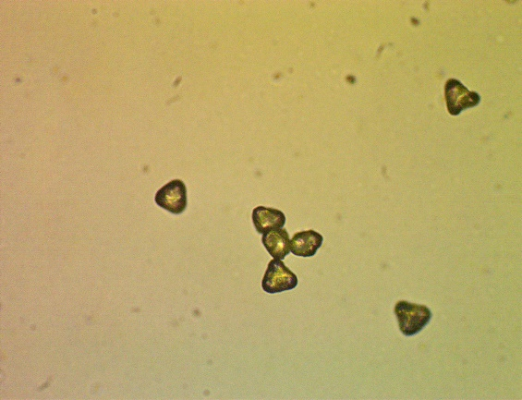 | 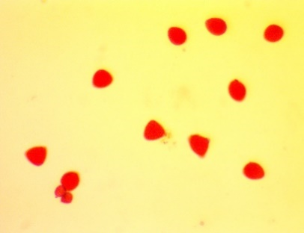
Picture 1: Pollen without acetocarmine test | Picture 2 :Pollen after acetocarmine test

In vitro pollen germination test:
Procedure: At the flowering stage, flowers were randomly collected from freshly dehisced anthers of five different plants for each guava cultivar. The pollen grains extracted from these flowers were thoroughly mixed on glazed paper and then evenly distributed onto the surface of a semisolid germination medium in petri dishes using a camel hairbrush. The germination medium was composed of 35% sucrose, 100 ppm boric acid, 100 ppm calcium nitrate, and 0.8% agar. Following pollen inoculation, the petri dishes were incubated in a BOD incubator at 25 ± 2 ºC for 24 hours in complete darkness, with three replications per treatment. Pollen grains were considered germinated if they produced a pollen tube longer than their diameter, and germination was expressed as a percentage (Vyas, 2021)
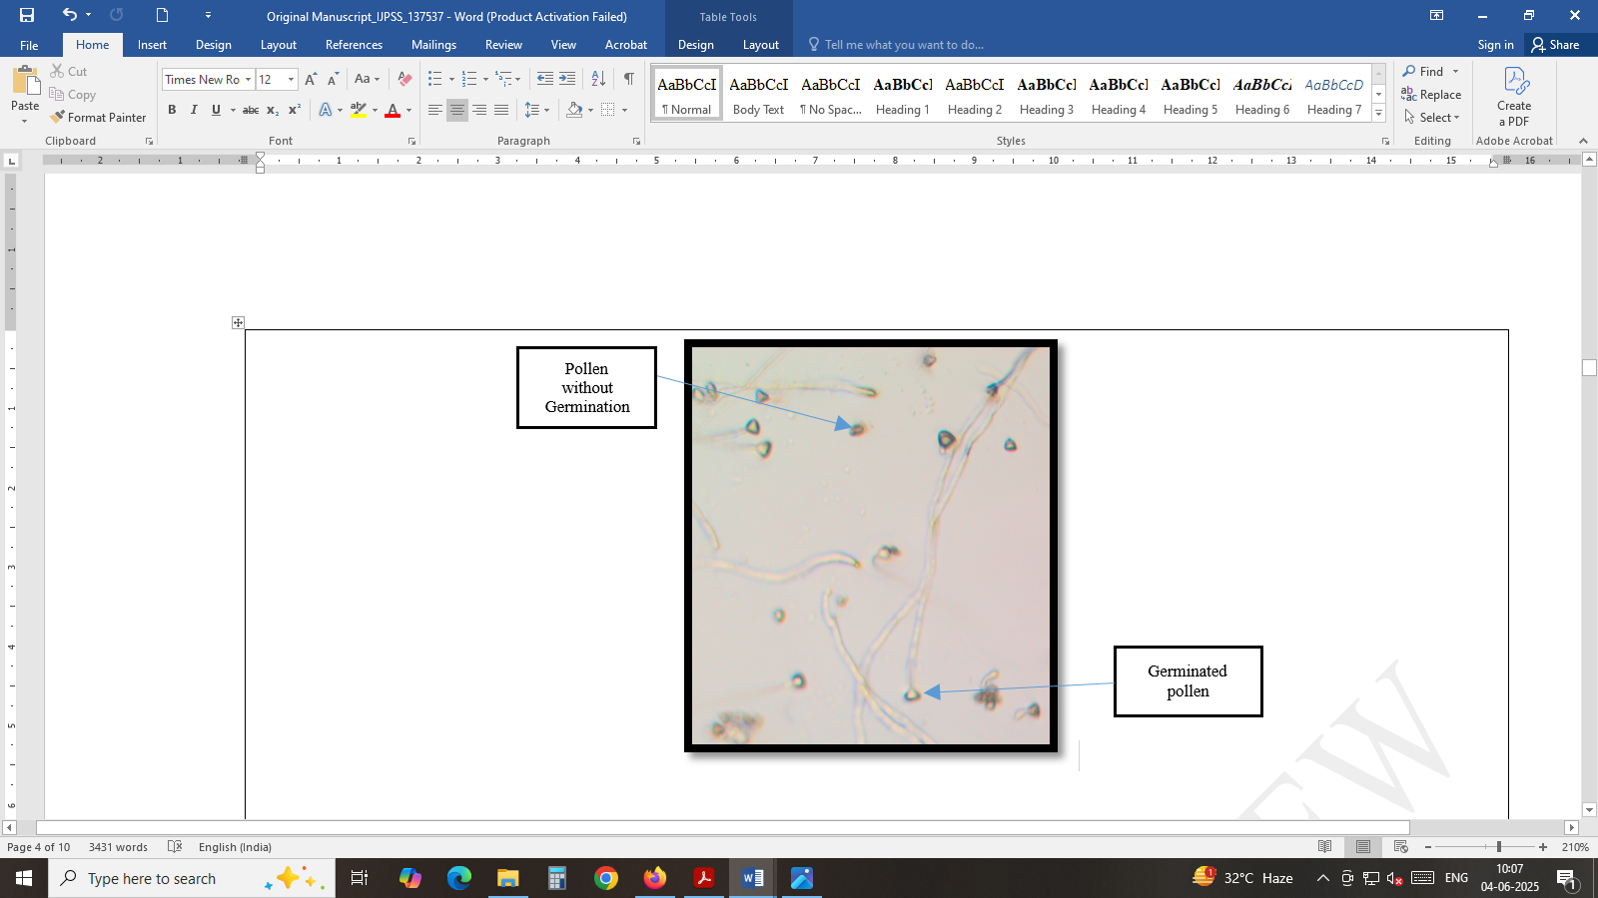
Picture 3 : In vitro pollen germination
Pollen germination was calculated by using following formula and expressed in percentage.
Pollen germination percentages = Total number of germinated pollen grains in microscopic field / Total number of pollen grain in microscopic field x 100
The various characters under investigation were statistically analyzed using the Analysis of Variance (ANOVA) method appropriate for a Randomized Block Design (RBD), following the procedure outlined by Panse and Sukhatme (1985). The significance of all traits was assessed using the “F” test. The standard error of the mean (SEm. ±) and critical differences (CD) at the 5% significance level were calculated. All statistical computations were performed at the Computer Cell, Department of Agricultural Statistics, College of Agriculture, Junagadh Agricultural University, Junagadh.

3. RESULTS AND DISCUSSION
3.1 Pollen viability
There was significant variation observed in the influence of pollen on pollen viability percentage during both years, as well as in the pooled data of different varieties. The data were presented in Table 1.
The pollen viability percentage values ranged from 85.64 % to 95.78 % among the five studied genotypes, during the pooled analysis. The data indicated that the highest pollen viability (96.23 %) was observed in Allahabad safeda (P₁), which was found to be at par with L-49 (P₂) and Lalit (P₃) (94.86 % and 92.99 %, respectively) during the year 2023-24. The highest pollen viability (96.70 % and 95.78 %) was recorded in L-49 (P₂), during the year 2024-25 and in the pooled data, which was at par with Lalit (P₃) (94.05 % and 93.52 %) and Allahabad safeda (P₁) (93.67 % and 94.95 %), respectively. In contrast, the lowest pollen viability (86.23 %, 85.05 % and 85.64 %) was recorded in Yogi (P₅), followed by Shweta (P₄) (89.44 %, 89.05 % and 89.25%) during the years 2023-24 and 2024-25, as well as in the pooled data.
Table 1 Fresh pollen viability of guava genotypes
Varieties/Genotypes | Fresh pollen viability ( %)
 | 2023-24 | 2024-25 |  | Pooled
Allahabad safeda (Female) | 96.23 | 93.67 |  | 94.95
L-49 (Male) | 94.86 | 96.70 |  | 95.78
Lalit (Male) | 92.99 | 94.05 |  | 93.52
Shweta (Male) | 89.44 | 89.05 |  | 89.25
Yogi (Female) | 86.23 | 85.05 |  | 85.64
S.Em.+ | 2.059 | 1.778 |  | 1.360
C.D. at 5 % | 6.72 | 5.80 |  | 4.08
C.V. % | 3.88 | 3.36 |  | 3.63
 | Year |  | Year × Treatment
S.Em.+ | 0.860 |  | 1.924
C.D. at 5 % | NS |  | NS
The variations in pollen viability among guava cultivars may be due to genetic differences and varietal traits. (Jha et al. 2020) or may be related to characteristics of the fruits and seed in the pollen donor genotypes (Silva et al. 2017). Environmental factors, especially temperature and rain fluctuations during flowering might also influence pollen viability.
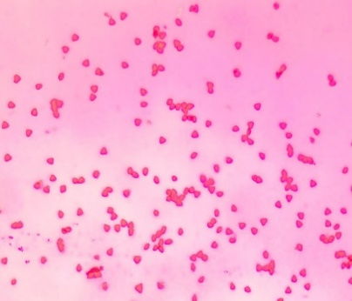 | 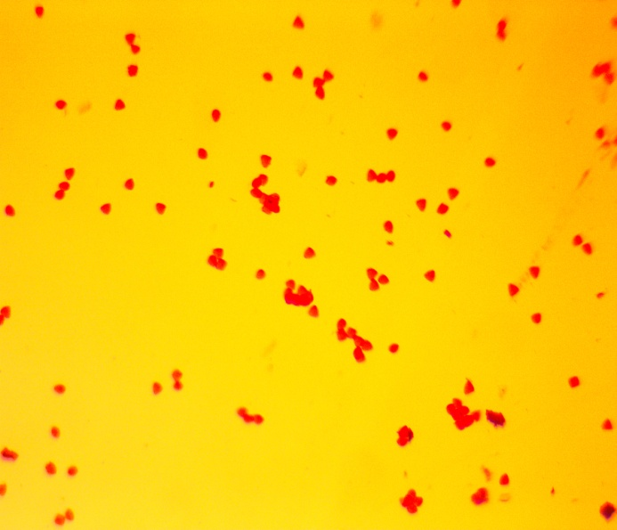 |  | 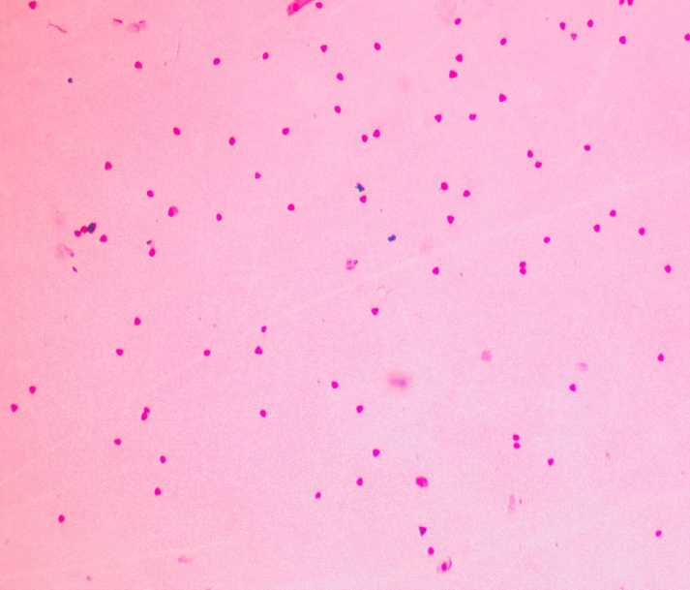
Allahabad safeda | L-49 |  | Shweta
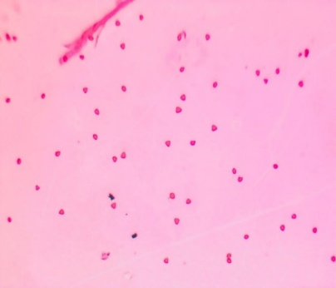 |  | 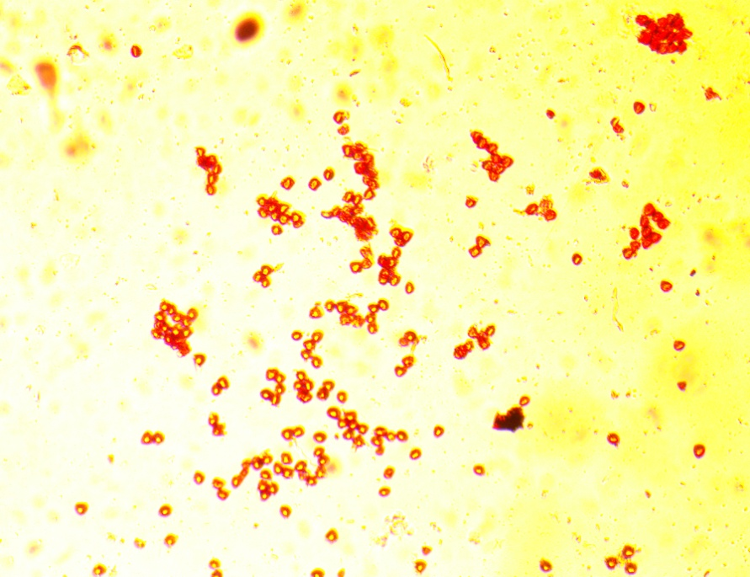
Lalit |  | Yogi
Plate 1 Fresh pollen viability of guava genotypes

Fig. 1 Fresh pollen viability of guava genotypes

Cultivars with higher pollen viability can be effectively used as donor parents in hybridization programs. Pollen viability is influenced by various factors such as soil fertility, climatic conditions and genetic makeup. Kahlon et al. (1987) reported the highest viability in the Sardar variety (98.90%), while Sarkar and Sarkar (2022) found similar results in the China cultivar (93.67%). Tandel et al. (2024) observed maximum viability in Lalit (92.96%). Earlier studies by Singh and Sehgal (1968) and Kundu and Mitra (1994) also recorded high viability in Chittidar (96.40% and 94.32%, respectively). Comparable trends have been observed in other fruit crops as well Sharma and Bist (2003) in pomegranate, Baswal et al. (2015) in sweet orange, Baswal et al. (2017) in grapefruit, and Mandal et al. (2020a) and Das et al. (2021) in mango highlighting the combined impact of genetic and environmental factors on pollen viability.

3.2 In vitro pollen germination
Significant differences in pollen germination were observed among varieties during both years, as well as in the pooled analysis. The data are presented in Table 2.
Pollen germination percentage values ranged from 81.18 % to 92.23 % among the five studied varieties/genotypes. The data indicated that the highest pollen germination (91.06 %, 93.40 % and 92.23 %) was observed in Lalit (P₃). It was found to be at par with Allahabad safeda (P₁) (90.42 %, 92.75 % and 91.59 %) and L-49 (P₂) (86.33 %, 89.66 % and 87.99 %) during both years, as well as in the pooled data. In contrast, the lowest pollen germination (79.85 %, 82.52 % and 81.18 %) was recorded in Yogi (P₅), followed by Shweta (P₄) (84.10 %, 85.77 % and 84.94 %) during the years 2023-24 and 2024-25, as well as in the pooled data, respectively. Pollen germination can vary depending on the location and the type of medium used in the study. Despite these variables, Nair et al. (1964), Sarkar et al. (2018), and Tandel et al. (2024) reported the highest germination percentages in the Sardar (L-49) cultivar, with values of 90.00%, 87.00%, and 79.52%, respectively. Similarly, Singh and Sehgal (1968) and Balasubrahmanyam (1959) recorded high germination rates in the Chittidar cultivar, at 96.10% and 98.80%, respectively. These observations are consistent with the findings of Nalawadi et al. (1973), Ratanpal and Dhaliwal (1996), Dhaliwal and Singla (2003), Tewari (1963) and Kahlon et al. (1987).
Table 2 In vitro pollen germination of guava genotypes
Varieties/Genotypes | In vitro pollen germination ( %)
 | 2023-24 | 2024-25 |  | Pooled
Allahabad safeda (Female) | 90.42 | 92.75 |  | 91.59
L-49 (Male) | 86.33 | 89.66 |  | 87.99
Lalit (Male) | 91.06 | 93.40 |  | 92.23
Shweta (Male) | 84.10 | 85.77 |  | 84.94
Yogi (Female) | 79.85 | 82.52 |  | 81.18
S.Em.+ | 2.119 | 1.986 |  | 1.452
C.D. at 5 % | 6.91 | 6.48 |  | 4.35
C.V. % | 4.25 | 3.87 |  | 4.06
 | Year |  | Year × Treatment
S.Em.+ | 0.918 |  | 2.053
C.D. at 5 % | NS |  | NS

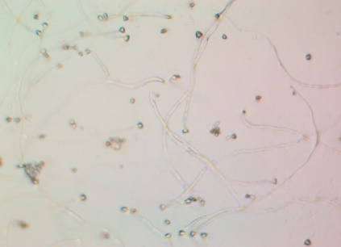 | 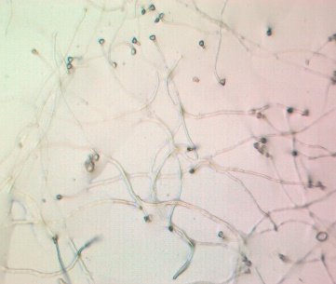 |  | 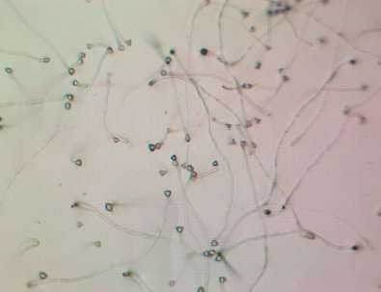
Allahabad safeda | L-49 |  | Lalit
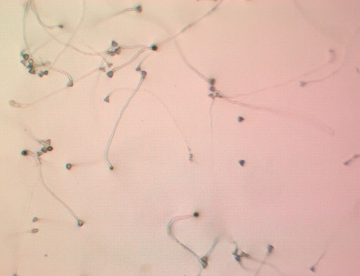 |  | 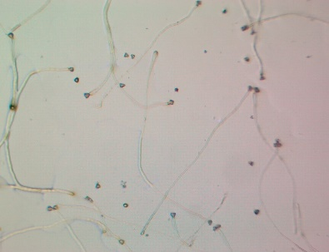
Shweta |  | Yogi
Plate 2 In-vitro pollen germination of guava genotypes

Fig. 2 In vitro pollen germination of guava genotypes

4. CONCLUSION
Based on the results obtained from the present investigation, it was observed that among the genotypes studied, L-49 exhibited the highest pollen viability, indicating its superior potential for successful fertilization and reproductive efficiency. In contrast, Lalit demonstrated the highest pollen germination percentage, suggesting its strong pollen performance under in vitro conditions. These findings highlight the distinct reproductive strengths of both genotypes. Further research focusing on the genetic and physiological factors influencing pollen viability in L-49 and germination efficiency in Lalit could provide valuable insights for improving breeding strategies. Combining the favorable traits of both genotypes may enhance hybrid development and overall crop productivity.

Disclaimer (Artificial intelligence)
Option 1:
I confirm that no generative AI technologies, including Large Language Models (such as Chat GPT, Copilot, etc.) or text-to-image generators, were used in the writing or editing of this manuscript.


Option 2:
Author(s) hereby declare that generative AI technologies such as Large Language Models, etc. have been used during the writing or editing of manuscripts. This explanation will include the name, version, model, and source of the generative AI technology and as well as all input prompts provided to the generative AI technology
Details of the AI usage are given below:
1.
2.
3.

REFERENCES:
Anonymous (2018). Horti. Statistics at a Glance-2018. Hort. Statistics Division, Department of Agriculture, Cooperation and Farmers Welfare, Agriculture and Farmers Welfare, Government of India. Available at http://www.agricoop.nic .in/statistics/Hort., accessed on 7 January, 2022.
Anonymous (2021ª). Area Production 2020-21. Horti. cultivation of crops, area and production Statistics Division, Director of Hort., Agriculture, Farmers Welfare and Cooperation Department, Government of Gujarat. Available at http://doh.gujarat.gov.in/Hort.-census.htm, accessed on 7 January, 2022.
Anonymous (2021^{b}). Agric. Statistics at a Glance-2021. Directorate economic and statistic, Department of Agriculture, and Farmer welfare, Ministry of Agriculture and Farmers Welfare, Government of India. Available at Visit us at: www.agricoop.nic.in & https://desagri.gov.in, accessed on 17 May, 2022.
Bailey, L. H. (1919). Standard encyclopaedia of Horticulture. Macmillan, New York, U.S.A. pp. 2847-2849.
Balasubramanyam, V. R. (1959). Studies on blossom biology of guava (Psidium guajava L.). Indian J. Hort., 16: 69-75.
Baswal, A. K., Rattanpal, H. S. and Sidhu, G. S. (2015). Assessment of pollen viability and floral biology in sweet orange (Citrus sinensis Obseck) cultivars under sub-tropical conditions of Punjab. The Bioscan, 10(4): 1573-1576.
Baswal, A. K., Rattanpal, H. S., Singh, G. S. and Uppal, G. S. (2017). Studies on pollen viability and floral biology in grapefruit (Citrus paradisi Mac Fadyen) cultivars under subtropical conditions of Punjab. Ecology Environment and Conservation, 23(1): 381–384.
Das, N. K., Sengupta, S., Singh, R. S., Kumar, S. and Sahay, S. (2021). Effect of pollen viability and germination on fruit set of different mango cultivars. The Pharma Innov. J., 10(7): 1715-1717.
Dhaliwal, G. S. and Singla, R. (2003). Pollen, pollination and fruit set studies in different genotypes of guava in winter and rainy season crops under Ludhiana condition. Haryana J. Hort. Sci., 32(3&4): 159-162.
Hayes, W. B. (1953). Fruit Growing in India. Kitabistan, Allahabad, 312-325.
Jha, M. K., Kumari, P., Sengupta, S., Rani, R., Singh, Y. K. (2020). Study of pollen viability and pollen germination in different cultivars of litchi in sabour Bhgalpur condition. J. Pharmacogn Phytochem. 9(2):1312–1317
Kahlon, P. S., Sharma, P. K. and Rambadi, J. L. (1987). Studies on floral biology of guava (Psidium guajavaL.) cultivar Allahabad Safeda and Lucknow-49. Haryana J. Hort. Sci.,16(1-2): 65-73.
Kundu, S. and Mitra, S. K. (1994). Studies on floral biology of different guava cultivars. Crop Res., 8(1): 80-85.
Mandal, S. K., Karuna, K., Kumar, A., Mankar, A. and Sahay, S. (2020ª). Floral biology andpollen viability of some mango (Mangifera indica L.) cultivars. Int. J. of Curr. Microbiology and App. Sci.,9(6): 2390-2400.
Marutani, M., Sheffer, R. D., Kameto, H. (1993). Cytological analysis of Arithurium andraenum (Araceae), its related taxa and their hybrids. Amer. J. Bot. 80:93-103.
McKellar, M. A., Quesenberry, K. H. (1992). Chromosome pairing and pollen viability in Desmodium ovalifolium Wall x Desmodium heterocarpon (L.) DC hybrids. Aust. J. Bot. 40:243-247.
Nair, P. K. K., Balasubrahmanyam, V. R., Khan, H. A. (1964). Palynological investigations of some guava varieties. Indian J. Hort., 21(1):79–84
Nalawadi, W. B., Farooqi, A. A., Reddy, M. A. N., Gubbiah and Nalini, A. S. (1973). Studies on floral biology of guava (Psidium guajava L.) variety Lucknow-49. Mysore J. Agric. Sci.,7: 24-37.
Panse VG, Sukhatme PV. Statistical Methods for Agricultural Workers. 3rd ed. Indian Council of Agricultural Research, New Delhi. p361; 1985.
Pathak, R. A. and Ojha, C. M. (1993). Studies on self-incompatibility and cross-compatibility in guava. Progressive Hort., 25(1–2): 20–24.
Ratanpal, H. S. and Dhaliwal, G. S. (1996). Studies on floral biology of guava. In proc. of silver jublee national seminar on arid hort., December, 5-6, CCS HAU, Hisar, pp: 209-211.
Sahoo, J., Tarai, R. K., Sethy, B. K., Sahoo A. K., Swain, S. C. and Dash, D. (2017). Flowering and fruiting behavior of some guava genotypes under East and South East coastal plain zone of Odisha. Int. J. Curr. Microbiol. App. Sci.,6(11): 3902-3911.
Sarkar, T., Sarkar, S. K. and Vangaru, S. (2018). Effect of sucrose and boric acid on in-vitro pollen germination of guava (Psidium guajava) varieties. Advances in Res., 15(1): 1–9.
Sharma, V. K. and Bist, H. S. (2003). Studies on flower and pollen characteristics in some new introduction of plum. Annuals of Agric. Res., 24(1): 40–44.
Shukla, P. S., Sharma, N., and Srivastava, R. (2011). Effect of temperature and humidity on pollen viability and fruit set in guava. J. of Applied Hort., 13(1): 50–54.
Silva S. N. D., Silva, M. S., Marcal, T. D. S., Ferreira, A., Fontes, M. M. P., Ferreira, M. F. D. S. (2017). Genetic parameters of pollen viability in guava (Psidium guajava L.). Aust. J. Crop. Sci. 11(1):1–8.
Singh, R. and Sehgal, O. P. (1968). Studies on blossom biology of Psidium guajava L. II. Pollen studies, stigmatal receptivity, pollination and fruit set. Indian J. Hort., 25(1 & 2): 52-59.
Tandel, Y. N., Jadav, H. M., Patel, N., Dangariya, V. D. and Zala, V. R. (2024). Pollen morphological Res. of guava cultivar under south Gujarat condition. Cenet Resour Crop Evol.,https://doi.org/10.1007/s10722-024-02250-6.
Tewari, G. N. (1963). Studies on pollen germination in guava (Psidium guajava L.). Hort. Sci., 1: 55-60.
Vyas, P. (2021). Study on the floral biology of different cultivars of guava (Psidium guajava L.). M. Sc. Thesis. Junagadh Agric. University, Junagadh, 113.
Yadava, A. K., Singh, D. B., and Singh, G. (2001). Pollination studies in guava (Psidium guajava L.). Indian J. of Hort., 58(3): 217–221.

