**Minireview Article**

**PREDICTION OF SEED GERMINATION, VIGOUR, AND VIABILITY USING HYPERSPECTRAL IMAGING**

**ABSTRACT**

The present review outlines the prospects for Hyperspectral imaging (HSI) implementation as a standard tool for predicting seed vigour, viability in commercial agriculture. The most extensively used optical detection methods for seed vitality mainly include machine vision detection, near-infrared spectroscopy, hyperspectral detection, Raman spectroscopy, fluorescence spectroscopy, and seed exhalation gas spectroscopy. Seed vigour and viability are integral to the performance of crops, from germination rates and seedling establishment to final yield potential. Traditional methods for assessing seed vigour and viability outcomes are reliant on time, labour, or both methods, which often result in destructive sampling of the seeds, making them cumbersome and unsuitable for high-volume seed quality assessment. Hyperspectral imaging (HSI) is a new and fast analytical method which is non-destructive to the sample and has great potential to estimate seed vigour and viability. The reviews identify how both spectral features and spatial features can be combined to monitor subtle biochemical and structural differences of seeds regardless of whether the seeds are affected by ageing, mechanical damage or physiological stress. The review also presents HSI results that have spectral regions that can differentiate germinable seeds and non-germinable seeds, machine learning algorithms capabilities to improve yield, and the use of high-throughput systems with faster and real-time data presentations. The potential for HSI to be used in seed science is enormous and creates a transformational opportunity for more rapid, accurate, and non-destructive seed testing for vigour and viability.

**Keywords**: Hyperspectral imaging, seed germination, non-destructive testing, spectral analysis, Machine learning algorithms

**1. INTRODUCTION**

“Seed viability is essential to have a homogeneous plant population. The seed industry cannot adopt traditional procedures for seed viability evaluation since they are destructive, time-consuming, and need chemicals. Several factors influence seed quality, including genetic purity, physical purity, moisture content, and viability. A crucial aspect of seed quality is viability, strongly related to germination rate, resilience to biotic and abiotic stress, and plant performance, which falls out as storage time increases” (Al Siam et al., 2024). Seed germination is an important biological process that controls the success of crop production and food security levels. Seed vigour is a quantitative trait which combines various factors that affect overall seed performance rather than functioning as a single measurable parameter, in contrast to germination and viability. These factors include rate and uniformity of germination, growth of seedlings, ability to emerge under unfavourable environments, and performance on completion of storage(Basu & Groot, 2023). The assessment of seed viability and vigour is essential for managing germplasm collections as well as for commercial seed production, allowing the seed industry to monitor physiological potential and make strategic decisions about high-quality seed lots that ensure optimal crop establishment(Marcos Filho, 2015; Mead & Gray, 1999). The evaluation of seed vigour through conventional methods relies on standard germination tests, electrical conductivity measurements, seedling growth assessments, accelerated ageing procedures, cold tests and tetrazolium analysis. These techniques, however, tend to be manual, time-consuming, and destructive and need specialised knowledge and skills to perform them. The methods lack suitability for large-scale implementation (Huang et al., 2024; Xia et al., 2019). The existing limitations require developing innovative seed quality assessment methods that deliver rapid results without destroying the samples.

The development of sophisticated computer and optical sensor systems has led to the adoption of numerous non-destructive testing approaches for determining seed vitality, each with its own advantages and drawbacks (T. Zhang et al., 2018). The most extensively used optical detection methods for seed vitality mainly include machine vision detection, near-infrared spectroscopy, hyperspectral detection, Raman spectroscopy, fluorescence spectroscopy, and seed exhalation gas spectroscopy. Hyperspectral imaging is an emerging technique that combines visible and near-infrared spectroscopy with imaging to obtain both spectral and spatial data of samples concurrently. Hyperspectral imaging (HSI) combines imaging and spectroscopy to acquire comprehensive spectral data from seeds over a broad spectrum of wavelengths. “The technique is widely used in the field of seed quality detection and classification, which is based on the detailed acquisition of the morphology of the tested material, as well as the characteristic information of its internal structure and chemical composition” (Zhou et al., 2020). “This technique facilitates the identification of biochemical and structural alterations indicative of germination potential. By examining spectral patterns related to seed moisture content, metabolic activity, and chemical composition, HSI offers a thorough evaluation of seed viability without causing any damage to the seeds”(Feng et al., 2019).

This review explores the principles and applications of hyperspectral imaging for accurate prediction of seed germination, vigour and viability. We considered the most important spectral characteristics useful for seed analysis, the use of machine learning methods for prediction improvement, and recent developments in HSI technology. Our review outlines prospects for HSI implementation as a standard tool for predicting seed vigour, and viability in commercial agriculture.

**2. PRINCIPLES OF HYPERSPECTRAL IMAGING**

“Hyperspectral imaging (HSI) is a technology that combines the capabilities of imaging, spectroscopy, and chemometrics into a unified optical sensing system” (Ma et al., 2019). “HSI obtains both spatial and spectral information simultaneously” (Mishra et al., 2020). “The fundamental principle of hyperspectral imaging is grounded on the fact that all materials, due to the difference in their chemical composition and inherent physical structure, reflect, scatter, absorb, and emit electromagnetic energy in distinctive patterns at specific wavelengths. This characteristic is called a spectral signature or a spectral fingerprint, or simply the spectrum and is unique to an object” (Elmasry et al., 2012). While conventional RGB imaging acquires data in three large bands - red, green, and blue, the hyperspectral system captures information from hundreds of narrow, contiguous spectral bands. “The result is a three-dimensional dataset often called "datacube" or "hypercube” as depicted in *Fig 1*. This format consists of two spatial dimensions, expressed as x and y coordinates, with one spectral dimension described by wavelength. A hyperspectral image contains a complete spectrum in every pixel and, therefore, carries comprehensive information about the chemical and physical properties of the materials within the scene. First, for each sub image (x, y) at one wavelength, there is spatial information of the spectral intensity (λ) at that wavelength. Second, for each pixel (x, y), the full wavelength spectrum is obtained. The above two perspectives are the most common strategies for studying hyperspectral cubes” (Elmasry et al., 2012; Wu & Sun, 2013)

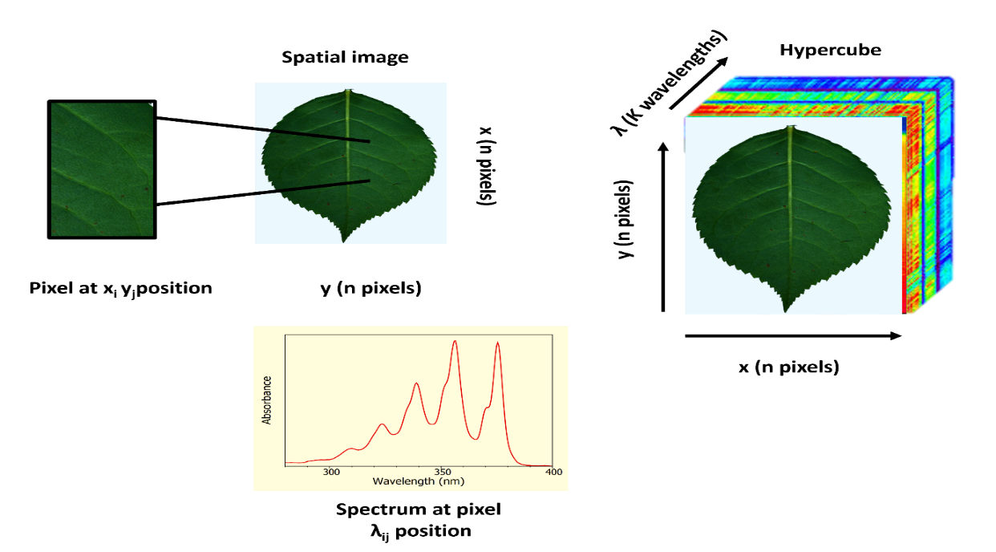

**Fig. 1. Basis of the hypercube in hyperspectral imaging.**

**3. HYPERSPECTRAL DATA PROCESSING AND ANALYSIS**

The spectrally rich data obtained through HSI undergoes several processing steps to achieve the relevant detection results and classification accuracy, as illustrated in Fig. 2. “Hyperspectral raw data are characterised by their high dimensionality, encompassing a vast array of spectral details. To improve the efficiency of processing and analysing this data, it is essential to reduce its dimensionality, effectively translating it from a high-dimensional space to a lower-dimensional one while preserving the most significant information. The raw hyperspectral data are rich in spectral details, and extracting valuable features from them is a crucial challenge. The preprocessing steps can enhance the quality and reliability of the data, reduce the impact of interfering factors, and provide a more reliable and effective basis for subsequent data analysis and applications, ultimately improving the accuracy of data analysis” (Cozzolino et al., 2023). Generally applied preprocessing techniques include methods such as smoothing, multiplicative scatter correction (MSC), standard normal variate (SNV),savitzky–golay (SG), minimal noise fraction (MNF), etc.(Nikzadfar et al., 2024; Shi et al., 2024; Özdoğan & Gowen, 2025).

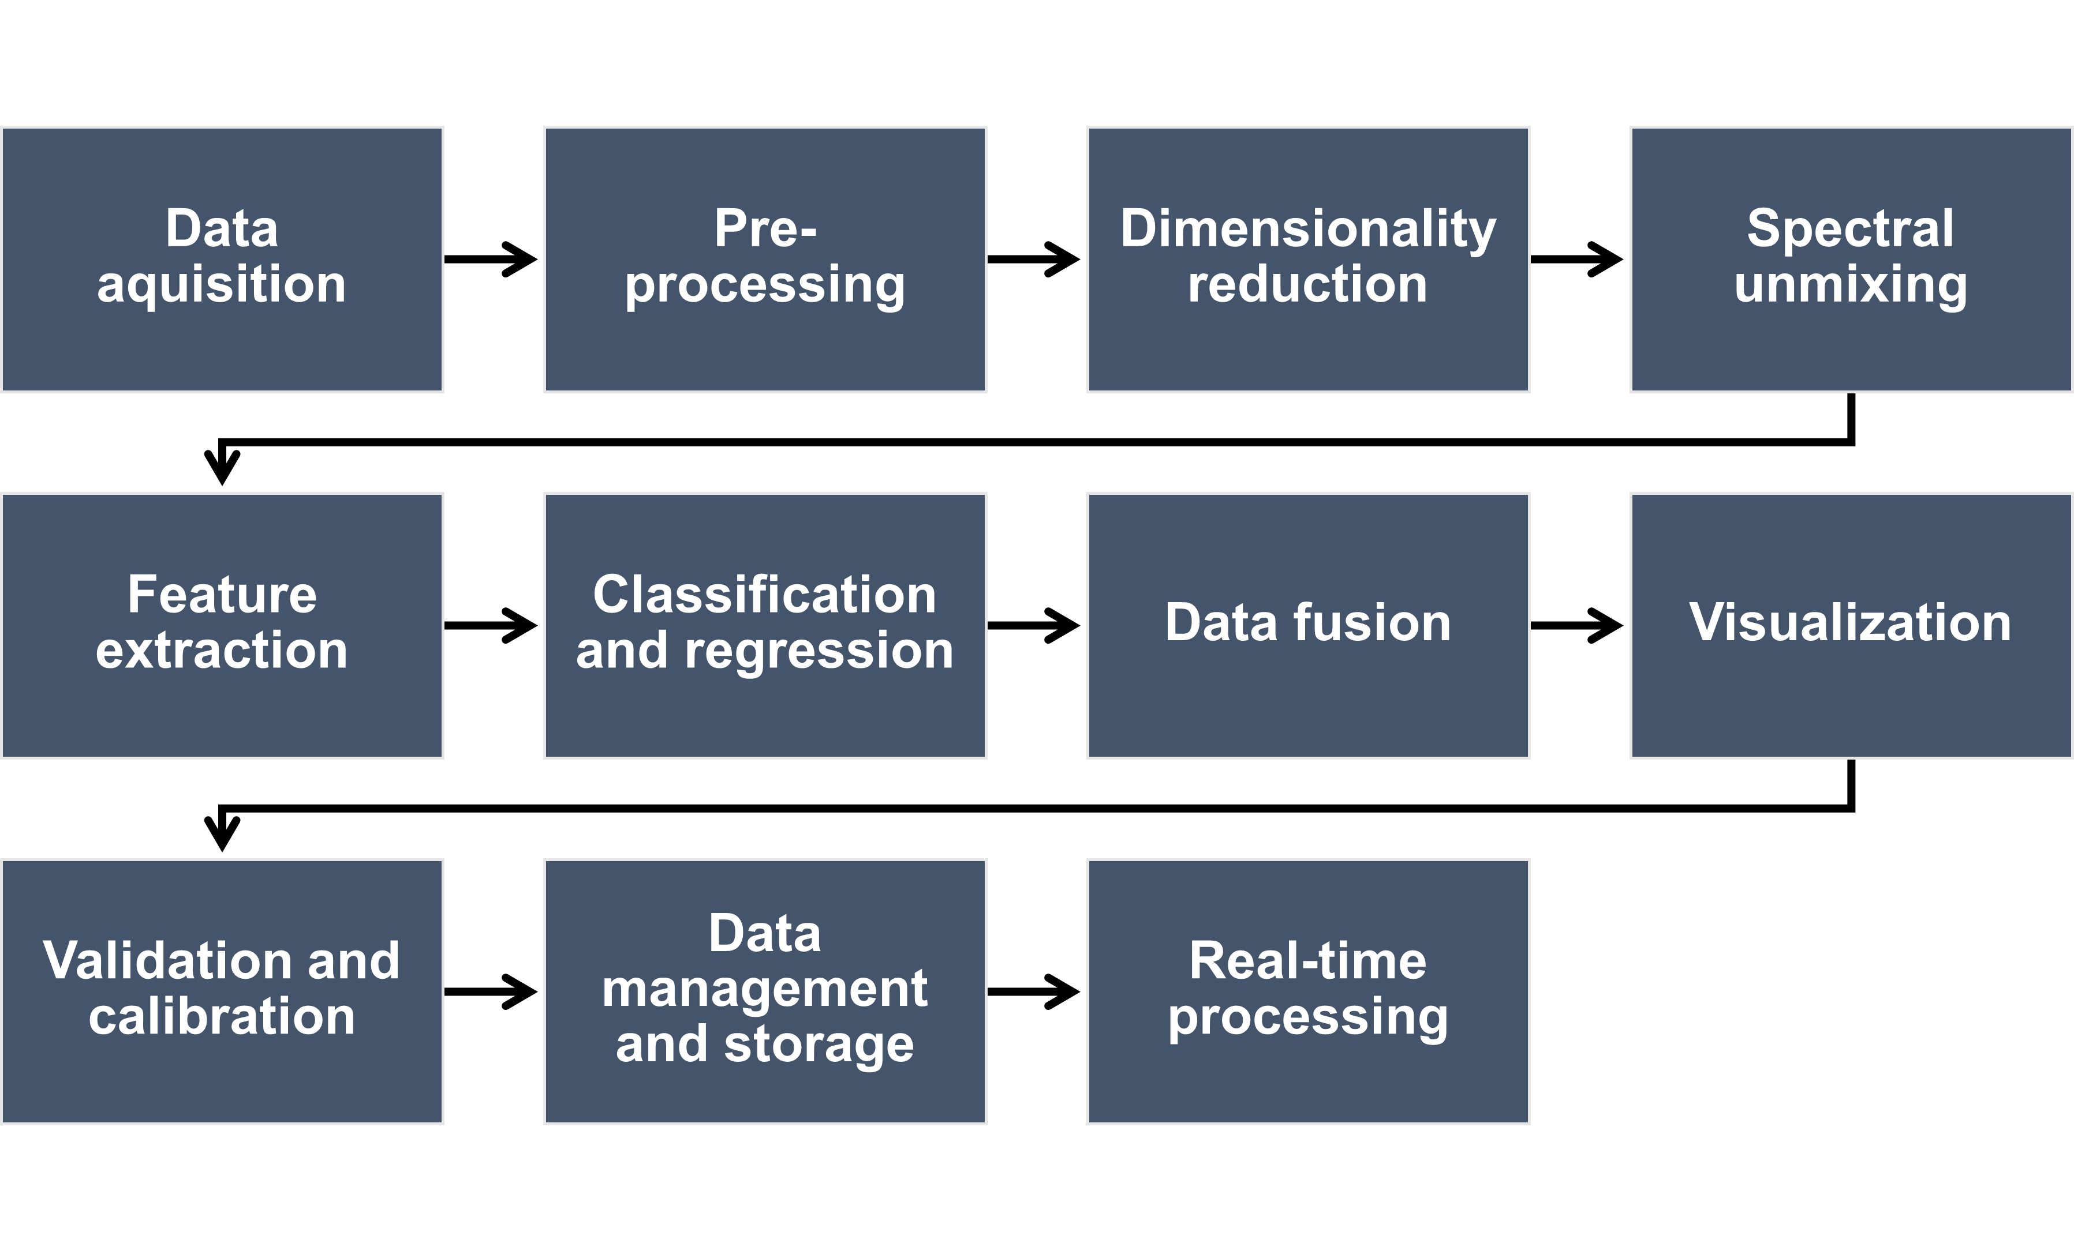

**Fig. 2. Steps involved in Hyperspectral imaging data processing**

“The data generated is highly collinear, necessitating the use of various statistical tools to extract information and model patterns” (Mishra et al., 2020). “Machine learning and Deep learning play an important role in processing and analysing hyperspectral image data sets”(Moharram & Sundaram, 2023). “Machine learning methods are pivotal in the analysis of hyperspectral data. Once data preprocessing is complete, these methods are primarily employed to model and analyse the data, facilitating the detection and identification of crop diseases and pests, as well as the classification and identification of agricultural products. Commonly used machine learning techniques in various application scenarios include Support Vector Machine (SVM)” (Melgani & Bruzzone, 2004; Guo et al., 2019), Random Forest (RF) (Amini et al., 2018), K-Nearest Neighbors (KNN), and Linear Discriminant Analysis (LDA). Deep learning represents a subset of machine learning methodologies, characterised by its reliance on artificial neural networks (N. Zhang et al., 2020). It employs multiple layers of neural networks to execute nonlinear transformations and feature extraction, thereby facilitating the modelling and processing of complex data. Major deep learning algorithms utilised for hyperspectral data analysis are convolutional neural networks deep neural networks, and residual networks, among others (Bharman et al., 2022)

**4.SEED VIABILITY AND GERMINATION POTENTIAL**

Ageing starts immediately after natural maturity in the seeds. During this process, the vitality will gradually decline, and this is the phenomenon that happens during the period of storage. The seed vigour is a very important index which determines the germination of seeds, seedling rate, growth potential of seedlings, plant stress resistance, and production potential.

Ambrose et al (2016) used hyperspectral imaging to evaluate the corn seed viability. Artificial ageing was applied to obtain seeds with low viability, and a germination test was conducted to determine seed viability as a reference. Three different varieties of corn seeds (yellow, white and purple) were identified. Different spectra pre-processing methods and different spectral ranges (1000–2500 nm and 400–1000 nm) were explored. PLS-DA models were built to determine the viability of seeds. Visualisation of treated and non-treated corn seeds were also achieved with hyperspectral imaging. The results demonstrated that the 1000–2500 nm spectral range performed better in the seed viability measurement. Xu et al.( 2022)used HSI to identify the vigour of artificially aged maize seeds by analysing the spectral data (959.3-1697.9nm). 1680 seeds of the maize variety “Zhengdan 958” were divided into 7 classes (240 seeds/class) and artificially aged using artificial climate box LRH-325-GSI-E3. This research used different algorithms, namely, successive projections algorithm (SPA), uninformative variable elimination (UVE), interval random frog (IRF), and iteratively variable subset optimization (IVSO) for the selection of feature wavelength for extracting valid information for comparison of different selection method. The ranking of feature wavelength selection algorithms in terms of efficiency is IRF＜SPA＜IVSO＜UVE in the order. The accuracy of the calibration and prediction sets of the models which includes decision tree (DT), support vector machine (SVM), K-nearest neighbour (KNN), linear discriminant analysis (LDA), random forest (RF), and artificial neural network (ANN) were ranged from 49.92 %~100 % and 25.48 %-95.24 %, respectively. The superiority in performance of these models were ANN ＞LDA＞SVM＞KNN＞RF＞DT in descending order. Among the different models, the best one was DE-UVE-ANN with identification accuracy reached 95.24 % which used the detrending (DE) for the preprocessing of the spectral data.

Wang et al (2022) successfully demonstrated the potential of hyperspectral imaging and chemometric methods for the rapid, non-destructive classification of new and aged maize seeds. The aged seeds had undergone controlled ageing treatments to simulate natural deterioration over time. Hyperspectral images of the seeds were captured using a hyperspectral imaging system that operated within the visible-near infrared (VNIR) spectral range. The average spectra of the embryo side, endosperm side, and both sides were extracted. The support vector machine (SVM) algorithm was used to develop classification models based on full spectra to evaluate the potential of hyperspectral imaging for maize seed detection and using the principal component analysis (PCA) and ANOVA to reduce data dimensionality and extract feature wavelengths. Both HS and GLCM image texture features were used to extract a total of 10 texture features from two-band ratio images for data fusion. The best classification accuracy of 97.5% for the prediction set was achieved by combining the two-band ratio of 1,987 nm/1,079 nm with image texture features, surpassing models using a single feature. The findings suggested that combining data in fusion models was more beneficial for maize seed classification compared to using single-feature models.

Hong et al (2022) applied visible–near-infrared (vis–NIR) hyperspectral imaging system and spectral–spatial information modelling for the viability of rice seeds. Various machine learning models were applied for viability prediction, including Partial Least Squares (PLS)–Discriminant Analysis, Support Vector Machine (SVM), PLS–SVM, and PLS–Artificial Neural Network. Furthermore, a one-dimensional Convolutional Neural Network (1D-CNN) was used for analysing the mean spectra of rice seeds. For hyperspectral seed images, models such as CNN, PLS–CNN, and dual-branch networks were implemented to enhance prediction accuracy. Most models exhibited accuracy of approximately 90% and high f1 scores. Also, it is confirmed that models using spectral and spatial information can classify hard samples more effectively and rapidly.

Alves et al (2023)assessed the potential of HSI collectively with preprocessing and machine learning compared to a X-ray fluorescence spectroscopy to evaluate the uptake of micronutrients by soybean seeds of varying levels of vigour during germination. Seeds of the cultivar M5917 were treated with micronutrients in the following quantities:15.1% Zn, 9.4% Mn, 6.7% Cu and 3.2% Mo. Preprocessing methods like MSC, SG and SNV, alongside machine learning algorithms such as ANN, DT, and PLS-DA, to effectively analyse spectral data. Among the models, PLS-DA provided a high accuracy of 97% and 100% for the cotyledon and embryonic axis regions, respectively. This approach successfully discriminates between high and low vigour seeds, regardless of micronutrient treatment, demonstrating the potential use of HSI for seed quality assessment. It was observed that low-vigour seeds consistently had higher reflectance in the near infrared portion of the spectrum, indicating a spectral signature for classification purposes.

Li et al. (2025) employed hyperspectral imaging and deep learning to identify seed vigour of common bean seeds. Seeds of five different common bean varieties were subjected to artificially accelerated ageing, to attain varying ageing periods, that is, 0, 2,4, and 6 days. A new, potential deep learning architecture, the Multi-scale Spectral Attention Residual Network (MSARN) was developed that integrated CNNs, LSTMs, attention mechanisms, and residual connections to effectively utilize both local and contextual spectral features. MSARN effectively performed better than classical models (SVM, RF, KNN, PLS-DA) and other deep learning baselines (VGG19, MobileNet) without preprocessing. Following the application of dual Successive Projections Algorithm (SPA), 40 wavelengths were selected which enabled the SPA-SPA-MSARN model to reach an accuracy of 98.75%, with certain single-variety datasets reporting an accuracy of 100%.

Sun *et al* (2024) discussed the practicality of using visible near-infrared hyperspectral imaging technology (Vis-NIR–HSI) for assessing the viability of the seeds of watermelon (*Citrullus lanatus*).15 g of seeds was taken and divided into 2 different sets containing 50 samples each. One of the samples was sterilized using Lichen Technology Electric Heating device at a moderate temperature and was denoted as (W-NL) and the unsterilized one was denoted as (W-L). The raw spectral data obtained initially was preprocessed with the help of different Savitzky–Golay (SG) smoothing, and standard normalized variate (SNV) preprocessing methods. Characteristic wavelength selection was done by PCA and VISSA algorithms and the data was classified using supervised machining learning (SVM) model optimized artificial bee colony (ABC) algorithm. The results indicated that by the introduction of ABC algorithm, the performance of the initial hybrid-SVM with a predictive accuracy rate of 100%, with a test set accuracy of 92.33% enhanced to an accuracy level of 100% in both the training and evaluation dataset. This research, serves to confirm the efficacy of the PCA-ABC-SVM model combined with HSI technology could predict seed viability by distinguishing viable watermelon seeds from their sterile counterparts, providing a reliable classification in a rapid and non-destructive manner

.

Huang et al (2024) used HSI for carefully analysing the spectral characteristics within the wavelength range of 384–1034 nm to achieve the effective prediction of seed vitality and moisture content in Sunflower. From 200g of seeds, 500 seeds were taken which were later divided into 5 batches each containing 100 seeds, among which one was kept as control without any treatments. The remaining seeds were artificially aged with treatments lasting 2 days,4 days, 6 days, and 8 days under constant conditions (temperature 45 °C, humidity 90%) in an artificial ageing chamber for creating seeds with different vigour gradients. The raw spectral data was preprocessed using Savitzky–Golay smoothing, standard normal variable correction (SNV), and multiplicative scatter correction (MSC). To extract the featured wavelength principal component analysis (PCA), extreme gradient boosting (XGBoost), and stacked autoencoders (SAE) were employed. Subsequently, random forests (RFs) and LightGBM algorithms were separately used to develop classification models for seed vitality and prediction models for moisture content. The results demonstrated that the SG-SAE-LightGBM model exhibited superior performance in the classification of sunflower seed vitality, attaining an accuracy rate of 98.65%. Meanwhile, the SNV-XGBoost-LightGBM model displayed outstanding achievement in moisture content prediction. This research indicated that Hyperspectral imaging and multivariate data analysis algorithms can accurately and rapidly predict the vitality of sunflower seeds.

Yang et al (2021) used HSI and Gauss kernel-based Support Vector Machine (SVM) to predict thegermination potential of sugarbeet seeds. 3072 sugar beet seeds of the variety “KWS 9147”, which were stored in a medium-term genebank, were selected and divided into 128 groups, each containing 24 samples, and placed in ambient conditions for temporary storage. Five different spectral preprocessing methods, including standard normal variate (SNV), multiplicative scatter correction (MSC), detrend correction (DET), Savitzky-Golay (SG),2D with band spacing of 1 were used to analyse the spectral data in the range of 381 to 1040 nm. Subsequently, Successive Projections Algorithm (SPA) was used to extract 16 characteristic wavelengths from the spectral data. Support vector machine radial basis function (SVM-RBF), k-nearest neighbour (KNN) and random forest (RF) models were performed at the full wavelength and characteristic wavelength, respectively, to predict the germination of sugarbeet seeds. The results indicated among the three different models, SVM-RBF model showed the highest prediction accuracy of 95.5% and 92.32% in the full wavelength and characteristic wavelength, respectively. A similar approach was adopted by Zhou et al (2020), where they utilised hyperspectral imaging to predict the vigour of the beet seeds. This work used six different preprocessing treatments, including First Derivative (1d), Second Derivative (2D), Multiple Scattering Calibration (MSC), Standard Normal Variate (SNV), detrend correction (DET) and Savitzky-Golay smoothing (SG).15 characteristic spectral bands were extracted by the tree model and the coefficient method. Among the three machine learning algorithms- Radial Basis Function SVM (RBF-SVM), Random Forest (RF) and Light Gradient Boosting Machine (LightGBM), LightGBM accurately predicted the seed germination with a classification prediction accuracy of 89%. These results showcased the feasibility of using HSI for non-destructive prediction of the germination potential of sugarbeet, which in turn provides valuable guidance for beet seed selection and breeding.

Dumont et al (2015) investigated the accuracy of Visible and near infrared (VNIR, 400-1000 nm range) and short-wave infrared (SWIR, 1000–2500 nm range) HSI by comparing to Infrared lifetime thermal imaging to evaluate the viability of Norway Spruce seeds. 1606 seeds, which include 609 filled/viable seeds, 221 empty seeds and 776 seeds infested with *Megastigmus sp*. larvae were used in total. SVM and Sparse logistic regression-based feature selection were used for the classification of three classes of seeds. It was observed that among the three classes of seeds, the viable seeds had higher absorbance levels compared to others. The SWIR range proved significantly more informative than VNIR, achieving 99% classification accuracy with 21 features and maintaining over 93% accuracy with just three key wavelengths (1310, 1710, 1985 nm). These findings demonstrate that HSI has potential as a high-throughput and automated seed screening technology, especially when reduced to key spectral bands.

**Conclusion**

Recent research suggests that hyperspectral imaging (HSI) can effectively, non-destructively, and rapidly predict seed germination and viability. Artificial ageing is commonly used to create seeds with varying levels of vigour and viability. Various machine learning algorithms, such as SVM, CNN, and PLS-based models, have been used with success to characterise spectral and spatial information, enhancing prediction precision. Although HSI shows great promise, there are obstacles, especially in obtaining naturally aged seed samples and creating a universal viability detection database. The substantial differences between artificial ageing and natural ageing also complicate real-world applications. Future studies should emphasise enhancing model generalisation, seed dataset expansion, and interdisciplinary collaboration to make HSI more applicable in real-world seed quality testing. With ongoing developments, HSI has the potential to transform seed testing, enabling precision agriculture and sustainable crop production.

**COMPETING INTERESTS DISCLAIMER:**

Authors have declared that they have no known competing financial interests OR non-financial interests OR personal relationships that could have appeared to influence the work reported in this paper.

**Disclaimer (Artificial intelligence)**

Option 1:

Author(s) hereby declare that NO generative AI technologies such as Large Language Models (ChatGPT, COPILOT, etc.) and text-to-image generators have been used during the writing or editing of this manuscript.

Option 2:

Author(s) hereby declare that generative AI technologies such as Large Language Models, etc. have been used during the writing or editing of manuscripts. This explanation will include the name, version, model, and source of the generative AI technology and as well as all input prompts provided to the generative AI technology

Details of the AI usage are given below:

1.

2.

3.

**REFERENCES**

Alves, R. M., Gomes-Junior, F. G., Carmo-Filho, A. D. S., Ribeiro, G. D. F. R., Rego, C. H. Q., Iost-Filho, F. H., & Yamamoto, P. T. (2023). Evaluation of the Effect of the Vigor of Soybean Seeds Treated with Micronutrients Using X-ray Fluorescence Spectroscopy and Hyperspectral Imaging. *Agronomy*, *13*(7), 1945. https://doi.org/10.3390/agronomy13071945

Ambrose, A., Kandpal, L. M., Kim, M. S., Lee, W.-H., & Cho, B.-K. (2016). High speed measurement of corn seed viability using hyperspectral imaging. *Infrared Physics & Technology*, *75*, 173–179. https://doi.org/10.1016/j.infrared.2015.12.008

Amini, S., Homayouni, S., Safari, A., & Darvishsefat, A. A. (2018). Object-based classification of hyperspectral data using Random Forest algorithm. *Geo-Spatial Information Science*, *21*(2), 127–138. https://doi.org/10.1080/10095020.2017.1399674

Basu, S., & Groot, S. P. C. (2023). Seed Vigour and Invigoration. In M. Dadlani & D. K. Yadava (Eds.), *Seed Science and Technology* (pp. 67–89). Springer Nature Singapore. https://doi.org/10.1007/978-981-19-5888-5_4

Bharman, P., Ahmad Saad, S., Khan, S., Jahan, I., Ray, M., & Biswas, M. (2022). Deep Learning in Agriculture: A Review. *Asian Journal of Research in Computer Science*, 28–47. https://doi.org/10.9734/ajrcos/2022/v13i230311

Cozzolino, D., Williams, P. J., & Hoffman, L. C. (2023). An overview of pre-processing methods available for hyperspectral imaging applications. *Microchemical Journal*, *193*, 109129. https://doi.org/10.1016/j.microc.2023.109129

Dumont, J., Hirvonen, T., Heikkinen, V., Mistretta, M., Granlund, L., Himanen, K., Fauch, L., Porali, I., Hiltunen, J., Keski-Saari, S., Nygren, M., Oksanen, E., Hauta-Kasari, M., & Keinänen, M. (2015). Thermal and hyperspectral imaging for Norway spruce (Picea abies) seeds screening. *Computers and Electronics in Agriculture*, *116*, 118–124. https://doi.org/10.1016/j.compag.2015.06.010

Elmasry, G., Kamruzzaman, M., Sun, D.-W., & Allen, P. (2012). Principles and Applications of Hyperspectral Imaging in Quality Evaluation of Agro-Food Products: A Review. *Critical Reviews in Food Science and Nutrition*, *52*(11), 999–1023. https://doi.org/10.1080/10408398.2010.543495

Feng, L., Zhu, S., Liu, F., He, Y., Bao, Y., & Zhang, C. (2019). Hyperspectral imaging for seed quality and safety inspection: A review. *Plant Methods*, *15*(1), 91. https://doi.org/10.1186/s13007-019-0476-y

Guo, Y., Yin, X., Zhao, X., Yang, D., & Bai, Y. (2019). Hyperspectral image classification with SVM and guided filter. *EURASIP Journal on Wireless Communications and Networking*, *2019*(1), 56. https://doi.org/10.1186/s13638-019-1346-z

Hong, S.-J., Yang, T., Kim, S.-Y., Kim, E., Lee, C., Nurhisna, N. I., Kim, S., Roh, S.-W., Ryu, J., & Kim, G. (2022). Nondestructive Prediction of Rice Seed Viability Using Spectral and Spatial Information Modeling of Visible–Near Infrared Hyperspectral Images. *Journal of the ASABE*, *65*(5), 997–1006. https://doi.org/10.13031/ja.14982

Huang, P., Yuan, J., Yang, P., Xiao, F., & Zhao, Y. (2024). Nondestructive Detection of Sunflower Seed Vigor and Moisture Content Based on Hyperspectral Imaging and Chemometrics. *Foods*, *13*(9), 1320. https://doi.org/10.3390/foods13091320

Li, S., Sun, L., Jin, X., Feng, G., Zhang, L., & Bai, H. (2025). Research on identification of common bean seed vigor based on hyperspectral and deep learning. *Microchemical Journal*, *211*, 113133. https://doi.org/10.1016/j.microc.2025.113133

Ma, J., Sun, D.-W., Pu, H., Cheng, J.-H., & Wei, Q. (2019). Advanced Techniques for Hyperspectral Imaging in the Food Industry: Principles and Recent Applications. *Annual Review of Food Science and Technology*, *10*(1), 197–220. https://doi.org/10.1146/annurev-food-032818-121155

Marcos Filho, J. (2015). Seed vigor testing: An overview of the past, present and future perspective. *Scientia Agricola*, *72*(4), 363–374. https://doi.org/10.1590/0103-9016-2015-0007

Mead, A., & Gray, D. (1999). Prediction of seed longevity: A modification of the shape of the Ellis and Roberts seed survival curves. *Seed Science Research*, *9*(1), 63–73. https://doi.org/10.1017/S0960258599000070

Melgani, F., & Bruzzone, L. (2004). Classification of hyperspectral remote sensing images with support vector machines. *IEEE Transactions on Geoscience and Remote Sensing*, *42*(8), 1778–1790. https://doi.org/10.1109/TGRS.2004.831865

Mishra, P., Polder, G., & Vilfan, N. (2020). Close Range Spectral Imaging for Disease Detection in Plants Using Autonomous Platforms: A Review on Recent Studies. *Current Robotics Reports*, *1*(2), 43–48. https://doi.org/10.1007/s43154-020-00004-7

Moharram, M. A., & Sundaram, D. M. (2023). Land use and land cover classification with hyperspectral data: A comprehensive review of methods, challenges and future directions. *Neurocomputing*, *536*, 90–113. https://doi.org/10.1016/j.neucom.2023.03.025

Nikzadfar, M., Rashvand, M., Zhang, H., Shenfield, A., Genovese, F., Altieri, G., Matera, A., Tornese, I., Laveglia, S., Paterna, G., Lovallo, C., Mammadov, O., Aykanat, B., & Di Renzo, G. C. (2024). Hyperspectral Imaging Aiding Artificial Intelligence: A Reliable Approach for Food Qualification and Safety. *Applied Sciences*, *14*(21), 9821. https://doi.org/10.3390/app14219821

Özdoğan, G., & Gowen, A. (2025). Identification of wheat kernel vitreousness by hyperspectral imaging: Comparing the Visible, Vis-NIR and SWIR range. *Computers and Electronics in Agriculture*, *235*, 110361. https://doi.org/10.1016/j.compag.2025.110361

Shi, T., Gao, Y., Song, J., Ao, M., Hu, X., Yang, W., Chen, W., Liu, Y., & Feng, H. (2024). Using VIS-NIR hyperspectral imaging and deep learning for non-destructive high-throughput quantification and visualization of nutrients in wheat grains. *Food Chemistry*, *461*, 140651. https://doi.org/10.1016/j.foodchem.2024.140651

Wang, Z., Huang, W., Tian, X., Long, Y., Li, L., & Fan, S. (2022). Rapid and Non-destructive Classification of New and Aged Maize Seeds Using Hyperspectral Image and Chemometric Methods. *Frontiers in Plant Science*, *13*, 849495. https://doi.org/10.3389/fpls.2022.849495

Wu, D., & Sun, D.-W. (2013). Advanced applications of hyperspectral imaging technology for food quality and safety analysis and assessment: A review — Part I: Fundamentals. *Innovative Food Science & Emerging Technologies*, *19*, 1–14. https://doi.org/10.1016/j.ifset.2013.04.014

Xia, Y., Xu, Y., Li, J., Zhang, C., & Fan, S. (2019). Recent advances in emerging techniques for non-destructive detection of seed viability: A review. *Artificial Intelligence in Agriculture*, *1*, 35–47. https://doi.org/10.1016/j.aiia.2019.05.001

Xu, P., Zhang, Y., Tan, Q., Xu, K., Sun, W., Xing, J., & Yang, R. (2022). Vigor identification of maize seeds by using hyperspectral imaging combined with multivariate data analysis. *Infrared Physics & Technology*, *126*, 104361. https://doi.org/10.1016/j.infrared.2022.104361

Yang, J., Sun, L., Xing, W., Feng, G., Bai, H., & Wang, J. (2021). Hyperspectral prediction of sugarbeet seed germination based on gauss kernel SVM. *Spectrochimica Acta Part A: Molecular and Biomolecular Spectroscopy*, *253*, 119585. https://doi.org/10.1016/j.saa.2021.119585

Zhang, N., Yang, G., Pan, Y., Yang, X., Chen, L., & Zhao, C. (2020). A Review of Advanced Technologies and Development for Hyperspectral-Based Plant Disease Detection in the Past Three Decades. *Remote Sensing*, *12*(19), 3188. https://doi.org/10.3390/rs12193188

Zhang, T., Wei, W., Zhao, B., Wang, R., Li, M., Yang, L., Wang, J., & Sun, Q. (2018). A Reliable Methodology for Determining Seed Viability by Using Hyperspectral Data from Two Sides of Wheat Seeds. *Sensors*, *18*(3), 813. https://doi.org/10.3390/s18030813

Zhou, S., Sun, L., Xing, W., Feng, G., Ji, Y., Yang, J., & Liu, S. (2020). Hyperspectral imaging of beet seed germination prediction. *Infrared Physics & Technology*, *108*, 103363. https://doi.org/10.1016/j.infrared.2020.103363

Al Siam, A., Salehin, M. M., Alam, M. S., Ahamed, S., Islam, M. H., & Rahman, A. (2024). Paddy seed viability prediction based on feature fusion of color and hyperspectral image with multivariate analysis. Heliyon, 10(17).

Zhou, S., Sun, L., Xing, W., Feng, G., Ji, Y., Yang, J., & Liu, S. (2020). Hyperspectral imaging of beet seed germination prediction. Infrared Physics & Technology, 108, 103363.