Growth Regulators and Cucumber Yield: A Study on Vegetative development and Yield Dynamics (*Cucumis sativus* L.)

**Abstract:** Bioregulators, commonly known as plant hormones, play a pivotal role in the development and productivity of crops. This study investigates the impact of various growth regulators on the vegetative and yield dynamics of cucumber (*Cucumis sativus* L.), a vital horticultural crop with significant economic and nutritional value. By examining the effects of specific growth regulators on cucumber plants, the research aims to enhance our understanding of how these substances influence growth patterns, flowering, fruit set and ultimately, yield. The findings have the potential to inform agricultural practices and optimize cucumber production, contributing to improved food security and sustainable farming practices. The experiment was carried out during summer season 2021 at Vegetable Research Farm, Institute of Agricultural Sciences, Banaras Hindu University. The trial was accomplished in a randomized block design with three replications and 13 treatments. Plant growth hormones viz., GA3 (50, 100 and 150 ppm), NAA (25, 50 and75 ppm), AgNO3 (125, 250 and 350 ppm) and ethrel (100, 200 and 300 ppm) were applied as foliar spray at two true leaf stage. The findings of the effects of plant growth regulators on cucumber growth, presented in this abstract serve as a valuable resource for researchers, agronomists and farmers seeking to optimize cucumber cultivation practices and meet the increasing demand for this popular vegetable crop. **Keywords:** Plant hormones, Vegetative growth, Yield dynamics, Crop production.

# Introduction

Cucumber is an annual climbing vegetable crop native to India and commonly grown in temperate and tropical climates all over the world. Botanically, it is known as *Cucumis sativus*, belonging to the family Cucurbitaceae having chromosome number 2n = 14 (Jia and Wang, 2021). The fruits are generally utilized in salads and pickles for culinary, medicinal and are high in vitamins and minerals and they can be used to treat skin illnesses, kidney and heart problems, as well as functioning as an alkalizer and antipyretic (Pal *et al*., 2020). Sex expression in cucurbits is influenced by environmental factors as well as hormone levels in plant, modification in environmental conditions as well as hormonal balance within the plant can readily alter the sex expression in cucurbits. Therefore, these two aspects have a large impact on sex manipulation (Manjunathagowda and Bommesh, 2017).

Exogenous treatment of plant hormones plays a key role in modifying the sex ratio of these plants hence growth regulating chemicals became significant tools in this regard (Dalai *et al*., 2016). The chemicals most commonly used on cucumber, watermelon and bottle gourd are gibberellic acid, naphthalene acetic acid, silver nitrate and maleic hydrazide. Gibberellic acid is a tetracyclic di-terpenoid molecule that promotes plant growth and development by promoting seed germination, initiate change from meristem to shoot growth, juvenile to adult leaf stage, vegetative to flowering and regulate the sex expression and fruit development (Gupta and Chakrabarty, 2013). Naphthalene acetic acid is a synthetic plant hormone from the auxin family and application of it improves vegetative growth parameters such as height of plant, leaves per vine, regulation of flowering, control fruits drops and development of parthenocarpic fruits (Arvindkumar *et al*., 2014). Silver nitrate (AgNO₃) plays a significant role in micropropagation, promoting flowering, enhancing plant growth, regulating fruit ripening, and influencing sex expression. It is particularly effective in inhibiting ethylene activity and inducing the development of male (staminate) flowers in cucurbit species (Zhang *et al*., 2017). Ethylene is a gaseous plant hormone which is commonly thought to be a growth inhibitor, it can also stimulate growth in certain tissues and cells at low quantities (Xin *et al*., 2019). The primary aim of this study was to assess the hormonal modulation of vegetative growth in cucumber and to examine how this affects reproductive efficiency and potential yield output.

# Materials and methods

The experiment was carried out during the summer season of 2021 at the Vegetable Research Farm, Institute of Agricultural Sciences, Banaras Hindu University. The study was laid out in a randomized block design (RBD) comprising 13 treatments, including a control, with each treatment replicated three times. Each plot consisted of 25 cucumber plants. The sowing of seeds was done in well prepared plot at a spacing of 120×60 cm during year 2021. Treatments include 50, 100 and 150 ppm of GA3; 25, 50 and 75 ppm of NAA; 125, 250 and 375 ppm of AgNO3 and 100, 200 and 300 ppm of ethrel applied as foliar spray at 15, 30 and 45 days after seed sowing. Observations like vine length, number of leaves, number of primary branches, internode length, days for maturity of fruits, total fruits per vine, length and diameter of fruits and total fruit yield/vine were taken from five randomly tagged plants of each replication. Data collected from the selected parameters were statistically analyzed using Analysis of Variance (ANOVA), and treatment means were compared using the Critical Difference (CD) at 5% level of significance. The Standard Error of Mean (SEm ±) was also computed to assess the reliability and precision of the results.

# Results and Discussion Growth parameters

The results pertaining to vegetative growth traits revealed that the application of different plant growth regulators (PGRs) at varying concentrations had a significant effect on the vegetative development of cucumber plants (Figure 1). At both 45 and 60 days after sowing, the maximum vine lengths (39.07 cm) and (103.77 cm), respectively, were observed in plants treated with AgNO3 at 375 ppm. In contrast, the shortest vines were recorded in the untreated control plots. This enhanced vine elongation under AgNO3 treatment may be attributed to its role, along with gibberellic acid, in stimulating cell elongation and accelerating cell division at active growth regions, thereby promoting more vigorous shoot development, the enhanced vine length by spray of plant growth regulators was also reported by (Nejatzadeh-Barandozi *et al*., 2016 and Rahman *et al*., 2020). Data on the number of primary branches per vine revealed that treatment with ethrel at 300 ppm resulted in the highest branching, with an average of (3.57) branches per vine. This enhancement in branching may be attributed to the presence of ethylene released from ethrel, which is known to antagonize the effects of gibberellins. Gibberellins typically promote stem elongation and suppress lateral bud growth; therefore, the inhibitory action of ethylene on gibberellin activity can lead to the stimulation of axillary bud development and increased branching. results of present study are similar as reported by Thappa *et al*. (2011) on cucumber, Kaur *et al*. (2016) on cucumber, Chaurasiya *et al*. (2016) on muskmelon, Dhakal *et al*. (2019) on cucumber and Rahman *et al*. (2020) on cucumber. Another growth parameter i.e., leaves/vine was observed that plants treated with ethrel (300 ppm) remarkably produced more leaves/vine (14.88) and (36.83) at 45 and 60 DAS, respectively. More leaves/vine was due to more branches/vine resulted more leaves as compared to other treatments, findings with similar results were also observed by Hilli *et al*. (2010), Murthy *et al*. (2007), Shafeek *et al.* (2016) and Sabri *et al*. (2021). On the basis of findings, it was noted that highest (11.32 cm) internodal length was recorded from treatment with GA3 (150 ppm) was measured in which might be due to cell enlargement and elongation effect of gibberellic acid on main vine as it increases internodal distance in plants, Dinesh *et al*. (2019) also recorded the similar findings on cucumber.

# Figure: 1 Effect of GA3, NAA, AgNO3 and ethrel on growth parameters.

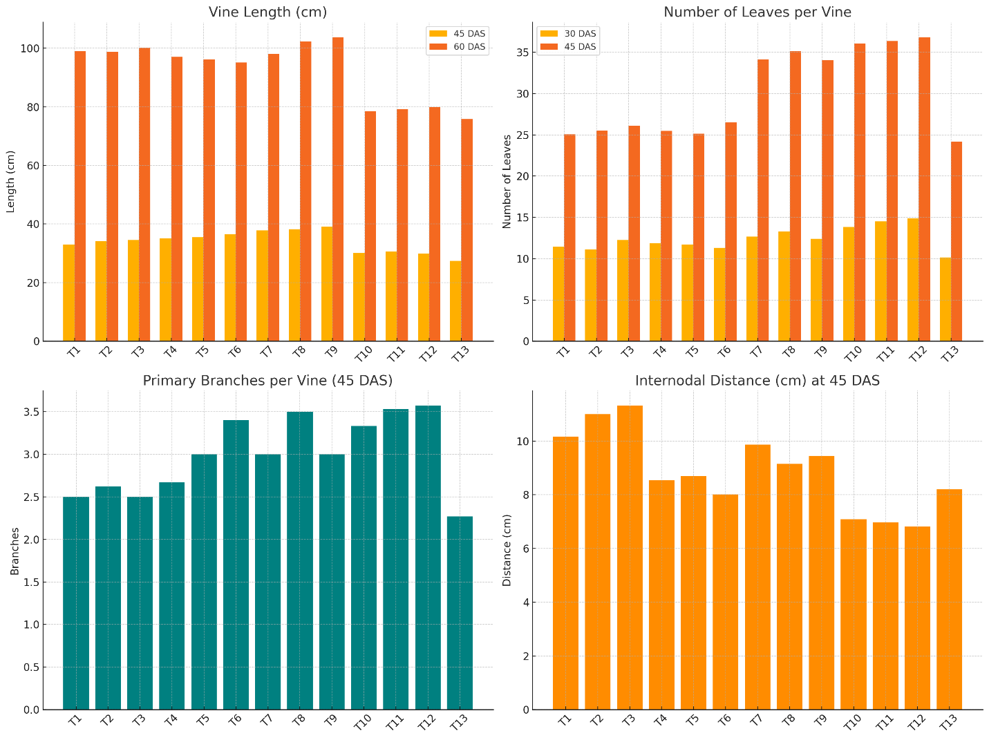

**Yield parameters**

Growth regulators applied as foliar spray significantly affected the yield and yield related traits of cucumber (**Figure-2&3**). Treatment with ethrel (100 ppm) resulted in maximum fruits per (11.75) vine as compared to control. This was due to ethrel spray resulted in a higher number of female flowers, which exhibited higher fruits per vine. The similar results were also observed by Hossain *et al*. (2006) in bottle gourd, Hilli *et al*. (2010) in bitter gourd, Akter and Rehaman (2010) in bitter gourd, Mahala *et al*. (2014) in ridge gourd and Dhakal *et al*. (2019) in cucumber, all recorded more fruits per vine. The earliest maturity of fruits was recorded with NAA (25 ppm) which indicates that naphthalene acetic acid promoted cell division and thus enhanced the early growth and maturity of cucumber fruits (Hu *et al*., 2019). Among all the treatments, the fruit length was comparatively more (16.75 cm) in treatment with GA3 (150 ppm) than control which was due impact of gibberellins on greater photosynthetic activity, quicker translocation and efficiency of utilizing photosynthetic products leading in increased cell elongation and rapid cell division in the growing section. Similar results were obtained by Prabhu *et al*. (2006), Akter and Rehaman (2010), Jyoti *et al*. (2016), Kadi *et al*. (2018) and Pawar *et al*. (2019). The maximum (4.83 cm) fruit girth was recorded with ethrel (300 ppm), while it was noticed that control produced fruits with minimum girth. Growth regulators boosted photosynthetic activity, faster translocation and improved photosynthate use efficiency, leading in cell elongation and rapid cell division in the growing section, resulting in increased girth. Dhakal *et al*. (2019) also found that fruit girth was remarkably increased with application of 300 ppm of ethrel in cucumber. Ethrel substantially boosted yield when compared to GA3, NAA, AgNO3 and control. Because of improvements in fruit yield contributing parameters such as number of fruits per vine and fruit diameter, treatment with ethrel 100 ppm produced maximum fruit yield per vine (2.35 kg). Increased the fruit yield per vine may also be due to the fact that plants remain physiologically "more active" in order to accumulate sufficient assimilates for producing flowers and fruits, resulting in higher yield. The current findings are consistent with those reported by Thomas (2008), Akter and Rehaman (2010), Jadav *et al*. (2010), Thappa et *al*. (2011) Kaur *et al*. (2016), Shafeek *et al*. (2016), Pandey *et al*. (2018) and Dhakal *et al*. (2019).

# Figure: 2 Effect of GA3, NAA, AgNO3 and ethrel on yield related traits.

# 

# Figure: 3 Effect of GA3, NAA, AgNO3 and ethrel on yield related traits.

# 

**Conclusion**

The application of phytohormones, such as auxins, cytokinins, gibberellins and ethylene, various aspects of cucumber development can be regulated and enhanced. It is always

crucial to consider optimal application methods and concentrations of PGRs, as they vary based on cultivar, growth stage and environmental conditions. Understanding the interactions between plant growth regulators (PGRs) and environmental factors such as light, temperature, and nutrient availability is crucial for optimizing their positive effects on cucumber growth. In this study, it was observed that different concentrations of GA3, NAA, AgNO3, and ethrel significantly influenced vegetative growth, flowering duration, sex expression, and yield-related traits in cucumber. The outcome obtained with this investigation concluded that application of GA3 150 ppm resulted in increased internodal distance of vine and AgNO3 at 375 ppm exhibited a greater number of male flowers than control. Results revealed that plants treated with ethrel at 100 ppm demonstrated significantly increased femaleness and early flowering as a result of higher number of pistillate flower which increased the total fruit yield. Overall, plant growth regulators provide valuable tools for cucumber growers to optimize growth, enhance flowering and maximize fruit yield. With proper understanding and application, these regulators can contribute to the successful cultivation of high-quality cucumbers, meeting market demands and ensuring profitability for farmers.

Disclaimer (Artificial intelligence)

Option 1:

Author(s) hereby declare that NO generative AI technologies such as Large Language Models (ChatGPT, COPILOT, etc.) and text-to-image generators have been used during the writing or editing of this manuscript.

Option 2:

Author(s) hereby declare that generative AI technologies such as Large Language Models, etc. have been used during the writing or editing of manuscripts. This explanation will include the name, version, model, and source of the generative AI technology and as well as all input prompts provided to the generative AI technology

Details of the AI usage are given below:

1.

2.

3.

# References

1. Akter, P. and Rahman, M. A. (2010). Effect of foliar application of IAA and GA3 on sex expression, yield attributes and yield of bitter gourd (*Momordica charantia* L.). The Chittagong University. *Journal of Biological Sciences*, **5**(1-2): 55-62.
2. Arvindkumar, P. R., Vasudevan, S. N. and Patil, M. G. (2014). Effect of foliar sprays of NAA, triacontanol and boron on growth and seed quality in bitter gourd (*Momordica charantia* L.) cv. Pusa Visesh. *Journal of Horticultural Sciences*, **9**(2): 148-152.
3. Chaurasiya, J., Verma, R. B., Ahmad, M., Adarsh, A., Kumar, R. and Pratap, T. (2016).

Influence of plant growth regulators on growth, sex expression, yield and quality of muskmelon (*Cucumis melo* L.). *Ecology, Environment and Conservation*, **22**: 39-43.

1. Dalai, S., Singh, M. K., Kumar, M., Singh, K. V. and Kumar, V. (2016). Growth, flowering and yield of cucumber (*Cucumis sativus* L.) as influenced by different levels of NAA and GA3. *Journal of Plant Development Sciences*, **8**(9): 445-450.
2. Dhakal, S., Karki, M., Subedi, P. and Aarati, G. C. (2019). Effect of ethephon doses on vegetative characters, sex expression and yield of cucumber (*Cucumis sativus* cv. Bhaktapur Local) in Resunga Municipality, Gulmi, Nepal. *International Journal of Applied Sciences and Biotechnology,* **7**(3): 370-377.
3. Dinesh, A., Prasanth, P., Lakshminarayana, D., Nagaraju, K. and Gouthami, P. (2019).

Efficacy of plant growth regulators on growth and flowering of cucumber (*Cucumis sativus* L.) cv. Malini under shade net conditions. *International Journal of Current Microbiology and Applied Sciences*, **8**(9): 313-317.

1. Gupta, R. and Chakrabarty, S. K. (2013). Gibberellic acid in plant: Still a mystery unresolved. *Plant Signaling and Behavior*, **8**(9): 25504.
2. Hilli, J. S., Vyakarnahal, B. S., Biradar, D. P. and Hunje, R. (2010). Effect of growth regulators and stages of spray on growth, fruit set and seed yield of ridge gourd (*Luffa acutangula* L. Roxb). *Karnataka Journal of Agricultural Sciences*, **23**(2): 239-242.
3. Hossain, D., Karim, M. A., Pramanik, M. H. R. and Rahman, A. S. (2006). Effect of gibberellic acid (GA3) on flowering and fruit development of bitter gourd (*Momordica charantia* L.). *International Journal of Botany*, **2**(3): 329-332.
4. Hu, C., Zhao, H., Shi, J., Li, J., Nie, X. and Yang, G. (2019). Effects of 2,4- dichlorophenoxyacetic acid on cucumber fruit development and metabolism. *International Journal of Molecular Sciences*, **20**(5): 1126.
5. Jadav, R. G., Patel, T. V., Parmar, A. B. and Saiyad, M. Y. (2010). Sex modification of cucumber vegetable through PGRs. *Journal of Pure and Applied Science*, **18**: 13-14.
6. Jia, H. and Wang, H. (2021). Introductory chapter: studies on cucumber. In (Ed.), Cucumber Economic Values and Its Cultivation and Breeding. Intech Open. pp.13-15.
7. Jyoti, S., Patel, N. B. and Patel, J. B. (2016). Effect of growth regulators and stages of spray on seed yield and seed quality parameters of ridge gourd [*Luffa acutangula* (Roxb) L.]. *Journal of Applied and Natural Science*, **8**(3): 1551-1555.
8. Kadi, S. A., Asati, K. P., Barche, S. and Tulasigeri, R. G. (2018). Effect of different plant growth regulators on growth, yield and quality parameters in cucumber (*Cucumis sativus* L.) under polyhouse condition. *International Journal of Current Microbiology and Applied Sciences*, **7**(4): 3339-3352.
9. Kaur, A., Khurana, D. S. and Dhall, R. K. (2016). Sex modification in cucumber (*Cucumis sativus* L.) under the influence of ethephon and maleic hydrazide. *International Journal of Advanced Research*, **4**(11): 2199-2205.
10. Mahala, P., Choudhury, M. R., Yadav, T. V., Singh, P. and Garhwala, O. P. (2014).

Effect of plant growth regulators on yield, quality and economics of bottle gourd [*Lagenaria siceraria* (Mol.) Standl.]. *Annals of Agri-Bio Research*, **19**(1):137-139.

1. Manjunathagowda, D. C. and Bommesh, J. C. (2017). Sex manipulation in cucurbitaceous vegetables. *International Journal of Current Microbiology and Applied Sciences*, **6**(9): 1839-1851.
2. Murthy, T. C. S., Negegowda, V. and Basavaiah. (2007). Influence of growth regulators on growth, flowering and fruit yield of gherkin (*Cucumis anguria* L.). *Asian Journal of Horticulture*, **2**(1): 44-46.
3. Nejatzadeh-Barandozi, F., Darvishzadeh, F. and Aminkhani, A. (2014). Effect of nano silver and silver nitrate on seed yield of (*Ocimum basilicum* L.). *Organic and Medicinal Chemistry Letters*, **4**: 11.
4. Pal, A., Adhikary, R., Shankar, T., Sahu, A. K. and Maitra, S. (2020). Cultivation of cucumber in greenhouse. Protected Cultivation and Smart Agriculture; Sagar Maitra, DJGATS, Ed.; New Delhi Publishers: New Delhi, India. 139-145.
5. Pandey, P., Shukla, I. N. and Upadhyay, A. (2018). Effect of different plant growth regulators on growth, yield and quality parameters of cucumber (*Cucumis sativus* L.) cv. Kalyanpur Green. *Journal of Pharmcognosy and Phytochemistry*, **10**(1): 2681- 2684.
6. Pawar, V., Meena, M. K., Jadia, M. and Basediya, S. S. (2019). Study of influence of plant growth regulators on yield attributing characters in cucumber. *International Journal of Pure and Applied Bioscience*, **7**(3): 318-324.
7. Prabhu, M. and Natarajan, S. (2006). Effect of growth regulators on fruit characters and seediness in ivy gourd (*Coccinia grandis* L). *Agricultural Science Digest*, **26**(3): 188- 190.
8. Rahman, M. A., Sikder, S. Bahadur, M. M. and Pramanik, S. K. (2020). Influence of gibberellic acid (GA3) on growth, flowering and fruit yield of cucumber. *Journal of Science and Technology*, **18**: 33-42.
9. Sabri, Z. N., Mujawal, A. K. and Kshash, B. H. (2021). Effect of ethephone, zinc and boron on growth and yield of cucumber (*Cucumis melo* var. Flexuosus) cultivated in plastic houses and the economic feasibility from that. In IOP Conference Series: *Earth and Environmental Science*, **910**(1): 012024.
10. Shafeek, M. R., Helmy, Y. I., Ahmed, A. A. and Ghoname, A. A. (2016). Effect of foliar application of growth regulators (GA3 and Ethrel) on growth, sex expression and yield of summer squash plants (*Cucurbita pepo* L.) under plastic house condition. *International Journal of Chem Tech Research*, **9**(6): 70-76.
11. Thappa, M., Kumar, S. and Rafiq, R. (2011). Influence of plant growth regulators on morphological, floral and yield traits of cucumber (*Cucumis sativus* L.). *Kasetsart Journal* (National Science), **45**: 177-188.
12. Thomas, T. (2008). The effect of in vivo and in vitro applications of ethrel and GA3 on sex expression in bitter melon (*Momordica charantia* L.). *Euphytica*, **164**(2): 317-323.
13. Xin, T., Zhang, Z., Li, S., Zhang, S., Li, Q., Zhang, Z. H., Huang, S. and Yang, X. (2019). Genetic regulation of ethylene dosage for cucumber fruit elongation. *The Plant Cell*, **31**(5): 1063–1076.
14. Zhang, J., Jianting, S. H. I., Gaojie, J. I., Zhang, H., Guoyi, G. O. N. G., Shaogui,

G.U.O., Yi, R. E. N., Jianguang, F. A. N., Shouwei, T. I. A. N. and Yong, X. U. (2017). Modulation of sex expression in four forms of watermelon by gibberellin, ethephone and silver nitrate. *Horticultural Plant Journal*, **3**(3): 91-100.