Original Research Article

Geo-Spatial Assessment of Rainfall Impact on Kharif Rice Area Estimation in Chhattisgarh Using Sentinel-1A

Abstract

This research uses satellite-based remote sensing and GIS approaches to examine the association between South-West monsoon rainfall and kharif rice acreage in Chhattisgarh. Planning for agriculture requires an awareness of rainfall variability since the state depends on rain-fed rice farming. Using rainfall data and microwave remote sensing, the research examines rice acreage trends at the district and block levels during the 2017 and 2019 monsoon seasons. Significant regional variation in rice response to rainfall is shown by the data, with the majority of places exhibiting positive correlations and others—particularly blocks that are wooded and prone to drought—displaying negative or unusual responses. The results highlight how crucial localized farming practices and early warning systems are to reducing climate- related hazards and promoting food security in rural areas that rely on rainfall.

**Keywords:** Remote Sensing, Rainfall Variability, Kharif Rice, Chhattisgarh, Agricultural Monitoring, Microwave Satellite Data

# Introduction

Chhattisgarh, also known as the "Rice Bowl of India," is a state whose rural population depends mostly on rice farming as their main agricultural activity and source of income. Given the prevalence of rain-fed agriculture, rainfall is a key factor in determining the amount of rice acreage in the area. Crop planning and yields are greatly impacted by erratic monsoon patterns, such as delayed start, unequal distribution, or deficiency rainfall. With high temporal and geographical resolution, technological innovations like remote sensing have become effective instruments for monitoring and evaluating agricultural factors across wide regions in recent years. In this project, satellite-based remote sensing data will be used to evaluate how rainfall affects rice acreage in several Chhattisgarh districts. Through the correlation of rainfall patterns with shifts in rice-growing regions, the research aims to provide important information for agricultural planning, water resource management, and policy-making to help farming communities remain resilient in the face of changing climate circumstances**.** One of India's most vital staple crops, rice sustains millions of people and makes a substantial contribution to the nation's agricultural economy. The monsoon rainfall, particularly during the southwest monsoon season, which receives the bulk of India's yearly precipitation, is crucial to rice production and output. Comprehending the correlation between rice acreage and monsoon patterns is essential for efficient agricultural planning and sustainable resource management. Restoring soil moisture, filling reservoirs, and sustaining agricultural activity across India are all made possible by the southwest monsoon, which normally lasts from June to September. It provides the bulk of the nation's yearly rainfall, which greatly aids in the development and yield of rice and other kharif crops. The distribution and sufficiency of rainfall in various locations are closely related to the performance of rice farming during the monsoon season. Technologies for remote sensing, such as optical and microwave sensors, have shown themselves to be useful resources for researching a range of agricultural topics. Sentinel and Landsat optical sensors provide high-resolution images for crop health evaluations and land cover change monitoring. However, microwave remote sensing, which uses longer wavelengths, has special features including the ability to measure soil moisture, penetrate clouds, and provide data in any weather (Entekhabi et al., 2010). Because cloud cover might obstruct optical sensor observations during the monsoon season, microwave remote sensing is especially well-suited for determining rice acreage. Crop acreage, growth phases, and moisture content are just a few of the agricultural factors that may be studied and tracked with the use of remote sensing technology, especially microwave remote sensing, which has been more popular in recent years. Microwave remote sensing's exceptional capacity to give constant observations in every weather condition has made it a priceless tool for large-scale agricultural activity monitoring (Jackson et al., 2008; Tiwari et al., 2021). Jyothi et al., (2024) stated that based on the phenology longer duration of the crop, the yield varies. Singh et al., (2025) found that crop planning of rice promotes adaptive strategies for better farming practices. Sarkar et al., (2020) stated that Global warming impacts the hydrological cycle, leading to dry seasons and affecting rain- fed crops and drought is a complex natural hazard affecting a large population. Accurate spatiotemporal agricultural data helps reduce its impact. Mandal et al., (2021) stated that the agricultural scenario outlines land resources, soil qualities, slope, and management strategy for effective natural resource use. In the Chhattisgarh plains agro-climatic zone, typical frame classes include Bhata (Entisols), Matasi (Inceptisols), Dorsa (Alfisols), and Kanhar (Vertisols). The research aims to characterize land resources in the Chhattisgarh Plains Agro-climatic Zone based on agricultural conditions. Agriculture is impacted by factors including NDSI, LULC, soil texture, and slope. The Analytical Hierarchy Process-based Multi-Criteria Decision Making Method (MCDM) was utilized to generate parameter weights and delineate agricultural settings in ArcGIS. Overall accuracy and kappa coefficient of agricultural scenario analysis were 73.09% and 0.64, respectively. Inceptionisols occur most in 25625.06 sq. km (33.21%), followed by Entisols (21.61%), Alfisols (19.10%), and Vertisols (10.36%). Higher management potential is required in Bhata land, followed by Matasi, Dorsa, and Kanhar soil, resulting in better agricultural conditions. The findings will aid farmers in choosing optimal crops and aid policymakers in managing natural land resources efficiently. Arumugam et al., (2021) specified that Local and national food security and farmer income depend on accurate and spatially precise yield data. Current crop cutting trial methods are costly and too late for income stability solutions like crop insurances. They used Gradient Boosted Regression (GBR) to predict rice yields at ~500 m spatial resolution in India, with potential for near-real-time estimations. For GBR model calibration, they utilized resampled intermediate resolution (~5 km) MODIS Leaf Area Index (LAI) data and observed yields at the district level in India. District yields were downscaled to 500 m using these GBRs. Re-aggregated downscaled yields were validated against out-of-sample district yields not utilized for model training and an independent block- level (below district-level) yield data set. Our downscaled and re-aggregated yields match 2003–2015 district-level data (r = 0.85 & MAE = 0.15 t/ha). Using distinct models for various rice cropping densities enhanced model performance (r = 0.93). An additional 2016 and 2017 out-of-sample validation yielded r = 0.84 and 0.77, respectively. Rainfed, water-limited agricultural systems have improved production simulation accuracy. They conclude that our GBR-based rice yield downscaling strategy is practicable throughout India and may complement insurance firms' and government agencies' timely rice yield estimating methods. Dash et al., (2023) examined rainfall trends and rainfall erosivity (R-factor) over 120 years in Chhattisgarh state, India and found that Northern hills showed the highest mean annual R- factor, followed by the Chhattisgarh plains and Bastar plateau. Tiwari et al., (2024) explored the use of satellite-based temporal analysis in weed detection from agricultural fields, specifically rice cultivation at Indira Gandhi Krishi Vishwavidyalaya in Raipur, Chhattisgarh. Snigdha et al., (2022) aimed to integrated remotely sensed data and the APSIM-ORYZA model for rice yield estimation in Nalgonda district, Telangana and the model showed linear regression with simulated yield and observed yield in farmers' fields, with an overall spatially averaged yield of 4925 kg ha-1, which deviated by 2% from the average yield in government statistics. De Clercq et al., (2024) investigated the accuracy of machine learning-based yield prediction models in predicting Kharif season rice yields at the district level in India and found that rice yields can be predicted with a reasonable degree of accuracy, with out-of-sample R2, MAE, and MAPE performance of up to 0.82, 0.29, and 0.16 respectively. The study highlights the potential for policymakers to consider scaling and operationalizing machine learning approaches to rice yield prediction in agricultural early warning systems. Although the connection between monsoon rainfall and rice production has been the subject of several studies at the state or regional level, block-level research within particular districts is lacking. In order to execute location-specific agricultural methods, it is essential to comprehend the geographical variability of rice acreage response to monsoon variability. Thus, the main goal of this research is to evaluate how the southwest monsoon affects rice acreage in various Raipur district blocks using microwave remote sensing data. The research looks at changes in rice acreage across many monsoon seasons and investigates the relationship between block-level rice farming and monsoon rainfall patterns. Crop monitoring under all weather conditions will record the crop's periodic changes and assist in taking preventative measures. It will be easier to forecast the yield and take action at the decision-making level with early notice of area covered. On a broader scale, it also improves the usefulness of services like plant protection, crop insurance, and precision farming. Early identification of vulnerable agricultural zones allows for the implementation of preventative measures.

**Materials and Methodology**

Gridded rainfall data for 2017 and 2019 of Grid size (0.25*0.25) was required for correlation analysis were downloaded from the India Meteorology Department (IMD) website**.** Sentinel-1A were processed utilizing Google Earth Engine (GEE). GEE serves as a cloud-based platform designed to facilitate the seamless access to high-performance computing resources for the processing of extensive geospatial datasets.

**Study Area**

The research, which aims to assess the effect of rainfall on kharif rice agriculture, will be carried out in many districts of Chhattisgarh (Fig 1). Using remote sensing and geospatial approaches, the main goal will be to evaluate how changes in monsoon rainfall affect the temporal and geographical extent of rice acreage. To get a more detailed picture of agricultural patterns, the research will differentiate between variances at the district and block levels.

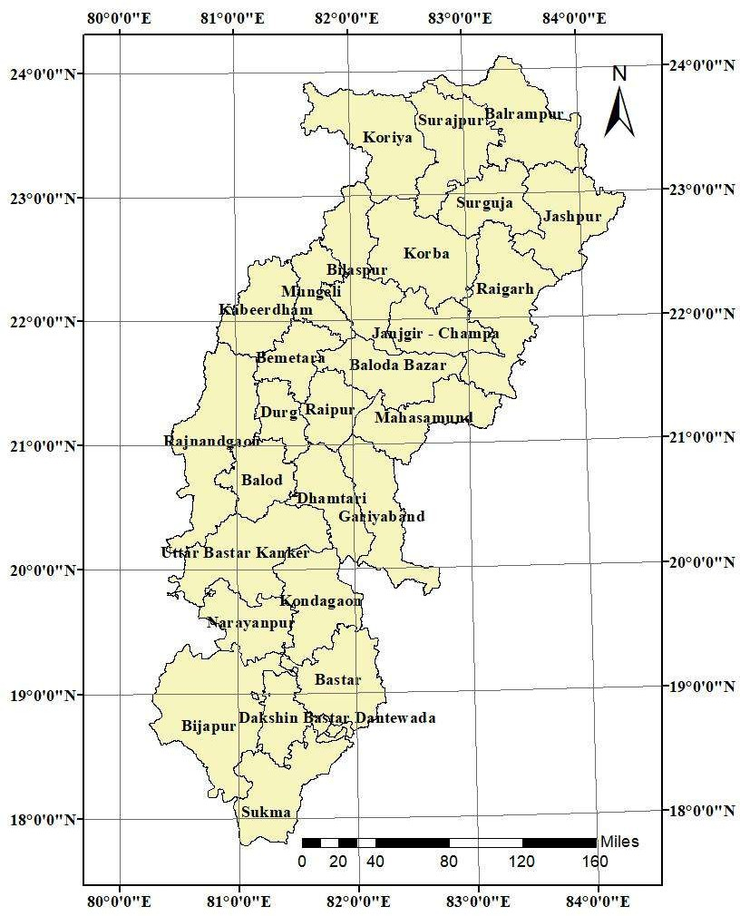

# Fig 1 Study Area

# Data Acquisition

Data from satellite remote sensing will be acquired during the kharif seasons of 2017 and 2019. Reliable meteorological sources will also be used to gather rainfall data for the same time period. To guarantee accuracy and consistency over years, the satellite pictures will undergo pre-processing, which will include geometric and radiometric adjustments. The satellite-based estimates will also be calibrated and validated using current government agriculture statistics and ground-truth data.

**Classified and Analyzed Images**

Using supervised classification techniques of Random Forest algorithm using Google Earth Engine (GEE) the satellite data will be classified for Kharif Rice area estimation. Training samples will be selected especially to identify agricultural areas, especially those used for kharif rice farming. We will utilize an algorithm designed to identify water stagnation, which is a stand-in for rice paddies. Both district and block-level estimates of rice acreage will be made using the categorized photos. The % error approach will be used to compare estimated values with published data in order to measure accuracy.

**Assessed Rainfall Correlation**

To assess the connection between South-West monsoon rainfall and rice acreage, correlation analysis will be performed. Block and district-level statistical comparisons and geographical correlation maps will be part of this. To determine how sensitive rice acreage is to variations in rainfall, areas exhibiting both positive and negative correlations will be found.

**Analyzed Meteorological Drought**

Using rainfall deviation criteria, the meteorological drought status for 2017 and 2019 will be established. Drought-affected districts and blocks will be charted, and the relationship between these and shifts in rice acreage will be investigated. In order to better understand the resilience and susceptibility of various locations, the effects of drought conditions on rice farming will be measured and shown.

**Validated and Interpreted**

The supplied data from agricultural departments will be used to verify the findings from the rainfall correlation and satellite categorization. We'll look at errors and anomalies further, such overestimations or underestimations in districts like Sukma and Dantewada. Future applications will benefit from these insights as they aid enhance accuracy and develop the process.

# Inclusion Criteria

The research will include Chhattisgarh districts and blocks where kharif rice is a key crop and where accurate rainfall and satellite data for 2017 and 2019 are available. Only areas with well-defined patterns of agricultural land usage and readily available official documents for verification will be taken into account.

# Exclusion Criteria

Blocks and districts with missing rainfall data or inadequate or subpar satellite images will not be included. The research will also exclude regions with a high concentration of non- agricultural land use, such as urban or densely wooded areas where rice farming is either nonexistent or irregular.

# Result

**Rice area estimation using satellite data**

Satellite data was organized based on training classes, with a specific focus on delineating agricultural lands and quantifying rice cultivation areas. District-wise kharif rice area in 2017 and 2019 are shown in Figure 2. and the accuracy of the rice area classification was determined using the percent error method. The estimated values for nearly all districts closely approximated the reported values, with error percentages falling within the range of

±20%. Notably, districts Sukma and Dantewada exceeded this acceptable error range in both years. This divergence may be attributed to two possible factors: primarily, the presence of a high direct- sown rice area and secondly, the current algorithm's reliance on detecting water stagnation in rice fields, which could lead to difficulties in mapping these regions. Additionally, the reported area may significantly underestimate or over-estimate the actual extent.

Another valuable application of this mapping approach is its ability to delineate areas at the block level. Block wise kharif rice area in 2017 and 2019 are shown in Figure 3. Obtaining block-level data is typically challenging, yet such an analysis reveals that even within a district, not all blocks respond uniformly to rainfall. At a broader scale, the district-level findings overshadow the nuances observed at the block level. Block-level mapping also identifies clusters of rice fields within districts. For instance, in the Northern Hill Zone, areas such as Bharatpur, Mahendragarh, and Sonhat in Koriya district, Oudgi and Premnagar blocks in Surajpur district, and Balrampur, Ramanujganj, Samri, and Wadrafnagar blocks in Balrampur district are characterized by forests and mountainous terrain, resulting in limited rice cultivation. In contrast,Surguja and Jashpur exhibit evenly distributed rice cultivation, with the Udaypur block in Surguja being an exception.

In the Chhattisgarh Plain Zone, in Korba district, particularly Korba and Poundi Uproda blocks, are predominantly covered by forests. Similarly, the Lormi block in Mungeli district, Bodla block in Kabeerdham district, and Chhuikhadan blocks in the Malkala range have limited agricultural land due to their forested nature. Manpur and Mohla blocks in Rajnandgaon districtwere also feature restricted cultivation areas because of dense and open forest covers. In the Mahanadi Basin, Kesdol block in Baloda Bazar district and Sarangarh block in Raigarh district display minimal cropland due to their location within the Nawapara forest range. Furthermore, the Nagri block in Dhamtari district, along with the

Bindranavagarh and Manipur blocks in Gariyaband districts due to feature dense and open forests, resulting in sparse or concentrated agriculture fields in select areas. Finally, Raipur and Durg blocks experience lower levels of cultivation due to high levels of urbanization in these regions.

In the Bastar Plateau Zone, Narayanpur, Bijapur, Bastar, and Sukma districts were predominantly covered by dense forests. Notably, the Narayanpur Basin, Indravati Plateau, Dantewada Plateau, and areas adjoining the Sabari River in Chhindgarh and Sukma blocks of Sukma district serve as the primary rice cultivation areas within this region.

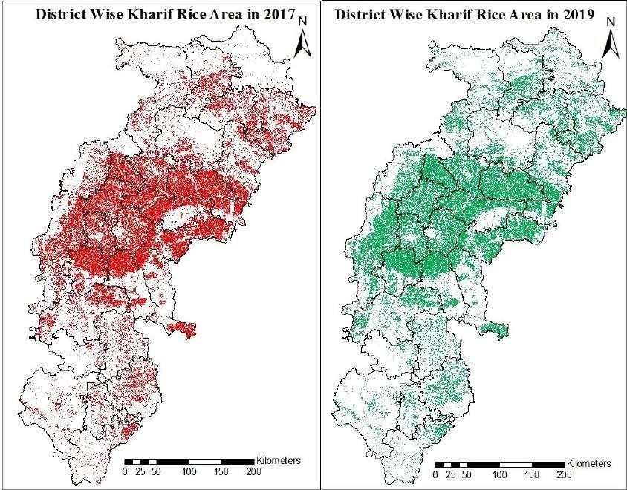

**Figure 2 District wise kharif rice area of Chhattisgarh in 2017 and 2019**

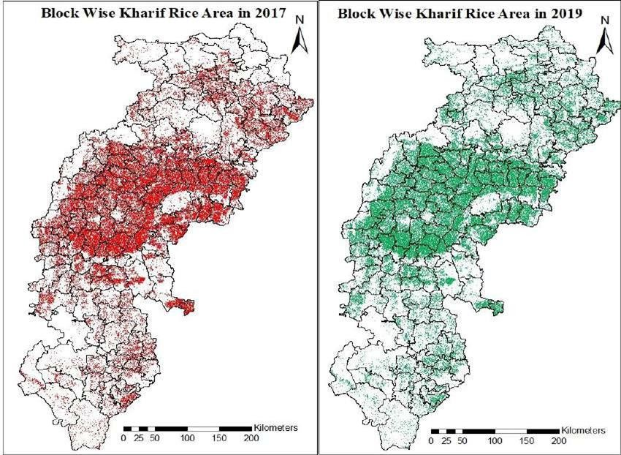

**Figure 3 Block wise kharif rice area of Chhattisgarh in 2017 and 2019**

**Table 1 Summary of actual and estimated values of kharif rice area**

|  |  |  |  |  |  |  |  |
| --- | --- | --- | --- | --- | --- | --- | --- |
| **S.**  **No** | **District** | **Actual**  **Area in 2017** | **Estimated**  **Area in 2017** | **Error (%)** | **Actual**  **Area in 2019** | **Estimated**  **Area in 2019** | **Error (%)** |
| **1.** | **Balod** | 171.71 | 173.16 | 1.0 | 201.91 | 190.98 | 4.4 |
| **2.** | **Baloda Bazar** | 222.12 | 232.77 | 3.2 | 235.09 | 241.27 | 2.6 |
| **3.** | **Balrampur** | 83.70 | 83.68 | 0.0 | 88.61 | 92.15 | 4.0 |
| **4.** | **Bastar** | 131.71 | 119.17 | 9.6 | 129.17 | 127.01 | 1.7 |
| **5.** | **Bemetara** | 169.28 | 180.29 | 6.5 | 186.45 | 188.44 | 1.1 |
| **6.** | **Bijapur** | 62.16 | 50.22 | 19.2 | 67.49 | 56.37 | 16.5 |
| **7.** | **Bilaspur** | 211.88 | 184.35 | 14.3 | 240.86 | 243.22 | 1.0 |
| **8.** | **Dantewada** | 70.68 | 39.25 | 44.5 | 71.00 | 40.47 | 43.0 |
| **9.** | **Dhamtari** | 140.16 | 144.83 | 0.0 | 188.68 | 154.28 | 17.7 |
| **10.** | **Durg** | 125.99 | 129.73 | 2.3 | 139.11 | 137.59 | 1.1 |
| **11.** | **Gariyaband** | 129.69 | 142.42 | 1.8 | 141.10 | 133.13 | 5.6 |
| **12.** | **JanjgirChampa** | 250.24 | 255.99 | 0.5 | 262.44 | 265.76 | 1.3 |
| **13.** | **Jashpur** | 183.35 | 207.32 | 12.7 | 184.27 | 213.28 | 15.7 |

|  |  |  |  |  |  |  |  |
| --- | --- | --- | --- | --- | --- | --- | --- |
| **14.** | **Kabeerdham** | 105.08 | 100.56 | 5.7 | 132.96 | 140.81 | 5.9 |
| **15.** | **Kondagaon** | 105.08 | 92.25 | 12.5 | 108.70 | 98.03 | 9.8 |
| **16.** | **Korba** | 108.35 | 88.33 | 18.9 | 107.70 | 94.35 | 11.5 |
| **17.** | **Koriya** | 67.67 | 63.65 | 6.1 | 72.60 | 73.89 | 1.8 |
| **18.** | **Mahasamund** | 252.75 | 259.19 | 7.8 | 290.63 | 257.52 | 11.4 |
| **19.** | **Mungeli** | 114.28 | 109.83 | 4.2 | 124.04 | 132.74 | 7.0 |
| **20.** | **Narayanpur** | 24.25 | 22.79 | 6.0 | 24.75 | 22.52 | 9.0 |
| **21.** | **Raigarh** | 215.65 | 224.58 | 1.2 | 244.70 | 248.33 | 1.5 |
| **22.** | **Raipur** | 156.86 | 148.88 | 8.3 | 172.81 | 163.18 | 5.6 |
| **23.** | **Rajnandgaon** | 292.94 | 284.10 | 3.1 | 340.27 | 343.48 | 0.9 |
| **24.** | **Sukma** | 84.36 | 61.73 | 26.8 | 86.40 | 59.65 | 31.0 |
| **25.** | **Surajpur** | 108.23 | 106.77 | 2.0 | 113.28 | 121.66 | 7.4 |
| **26.** | **Surguja** | 114.15 | 119.90 | 2.7 | 115.07 | 119.41 | 3.8 |
| **27.** | **Uttar Bastar**  **Kanker** | 176.76 | 176.57 | 2.8 | 195.94 | 181.63 | 7.3 |

**Table 2 Summary of rainfall and estimated values at the Block level***.*

|  |  |  |  |  |  |
| --- | --- | --- | --- | --- | --- |
| **S.No** | **Blocks** | **2017 SW**  **rainfall** | **Estimated 2017 Kharif**  **area in ha** | **2019 SW**  **rainfall** | **Estimated 2019 Kharif**  **area in ha** |
| **1** | **Balod** | 1102.9 | 19941.92 | 1059.3 | 22378.3 |
| **2** | **Dondi Luhara** | 1148.3 | 24273.94 | 1107.4 | 25849.18 |
| **3** | **Dondi** | 1160.7 | 50919.87 | 1124.3 | 55101.08 |
| **4** | **Gunderdehi** | 879.1 | 52450.44 | 1072.7 | 58043.29 |
| **5** | **Gurur** | 1004.3 | 25574.09 | 1011.3 | 29607.12 |
| **6** | **Baloda Bazar** | 840.4 | 40679.97 | 982.2 | 41267.59 |
| **7** | **Bhatapara** | 683.8 | 31542.02 | 966.6 | 33706.73 |
| **8** | **Bilaigarh** | 747.2 | 35100.22 | 1199.9 | 35753.32 |
| **9** | **Kesdol** | 827.1 | 40863.48 | 1152.8 | 41961.82 |
| **10** | **Palari** | 670.6 | 45287.67 | 1029.2 | 46721.9 |
| **11** | **Simga** | 642.8 | 39294.17 | 989.4 | 41858.09 |
| **12** | **Balarampur** | 974.6 | 718.87 | 1073.2 | 13187.67 |
| **13** | **Rajpur** | 1121.1 | 1682.7 | 1114.4 | 13683.02 |
| **14** | **Ramanujanj** | 842.1 | 892.41 | 944.3 | 15682.83 |
| **15** | **Samri** | 1001.3 | 1906.57 | 1020.8 | 18570.87 |

|  |  |  |  |  |  |
| --- | --- | --- | --- | --- | --- |
| **16** | **Shankargarh** | 1027.3 | 1633.88 | 1140.7 | 11830.3 |
| **17** | **Wadrafnagar** | 854.0 | 1533.7 | 983.7 | 19197.69 |
| **18** | **Bakawand** | 1276.1 | 26583.42 | 1488.2 | 26588.61 |
| **19** | **Bastanar** | 1340.3 | 9020.72 | 1808.2 | 9732.87 |
| **20** | **Bastar** | 1287.8 | 29370.52 | 1692.5 | 28839.89 |
| **21** | **Darbha** | 1432.2 | 14870.98 | 1782.5 | 15006.88 |
| **22** | **Jagadalkpur** | 1293.7 | 14703 | 1694.5 | 17044.38 |
| **23** | **Jagadalkpur** | 1279.2 | 12708.74 | 1790.3 | 15627.96 |
| **24** | **Tokpal** | 1331.1 | 11908.41 | 1909.9 | 14173.27 |
| **25** | **Bemetara** | 795.8 | 48096.65 | 1101.6 | 49049.27 |
| **26** | **Berla** | 787.6 | 41893.82 | 1175.8 | 47934.45 |
| **27** | **Nawagarh** | 723.5 | 66664.89 | 1004.0 | 72058.08 |
| **28** | **Saja** | 994.2 | 30900.69 | 1434.8 | 29119.91 |
| **29** | **Thankhamariya** | 936.9 | 20222.16 | 1333.4 | 19050.88 |
| **30** | **Bhairamgarh** | 1139.8 | 15461.72 | 1530.4 | 17339.89 |
| **31** | **Bhopal Pattanam** | 1035.7 | 11312.55 | 1534.9 | 12767.75 |

|  |  |  |  |  |  |
| --- | --- | --- | --- | --- | --- |
| **32** | **Bijapur** | 1191.7 | 13094.63 | 1505.6 | 14534.65 |
| **33** | **Usur** | 1100.3 | 10352.58 | 1627.1 | 11731.71 |
| **34** | **Bilaspur** | 1067.8 | 19277.19 | 1101.0 | 24001.77 |
| **35** | **Bilha** | 886.7 | 21448.08 | 1045.6 | 23839.58 |
| **36** | **Kota** | 1064.9 | 26336.6 | 1393.0 | 33863.72 |
| **37** | **Marwahi** | 851.4 | 17203.76 | 1214.8 | 25147.67 |
| **38** | **Masturi** | 1036.2 | 39419.02 | 1035.9 | 49920.17 |
| **39** | **Pendra** | 1073.8 | 9044.1 | 1386.0 | 16544.77 |
| **40** | **Pendra Road Gourela** | 1055.8 | 17940.9 | 1417.3 | 24462.08 |
| **41** | **Thakatpur** | 851.7 | 33676.01 | 1210.4 | 45443.25 |
| **42** | **Dantewada** | 1366.9 | 11584.27 | 1516.2 | 11955.01 |
| **43** | **Gidam** | 1224.2 | 13657.47 | 1587.8 | 13977.57 |
| **44** | **Ketekalyan** | 1674.6 | 6768.33 | 1606.9 | 6937.82 |
| **45** | **Kuakonda** | 1721.7 | 7236.34 | 1509.1 | 7594.96 |
| **46** | **Damdatri** | 930.7 | 34004.15 | 954.1 | 37273.79 |
| **47** | **Kurud** | 930.7 | 47246.49 | 954.1 | 50685.82 |
| **48** | **Magalroad** | 797.7 | 25613.74 | 887.8 | 27494.01 |
| **49** | **Nagri** | 828.0 | 37963.49 | 886.5 | 39822.99 |

|  |  |  |  |  |  |
| --- | --- | --- | --- | --- | --- |
| **50** | **Dhamdha** | 837.5 | 50891.17 | 1236.6 | 56295.87 |
| **51** | **Durg** | 777.0 | 29706.66 | 1093.4 | 31577.54 |
| **52** | **Patan** | 795.7 | 49136.13 | 1120.5 | 49719.42 |
| **53** | **Bendranawagaon** | 933.1 | 19321.85 | 1058.2 | 17952.96 |
| **54** | **Churra** | 878.8 | 27521.18 | 1155.9 | 25660.98 |
| **55** | **Devbhog** | 916.9 | 23814.00 | 1191.8 | 22600.48 |
| **56** | **Mainpur** | 922.2 | 36556.56 | 1097.7 | 34417.01 |
| **57** | **Rajim** | 884.2 | 35208.47 | 1180.4 | 32494.52 |
| **58** | **Akaltara** | 1062.7 | 23338.81 | 991.0 | 25155.69 |
| **59** | **Baloda** | 1152.8 | 16979.24 | 1129.7 | 17667.16 |
| **60** | **Champa** | 737.2 | 26407.81 | 914.7 | 27580.48 |
| **61** | **Dabhara** | 979.6 | 29190.44 | 1422.6 | 29644.12 |
| **62** | **Jaijaipur** | 855.6 | 32114.37 | 1134.3 | 33017.79 |
| **63** | **Janjgir** | 983.0 | 17433.34 | 952.3 | 18570.28 |
| **64** | **Malkharoda** | 1013.6 | 25923.91 | 1274.7 | 26244.45 |
| **65** | **Nawagarh** | 848.4 | 27489.02 | 1021.5 | 28771.66 |
| **66** | **Pamgarh** | 978.9 | 32470.49 | 971.2 | 33760.98 |

|  |  |  |  |  |  |
| --- | --- | --- | --- | --- | --- |
| **67** | **Shakti** | 920.8 | 24641.41 | 1051.8 | 25343.84 |
| **68** | **Bagicha** | 1090.7 | 47898.34 | 1281.5 | 49269.29 |
| **69** | **Duldulla** | 1277.4 | 15010.88 | 1286.1 | 15863.68 |
| **70** | **Farsabhar** | 1285.7 | 27104.74 | 1287.8 | 28179.85 |
| **71** | **Jaspur** | 1263.8 | 20830.39 | 1199.2 | 21487.4 |
| **72** | **Kanshabel** | 1164.4 | 18108.85 | 1311.0 | 18660.39 |
| **73** | **Kunkuri** | 1168.8 | 20375.87 | 1302.2 | 21051.27 |
| **74** | **Manora** | 1106.9 | 19090.66 | 1233.6 | 19096.26 |
| **75** | **Pathalgaon** | 1284.2 | 38899.55 | 1239.3 | 39667.44 |
| **76** | **Bodla** | 1132.3 | 20256.52 | 1103.8 | 31007.82 |
| **77** | **Kawardha** | 979.8 | 20141.52 | 991.8 | 31318.34 |
| **78** | **Pandariya** | 941.6 | 33664.4 | 1132.0 | 42350.72 |
| **79** | **Sahaspur Lohara** | 957.9 | 26500.18 | 1213.6 | 36132.32 |
| **80** | **Bade Rajpur** | 1132.7 | 16044.18 | 1171.4 | 16764.96 |
| **81** | **Farasgaon** | 1104.3 | 17331.63 | 1284.5 | 19931.38 |
| **82** | **Keskal** | 1044.6 | 14767.93 | 1099.9 | 16213.92 |
| **83** | **Kondagaon** | 1169.4 | 25857.28 | 1411.0 | 25895.64 |

|  |  |  |  |  |  |
| --- | --- | --- | --- | --- | --- |
| **84** | **Makdi** | 1188.5 | 18251.53 | 1163.4 | 19228.66 |
| **85** | **Kartala** | 964.4 | 17049.65 | 1067.7 | 19351.10 |
| **86** | **Kartghora** | 1112.3 | 13101.13 | 1169.5 | 14014.94 |
| **87** | **Korba** | 1154.9 | 14135.00 | 1133.2 | 15533.06 |
| **88** | **Pali** | 1117.4 | 23254.24 | 1231.8 | 23555.92 |
| **89** | **Poundi Uproda** | 1087.2 | 20792.03 | 1198.7 | 22894.21 |
| **90** | **Baikunthpur** | 1001.7 | 14650.32 | 1153.3 | 18314.46 |
| **91** | **Bharatpur** | 766.5 | 14221.82 | 1150.5 | 16940.4 |
| **92** | **Khadganva** | 863.4 | 12945.68 | 1056.0 | 15658.79 |
| **93** | **Mahendragarh** | 743.4 | 12483.39 | 1028.9 | 13309.88 |
| **94** | **Sonhat** | 880.8 | 9351.59 | 1094.4 | 9666.47 |
| **95** | **Bagbahara** | 882.8 | 49194.63 | 1292.9 | 48960.97 |
| **96** | **Basna** | 782.0 | 44635.89 | 1218.7 | 44359.24 |
| **97** | **Mahasamund** | 879.5 | 56409.65 | 1238.3 | 56034.57 |
| **98** | **Pithora** | 859.6 | 58824.73 | 1218.6 | 58343.92 |
| **99** | **Saraipali** | 811.3 | 50124.49 | 1279.4 | 49824.22 |
| **100** | **Lormi** | 1004.3 | 35224.28 | 1372.7 | 44161.21 |
| **101** | **Mungeli** | 786.9 | 41359.64 | 1028.6 | 50058.28 |

|  |  |  |  |  |  |
| --- | --- | --- | --- | --- | --- |
| **102** | **Pathariya** | 747.7 | 33243.54 | 1091.4 | 38520.37 |
| **103** | **Narayanpur** | 1073.0 | 20666.79 | 1518.9 | 20338.64 |
| **104** | **Orchha** | 1020.0 | 2127.09 | 1649.1 | 2177.73 |
| **105** | **Baramkela** | 892.3 | 28602.15 | 1504.2 | 31260.26 |
| **106** | **Gharghoda** | 1154.1 | 14844.08 | 1261.6 | 16571.56 |
| **107** | **Kharsia** | 1104.3 | 21627.16 | 1273.9 | 23740.41 |
| **108** | **Lailunga** | 1198.6 | 21593.42 | 1260.9 | 24690.71 |
| **109** | **Pusour** | 1012.3 | 25703.37 | 1588.9 | 27966.45 |
| **110** | **Raigarh** | 1145.9 | 20009.51 | 1499.7 | 22084.53 |
| **111** | **Sarangarh** | 823.9 | 36000.22 | 1388.2 | 38989.88 |
| **112** | **Tamnar** | 1162.0 | 16627.89 | 1406.0 | 18674.51 |
| **113** | **Udaipur** | 1308.6 | 39569.76 | 1170.3 | 44348.83 |
| **114** | **Abhanpur** | 846.5 | 33233.9 | 1118.5 | 36600.49 |
| **115** | **Arang** | 830.6 | 53948.7 | 1169.7 | 57232.78 |
| **116** | **Raipur** | 773.0 | 23121.36 | 1127.6 | 26180.18 |
| **117** | **Tilda** | 661.9 | 38580.73 | 1014.3 | 43162.58 |

|  |  |  |  |  |  |
| --- | --- | --- | --- | --- | --- |
| **118** | **Ambarg** | 1232.2 | 18903.55 | 931.9 | 23949.6 |
| **119** | **Chhuikadhan** | 704.8 | 38672.49 | 838.1 | 43106.91 |
| **120** | **Chhuriya** | 940.1 | 42090.97 | 836.2 | 47953.23 |
| **121** | **Dongargaon** | 940.1 | 23928.53 | 836.2 | 28526.00 |
| **122** | **Dongargarh** | 816.1 | 33940.19 | 772.7 | 45808.86 |
| **123** | **Khairagarh** | 709.9 | 50105.00 | 853.2 | 60224.00 |
| **124** | **Manpur** | 1117.1 | 17577.62 | 1338.6 | 22456.00 |
| **125** | **Mohla** | 1189.6 | 17012.17 | 1163.1 | 21699.91 |
| **126** | **Rajnangdon** | 794.5 | 42870.81 | 943.0 | 49751.55 |
| **127** | **Chhindgarh** | 1761.3 | 24188.78 | 1537.9 | 23579.13 |
| **128** | **Konta** | 1484.3 | 20800.81 | 1538.4 | 19826.99 |
| **129** | **Sukma** | 648.5 | 16737.26 | 496.0 | 16244.58 |
| **130** | **Bhaiyathan** | 1398.2 | 20990.91 | 1357.2 | 23681.84 |
| **131** | **Odugi** | 988.1 | 12123.49 | 1090.0 | 15731.90 |
| **132** | **Pratappur** | 1034.6 | 25809.70 | 1063.1 | 29738.27 |
| **133** | **Premnagar** | 1289.8 | 7136.39 | 1201.7 | 9455.07 |
| **134** | **Ramanujnagar** | 1469.7 | 16257.18 | 1509.8 | 18724.47 |
| **135** | **Surajpur** | 1289.8 | 24453.55 | 1201.7 | 24325.04 |
| **136** | **Ambikapur** | 1307.8 | 22037.55 | 1117.9 | 21209.67 |

|  |  |  |  |  |  |
| --- | --- | --- | --- | --- | --- |
| **137** | **Batoule** | 1307.8 | 11468.26 | 1117.9 | 12325.83 |
| **138** | **Lakhanpur** | 1357.6 | 20691.89 | 1094.1 | 19824.64 |
| **139** | **Lundra** | 1185.9 | 19076.94 | 1163.8 | 19013.38 |
| **140** | **Mainpat** | 1347.3 | 15638.58 | 1162.5 | 16871.58 |
| **141** | **Sitapur** | 1269.6 | 17180.42 | 1232.7 | 16952.41 |
| **142** | **Udaypur** | 1324.3 | 13807.71 | 1110.9 | 13210.00 |
| **143** | **Antagarh** | 1002.9 | 20054.33 | 1352.9 | 20589.36 |
| **144** | **Bhanupratappur** | 1033.8 | 19148.17 | 1053.9 | 19733.41 |
| **145** | **Charma** | 1006.7 | 25616.66 | 977.9 | 26546.11 |
| **146** | **Durgkondal** | 1117.5 | 17170.41 | 1292.4 | 17658.98 |
| **147** | **Kanker** | 949.8 | 23339.88 | 890.2 | 23940.92 |
| **148** | **Narharpur** | 886.4 | 29303.79 | 885.6 | 30057.83 |
| **149** | **Pakhanjur** | 1003.2 | 41939.02 | 1543.4 | 43104.10 |

# Response of districts to rainfall

Correlation between rainfall and kharif rice area in Chhattisgarh were given in Figure 4. Most parts of the state have positive correlation with rainfall. But in the Northern Hill Zone, in Surajpur district, only Bhaiyathan and Premnagar blocks were negatively correlated. In Balrampur district Rajpur block, in Surguja district Batouli, and Mainpat blocks, and in Jashpurdistrict Jashpur and Pathalgaon blocks were negatively correlated. At the Chhattisgarh Plain Zone, in Korba district, Korba block, in Raigarh district Udaipur block, in Bilaspur district, Masturi block and in Janjgir Champa district Akaltara, Baloda, Janjgir, and Pamgarh blocks wereobserved negative correlation with rainfall. In the Badla block of Kabeerdham district, Saja andThanakhamria block of Bemetara district, Ambargarh, Chhuriya, Dongargaon, Dongargarh, andMohla blocks of Rajnandgaon district noted a negative correlation. In the Balod district Balod, Dondi, and Dondi Luhara blocks and in Kanker district Charama, Kanker, and Narharpur blockswere noted negative correlation with rainfall. The entire blocks of Gariyaband and Mahasamund districts were observed negative correlation. In the Bastar Plateau Zone, Narayanpur block of Narayanpur district, Makdi block of Kondagaon district, Katekalyan and Kuakonda block of Bastar district, and Konta block of Sukma district were noted negative correlation with rice. At the district level Surajpur, Mahasamund, Gariyaband, and Narayanpur districts were noted negative correlation with rainfall. Out of nine blocks, five blocks of Rajnandgaon district had a negative correlation but it doesn’t replicate at the district level because these blocks were havinglesser rice area coverage than the rest of the four blocks. The study's use of satellite data and GIS tools exemplifies the potential for remote sensing technologies in agricultural monitoring, especially during challenging monsoon seasons (Tiwari *et al*., 2021)

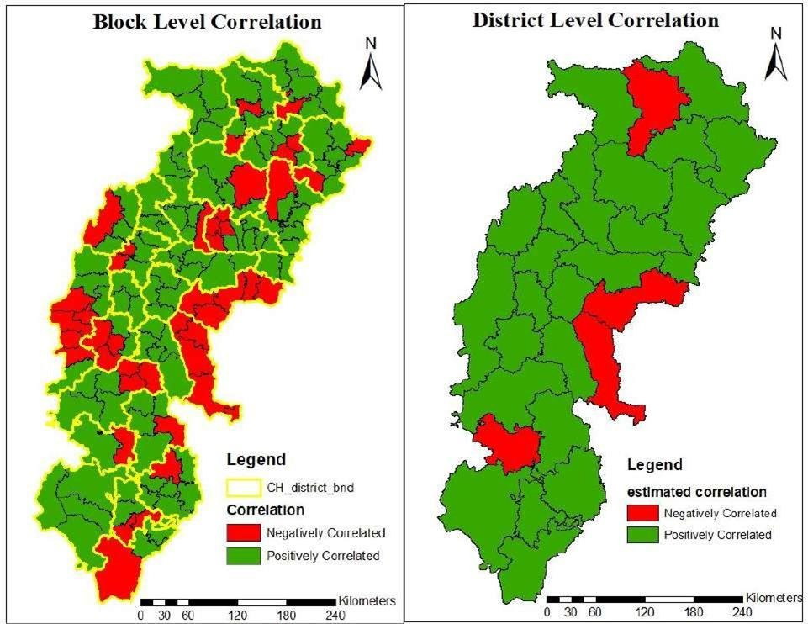

**Figure 4 Correlation between rainfall and kharif rice area in Chhattisgarh**

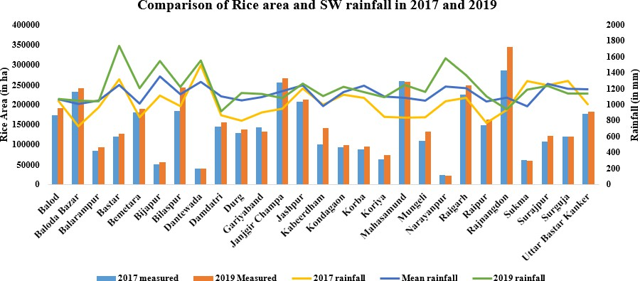

**Figure 5 Comparison between rice area and SW rainfall in 2017 and 2019**

**Table 3 Status of South West monsoon rainfall during 2017 and 2019**

|  |  |  |  |  |
| --- | --- | --- | --- | --- |
| **Sl.** | **District** | **2017 Rainfall** | **Mean Rainfall** | **2019 Rainfall** |
| **1.** | **Balod** | 1059.02 | **1078.00** | 1075.00 |
| **2.** | **Baloda Bazar** | 734.32 | **957.93** | 1053.34 |
| **3.** | **Balrampur** | 970.06 | **1039.12** | 1046.20 |
| **4.** | **Bastar** | 1320.05 | **1271.67** | 1738.17 |
| **5.** | **Bemetara** | 847.79 | **1033.80** | 1209.91 |
| **6.** | **Bijapur** | 1116.86 | **1409.53** | 1549.47 |
| **7.** | **Bilaspur** | 986.02 | **1112.86** | 1224.49 |
| **8.** | **Dantewada** | 1497.09 | **1324.73** | 1555.01 |
| **9.** | **Dhamtari** | 871.77 | **1077.13** | 921.13 |
| **10.** | **Durg** | 803.40 | **1039.27** | 1150.17 |
| **11.** | **Gariyaband** | 907.04 | **1086.78** | 1136.82 |
| **12.** | **JanjgirChampa** | 953.25 | **1126.88** | 1086.47 |
| **13.** | **Jashpur** | 1204.37 | **1233.59** | 1267.60 |
| **14.** | **Kabeerdham** | 1002.90 | **1034.00** | 1110.30 |
| **15.** | **Kondagaon** | 1128.10 | **1130.28** | 1226.24 |
| **16.** | **Korba** | 1087.44 | **1206.74** | 1160.18 |
| **17.** | **Koriya** | 851.16 | **1124.58** | 1096.63 |
| **18.** | **Mahasamund** | 843.02 | **1054.18** | 1249.55 |
| **19.** | **Mungeli** | 846.63 | **1057.60** | 1164.23 |
| **20.** | **Narayanpur** | 1046.51 | **1109.55** | 1583.99 |
| **21.** | **Raigarh** | 1089.34 | **1200.43** | 1372.75 |
| **22.** | **Raipur** | 778.00 | **984.83** | 1107.81 |
| **23.** | **Rajnandgaon** | 938.38 | **1063.42** | 945.89 |
| **24.** | **Sukma** | 1298.38 | **1054.37** | 1190.76 |
| **25.** | **Surajpur** | 1245.03 | **1069.60** | 1237.25 |
| **26.** | **Surguja** | 1300.04 | **1179.17** | 1142.83 |
| **27.** | **Uttar Bastar Kanker** | 1000.04 | **1230.73** | 1142.33 |

# Status of Meteorological Drought and its Correlation between kharif rice area and Rainfall

Comparisons between the kharif rice area and rainfall are given in Figure 5. Correlation between kharif rice area and meteorological drought are shown in Figure 6. In the Northern Hill Zone, only the Koriya district had a meteorological drought. Bharatpur, Khadganva, and Manendragarh blocks were also noted meteorological drought during this period. In the Chhattisgarh Plain Zone, in Baloda Bazar district (Bhatapar, Bilaigarh, Palari and Simga blocks), Bemetara (Nawagarh block), Bilaspur (Marwahi and Takhatpur blocks), Dhamtari (Magarlod and Nagri block), Durg (Durg block), Janjigir – Champa (Champa, Janijaipur, Nawagarh, and Sakti block), Mungeli (Mungeli and Pathariya block), Mahasamund (Basna and Saraipali blocks), Raigarh (Baramkela block), Raipur (Raipur and Tilda blocks) Rajnandgaon (Chhuikhadan and Khairagarh blocks). In total 26 blocks had meteorological drought during 2017 and in which, only Basna and Saraipali block of Mahasamund only noted negative correlation with kharif rice area and rainfall which is due to underestimation of these blocks area in 2019. As a distict Mahasamund area has increased during 2019 compared to 2017. Error percent in 2017 was 7.8 and in 2019 was 11.5. So, all district and blocks which had meteorological drought in 2017 had reduced kharif rice area which had an impact of rainfall.

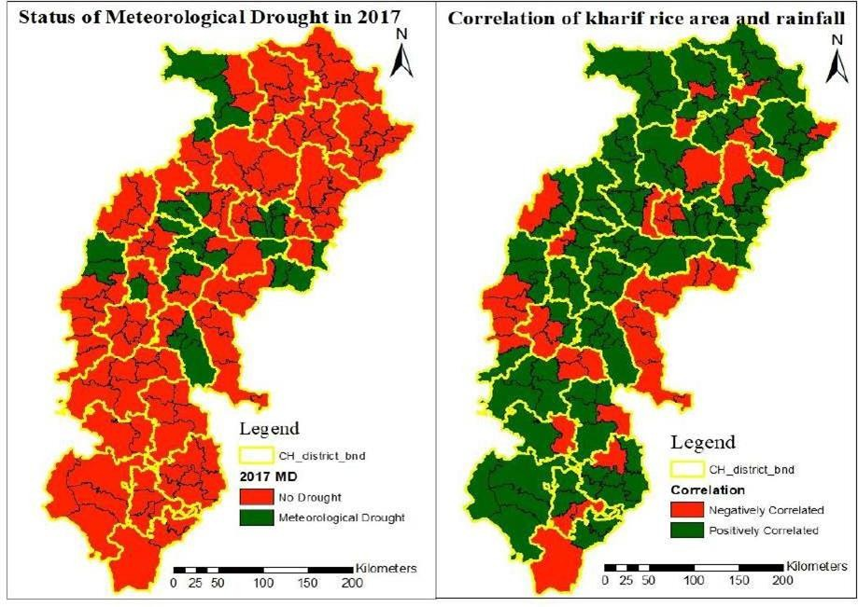

**Figure 6 Correlation between kharif rice area and meteorological drought**

# Discussion

The research will show how rice acreage responds differently to rainfall in different Chhattisgarh districts and blocks. The majority of areas will have a positive connection, suggesting that more rainfall causes more rice to be grown. However, certain blocks will have larger error margins and negative correlations, especially those in areas like Sukma and Dantewada that are dominated by forests or are prone to drought. The existence of direct-sown rice, unusual land use techniques, or forest cover might all contribute to this oddity. Significant intra-district heterogeneity will also be shown by block-level analysis, underscoring the shortcomings of using district-level data alone for agricultural planning. Reductions in rice acreage will also be correlated with the documented meteorological droughts in certain places, highlighting the significance of climatic conditions in crop performance. These results will highlight the need of tailored support programs and regional climate-adaptive agricultural practices. Thus, satellite data and precise rainfall records will be crucial for effective management of agricultural resources.

# Conclusion

This study demonstrates how rainfall, particularly in rain-fed systems, plays a crucial influence in influencing the amount of land used for kharif rice in Chhattisgarh. The regional variation in rainfall response highlights the need for granular, block-level research, even if remote sensing is a useful tool for tracking rice production trends. The results show that depending just on data at the district level may miss important local differences that are essential for efficient agricultural planning and policy. Combining rainfall and drought data with satellite images creates a potent foundation for climate-smart and adaptable agriculture. Block-specific interventions, early warning systems, and capacity-building for farmers to react proactively to climate changes should be the top priorities of future initiatives.

Disclaimer (Artificial intelligence)

No Artificial intelligence has been used

Option 1:

Author(s) hereby declare that NO generative AI technologies such as Large Language Models (ChatGPT, COPILOT, etc.) and text-to-image generators have been used during the writing or editing of this manuscript.

# References

Arumugam, P., Chemura, A., Schauberger, B., & Gornott, C. (2021). Remote sensing based yield estimation of rice (Oryza sativa l.) using gradient boosted regression in India. *Remote Sensing*, *13*(12), 2379.

Dash, C. J., Yadav, P., Kumar, R., Patra, S. S., Hombegowda, H. C., & Adhikary, P. P. (2023). Appraisal of long-term rainfall trends and rainfall erosivity in diverse agroclimatic zones of Chhattisgarh state, India: Implication for soil and water conservation measures.

De Clercq, D., & Mahdi, A. (2024). Feasibility of machine learning-based rice yield prediction in India at the district level using climate reanalysis and remote sensing data. *Agricultural Systems*, *220*, 104099.

Entekhabi, D., Njoku, E. G., O'neill, P. E., Kellogg, K. H., Crow, W. T., Edelstein, W. N., ... & Van Zyl, J. (2010). The soil moisture active passive (SMAP) mission. *Proceedings of the IEEE*, *98*(5), 704-716.

Jackson, T. J., Cosh, M., Bindlish, R., Dinardo, S., Yueh, S., & O‘Neill, P. (2008). Soil moisture active passive validation experiment 2008 (SMAPVEX08). In *AGU Fall Meeting Abstracts* (Vol. 1, p. 1031).

Jyothi, C., Davis, P. L., Ajithkumar, B., Latha, A., & Vysakh, A. (2024). Impact of Weather Variables on Phenophase and Yield of Kharif Rice (Oryza sativa L.) in Central Zone of Kerala. *International Journal of Environment and Climate Change*, *14*(12), 800-808.

Mandal, S., Khalkho, D., Tripathi, M. P., Das, S., & Kumar, L. (2021). Delineation and characterization of land resources to assess agro-climatic zone based farming situation in Chhattisgarh plains. *Journal of Soil and Water Conservation*, *20*(3), 257-268.

Sarkar, H., Soni, S., Ahmad, I., & Verma, M. K. (2020). Assessment of agricultural drought in upper Seonath Sub-Basin of Chhattisgarh (India) using remote sensing and GIS-based indices. *Journal of the Indian Society of Remote Sensing*, *48*, 921-933.

Singh, B. G., Suresh, R., Sahu, R. K., Jha, C. K., & Kumar, M. (2025). Probabilistic Rainfall Assessment and Climate-resilient Crop Strategies for North Bihar's Zone II. *Journal of Scientific Research and Reports*, *31*(5), 799-808.

Snigdha, G. (2022). *Rice yield estimation using remote sensing and crop simulation model in Nalgonda district, Telangana* (Doctoral dissertation, Professor Jayashankar Telangana State Agricultural University).

Tiwari, M., Gupta, P. K., Tiwari, N., & Chitale, S. (2024). Potential of temporal satellite data analysis for detection of weed infestation in rice crop. *The Egyptian Journal of Remote Sensing and Space Sciences*, *27*(4), 734-742.

Tiwari, S. K., Rao, M. P., & Rao, G. P. (2021). Paddy crop acreage assessment using Sentinel-1 (C-band) SAR data in Andhra Pradesh state, India.