Determining the growth trends, varietal status, and economic benefits of selected black gram Variety released by Dr. PDKV, Akola, Maharashtra, India

Abstract
This study aims to examine the growth trends, varietal status, and economic benefits of the selected black gram variety released by the University Dr. Panjabrao Deshmukh Krishi Vidyapeeth, Akola. Black gram grains are an important pulse diet of the nation and used in different food preparations. In the varietal front of the Pulses Research Station, Dr. PDKV has made significant progress by releasing 03 excellent black gram Varieties for Maharashtra. In the Black Gram variety, TAU 1 was released in 1985. It comprises a selection of pulses research units, methods of data collection, and analysis of data by applying appropriate statistical tools. The data on costs and returns of Udid TAU 1 and other varieties data of respective crops for the year 2019-20 were compiled from the Black gram quick estimate reports of Agricultural Price Cost and Scheme, Department of Agril. Economics and Statistics, Dr.PDKV, Akola. In addition to this primary data has been collected from the survey of sample cultivators through personal interviews. A partial budget approach was used for estimating the impact of research outcomes on income generation. The result revealed that the total economic worthiness of the university-released Black gram production technology over other competing varieties of Black gram in the region was Rs.14608.12/- per hectare respectively. It means the Net Economic Impact to the farming community in Maharashtra state was Rs. 58.92 crores for black gram in the year 2019-20. The area under University released black gram varieties for the year 2019-20 was 58560.75 hectares. Black gram variety, the Gross economic impact of University variety for the last 15 years was Rs. 3904.72 crores. As per the demand of farmers, it is need to increase the seed production of TAU1 varieties of Black gram.

Keywords: Black gram, growth trends, TAU 1, Economic Impact

Introduction
Black gram [Vigna mungo (L.)] is an important pulse crop preferred in India due to its daily dietary component. Black gram is highly sensitive to abiotic stresses. Being observed, the productivity of black gram is low in India as well as in Maharashtra due to lack of knowledge. Among them, the time of sowing and selection of suitable cultivars are some of the suitable dates of sowing and higher cultivars for black gram under agroclimatic conditions of Amritsar (Swaminathan et al., 2023; Chavhan et al., 2024; Kumar & Kumar, 2022). Agricultural research in developing high-yielding varieties and improved technologies was largely responsible. Thus, the contributions of agricultural research helped to improve welfare gains and reduce poverty in rural and urban areas by lowering prices of food commodities due to increased production and productivity (Suresh & Chandrakant, 2015). Black gram grains are an important pulse diet of the nation and used in different food preparations (Dhandapani et al., 2023). The global scenario observed that the area under pulses in India during 2019-2020 was 148.30 lakh hectares producing 80.91 lakh tonnes. All over India area under Black gram during 2019-20 was 36.44 lakh hectares producing 16.93 lakh tonnes. A large portion of Udid is consumed in the same country where they are produced. India alone accounts for more than 50 per cent of the world's production. About 95 per cent of Blackgram production comes from 10 states of Madhya Pradesh, Rajasthan, Andhra Pradesh, Uttar Pradesh, Tamil Nadu, Maharashtra, Jharkhand, Gujarat, Karnataka and West Bengal (Prasanthi & Kumar , 2023, Pokharkar et al., 2018).
In Black gram (3.08 lakh ha), fourth rank in Maharashtra after Madhya Pradesh(17.52 lakh ha), Rajasthan(5.02 lakh hectare) & Uttar Pradesh(5.19 lakh ha) in 2019-20. The Production under Udid in Maharashtra constitutes 1.28 lakh tonnes [DES, ministry of Agri.& FW (DAC&FW), Govt. of India; 2019-20].
In Black gram, the TAU 1 variety is moderately resistant to powdery mildew and blight. Seeds are generally bold black in colour. It is high high-yielding variety. It gives 10 to 12 qtl/ha yield and crop duration is 70 - 75 days. TAU 1 variety is wider adoptability i.e. cultivated in all the states of India. Keeping in view of these aspects the objective of this present study is to analyze the growth rates, varietal adoption, and economic impact of selected black gram varieties.
Methodology
The present study was undertaken to study an impact assessment of the Black gram variety released by Dr.PDKV, Akola. It comprises a selection of pulses research units, methods of data collection, and analysis of data by applying appropriate statistical tools.
Selection of Pulses Research Unit
The Pulses Research Station, Dr. P. D. K. V., Akola was selected for estimating the economic impact of TAU 1 varieties of Black gram in Maharashtra.
- Selection of Variety :
TAU 1 varieties were selected for the present study because this variety was widely used under the cultivation of Black gram and the Other variety used as a check.
- Collection of data:
The data on the area, production and productivity of Black gram for Maharashtra and India were collected from the Annual report, the Ministry of Agriculture and Farmers Welfare, Government of India for the years 1990-91 to 2019-20. The information on expenditure on research, extension, salary, contingency etc. was availed from the office record of Pulses Research Unit, Dr.PDKV, Akola. Data on seed sales of TAU 1 was collected from the Pulses Research Unit, Dr.PDKV, Akola and Mahabheej, Akola.
As the farmers retained the seed for the next year also distributed among the other farmers as per demand. So the area under seed spread was considered a 25% increase over total seed. The data on costs and returns of Black gram TAU 1 and other varieties for the year 2019-20 was compiled from the Black gram quick estimate reports of Agricultural Price Cost and Scheme, Department of Agril. Economics and Statistics, Dr.PDKV, Akola. In addition to this project, primary data has been collected from the survey of sampled cultivators through personal interviews with the help of pre-tested and structured schedule for the year 2019-20.
Performance of Black gram:
Compound growth rate:
The compound growth rates were computed based on time series data on area, production and productivity of Black gram for Maharashtra and India for the study period viz., 2000-01 to 2019-20 using the log-linear function. The period 2000-01 to 2019-20 was subdivided into two sub-periods viz., Period-I(2000-01 to 2010-11), Period-II (2011-12 to 2019-20) and entire period (2000-01 to 2019-20).

Instability analysis:
To measure the instability in area, production & productivity, an index of instability was used as a measure of variability for two periods and overall. The coefficient of variation(CV) was calculated by the formula.
Standard Deviation
C.V.(%) = ------------------------------- x 100
Mean
Partial budgeting technique:
Partial budgeting is used to find the economic viability of partial change in the farm such as the use of new variety or new technology or new innovation or new practice or new equipment or new service. Partial budget approach was used for estimating the impact of research outcome on income generation. Partial budgeting is a method of organizing experimental data and information about the cost and benefits of some change in the technologies being used on the farm. The aim is to estimate the change that will occur in farm profit or loss from some change in the farm plan (Boehlije & Eidman, (1985).
In this study the four components of partial budgeting were considered viz: i) Added expenditure due to cultivation of improved black gram variety ii) Reduced returns due to cultivation of improved black gram variety iii) Reduced cost due to cultivation of improved black gram variety and iv) Added returns due to cultivation of improved black gram variety. For up-scaling the economic impact the probability performance of the technology, rate of adoption of technology and depreciation of the technology was considered.
Results and Discussion
Keeping in view the objectives of the study, the data were analysed using suitable techniques. The results obtained from this study have been presented and discussed critically.
Region-wise Area, Production & Productivity of Black gram in Maharashtra
Area of Black gram:
Table: 1: Region-wise Area of Black gram in Maharashtra (Area: 00 ha)
S.N. |  | Region
S.N. | Year | Western  Maharashtra | Marathwada | Vidarbha | Konkan | Maharashtra
1 | 1990-91 | 1292.00  (32.93) | 1170.00  (29.82) | 1436.00  (36.60) | 25.00  (0.64) | 3923.00  (100.00)
2 | 2000-01 | 1219.00  (21.24) | 2614.00  (45.54) | 1845.00  (32.14) | 62.00  (1.08) | 5740.00  (100.00)
3 | 2010-11 | 1276.00  (26.48) | 2343.00  (48.63) | 1145.00  (23.77) | 54.00  (1.12) | 4818.00  (100.00)
4 | 2019-20 | 1269.39  (41.22) | 1220.92  (39.65) | 554.47  (18.00) | 34.75  (1.13) | 3079.53  (100.00)
Source: Maharashtra Agricultural Departmental Website: www.mahaagri.com

Table 1 revealed that the area of a Black gram in Maharashtra State was observed more in Western Maharashtra i.e 126939 ha (41.22 %) & Marathwada i.e. 122092 ha (39.65%) in the year 2019-20. It means the major crops of the area were Western Maharashtra & Marathwada. & third rank position of Black gram crop was observed in Vidarbha i.e. 55447 ha (18.00 %). It is also noted that the percentage of Western Maharashtra(32.93 to 41.22%) and Marathwada(29.82 to 39.65%) were increasing trend during over a period of time. And Vidarbha region decreasing trend i.e. 36.69 to 18.00 per cent over a period of time
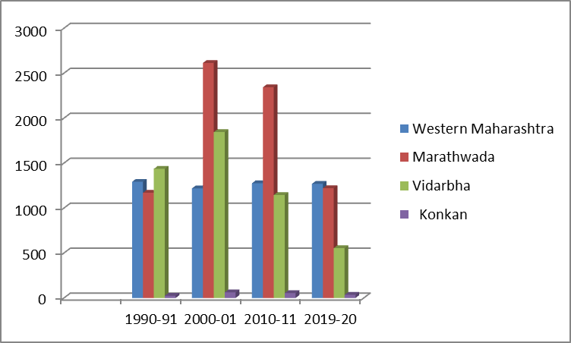
Fig 1: Region-wise Area of Black Gram in Maharashtra State

Production of Black gram:
Table: 2 Region-wise Production of Black gram in Maharashtra
 |  |  |  | Production: 00 Tonnes
S.N. |  | Region
 | Year | Western | Marathwada |  | Vidarbha | Konkan | Maharashtra
 |  | Maharashtra
1 | 1990-91 | 725.00  (41.71) | 478.00  (27.50) |  | 527.00  (30.32) | 8.00  (0.46) | 1738.00  (100.00)
2 | 2000-01 | 424.00  (20.67) | 878.00  (42.81) |  | 711.00  (34.67) | 38.00  (1.85) | 2051.00  (100.00)
3 | 2010-11 | 916.00  (27.86) | 1559.00  (47.42) |  | 781.00  (23.76) | 31.46  (0.96) | 3287.46  (100.00)
4 | 2019-20 | 469.90  (36.51) | 548.70  (42.53) |  | 254.19  (19.75) | 14.25  (1.11) | 1287.03  (100.00)
Source: Maharashtra Agricultural Departmental Website: www.mahaagri.com

Table 2 revealed that the Production of a Black gram in Maharashtra state decreased in the Vidarbha region i.e from 52700(30.32%) to 25419(19.75 %) tonnes in the year 190-91 to 2019-20. And increased in production of Marathwada i.e. from 47800(27.50%) to 54870(42.53%) tonnes during 1990-91 to 2019-20.
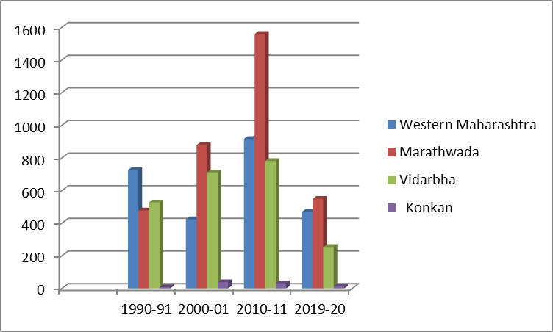

Fig 2: Region-wise Production of Black gram in Maharashtra State

Productivity of Black gram:
Table 3: Region-wise Productivity of Black gram in Maharashtra
 |  |  |  | Productivity: Kg/ha
S.N. |  | Region
S.N. | Year | Western  Maharashtra | Marathwada | Vidarbha | Konkan | Maharashtra
1 | 1990-91 | 561.15 | 408.55 | 366.99 | 320.00 | 414.17
2 | 2000-01 | 348.00 | 355.00 | 843.00 | 613.00 | 539.75
3 | 2010-11 | 717.00 | 665.00 | 1446.00 | 582.60 | 852.65
4 | 2019-20 | 370.18 | 449.45 | 1478.30 | 409.88 | 676.95
Source: Maharashtra Agricultural Departmental Website: www.mahaagri.com

Table 3, the productivity of Black gram during the period 2019-20 for different regions of Maharashtra was higher in Vidarbha region i.e. 1478.30 Kg/ha followed by Marathwada i.e. 449.45 kg/ha and Konkan observed that, 409.88 kg/ha.
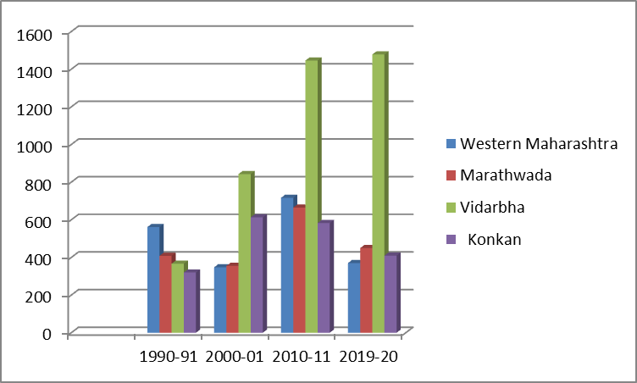
Fig 3: Region-wise Productivity of Black gram in Maharashtra State

Compound Growth Rates of selected Black gram :

Table: 4 Region-wise Performance of Black gram in Maharashtra
 |  | Region
Period | Particular | Western Maharashtra | Marathwada | Vidarbha | Konkan | Maharashtra
Period-I  (2000-2010) | Area | -1.32 | -5.95** | -8.21** | 1.18 | -5.79**
Period-I  (2000-2010) | Production | -0.89 | -10.23 | -13.93** | 5.25 | -8.16*
Period-I  (2000-2010) | Productivity | 0.44 | -7.90* | -0.96 | -0.6 | -2.51
Period-II  (2011-2019) | Area | 1.62 | -1.45 | -6.77* | -6.03** | -2.42
Period-II  (2011-2019) | Production | -7.81** | -7.58 | -11.02 | -12.52** | -8.90
Period-II  (2011-2019) | Productivity | -7.59 | -6.23 | -9.70 | -5.59 | -6.69
Overall Period (2000-2019) | Area | -0.19 | -0.69 | -7.05** | -3.42** | -3.83**
Overall Period (2000-2019) | Production | -2.57* | -4.69 | -7.42** | -6.41** | -4.51**
Overall Period (2000-2019) | Productivity | -0.69 | -0.33 | -5.09** | -4.59* | -0.69
Note: * & ** indicate significance at 5 and 1 % level respectively
It is revealed from table 4 that, the area, production and productivity of Black gram was almost stagnant in Western Maharashtra and Marathwada highly negative growth rate. On the other hand, the compound growth rates for area, production and productivity for Vidarbha and Konkan regions were negative and significant. It indicates that the area, production and productivity were decreased over a period of time. Similar results were obtained for Maharashtra State for the overall period (2000- 2019).
Region-wise Co-efficient of Variation of Black gram in Maharashtra:
The coefficient of variation technique was employed to examine the extent of instability area, production and productivity of black gram in the Vidarbha region
Table: 5 Co-efficient of Variation of Black Gram in Maharashtra
 |  | Region
Period |  | Western Maharashtra | Marathwada | Vidarbha | Konkan | Maharashtra
Period-I  (2000-01 to 2009-10) | Area | 12.09 | 24.61 | 26.74 | 7.43 | 20.37
Period-I  (2000-01 to 2009-10) | Production | 27.21 | 53.14 | 51.11 | 19.91 | 39.01
Period-I  (2000-01 to 2009-10) | Productivity | 18.71 | 37.01 | 22.34 | 17.79 | 23.40
Period-II  (2010-11 to 2019-20) | Area | 15.92 | 38.24 | 34.69 | 23.13 | 16.52
Period-II  (2010-11 to 2019-20) | Production | 34.48 | 59.34 | 62.17 | 47.00 | 45.72
Period-II  (2010-11 to 2019-20) | Productivity | 63.06 | 35.58 | 57.52 | 44.55 | 33.29
Overall Period (2000-01 to 2019-20) | Area | 14.92 | 37.29 | 45.04 | 23.24 | 27.51
Overall Period (2000-01 to 2019-20) | Production | 31.05 | 55.79 | 60.94 | 41.02 | 43.50
Overall Period (2000-01 to 2019-20) | Productivity | 48.81 | 37.17 | 41.89 | 34.02 | 28.92

Table 5 indicates that the overall period of coefficient variation of Black gram area was highest(45.04%) in Vidarbha followed by (39.29%) in Marathwada. In Maharashtra, it was 27.51 per cent. In the case of productivity highest coefficient of variation was observed in Vidarbha(60.94%) followed by Marathwada(55.79%). In concern of productivity at the overall period western Maharashtra exhibits the highest coefficient of Vidarbha(48.84%) followed by Vidarbha(41.89%) from the production, productivity performance is formal to be consistent.

Varietal status of Black gram varieties:

The important Black gram varieties released by Dr.PDKV, Akola since its establishment are presented in Table 6.
Table: 6 Varieties developed by Dr PDKV, Akola in Pulses Research Unit

S.N. | Variety | Year of Release | Place
1 | TAU 1 | 1985 | Maharashtra State, Madhya Pradesh, Andhra Pradesh, Karnataka, Rajasthan, West Bengal and Tamilnadu & also spread in all over India
2 | PKV Udid 15(AKU 15) | 2007 | Maharashtra State
3 | PDKV Blackgold(AKU 10-1) | 2016 | Maharashtra State, Madhya Pradesh

The Black gram variety viz., TAU 1 was released in the year 1985. TAU 1, variety is very popular amongst the farmers in earlier periods & also the current era. This variety is cultivated in all the states of India. Seeds are generally bold and black in colour bold seed and wider adoptability. It is moderately resistant to powdery mildew and blight. It is mostly adopted in states like Maharashtra State, Madhya Pradesh, Andhra Pradesh, Karnataka and Chhattisgarh. It gives 8 -10 quintal per hectare yield.
University alone is unable to supply the huge demand for seed. The MAHABEEJ, Akola and NSC, Pune selling the seeds to farmers from 2000 onwards.
Economic Impact of Black Gram Varieties:
The Black Gram TAU 1 variety was released from the year 1985 onwards. However, the majority and prominent varieties of Black gram were released after 1985.

Table: 7 Economic Impact of University released Black gram variety TAU 1
(2019-20)
S.N | Debit Side |  | Credit Side
 | Particular | Cost  (Rs/ha) | Particular | Cost  (Rs/ha)
 | A. Item of added expenditure due to cultivation of improved variety of Black gram (TAU 1). |  | C. Reduced cost(or savings) due to cultivation of University released variety
1 | Additional total Human Labour Cost | 152.88
2 | Additional total Bullock Labour cost | -416.14
3 | Additional total Machine Labours cost | 129.69
4 | Additional total Seed Cost | -143.30
 | Additional Manure Cost | -59.66
5 | Additional Fertilizers Cost | 249.53
6 | Additional Irrigation Charges | 0.00
7 | Additional Bio-fertilizers/Micronutrient | 0.00
8 | Additional Plant Protection | 179.06
 | Total additional cost | 91.96 | Total saving due to cultivation of University Released Variety | 0
11 | Opportunity cost of capital @ 6 % per annum for 6 month | 2.76
12 | Management cost @ 5 % | 4.60
13 | Risk premium @ 5 % | 4.60 | Added returns from university Released variety 2.95 qtl. Added Main produce @ 4991.33/-/qtls. | 14724.42
14 | Research Cost Per ha. | 12.32
15 | Extension cost per ha. | 0.06
 | Total additional cost due to cultivation of Black gram | 116.30
 | B. Reduced returns due to cultivation of Improved Black gram (TAU 1) variety | 0.00
 | Total debit side | 116.30 | Total Credit Side | 14724.42
Economic Impact of University released Black gram Production technology over other competing variety of Black gram : 14724.42 – 116.30 = 14608.12 |  |  |  | 14608.12

It is noted from Table 7 that the total additional cost (Direct + Indirect) of university-released varieties over other competing varieties was observed to be Rs. 116.30 per ha. However the reduced costs (or savings) and added returns due to University released varieties over other competing varieties was Rs. 14724.42 ha. Thus, the total economic worthiness of the University released Black gram production technology over other competing varieties of Black gram in the region was Rs 14608.12 per ha.
Upscaling the Economic Impact of Black gram:
Table: 8 Upscaling the economic Impact of Black gram Variety TAU 1 covering
the area of adoption

S.N. | Economic impact of University released Black gram varieties | Cost (Rs.)
1 | Probability performance of TAU-1 variety | 0.82
2 | Rate of adoption of Black gram variety | 0.84
3 | Depreciation of technology (if 1, No depreciation) | 1.00
4 | Economic worthiness of the University released variety per ha | 14608.12
5 | Economic impact of University released variety per ha | 10062.07
6 | Area adopted under University released Black gram Variety TAU-1 upto 2019-20(Ha) | 58560.75
7 | Total Economic Impact(Rs. In Crores) for the year 2019-20 | 58.92

These implicitly capture the operation of the LDMR since the field conditions are not akin to the lab conditions and the farmer is different from the researcher. The upscaling of the economic impact of Black gram research is presented in Table 8. Accordingly, the ultimate economic impact of Black gram per hectare works out to 14608.12 X 1.00 X 0.84 X 0.82 = 10062.07. The area under University released Black gram varieties for the year 2019-20 was 58560.75 ha. So, the Total Economic Impact on the farming community in Maharashtra state was Rs. 58.92 crores for the year 2019-20.
Economic impact of Black gram varieties in India (Maharashtra + Other state)
The economic impact of Black gram varieties for 15 years (from Year 2005-06 to 2019-20) has been estimated and presented in Table 9.

Table 9: Economic impact of Black gram TAU 1 variety in India
(Maharashtra + Other state)
Sr.  No. | Year | Gross Gain (R/ha) | Net Gain (Rs/ha) | Area  (MS+OS)  (ha) | Net Economic Impact  (Crores) | Gross Economic Impact (Crores)
1 | 2005-06 | 13505.74 | 3295.04 | 77643.00 | 25.58 | 104.86
2 | 2006-07 | 14923.47 | 3640.93 | 210510.00 | 76.65 | 314.15
3 | 2007-08 | 16203.55 | 3953.23 | 75042.00 | 29.67 | 121.59
4 | 2008-09 | 18044.04 | 4402.27 | 102627.00 | 45.18 | 185.18
5 | 2009-10 | 20957.08 | 5112.97 | 93357.00 | 47.73 | 195.65
6 | 2010-11 | 23285.64 | 5681.08 | 106651.71 | 60.59 | 248.35
7 | 2011-12 | 25393.28 | 6195.29 | 119357.28 | 73.95 | 303.09
8 | 2012-13 | 28277.60 | 6898.98 | 120871.08 | 83.39 | 341.79
9 | 2013-14 | 31988.23 | 7804.28 | 61981.20 | 48.37 | 198.27
10 | 2014-15 | 34359.00 | 8382.68 | 85369.95 | 71.56 | 293.32
11 | 2015-16 | 36015.73 | 8786.88 | 112595.67 | 98.94 | 405.52
12 | 2016-17 | 37594.70 | 9172.11 | 131560.74 | 120.67 | 494.60
13 | 2017-18 | 38479.74 | 9388.03 | 84227.67 | 79.07 | 324.11
14 | 2018-19 | 39345.33 | 9599.21 | 60382.98 | 57.96 | 237.58
15 | 2019-20 | 41242.49 | 10062.07 | 58560.75 | 58.92 | 241.52
Total Economic Impact of Black gram for 15 Years |  |  |  |  | 952.65 | 3904.72

The gross and net gain from University varieties for the year 2019-20 over check variety has been deflated on the basis of the Consumer Price Index (CPI). It is noted from the table that the gross and net economic impact of Black gram varieties on the farming community in Maharashtra state for 15 years was Rs 3904.72 crores and ` Rs. 952.65 crores.
The data on actual seed sales of Black gram variety from different agencies was not available. Hence, the data under the University Black gram varieties was estimated on the basis of breeder seed produced by the University. Breeder seed was converted into foundation and certified seed.
Conclusions
The Agriculture sector is an important contributor to the economic and social well-being of a country. By recognizing this fact, it was felt necessary to take up a study on the Impact Assessment of Black gram Variety released by Dr.PDKV, Akola. The results that emerged from the present study are summarized in the following conclusion.

- Maharashtra state ranks second(29.82%) in black gram, and it ranks fourth in area and production.
- Maharashtra state ranks ninth for productivity of black gram in India
- The area, production and productivity declined during the last 20 years in all regions and the State as a whole.
- The total economic worthiness of university-released black gram production technology over other competing varieties of black gram in the region was Rs.14608.12 per hectare i.e. the Net Economic Impact to the farming community was Rs. 58.92 crores for Udid in the year 2019-20.
- The area under University released black gram variety for the year 2019-20 was 58560.75 hectares.
It is concluded that the farmers earned a gross economic benefit of Rs.3904.72 crores from fifteen years from Dr. PDKV, Akola released of TAU 1. It is therefore recommended that the government should provide substantial funds to the University for further Research and Extension of their verities for the benefit of the farming community. As per the demand of farmers, it is need to increase the seed production of TAU1 varieties of black gram.

Disclaimer (Artificial intelligence)
Option 1:
Author(s) hereby declare that NO generative AI technologies such as Large Language Models (ChatGPT, COPILOT, etc.) and text-to-image generators have been used during the writing or editing of this manuscript.
Option 2:
Author(s) hereby declare that generative AI technologies such as Large Language Models, etc. have been used during the writing or editing of manuscripts. This explanation will include the name, version, model, and source of the generative AI technology and as well as all input prompts provided to the generative AI technology
Details of the AI usage are given below:
1.
2.
3.

References:
Boehlije, M.D., & Eidman, V.R. (1985). Farm Management- An overview of farm business analysis. American Journal of Agricultural Economics, 67(2), 446-447
Kharif Pulses Prospects -2020-21, DPD, Bhopal.
Pokharkar, V.G., C.M. Gulave & D.B. Yadav 2018. Economic impact of pomegranate research and extension on farm economy. Indian Journal of Economics and Development. 14(3), 497-503.
Report: Pulses India: an India pulses and Grains Association Publication, www.ipga.co.in,
Vol. IV, Issue 02: July – Sept. 2019.
Suresh, K., & Chandrakant, M.G. (2015). Total factor productivity and returns to
investments in Ragi (Finger millets) crop research in Karnataka state, India.
Indian Journal of Economics and Development. 3(3), 199-205.
www.mahaagri.com
Chavhan, L. P., Gote, G. N., Mane, R. B., Kadam, Y. E., & Aundhkar, P. S. A. M. (2024). Assessment of suitable thermal sensitive varieties of black gram at Parbhani Maharashtra. International Journal of Research in Agronomy, 7(10), 592-595.
Kumar, K., & Kumar, R. (2022). Effect of different dates of sowing on growth, yield attributes and yield of various cultivars of Kharif blackgram (Vigna mungo L.) under Amritsar conditions. Agricultural Science Digest-A Research Journal, 42(1), 84-87.
Prasanthi , S., & Kumar , K. N. R. (2023). Factors Affecting the Adoption of Blackgram Variety LBG-752 in Krishna District of Andhra Pradesh. Asian Journal of Agricultural Extension, Economics & Sociology, 41(6), 125–130. https://doi.org/10.9734/ajaees/2023/v41i61929
Dhandapani, M., Chitra, S., Sangeetha , M., Geethanjali, S., Shanmugam , A., Navamaniraj , K. N., & Subrahmaniyan, K. (2023). Source-Sink Alterations in Rice Fallow Adaptive Blackgram Variety ADT3 for Enhancement of Yield and Quality of Seed. International Journal of Environment and Climate Change, 13(6), 194–202. https://doi.org/10.9734/ijecc/2023/v13i61815
Swaminathan, C., Surya, R., Subramanian, E., & Arunachalam, P. (2023). Challenges in pulses productivity and agronomic opportunities for enhancing growth and yield in blackgram [Vigna mungo (L.) Hepper]: a review. Legume Research-An International Journal, 46(1), 1-9.
Directorate of Economics and Statistics (DES), Ministry of Agriculture and Farmers Welfare (DAC&FW), Government of India. (2019-20). Retrieved from https://desagri.gov.in/session-year/2019-20/

