Exploration and Characterization of Native Rhizobacteria from Saline Soils of Brebes, Indonesia for Growth Promotion of *Allium ascalonicum* L.

.

ABSTRACT

|  |
| --- |
| **Aims:** The present study was design to investigated the potential of rhizosphere bacteria as plant growth-promoting rhizobacteria (PGPR) to enhance shallot growth in salinity-affected soils. The focus objectives were to identify and characterized bacterial isolates capable of producing indole-3-acetic acid (IAA), solubilizing phosphate, and tolerating high salinity levels.  **Study design:** The experiment was carried out in a survey method combined with purposive sampling.  **Place and Duration of Study:** Soil samples were collected from a coastal agricultural area in Brebes Regency, Central Java, Indonesia. Laboratory analyses were conducted between August and December 2024 at the Microbiology Laboratory and the Integrated Research Laboratory, Faculty of Biology, Jenderal Soedirman University, and Laboratory of the Agricultural Instrument Standardization Center, Bogor, Indonesia.  **Methodology:** Rhizosphere soil samples were collected from the root zone using purposive sampling and cultured on selective media. The selected isolates were then subjected to salinity tolerance testing, phosphate solubilization, indole-3-acetic acid (IAA) production, siderophore production, and nitrogen fixation assays.  **Results:** The highest indole-3-acetic acid (IAA) production was recorded in isolate KL1K2, while the greatest phosphate solubilization activity was exhibited by isolate KL3ASH1. Nitrogen fixation ability was observed in isolates KL1K2, KL4ASH3, K4K1, K4P1, K4RZ3, K4RZ6, K3RZ1, K3IS4, and KL3ASH1. Additionally, siderophore production was detected in isolates KL1K2, K3RZ1, K4RZ3, K4P1, and KL4ASH3.  **Conclusion:** Among all tested isolates, KL3ASH1 and K3IS4 met all selection criteria and exhibited stable nitrogenase activity. These strains are promising candidates for bio-inoculant development, particularly for improving crop productivity in saline soil environments. |

*Keywords: Shallot, PGPR, IAA, phosphate solubilization, saline soil, sustainable agriculture.*

1. INTRODUCTION

Shallots (*Allium ascalonicum* L.) were a vital horticultural commodity in many developing countries, including Indonesia. In Indonesia, shallots were not only essential for culinary use but also designated as a national strategic crop due to their significant contributions to both the agro-economy and socio-economy (Saptana et al., 2021). Despite their importance, shallot production had been facing serious challenges. According to data from BPS Brebes (2024), shallot’s production declined from 384,448.2 tons in 2022 to 289,942 tons in 2023, with a cultivated area of 26,331 hectares and productivity of 11.99 tons per hectare. This downward trend was projected to continue in the following years, primarily due to factors such as reduced cultivated land caused by prolonged drought, climate change, and land-use conversion.

At the same time, national demand for shallots reached approximately 795,000 tons per year for household consumption alone (Badan Pangan Nasional, 2023). However, the sustainability of shallot production was increasingly threatened by several problems, including land degradation and the presence of unfit agricultural land near coastal areas, which were characterized by high salt concentrations. These challenges were further compounded by climate change, which altered precipitation patterns and intensified drought and seawater intrusion. Salinity stress adversely affected plant physiology, leading to reduced water uptake, inhibition of nutrient absorption, and, consequently, decreased crop productivity. The sensitivity of shallots to these abiotic stressors had been well-documented, often resulting in substantial yield reductions, as evidenced by research conducted by Trisnaningsih et al. (2023). The impact of soil salinity on shallot growth and yield served as a salient example of this vulnerability.

Traditionally, farmers have relied on synthetic chemical fertilizers to enhance crop productivity. While these inputs can yield immediate gains, their prolonged utilization frequently results in deleterious effects such as soil acidification, nutrient imbalances, and a decline in soil microbial diversity (Hendarto et al., 2021). The escalating costs of agrochemicals impose financial constraints on small-scale farmers, while environmental concerns surrounding groundwater contamination and greenhouse gas emissions underscore the need for more sustainable agricultural practices.

In this context, plant growth-promoting rhizobacteria (PGPR) have emerged as a promising eco-friendly alternative. PGPR are beneficial soil microorganisms that colonize plant roots and enhance plant growth. These bacteria facilitate plant growth through various mechanisms, including increasing the availability of essential nutrients like nitrogen (N), phosphorus (P), and potassium (K) (Amalia et al., 2025). These microbial traits enhance nutrient availability and help plants better tolerate abiotic stress, such as salinity. This makes PGPR a potential tool for sustainable shallot cultivation under changing climatic conditions.

Previous studies on PGPR have largely focused on isolates obtained from non-saline environments or relied on commercial microbial strains, which may not be well-adapted to saline soils or specific agro ecological conditions found in Indonesia (Egamberdieva et al., 2017). There remains a significant knowledge gap regarding the potential of native PGPR strains isolated from saline soils, particularly in key shallot-producing regions such as Brebes, Central Java, Indonesia.

The objective of this study was to explore, investigate, and characterize local rhizosphere bacterial isolates from shallots that had the potential to act as plant growth-promoting rhizobacteria (PGPR). These isolates exhibited key traits such as indole-3-acetic acid (IAA) production, phosphate solubilization, nitrogen fixation, and siderophore production, which could contribute to enhancing shallot growth under saline soil conditions.

2. METHODOLOGY

**2.1 Study Site and Sampling Method**

This study was conducted between August and December 2024 in the coastal agricultural area of Brebes Regency, Central Java, Indonesia, a region known for shallot cultivation under saline soil conditions. Soil samples were collected from four distinct sampling sites: 6°48'19.8"S 109°03'11.3"E; 6°48'33.9"S 109°03'04.1"E; 6°48'46.2"S 109°02'34.2"E; and 6°48'43.2"S 109°01'55.4"E. Rhizosphere soil was collected from the root zone (10–15 cm depth) of healthy shallot plants using purposive sampling. Rhizosphere soil samples were collected from the root zone (10–15 cm depth) of healthy shallot plants using purposive sampling. During sampling, *in situ* measurements of soil parameters were done, including soil pH, moisture content, and temperature, using portable sensors (Tool Planet EZ9908 COM-600). Soil electrical conductivity (EC) was measured later in the laboratory using a digital EC meter (Modification from Joshi et al., 2021). Laboratory analyses were conducted at the Microbiology Laboratory and the Integrated Research Laboratory, Faculty of Biology, Jenderal Soedirman University, and Laboratory of the Agricultural Instrument Standardization Center, Bogor, Indonesia.

**2.2 Isolation of Rhizobacteria**

Rhizobacteria were isolated using serial dilution and spread plate techniques. One gram of sample rhizosphere soil was suspended in 9 mL of sterile distilled water and serially diluted up to 10⁻⁶. Each dilution was plated onto three different media: (1) Nutrient Agar (Himedia, India) supplemented with NaCl (5 ms/cm) (Merck, Germany) to select for halotolerant bacteria, (2) Yeast Mannitol Agar (Himedia, India) with Congo Red to isolate *Rhizobium*, and (3) Yeast Mannitol Agar (Himedia, India) with Ashby’s medium to isolate *Azotobacter*. Plates were incubated at room temperature (~28°C) for 3–7 days. Distinct colonies were purified through repeated quadrant streaking and maintained as pure cultures (Modification from Joshi et al., 2021).

**2.3 Salinity Tolerance Test**

To assess the salinity tolerance of the bacterial isolates, cultures were inoculated into Nutrient Broth (Himedia, India) supplemented with NaCl (Merck, Germany) at concentrations of 3%, 7%, and 8% (w/v). The cultures were incubated under static conditions at room temperature (~28°C) for 72 hours. Bacterial growth was evaluated both visually and quantitatively by measuring optical density at 600 nm using a UV-Vis spectrophotometer (DLab SP-UV1000) (Manshur et al., 2020).

**2.4 Phosphate Solubilization Test**

Qualitative phosphate solubilization was assessed on Pikovskaya’s Agar (Himedia, India) by observing clear halo formation around bacterial colonies after 7 days of incubation. For quantitative analysis, isolates were cultured in 10 mL of Pikovskaya’s Broth (Himedia, India) and incubated at room temperature (~28°C) for 7 days under shaking conditions. After incubation, cultures were centrifuged using high-speed refrigerated centrifuge (Hitachi himac CR 21G GII), and the soluble phosphate content in the supernatant was determined using the molybdenum blue method. Briefly, 1 mL of the supernatant was mixed with ammonium molybdate and stannous chloride reagents, and the absorbance was measured using UV-Vis spectrophotometer (DLab SP-UV1000) at 693 nm. Phosphate concentration was calculated using a KH₂PO₄ standard curve (Amri et al., 2023; Larasati, 2018).

**2.5 Indole-3-Acetic Acid (IAA) Production Test**

Isolates were cultured in Nutrient Broth (Himedia, India) supplemented with 0.2% L-tryptophan (Merck, Germany) and incubated at room temperature for 48 hours under shaking conditions. 1 mL of the supernatant was mixed with 2 mL of Salkowski reagent (Merck, Germany) and incubated in the dark room for 30 minutes. The development of a pink coloration indicated the presence of IAA, which was quantified by measuring absorbance at 530 nm using a UV-Vis spectrophotometer (DLab SP-UV1000). IAA concentrations were determined using a standard curve (Amalia et al., 2020).

**2.6 Siderophore Production Test**

Siderophore production was qualitatively assessed using Chrome Azurol S (CAS) Agar (Himedia, India). Bacterial cultures were spot-inoculated onto the medium and incubated at room temperature (~28°C) for 3 days. The appearance of orange or yellow halos around the colonies indicated positive siderophore production (Agunbiade et al., 2024).

**2.7 Nitrogen Fixation Ability Test**

Isolates were streaked onto Nitrogen-Free Bromthymol Blue (NfB) agar (Merck, Germany; Himedia, India) and incubated for 7 days. Visible growth on NfB medium indicated the potential for atmospheric nitrogen fixation. Nitrogenase activity was quantified using the Acetylene Reduction Assay (ARA). Bacterial isolates were inoculated into tubes containing nitrogen-free liquid medium (NfB broth) and incubated at room temperature (~28°C) for 48 hours. Following incubation, 10% of the headspace in each tube was replaced with acetylene gas (C₂H₂), and the tubes were sealed tightly and further incubated for 24 hours. The production of ethylene (C₂H₄), resulting from the reduction of acetylene by the nitrogenase enzyme, was measured using gas chromatography (GC) (Thermo Fisher Scientific, US). Nitrogen fixation activity was expressed as μmol C₂H₄/mL/h (Montes-Luz et al., 2023).

3. results and discussion

3.1 Physicochemical Characteristics

Table 1. Physicochemical properties of shallot rhizosphere soils in Kaliwlingi, Brebes Regency

|  |  |  |  |  |
| --- | --- | --- | --- | --- |
| Sampling site | Temperature  (oC) | pH | Moisture (%) | Electrical conductivity/EC (mS/cm) |
| 1 | 25 ± 0 | 7.9 ± 0.1 | 45 ± 0 | 5 ± 1 |
| 2 | 34.5 ± 1.9 | 6.8 ± 0.5 | 50 ± 1 | 4 ± 0.5 |
| 3 | 34.5 ± 1.9 | 7.5 ± 0.2 | 50 ± 1 | 4 ± 0.29 |
| 4 | 28 ± 3.6 | 8 ± 2.5 | 49 ± 2.5 | 5 ± 2.7 |

*Sampling site (1, 2, 3, 4) indicating the sampling distance (km) from the shoreline; values are mean ± S.D.*

The physicochemical characteristics of shallot rhizosphere soil from four sampling sites are presented in Table 1. Soil temperatures ranged from 25°C to 34.5°C, reflecting microclimatic variation typical of coastal agricultural zones. These temperatures fall within the tolerance range for mesophilic soil bacteria, including many plant growth-promoting rhizobacteria (PGPR) (Glick, 2012). However, Site 2 was excluded from further analysis due to its neutral pH, indicating non-saline soil conditions.

The observed variations in soil temperature and moisture across the four sampling sites can be attributed to coastal microclimatic factors and land surface characteristics. The relatively lower soil temperature at site 1, which is closest to the shoreline, is likely due to the sea breeze effect, where cooler, moisture-laden air from the ocean suppresses surface heating near the coast (Stull, 2015). Additionally, the high heat capacity of seawater allows it to absorb heat more slowly and release it gradually, further moderating the temperature of adjacent land areas (Xu et al., 2025). However, despite the lower temperature, soil moisture at site 1 remained low due to its sandy texture and coarse structure, which results in reduced water-holding capacity and faster evaporation (Liu et al., 2022). In contrast, site 4, located further inland, also exhibited low temperature but comparatively higher moisture retention, which may be influenced by increased vegetation cover. Plant canopy in inland zones buffers temperature fluctuations and promotes soil moisture through evapotranspiration and shading effects (Zhao et al., 2022).

The pH values ranged from 7.5 to 8.0, indicating slightly to moderately alkaline conditions. Soil pH significantly affects nutrient solubility and microbial community structure. Alkaline soils tend to reduce the availability of phosphorus and micronutrients, thereby enhancing the ecological relevance of phosphate-solubilizing bacteria (Nautiyal, 1999). Furthermore, some PGPR strains are well adapted to alkaline environments and remain metabolically active under such conditions (Egamberdieva et al., 2017).

Soil moisture content was relatively stable (45–50%) across the sites, suggesting suitable water availability for microbial metabolism and root-associated interactions (Cappuccino & Sherman, 2014). Electrical conductivity (EC) values ranged from 4 to 5 mS/cm, classifying the soil as moderately saline according to USDA salinity standards. Soils with EC >4 mS/cm can hinder plant growth and affect microbial viability. However, salinity-tolerant PGPR can thrive under such stress and even contribute to alleviating salt-induced damage in host plants (Upadhyay et al., 2011). Therefore, the rhizosphere environment in this site provides an appropriate ecological context for isolating halotolerant PGPR with potential application in salinity-stressed agricultural systems.

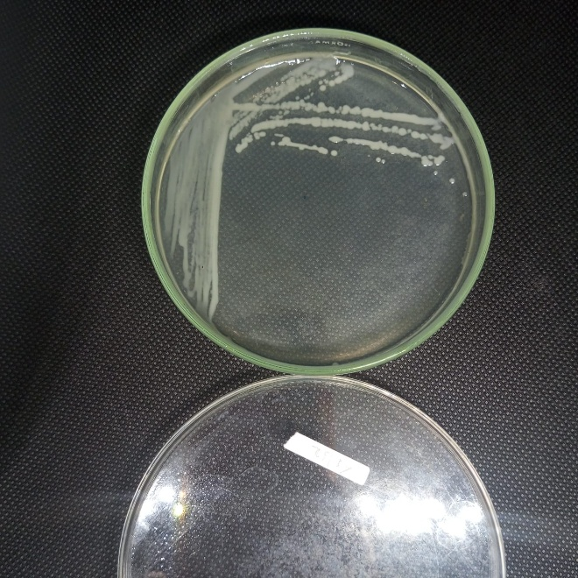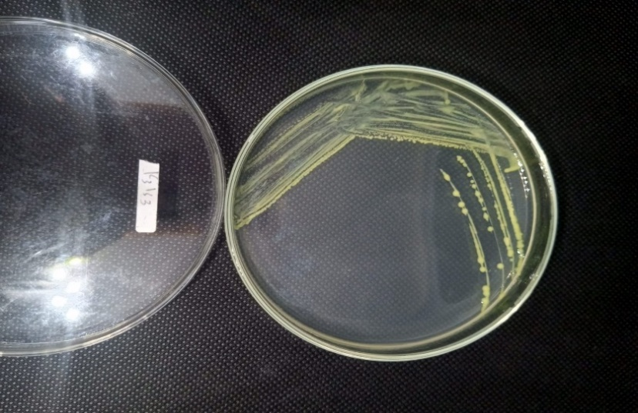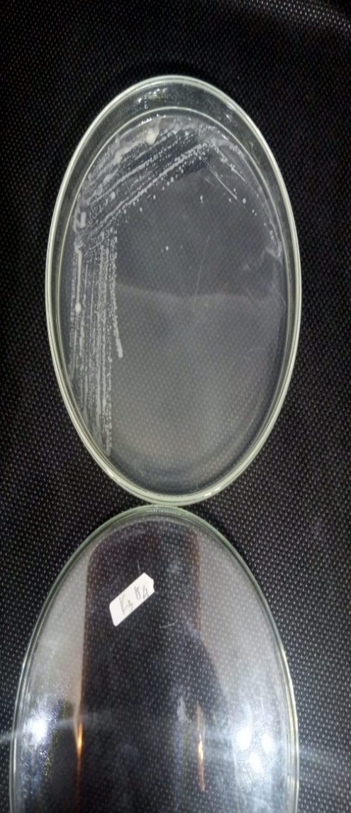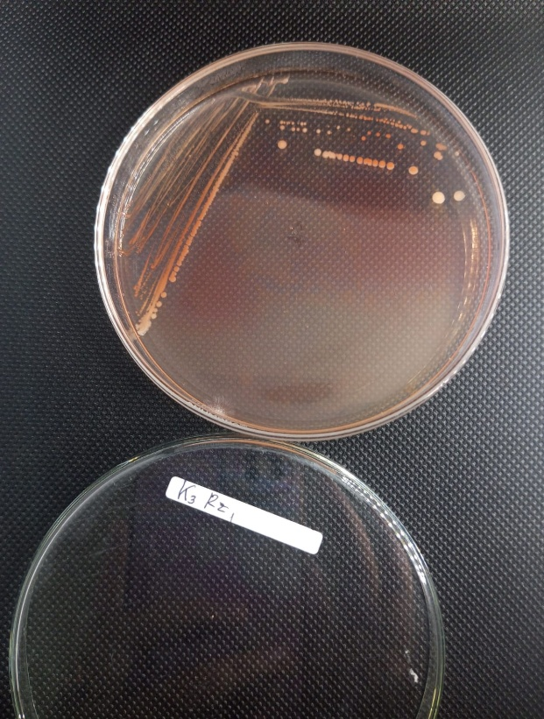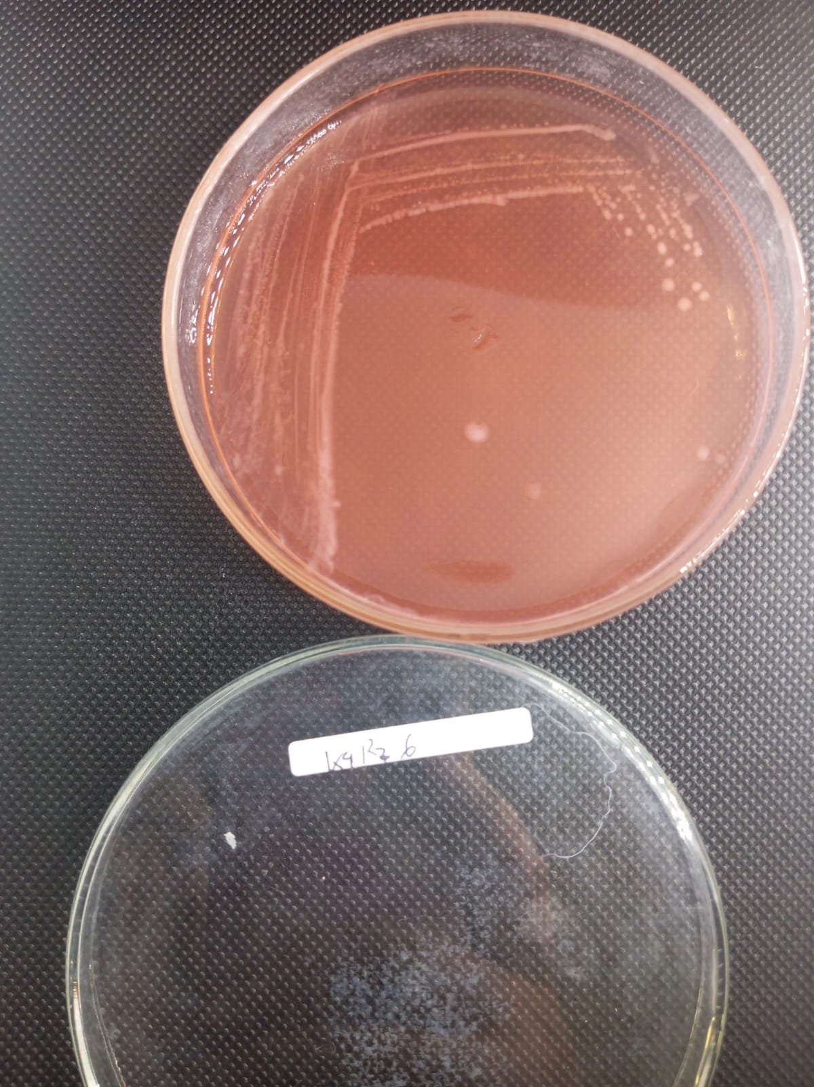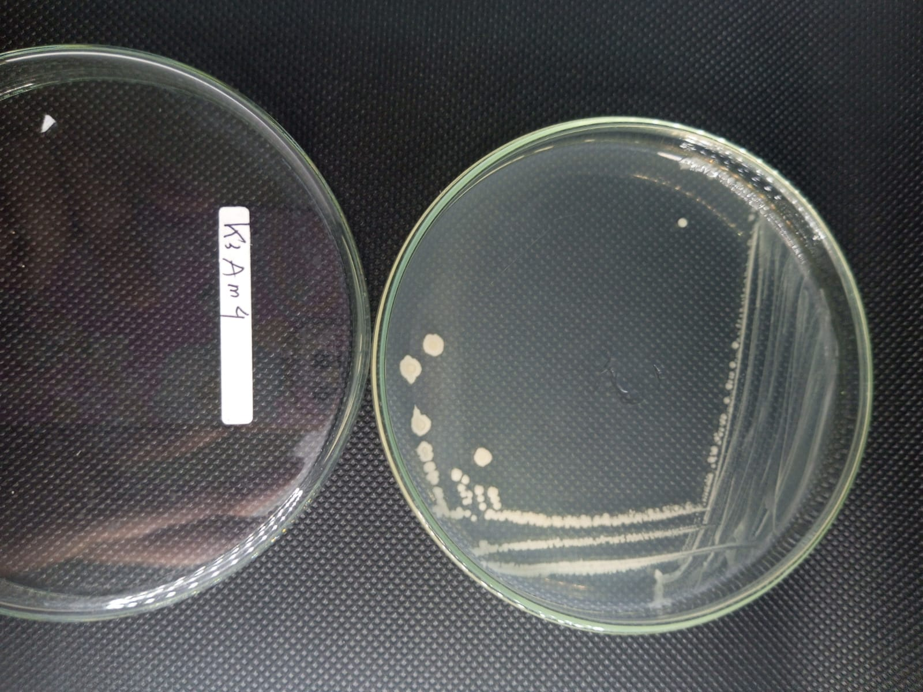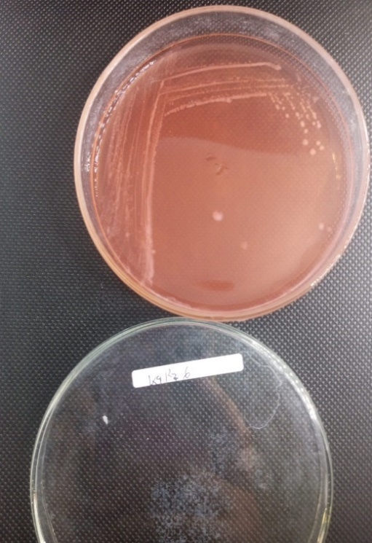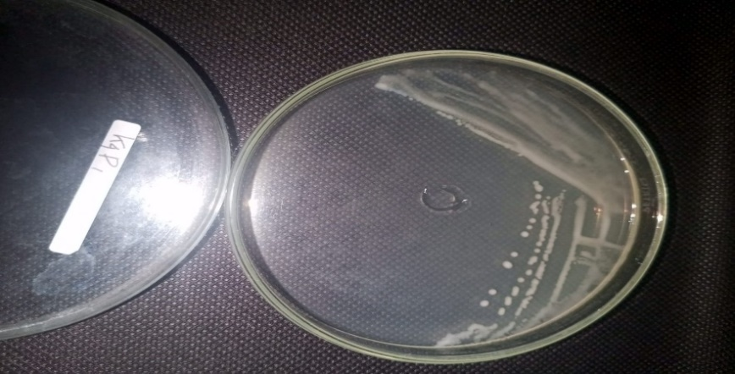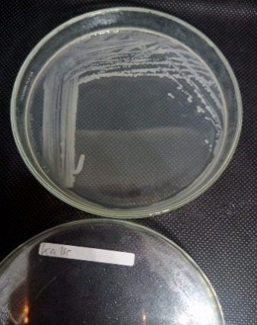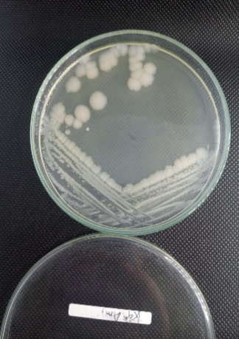

e

c

b

a

d

i

j

h

g

f

**Figure 1. Morphological appearance of bacterial isolates: (a) KL1K2; (b) KL3ASH1; (c) K3IS4; (d) K3RZ1; (e) K4RZ6; (f) K4K6; (g) K4RZ3; (h) K4P1; (i) K4K1; (j) KL4ASH3.**

**3.2 Salinity Tolerance Test**

Table 2.  Salinity tolerance test of selected isolates

|  |  |  |  |  |
| --- | --- | --- | --- | --- |
| Isolate code | Sampling site | NaCl tolerance level | | |
| 3% | 5% | 8% |
| KL1K2 | 1 | + | - | - |
| KL3ASH1 | 3 | + | + | + |
| K3IS4 | 3 | + | + | + |
| K3RZ1 | 3 | + | + | + |
| K4RZ6 | 4 | + | + | + |
| K4K6 | 4 | + | + | + |
| K4RZ3 | 4 | + | + | + |
| K4P1 | 4 | + | + | + |
| K4K1 | 4 | + | + | + |
| KL4ASH3 | 4 | + | + | + |

*+: indicates bacterial growth at 3%, 5%, or 8% NaCl; –: indicates no growth*

Salt tolerance testing was performed to evaluate the ability of bacterial isolates to grow under salinity conditions, specifically at elevated NaCl concentrations (3%, 7%, and 8%). All isolates showed growth ability at 3% NaCl, indicating baseline tolerance to low salinity. However, only isolate KL1K2 failed to grow at 7% and 8%, while the remaining nine isolates continued to grow even at higher salt concentrations. This result suggests that most of the isolates exhibit strong salinity tolerance and have potential for application in soils with moderate to high salinity levels.

High salinity creates osmotic stress that inhibits the growth of non-halotolerant microbes. However, certain PGPR are physiologically adapted through mechanisms such as exopolysaccharide production, osmolyte regulation (e.g., proline or glycine betaine), and stabilization of enzyme function under hyperosmotic conditions (Nguyen et al., 2019; Szymańska et al., 2020). These adaptations allow the bacteria to remain active and continue supporting plant growth under salt stress. The ability of the isolates to survive up to 8% NaCl indicates that most bacteria isolated from shallot rhizosphere in coastal areas are already adapted to extreme abiotic stress, including salinity. This tolerance is a key criterion for selecting PGPR candidates suitable for use in marginal lands, such as coastal and tidal zones that are increasingly affected by climate change (Mansour et al., 2021). The failure of KL1K2 to grow at 7–8% NaCl suggests a limited salinity tolerance, possibly due to differences in cell membrane structure or an inability to efficiently synthesize osmoprotective compounds (Ali et al., 2020).

**3.3 Phosphate Solubilization**

**Fig. 1. Phosphate solubilization capacity of selected isolates**

All isolates exhibited the ability to solubilize inorganic phosphate, with values ranging from 4.49 to 16.05 ppm. Isolate KL3ASH1 recorded the highest solubilization activity (16.05 ppm), followed by K4K6 (11.67 ppm), while several others fell within the moderate range of 6–8 ppm. Phosphate solubilization is one of the key mechanisms by which PGPR enhance phosphorus availability for plants. In many soils, phosphate exists in insoluble forms that cannot be directly absorbed by plant roots. Phosphate-solubilizing bacteria (PSB) produce organic acids such as gluconic and citric acid, which reduce local pH and release phosphate ions from their bound forms (Sharma et al., 2013; Zaidi et al., 2016).

The high solubilization value observed in KL3ASH1 indicates strong potential for improving phosphate fertilization efficiency in saline soils, which typically have lower available phosphorus due to precipitation with calcium and magnesium ions (Chen et al., 2021). Nonetheless, isolates with moderate solubilizing activity remain functionally relevant, as phosphate availability in the rhizosphere is also influenced by environmental interactions and microbial dynamics (Alori et al., 2017). The combination of phosphate-solubilizing ability and salt tolerance is a critical factor in selecting promising PGPR strains. While some isolates may not exhibit the highest solubilization levels, their ability to grow under high salinity and maintain functional activity still makes them worthy of further evaluation in plant-based assays.

**3.4 IAA (indole-3-acetic acid) Production Assay**

**Fig. 2. IAA production of selected isolates**

All isolates demonstrated the ability to produce IAA in the range of 1.25 to 2.01 mg/L. The highest production was recorded in isolate KL1K2 (2.01 mg/L), followed by others that generally ranged between 1.56 and 1.90 mg/L. IAA is a key phytohormone from the auxin group that plays an important role in promoting root elongation, cell division, and vascular tissue development in plants (Spaepen et al., 2014). IAA production by PGPR is known to enhance nutrient and water uptake, especially under abiotic stress such as salinity (Arora & Ramawat, 2017).

Although KL1K2 produced the highest level of IAA, it did not tolerate high salinity (7–8% NaCl). This indicates that high IAA production does not necessarily correlate with stress tolerance. In fact, excessive IAA levels may be counterproductive, as too much auxin can inhibit root growth and lead to hormonal imbalance in plants (Vacheron et al., 2013; Remans et al., 2014). Therefore, isolates that produce moderate but stable levels of IAA under stress conditions are more suitable as potential PGPR candidates.

In this study, most isolates produced IAA at concentrations considered optimal for promoting plant growth without inducing adverse effects. This confirms that the isolates from shallot rhizosphere in saline soils of Kaliwlingi, Brebes Regency are not only physiologically active but also hold strong potential for application in sustainable agriculture systems.

**3.5 Nitrogen Fixation Ability and Siderophore Production**

**Table 3. Nitrogen fixation ability and siderophore production of selected isolates**

|  |  |  |
| --- | --- | --- |
| Isolates Code | Nitrogen Fixation | Siderophore Ability |
| KL1K2 | + | + |
| KL3ASH1 | + | + |
| K3IS4 | - | + |
| K3RZ1 | + | + |
| K4RZ6 | + | - |
| K4K6 | - | - |
| K4RZ3 | + | + |
| K4P1 | + | + |
| K4K1 | + | + |
| KL4ASH3 | + | + |

*+: indicates bacterial growth at 3%, 5%, or 8% NaCl; –: indicates no growth*

Qualitative nitrogen fixation was evaluated using nitrogen-free bromothymol blue (Nfb) medium, where eight out of ten isolates demonstrated visible growth. The isolates showing positive results on Nfb were KL1K2, KL3ASH1, K3IS4, K3RZ1, K4RZ6, K4RZ3, K4P1, and KL4ASH3. In contrast, isolates K4K1 and K4K6 did not grow, indicating the absence of biological nitrogen fixation ability. Nitrogen fixation is a key trait of PGPR, particularly relevant for improving soil fertility in the absence of synthetic nitrogen inputs. Nitrogen-fixing bacteria convert atmospheric nitrogen into ammonia, a form readily taken up by plants. This trait is especially valuable in marginal environments such as saline soils, where fertilizer efficiency is often reduced and input costs are high (Rilling et al., 2020).

Siderophore production was assessed using Chrome Azurol S (CAS) medium. Most isolates produced siderophores, except for K4K1, K4K6, K4RZ3, and KL4ASH3. Siderophores enhance iron availability in the rhizosphere, particularly under Fe-deficient conditions such as alkaline and saline soils. In addition, they contribute to biological control by limiting iron access to soilborne pathogens through competitive mechanisms (Ahmed & Holmström, 2014; Sharma et al., 2021).

Two isolates, KL3ASH1 and K3IS4, demonstrated outstanding performance, meeting all the observed PGPR criteria, including nitrogen fixation, phosphate solubilization, IAA production, high salinity tolerance, and siderophore synthesis. These isolates were therefore selected for further evaluation using the Acetylene Reduction Assay (ARA) to quantify their nitrogen-fixing capacity more accurately (Jha & Subramanian, 2014).

**Fig. 3. Nitrogenase activity of two selected isolate**

Nitrogenase activity was assessed using the Acetylene Reduction Assay (ARA) on two selected isolates, KL3ASH1 and K3IS4, as both fulfilled all major PGPR criteria. The results indicated that KL3ASH1 exhibited the highest nitrogenase activity at 0.069 μmol C₂H₄/mL/h, while K3IS4 recorded an activity of 0.044 μmol C₂H₄/mL/h.

ARA is a widely used indirect quantitative method for measuring biological nitrogen fixation, based on the enzymatic reduction of acetylene (C₂H₂) to ethylene (C₂H₄) by nitrogenase (Das, S. & De, T. K. (2018); Jha & Subramanian, 2014). Higher ARA values indicate greater potential for atmospheric nitrogen fixation. The activities observed in both isolates are considered moderate but stable, suggesting their suitability for field application, particularly in saline soils, which are often nitrogen-deficient.

Moreover, the presence of complementary traits such as phosphate solubilization, IAA production, and salinity tolerance further supports the multifunctional potential of these isolates as effective PGPR (Bhattacharyya et al., 2020).

4. Conclusion

Ten bacterial isolates from the shallot rhizosphere in saline soil were successfully characterized. Most isolates exhibited tolerance to up to 8% NaCl concentration and demonstrated multiple plant growth-promoting traits, including indole-3-acetic acid (IAA) production (1.26–2.01 mg/L), phosphate solubilization (4.49–16.05 ppm), nitrogen fixation, and siderophore production. Among them, isolates KL3ASH1 and K3IS4 emerged as the most promising candidates, fulfilling all selection criteria and showing stable nitrogenase activity. These isolates hold potential for development as bio-inoculants for sustainable crop production in saline-affected agricultural systems.

AcknowledgEments

This research was supported by the Indonesia Education Fund Management Institution (*Lembaga Pengelola Dana Pendidikan*, LPDP), Ministry of Finance, Republic of Indonesia. The authors express their sincere gratitude for the funding and support provided.

**COMPETING INTERESTS**

Authors have declared that no competing interests exist.

**AUTHOR’S CONTRIBUTION**

DALA conceptualized the study, responsible for sample collection, laboratory experiment, data acquisition, and write the rough draft, OO and SA supervised the entire research process, MNA contributed to preparation of figures, write and formatting the manuscript. All authors reviewed, revised, and approved the final version of the manuscript.

References

Agunbiade, V.F., Fadiji, A.E., Agbodjato, N.A. & Babalola, O.O. (2024). Isolation and Characterization of Plant-Growth-Promoting, Drought-Tolerant Rhizobacteria for Improved Maize Productivity. *Plants*, 13(10), 1298.

Ahmed, E. and Holmström, S.J.M. (2014). Siderophores in environmental research: Roles and applications. Microbial Biotechnology, 7(3), 196–208. <https://doi.org/10.1111/1751-7915.12117>.

Ali, S., Rizwan, M., Arif, M.S. & Ibrahim, M. (2020). Biological strategies for salinity stress alleviation in crop plants: Recent advances. Plant Physiology and Biochemistry, 155, 661–674. <https://doi.org/10.1016/j.plaphy.2020.07.023>.

Alori, E.T., Glick, B.R. & Babalola, O.O. (2017). Microbial phosphorus solubilization and its potential for use in sustainable agriculture. Frontiers in Microbiology, 8, 971. https://doi.org/10.3389/fmicb.2017.00971.

Amalia, D. A. L., A’yun, S. H. Q., Ardian, M. N., & Purwanto, P. (2025). Potential of Rhizospheric Bacteria for Increasing Growth and Yield of Shallots (*Allium ascalonicum* L.) in Saline Soil. BIO Web of Conferences,158, 03026. EDP Sciences.

Amalia, D.A.L., Oedjijono, O. & Purwanto, P. (2020). Eksplorasi Bakteri Diazotrof dari Rizosfer Tanaman Bawah Merah (Allium ascalonicum L.) di Brebes, Jawa Tengah. BioEksakta: Jurnal Ilmiah Biologi Unsoed, 2(3), 464-478.

Amri, M., Rjeibi, M.R., Gatrouni, M., Mateus, D.M., Asses, N., Pinho, H.J. and Abbes, C. (2023). Isolation, identification, and characterization of phosphate-solubilizing bacteria from Tunisian soils. Microorganisms, 11(3), 783.

Arora, N.K. and Ramawat, N. (2017). Plant growth-promoting rhizobacteria for sustainable agriculture. In: N.K. Arora, ed. Plant Microbe Symbiosis: Fundamentals and Advances. Singapore: Springer, 63–75. <https://doi.org/10.1007/978-981-10-1459-0_4>.

Badan Pangan Nasional. (2023). Optimalisasi peningkatan produksi bawang merah, Badan Pangan Nasional dukung ekspor dan bangun ekosistem hulu sampai hilir. <https://badanpangan.go.id/blog/post/optimalisasi-peningkatan-produksi-bawang-merah-badan-pangan-nasional-dukung-ekspor-dan-bangun-ekosistem-hulu-sampai-hilir>.

Badan Pusat Statistik Kabupaten Brebes. (2024). Produksi tanaman sayuran dan buah-buahan semusim menurut jenis tanaman di Kabupaten Brebes tahun 2023. <https://brebeskab.bps.go.id/id/statistics-table/3/VFV4MmQxaG9kakZrVUdWeEx6aDFUMnN6WmpocVp6MDkjMw==/produksi-tanaman-sayuran-dan-buah---buahan-semusim-menurut-jenis-tanaman-di-kabupaten-brebes--2024.html>.

Bhattacharyya, P.N., Korir, H. and Singh, A. (2020). Advances in PGPR-mediated management of soil nutrients and plant health under abiotic stress conditions. Rhizosphere, 13, 100192. <https://doi.org/10.1016/j.rhisph.2019.100192>.

Cappuccino, J. G., & Sherman, N. (2014). Microbiology: A Laboratory Manual (10th ed.). Pearson Education.

Chen, H., Qin, W., Ma, L. and Huang, J. (2021). Phosphate-solubilizing microorganisms in saline-alkaline soil: Characteristics, mechanisms, and application. Agronomy, 11(8), 1614. <https://doi.org/10.3390/agronomy11081614>.

Das, S., & De, T. K. (2018). Microbial assay of N2 fixation rate, a simple alternate for acetylene reduction assay. MethodsX, *5*, 909–914. https://doi.org/10.1016/j.mex.2017.11.010.

Egamberdieva, D., Wirth, S. J., Shurigin, V. V., Hashem, A., & Abd Allah, E. F. (2017). Endophytic bacteria improve plant growth, symbiotic performance of chickpea (*Cicer arietinum* L.) and induce suppression of root rot caused by Fusarium solani under salt stress. Frontiers in Microbiology, 8, 1887.

Glick, B.R. (2012). Plant growth‐promoting bacteria: mechanisms and applications. Scientifica, 2012(1), 963401.

Hendarto, K., Widagdo, S., Ramadiana, S. & Meliana, F.S. (2021). Pengaruh pemberian dosis pupuk NPK dan jenis pupuk hayati terhadap pertumbuhan dan produksi tanaman bawang merah (*Allium ascalonicum* L.). Jurnal Agrotropika, 20(2), 110.

Jha, P.N. & Subramanian, R.B. (2014). PGPR regulating the functional expression of plant genes related to stress resistance: Current status and future prospects. In: D.K. Maheshwari, ed. Bacteria in Agrobiology: Stress Management. Berlin, Heidelberg: Springer, 291–307. <https://doi.org/10.1007/978-3-642-37596-0_15>.

Joshi, G., Kumar, V. and Brahmachari, S.K. (2021). Screening and identification of novel halotolerant bacterial strains and assessment for insoluble phosphate solubilization and IAA production. Bulletin of the National Research Centre, 45(1), 83.

Larasati, E. D., Rukmi, M. I., Kusdiyantini, E., & Ginting, R. C. B. (2018). Isolasi dan identifikasi bakteri pelarut fosfat dari tanah gambut. Bioma: Berkala Ilmiah Biologi, 20(1), 1-8.

Liu, Y., Guo, Y., Long, L., & Lei, S. (2022). Soil water behavior of sandy soils under semiarid conditions in the Shendong mining area (China). Water, 14(14), 2159.

Manshur, T.A., Fauzan, I.A. & Junianti, E. (2020). Indole Acetic Acid (IAA) Producing Bacteria from Saline Paddy Soil in Kebumen. IOP Conference Series: Earth and Environmental Science, 593 (1), 012006. IOP Publishing.

Mansour, M.M.F., Ali, E.F. & Hasanuzzaman, M. (2021). Salinity stress and root microbiome: Understanding crosstalk and biotechnological applications. Plant Physiology and Biochemistry, 167, 462–472. <https://doi.org/10.1016/j.plaphy.2021.08.004>.

Montes-Luz, B., Conrado, A. C., Ellingsen, J. K., Monteiro, R. A.,de Souza, E. M., & Stacey, G. (2023). Acetylene reduction assay: Ameasure of nitrogenase activity in plants and bacteria. Current Protocols, 3, 766.

Nautiyal, C.S. 1999. An efficient microbiological growth medium for screening phosphate solubilizing microorganisms. FEMS microbiology Letters, 170(1), 265-270.

Nguyen, H.T., Lim, Y.J., Lee, J.Y. & Lee, C.H. (2019). Salinity stress tolerance in rhizobacteria: Mechanisms and biotechnological applications. Journal of Microbiology and Biotechnology, 29(7), 955–964. <https://doi.org/10.4014/jmb.1902.02011>.

Remans, R., Beebe, S., Blair, M., Manrique, G., Tovar, E., Rao, I.M. et al. (2014). Physiological and genetic analysis of root responsiveness to auxin-producing plant growth-promoting bacteria in common bean (*Phaseolus vulgaris* L.). Plant and Soil, 365, 175–190. <https://doi.org/10.1007/s11104-012-1343-3>.

Rilling, J.I., Acuña, J.J., Sadowsky, M.J. & Jorquera, M.A., (2020). Putative nitrogen-fixing bacteria associated with the rhizosphere and root endosphere of crop plants. Biology and Fertility of Soils, 56, 491–502. <https://doi.org/10.1007/s00374-020-01428-0>.

Saptana, Gunawan, E., Perwita, A. D., Sukmaya, S. G., Darwis, V., Ariningsih, E., & Ashari. (2021). The competitiveness analysis of shallot in Indonesia: A Policy Analysis Matrix. Plos one, 16(9), e0256832.

Sharma, A., Shankhdhar, D. and Shankhdhar, S.C. (2021). Plant growth promoting microbes for sustainable food production. Frontiers in Microbiology, 12, 697974. <https://doi.org/10.3389/fmicb.2021.697974>.

Sharma, S.B., Sayyed, R.Z., Trivedi, M.H. & Gobi, T.A. (2013). Phosphate solubilizing microbes: Sustainable approach for managing phosphorus deficiency in agricultural soils. SpringerPlus, 2, 587. <https://doi.org/10.1186/2193-1801-2-587>.

Spaepen, S., Vanderleyden, J. & Remans, R. (2014). Indole-3-acetic acid in microbial and microorganism-plant signaling. FEMS Microbiology Reviews, 38(4), 509–530.<https://doi.org/10.1111/1574-6976.12044>.

Stull, R. B. (2015). Practical meteorology: an algebra-based survey of atmospheric science. University of British Columbia.

Szymańska, S., Płociniczak, T. & Piotrowska-Seget, Z. (2020). Adaptation of soil bacteria to salinity stress by osmoprotectant production and its role in plant growth promotion. Applied Soil Ecology, 147, 103365. <https://doi.org/10.1016/j.apsoil.2019.103365>.

Trisnaningsih, U., Sidik, J., & Saleh, I. (2023). The Response of Shallot (*Allium ascalonicum*) to Salinity Stress. Jurnal Agrosci, 1(2), 86-93.

Upadhyay, S.K., Singh, J.S. & Singh, D.P. (2011). Exopolysaccharide-producing plant growth-promoting rhizobacteria under salinity condition. Pedosphere, 21(2), 214-222.

Vacheron, J., Desbrosses, G., Bouffaud, M.L., Touraine, B., Moënne-Loccoz, Y., Muller, D. et al. 2013. Plant growth-promoting rhizobacteria and root system functioning. Frontiers in Plant Science, 4, 356. <https://doi.org/10.3389/fpls.2013.00356>.

Xu, X., Yu, X., Wu, J., Xiao, K., & Xin, P. (2025). Tidal influences on temperature dynamics and heat exchange in coastal wetlands. Water Resources Research, 61(2), e2024WR038374.

Zaidi, A., Khan, M.S., Ahemad, M., Oves, M. & Wani, P.A. (2016). Recent advances in plant growth promotion by phosphate-solubilizing microbes. In: D.P. Singh, H.B. Singh & R. Prabha, eds. Microbial strategies for crop improvement. Cham: Springer, 23–50. <https://doi.org/10.1007/978-3-662-49370-0_2>.

Zhao, X., Rivera-Monroy, V. H., Li, C., Vargas-Lopez, I. A., Rohli, R. V., Xue, Z. G., et al. (2022). Temperature across vegetation canopy-water-soil interfaces is modulated by hydroperiod and extreme weather in coastal wetlands. Frontiers in Marine Science, 9, 852901.