**Original Research Article**

**Synthesis of Eco-friendly Silver Nanoparticles (AgNPs) by *Lacticaseibacillus rhamnosus* for Combating Antibiotic Resistance and Boosting Antioxidant Activity.**

**Abstract:**  
Antimicrobial resistance (AMR) is an imperative global health threat, prompting the need to design novel therapeutic options. In this work, silver nanoparticles (AgNPs) were biosynthesised from *Lacticaseibacillus rhamnosus* using a green synthesis method. Characterisation was ensured by a colour change visible to the naked eye and a UV–Visible absorption maximum at 429 nm. The antimicrobial activity of the biosynthesised AgNPs (AgNPs-LR) was tested against standard and multidrug-resistant (MDR) strains of bacteria through agar well diffusion and MIC assays. The findings showed potent, dose-dependent antibacterial potential, with clear zones of inhibition recorded in Escherichia coli (ESBL, 19 mm) and Klebsiella pneumoniae (MDR, 17 mm) at 150 µL. MIC analysis showed high sensitivity in *E. coli* and *Pseudomonas aeruginosa* ATCC strains (MIC <2 µg/mL), whereas Serratia marcescens and *K. pneumoniae* (MDR) were inhibited at ≤8 µg/mL, validating the broad-spectrum potential of AgNPs-LR, especially against Gram-negative and MDR pathogens. Gram-positive strains manifested variable resistance, suggesting the necessity for further optimisation of formulation. Moreover, AgNPs-LR manifested concentration-dependent antioxidant activity in the DPPH radical scavenging assay, exhibiting comparable performance to ascorbic acid at elevated concentrations. The above findings reinforce the dual functionality of AgNPs-LR as a potent antimicrobial and antioxidant compound, and thus underscore its potential as a viable candidate for the fight against AMR and oxidative stress management in biomedical applications

**Keywords:** Antimicrobial resistance, Multidrug Resistance (MDR), Silver nanoparticles, *Lacticaseibacillus rhamnosus*, biosynthesis, antimicrobial activity, antioxidant activity.

**Introduction**

The Centers for Disease Control and Prevention (CDC) and the World Health Organisation (WHO) have named antimicrobial resistance (AMR) as one of the most severe worldwide health threats of the twenty-first century [1]. Such drug resistance in most Gram-negative bacteria, particularly the multidrug-resistant (MDR) pathogens of the family Enterobacteriaceae and Pseudomonas aeruginosa [2] and Gram-positive such as Methicillin-resistant Staphylococcus aureus (MRSA) and Vancomycin-Resistant Enterococci (VRE), is a big public health hazard[3]. Although several antibiotic stewardship programs exist, rational antimicrobial use, together with effective diagnosis and treatment, would help in the battle against drug-resistant infections. The complexity of antimicrobial resistance (AMR) is compounded by limitations in medication development and a lack of new antimicrobial treatments [4]. As commonly used antibiotics become ineffective due to resistance, there is a critical need to explore alternative approaches for treating drug-resistant bacteria. Probiotics, phages, cationic peptides, phytochemicals, nanoparticles, antibodies, predatory bacteria, and endolysins are among the most commonly used alternative ways to combat multidrug resistance. One potential option is nanotechnology, which has recently piqued the interest of academics because of its advantages and benefits in domains such as energy conservation, environmental safety and healthcare [5].

Nanotheranostics is a scientific innovation in nanomedicine that connects nanomaterials and nanotechnology for therapeutic purposes with increased effectiveness [6]. Nanoparticles are commonly used as host-targeting alternatives to antibiotics due to their unique physicochemical features, focused delivery, and lower risk of resistance development. It may also circumvent resistance mechanisms, allowing for an alternate therapy [7]. A lot of research is being done on making metal nanoparticles because they have many bioactive properties, such as antibacterial, antifungal, antiviral, anticancer, antioxidant, and anti-inflammatory [8]. Medicine, food, and the environment extensively employ several metal nanoparticles, including silver (Ag), gold (Au), and zinc (Zn) [9]. Being a popular nanoparticles of their antimicrobial mechanism of silver nanoparticles (AgNPs) is based on four established mechanisms: (1) binding of AgNPs to cell wall and membrane surface, (2) AgNPs entry into cells to cause damage to intracellular structures such as mitochondria, vacuoles, and ribosomes, as well as to essential biomolecules like proteins, lipids, and DNA, (3) induction of cytotoxicity and oxidative stress through the production of ROS and free radicals, and (4) disruption of cellular signal transduction processes. Alongside these main mechanisms, AgNPs also affect the human immune system by regulating inflammatory reactions, further assisting in microbial inhibition.[11]. This property makes them an effective strategy in medicine to combat antibiotic resistance. However, traditional methods of producing AgNPs sometimes use hazardous compounds, raising concerns about their environmental effect and biocompatibility [10].

Green synthesis techniques, especially those using microbes, provide an environmentally acceptable and cost-effective option to generate these nanoparticles using non-toxic chemicals [40]. Silver nanoparticles (AgNPs) offer potent antimicrobial properties, effectively combating drug-resistant pathogens by disrupting cell membranes and inhibiting protein synthesis [12]. Probiotics, particularly lactic acid bacteria (LAB), enhance immune health and have demonstrated effectiveness against multidrug-resistant (MDR) strains [13]. When combined, probiotics can enable the eco-friendly green synthesis of AgNPs, eliminating the reliance on harmful chemicals in nanoparticle production. This synergy enhances the antimicrobial efficacy of AgNPs while providing a safer and more sustainable method for addressing resistant infections, presenting a promising alternative to traditional antibiotics. [14].

This approach makes biological systems safer and more compatible compared to chemically manufactured AgNPs. In addition, they are safer to employ in medical applications, such as wound healing, infection control, and antibacterial agents in healthcare settings [15]. Furthermore, AgNPs may influence the immune system, so improving the body's natural defences against infections [16]. Probiotic-synthesised AgNPs are a novel, natural strategy to combat AMR because they combine AgNPs' antibacterial potency with probiotics' health-promoting qualities [17]. It has been reported that AgNPs made from different LAB strains have antimicrobial properties [18]. In this study, Lactobacillus rhamnosus was utilized for the green synthesis of silver nanoparticles (AgNPs) to assess their antibacterial activity against multidrug-resistant (MDR) pathogens and their antioxidant potential.

**Materials and methods**

1. **Isolation and preliminary identification of *Lacticaseibacillus rhamnosus***

*Lacticaseibacillus rhamnosus*GG (TCC 53103) were purchased as probiotic capsules (VIZYLAC GG Capsule) supplied by several pharmacies in Chennai, India. Transported in sterile plastic bags to prevent contamination. Upon arrival, the capsules were homogenised in 10 mL of sterile peptone water and serially diluted, where 100 μL of 105 dilution is spread on deMan, Rogosa and Sharpe (MRS) agar medium (Hi-Media, India) to promote LAB growth. Colony morphology, biochemicals and carbohydrate fermentation were conducted accordingly following methods as previously mentioned [19].

1. **Synthesis of silver nanoparticles using *Lacticaseibacillus rhamnosus*. (AgNPs-LR)**

The active culture of *L. rhamnosus* was inoculated into fresh MRS media and incubated at 37°C overnight. Following incubation, the grown culture was centrifuged for 10 minutes at 10,000 rpm and 4oC to collect the culture supernatant. Then, culture supernatant (10 mL) was mixed with 0.1 mM silver nitrate solution (90 mL) and incubated at 30oC for 24 hrs in the dark condition. Observations of color change due to AgNPs synthesis after 24 hrs were made accordingly.

1. **UV-visible spectroscopy.**

The UV-Vis spectrum using a SPEC ORD M-400 spectrophotometer was performed, which measured absorbance from 400 to 800 nm and deionised water was used as a blank. The spectra exhibited high peaks at 420 and 450 nm, confirming surface plasmon resonance in silver nanoparticles [20].

4. **Biological applications for AgNPs-LR**

4.1. **Microorganisms and Inoculum Preparations**.

We investigated the antibacterial properties of biosynthesised silver nanoparticles (AgNPs-LR) against laboratory-maintained strains from the Department of Microbiology, University of Madras, both MDR pathogens of Gram-negative and Gram-positive bacteria. Initially, 10 μL of an overnight bacterial culture was transferred into a flask with 20 mL of freshly manufactured Muller Hinton (CA-MH; HiMedia, Mumbai) broth and cultivated in an incubator shaker at 28 °C and 150 rpm for 24 hours. After incubation, the overnight culture was adjusted to 0.5 McFarland standard, which is about 1.5x108 CFU/mL, by adding additional Mueller-Hinton broth.

4.2 **Antimicrobial activity of AgNPs-LR**

The antibacterial efficacy of biosynthesised silver nanoparticles (AgNPs) was assessed using the agar well diffusion technique [23] against a variety of Gram-positive and Gram-negative bacteria, including standard and multidrug-resistant (MDR) strains. *E. coli* ATCC 25922, *Pseudomonas aeruginosa* ATCC 27853, *Staphylococcus aureus* ATCC BAA 1026, *Enterococcus faecalis* ATCC 29212, *Streptococcus pyogenes* MTCC 1927, *Serratia marcescens* ATCC 14756 and MDR strains of *E. coli, Klebsiella pneumoniae* were tested. AgNPs-LR were administered at different concentrations (25, 50, 75, 100, and 150 µL), and the zone of inhibition was assessed to test antibacterial effectiveness using the agar well diffusion method.

4.3. **Determination of minimal inhibitory concentration.**

The minimum inhibitory concentration (MIC) is defined as the lowest concentration of an antimicrobial agent that inhibits visible bacterial growth. MIC determination was performed using the standard microdilution method in a 96-well polystyrene microtiter plate, by CLSI guidelines (2018) [39]. Each well was loaded with 50 μL of Mueller–Hinton Broth (MHB), 75 μL of AgNPs-LR at varying 6 concentrations prepared via two-fold serial dilution, and 75 μL of a 1:75 diluted bacterial suspension. Wells containing only MHB served as negative controls, while wells containing bacterial inoculum without treatment served as positive controls. The plates were incubated at 37 °C for 24 hours. Following incubation, bacterial growth was quantified spectrophotometrically at 630 nm. Subsequently, 10 μL from each well was subcultured onto Mueller–Hinton Agar (MHA) plates and incubated under the same conditions to assess bactericidal activity. The MIC was recorded as the lowest concentration of AgNPs-LR that visibly inhibited bacterial growth, confirming its antibacterial efficacy.

4.4. **Antioxidant activity of biosynthesised AgNPs-LR**

The DPPH-based free radical scavenging test for green-synthesised AgNPs-LR was carried out according to the protocol reported in [24]. Green-synthesised AgNPs (100 μL from concentrations of 20, 40, 60, 80, and 100 μg/mL) were combined with 35 μL of 0.10 mM DPPH (3.94 mg in 100 mL methanol) and incubated at room temperature in the dark for 30 minutes. The DPPH in distilled water without AgNPs-LR served as the blank. The standard antioxidant was ascorbic acid at concentrations of 20, 40, 60, 80, and 100 μg/mL. We determined the absorbance at 517 nm after incubation. DPPH scavenging activity was estimated using the formula (A Control – A Test) / A Control × 100, where A Control represents the control absorbance and A Test represents the test sample absorbance.

**Results and Discussion**

1. **Isolation and Preliminary Identification of *Lacticaseibacillus rhamnosus***

The single bacterial strain showed phenotypic features typical of *Lacticaseibacillus rhamnosus*, as presented in Table 1. The colonies were creamy white, smooth, and round, typical of this species. The microscopic view assured the presence of Gram-positive bacilli, and biochemical tests confirmed catalase and oxidase negativity. The strain showed minimal ammonia production from arginine, reflecting low amino acid catabolism. The isolate was negative for nitrate reductase and urease tests and was non-motile. The carbohydrate fermentation tests were positive for sorbitol, cellobiose, mannose, lactose, galactose, and arabinose, but negative for rhamnose, trehalose, melibiose, and sucrose Table 2. This agrees with earlier reports of *L. rhamnosus* and indicates its promise as a probiotic candidate and biosynthetic agent for nanomaterial synthesis [30,31].

|  |  |
| --- | --- |
| **Test** | **Results** |
| Morphology: Culture and microscopic characteristic | Smooth round, Cream white colonies/ Rod non spore former |
| Gram stain | Positive |
| Catalase test | Negative |
| Oxidase test | Negative |
| NH3 Production from arginine | Negative |
| Motility | Negative |
| H2S Production | Negative |
| Nitrate reduction | Negative |
| Acid and Gas from glucose | Positive |
| Urease test | Negative |

**Table 1: The Cultural, Microscopic, and Biochemical Characterisation of *L. rhamnosus***

|  |  |
| --- | --- |
| **Carbohydrate used** | **Fermentation results** |
| Mannitol | Positive |
| Salicin | Positive |
| Sorbitol | Positive |
| Cellobiose | Positive |
| Mannose | Positive |
| Lactose | Positive |
| Sucrose | Negative |
| Melibiose | Negative |
| Trehalose | Negative |
| Galactose | Positive |
| Arabinose | Positive |
| Rhamnose | Negative |

**Table 2: Carbohydrate utilization test results of *L. rhamnosus***

1. **Biosynthesis of Silver Nanoparticles Using *L. rhamnosus* (AgNPs-LR)**

The silver nanoparticle biosynthesis was demonstrated by a colour change from white to dark brown upon incubation for 24 hours (Figure 1), reflecting the reduction of Ag⁺ to Ag⁰. This is due to bacterial metabolites, such as proteins and organic acids, that serve as reducing and stabilising agents within the medium [22,33]. UV–Visible spectroscopy also testified to the formation of AgNPs with a sharp absorption peak at 429 nm (Figure 2), which is within the typical surface plasmon resonance range for silver nanoparticles (420–450 nm). These results are in accordance with existing research on biologically synthesized AgNPs using probiotic strains [30,31,34]. Green synthesis methods of AgNPs has gained momentum due to their lower toxicity and environmental impact compared to similar chemical synthesis techniques [27, 29]. Green synthesis techniques also allow for control over nanoparticle morphology and size, which are important modifiable parameters of AgNPs that contribute to their stability, bioavailability, and biological activity [36].

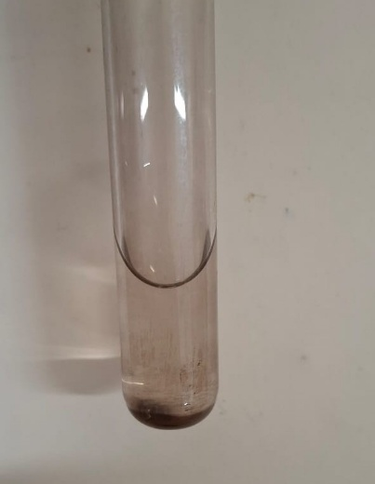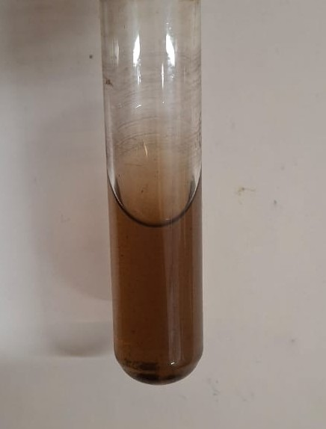

**1. A. Control 1. B. AgNPs-LR**

**Figure 1: 1.A) Control sample of Silver Nanoparticles, 1.B) Biosynthesized silver nanoparticles (AgNPs) using *Lacticaseibacillus rhamnosus*. (AgNPs-LR)**

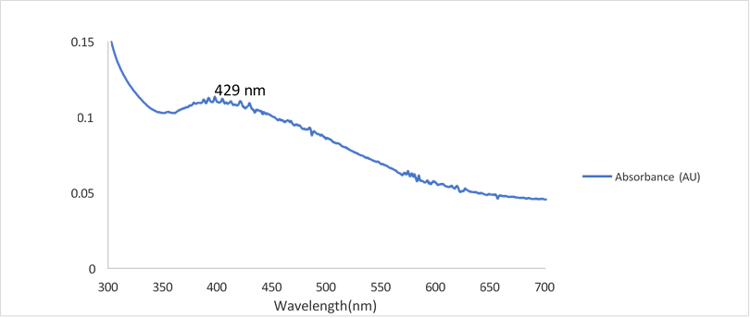

**Figure 2: UV–Visible spectroscopy of AgNPs-LR**

1. **Antimicrobial Activity of AgNPs-LR**

The antimicrobial efficacy of AgNPs-LR was assessed through agar well diffusion and MIC assays. The AgNPs exhibited strong and dose-dependent inhibitory activity against a range of pathogens, particularly Gram-negative and MDR strains (Figure 3). Specifically, Klebsiella pneumoniae (MDR) and Escherichia coli (ESBL) produced the largest zones of inhibition (17 mm and 19mm, respectively) at the highest concentration (150µL), supporting the contention that the AgNPs are effective against those strains. This also supports previous findings that AgNPs are toxic to bacterial membranes and biological matrices by the generation of ROS [38,39]. MIC analysis (Table 3) indicated ATCC strains of E. coli and Pseudomonas aeruginosa were very sensitive, with the MIC concentrations and values being <2, whereas E. coli ESBL and S. aureus were resistant to higher concentrations (or >16 and 4, respectively). Enterococcus faecalis showed resistance at 8, while Serratia marcescens and K. pneumoniae (MDR) were sensitive at ≤8 µg/mL.

These findings support previous studies that observed a particularly effective action by AgNPs against Gram-negative bacteria, possibly due to the much thinner layer of peptidoglycan that comprises Gram-negative bacterial membranes and facilitates nanoparticle penetration into the bacterial cell [27,29]. Variable activity that was noted against Gram-positive strains suggests there is a need for additional optimization of AgNP/LR nanoparticles toward additional formulations that can offer broad-spectrum effectiveness.

With the increase of antimicrobial resistance (AMR), especially in nosocomial pathogens such as *P. aeruginosa* and *E. coli*, AgNPs provide a promising adjunct or alternative to conventional antibiotics. The multimodal mechanism of action disrupting membranes, inactivating proteins, and inhibiting DNA replication means they are still efficacious against resistant phenotypes [26,28].

|  |  |
| --- | --- |
| Organism | MIC Breakpoint (μg/ml) |
| *E. coli* – ATCC | 2 |
| *E. coli* strain (ESBL) | 16 |
| *Pseudomonas aeruginosa* – ATCC | 2 |
| *Staphylococcus aureus* – ATCC | 4 |
| *Enterococcus faecalis* – ATCC | 8 |
| *Streptococcus pyogenes* – MTCC | 16 |
| *Klebsiella pneumonia* (MDR) | 8 |
| *Serratia marcescens* – ATCC | 8 |

**Table 3: -MIC Results of *AgNPs-LR***

|  |  |  |  |  |  |
| --- | --- | --- | --- | --- | --- |
| Microorganisms | 25 μL | 50 μL | 75 μL | 100 μL | 150 μL |
| E. coli– ATCC | _ | _ | 19mm | 21mm | 23mm |
| Pseudomonas aeruginosa– ATCC | _ | _ | 13mm | 16mm | 18mm |
| Staphylococcus aureus– ATCC | _ | _ | - | - | 11mm |
| Streptococcus pyogenes– MTCC | _ | _ | _ | 13mm | 15mm |
| Enterococcus faecalis– ATCC | _ | _ | _ | 11mm | - |
| Serratia marcescens– ATCC | _ | _ | 8mm | 10mm | - |
| E. coli strain (ESBL) | _ | _ | _ | 19mm | - |
| Klebsiella pneumoniae (MDR) | _ | _ | _ | 13mm | 17mm |

**Table 4: - Zone of inhibition Diameter**

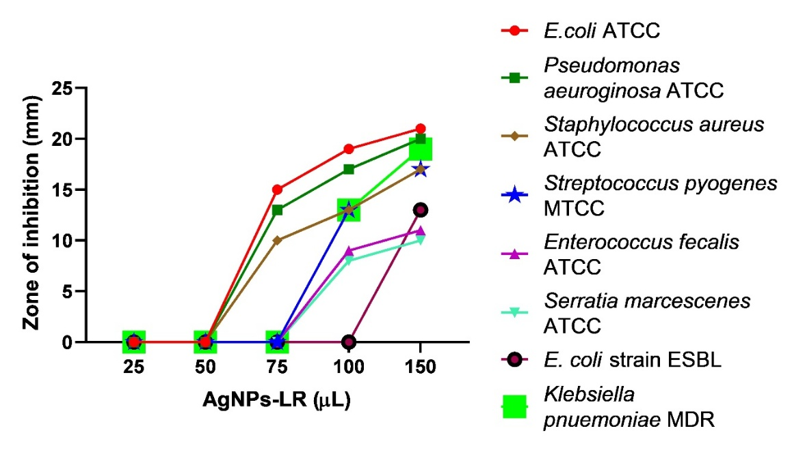

**Figure 3: Antimicrobial activity of AgNPs-LR**

1. **Antioxidant Activity of AgNPs-LR**

The antioxidant activity of biosynthesised AgNPs-LR was determined with the DPPH radical scavenging assay. The data showed a dose-dependent increase in radical scavenging activity, although the antioxidant capacity of AgNPs-LR continued to be lower than that of ascorbic acid (Figure 4). However, the antioxidant capacity observed in these studies further supports AgNPs-LR multi-functionality as agents that may exert both antimicrobial and antioxidant activities. This was consistent with previous findings from Lima et al. [37], who concluded that there was a positive relationship between AgNP concentration and DPPH radical scavenging ability. Such an antioxidant ability may augment the biomedical applications for AgNPs, which provide a protective effect against damage to the cells from oxidative stress, particularly in inflammation, wound healing and cancer therapy [37, 38].

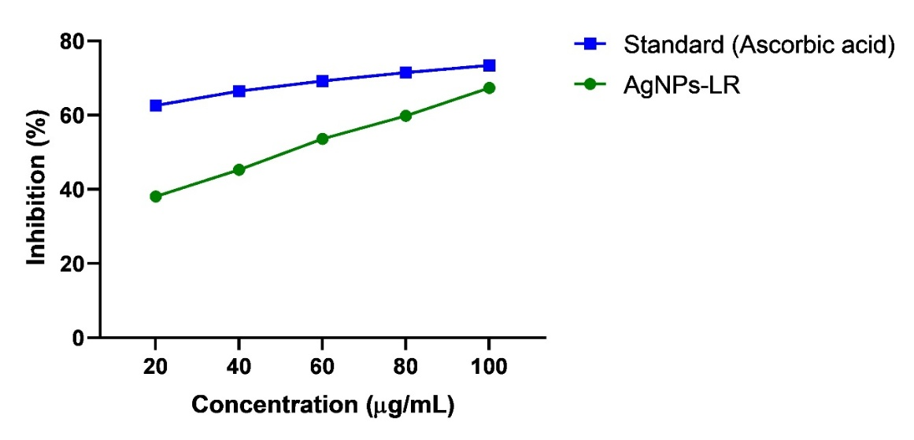

**Figure 4: Antioxidant Activity results of AgNPs-LR**

### Conclusion

The impact of this study is significant in advancing the field of sustainable nanotechnology, particularly in the use of probiotics for the biosynthesis of silver nanoparticles (AgNPs-LR). The successful production of AgNPs-LR using Lacticaseibacillus rhamnosus demonstrates a cost-effective and eco-friendly approach that could reduce the environmental footprint associated with traditional chemical and physical nanoparticle synthesis methods. The antimicrobial and antioxidant properties of the synthesised AgNPs-LR, especially against multidrug-resistant (MDR) bacterial strains, suggest their potential as alternative therapeutic agents, offering a solution to the growing global concern over antibiotic resistance. Furthermore, the findings contribute to the broader understanding of the mechanisms underlying microbial nanoparticle synthesis and its potential applications in fields such as food safety, medicine, and biotechnology. By providing a sustainable method for nanoparticle production, this study paved the way for the development of probiotic-based, biologically synthesised AgNPs-LR in various industrial and medical applications. However, further research is needed to optimise their properties and explore their in vivo efficacy and safety to fully harness their potential.

**COMPETING INTERESTS DISCLAIMER:**

Authors have declared that they have no known competing financial interests OR non-financial interests OR personal relationships that could have appeared to influence the work reported in this paper.

Disclaimer (Artificial intelligence)

Option 1:

Author(s) hereby declare that NO generative AI technologies such as Large Language Models (ChatGPT, COPILOT, etc.) and text-to-image generators have been used during the writing or editing of this manuscript.

Option 2:

Author(s) hereby declare that generative AI technologies such as Large Language Models, etc. have been used during the writing or editing of manuscripts. This explanation will include the name, version, model, and source of the generative AI technology and as well as all input prompts provided to the generative AI technology

Details of the AI usage are given below:

1.

2.

3.

REFERENCE

1. Bertagnolio S, Dobreva Z, Centner CM, Olaru ID, Donà D, Burzo S, Huttner BD, Chaillon A, Gebreselassie N, Wi T, Hasso-Agopsowicz M. WHO global research priorities for antimicrobial resistance in human health. The Lancet Microbe. 2024 Aug 12.
2. El Aila NA, Al Laham NA, Doijad SP, Imirzalioglu C, Mraheil MA. First report of carbapenems encoding multidrug-resistant gram-negative bacteria from a pediatric hospital in Gaza Strip, Palestine. BMC microbiology. 2024 Oct 9;24(1):393.
3. Wang C, Le MN, Kawada-Matsuo M, Hisatsune J, Sugawara Y, Arai C, Nakanishi J, Takeda K, Shiba H, Sugai M, Komatsuzawa H. Ursoricin, a bacteriocin of Streptococcus ursoris, has potent activity against methicillin-resistant Staphylococcus aureus and vancomycin-resistant enterococci. Applied and Environmental Microbiology. 2024 Jun 18;90(6):e00162-24.
4. Ahmed SK, Hussein S, Qurbani K, Ibrahim RH, Fareeq A, Mahmood KA, Mohamed MG. Antimicrobial resistance: impacts, challenges, and future prospects. Journal of Medicine, Surgery, and Public Health. 2024 Apr 1;2:100081.
5. Arshad F, Naikoo GA, Hassan IU, Chava SR, El-Tanani M, Aljabali AA, Tambuwala MM. Bioinspired and green synthesis of silver nanoparticles for medical applications: a green perspective. Applied Biochemistry and Biotechnology. 2024 Jun;196(6):3636-69.
6. Al-Thani AN, Jan AG, Abbas M, Geetha M, Sadasivuni KK. Nanoparticles in cancer theragnostic and drug delivery: A comprehensive review. Life sciences. 2024 Jul 9:122899.
7. Jiang H, Li L, Li Z, Chu X. Metal-based nanoparticles in antibacterial application in biomedical field: Current development and potential mechanisms. Biomedical Microdevices. 2024 Mar;26(1):12.
8. Al-Gheffari HK, Aljahdali SM, Albalawi M, Obidan A, Binothman N, Aljadani M, Aldawood N, Alahmady NF, Alqahtani SS, Alkahtani AM, Allohibi A. Mycogenic Zinc Nanoparticles with Antimicrobial, Antioxidant, Antiviral, Anticancer and anti-Alzheimer Activities Mitigate the Aluminium Toxicity in Mice: Effects on Liver, Kidney, and Brain Health and Growth Performance. Pakistan Veterinary Journal. 2024 Jul 1;44(3).
9. Naseem K, Aziz A, Khan ME, Ali S, Khalid A. Bioinorganic metal nanoparticles and their potential applications as antimicrobial, antioxidant and catalytic agents: a review. Reviews in Inorganic Chemistry. 2024 Apr 8(0).
10. Rodrigues AS, Batista JG, Rodrigues MÁ, Thipe VC, Minarini LA, Lopes PS, Lugão AB. Advances in silver nanoparticles: A comprehensive review on their potential as antimicrobial agents and their mechanisms of action elucidated by proteomics. Frontiers in Microbiology. 2024 Jul 31;15:1440065.
11. Dakal, T. C., Kumar, A., Majumdar, R. S., & Yadav, V. (2016). Mechanistic basis of antimicrobial actions of silver nanoparticles. *Frontiers in microbiology*, *7*, 1831.
12. Do AD, Quang HP, Phan QK. Probiotic cell-free supernatant as effective antimicrobials against Klebsiella pneumoniae and reduce antibiotic resistance development. International Microbiology. 2024 Aug 9:1-0.
13. Nandhini J, Karthikeyan E, Rani EE, Karthikha VS, Sanjana DS, Jeevitha H, Rajeshkumar S, Venugopal V, Priyadharshan A. Advancing engineered approaches for sustainable wound regeneration and repair: harnessing the potential of green synthesized silver nanoparticles. Engineered Regeneration. 2024 Sep 1;5(3):306-25.
14. Karnwal A, Jassim AY, Mohammed AA, Sharma V, Al-Tawaha AR, Sivanesan I. Nanotechnology for Healthcare: Plant-Derived Nanoparticles in Disease Treatment and Regenerative Medicine. Pharmaceuticals. 2024 Dec 18;17(12):1711.
15. Vadakkan K, Rumjit NP, Ngangbam AK, Vijayanand S, Nedumpillil NK. Novel advancements in the sustainable green synthesis approach of silver nanoparticles (AgNPs) for antibacterial therapeutic applications. Coordination Chemistry Reviews. 2024 Jan 15;499:215528.
16. Barua N, Buragohain AK. Therapeutic Potential of Silver Nanoparticles (AgNPs) as an Antimycobacterial Agent: A Comprehensive Review. Antibiotics. 2024 Nov 20;13(11):1106.
17. Vijayaram S, Razafindralambo H, Sun YZ, Piccione G, Multisanti CR, Faggio C. Synergistic interaction of nanoparticles and probiotic delivery: A review. Journal of Fish Diseases. 2024 May;47(5):e13916.
18. Arshad F, Naikoo GA, Hassan IU, Chava SR, El-Tanani M, Aljabali AA, Tambuwala MM. Bioinspired and green synthesis of silver nanoparticles for medical applications: a green perspective. Applied Biochemistry and Biotechnology. 2024 Jun;196(6):3636-69.
19. Zhang J, Li K, Bu X, Cheng S, Duan Z. Characterization of the anti-pathogenic, genomic and phenotypic properties of a Lacticaseibacillus rhamnosus VHProbi M14 isolate. Plos one. 2023 May 15;18(5):e0285480.
20. Huq MA, Khan AA, Alshehri JM, Rahman MS, Balusamy SR, Akter S. Bacterial mediated green synthesis of silver nanoparticles and their antibacterial and antifungal activities against drug-resistant pathogens. Royal Society Open Science. 2023 Oct 25;10(10):230796.
21. Huq MA, Khan AA, Alshehri JM, Rahman MS, Balusamy SR, Akter S. Bacterial mediated green synthesis of silver nanoparticles and their antibacterial and antifungal activities against drug-resistant pathogens. Royal Society Open Science. 2023 Oct 25;10(10):230796.
22. Lavecchia R, García-Martínez JB, Contreras-Ropero JE, Barajas-Solano AF, Zuorro A. Antibacterial and Photocatalytic Applications of Silver Nanoparticles Synthesized from Lacticaseibacillus rhamnosus. International Journal of Molecular Sciences. 2024 Nov 3;25(21):11809.
23. Lima AK, Souza LM, Reis GF, Junior AG, Araújo VH, Santos LC, Silva VR, Chorilli M, Braga HD, Tada DB, Ribeiro JA. Synthesis of silver nanoparticles using extracts from different parts of the Paullinia cupana kunth plant: Characterization and in vitro antimicrobial activity. Pharmaceuticals. 2024 Jul 2;17(7):869.
24. Flieger J, Franus W, Panek R, Szymańska-Chargot M, Flieger W, Flieger M, Kołodziej P. Green synthesis of silver nanoparticles using natural extracts with proven antioxidant activity. Molecules. 2021 Aug 17;26(16):4986.
25. Kalairaj A, Rajendran S, Karthikeyan R, Panda RC, Senthilvelan T. A Comprehensive Review on Preparation of Silver Nanoparticles from a Bacteriocin for the Natural Preservation of Food Products. Applied Biochemistry and Biotechnology. 2024 Dec 2:1-34.
26. Aslam B, Asghar R, Muzammil S, Shafique M, Siddique AB, Khurshid M, Ijaz M, Rasool MH, Chaudhry TH, Aamir A, Baloch Z. AMR and Sustainable Development Goals: at a crossroads. Globalization and Health. 2024 Oct 17;20(1):73.
27. Wahab S, Salman A, Khan Z, Khan S, Krishnaraj C, Yun SI. Metallic nanoparticles: a promising arsenal against antimicrobial resistance—unraveling mechanisms and enhancing medication efficacy. International journal of molecular sciences. 2023 Oct 4;24(19):14897.
28. Yusuf A, Almotairy AR, Henidi H, Alshehri OY, Aldughaim MS. Nanoparticles as drug delivery systems: a review of the implication of nanoparticles’ physicochemical properties on responses in biological systems. Polymers. 2023 Mar 23;15(7):1596.
29. Mba IE, Nweze EI. Nanoparticles as therapeutic options for treating multidrug-resistant bacteria: research progress, challenges, and prospects. World Journal of Microbiology and Biotechnology. 2021 Jun;37:1-30.
30. Singh A, Tyagi S, Mishra A, Verma PK, Kushwaha HR, Singh A. Eco-compatible Synthesis of Metal Nanoparticles Using Bacterial Nanofactories and Their Applications in Optoelectronics and Magnetic Technologies. InMaterials for Electronic, Magnetic, and Spintronic Technologies: Characterization and Applications from Energy Storage to Disease Detection 2024 Aug 13 (pp. 65-89). Cham: Springer Nature Switzerland.
31. Mohammed AA, Hegazy AE, Salah A. Novelty of synergistic and cytotoxicity activities of silver nanoparticles produced by Lactobacillus acidophilus. Applied Nanoscience. 2023 Jan;13(1):633-40.
32. Bisht V, Das B, Hussain A, Kumar V, Navani NK. Understanding of probiotic origin antimicrobial peptides: a sustainable approach ensuring food safety. npj Science of Food. 2024 Sep 19;8(1):67.
33. Zille A, Fernandes MM, Francesko A, Tzanov T, Fernandes M, Oliveira FR, Almeida L, Amorim T, Carneiro N, Esteves MF, Souto AP. Size and aging effects on antimicrobial efficiency of silver nanoparticles coated on polyamide fabrics activated by atmospheric DBD plasma. ACS applied materials & interfaces. 2015 Jul 1;7(25):13731-44.
34. Tiwari A, Ika Krisnawati D, Susilowati E, Mutalik C, Kuo TR. Next-Generation Probiotics and Chronic Diseases: A Review of Current Research and Future Directions. Journal of Agricultural and Food Chemistry. 2024 Nov 26.
35. Abouelela ME, Helmy YA. Next-generation probiotics as novel therapeutics for improving human health: current trends and future perspectives. Microorganisms. 2024 Feb 20;12(3):430.
36. Risal S, Wu C, Wang F, Risal S, Hernandez FC, Zhu W, Yao Y, Fan Z. Silver-carbon interlayers in anode-free solid-state lithium metal batteries: Current development, interfacial issues, and instability challenges. Carbon. 2023 Sep 1;213:118225.
37. Lima AK, Souza LM, Reis GF, Junior AG, Araújo VH, Santos LC, Silva VR, Chorilli M, Braga HD, Tada DB, Ribeiro JA. Synthesis of silver nanoparticles using extracts from different parts of the Paullinia cupana kunth plant: Characterization and in vitro antimicrobial activity. Pharmaceuticals. 2024 Jul 2;17(7):869.
38. Liu S, Zhang D, Chen W, Wang X, Ji H, Fu Y, Lü C. Synthesis, antibacterial activity and action mechanism of silver-based nanomaterials with thermosensitive polymer-decorated graphene oxide as a stable support. Materials Today Communications. 2023 Aug 1;36:106598.
39. Charannya, S., Duraivel, D., Padminee, K., Poorni, S., Nishanthine, C., & Srinivasan, M. R. (2018). Comparative evaluation of antimicrobial efficacy of silver nanoparticles and 2% chlorhexidine gluconate when used alone and in combination assessed using agar diffusion method: an: in vitro: study. *Contemporary clinical dentistry*, *9*(Suppl 2), S204-S209.
40. Farouk, S. M., Abu-Hussien, S. H., Abd-Elhalim, B. T., Mohamed, R. M., Arabe, N. M., Hussain, A. A., ... & Galal, A. (2023). Biosynthesis and characterization of silver nanoparticles from Punica granatum (pomegranate) peel waste and its application to inhibit foodborne pathogens. *Scientific Reports*, *13*(1), 19469.