**A Rare Case of Crouzon Syndrome**

**ABSTRACT**

Background

Crouzon’s syndrome is a rare autosomal dominant genetic disorder caused by mutations in the FGFR2 gene. It leads to craniosynostosis, where the premature fusion of skull bones results in distinct craniofacial abnormalities. Key clinical features include towering skull, hypertelorism, midface hypoplasia, bilateral proptosis and retrognathia. Early diagnosis and intervention are crucial for optimizing patient outcomes.

Case Summary

A 9-year-old girl presented with characteristic craniofacial features of Crouzon’s syndrome, including skull abnormalities, wide-set eyes, and protruding eyes. Additionally, she exhibited ENT complications, such as recurrent sore throat, nasal discharge, tonsillar hypertrophy, and mixed hearing loss. Radiographic findings confirmed cranial abnormalities, and biochemical tests showed altered metabolic markers. Given the positive family history and absence of limb anomalies, the diagnosis was confirmed. Management included antibiotic therapy, symptomatic relief, and a planned adenotonsillectomy surgery to address airway obstruction and improve quality of life.

Conclusion

This case emphasizes the importance of early diagnosis, multidisciplinary intervention, and long-term follow-up in Crouzon’s syndrome. A comprehensive approach enhances both functional and aesthetic outcomes, ultimately improving the patient’s quality of life.

**Keywords:** Crouzon’s Syndrome, Craniosynostosis, FGFR2 Mutation, Craniofacial Abnormalities

**INTRODUCTION**

Crouzon syndrome is a rare genetic disorder characterized by premature closure of cranial sutures, exophthalmos and mid facial hypoplasia. Crouzon syndrome occurs in approximately 1 in 25,000 births world wide and 16.5 per 1,000,000 live births in United States. It makes up approximately 4.8% of all cases of, craniosynostosis, making it the most common syndrome within the craniosynostosis group. It may be transmitted as an autosomal dominant genetic condition or appear as a mutation .No known race or sex predilection exists [1]. The majority of the patients with Crouzon syndrome have mutations in the extracellular immunoglobulin III domain of the Fibroblast Growth Receptors 2(FGFR2) gene [2]. The differential diagnosis of Crouzon syndrome includes Apert syndrome, Pfeiffer, Jackson-Weiss, Carpenter and Saethre-Chotzen syndrome. Crouzon syndrome is distinguishable from other craniosynostosis syndromes by lack of hand and/or foot abnormalities [3]. Multiple staged surgeries are the general treatment plan for patients with Crouzon syndrome [4].

**CASE PRESENTATION**

A 9-year-old girl presented to the pediatric clinic with a chief complaint of recurrent sore throat, fever, cold, intermittent headache since 1month, nasal cavity bleed since 2days, nasal discharge, she also had ear discharge 6months back, partial hearing loss. A detailed family and medical history were collected because the child's appearance and head size were abnormal. The child was born prematurely at 28weeks due to early labor pains; The mother had a Lower Segment Caesarean Section (LSCS) delivery and was the second child from a non-consanguineous marriage. The first female child passed away after 1day of birth. The child was taking no medications and the parents denied any history of allergies. The child was developing normally for her age and all milestones were achieved at the appropriate age.

Developmental Milestones

1. Neck holding at 6-7months
2. Sitting without support at 9 months
3. Walking at18months
4. Monosyllable by 6 months
5. Bi syllables by 9month
6. Toilet indication at 1year

A general head-to-toe examination of the child was done.

It revealed a towering skull with dolichocephaly, long face, high sloping forehead, up slanting palpebral fissure, hypertelorism, midface hypoplasia, bilateral proptosis, retrognathia.

Ear examination

Ear examination revealed that left ear has moderately severe mixed hearing loss and there was a wax in both the ears, patient had no finger abnormalities.

Intraoral examination

Intraoral examination revealed a high arched palate, grade 3 tonsillar hypertrophy.

Nasal examination

Nose examination revealed Bilateral inferior turbinate hypertrophy. History showed that these features began to develop from the birth of the baby and gradually increased in severity over time.

There was no significant positive family history. Given the above findings, radiographs of the skull were taken, showing copper beaten skull, Grade 2 adenoid hypertrophy, CT brain were also taken which was found to be normal.

Other systemic examination was found to be normal. Routine Biochemical tests revealed that there was an decrease in urea levels[4mg/dl], creatinine levels [0.54mg/dl] and uric acid levels [2.82mg/dl] and there was an increase in alkaline phosphate levels[289mg/dl] and globulin levels[3.84mg/dl]and hematological findings were within normal limits.

Based on the above clinical and radiological findings and in the absence of hand and feet anomalies, a diagnosis of Crouzon’s Syndrome was made.

Treatment Plan-

Patient was treated with tablet AMOXYCLAV 375MD/PO/BD, TAB PAN 20MG/PO/OD, TAB PCM 250MG/PO/BD, TAB LEVOCETRIZINE 5MD/PO/HS, NASOCLEAR DROPS 2DROPS TID, SYP AMBROXYL 5ML BD, DEWAX EAR DROPS 3DROPS QID and planned for ADENOTONSILLECTOMY Surgery.

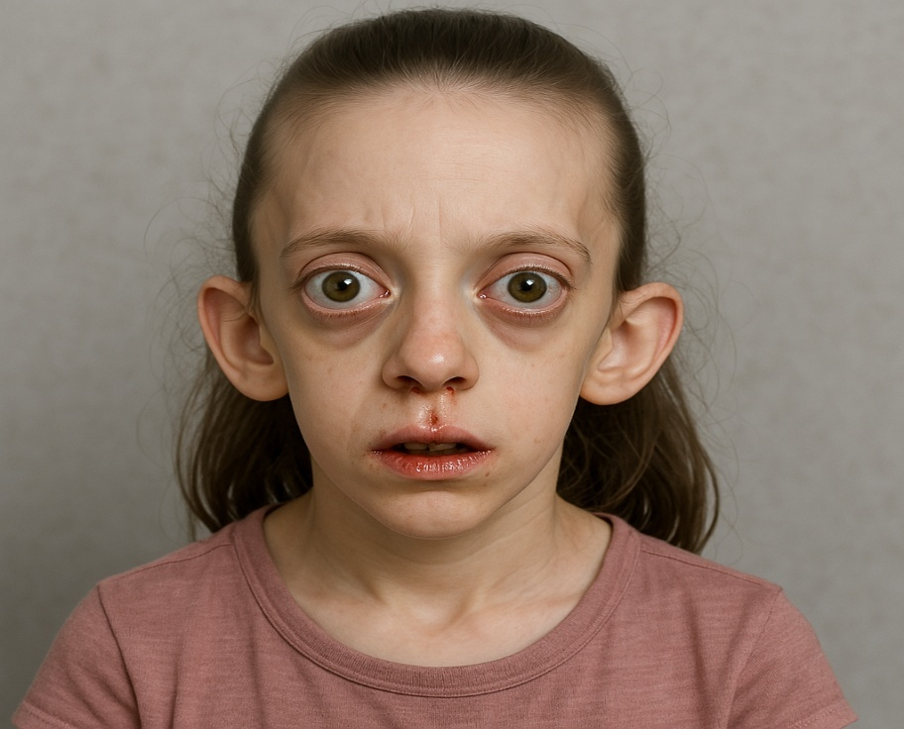

Fig 1: AI generated Image*

**DISCUSSION:**

In 1912, French neurologist Octave Crouzon (1874–1938) reported that a mother and son had a genetic condition called craniofacial synostosis. He defined the trifecta as exophthalmos, facial anomalies, and skull deformities—now referred to as Crouzon syndrome. It is a fully penetrant, autosomal dominant condition with varying expressivity [3]. Mutations in the fibroblast growth factor receptor-2 (FGFR2) gene, which is mapped to chromosome locus 10q25–10q26, are the cause. However, there is locus heterogeneity, with different affected individuals having causal mutations in FGFR-2 (Crouzon syndrome) and FGFR3 (Crouzon syndrome with Acanthosis nigricans) [2]. Shallow orbits, ocular proptosis, orbital hypertelorism, strabismus, papilledema, optic atrophy, exposure keratitis, and vision loss are among the most prevalent ocular disorders. Rare cases of nystagmus, iris coloboma, cataract, ectopia Lentis, blue sclera, glaucoma, luxation of the eye, aniridia, anisocoria, microcornea, and megalocornea have also been reported [3].

The sequence, pace, and development of sutural synostosis determine the degree of craniofacial deformity in Crouzon's syndrome. Typically, craniosynostosis starts in the first year of life and is finished by the time a child is three years old [5]. When a suture is fused, its ability to grow upright is limited. Consequently, compensatory development occurs at the remaining open sutures, leading to aberrant bone formation [6].

Premature craniotomies, exophthalmos (optic disc edema and proptosis), and midface hypoplasia are the three hallmarks of Crouzon's syndrome. Brachycephaly, hypertelorism, divergent squint, cloverleaf skull, nasal septal deviation, wide-beaked curved nose that resembles a parrot's nose, and cleft lip are further craniofacial traits observed [7]. Towering skull with dolichocephaly, long face, high sloping forehead, up slanting palpebral fissure, hypertelorism, midface hypoplasia, bilateral proptosis, retrognathia, left ear has moderately severe mixed hearing loss, arched palate, grade 3 tonsillar hypertrophy, nose examination revealed bilateral inferior turbinate hypertrophy, radiographs of the skull showed copper beaten skull these are the findings were observed in our patient.

The narrow orbit causes exophthalmia. Although the height of the palate is normal by measurement, maxillary hypoplasia causes the anterior posterior dimension of the upper arch and the breadth of the dental arch to decrease, producing the impression of a strongly arched palate [3]. Crowding of the teeth, crossbite, anterior open bite, and cleft palate are further intraoral symptoms.

Symptoms of the central nervous system include conductive hearing impairment, headache, dizziness, epilepsy, hydrocephalus, and bilateral jugular foraminal stenosis. These individuals often have normal levels of mental capacity and psychomotor development. However, mental retardation can result from elevated intracranial pressure. Significantly frequent side effects include jugular foramen stenosis with venous blockage, chronic tonsillar herniation, and progressive hydrocephalus [8].

Crouzon's condition can lead to blindness, luxation of the eye globes, exotropia, conjunctivitis or keratitis from proptosis, and impaired vision from corneal damage and optic atrophy [9].

The diagnosis of cranio-synostosis and other related skeletal abnormalities depends heavily on radiographic assessment. The first radiological indicators of cranial suture synostosis are overlapping margins and sclerosis. Radiolucent sutures that often appear on the skull on radiography, the patient had a copper-beaten skull and obliteration of the sagittal suture, which suggested internal remodeling of the calvaria brought on by an increase in intracranial pressure from premature sutural fusion [10].

Saethre-Chotzen syndrome, Apert syndrome, Pfeiffer syndrome, and Carpenter syndrome are all differential diagnoses for Crouzon's syndrome. All of CS's symptoms, as well as hand and foot syndactyly, are present in Apert syndrome. Along with characteristics of CS, Pfeiffer syndrome will also have wide large toes, either with or without soft tissue syndactyly of the hands and feet [11].

Early diagnosis is crucial for the interdisciplinary management of Crouzon's illness. The patient's age and the severity of the illness determine how they are managed. In order to provide sufficient cranial room for brain growth and expansion, it is preferable to surgically remove the prematurely fused sutures of the skull within the first year of life. For optimal effects, skull reshaping may need to be repeated as the kid gets older. Jaw surgery and mid-facial advancement may be required to decrease the exophthalmos and give sufficient orbital volume. A psychiatrist may be required in certain cases when psychological issues brought on by the cosmetic defect are observed [12]. Management of Crouzon syndrome is multidisciplinary and early diagnosis paves the way for the betterment of the patient. In the first year of life, it is preferred to release the synostosis sutures of the skull to allow adequate cranial volume, thus allowing for brain growth and expansion. Orthodontic evaluation should begin at an early age in these children. Early intervention would help in correction of the developing anterior crossbite, the development of skeletal class III deformity, and associated functional abnormalities. The orthopedic force of the rapid maxillary expansion (RME)-facemask therapy stimulates cellular activity in circummaxillary sutures and maxillary tubercula, and this facilitates maxillary forward displacement [13].

**CONCLUSION**

Crouzon syndrome is an uncommon condition in which the patient presents with distinct facial features. Clinicians must be able to recognize these distinctive symptoms in patients who are ignorant of their condition in order to provide early care and prevent consequences caused by late diagnosis.

**Disclaimer (Artificial intelligence)**

Author(s) hereby declare that generative AI technologies such as Large Language Models, have been used .

Details of the AI usage are given below:

1.Version name : COPILOT on windows 11

2.Prompt: Create an image of an female child with crouzon syndrome possessing clinical features like towering skull with dolichocephaly, long face, high sloping forehead, up slanting palpebral fissure, hypertelorism, midface hypoplasia, bilateral proptosis, retrognathia

**REFERENCES**

1. Cohen, M.M. Jr. and S. Kreiborg, 1992. Birth prevalence studies of the Crouzon syndrome: Comparison of direct and indirect methods. Clin. Genet., 41: 12-15.
2. Jabs, E.W., X. Li, A.F. Scott, G. Meyers and W. Chen et al., 1994. Jackson-Weiss and Crouzon syndromes are alleilic with mutations in fibroblasts growth factor receptor 2. Nat. Genet., 8: 275-279**.**
3. Bowling, E.L. and F.D. Burstein, 2006. Crouzon syndrome. Amer. Optometry Assoc., 77: 217-222.
4. Posnick, J.C. and R.L. Ruiz, 2000. The craniofacial dysostosis syndromes: Current surgical thinking and future directions. Cleft Palate Craniofac. J., 37: 433-433.
5. David Lisa R, Velotta Emily, Weaver R Grey, Wilson John A, Argenta Louis C. (2002). Clinical findings precede objective diagnostic testing in the identification of increased intracranial pressure in syndromic craniosynostosis. J Craniofac Surg 13: 676-80.
6. Da Silva DL, Palheta Neto FX, Carneiro SG, Palheta ACP, Monteiro M, Cunha SC, et al. Crouzon's Syndrome: Literature Review. Intl Arch Otorhinolaryngol 2008; 12: 436-41
7. Chen CP, Lin SP, Su YN, Huang JK, Wang W. A cloverleaf skull associated with Crouzon syndrome. Arch Dis Child Fetal Neonatal Ed 2006; 91: F98.
8. Martinez‑Perez D, Vander Woude DL, Barnes PD, Scott RM, Mulliken JB. Jugular foraminal stenosis in Crouzon Syndrome. Pediatr Neurosurg 1996; 25: 252-5.
9. Gorlin RJ, Cohen MM, Levin LS. Syndromes of the head and neck. 4th ed. Oxford: Oxford University Press; 2001. p. 658-9.
10. Padmanabham V, Hegde AM, Rai K. Crouzon’s syndrome: A review of literature and case report. Contemp Clin Dent 2011; 2: 211-4.
11. Kaur H, Waraich HS, Sharma CM. (2006). Crouzon syndrome: A case report and review of literature. Indian J Otolaryngology Head Neck Surg. 58: 381-82.
12. Hlongwa P. Early orthodontic management of Crouzon syndrome: A case report. J Maxillofac Oral Surg 2009; 8: 74-6.
13. Aparna, P. V., Massillamani, F., Priyadharshini, A., & Lakshminrusimhan, D. K. S. (2018). Clinicoradiological Correlation of Crouzon Syndrome – A Case Report. Journal of Advances in Medicine and Medical Research, 25(4), 1–5. https://doi.org/10.9734/JAMMR/2018/38904