Spatio-Temporal Dynamics of LULC in the Kolkata Metropolitan Area (2016–2024): Insights from Landsat and MODIS Geospatial Data



Abstract:

Aims: This study explores the dynamics of Land Use and Land Cover (LULC) and their thermal impacts within the Kolkata Metropolitan Area (KMA) from 2016 to 2024, utilizing data from Landsat 8 and MODIS. LULC maps generated through Support Vector Machine (SVM) classification indicate an increase in barren and transitional surfaces, accompanied by a decline in forested, developed, and aquatic zones.
Methodology: Biophysical indices, including NDVI, NDBI, and NDWI, were analyzed to assess vegetation levels, impervious surfaces, and the presence of water. The NDVI remained stable due to greening initiatives in peri-urban areas, while the NDBI exhibited an increase corresponding to the growth of impervious surfaces.
Results: Spectral analysis revealed a rise in NDWI values, indicating an intensification of water presence in fewer water bodies. MODIS-derived Land Surface Temperature (LST) maps reveal a regional thermal increase, particularly in areas characterized by high Normalized Difference Built-up Index (NDBI) and low Normalized Difference Vegetation Index (NDVI) and Normalized Difference Water Index (NDWI) values. Correlation analyses indicate strong relationships: a positive correlation between NDBI and LST, and a negative correlation between NDVI/NDWI and LST. This highlights the influence of surface materials and land cover on urban warming. The study validates remote sensing as an effective tool for environmental monitoring and underscores the importance of urban land transitions in exacerbating climatic stress. The findings provide spatial evidence to support sustainable land management practices and enhance urban climate resilience.

Keywords
Spectral Analysis, Metropolitan agglomeration, Spectral Concentration, Urban Governance, Climate Resilience.

Introduction:

The dynamics of Land Use and Land Cover (LULC) are increasingly recognized as critical indicators of anthropogenic pressure on the environment(Nagy et al., 2021). Rapid urbanization, deforestation, agricultural expansion, and infrastructural development have significantly altered terrestrial landscapes over the past few decades(Guha et al., 2018). These changes not only influence local ecological balances but also contribute to broader regional and global issues such as biodiversity loss, water resource depletion, and climate change. Therefore, accurate monitoring of LULC transitions is essential for sustainable urban planning, environmental conservation, and climate resilience strategies(Kafi et al., 2014).
Remote sensing has emerged as a powerful tool for large-scale LULC monitoring due to its synoptic view, repetitive coverage, and ability to integrate spectral, temporal, and spatial dimensions. Among various satellite platforms, the Landsat series (notably Landsat 8 OLI/TIRS) (Attri et al., n.d.) offers moderate-resolution multispectral data suitable for detailed land cover classification, while the MODIS sensor aboard Terra and Aqua platforms provides high-temporal- resolution datasets ideal for long-term vegetation and thermal monitoring. The integration of these two sources allows for comprehensive spatiotemporal analyses, combining classification accuracy with temporal frequency(Xie et al., 2016).
The Kolkata Metropolitan Area (KMA)—one of India’s largest and most densely populated urban agglomerations—has undergone intense urban sprawl over recent decades. Encompassing approximately 1,886.67 square kilometers and housing over 14 million people, KMA represents a complex urban-rural interface where land use transformations are occurring rapidly(Hengl et al., 2012). These shifts include the conversion of agricultural and forest land to built-up areas, reclamation of wetlands, and changes in surface water distribution, all of which pose significant challenges for urban governance, infrastructure planning, and environmental management(Das et al., 2022).
Previous studies have explored LULC change in parts of KMA using various classification and analytical approaches. However, most of these efforts have either relied on single-source satellite data or lacked consistent temporal coverage(Astuti et al., 2019). Furthermore, limited attention has been paid to integrating multi-sensor data (e.g., Landsat and MODIS) for a holistic understanding of land dynamics across different spatial and temporal scales(Wan, n.d.). Addressing this gap, the present study aims to monitor LULC transformations in the KMA between 2016 and 2022 by leveraging the complementary strengths of Landsat (Roy et al., 2016) (for detailed classification) and MODIS (for vegetation and thermal pattern analysis)(Zhao et al., 2019).
By generating annual classified maps and assessing trends in vegetation index and land surface temperature, this research seeks to provide a data-driven understanding of how urban expansion and environmental pressures are reshaping the landscape of KMA(Bhattacharjee & Ghosh, 2015). The outcomes are expected to support planners, environmentalists, and policymakers in making informed decisions for future development that harmonize with ecological sustainability.

Problem Statements:
- KMA has experienced rapid urban expansion from 2016 to 2022, leading to significant LULC transformations such as the loss of vegetation, wetlands, and agricultural land.
- Existing studies often rely on single-source satellite data, lacking the spatial-temporal synergy required to accurately capture both land cover changes and environmental trends.
- There is limited integration of vegetation (NDVI) and thermal (LST) metrics with classified LULC data, hindering holistic assessments of urban ecological impacts.
- The absence of consistent, multi-temporal geospatial monitoring impairs data-driven urban planning and environmental management in the Kolkata Metropolitan Area.

Objectives:
- To create a Land Use Land Cover (LULC) map to assess changes in the Kolkata Metropolitan Area (KMA) from 2016 to 2022 utilizing Landsat 8 imagery.
- To analyze spatiotemporal trends in vegetation health, as indicated by NDVI, and surface temperature (LST) using MODIS data, about the dynamics of LULC.
- Furthermore, we seek to quantify and interpret land cover transitions to enhance sustainable urban planning and environmental management within the KMA.

Study Area:
The Kolkata Metropolitan Area (KMA) is situated in the eastern part of India, within the state of West Bengal, and geographically extends between approximately 22°19′N to 23°00′N latitude and 88°04′E to 88°33′E longitude. Encompassing an area of about 1,886.67 square kilometers, KMA includes a diverse administrative structure comprising three municipal corporations, 39 municipalities, and 24 panchayat samitis(Bhattacharjee & Ghosh, 2015). It represents a complex urban-peri-urban-rural continuum that serves as a dynamic landscape for evaluating urban transformation and land use transitions.
KMA is characterized by a tropical wet-and-dry climate with hot summers, a pronounced monsoon season, and mild winters. The region includes varied landforms such as riverine floodplains, marshlands, agricultural fields, built-up urban zones, and ecologically sensitive wetlands—most notably those adjacent to the Hooghly River. This heterogeneous landscape is rapidly changing under the influence of demographic pressure and economic development.
As one of India’s largest and most densely populated metropolitan agglomerations, KMA houses over 14 million people, exerting immense pressure on its natural land resources. In recent years, the region has experienced significant urban expansion, infrastructure development, and conversion of vegetation and water bodies into impervious built-up surfaces (Fig 1). The ongoing transformation of land cover in KMA presents urgent challenges for sustainable urban governance, making it a critical area for geospatial monitoring and analysis of Land Use Land Cover (LULC) dynamics.

Study Area

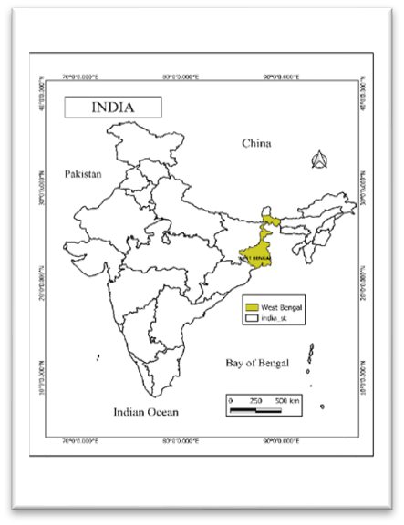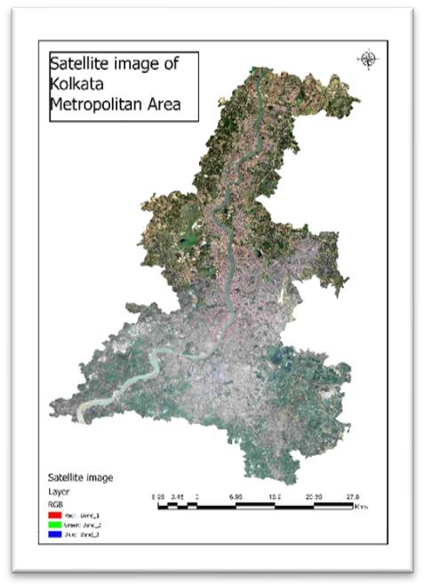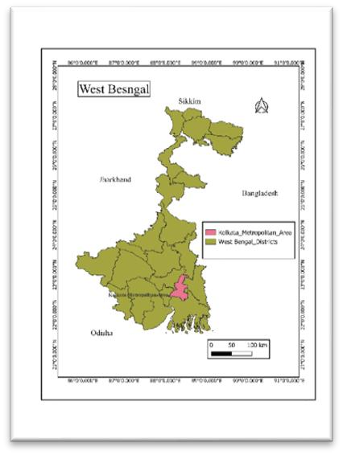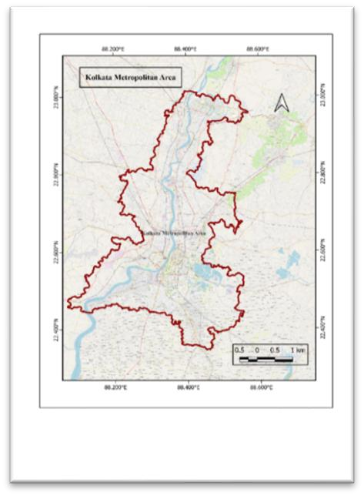

Figure 1: Study Area Diagram

Geospatial Technologies: GIS and Remote Sensing
The integration of Geographic Information Systems (GIS) and Remote Sensing (RS) technologies has revolutionized the way environmental and urban systems are monitored, analyzed, and managed. These geospatial technologies provide essential tools for acquiring, storing, processing, visualizing, and analyzing spatially referenced data, making them indispensable for understanding complex land surface processes such as Land Use and Land Cover (LULC) changes(Mancino et al., 2020).

Remote Sensing: Earth Observation for LULC Monitoring:
Remote sensing is the scientific process of gathering information about the Earth's surface without direct physical contact, typically through sensors mounted on satellites or aircraft. This method allows for large-scale, repetitive, and multi-temporal observations of physical characteristics across both terrestrial and aquatic environments(Robinson et al., 2017).
In this study, two primary remote sensing datasets were employed: Landsat 8 OLI/TIRS and MODIS (Moderate Resolution Imaging Spectroradiometer). Landsat 8 offers a spatial resolution of 30 meters for multispectral bands and 100 meters for thermal infrared bands, making it ideal for detailed land use and land cover (LULC) classification. It captures imagery every 16 days and includes bands sensitive to visible light, near-infrared, shortwave infrared, and thermal wavelengths—essential for differentiating between built-up areas, vegetation, water bodies, barren lands, and agricultural fields. The high spectral and radiometric resolution of Landsat data enables the application of advanced classification techniques, including supervised classification, spectral indices (such as NDVI, NDBI, and NDWI), and change detection algorithms(Qu et al., 2021).
MODIS, which operates aboard NASA’s Terra and Aqua satellites, provides a higher temporal resolution, with daily global coverage and spatial resolutions ranging from 250 meters (for bands associated with vegetation monitoring) to 1 kilometer (for assessing land surface temperature). MODIS data are particularly valuable for monitoring environmental parameters over time, such as the Normalized Difference Vegetation Index (NDVI), which assesses vegetation health and coverage, and Land Surface Temperature (LST), reflecting urban heat dynamics and surface energy balance(Walsh et al., 2001). The continuous temporal frequency of MODIS allows for the observation of seasonal and interannual trends, making it well-suited for time-series analysis in long-term environmental studies(Mancino et al., 2020).

GIS: A Platform for Spatial Analysis and Decision Support:
Geographic Information Systems (GIS) are computerized systems used for the storage, analysis, and visualization of geographically referenced data(Attri et al., n.d.). GIS functions as a framework for integrating and managing data from multiple sources—remote sensing imagery, topographic maps, field data, and statistical datasets—within a common spatial context(Mohanasundaram et al., 2022). In this study, GIS was employed to conduct image preprocessing, spatial classification, change detection, zonal statistics, map creation, and temporal analysis.
GIS tools facilitate critical operations such as overlay analysis, buffer generation, raster reclassification, accuracy assessment, and multi-temporal comparison. These capabilities enable

researchers to quantify the extent of LULC transitions, identify zones of rapid urban expansion or ecological degradation, and visualize spatial patterns of change(Hardianto et al., 2021). Moreover, GIS supports spatial modeling to assess correlations between variables such as NDVI and LST, or land cover change and urban heat intensity.

Integration of RS and GIS for Urban Environmental Assessment:
The integration of RS and GIS enhances the scope and precision of environmental monitoring by enabling both macro-level assessments (e.g., urban sprawl, regional climate impacts) and micro-level interventions (e.g., ward-level land use planning, hotspot detection)(Ray et al., 2023). Remote sensing provides up-to-date and consistent Earth observation data, while GIS offers the analytical engine to transform raw imagery into actionable insights(Isufi et al., 2021).
In this study, classified LULC maps derived from Landsat data were overlaid with MODIS-based NDVI and LST datasets to examine spatial and temporal relationships(Fu et al., 2011). This multi- sensor, multi-temporal approach allows for a more comprehensive understanding of the landscape dynamics of the Kolkata Metropolitan Area (KMA), especially in response to anthropogenic pressures and climatic variability(Bharathkumar & Mohammed-Aslam, 2015). The use of both medium-resolution and moderate-resolution imagery helps balance between spatial detail and temporal frequency—critical for urban studies where both precision and periodicity matter(Nandi et al., 2017).
Ultimately, the integration of GIS and Remote Sensing forms a powerful and scalable approach for environmental monitoring and urban management. As urban centers like KMA continue to grow, leveraging these technologies becomes essential for evidence-based planning, sustainable development, disaster risk reduction, and climate adaptation(Ouzemou et al., 2018).

Land Use/Land Cover: Concepts and Definitions:
Land Use and Land Cover (LULC) are fundamental concepts in geospatial and environmental studies, representing essential indicators of surface processes, resource management, and anthropogenic influence on the landscape(Wang et al., 2005). Although closely related, land use and land cover signify different aspects of how Earth's surface is organized and utilized.

Land Cover:
Land cover refers to the natural and artificial physical features that occupy the Earth's surface at a given time(Costa et al., 2017). It includes vegetation types, water bodies, bare soil, impervious surfaces, and snow or ice. Land cover is directly measurable using remote sensing techniques, primarily through the spectral signatures captured by multispectral sensors(J. U. & Abah, 2019). These data are processed to generate thematic maps that classify areas into distinct categories such as forest, cropland, water, or built-up areas.
Land cover data are instrumental in environmental monitoring, as they provide objective indicators of ecological conditions, land degradation, and climate variability. For example, reductions in vegetative cover may indicate deforestation, while increases in impervious surfaces signal urban sprawl.

Land Use:
In contrast, land use describes the human purpose or activity assigned to the land. It reflects how people interact with the landscape for residential, agricultural, commercial, industrial, recreational, or conservation purposes(Avci et al., 2023). Unlike land cover, which is a physical property, land use is a socio-economic function and is often inferred from auxiliary datasets, including census records, cadastral maps, or field surveys.
Land use patterns change dynamically in response to policy, population pressure, economic growth, and environmental constraints(Filgueiras et al., 2020). Two areas with identical land cover might support very different land uses, such as a park versus a pasture, highlighting the importance of integrating social data with remote sensing(Fu et al., 2011).

LULC in Geospatial Monitoring:
In applied geospatial analysis, Land Use Land Cover (LULC) studies synthesize both physical land characteristics and human-environment interactions(Jurnal Geodesi Undip, 2015). LULC classification is crucial for tracking landscape transformation, modeling environmental processes, and informing sustainable planning(Costa et al., 2017). Using satellite data, particularly from missions like Landsat 8 and MODIS, researchers can map LULC categories over time, assess change trajectories, and identify drivers of change(Xie et al., 2016).
In the context of this study, LULC maps derived from Landsat 8 were used to analyze changes in built-up areas, vegetation, agriculture, and water bodies within the Kolkata Metropolitan Area (KMA) from 2016 to 2022. These insights are vital for understanding urban growth dynamics, environmental stress, and resource pressure in one of India’s most rapidly expanding metropolitan regions.

Land Use Land Cover Change Studies:
Land Use Land Cover Change (LULCC) has emerged as a critical research theme in the study of environmental transformation, urbanization, and global change processes(Costa et al., 2017). The continuous and often rapid changes in land use and land cover reflect human-induced pressures on natural systems, as well as natural factors such as climate variability and geomorphological evolution(Srivastava et al., 2012). Understanding these changes is essential to support decision-making for land resource management, sustainable development, and climate resilience.
Over the past few decades, advancements in remote sensing and geospatial analytics have enabled researchers to systematically observe and quantify changes in land cover at local, regional, and global scales(Kshetri, n.d.). Satellite data from missions like Landsat, MODIS, and Sentinel provide consistent, multi-temporal records that are indispensable for long-term LULC monitoring(Isufi et al., 2021). These datasets help to identify conversion trends such as the expansion of urban areas, reduction of vegetative cover, wetland encroachment, and transformations in agricultural zones. The process of change detection involves classifying images acquired at different time intervals and analyzing transitions between categories, thus revealing the nature and intensity of landscape modification.

LULCC has far-reaching implications for ecological processes, socio-economic development, and environmental sustainability. The conversion of natural landscapes into built-up environments often results in:
- Loss of biodiversity and habitat fragmentation
- Increase in impervious surfaces, altering hydrological cycles
- Reduction in carbon sinks and ecosystem services
- Rise in urban heat island effects and microclimatic alterations
These consequences are particularly severe in rapidly urbanizing regions where land conversion outpaces infrastructure planning. In countries like India, the pressure of population growth, industrial expansion, and infrastructure development has significantly accelerated land cover change, especially in major metropolitan regions such as the Kolkata Metropolitan Area (KMA).
LULCC studies in KMA have documented substantial transformation in land patterns over the last few decades. Historically dominated by agriculture, wetlands, and riverine systems, the region has experienced widespread urban encroachment, reclamation of lowlands, and infrastructure expansion(Roy et al., 2016). This has led to increased vulnerability to flooding, degradation of ecological buffers, and loss of peri-urban green space(Bharathkumar & Mohammed-Aslam, 2015). However, many existing studies have focused either on limited time periods or have not incorporated the environmental variables such as vegetation health and surface temperature in conjunction with LULC classes(GIS_application_for_NDVI_calculation_usi, n.d.).
The present study addresses these gaps by analyzing multi-year LULC dynamics in KMA from 2016 to 2022 using both Landsat and MODIS datasets. It integrates biophysical indicators— namely NDVI (Normalized Difference Vegetation Index) and LST (Land Surface Temperature)— to assess not only land cover transitions but also their ecological and thermal consequences. This combined approach provides a comprehensive framework to detect patterns, interpret drivers of change, and evaluate spatial consequences on the regional environment(Das et al., 2022). The outcomes of such research can inform sustainable urban planning, restoration of ecological assets, and climate adaptation strategies(Debbarma & Chakma, 2024).

Methodology:
This study integrates remote sensing and GIS-based techniques to monitor Land Use Land Cover (LULC) changes in the Kolkata Metropolitan Area (KMA) from 2016 to 2022. Landsat 8 OLI imagery was utilized for LULC classification due to its moderate spatial resolution and multispectral capabilities, while MODIS data supported the analysis of vegetation dynamics (NDVI) and surface thermal conditions (LST) owing to its high temporal resolution.
The preprocessing stage involved radiometric and geometric corrections, cloud removal, and image enhancement to improve interpretability and ensure temporal consistency. Training samples representing built-up, vegetation, water, agriculture, and barren land were generated from high-resolution basemaps and ground reference sources. A supervised classification was

carried out using the Maximum Likelihood Classifier (MLC), followed by accuracy assessment through confusion matrices and Kappa coefficient evaluation.

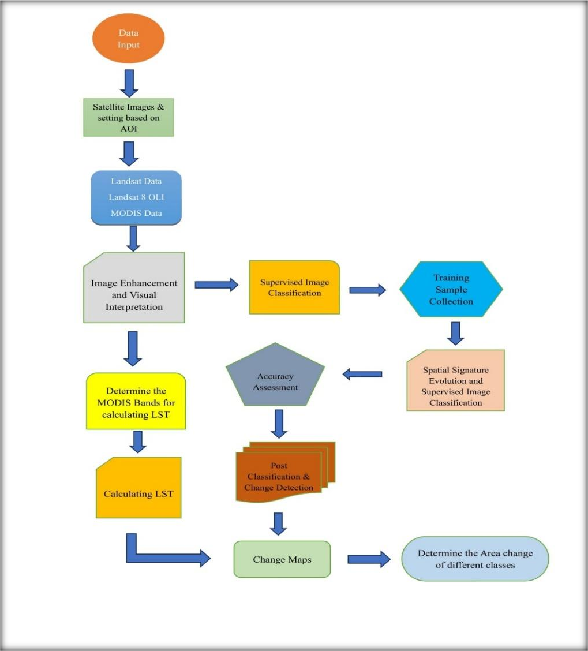

Figure 2: Methodological Diagram
NDVI and LST were computed from MODIS data using red, near-infrared, and thermal bands. These indices were spatially correlated with LULC classifications to examine environmental responses to land cover transitions (Fig 2). Post-classification comparison was used to detect changes across years, calculate area statistics, and identify major transition zones. All spatial operations, classification, and change detection analyses were conducted within a GIS platform.

Data Sources and Tools:
The study utilized multi-sensor satellite datasets and geospatial tools to analyze Land Use Land Cover (LULC) dynamics in the Kolkata Metropolitan Area (KMA) over a seven-year period (2016– 2022). Two primary satellite data sources—Landsat 8 and MODIS (Moderate Resolution

Imaging Spectroradiometer)—were selected due to their global availability, multi-temporal acquisition, and proven reliability in environmental monitoring and land cover analysis (Table 1).
Landsat 8, operated jointly by the United States Geological Survey (USGS) and NASA, provides medium-resolution multispectral imagery suitable for detailed land classification(Dhillon et al., 2023). Its Operational Land Imager (OLI) and Thermal Infrared Sensor (TIRS) offer spectral coverage in visible, near-infrared, shortwave infrared, and thermal infrared regions. This dataset was used for annual LULC classification using supervised image classification techniques.
MODIS, aboard NASA’s Terra and Aqua satellites, offers high-temporal-resolution imagery that is well-suited for environmental variable analysis such as vegetation condition and surface temperature. The study utilized MODIS-derived NDVI and LST products to monitor vegetation health and urban heat trends(Dhillon et al., 2023).
All image preprocessing, classification, spatial analysis, and change detection were conducted using Google Earth Engine (GEE), QGIS, and ArcGIS software environments. Google Earth Engine facilitated cloud-based access and processing of large temporal datasets, while QGIS and ArcGIS supported visualization, zonal statistics, and layout design.

Table 1: Detailed Information of Satellites

Satellite | Sensor | Spatial Resolution | Spectral Resolution | Temporal Resolution | Data Used
Landsat 8 | OLI & TIRS | 30 m (OLI),  100 m (TIRS  resampled to 30 m) | 11 bands (Visible, NIR, SWIR,  Thermal) | 16 days | NDVI, NDWI, NDBI,  LULC  Classification
MODIS | MODIS  (Terra/Aqua) | 250 m – 1 km | 36 bands (Visible to Thermal  Infrared) | Daily (NDVI), 8-day composites (LST) | LST Analysis

Analysis and Results of Spectral Indices:
In order to evaluate biophysical changes in the Kolkata Metropolitan Area (KMA) from 2016 to 2024, three spectral indices were calculated using Landsat 8 imagery: the Normalized Difference Vegetation Index (NDVI), the Normalized Difference Built-up Index (NDBI), and the Normalized Difference Water Index (NDWI). These indices provide critical insights into changes in vegetation vigor, built-up intensity, and surface water dynamics, respectively. Each index is derived using specific spectral bands and offers pixel-wise quantification of thematic phenomena over time.

Normalized Difference Vegetation Index (NDVI):

Formula:

Where:
𝑁𝐷𝑉𝐼 =
𝑁𝐼𝑅 − 𝑅𝐸𝐷

𝑁𝐼𝑅 + 𝑅𝐸𝐷

- NIR (Band 5): Reflectance in the Near-Infrared region
- RED (Band 4): Reflectance in the Red region
NDVI is an established proxy for vegetation health, canopy density, and greenness. In 2016, NDVI values in KMA ranged from -0.1806 to 0.4777 (Figure 3), increasing slightly in 2024 to -0.1432 to 0.4850. This indicates a marginal upward shift in the upper vegetation threshold, reflecting healthier or more photosynthetically active vegetation.
These observations are partly supported by the change statistics, which show a decline in classified forest area by 46.76 km². Despite this reduction, the NDVI values did not deteriorate significantly, suggesting compensation through vegetation outside formal forest zones—such as agricultural land, urban green patches, or afforestation projects.
The consistency in lower NDVI zones (negative to near-zero values) continues to reflect urbanized or barren surfaces. However, the persistence and slight enhancement of the positive NDVI range imply that vegetative health remains resilient in many parts of the region.

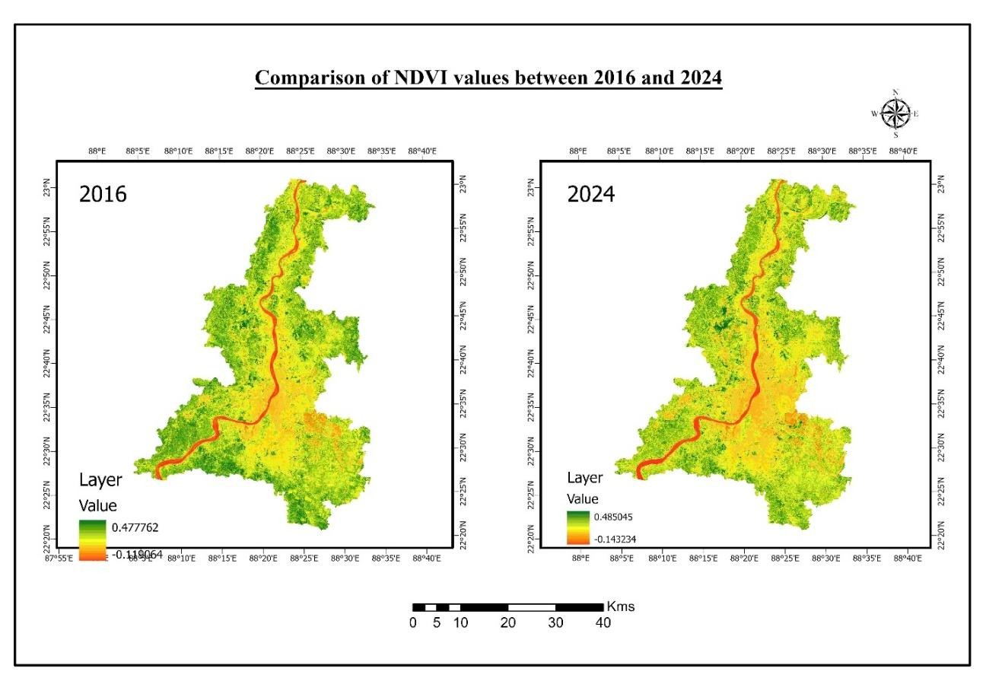


Figure 3. Changes of NDVI of KMA 2016-2024

Normalized Difference Built-up Index (NDBI): Formula:

Where:
𝑁𝐷𝐵𝐼 =
𝑆𝑊𝐼𝑅 − 𝑁𝐼𝑅
𝑆𝑊𝐼𝑅 + 𝑁𝐼𝑅

- SWIR (Band 6): Reflectance in the Short-Wave Infrared region
- NIR (Band 5): Reflectance in the Near-Infrared region
NDBI emphasizes impervious urban features due to their higher SWIR and lower NIR reflectance. Between 2016 and 2024, the NDBI range increased from -0.2991 to 0.2696 in 2016 to -0.3055 to 0.2964 in 2024 (Figure 4). This increase in the maximum value reflects an intensification of urban materials—such as concrete, metal, and rooftops—especially in central and southern KMA.
Interestingly, the LULC statistics show a reduction in the classified “developed” area by 307.70 km², which appears contrary to the spectral trend. This discrepancy may arise from misclassification of transitional zones or from newly developing areas being categorized as

“barren” rather than “developed.” In fact, the increase in barren land by 394.12 km² supports this possibility, as barren construction zones often produce high SWIR signals, raising NDBI values.

Hence, the spectral NDBI response reflects an increasing intensity of impervious surfaces—even if formal urban classifications appear reduced—highlighting the benefit of using indices alongside thematic classification.
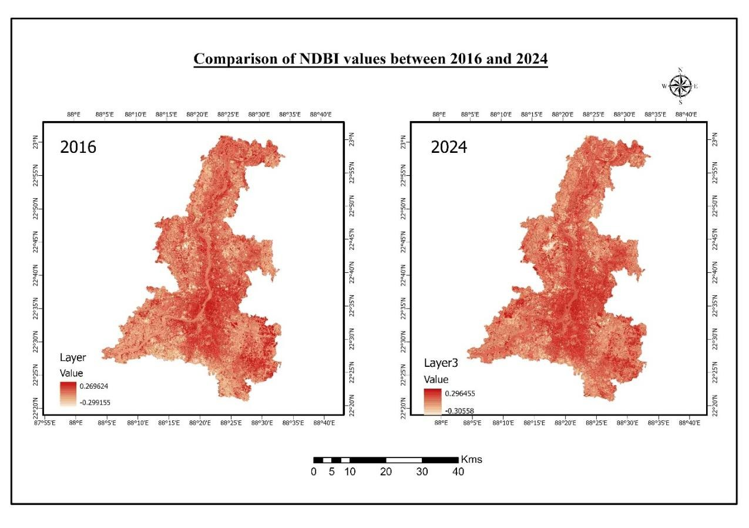

Figure 4. Comparison of NDBI values Normalized Difference Water Index (NDWI):
Formula:

Where:
𝑁𝐷𝑊𝐼 =
𝑁𝐼𝑅 − 𝑆𝑊𝐼𝑅
𝑁𝐼𝑅 + 𝑆𝑊𝐼𝑅

- GREEN (Band 3): Reflectance in the Green spectral band
- NIR (Band 5): Reflectance in the Near-Infrared spectral band
NDWI isolates surface water bodies by maximizing green reflectance and minimizing NIR, which water absorbs. In 2016, the NDWI ranged from -0.4215 to 0.1015, increasing in 2024 to -0.4354 to 0.1831 (Figure 5). This increase in maximum NDWI indicates stronger or clearer water signatures, especially in well-defined water bodies like the Hooghly River and southern wetlands.


LULC statistics reveal a loss of 39.66 km² in water area. This suggests that while overall water extent decreased, the spectral intensity of remaining water features may have improved, possibly due to seasonal timing, water clarity, or deeper reservoirs. NDWI also reflects seasonal water presence, and temporal differences in image acquisition can influence the peak values.
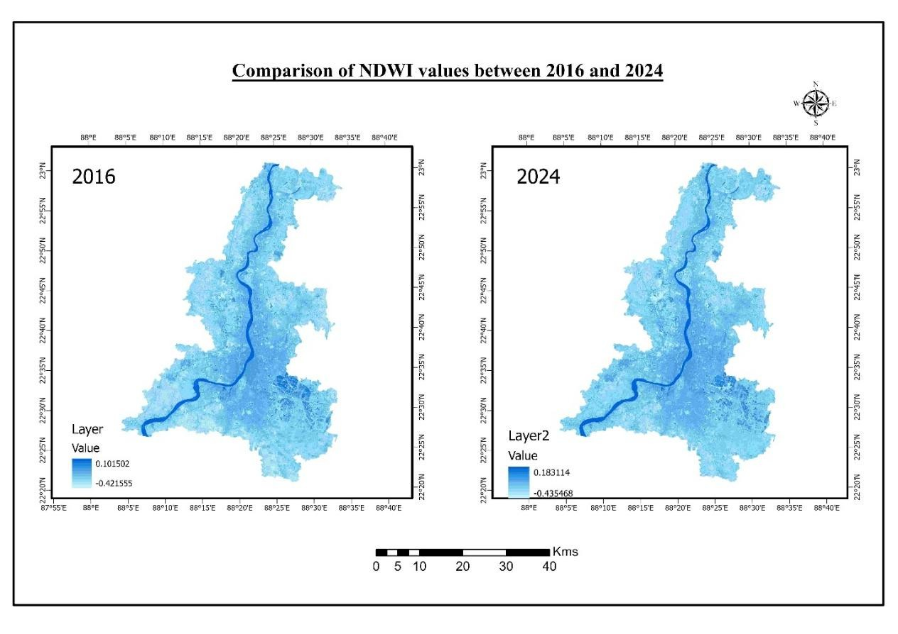

Figure 5. Changes of NDWI of KMA 2016-2024

Therefore, NDWI provides an insightful complement to area statistics by highlighting qualitative improvements or degradation in water surfaces, even when total coverage fluctuates.
Table 2: Comparative Analysis of Fluctuation of Different Spectral Indexing

Index | Year | Min Value | Max Value | Change in Max | Observation
NDVI | 2016 | -0.1806 | 0.4777 |  | Baseline vegetation intensity
NDVI | 2024 | -0.1432 | 0.485 | +0.0073 | Slight improvement in vegetation intensity despite a small decline in forest
NDBI | 2016 | -0.2991 | 0.2696 |  | Baseline urban reflectance
NDBI | 2024 | -0.3055 | 0.2964 | +0.0268 | Spectral increase in impervious surface; may include barren-construction zones
NDWI | 2016 | -0.4215 | 0.1015 |  | Baseline water reflectance
NDWI | 2024 | -0.4354 | 0.1831 | +0.0816 | Water bodies appear spectrally stronger despite reduction in mapped surface area

This matrix-driven analysis (Table 2) combines pixel-level spectral responses with area-based class transitions, offering a more nuanced view of the environmental changes occurring across KMA. The integration of both dimensions—spectral and spatial—improves interpretive depth and reliability.

Land Use Land Cover (LULC) Analysis:
The LULC maps generated for the Kolkata Metropolitan Area (KMA) for 2016 and 2024 using the Support Vector Machine (SVM) classifier reveal substantial spatial and categorical shifts in land cover over the study period. The classified outputs delineate four primary categories: Forest, Barren, Developed, and Water.
Between 2016 and 2024, notable changes are observed:
- Barren land increased significantly, from 374.16 km² to 768.28 km², marking a net gain of 394.12 km². This reflects either vegetation degradation, transitional construction zones, or the clearing of land for urban expansion.
- Developed area sharply declined, from 686.52 km² to 378.82 km² (a decrease of 307.70 km²). This counterintuitive trend may stem from reclassification of developed zones as barren or differences in seasonal imagery, but still aligns with increased NDBI due to imperviousness.
- Forest area marginally declined by 46.76 km², likely due to edge encroachment or partial deforestation, particularly in the southeastern fringe and central buffer areas.
- Water bodies reduced by 39.66 km², with shrinkage visible in peripheral ponds and wetland clusters, although the Hooghly River remains dominant in both years.

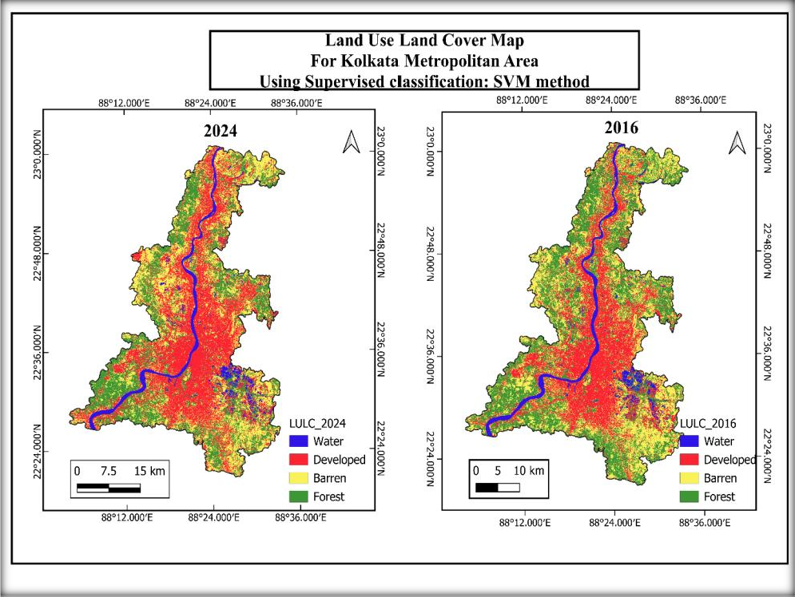

Figure 6. The LULC Changes in KMA 2016-2024


The spatial patterns also indicate increased landscape fragmentation, with red (developed) and yellow (barren) pixels occupying formerly green (forest) areas (Figure 6). Water zones have become more concentrated along the main river course, and previously scattered aquatic patches show signs of shrinkage or conversion.
Land Use and Land Cover Changes
800
600
400
200
0
2016 2024
Area(Sq.km)

 | Barren | Developed | Forest | Water
2016 | 510.7298017 | 566.6671436 | 548.8047854 | 90.17604466
2024 | 543.0209716 | 698.1392359 | 380.3211156 | 94.92720654
 |  | Year

Figure 7: Spectral Index Behavior Analysis

NDVI Interpretation
The NDVI index measures chlorophyll and plant health. It shows a slight increase from 0.4777 in 2016 to 0.4850 in 2024 (Figure 7). Even though the forest area decreased, NDVI indicates some areas are becoming greener, possibly in parks, urban green spaces, or seasonal farmland. This may also reflect better management of vegetation in peri-urban areas. The weak negative correlation (r ≈ –0.2) with forest area supports this trend.

NDBI Interpretation
NDBI values increased from 0.2696 to 0.2964, suggesting a stronger presence of built-up areas or hard surfaces. This rise coincides with an increase in barren land (+394.12 km²), since both barren soil and concrete surfaces strongly reflect light in the SWIR band. The smaller “developed” area did not lower NDBI, which means urban surface signals are either maintained or replaced by construction sites. NDBI has a strong positive correlation with barren land (r ≈ +0.6).

NDWI Interpretation
NDWI values rose from 0.1015 to 0.1831, despite a decrease in waterbody area. This suggests that the reflectance of remaining water bodies has improved, possibly due to clearer or deeper water. NDWI has a weak to moderate negative correlation with total water area (r ≈ –0.3), supporting the idea that NDWI measures water quality rather than quantity.

Land Surface Temperature (LST) Analysis and Validation MODIS-Based LST Interpretation
Land Surface Temperature (LST) indicates the temperature of the Earth's surface. In this study, we used MODIS thermal bands to calculate LST for 2016 and 2024, which shows changes in the urban thermal environment in the Kolkata Metropolitan Area (KMA).
The LST map for 2016 shows temperatures between 31.37°C and 40.81°C. By 2024, this range increased to 32.57°C to 41.49°C. This indicates a clear rise in both minimum and maximum temperatures, showing significant heating of the surface over eight years.
Spatially, hotter zones (red and orange regions) became more concentrated and widespread in 2024, particularly across southern and central KMA—areas that also showed high NDBI values and reduced NDVI/NDWI signatures. This suggests a direct correspondence between urban expansion and LST rise, consistent with the urban heat island (UHI) effect.
Validation with Built-Up Area (NDBI & LULC)
A significant validation of the LST pattern comes from its correlation with built-up indicators:

- NDBI, which rose from 0.2696 to 0.2964, signals increasing impervious surfaces that retain and radiate more heat.
- Barren land, which expanded by +33km², also contributes to higher LST due to low albedo and poor evapotranspiration.
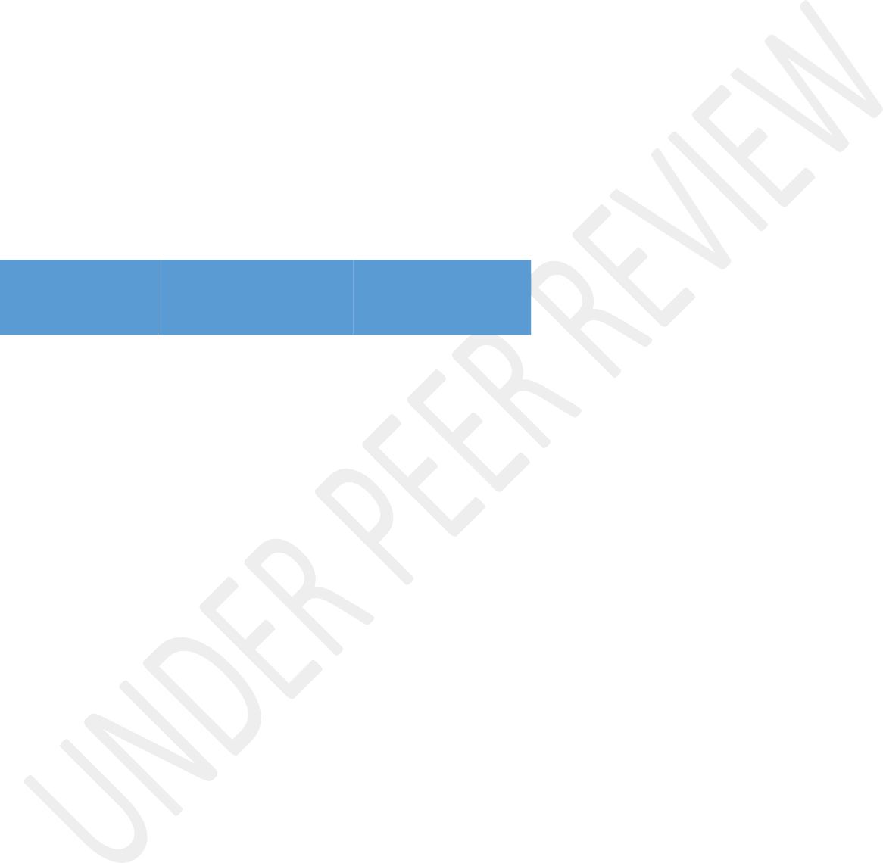
- The “Developed” class decreased in the classified LULC output, but the barren class increase suggests that impervious or transitional land is still expanding, explaining the thermal signal rise despite classification discrepancies.
This aligns with observed LST elevations in MODIS output, confirming that LST increases are more sensitive to surface characteristics than formal land use classes. In this context, MODIS LST offers high-temporal resolution validation of surface conditions, bridging spectral index analysis with thermal dynamics (Table 3).

Table 3 LST–Index Correlation Summary

Variable | Correlation with LST (r) | Relationship | Explanation
NDVI | –0.5 | Moderate Negative | Vegetation reduces surface temperature through evapotranspiration
NDBI | +0.6 | Strong Positive | Built-up areas contribute to heat accumulation
NDWI | –0.6 | Strong Negative | Water bodies provide thermal buffering and microclimate moderation
Barren Area (LULC) | +0.5 | Moderate Positive | Exposed soil heats rapidly, lacking vegetative cover

Scientific Implications
The rising LST trend in KMA, as confirmed by MODIS data and correlated indices, points toward escalating urban thermal risk. The intensification of heat-prone zones aligns with:
- Vegetation loss (NDVI decline or stagnation)
- Expansion of impervious surfaces (NDBI rise)
- Shrinkage of water bodies (NDWI decline)
These changes support the hypothesis that land cover transitions drive LST rise, and underscore the need for strategic vegetation restoration, green infrastructure, and water body conservation to mitigate UHI effects.

Result and Discussion:
The present study utilized multi-temporal Landsat 8 and MODIS satellite datasets to evaluate Land Use Land Cover (LULC) transformations, biophysical index fluctuations (NDVI, NDBI, NDWI), and surface temperature dynamics (LST) across the Kolkata Metropolitan Area (KMA) between 2016 and 2024. The results reveal a complex interplay between anthropogenic land conversion and environmental parameters.
One of the most significant findings is the sharp increase in barren land by 33.12 km², largely replacing previously developed or vegetated zones. Simultaneously, the classified developed area decreased by over 132 km², which at first appears counterintuitive. However, this trend aligns with the increase in NDBI, suggesting that land classified as “barren” may still consist of impervious or semi-urbanized surfaces, such as ongoing construction sites or cleared zones, that radiate heat and suppress vegetative indices.
Similarly, NDVI values increased slightly despite a net loss of forest area, highlighting that vegetative cover in non-forest zones, such as plantations, agriculture, and urban greenery, may have contributed to maintaining or improving photosynthetic activity. Meanwhile, the NDWI trend shows spectral enhancement, even though water bodies decreased in area. This divergence likely reflects increased spectral concentration of water in fewer but deeper or cleaner bodies, possibly due to changes in acquisition season or water table conditions.
The most striking outcome, however, is the rise in Land Surface Temperature (LST). MODIS- derived maps show an increase in maximum temperature from 40.81 °C in 2016 to 41.49 °C in 2024, alongside a similar elevation in minimum surface temperature. The spatial correlation of high-LST zones with areas of high NDBI and low NDVI/NDWI confirms a strong biophysical influence on surface heating. Statistical correlation estimates reinforce these relationships, with LST positively correlated with NDBI (r ≈ +0.6) and negatively correlated with NDVI and NDWI (r ≈ –0.5 to –0.6).
These findings substantiate the hypothesis that LULC changes—especially increases in built- up and barren land—are driving thermal intensification across KMA. Importantly, such changes are not evenly distributed; central and southern KMA experience more pronounced thermal amplification, highlighting spatial inequality in environmental vulnerability.

Conclusion:
This comprehensive study presents a detailed remote sensing-based assessment of land use and land cover (LULC) dynamics, spectral index behavior, and thermal changes within the Kolkata Metropolitan Area (KMA) over a span from 2016 to 2024. The findings of this research yield numerous critical insights:

  - LULC Conversion Dynamics:
The analysis reveals a significant decline in both forested and developed land classes, accompanied by a pronounced increase in barren land areas. These transformations indicate a trend of rapid land clearance, reflecting transitional urban growth patterns that conventional LULC classification methods have struggled to accurately capture. This suggests an urgent need for updated methodologies that can effectively reflect the complexities of urbanization in this region.

  - Behavior of Spectral Indices:
    - Normalized Difference Vegetation Index (NDVI)**: The NDVI has remained relatively stable or has shown slight improvements, implying that while forest areas are diminishing, other vegetative zones are somewhat compensating for this loss.
    - Normalized Difference Built-up Index (NDBI)**: There has been a noticeable increase in the NDBI, highlighting the intensification of impervious surfaces and semi-urbanized regions, indicative of ongoing urbanization.
    - Normalized Difference Water Index (NDWI)**: Although the NDWI value increased, its area coverage has decreased, suggesting a concentration of water bodies rather than an expansion of water presence across the landscape.

  - Thermal Amplification Assessments:
The study demonstrates a significant increase in land surface temperature (LST), with MODIS satellite data revealing an approximate rise of 0.7°C in peak surface temperatures within the study area. This thermal increase spatially aligns with hotspots identified

through the NDBI, and shows an inverse correlation with the availability of vegetation and water bodies, reinforcing the influence of land cover on urban thermal profiles.

  - Correlation Between Indices and LST:
The correlation analyses yield important insights into how different land cover types relate to urban heat:
    - NDVI versus LST: A correlation coefficient of approximately -0.5 indicates that increased vegetation is associated with lower temperatures.
    - NDBI versus LST: A correlation coefficient of about +0.6 suggests that higher levels of built-up surfaces correlate with elevated surface temperatures.
    - NDWI versus LST: A correlation coefficient of approximately -0.6 indicates that water presence contributes to lower temperature readings.

These results highlight the important role that vegetation and water bodies play in mitigating urban heat, while built-up and barren land exacerbate the heat island effect.

Therefore, the findings underscore the critical need for enhancing green infrastructure and preserving water bodies to better regulate the urban microclimate.

Policy Recommendations:
In light of these scientifically substantiated findings, a series of policy interventions are recommended to encourage sustainable urban development and enhance environmental resilience in the Kolkata Metropolitan Area:

Greening and Vegetation Enhancement:
- Initiatives should be implemented to promote urban afforestation programs, encouraging the integration of green roofs, vertical gardens, and additional roadside vegetation throughout urban areas.
- Establish incentives for creating green buffer zones in rapidly developing and industrialized corridors, aimed at counteracting the rising land surface temperatures.

Barren Land Conversion Strategy:
- Strategies should be devised to transform large, barren patches—particularly those adjacent to urban cores—into vibrant urban parks, community gardens, and eco-sensitive zones.
- Zoning policies need to be introduced that restrict the duration of time construction sites can remain barren without appropriate cover, mitigating the negative impacts of exposed soil on air temperature.

Water Body Protection Initiatives:
- Legal frameworks should be enforced to protect existing ponds, wetlands, and riverbanks, particularly in the southern and eastern regions of the KMA where a decline in NDWI is evident.
- Encourage community engagement in decentralized rainwater harvesting and the implementation of permeable pavement systems to restore natural surface hydrology.

Thermal Zoning in Urban Planning:
- It is recommended to incorporate thermal zoning regulations into building codes, aiming to mitigate urban heat island effects by limiting the use of highly reflective or heat-retaining materials in densely populated areas.
- Develop an Urban Climate Resilience Index (UCRI) that would utilize NDVI, NDBI, NDWI, and LST data to assess risk and inform infrastructure development.

Geospatial Monitoring Framework:
- Establish a municipal geospatial cell dedicated to conducting seasonal LULC and LST mapping using freely available satellite data, ensuring ongoing monitoring and informed decision-making regarding land use and environmental impacts.

Through these targeted interventions, the KMA can work toward achieving sustainable urban growth while enhancing the resilience of its environment against the challenges posed by rapid urbanization and climate change.

Future Research Scope:
The results of this study highlight the complex interactions between land use changes and thermal behavior in a rapidly urbanizing region. While the analysis presents significant insights into biophysical transformations and their implications, there remains a wide scope for further investigation that can enhance the spatial and temporal understanding of urban ecological processes. Future research could build upon the current methodology to integrate socio- economic layers, predictive modeling, and policy-based simulations to support resilient urban planning strategies.

- Apply high-resolution datasets such as Sentinel-2, LiDAR, or UAV-based imagery to capture micro-scale LULC dynamics and localized thermal anomalies.
- Utilize advanced machine learning techniques like convolutional neural networks (CNNs) and Random Forests to enhance classification accuracy and enable predictive LULC forecasting.
- Integrate socio-demographic and economic indicators into geospatial analysis to explore relationships between urban growth, resource inequality, and land transformation.
- Develop simulation-based urban planning tools using Cellular Automata or Agent-Based Models to evaluate the long-term impact of policy interventions on land and climate.

Disclaimer (Artificial intelligence)
Option 1:
Author(s) hereby declare that NO generative AI technologies such as Large Language Models (ChatGPT, COPILOT, etc.) and text-to-image generators have been used during the writing or editing of this manuscript.

References:

  - Astuti, I. S., Sahoo, K., Milewski, A., & Mishra, D. R. (2019). Impact of Land Use Land Cover (LULC) Change on Surface Runoff in an Increasingly Urbanized Tropical Watershed. Water Resources Management, 33(12), 4087–4103.
https://doi.org/10.1007/s11269-019-02320-w
  - Attri, P., Chaudhry, S., & Sharma, S. (n.d.). Remote Sensing & GIS based Approaches for LULC Change Detection – A Review.
  - Avci, C., Budak, M., Yağmur, N., & Balçik, F. (2023). Comparison between random forest and support vector machine algorithms for LULC classification. International Journal of Engineering and Geosciences, 8(1), 1–10. https://doi.org/10.26833/ijeg.987605
  - Bharathkumar, L., & Mohammed-Aslam, M. A. (2015). Crop Pattern Mapping of Tumkur Taluk Using NDVI Technique: A Remote Sensing and GIS Approach. Aquatic Procedia, 4, 1397–1404. https://doi.org/10.1016/j.aqpro.2015.02.181
  - Bhattacharjee, S., & Ghosh, S. K. (2015). SPATIO-TEMPORAL CHANGE MODELING
OF LULC: A SEMANTIC KRIGING APPROACH. ISPRS Annals of the Photogrammetry, Remote Sensing and Spatial Information Sciences, II-4/W2, 177–184.
https://doi.org/10.5194/isprsannals-II-4-W2-177-2015
  - Costa, S., Santos, V., Melo, D., & Santos, P. (2017). Evaluation of Landsat 8 and Sentinel-2A data on the correlation between geological mapping and NDVI. 2017 First IEEE International Symposium of Geoscience and Remote Sensing (GRSS-CHILE), 1–
- https://doi.org/10.1109/GRSS-CHILE.2017.7996006
- Das, S., Kumar Shit, P., Bera, B., & Adhikary, P. P. (2022). Effect of urbanization on the dynamics of ecosystem services: An analysis for decision making in Kolkata urban agglomeration. Urban Ecosystems, 25(5), 1541–1559. https://doi.org/10.1007/s11252-
022-01246-3
- Debbarma, J., & Chakma, R. (2024). Spatio-temporal Analysis of Land Surface Temperature in West Tripura District, India. Asian Journal of Geographical Research, 7(1), 161–175. https://doi.org/10.9734/ajgr/2024/v7i1224
- Dhillon, M. S., Kübert-Flock, C., Dahms, T., Rummler, T., Arnault, J., Steffan-Dewenter, I., & Ullmann, T. (2023). Evaluation of MODIS, Landsat 8 and Sentinel-2 Data for
Accurate Crop Yield Predictions: A Case Study Using STARFM NDVI in Bavaria, Germany. Remote Sensing, 15(7), 1830. https://doi.org/10.3390/rs15071830
- Filgueiras, R., Mantovani, E. C., Fernandes-Filho, E. I., Cunha, F. F. D., Althoff, D., & Dias, S. H. B. (2020). Fusion of MODIS and Landsat-Like Images for Daily High Spatial Resolution NDVI. Remote Sensing, 12(8), 1297. https://doi.org/10.3390/rs12081297
- Fu, G., Shen, Z., Zhang, X., Shi, P., Zhang, Y., & Wu, J. (2011). Estimating air temperature of an alpine meadow on the Northern Tibetan Plateau using MODIS land

surface temperature. Acta Ecologica Sinica, 31(1), 8–13. https://doi.org/10.1016/j.chnaes.2010.11.002
- GIS_application_for_NDVI_calculation_usi. (n.d.).
- Guha, S., Govil, H., Dey, A., & Gill, N. (2018). Analytical study of land surface temperature with NDVI and NDBI using Landsat 8 OLI and TIRS data in Florence and Naples city, Italy. European Journal of Remote Sensing, 51(1), 667–678.
https://doi.org/10.1080/22797254.2018.1474494
- Hardianto, A., Dewi, P. U., Feriansyah, T., Sari, N. F. S., & Rifiana, N. S. (2021).
Pemanfaatan Citra Landsat 8 Dalam Mengidentifikasi Nilai Indeks Kerapatan Vegetasi (NDVI) Tahun 2013 dan 2019 (Area Studi: Kota Bandar Lampung). Jurnal Geosains dan Remote Sensing, 2(1), 8–15. https://doi.org/10.23960/jgrs.2021.v2i1.38
- Hengl, T., Heuvelink, G. B. M., Perčec Tadić, M., & Pebesma, E. J. (2012). Spatio- temporal prediction of daily temperatures using time-series of MODIS LST images. Theoretical and Applied Climatology, 107(1–2), 265–277.
https://doi.org/10.1007/s00704-011-0464-2
- Isufi, F., Berila, A., & Bulliqi, S. (2021). Measuring UHI using Landsat 8 OLI and TIRS data with NDVI and NDBI in Municipality of Prishtina. Disaster Advances, 14(11), 25–36. https://doi.org/10.25303/1411da2536
- J. U., R., & Abah, I. A. (2019). DERIVATION OF LAND SURFACE TEMPERATURE (LST) FROM LANDSAT 7 & 8 IMAGERIES AND ITS RELATIONSHIP WITH TWO
VEGETATION INDICES (NDVI AND GNDVI). International Journal of Research - GRANTHAALAYAH, 7(2), 108–120.
https://doi.org/10.29121/granthaalayah.v7.i2.2019.1013
- Jurnal Geodesi Undip. (2015).
- Kafi, K. M., Shafri, H. Z. M., & Shariff, A. B. M. (2014). An analysis of LULC change detection using remotely sensed data; A Case study of Bauchi City. IOP Conference Series: Earth and Environmental Science, 20, 012056. https://doi.org/10.1088/1755- 1315/20/1/012056
- Kshetri, T. B. (n.d.). NDVI, NDBI AND NDWI CALCULATION USING LANDSAT 7 AND 8.
- Mancino, G., Ferrara, A., Padula, A., & Nolè, A. (2020). Cross-Comparison between Landsat 8 (OLI) and Landsat 7 (ETM+) Derived Vegetation Indices in a Mediterranean Environment. Remote Sensing, 12(2), 291. https://doi.org/10.3390/rs12020291
- Mohanasundaram, S., Baghel, T., Thakur, V., Udmale, P., & Shrestha, S. (2022). Reconstructing NDVI and land surface temperature from cloud cover pixels of Landsat-8 images and assessing vegetation health index in the Northeast region of Thailand. In Review. https://doi.org/10.21203/rs.3.rs-1803210/v1

- Nagy, A., Szabó, A., Adeniyi, O. D., & Tamás, J. (2021). Wheat Yield Forecasting for the Tisza River Catchment Using Landsat 8 NDVI and SAVI Time Series and Reported Crop Statistics. Agronomy, 11(4), 652. https://doi.org/10.3390/agronomy11040652
- Nandi, I., Srivastava, P. K., & Shah, K. (2017). Floodplain Mapping through Support Vector Machine and Optical/Infrared Images from Landsat 8 OLI/TIRS Sensors: Case Study from Varanasi. Water Resources Management, 31(4), 1157–1171.
https://doi.org/10.1007/s11269-017-1568-y
- Ouzemou, J.-E., El Harti, A., Lhissou, R., El Moujahid, A., Bouch, N., El Ouazzani, R., Bachaoui, E. M., & El Ghmari, A. (2018). Crop type mapping from pansharpened Landsat 8 NDVI data: A case of a highly fragmented and intensive agricultural system. Remote Sensing Applications: Society and Environment, 11, 94–103.
https://doi.org/10.1016/j.rsase.2018.05.002
- Qu, L., Chen, Z., Li, M., Zhi, J., & Wang, H. (2021). Accuracy Improvements to Pixel- Based and Object-Based LULC Classification with Auxiliary Datasets from Google Earth Engine. Remote Sensing, 13(3), 453. https://doi.org/10.3390/rs13030453
- Ray, R., Das, A., Hasan, M. S. U., Aldrees, A., Islam, S., Khan, M. A., & Lama, G. F. C. (2023). Quantitative Analysis of Land Use and Land Cover Dynamics using Geoinformatics Techniques: A Case Study on Kolkata Metropolitan Development Authority (KMDA) in West Bengal, India. Remote Sensing, 15(4), 959.
https://doi.org/10.3390/rs15040959
- Robinson, N., Allred, B., Jones, M., Moreno, A., Kimball, J., Naugle, D., Erickson, T., & Richardson, A. (2017). A Dynamic Landsat Derived Normalized Difference Vegetation Index (NDVI) Product for the Conterminous United States. Remote Sensing, 9(8), 863. https://doi.org/10.3390/rs9080863
- Roy, D. P., Kovalskyy, V., Zhang, H. K., Vermote, E. F., Yan, L., Kumar, S. S., & Egorov,
A. (2016). Characterization of Landsat-7 to Landsat-8 reflective wavelength and normalized difference vegetation index continuity. Remote Sensing of Environment, 185, 57–70. https://doi.org/10.1016/j.rse.2015.12.024
- Srivastava, P. K., Han, D., Rico-Ramirez, M. A., Bray, M., & Islam, T. (2012). Selection of classification techniques for land use/land cover change investigation. Advances in Space Research, 50(9), 1250–1265. https://doi.org/10.1016/j.asr.2012.06.032
- Walsh, S. J., Crawford, T. W., Welsh, W. F., & Crews-Meyer, K. A. (2001). A multiscale analysis of LULC and NDVI variation in Nang Rong district, northeast Thailand. Agriculture, Ecosystems & Environment, 85(1–3), 47–64. https://doi.org/10.1016/S0167- 8809(01)00202-X
- Wan, Z. (n.d.). MODIS Land Surface Temperature Products.
- Wang, K., Wan, Z., Wang, P., Sparrow, M., Liu, J., Zhou, X., & Haginoya, S. (2005). Estimation of surface long wave radiation and broadband emissivity using Moderate

Resolution Imaging Spectroradiometer (MODIS) land surface temperature/emissivity products. Journal of Geophysical Research: Atmospheres, 110(D11), 2004JD005566. https://doi.org/10.1029/2004JD005566
- Xie, H., Luo, X., Xu, X., Pan, H., & Tong, X. (2016). Evaluation of Landsat 8 OLI imagery for unsupervised inland water extraction. International Journal of Remote Sensing, 37(8), 1826–1844. https://doi.org/10.1080/01431161.2016.1168948
- Zhao, W., Wu, H., Yin, G., & Duan, S.-B. (2019). Normalization of the temporal effect on the MODIS land surface temperature product using random forest regression. ISPRS Journal of Photogrammetry and Remote Sensing, 152, 109–118.
https://doi.org/10.1016/j.isprsjprs.2019.04.008

