District-level Assessment of Climate Change Impacts on Rice Yield in Chhattisgarh using DSSAT Simulation Model

Abstract
This study focuses on the calibration and validation of the DSSAT crop simulation model calibrated with local data, the study projects rice yield changes under RCP 4.5 and 8.5 scenarios for the years 2030, 2050, and 2070 in the Chhattisgarh Plain Zone and nearby agro-climatic regions of Chhattisgarh, India. The model was tuned to replicate rice development and yield with great accuracy across many locations using past weather and soil data. Variations in temperature, rainfall, and soil conditions affected the notable disparities in yield seen among sites. To maintain output, the research stresses the need of adaptive techniques like site-specific crop planning, effective water management, and heat-tolerant rice cultivars. These results provide insightful analysis for enhancing agricultural resilience and direction of policy choices in the face of fluctuating climate.
Keywords: Rice Yield Prediction, Climate Change, Chhattisgarh Plain Zone, Agro-Climatic Zones, Calibration and Validation, Sustainable Agriculture.

Introduction:
More over half of the world's population depends on rice as a staple diet, and in Asia alone, over 2000 million people get 60–70% of their calories from rice and its derivatives. In Asia, about 80% of the population eats rice. India is the world's second-largest producer and consumer of rice. In India, rice is the main food crop. With a production of 116.42 Mt and a productivity of 2659 kg/ha, rice accounts for 22% of the nation's gross cropped area and is produced on 43.79 M ha. Due to population increase, the country's estimated need for rice by 2050 would be 137.3 Mt, with a 25.8 MT imbalance between supply and demand at a growth rate of 0.36 percent. The state of Chhattisgarh is located in central India and spans 137.90 lakh hectares. It is referred to be the "rice bowl of India" and is well-known for its rice farming. It is vital to assess its absolute change and forecast the state's anticipated supply of this crop as well as other cereal crops like maize and wheat (Jaiswal et al., 2024). With about 4.8 million hectares of land devoted to rice farming, the state produces around 15% of all of India's rice. Rice is the mainstay of Chhattisgarh's agricultural economy, accounting up around 70% of the state's total planted land. Rice cultivation is made possible by the region's tropical environment, which has moderate rainfall of 1,000 to 1,500 mm per year, as well as rich clayey and loamy soils. The state's capability to produce rice is further supported by its extensive network of irrigation canals and rain-fed agricultural systems, which provide consistent water supply. The state's economy is based mostly on agriculture, and millions of farmers and agricultural workers are employed directly or indirectly in the rice industry. Beyond its economic importance, rice's role as a staple crop is cemented by its profound integration into the state's cultural and nutritional traditions (Goswami & Verma, 2024). Given the significance of the rice crop in Chhattisgarh state and its current situation, it is essential to understand the precise changes in rice crop area, productivity, and output (Jaiswal et al., 2024). A worldwide concern, climate change affects human health, food security, water availability, and the general advancement of society in many nations (Liu & Masago, 2023; Crespi et al., 2023). Because agriculture depends on temperature, rainfall, and soil conditions, climate change shows up as droughts, floods, and irregular monsoons, which have an impact on farmers' incomes and agricultural production (Change, 2001). One of the major problems the world is now experiencing is the trend of global warming. As industrialization and human activity continue to grow, greenhouse gas emissions also rise, which causes the Earth's temperature to climb steadily. This tendency has significant effects on agriculture in addition to the Earth's climate system (Xu et al., 2023; Man-xue et al., 2024). For every degree increase in mean temperature, the adverse effects of climate change may cause a 3–7% decrease in agricultural output (Aggarwal, 2008; Dhanya & Ramachandran, 2016), raising the possibility of hunger and undernourishment (Khan et al., 2022). Another important aspect of climate change is the rise in the frequency of severe weather occurrences. Agricultural output is becoming more unpredictable and vulnerable as a result of the rising frequency and severity of severe weather events including hurricanes, droughts, and heavy rains (Wu HaiYan et al., 2014). In India, the effects of climate change on agriculture range depending on the location (Rao et al., 2016). Extreme rainfall occurrences are predicted to rise in the west and south-central regions (Sreenath et al., 2023). In the northwest, winter rainfall is predicted to rise while summer monsoon rainfall is predicted to decrease (Subash et al., 2023). Higher rates of drought and flooding might result from this, impacting both the winter season crops (rabi), which are generally planted from October to December and harvested from April to June, and the rainy season crops (kharif), which are normally seeded from June to July and harvested from September to October (Joshi & Kar, 2009). The negative effects of climate change may cause India's agricultural production to decline by 4.5% to 9% a year between 2020 and 2039 (Kamdi et al., 2023). This may lead to a yearly GDP decline of 0.7% to 1.3% if converted into monetary terms (Singh, 2022). It is clear that the agriculture sector is being impacted by climate change. One of the most significant staple crops in the world, rice, is also negatively impacted (Hong et al., 2016). Rice production and quality are directly impacted by climate change, in addition to the growing environment. Developing climate change mitigation techniques for rice agriculture is essential. The study's goal is to evaluate how future climate change will affect rice production in various Chhattisgarh districts by examining how changes in temperature, precipitation, and extreme weather events affect rice yield, the area under cultivation, and total production. In light of shifting climatic circumstances, the research seeks to identify vulnerabilities unique to a given location and provide insights that might direct the creation of flexible plans and regulations to guarantee sustainable rice farming and food security.

Materials

The study utilizes both primary and secondary data:

    - Primary Data: Field trial observations from the All India Coordinated Research Project on Agrometeorology (AICRPAM) for the year 2021 and 2022, provided by the Department of Agrometeorology, Indira Gandhi Krishi Vishwavidyalaya (IGKV), Raipur.
    - Secondary Data: Historical weather data and future climate projections were obtained from:
      - India Meteorological Department (IMD) for baseline weather data.
      - CORDEX or CMIP5 climate models under RCP 4.5 and RCP 8.5 scenarios for future climatic projections (2030, 2050, 2070).

Methodology
This study uses a methodical methodology to evaluate how Chhattisgarh's rice production is affected by climatic variability and change. It entails analyzing historical patterns and forecasting future results using crop simulation tools, climate models, and secondary data. A thorough and scientific knowledge of the connection between crop production and climatic conditions is guaranteed by the technique.

Study Area
Three primary Agro Climatic Zones (ACZs) were the focus of the research, which was carried out in the state of Chhattisgarh: the Bastar Plateau Zone (BPZ), the Northern Hill Zone (NHZ), and the Chhattisgarh Plains Zone (CPZ) as mentioned in Figure 1. These regions may be used to evaluate the regional effects of climate change on rice production since they have different soil properties, cropping practices, and meteorological circumstances.
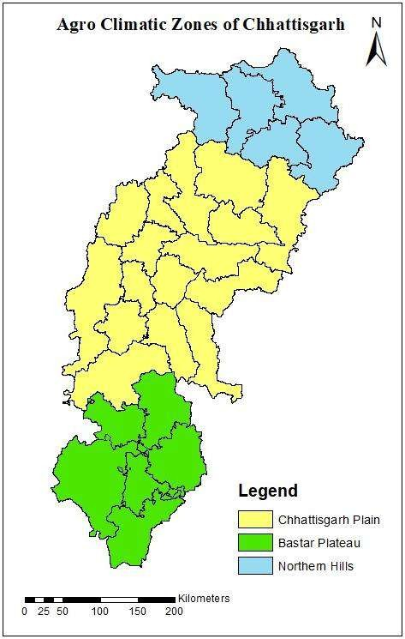

Fig 1. Agroclimatic zones of Chhattisgarh

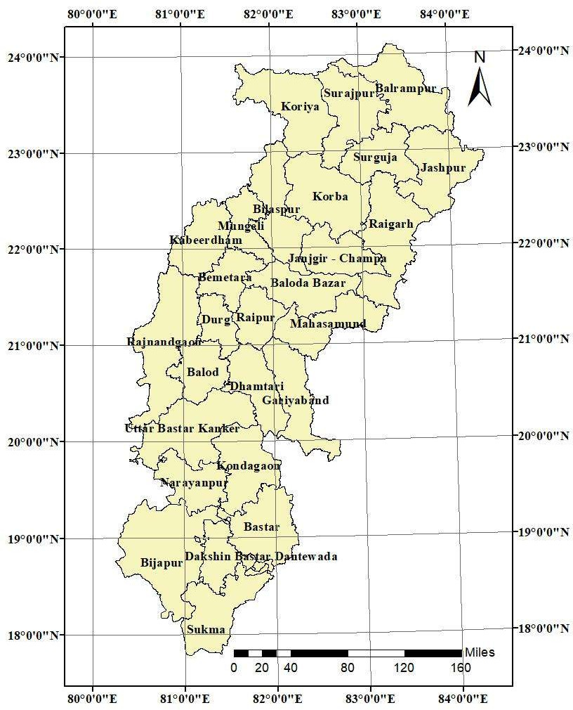

Fig. 2 District wise map of Study Area

Model Description

The DSSAT (Decision Support System for Agrotechnology Transfer) V4.7 model was employed for simulating rice growth, development, and yield. This model simulates rice growth and yields by different developmental processes such as extension of development, biomass accumulation, and portioning, effects of stress, water balance, soil, and flood water nutrients. Being a process-based model, we can adjust various processes above mentioned to simulate rice production under such conditions.

Model Calibration

Model calibration involved tuning genotype-specific parameters using field-observed data to ensure simulated outputs closely matched observed values. The key steps included:

    - Parameters calibrated: Anthesis day, Physiological Maturity day, and Grain Yield (kg/ha).
    - Year used for calibration: 2021 AICRPAM dataset.
    - Calibration was done by iterative adjustment of genetic coefficients (e.g., P1, P2R, P5, G1, G2, G3, PHINT) until the model output aligned with the observed data.

Statistical indicators used:
      - Root Mean Square Error (RMSE)
      - Coefficient of Determination (R²)
      - Index of Agreement (d-stat)

Model Validation
Validation was conducted using independent field data from 2022 not used during calibration to assess the robustness of the model.
    - Parameters validated: Anthesis day, Physiological Maturity, and Yield.
    - Model performance was evaluated using the same statistical metrics (RMSE, R², d- stat).

Climate Scenario Development

To project the future impacts of climate change on rice production, two Representative Concentration Pathways (RCPs) were used RCP 4.5 and RCP 8.5 (Table 1).

Table 1 Description of Representative Concentration Pathway (RCP) Scenarios

RCP | Description
RCP 4.5 | This is a situation in which we aim to achieve stabilization of total radiative forcing before the year 2100 through the implementation of various technologies and strategies designed to mitigate greenhouse gas emissions.
RCP 8.5 | This scenario is marked by a progressive rise in greenhouse gas emissions over  time and serves as an illustration of trajectories leading to elevated concentrations of greenhouse gases.

Climate projections for 2030, 2050, and 2070 were generated for each RCP using downscaled data for the three ACZs. The parameters considered included:
    - Maximum Temperature (Tx)
    - Minimum Temperature (Tn)
    - Rainfall (R)

Simulation for Future Projections

Using the calibrated and validated DSSAT model, rice yields were simulated under both current and future climate conditions. The genetic coefficients obtained during calibration were used for consistency.

    - The simulations were run separately for each RCP and time period.
    - Changes in yield and phenological stages were analyzed in response to variations in temperature and rainfall.
    - Seasonal as well as annual impacts were assessed.

Statistical Analysis
The performance of the model was evaluated using the following metrics:
    - Root Mean Square Error (RMSE): Measures average error between observed and simulated values.
    - R² (Coefficient of Determination): Indicates goodness of fit.
    - d-Statistic (Willmott’s index): Assesses the degree to which observed and simulated data agree.
Thresholds for acceptable model performance were adopted based on (Jing et al., 2017), where d-stat > 0.7 indicates acceptable model performance.

Result
Results of crop simulation model and how efficiently it replicates the field condition are discussed here. Along with that, the future climatic scenario and how it’s going to affect rice production was also analyzed.

Calibration of the model
Calibration is generally training the model with observed values. Adjustments were done until outputs were close to the input values. In this model three key parameters were taken namely., Anthesis day, Physiological maturity day, and yield. The calibration process utilizes the AICRPM field trial data from 2021 which is collected from the Dept. of Agrometeorology, IGKV, Raipur. When comparing the simulated values with the measured data, the model effectively replicates the field conditions at a statistically significant level. Specifically, the Root Mean Square Error (RMSE) is three percent for both anthesis and physiological maturity, and eight percent for yield. Furthermore, the d-stat value stands at 0.6 for anthesis and physiological maturity, and an impressive 0.95 for yield, indicating a high level of accuracy in yield simulation (Table 2).

Table 2 Model Calibrated Output

Particulars | Anthesis Day |  | Physiological Maturity |  | Yield (kg/ha)
Particulars | Simulated | Measured | Simulated | Measured | Simulated | Measured
2021 | 95 | 91 | 122 | 119 | 4019 | 4199
R Square | 1 | 1 | 1 | 1 | 1 | 1
RMSE | 3.53 |  | 3.00 |  | 280.64
D- Stat | 0.61 |  | 0.60 |  | 0.95

Validation of the model

Validation is cross-checking the output of trained model with another observed values which is not used during calibration. To validate the model, AICRIPAM rice crop data from the year 2022 were employed. During the validation process, the model demonstrates a remarkably high level of accuracy in simulating the anthesis day. The Root Mean Square Error (RMSE) remains less than one percent for anthesis day, while it reaches three percent for physiological maturity and eight percent for yield, which is considered quite favorable for model acceptance. Additionally, the d-stat value exceeds 0.9 for both anthesis and yield, reflecting strong accuracy, while physiological maturity achieves a d-stat value of 0.6 (Table 3).
Table 3 Model Validated Output

Particulars | Anthesis Day |  | Physiological Maturity |  | Yield (kg/ha)
Particulars | Simulated | Measured | Simulated | Measured | Simulated | Measured
2022 | 95 | 94 | 122 | 117 | 3862 | 3593
R  Square | 1 | 1 | 1 | 1 | 1 | 1
RMSE | 0.7 |  | 4.1 |  | 224.63
D- Stat | 0.98 |  | 0.67 |  | 0.96

For the selected parameters, model performance was good at calibration and validation. According to Jing et al., (2017) the d-stat value greater than 0.7 indicates an acceptable level. In case of both validation and calibration, the d-stat index was 0.95 and 0.96 respectively. Hence it can be understood that the model was able to predict the yield in an acceptable level of accuracy. So, it can be used for future projections. The final genetic coefficient used for simulation in given in Table 4.
Table 4 Genetic coefficients generated after calibration and validation

P Coefficient |  | G Coefficient
P1 | 430.8 | G1 | 56.56
P2R | 270.4 | G2 | 0.015
P5 | 300.5 | G3 | 1.045
P20 | 11.55 | PHINT | 83.00

Future climatic scenario
The future trend of maximum temperature (Tx) shows consistent increases across different Agro Climatic Zones (ACZs) and seasons, at varying magnitudes. Various studies conducted during different time periods also suggested a similar increase of temperature over Chhattisgarh (Chaturvedi et al., 2011) and (Gupta & Jain, 2018). In the annual scenario, Chhattisgarh Plain Zone (CPZ) exhibit the most significant rise, ranging from 1 to 3℃ compared to the long-term average, followed by the Northern Hill Zone (NHZ) with an increase of 0.3 to 1.8℃. On the other hand, the Bastar Plateau Zone (BPZ) experiences a decrease in temperature by 1.5℃ in 2030, with a slight subsequent rise of 0.3℃ by 2070. This suggests that BPZ is not following a consistent warming trend in Tx.
During the southwest monsoon season (SW), similar temperature trends are observed, although with slight variations in values. For minimum temperature (Tn), NHZ initially witnesses a reduction of 0.8℃, followed by a subsequent increase of 0.8℃. In contrast, CPZ records the most substantial rise, ranging from 2.4 to 4.0℃. BP experiences a minor decline of 0.3℃ during this season, gradually transitioning to an increase of 1.3℃. Throughout the SW season, CPZ exhibits a similar temperature trend. Notably, the decline in Tn during SW ranges from
0.4 to 1.7℃, which is approximately twice the magnitude of the annual decline observed in NHZ. In BPZ, Tn decreases by 0.2 to 1.7℃ during SW, reflecting the annual trend to some extent.
Regarding rainfall, there are distinct patterns observed among different regions. The Northern Hill Zone (NHZ) and Bastar Plateau Zone (BPZ) exhibit increased rainfall compared to the current scenario, whereas the Chhattisgarh Plains Zone (CPZ) experiences a decrease. In NHZ, the rainfall gradually decreases from 239.1 mm to 74.9 mm. On the other hand, CPZ witnesses fluctuating rainfall levels, ranging from 20-30 mm (Table 5).

Table 5 The change in annual mean of weather parameters in RCP 4.5 with respect to Long Period Average (LPA) in various Agro Climatic Zone (ACZ)

ACZ | Tx |  |  | Tn |  |  | R
ACZ | 2030 | 2050 | 2070 | 2030 | 2050 | 2070 | 2030 | 2050 | 2070
NHZ | 0.3 | 1.2 | 1.8 | -0.8 | 0.2 | 0.8 | 239.1 | 166.7 | 74.9
CPZ | 1.3 | 2.3 | 3.0 | 2.4 | 3.3 | 4.0 | -32.3 | -37.2 | -21.4
BPZ | -1.4 | -0.6 | 0.3 | -0.3 | 0.6 | 1.3 | 192.4 | 226.5 | 163.7

The deficit in BPZ reaches its maximum during 2050 at 226.5 mm and then decreases by 163.7 mm in 2070. During the southwest monsoon (SW) season, NHZ follows a somewhat similar pattern, but there is a notable increase of around 150 mm in rainfall during 2030 compared to the annual average of 240 mm. In CPZ, the SW season anticipates a deficit ranging from 40- 60 mm. BP, on the other hand, will experience significantly higher rainfall during SW, reaching
223.5 mm. This suggests that the SW season will receive intense rainfall in BPZ, while the other seasons will receive comparatively less. However, by 2070, BPZ's SW rainfall decreases to 77.4 mm, nearly half of the annual rainfall, indicating that other seasons are expected to receive more rainfall (Table 6).

Table 6 The Change in Mean of Weather Parameters of SW in RCP 4.5 with Respect to Long Period Average (LPA)

ACZ | Tx |  |  | Tn |  |  | R
ACZ | 2030 | 2050 | 2070 | 2030 | 2050 | 2070 | 2030 | 2050 | 2070
NHZ | -0.4 | 0.5 | 1.0 | 0.4 | 1.2 | 1.7 | 151.8 | 165.0 | 47.7
CPZ | 1.2 | 2.0 | 2.7 | 2.3 | 3.1 | 3.7 | -43.9 | -63.0 | -36.2
BPZ | -1.1 | -0.4 | 0.6 | 0.2 | 1.0 | 1.7 | 223.5 | 213.4 | 77.4

Under the RCP 8.5 scenario, there is a gradual increase in maximum temperature (Tx) across all three Agro Climatic Zones (ACZs). Districts of the Chhattisgarh Plains Zone (CPZ) experiences the highest increase, ranging from 1.5 to 3.8℃, followed by the districts of the Bastar Plateau Zone (BPZ) with an increase of 0.5 to 2.6℃, and the districts of the Northern Hill Zone (NHZ) with a slight decrease of 0.2℃ in 2030, eventually rising to 2.0℃ by 2070. A similar pattern is observed in NHZ and CPZ during the southwest monsoon (SW) season, but BPZ shows a comparatively lower increase compared to the annual trend. In 2030, there is no change in BPZ, followed by a rise of 0.9℃ and 1.8℃ during 2050 and 2070. As for minimum temperature (Tn), there is a slight decrease of around 0.3℃ in the 2030s, which then increases to around 2.3℃ by 2070 for NHZ and BP. In contrast, CPZ experiences a substantial rise of approximately 3 to 6℃. During the SW season, NHZ exhibits a twofold increase in Tn compared to the annual trend, followed by BPZ with an increase ranging from 0.7 to 2.7℃. CPZ, on the other hand, shows minimal changes compared to the annual variation (Table 7).
Table 7 The Annual Mean of Weather Parameters in RCP 8.5

ACZ | Tx |  |  | Tn |  |  | R
ACZ | 2030 | 2050 | 2070 | 2030 | 2050 | 2070 | 2030 | 2050 | 2070
NHZ | -0.2 | 0.8 | 2.0 | -0.2 | 1.0 | 2.5 | 174.5 | 216.2 | 160.0
CPZ | 1.5 | 2.6 | 3.8 | 2.8 | 4.1 | 5.7 | 36.9 | -15.9 | 52.0
BPZ | 0.5 | 1.5 | 2.6 | -0.4 | 0.7 | 2.0 | 105.8 | 86.4 | 83.8

In terms of rainfall trends, there is an increase observed in the Northern Hill Zone (NHZ) districts and Bastar Plateau Zone (BPZ) districts. The Chhattisgarh Plains Zone (CPZ) districts also exhibit a rising pattern, but there is a decrease of 16 mm in 2050. In NHZ, rainfall fluctuates around 170 mm, while in BPZ, it initiates at 106 mm and concludes at 84 mm. A similar rainfall pattern is observed during the southwest monsoon (SW) season, with only a 10% decrease compared to the annual value (Table 8).
Table 8 Mean of Weather Parameters during Southwest Monsoon Season in RCP 8.5

ACZ | Tx |  |  | Tn |  |  | R
ACZ | 2030 | 2050 | 2070 | 2030 | 2050 | 2070 | 2030 | 2050 | 2070
NHZ | 0.0 | 0.9 | 2.0 | 1.0 | 2.0 | 3.2 | 159.8 | 177.4 | 128.7
CPZ | 1.5 | 2.5 | 3.6 | 2.7 | 3.8 | 4.1 | 23.6 | -16.2 | 22.1
BPZ | 0.0 | 0.9 | 1.8 | 0.7 | 1.6 | 2.7 | 95.8 | 39.7 | 66.8

In general, it can be briefed that in the study area maximum temperature and minimum temperature showed increase in future under both the scenario especially under RCP 8.5. These results are in agreement with the findings of (Birthal et al., 2014) who also revealed a significant rise of temperature in India with non-significant disparity of rainfall in the future.

Simulated yield output in the future
The simulated yield under different reference years under different RCP scenarios are represented in Figure 1. In general, we observe a gradual decrease in crop yield from 2050 to 2070 under both RCP scenarios. However, when comparing RCP 8.5 to RCP 4.5, RCP 8.5 tends to have lower yields, with a few exceptions. These results are well supported by (Aswathi et al., 2022), who also simulated a reduced yield under future using CERES DSSAT under different RCP scenarios. Overall, Bastar Plateau Zone shows the least impact on crop yield, followed by the Northern Hill Zone, indicating minimal consequences for these areas. Conversely, the Chhattisgarh Plains face a severe negative impact on crop yield.
The reason for the minimal impact in 2030 is the exposure time. Until 2030, there won't be a significant effect from RCP, but by 2050 and 2070, there could be two to five decades of altered climate conditions. If appropriate actions aren't taken during this time, it could further affect the future. The yield reduction in future and different RCP scenarios can be further investigated by analyzing a correlation between weather parameters and yield under different RCPs and future time periods.
Districts in the NHZ such as Jashpur under RCP 4.5 and 8.5, the yield will increase by 211% and 194% followed by Koriya with 126% and 68% increase. Finally, Surguja will experience a 107% and 77% rise in yield from the current scenario. CPZ districts will have a drop in their yield. The highest drop will be in Janjigir - Champa district at 53% and 68%, then at Raipur with 27% and 35%, followed by Bilaspur district with 20% and 33% and Durg district with 19% and 35%. Korba district alone has a rise of 28% and 9.5% in the future. BPZ districts will also follow the same pattern as NHZ districts in which Jagdalpur and Bastar blocks of Bastar district will have 178% & 156% and 139% & 149% respectively. Dantewada district will have an 5.5% and 164% rise in the yield under RCP 4.5 and 8.5 scenarios (Table 9).
Table 9 Average Yield of Districts in Current and Future Scenarios

District | Current (Kg ha-1) | RCP 4.5 (Kg ha-1) | RCP 8.5 (Kg ha-1)
Bastar | 1571 | 3760 | 3913
Bilaspur | 1844 | 1473 | 1227
Dantewada | 1466 | 1548 | 3878
Durg | 2055 | 1658 | 1325
Jagdalpur | 1571 | 4370 | 4024
Janjigir-Champa | 2861 | 1325 | 887
Jashpur | 1250 | 3894 | 3686
Korba | 1367 | 1753 | 1497
Koriya | 1462 | 3306 | 2461
Raipur | 2128 | 1546 | 1378
Surguja | 1549 | 3216 | 2753

Impact of weather parameters on the yield

Correlation studies (Table 10 and Table 11) provide clear insights indicating that as maximum and minimum temperatures increase, there is a gradual reduction in yield. Interestingly, rainfall and solar radiation do not exhibit any significant positive or negative impact on yield in most cases. However, it's important to note that this general trend doesn't apply all the time. Specific districts like Bilaspur, Janjgir-Champa, and Korba demonstrate a notably strong positive correlation between solar radiation and yield. On the other hand, Jashpur shows a mild negative correlation in this context.
In several districts, like Bilaspur, Janjigir Champa, Jashpur, and Raipur, we observed a moderate negative relationship between rainfall and crop yield. This means that when there's more rain in these areas, the crop yields tend to be lower. Conversely, Durg showed a moderate positive connection, indicating that in Durg, more rainfall tends to result in higher crop yields. In Jagdalpur, located in Bastar Plateau there was a strong positive correlation between rainfall and crop yield, suggesting that increased rainfall in Jagdalpur leads to better crop yields.

Table 10 Correlation between weather parameters and yield (Annual)

Districts | SRD | Tx | Tn | R
Bastar | -0.07 | -0.78 | -0.71 | 0.32
Bilaspur | 0.56 | -0.99 | -0.95 | -0.53
Durg | 0.00 | -0.97 | -0.95 | 0.55
Dantewada | 0.14 | -0.95 | -0.92 | 0.25
Janjigir Champa | 0.71 | -0.89 | -0.90 | -0.45
Jashpur | -0.32 | -0.84 | -0.77 | -0.58
Jagdalpur | -0.01 | -0.77 | -0.73 | 0.76
Korba | 0.77 | -0.99 | -0.99 | 0.30
Koriya | -0.13 | -0.48 | -0.52 | 0.25
Raipur | 0.19 | -0.98 | -0.94 | -0.39
Surguja | 0.09 | -0.65 | -0.69 | -0.03
 | 0.18 | -0.85 | -0.83 | 0.04

Table 11 Correlation between weather parameters and yield (SW)

Districts | SRD | Tx | Tn | R
Bastar | -0.07 | -0.74 | -0.69 | 0.39
Bilaspur | 0.68 | -0.97 | -0.95 | -0.62
Durg | 0.02 | -0.97 | -0.96 | 0.45
Dantewada | -0.11 | -0.94 | -0.93 | 0.08
Janjigir Champa | 0.48 | -0.94 | -0.91 | -0.38
Jashpur | -0.54 | -0.80 | -0.77 | -0.40
Jagdalpur | -0.11 | -0.80 | -0.74 | 0.42
Korba | -0.43 | -0.99 | -0.98 | 0.83
Koriya | -0.11 | -0.49 | -0.50 | -0.02
Raipur | 0.42 | -0.97 | -0.94 | -0.54
Surguja | 0.17 | -0.65 | -0.70 | 0.12
 | 0.04 | -0.84 | -0.82 | 0.03

For the remaining districts, there wasn't a strong connection between rainfall and crop yield, suggesting that other factors may have a more significant impact on crop production. This highlights that in the future, even with assured irrigation, crop yields will largely depend on maximum and minimum temperatures. These temperature factors have a stronger influence on yields compared to factors like solar radiation and rainfall.
As mentioned earlier yield is negatively correlated with temperature. The relationship of yield and temperature experienced during growing stage under different RCP and time period is pictorially represented from (Figure 3 to 8). From the figures it is understood that, the districts with highest value of temperature are observed with lower yield. Under RCP 4.5, districts like Bastar, Dantewada, Jashpur, Jagdalpur, and Surguja are expected to receive much more rainfall than they do now. However, this could potentially lead to severe soil erosion and landslides in the Northern Hill Zone due to its steep slopes. Rainfall in the other districts in the study varies, with fluctuations between 200 mm in the three reference years. This could result in an increasing trend, a decreasing trend, or maintaining a similar range compared to the current scenario.
In general, the reduction in yield in future under various climate change scenarios may be due to the increase in maximum and minimum temperature and changes in rainfall. Various literature has proposed the similar findings. According to (Amgain et al., 2006) increasing
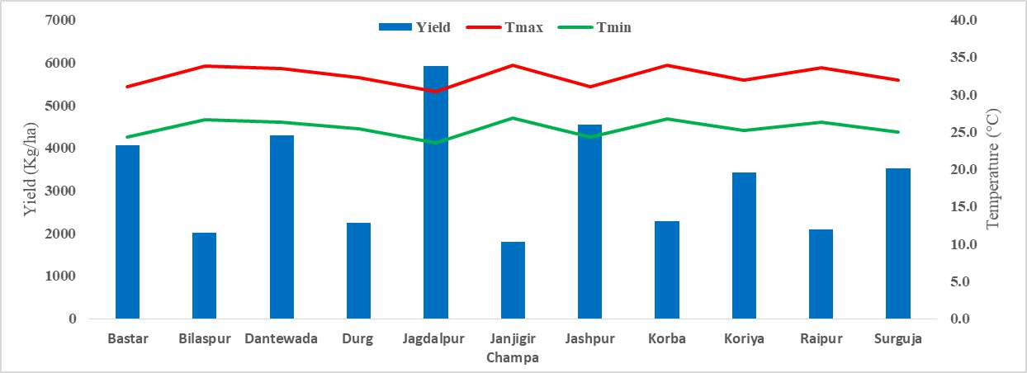
maximum temperature reduce rice yield. Increase in minimum temperature also reduces rice yield according to (Pathak et al., 2003). The reason for declined yield due to increased temperature as due to various detrimental effects of high temperature on rice such as accelerated crop growth cycle, pollen sterility, and reduced fertilization (Debnath et al., 2021).

Fig. 3 Variation of yield under RCP 4.5 during 2030 with Temperature in different district
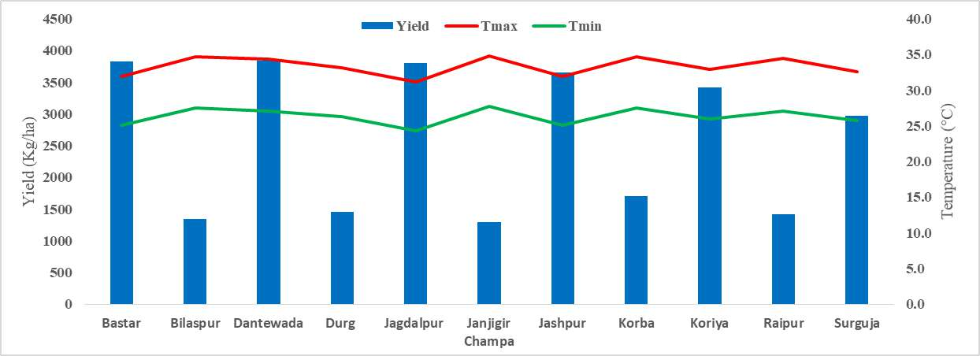

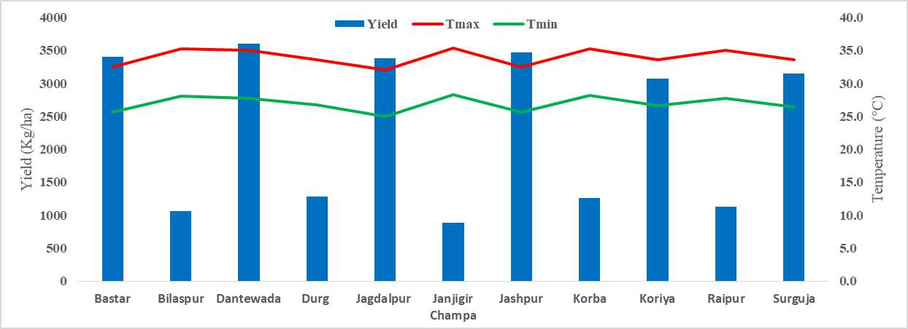
Fig. 4 Variation of yield under RCP 4.5 during 2050 with Temperature in different district
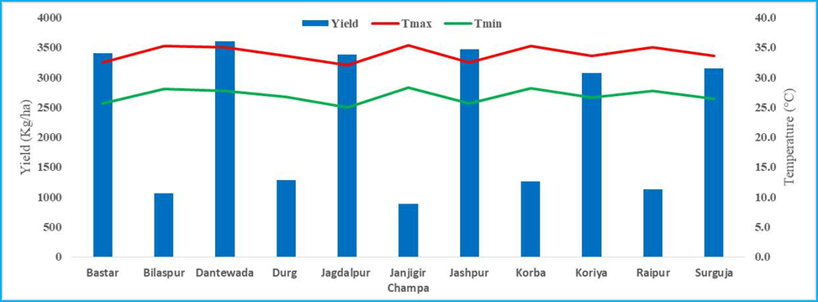Fig. 5 Variation of yield under RCP 4.5 during 2070 with Temperature in different district

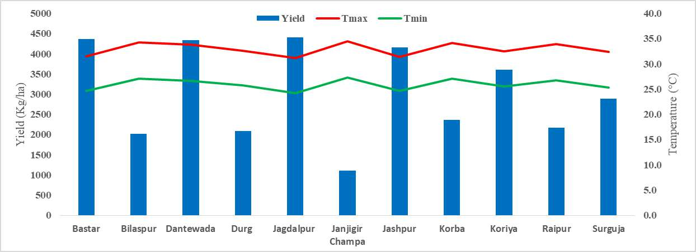

Fig. 6 Variation of yield under RCP 8.5 during 2030 with Temperature in different district
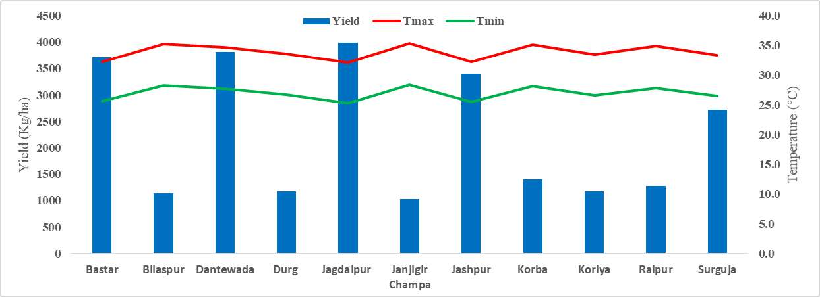

Fig. 7 Variation of yield under RCP 8.5 during 2050 with Temperature in different district
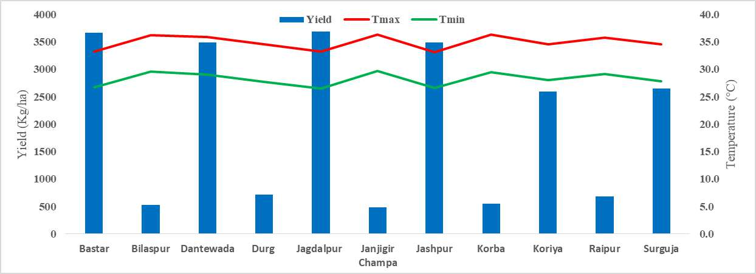

Fig. 8 Variation of yield under RCP 8.5 during 2070 with Temperature in different district

Discussion
The simulation results utilizing the DSSAT model, calibrated with 2021 and verified with 2022 AICRPM rice trial data, showed good accuracy in projecting rice phenology and yield throughout Chhattisgarh's agro-climatic zones (ACZs), hence verifying the model's dependability for climate impact assessment. Significant rises in both maximum and minimum temperatures are expected under future climate scenarios RCP 4.5 and RCP 8.5, especially in the Chhattisgarh Plain Zone (CPZ), where temperature rise could reach up to 3.8°C (Tx) and
5.7°C (Tn), so causing heat stress, shortened crop duration, and reduced yield. While Northern Hills Zone (NHZ) and Bastar Plateau Zone (BPZ) may see increasing yearly rainfall, CPZ is anticipated to get less rainfall during the vital Southwest monsoon season, therefore aggravating water stress problems. Rainfall estimates indicated varying patterns. Furthermore, displaying non-linear climatic trends, BPZ complicated attempts for response. These climatic changes imply that although NHZ and BPZ may gain from more water availability, heavy rainfall and heat surges might provide new difficulties for rice output in CPZ without adaptation. The findings highlight the necessity of region-specific policies like the acceptance of heat-tolerant rice cultivars, enhanced irrigation management, and changed planting dates to minimize the negative consequences of climate change. Confirming the regional sensitivity of Chhattisgarh to climate change, the expected warming trends and rainfall changes line with past studies by (Chaturvedi et al., 2011; Gupta & Jain, 2018). The consistency across many research emphasizes the need of region-specific climate resilience planning and helps to increase the reliability of the present simulation results.

Conclusion
The study successfully calibrated and validated the DSSAT model for rice yield prediction in Chhattisgarh’s diverse agro-climatic zones, demonstrating its effectiveness in simulating crop response under varying climatic conditions. With the Chhattisgarh Plain Zone most at danger of heat stress and water shortages possibly lowering rice output, climate forecasts show significant temperature rises and changed rainfall patterns by 2070. On the other hand, certain areas could get more rain, which presents both possibilities and problems. These results underline how urgently tailored adaptation strategies such as heat-tolerant cultivars, improved irrigation, and changed cropping calendars are needed to maintain rice output in the face of climate change. All things considered, this study offers legislators and farmers important new ideas to create climate-resilient rice farming methods in Chhattisgarh.

Disclaimer (Artificial intelligence)
Option 1:
Author(s) hereby declare that NO generative AI technologies such as Large Language Models (ChatGPT, COPILOT, etc.) and text-to-image generators have been used during the writing or editing of this manuscript.

References
Aggarwal, P. K. (2008). Global climate change and Indian agriculture: impacts, adaptation and mitigation. Indian Journal of Agricultural Sciences, 78(11), 911.
Amgain, L. P., Devkota, N. R., Timsina, J., & Bijay-Singh, B. (2006). Effect of climate change and CO 2 concentration on growth and yield of rice and wheat in punjab: simulations using CSM-CERES-Rice and CSM-CERES-Wheat models. Journal of the Institute of Agriculture and Animal Science, 27, 103–110.
Aswathi, K. P., Ajith, K., Ajithkumar, B., & Abida, P. S. (2022). Impact of climate change on rice yield under projected scenarios in central zone of Kerala. Journal of Agrometeorology, 24(3), 280–285.
Birthal, P. S., Khan, T., Negi, D. S., & Agarwal, S. (2014). Impact of climate change on yields of major food crops in India: Implications for food security. Agricultural Economics Research Review, 27(2), 145–155.
Change, I. P. O. C. (2001). Climate change 2007: Impacts, adaptation and vulnerability.
Genebra, Suíça.

Chaturvedi, R. K., Gopalakrishnan, R., Jayaraman, M., Bala, G., Joshi, N. V, Sukumar, R., &

Ravindranath, N. H. (2011). Impact of climate change on Indian forests: a dynamic vegetation modeling approach. Mitigation and Adaptation Strategies for Global Change, 16, 119–142.
Crespi, A., Renner, K., Zebisch, M., Schauser, I., Leps, N., & Walter, A. (2023). Analysing spatial patterns of climate change: Climate clusters, hotspots and analogues to support climate risk assessment and communication in Germany. Climate Services, 30, 100373.
Debnath, S., Mishra, A., Mailapalli, D. R., & Raghuwanshi, N. S. (2021). Identifying most promising agronomic adaptation strategies to close rainfed rice yield gap in future: a model-based assessment. Journal of Water and Climate Change, 12(6), 2854–2874.
Dhanya, P., & Ramachandran, A. (2016). Farmers’ perceptions of climate change and the proposed agriculture adaptation strategies in a semi arid region of south India. Journal of Integrative Environmental Sciences, 13(1), 1–18..
Goswami, P., & Verma, A. (2024). The Role of Renewable Energy in Rice Production in the Rice Bowl of Chhattisgarh.
Gupta, V., & Jain, M. K. (2018). Investigation of multi-model spatiotemporal mesoscale drought projections over India under climate change scenario. Journal of Hydrology, 567, 489–509.
Hong, Z., Runyuan, W., Yan, S., Heling, W., Kai, Z., Funian, Z., Yue, Q. I., & Fei, C. (2016). Progress and perspectives in studies on responses and thresholds of major food crops to high temperature and drought stress. Journal of Arid Meteorology, 34(1), 1.
Jaiswal, N., Soni, S., Nayak, S., & Sarawgi, A. K. (2024). To measures absolute change in
area, production and productivity of rice crop in different agro-climatic zone of Chhattisgarh state.
Jing, Q., Shang, J., Huffman, T., Qian, B., Pattey, E., Liu, J., Dong, T., Drury, C. F., & Tremblay, N. (2017). Using the CSM–CERES–Maize model to assess the gap between actual and potential yields of grain maize. The Journal of Agricultural Science, 155(2), 239–260.
Joshi, N. L., & Kar, A. (2009). Contingency crop planning for dryland areas in relation to climate change. Indian Journal of Agronomy, 54(2), 237–243.
Kamdi, P. J., Swain, D. K., & Wani, S. P. (2023). Developing climate change agro-adaptation strategies through field experiments and simulation analyses for sustainable sorghum production in semi-arid tropics of India. Agricultural Water Management, 286, 108399.
Khan, S. A. R., Razzaq, A., Yu, Z., Shah, A., Sharif, A., & Janjua, L. (2022). Disruption in food supply chain and undernourishment challenges: An empirical study in the context of Asian countries. Socio-Economic Planning Sciences, 82, 101033.
Liu, F., & Masago, Y. (2023). An analysis of the spatial heterogeneity of future climate change impacts in support of cross-sectoral adaptation strategies in Japan. Climate Risk Management, 41, 100528.
Man-xue, R. A. N., Jun-jun, D., Dong-bao, S. U. N., & Feng-xue, G. U. (2024). A review of the response characteristics of soil respiration to temperature and moisture changes under global climate change. Chinese Journal of Agrometeorology, 45(01), 1.
Pathak, H., Ladha, J. K., Aggarwal, P. K., Peng, S., Das, S., Singh, Y., Singh, B., Kamra, S. K., Mishra, B., & Sastri, A. (2003). Trends of climatic potential and on-farm yields of rice and wheat in the Indo-Gangetic Plains. Field Crops Research, 80(3), 223–234.
Rao, C. A. R., Raju, B. M. K., Rao, A. V. M. S., Rao, K. V, Rao, V. U. M., Ramachandran, K., Venkateswarlu, B., Sikka, A. K., Rao, M. S., & Maheswari, M. (2016). A district level assessment of vulnerability of Indian agriculture to climate change. Current Science, 1939–1946.
Singh, T. (2022). Economic growth and the state of poverty in India: sectoral and provincial perspectives. Economic Change and Restructuring, 55(3), 1251–1302.
Sreenath, A. V, Abhilash, S., & Ajilesh, P. P. (2023). Changes in the dynamical, thermodynamical and hydrometeor characteristics prior to extreme rainfall events along the southwest coast of India in recent decades. Atmospheric Research, 289, 106752.
Subash, N., Dutta, D., Ghasal, P. C., Punia, P., Mandal, V. P., & Chaudhary, V. P. (2023). Relevance of climatological information on spatial and temporal variability of Indian Summer monsoon rainfall (ISMR) in recent El Niño years and its impact on four important kharif crops over India. Climate Services, 30, 100370.
Wu HaiYan, W. H., Sun TianTian, S. T., Fan ZuoWei, F. Z., & Zhao LanPo, Z. L. (2014). The major food crops in response to climate change and its yield effect in Northeast of China.
Xu, Y., Zhao, M., Li, K., Zhao, Y., & WANG, C. (2023). Review on the research progress of agricultural adaptation to climate change and perspectives. Chinese Journal of Eco- Agriculture, 31(8), 1155–1170.

