**Evaluating the Water Purification Potential of *Azadirachta indica* (Neem): A Low-Cost Solution for Microbial and Chemical Contaminant Reduction in Guyana**

**Abstract**

Access to clean water remains a critical challenge in low- and middle-income countries (LMICs). This study investigates the potential of Azadirachta indica (Neem) as a natural, low-cost solution for water purification, focusing on its antimicrobial properties and impact on key water quality parameters. Water samples from Laluni Creek, Guyana, were treated with varying concentrations of Neem seed powder (0.5–3.0 g/L) and Neem leaf solutions (0.75–1.50 g/150 mL). Water samples were treated using a multi-layer filter and Neem extracts tested for microbial and chemical indicators. Results indicated that Neem leaves at 1.50 g/150 mL eliminated E. coli, meeting WHO guidelines, while higher seed concentrations (3.0 g/L) neutralized pH (7.63) but increased turbidity (17.2 NTU) and total dissolved solids (229 mg/L). Statistical analysis (Friedman test, χ² = 14.286, *p* < 0.001) confirmed significant effects of Neem concentration on post-filtration water quality. The study highlights Neem’s promise for microbial reduction but underscores challenges in turbidity and TDS management, suggesting the need for optimized formulations or hybrid treatments.

**Keywords:** *Neem, water treatment, E. coli, turbidity, low-cost filtration, SDG 6*

1. **Introduction**

Providing all people of the world with clean and safe drinking water is arguably the biggest global issue to be tackled in the 21st century. As of 2022, the World Health Organization (WHO) reported that 2.2 billion people globally do not use safely managed drinking water services and that 785 million people lack basic drinking water services, most of whom are located in low- and middle-income countries (LMICs) (Environment, Climate Change and Health (ECH), 2025). Water that is not safe because it is contaminated serves as the vessel for water borne diseases, such as cholera, dysentery, and typhoid, contributing to 505,000 deaths per year (WHO, 2023). In rural communities such as Guyana, with limited access to centralized water treatment plants, residents consume untreated surface water from rivers, creeks and streams, which poses a major public health threat (Environment, Climate Change and Health (ECH), 2025).

Chlorination and reverse osmosis are types of traditional water treatment methods that approach surface water sources of highly impoverished individuals. They are expensive and not accessible to those in poverty (Abebe et al., 2016). This has led to a growing focus on alternative supply methods that are less expensive and more natural (Abebe et al., 2016). One such method is the use of low cost coagulants like Azadirachta indica (Neem). Neem is a tropical tree that belongs to Meliaceae, the mahogany family and is indigenous to South Asia. It has been used in traditional therapeutics for centuries and in water purification processes to remove contaminants (Alzohairy, 2016; Sarkar et al., 2021). The clinical applications of Neem's water treatment abilities may support its use as an alternative to chemical approaches which are expensive, prohibitive, and contain toxic by-products (Maurya et al., 2018; Koul et al., 2022). Neem's coagulant property is the result of bioactive compounds such as azadirachtin, nimbidin, and quercetin, which are also bactericidal and coagulant and flocculant agents (Ali et al, 2021; Chandrasekaran et al., 2015; Sarkar et al., 2021).

While Neem shows promise as an alternative to conventional chemical treatments, achieving the destruction of both microbial and chemical contaminants requires more research, especially in decentralized systems. Most studies concentrated on lab scale experiments examining physical morphology with limited validation studies assessing the field efficacy (Pandey et al., 2020; Maurya & Daverey, 2018). Neem of various forms, powder and extracts have proven to be effective in decreasing microbial loads, such as E. coli reduction of 85%–90% from contaminated groundwater (Pandey et al., 2020); however, their efficacy in the physicochemical parameters of turbidity, total dissolved solids (TDS), or pH remain unclear. Studies examining the physicochemical variables exhibit tradeoffs; Khan et al. (2023) stated that Neem seed powder reduced turbidity by 65% in synthetic wastewater but added 20%–30% turbidity from organic leaching. Maurya and Daverey (2018) provided further support to these findings when they also observed that their treatment with Neem seed powder, obtained by drying Neem leaves, increased turbidity (average turbidity of untreated = 15.439 NTU; treated with 5mg, 20mg, 100mg = average turbidity range of 18.448–21.634 NTU) and/or TDS (average TDS of untreated = 30.64 mg L-1; treated with 5mg, 20mg, 100mg = TDS range average of 73.250–64.440 mg L-1) and chemical oxygen demand (COD; the average COD of untreated (sample) = 20.145 mg L-1; treated with 5mg, 20mg, 100mg = average COD range of 60.37–87.83 mg L-1). Aziz et al. (2023) cautioned that some plant-based coagulants can add TDS and COD to treatment, which reinforces hybrid methods that balance a better treated product. Recent evidence has been presented, examining the potential of nanotechnology related to Neem treatments, most recently in the form of Neem leaf extract-silver nanoparticle composites, achieving 99.9% bacterial inactivation of Escherichia coli and Salmonella sp. within 60 minutes (Namratha & Monica, 2013). However, concerns with scalability and economic feasibility present known barriers to implementation (Selvaajan et al., 2023). While the actions of azadirachtin are well documented, (i.e., disrupting the integrity of bacterial cells by damaging membranes, disrupting adenosine triphosphate sources) (Ali et al., 2021), and Alzohairy (2016) also confirmed virucidal effects against enveloped viruses , much is still unknown regarding longer-term stability, and rates of byproduct formation (Environment, Climate Change and Health (ECH), 2025).

Examining water purification problems in low resource settings reveals the need for assessing biological treatments aimed at reducing costs when compared to traditional methods. There is growing evidence of Bacillus subtilis bioflocculants, which not only inhibited coliform bacterial populations in well water, stream water, and even abattoir water samples but also exhibited coagulation (Omiyale & Ekundayo, 2019). In the same category, Moringa oleifera seed powder possesses coagulating and inhibitory effects, although in some cases, it has been suggested that a chemically formulated disinfectant, such as chlorine, would be more effective (Omiyale & Ekundayo, 2019). These findings suggest the potential for natural, biologically derived agents to contribute to water purification strategies, warranting further investigation into other readily available natural resources, such as *Azadirachta indica* (Neem), for their water treatment capabilities in similar contexts.

While studies have demonstrated antimicrobial potential, few have assessed combined physiochemical and microbial performance in field-like, low-cost systems. This study fills these gaps and focuses on the multiple uses of Neem seeds/leaves in a low-cost filtration system to evaluate the effectiveness of these systems measured through microbial contamination (E. coli, total coliforms) and water quality indicators (pH, turbidity, TDS). This project adds to the body of literature on nature-based water treatment solutions and directly relates to the Sustainable Development Goals, particularly SDG 6 related to clean water and universal access to water without contamination. By connecting laboratory-based work with practical applications, this research engages with scaling sustainable and cost-effective water purification solutions for under-served communities.

1. **Materials and Methodology**

This study was conducted in a controlled environment at the GWI Water Quality Lab to ensure standardised conditions for experimentation and illustration purposes.

**2.1 Apparatus**

**Laboratory Testing Equipment**

Used at the Guyana Water Inc. Water Quality Laboratory for analyzing water quality parameters such as pH, conductivity, salinity, turbidity, total dissolved solids (TDS), and microbial contamination (E. coli and Total Coliforms). This included Hach DR6000/DR3900 Spectrophotometer, Portable Multiparameter Meter, Spectrophotometer, Benchtop Multiparameter Meter, and microbiological testing kits.

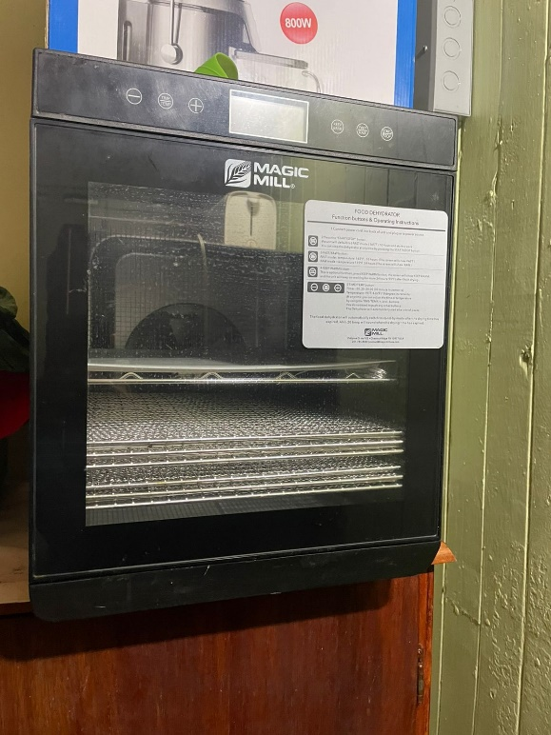

Image 2: Grinder/ Blender (This was used to grind dried Neem leaves and seeds into a fine powder, which was then used in various concentrations for water treatment.)

Image 1: Dehydrator (The Dehydrator was utilized to the dry Neem leaves and seeds before they were ground into powdered form. This was done to ensure consistency in treatment application.)

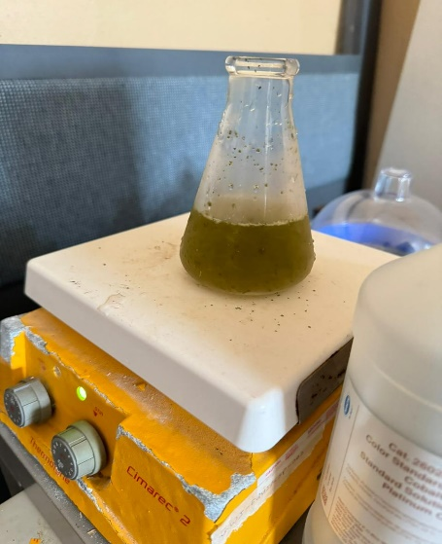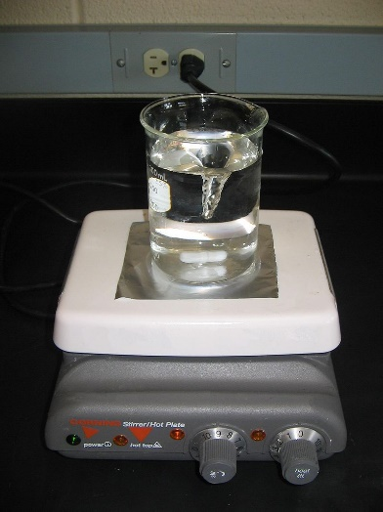

Image 3: Magnetic Stirrer (This was used to thoroughly mix Neem leaves and seed powder into water samples, ensuring even distribution of the treatment.)

Image 4: Water Filter Assembly (Constructed and assembled by students at Guyana Water Incorporated, this low-cost filtration system was designed to test the efficacy of Neem-based treatments)

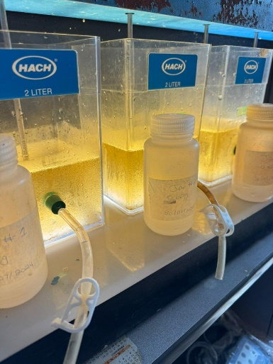

**Image 5: Jar Test Apparatus (**Used to simulate coagulation and flocculation processes, allowing for the assessment of Neem's effectiveness in removing contaminants from simple water)

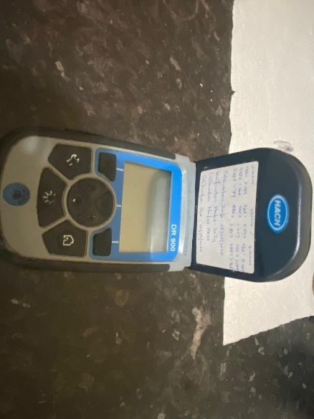

**Image 7: Portable Multiparameter Meter**

**(Tested: Colour)**

**Image 6: Hach DR6000/DR3900 Spectrophotometer**

**(Tested: pH)**

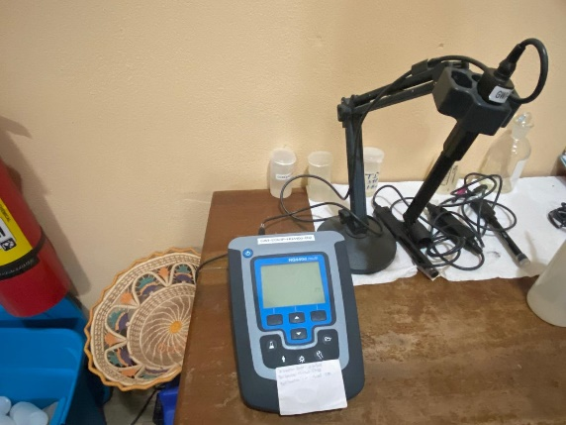

**Image 8: Spectrophotometer**

**(Tested: Turbidity)**

**Image 9: Benchtop Multiparameter Meter: Hach HQ440d**

**(Tested: Salinity, Conductivity and TDS)**

**Additional Apparatus**

* Neem Seeds and leaves
* Sand
* Stone
* Charcoal
* 500ml water bottles
* Sample bottles
* Knife/blade
* All-inclusive water sample testing kit (which will be provided by the lab)
* Deionized water
* Sample water
* Cloth
* Storage containers
* 70% Alcohol
* Processor
* An electronic scale and balance

**2.2 Method**

**Step 1: Picking, Drying and Graining of Need Leaves and Seem:**

The process began with the collection of neem leaves and seeds, which were thoroughly rinsed with water. The leaves were then placed in a dehydrator set at 110°F and left to dry for 24 hours, ensuring all moisture was completely removed. Once dried, the leaves were ground into a fine powder using a processor and carefully stored in a sterilized glass container.

The seeds underwent a similar but slightly different treatment. First, they were peeled to remove the outer layer. Then, they were placed in the dehydrator at a higher temperature of 165°F for a longer duration of 72 hours to ensure complete moisture removal. After drying, the seeds were also ground into a powder using a processor. Like the leaf powder, the ground seeds were stored in a separate sterilized glass container for future use.

**Step 2: Washing and Drying of Sand and Stone and Graining of Charcoals**

**Washing and Drying of Stone**

The stones were collected and washed extensively with tap water in order to eliminate any particles and impurities present among them. Following the even placement of the stones on a baking sheet, they were subjected to a temperature of 250o F for duration of three (3) hours. This baking process serves as a means of sterilisation and disinfection, while also preserving the structural integrity of the stones. The dried sand was then kept in a sterilized glass container.

**Washing and drying of sand**

The sand was subjected to a similar procedure as the stone, with the only difference being the baking duration. The sand was baked at a temperature of 250°F for four (4) hours. This was done since the sand particles are smaller and have a higher water retention capacity compared to the stone. The dried stones were then kept in a sterilized glass container.

**Graining of charcoals**

The charcoals were crushed on a sterile baking sheet into small fragments, about 1/3 of an inch in size, to aid the grinding process in the processor, resulting in powdered activated charcoal. The activated charcoal was then kept in a sterilized glass container.

**Step 3: Sampling Design**

**Sterilization of sampling bottles**

Forty-eight 500 mL sample bottles were cleansed using a dishwashing liquid solution, washed three times, and then rinsed three times with tap water and once with deionised water (DI Water). The bottles were subsequently inverted and allowed air dry for 24 hours.

**Sample Collection**

The water samples were obtained from Laluni Creek, located on the Soesdyke Highway. These samples represent the baseline water conditions. Each sample was rinsed three times with creek water before being collected. The samples were taken one (1) foot below the water's surface and away from the creek bank. Each sample bottle was labelled appropriately, indicating the date, time, name of sampler and location of collection. The bottles were then placed on ice within a cooler and taken to GWI’s water quality laboratory.

**Step 4: Construction of filters**

The bottom of one bottle was detached (Bottle A), while the cap of a second bottle was removed (Bottle B). The initial bottle, with its bottom removed, was placed upright within the second bottle, which had its top removed. The first bottle was then inserted upside down into the top of the second bottle, serving as a funnel for filtering the water. The filter media were subsequently inserted into bottle A, starting with a sterile cloth at the base, followed by a layer of stone that was 3 inches thick, then a layer of sand that was 2 inches thick, and finally, a layer of charcoal that was 1 inch thick, completing the water filter. This process was performed five additional times, ensuring that each bottle A was firmly nested within the one directly below it to prevent any leaking.

**Image 10: Bottle A and Bottle B**

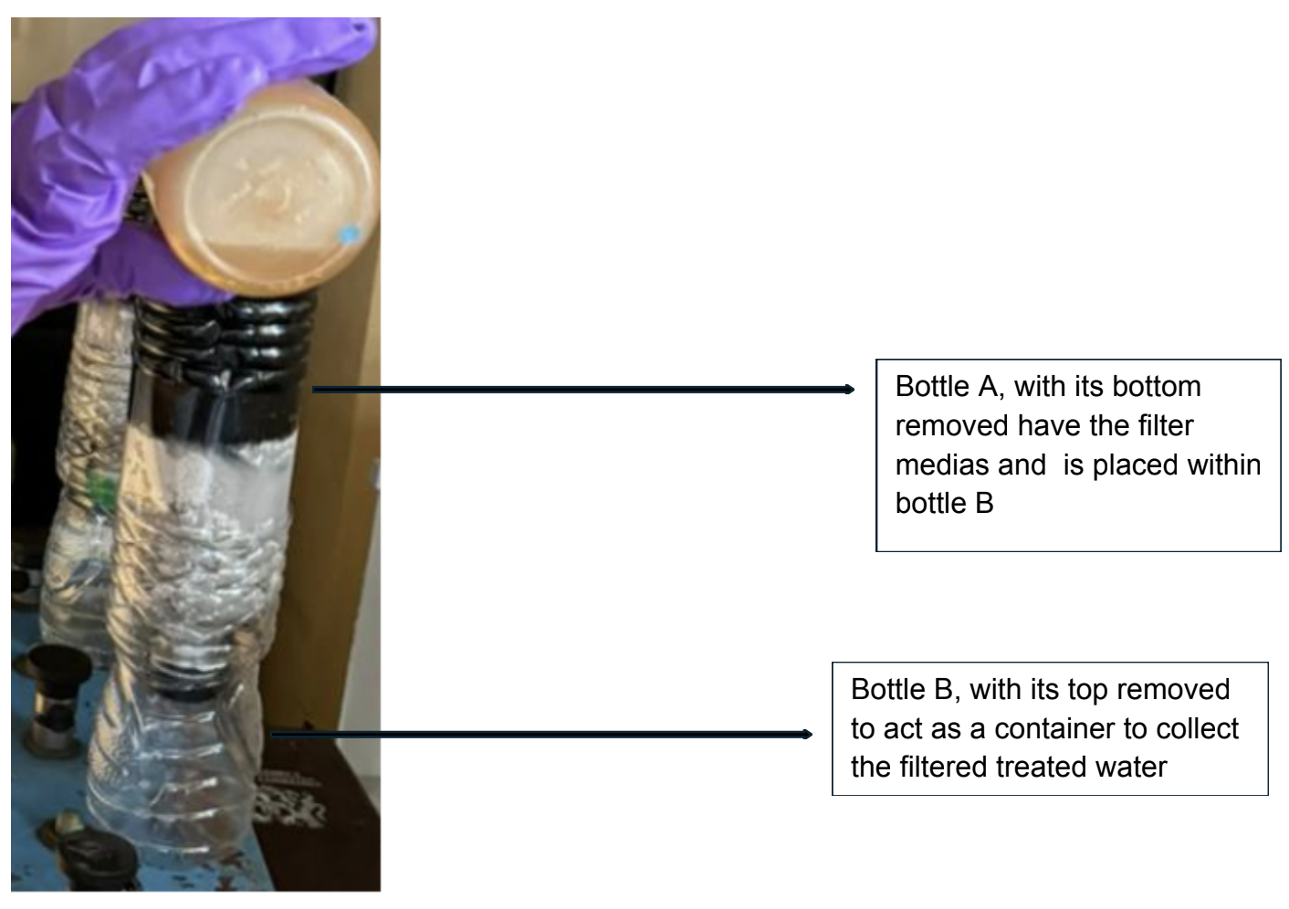

**Step 5: Testing**

**Neem seed jar testing (Flocculation) and Filtration**

Four (4) jars were filled with 1 litre of water from the baseline samples to be mixed. An electronic scale and balance were used to measure 0.5g, 1.0g, 2.0g, and 3.0g of pulverised Neem seeds. These measurements were then placed in separate jars of water. The jars were sequentially labelled 1-4, with jar 1 containing a concentration of 0.5g/L and the concentration increasing in ascending order up to jar 4. The jars were then positioned on the jar test apparatus.

**Mixing:**

1. **Rapid Mixing:** The paddles first stirred the baseline water and the coagulants (Neem seeds) at a high speed of 300 RPM for 2 minutes. This was to ensure a thorough mixing of the coagulants with the water.
2. **Slow Mixing:** The paddles were then set to stir at a speed of 30 RPM for an extended period of 20 minutes. This promotes the aggregation of small particles into larger flocs.
3. **Settling:** After mixing, the stirring was stopped, and the jars were allowed to sit undisturbed for 30 minutes. During this time, the flocs settled to the bottom of the jars.

After settling, samples of 150ml were taken from each jar and tested for the following parameters: pH, Conductivity, Salinity, Turbidity, Total Dissolved Solids (TDS) and Colour. The remaining water within each jar had passed through its filter and was tested for the parameters mentioned above.

**Neem leaves microbial test**

Three (3) conical flasks were used, each containing 150 mL of baseline sample water. The flasks were labelled as samples 1, 2, and 3. Utilising an electronic scale and balances, measurements of 0.75g, 1.00g, and 1.25g were obtained and subsequently placed into separate conical flasks containing water. The conical flasks containing the water sample and Neem leaves were placed on a magnetic stirrer for 10 minutes to ensure uniform mixing. After mixing, the solutions of 0.75 g/150 mL, 1.00 g/150 mL, and 1.25 g/150 mL were strained using a sterilised strainer and transferred into labelled sampling bags for testing for Total Coliforms and E. coli. The recording of the microbiological tests was obtained 24 hours after.

**Step 6: Evaluation**

Following the collection of data for the baseline water samples from Neem seed jar testing, filtered flocculation, and Neem leaf solutions, a comparison analysis was conducted to assess the efficacy of Neem seeds and leaves. The disparities in water quality indicators between the treated waters and the baseline water samples were documented.

**Image 11: Schematic of Filtration System**

1. **Results**

**Table 1: Descriptive Statistics of Key Variables**

|  |  |  |  |  |  |  |  |  |
| --- | --- | --- | --- | --- | --- | --- | --- | --- |
| **Variable** | **N** | **Mean** | **Std. Deviation** | **Minimum** | **Maximum** | **25th Percentile** | **50th Percentile (Median)** | **75th Percentile** |
| **After Filtration** | 28 | 130.23 | 130.634 | 0 | 434 | 7.60 | 136.50 | 201.05 |
| **Neem Seed**  **Concentration** | 28 | 2.37 | 1.317 | 1 | 4 | 0.88 | 2.50 | 3.75 |

Table 1 presents descriptive statistics for key variables in the study. Post-filtration values (likely referring to a water quality parameter after treatment) exhibit substantial variability, as indicated by a high standard deviation (SD = 130.634). Neem seed concentrations were tested across a range from 1 (representing 0.5 g/L) to 4 (representing 3.0 g/L), with a median concentration of 2.50. This table provides an overview of the distribution and central tendency of these critical variables.

**Microbial Contamination Reduction**

| **Parameter** | **WHO Guideline** | **Raw Water** | **0.75g/150mL** | **1.00g/150mL** | **1.25g/150mL** | **1.50g/150mL** |
| --- | --- | --- | --- | --- | --- | --- |
| **Total Coliform** | 0/100 mL | TNTC | TNTC | TNTC | TNTC | TNTC |
| **E. coli** | 0/100 mL | 12 | 36 | 10 | 2 | 0 |

**Table 2: Coliform and E. coli Levels**

Table 2 illustrates the impact of varying Neem leaf concentrations on microbial contamination levels. The results indicate that a concentration of 1.50g/150mL of Neem leaves effectively eliminated *E. coli*, achieving the World Health Organisation (WHO) guideline of 0/100 mL. However, total coliform levels remained "Too Numerous To Count" (TNTC) across all tested Neem concentrations, suggesting a limited effect on this broader group of bacteria.

**Statistical Analysis of Neem Seed Effects**

**Table 3: Friedman Test Results**

| **Statistic** | **Value** |
| --- | --- |
| **N** | 28 |
| **Chi-Square** | 14.286 |
| **df** | 1 |
| **Asymptotic Sig. (p)** | 0.000 |

**Table 4: Post-hoc Nemenyi Test Results**

|  |  |
| --- | --- |
| Concentration | Ranks |
| 0.5g/L | 1.14 |
| 1.0g/L | 1.14 |
| 2.0g/L | 1.86 |
| 3.0g/L | 1.86 |

Table 3 presents the statistical analysis of Neem seed concentration effects on water quality. A Friedman test revealed a significant overall effect of Neem concentration (p < 0.001). However, post-hoc Nemenyi tests indicated that no specific Neem concentrations significantly outperformed others in pairwise comparisons, as the absolute differences in mean ranks were less than the critical difference. This suggests that while Neem concentration does influence water quality parameters, the specific concentrations tested did not yield statistically distinguishable improvements over one another.

**Table 5: Water Quality Parameters by Neem Concentration**

|  |  |  |  |  |  |  |  |  |
| --- | --- | --- | --- | --- | --- | --- | --- | --- |
| **Neem Seed (g/L)** | **N** | **pH Mean** | **pH Std. Dev.** | **pH Min** | **pH Max** | **pH Median** | **Conductivity (μS/cm)** | **Salinity** |
| 0.5 | 7 | 7.53 | 0.083 | 7.47 | 7.63 | 7.59 | 306 | 0.16 |
| 1.0 | 7 | 6.96 | 0.081 | 6.84 | 7.08 | 6.92 | 366 | 0.19 |
| 2.0 | 7 | 7.59 | 0.043 | 7.55 | 7.63 | 7.59 | 369 | 0.19 |
| 3.0 | 7 | 7.63 | 0.009 | 7.63 | 7.64 | 7.63 | 434 | 0.23 |

Table 5 presents the impact of varying Neem seed concentrations on key water quality parameters. The data reveals that pH was generally neutralized within the WHO-recommended range (6.5-8.5), except at a concentration of 1.0 g/L. Conductivity and salinity exhibited a positive correlation with Neem concentration, increasing as the concentration increased. Turbidity data (detailed in the full document) did not show a consistent trend related to Neem concentration.

**Comparison with WHO Standards**

**Table 6: Key Parameters vs. WHO Guidelines**

| **Parameter** | **WHO Guideline** | **Raw Water** | **Neem Treatment (Median)** | **Result** |
| --- | --- | --- | --- | --- |
| **pH** | 6.5–8.5 | 5.31 | 7.59 (2.0g/L) | Within guideline |
| **Conductivity (μS/cm)** | ≤1000 | 26.8 | 434 (3.0g/L) | Exceeded |
| **E. coli** | 0/100 mL | 12 | 0 (1.50g/150mL) | Met at highest dose |

Table 6 compares key water quality parameters in raw water and Neem-treated water against World Health Organization (WHO) guidelines. Neem treatment effectively adjusted the pH to fall within the acceptable range (6.5-8.5) and successfully eliminated *E. coli*, meeting WHO standards at the highest dose tested (1.50 g/150 mL). However, the conductivity increased after Neem treatment, exceeding the raw water level, but staying well within the WHO guidelines.

1. **Discussion**

The promise of Azadirachta indica (Neem) as an inexpensive, natural method for water treatment has been demonstrated in this study, particularly with its ability to eradicate microbial contaminants. The results contribute to the growing body of literature supporting the use of plant-based coagulants as a viable and sustainable alternative to conventional water treatment, particularly in resource-limited settings. However, the results also reveal some serious issues that need to be worked on before one can utilise Neem for practical purposes.

One of the significant findings of this study was the complete elimination of E. coli at a Neem leaf concentration of 1.50 g/150 mL, which falls within the limits for safe drinking water as set by the WHO. This is supported by recent studies that declare Neem's bioactive compounds, such as azadirachtin and nimbidin, have antimicrobial properties by disrupting bacterial cell membranes and metabolic processes (Ali et al., 2021; Namratha & Monica, 2013. Nonetheless, a lack of total coliform reduction indicates that Neem's antimicrobial activity may be more selective, especially since it is known that Gram positive Staphylococcus aureus is less sensitive as compared to Gram negative Escherichia coli (E. coli) bacteria due to differences in their cell walls (Sarkar et al., 2021; Koul et al., 2022). This selectivity highlights the need to further study the activity profile for Neem, and possible interactions with other natural coagulants such as Moringa oleifera which, in prior studies, showed greater reductions of microorganisms than Neem (Pandey et al., 2020). Neem seeds effectively reduced pH levels: however, with increased concentrations, undesirable increases in turbidity and total dissolved solids (TDS) were observed. This phenomenon has also been observed in studies of plant-based coagulants where organic leachates present in natural materials give rise to new challenges such as water clarity and the chemical load of the (Maurya & Daverey, 2018; Khan et al., 2023).

The statistical testing results relayed in this study confirm that Neem concentration impacts water quality, yet the post-hoc tests indicate there was no benefit from a specific dose. This finding supports the consideration of a complementary approach to mitigate the adverse effects on the physicochemical parameters of Neem-based treatments for potable water (i.e., adsorption or filtration).

Neutral factors to consider over the long term include relevant stability testing and by-product studies, which are necessary to evaluate the feasibility of Neem-based treatments in continuous use. Residual Neem compounds, like azadirachtin and its derivatives, may present environmental or health problems if left untested or unassessed. Furthermore, caution is warranted regarding the ecological effects of these compounds, as reported in the literature, such as Maranho et al. (2014), which found that prolonged exposure to Neem extracts had adverse effects on Daphnia magna, a vital freshwater organism. In addition, a similar finding by Selvarajan et al. (2023) regarding the impact of Neem leftovers on beneficial soil microorganisms revealed a reduction in microbial functions in soil ecosystems. Many of the environmental implications continued in the need for a risk assessment agenda yet are almost absent from the conclusions of assessments of Neem as a water treatment option.

1. **Conclusion**

This research provides empirical evidence supporting the potential of *Azadirachta indica* (Neem) as a viable and sustainable solution for water treatment, with a particular emphasis on mitigating microbial contamination in resource-constrained environments. Quantitatively, the study shows that a concentration of Neem leaves at 1.50 g/150 mL will eliminate E. coli from a baseline of 12 CFU/100mL to 0 CFU/100mL, and the water would then be compliant with WHO's safe drinking water guidelines. Statistical analysis (Friedman test, χ² = 14.286, *p* < 0.001) further confirms a significant overall effect of Neem seed concentration on post-filtration water quality parameters. Specifically, higher Neem seed concentrations (2.0-3.0 g/L) facilitate the neutralization of pH, bringing it within the WHO-recommended range of 6.5-8.5, as evidenced by an improvement from a raw water pH of 5.31 to a treated range of 7.59-7.63. Concurrently, conductivity exhibits an increase with Neem seed concentration, reaching 434 μS/cm at 3.0 g/L, albeit remaining below the WHO guideline limit of 1000 μS/cm.

However, it is imperative to acknowledge the limitations identified within this study. The observed increases in turbidity and total dissolved solids (TDS) at elevated Neem seed concentrations present a challenge that warrants careful consideration. These findings suggest that while Neem demonstrates promising antimicrobial and pH-balancing properties, its application necessitates strategic optimization to address potential physicochemical trade-offs. Further investigation is therefore crucial to explore hybrid treatment methodologies and assess long-term stability, thereby ensuring the consistent and reliable performance of Neem-based water treatment systems.

In summary, this research contributes to the growing body of knowledge supporting the use of natural coagulants in water treatment, particularly in settings where conventional technologies may be economically or logistically prohibitive. By addressing the identified limitations and pursuing the recommended avenues for future research, Neem-based systems have the potential to play a significant role in achieving Sustainable Development Goal 6, which aims to ensure universal access to clean and safe water resources.

Top of Form

1. **Recommendations**

Future research should assess the optimization of hybrid systems that include Neem with other engineered or natural materials to increase overall treatment efficiency while reducing unintended ecological problems. In addition, scaling to larger applications of nanotechnology-enhanced Neem would also be important like applying Neem via silver nanoparticle composites (Namratha & Monica, 2013) to repel microbial growth while improving scalability and cost barriers. Field scale verifications and implementation of community level studies are critical in assessing the practical implications of these ideas.

**Disclaimer (Artificial intelligence)**

Option 1:

Author(s) hereby declare that NO generative AI technologies such as Large Language Models (ChatGPT, COPILOT, etc.) and text-to-image generators have been used during the writing or editing of this manuscript.

**References**

Abebe, L., Chen, X., & Sobsey, M. (2016). Chitosan coagulation to improve microbial and turbidity removal by ceramic water filtration for household drinking water treatment. International Journal of Environmental Research and Public Health, 13(3), 269. <https://doi.org/10.3390/ijerph13030269>

Ali, E., Islam, M. S., Hossen, M. I., Khatun, M. M., & Islam, M. A. (2021). Extract of neem (Azadirachta indica) leaf exhibits bactericidal effect against multidrug resistant pathogenic bacteria of poultry. Veterinary Medicine and Science, 7(5), 1921–1927. <https://doi.org/10.1002/vms3.511>

Alzohairy, M. A. (2016). Therapeutics role of Azadirachta indica (Neem) and their active constituents in diseases prevention and treatment. *Evidence-Based Complementary and Alternative Medicine, 2016*, 7382506. <https://doi.org/10.1155/2016/7382506>

Aziz, K. H. H., Mustafa, F. S., Omer, K. M., Hama, S., Hamarawf, R. F., & Rahman, K. O. (2023). Heavy metal pollution in the aquatic environment: efficient and low-cost removal approaches to eliminate their toxicity: a review. *RSC Advances*, *13*(26), 17595–17610. https://doi.org/10.1039/d3ra00723e

Chandrasekaran, N., Jayakumar, J., Makwana, P., Kumar, S., Mukherjee, A., & Sundaramoorthy, R. (2015). Antibacterial activity of neem nanoemulsion and its toxicity assessment on human lymphocytes in vitro. *International Journal of Nanomedicine*, 77. https://doi.org/10.2147/ijn.s79983

Environment, Climate Change and Health (ECH). (2025, February 24). *WHO global water, sanitation and hygiene: annual report 2023*. https://www.who.int/publications/i/item/9789240106079

Khan, Q., Imran, U., Ullman, J. L., & Khokhar, W. A. (2022). Turbidity removal through the application of powdered azadirachta indica (neem) seeds. *Mehran University Research Journal of Engineering and Technology*, *42*(1), 1. https://doi.org/10.22581/muet1982.2301.01

Krishnani, K. K., Gupta, B. P., Joseph, K. O., Muralidhar, M., & Nagavel, A. (2002). Studies on the use of neem products for removal of ammonia from brackish water. Journal of Environmental Science and Health, Part A, 37(5), 893–904. <https://doi.org/10.1081/ESE-120003595>

Lwasa, A., Mdee, O. J., Ntalikwa, J. W., & Sadiki, N. (2024). Performance analysis of plant-based coagulants in water purification: a review. *Discover Water*, *4*(1). https://doi.org/10.1007/s43832-024-00171-0

Maranho, Lucineide & Botelho, Rafael & Inafuku, M. & Nogueira, L. & Olinda, Ricardo & Sousa, B.A. & Tornisielo, V.L.. (2014). Testing the Neem Biopesticide (Azadirachta indica A. Juss) for Acute Toxicity with Danio rerio and for Chronic Toxicity with Daphnia magna. Journal of Agricultural Science and Technology. 16. 105-111.

Maurya, S., & Daverey, A. (2018). Evaluation of plant-based natural coagulants for municipal wastewater treatment. 3 Biotech, 8(1). <https://doi.org/10.1007/s13205-018-1103-8>

Namratha, N., & Monica, P. V. (2013). Synthesis of silver Nanoparticles using Azadirachta indica (Neem) extract and usage in water purification. *Asian Journal of Pharmaceutical Technology, 3*(4), 170-174.

Omiyale, F. B., & Ekundayo, F. O. (2019). Comparative Effects of Conventional and

Non-Conventional Flocculants and Disinfectants on Microbial Contaminants in Water Purification. Journal of Advances in Microbiology, 18(3), 1–15. https://doi.org/10.9734/jamb/2019/v18i330172

Pandey, P., Khan, F., Ahmad, V., Singh, A., Shamshad, T., & Mishra, R. (2020). Combined efficacy of Azadirachta indica and Moringa oleifera leaves extract as a potential coagulant in ground water treatment. SN Applied Sciences, 2(7). <https://doi.org/10.1007/s42452-020-3124-2>

Sarkar, S., Singh, R. P., & Bhattacharya, G. (2021). Exploring the role of Azadirachta indica (neem) and its active compounds in the regulation of biological pathways: an update on molecular approach. *3 Biotech*, *11*(4). https://doi.org/10.1007/s13205-021-02745-4

Selvarajan, V. S., Selvarajan, R., Pandiyan, J., & Abia, A. L. K. (2023). Unveiling the Potency and Harnessing the Antibacterial Activities of Plant Oils against Foodborne Pathogens. Microbiology Research, 14(3), 1291–1300. <https://doi.org/10.3390/microbiolres14030087>

*UN Guyana Annual Results Report 2023*. Guyana. https://guyana.un.org/en/269507-un-guyana-annual-results-report-2023

Koul, B., Bhat, N., Abubakar, M., Mishra, M., Arukha, A. P., & Yadav, D. (2022). Application of Natural Coagulants in Water Treatment: A Sustainable Alternative to Chemicals. *Water*, *14*(22), 3751. https://doi.org/10.3390/w14223751