Population Assessment of Economically Valuable Threatened Timber Species Distributed in Chhattisgarh Forest Divisions, India

ABSTRACT

Aims: The present study deals to document the distribution of economically important threatened tree species in the different forest divisions of Chhattisgarh state. This research intends to provide researchers with the necessary information to locate these species for initiation of conservation programs within the region.
Study design: The systematic random sampling method was used for tree sampling.
Place and Duration of Study: Forest divisions selected for documentation of tree species spread across over Raigarh, Jashpur, Dharamjaigarh, Korba, Bilaspur, Gourela-Pendra-Marwahi, Kawardha, Mahasamund, Gariyaband, Kanker, Dhamtari, Kondagaon, West Bhanupratapur, Jagdalpur, Sukma and Dantewara divisions.The survey was conducted for two years from 2021 to 2023.
Methodology: To identify regions with greater species richness, sample plots were laid out in the forest division. A total of 12.8 hectares were covered by 320 sample plots (20 m × 20 m) spaced 100 m apart. Tree height and girth at breast height were measured with a Range Finder and Measuring Tape. Coordinates of each plot were recorded with a Garmin GPS. Relative density was calculated (Number of individuals of a species / Total number of individuals of all species) x 100. Distribution maps of targeted species were prepared using ArcGis 10.8 sofware.
Results: Survey of 16 Forest Divisions in Chhattisgarh revealed 24 threatened tree species. Buchanania lanzan and Shorea robusta were the most widespread found in all divisions. Gariyaband division exhibited the highest number of threatened species (16), whereas Kondagaon and West Bhanupratappur had the least (7).
Conclusion: This study identifies the distribution of threatened tree species across Chhattisgarh Forest Divisions. The information has assumed significance in the wake of conservation, planning and the development of species distribution models. The resulting data, including distribution maps of targeted species, will enable conservationists to locate areas for preservation efforts.
Keywords: Chhattisgarh forest division, Conservation, Distribution mapping, Economic importance, Population assessment and Threatened tree species

1. INTRODUCTION

Trees are among the most valuable gifts of nature and are essential part of every terrestrial ecosystem [1]. Trees provide numerous direct and indirect benefits including carbon sequestration to making cities more liveable [2]. The trees provide timber as a raw material for various industries to manufacture wood-based products i.e. Paper & Pulp, Plywood, Particle Boards, Furniture, Cosmetics, Beverages and Construction etc. Trees are the source of Medicine, Gums, Oleoresins, Resins, Fibres, Tannins, Cutch and Katha, Dyes, Fruits, Essential oils and more articles of economical important.

Each tree species exhibits unique characteristics, some are deciduous in nature and others are evergreen, some have wonderful leaves or fruits, whereas others have beautiful blossoms, some have scents, while others are unattractive yet economical important [1]. Because of these unique characteristics some are directly consumable and others are used for other purposes. For instance, Gardenia gummifera fruits can directly be consumed by humans and animals whereas the Cleistanthus collinus has toxic properties is used for deliberate self-harm [3]. Over exploitation of forest leads to loss of biodiversity, fragmentation of habitat, deforestation and climate change, soil degradation, soil erosion besides having economic consequences, loss of traditional knowledge, social and cultural impact etc. The decline of wild populations further leads to species extinctions, consequently reductions to overall biodiversity [4].

Globally 22,035 tree species are under threatened category, approximately one third of the global tree species are at risk of becoming extinction [5]. The extinction of tree species directly affects the survival of the life forms on the earth. Hence, conservation of these economically important tree species is need of the hour before they permanently vanish from their habitat. There is a striking absence of recent and thorough assessments on the populations of important timber species in the forest areas of Chhattisgarh. Most research on forest has either included all forest species or centered on conservation without looking closely at the populations of timber trees. Moreover, not enough assessments are done for each region, so there is a big lack of details about species local distribution, how easily they can come back and what dangers they are facing. So, it is important to focus on the documentation of the economical important threatened tree species and its distribution in different forest divisions of the Chhattisgarh state to help researchers to find the location of threatened tree species existing in Chhattisgarh for launching its conservation / breeding program.

2. methodology

Study Area:

The study site was selected in different forest divisions of Chhattisgarh. Chhattisgarh's geographical location ranges from 17°46' to 24°5' north latitude and
80°15' to 84°20' east longitude, with an average rainfall of 1400 mm [6] (Figure 1). The overall geographical area of the state is approximately 1,35,192 square kilometers. Chhattisgarh is one of the most biodiverse states in the country, with around 55,811.75 square kilometers of forest cover, accounting for 41.28 % of its entire geographical area. The state of Chhattisgarh accounts for 8.15 % of India's total forest cover (520365.32 square kilometers) [7].
The study was conducted in sixteen distinct Forest Divisions in the Indian state of Chhattisgarh. Raigarh, Jashpur, Dharamjaigarh, Korba, Bilaspur, Gourela-Pendra-Marwahi (GPM), Kawardha, Mahasamund, Gariyaband, Kanker, Dhamtari, Kondagaon, West Bhanuprattapur, Jagdalpur, Sukma, and Dantewara forest division were selected. Collection of field data and its documentation of prioritized tree species were carried out during 2021 – 2023 year. To ensure unbiased and representative sampling of each tree species, sampling plots were selected using a systematic random sampling technique. Areas with increased species diversity within each specified forest division were identified using the relevant forest division maps. To count trees, twenty (20) sample plots measuring 20 m x 20 m (400 m²) were set up in each forest divisions. To ensure sampling consistency, the plots were spaced at regular 100-meter intervals. A total of 320 sample plots were surveyed, covering an area of 12.8 hectares. Every tree in each 20 x 20 m sample plot was counted. The following metrics were measured for every single tree that was encountered:
Height: Tree's height was measure with the help of Range Finder.
Girth at Breast Height (GBH): Using standard measuring tapes, the circumference of the tree trunk at a height of 1.37 meters (4.5 feet) above ground level was determined.
A Garmin GPS device was used to record the latitude and longitude of the center of each sample plot. After data collected the data was compiled, tabulated and checked its accuracy with secondary data. The following formula was used to determine the relative density of each documented tree species within each forest division:

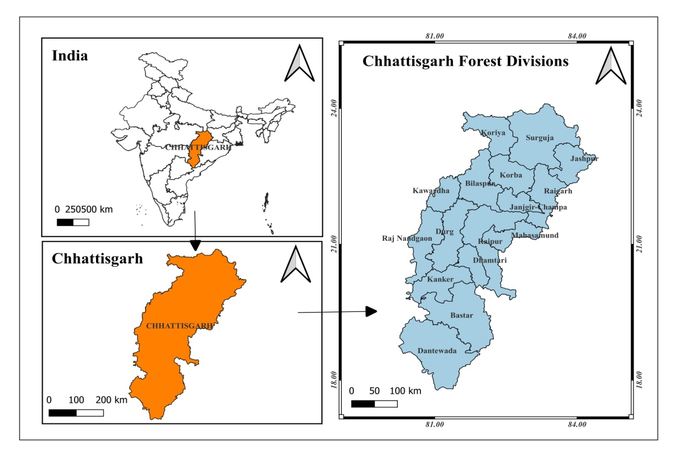
A comprehensive review of all available and appropriate literature sources was used to compile the economic importance of individual tree species. ArcGis 10.8 software was used to depict the distribution and behaviors of tree species spatially all over the study area.

Figure 1- Map of Study Site

3. results and discussion

Economically important 24 tree species representing 20 families were recorded from the 16 Forest Divisions of Chhattisgarh which comes under threatened category of IUCN Red data book list. Out of these 24 threatened species, two species are "Critically Endangered" one species is "Endangered" eleven species are "Vulnerable" and ten species are "Near to Threatened” (Table.1). These species have economic importance to the society directly or indirectly and forest dwellers are exploiting these species for their livelihood. Over exploitation of species lead to threat to their existence. In case of Cleistanthus collinus species is effective medicine to control various infectious diseases both human being and animals [8], apart from this, wood has high caloric value of 4595 Kcal/kg compared to the other fuel wood species. This resultant into over exploitation for fuel wood by the forest dwellers [9]. Some species exhibit seed dormancy due to unfavourable conditions, like Dillenia pentagyna (Karmal) showing low seed germination capacity while the species shows reasonable germination percentage when fruits are consumed by the elephants and excrete out [10]. Due to the disintegration of elephant’s habitat, the germination of Karmal seed has been declined over the decades. In case of B. serrata, unsustainable harvesting or tapping (brutal method) of gum extraction leads the species in threatened category. New tapping method using "Ethephon" (2-chloroethylphosphonic acid), a plant growth regulator, is safe, affordable and non toxic boosted gum/resin exudation in various tree species including Anogiessus latifolia, Boswellia serrata, Commiphora wightii or Sterculia urens. These procedures also ensure the long-term productivity, regeneration and survival of gum yielding trees [11].

Table 1. List of tree species with its Economic Importance Existing in Chhattisgarh Forest Divisions

S.No. | Scientific Name of Species | Family | Local name | Status in IUCN List | Economic Importance
 | Aegle marmelos  (L.) Correa | Rutaceae | Bael | Near Threatened [12] | Fruits are edible and has cultural importance.
 | Acacia catechu  (L.f.)Willd. | Fabaceae | Khair | Near Threatened [13] | The heart wood used to extraction of cutch and Katha.  Ethnobotany: A 20 ml decoction of bark is used twice a day to treat stomach discomfort [14].
 | Boswellia serrata  Roxb. Ex Colebr. | Burseraceae | Salai | Near threatened [13] | It is an economically important plant because of its high-quality oleo gum resin and essential oil. Essential oils are utilized as flavorings in food and in the perfume industry [15].
 | Buchanania lanzan  Spreng. | Anacardiacae | Chironji | Vulnerable [13] | Seed kernels used as dry fruits in Indian deserts.  EthnobotanyUses: - Powder of leaves is used during loose motion.
 | Careya arborea Roxb. | Lecythidaceae | Kumbhi,  Ghohar | Vulnerable [13] | Fruits of Kumbhi helps in promoting Digestion, As astringent [16].
 | Chloroxylon swietenia Roxb. DC. | Rutaceae | Bhirra | Vulnerable [12] | Main stem used by butchers for chopping meat.
 | Cleistanthus collinus (Roxb.) Benth. Ex Hook.f. | Phyllanthaceae | Garari | Vulnerable [12] | Wood has high caloric value and suitable for fuel wood.
 | Cordia macleodii (Griff.) Hook.f. & Thomson | Boraginaceae | Dahipalash | Endangered [13] | In cases of high fever, a fresh paste made from the leaves is applied to the forehead as wound treatment. Stem bark is useful for jaundice [17].
 | Dalbergia latifolia Roxb. | Fabaceae | Shisham | Vulnerable [12] | Timber used in furniture industry
 | Dillenia pentagyna Roxb. | Dilleniaceae | Karmal | Critically Endangered [13] | Traditional medicine uses the leaves, bark, and fruit of these plants, which have beneficial therapeutic properties [18].
 | Garuga pinnata Roxb. | Burseraceae | Kankad | Vulnerable [13] | Fruits are edible & used for pickle making by tribals in India.  The barkused for treating wounds and inflammation in folklore medicine [19].
 | Grewia tiliifolia Vahl | Tiliaceae | Dhaman | Near Threatened [13] | Traditional medicine uses the bark and roots to treat fractures, diarrhea, and skin disorders. The wood is used to make tool handles. The fruits are edible.
 | Hymenodictyon excelsum (Roxb.) Wall. | Rubiaceae | Bhonrsal | Near Threatened [13] | The wood used in pencil industry [20].
 | Ougeinia oojeinensis (Roxb.) Hochreut | fabaceae | Tiwas | Near Threatened [13] | Different plant parts, including leaves, stems, roots, and barks, were utilized as medicines in homeopathic, Siddha, Ayurvedic and Unani therapeutics [21].
 | Pterocarpus marsupium Roxb. | Papilionaceae | Bijasal | Vulnerable [13] | The timber has economic importance
 | Schleichera oleosa (Lour.) Oken | Sapindaceae | Lac Tree | Near Threatened [13] | The tree is host for lac insect and produce lac resin.
 | Schrebera swietenioides Roxb. | Oleaceae | Mokha | Near Threatened [13] | The root, bark and leaves have anthelmintic, digestive, constipating, acrid and bitter properties. Flatulence, skin conditions, leprosy, diarrhea, anemia and rectal illnesses can all benefit from them [22].
 | Semecarpus anacardium L.f. | Anacardiaceae | Bhilawan | Near Threatened [13] | The fruits are edible
 | Soymida febrifuga (Roxb.) A. Juss | Meliaceae | Rohan | Vulnerable [13] | The bark extract is widely used to treat dysmenorrhea, menorrhagia and leucorrhea [23].
 | Spondias mangifera Willd. (L.f.) Kurz | Anacardiaceae | Amra | Near threatened [13] | The trunk bark usedtraditionally as refrigerant, tonic, antiseptic,astringent and for the treatment of dysentery,diarrhoea and prevent vomiting [24].
 | Sterculia urens Roxb. | Sterculiaceae | Kullu, | Vulnerable [13] | Gumkaraya extracted from tree stem
 | Stereospermum chelonoides Roxb. (D.C) | Bignoniaceae | Padri Tree | Vulnerable [13] | It has been used for Diarrhoea, Skin diseases&Fever [25].
 | Terminalia chebula Retz. | Combretaceae | Harra | Near Threatened [13] | Fruits are used in making triphalachurnam in avurveda
 | Wrightia tinctoria (Dennst.) Mabb. | Apocynaceae | Dudi | Vulnerable [13] | The tree has good analgesic, anti-inflammatory, anti-hermitic,antiulcer, anti-dysenteric,anti-diabetic, anticancer, antipyretic activities and also effective in the treatment of psoriasis [26].

3.1. Distribution of species and their relative density:

A total of 16 Forest Divisions of Chhattisgarh were surveyed to document the threatened species in the selected area. Among the 24 threatened species B. lanzan and S. oleosa were recorded in all 16 forest divisions, T.chebula, S. anacardium, P. marsupium & C. arborea species were recorded in 14 forest divisions, C. collinus was recorded in 12 forest divisions, A. marmelos, B. serrata & O. oojeinensis were documented in 11 forest divisions, S. febrifuga spread over the eight forest divisions, C. swietenia, G. pinnata & S. chelonoides were enumerated in seven forest divisions, D. pentagyna recorded in five forest divisions, A. catechu, D. latifolia, G. Tiliifolia & S. urens documented in four forest divisions, S. swietenioides, H. orixense & W. tinctoria were recorded in two forest divisions and S. Mangifera & C. macleodii were recorded in one forest division depicted in (Figure 3,A-X). Tree species, revealing varied distribution patterns from wide spread species, such as Buchanania lanzan and Schleichera oleosa, to those restricted to only one or two divisions, a pattern potentially influenced by habitat specificity and localized pressures [27].

In Gariyaband Forest division, 19 threatned tree species were documented while 17 species in Dantewara, 16 species in Jashpur, 15 species in Jagdalpur, 14 species in Sukma, Korba & Bilaspur, 12 species in Kawardha, 11 species in Mahasamund, 10 species in Damtari, Nine species in Raigarh, GPM & Kanker, eight species in Dharamjaigarh and seven species in Kondagaon & West Bhanuprattapur forest divisions.The significant variation in threatened species richness among divisions, with localities such as Gariyaband and Dantewara having a high number, highlights the ecological importance of these regions as critical conservation sites. These distribution and density patterns provide important baseline data for developing targeted conservation and management strategies for vulnerable tree flora in the state’s [28, 29].

The “Heat map” (Figure 2) displays the relative density of the 24 endangered tree species in the 16 Chhattisgarh Forest Divisions. The heat map analysis reveals significant differences in relative densities among these species. Remarkably, the relative density of Acacia catechu was significantly higher in the Mahasamund (26.53%) division. Additionally, higher relative densities were noted for Pterocarpus marsupium in the Bilaspur (24.29%) and Soymida febrifuga in the Mahasamund (25.45%) divisions. Several species and divisions displayed moderate or at-par relative densities, usually between 5% and 12%, suggesting that population representation varied throughout the landscape. Conversely, several species recorded the lowest relative densities (2.7%), particularly species with restricted distributions such as Cordia macleodii & Spondias mangifera, which showed low densities across the divisions where they were present, i.e., Jagdalpur: 3.01% & Bilaspur: 3.1%.

The variation noted between relative densities of species and divisions exhibits the geographical variation among Chhattisgarh's threatened tree populations. Increased relative density of species such as Acacia catechu in particular divisions could suggest favorable habitat conditions or localized threats being less severe, leading to healthier populations [30, 31]. Low relative abundances, especially in species with small populations, indicate potential issues such as habitat specialization, poor regeneration, or increased susceptibility to anthropogenic stresses, indicating their vulnerability [32]. These are important in determining key habitats and implementing conservation efforts to increase the populations of threatened tree species [31].

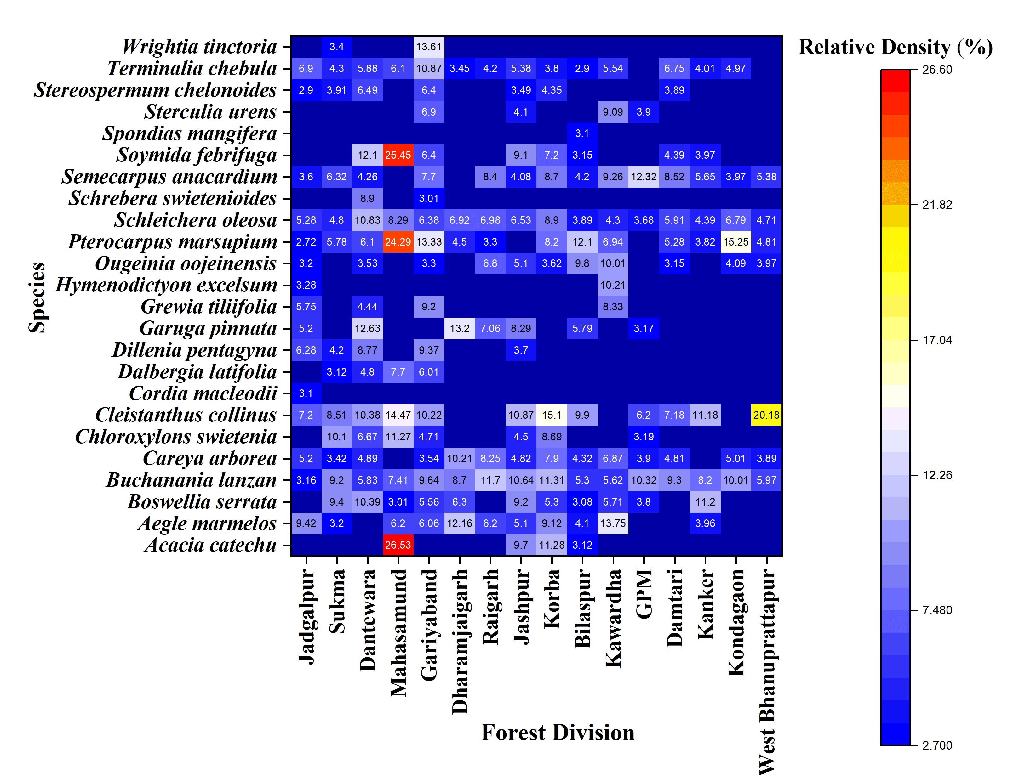

Figure 2. Relative Density of Threatened Tree Species in Different Forest Divisions of Chhattisgarh State.

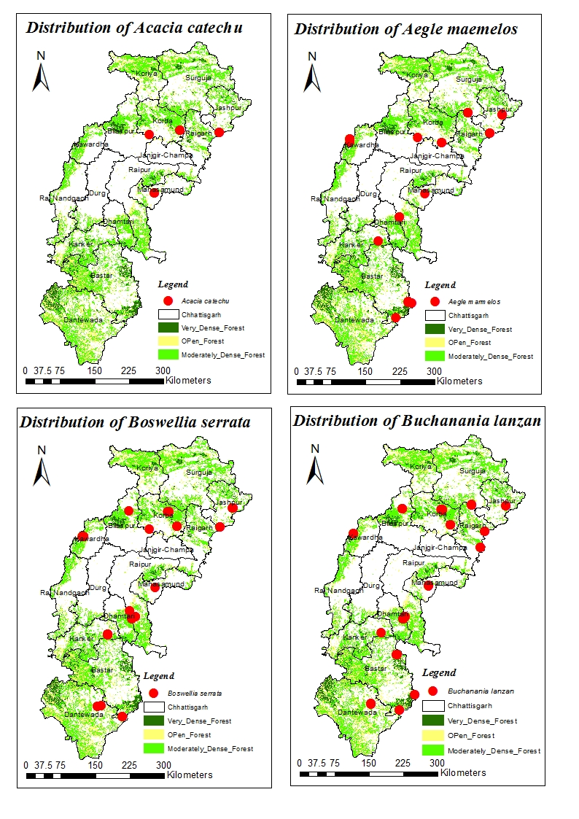  A | B | C
D | 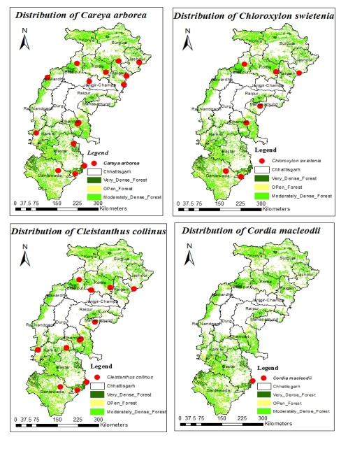  E | 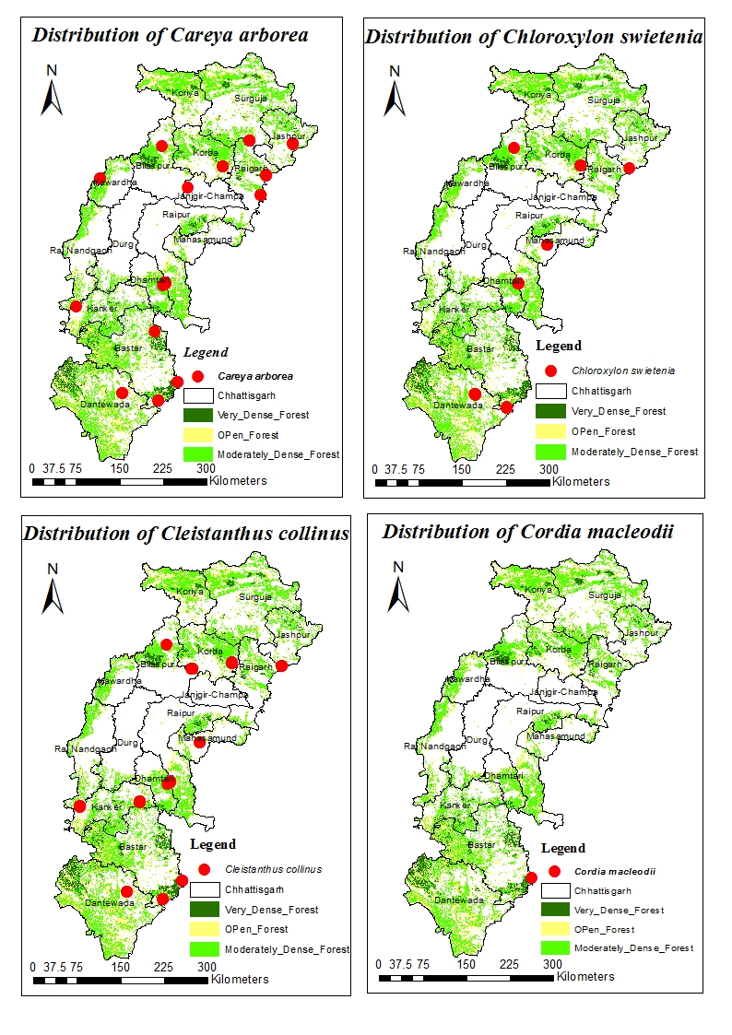  F
G | H | 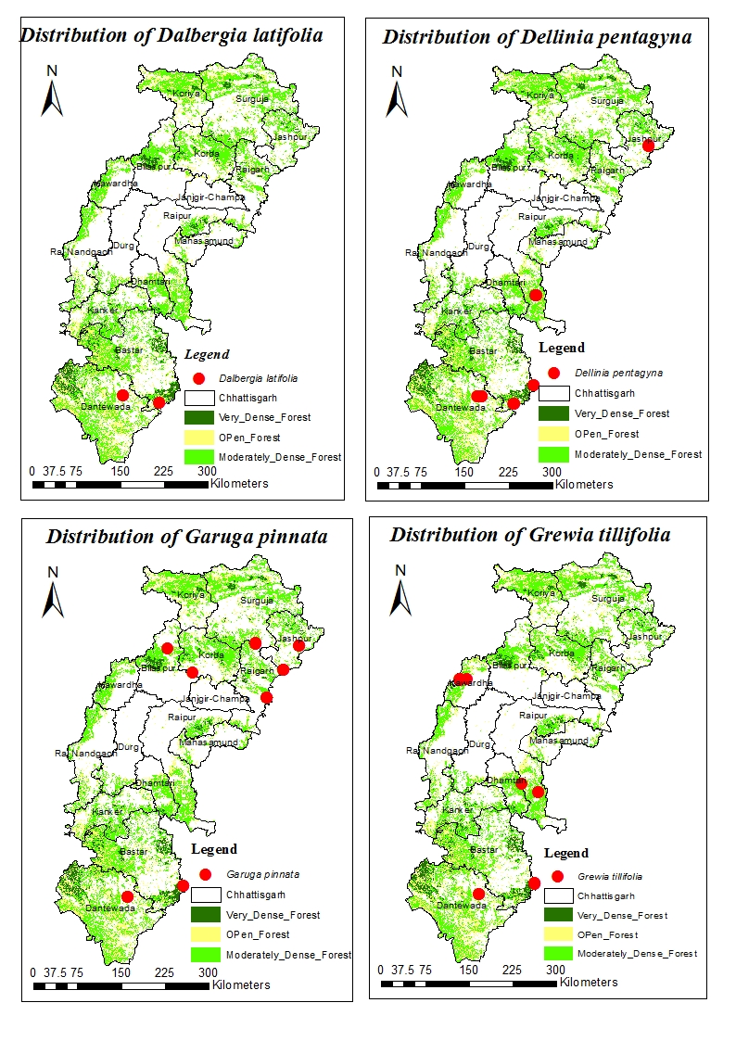  I

J | K | L
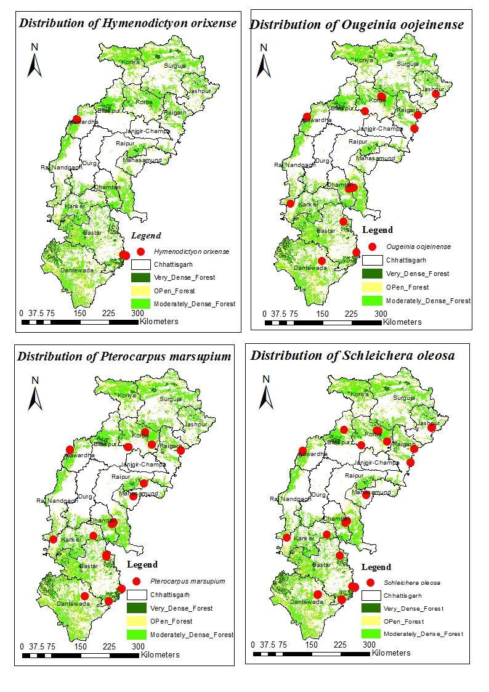  M | N | O
P | 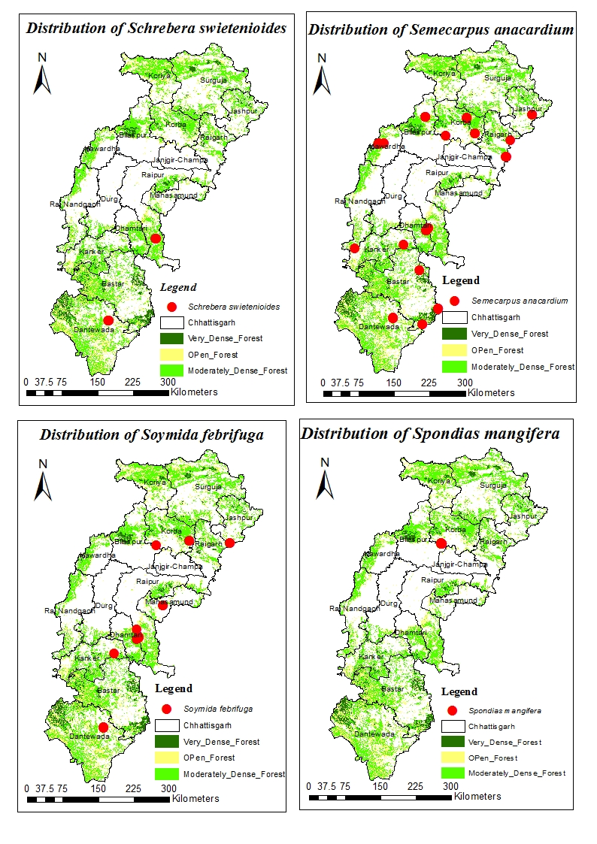  Q | R

S | T | 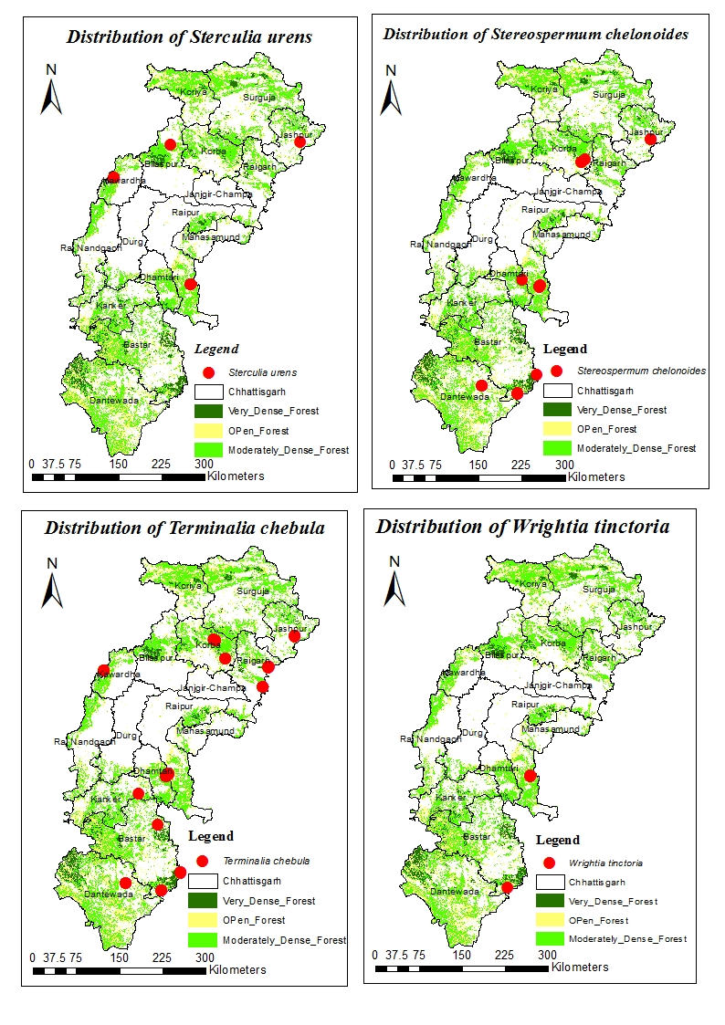  U
V | W | X

Figure 3. (A-X) - Distribution Maps of 24 Threatened Tree Species In Chhattisgarh Forest Divisions.

Conclusion:
The Comprehensive study conducted in 16 forest divisions and documented population distribution of prioritized species in Chhattissgarh forest division. The study concludes species distribution in the different forest type especially Buchanania lanzan and Schleichera oleosa dominated in all 16 forest division indicating that they are comparatively resistant or have a broader ecological amplitude. While in case of Spondias mangifera and Cordia macleodii were recorded only in one forest division i.e. Bilaspur and Jagdalpur. or in other words the species are categorized under high risk of extinction and need to pay attention for its conservation plan. In Gariyaband forest division, highest numbers (19) of threatened tree species were recorded. While in the Kondagaon forest division and West Bhanuprattapur forest division are reported only seven species under threatened category. The relative density of Acacia catechu was significantly maximum (26.53 percent) in Mahasamund forest division. In contrast, Cordia macleodii and Spondias mangifera were having minimum relative density (3 percent) in Jagdalpur and Bilaspur divisions.
The data revealed species dominance in particular forest division to maintain its population in local habitat. The maps generated in this study can be directly utilized by conservationists to identify the populations of threatened species and prioritize intervention precisely.
To help the threatened and near to threatened species identified in this study, the following measure should be done “immediately”
- Demarked areas with high concentration of threatened species (like Gariyaband) as a preservation plots to conserve within its natural habitat.
- Make specific conservation action plans for the most vulnerable species.
- Rehabilitation of the species will be helpful by in-situ and ex–situ conservation, propagation programs with the involvement of local communities recommended.
- Proper documentation by displaying about species picture/chart/poster/graph should be promoted through special campaign of its conservation during international forest day/world environment day or biodiversity day in mission mode.
- It is also suggested that sustainable harvesting of gum yielding species will be promoted during the event.

Disclaimer (Artificial intelligence):

Author(s) hereby declare that NO generative AI technologies such as Large Language Models (ChatGPT, COPILOT, etc.) and text-to-image generators have been used during the writing or editing of this manuscript.

References:

- Seth, M. K. (2003). Trees and their economic importance. The Botanical Review, 69(4), 321–376.
- Cannon, C. H., Dhyani, A., Jin, C., & Rivers, M. (2023). The Global Tree Assessment provides a multifaceted view on the future of tree diversity conservation. Plants, People, Planet, 5(4), 461–465.
- Chrispal, A. (2012). Cleistanthus collinus poisoning. Journal of Emergencies, Trauma and Shock, 5(2), 160–166.
- Chapin Iii, F. S., Zavaleta, E. S., Eviner, V. T., Naylor, R. L., Vitousek, P. M., Reynolds, H. L., Hooper, D. U., Lavorel, S., Sala, O. E., Hobbie, S. E. & Mack, M. C. (2000). Consequences of changing biodiversity. Nature, 405(6783), 234–242.
- Gardens, B. (2021). Botanic Gardens Conservation International. State of the world's trees, 1-25.
- Bhuarya, S. K., Chaudhary, J. L., Manikandan, N., & Khalkho, D. (2015). Spatial analysis of rainfall and rainy days in Chhattisgarh State, India. Journal of Agriculture PhysicsS, 15, 140-149.

- Forest Survey of India. (2023). Indian State of Forest Report 2023. Ministry of Environment Forest and Climate Change. Kaulagarh road, P.O. IPE Dehradun – 248195, Uttarakhand. https://fsi.nic.in/forest-report-2023-details.
- Elangomathavan, R. (2013). Bio-prospecting of Cleistanthus collinus and its antibacterial activity. Asian Journal of Pharmaceutical and Clinical Research, 6(4), 206–209.
- Chichaghare, A. R., Deshmukh, H. K., Kumar, N. M., & Jamatiya, A. (2019). Garari (Cleistanthus collinus): Multipurpose hedge crop for organic farming through agroforestry intervention. Journal of Pharmacognosy and Phytochemistry, 8(2), 2124–2127.
- Vinod, T. R. (1994). Food and feeding habits of Asian elephants (Elephas maximus Linn.) [Doctoral dissertation, College of Forestry, Vellanikkara].
- Nair, M. B. (2000). Sustainable utilization of gum and resin by improved tapping technique in some species. In Harvesting of Non-Wood (p. 293).
- International Union for Conservation of Nature (IUCN). (2024). The IUCN Red List of Threatened Species (Version 2024-1).
- Khanna, K. K., Dubey, P. C., Tiwari, A. P., & Sikarwar, R. L. S. (2021). Studies on threat status of tree species of Madhya Pradesh, India, 147(2), 137-140.
- Dahare, D. K., & Jain, A. (2010). Ethnobotanical studies on plant resources of Tahsil Multai, District Betul, Madhya Pradesh, India. Ethnobotanical Leaflets, 14, 694–705.

- Mothana, R. A., Hasson, S. S., Schultze, W., Mowitz, A., & Lindequist, U. (2011). Phytochemical composition and in vitro antimicrobial and antioxidant activities of essential oils of three endemic Soqotraen Boswellia species. Food Chemistry, 126(3), 1149–1154.
- Rimi, S., Mishra, H. S., Kumar, A. A., Rinky, J., Kumar, S. A., & Pooja, S. (2023). Therapeutic potential of Carea arborea Roxb. World Journal of Pharmaceutical Research, 12(17), 721–734.
- Quattrocchi, U. (2012). CRC world dictionary of medicinal and poisonous plants: Common names, scientific names, eponyms, synonyms and etymology (5-volume set).
- Gandhi, D., & Mehta, P. (2013). Dillenia indica Linn. and Dillenia pentagyna Roxb.: Pharmacognostic, phytochemical and therapeutic aspects. Journal of Applied Pharmaceutical Science, 3(11), 134–142.
- Bhagwat, J. A., & Bhagwat, A. M. (2013). Stem bark of Garuga pinnata Roxb.: A renewable resource for wound healing drug. International Journal of Pharmacology & Biological Sciences, 7(2), 9.
- Tint, U. S. (1987). Study on some Burmese timbers suitable for pencil making. https://www.forestdepartment.gov.mm/sites/default/files/Research%20Books%20file/11%281987%29.pdf
- Tiwari, A., Patel, A., Shrivastava, S., Karole, S., Vishwakarma, U., & Mishra, P. (2020). Comprehensive review on phytochemistry, ethnobotanical, bioactivities and medicinal mysteries of Ougeinia oojeinensis (Roxb.) Hochr. Pharmaceutical and Biosciences Journal, 8(2), 29–34.
- Bagali, R. S., Jalalpure, S. S., & Patil, S. S. (2020). Evaluation of Schrebera swietenioides Roxb. fruit ethanolic extract for antioxidant and hepatoprotective activity against CCl₄-induced liver injury in rats. Research Journal of Pharmacy and Technology, 13(11), 5115–5120.
- Krushna Palei, A., Nishteswar, K., & Shukla, V. J. (2013). Phytochemical screening of Soymida febrifuga Roxb. (Meliaceae) root bark. International Journal of Pharmacy & Life Sciences, 4(2), 2371.
- Kirtikar, K. R., & Basu, B. D. (1975). Indian Medicinal Plants (Vol. 1, pp. 672–675). Bishen Singh Mahendra Pal Singh.
- Maurya, R., & Dongarwar, N. (2012). Studies on the medicinal uses of wild trees of Nagpur district. International Journal of Life Science and Pharma Research, 2(1), 21–24.
- Chandrashekar, R., Adake, P., Rao, S. N., & Santanusaha, S. (2013). Wrightia tinctoria: An overview. Journal of Drug Delivery and Therapeutics, 3(2).
- Christensen, M., & Heilmann-Clausen, J. (2009). Forest biodiversity gradients and the human impact in Annapurna Conservation Area, Nepal. Biodiversity and Conservation, 18(8), 2205–2221.
- Zhang, Y.-B., & Ma, K.-P. (2008). Geographic distribution patterns and status assessment of threatened plants in China. Biodiversity and Conservation, 17(7), 1783–1798.
- Mahatara, D., Sharma, D., Acharya, A., Ulak, S., Paudel, P., & Dhakal, B. (2021). Maxent modelling for habitat suitability of vulnerable tree Dalbergia latifolia in Nepal. Silva Fennica, 55(4).
- Cheyne, S. M., Gilhooly, L. J., Hamard, M. C., Höing, A., Houlihan, P. R., Kursani, Loken, B., Phillips, A., Rayadin, Y., Ripoll Capilla, B., Rowland, D., Sastramidjaja, W. J., Spehar, S., Thompson, C. J. H., & Zrust, M. (2016). Population mapping of gibbons in Kalimantan, Indonesia: Correlates of gibbon density and vegetation across the species’ range. Endangered Species Research, 30, 133–143.
- Vergeer, P., Ouborg, N. J., Copal, A., & Rengelink, R. (2003). The interacting effects of genetic variation, habitat quality and population size on performance of Succisa pratensis. Journal of Ecology, 91(1), 18–26.
- Murphy, D. D., Freas, K. E., & Weiss, S. B. (1990). An environment‐metapopulation approach to population viability analysis for a threatened invertebrate. Conservation Biology, 4(1), 41–51.

Table 2: Population density of each species (Individuals per hectare)

Sl.No. | Name of Species | Population of each species (Individuals per hectare)
 | Acacia catechu (L.f.) Willd. | 22.40
 | Aegle marmelos (L.) Corrêa | 13.93
 | Boswellia serrata Roxb. ex Colebr. | 11.43
 | Buchanania lanzan Spreng. | 17.03
 | Careya arborea Roxb. | 9.03
 | Chloroxylon swietenia Roxb. DC. | 12.19
 | Cleistanthus collinus (Roxb.) Benth. ex Hook.f. | 26.56
 | Cordia macleodii Hook.f. and Thomson | 6.25
 | Dalbergia latifolia Roxb. | 10.55
 | Dillenia pentagyna Roxb. | 8.44
 | Garuga pinnata Roxb. | 15.31
 | Grewia tiliifolia Vahl | 8.98
 | Hymenodictyon excelsum (Roxb.) Wall. | 10.94
 | Ougeinia oojeinensis (Roxb.) Hochreut | 12.50
 | Pterocarpus marsupium Roxb. | 14.14
 | Schleichera oleosa (Lour.) Oken | 9.53
 | Schrebera swietenioides Roxb. | 12.50
 | Semecarpus anacardium L.f. | 11.98
 | Soymida febrifuga (Roxb.) A. Juss | 15.94
 | Spondias mangifera Willd. (L.f.) Kurz | 11.94
 | Sterculia urens Roxb. | 9.38
 | Stereospermum chelonoides Roxb.(D.C) | 6.56
 | Terminalia chebula Retz. | 9.29
 | Wrightia tinctoria (Dennst.) Mabb. | 20.31

