Assessment of Climate Change on Soil Erosion Using Geospatial Techniques: A Review

Abstract— Climate change is accelerating soil erosion, presenting a significant threat to food security and ecosystem health globally. This review investigates the impact of climate change on soil erosion using advanced geospatial methods and the Revised Universal Soil Loss Equation (RUSLE). An analysis of over 100 recent peer-reviewed articles (including research from 1990 to 2024) explores how factors such as shifting precipitation patterns, rising temperatures, extreme weather events, and land-use changes influence erosion across various scales. Climate change-induced shifts in precipitation patterns and intensifying weather events significantly affect soil erosion rates. Heavy rainfall events can cause substantial soil displacement, while droughts dry out the soil, leaving it vulnerable to wind erosion. Rising temperatures further exacerbate the problem by altering soil moisture levels and influencing vegetation cover, a crucial factor in erosion control. Land-use changes, including deforestation, urbanization, and agricultural practices, disturb soil stability and increase erosion rates. Remote sensing, GIS, and AI-machine learning are increasingly combined with advanced RUSLE variations to identify erosion hotspots with greater precision. These technologies enable monitoring of spatiotemporal patterns and assessment of future risks under various climate scenarios. Remote sensing techniques allow for high-resolution mapping of erosion-prone areas, while AI and machine learning enhance predictive models, providing more targeted and effective adaptation strategies. Despite potential temporary reductions in erosion in regions experiencing initial increases in vegetation cover, projections indicate a significant global soil loss increase by mid-century (2050). This increase is driven by heavier precipitation, intensifying droughts, and more frequent and severe floods. The resulting erosion can have devastating effects on agricultural productivity, water quality, and biodiversity. Integrated soil conservation practices, such as reduced tillage, cover cropping, and revegetation, are essential for building resilience against this growing threat. These practices help stabilize soil, improve water retention, and enhance the land's overall health. In addition, landscape management techniques, including contour farming and agroforestry, can further mitigate erosion risks. Advancements in AI-machine learning-based erosion prediction models offer promising opportunities for more precise and timely interventions. By integrating these models with remote sensing data, researchers can develop more accurate risk assessments and design more efficient mitigation strategies. High-resolution remote sensing allows for continuous monitoring and evaluation of erosion patterns, enabling adaptive management approaches. As results emerging technologies and innovative management practices offer new tools and approaches to address this challenge. By investing in research and adopting advanced geospatial methods, policymakers and stakeholders can work together to develop more effective strategies for mitigating soil erosion and safeguarding global food security and biological systems

Keywords: Soil Erosion, Remote Sensing, Climate Change, RUSLE

INTRODUCTION
Climate change poses a significant threat to soil, which sup- ports biological processes and agricultural output. Examining the effect of change, the Revised Universal Soil Loss Equation (RUSLE) is a valuable tool for predicting and investigating the impact of climate on soil erosion. This study explores the relationship between climate change, soil erosion, and the growing use of geospatial technologies such as remote sensing and GIS, based on ongoing research. Through a variety of means, climate change makes soil erosion even more potent. Studies by [27]. (Based on future climate scenarios, the 2022) project intensified soil loss in Iran, highlighting the critical need to consider long-term climate trends. [64] demonstrate the efficacy of geospatial tools for in-depth analysis by utilizing the RUSLE within Google Earth Engine (GEE) to reveal seasonal and spatial variations in erosion across the Pindos Mountains. The integration of geospatial advancements with RUSLE altogether upgrades its accuracy and applicability.[81] exhibit the worth of remote detecting and GIS in giving essential information to soil erosion assessment in Seaside Odisha, India. Similar to this, [69] reiterated the anticipated impacts of shifting climate and land use on soil erosion in Thailand, emphasizing the need of considering several factors while designing displays. The steady refinement of the RUSLE model for worldwide relevance stays pivotal. [10] survey the RUSLE, zeroing in on strategies to further develop soil loss estimates and upgrade its utility across different geoclimatic districts. [60] adjust crucial factors to improve RUSLE’s global applicability and contribute to ongoing efforts to make the model more accurate. [41] feature the down-to-earth use of geospatial techniques and RUSLE by measuring soil erosion in Pakistan, featuring the significance of local-scale evaluations for informing targeted erosion control systems. This lines up with the call by [28] for erosion management scenarios involving future climates.
Envision a future where rich terrains disappear, streams gag on dregs, and environments disintegrate - a brutal reality driven by the speeding up erosion of our valuable soil. In this ongoing drama, the powerful antagonist of climate change is accelerating erosion, putting food security in jeopardy, and disrupting the delicate balance of nature. Fortunately, progressions in science offer a promise of something better. Using geospatial tools and the Revised Universal Soil Loss Equation (RUSLE) will help us better understand and manage this growing threat. The outcomes of erosion go a long way past simple topsoil loss. The loss of fertile layers has a significant negative impact on agricultural productivity. Research con- ducted by [9] demonstrates the model’s capacity for prediction erosion scenarios in the future under various climate and land- use changes, providing insight into proactive measures for adaptation. This, in turn, can put food security at risk, especially in areas where agriculture is the community’s lifeblood. Erosion’s effect isn’t restricted to land; it unleashes havoc in water bodies as well. Increased sedimentation, as featured by [61], further jeopardizes ecosystem health and biodiversity by deteriorating water quality and aquatic habitats. The apparition of soil degradation poses a potential threat, powered by climate change. [7] cautioned about likely decreases in water retention capacity and soil fertility, further sabotaging agricultural systems. [78] adds one more layer of concern: loss of arable land because of erosion, prompting diminished crop variety and in- creased prone to food deficiencies. The interconnectedness of these issues highlights the squeezing need to address climate- induced erosion in the event that we are to shield food security and ecosystem integrity. Luckily, progressions in innovation offer a beam of trust. Geospatial apparatuses, similar to remote sensing and GIS, engage researchers to plan weak regions and screen erosion dynamics with remarkable detail.
- accentuates the worth of these apparatuses in figuring out the spatial and worldly examples of erosion, empowering designated conservation endeavors. [70] further feature how these devices guide conservation and management strategies, moderating erosion’s unfavorable impacts on food security and environment. Besides, [49] exhibit how geospatial instruments assist with surveying the likely effects of energy improvement on soil erosion, encouraging a more holistic comprehension of the interconnected difficulties. The RUSLE model, joined with geospatial experiences, gives an amazing asset to foreseeing and relieving erosion. This model, as evaluated by [9], has been ceaselessly refined to further develop soil loss measures and improve its worldwide applicability. Studies by [9] exhibit the model’s capacity to project future erosion situations under in the face of shifting land use and climate, illuminating proactive adaptation strategies.
The Revised Universal Soil Loss Equation (RUSLE) has secured itself as a foundation of environmental and geotechnical research, offering priceless experiences into soil erosion elements. As a development of the Universal Soil Loss Equation (USLE), RUSLE has reformed the assessment of soil erosion across different geological locales, remembering semi-parched watersheds for Tamil Nadu, India [26][32]. A dedicated research team computerized the USLE and im- proved it, resulting in a more comprehensive and accurate method for estimating soil loss [26][32]. RUSLE’s adaptability stretches out past its center application. By coupling it with the Modified Universal Soil Loss Equation (MUSLE), analysts have reenacted the hydrological advantages of vegetation rebuilding, featuring its relevance in different ecological settings [53][23]. Additionally, the model has been useful in gaining an understanding of the spatiotemporal patterns of soil erosion following tree harvesting, providing insight into the potential for sediment deposition in various landscapes [94][85]. Further exhibiting its significance in environmental management, RUSLE has been coordinated with GIS and remote sensing to focus on watershed interventions [66][42]. These different applications solidify RUSLE’s situation as an imperative device in environmental and geotechnical research. By giving an exhaustive outline of soil erosion risk and driving informed decision-making, RUSLE assumes a critical part in advancing sustainable land management practices and mitigating the detrimental effects of soil erosion.
Think of rich terrains vanishing, casualties of an erosion epidemic fueled by climate change. This review digs into this complicated danger, investigating its effect on erosion rates and patterns with unrivaled precision by analyzing over 100 recent studies. The established RUSLE model is combined with cutting-edge geospatial tools like remote sensing, GIS, and machine learning. Studies like [6][83] tackle model un- certainty, while [71][14] focus on confined Ethiopian effects. [101][69] paint a large-scale image of European situations, and [19] examine the role of rainfall in North Indian erosion. [4]investigate the special difficulties at the Tibetan Level, inspecting associations between climate and silt yield. By incorporating these different viewpoints, we expect to portray what climate change means for soil erosion across scenes and climates. This review aims to empower us with useful insights for developing efficient strategies for adaptation and mitigation against this growing threat, armed with cutting-edge tools and the RUSLE model.

  - CLIMATE CHANGE AND SOIL EROSION
While instinctively matched, the hypothetical connection between environmental change and soil erosion is nuanced and diverse. Studies like [50] feature the essential comprehension of what climate variances mean for land surface cycles, especially the complicated association between hydrology and erosion. However, as [55] highlight, clearly establishing theoretical relationships remains challenging. [97]. Moving forth, [77] emphasize the necessity of comprehensive assessments that take into account the interaction between changes in land use, erosion, and climate at various scales. Further improving this point of view, [63] incorporate biophysical and socioeconomic variables, featuring the significance of a more extensive focal point. Similar to that, [56] and [2] stress the interconnectedness of erosion, weathering, vegetation dynamics, and hydrological processes, encouraging further exploration, especially in an evolving climate.
The studies paint a clear picture: Various scenarios of how climate change affects soil loss are illustrated by the fact that specific climate factors act as potent drivers of increased erosion. For example, [76] raise concerns about increased precipitation events, pointing to their potential to worsen erosion and jeopardize water security. Essentially, studies like [62], as well as [21] notice direct associations between changed precipitation patterns (especially the erosive force of precipitation) and expanded soil erosion rates. Taking a more extensive point of view,[80] and [72], establish a standard: Water erosion is fueled by more precipitation, whereas it decreases in dry conditions. [22] provide additional specific evidence and[31], whose reviews gauge significant erosion rate increases connected to precipitation changes. In past observations, [45] and [100] utilize simulations to investigate the future. Their figures illustrate intensified erosion driven by increasing intensity and recurrence of heavy precipitation events under climate and land-cover changes. A variety of factors make up the crucial climate variables that affect soil erosion and their intricate interactions. Precipitation force assumes a vital part in soil disintegration, with heavy precipitation events prompting expanded erosion because of the erosive force of precipitation [96]. Furthermore, precipitation patterns, including duration and kinetic energy, fundamentally impact erosion processes, with differing precipitation qualities influencing erosion rates [36]. Temperature fluctuations additionally add to soil erosion dynamics, with outrageous weather events prompting increased erosion [16]. Furthermore, the relationship between changes in groundwater levels and the deterioration of soil caves emphasizes the intricate link between hydrological cycles and erosion [79]. Soil-related factors, including soil depth and slope angle, are basic in controlling erosions and avalanches, featuring the complicated communications between soil properties and disintegration vulnerability [8]. Besides, the job of soil natural carbon loss under wind erosion highlights the meaning of soil biotas in erosion processes [59]. The distinguishing proof of erosion source regions is pivotal for understanding the basic variables controlling erosion and sediment transport, featuring the requirement for designated watershed management interventions [30]. Moreover, the impact of intensive tillage erosion further shows the complicated connections between surface runoff, tillage, and precipitation in soil and water loss [93].
  - GEOSPATIAL TECHNIQUES IN SOIL EROSION ASSESSMENT
Disclosing the insights of soil erosion requires a sharp eye, helped by integral tools. Enter the domain of geospatial innovations, where remote detection, Geographic Information Systems (GIS), and satellite imagery structure a powerful ar- senal in understanding and dealing with this complicated phenomenon. Driving the charge are studies like [3], who feature the synergistic force of blending GIS with the established Universal Soil Loss Equation (USLE) for risk evaluation. Their work features the tremendous worth of GIS in making exact environmental models. Likewise, [20] shows the effectiveness of consolidating the RUSLE model with satellite remote detecting and GIS mapping, offering a significant toolkit for both erosion evaluation and conservation planning. These advances go past hypothetical applications. [43] show their true effect by using them for nitty gritty disintegration risk mapping in the Kartikeya dam watershed. This represents the force of geospatial instruments for pragmatic decision- making. Moreover, [33] underlines GIS and remote sensing applications for producing vital land use/cover data through digital image processing, laying the basis for informed land management practices. The flexibility of GIS radiates through in examinations like [68] and [73]. While Aydın and Techiman influence GIS for erosion risk assessment, [89] use it for soil loss risk examination. These assorted applications robust the significance of GIS in exhaustively understanding and managing erosion elements across different scales.
From shifting coastlines to changing vegetation patterns, remote detecting and GIS advances penetrate through the shroud, offering significant bits of knowledge into soil erosion elements. Researchers and policymakers have access to crucial tools for mapping, monitoring, and comprehending this complex phenomenon thanks to their combined power in data acquisition and analysis. Studies like [48] are leading the charge. 2010), satellite imagery is used to keep an eye on sediment transport along coastal areas. This features the wide perception reach and cost-viability of remote detecting, especially for long-term observing, as further underlined by [87] with their multisource satellite methodology. Moreover,[37] exhibit the force of multispectral information in avalanche mapping, showing its capacity to pinpoint even unobtrusive changes in the scene. However, information alone isn’t sufficient. Enter GIS, the maestro of spatial investigation. By incorporating remote detecting information, concentrates on like [38] open the maximum capacity of these perceptions, empowering comprehensive assessments of vegetation and land cover change. This cooperative energy goes past earthbound applications, as featured by [46], who use remote detecting’s close to continuous capacities to successfully guide and track marine pollution, showing its adaptability across different conditions. These technologies can be used for a wide range of things, from keeping an eye on subtle shifts in the patterns of erosion to making detailed inventories of landslides. Studies like these feature the synergistic force of remote detecting and GIS: one assembles the information, and the other interprets it, uncovering a comprehensive image of erosion elements and ecological changes. This information enables us to handle soil erosion, defending our landscapes and their essential assets (Figure 1.).
Understanding the mind-boggling connection between climatic factors and erosion patterns requires a sharp eye and useful tools. Geospatial approaches provide significant benefits in assessing the impact of climatic conditions on erosion at various scales and regions. The Revised Universal Soil Loss Equation (RUSLE) proposed by [88], [98], [17], and [57] is driving this movement [88][98][17][57]. This flexible model goes about as a workhorse for enormous scope evaluations, incorporating critical climate factors like precipitation and temperature into erosion elements across provincial and worldwide scales. Past static assessments, and simulations become central members. [15][44][75] underlines the meaning of displaying strategies to analyze the impact of climate factors

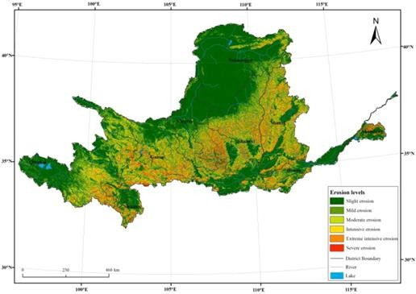

Fig. 1. The Yellow River Basin’s average level of soil erosion between 1990 and 2015. (Source: [90])

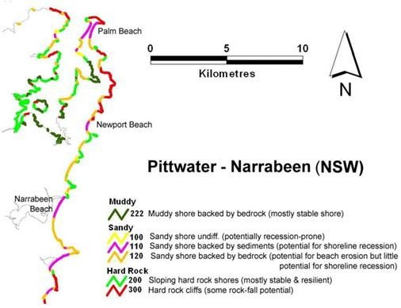
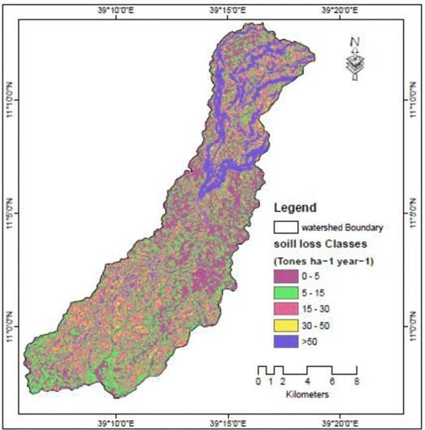
These simulations, controlled by geospatial methods, empower us to assess erosion processes across different scenes, encouraging an extensive comprehension of the complex interplay among climate and erosion dynamics. Yet, a one-size- fits-all approach doesn’t work with regard to landscapes. The significance of explicit spatial downscaling techniques is emphasized by [65][74]. This careful methodology expressly thinks about spatial contrasts in climate situations and changeability, considering a more exact evaluation of erosion patterns at better scales where explicit climatic conditions and landscape characteristics rule [29]. The picture that these examples paint is compelling: geospatial methods are not simple onlookers in that frame of mind of climate- driven erosion. They are dynamic members, offering integral assets like the RUSLE model and downscaling techniques [84]. They provide valuable insights into how specific climate variables shape erosion patterns across diverse landscapes by bridging the gap between large-scale assessments and fine- grained analyses. This information enables us to foresee, relieve, and eventually deal with this complex environmental challenge (Figure 2.)(Figure 3.)
Fig. 2. Coastal stability from Smartline in the Pittwater Narrabeen Fig. 3. Map showing the geographical variance of the Geladas watershed’s New South Wales region. (Source: [1]) soil erosion loss (Source: [92])

  - REVISED UNIVERSAL SOIL LOSS EQUATION (RUSLE) : The RUSLE model has different parts that help us figure out how likely soil erosion is to happen. These parts look at things like how much rain and water there is (R-factor), how easily the soil can be eroded (K-factor), how long and steep the land is (LS-factor), how the land is covered and managed (C-factor), and what practices are in place to prevent erosion (P-factor). One part, the R-factor, looks at how much rain and water can cause erosion, while another part, the K-factor, checks how easily the soil can be eroded based on things like its texture and organic matter content. The equation’s many variables each represent a distinct com- ponent that causes soil erosion. These variables include a wide range of measurements and reflect several aspects of the process. For example, the metric tons of soil lost per hectare per year is the average annual soil loss (A). Rainfall erosivity
(R) is the amount of erosion that rainfall has the ability to produce per unit area. It is measured in megajoules per millimeter per hectare per year. Soil erodibility (K) is the measure of the ease or potential for soil erosion expressed in metric tons per hectare per hour per megajoule per millimeter. The link between erosion and these two characteristics may be seen in the combined slope length and steepness (LS). Cover management (C) signifies the impact of protective measures on erosion, while support practice (P) gauges the effectiveness of erosion-reducing techniques. These variables are intricately interconnected and utilized to compute the overall extent of soil erosion within a specific region. (Refer to Figure 4 for visual representation).It was carefully considered when developing the Re- vised Universal Soil Loss Equation (RUSLE) for how climate change influences precipitation patterns and extreme weather. The model’s capacity to evaluate the danger of soil erosion in the context of climate change has been significantly improved by these adjustments. An exemplary illustration of this is seen in the work of [75][5], who skillfully combined RUSLE data with model-reconstructed data to produce a comprehensive and uninterrupted historical record of rain-erosivity anomalies. By doing so, they were able to uncover the fundamental shifts in climate erosivity that have occurred from 1580 to 2004,
providing valuable insights into natural climate variability.
Fig. 4. Shows the degree of soil erosion in the Yellow River Basin from 1990 to 2015: 1990, 1990,1990, 1990, 2000, 2005, 2010and 2015. (Source: [91])
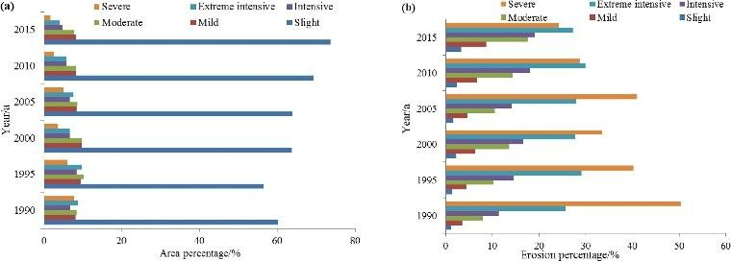

Here are instances of contextual analyses exhibiting the use of the Revised Universal Soil Loss Equation (RUSLE) under varying climate conditions: [82] looked at erosion rates before and after a wildfire in a Greek Mediterranean site [47][39]. The results shed light on the patterns of erosion after the fire and how well RUSLE could assess the risk of erosion. [67] assessed soil misfortune in semi-bone- dry Indian watersheds under changing climatic situations, uncovering spatial and transient varieties in erosion dynamics affected by climate change. [13] coordinated RUSLE with climate change projections to demonstrate soil erosion in a Canadian watershed, featuring expanded precipitation erosivity and the watershed’s weakness to disintegration. [95] [52][5][40] regionalized the Modified Universal Soil Loss Equation (MUSLE) in Ethiopia, offering experiences into MUSLE’s flexibility and local soil loss varieties un- der changing climate conditions [58][54][34][24][35][99][12]. These studies shed light on the adaptability of RUSLE in assessing soil erosion in changing climates and offer useful insights into the patterns of erosion influenced by climate change (Figure 5.)
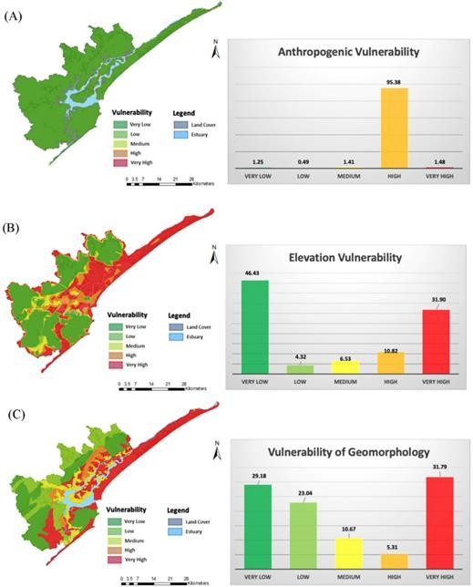
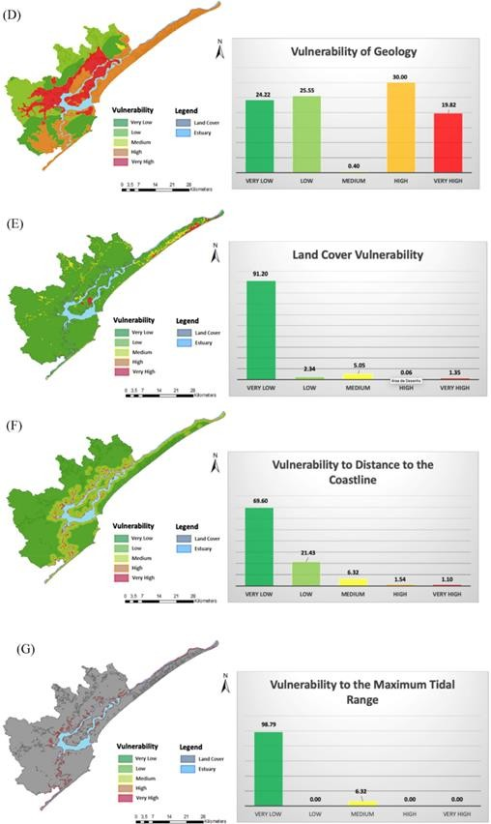
Fig. 5.Vulnerability levels and percentages were modeled A) human activities, (B) elevation, and (C) geomorphology (D) geology, with related susceptibility percentages and levels; (E) land cover; (F) distance to the shore; and (G) maximum tidal range. (Source: [86])

- Precipitation/Rainfall Erosivity Component (R): Precipitation serves as a crucial prerequisite for the occurrence of water erosion [25]. The magnitude and intensity of precipitation are the two key characteristics that greatly influence erosion [36]. It is observed that waterborne erosion becomes more prominent when these precipitation attributes are on the higher end [25]. To assess the erosive force exerted by precipitation, the rainfall erosivity factor (R) takes into account both the intensity and volume of precipitation [104], [46], [25]. This element is ascertained through the meticulous calculation of the cumulative EI values of every storm over a prolonged timeframe, typically spanning 20 years, to account for recurring precipitation patterns. The abbreviation EI embodies the intertwined influence of energy and peak intensity of rainfall over a brief span. The extent of soil erosion is intricately tied to the amalgamated force of a storm’s energy and maximum intensity within a half-hour window. The EI30 index, commonly referred to as the storm erosivity index, eloquently measures the energy dissipated per unit area and time during a storm event. By
considering the combined impact of soil erosion and runoff, it accurately assesses the erosive power of the storm. By averaging annual aggregates over a suitable timeframe, the precipitation erosivity factor can be calculated. Various researchers have developed equations for calculating the R factor, which are currently being utilized in diverse geographical locations (Table 1).

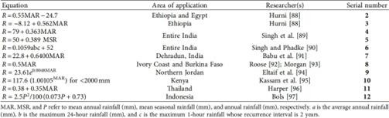

Table 1. The R component algorithms.(Source: [51])

- Soil Erodibility Element (K): Diverse soil types possess varying degrees of susceptibility to erosion caused by water [25]. In order to effectively address the pressing issue of soil erosion and promote conservation efforts, it is crucial to possess a thorough understanding of the concept of soil erodibility [15], [94]. Erosion is significantly influenced by soil qualities, especially erodibility. Physical and chemical characteristics affect the K factor, a gauge of soil erosion susceptibility [15], [25], and [94]. Particle distribution, organic matter content, soil structure, and susceptibility are the main determinants of erodibility according to the RUSLE model (see Table 2).
C: Slope Length and Slope Steepness (LS) Element: The incorporation of the LS factor within the RUSLE model is of utmost importance in comprehending the geological composition of a landscape and its profound influence on the occurrence of soil erosion [33]. By combining the measurements of slope length and steepness, this factor possesses the erosion remarkable ability to discern the exact impact of the terrain on the erosive processes taking place. This invaluable insight aids in providing a sophisticated understanding of the intricate relationship between landforms and erosion dynamics. [26], [7]. The LS factor plays a crucial role in the RUSLE model, as it considers both slope length and steepness in determining soil It is widely recognized that longer slopes and steeper gradients lead to increased soil loss. Therefore, accurately accounting for the LS variable is essential in understanding how landscape characteristics impact soil degradation. The length of the slope directly affects soil loss, as a greater distance from runoff to surface water results in more erosion. Similarly, slope steepness also contributes to erosion, although factors like vegetation cover and soil particle size can influence this impact. Researchers have developed various methods for calculating the LS factor, often using advanced technologies like digital elevation models and remote sensing to gather precise landscape data. Incorporating these topographical features into the RUSLE model allows for a comprehensive analysis of the factors influencing soil erosion [19].
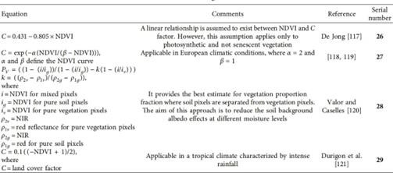
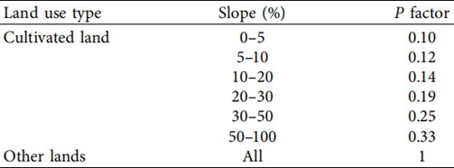
D. Cover Management Element (C): The significance of vegetation cover in mitigating soil erosion cannot be overstated, trailing only behind the breath- taking scenery and landscape features. In evaluating vegetation cover, equal importance should be placed on ground cover and plant growth. Hence, a thorough assessment and precise determination of the spatial distribution of vegetation cover are imperative to effectively combat the pressing matter of soil erosion [18]. The presence of vegetation provides a crucial shield, gracefully diffusing the impact of raindrops, thus safeguarding the integrity of our precious soil [15], [18]. Additionally, the presence of vegetation promotes the infiltration of precipitation, a crucial process for sustaining the Earth’s water cycle. In the esteemed RUSLE model, the significance of vegetation cover is encapsulated by the cover management factor (C), a pivotal variable that quantifies the extent to which managed land prevents soil loss compared to barren soil. This factor is profoundly influenced by various factors, including the type of vegetation, its growth stage, and the percentage of land adorned with lush greenery. Moreover, the crop management factor embodies the profound impact that vegetation cover and meticulous agricultural practices have on safeguarding our precious soil and preventing erosion. This factor’s values elegantly span from 0 to 1, signifying the diverse types of land cover that exist and their respective contributions to soil preservation [46], [12]. The existence of plant influences the C factor, creating a compelling potential for human action to successfully address soil erosion. The RUSLE model evaluates the C factor using a variety of criteria, including land use, plant cover, residue management, soil surface conditions, and soil moisture levels. To accurately determine the crop management component in the model, precise information on ground cover is required, which may be obtained via satellite images. This innovative technique enables the generation of land cover maps, resulting in more effective natural resource management. Experts propose using estimating soil erosion using remote sensing methods, such as the normalized difference vegetation index (NDVI), in conjunction with the RUSLE model. Data analysis establishes a relationship between C factor values and NDVI values from remote sensing pictures, resulting in the construction of regression equations that efficiently relate certain C factor features to NDVI levels.
Table 2. The C component algorithms.(Source: [51]) Table 3. The C component algorithms.(Source: [51])

E. Support Practice Component (P)The P factor in the RUSLE model is a bit uncertain and not completely trusted. It looks at how different farming practices can help prevent soil erosion. Things like building structures, terraces, and planting certain crops can reduce soil runoff. The P factor measures how effective these practices are compared to traditional farming methods on sloping land. A lower P factor means the conservation practices are working well. Experts use different methods to determine P factor values, but some are outdated. Some researchers are trying new ways to measure the impact of support practices on soil erosion. One approach considers both farming practices and the landscape of the area. While models can predict P factor values, they may only work in specific regions.
P = 0.2 + 0.03 × S
The P factor is a number that represents how steep a slope is. It has been studied by experts who have figured out the best way to calculate it. However, it’s important to know that the accuracy of the results depends on how good the maps they use are. Not many people use this method yet, so we need to be careful when using it in different places around the world. To make sure it’s correct, we should compare it to other methods.

  - EMPIRICAL FINDINGS AND KNOWLEDGE GAPS: Key discoveries from both individual case studies and a more extensive examination of over 100 investigations un- cover huge insights into the connection between climatic change and soil erosion. The first case study found a direct link between rising temperatures and increased soil erosion, while the second highlighted the impact of land-use changes on erosion patterns and the importance of sustainable land management techniques. Research indicates a strong link between climate change and soil erosion. Erosion rates vary by location and soil type, requiring region-specific mitigation techniques. Limitations in understanding ebb and flow of cli- mate change on soil erosion include limited evidence on long- term implications, complicated relationships between factors, and regional disparities in research gaps. To address these gaps, potential exploration headings (Aslam et al., 2020) include directing long- term monitoring investigations, incorporating interdisciplinary examination approaches, and developing region-specific models and alleviation systems. By zeroing in on these headings, we can upgrade how we can interpret the elements between climate change and soil erosion, prompting more effective strategies for sustainable land management and environmental conservation
  - CHALLENGES AND LIMITATIONS: The constraints of procedures and models utilized in re- viewed studies, especially with regard to climate change influence evaluation, are significant to consider. In climate change impact assessment models, one of the main limitations is that they oversimplify complex systems, which could make it hard to accurately predict future scenarios and assess the effects on the environment. Additionally, biases and errors in modeling results can be introduced by uncertainties in data inputs like climate projections and soil erosion rates. Models usually rely on assumptions and parameterization to bridge knowledge gaps or solve complicated cycles, which may not always reflect the true features of climate change and soil erosion, resulting in potential errors in assessment conclusions. A few procedures and models might need adequate spatial and temporal resolution to catch restricted varieties in climate change influences on soil erosion, bringing about summed- up evaluations that disregard explicit weaknesses in specific locales. Approving and aligning models for climate change influence evaluation can be challenging because of the absence of extensive ground-truth data or information, presenting vulnerabilities in model results and influencing the dependability of appraisal results. Addressing these constraints requires a more nuanced way to deal with strategy improvement and model refinement in climate change impact assessment, including the fuse of cutting-edge modeling techniques, upgrades in information quality and resolution, and improvements in approval cycles to moderate these difficulties and further develop appraisal exactness in understanding climate change influences on soil erosion. The inherent limitations of geospatial data and tools can affect their usefulness and accuracy. These include inaccuracies in information collection, processing errors, or obsolete data, influencing the exactness of geospatial devices. Moreover, differing levels of resolution in geospatial data can affect the accuracy of analyses and decision-making, with the restricted availability of geospatial information in certain locales further confining the viability of geospatial analyses. These impediments highlight the significance of thinking about the quality, resolution, and availability of geospatial information while utilizing geospatial apparatuses for decision-making and analysis
  - MITIGATION AND ADAPTATION STRATEGIES: Geospatial data can be effectively incorporated into soil erosion management strategies through different methodologies. It, first and foremost, supports recognizing weak regions by dissecting factors like slope, land use, soil type, and precipitation patterns, empowering designated mediations in high-risk zones. Furthermore, geospatial apparatuses constantly monitor and evaluate soil erosion cycles and land cover changes, pro- viding partners and stakeholders with valuable information for decision-making. Thirdly, geospatial modeling methods empower the simulation of erosion cycles and prediction of future patterns, helping with gauging erosion chances and assessing management strategies. Additionally, accuracy conservation practices benefit from geospatial information by advancing the position of erosion control measures, amplifying relief efforts’ effect. Furthermore, geospatial apparatuses improve stakeholder engagement through perceptions and interactive platforms, encouraging coordinated efforts in soil erosion management. These tools can likewise be incorporated into decision

support systems, giving evidence-based proposals for policymakers and land managers. Utilizing geospatial information and insights can upgrade moderation and variation techniques, advancing feasible land use practices and im- proving environmental outcomes. For policymakers and land managers, focusing on information collection, progressing interdisciplinary research, creating region-specific strategies, tending to explore gaps, and advancing adaption in agriculture are pivotal strides towards viable soil erosion management under changing climate conditions.
  - CONCLUSION: This comprehensive study dives into the intricate link between climate change and soil erosion using geospatial approaches and the RUSLE model. It features the worsening impact of environment factors, for example, moving precipitation patterns, increasing temperatures, and outrageous climate events on soil erosion rates universally. The integration of geospatial apparatuses like remote sensing, GIS, and AI with RUSLE empowers the mapping of erosion hotspots, checking spatial and temporal patterns, and appraisal of future dangers under climate change situations. Perceiving the basic significance of understanding this interaction, the survey highlights the extreme dangers presented by soil erosion to food security, biodiversity, and biological system wellbeing. Continued erosion may prompt declining agricultural productivity, in- creased sedimentation of water bodies, loss of arable land, and diminished water retention capacity. Besides, it accentuates the important job of geospatial techniques and the RUSLE model in predicting erosion, directing conservation strategies, and illuminating climate adaptation planning. Anticipating the future, continued exploration and advancements in this area are essential for developing precise mitigation and adaptation strategies that enhance resilience against the escalating impacts of climate change on global soil erosion. Advancements in monitoring and assessment techniques will also bolster efficient, research-driven responses to this urgent environmental challenge

REFERENCES
    - Data and visualisation sources to help understand flood and erosion risk — CoastAdapt — coas- tadapt.com.au. https://coastadapt.com.au/how-to-pages/
- L. Bastian, M. Revel, G. Bayon, A. Dufour, and
N. Vigier. Abrupt response of chemical weathering to late quaternary hydroclimate changes in northeast africa. Scientific Reports, 7, 2017.
- P. Bazzoffi. Measurement of rill erosion through a new uav-gis methodology. Italian Journal of Agronomy, 10, 2015.
- R. Benavidez, B. Jackson, D. Maxwell, and K. Norton. A review of the (revised) universal soil loss equation (r/usle): with a view to increasing its global applicability and improving soil loss estimates. 2018.
- P. Borrelli, C. Ballabio, J. E. Yang, D. A. Robinson, and
P. Panagos. Glosem: high-resolution global estimates of present and future soil displacement in croplands by water erosion. Scientific Data, 9, 2022.
- P. Borrelli, D. A. Robinson, L. R. Fleischer, E. Lugato,
C. Ballabio, C. Alewell, K. Meusburger, S. Modugno,
B. Schu¨tt, V. Ferro, V. Bagarello, K. V. Oost, L. Mon- tanarella, and P. Panagos. An assessment of the global impact of 21st century land use change on soil erosion. Nature Communications, 8, 2017.
- H. M. Chala. A geographic information system based soil erosion assessment for conservation planning at west hararghe, eastern ethiopia. Civil and Environmen- tal Research, 2019.

use-national-mapping-help-understand-flood-and-erosion-ris14. ] C. Chen, S. S. Tfwala, and C. Tsai. Climate change im-

[Accessed 18-02-2024].
  - D. Agarwal, K. Tongaria, S. Pathak, A. Ohri, and
M. Jha. Soil erosion mapping of watershed in mirzapur district using rusle model in gis environment. Inter- national Journal of Students’ Research in Technology Amp; Management, 4:56–63, 2016.
  - S. Ahmed, T. S. Griffin, D. Kraner, M. Scha¨ffner,
D. Sharma, M. Hazel, A. Leitch, C. M. Orians,
H. Wang, J. R. Stepp, A. Robbat, C. J. Matyas, C. Li,
D. Xue, R. F. Houser, and S. B. Cash. Environmental factors variably impact tea secondary metabolites in the context of climate change. Frontiers in Plant Science, 10, 2019.
  - M. A. S. Almouctar, Y. Wu, F. Zhao, and J. F. Dossou. Soil erosion assessment using the rusle model and geospatial techniques (remote sensing and gis) in south- central niger (maradi region). Water, 13:3511, 2021.
  - A. Aydın and H. B. Tecimen. Temporal soil erosion risk evaluation: a corine methodology application at elmalı dam watershed, istanbul. Environmental Earth Sciences, 61:1457–1465, 2010.
  - J. Bahrawi, M. Elhag, A. Y. Aldhebiani, H. Galal, A. K. Hegazy, and E. Alghailani. Soil erosion estimation using remote sensing techniques in wadi yalamlam basin, saudi arabia. Advances in Materials Science and Engineering, 2016:1–8, 2016.
  - M. Balasubramanian. Forest ecosystem services contri- bution to food security of vulnerable group: a case study from india. Environmental Monitoring and Assessment, 193, 2021.
pacts on soil erosion and sediment yield in a watershed.
Water, 12:2247, 2020.
- X. Chen, M. Xue, and Y. Song. Analysis of the influence of groundwater level fluctuation on karst soil cave collapse. Geofluids, 2023:1–17, 2023.
- Y. Chen, H. Wuxing, H. Qian, and B. Li. Research on holocene loess erosion associated to climate evolution in china. Polish Journal of Environmental Studies, 29:409– 417, 2019.
- S. L. Cutter. Vulnerability to environmental hazards.
Progress in Human Geography, 20:529–539, 1996.
- R. Dahal. Soil erosion estimation using rusle modeling and geospatial tool: case study of kathmandu district, nepal. Forestry: Journal of Institute of Forestry, Nepal, 17:118–134, 2020.
- R. Dahal. Soil erosion estimation using rusle modeling and geospatial tool: case study of kathmandu district, nepal. Forestry: Journal of Institute of Forestry, Nepal, 17:118–134, 2020.
- J. Eekhout, J. E. Hunink, W. Terink, and J. d. Vente. Why increased extreme precipitation under climate change negatively affects water security. Hydrology and Earth System Sciences, 22:5935–5946, 2018.
- J. Eekhout, A. Millares, A. Mart´ınez-Salvador,
R. Garc´ıa-Lorenzo, P. Pe´rez-Cutillas, C. Conesa- Garc´ıa, and J. d. Vente. A process-based soil erosion model ensemble to assess model uncertainty in climate- change impact assessments. Land Degradation Amp; Development, 32:2409–2422, 2021.
- J. Eekhout, A. Millares, A. Mart´ınez-Salvador,

R. Garc´ıa-Lorenzo, P. Pe´rez-Cutillas, C. Conesa- Garc´ıa, and J. d. Vente. A process-based soil erosion model ensemble to assess model uncertainty in climate- change impact assessments. Land Degradation Amp; Development, 32:2409–2422, 2021.
- J. Eekhout and J. d. Vente. How soil erosion model conceptualization affects soil loss projections under climate change. Progress in Physical Geography: Earth and Environment, 44:212–232, 2019.
- J. Eekhout and J. d. Vente. How soil erosion model conceptualization affects soil loss projections under climate change. Progress in Physical Geography: Earth and Environment, 44:212–232, 2019.
- Environmental and Energy Study Institute (EESI). No-Till Farming Improves Soil Health and Mitigates Climate Change — Article — EESI
— eesi.org. https://www.eesi.org/articles/view/
rate of agewmariam watershed, northern ethiopia. Air, Soil and Water Research, 14:117862212199584, 2021.
- S. Hafeez, M. S. Wong, S. Abbas, C. Y. T. Kwok, J. E. Nichol, K. Lee, and D. Tang. Detection and monitoring of marine pollution using remote sensing technologies. Monitoring of Marine Pollution, 2019.
- D. Higgitt. Soil erosion and soil problems. Progress in Physical Geography: Earth and Environment, 17:461– 472, 1993.
- E. Istanbulluoglu and R. L. Bras. On the dynamics of soil moisture, vegetation, and erosion: implications of climate variability and change. Water Resources Research, 42, 2006.
- A. Ito. Simulated impacts of climate and land-cover change on soil erosion and implication for the carbon cycle, 1901 to 2100. Geophysical Research Letters, 34, 2007.

no-till-farming-improves-soil-health-and-mitigates-climate- [38]. Jeong, C. O. Choo, J. Ryu, and H. Cho. Effects of

[Accessed 18-02-2024].
  - M. Erdog˘an, H. Esbah, and S. Berberog˘lu. Erosion risk mapping using rusle with gis: case study of bu¨yu¨k menderes river basin of turkey. International Journal of Safety and Security Engineering, 6:132–140, 2016.
  - B. Farokhzadeh, O. Bazrafshan, V. Singh, S. Choobeh, and M. Saravi. Future rainfall erosivity over iran based on cmip5 climate models. Water, 14:3861, 2022.
  - N. Fartas, B. E. Fellah, M. Mastere, B. Benzougagh, and M. E. Brahimi. Potential soil erosion modeled with rusle approach and geospatial techniques (gis tools and remote sensing) in oued joumouaa watershed (western prerif-morocco). Iraqi Geological Journal, 55:47–61,
rainfall intensity, soil slope, and geology on soil erosion in korea. International Conference of Recent Trends in Environmental Science and Engineering, 2017.
- W. Jiang, Z. Pang, X. Qin, H. Ju, X. Ding, L. Li,
J. Fu, H. Li, J. Lu, and T. Feng. Soil erosion dynamic monitoring in the northeast inner mongolia of china from 1978 to 2018. IOP Conference Series: Earth and Environmental Science, 1004:012002, 2022.
- B. Kazaz, J. C. Schussler, L. C. Dickey, and M. A. Perez. Soil loss risk analysis for construction activi- ties. Transportation Research Record: Journal of the Transportation Research Board, 2676:503–513, 2022.
- A. Khan and . Atta −

2022. urRahman.Quantificationofsoilerosionbyintegratinggeospat
  - R. France, C. Zhang, and G. Brewster. Integrated 17 − −28, 2022.
modeling of soil erosion for a canadian watershed in [42] D. Khare, A. Mondal, S. Kundu, and P. K. Mishra. Climate

response to projected changes in climate and consequent adoption of mitigating best management practices. Jour-
change impact on soil erosion in the mandakini river basin, north india. Applied Water Science, 7:2373–2383, 2016.

nal of Geoscience and Environment Protection, 06:12 [43] D. Khare, A. Mondal, S. Kundu, and P. K. Mishra. Climate

34, 2018.
  - F. Gambella, A. Colantoni, G. Egidi, N. Morrow,
change impact on soil erosion in the mandakini river basin, north india. Applied Water Science, 7:2373–2383, 2016.

M. Prokopova´, L. Salvati, A. Gime´nez-Morera, and [44] R. Lal. Soil degradation by erosion. Land Degradation Amp;
J. Rodrigo-Comino. Uncovering the role of biophysical Development, 12:519–539, 2001.
factors and socioeconomic forces shaping soil sensitive [ 45] C. Li, Z. Li, M. Yang, B. Ma, and B. Wang. Grid-scale impact

ity to degradation: insights from italy. Soil Systems, 5:11, 2021.
  - M. Gianinetto, M. Aiello, R. Vezzoli, F. N. Polinelli,
of climate change and human influence on soil erosion within east african highlands (kagera basin). International Journal of Environmental Research and Public Health, 18:2775, 2021.

M. C. Rulli, D. D. Chiarelli, D. Bocchiola, G. Ravaz [46] L. Li, W. Zhu, J. Liu, L. Zhang, L. Zhu, L. Wang, C. Chen,

zani, and A. Soncini. Future scenarios of soil erosion in the alps under climate change and land cover trans- formations simulated with automatic machine learning. Climate, 8:28, 2020.
N. Ahmed, and S. B. Gurung. Study on multidimen- sional changes of rainfall erosivity during 1970–2017 in the north–south transition zone, china. Frontiers in Environmental Science, 10, 2022.

  - G. Girmay, A. Moges, and A. Muluneh. Assessment of [47] H. S. Lim, M. Z. MatJafri, and K. Abdullah. Tss monitoring

current and future climate change impact on soil loss rate of agewmariam watershed, northern ethiopia. Air, Soil and Water Research, 14:117862212199584, 2021.
by using theos satellite imagery over penang island, malaysia. Remote Sensing of the Coastal Ocean, Land, and Atmosphere Environment, 2010.

  - G. Girmay, A. Moges, and A. Muluneh. Assessment of [48] H. Lin, X. Cheng, L. A. Bruijnzeel, X. Duan, J. Zhang, current and future climate change impact on soil loss L. Chen, Z. Wen, S. Lu, Y. Dong, J. Huang, R. Zhong, and

L. Chun. Land degradation and climate change lessened soil erodibility across a wide area of the southern tibetan plateau over the past 35–40 years. Land Degradation Amp;
velopment of a soil erosion risk map for perak, malaysia. International Journal of Academic Research in Business and Social Sciences, 8, 2018.

Development, 34:2636–2651, 2023. [63] D. L. D. Panditharathne, N. S. Abeysingha, K. G. S. Nirmanee,

- J. Linard, A. M. Matherne, K. J. Leib, N. B. Carr, J. E. Diff- endorfer, S. J. Hawkins, N. Latysh, D. A. Ignizio, and N. C. Babel. Two decision-support tools for assessing the potential effects of energy development on hydrologic resources as part
and A. P. Mallawatantri. Application of revised universal soil loss equation (rusle) model to assess soil erosion in “kalu ganga” river basin in sri lanka. Applied and Environmental Soil Science, 2019:1–15, 2019.

of the energy and environment in the rocky mountain area[64] S. Papaiordanidis, I. Z. Gitas, and T. Katagis. Soil erosion

interactive energy atlas. Open-File Report, 2014.
- D. Lu, G. Li, G. S. Valladares, and M. Batistella. Mapping soil erosion risk in rondoˆnia, brazilian amazonia: using rusle,
prediction using the revised universal soil loss equation (rusle) in google earth engine (gee) cloud-based platform. Dokuchaev Soil Bulletin, pages 36–52, 2020.

remote sensing and gis. Land Degradation Amp; Development [65] S. Paramananthan, N. Muhamad, and J. J. Pereira. Soil related

15:499–512, 2004.
- A. Luvai, J. Obiero, and C. Omuto. soil loss assessment using
factors controlling erosion and landslides in malaysia. Bulletin of the Geological Society of Malaysia, 72:165–175, 2021.

the revised universal soil loss equation (rusle) model. Applied [66] R. Parveen and U. Kumar. Integrated approach of universal soil

and Environmental soil Science, 2022:1–14, 2022.
- E. O. Makinde and E. I. Oyebanji. The application of remote sensing and gis technology to erosion risk mapping. The Economy, Sustainable Development, and Energy International
loss equation (usle) and geographical information system (gis) for soil loss risk assessment in upper south koel basin, jhark- hand. Journal of Geographic Information System, 04:588–596, 2012.

Conference, 2018. [67] R. Parveen and U. Kumar. Integrated approach of universal soil

- C. S. Matli and N. N. John. Estimation of soil loss from watershed for identifying high risk erosion zones using gis. Journal of Water Engineering and Management, 1, 2020.
- H. Mehner, M. E. J. Cutler, D. Fairbairn, and G. Thompson.
loss equation (usle) and geographical information system (gis) for soil loss risk assessment in upper south koel basin, jhark- hand. Journal of Geographic Information System, 04:588–596, 2012.

Remote sensing of upland vegetation: the potential of high [68] D. L. Phillips, D. White, and B. Johnson. Implications of

spatial resolution satellite sensors. Global Ecology and Bio- geography, 13:359–369, 2004.
climate change scenarios for soil erosion potential in the usa.
Land Degradation Amp; Development, 4:61–72, 1993.

- N. Milentijevic´, M. Ostojic´, R. Fekete, K. Kalkan, D. Risti c[69] F. F. Pruski and M. A. Nearing. Climate-induced changes in

N. Bacˇevic´, V. Stevanovic´, and M. Pantelic´. Assessment of soil erosion rates using revised universal soil loss equation (rusle)
erosion during the 21st century for eight u.s. locations. Water Resources Research, 38, 2002.

and gis in bacˇka (serbia). Polish Journal of Environmental [70] O. Pryiatelchuk and O. Novak. Russia’s war against ukraine

Studies, 30:5175–5184, 2021.
- A. Moeini, N. K. Zarandi, E. Pazira, and Y. Badiollahi. The
as a global threat to food security: short-term effects. Actual Problems of International Relations, pages 55–68, 2022.

relationship between drainage density and soil erosion rate [71] T. Qing, Y. Xu, S. J. Bennett, and L. Yang. Assessment of

a study of five watersheds in ardebil province, iran. WIT Transactions on Ecology and the Environment, 2015.
- D. Mullan, D. Favis-Mortlock, and R. Fealy. Addressing key
soil erosion using rusle and gis: a case study of the yangou watershed in the loess plateau, china. Environmental Earth Sciences, 73:1715–1724, 2014.

limitations associated with modelling soil erosion under the [72] L. Qiu, Q. Zhang, H. Zhu, P. B. Reich, S. Banerjee, M. G. A.

impacts of future climate change. Agricultural and Forest Meteorology, 156:18–30, 2012.
- M. W. Mwaniki, M. Mo¨ller, and G. Schellmann. Landslide inventory using knowledge based multi-sources classification
v. d. Heijden, M. J. Sadowsky, S. Ishii, X. Jia, M. Shao, B. Liu,
H. Jiang, H. Li, and X. Wei. Erosion reduces soil microbial diversity, network complexity and multifunctionality. The ISME Journal, 15:2474–2489, 2021.

time series mapping: a case study of central region of kenya [7.3] D. Raclot, Y. L. Bissonnais, M. Annabi, M. Saad, and

GIF orum, 1 : 209 − −219, 2015.
- V. Naipal, P. Ciais, Y. Wang, R. Lauerwald, B. Guenet, and
K. V. Oost. Global soil organic carbon removal by water
A. Smetanova´. Main issues for preserving mediterranean soil resources from water erosion under global change. Land Degradation Amp; Development, 29:789–799, 2017.

erosion under climate change and land use change during [74] K. H. Rao, R. Rejani, P. Yogitha, M. Osman, G. R. Chary,

1850–2005 ad. 2018.
- V. Naipal, C. Reich, J. Pongratz, and K. V. Oost. Improving the global applicability of the rusle model – adjustment of the topographical and rainfall erosivity factors. 2015.
K. S. Reddy, and C. S. Rao. Estimation of soil loss under changing climatic scenarios in semi-arid watersheds. Indian Journal of Dryland Agricultural Research and Development, 31:89, 2016.

- W. Nayananjalie. Role of farm animals and its contribution to [75] H. M. Rizeei, M. A. Saharkhiz, B. Pradhan, and N. Ahmad.

ecosystems. Sri Lankan Journal of Agriculture and Ecosys- tems, 3:1–4, 2021.
- M. N. Omar, Z. A. Rahaman, and M. Hashim. The de-
Soil erosion prediction based on land cover dynamics at the semenyih watershed in malaysia using ltm and usle models. Geocarto International, 31:1158–1177, 2016.

- N. Ruksajai, S. Konyai, and V. Sriboonlue. Forecasting soil [90] J. Xiao, J. Yang, B. Guo, Y. Lu, R. Zhang, D. Zhang, X. Zhen,

erosion risk using gis and remote sensing for the nam un basin, sakon nakhon province, thailand. Polish Journal of Environmental Studies, 32:1767–1780, 2023.
- R. K. Samanta, G. S. Bhunia, and P. K. Shit. Spatial modelling of soil erosion susceptibility mapping in lower basin
S. Chen, H. Wu, C. Wei, L. Yang, Y. Zhang, W. Zang,
X. Huang, G. Sun, and W. Zhen. Spatial–temporal evolution patterns of soil erosion in the yellow river basin from 1990 to 2015: impacts of natural factors and land use change. Geomatics, Natural Hazards and Risk, 12:103–122, 2020.

of subarnarekha river (india) based on geospatial technique [91] J. Xiao, J. Yang, B. Guo, Y. Lu, R. Zhang, D. Zhang, X. Zhen,

Modeling Earth Systems and Environment, 2, 2016.
- V. Santarsiero, A. Lanorte, G. Nole`, G. Cillis, B. Tucci, and B. Murgante. Analysis of the effect of soil erosion in abandoned agricultural areas: the case of ne area of basilicata region (southern italy). Land, 12:645, 2023.
S. Chen, H. Wu, C. Wei, L. Yang, Y. Zhang, W. Zang,
X. Huang, G. Sun, and W. Zhen. Spatial–temporal evolution patterns of soil erosion in the yellow river basin from 1990 to 2015: impacts of natural factors and land use change. Geomatics, Natural Hazards and Risk, 12:103–122, 2020.

- L. A. Scuderi, L. D. McFadden, and J. R. McAuliffe. Den [92] A. Y. Yesuph and A. B. Dagnew. Soil erosion mapping and

drogeomorphically derived slope response to decadal and centennial scale climate variability: black mesa, arizona, usa. Natural Hazards and Earth System Sciences, 8:869–880, 2008.
severity analysis based on rusle model and local perception in the beshillo catchment of the blue nile basin, ethiopia. Environmental Systems Research, 8, 2019.

- S. G. Setegn, R. Srinivasan, B. Dargahi, and A. M. Melesse [93] Z. Yu, C. Colin, F. Bassinot, S. Wan, and G. Bayon. Climate-

Spatial delineation of soil erosion vulnerability in the lake tana basin, ethiopia. Hydrological Processes, 23:3738–3750, 2009.
driven weathering shifts between highlands and floodplains.
Geochemistry, Geophysics, Geosystems, 21, 2020.

- R. Srinivasan, S. Singh, D. Nayak, R. Hegde, and M. Ramesh [9.4] M. A. M. Yusof, M. A. M. Razi, H. Z. H. Daud, E. A. K.

Estimation of soil loss by usle model using remote sensing a nd gis techniques - a case study of coastal odisha, india. Eurasian Journal of Soil Science (Ejss), 8:321–328, 2019.
- M. A. Tegegne, Y. Zewudu, and T. Fentahun. Erosion source
Azhar, M. S. M. Rani, and A. Al-Gheethi. Sediment erosion and yield analysis on the coast of kedah and langkawi, malaysia: a case study. IOP Conference Series: Earth and Environmental Science, 1205:012025, 2023.

area identification using rusle and multi-criteria decision anal [95] A. Yu¨ksel, R. Gu¨ndog˘an, and A. E. Akay. Using the re-

ysis, acase of andassa watershed, upper blue nile basin. 2022.
- H. Teng, Z. Liang, S. Chen, Y. Liu, R. A. V. Rossel, A. Chap- pell, Y. Wu, and Z. Shi. Current and future assessments of
mote sensing and gis technology for erosion risk mapping of kartalkaya dam watershed in kahramanmaras, turkey. Sensors, 8:4851–4865, 2008.

soil erosion by water on the tibetan plateau based on rusle [96] H. Zhang and Z. Li. The impact of soil erosion on internal and cmip5 climate models. Science of the Total Environment, migration in china. Plos One, 14:e0215124, 2019.
635:673–686, 2018. [97] H. Zhang, Q. Wang, L. Dai, G. Shao, L. Tang, S. Wang, and

- M. G. Tsige, A. Malcherek, and Y. Seleshi. Estimating the best exponent of the modified universal soil loss equation and regionalizing the modified universal soil loss equation under hydro-climatic condition of ethiopia. 2022.
H. Gu. Quantifying soil erosion with gis-based rusle under different forest management options in jianchang forest farm. Science in China Series E: Technological Sciences, 49:160– 166, 2006.

- M. v. d. Velde, J. Balkovicˇ, C. Beer, N. Khabarov, M. Ober [98] K. Zhang, Y. Yu, J. Dong, Q. Yang, and X. Xu. Adapting

steiner, R. Skalsky´, W. Xiong, and P. Smith. Future climate variability impacts on potential erosion and soil organic carbon in european croplands. 2014.
amp; testing use of usle k factor for agricultural soils in china. Agriculture, Ecosystems Amp; Environment, 269:148– 155, 2019.

- L. R. Vieira, J. Vieira, I. M. d. Silva, E. Barbieri, and [99] X. C. Zhang. A comparison of explicit and implicit spatial

F. Morgado. Gis models for vulnerability of coastal erosion assessment in a tropical protected area. ISPRS International
downscaling of gcm output for soil erosion and crop produc- tion assessments. Climatic Change, 84:337–363, 2007.

Journal of Geo-Information, 10:598, 2021. [100] C. Zhao, H. Zhang, M. Wang, H. Jiang, J. Peng, and Y. Wang.

- Q. Wang, J. Qi, H. Qiu, J. Li, J. Cole, and S. Waldhoff. Pronounced increases in future soil erosion and sediment
Impacts of climate change on wind erosion in southern africa between 1991 and 2015. 2020.

deposition as influenced by freeze–thaw cycles in the upper[ 101] H. Zhou, X. Pan, and W. Zhou. Assessing spatial distribution

mississippi river basin. Environmental Science Amp; Technol- ogy, 55:9905–9915, 2021.
- Y. Wang, Y. Jin, J. Wang, Z. Ma, X. Liu, and X. Liang. Combined impacts of rainfall patterns and intensive tillage erosion on soil and water loss in a simulated tillage-eroded area. 2023.
- W. Wei, L. Chen, and B. Fu. Effects of rainfall change on water erosion processes in terrestrial ecosystems: a review. Progress in Physical Geography: Earth and Environment, 33:307–318, 2009.
of soil erosion in a karst region in southwestern china: a case study in jinfo mountains. IOP Conference Series: Earth and Environmental Science, 52:012047, 2017.

