Effect of Aqueous Extract of Carica papaya and Gongronema latifolium Leaves on Some Serum Enzymes and Lipid Profiles of Carbon Tetrachloride (CCl₄) Induced Wistar Rats

ABSTRACT
Aim: To investigate the aqueous leaf extract of Carica papaya (pawpaw) and Gongronema latifolium (utazi) in the treatment of Wistar rats induced with carbon tetrachloride (CCl₄)-liver damage so as to ascertain the effect of both extracts on selected biochemical parameters.
Study design: Twenty-five (25) wistar rats with mean weight of 125g were used for the study, grouped into 5 of 5 rats each. Group 1 served as the normal control which was given the standard feed and water ad libitum; group 2 served as the test control, was induced with CCl₄ intraperitoneally but untreated with the extracts; while groups 3 to 5 were induced with CCl₄, and treated daily intraperitoneally with the leaf extracts with concentrations of 5%, 10%, and 15% for 14 days after 7 days of acclimatization..
Place and Duration of Study: The animal house of the Biochemistry Department, University of Port Harcourt; and Department of Chemical Pathology, University of Port Harcourt Teaching Hospital (UPTH), between March and August 2019.
Methodology: After 14 days of treatment with both extracts in Groups 3-5, the 25 animals were sacrificed upon which their blood and a liver sample per group were taken for biochemical analysis. Biochemical tests such as Glucose, Alanine and Aspartate aminotransferases (ALT and AST), Alkaline phosphatase (ALP), Triacylglycerol (TAG), Cholesterol (CHOL), High and low density lipoprotein cholesterol (HDL-C and LDL-C) were assayed using Randox and Agappe kits, and autoanalysers.
Results: Upon CCl₄ induction, a significant increase in the parameters levels (P<0.05) was shown while following the extracts administration, a significant decrease (P>0.05) in such levels except for HDL was shown.
Conclusion: The management of liver damage by the aqueous leaf extract of both plants was effective with increased concentration as the ameliorative effect was visible.

Key words: Carica papaya, Gongronema latifolium, Biochemical analysis, Liver damage, Liver enzymes.

- INTRODUCTION
“The liver is the main organ responsible for drug metabolism and appears to be a sensitive target site for substances modulating biotransformation. During the course of aerobic metabolic reactions, considerable amounts of reactive oxygen species (ROS) such as superoxide anion (O²⁻) and hydrogen peroxide (H₂O₂) are generated which undergo a variety of chain reactions and produce free radicals such as OH⁻. These hydrogen species attack polyunsaturated fatty acids and thereby initiate the process of lipid peroxidation resulting in degradation and inactivation of various important biomolecules” (Gupta et al., 2004).
“Herbs have recently attracted attention as health beneficial foods and as source materials for drug development. Herbal medicines derived from plants extracts are being increasingly utilized to treat a wide variety of clinical diseases including liver disease, ischemia, reperfusion injury, atherosclerosis, acute hypertension, haemorrhagic shock, diabetes mellitus, and cancer with relatively little knowledge regarding their modes of action” according to Guyton and Hall (1996).
“The papaya, raw papaya pulp contains 88% water, 11% carbohydrates, and negligible fat and protein. In a 100g amount, papaya fruit provides 43 kilocalories and is a significant source of vitamin C (75% of the Daily Value, DV) and a moderate source of folate (10% DV), but otherwise has low content of nutrients. The origin of Carica papaya is in the tropics of the Americas, perhaps from Southern Mexico and neighbouring Central America” (Heywood et al., 2007). Gongronema latifolium leaves belong to the family of plants known as Asclepiadoideae (Balogun et al., 2016).
1.1 Aim and Objectives of the Study
Aim: The aim of this research is to determine the hepatoprotective nature of Carica papaya (pawpaw) leaf and Gongronema latifolium (utazi) leaf, and to evaluate the effect of aqueous extract of the leaves on selected parameters of Wistar rats.
Objectives: The objectives of this research are:
- To determine the effect of aqueous extract of pawpaw leaf on the serum enzymes and lipid profile of the induced Wistar rats.
- To determine the effect of aqueous extract of utazi leaf on the serum enzymes and lipid profile of the induced Wistar rats.

1.2 Significance of the Study
The study evaluates the use of the two leaves on the serum enzymes and lipid profile of Wistar rats, intends to make available adequate scientific information about diseases on the lipid dysfunction in Wistar rats, and can serve as a reference to other researchers.
1.3 Phytochemicals
“Papaya skin, pulp, and seeds contain a variety of phytochemicals including carotenoids and polyphenols” (Rossetto et al., 2008), as well as benzyl isothiocyanates and benzyl glucosinates, with skin and pulp levels that increase during ripening (Seigler et al., 2002). “Papaya seeds also contain the cyanogenic substance, Prunasin” (Titanji et al., 2008). “Utazi has a characteristic sharp, bitter, slightly sweet taste, mainly when eaten fresh. It contains essential oils, flavonoids, glycoside, alkaloids, saponins, tannin, steroids, and terpenoids” (Akinjogunla et al., 2010).
1.4 Study Area
The study area includes Choba community in Obio/Akpor Local Government Area of Rivers State, Nigeria. This area is located in the Niger Delta region bordering the Atlantic Ocean and lies approximately in latitudes 6°54'N and longitudes 4°53'E.
2. MATERIALS AND METHODS
2.1 Experimental Animals
A total of twenty-five (25) Wistar rats (3 - 4 months old) of both sexes (male and female) weighing between 120-130g were purchased from the animal house of the Department of Biochemistry, University of Port Harcourt, Rivers State, Nigeria. They were housed in stainless steel cages (5 rats per cage) and kept in a well-ventilated room where they acclimatized to their new environment within a week. During and after the period of acclimatization, the rats were fed with standard diet (Livestock Feeds Nig. Ltd. Ikeja, Nigeria) and water ad libitum.
2.2 Carbon tetrachloride
Carbon tetrachloride, also known by other names [the most notable being tetrachloromethane, also recognized by the International Union of Pure and Applied Chemistry (IUPAC)] is an organic compound with the chemical formula, CCl₄. It is a colourless liquid with a “sweet” smell that can be detected at low levels. It has practically no flammability at lower temperatures. It was formerly widely used in fire extinguishers, as a precursor to refrigerants and as a cleaning agent, but has since been phased out because of toxicity and safety concerns. Exposure to high concentrations of CCl₄ (including vapour) can affect the central nervous system, degenerate the liver and kidneys. Prolonged exposure can be fatal (Doherty, 2000).
2.3 Preparation of Carbon tetrachloride (CCl₄)
The CCl₄ administered intraperitoneally to the Wistar rats was prepared using the pilot study lasted for 14 days. It was done in order to determine the proper dose administered to each rat; and this is the amount each rat tolerated till the end of the study. For the preparation of CCl₄, 20ml of olive oil was measured into a clean bottle, and then another 20ml of CCl₄ was measured and put into the same bottle with olive oil. The solution was then shaken for 5 minutes to ensure a proper mixture. The mixture (20ml of CCl₄ diluted in 20ml of olive oil in ratio 2:2) was administered to the rats for initiating liver damage before extract administration.
2.4 Plant Material
2.4.1 Sources of Plants Leaves
Pawpaw leaves (Carica papaya) were collected from a tree behind the University of Port Harcourt animal house building at Choba campus, while the Utazi leaves (Gongronema latifolium) were purchased from Alakahia market opposite the University of Port Harcourt Teaching Hospital road. They were, then, identified at the herbarium of the University of Port Harcourt for reference purposes. The leaves were dried properly at room temperature.
2.4.2 Preparation and Collection of Plants Leaves extract
The dried leaves of Carica papaya and Gongronema latifolium were ground properly to powder form and were weighed 5 g each and dissolved in 100 ml of distilled water each. After vigorous shaking of the sample mixture for 5 minutes, it (the solution) was allowed to stand for 24 hours at 37°C. The mixture was then filtered thrice, each time through a piece of white cotton cloth and into a collecting beaker until a fine filtrate or clear solution of the juice which was needed was obtained or extracted. The clear solution became the stock. The filtrate was then stored at room temperature and dilutions (solutions of 5%, 10%, and 15% prepared from the stock) were made as recommended and administered peritoneally to the rats daily for a period of 14 days.
The relative density of the extracts to water was calculated to measure the volume of the extracts that was administered to each animal per kg body weight. The known density of a fluid such as water was used to calculate the unknown density of the extracts on three dilutions.
Calculation to derive the formula for the mass of the extracts to ascertain the dilution of 5%, 10%, and 15% from the 5% (5g/100ml) stock
Relative density (RD) of extracts = Density of extracts
Density of water (1g/cm³ or 1g/ml)
Where Density = Mass
Volume
RD of extracts = Mass of extracts (ME) ÷ 1
Volume of extracts (VE) 1g/cm³
RD of extracts = Mass of extracts (ME) × gcm⁻³
Volume of extracts (VE)
RD of extracts = ME × Mass of water (gH₂0)
VE × Volume of water (cm³H₂0)
ME × gH₂0 = RD of extracts × VE × cm³H₂0
Therefore, ME = RD of extracts × VE × cm³H₂0 × 1
gH₂0
Also, putting the body weight into cognizance, we use the formula:
Dose = Standard dose (ME) × Body weight
1kg (1000g)

2.5 Study Design
A total of 25 Wistar rats were used in this study and they were grouped into 5 as shown below.

TABLE 1 Study design
GROUP | GROUP NAME | NUMBER OF RATS
1 | Normal control group | 5
2 | CCl₄ (test) control group | 5
3 | CCl₄ + 5% leaves extract | 5
4 | CCl₄ + 10% leaves extract | 5
5 | CCl₄ + 15% leaves extract | 5

2.6 Collection and Preparation of Blood and Liver Samples
After 14 days of treatment, the animals were placed under anaesthesia using chloroform and sacrificed, blood samples were collected by cardiac puncture into (a) lithium heparin bottles (b) fluoride oxalate bottles and (c) plain bottles. The animals were then quickly dissected and the liver collected into plain plastic specimen container with 10% formalin. The dissected liver was then suspended in ice-cold solution and homogenized. The blood samples were then taken to the Chemical Pathology laboratory at the University of Port Harcourt Teaching Hospital.
2.7 Biochemical and Enzyme Analysis
2.7.1 Analysis of Biochemical Parameters
Biochemical tests such as Glucose, Alanine aminotransferase (ALT), Aspartate aminotransferase (AST), Alkaline phosphatase (ALP), Triglyceride (TG) or Triacylglycerol (TAG), Total cholesterol (Total CHOL) or Cholesterol (CHOL), High density lipoprotein cholesterol (HDL-C) cholesterol, and Low density lipoprotein cholesterol (LDL-C) were assayed using Randox and Agappe kits as described by Kaplan and Pesce (2001). Glucose is usually determined after an enzymatic oxidation in the presence of glucose oxidase. The hydrogen oxide formed reacts, under catalysis of peroxidase, with phenol and 4-aminophenazone to form a red-violet quinoneimine dye as indicator according to Kaplan and Pesce (2001). The triglycerides are determined using the colorimetric method which is after enzymatic hydrolysis with lipases. The indicator is a quinoneimine formed from hydrogen peroxide, 4-aminophenazone, and 4-chlorophenol under the catalytic influence of peroxidase according to Kaplan and Pesce (2001). Enzymatic colorimetric determination of total cholesterol according to the following reactions: Cholesterol esterase catalyzes the hydrolysis of cholesterol ester, breaking it down into free cholesterol and a fatty acid. Cholesterol oxidase catalyzes the oxidation of cholesterol to yield 4-cholesten-3-one and hydrogen peroxide (H₂O₂). Peroxidase catalyzes the reaction of phenol and 4-aminophenazone in the presence of hydrogen peroxide (H₂O₂) to produce a red quinoneimine chromogen with water as a byproduct of the reaction according to Kaplan and Pesce (2001).
LDL, very low density lipoproteins (VLDL), and chylomicron fractions are precipitated quantitatively by the addition of phosphotungstic acid (PTA) in the presence of magnesium ions. After centrifugation, the cholesterol concentration in the HDL fraction, which remains in the supernatant, is determined as described by Kaplan and Pesce (2001). Calculation for LDL in mmol/L was done using the following method;
LDL-C = Total CHOL – HDL-C – (Triglycerides/2.2)
2.7.2 Enzymes Assays
The determination of alanine aminotransferase (ALT) in the serum samples, performed at 37⁰C, was determined by the colorimetric method (Ibekwe et al., 2007). ALT catalyzes the reaction between L-alanine and α-ketoglutarate (2-oxoglutarate) to form pyrurate and L-glutamate. For aspartate aminotransferase (AST), L-aspartate replaced L-alanine (Ibekwe et al., 2007). AST catalyzes the reaction between L-aspartate and α-ketoglutarate (2-oxoglutarate) to form oxaloacetate and L-glutamate. The alkaline phosphatase (ALP) acts upon the alkaline monophosphate (AMP)-buffered sodium thymolphthalein-monophosphate. The addition of an alkaline reagent stops enzyme activity and simultaneously develops a blue chromogen, which is measured photometrically according to Kaplan and Pesce (2001). The level of ALP in the blood is checked through the ALP test, which is often part of routine blood tests. The levels of this enzyme in the blood depend on factors such as age, sex, or blood type as described by Dhruv and Savio (2017). Abnormal levels of ALP in the blood could indicate issues relating to the liver, gall bladder, or bones (ALP: The Test, 2016).
2.8 Histopathology
The sections of the preserved liver slices obtained with the use of a tissue slicer were fixed on microscopic slides and stained before observing under the microscope following the method described by Baker and Silverton (2005).
2.9 Statistical analysis
All data were statistically analyzed with analysis of variance (ANOVA) at 95% confidence level and expressed as mean ± standard error of mean (SEM).
3. RESULTS AND DISCUSSION
3.1 RESULTS
The results below, represented in figures, show details of the effect of Glucose, AST, ALT, ALP, Cholesterol, Triacylglycerol, and High density lipoprotein values in the control and test animals.

Figure 1 Groups 1 to 5 showing the Glucose and Liver enzyme markers levels of the Wistar rats after treatment with the various concentration of extracts.
Values are expressed as mean ± SEM. Values with different superscripts are statistically different (p<0.05). Superscript a compares the groups to Group 1 (normal control) along the column, Superscript b compares the groups to Group 2 (test control) along the column while Superscript c compares the groups to Groups 3 to 5 (extract treatments) along the column.

Figure 2 Groups 1 to 5 showing the Lipid profile levels (mmol/l) of the Wistar rats after treatment with the various concentration of extracts.
Values are expressed as mean ± SEM. Values with different superscripts are statistically different (p<0.05). Superscript a compares the groups to Group 1 (normal control) along the column, Superscript b compares the groups to Group 2 (test control) along the column while Superscript c compares the groups to Groups 3 to 5 (extract treatments) along the column.

Figure 3 Glucose and Liver enzyme markers levels in Groups 1 to 5 of the Wistar rats after treatment with the various concentration of extracts.
Values are expressed as mean ± SEM. Values with different superscripts are statistically different (p<0.05). Superscript a compares the groups to Group 1 (normal control) along the column, Superscript b compares the groups to Group 2 (test control) along the column while Superscript c compares the groups to Groups 3 to 5 (extract treatments) along the column.

Figure 4 Lipid profile levels (mmol/l) in Groups 1 to 5 of the Wistar rats after treatment with the various concentration of extracts.
Values are expressed as mean ± SEM. Values with different superscripts are statistically different (p<0.05). Superscript a compares the groups to Group 1 (normal control) along the column, Superscript b compares the groups to Group 2 (test control) along the column while Superscript c compares the groups to Groups 3 to 5 (extract treatments) along the column.

3.1.1 Histopathology Results
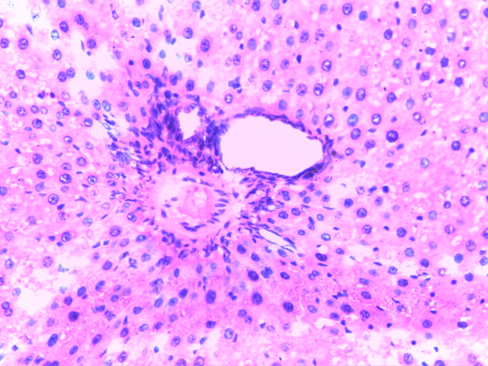
Sections of the liver showing a normal liver architecture
Plate 1 Liver architecture of normal control Wistar rat in group 1 for day 15 (a day after sacrifice).(H & E ×20)

Sections of the liver showing micro and macro lipid vesicles in approximately 90% of hepatocytes
Histology: Sections of the liver show normal portal tract (blue) and normal hepatocytes (black). Normal liver.
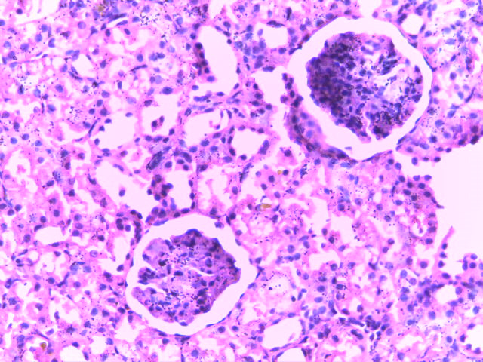
Plate 2 Liver architecture of test control Wistar rat in group 2 for day 15(H & E ×20)
Histology: Sections of the liver show severe lymphocytic infiltration of the portal tract (blue) and severe hepatic damage (black). Diagnosis: Severe steatosis
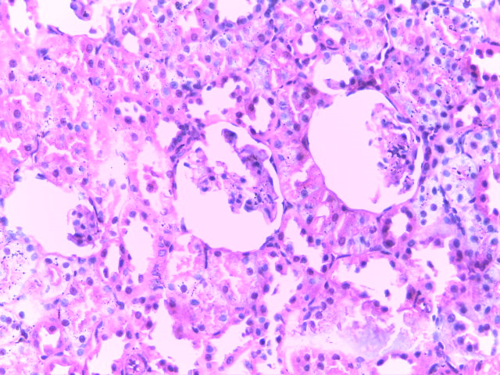
Sections of the liver showing micro and macro lipid vesicles in approximately 50% of hepatocytes
Plate 3 Liver architecture of Wistar rat in group 3 (administered 5% leaves extract) for day 15(H & E ×20)
Histology: Sections of the liver show moderate lymphocytic infiltration (blue) and moderate hepatic damage (black).
Diagnosis: moderate hepatic damage

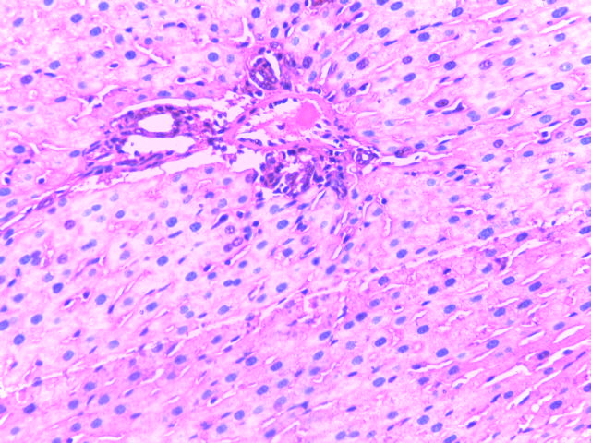
Section of the liver showing mild hepatic damage
Section of the liver showing lipid vesicles in approximately 30% of hepatocytes
Plate 4 Liver architecture of Wistar rat in group 4 (administered 10% leaves extract) for day 15(H & E ×20)
Histology: Sections of the liver show mild lymphocytic infiltration of the portal tract (blue) and mild hepatic damage (black).
Diagnosis: mild steatosis

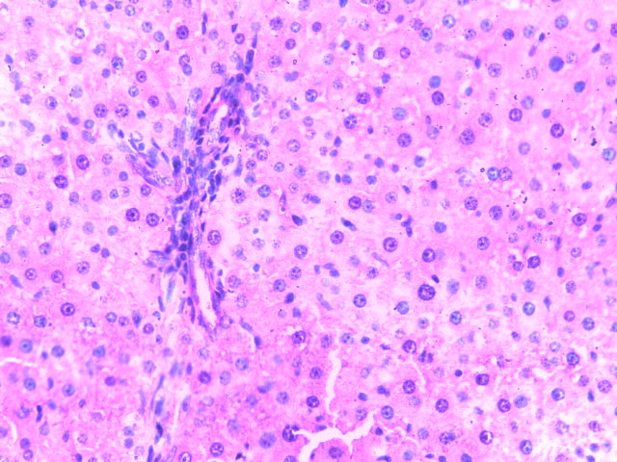
Section of the liver showing normal liver architecture
Section of the liver showing micro and macro lipid vesicles in approximately 10% of hepatocytes
Plate 5 Liver architecture of Wistar rat in group 5 (administered 15% leaves extract) for day 15(H & E ×20)
Histology: Sections of the liver show mild lymphocytic infiltration of the portal tract (blue) and normal hepatocytes (black)
Diagnosis: mild to apparently normal steatosis

3.2 DISCUSSION
Plants have always been a good source of drugs. Numerous studies have shown that a wide variety of plant extracts are effective in the cardiovascular system according to Deeni and Sadiq (2002). Drug induced liver disorders occurring frequently can be life threatening and mimic all forms of liver diseases (Roy et al., 2023; Mishra et al., 2021).
Both leaves have very high nutritional value and contain nutrients such as potassium, calcium, sodium, proteins, copper, manganese, and fibre (Ludwiczuk et al., 2017). Researchers agree that the active constituents in form of minerals and phytochemicals such as steroids, terpenoids, and flavonoids, which are stored in the various parts of the plant such as the leaves in this study, give utazi some of its therapeutic properties (Chatuphonprasert et al., 2018; Lubik et al., 2016; Akinjogunla et al., 2010).
Following CCl₄ induction, a significant increase in the parameters levels (P<0.05) was shown while following the extracts administration, a significant decrease (P>0.05) in such levels, except for HDL which showed a significant increase in the levels (P<0.05), was shown.
From the glucose concentration chart, the normal control shows the moderate concentration of glucose present in the sample while the test control shows high concentration of glucose compared to the normal control as corroborated by McGill (2005). It was also shown that for LDL, the test control levels decreased compared to the levels of the treated groups as corroborated by Stocker and Keaney (2004).
The charts show the treatments of all parameters carried out. In glucose, there were significant differences in all the treatments compared to the normal control. In ALT, normal control is significantly different (P>0.05) to the test control, and treatment three is significantly higher (P>0.05) compared to treatments one and two while in AST, there was significant differences (P<0.05) between treatment one, treatment two, and treatment three. In comparing the parameters in this group; treatment one, treatment two, and treatment three are significantly different (P<0.05) from the test control and normal control. In cholesterol, TAG, and HDL, there were significant differences (P<0.05) in all treated groups as corroborated by Mosca et al. (2004).
Result from group 4 which was treated with 10% extract concentration was slightly less effective compared to that of group 5 while group 3 treated with 5% extract concentration had the lowest ameliorative effect on the rats whose liver had been damaged by CCl₄-induction.
4. CONCLUSION
The best result was obtained with group 5 which was treated with 15% extract concentration. The combined leaves extract of Carica papaya and Gongronema latifolium has been shown to reverse the toxic effects of CCl₄ on the liver of Wistar rats due to their antioxidant and hepatoprotective effect. Both plants leaves could be used as a potential therapy management due to its ability in ameliorating CCl₄-induced liver damage.

Ethical approval
The study was based on standard and approved guidelines for the handling and care of laboratory animals. These guidelines (including applying humane actions during sacrifice) were adhered to. The researchers strived to avoid bias in their study design to ensure accuracy.
Disclaimer (Artificial intelligence)
Option 1:
Author(s) hereby declare that NO generative AI technologies such as Large Language Models (ChatGPT, COPILOT, etc.) and text-to-image generators have been used during the writing or editing of this manuscript.

REFERENCES
Akinjogunla O. J., Yah C. S., Eghafona N. O., & Ogbemudia F. O. (2010). Antibacterial activity of leaf extracts of Nymphaea lotus (Nymphaeaceae) on Methicillin resistant Staphylococcus aureus (MRSA) and Vancomycin resistant Staphylococcus aureus (VRSA) isolated from clinical samples. Annals of Biological Research, 1(2), 174–184.
ALP: The Test - Alkaline Phosphatase (2016). Lab Tests Online, American Association for Clinical Chemistry (AACC), pp. 8-23.
Baker, F. J. & Silverton, R. E. (2005). Introduction to Medical Laboratory Techniques, 7th edition, Butterworts, London. pp. 310-330.
Balogun, M. E., Besong, E. E., Obimma, J. N., Mbamalu, O. S., & Djobissie, S. F. A. (2016). Gongronema latifolium: A Phytochemical, Nutritional and Pharmacological Review. Journal of Physiology and Pharmacology Advances, 6(1), 811-824.
Chatuphonprasert, W., Jarukamjorn, K., & Ellinger, I. (2018). Physiology and Pathophysiology of Steroid Biosynthesis, Transport and Metabolism in the Human Placenta. Frontiers in Pharmacology, 9, 1027.
Deeni, Y. Y. & Sadiq., N. M. (2002). Anti-microbial properties phytochemical constituents of the leaves of African Mistletoe (Loranthacea), An ethanomedicinal plant in Hausaland, Northern Nigeria. Journal of Ethnopharmacology, 839(3), 235-240.
Dhruv, L. & Savio, J. (2017). Alkaline Phosphatase. StatPearls, Florida, United States of
America. pp. 9-20.
Doherty, R. E. (2000). A history of the production and use of carbon tetrachloride, tetrachloroethylene, and 1,1,1-trichloroethane in the United States: part 1â€″ historical background; carbon tetrachloride and tetrachloroethylene. Environmental Forensics, 1(2), 934-945.

Gupta, M., Mazumder, U. K., Kumar, S. T., & Gomathi, P. (2004). Antioxidant and hepatoprotective effects of Bauhinia racemosa against paracetamol and carbon tetrachloride induced liver damage in rats. Iran Journal of Pharmacology and Therapeutics, 3, 12-20.
Guyton & Hall (1996). Textbook of Medical Physiology, 9th edition, Saunders, 498-604.
Heywood, V. H., Brummitt, R. K., Culham, A., & Seberg, O. (2007). Flowering plant families of the world. Firefly Books, Buffalo. p. 424.
Ibekwe, S. E.; Uwakwe, A. A. and Monanu, M. O. (2007). In vivo effects of sodium benzoate on plasma aspartate aminotransferase and alkaline phosphatase of Wistar albino rats. Scientific Research and Essay, 2(1), 010-012.
Kaplan, L. A. & Pesce, A. J. (2001). Clinical chemistry. 4th edition. St. Louis, M. O.: Mosby. p. 175.
Lubik, A. A., Nouri, M., Truong, S., Ghaffari, M., Adomat, H. H., Corey, E., Cox, M. E., Li, N., Guns, E. S., Yenki, P., Pham, S., & Buttyan, R. (2016). Paracrine Sonic Hedgehog Signaling Contributes Significantly to Acquired Steroidogenesis in the Prostate Tumor Microenvironment. International Journal of Cancer, 140(2), 358–369.
Ludwiczuk, A., Skalicka-Woźniak, K., & Georgiev, M. I. (2017). Terpenoids. Pharmacognosy, 233–266.
McGill, J. B. (2005). The Link Between Diabetes & Obesity. American Association of Clinical Endocrinologists. Endocrine, 6(3), 13.
Mishra, A., Padale, A., Manwani, T., Wanjari, A., & Acharya, S. (2021). Effect of Diet on Non-Alcoholic Fatty Liver Disease. Journal of Pharmaceutical Research International, 33(63A), 427-436.
Mosca, L., Appel, L. J., & Benjamin, E. J. (2004). American Heart Association. Evidence-based
guidelines for cardiovascular disease prevention in women. Circulation, 109, 672-693.
Rossetto, M. R. M., Oliveira do Nascimento, J. R., Purgatto, E., Fabi, J. P., Lajolo, F. M., &
Cordenunsi, B. R. (2008). Benzylglucosinolate, Benzylisothiocyanate, and Myrosinase Activity in Papaya fruit during development and ripening. Journal of Agricultural and Food Chemistry, 56(20), 9592-9599.
Roy, U., Mondal, A., & Rukunuzzaman, M. (2023). Assessment of Chronic Liver Disease (CLD) Based on Esophageal Varices in Children. Asian Journal of Pediatric Research, 13(4), 90-98.
Seigler, D. S., Pauli, G. F., Nahrstedt, A., & Leen, R. (2002). Cyanogenicallosides and
glucosides from Passifloraedulis and Carica papaya. Phytochemistry, 60(8), 873-882.
Stocker, R. & Keaney, J. F. J. (2004). Role of oxidative modifications in atherosclerosis.
Physiology Review, 84(4), 1381-1478.

APPENDICES
Appendix A Glucose (GLU) and liver enzyme markers (AST, ALT, ALP) levels for all the groups
GROUPS | GLU (mmol/l) | AST (IU/l) | ALT (IU/l) | ALP (IU/l)
NORMAL CONTROL | 5.00±0.62ª | 20.00±2.00ª | 23.00±1.00ª | 63.17±2.17ª
TEST CONTROL | 6.03±0.65^{b} | 70.00±1.00^{b} | 56.85±11.83^{b} | 159.33±2.33^{b}
TREATMENT ONE | 5.23±1.48^{a,b} | 42.50±4.16^{a,b} | 27.33±4.16^{a,b} | 62.07±5.24^{a,b}
TREATMENT TWO | 5.10±0.06^{a,b} | 35.00±4.51^{a,b} | 24.50±3.00^{a,b} | 59.33±3.07^{a,b}
TREATMENT THREE | 5.03±0.47^{a.b} | 25.00±4.51^{a,b} | 23.97±4.36^{a,b} | 44.67±6.89^{a,b}

Appendix B Lipid profile (CHOL, TAG, HDL, and LDL) levels for all the groups
GROUPS | CHOL (mmol/l) | TAG (mmol/l) | HDL (mmol/l) | LDL (mmol/l)
NORMAL CONTROL | 4.88±0.80ª | 1.46±0.36ª | 1.60±0.20ª | 2.26±0.21ª
TEST CONTROL | 6.20±0.40^{b} | 2.50±0.30^{b} | 0.80±0.10^{b} | 3.78±0.67^{b}
TREATMENT ONE | 5.73±0.45^{a,b} | 2.20±0.32^{a,b} | 1.27±0.88^{a,b} | 3.15±0.98^{a,b}
TREATMENT TWO | 5.13±0.07^{a,b} | 1.76±0.34^{a,b} | 1.43±0.58^{a,b} | 2.76±1.25^{a,b}
TREATMENT THREE | 5.00±0.70^{a,b} | 1.53±0.39^{a,b} | 1.57±0.85^{a,b} | 2.53±0.18^{b}

