Evaluation of Antiradical Effect and Dosage of Total Polyphénols of Extracts Abrus prectorius Leaves , a Plant used in the Treatment of Diabetes in Côte d’Ivoire

.

abstract
Aims: The aim of this study was to evaluate the antiradical effect of extracts aqueous and ethanolic of Abrus precatorius Leaves and to determine the polyphenols.
Place and Duration of Study: Microbiology and Biotechnology Laboratory, Ecology Research Center, Nangui Abrogoua University, BP 109, Abidjan 08, Côte d'Ivoire.
The first part of this study was carried out from November 28, 2024 to December 31, 2024; the second part was conducted from January 18, 2025 to Mars 13, 2025.
Methodology: The anti-radical effect was determined by scavenging DPPH free radical in the presence of control (Vitamin C) and inhibition concentration 50 (IC₅₀) of each extract was determined. The polyphenols were dosed using the Folin-Ciocalteu reagent.
Results: All extracts exhibited marked antiradical effect by scavenging DPPH free radical in a concentration dependent manner. There were recorded IC50 values of 0.813 mg/ml for aqueous extract and 0.283 mg/ml for ethnolic extract which are different from Vitamin C (7.10-3 mg/mL). Aqueous and ethanolic extracts of A. precatorius leaves are rich in polyphenols with levels of 178.34 ± 1.67 mg/g GAE and 163,28 ± 1,31 mg/g GAE respectively. The extracts of A precatorius show anti-radical effect in DPPH test with good polyphenol content, characterized by high levels of flavonoids (93.44 ± 1.83 mg/g GAE) and condensed tannins (16,31 ± 0,24 mg/g GAE ) with aqueous extract.
Conclusion: The antiradical effect observed with extracts of A. precatorius leaves rich in polyphenols could justify its antioxidant activity which would be at the origin of the antidiabetic properties attributed to the plant.

Keywords: Abrus precatorius, antiradical effect, antioxidant, polyphenols, diabetes. Côte d’Ivoire

1. INTRODUCTION

Abrus precatorius is a climbing plant of the Fabaceae family known for its multiple uses in traditional medicine [1]. The leaves are used to treat childhood cough, fever, stomach disorders, asthma, bronchitis [1, 2]. An ethnobotanical survey carried out in the department of Zouénoula, in West Center of Côte d'Ivoire, revealed that Abrus precatorius leaves are used in the treatment of diabetes [3]. In fact, Diabetes is a metabolic disorder characterized by a disorder in the regulation of carbohydrate metabolism leading to hyperglycemia [4, 5]. The complications of diabetes cause severe degenerative in the heart, vessels, eyes, kidneys and nerves [5]. Oxidative stress, which is the excess of harmful free radicals, could also be associated with factors involved in the onset of diabetes [6]. It would act as a triggering factor or be associated with the various complications linked to the development of diabetes [7]. Currently, diabetes therapy is based on the use of hypoglycaemics (sulfonamides, biguanides, insulin), on hygieno-diet measures and exercises [5]. This requires a long treatment, which patients find difficult to tolerate [5]. In the search of means of fighting, the medicinal properties of many wild plants are being used, including those of Abrus precatorius. [5]. The studies showed that the aqueous extract of A. precatorius leaves at effective dose (ETAAP 40 mg/ml) decreases the hyperglycemia caused in rats with good blood sugar regulation [5] and no toxicity at this dose [8]. Methanolic extract of A. precatorius leaves has a potential effect against diabetes mellitus type-1 type 1 diabetes [9]. The antidiabetic properties attributed to the plant Abrus precatorius would be caused by the presence of natural chemical groups: saponins, quinones (coumarins), sterols, triterpenes and reducing compounds alkaloids flavonoids and tannins [1, 5]. Among these natural chemical groups, flavoinoids and tannins are recognized for their antioxidant activity [10]. The present study aims to evaluate antiradical effect of aqueous and ethanolic extracts of A. precatorius leaves and to dosaged polyphenols.

2. material and methods

2.1 Materials
Plant material: Abrus precatorius leaves were harvested in December 2024 in the outskirts of Abidjan, in South of Côte d'Ivoire. The plant was identified at the National Floristic Center of Félix Houphouët-Boigny University by comparing it to reference samples : Abrus precatorius (Fabaceae): Aboudé-Mandéké (Côte d’Ivoire), May 23, 1990, N’guessan Koffi 165 [11]. The leaves dried away from the sun were crushed and the powder obtained was used to prepare the extracts.
2.2 Methods

2.2.1. Preparation of extracts
The aqueous and ethanolic extracts were obtained, respectively, by decoction with distilled water and by maceration with ethanol using the modified method of [1]. .

2.2.1.1 Decoction
10 g of powder of leaves taken up in 100 ml of distilled water is heated to boiling for 1h. After cooling, aqueous mixture is filtered several times and then put in an oven at of 55 ° C to dry for 24 h. Then the aqueous extract was obtained (EA).

2.2.1.2 Maceration
25 g of powder of leaves was subject to maceration under magnetic agitation for 48 hours in 125 ml of ethanol. It was filtered once on cotton wool and then filtered on filter paper (whatman). The filtrate is put in an oven at of 55 ° C to dry for 24 h. Then the ethanolic extract was obtained (EE).

2.2.2 Antiradical effect of extracts in DPPH test
2,2-diphenyl-1 picrylhydrazyl (DPPH) free radical scavenging assay was performed to determine the effect antiradical of different concentrations of extracts (aqueous and ethnol) and ascorbic acid (1000 to 62. 5 µg/ml). DPPH (0.04%) was used as free radical. An equal volume of various concentrations of DPPH and methanolic extracts were mixed in the micro-plates and were incubated at room temperature in the dark for 30 minutes. The optical density was measured at 517 nm. Their using a micro-plate reader. The degree of stable DPPH* decolorization to DPPHH (reduced form of DPPH) yellow indicated the scavenging efficiency of the extracts. Vitamin C was used as the positive standard and methanol as the blank. The scavenging activity of the extracts against the stable DPPH* was calculated using the following equation:

DPPH radical scavenging activity (%) = [(A₀ – A₁)/(A₀)] X 100

A₀ is the absorbance of DPPH radical + methanol
A₁ is absorbance DPPH radical + sample extract/standard.

IC₅₀ value was determined from the plotted graph of scavenging activity against the different concentrations of extracts.

2.2.3 Determination of polyphenols

The content of total phenolic compounds was determined with Folin-Ciocalteu reagent [12] according to the modified method of [13].
One (1) mL of extract diluted 1/10 with distilled water, 1.5 mL of sodium carbonate (Na2CO3) (17%, m/v) and 0.5 mL of Folin-Ciocalteu reagent (0.5N) were added.
The reaction mass was incubated at 37°C for 30 minutes; the absorbance was read at 760 nm against a control without extract, taken as reference.
Gallic acid at different concentrations (0 to 1000 μg/mL) under the same conditions as the sample was used as a reference standard for the establishment of the calibration curve and for the quantification of total polyphenol contents expressed in mg of gallic acid equivalent per gram of extract (mg EAG/g of extract). The tests were carried out in triplicate for each sample. The total polyphenol contents of the aqueous and ethanolic extracts were determined from the calibration curve: Y = 75.29x – 27.462 traced using gallic acid as a standard.

2.2.4 Dosage of flavonoids
The dosage of total flavonoids was carried out according to the modified method of [14] taken up by [13].
Two (2) mL of extract were diluted 1/10 and mixed with 100 μL of Neu's reagent. Absorbance was read at 404 nm with quercetin taken as standard (0.05 mg/mL), diluted under the same conditions and treated with the same amount of reagent. Quercetin was used as a reference standard for establishing the calibration curve and for quantifying total flavonoid levels expressed in milligrams of quercetin equivalent per gram of extract (mg EQ/g of extract). The tests were performed in triplicate for each sample. The flavonoid contents of the aqueous and tetanolic extracts were determined from the calibration curve.
Y = 20.317x + 35.18 traced using quercetin as the standard.

2.2. 5 Dosage of condensed tannins
The dosage of condensed tannins in the different extracts was carried out according to the modified method described by [15] taken up by [16].
A quantity of 400 μL of each sample or standard was added to 3 mL of a 4% methanolic vanillin solution and 1.5 mL of concentrated hydrochloric acid. The mixture was incubated for 15 minutes and the absorbance was read at 500 nm. Condensed tannin concentrations were deduced from the calibration ranges established with catechin. Quantification of condensed tannin contents was expressed as mg catechin equivalent per g dry matter (mgCE/g DM).
The tests were carried out in triplicate for each sample. The condensed tannin contents of the aqueous and ethanolic extracts were determined from the calibration curve Y = 4.5427x – 0.5443 traced using catechin as a standard.

2.2.6 Statistical Analyses
All results are expressed as mean ±SD. The significance of difference was calculated by Student’s t test, and significant difference was accepted at p <0.05 significant.

3. results and discussion

3.1. Antiradical effect of extracts in DPPH test

The determination of the IC₅₀ of the aqueous and ethanolic extracts of the leaves of A. precatorius (Figure 1, 2) was carried out under the same conditions as that of Vit C (Figure 3, 4). The respective IC₅₀ values of the extracts against the control (Vit C) are reported in table 1. The results obtained show that the aqueous and ethnolic extracts of the leaves of Abrus precatorius have antiradical effects in the DPPH test as well as Vit C.

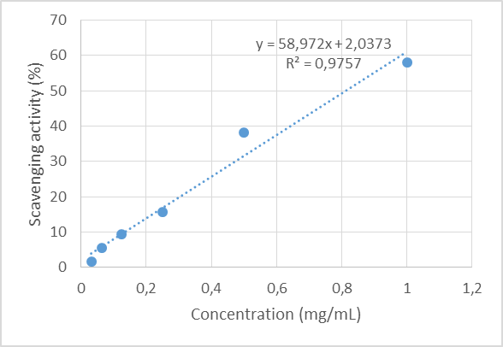

Fig. 1: Antiradical effect of aqueous extract of Abrus precatorius (EA)

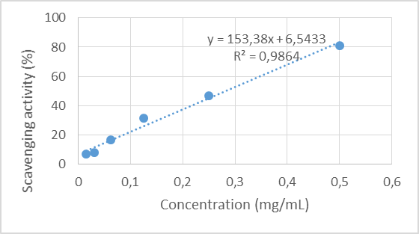

Fig. 2: Antiradical effect of ethnolic extract of Abrus precatorius (EE)

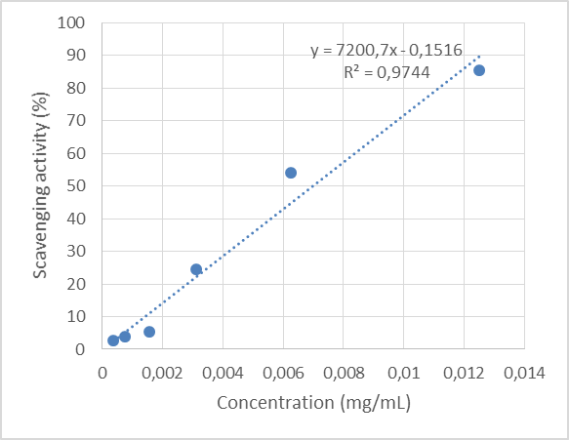

Fig. 3: Antiradical effect of ethnolic extract of Vitamine

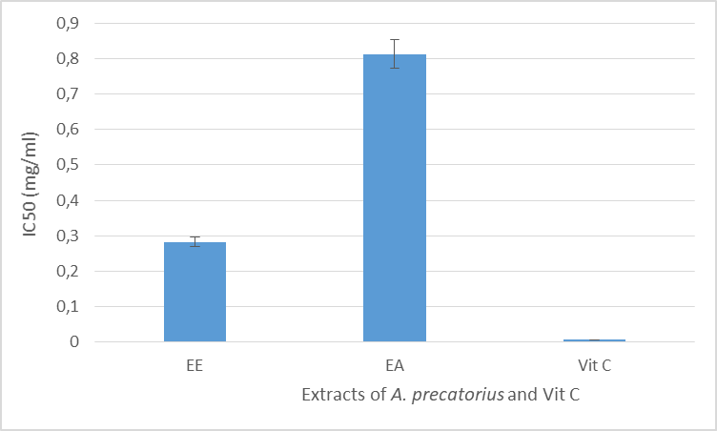

Fig. 4: Antiradical effect of extract A. precatorius and Vit C

Table 1: DPPH radical scavenging activity (IC₅₀) of extracts Abrus prectorius leaves

Extracts A. prectorius leaves | Aqueous extract | Ethanolic extract | Vit C
IC₅₀ (mg/mL) | 0.813 | 0.283 | 0.007

3.2. Total Phenol content of the extracts

The total polyphenol values of aqueous and ethanolic extracts of A. precatorius leaves are shown in table 2. The aqueous extract has the highest polyphenol content (Figure 5).

Table. 2 : Total Phenol content of the extracts of A. precatorius Leaves

Extracts | Means (mg/g GAE)
Extract aqueous  Extract ethanolic | 178.34 ± 1.67  163.28 ± 1.31

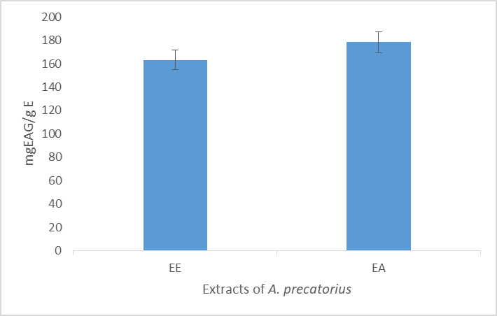

Fig. 5 : Classification of total polyphenol contents according to A. precatorius leaves extracts

3.3. Total Flavonoid content of extracts

The aqueous and ethanolic extracts of A. precatorius leaves contain varying levels of total flavonoids (Table 3). The aqueous extract has the highest flavonoid content (Figure 6).

Table 3 : Total Flavonoid content of extracts of A. precatorius leaves

Extracts | Means (mg/g EQ)
Extract aqueous  Extract ethanolic | 93.44 ± 1.83  81.18 ± 0.42

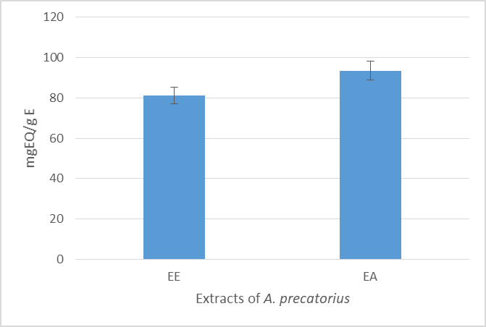

Fig. 6 : Classification of total flavonoids contents according to extracts of A. precatorius leaves

3.4. Condensed tannin content of the extracts

The aqueous and ethanolic extracts of A. precatorius leaves contain condensed tannins of varying levels (Table 4). The ethanolic extract has the highest flavonoid content (Figure 7).

Table 4 : Condensed tannin content of extracts A. precatorius leaves

Extracts | Means (mg/g EC)
Extract aqueous  Extract ethanolic | 16.31 ± 0.24  2.07 ± 0.90

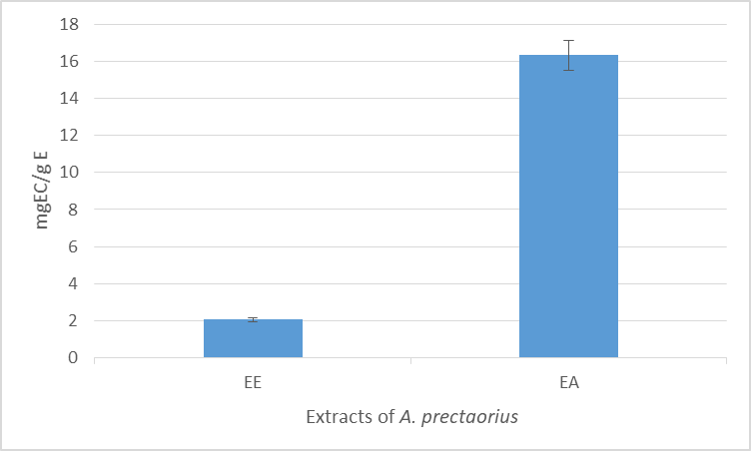

Fig. 7 : Classification of Condensed tannin content according to extracts of A. precatorius leaves

The aqueous and ethanolic extracts of Abrus precatorius leaves have an antiradical effect in the DPPH test as Vit C. The IC₅₀ values of the extracts are different from those Vit C. The ethanolic extract showed a better antiradical effect with a lower IC₅₀ than that of the aqueous extract. The ethanolic extract showed a better antiradical effect with a lower IC₅₀ than aqueous extract. These results are comparable to those obtained by certain authors [17, 18]. whose results showed that crude methanolic extract of seeds of Abrus precatorius has antiradical activity. The dosage of polyphenols in the aqueous and ethanolic extract of A. precatorius leaves revealed good phenol content in extracts. The presence of phenolic substances such as total flavonoids and condensed tannins in extracts was observed. Secondary metabolites found in extracts A. precatorius leaves could be responsible for antiradical effects recorded. These results are in agreement with those obtained by [18]. The work of these authors showed the antiradical activity of methanolic extract of seeds of A. precatorius could be attributed to phenolic substances such as flavonoids. Other authors have shown that the methanolic extract of A. precatorius leaves characterized by the presence of flavonoids and tannins possessed antioxidant activity to DPPH test [19]. The reducing power of the plant A. precatorius is probably due to the presence of hydroxyl groups in phenolic compounds which can serve as electron givers. Flavonoids containing hydroxyl groups can function either as metal chelators (quercetin) or as scavengers of hydroxyl, superoxide, alkyl, and peroxide radicals [20].Therefore, antioxidants are considered as reducers and inactivators of oxidants [21]. Previous studies have also shown that the reducing power of a compound can serve as a significant indicator of its potential antioxidant activity [22]. .Thus, any substance capable of capturing the single electron of a free radical without itself giving a radical product is defined as a free radical scavenger [23]. The effects therapeutic effects against diabetes of A. prectorius [9] could be due to its blood sugar regulating effect related to the antioxidant activity linked to the scavenging of free radicals [18].

4. Conclusion

Aqueous and ethanolic extracts of Abrus precatorius leaves demonstrated antiradical effects in the DPPH test, with a good polyphenol content. These extracts were rich in phenolic substances such as total flavonoids and condensed tannins. The antioxidant properties attributed to the plant could justify its proven therapeutic effects in the treatment of diabetes.

Disclaimer (Artificial intelligence)
Option 1:
Author(s) hereby declare that NO generative AI technologies such as Large Language Models (ChatGPT, COPILOT, etc.) and text-to-image generators have been used during the writing or editing of this manuscript.
Option 2:
Author(s) hereby declare that generative AI technologies such as Large Language Models, etc. have been used during the writing or editing of manuscripts. This explanation will include the name, version, model, and source of the generative AI technology and as well as all input prompts provided to the generative AI technology
Details of the AI usage are given below:
1.
2.
3.

References

1 Lébri, M., Bahi, C., Fofié, Y.B.N., Gnahoué G., Lagou, S.M., Achibat, H., by et al. (2015). Phytochemical analysis and acute oral toxicity assessment in rats of the total aqueous extract of the leaves of Abrus precatorius Linn (Fabaceae). International Journal of Biological and Chemical Sciences, 9(3):1470-1476.
2 Gairola, S., Gupta, V., Bansal, P., Singh, R., & Maithani, M. (2010). Herbal antitussives and expectorants. International Journal of Pharmaceutical Sciences Review and Research, 5(2): 5-6.
3 Gnagne, A.S., Camara, D., Fofié N.B.Y., Béné, K. & Zirihi, G.N. (2017) Ethnobotanical study of medicinal plants used in the treatment of diabetes in the Department of Zouénoula (Côte d’Ivoire). Journal of Applied Biosciences, 113: 11257-11266
4 Calop, J., Limat, S., & Frnandez, C. (2008). Clinical and therapeutic pharmacy. Masson, Elsevier Masson, Paris 3rd Ed, 417-427.
5 Lébri M., Lagou S.M., Fofié N.B.Y., Bahi, C., Zirihi, G.N., Coulibaly, A., et al. (2019). Phytochemical screening and antidiabetic effect of aqueous extract of Abrus precatorius Linn (Fabaceae). Science and technology, Health Sciences, 42(2): 6-168
6 Dasgupta, N., & De, P. (2007). Antioxidant activity of some leafy vegetables of India: a comparative study. Food Chemistry, 101, 471-474 pp.
7 Sohal, R. S., Mockett, R. J., Orr, W. C. (2002). Mechanisms of aging: an appraisal of the oxidative stress hypothesis, Free Radical. Biology and Medicine, 33: 575-586 pp.
8 Lébri, M., Lagou, S.M., Fofié N.B.Y., Bahi, C., Zirihi, G.N., Coulibaly, A., et al. (2023). Subacute toxicity assessment in rats of aqueous extract from Abrus precatorius leaves (Fabaceae) a medicinal plant used in the treatment of diabetes. International Journal of Biology Sciences, 5(1): 190-197
9 Oluwaseun, O.T., Olawale, M.O., Lateef, A.S., Sabur, O. S., Precious, O.A., Dennis, V.D., et al. (2024). Abrus precatorius leaf bioactives: invivo anti-diabetes mellitus type-1 activity, PPARA and SCD as novel targets. Journal of Umm Al-Qura University for Applied Sciences, 10:421–437.
10 Lagou SM, Lébri M, Tra.Bi .FH, Koné MW., Chigr F., Hafid A. & Kouilli M. (2025) Phytochemical screening and in vitro antioxidant activity of extracts of Bombax brevicuspe (Sprague) Roberty (Malvaceae), a medicinal plant used in the treatment of obstetric fistula in Côte d’Ivoire. European Scientific Journal, ESJ, 21 (3), 127–137.
11 N’guéssan, K., Zirihi, N., Boraud, N.K.M. (2010). Ethnopharmacological study of plants used to facilitate childbirth in Abbey and Krobou country, southern Côte d’Ivoire. Int. J. Biol. Chem. Sci, 4(4): 1009–1010.
12 Cicco, N., Lanorte, M.T., Paraggio, M., Viggiano, M., Lattanzio, V. (2009). A reproducible, rapid and inexpensive Folin-Ciocalteu micro-method in determining phenolics of plant methanol extracts. Microchemical Journal, 91, 107-110.
13 Djamilatou, Z.S., Djibo, A.K., Sahabi, B., & Seini, S.H. (2021). Phytochemical screening, dosage of polyphenols and determination of the antioxidant activity of two anti-hypertensive plants from Niger. European Scientific Journal, 17(17): 335-349.
14 Dirar, A.I., Alsaadi, D.H.M., Wada, M.M.M.A., Watanabe, T., Devkota, H.D. (2019). Effects of extraction solvents on total phenolic and flavonoid contents and biological activities of extracts from Sudanese medicinal plants. South African Journal of Botany, 120(1): 261-267.
15 Heimler, D., Vignolini, P., Dini, M.G., Vincieri, F.F., Romani, R. (2006). Antiradical activity and polyphenol composition of local Brassicaceae edible varieties. Food Chemistry, 99(3), 464-469.
16 Kouamé, T.K., Siaka, S., Kassi, A.B.B., & Soro, Y. (2021). Determination of total polyphenol, total flavonoid, and tannin contents in young, unopened leaves of Piliostigma thonningii (Caesalpiniaceae). International Journal of Biological and Chemical Sciences, 15(1): 97-105.
17 Vadivel, V., Nandety, A., Biesalski, H.K. (2011). Antioxidant, free radical scavenging and type II diabetes-related enzyme inhibition properties of traditionally processed Jequirity bean (Abrus precatorius L.). International Journal of Food Science and Technology, 46(12):2505-2512.
18 Lubna, M., Syed, A.S., Rashida, A., Syed, M.G.S., & Rahil, A. (2017). Antibacterial, antioxidant and phenolics compound analysis of Abrus precatorius seed coat extract and its different fractions. Pakistan Journal of Botany, 49(6): 2499-2506.
19 Fatima, M.M., Adamu, Y. K., Olofu O.E., Abdullahi, M. (2019). Antioxidant Properties and Effect of Abrus precatorius Leaves Extract on Haematological and Biochemical Parameters in Rats. Iranian Journal of Toxicology,13 (2):13-18.
20 Madhavi, D.; L., Deschpandes, S., Salunkhe, D. K. (1996). Foods antioxidants technology, toxicological and health perspectives. Ed. Marcel Dekker, New York (United States of America), 479 p.
21 Siddhuraju, P., & Becker, K. (2017). The antioxidant and free radical scavenging activities of processed cowpea (Vigna unguiculata Walp) seed extracts. Food Chemistry, 101(1): 10-19.
22 KumaranA., & Karunakaran, R.J. (2007). In vitro antioxidant activities of methanol extracts of five Phyllanthus species from India. Lebensmittel-Wissenschaft und Technologie, 40: 344-352.
23 Béné, K., Camara D., Kanga, Y., & Zirihi, G.N. (2017). Antiradical potential of leaf extracts of Bersama abyssinica Fresen. (Melianthaceae). International Journal of Biology Sciences 11(6): 2962-2970.

