Analysis of biochemical variability and antimicrobial resistance profile of Escherichia coli strains isolated from the vegetable food chain in Niamey, Niger

ABSTRACTS
Escherichia coli (E. coli), is important both in terms of its frequency and the severity of the conditions it causes. It is a commensal of the human digestive tract. The presence of E. coli in food products indicates direct or indirect faecal contamination due to hygiene deficits during product preparation. The objective of this study was to analyze the biochemics variability and level of antibiotic resistance of Escherichia coli strains isolated from vegetables produced and sold in Niamey. A total of 124 vegetable samples and 29 irrigation water samples were collected and analyzed. The biochemical characteristics were searched on the API24 gallery. The antibiotic resistance phenotype was determined using the standard Kirby-Bauer agar diffusion method. Approximately, 05.64% of vegetable samples were contaminated with E. coli, with tomato samples most affected (08.57%), followed by onion samples (08.33%). The study of the biochemical characteristics divides the strains into three (3), of which Group 1 is characterized by the absence of DHA and Groups 2 and 3 by the presence of DHA. The most frequently observed resistance phenotypes concerned CRO, AMC, ATM, SXT and TET. The presence of multi-resistant strains of Escherichia coli in vegetables testifies the potential risk associated with the consumption of these vegetables. It is important to look for the potential resistance and virulence genes of these strains for better management of infectious diseases.
Keywords : E. coli, vegetable, contamination, Niamey
INTRODUCTION
Every day, we ingest a large number of microorganisms in our food. Due to their microscopic size, they are invisible to the eye and therefore represent an invisible danger. A minority of these microorganisms are pathogenic (China et al., 2002). Food for humans is an exceptional culture medium for microorganisms in general (China et al., 2002). Enteropathogenic bacteria, including Escherichia coli, play an important role both in terms of their frequency and the severity of the conditions they cause (Carré et al., 2004; Guindo et al., 2022). Escherichia coli (E. coli) is a commensal colibacille of the human digestive tract and it is one of the bacterial species often encountered in human pathology (Foka et al., 2022). E. coli is considered a normal colonizer of the human digestive microflora but may nevertheless be pathogenic. This is the case of enterohaemorrhagic pathovars (EHEC), enteropathogenic (EPEC), enterotoxigenic (ETEC), enteroinvasive (EIEC), enteroaggregative (EAggEC). These strains cause various types of diarrhea and colitis, regularly acquired through food poisoning (Mariani-Kurkdjian et al., 2016; Sara & Yousra, 2021; Guindo et al., 2022). The presence of E. coli in food products indicates direct or indirect fecal contamination due to hygiene deficiencies during product preparation (Cyuzuzo et al., 2023). Today, the world faces a problem of antibiotic resistance in these bacteria, which is a serious global public health issue (Akree et al., 2022). Initially, antimicrobial resistance is seen as a human problem, which is not the case today (Cyuzuzo et al., 2023). The misuse and uncontrolled use of antibiotics in human and veterinary medicine and agriculture has resulted in a selection of resistant bacterial strains (Cyuzuzo et al., 2023). According to WHO, the use of antimicrobials in agriculture has a positive impact on the growth of antimicrobial resistance (Economou and Gousia, 2015). The antibiotic resistance gene can be transmitted to humans directly or indirectly through consumption of contaminated products (Cyuzuzo et al., 2023). The objective of this study is to evaluate the biochemical variability and level of antibiotic resistance of Escherichia coli strains isolated from vegetables in Niamey.
MATERIALS AND METHODS
Study area
The study was conducted in the urban community of Niamey. The region of Niamey is located in the south-western part of Niger between latitude 13° 24' and latitude 13°35' N and longitude 2°00’ and longitude 2°15' E with an altitude between 160 and 250 m. Its administrative limits extend over 552.27 km2 of which approximately 297,46km2 of built-up area (INS, 2018). The population of Niamey is estimated at approximately 1,407,635 hbts. The city of Niamey is subdivided into five municipal arrondissements whose population distribution by municipal district is as follows: Niamey I: 287,902 inhabitants; Niamey II: 338,455 inhabitants; Niamey III: 223,685 inhabitants; Niamey IV: 376 271 inhabitants; Niamey V: 181,321 inhabitants (INS, 2022). The climate is Sahelo-Sudanese type and includes a long dry season from October to May and a short rainy season from June to September. The cold dry season is the most favourable for vegetable production, during which the majority of crops are grown. The study was conducted in three (3) large vegetable markets (Gounti yéna, Gamkalé and Harobanda) and five (5) markets (Small market, Dar es Salam market, Dolé market, Wadata market and Harobanda market) for selling vegetables from the urban community of Niamey.

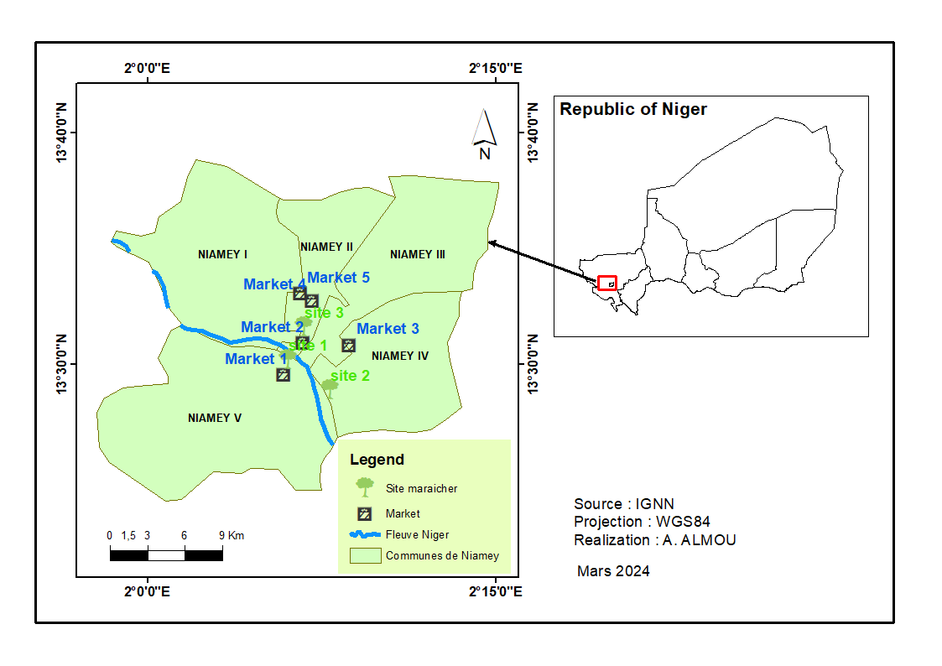 Fig 1 : Map showing study location

Method of sampling
Samples of vegetables were taken from production and sales sites (markets). Samples were taken under sterile conditions using sterile single-use gloves and alcohol to avoid external contamination. These samples included lettuce without root, whole tomatoes with no visible alterations or cracks, whole carrots and whole onion. A lettuce samples were three (3) lettuce heads and a tomato samples were three (3) fruits without cracking, weighing approximately 150g taken at random from different corners of the production site or in the same lot from the seller. The samples of carrots and onions were taken at the point of sale only, a sample of carrots is made up of at least three carrots weighing at least 150g taken at random from the same seller. A batch of approximately 150g was used as sample for the onions. Each sample was accompanied by an information sheet. A total of 124 vegetable samples and 29 irrigation water samples were collected and analyzed.
Condition of carriage
Each sample collected was well packaged in a polyethylene bag and then carefully labelled. The samples were then transferred, after being packaged and placed in a cooler containing carboglaces which keep the temperature low at around 4°C to the microbiology laboratory of the Faculty of Science and Technology (FAST).
Bacteriological analysis
Isolation of Escherichia coli
Each sample of vegetables was grounded. Then, 25 grams of the broyate were taken and placed in 225 mL of BPW prepared and sterilized. The resulting solution was seeded on EMB agar (Bio-rad, France) according to ISO 18140 (give the references). After incubation at 37°C for 24 hours, the characteristic colonies of E. coli (green with metallic reflection) were selected and propagated on nutritive agar to obtain a pure culture.
Identification of Escherichia coli
The API 20E (Bio Mérieux, France) is a standardized system with 20 microtubes containing dehydrated substrates (AFNOR, 1996). The microtubes are inoculated with bacteria suspensions. The reactions produced during the incubation period result in color changes that occur spontaneously or are revealed by the addition of reagents. These reactions were read using the reading board and identification was obtained using the identification software (WEB API).
Antibiotic sensitivity test
Preparation of the inoculum
The inoculum was prepared from young colonies grown the day before at 37°C on nutrient agar. A standardized 0.5 Mac Farland inoculum corresponding to 10⁸ CFU/mL (CA-SFM/ EUCAST, 2023) was prepared. Then 100 μL of this inoculum was diluted in 10 mL of physiological water to a final concentration of 10⁶ CFU/mL.
Seeding
The final inoculum was seeded by swabbing on Petri dishes., The swab is soaked in the bacterial suspension and then squeezed firmly onto the inner wall of the tube. Then it is rubbed on the entire surface of the Mueller Hinton (MHA) surface, from top to bottom in tight streaks. The operation is repeated three (3) times by turning the box 60° each time. Seeding is completed by passing the swab on the periphery of the agar (Djelloul-Daouadji, 2010; Rahal, 2011; Chaabane &Latreche, 2020). After seeding, nine (09) antibiotic-impregnated discs (Bio-rad, France) of the β-lactam family (Amoxicillin + clavulanic acid, Aztreonam, Ceftriaxone, Imipenem, Meropenem), Quinolone (Ciprofloxacine), Tetracycline (Tetracycline), Nitrofuran (Nitrofurantoin, Trimethoprim/Sulfamethoxazole) were disposed on the surface of MHA using some pre-sterilized forceps. The boxes were left at room temperature for about 15 minutes after the discs were placed, to allow a pre-diffusion of antibiotics, and then incubated at 37°C for 24 hours. After incubation, the inhibition diameters around the antibiotic discs were measured. The strains were then categorized as Sensitive, Intermediate, or Resistant by comparing these diameters to critical diameters for enterobacteria (for each antibiotic) fixed by CA-SFM/ EUCAST (2023).
Statistical analysis
The IBM SPSS statistics software version 23.0.0.0 was used to calculate averages and standard deviations. Microsoft Excel was used to generate the tables and graphs. The document was developed in Microsoft Word. The Gis arc software was used to design the geographic map of the study area. The differences were considered significant for values of p<0.05.
RESULTS
Overall prevalence of identified strains of Escherichia coli in vegetable and watering water samples according to sampling sites

The prevalence of Escherichia coli by the sampling site is presented in Table I. A total of 10 strains of E. coli have been identified in 151 samples of vegetables and watering waters analyzed (6.62%). The prevalence varies from one sampling site to another (5.00 and 9.80%, respectively in markets and horticultural sites). Two types of Escherichia coli have been found, which are Escherichia coli 1 and 2. Escherichia coli 1 is mainly found both on the markets and in vegetable gardens (4.00 and 7.84% respectively) against (1.00 and 1.96%) for Escherichia coli 2.

Table I. Distributions of the strains of Escherichia coli identified in vegetable and watering water samples according to market and market location
Cash | Distribution according to market sites  (n) % |  | Total
Cash | Markets | Garden sites | Total
Escherichia coli1 | 4(4.00)ª | 4(7.84)ª | 8(5.30)
Escherichia coli2 | 1(1.00)ª | 1(1.96)ª | 2(1.32)
Total | 5(5.00) | 5(9.80) | 10(6.62)
Values with the same letter in the same column are not significantly different (P>0.05)

Prevalence of Escherichia coli isolate from vegetables according to sampling sites

Table II shows the distribution of Escherichia coli strains by type of vegetable. Escherichia coli was found in vegetable samples at a rate of 04.23%. Tomato samples were the most affected (08.57), followed by onion samples (08.33%) and finally lettuce samples (06.15%). No strains were identified in the core samples. Indeed, Escherichia coli1 represents more than 2/3 of the strains identified (five (5) strains or 04.32%). Markets record four (4) strains of E. coli1 and garden sites one (1) strain in tomato samples. Only two (2) strains of Escherichia coli2 have been identified, one at market level in lettuce and the other at market sites in tomato. No significant difference is recorded between sampling sites (P-value>0.05).

Table II . Prevalence of Escherichia coli strains by sampling site and type of vegetable
Species | Site | Type of product |  |  |  | Total
Species | Site | Lettuce | Onion | Tomato | Carrot | Total
Escherichia coli 1 | Market 1 |  | 1(25.00)ª |  | - | 1(3.85)
Escherichia coli 1 | Market 2 |  |  | 1(12.50)ª | - | 1(4.55)
Escherichia coli 1 | Market 3 | 1(25.00)ª |  |  | - | 1(10.00)
Escherichia coli 1 | Market 5 | 1(9.09)ª |  |  | - | 1(4.55)
Escherichia coli 1 | Site 1 |  |  | 1(16.67)ª | - | 1(16.67)
Escherichia coli 1 | Site 3 |  |  |  | - | -
Escherichia coli 1 | Total | 2(3,08) | 1(8,33) | 2(8,00) | - | 5(04,32)
Escherichia coli 2 | Market 1 | 1(7,14)ª |  |  | - | 1(3,85)
Escherichia coli 2 | Site 1 |  |  | 1(16,67)ª | - | 1(4,00)
Escherichia coli 2 | Total | 1(1,54) |  | 1(4,00) | - | 2(1,61)
Total |  | 4(06,15) | 1(08,33) | 3(08,57) |  | 7(05,64)
Values with the same letter in the same column are not significantly different (P>0.05). Market 1: Small market; Market 2: Dar es Salaam; market 3: Dolé; market 4: Wadata; market 5: Harobanda; Site 1: Gounti yéna; site 2: Gamkalé; site 3: Harobanda.

Study of the biochemical similarity of identified strains of Escherichia coli

The Hierarchical Ascending Classification (AMP) the biochemical characteristics of Escherichia coli strains based on Euclidean distance according to Ward’s method and analysis of dendrogram generated by this AMP allowed to classify the identified Escherichia coli strains into Three (3) groups (Figure 2). Groups 1 and 3 comprise 60% and 40% of the strains, respectively. Group 2 is a single strain (E. coli2.1). Factorial analysis of the different biochemical characteristics discriminates the three (3) groups on the basis of six (6) characters (ADH, LDC, IND, GEL, INO and RHA). Group 1 is characterized by the absence of DHA and groups 2 and 3 by the presence of DHA. Group 3 is distinguished from the second by glucose fermentation.

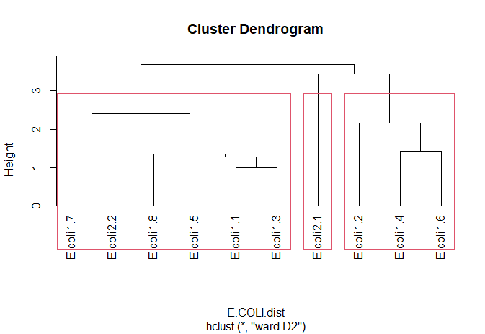
G1
G2
G3

Figure 2. Dendrogram generated by hierarchical ascending classification of the biochemical characteristics of Escherichia coli strains

To better explore this biochemical variability between the strains of Escherichia coli identified from vegetables, a Principal Component Analysis (PCA) (Figure 3) was performed. It is clear from this ACP that axis 1 better explains this biochemical difference between the strains (which represents about 39.89%). The analysis of these factorial axes shows that the variables LDC, RHA, ARA, SOR, ONPG, MAN, ODC, SAC, INO, MEL and AMY are positively correlated with axis 1 and GEL, IND and ADH negatively. The variables ONPG, SOR, ARA and MAN are positively correlated with each other. Negative correlations are observed between LDC and ADH and between IND and INO.
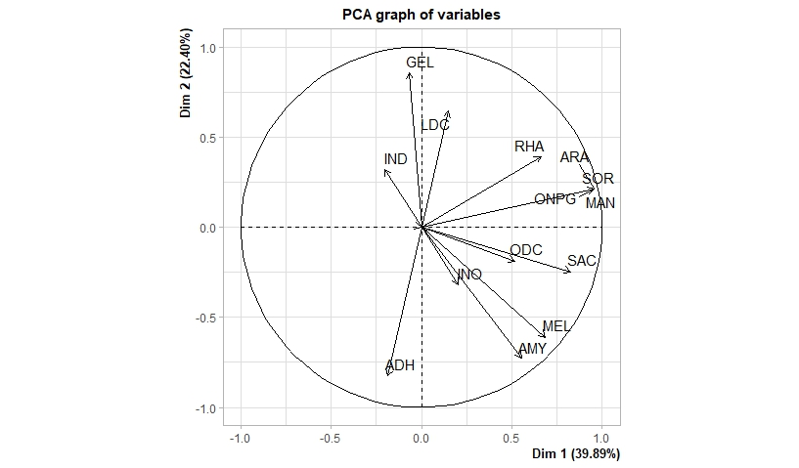
Figure 3. Projection of biochemical characteristics in the factorial plane after ACP
The projection of the different characteristics in the factorial plane shows that E. coli1.2 strains; E. coli1.4 and E. coli1.6 which form group 3 are located on the positive side of axis 2 with similar characters LDC, ONPG, RHA, MAN, ARA and SOR. The strain E. coli1.2 is found on the negative side of axis 1 with discriminating characters GEL and IND. Then the strains forming group 1 (E. coli1.1; E. coli1.4; E. coli1.5; E. coli1.6; E. coli1.7; E. coli1.8 and E. coli2.2) with similar characters ODC, SAC, INO, MEL and AMY. E. coli1.1 and E. coli1.5 are distinguished by their ability to metabolize MEL and AMY. The E. coli2.1 strain that forms group 2 is located on the negative sides of axes 1 and 2. There are ADT, ADH and URE in this strain. In addition, strains of E. coli2.1 are positioned on the negative side of axis 2 and E. coli2.2 on axis 2, both (2) strains are characterized by the absence of ODC and fermentation of SOR. It is clear on the factorial plane that these strains are placed far from these two characters.
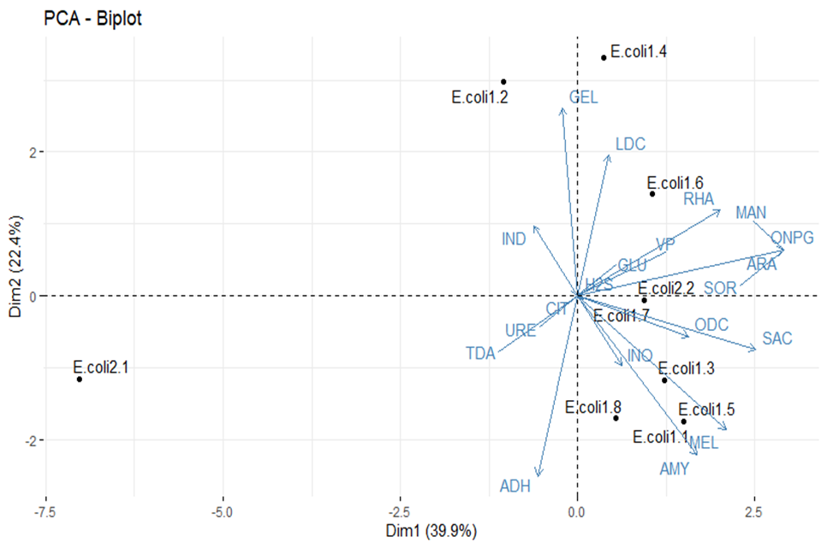
Figure 4. Projective of the different strains in the factorial plane formed by the ACP

Strains of E. coli are globally resistant to 35.59% of the antibiotics tested, with strains of E. coli 2 being more resistant than those of E. coli 1, 62,50 and 25,58%, respectively. Resistance rates do not differ significantly from strain to strain (P-value>0). Antibiotic resistance phenotypes of E. coli strains isolated from vegetables are shown in Table III. E. coli strains showed very diverse responses to the antibiotics tested, with several antibiotic resistance phenotypes observed. E. coli 1 strains were most frequently resistant to ATM, CRO and AMC (66.67%, 60.00% and 60.00%, respectively), while E. coli 2 strains were 100% resistant to AMC, CRO and SXT. In addition, E. coli 2 strains showed resistance to F and MRP (around 50% each). However, E. coli 1 strains are sensitive to F, IPM and MRP (100% each) and to CIP, SXT and TET (around 80% each). No significant differences were observed between antibiotics (P-value>0,05).

Table III. Antibiotic resistance phenotypes of Escherichia coli strains isolated from vegetables
 | E. coli 1 |  |  | E. coli 2 |  | P-value
 | R | S |  | R | S | P-value
AMC | 3(60.00)ª | 2(40.00)ª |  | 2(100)ª | 0ª | 0.256
ATM | 2(66.67)ª | 1(33.33)ª |  | 0ª | 0ª | 0.072
CIP | 1(20.00)ª | 4(80.00)ª |  | 1(50.00)ª | 1(50.00)ª | 0.570
CRO | 3(60.00)ª | 2(40.00)ª |  | 2(100)ª | 0ª | 0.391
F | 0ª | 5(100)^{b} |  | 1(50.00)ª | 1(50.00)^{b} | 0.047
IPM | 0ª | 5(100)ª |  | 0ª | 2(100)ª | -
MRP | 0ª | 5(100)ª |  | 1(50.00)ª | 1(50.00)ª | 0.570
SXT | 1(20.00)ª | 4(80.00)ª |  | 2(100)ª | 0ª | 0.072
TET | 1(20.00)ª | 4(80.00)ª |  | 1(50.00)ª | 1(50.00)ª | 0.570
AMC : Amoxicilline + Acide Clavulanique ; ATM : Aztréonam ; CIP : Ciprofloxacine ; CRO : Ceftriazone ; F : Nitrofurantoïne ; IPM : Imipenème ; MRP : Méropénème ; SXT : Triméthoprime/Sulfaméthoxazole ; TET : Tétracycline.

Figure 5 shows the resistance rates of E. coli strains to each of the antibiotics tested. The most frequently observed resistances were to CRO, AMC, ATM, SXT and TET (77.78%, 66.67%, 44.44% and 33.33%, respectively).

Figure 5. Resistance rates of Escherichia coli strains to each of the antibiotics tested

The study of the similarity of the responses of the different strains to antibiotics led us to carry out an Ascending Hierarchical Classification (AHC) based on the antibiotic resistance test data. Three (3) distinct groups emerged from this AMP. Group 1 comprises two (2) strains (E. coli1.6 and E. coli1.7), group 2 comprises E. coli1.2 and E. coli2.1, and group 3 comprises five (5) strains (E. coli1.4; E. coli2.2; E. coli1.3; E. coli1.5 and E. coli1.8). Group 1 strains are all susceptible to the various antibiotics tested. Group 2 strains are resistant to MRP, SXT, CRO and TET, while the third group is characterized by strains that are 100% resistant to AMC and CRO only.
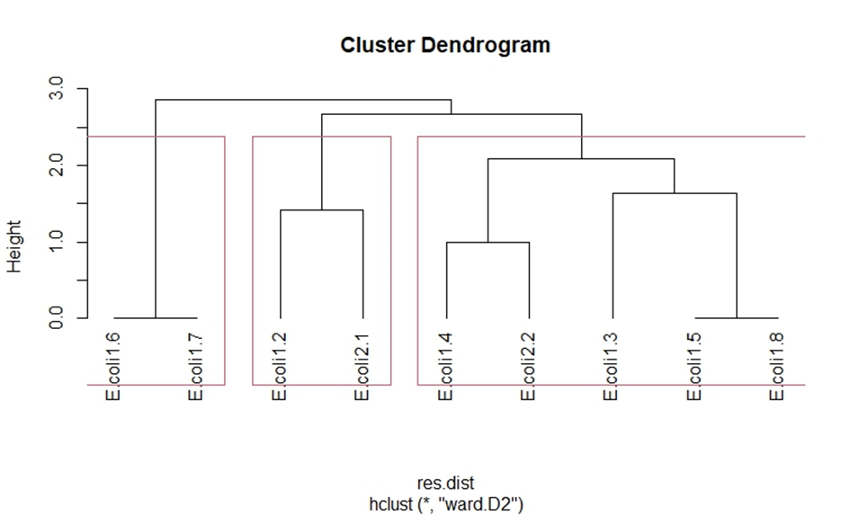
G2
G1
G3
Figure 6. Dendrogram of Escherichia coli strain response similarity to the antibiotics tested
Prevalence of resistant Escherichia coli strains isolated from vegetables by sampling site

Table IV shows the prevalence of E. coli strains resistant to at least one antibiotic, by type of vegetable tested. The results show that the prevalence of Escherichia coli strains resistant to at least one antibiotic is 5.65%. E. coli 1 strains were more resistant (4.03%) than E. coli 2 strains (1.61%). In fact, strains isolated from tomato samples are more resistant, followed by strains isolated from onion and lettuce (around 8.57%; 8.03%; 4.62%, respectively). Differences were not significant between types of vegetable (P-value>0.05).

Table IV. Prevalence of antibiotic-resistant E. coli by vegetables types
Types of vegetable | Number of vegetable | Escherichia coli strains |  | Total
Types of vegetable | Number of vegetable | E. coli 1 | E. coli 2 | Total
Carotte | 12 | 0 | 0 | 0
Laitue | 65 | 2(3.08)ª | 1(1.54)ª | 3(4.62)
Oignon | 12 | 1(8.06)ª | 0ª | 1(8.06)
Tomate | 35 | 2(5.71)ª | 1(2.86)ª | 3(8.57)
Total | 124 | 5(4.03) | 2(1.61) | 7(5.65)
Values with the same letter in the same column are not significantly different (P>0.05) (P>0,05)

Person's correlation between the biochemical characteristics of E. coli strains and their resistance to antibiotics
Table V shows the correlation coefficients between the biochemical characteristics of strains and their level of resistance. The results showed perfect positive correlations significant at the 10% threshold, between Nitrofurantoin and ONPG, MAN, SOR and ARA (r = 1 for each association) and between Tetracycline and Melibiosis (r = 1). Then, strong correlations significant at the 5% threshold were observed between Meropenem and Saccarose (r = 0.756); Ceftriaxone and Melibiose (r = 0.791) and between Tetracycline and Saccarose (0.756) and Amylase (r = 0.791). On the other hand, a strong negative correlation significant at the 5% threshold was observed between tetracycline and Gelatinase (r = -0.756).

Table V. Person's correlation between the biochemical characteristics of E. coli strains and their antibiotics resistance level
 | CIP | MRP | AMC | VA | SXT | CRO | ERY | F | TET
ONPG | -0.250 | 0.500 | 0.25 | 0.167 | 0.395 | 0.189 | 0.187 | 1.000** | 0.500
ADH | 0.158 | -0.316 | -0.632 | -0.354 | 0.350 | -0.478 | -0.017 | -0.395 | 0.158
LDC | -0.189 | 0.378 | 0.189 | -0.167 | -0.060 | 0.357 | 0.443 | 0.189 | -0.189
ODC | -0.158 | 0.316 | -0.316 | -0.354 | 0.550 | -0.060 | 0.472 | 0.395 | 0.316
GEL | -0.189 | -0.189 | 0.189 | -0.258 | -0.598 | -0.286 | 0.443 | 0.189 | -0.756*
MAN | -0.250 | 0.500 | 0.25 | 0.167 | 0.395 | 0.189 | 0.187 | 1.000** | 0.500
INO | 0.250 | 0.250 | -0.25 | -0.167 | 0.316 | -0.189 | -0.187 | 0.125 | 0.250
SOR | -0.250 | 0.500 | 0.25 | 0.167 | 0.395 | 0.189 | 0.187 | 1.000** | 0.500
RHA | -0.378 | 0.189 | 0.378 | 0.167 | 0.060 | 0.286 | 0.282 | 0.661 | 0.189
SAC | -0.378 | 0.756* | -0.189 | 0.258 | 0.598 | 0.286 | 0.282 | 0.661 | 0.756*
MEL | 000 | 0.500 | 000 | 0.354 | 0.791* | 0.378 | -0.267 | 0.500 | 1.000**
AMY | -0.158 | 0.316 | -0.316 | 0.354 | 0.550 | -0.060 | -0.135 | 0.395 | 0.791*
ARA | -0.250 | 0.500 | 0.250 | 0.167 | 0.395 | 0.189 | 0.187 | 1.000** | 0.500

DISCUSSION

This study revealed the presence of antibiotic-resistant strains of E. coli in vegetables from the urban community of Niamey. The prevalence of Escherichia coli was 5.00% in markets and 9.80% in market gardens. In lettuce, onion, tomato and irrigation water samples, prevalences were 4.62%, 8.33%, 12.00% and 11.11% respectively. Tomato samples were the most contaminated with Escherichia coli. This results is in agrrement with those reported from Côte d'Ivoire in lettuce (26.4%) and tomato (17.7%) (Toe et al., 2017) or Pakistan in lettuce (31.8%) (Shah et al., 2015) and the prevalences observed in Mexico in tomato (10% and 11%) (Carlos et al., 2013). This disparity in prevalences could be explained by soil structure and texture, vegetation, climate and growing and selling conditions, which are probably different (Toe, 2018). The presence of bacteria responsible for food poisoning such as Escherichia coli on the vegetable samples analyzed highlights the poor conditions under which vegetables are produced, harvested, transported and sold on markets, as well as the likely health risks for consumers if they are consumed as they are (Toe et al,. 2017). This section shows the importance of cleaning and disinfecting vegetables before consumption. These vegetables are mainly used in the preparation of vegetable salads and consumed raw without the heat treatment, adequate cleaning or effective disinfection necessary to reduce the bacterial load (Almou et al., 2024). Washing vegetables in clean water reduces only an insignificant fraction of microbial populations, whereas the use of disinfectants such as chlorine and others has a considerable impact on the microbiological quality of fresh produce. These disinfectants provide an additional reduction of 1 to 2 Log10 CFU in the initial bacterial population due to the conditions of cultivation in the field and sale in the market (Heard, 2000).
Thus, the results of the antibiotic resistance test show that the strains tested are all resistant to at least one antibiotic. The presence of antibiotic-resistant E. coli in vegetables has been reported by other authors, in Portugal (Campos et al., 2013), Pakistan (Shah et al., 2015), Iran (Shakerian et al., 2016), Lebanon (Klingbeil et al., 2016), Morocco (Nayme et al., 2017), Brazil (Araujo et al., 2017; Lima et al., 2017) and Côte d'Ivoire (Toe et al., 2017). The antibiotic-resistant E. coli strains isolated from lettuce samples would reflect probable contamination by strains possessing at least one antimicrobial resistance gene (Wognin, 2014) and originating from healthy carriers, among people handling these products (Kashina and Brown 2012). On the other hand, this resistance could be explained by the indirect contamination of vegetables by fecal bacteria from animals during the fertilization process using manure (Alio Sanda et al., 2017; Toe, 2018). The majority of growers used manure from livestock, particularly chicken, to fertilize vegetable soils. In these farms, antibiotics are widely and abusively used to prevent and treat infections and also to accelerate animal growth (Ouattara et al., 2013; Toe, 2018). The majority of producers used manure from livestock, particularly chicken, to fertilize the soil for vegetable crops. In these farms, antibiotics are widely and abusively used to prevent and treat infections and also to accelerate animal growth (Ouattara et al., 2013; Toe, 2018). The use of antibiotics can promote the selection of resistant bacteria in enteric strains, which are then eliminated via their feces (Toe, 2013; Toe, 2018).
Escherichia coli is a commensal bacterium implicated in numerous human pathologies. Antibiotic resistance levels in this bacterium have increased in recent years (Foka et al., 2023). The E. coli strains tested in this study are 35.59% resistant to antibiotics, with E. coli 1 accounting for 62.50% of this resistance overall. Our results corroborate those of numerous studies carried out previously around the world in vegetables (Wognin, 2014; Toe, 2018; Amine et al., 2023) and in calves (Akre et al., 2022) in Côte d'Ivoire, in Meat carcasses (Ahouandjinou et al., 2016) in Benin, poultry (Rahmatallah et al., 2016; Cyuzuzo et al., 2023) in Rwanda, poultry farming (Bodering et al., 2017) in Chad, and in clinical samples in Niger (Fody et al., 2017) and Cameroon (Foka et al., 2023). Frequently encountered resistances concerned cephalosporins (CRO (77.78%)), penicillins (AMC (66.67%)), monobactams (ATM (66.67%)), Sulfonamides (SXT (44.44%)), fluoroquinones (CIP), Carbapenems (MRP) and tetracyclines (TET) (33.33%, respectively). It should be noted that our results are lower than those of Wognin (2014) concerning TET (90.6%). Resistances ranging from (62.5% to 73.5%) and (67% to 86%) for AMC and TET, respectively have been reported in lettuce samples in Côte d'Ivoire (Amine et al., 2023). Ahouandjinou et al. (2016) reported E. coli resistance rates of 88.49% to CRO and 66.19% to AMC. The results of Rahmatallah et al. (2016) are higher than our observations for AMC (90.9%) and SXT (82.2%). The observations of Yao et al. (2017) are also far superior to our results for ATM (95.3%), CRO (89.4%), TET (97.6%), and SXT (69.4%). On the other hand, these results are lower than our observations for AMC (61.2%).
Several authors have reported antibiotic-resistant strains of E. coli in clinical samples. In Niger, authors have reported resistance rates of 93.1%; 83.9%; 82.2%; 77.4%; 95.4% and 21.7% for AMC, CRO, CIP, ATM, SXT and F, respectively (Fody et al., 2017). In Benin, an increase in resistance to CRO from 1.68% to 40.22% has been reported (Salah et al., 2021). In Cameroon, between 2018 and 2021, carbapenem resistance rose from 11% to 47.1%; aminoglycosides from 31.5% to 52.9% and quinolones from 52.4% to 77.8% (Foka et al., 2023). Antibiotic resistance is therefore the evolutionary response of bacteria to the strong selective pressure resulting from exposure to these antibiotics (Wright, 2010). Moreover, in the natural environment, bacteria can harbor resistance genes derived from the use of antibiotics in animals. Of particular note is the ability of enterobacteria to acquire and exchange gene fragments carrying resistance factors. The intestinal flora provides an extraordinary opportunity for the circulation of genetic information between bacteria (Yao et al., 2017).
CONCLUSION
This study highlighted the presence of resistant Escherichia coli strains in market gardens and markets in the urban community of Niamey. Resistance involved several antibiotic families. The most common resistance phenotypes were CRO, AMC, ATM, SXT and TET. The presence of Escherichia coli strains resistant to several antibiotics in the vegetable samples analyzed testifies a lack of good hygiene practices in market gardening and markets in the urban community of Niamey. Given the importance of fresh vegetables in the human diet, and the high prevalence of multi-resistant strains recorded, it is important to implement a national health monitoring policy to control the circulation of multi-resistant strains.

Disclaimer (Artificial intelligence)

Option 1:

Author(s) hereby declare that NO generative AI technologies such as Large Language Models (ChatGPT, COPILOT, etc.) and text-to-image generators have been used during the writing or editing of this manuscript.
REFERENCES
Mariani-Kurkdjian, P., Bonacorsi, S., Bingen, E. (2016). Bacteriological Diagnosis of Gastrointestinal Infections. Medical Bacteriology, 149-161
Solayman A. (2015). Extended-Spectrum Beta-Lactamase (ESBL)-Producing Enterobacteriaceae: Current Epidemiological Profile and Therapeutic Consequences, Doctoral Thesis in Medicine, Marrakech: University of Marrakech; Morocco
Toukam M., Lyonga EE., Assoumou MCO., Fokunang CN., Atashili J., Kechia AF., Gonsu HK. (2010). Quinolone and Fluoroquinolone Resistance in Enterobacteriaceae Isolated from Hospitalized and Community Patients in Cameroon. Journal of Medicine and Medical Sciences, 1(10): 490-4.
Carré D. (2004). Management of Acute Diarrhea. Etiologies. EMC-surgery, 1(5):493-532.
Le Bouguénec C. (1999). Diagnosis of different Escherichia coli pathovars responsible for diarrhea in humans. Rev Fr Lab, 314:33-7.
Sara A., Yousra M. (2021). Development of methods for detecting Shiga toxin-producing Escherichia coli [Master's thesis]: Mohamed El Bachir El Ibrahimi University;
Cyuzuzo E., Amosun EA., Byukusenge M., Musanayire V. (2023). Antimicrobial Resistance Profiling of Escherichia coli Isolated from Chickens in Northern Province of Rwanda. African Journal of Biomedical Research, 26: 151-154
Chaabane N., Latreche O. (2020). In vitro study of the biological activity of Daucus carota L. Applied Biochemistry, Echahid Hamma Lakhdar University -El OUED, Algeria, 66p.
Djelloul-Daouadji S. (2010). Detection of Staphylococcal Biofilm on Venous Catheters. Master's Thesis in Molecular and Cellular Biology. Abou Bekr Belkaid University. Tlemcen, Algeria. 77p.
Rahal K. (2011). Standardization of Antibiogram in Human Medicine at the National Scale According to WHO Recommendations; Algiers, Algeria. P: 116
CA-SFM/EUCAST (2023). Antibiogram Committee of the French Society of Microbiology, 132p.
AFNOR (1996). Microbiological Analyses. Volume II. Quality Control of Food Products, AFNOR Editions, 545p. Toe E., Dadié A., Dako E., Loukou G. Djé, K., (2017). Bacteriological quality and risk factors for contamination of raw mixed vegetable salads served in collective catering in Abidjan (Ivory Coast). Advances in Microbiology 7:405-419.
Shah MS., Eppinger M., Ahmed S., Shah AA., Hameed A., Hasan F. (2015). Multidrug resistant diarrheagenic E. coli pathotypes are associated with ready-to-eat salad and vegetables in Pakistan. Journal of Korean Society for Applied Biological Chemistry. 58(2):267–273
Carlos A., Gómez-Aldapa M., Del Refugio TV., Otilio A., Acevedo-Sandova L., Esmeralda RV., Angélica VL., Javier CR. (2013). Presence of Shiga Toxin-Producing Escherichia coli, Enteroinvasive E. coli, Enteropathogenic E. coli, and Enterotoxigenic E. coli on Tomatoes from Public Markets in Mexico. Journal of Food Protection 9: 1621–1625
Toe E. (2018). Assessment of Risk Factors for Biocontamination by Virulent Salmonella and Escherichia coli in the Vegetable Food Chain in Abidjan (Côte d'Ivoire). Thesis in Food Microbiology and Biotechnology, Côte d'Ivoire: University of Nangui Abrogoua. 186p.
Campos J., Mourão J., Pestana N., Peixe L., Novais C., Antunes P. (2013). Microbiological Quality of Ready-to-Eat Salads: An Underestimated Vehicle of Bacteria and Clinically Relevant Antibiotic Resistance Genes. International Journal of Food Microbiology 166 (3): 464–470
Shakerian A., Rahimi E., Emad P. (2016). Vegetables and restaurant salads as a reservoir for shigatoxinogenic Escherichia coli: Distribution of virulence factors, O-serogroups and antibiotics properties. Prot., 79(7):1154-60
Klingbeil DF., Kuri V., Fadlallah S., Matar GM. (2016). Prevalence of antimicrobial resistant Escherichia coli from raw vegetables in Lebanon. The Journal of Infection in Developing Countries. 10(4):354–362.
Nayme K., Barguigua A., Bouchirf B., Diawara I., Otmani FEI., Elmdaghri N., Zerouali K., Timinouni (2017). Occurrence of extended-spectrum beta-lactamase AmpC and virulence genes in Escherichia coli isolates from vegetable salads in Morocco. British Food Journal 119(7):1633–1647
Araujo S., Silva IAT., Tacao M., Patinha C., Henriques I. (2017). Characterization of antibiotic resistant and pathogenic Escherichia coli in irrigation water and vegetables in household farmers. International Journal of Food Microbiology 25:192–200.
Lima CM., Souza IEGL., Alves T., Dos ST., Leite CC., Evangelista-Barreto NS., Almeido RCC. (2017). Antimicrobial resistance in diarrheagenic Escherichia coli from ready-to-eat foods. Journal of Food Science and Technology. 54 (11):3612-3619.
Wognin A.S. (2014). Contamination risk factors and virulence genes associated with Escherichia coli in the market garden environment: the case of lettuce (Lactuca sativa) in the peri-urban area of ​​Abidjan. Doctoral thesis from Nangui Abrogoua University: microbiology and molecular biology. 122p.
Kashina AF., Brown PD. (2012). Diversity of Antimicrobial Resistance and Virulence Determinants in Pseudomonas aeruginosa Associated with Fresh Vegetables. International Journal of Microbiology (10): 1155-1165.
Alio Sanda A., Inoussa MM., Samna Soumana O., Bakasso Y. (2017). Diversity and Dynamics of Salmonella Isolated from Lettuce (Lactuca sativa L.) in Market Garden Crops in Niger (West Africa). Journal of Applied Biosciences 119: 11917-11928.

Ouattara ND., Guessennd N., Gbonon V., Toe E., Dadié T., Tiécoura B. (2013). Antibiotic Consumption in the Poultry Sector in Abidjan: Case Study of Some Semi-Industrial Farms. European Journal of Scientific Research 94: 80-85.
Toe E. (2013). Analysis of Antibiotic Therapy Practices in Poultry Farms and Antibiotic Resistance of Escherichia coli Isolated from Chicken Manure in Abidjan, Ivory Coast. (Master's Thesis in Microbiology and Molecular Biology), Nangui Abrogoua University, Abidjan, Ivory Coast. 63p
Foka FRG., Noubom M., Chafa A., Lyonga MEE., Toukam M., Gonsu H. (2023). Evolution of the Antibiotic Resistance Profile of Escherichia coli at the Yaoundé University Hospital from 2012 to 2021. Health Sciences Diseases 24(9): 16-24.
Amine KTN., Koné A., Goly KRC., Benié CKD., Dadié A. (2023). Antibiotic resistance profile of Escherichia coli strains isolated from lettuce (Lactuca sativa) from 3 market gardening sites in the commune of Port Bouët in Abidjan (Côte d’Ivoire). International Journal of Innovation and Applied Studies 41(1): 188-196
Akre DST., Okou OC., Koffi AE., Ebe KB., Ackah JAAB. (2022). Prevalence and phenotypes of antibiotic resistance of Escherichia coli strains responsible for calf diarrhea in Daloa, Côte d’Ivoire. International Journal of Biological and Chemical Sciences 16(6): 2685-2698
Ahouandjinou H., Baba-Moussa F., Gbaguidi B., Haziz S., Kifouli A., Wassiyath M., Sylviane PW., Fatiou TB., PhD Mohamed S., Baba-Moussa L. (2016). Antibiotic Resistance and Virulence Factors of Isolated Escherichia coli Strains
Rahmatallah N., Nassik N., El Rhaffouli H., Amine IL., El Houadfi M. (2017). Detection of Multi-Drug-Resistant Escherichia coli Strains of Avian Origin in the Rabat-Salé-Zemmour-Zaer Region. Moroccan Journal of Agronomic and Veterinary Sciences (2): 96-102. Bodering A., Ndoutamia G., Ngandolo Bn. Ngakou A. (2018). Antibiotic Use and Resistance Profile of Salmonella spp. and Escherichia coli Strains Isolated from Poultry Farms in the Cities of N'Djamena and Doba, Chad. International Journal of Biological and Chemical Sciences 11(4): 1669-1684.
Wright GD. (2010). Antibiotic Resistance: Where Does It Come From and What Can We Do About It? BMC Biology 8(123): 1-6
Yao KR., Coulibaly KJ., Cissé S., Tiécoura KB., Goualié B., Gueu KR., Yapi HF., Djaman AJ. (2017). Prevalence of Salmonella Strains in Cattle Breeding in the District of Abidjan (Côte d'Ivoire). International Journal of Current Microbiology Applied Sciences 6(3): 1154-1162.

