***Original Research Article***

**Formulation of Cookie Flour from a Mixture of Wheat, Yam and Cashew Apple for Infant Food**

|  |
| --- |
| **Abstract**  The aim of this study is to formulate a cookie flour made from a mixture flour of yam (*Dioscorea alata*, Bètè Bètè variety) and cashew apple (*Anacardium occidentale*), as a substitute for wheat flour in equivalent nutritional value for infant diet. A mixing plan was designed with constraints on proportions of different constituents. The proportions are between 50%-70%, 0%-20%, 30%-50% respectively for yam, cashew apple and wheat. Flour formulations obtained were analyzed, for some physio-chemical parameters, to assess their relevance from a technological, nutritional and conservation point of view. Iso-response curves were obtained for each response studied, in order to establish the impact of factors. The results show that moisture and lipid contents of the different formulations increases respectively from 7.72±1.02% to 11.6±1.11% and from 0.81±0.01% to 4.14±0.16% for yam flour incorporations ranging from 60% to 65%. Ash, fiber and protein content increase proportionally with the addition of cashew apple flour. Indeed, addition of 20% cashew apple flour results in maximum values of 2.08±0.15% ash, 6.10±0.57% fiber and 9.5±0.58% protein. The particle size of composite flours was refined from 63.60 ± 0.002% to 73.41 ± 0.002% of outcrop rate in proportion to the incorporation of wheat ranging from 30% to 50%.  *Keywords: yam flour, wheat flour, cashew apple flour, cookie flour, formulation, infant food*, |

# **1. INTRODUCTION**

Childhood is an essential phase when it comes to growth. This is the stage when maximum physical, physiological and intellectual development occurs (Saavedra & Prentice, 2023) . In addition, a child’s diet greatly contributes to this development. Consequently, one must ensure optimal satisfaction of nutritional needs of a child to maximize growth. These nutritional phases are in turn greatly impacted by feeding practices. In cases of insufficient nutritional intake both in quantity and quality, the consequences are malnutrition. Child malnutrition gives way to child morbidity or leads to physical or intellectual disabilities. Which occurring at a greater scale, becomes detrimental to a country's development. The main causes of malnutrition are not only poor eating habits, but also military-political and climatic crises, which play a very important role in food insecurity. Malnutrition is a major public health problem for developing countries. In Côte d'Ivoire, about 20,2% of children under 5 years of age suffer from malnutrition (FAOSTAT, 2022).

Malnutrition results from a diet low in energy and/or protein (Bain et al., 2013) and to which are added severe or moderate deficiencies in essential nutrients such as vitamins (vitamin A), minerals (iron, zinc), or essential amino acids (Delzenne, 2024). This malnutrition in children could be avoided by a diet containing sufficient quantity and quality of carbohydrates, lipids and proteins. It must also contain a sufficient amount of fiber, which helps maintain good intestinal transit and fights metabolic diseases such as diabetes.

In Ivory Coast, the traditional complementary foods generally given to children are made of tubers (cassava, yam, sweet potato) or cereals (millet, maize, rice, sorghum) that cannot fully cover their nutritional needs. Industrial food made from wheat, on the other hand, is out of reach for many households. Unfortunately, the climatic and socio-political crises experienced by exporting countries have considerably increased the price of wheat flour. The strong demand for bakery products presents a way of enhancing the value of our agricultural resources. Therefore, to improve the nutritional value of complementary food, it is advised to rely on the formulation and promotion of good quality complementary foods, constructed from local raw materials (Olive et al., 2020)**.**

Ivory Coast has many starchy raw materials capable of being transformed into flour and used in infant food. Yams are the leading food crop, with a production of 7967113,65 tons/year (FAOSTAT, 2023). This places Côte d'Ivoire third among the world's producers (FAOSTAT, 2023). Yam is culturally accepted as it plays an important role in the religious ceremonies and celebrations of many peoples. It can contain 79-95% starch and 3.4-12.5% protein, depending on the species (Jeannoda et al., 2010; Lombe et al., 2024). Yam can be found in several food forms: boiled, fried, braised, in chips and in flour. Several authors have used yam in flour to formulate various foods, such as porridge for children (Gampoula et al., 2020) and bread flour (Bwebwe et al., 2023). The D. alata species represents 55 to 60% of national production (Digbeu *et al.,* 2009), of which the bètè bètè variety accounts for 26.89% (Dibi et al., 2021). Also, the bètè bètè variety has particularly good flour making skills (Soro et al., 2013; Kokoh *et al.,* 2019). Supplementation with cashew apple flour would increase the nutritional value of yam flour, which has certain deficiencies. Indeed, Côte d'Ivoire is the world's leading producer of cashew nuts, with production expected to reach 1000000 tons by 2024 (C.C.A, 2025). The cashew apples, the false fruit of the cashew tree, are rich in sugar, protein, carotenoids(Da Silva et al., 2014) (Ndiaye et al., 2022), vitamin C, Mn and fiber. It is the subject of several scientific studies due to its high nutritional and economic potential. Cashew apples are processed into jam, wine, liqueur, vinegar, flour and juice (Gnagne et al., 2023). Processing into juice remains the main way of adding value to the apple (Thiocone, 2024). Cashew apple juice is rich in minerals, making the cashew apple an ideal substrate for making up for certain nutrient deficiencies, especially among children and nursing mothers (Ndiaye, 2023). The use of composite flour made from yam, cashew apple and wheat could reduce our imports of wheat flour and develop biscuits with improved nutritional profiles. Biscuits that will help combat malnutrition in children.

This work will consist of formulating and studying certain physicochemical characteristics of wheat, yam and cashew apple composite flours with an emphasis on their use in the manufacturing of children's cookies, which could ensure good conservation of the biscuits and offer authentic organoleptic characteristics by maximizing the use of local flours.

# **2.** **MATERIAL AND METHODS**

## **2.1 Material**

The yam tubers (fig.1A) (*Dioscorea alata,* bètè bètè variety) were purchased at “Mo Fetai” market in Yamoussoukro (Côte d’Ivoire). The cashew apples (fig.1B) (*Anacardium occidentale*) came from a plantation located in Lamidougou/Yamoussoukro (Côte d’Ivoire). As for the wheat flour (fig.1C) (Grand Moulin d’Abidjan), it was bought from a store (which sells retail) at Yamoussoukro's main market.

C

A

B

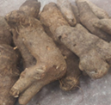 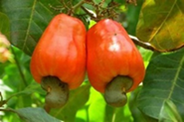 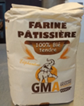

Figure 1. (A) Yam from Côte d’Ivoire; (B) Cashew apple; (C) Wheat flour

## **2.2 Methods**

### **2.2.1 Yam Flour Production**

The method used was described by Soro (2013) with slight modifications. The yam tubers were washed and peeled with a stainless-steel knife. Then cut into slices about 3 cm thick and kept immersed in a vat of water (1/2; mass/volume) to avoid enzymatic browning. The yam slices were brought to a boil for 15 minutes in a stainless-steel saucepan containing water (1/2; m/v). Then yam slices were fermented for 24 hours at room temperature in a tank containing water (1/2; mass/volume). The yam slices of 3 cm were drained, cut into thin slices (2 mm) and dried at 65 °C for 18 hours in a dryer (electric hot air food dryer,China). Then dried slices were grinded using a refiner (INPHB Yamoussoukro, Côte d’Ivoire) to obtain flour. The production diagram of yam flour is shown in Figure 2.

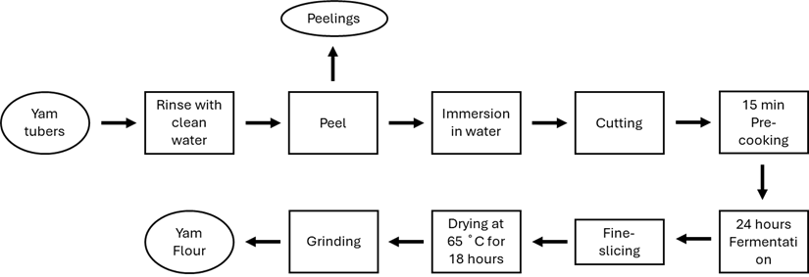

**Figure 2**: Yam flour production diagram

### **2.2.2 Cashew apple flour production**

The apples were carefully separated from the nuts, washed several times with clean water and disinfected with sodium hypochlorite (100 ppm). Then cashew apples were cut into 1 cm thick slices and dried at 65°C for 15 hours (adapted to the method of Ogunjobi and Ogunwolu, 2010) in a dryer (Electric hot air food dryer, China). The dried apples were grinded in a mini laboratory grinder (Philips HR2058, Pays-Bas) to obtain flour. The cashew apple flour production flow chart is shown in Figure 3.



**Fig. 3:** Cashew apple flour production diagram

### **2.2.3 Cookie flours formulation**

The formulations were established from a mixing plan (simplex-centroid design), made and analyzed with Design Expert 11.1.2.0 software (Stat-Ease, Inc., Minneapolis, USA), with the following proportions (equations 3, 4, 5):

X1: Wheat → 0,3 ≤ X1 ≤ 0,5 (3)

X2: Yam → 0,5 ≤ X2 ≤ 0,7 (4)

X3: Cashew → 0 ≤ X3 ≤ 0,2 (5)

The 03-component simplex-centroid mixing plan was adopted to determine the optimal formulation of composite flour used for cookie. Controlled variables were the flours of pastry-wheat (X1), yam (X2) and cashew (X3); and the answers were the chemical parameters: moisture, ash, lipids, fibers, proteins, particle size. Significant factors (p < 0.05) were determined by performing an analysis of variance (ANOVA) on the experimental results obtained.

Pastry-wheat, yam and cashew apple flours were mixed using a mixer (Philips HR2058, Pays-Bas) to form 14 samples of flours composed in different proportions according to the centered mixing plane (Table 1) and conserve into polypropylene bags.

**Table 1:** Mixing matrix table

|  |  |  |  |
| --- | --- | --- | --- |
| Test n° | %X1 | %X2 | %X3 |
| F1 | 0.37 | 0.57 | 0.06 |
| F2 | 0.30 | 0.70 | 0.00 |
| F3 | 0.30 | 0.65 | 0.05 |
| F4 | 0.30 | 0.60 | 0.10 |
| F5 | 0.40 | 0.60 | 0.00 |
| F6 | 0.30 | 0.50 | 0.20 |
| F7 | 0.50 | 0.50 | 0.00 |
| F8 | 0.30 | 0.60 | 0.10 |
| F9 | 0.33 | 0.54 | 0.13 |
| F10 | 0.40 | 0.50 | 0.10 |
| F11 | 0.40 | 0.50 | 0.10 |
| F12 | 0.40 | 0.60 | 0.00 |
| F13 | 0.40 | 0.60 | 0.00 |
| F14 | 0.44 | 0.53 | 0.03 |

X1: Wheat flour, X2: Yam flour, X3: Cashew apple flour

### **2.2.4 Physicochemical analyses**

#### 2.2.4.1 Moisture

The moisture content of the samples was determined using a moisture meter (OHAUS® model MB 120). 5 g of the sample was placed in an aluminum cup and then placed in the device at a temperature of 120°C for 15 minutes. Then, the screen has displayed the moisture content of the sample.

#### 2.2.4.2 Ash content assessment

Ash content was obtained by incineration of the sample.5 g of the sample (Ms) was weighed in an empty weight crucible (Mc) and then placed in a muffle furnace (Nabertherm, Germany) at 550°C during 24h (AOAC 942.05, 1942). The calcined samples are removed, from the muffle furnace and placed in a dryer for cooling, then weighed and the final weight (Mf) noted.

The ash content (%C) was calculated according to following equation 6:

$\%C=\frac{Mf-Mc}{Ms}×100$ (6)

With %C: Ash rate; Ms: Sample mass; Mf: Final mass (crucible + calcined sample)) and Mc: Empty crucible mass.

#### 2.2.4.3 Lipid content assessment

Lipid content was determined by extraction with a solvent (hexane) (Soxhlet method). 5 g of each sample (Ms) was put into a cartridge and then placed in a Soxhlet. About 200 mL of hexane was put in a balloon of known weight (Mc) and all adapted to the Soxhlet. The extraction was carried out hot (boiling on a hot plate) for 4 hours. The solvent was then evaporated by distillation at the rotary evaporator. The distillate is then dried in oven for 1 hour. The flask containing fat is cooled in desiccant and then weighed again and final weight (Mf) recorded. The percentage of fat to dry matter was calculated using the following equation 7:

$\%Lipides=(Mf-Mc)×\frac{100}{Ms}$ (7)

With Mf: Final weight (flask + fat); Mc: Balloon empty weight; Ms: Sample mass

#### 2.2.4.4 Protein content assessment

The determination of the protein content was obtained according to Kjeldahl method. It consists of mineralizing sample by the action of an acid and measuring nitrogen in the medium. The organic nitrogen in the sample is converted into mineral nitrogen in form of ammonia (NH4)2SO4 by oxidizing action of boiling concentrated sulfuric acid (H2SO4) in presence of a catalyst. After displacement by soda, the ammonia is distilled and then titrated by sulphury acid in the presence of a colored indicator (boric acid) by acidimetry. The total protein content is calculated using the conversion factor (6, 25) i.e. 16% nitrogen in the protein.

Procedure: 0.5 g of crushed sample (Pe) is placed in a mineralization tube (matras Kjeldahl) to which a Kjeltabs ck catalyst pellet [3.5 g of potassium sulphate (K2SO4) and 0.4 g of copper sulphate (CuSO4) is added], followed by 10 mL of concentrated H2SO4 (0.1N). The prepared samples are mineralized on a heating block at a progressive temperature (90, 120, ... 400°C) for three (3) hours (total discoloration of the solution). The mineralized material obtained is then diluted with about 50 mL of distilled water. Distillation is then carried out with concentrated soda (10 N). The distillate (150 mL) is collected in a beaker containing 5 mL of colored indicator composed of bromocresol green, methyl red and boric acid. The whole is titrated with 0.1 N of H2SO4 until the indicator turns from green to pink. The protein content in relation to dry matter is determined using the following equation 8:

$\%Protein=6,25×0,014×0,1×(Vd-Vb)×\frac{100}{Ms}$ (8)

With Vb: Blank Volume; Vd: Distillate Volume; Ms: Sample Mass; 0,1= Titration of sulfuric acid; 0,014= Molar weight of nitrogen X 10-3

#### 2.2.4.5 Fiber content assessment

The determination of fiber content was carried out according to the method of Wolf (1968) which consists of incinerating the raw material in the presence of acid, then a base. Thus, 2 g of dried and crushed sample were introduced into a flask and then 50 mL of sulfuric acid at 0.25 N were added. Mixture obtained was homogenized and brought to a boil for 30 minutes under reflux refrigeration. After 30 min, 50 mL of 0.31 N NaOH was added to the contents and brought back to a boil under reflux refrigerant for 30 min. The resulting extract was filtered on Whatman paper and the residue was washed several times in hot water until the alkali was completely removed. The residue was dried in an oven at 105°C for 8 hours. After cooling in a desiccator, the residue was weighed and then incinerated in the oven at 550 °C for 3 hours. After cooling, the ashes obtained were weighed. The crude fiber content was given as a percentage of sample mass as follows (equation 9).

$\%Fiber = \frac{\left(M_{1}- M_{2}\right) ×100}{Ms}$ (9)

With M1: mass (g) of dried residue; M2: mass (g) of the ash obtained; Ms: mass (g) of the sample.

#### 2.2.4.6. Outcrop rate (particle size)

This measurement consists of measuring the size of the particles, by passing through sieves of different sizes. Outcrop rate was achieved according to the following method described: A test portion of 100 g for each of the flours was passed through a series of opening sieves of decreasing mesh size (200μm-180μm-150μm). The sieves are stacked on a laboratory sieve machine (RETSCH AS200 control, Germany). The rejection quantities for each sieve obtained after sieving for 5 min, with uniform oscillation at 60 rpm through the sieve series are weighed with a precision technical scale of 10-3 g.

The mass of rejects is expressed as a percentage according equation 10:

$TA(\%)=\frac{M_{0}}{M_{1}}×100$ (10)

With M0: Mass of rejects; M1: Sample mass; TA: Outcrop rate;

### **2.2.5 Mathematical validations and statistical analysis**

Experimental data for each response were fitted to a cubic model according to the following expression (equation 11):

Y= b1X1 + b2X2 +b3X3 + b12X1X2 + b13X1X3 + b23X2X3 + b123X1X2X3 (11)

With Y: Measured response; bi: Model coefficients; Xi : Model factors.

The results obtained are subjected to an analysis of variance (ANOVA) using the Design-Expert version 11.1.2.0 software (Stat-Ease Inc. Minneapolis, USA). The coefficient of determination R2 defines the ratio of the variation in responses that is explained by the model, The closer the value of the R2 is to 1, the better the fit quality of the model. A low value of R2 indicates that the model is inappropriate to explain the relationship between variables (Krishnaiah, 2015; Koné, 2019). Adjusted R2 is a correction to the value of R2 as a function of the number of degrees of freedom.

Design-Expert is also used to fit the developed equations and to evaluate the statistical significance of the models. The model is said to be significant for the values of P<0.05.

### **2.2.6 Optimization**

After fitting the model, iso-response curves are established over the entire experimental range. These curves represent planes for response surfaces, i.e. the graphical representation of the results in order to be able to derive optimums (Samira, *et al.,* 2018).

The numerical and graphical methods of the Design Expert 11 software are used to optimize the responses. For the numerical method, multi-objective optimization is performed using the constraints described in Table 2.

Table 2: Numerical optimization constraint.

|  |  |  |  |  |  |  |
| --- | --- | --- | --- | --- | --- | --- |
| **Factors** | **Goal** | **Lower limit** | **Upper limit** | **Lower weight** | **Higher weight** | **Importance** |
| Wheat | Is in range | 0.3 | 0.5 | 1 | 1 | *** |
| Yam | Is in range | 0.5 | 0.7 | 1 | 1 | *** |
| Cashew | Is in range | 0 | 0.2 | 1 | 1 | *** |
| **Responses** | **Goal** | **Lower limit** | **Upper limit** | **Lower weight** | **Higher weight** | **Importance** |
| Humidity | Minimize | 7.72 | 11.64 | 1 | 0.1 | *** |
| Ashes | Maximize | 1.43 | 2.09 | 0.1 | 1 | *** |
| Protein | Maximize | 2.60 | 9.50 | 0.1 | 1 | *** |
| Fibers | Maximize | 3.68 | 5.95 | 0.1 | 1 | *** |
| Lipids | Minimize | 0.81 | 4.14 | 1 | 0.1 | *** |
| Granulometric | Maximize | 63.60 | 73.41 | 0.1 | 1 | *** |

For the graphical method, the response surfaces obtained are superimposed on the same graph in order to obtain an optimum value.

The desirability function is very useful when it is necessary to find the best compromise between a set of answers (Goupy 2005). The desirability factor (D) ranges from 0 to 1, where 1 has maximum satisfaction and 0 has complete rejection (Goupy and Creignton 2006; Namous, 2013).

The coefficients of the independent variables, Xi, were identified as significant when their absolute value was greater than the standard error (Morineau and Chatelin 2005; Koné *et al.* 2019).

# **3 RESULTS AND DISCUSSION**

## **3.1 Modeling of Physiochemical Content**

After the fourteen (14) cookie flour formulation tests, physicochemical parameters (responses) obtained are shown in Table 3.

**Table 3:** Physiochemical parameters of composite flours

|  |  |  |  |  |  |  |
| --- | --- | --- | --- | --- | --- | --- |
| **Formulations** | **%Humidity** | **%Ashes** | **%Fibers** | **%Lipids** | **%Protein** | **%Particle size** |
| F3B**/**57I**/**06C(F1) | 9.30 | 1.70 | 5.95 | 3.48 | 3.75 | 70.00 |
| F3B**/**7I(F2) | 7.84 | 1.84 | 5.00 | 1.28 | 5.00 | **63.60** |
| F3B**/**65I**/**05C(F3) | **11.6** | 1.64 | 5.23 | **4.14** | 3.50 | 68.02 |
| F3B**/**6I**/**1C(F4) | 8.34 | 1.63 | 4.25 | 2.53 | 6.00 | 67.11 |
| F4B**/**6I(F5) | 8.60 | 1.60 | **3.68** | 1.43 | 5.00 | 69.95 |
| F3B**/**5I**/**2C(F6) | 8.17 | **2.08** | **6.10** | 1.77 | **9.50** | 64.77 |
| F5B**/**5I(F7) | 9.46 | **1.43** | 4.75 | 3.16 | **2.60** | **73.41** |
| F3B**/**6I**/**1C(F8) | 8.73 | 1.65 | 5.00 | 1.71 | 4.00 | 65.75 |
| F33B**/**54I**/**13C(F9) | 8.49 | 1.94 | 4.70 | 2.08 | 9.00 | 67.63 |
| F4B**/**5I**/**1C(F10) | 9.28 | 1.46 | 5.58 | 2.03 | 5.00 | 66.99 |
| F4B**/**5I**/**1C(F11) | 9.05 | 1.49 | 4.25 | 3.09 | 4.50 | 69.92 |
| F4B**/**6I(F12) | 7.80 | 1.57 | 4.12 | **0.81** | 6.00 | 71.20 |
| F4B**/**6I(F13) | **7.72** | 1.56 | 4.80 | 2.93 | 3.00 | 70.14 |
| F44B/53I/03C(F14) | 8.18 | 1.67 | 5.85 | 2.77 | 3.50 | 72.27 |

*F1:30% wheat flour/ 57% yam flour/ 6%cashew apple flour ;F2:30% wheat flour/ 71% yam flour F3: 30% wheat flour/ 65% yam flour/ 5%cashew apple flour; F4: 30% wheat flour/ 60% yam flour/ 10%cashew apple flour; F5: 40% wheat flour/ 60% yam flour; F6: 30% wheat flour/ 50% yam flour/ 20%cashew apple flour; F7: 50% wheat flour/ 50% yam flour; F8: 30% wheat flour/ 60% yam flour/ 10%cashew apple flour; F9: 33% wheat flour/ 54% yam flour/ 13%cashew apple flour; F10: 40% wheat flour/ 50% yam flour/10%cashew apple flour; F11: 40% wheat flour/ 50% yam flour/ 10%cashew apple flour; F12: 40% wheat flour/ 60% yam flour; F13: 40% wheat flour/ 60% yam flour; F14: 44% wheat flour/ 60% yam flour/ 3%cashew apple flour*

Analysis of Table 2 revealed varying responses for the different formulations. These variations in responses are conducive to a better optimized formulation of cookie flour.

Indeed, the results show that, moisture content has varied from 7.72% to 11.6% for the range of formulations. As for the ash content, the variation was small, ranging from 1.43 to 2.08 %. For fibers content, variation was between 3.68 and 6.10 %. The variation in protein content ranged from 2.6% to 9.5%. The lipid content is between 0.81% and 4.14%. And the particle size of flours with particles less than 200 μm is between 63.601% and 73.411%.

### **3.1.1 Moisture Content**

The moisture content is higher for a 65% yam flour in the mixture (11.64%). The iso-response curves shown in Figure 4, generated by the adopted model, indicate the interactions between the variables (A, B, C) and humidity. The equation of the model is written in the following form:

Moisture%=9.50A+7.93B+8.21C-3.60AB+1.56AB+1.81BC+28.48ABC-8.42AB(A-B)-17.70AC(A-C) +33.15BC(B-C) (1)

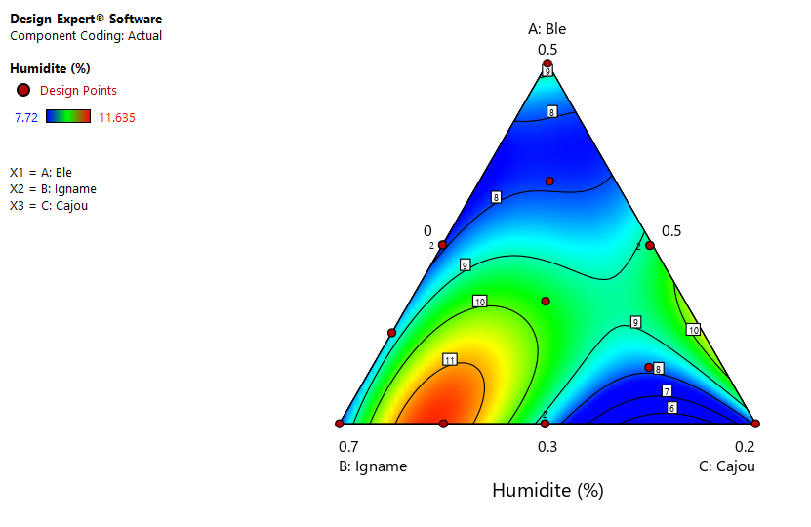



**Figure 4**: Iso-response curves of mixing effects on moisture content

The moisture content resulting from the different formulations increases (F13: 7.72% to F3: 11.6%) with the increasing addition of the amount of yam flour. This observation was also made by (Amandikwa *et al*., 2015) in the formulation of wheat-yam flour composite bread. The results obtained are less than 12% of moisture content. According to Mingle *et al*. (2017) and Kokoh *et al*.,(2019), a moisture content of less than 12% slows deterioration during storage and slows down microbial activity. Low humidity is favorable for controlling the hydration of the flour during the manufacture of biscuits. The model suggested for moisture by the analysis of variance (ANOVA), is a cubic model. The moisture content model is significant with a value of p (0.0129) <0.05. When the model is significant, it means that at least one of the factors influences the response. Thus, the terms AB, BC, ABC, AB(A-B), AC(A-C), BC(B-C); whose absolute values of the coefficients are higher than the standard errors, influence the moisture content. The observed R2 value shows that the model can explain the variations in the response to 96.64% for moisture. This means that the chosen model is significant, thus confirming the strong correlation between ash and the factors. The lack of fit (p=0.0542) is non-significant. The lack of fit non-significant fit is good, so the experimental errors are small. The experimental error and the calculated error of the model are very close. This indicates that the suggested model for moisture is valid and properly adjusted.

### **3.1.2 Ash Content**

The ash content is between 1.43% and 2.08% for the F7 and F6 formulations respectively. The ash content is higher for a 20% amount of whole cashew apple flour in the mix. The iso-response curves shown in Figure 5, generated by the adopted model, indicate the interactions between the variables (A, B, C) and the ash content. The equation of the model is written in the following form:

Ashes%=1.44A+1.86B+2.09C-0.2757AB-1.17AC-1.23BC+7.01ABC+1.45AB(A-B) (2)

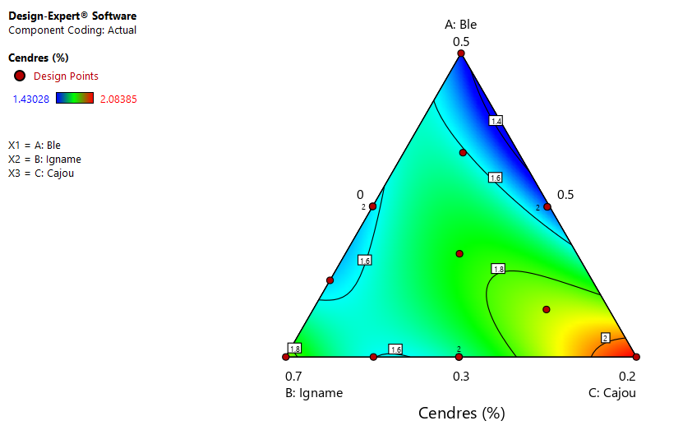

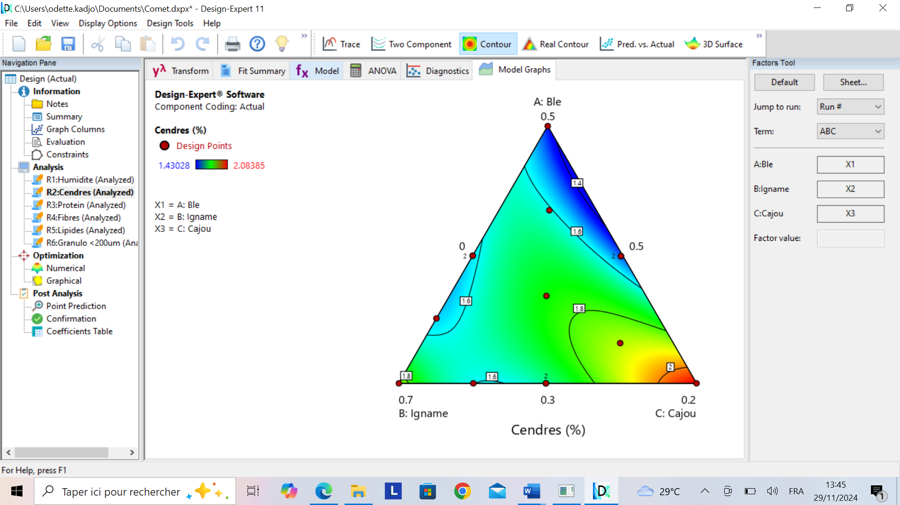

**Figure 5** : Iso-response curves of the effects of mixing on ash content

The ash content indicates the presence of minerals contained in the composite flour. Minerals play a fundamental role because they help strengthen a child's immune and nervous system, as well as build muscles. The ash content in the 14 trials increases with the increasing substitution rate of cashew apple flour. The work of (Ogunjobi and Ogunwolu, 2010) and (Offia-Olua and Onwubiko, 2015)have shown that ash levels increase in proportion to the level of substitution of cashew apple flour. The ash content of formulations containing 10% cashew apple substitution (either F10(1,46%),F11(1,49%) et F4(1,63%)) is lower than that obtained by the latter for the same percentage of incorporation. Nevertheless, the ash content for a percentage of substitution of 20% is approximately equal to that obtained by (Offia-Olua and Onwubiko, 2015) which is 2.00%. These differences could be due to the composition of cashew apple varies on factors such as geographical differences, processing factor, agronomic practices, and stage of ripeness (Aidoo *et al*., 2022 ; Ojediran *et al*., 2024)but also to the interaction with the other matrices present in the mixture. The model suggested for ash by the analysis of variance (ANOVA), is a cubic model. The suggested model for ash content is significant with a p value of 0.0202, <0.05. Thus, the interactions AB, AC, BC, ABC, AB(A-B); whose absolute values of the coefficients are greater than the standard errors, influence the response. The observed R2 value shows that the model can explain the variations in the response to 95.75% for ashes. This means that the chosen model is significant, thus confirming the strong correlation between ash and the factors. The value of the lack of adjustment (0.0034), is significant for the ash content. There is only a 0.340% chance that such a large lack of fit value will occur due to noise. A significant lack of adjustment is bad. The validity of the model is therefore to be questioned. However, the model can adapt.

### **3.1.3 Fibers Content**

The fiber content ranges from 3.68% to 6.00% for the F5 and F6 formulations. The fiber content is higher for a 20% amount of cashew flour in the mix. The iso-response curves shown in Figure 6 plotted from the model indicate the effects of interactions between variables (A, B, C) and fiber content. The equation of the model is written in the following form:

Fiber%=4.73A+4.95B+5.63C+30.30ABC+12.01AB(A-B)+ 7.80BC(B-C) (3)

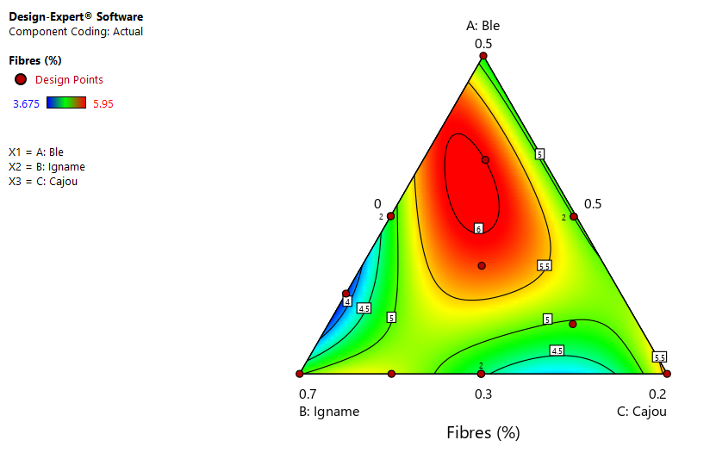

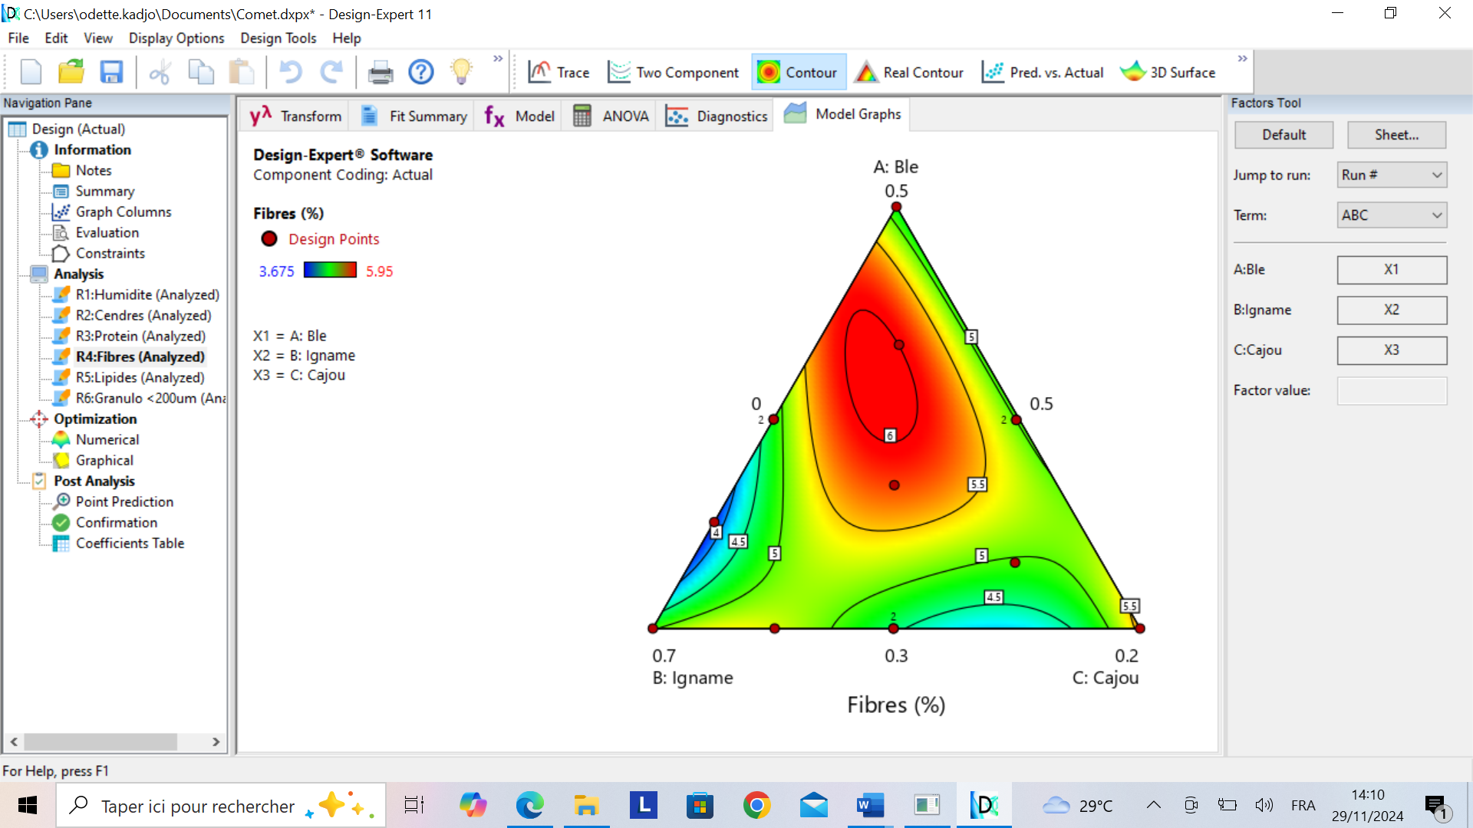



**Figure 6** : Iso-response curves of the effects of the mixture on fiber content

The fiber content increases for high levels of cashew apple substitution. This observation was made by (Ebere *et al*., 2015). The addition of cashew apple flour to the mixture resulted in fiber levels approximately equal to 6g per 100g of product on a dry matter basis, i.e. 6% fiber in children's food as recommended by the (FAO/WHO, 2009). Indeed, there is a relationship between dietary fiber intake and improved colon function, gut motility, and reduced colorectal cancer (CRC) risk (Munteanu and Schwartz, 2024). They are present in large quantities in fruits and vegetables that are not consumed much by children. The substitution of wheat flour by cashew apples in biscuits is a way to increase the level of fiber consumption among children. However, the fiber content decreases for F4 and F11 formulations containing 10% cashew, this could be due to a loss of fiber during alkaline leaching. The model suggested for fibers by analysis of variance (ANOVA), is a cubic model. The fiber content model is not significant for a p value of 0.4729, >0.05. Only ABC, AB(A-B), BC(B-C) interactions; whose absolute values of the coefficients are greater than the standard errors, influence the response. The observed R2 value shows that the model can explain the variations in the response to 72.53% for fibers. However, the value of the lack of adjustment (0.1980) is not significant for the fiber content.

### **3.1.4 Protein Content**

The protein content of 2.6% to 9.5% for the formulations F7 (50% wheat/50% yam) and F6 (30% wheat/ 50% yam/ 20% cashew). The iso-response curves shown in Figure 7 drawn from the model indicate the effects of interactions between variables (A, B, C) and protein content. The equation of the model is written in the following form:

Protein%=2.71A+5.23B+9.60C-18.07BC(B-C) (4)

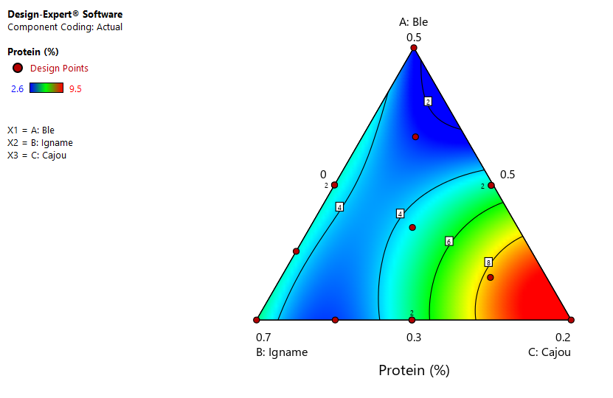

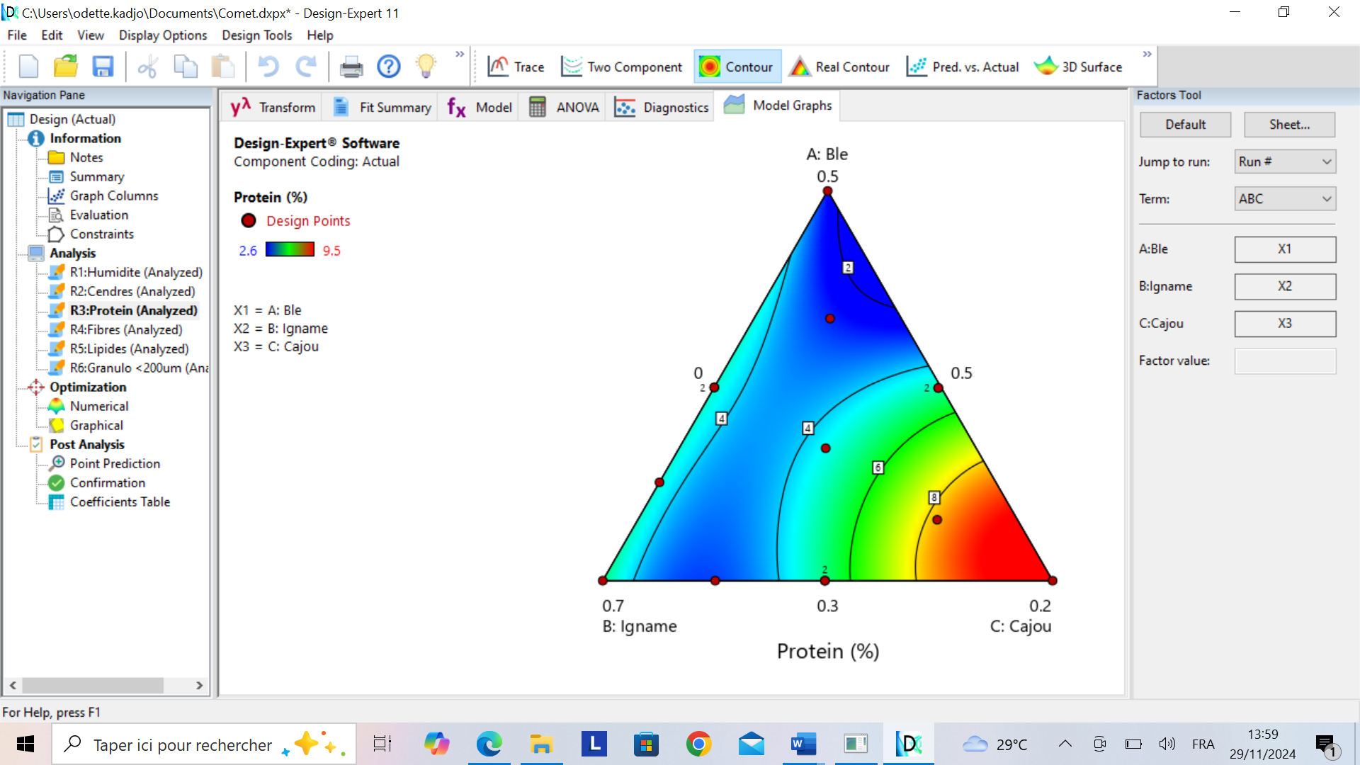



**Figure 7**: Iso-response curves of the effects of mixing on protein content

Also, protein content increases in proportion to the addition of cashew apples. These results are in agreement with those of (Ogunjobi & Ogunwolu, 2010). Protein plays an essential role in the growth and proper functioning of the body. The protein content in a baking flour influences the quality of the finished product, so the target protein content should be between 7.5 and 10%. However, it must remain below 11%, since a flour with high protein content leads to high dough elasticity, causing it to shrink during rolling and baking; therefore adversely resulting in small and thick biscuits (Menard *et al*., 1992 ; Colas 1998 ; Feillet 2000 ; Benkradi 2010). The protein contents of 12 out of 14 assays (formulations F1, F2, F3, F4, F5, F7, F8, F10, F11, F12, F13, F14) are less than 7% (2.6%-6%). These values are lower than the protein values determined by (Digbeu et al., 2009) for the characterization of the variety of bètè bètè yam from the city of Yamoussoukro (5.34±0.24%). This decrease could be explained by the decrease in protein synthesis during storage(Kumar et Kwnols, 1993a ; Dje *et al*., 2010). However, the formulations F6 (9.5%) and F9 (9%) have content in the range of 7.5-10%. The model suggested for protein content by analysis of variance (ANOVA), is a cubic model. The protein content model is not significant for a p value of 0.2070, >0.05. Only the term BC(B-C), whose absolute value of the coefficient is greater than the standard error, influences the response. The observed R2 value shows that the model can explain the variations in the response to 84.38% for protein. The value of the lack of adjustment (p=0.4099) is not significant for protein content. There is a 40.99% chance that a significant lack of fit will occur due to noise.

### **3.1.5 Lipid Content**

The lipid content is between 0.81% and 4.14% respectively for the formulations F12 (40% wheat / 60% yam) and F3 (30% wheat/ 65% yam/ 5% cashew). The iso-response curves shown in Figure 8 drawn from the model indicate the effects of interactions between variables (A, B, C) and lipid content. The equation of the model is written in the following form:

Lipids%=1.43A+1.31B+3.17C+2.12AB+1.03AC+35.10ABC+3.91AB(A-B)+25.81BC(B-C) (5)

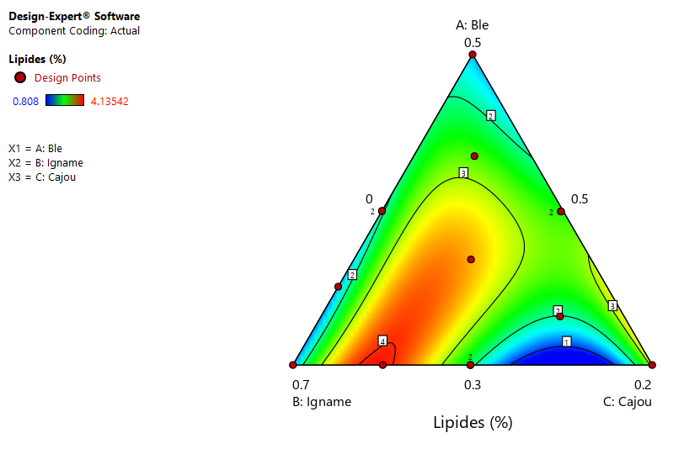

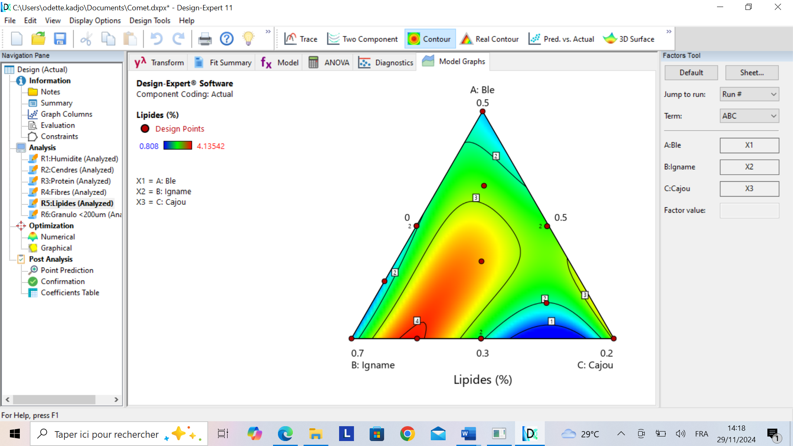

**Figure 8** : Iso-response curves of the effects of the mixture on lipid content

Lipid levels increase in proportion to the addition of yam flour, which is thought to be due to the fermentation of yams. According to (Odunfa 1983 ; Fofana *et al*., 2017),the increase in lipids could be due to the increased activities of lipases that hydrolyze fats into glycerol and fatty acids, which can be used for the synthesis of new lipids. The lipid content in the different formulations is lower (0.81%-4.14%) than the standard of 8% (FAO/OMS, 2009). However, a low lipid content in the flour would limit rancidity, thus allowing for a longer shelf life. The model suggested for lipids by the analysis of variance (ANOVA) is a cubic model. The lipid content model is not significant for a p value of 0.4491, >0.05. Only the AB, AC, ABC, AB(A-B), BC(B-C), interactions whose absolute values of the coefficients are greater than the standard error, influence the response. The observed R2 value shows that the model can explain the variations in the response to 73.60% for lipids. The value of the lack of adjustment (0.8687) is not significant for lipid content.

### **3.1.6 Particle Size**

The particle size of flours with particles smaller than 200μm is between 63.60% and 73.41% for the F3B**/**7I and F5B**/**5I formulations. The iso-response curves shown in Figure 9 drawn from the model indicate the effects of the interactions between the variables (A, B, C) and the flour particle size. The equation of the model is written in the following form:

Particle size%=73.54A+63.88B+64.89C+8.71AB+9.09BC (6)

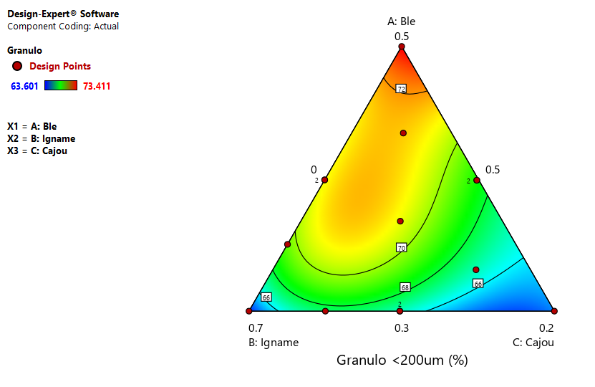 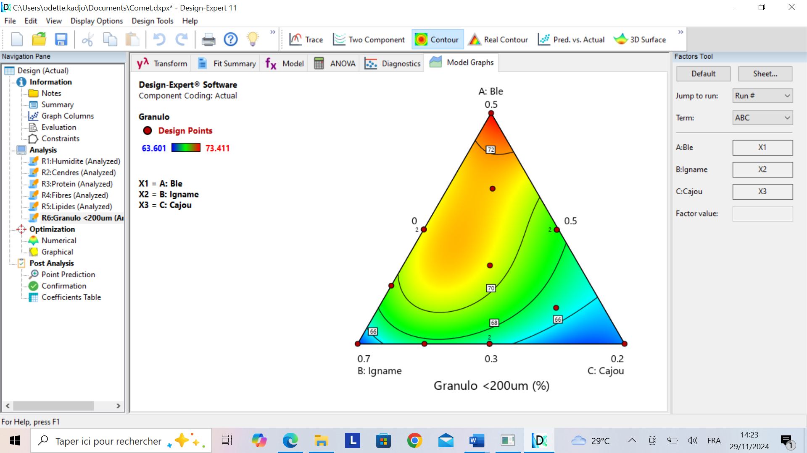



**Figure 9**: Iso-response curves of the effects of mixing on particle size

The particle size of a flour makes it possible to characterize the distribution in size and number of the particles of which it is composed. The flour performance during processing, in particular the speed of hydration (Feillet, 2000 ; Mahiddine et Mekhelef,2022), and the amount of absorbed water (Colas et Tharrault,1997; Mahiddine et Mekhelef,2022) , depends on it. The fineness of the grain size also aims to reduce the spreading rate of the dough and to produce a more resistant biscuits after baking (Scanlom *et al*., 2018;Darimont 2022). The finest fractions give the best biscuits overall (Charun & Morel, 2001). The particle size’s fineness of the composite flour increases with the addition of wheat flour. Indeed, soft wheat pastry flour is a very fine flour with 98% of particles smaller than 200 μm. Improving the milling process or using other equipment could increase the fineness of yam flour and cashew apple flour. The suggested model for particle size by analysis of variance (ANOVA), is a cubic model. The particle size model is not significant for a p value of 0.0692, >0.05. Only the terms AB, BC; whose absolute values of the coefficients are greater than their standard errors, influence the response. The observed R2 value shows that the model can explain the variations in the response to 91.75% for particle size. The value of the lack of adjustment (0.3054), is not significant for the particle size. The lack of non-significant adjustment is good.

## **3.2 Analysis of Models**

The analysis of variance (ANOVA) of the suggested models representing the results of the mixing designs used are shown in Table 4. The statistical significance of the sources of variance in the models was defined as 0.05.

All the necessary fitting characteristics of the models obtained are shown in Table 4. The coefficient of determination R2 defines the ratio of the variation in responses that is explained by the model, the closer the value of the R2 is to 1, the better the fit quality of the model.

**Table4:** Results of the analysis of variance and the adjustment of the mathematical models adopted for the responses of the physicochemical parameters of composite flours.

|  |  |  |  |  |  |  |
| --- | --- | --- | --- | --- | --- | --- |
| Parameters | Humidity% | Ashes% | Fibers% | Lipids% | Protein% | Particle size% |
| Model (P<0.05) | 0.0129** | 0.0202** | 0.4729NS | 0.4491NS | 0.2070 NS | 0.0692 NS |
| Failure to fit | 0.0542NS | 0.0034** | 0.1980NS | 0.0324NS | 0.9128NS | 1.5200NS |
| R2 | 0.9664 | 0.9575 | 0.7253 | 0.7360 | 0.8438 | 0.9175 |

**: meaningful (p≤0.05); NS: non-significant (p≥0.05); R2: Correlation coefficient

The values of the correlation coefficients R2 are close to 1, so the answers indicate a good match between the models adopted and the experimental values. The p-values from Table 4 indicate that the main regression effects are non-significant with a p-value probability greater than 0.05 except for ash.

## **3.3 Optimization of Flour Composite Formula**

The multi-criteria analysis using the desirability function made it possible to determine the compound flour with optimal responses for the physicochemical parameters from the previously established model. The constraints imposed were: the moisture must be less than 11%; ash greater than 2%, fiber greater than 4%, lipids less than 4%, protein greater than 3% and particle size greater than 70%. The results show that the desirability is about 0.95 1 (Figure 10) when the following optimal multi-criteria conditions are met: Soft wheat flour (A) = 32%, Yam flour (B) = 54%, Cashew flour (C) = 14%

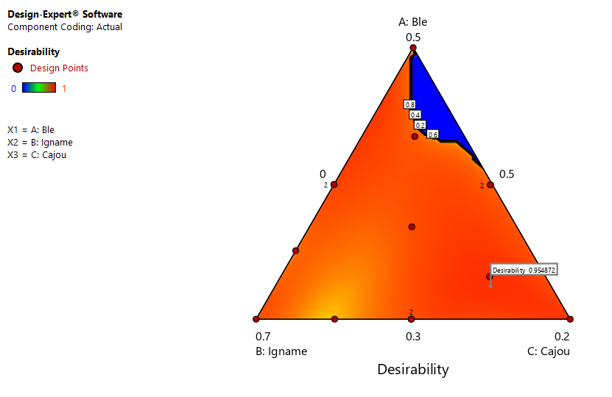

Figure 10: Iso-response curves showing the variation in desirability

The response surface curves (figure 11) show in yellow the areas where the optimum formulation of the composite flour is obtained. Moreover, the response surface curves (figure 11) show in yellow the areas where the optimum formulation of the composite flour is obtained. This optimal zone confirms that for a desirability of 0.95, the optimal factors are: 32% wheat flour; 14% cashew nut flour; and 54% yam flour.

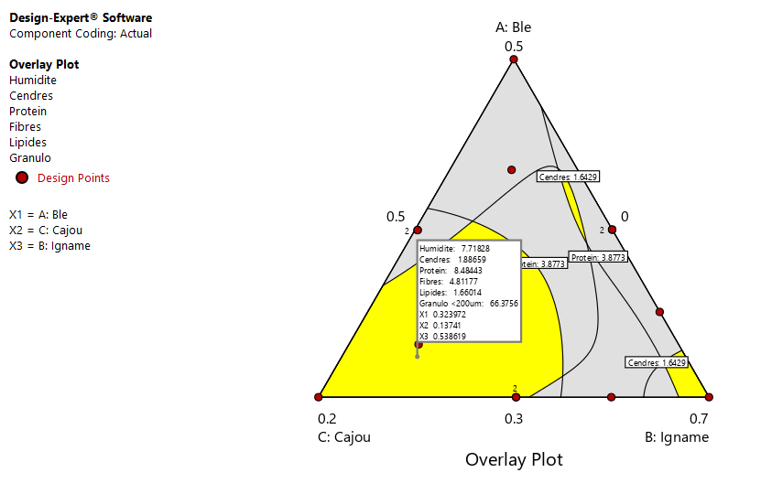



X1= Wheat flour

X2=Cashew apple flour

X3=Yam flour

Figure 11: Response surfaces curves showing the optimal area (in yellow) for optima’s factors

## **3.4 Validation of Flour Composite Formula**

The theoretical composition of the optimum composite flour, determined by computation, was actually achieved. Response parameter values obtained during the trials were then compared with those obtained by computation to validate the formula of composite flour.

**Table 5:** Provides a comparison between the values of predicted responses and those observed responses under optimal conditions.

|  |  |  |  |  |  |  |
| --- | --- | --- | --- | --- | --- | --- |
| Answers | Humidity | Ashes | Protein | Fibers | Lipids | Particle size |
| Experimental value | 7.63 | 1.66 | 9.67 | 3.83 | 1.47 | 66.13 |
| Predicted value | 7.72 | 1.89 | 8.48 | 4.81 | 1.66 | 66.38 |
| R2 | 0.99 | | | | | |

Analysis of Table 5 shows a strong correlation (R²=0.99) between the values predicted by the models and the values observed during validation tests. The composite flour formula was therefore validated.

# **4 CONCLUSION**

Using method of mixing plans has allowed to develop models with a good level of predictability to estimate physiochemical parameters of composite flours (soft wheat, yam and cashew) with a perspective to their valorization in cookie factories. The optimum mixture suggested is a composition of 54% yam flour, 14% cashew apple flour and 32% wheat flour. This optimized composite flour has a moisture content of 7.72%, an ash content of 1.89%, a protein content of 8.48%, a fiber content of 4.81%, a lipid content of 1.66% and a particle size rate of 66.38%.

Using of yams and cashew apples in cookie factories would reduce the import of wheat flour, but also improve the nutritional value of the biscuits offered to children. The addition of cashew apples to infant biscuit flour is a vector for improving children's health.

**COMPETING INTERESTS DISCLAIMER:**

Authors have declared that they have no known competing financial interests OR non-financial interests OR personal relationships that could have appeared to influence the work reported in this paper.

Disclaimer (Artificial intelligence)

Author(s) hereby declare that NO generative AI technologies such as Large Language Models (ChatGPT, COPILOT, etc.) and text-to-image generators have been used during the writing or editing of this manuscript.

# **REFERENCES**

Aidoo, R., Kwofie, E. M., & Ngadi, M. O. (2022). Circularity of Cashew Apples: Examining the Product-Process Pathways, Techno-Functional, Nutritional/Phytomolecular Qualities for Food Applications. ACS Food Science & Technology, 2(7), 1051-1066. https://doi.org/10.1021/acsfoodscitech.2c00093

Benkradi, S. (2010). Contribution to the Diversification of Diets for Celiac Children: Manufacturing Gluten-Free Biscuit Flours (pp. 1-88) [Thesis]. MENTOURI UNIVERSITY OF CONSTANTINE.

Bwebwe, V. A., Mboma, M. J., Bamuene, S. D., Syauswa, M. D., & Umba di, M. J. (2023). Incorporation of yam flour (Dioscorea spp.) in bread making in Kinshasa/DR Congo. *Journal of Animal and Plant Sciences*, *58*(1), 10622‑10635. https://doi.org/10.35759/JAnmPlSci.v58-1.43

C.C.A. (2025). *Conseil Coton Anacarde, production d’anacarde*. CCA. https://cca-website.test.do.incubtek.com/filieres/filiere-anacarde/production

Charun, E. P. J., & Morel, M. H. (2001). What Characteristics for Biscuit Flour? Influence of wheat hardness and the biochemical composition of flours on their biscuit-making ability. 125, 2-16.

Colas, A. (1998). Defining flour quality for different uses. In GODON B., WILLM C. The primary cereal processing industries. (Lavoisier. Tec et Doc/Apria. Paris: 579589, p. 679 p.).

Colas, A., & Tharrault, J. (1997). Particle size distribution. In GODON B. and LOISEL W. Practical guide to analysis in the cereal industries. (Lavoisier. Tec et Doc/Apria. Paris: 42-49. 819 p.).

Darimont, L. (2022). Design of children's biscuits based on chickpea flour [Dissertation]. University of Liège. https://matheo.uliege.be/handle/2268.2/16279

Digbeu, D. Y., Due, A. E., & Brou, K. (2009). Characterization of yam land races in Côte d’Ivoire with respect to food quality and end uses. Journal of Applied Biosciences 20, 1203-1214.

Dje, M. K., Dabonne, S., Guehi, S. T., & Kouame, L. P. (2010). Effects of post-harvest storage on some biochemical parameters of different parts of two yams species (Dioscorea spp). International Scholars Journals, 1(1), 001-009.

Ebere, C. O., Emelike, N. J. T., & Kiin-Kabari, D. B. (2015). Physicochemical and Sensory Properties of Cookies Prepared from Wheat Flour and Cashew-Apple Residue as a Source of Fiber. Asian Journal of Agriculture and Food Sciences, 03(02), 213-218.

Fadil, M., Farah, A., Ihssane, B., Haloui, T., & Rachiq, S. (2015). Optimization of parameters influencing the hydrodistillation of Rosmarinus officinalis L. by response surface methodology. 6, 2346-2357.

FAO/WHO. (2009). Joint FAO/WHO Food Standards Programme. Codex Alimentarius Commission, 32nd Session, Rome, Italy, 29 June-4 July 2009. Report of the 30th Session of the Codex Committee on Nutrition and Foods for Special Dietary Uses. Cape Town (South Africa) 3-7 November 2008. P 1-223.

FAOSTAT 2022. (n.d.). Food Security Data. Accessed May 8, 2024, at https://www.fao.org/faostat/fr/#data/FS

FAOSTAT 2023. (n.d.). Yam Production in Côte d'Ivoire. Accessed May 8, 2024, at https://www.fao.org/faostat/fr/#data/QCL

Feillet, P. (2000). Wheat Grain, Composition and Utilization (INRA. Paris. 308p).

Fofana, I., Soro, D., Yeo, M. A., & Koffi, E. K. (2017). Influence of Fermentation on the Physicochemical and Sensory Characteristics of Plantain and Cashew Almond Composite Flour. European Scientific Journal, ESJ, 13(30), 395. https://doi.org/10.19044/esj.2017.v13n30p395

Gampoula, R. H., M.Gadet Dzondo, J. E. Moussounga, P. Diakabana, N.P.G Pambou-Tobi, Arnaud W.G. Tamba Sompila, & Roniche Nguie. (2020). Development of a process for formulating infant flour based on yam (Discorea cayenensis) enriched with proteins by incorporating food additives of agricultural and fishing origin.*IOSR Journal of Biotechnology and Biochemistry (IOSR-JBB)*, *6*(6), 24‑32. https://doi.org/10.9790/264X-0606032432

Gnagne, A., Soro, D., Ouattara, Y., Koui, E., & Koffi, E. (2023). *A LITERATURE REVIEW OF CASHEW APPLE PROCESSING*. *23*(2), 22452‑22469. <https://doi.org/10.18697/ajfand.117.20705>

Goupy, J. (2005). *Pratiquer les plans d’expériences* (Edition Dunod,Paris .551p).

Goupy, J., & Creignton, L. (2006). *Introduction aux plans d’expériences* (Edition: Dunod. 336 P).

Jeannoda, V. H., Jeannoda, V., Hladik, A., & Hladik, C. M. (2010). Madagascar Yams: Diversity, Uses and Perceptions. *Hommes et plantes*, *47*, 10‑23.

Kokoh, A.-M., Elleingand, E., & Koffi, E. (2019). Physico-Chemical and Sensory Properties of Breads Produced from Wheat and Fermented Yam Composite Flour Fortified with Moringa Leaves Powder. *Journal of Food and Nutrition Research*, *7*(11), 772‑777. <https://doi.org/10.12691/jfnr-7-11-3>

Koné, K. Y., Karidioula, D., Adjé, A. F., Soro, D., Assidjo, N. E., Yao, K. B., & Laguerre, J.-C. (2019). Optimization of annealing treatment in production of functional wheat flour. *ARPN Journal of Engineering And Applied Sciences*, *14*(19), 3310‑3322.

Lombe, R. M., Kamalandua, B. M., Bekomo, J. I., Ngandu, K., & Ngbolua, K.-T.-N. J.-P. (2023). Phytochemical study and evaluation of the anti-radical activity of Dioscorea alata L and D. rotundata Poir (Dioscoreaceae). Moroccan Journal of Agronomic and Veterinary Sciences, 4 (12),240-251

MAHIDDINE, T., & MEKHELEF, N. (2022). Attempt to Enhance the Valorization of Durum Wheat Flour by Incorporating Its Use in Biscuit Manufacturing (p. 102) [Thesis]. Mouloud Mammeri University of Tizi-Ouzou.

Menard, G., Emond, S., Segin, R., Bolduc, R., Boudreau, A., Marcous, D., Painchaud, M., & Poirier, D. (1992). Industrial Biscuit Making. In BOUDREAU A., MENARD G. (1992). Wheat: Fundamental Elements and Transformation. (Laval University Press. Sainte-Foy. Canada: 287348, p. 439 p).

Munteanu, C., & Schwartz, B. (2024). Interactions between Dietary Antioxidants, Dietary Fiber and the Gut Microbiome: Their Putative Role in Inflammation and Cancer. International Journal of Molecular Sciences, 25(15), Article 15. https://doi.org/10.3390/ijms25158250

NAMOUS, H. (2013). Formulation of a gluten-free weaning flour biscuit based on rice, corn and chickpeas [Thesis]. Constantine University -1-

Ndiaye, L. (2023). Agromorphometric variability of the cashew tree (Anacardium occidentale L.) and valorization of the cashew apple in Casamance (Senegal). ASSANE SECK UNIVERSITY OF ZIGUINCHOR.

Ndiaye, L., Charahabil, M. M., Niang, L., & Diouf, A. (2022). Nutritional and energy value of cashew apples (Anacardium occidental L.) from Casamance, Senegal. Afrique SCIENCE 21(2), 13-24

Odunfa, S. (1983). Biochemical Changes During Production of Ogiri, a Fermented Melon (Citrus vulgaris Schard) Product. Qualitas Plantarum: Plant Foods Hum. Nutr, 32, 45-52.

Offia-Olua, B. I., & Onwubiko, Glory. I.C. (2015). Physico-chemical properties and micronutrients of whole wheat flour partially substituted with cashew apple powder. Journal of Food Science and Technology, 2(5), 044-051.

Ogunjobi, M. A. K., & Ogunwolu, S. O. (2010). Physicochemical and Sensory Properties of Cassava Flour Biscuits Supplemented with Cashew Apple Powder. Journal of Food Technology, 8(1), 24-29. https://doi.org/DOI: 10.3923/jftech.2010.24.29

Ojediran, T. K., Olorunlowu, S. A., Oyekola, O., Olagoke, O. C., & Emiola, I. A. (2024). Cashew Apple: Nutritional Composition, Nutritive Value and Potential as Commercial Feedstuff for Livestock. Aceh Journal of Animal Science, 3(9), 128-137. https://doi.org/10.13170/ajas.9.3.38550

Olive, F., Mouquet-Rivier, C., Fioroni, N., Bichard, A., Boulle-Martinaud, N., Kaboré, C., Denizeau, M., Zagré, N., Le Dain, A., Ndiaye, N., Tou, E. H. K. P., & Aho, A. (2020). The locally produced infant flour sector in 6 Sahelian countries. UNICEF. https://doi.org/10.23708/fdi:010080274

Saavedra, J. M., & Prentice, A. M. (2023). Nutrition in school-age children: A rationale for revisiting priorities. Nutrition Reviews, 81(7), 823-843. https://doi.org/10.1093/nutrit/nuac089

Samira, B., Djamel, E. H., & Ali, A. (2018). Development of a composite bread.

Scanlom, M. G., Thakur, S., Tyler, R. T., Milani, A., Der, T., & Paliwal, J. (2018). The Critical Role of Milling in Pulse Ingredient Functionality. In In: Cereal Foods World. (https://doi.org/10.1094/CFW-63-5-0201).