***Original Research Article***

**INSTANT IDLI PRE MIX FORTIFIED WITH FINGER MILLET: DEVELOPMENT, NUTRITIONAL PROFILE, AND FUNCTIONAL PROPERTIES**

**Abstract**

The growing demand for nutrient-dense, ready-to-cook food products has driven interest in millet-based fortification of traditional staples. This study focused on developing an instant idli premix enriched with finger millet (Eleusine coracana) to improve nutritional quality without compromising sensory attributes. Six formulations were prepared—five with varying levels of finger millet (30% to 70%) and one control without millet. Among these, the T3 formulation, comprising 50% finger millet, 30% rice, and 20% black gram, demonstrated a superior balance of nutrition and acceptability. T3 recorded significantly higher protein (24.06 g/100 g) and crude fiber (10.12 g/100 g) compared to the control. The moisture content ranged from 7.11% to 8.92%, with T3 showing 8.26%, supporting shelf stability. Fermentation quality was confirmed by pH (4.60) and titratable acidity (0.64%). Functional parameters including water absorption capacity (145.3%), wettability (10.7 g/min), and reconstitution time (41 s) indicated favorable rehydration properties. Sensory evaluation revealed that T3 outperformed the control (T6) in all major parameters: colour and appearance (8.83 vs. 8.70), texture (8.60 vs. 8.43), flavour (8.40 vs. 8.30), taste (8.50 vs. 8.40), and overall acceptability (8.60 vs. 8.40). These findings demonstrate that finger millet fortification at optimized levels can enhance the nutritional profile of instant idli premix while maintaining consumer-preferred sensory characteristics, offering a promising approach to functional food product development.

**Keywords** :-Finger millet, Instant idli premix, Nutritional fortification, Functional properties, Protein enhancement, Shelf stability, Water absorption capacity, Ready-to-cook mix, Fermentation, Food innovation.

1. **INTRODUCTION**

Instant foods have become an integral part of modern lifestyles, especially for urban populations, working professionals, and students, because of their convenience and minimal preparation time. The shift from traditional home-cooked meals to instant options is due to factors like urbanization, busy work schedules, and evolving consumer preferences (Khurana & Goyal, 2021). Studies highlight that taste, branding, and social recommendations significantly influence market for these product, while a growing awareness of health risks associated with processed foods is pushing consumers toward healthier alternatives. As a result, food manufacturers are focusing on innovation to enhance the nutritional quality of instant meals, aligning them with both convenience and well-being (Mathew & Mathew, 2024). Commercial premixes used in nutritional products and complementary foods often have limited nutritional value due to inconsistencies in ingredient ratios, inefficient production methods, and weak compliance with fortification guidelines. A global review of 108 premixed complementary foods across 22 low- and middle-income countries found considerable variation in nutrient composition, with only a small percentage meeting essential benchmarks for fat, protein, iron, or zinc (Masters et al. 2017).The objective of this study is to develop and assess a fortified instant idli mix with finger millet, enhancing its nutritional value while maintaining taste and texture. Key evaluations include nutritional profile, functional properties and shelf stability for a convenient, health-focused alternative.

The formulation and evaluation of a finger millet-based instant idli premix are well supported by a series of earlier studies conducted by the authors across various areas of food and agricultural engineering. The analysis of jowar production trends using pivot tables offered insights into millet cultivation patterns, which are valuable when selecting nutrient-rich grains like finger millet for functional food development (Kahar et al., 2024a). The exploration of ethylene inhibitors and edible coatings in guava preservation provides a scientific foundation for extending the shelf life of premix products using similar preservation strategies (Kahar et al., 2024b). Research on fish-based extruded snacks demonstrated successful product formulation and packaging for protein-enriched ready-to-eat foods, closely aligning with the goals of enhancing the nutritional profile of idli premix without compromising sensory quality (Kahar et al., 2024c). Complementary to this, the review on smart packaging solutions in seafood preservation highlights the importance of intelligent and protective packaging, reinforcing the selection of HDPE pouches to maintain the premix’s stability over time (Manaswini et al., 2025). Moreover, the application of plant extract-based active packaging in strawberries supports the integration of natural additives and barrier materials for product safety and longevity (Ganesh Santosh, 2022). Techniques like pulsed electric field processing (Khatal et al., 2024) and the implementation of AI and IoT in agricultural engineering (Kahar et al., 2024d) further underline the potential for adopting modern, sustainable, and automated technologies in the production and monitoring of such ready-to-cook formulations.

Idli is a soft, fermented, spongy cake enjoyed as breakfast or a snack in South east Asian countries Particularly in Insia and Sri lanka, made from parboiled rice and black gram (i.e cerials and legumes). Fermentation enriches its nutritional profile by adding probiotics, vitamins, and amino acids while improving texture and digestibility by increasing beneficial enzymes, acids, and essential nutrients and reducing antinutrients. The microflora from black gram plays a key role in this process, improving digestibility and mineral bioavailability (Kumari et al. 2010). Lactic acid bacteria contribute to leavening, increasing batter volume, which ensures light, fluffy idlis (Ravindran et al. 2021).Fortified fermented batters could also serve as probiotic carriers, enhancing gut microbiota diversity and immune function (Tsafrakidou et al. 2020).Fortification involves adding essential nutrients (e.g., vitamins, minerals) to foods to address deficiencies and improve public health. Cereals (e.g., rice) are rich in sulfur-containing amino acids but lack lysine, while legumes (e.g., black gram) are lysine-rich but low in methionine and cysteine. Rice, a gluten-free, easily digestible staple crop with high glycemic index (GI), provides quick energy, making it ideal for athletes (Dubey et al.2023). While coming to fortification ingredients, millets are ancient grains widely cultivated in the Eastern hemisphere, particularly in Africa and India, where they serve as a staple food in hot, dry regions. India is the largest producer, contributing 36% of global millet production (FAO, 2017). These nutrient-rich cereals are packed with protein, fiber, and essential minerals, offering health benefits such as blood sugar regulation, heart health, and improved digestion (Khatoniar et al. 2022).Foxtail millet is a nutrient-rich grain that supports food fortification with its high protein content, helps in prevention of malnutrition . It is packed with dietary fiber, promoting digestion and heart health, while also offering essential micronutrients like iron and B vitamins making it a prominsing ingredient for fortification (Thara et al. 2021; Tsafrakidou et al. 2020).

Fortifying Idli batter tackles issues like microbial inconsistency, short shelf life, and nutrient deficiencies while enhancing texture and consumer appeal. Adding fortified ingredients boosts essential micronutrients, prolongs freshness, and supports controlled fermentation (Mandhania et al. 2019; Regubalan & Ananthanarayan, 2018). Large-scale implementation aligns with nutrition goals but faces hurdles such as nutrient degradation, regulatory limitations, and cost concerns (Olson et al. 2021). Integrating traditional preparation with modern fortification methods can establish idli as a sustainable, health-enriching staple in South Asia and beyond.

By addressing this demand, the objective of the research work is to develop an idli premix fortified with finger millet, aiming to enhance its nutritional value and promote the use of underutilized millets in daily diets. The study focuses on analyzing the nutritional profile of the developed premix, including key macro- and micronutrients, and evaluating its functional properties such as water absorption, bulk density, and swelling capacity, which are essential for ensuring product quality, texture, and consumer acceptability.

# **Material and Methodology**

**2.1 Location of the experiment**

The experiment was conducted at the Bakery Unit of Department of Processing and Food Engineering, College of Agricultural Engineering and Technology, Dr. Balasaheb Sawant Konkan Krishi Vidyapeeth, Dapoli, Dist. Ratnagiri (M.S)

**2.2 Procurement of raw materials**

For this research study, Rice (Oryza sativa), Black Gram (Vigna mungo) and millets like finger millet (Ragi- Eleusine Coracana), leavening agent (sodium bicarbonate) and Citric acid were procured from the local market of Dapoli.

**2.3** **Equipment and Instruments**

The equipment used in this research included a Vernier caliper, weighing balance, grinder, tray dryer, sieve shaker, hot air oven, Soxhlet apparatus, Kjeldahl unit, muffle furnace, and pH meter, sourced from the Departments of Processing and Food Engineering, APE, and Food Science & Technology at MPKV, Rahuri. Packaging materials used were HDPE standing pouches, HDPE aluminum-laminated pouches, and polypropylene packs

#### **2.4 Optimization, Standardization, and Characterization of Instant Idli Premix**

The formulation of the instant idli premix was optimized by varying the proportions of finger millet, rice, and black gram to achieve an optimal balance between enhanced nutritional content and acceptable sensory qualities. Six different formulations were prepared, with finger millet levels ranging from 30% to 70%, alongside a control sample without millet. Through preliminary trials, the formulation containing 50% finger millet, 30% rice, and 20% black gram (designated as T3) was identified as the most balanced in terms of nutritional enhancement and sensory acceptance. The standardization process involved maintaining consistent preparation and processing conditions to ensure reproducibility. Characterization of the optimized premix included measurement of moisture content to ensure shelf stability, assessment of fermentation quality via pH and titratable acidity, and evaluation of key functional properties such as water absorption capacity, wettability, and reconstitution time. These analyses confirmed that the optimized and standardized premix exhibited favorable nutritional, functional, and sensory attributes suitable for the preparation of gluten-free instant idli.

**2.5 Idli Pre mix Formulation**

The ingredients used for the preparation of Idli pre mix -were shown in Below.

**T1 = Rice : Finger Millet : Black gram = 50 : 30 : 20**

**T2 = Rice : Finger Millet : Black gram = 40 : 40 : 20**

**T3 = Rice : Finger Millet : Black gram = 30 : 50 : 20**

**T4 = Rice : Finger Millet : Black gram = 20 : 60 : 20**

**T5 = Rice : Finger Millet : Black gram = 10 : 70 : 20**

**T6 (Control) = Rice : Finger Millet : Black gram = 80 : 00 : 20**

**2.5.1 Process for preparation of instant Idli-Premix**

The preparation of instant idli premix begins with the selection of rice, black gram, and finger millet of good quality. These ingredients are then soaked in water for 8 hours to soften them for grinding.After soaking, the ingredients are individually ground and then uniformly mixed to form a homogenous batter. The batter is allowed to ferment for 8–10 hours, enabling the development of flavor and texture.Post-fermentation, the batter is dried in a tray dryer at 60 °C for 6 hours to reduce moisture content. The dried material is then coarsely ground, followed by fine grinding using a pulverizer with a 150-micron sieve (0.15 mm) to obtain a uniform premix powder.Finally, the prepared premix is weighed and packed for storage at room temperature, making it ready for instant idli preparation whenever required.

## **2.6 Proximate and Nutritional Composition of Idli Pre-Mix**

### **2.6.1 Moisture Content**

Moisture content was estimated following the method described by Ranganna (1995).  
Formula:  
Moisture Content (%) = ((W₂ - W₃) / (W₂ - W₁)) × 100  …(.1)  
Where:  
W₁ = Weight of empty sample box (g)  
W₂ = Weight of box + sample before drying (g)  
W₃ = Weight of box + sample after drying (g)

### **2.6.2 Ash Content**

Ash content was determined as per the procedure outlined by Ranganna (1995).  
Formula:  
Ash Content (%) = ((W₂ - W) / (W₁ - W)) × 100  …(.2)  
Where:  
W = Weight of crucible (g)  
W₁ = Weight of crucible and flour (g)  
W₂ = Weight of crucible with ash (g)

### **2.6.3 Crude Fat**

Crude fat content was determined using the Soxhlet extraction method as described by AOAC (2000).  
Formula:  
Fat (%) = ((W₁ - W₂) / W) × 100  …(3)  
Where:  
W = Weight of sample (g)  
W₁ = Initial weight of sample with flask (g)  
W₂ = Final weight of sample with flask (g)

### **2.6.4 Crude Fibre**

Crude fibre content was estimated following the method given by AOAC (2000).  
Formula:  
Crude Fibre (%) = ((W₂ - W₃) / W₁) × 100  …(.4)  
Where:  
W₁ = Weight of the sample (g)  
W₂ = Weight of insoluble matter (g)  
W₃ = Weight of ash (g)

### **2.6.5 Protein**

Protein content was determined using the Kjeldahl method as described by AOAC (2000), applying a nitrogen-to-protein conversion factor of 6.25.  
Formula:  
Protein (%) = ((S - B) × N × 14.01 × 100 × 6.25) / (W × 1000)  …(5)  
Where:  
S = Volume of standard acid (0.1 N HCl) used for titration (ml)  
B = Volume of 0.1 N HCl used for blank (ml)  
N = Normality of acid (0.1 N HCl)  
W = Weight of sample (g)

### **2.6.6 Carbohydrates**

Carbohydrate content was calculated by difference, subtracting the sum of moisture, protein, fat, fibre, and ash from 100, as per AOAC (2000).  
Formula:  
Carbohydrates (%) = 100 - (Moisture % + Protein % + Fat % + Fibre % + Ash %)  …(.6)

### **2.6.7 Energy**

Energy value (kcal) was calculated using the Atwater factors (AOAC, 2000).  
Formula:  
Energy = (4 × Protein %) + (9 × Fat %) + (4 × Carbohydrate %)  …(.7)

### **2.6.8 Mineral Analysis**

Mineral content was estimated from the ash solution as per the procedure given by Ranganna (1986).

#### **2.6.8.1 Calcium, Magnesium, and Phosphorus**

These minerals were determined using titrimetric and spectrophotometric methods as outlined by Ranganna (1986) and AOAC (2000).

#### **2.6.8.2 Zinc, Iron, and Copper**

These were analyzed using atomic absorption spectrometry as described by AOAC (2000).

## **2.6.9 Reconstitutional Properties of Idli Mix Powder**

### **2.6.9.1 Water Absorption Capacity (WAC)**

WAC was determined using the method described by Sosulski et al. (1976).  
Formula:  
WAC (%) = (Weight of water absorbed × Density of water) / Weight of Sample × 100

### 2.5.9.2 Rehydration Ratio

The rehydration ratio of the idli premix was determined using the method outlined by Mridula et al. (2015).  
Formula:  
Rehydration Ratio = Weight of rehydrated mix (Wr) / Weight of dry mix (Wd)

### **2.6.9.3 Wettability**

Wettability, defined as the time required for complete submersion of powder particles in water, was measured using the protocol by Kumar et al. (2017).

### **2.6.9.4 Reconstitution Time**

Reconstitution time was determined by measuring the time required to achieve the desired idli batter consistency.

## **2.6.9.5 Measurement of Expansion Ratio of Batter**

The expansion ratio of the batter was determined using a graduated transparent measuring cylinder.  
Formula:  
Expansion Ratio = Initial Volume / Final Volume

## **2.6.9.6** **Sensory Evaluation**

Sensory evaluation of the reconstituted idlis was conducted by a semi-trained panel of 10 members using a 9-point Hedonic scale as per Ranganna (1986). Parameters such as appearance, color, flavor, texture, taste, and overall acceptability were rated. The mean scores were used to assess consumer acceptability.

**2.6.9.7** **Storage**

Idli pre-mix samples were stored in different packaging materials including PP, HDPE standing pouch, LDPE standing pouch, and LDPE bag. The samples packed in LDPE bags were evaluated for a storage period of up to 3 months to assess shelf life and quality stability."

**2.6.9.8 Statistical analysis**

The analysis of variance of the data obtained was done by using Completely Randomized Design (CRD) for different treatments as per the method given by (Panse & Sukhatme, 1985). The analysis of varience revealed at significance of P ≤0.05 level, S.E. and C.D. at 5 % level is mentioned wherever required.

**3. Result and Discussion**

**3.1 Nutritional Composition of Instant Idli Mix Powder**

3.1.1 **Moisture Content**

Moisture content of all idli premix flour samples was calculated and is presented in Figure 1. Moisture ranged from 7.11% to 8.92% (g/100 g), with the lowest value observed in treatment T1 (7.11%) and the highest in the control treatment T6 (8.92%). Among the treated samples, T5 showed the highest moisture content (8.87%), which increased with higher levels of finger millet and lower levels of rice. ANOVA revealed significant differences (p < 0.05) among the treatments. The coefficient of variation (C.V.) was 0.017%, and the critical difference (C.D.) was 0.014%.

**3.1.2 Protein Content**

Protein content of the developed idli premix flour samples was recorded. Protein content ranged from 11.38 to 29.75 g/100 g, with the highest value observed in treatment T5 (29.75 g/100 g) and the lowest in the control treatment T6 (11.38 g/100 g). Protein content progressively increased with higher levels of finger millet and lower levels of rice from T1 to T5. ANOVA showed significant differences (p < 0.05) among the treatments. The coefficient of variation (C.V.) was 0.008%, and the critical difference (C.D.) was 0.019%, as shown in Figure 2.

**3.1.3 Fat Content**

The fat content of the idli premix flour was determined and ranged from 0.88 g/100 g to 1.22 g/100 g. Treatment T5 had the highest fat content (1.22 g/100 g), while the control treatment (T6) had the lowest value (0.88 g/100 g). A gradual increase in fat content was observed as the proportion of finger millet increased and the rice content decreased.From the ANOVA analysis, the differences in fat content across treatments were statistically significant at the 5% level. The coefficient of variation was 0.128%, indicating minor variability. The critical difference was calculated as 0.014%, as shown in Figure 3.

**3.1.4 Carbohydrate Content**

The carbohydrate content of the idli premix flour samples ranged from 45.96 g/100 g to 73.62 g/100 g. The highest value was recorded for the control treatment T6 (73.62 g/100 g), while the lowest was found in treatment T5 (45.96 g/100 g). A gradual decline in carbohydrate content was observed from T1 to T5, corresponding to the increasing substitution of finger millet for rice.According to the ANOVA, carbohydrate content was significantly affected by treatment at the 5% significance level. The coefficient of variation was 0.005%, indicating very low variation. The critical difference was calculated as 0.030%, as presented in Figure 4.

**3.1.5 Crude Fibre Content**

The crude fibre ranged from 4.70 g/100 g to 12.48 g/100 g. The highest value was found in treatment T5 (12.48 g/100 g), while the lowest was observed in the control treatment T6 (4.70 g/100 g). The fibre content increased with the rising percentage of finger millet, which is known to be rich in dietary fibre.From the ANOVA, it was observed that the effect of treatments on crude fibre content was significant at the 5% level. The coefficient of variation was 0.017%, indicating consistent results. The critical difference was recorded as 0.016%, as shown in Figure 5.

**3.1.6 Ash Content**

Ash content in the idli premix flour samples was determined. the Ash content ranged from 0.40 g/100 g to 1.72 g/100 g. The highest ash content was recorded in T5 (1.72 g/100 g), while the lowest was in T1 (0.40 g/100 g). The control treatment, T6, had a moderate ash content of 0.50 g/100 g. Ash content showed an increasing trend with higher levels of finger millet substitution.

As per the analysis, the ash content was significantly affected by treatment differences at the 5% level of significance. The coefficient of variation was 0.169%, and the critical difference was observed to be 0.014%, as shown in Figure 6.

**3.1.7 Engergy Content**

The energy content of the developed idli premix treatments was calculated using the formula described in the previous section. It was observed that the energy content of the premix samples ranged from 313.82 to 347.92 kcal/100 g. Treatment T6 (Control) exhibited the highest energy value of 347.92 kcal/100 g, followed by T1 with 344.22 kcal/100 g. The lowest energy content was recorded for treatment T5 (313.82 kcal/100 g). The decrease in energy content from T1 to T5 can be attributed to the gradual reduction in carbohydrate and fat contents, along with an increase in crude fiber, corresponding to the increasing levels of finger millet substitution

**Fig. 1 Moisture content values of developed Idli pre mix**

**Fig. 2 Protein content values of developed Idli pre mix**

**Fig. 3 Fat content values of developed Idli pre mix**

**Fig. 4 Carbohydrate content values of developed Idli pre mix**

**Fig. 5 Crude Fiber content values of developed Idli pre mix**

**Fig. 6 Ash content values of developed Idli pre mix**

**3.2 Physical, Chemical, and Functional Characteristics of Idli Powder and Batter**

**3.2.1 pH**

The pH of the idli premix samples showed a decreasing trend with increasing levels of finger millet incorporation, ranging from 5.1 in the control sample (T6) to 4.4 in treatment T5. This suggests that the addition of finger millet slightly increased the acidity of the premix.

Titratable acidity (%) followed an opposite trend, with the highest value observed in T1 (1.60%) and the lowest in T5 (0.25%), reflecting the typical inverse relationship between pH and acidity. The control sample showed moderate acidity at 0.76%.

Total Soluble Solids (TSS) also exhibited a decreasing pattern, starting from 6.13°Brix in T1 to 5.10°Brix in T5, while the control sample (T6) recorded the highest TSS value of 6.50°Brix. These changes in pH, acidity, and TSS across the different treatments proved statistically significant, as confirmed by the values of Standard Error (S.E), Critical Difference (C.D), and Coefficient of Variation (C.V). This outcome clearly indicates that incorporating finger millet significantly influenced the chemical characteristics of the idli premix, as illustrated in Table 1.

**Table 1 Effect of Treatment on pH,Titrable acidity and TSS**

|  |  |  |  |
| --- | --- | --- | --- |
| **Treatment** | **pH** | **Titratable Acidity (%)** | **TSS (°Brix)** |
| T1 | 4.8 ± 0.07 | 1.60 ± 0.0045 | 6.13 ± 0.08 |
| T2 | 4.7 ± 0.065 | 0.99 ± 0.0038 | 5.80 ± 0.07 |
| T3 | 4.6 ± 0.072 | 0.64 ± 0.0042 | 5.60 ± 0.075 |
| T4 | 4.5 ± 0.068 | 0.52 ± 0.0041 | 5.40 ± 0.078 |
| T5 | 4.4 ± 0.066 | 0.25 ± 0.0039 | 5.10 ± 0.074 |
| T6 (Control) | 5.1 ± 0.071 | 0.76 ± 0.0040 | 6.50 ± 0.079 |

**3.2.2 Expansion Ratio of Batter**

The expansion ratio of idli batter prepared from different treatments of pre-mix ranged from 1.50 to 2.10. The highest expansion ratio (2.10) was observed in the control (T6) sample, indicating superior fermentation and gas retention capacity. Among the treated samples, T1 showed the highest expansion ratio (1.90), followed by T2 (1.80) and T3 (1.70). A gradual decline in expansion ratio was noted from T1 to T5, suggesting that the treatments influenced the fermentability and aeration potential of the batter. Lower expansion in T5 (1.50) indicates reduced leavening or gas-holding capacity.

**3.3 Reconstitutional properties of Idli mix powder**

The functional properties of the optimized idli premix (T3: 50% finger millet, 20% blackgram, 30% rice) showed notable differences compared to the control. T3 had a lower water absorption capacity (145.3%) than the control (170.5%), likely due to its higher protein and fiber content. However, wettability was better in T3 (10.7 g/min), suggesting quicker water penetration. As shown in Fig 3, 10, 11, 12, the rehydration ratio was lower in T3 (2.0) compared to the control (2.9), indicating less water uptake during cooking but still acceptable results. The mix-to-water ratio for T3 was slightly reduced (1:1.8 vs. 1:2), aligning with its water absorption behavior. Notably, T3 reconstituted faster (41 seconds) than the control (52 seconds), offering improved preparation convenience. Overall, T3 enhanced wettability and reduced reconstitution time, with a slight compromise in water absorption and rehydration.

**Fig 7 "Effect of Treatment on Water Absorption Capacity (%) of Idli Powder"**

**Fig 8 Impact of Treatments on Wettability (g/min) of Instant Idli Mix"**

**Fig 9 Comparison of Rehydration Ratio between Treated and Control Instant Idli Mix"**

**Fig 10 Influence of Treatment on Reconstitution Time (s) of Instant Idli Mix"**

**3.4 Sensory Evaluation of Idli Prepred from Idli pre mix**

Treatment T3 received the highest score for colour and appearance (8.83), making it the most visually appealing sample. The control sample T6 followed closely with a score of 8.70. Treatments T2 and T4 also showed good acceptance, scoring 8.13 and 8.03, respectively. In contrast, T1 (7.43) and T5 (7.30) received lower scores, likely due to the darker shade caused by higher finger millet content.For texture, T3 again achieved the top rating (8.60), indicating a soft and pleasant mouthfeel. The control sample T6 scored well at 8.43, while T1 and T5 had lower scores of 7.26 and 7.23, respectively—possibly due to a firmer texture resulting from the formulation.

In terms of flavour, T3 (8.40) and T6 (8.30) were most favored by the panelists. On the other hand, T5 received the lowest score (6.96), suggesting that excessive finger millet content may have negatively influenced flavour acceptability.Taste ratings followed a similar trend: T3 led with 8.50, followed by T6 at 8.40 and T2 at 8.03. Again, T5 scored the lowest (7.03), which may be attributed to the stronger and possibly overpowering flavour of finger millet.Overall acceptability was highest for T2 (8.70), slightly higher than T3 (8.60) and the control T6 (8.40), indicating that the panelists found these formulations most acceptable. T4 had the lowest overall acceptability (7.01), making it the least preferred sample.

These findings are summarized in Table 2 and visually presented in Figure 11,12.

**Table 2 Average sensory score values of Prepared Idli From Pre mix**

|  |  |  |  |  |  |
| --- | --- | --- | --- | --- | --- |
| **Treatment** | **Colour &Appearance** | **Texture** | **Flavour** | **Taste** | **Overall Acceptability** |
| T1 | 7.43 | 7.26 | 7.36 | 7.16 | 7.30 |
| T2 | 8.13 | 8.16 | 7.13 | 8.03 | 8.70 |
| T3 | 8.83 | 8.60 | 8.40 | 8.50 | 8.60 |
| T4 | 8.03 | 7.63 | 7.63 | 7.83 | 7.01 |
| T5 | 7.30 | 7.23 | 6.96 | 7.03 | 7.08 |
| T6  (Control) | 8.70 | 8.43 | 8.30 | 8.40 | 8.40 |
| SE(d) | 0.514 | 0.486 | 0.492 | 0.504 | 0.565 |
| CD (5%) | 1.145 | 1.082 | 1.096 | 1.122 | 1.260 |

Bottom of Form

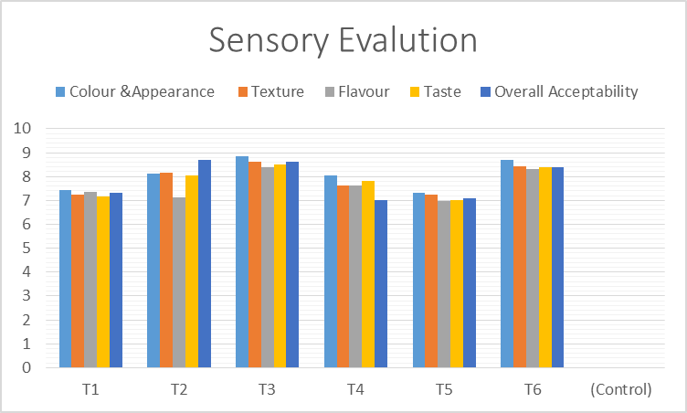

**Fig 11 Sensory Analysis of Treatment T1 to T6**

|  |  |
| --- | --- |
| **Developed Idli From Pre Mix Treatment T1** | **Developed Idli From Pre Mix Treatment T2** |

|  |  |
| --- | --- |
| **Developed Idli From Pre Mix Treatment T3** | **Developed Idli From Pre Mix Treatment T4** |
| **Developed Idli From Pre Mix Treatment T5** | **Treatment T6 Control** |

**Fig 12** Nutritionally Health-Enhanced Premix Idli **T1 to T6**

**3.5 Storage**

The **Idli premix samples stored in HDPE standing pouch packaging maintained stable quality throughout the three-month storage period**. Key physicochemical parameters such as **pH, total soluble solids (TSS), acidity, moisture content (MC), and water activity (WAC)** exhibited **minimal variation**, indicating effective preservation of the product. The **pH levels remained largely unchanged**, suggesting limited microbial activity and chemical degradation. Similarly, **TSS and acidity values showed no significant fluctuations**, reflecting the retention of freshness and flavor. **Moisture content and water activity were effectively controlled**, which is essential for inhibiting microbial growth and ensuring shelf stability. Overall, the **HDPE standing pouch demonstrated excellent barrier properties**, making it highly suitable for preserving the **quality and safety of idli premix** during storage, as illustrated in **Figure 13**..

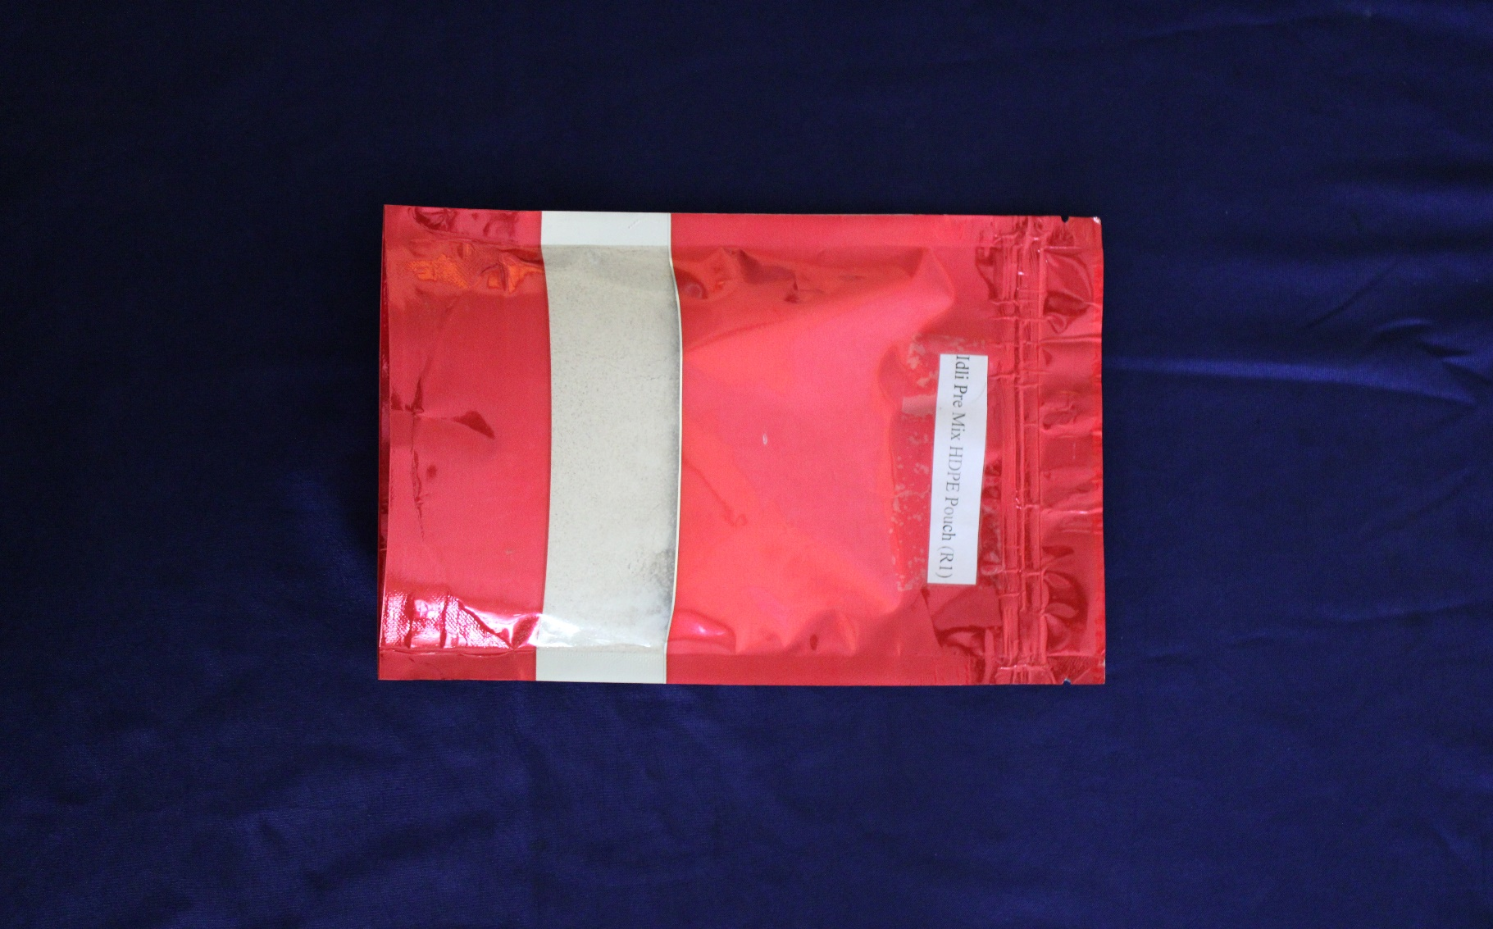 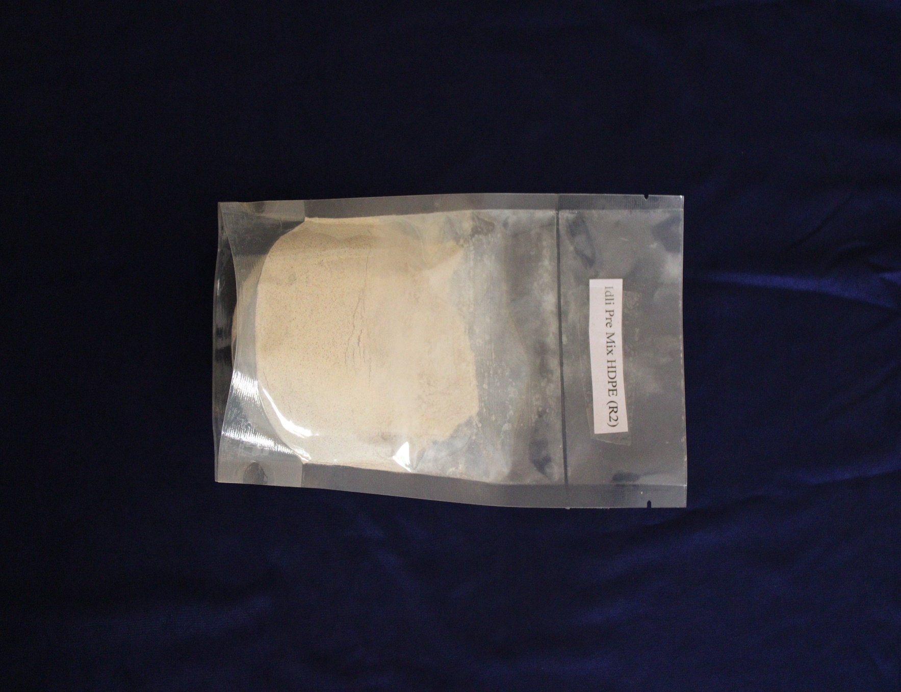

**Fig 13 Packaging Materials of selected HDPE standing Pouches T3**

**Conclusion:**

Finger millet *(Eleusine coracana L.)* is a highly nutritious, gluten-free cereal commonly grown across Asia and Africa. Known for its robustness and rich content of dietary fiber, calcium, and protein, this grain has traditionally been underexploited in mainstream food products. Incorporating finger millet into staple foods presents an opportunity to combat malnutrition while meeting the growing consumer demand for functional, ready-to-cook options. This study, conducted at the Department of Process and Food Engineering, aimed to develop a finger millet-enriched instant idli premix that enhances nutritional quality without sacrificing sensory appeal.

The research successfully demonstrated the benefits of fortifying instant idli premix with finger millet. The optimal blend—comprising 50% finger millet, 30% rice, and 20% black gram—significantly increased essential nutrients such as protein, dietary fiber, and ash, while reducing carbohydrate content, thus promoting healthier dietary choices. Functional attributes and reconstitution behavior of the premix remained favorable, ensuring easy preparation and maintaining sensory acceptance. Utilizing HDPE standing pouch packaging effectively preserved the physicochemical stability of the mix during three months of storage, indicating strong potential for commercial scalability. This fortified premix not only caters to health-conscious consumers but also provides a sustainable, convenient approach to improving the nutritional profile of traditional foods in a ready-to-cook format.

The study achieved the successful development of a finger millet-based instant idli premix that enhances nutritional value while retaining desirable sensory and functional properties. The optimized formulation is rich in protein, fiber, and calcium and is gluten-free, making it an excellent functional food alternative. The use of low-temperature drying techniques preserved vital micronutrients, and the premix maintained quality over 90 days of storage. Overall, this research underscores the promising role of finger millet fortification in creating nutritious, convenient, and consumer-friendly ready-to-cook foods aligned with contemporary health trends and dietary requirements.

Disclaimer (Artificial intelligence)

Option 1:

Author(s) hereby declare that NO generative AI technologies such as Large Language Models (ChatGPT, COPILOT, etc.) and text-to-image generators have been used during the writing or editing of this manuscript.

Option 2:

Author(s) hereby declare that generative AI technologies such as Large Language Models, etc. have been used during the writing or editing of manuscripts. This explanation will include the name, version, model, and source of the generative AI technology and as well as all input prompts provided to the generative AI technology

Details of the AI usage are given below:

1.Refer option First only Quliboat premium used for Paraphsing

2.

3.

**REFERENCES**

AOAC INTERNATIONAL. (2023). Official methods of analysis of AOAC INTERNATIONAL (22nd ed.). Rockville, MD, USA: AOAC INTERNATIONAL.

Dubey, P. K., Kumar, K. S., Rawson, A., Anandakumar, S., Baskaran, N., & Thamburaj, S. (2023). Effect of pulsed electric field on physicochemical properties of rice and black gram fermented batter. Journal of Food Process Engineering, 46(9), e14411. https://doi.org/10.1111/jfpe.14411

Khatoniar, S., & Das, P. (2022). Millet based multigrain mix: its physico-chemical properties and value addition: a review. Journal of Postharvest Technology, 10(3), 27–40.

Khurana, N., & Goyal, P. (2021). Consumer perception towards instant food products—a study of youngsters in India. ICTACT Journal on Management Studies, 7(4), 1483–1487.

Kumari, S., Bhinder, S., Singh, B., Kaur, A., & Singh, N. (2020). Effect of buckwheat incorporation on batter fermentation, rheology, phenolic, amino acid composition and textural properties of idli. LWT, 122, 109042. https://doi.org/10.1016/j.lwt.2020.109042

Mandhania, M. H., Paul, D., Suryavanshi, M. V., Sharma, L., Chowdhury, S., Diwanay, S. S., ... & Patole, M. S. (2019). Diversity and succession of microbiota during fermentation of the traditional Indian food idli. Applied and Environmental Microbiology, 85(13), e00368-19. https://doi.org/10.1128/AEM.00368-19

Masters, W. A., Nene, M. D., & Bell, W. (2017). Nutrient composition of premixed and packaged complementary foods for sale in low‐ and middle‐income countries: Lack of standards threatens infant growth. Maternal & Child Nutrition, 13(4), e12421. https://doi.org/10.1111/mcn.12421

Kahar, G. S., Kolhe, P., Khatal, M. M., Jadhav, V., Mishra, A. K., Dalvi, S. B., ... & Khune, P. M. (2024). The production, yield, and area of the jowar (great millet) in the states of India using the pivot table. International Journal of Engineering and Computer Science, 6(1), 56–60.

Ganesh S Kahar, Pravin Jawake, AA Sawant, PB Bansode, KS Langote and RA Gosavi. Shelf-life enhancement of guava by using ethylene inhibitor and different coating material. Int. J. Adv. Biochem. Res. 2024;8(1S):460-469. DOI: 10.33545/26174693.2024.v8.i1Sg.369

Kahar, Ganesh S., Rinkesh Gosavi, Manjit M Khatal, Pooja P Thul, A.A. Sawant, and C Manaswini. 2024. “Development and Shelf-Life Study of Twin-Screw Extruded Fish Snacks Using Mackerel and Rohu Powder”. Journal of Biochemistry International 11 (1):72-82. https://doi.org/10.56557/jobi/2024/v11i19074.

Manaswini, C., K. Dhanapal, K. Sravani, G. Praveen kumar, and Ganesh S. Kahar. 2025. “Review on Innovative Smart Packaging Solutions for Seafood Preservation”. European Journal of Nutrition & Food Safety 17 (4):167-82. https://doi.org/10.9734/ejnfs/2025/v17i41689.

Ganesh Santosh, K. (2022). Plant extract based active packaging for extension of shelf life of strawberries.

Manjit M Khatal, GS Kahar, RA Gosavi, Pooja P Thul, AM Kutwal, KK Kashid and Anunay Kumar. Pulsed electric field: A novel technique for sustainability in fruit and vegetable processing. International Journal Agriculture And Food Science. 2025;7(3):60-67. DOI: https://doi.org/10.33545/2664844X.2025.v7.i3a.315

Kahar, G. S., Gosavi, R., Sawant, A. A., Kad, V. P., Kalse, S. B., & Rupanawar, H. D. (2024). Transforming agricultural process engineering: The convergence of IoT and AI. International Journal of Food Science and Nutrition,10(1), 42-52.

Mathew, A. P., & Mathew, D. (2024). The instant food revolution: Exploring modern consumer buying patterns. International Socioeconomic Review, 2(1), 17–32.

Olson, R., Gavin-Smith, B., Ferraboschi, C., & Kraemer, K. (2021). Food fortification: The advantages, disadvantages and lessons from sight and life programs. Nutrients, 13(4), 1118. https://doi.org/10.3390/nu13041118

Ranganna, S. (1986). Handbook of analysis and quality control for fruit and vegetable products (2nd ed.). New Delhi: Tata McGraw-Hill Publishing Company Ltd.

Ravindran, N., Venkatachalapathy, N., Loganathan, M., & Eyarkai, V. (2021). Effect of stirring on the rheological, textural and structural characteristics of idli batter and steamed idli. The Pharma Innovation Journal, 10(10), 1252–1255.

Regubalan, B., & Ananthanarayan, L. (2018). Shelf life improvement of idli batter by addition of mustard essential oil as bio-preservative. Journal of Food Science and Technology, 55(9), 3417–3426. https://doi.org/10.1007/s13197-018-3242-6

Thara, K. D., & Nazni, P. (2021). Formulation and quality evaluation of foxtail millet and semolina incorporated ready-to-cook upma mix. Bioscience Biotechnology Research Communications, 14(4), 1531–1537.

Tsafrakidou, P., Michaelidou, A. M., & Biliaderis, C. G. (2020). Fermented cereal-based products: Nutritional aspects, possible impact on gut microbiota and health implications. Foods, 9(6), 734. https://doi.org/10.3390/foods9060734