*Original Research Article*

An exploration of dietary changes during pregnancy and lactation in a rural community in Korhogo, Côte d'Ivoire: A Qualitative Study

ABSTRACT

|  |
| --- |
| Adequate nutrition during pregnancy and breastfeeding is essential for maternal and child health, especially in rural communities where access to nutritional information and resources may be limited. If the nutritional needs of the mother are not met, this can lead to lasting and serious health risks for both mother and infant.  **Aims:** To explore dietary changes during pregnancy and breastfeeding among women in rural settings, and to identify the reasons influencing these changes.  **Study design:** A qualitative cross-sectional study.  **Place and Duration of Study:** The study was conducted from 28 October to 12 December 2022 in villages located in the Korhogo district, in northern Côte d'Ivoire.  **Methodology:** A questionnaire was administered to 140 breastfeeding and 45 pregnant women in eight rural villages. Participants, all women farmers, were selected on a voluntary basis. The questionnaire focused on dietary intake and changes during pregnancy and breastfeeding. Data were analyzed manually using thematic framework analysis.  **Results:** During pregnancy, 62% of women reported reducing or eliminating at least one food group (e.g., cereals, starchy roots, or nuts) due to gastrointestinal issues, food aversions, or fear of negative pregnancy outcomes. In contrast, 92% increased their intake of certain foods (e.g., cereals, roots, eggs) to meet cravings and gain strength. Among breastfeeding women, 42% excluded certain fruits (e.g., mango, cashew apple) due to perceived risks to the baby’s health or breastmilk quality. Many women increased their intake of cow's milk and dairy products to stimulate milk production.  **Conclusion:** This study shows that women change their diets during pregnancy and breastfeeding due to symptoms, cultural beliefs, and health concerns. It underlines the importance of better nutrition education and counselling to help women make informed food choices during these key periods. |

*Keywords: maternal nutrition, dietary changes, food restrictions, diet, pregnancy, breastfeeding, cultural beliefs, Côte d’Ivoire.*

1. INTRODUCTION

Nutritional deficiencies of the mother have a long-term effect on the infant well-being (Delisle, 2008). Indeed, maternal nutrition influences the development of the fetus. Specifically, a diet lacking key nutrients will result in adverse pregnancy outcomes (Bodnar et al., 2007; Hong-Bi et al., 2018; Huang et al., 2015; Mishra et al., 2020). Key nutrients such as iron, B vitamins, vitamin D, vitamin A, iodine and zinc play a major role during pregnancy. For instance, an insufficient iron intake contributes to low birthweight and intrauterine restriction (Figueiredo et al., 2018; Huang et al., 2015). Moreover, anemia remains among the leading causes of female mortality and morbidity with low and middle-income countries bearing the highest prevalence rate (Adesuyi, 2016; Darnton-Hill & Mkparu, 2015; Hasan et al., 2021). Similarly, vitamin B12 deficiency can lead to birth defects and contribute to preterm delivery. Furthermore, a deficiency in vitamin A intake induces a high risk of infant mortality and eye diseases such as night blindness and xerophthalmia (Brown, 2011). After pregnancy, breast milk takes over for the provision of the necessary nutrients. In this regard, previous studies highlighted the impact of maternal dietary intake on milk composition (Allen, 2005; Ares Segura et al., 2016).

Malnutrition remains a public health problem in the population. For example, in 2012, a demographic health survey conducted in Côte d'Ivoire showed that 64% and 55% of pregnant and lactating women were anemic, respectively (INS, 2012). Additionally, folate deficiency affects 86.1% of women aged 15-49 years with a prevalence of 91.2% in urban areas and 80.4% in rural areas (Rohner et al., 2014). In general, maternal dietary intake is influenced by several factors, including food choices which are strongly associated with socioeconomic environment, lifestyle choices, and cultural beliefs (Shepherd, 1999). In particular, in many Sub-Saharan African countries, pregnancy and breastfeeding are critical periods during which cultural norms are affecting the quality of the diet (Hadush et al., 2017; Lartey, 2008). Moreover, lack of nutrition education, social pressure, and low levels of education are considered contributing factors (Biza Zepro, 2015; Ogunbiyi & Akinyele, 2010).

This survey was conducted in the north of Côte d’Ivoire, reported as one of the regions with the highest prevalence of chronic malnutrition in the country (INS, 2012). Given this context, the aim of this study is to investigate the specific types of foods that are reduced or increased during pregnancy and breastfeeding. Additionally, we seek to understand the cultural and socio-economic reasons behind these dietary changes. Ultimately, this study would provide insights into the dietary habits of pregnant and breastfeeding women in Côte d'Ivoire, potentially identify nutritional gaps and opportunities to improve maternal and infant nutrition in this region.

2. material and methods

**2.1 Study setting and population**

Côte d'Ivoire is a French-speaking country, located in West Africa with an estimated population of 29 million. A qualitative study was conducted in the district of *Korhogo* in the *Poro* region, northern part of Côte d’Ivoire. The climate is of the transient tropical type with rainfall fluctuating between 1000-1300 mm per year. The year is divided into a rainy season from April to October and a dry season from November to March (Kouakou et al., 2012). In this area, the population is 536,851 in total, with a roughly equal proportion of men and women according to the National Statistics Institute in 2015 (Institut National de la Statistique (INS), 2015). The study targeted rural populations. Within these communities, agricultural crop and livestock farming are the most common activities. Cashew nuts, cotton, rice, yams, and maize are the main crops cultivated in this region. Eight villages were selected based on the network of Helen Keller organization working with multiple women farming groups on nutrition and education in this area. The selection of pregnant or breastfeeding women was done on a voluntary basis. In total, 185 women were recruited in the study: 140 breastfeeding and 45 pregnant women. All the women completed the survey.

**2.2 Study setting and population**

Students in sociology from *Peleforo Gon Coulibaly* University, fluent in local dialects, were recruited as interviewers to facilitate the data collection. Three days of training was given to the interviewers prior to the study. Interviews were conducted from October 28th to December 1st, 2022. At the beginning of each interview, a presentation of the project was made, after which the informed consent of the participant was obtained. The data were recorded on an electronic tablet via the Open Data Kit (ODK) platform (version 2022.3.2) (Tassy et al., 2021). An open-ended dietary change questionnaire was adapted from a pre-established template made by Forbes et al. (Forbes et al., 2018). While Forbes' study focused solely on pregnant women, our adaptation also included breastfeeding women, with additional sections specifically tailored to their experiences. The first part of the questionnaire was to collect data on socio-demographic variables. The second part was on dietary changes during pregnancy and was asked to all participants. Each woman was requested to name foods of which the consumption was either reduced or eliminated from the diet, and those that were increased or introduced during the current pregnancy, or during the previous pregnancy for breastfeeding women. In contrast to Forbes' open-ended approach, our version included checkboxes for reasons for dietary changes, along with a space for additional reasons not listed. This structure allowed participants to select from predefined options, which helped standardize the responses while still allowing for open-ended feedback where applicable. For the reduction or elimination of foods during pregnancy, the predefined options included: nausea/vomiting, constipation, diarrhea, heartburn, aversion, and risks to the pregnancy (such as weight gain, miscarriage, or complications). For the introduction or increase of foods during pregnancy, the predefined reasons included: food cravings/preferences and relief of illness. Then for each food mentioned, the reasons for these changes were asked. All predefined options were not read aloud to participants in order to avoid influencing their responses. Instead, the interviewer would mark the relevant options based on the participant's response. In our version, a specific section was added for breastfeeding women, asking them to list foods they had eliminated since they began breastfeeding. This section was open-ended, allowing breastfeeding women to provide their reasons for food elimination without predefined options. Another section was also included for breastfeeding women to list foods consumed to increase milk production. The third part of the questionnaire on dietary changes during breastfeeding was only answered by breastfeeding women.

**2.3 Data Analysis**

Raw data was collected in Excel version 2305. The coding of the results was done in two stages. The first phase involved classifying each food item into corresponding food group according to the classification of West African food composition table (WAFCT): cereals; starchy roots & tubers; legumes; vegetables; fruits; nuts & seeds; eggs; milk & dairy products; nonalcoholic beverages (Stadlmayr et al., 2012). Based on the questionnaire, the frequency of each food group reported was estimated. The second phase was to analyze the reasons for food choice. The reasons for reduction or elimination of food intake during pregnancy were classified into three categories. Two categories were selected from previous literature: gastrointestinal problems (constipation, gastric reflux, nausea/ vomiting, abdominal pain, etc.) and food aversions (Zielinski et al., 2015). The third category named adverse pregnancy outcomes was added for the responses which did not fall into the two previous categories. The reasons to increase or introduce foods during pregnancy were classified into four categories. Two categories were included based on previous studies: food cravings and preferences, relief of gastrointestinal problems (Nazik & Eryilmaz, 2014; Orloff et al., 2016). Two categories were created if the responses did not fall into these two categories: giving strength and rich in vitamins. For breastfeeding-related dietary changes, responses regarding the reasons for decreasing or eliminating food intake were grouped into 4 categories: baby health (can make the child sick, give diarrhea to the baby, etc.), affects milk quality and milk supply (decreased milk volume, diluted breast milk, drying-up of breast milk), food aversion and nausea/vomiting.

Statistical analysis was performed using R studio software version 4.2.1. Raw data were visualized using mosaic plot to see the relationship between the two variables: food groups and the reasons given for each dietary change. For each type of dietary change observed, a contingency table consisting of the main food items contributing to more than 10% of the overall reported foods and the reasons behind the changes was presented. Chi - squared test was performed to check the correlation between the two variables. The level of significance was set at *P* < .05. When a correlation was confirmed, a multinomial regression was performed to understand the nature of the correlation. The predictor variables were reasons for eliminating or increasing food intake and the outcome variables were foods items.

3. results and discussion

**3.1 Results**

**3.1.1 Socio-demographics characteristics**

All participants (n = 185) completed the interviews. The average age was 28 years, and this information was available for only 30% of the respondents. Most of the women were unschooled, married, and practiced farming as their main source of income. Trade represented an additional source of income for only three women. There was a significant difference in the number of births (*P* = .04) and household size (*P* = .02). No statistically significant difference was found in age, education, marital status and source of income (Table 1).

**Table 1**. Characteristics of pregnant and breastfeeding women in northern Côte d’Ivoire

| **Characteristic** | **B, N = 140a** | **P, N = 45a** | **Overall, N = 185a** | ***P* valueb** |
| --- | --- | --- | --- | --- |
| **Age (years), Mean [SD]a** | 29 [7] | 27 [6] | 28 [7] | .26 |
| Unknown | 62 | 25 | 87 |  |
| **Education, % (n/N)a** |  |  |  | .74 |
| Unschooled | 81% (114/140) | 80% (36/45) | 81% (150/185) |  |
| Primary | 16% (23/140) | 16% (7/45) | 16% (30/185) |  |
| Secondary | 2.1% (3/140) | 4.4% (2/45) | 2.7% (5/185) |  |
| **Number of births, Mean [SD]a** | 3.27 [1.90] | 2.56 [1.56] | 3.10 [1.85] | .04* |
| **Marital status, % (n/N)a** |  |  |  | 1.00 |
| Married/cohabiting | 98% (137/140) | 100% (45/45) | 98% (182/185) |  |
| Divorced, separed | 1.4% (2/140) | 0% (0/45) | 1.1% (2/185) |  |
| Widowed | 0.7% (1/140) | 0% (0/45) | 0.5% (1/185) |  |
| **Household size, Mean [SD]a** | 8.8 [5.1] | 7.1 [3.7] | 8.4 [4.9] | .02* |
| **Source of income, % (n/N)a** |  |  |  | 1.00 |
| Agriculture, breeding | 96% (135/140) | 100% (45/45) | 97% (180/185) |  |
| Trading | 2.1% (3/140) | 0% (0/45) | 1.6% (3/185) |  |
| Craftsman, liberal activity | 0.7% (1/140) | 0% (0/45) | 0.5% (1/185) |  |
| Unemployed | 0.7% (1/140) | 0% (0/45) | 0.5% (1/185) |  |

a) SD: Standard deviation; % (n/N): Percentage (number of participants with the characteristic / total number of participants); P: Pregnant women; B: Breastfeeding women.  
b) Statistical tests used: Wilcoxon rank-sum test and Fisher’s exact test.

Statistically significant differences between groups (*P* ≤ .05) are indicated by *.

**3.1.2 Dietary changes during pregnancy**

Questions about dietary changes during pregnancy were asked to all pregnant and lactating women (n=185). The interest was focused on foods that contributed to more than 10% of all reported food groups based on the dietary changes during pregnancy. Among all participants, 62% reported having reduced or eliminated at least one food in their diet, while 92% reported having increased or introduced at least one food. Among the identified food groups, cereals contributed the most to the reported changes, representing 37% of the foods that were reduced or eliminated and 24% of the foods that were added or increased. Nuts & seeds represented 16%, while starchy roots & tubers accounted for 12% of the foods reduced or eliminated from the diet. There was an increased consumption of starchy roots and eggs, corresponding to 21% and 13% of the total of reported foods, respectively (Table 2).

**Table 2.** Dietary changes during pregnancy

| **Characteristic** | **Food groups contributing ≥10% of reported dietary changes** | |
| --- | --- | --- |
| **Top Food Groups** | **Reduced or Eliminated, N = 206a** | **95% CIb** |
| **Cereals** | **77 (37%)** | **31 - 44%** |
| *Corn* | *17 (22%)* |  |
| *Rice* | *55 (71%)* |  |
| *Wheat* | *4 (5%)* |  |
| **Starchy roots, tubers** | **25 (12%)** | **8 - 17%** |
| *Cassava* | *12 (48%)* |  |
| *Sweet potatos* | *10 (40%)* |  |
| *Yam* | *3 (12%)* |  |
| **Nuts, seeds** | **33 (16%)** | **11 - 21%** |
| *Groundnut* | *33 (100%)* |  |
| **Top food groups** | **Increased or introduced**, N = 195a | **95% CIb** |
| **Cereals** | **47 (24%)** | **18 - 30%** |
| *Corn* | *25 (43%)* |  |
| *Rice* | *13 (28%)* |  |
| *Wheat* | *9 (19,15%)* |  |
| **Starchy roots, tubers** | **41 (21%)** | **15 - 27%** |
| *Cassava* | *7 (17%)* |  |
| *Sweet potatos* | *12 (29%)* |  |
| *Yam* | *22 (54%)* |  |
| **Eggs** | **26 (13%)** | **9 - 18 %** |

a) % (n/N): Percentage by food groups (number of food items with the characteristic / total number of food items).

b) CI: Confidence Interval.

**3.1.3 Reasons for changing dietary intake during pregnancy.**

The most reported reasons for reducing or eliminating food intakes were gastrointestinal-related issues (56%), aversion (34%), and those perceived to have adverse pregnancy outcomes (10%). The mosaic plot in figure 1 compares the distribution of reasons for eliminating food intake during pregnancy across the reported food groups. This plot highlights a difference between those perceived to have adverse pregnancy outcomes and the other two categories driven by the food groups legumes and cereals. Legumes were more often reported for perceived adverse pregnancy outcomes (39% of the foods reported), while cereals were more often reported for aversion and gastrointestinal issues (43% and 44% of the foods reported, respectively).

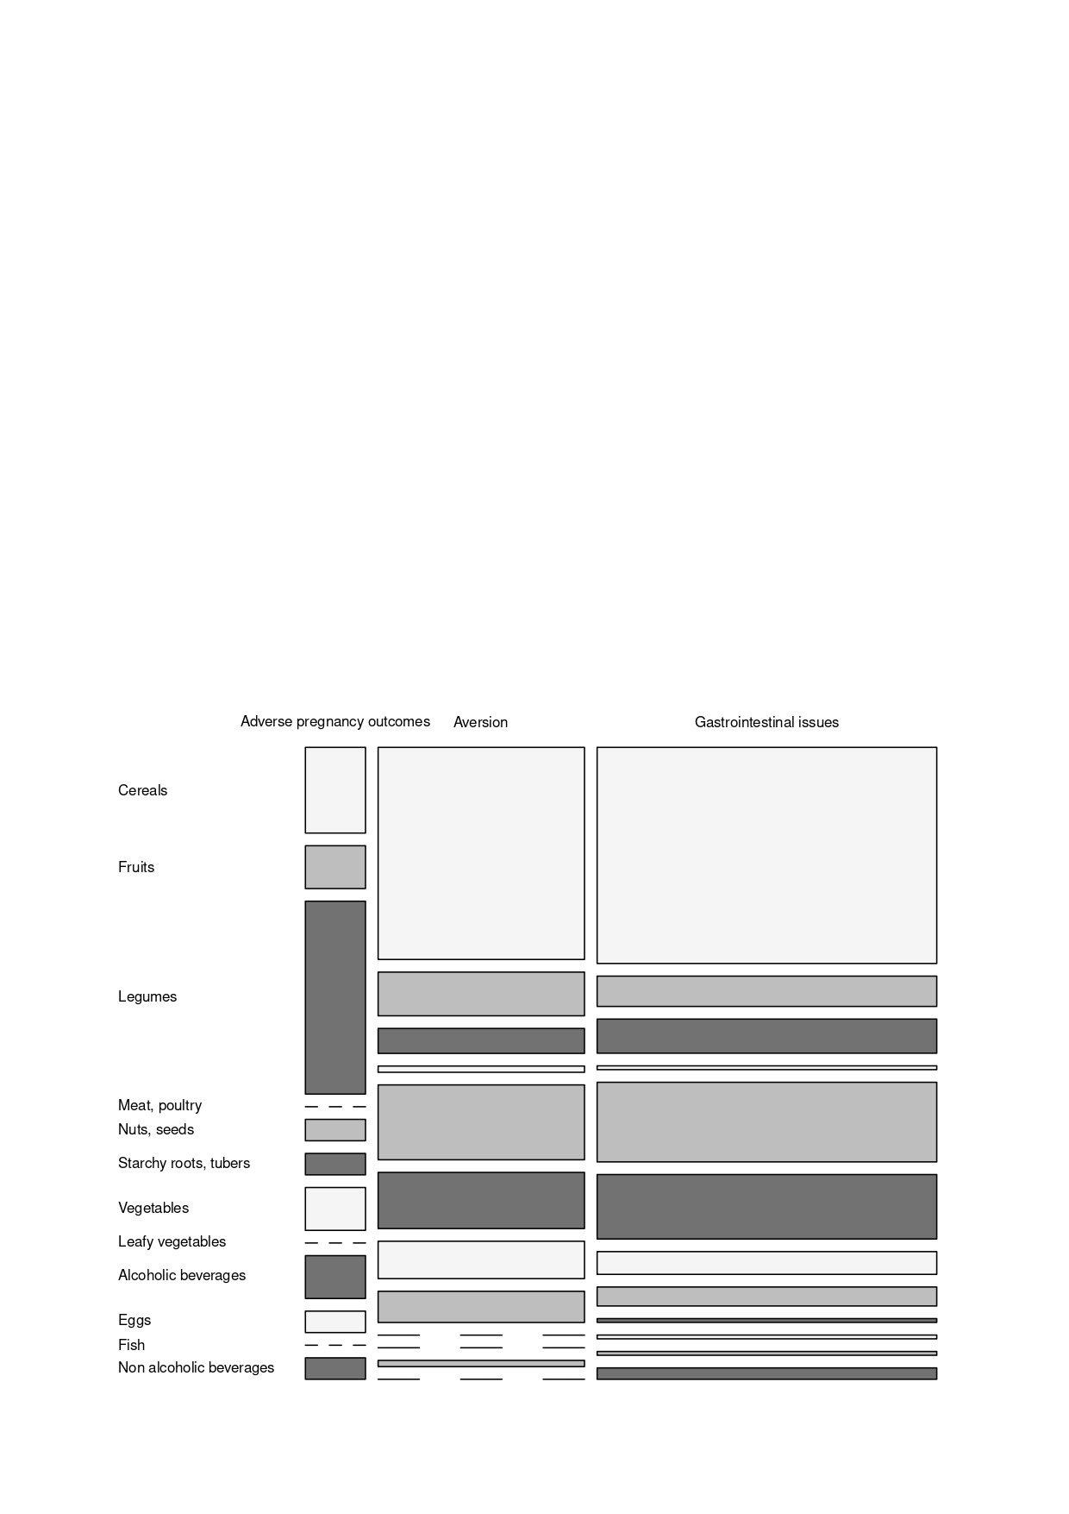

**Figure 1**. Mosaic plot showing the distribution of reasons for eliminating food intake during pregnancy across the reported food groups.

A Chi-Square test was then performed to assess the relationship between the main food groups contributing to at least 10% of all the foods and reasons for reducing or eliminating food intake. Despite the observation made above, the statistical test did not highlight a significant relationship between the two variables (p > .05) (Table 3).

**Table 3**. Reasons for eliminating or reducing foods during pregnancy.

| **Characteristic** | **N = 232a** | **95% CIb** | ***P* valuec** |
| --- | --- | --- | --- |
| ***Frequency of reasons*** |  |  |  |
| **Gastrointestinal issues, % (n/N)a** | 130 (56%) | 50 - 62% | 1.00 |
| *Cereals* | *57 (44%)* |  |
| *Nuts, seeds* | *21 (16%)* |  |
| *Starchy roots, tubers* | *17 (13%)* |  |
| **Aversion, % (n/N)a** | 79 (34%) | 28 - 40% |
| *Cereals* | *34 (43%)* |  |
| *Nuts, seeds* | *12 (15%)* |  |
| *Starchy roots, tubers* | *9 (11%)* |  |
| **Adverse pregnancy outcomes % (n/N)a** | 23 (10%) | 6 - 14% |
| *Legumes* | *9 (39%)* |  |
| *Cereals* | *4 (17%)* |  |

a) % (n/N): Percentage (number of reasons for a specific characteristic / total number of reasons).  
b) CI: Confidence Interval.

c) Statistical tests: Pearson's Chi-squared test.

The most reported reasons for increasing or introducing food intake were food cravings and preferences (84%), those perceived to give strength (11%), to relieve gastrointestinal issues (2.5%) and those considered to be rich in vitamins (2.5%). The mosaic plot in Figure 2 compares the distribution of reasons for increasing food intake during pregnancy across the reported food groups. This plot shows that there was no difference between foods perceived to give strength and those perceived to relieve gastrointestinal issues. It also highlighted a difference between those perceived to give strength and the three other categories driven by cereals, eggs, and starchy roots, tubers. Eggs seem to be more often reported as linked to those perceived to give strength (23% of the food reported), while cereals and starchy roots and tubers were more often reported for food cravings (31% and 23% of the food reported, respectively).

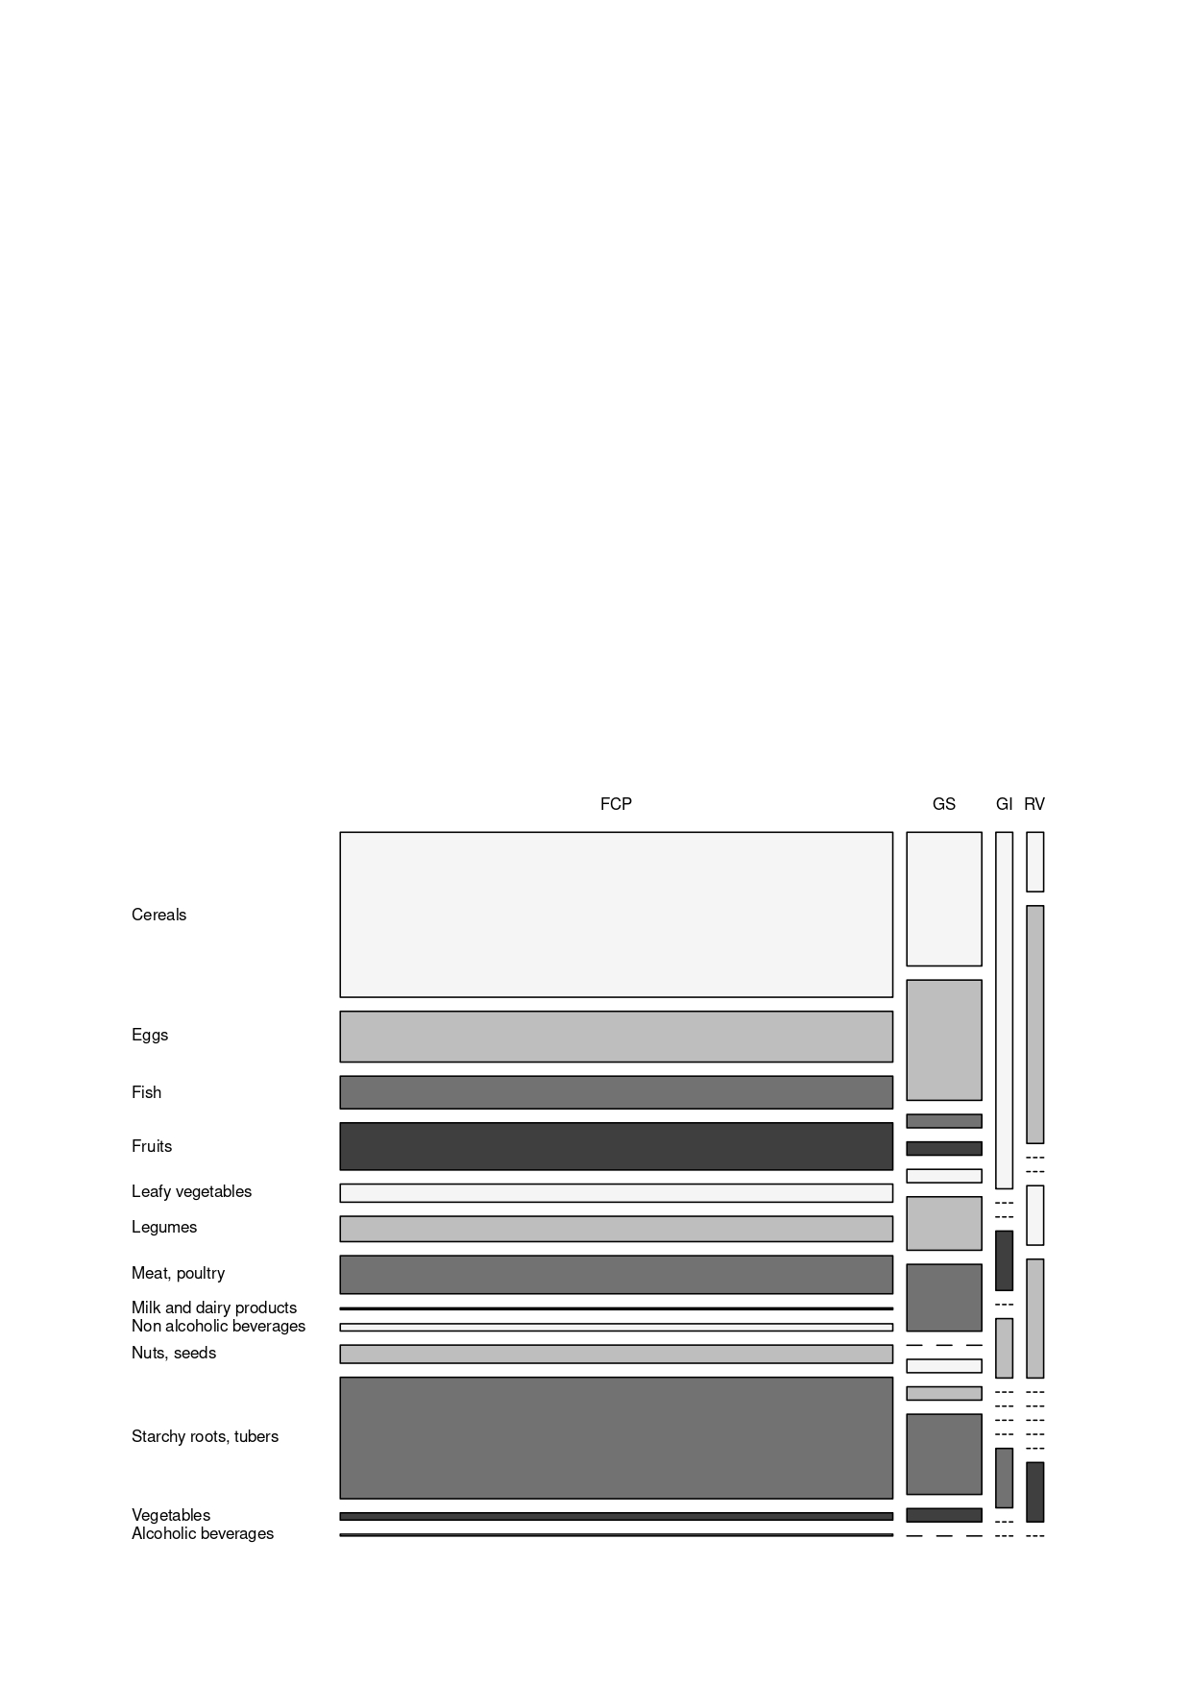

**Figure 2**. Mosaic plot showing the distribution of reasons for increasing food intake during pregnancy across the reported food groups. (FCP: Food Cravings and Preferences; GS: Give Strength; GI: to relieve Gastrointestinal Issues; RV: Rich in Vitamins).

A Chi-square test was performed to assess the relationship between food groups contributing to at least 10% of all the food and reasons for introducing or adding a food. There was a significant relationship between the two variables (p < .05) (Table 4).

**Table 4**. Reasons for introducing or increasing foods during pregnancy.

| **Characteristic** | **N = 353a** | **95% CIb** | **Pc** |
| --- | --- | --- | --- |
| ***Frequency of reasons*** |  |  | <.001* |
| **Food cravings and preferences** | 295 (84%) | 80 - 87% |
| *Cereals* | *91 (31%)* |  |
| *Starchy roots, tubers* | *67 (23%)* |  |
| **Give strenght** | 40 (11%) | 8 - 15% |
| *Cereals* | *10 (25%)* |  |
| *Eggs* | *9 (23%)* |  |
| *Starchy roots, tubers* | *6 (15%)* |  |
| *Meat, poultry* | *5 (13%)* |  |
| **Relieve gastrointestinal issues** | 9 (2.5%) | 1 - 4% |
| *Fruits* | *6 (66%)* |  |
| **Rich in vitamins** | 9 (2.5%) | 1 - 4% |
| *Eggs* | 4 (44%) |  |

a) % (n/N): Percentage (number of reasons for a specific characteristic / total number of reasons).

b) CI: Confidence Interval.

c) Statistical tests: Pearson's Chi-squared test.

Statistically significant differences between groups (*P* ≤ .05) are indicated by *.

A multinomial regression was used to understand the nature of the correlation. Eggs were less likely to be mentioned for food cravings and preferences compared to starchy roots, tubers (reference level for the categorical variable) (OR = 0.28; 95% CI: 0.09 – 0.086). No other statistically significant differences were found when comparing food groups to starchy roots, tubers by reasons for elimination (Table 5).

**Table 5**. Multinomial logistic regression analysis of reasons for increasing food intake and associated food groups (Baseline: Starchy Roots and Tubers).

| **Characteristic** | **ORa** | **95% CIb** | ***P* valuec** |
| --- | --- | --- | --- |
| **Food cravings and preferences** | | | |
| (Intercept) | 11.2 | 4.8 - 25.7 | <.001 |
| **Food groups** |  |  |  |
| Starchy roots, tubers | — | — |  |
| Cereals | 0.81 | 0.28 - 2.35 | .70 |
| Eggs | 0.28 | 0.09 - 0.86 | .03* |
| **Relieve gastrointestinal issues** | | | |
| (Intercept) | 0.17 | 0.02 - 1.38 | .10 |
| **Food groups** |  |  |  |
| Starchy roots, tubers | — | — |  |
| Cereals | 3.60 | 0.34 - 37.6 | .29 |
| Eggs | 0.00 | [0.00, +∞] | .84 |
| **Rich in vitamins** | | | |
| (Intercept) | 0.00 | [0.00, +∞] | .94 |
| **Food groups** |  |  |  |
| Starchy roots, tubers | — | — |  |
| Cereals | 17,403 | [0.00, +∞] | .95 |
| Eggs | 77,377 | [0.00, +∞] | .95 |

a) OR: Odds Ratio.

b) CI: Confidence Interval.

c) Statistical tests: Multinomial logistic regression. Statistically significant differences between groups (*P ≤ .05).

d) All values greater than 50 are replaced by +∞.

**3.1.4 Dietary changes during breastfeeding.**

Dietary changes questions were asked to lactating women (n=140). The interest was focused on foods that contributed more than 10% of all food groups listed for each category (reduced or eliminated/increased or introduced). 42% and 81% participants reported having reduced or eliminated and increased or introduced at least one food in their diet. Of all the food groups listed, fruits (72%) and starchy roots, tubers (11%) were the most frequently removed from the diet. To stimulate breastmilk production, women reported increased consumption for a variety of food groups including milk and dairy products (27%), non-alcoholic beverages (23%), nuts and seeds (21%) and cereals (11%) (Table 6).

**Table 6**. Dietary changes during breastfeeding

| **Characteristic** | **Food groups contributing ≥10% of reported dietary changes** | |
| --- | --- | --- |
| **Top food groups** | **Reduced or eliminated, N = 94a** | **95% CIb** |
| **Fruits** | **68 (72%)** | **63-81%** |
| *Cashew apple* | *39 (57%)* |  |
| *Mango* | *24 (35%)* |  |
| **Starchy roots, tubers** | **10 (11%)** | **4-17%** |
| *Sweet potatos* | *8 (80%)* |  |
| **Top food groups** | **Increased or introduced to stimulate lactation**, **N = 229**a | **95% CIb** |
| **Milk and dairy products** | **64 (27%)** | **22-33%** |
| *Dairy products* | *37 (58%)* |  |
| *Cow’s milk* | *27 (42%)* |  |
| **Non alcoholic beverages** | **54 (23%)** | **18-28%** |
| *Rice drink* | *20 (37%)* |  |
| *Millet drink* | *23 (43%)* |  |
| *Coffee with milk* | *7 (13%)* |  |
| **Nuts, seeds** | **50 (21%)** | **16-27%** |
| *Groundnut* | *49 (98%)* |  |
| **Cereals** | **26 (11%)** | **7-15%** |
| *Rice porridge* | *9 (35%)* |  |
| *Cooked rice* | 1. *(27%)* |  |

a) % (n/N): Percentage by food groups (number of food items with the characteristic / total number of food).

b) CI: Confidence Interval.

**3.1.5 Reasons for changing dietary intake during breastfeeding.**

The most reported reasons for reducing or eliminating food intake were perceived insufficient milk quality and supply (47%), and concern for baby health (45%). The mosaic plot in Figure 3 compares the distribution of reasons for eliminating food intake during breastfeeding across the reported food groups. This plot highlighted a difference between those considered to affect milk quality and supply and the other categories. The fruits seem to be more often reported for those perceived to give insufficient breastmilk quality and supply (96% of the food reported).

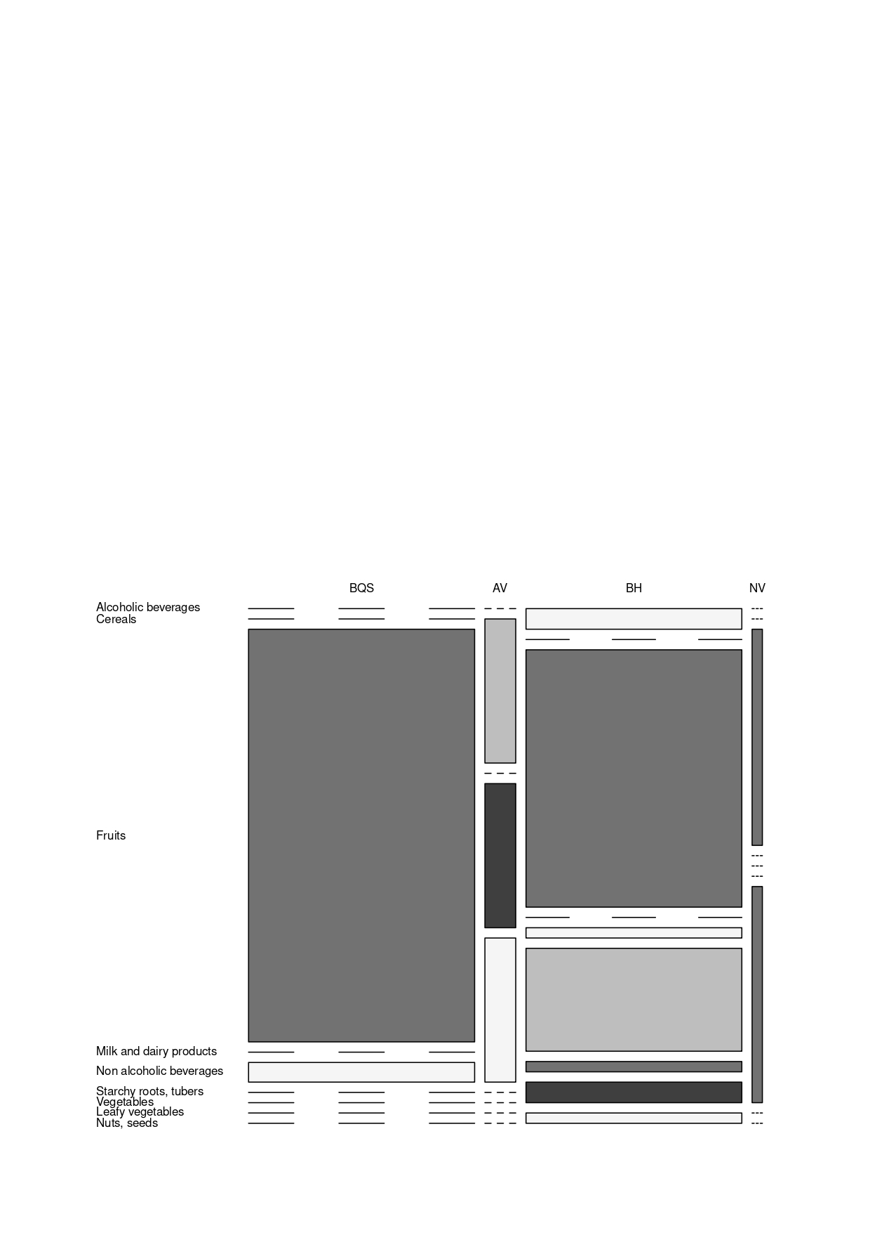

**Figure 3.** Mosaic plot showing the distribution of reasons for eliminating food intake during breastfeeding according to the identified food groups. (BQS: Breastmilk Quality and Supply; AV: Aversions; BH: Baby Health; NV: Nausea Vomiting)

A Chi-square test was performed to assess the relationship between food groups and reasons for reducing or eliminating the foods. There was a significant relationship between the two variables (p < .001) (Table 7). A multinomial regression was used to understand the nature of the correlation. The odds ratio could not be estimated due to the low sample size.

**Table 7**. Reasons for Eliminating or Reducing Foods During Breastfeeding.

| **Characteristic** | **N = 94a** | **95% CIb** | ***P*c** |
| --- | --- | --- | --- |
| ***Frequency of reasons*** |  |  | <.001 |
| **Affect breast milk quality and supply** | 44 (47%) | 37-57% |
| Fruits | 42 (96%) |  |
| **Baby health** | 42 (45%) | 35-55% |
| Fruits | 25 (60%) |  |
| Starchy roots, tubers | 10 (24%) |  |

a) % (n/N): Percentage (number of reasons for a specific characteristic / total number of reasons).

b) CI : Confidence Interval.

c) Statistical tests : Pearson’s Chi-squared test.

**3.2 Discussion**

**3.2.1 Dietary changes during pregnancy and women’s reasons for change**

This current study showed that 62% of women acknowledged having eliminated foods from their diet or having reduced their consumption. The frequently reported foods were rice, corn, groundnuts, cassava and sweet potato. Previous studies have shown that gastrointestinal issues and food aversion were the common reason for women to reduce their food intake during pregnancy (Bayley et al., 2002; Huybregts et al., 2009; Ramya et al., 2014; Selmi et al., 2015)*.* We also found that cultural beliefs cause women to categorize foods. Indeed, for some women, the elimination of certain foods was due to the perception that they have harmful effect on the health of the fetus. These cultural norms within various communities have already been the subject of several studies (Hussain et al., 2012; Ravaoarisoa et al., 2018)*.* To date, it seems that the food choices according to the mother’s perception of the effect on her heath and the fetus is made subjectively (Blau et al., 2020)*.*

Many women (92%) reported increasing their intake of rice, corn, yam and sweet potato. The main reasons given were food cravings and the need for energy to carry out daily activities. Others also reported that an increase in food intake during pregnancy was influenced by cravings and food preferences (Bayley et al., 2002; Blau et al., 2020). All participants indicated that they would give in to their food cravings if it did not jeopardize their pregnancy. This drive could push women to overconsume certain foods, increasing the risk of dietary imbalance (Orloff et al., 2016). Even if it represented only 11% of the reasons mentioned, we noted that the consumption of food with high energy density was significant for these women. This need could be explained by the energy demand linked to the growth of the fetus (Allen, 2005; Lawrence et al., 1987).

It is noteworthy that certain foods, such as cereals (corn, rice, wheat) and starchy roots and tubers (cassava, sweet potato, yam), appear both among those whose consumption is reduced or eliminated and those whose consumption is increased or introduced. This phenomenon may be attributed to the limited availability and low diversity of accessible foods in the region, prompting women to adjust their consumption patterns based on the circumstances.

**3.2.2 Dietary changes during breastfeeding and women’s reasons for change**

The present study showed that 42% of women believe that fruits (cashew apple, mango) and starchy roots, tubers (sweet potato, cassava) should be removed from the diet for concerns related to baby’s health, as well as milk quality and quantity. Cultural beliefs are strong motivators of dietary changes during breastfeeding, which could result in limiting the intakes of important nutrients (De Garine, 1972; Tobing et al., 2019). In the community, the knowledge of cultural norms is transmitted from generation to generation by the elders (Tobing et al., 2019). Adopting these practices strengthens the bonds among community members, which leads recalcitrant mothers to comply (Hall, 2017). Similar behaviors have been observed in previous studies. Lokossou et al., reported on feeding practices of mothers in Benin, that women avoided eating fruits during breastfeeding because of the perception on its impact on baby’s digestive system (Lokossou et al., 2021). Women in Tamil Nadu, India, avoided mango to prevent the infants from cough and cold (Banu et al., 2016). However, the consumption of fruits during pregnancy and lactation has beneficial health effects on offspring. Indeed, the anti-inflammatory effects of polyphenol-rich fruits has a protective effect against chronic diseases (Morais et al., 2015). Furthermore, maternal nutritional deficiencies could lead to impair cognitive ability, growth and development in infant (Delisle, 2008). In our study, we observed that some women attributed breast milk quality to the density and the volume of milk. According to their perception, fruits like cashew apple, increased the risk of having watery milk and drying up the breasts. Breast milk production remains one of the difficulties encountered by these women. Galipeau et al. explained that the perception of insufficient milk production was reinforced when the infant's ability to suck was not effective (Galipeau et al., 2017). Genetic variations (Golan & Assaraf, 2020), the breast’s capacity to produce milk (Cabezuelo et al., 2019) and low frequency of mammary gland stimulation influence the amount of milk transferred to the child. In fact, addressing milk insufficiency remains difficult because of lack of accurate tools to diagnose the causes that affect their lactation performance (Galipeau et al., 2017).

To address this issue, women increased the consumption of certain foods because of their possible effect on milk production. 81% of women believed that consumption of milk and dairy products; non-alcoholic beverages; nuts and seeds; and cereals stimulated lactation. Women consumed cow's milk and dairy products mixed with porridge or traditional drinks to support lactation.Beyond the perception of the effect of milk and dairy product of stimulating lactation, studies have shown that the fatty acid present in dairy product lowered the risk of food allergy in offspring and provide numerous health benefits (Denis et al., 2012; Stråvik et al., 2020; Tuokkola et al., 2016)*.* To our knowledge, research on the impact of maternal consumption of dairy products on lactation performance is unavailable. Women also resorted to other recipes to overcome the lack of breast milk. Thus, the consumption of cereal-based porridge such as millet and rice was recommended by elders and midwives. Additionally, flour made from these cereals were also used to make cold drinks. For most lactating women, these drinks could replace water, as besides being perceived to stimulate breast milk production, they also thought to have an energizing effect. The contribution of cereals such as millet and rice on stimulating milk production could be explained by the presence of specific chemical compounds. For example, it has been shown that certain dietary fibers, such as β-glucan, stimulated the production of prolactin, a hormone that in turn stimulated milk production (Quesnel et al., 2009; Wood, 2007). For many mothers, there was a strong belief that groundnuts had a positive effect on stimulating milk production. These were usually eaten directly as a snack several times a day or made into pastes used for the preparation of a sauce. In Europe and Asia, fenugreek, from the same family as groundnuts, is also frequently used for its galactogenic properties (Khan et al., 2018; Penagos Tabares et al., 2014). The use of stimulant plants in other communities has also been studied.For example*,* a study conducted with Thai mothers showed a correlation between the consumption of banana flower, bottle gourd, pumpkin, some protein-rich foods such as fish and eggs and human milk volume (Buntuchai et al., 2017). In Ghana, women consumed some leafy vegetables, groundnut and millet to enhance their lactation (Ali et al., 2020). However, currently, studies clearly demonstrating the effect of these galactagogues on human lactation are limited (McBride et al., 2021, 2022).

**3.2.3 *Study limitations and mitigation strategies***

It is important to address the limitations in order to provide a comprehensive understanding of their potential impact on the study's findings.

Sample Size: One of the major limitations of this study is the relatively small sample size. The study was conducted in a specific district in Côte d'Ivoire, and the participants consisted of 185 women, including both pregnant and breastfeeding women. While the sample was sufficient for the purposes of this qualitative study, a larger and more diverse sample could have provided a more comprehensive picture of dietary changes during pregnancy and breastfeeding across different regions and populations in the country.

Generalizability: Due to the specific focus on the district of Korhogo in northern Côte d'Ivoire, the findings of this study may not be fully representative of the entire country's population. The dietary habits and cultural practices related to pregnancy and breastfeeding could vary significantly across different regions of Côte d'Ivoire. Thus, caution should be exercised when looking at this study's results and applying the results of this study to other regions

Recall Bias: Since data was collected through interviews and self-reporting by the participants, recall bias is a potential limitation. The accuracy of dietary information provided by the women might be influenced by their ability to recall specific foods and changes accurately. Additionally, some women may be more inclined to provide socially desirable responses, which could affect the validity of the data.

Selection Bias: The study focused on rural populations in the Korhogo district and was conducted in collaboration with the Helen Keller Organization. This partnership might introduce selection bias, as the women who volunteered to participate may have different characteristics or dietary habits compared to those who did not participate. Furthermore, the inclusion of women from farming communities might skew the findings towards dietary changes associated with agricultural practices.

To address and mitigate the potential impact of these limitations, several steps were taken during the data collection and analysis processes. Firstly, the researchers ensured that the interviewers were fluent in local dialects and provided them with three days of training to conduct the interviews effectively and sensitively. This training aimed to reduce interviewer bias and enhance data quality. Regarding the small sample size and non-randomized sampling, the researchers acknowledged the limitation and stated it clearly so readers could interpret the findings accurately. To minimize recall bias, interviewers used open-ended questions and encouraged participants to provide as much detail as possible about their dietary changes during pregnancy and breastfeeding. Additionally, efforts were made to establish rapport with the participants to create a comfortable environment for sharing information. Despite these efforts to address the limitations, it is important for future studies to consider larger and more diverse samples from various regions of Côte d'Ivoire to better allow for generalizability of findings and provide a more comprehensive understanding of maternal dietary changes during pregnancy and breastfeeding in the country.

4. Conclusion

This study provided insights to women's dietary changes during pregnancy and lactation and the reason behind these changes. The consumption of starchy roots, tubers, and cereals was the most impacted during pregnancy. These foods were sometimes eliminated to reduce discomfort or consumed to relieve a craving or meet caloric needs. During breastfeeding, concerns related to the negative impact on infant’s health and the production of breast milk led mothers to reduce or even eliminate fruit intake. Misinformed dietary restrictions can be detrimental to the health of the fetus, mother, and infant in the long term. To overcome these issues, it is crucial to provide nutrition education to community health workers and midwives and make nutrition counselling during pregnancy and breastfeeding as a priority. Additionally, encouraging the cultivation of nutritious foods could promote healthier eating practices among these women.

Consent

Written informed consent was obtained from all participants before data collection. The consent was recorded by trained interviewers, in accordance with the protocol approved by the ethics committee. Participation was voluntary, and participants were free to withdraw at any time without any consequences.

Ethical approval

Ethical approval for this study was obtained from the National Ethics Committee for Life and Health Sciences (Comité National d'Éthique des Sciences de la Vie et de la Santé, CNESVS), Ministry of Health, Public Hygiene, and Universal Health Coverage of Côte d'Ivoire (project identification code: IRB 000 119 17). The study was conducted in accordance with the guidelines issued by the ethics committee.

. **Disclaimer**

This paper is an extended version of a preprint document of the same author.

The preprint document is available in this link: <https://www.researchsquare.com/article/rs-3873135/v1>

[As per journal policy, preprint /repository article can be published as a journal article, provided it is not published in any other journal]

Disclaimer (Artificial intelligence)

Option 1:

Author(s) hereby declare that NO generative AI technologies such as Large Language Models (ChatGPT, COPILOT, etc.) and text-to-image generators have been used during the writing or editing of this manuscript.

Option 2:

Author(s) hereby declare that generative AI technologies such as Large Language Models, etc. have been used during the writing or editing of manuscripts. This explanation will include the name, version, model, and source of the generative AI technology and as well as all input prompts provided to the generative AI technology

Details of the AI usage are given below:

1.

2.

3.

References

Delisle, H. F. (2008). Poverty: The Double Burden of Malnutrition in Mothers and the Intergenerational Impact. *Annals of the New York Academy of Sciences*, *1136*, 172–184. https://doi.org/10.1196/annals.1425.026

Bodnar, L. M., Catov, J. M., Simhan, H. N., Holick, M. F., Robert W., P., & James M., R. (2007). Maternal Vitamin D Deficiency Increases the Risk of Preeclampsia. *The Journal of Clinical Endocrinology and Metabolism*, *92*, 3517–3522. https://doi.org/10.1210/jc.2007-0718

Hong-Bi, S., Yin, X., Xiaowu, Y., Ying, W., Yang, X., Ting, C., & Na, W. (2018). High prevalence of vitamin D deficiency in pregnant women and its relationship with adverse pregnancy outcomes in Guizhou, China. *Journal of International Medical Research*, *46*, 4500–4505. https://doi.org/10.1177/0300060518781477

Huang, L., Purvarshi, G., Wang, S., Zhong, L., & Tang, H. (2015). The Influence of Iron-deficiency Anemia during the Pregnancy on Preterm Birth and Birth Weight in South China. *Journal of Food and Nutrition Research*, *3*, 570–574. https://doi.org/10.12691/jfnr-3-9-2

Mishra, J., Tomar, A., Puri, M., Jain, A., & Saraswathy, K. n. (2020). Trends of folate, vitamin B12, and homocysteine levels in different trimesters of pregnancy and pregnancy outcomes. *American Journal of Human Biology*, *32*, e23388. https://doi.org/10.1002/ajhb.23388

Figueiredo, A., Gomes-Filho, I., Silva, R., Pereira, P., Mata, F., Lyrio, A., Souza, E., Cruz, S., & Pereira, M. (2018). Maternal Anemia and Low Birth Weight: A Systematic Review and Meta-Analysis. *Nutrients*, *10*, 601. https://doi.org/10.3390/nu10050601

Adesuyi, E. (2016). Attitude of Pregnant Women Attending Ante-natal Clinic towards Adequate Diet in the Prevention of Anaemia in Selected Hospitals in Osogbo. *British Journal of Medicine and Medical Research*, *14*(12), 1–10. https://doi.org/10.9734/BJMMR/2016/23427

Darnton-Hill, I., & Mkparu, U. C. (2015). Micronutrients in Pregnancy in Low- and Middle-Income Countries. *Nutrients*, *7*, 1744–1768. https://doi.org/10.3390/nu7031744

Hasan, M. M., Magalhaes, R. J. S., Ahmed, S., Pervin, S., Tariqujjaman, M., Fatima, Y., & Mamun, A. A. (2021). Geographical variation and temporal trend in anemia among children aged 6–59 months in low- and middle-income countries during 2000–2018: Forecasting the 2030 SDG target. *Public Health Nutrition*, *24*, 6236–6246. https://doi.org/10.1017/S1368980021002482

Brown, L. S. (2011). Nutrition requirements during pregnancy. In J. Sharlin & S. Edelstein (Eds.), *Essentials of Life Cycle Nutrition* (1st ed., pp. 2–19). United States of America, Jones and Bartlett Publishers.

Allen, L. H. (2005). Multiple micronutrients in pregnancy and lactation: An overview2. *The American Journal of Clinical Nutrition*, *81*, 1206S-1212S. https://doi.org/10.1093/ajcn/81.5.1206

Ares Segura, S., Arena Ansótegui, J., & Marta Díaz-Gómez, N. (2016). The importance of maternal nutrition during breastfeeding: Do breastfeeding mothers need nutritional supplements? *Anales de Pediatría (English Edition)*, *84*, 347.e1-347.e7. https://doi.org/10.1016/j.anpede.2015.07.035

INS. (2012). *Enquête Démographique et de Santé et à Indicateurs Multiples 2011—2012 [Côte d’Ivoire Demographic and Health Survey (DHS) 2011-2012]* (p. 591). Institut National de la Statistique (INS) et ICF International. https://dhsprogram.com/pubs/pdf/fr272/fr272.pdf

Rohner, F., Northrop-Clewes, C., Tschannen, A. B., Bosso, P. E., Kouassi-Gohou, V., Erhardt, J. G., Bui, M., Zimmermann, M. B., & Mascie-Taylor, C. N. (2014). Prevalence and public health relevance of micronutrient deficiencies and undernutrition in pre-school children and women of reproductive age in Côte d’Ivoire, West Africa. *Public Health Nutrition*, *17*, 2016–2028. https://doi.org/10.1017/S136898001300222X

Shepherd, R. (1999). Social determinants of food choice. *Proceedings of the Nutrition Society*, *58*, 807–812. https://doi.org/10.1017/S0029665199001093

Hadush, Z., Birhanu, Z., Chaka, M., & Gebreyesus, H. (2017). Foods tabooed for pregnant women in Abala district of Afar region, Ethiopia: An inductive qualitative study. *BMC Nutrition*, *3*, 40. https://doi.org/10.1186/s40795-017-0159-x

Lartey, A. (2008). Maternal and child nutrition in Sub-Saharan Africa: Challenges and interventions. *Proceedings of the Nutrition Society*, *67*, 105–108. https://doi.org/10.1017/S0029665108006083

Biza Zepro, N. (2015). Food Taboos and Misconceptions Among Pregnant Women of Shashemene District, Ethiopia, 2012. *Science Journal of Public Health*, *3*, 410. https://doi.org/10.11648/j.sjph.20150303.27

Ogunbiyi, B. O., & Akinyele, I. O. (2010). Knowledge and belief of nursing mothers on nutritional management of acute diarrhoea in infants, Ibadan, Nigeria. *African Journal of Food, Agriculture, Nutrition and Development*, *10*, Article 3. https://doi.org/10.4314/ajfand.v10i3.54084

Kouakou, K. E., Goula Bi, T. A., & Kouassi, A. M. (2012). Analyze of climate variability and change impacts on hydro-climate parameters: Case study of Côte d’Ivoire. *International Journal of Scientific & Engineering Research*, *3*, 1–8.

Institut National de la Statistique (INS). (2015). *Répertoire des localités: Focus sur la Région du PORO au Nord de la Côte d’Ivoire [Directory of localities: Focus on the Poro Region in Northern Côte d’Ivoire.]* (p. 8). Côte d’Ivoire : Institut National de Statistique. https://www.ins.ci/documents/rgph/PORO.pdf

Tassy, M., Eldridge, A. L., Sanusi, R. A., Ariyo, O., Ogundero, A., Eyinla, T. E., & Wang, D. (2021). Nutrient Intake in Children 4–13 Years Old in Ibadan, Nigeria. *Nutrients*, *13*, Article 6. https://doi.org/10.3390/nu13061741

Forbes, L., Graham, J., Berglund, C., & Bell, R. (2018). Dietary Change during Pregnancy and Women’s Reasons for Change. *Nutrients*, *10*, 1032. https://doi.org/10.3390/nu10081032

Stadlmayr, B., Charrondiere, U. R., Enujiugha, V. N., & Bayili, R. G. (Eds.). (2012). *Table de composition des aliments d’Afrique de l’Ouest. [West African food composition table]*. Rome, Food and Agriculture Organization of the United Nations (FAO). https://cgspace.cgiar.org/handle/10568/104619

Zielinski, R., Searing, K., & Deibel, M. (2015). Gastrointestinal Distress in Pregnancy: Prevalence, Assessment, and Treatment of 5 Common Minor Discomforts. *Journal of Perinatal & Neonatal Nursing*, *29*, 23–31. https://doi.org/10.1097/JPN.0000000000000078

Nazik, E., & Eryilmaz, G. (2014). Incidence of pregnancy-related discomforts and management approaches to relieve them among pregnant women. *Journal of Clinical Nursing*, *23*, 1736–1750. https://doi.org/10.1111/jocn.12323

Orloff, N. C., Flammer, A., Hartnett, J., Liquorman, S., Samelson, R., & Hormes, J. M. (2016). Food cravings in pregnancy: Preliminary evidence for a role in excess gestational weight gain. *Appetite*, *105*, 259–265. https://doi.org/10.1016/j.appet.2016.04.040

Bayley, T. M., Dye, L., Jones, S., DeBono, M., & Hill, A. J. (2002). Food cravings and aversions during pregnancy: Relationships with nausea and vomiting. *Appetite*, *38*, 45–51. https://doi.org/10.1006/appe.2002.0470

Huybregts, L. F., Roberfroid, D. A., Kolsteren, P. W., & Van Camp, J. H. (2009). Dietary behaviour, food and nutrient intake of pregnant women in a rural community in Burkina Faso. *Maternal & Child Nutrition*, *5*, 211–222. https://doi.org/10.1111/j.1740-8709.2008.00180.x

Ramya, R., Jayanthi, N., Alexander, P., Vijaya, S., & Jayanthi, V. (2014). Gastroesophageal reflux disease in pregnancy: A longitudinal study. *Tropical Gastroenterology*, *35*, 168–172. https://doi.org/10.7869/tg.205

Selmi, C., De Santis, M., Laghi, L., & Generali, E. (2015). Gastrointestinal Symptoms and Nutritional Profile During Pregnancy. In E. Ferrazzi & B. Sears (Eds.), *Metabolic Syndrome and Complications of Pregnancy* (pp. 105–115). Springer International Publishing.

Hussain, U., Ashai, Y., & Hussain, N. (2012). Health Consciousness among Illiterate and Literate Women in District Srinagar. *Studies on Home and Community Science*, *6*, 173–178. https://doi.org/10.1080/09737189.2012.11885383

Ravaoarisoa, L., Rakotonirina, J., Andriamiandrisoa, D., Humblet, P., & Rakotomanga, J. (2018). Dietary habits of mothers during pregnancy and breastfeeding in Amoron’i Mania Madagascar: Qualitative survey. *Pan African Medical Journal*, *29*, 194–194. https://doi.org/10.11604/pamj.2018.29.194.12873

Blau, L. E., Lipsky, L. M., Dempster, K. W., Eisenberg Colman, M. H., Siega-Riz, A. M., Faith, M. S., & Nansel, T. R. (2020). Women’s Experience and Understanding of Food Cravings in Pregnancy: A Qualitative Study in Women Receiving Prenatal Care at the University of North Carolina–Chapel Hill. *Journal of the Academy of Nutrition and Dietetics*, *120*, 815–824. https://doi.org/10.1016/j.jand.2019.09.020

Lawrence, M., Coward, W. A., Lawrence, F., Cole, TimothyJ., & Whitehead, RogerG. (1987). Energy requirements of pregnancy in the Gambia. *The Lancet*, *330*, 1072–1076. https://doi.org/10.1016/S0140-6736(87)91492-9

De Garine, I. (1972). The socio‐cultural aspects of nutrition. *Ecology of Food and Nutrition*, *1*, 143–163. https://doi.org/10.1080/03670244.1972.9990282

Tobing, V. Y., Afiyanti, Y., & Rachmawati, I. N. (2019). Following the cultural norms as an effort to protect the mother and the baby during the perinatal period: An ethnographic study of women’s food choices. *Enfermería Clínica*, *29*, 831–836. https://doi.org/10.1016/j.enfcli.2019.04.125

Hall, B. (2017). Cultural Communication Norms. In Y. Yun kim & K. L. McKay-Semmler (Eds.), *The International Encyclopedia of Intercultural Communication* (1st ed., pp. 1–8). Hoboken, New-jersey : Wiley-Blackwell.

Lokossou, Y. U. A., Tambe, A. B., Azandjèmè, C., & Mbhenyane, X. (2021). Socio-cultural beliefs influence feeding practices of mothers and their children in Grand Popo, Benin. *Journal of Health, Population and Nutrition*, *40*, 33. https://doi.org/10.1186/s41043-021-00258-7

Banu, K. K., Prathipa, A., Anandarajan, B., Ismail Sheriff, A. M., Muthukumar, S., & Selvakumar, J. (2016). Food taboos during antenatal and postpartum period among the women of rural and urban areas of Tamilnadu. *International Journal of Biomedical and Advance Research*, *7*, 393. https://doi.org/10.7439/ijbar.v7i8.3539

Morais, C. A., Oyama, L. M., De Moura Conrado, R., De Rosso, V. V., Do Nascimento, C. O., & Pisani, L. P. (2015). Polyphenols-rich fruit in maternal diet modulates inflammatory markers and the gut microbiota and improves colonic expression of ZO-1 in offspring. *Food Research International*, *77*, 186–193. https://doi.org/10.1016/j.foodres.2015.06.043

Galipeau, R., Dumas, L., & Lepage, M. (2017). Perception of Not Having Enough Milk and Actual Milk Production of First-Time Breastfeeding Mothers: Is There a Difference? *Breastfeeding Medicine*, *12*, 210–217. https://doi.org/10.1089/bfm.2016.0183

Golan, Y., & Assaraf, Y. G. (2020). Genetic and Physiological Factors Affecting Human Milk Production and Composition. *Nutrients*, *12*, 1500. https://doi.org/10.3390/nu12051500

Cabezuelo, M. T., Zaragozá, R., Barber, T., & Viña, J. R. (2019). Role of Vitamin A in Mammary Gland Development and Lactation. *Nutrients*, *12*, 80. https://doi.org/10.3390/nu12010080

Denis, M., Loras-Duclaux, I., & Lachaux, A. (2012). Sensitization and allergy to cow’s milk proteins in breastfed children. *Archives de Pédiatrie*, *19*, 305–312. https://doi.org/10.1016/j.arcped.2011.12.002

Stråvik, M., Barman, M., Hesselmar, B., Sandin, A., Wold, A. E., & Sandberg, A.-S. (2020). Maternal Intake of Cow’s Milk during Lactation Is Associated with Lower Prevalence of Food Allergy in Offspring. *Nutrients*, *12*, 3680. https://doi.org/10.3390/nu12123680

Tuokkola, J., Luukkainen, P., Tapanainen, H., Kaila, M., Vaarala, O., Kenward, M. G., Virta, L. J., Veijola, R., Simell, O., Ilonen, J., Knip, M., & Virtanen, S. M. (2016). Maternal diet during pregnancy and lactation and cow’s milk allergy in offspring. *European Journal of Clinical Nutrition*, *70*, 554–559. https://doi.org/10.1038/ejcn.2015.223

Quesnel, H., Meunier-Salaün, M.-C., Hamard, A., Guillemet, R., Etienne, M., Farmer, C., Dourmad, J.-Y., & Père, M.-C. (2009). Dietary fiber for pregnant sows: Influence on sow physiology and performance during lactation1. *Journal of Animal Science*, *87*, 532–543. https://doi.org/10.2527/jas.2008-1231

Wood, P. J. (2007). Cereal β-glucans in diet and health. *Journal of Cereal Science*, *46*, 230–238. https://doi.org/10.1016/j.jcs.2007.06.012

Khan, T. M., Wu, D. B.-C., & Dolzhenko, A. V. (2018). Effectiveness of fenugreek as a galactagogue: A network meta-analysis. *Phytotherapy Research*, *32*, 402–412. https://doi.org/10.1002/ptr.5972

Penagos Tabares, F., Bedoya Jaramillo, J. V., & Ruiz-Cortés, Z. T. (2014). Pharmacological Overview of Galactogogues. *Veterinary Medicine International*, *2014*, 1–20. https://doi.org/10.1155/2014/602894

Buntuchai, G., Pavadhgul, P., Kittipichai, W., & Satheannoppakao, W. (2017). Traditional Galactagogue Foods and Their Connection to Human Milk Volume in Thai Breastfeeding Mothers. *Journal of Human Lactation*, *33*, 552–559. https://doi.org/10.1177/0890334417709432

Ali, Z., Bukari, M., Mwinisonaam, A., Abdul-Rahaman, A.-L., & Abizari, A.-R. (2020). Special foods and local herbs used to enhance breastmilk production in Ghana: Rate of use and beliefs of efficacy. *International Breastfeeding Journal*, *15*, 96. https://doi.org/10.1186/s13006-020-00339-z

McBride, G. M., Stevenson, R., Zizzo, G., Rumbold, A. R., Amir, L. H., Keir, A. K., & Grzeskowiak, L. E. (2021). Use and experiences of galactagogues while breastfeeding among Australian women. *PLOS ONE*, *16*, e0254049. https://doi.org/10.1371/journal.pone.0254049

McBride, G. M., Stevenson, R., Zizzo, G., Rumbold, A. R., Amir, L. H., Keir, A. K., & Grzeskowiak, L. E. (2022). Knowledge of Galactagogue Use During Breastfeeding in Australia: A Cross Sectional Online Survey. *Journal of Human Lactation*, *38*, 740–748. https://doi.org/10.1177/08903344221077131

APPENDIX

**Appendix 1: Verbal Informed Consent Script (Translated from French)**

**Informed Consent & Confidentiality Statement (TO BE READ TO THE PARTICIPANT)**

**Study on dietary changes during pregnancy and breastfeeding in in rural communities of Korhogo, Côte d’Ivoire**

Good morning Madam,  
My name is [*Name of the interviewer*].  
I am working with a research team conducting a study to better understand women's eating habits during pregnancy and breastfeeding, and why these habits may change during these periods.

If you agree, I will ask you a few questions on this topic.  
Your participation is entirely voluntary. You are free to refuse to participate or to stop at any time, without any consequences.

All the information you provide will remain **strictly confidential** and will be used **solely for scientific research purposes**.

If you agree to participate in the study, **please tell me orally**.

**Do you agree to participate in this study?**  
☐ Yes, I agree to participate  
☐ No, I do not wish to participate

**Do you have any questions before we begin?**

**Date of the interview:** …… / …… / 20……  
**Name of interviewer:** ………………………………………  
**Participant's name (or code only):** …………………  
**Name of the village:** …………………………………………………  
**Start time:** …………………  **End time:** …………………