**Evaluation of Agro-Morphological and Nutritional Traits of Indigenous African Eggplant (*Solanum aethiopicum*) Accessions in the Sudanian-Sahelian Agro-Ecological Zone of Burkina Faso**

**Abstract**

African eggplant (*Solanum aethiopicum*), which possesses high genetic potential, may adapt better to climate change and offer high fruit yield capacity. In several parts of sub-Saharan Africa, local populations report that the consumption of wild African eggplant can alleviate various ailments. This study was conducted in the Central Plateau of Burkina Faso, under the Sudanian-Sahelian climate. The study aimed to assess the nutritional and food potential of African eggplant cultivars while evaluating their agronomic performance under the influence of an optimal compost dose. The study was conducted starting in June 2024 on an agricultural plot located in Dapelgo. This area is characterised by annual rainfall ranging from 600 to 900 mm and temperatures varying between 18°C and 40°C. The soil at the experimental site was subjected to physicochemical analysis by the National Soil Bureau of Burkina Faso (BUNASOL). The experiment was carried out using a Fisher's randomised block design with three replications. Three morphotypes were studied: dark green-fruited, white-fruited, and purple-fruited morphotypes. Data analysis was performed using RStudio version 4.4.3. A two-factor analysis of variance (ANOVA) was conducted to assess the effects of cultivar and compost dose on morphological and chemical traits. Analysis of variance at the 5% significance level revealed significant differences among the three morphotypes. During and at the end of the experiment, the white-fruited morphotype showed the greatest plant height, as well as the highest number and weight of fruits. The compost dose of 5 t/ha was found to be the most suitable for optimal yield. In terms of biochemical performance, significant differences were also observed among the morphotypes. The dark green-fruited morphotype exhibited the highest contents of iron, sodium, potassium, and phosphorus. Regarding nutritional compounds such as alkaloids and flavonoids, the best results were recorded for the white-fruited morphotype. In contrast, the dark green-fruited morphotype showed higher levels of saponins and phenols. Overall, the 5 t/ha compost dose provided the best outcomes. Amongst the white, green, and purple, the green-fruited morphotype would be more beneficial to consumers due to its chemical and nutritional potential.

**Keywords**: Central Plateau, Sudanian-Sahelian zone, analysis of variance, morphotype, compost dose, nutritional compound.

**Introduction**

Climate change is increasingly having detrimental effects on many plant species worldwide. It poses significant challenges to global agriculture, with rising temperatures, altered precipitation patterns, and increased frequency of extreme weather events threatening crop yields (Terán et al.,2024). In this context, exotic plant species appear to be particularly vulnerable in Africa. In Burkina Faso, several exotic species are at risk of extinction. This concern related to climate change is compounded by a second major issue: rapid population growth. As a result, the country is facing mounting challenges in food security, pushing rural and agricultural communities further into poverty and increasing the prevalence of nutrition- and food-related diseases.

However, some indigenous crops, such as the African eggplant (*Solanum aethiopicum*), which possesses high genetic potential, may adapt better to climate change and offer high fruit yield capacity. *Solanum aethiopicum* is a very important vegetable for both rural and urban communities in Africa. The crop is rich in both macro- and micronutrients compared with other vegetables and is suitable for ensuring food and nutritional security (Han et al.,2021; Choi & Choi,2024).

The African wild eggplant populations are particularly interesting because sub-Saharan Africa is a hotspot of wild relatives of all domesticated eggplants, including brinjal eggplant (Omondi et al.,2024). In several parts of sub-Saharan Africa, local populations report that the consumption of wild African eggplant can alleviate various ailments (Opabode & Owojori, 2018) (Ellong et al., 2015). Typically, its cultivation is managed by small-scale farmers in both rural and urban areas (Lassina Fondio et al., 2016).

Despite its importance, few studies have been conducted to improve cultivation practices for this crop in Burkina Faso. Most farmers grow it without a structured cropping system and without prior knowledge of the optimal compost dosage. Yet, identifying the compost requirements of African eggplant could help farmers increase their income, while consumers would benefit from improved nutritional intake through this native food source.

**Materials and Methods**

**Plant Material**

Three (03) cultivars of African eggplant (*Solanum aethiopicum*) were used in this study. These cultivars were collected from three different administrative regions of Burkina Faso. The purple-fruited cultivar was sourced from the Central Plateau region, the green-fruited cultivar from the Centre-West region, and the white-fruited cultivar from the Central region. All three cultivars were obtained directly from local farmers (Figure 1).

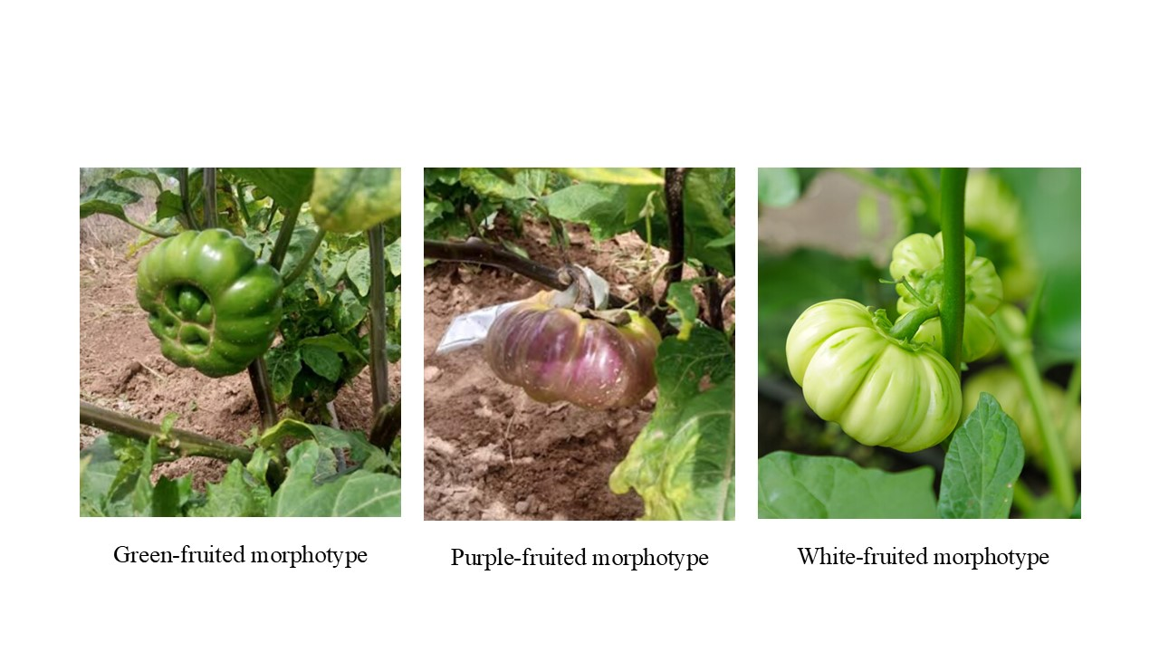

**Figure 1**: Three African eggplant cultivars grown in Burkina Faso

**Experimental site**

The study was conducted starting in June 2024 on an agricultural plot located in Dapelgo. This site is situated approximately 35 km from Ouagadougou along the Ouaga-Kongoussi road. It lies within the northern Sudanian zone of Burkina Faso. This area is characterised by annual rainfall ranging from 600 to 900 mm and temperatures varying between 18°C and 40°C (Thiombiano & Kampmann, 2010).

**Physicochemical Characteristics of Soil and Compost**

The soil at the experimental site was subjected to physicochemical analysis by the National Soil Bureau of Burkina Faso (BUNASOL). Similarly, the compost used in the study was also analysed by the same institution (Table 1).

**Table 1**: Physico-chemical analysis of the study soil and the compost used

|  |  |  |
| --- | --- | --- |
| Physico-chemical characteristics | **Soil** | **Compost** |
| clay (< 2µ) (%) | 9.55 - 12.58 | - |
| Total silt (%) | 28.52 - 29.25 | - |
| Sand (50-200µ) (%) | 56.52 - 61.56 | - |
| Total organic matter (%) | 0.854 - 1.895 | 37.83 |
| Total nitrogen (%) | 0.035 - 0.059 | 2.15 |
| Available potassium (ppm K) | 67.14 - 87.73 | 03.67 |
| Available phosphorus (ppm P) | 7.34 - 9.87 | 04.81 |

**Experimental Design**

The experimental design used was a Fisher randomised block design with three replications. Each replication was separated by a 1-meter pathway. Within each replication, each cultivar was sown in 4-meter rows, alternating with rows occupied by other cultivars. For each cultivar, 11 planting holes (hills) were sown, with four to five seeds per hole. The spacing between rows and between successive holes was 0.70 m and 0.40 m, respectively. Thinning to one plant per hole was carried out 21 days after sowing. Immediately after ploughing, five compost application rates were tested: 0 t/ha (control), 1 t/ha, 3 t/ha, 5 t/ha, and 9 t/ha.

**Measured variables**

**Agronomic parameters**

The agronomic parameters measured included:

* Days to emergence, defined as the number of days between sowing and the emergence of 50% of the planting holes in a row;
* Days to 50% flowering, defined as the number of days from sowing to when 50% of the plants in a row had flowered;
* Plant height, measured from the soil surface to the uppermost leaf;
* Fuit weight per plant;
* Number of fruits per plant, based on observations from four representative plants per row.

**Chemical parameters**

The mineral content of the fruits was evaluated by the National Soil Bureau of Burkina Faso (BUNASOL). For micronutrients, copper (Cu), iron (Fe), manganese (Mn), and zinc (Zn) were analysed using atomic absorption spectrophotometry. Other chemical elements such as nitrogen (N), total potassium (K), total phosphorus (P), and magnesium (Mg) were also analysed. Mineralisation was performed using a mixed solution of sulfuric acid, selenium, and salicylic acid. Following mineralisation, total phosphorus and nitrogen were determined from the digest using a SKALAR auto-analyser, with ammonium molybdate and ascorbic acid used as indicators for phosphorus, and Nessler’s reagent used for nitrogen. Potassium was quantified using a flame photometer, and magnesium was measured by atomic absorption at 285.2 nm.

**Statistical Analyses**

Data analysis was performed using R studio version 4.4.3. A two-factor analysis of variance (ANOVA) was conducted to assess the effects of cultivar and compost dose on morphological and chemical traits. The figures and tables were generated by the same software.

**Results**

**Agronomic performance of cultivars under the influence of compost doses**

Following nursery sowing, a wide range of variation was observed in seedling emergence time, indicating clear differences among the three cultivars. Analysis of variance (ANOVA) revealed a significant effect of both the cultivar and compost dose on the number of days to emergence (*p*-value < 0.05; Table 2). Early and late emergences were recorded across treatments. The cultivar producing white fruits exhibited the earliest emergence, followed by the purple-fruited cultivar. In contrast, the dark green-fruited cultivar showed the latest emergence (Figure 2).

With regard to the number of days from sowing to 50% flowering, the significant variation was attributed to compost dose rather than cultivar (Table 3). Cultivars receiving 1 t/ha of compost flowered later, while those treated with 3 t/ha and 5 t/ha flowered earlier. Overall, regardless of the compost dose, the purple-fruited cultivar was the earliest to flower, while the white-fruited cultivar was the latest (Figure 3).

ANOVA also revealed significant differences in plant height between cultivars, with these differences being more pronounced across compost doses than within cultivars under the same dose (Table 4). The white-fruited cultivar produced the tallest plants, followed by the dark green-fruited cultivar (Figure 4).

Significant differences were also observed among cultivars for fruit weight (Table 5). The heaviest fruits were produced by the white-fruited cultivar, followed by the dark green-fruited one (Figure 5).

In terms of fruit number, compost dose had a significant effect, both across and within compost treatments (Table 6). The white-fruited cultivar produced the highest number of fruits, followed by the purple-fruited cultivar (Figure 6).

**Table 2:** Emergence performance of the three cultivars

|  |  |  |  |  |  |
| --- | --- | --- | --- | --- | --- |
| Source of variation | Df | SMG | SME | F statistic | P value |
| Dose of compost | 4 | 9582.872 | 2395.718 | 45.4 | <0.001 |
| Morphotype | 2 | 1854.458 | 927.229 | 12.5 | <0.001 |
| Dose*compost | 8 | 8654.214 | 1081.77675 | 26.4 | <0.001 |
| Résidu | 16 | 7812.524 | 488.28275 |  |  |
| Total | 30 | 27904.068 |  |  |  |

***Legend****: df: degree of freedom, SMG: means squared of genotype, SME: means squared of the residual*

**Table 3**: Number of days to 50% flowering of the cultivars

|  |  |  |  |  |  |
| --- | --- | --- | --- | --- | --- |
| Source of variation | Df | SMG | SME | F statistic | P value |
| Dose of compost | 4 | 54123.412 | 13530.853 | 51.12 | <0.001 |
| Morphotype | 2 | 24587.254 | 12293.627 | 47.45 | <0.001 |
| Dose*compost | 8 | 37788.458 | 4723.55725 | 17.54 | <0.001 |
| Résidu | 16 | 34587.547 | 2161.72169 |  |  |
| Total | 30 | 151086.671 |  |  |  |

***Legend****: df: degree of freedom, SMG: means squared of genotype, SME: means squared of the residual*

**Table 4**: Height evaluation of the three cultivars

|  |  |  |  |  |  |
| --- | --- | --- | --- | --- | --- |
| Source of variation | Df | SMG | SME | F statistic | P value |
| Dose of compost | 4 | 894524.417 | 223631.104 | 24.21 | <0.001 |
| Morphotype | 2 | 4584.145 | 2292.0725 | 4.46 | <0.022 |
| Dose*compost | 8 | 487956.748 | 60994.5935 | 18.37 | <0.001 |
| Résidu | 16 | 427854.785 | 26740.9241 |  |  |
| Total | 30 | 1814920.1 |  |  |  |

***Legend****: df: degree of freedom, SMG: mean squared genotype, SME: mean squared error of the residual*

**Table 5**: Weight evaluation of the three cultivars

|  |  |  |  |  |  |
| --- | --- | --- | --- | --- | --- |
| *Source of variation* | *Df* | *SMG* | *SME* | *F statistic* | *P value* |
| *Dose of compost* | *4* | 879.258 | 219.8145 | 5.25 | <0.001 |
| *Morphotype* | *2* | 458.457 | 229.2285 | 4.45 | <0.001 |
| *Dose*compost* | *8* | 698.213 | 87.276625 | 4.67 | <0.001 |
| *Résidu* | *16* | 315.258 | 19.703625 |  |  |
| *Total* | *30* | 2351.186 |  |  |  |

***Legend****: df: degree of freedom, SMG: mean squared genotype, SME: mean squared error of the residual*

**Table 6:** Evaluation of the number of fruits per plant of the three cultivars

|  |  |  |  |  |  |
| --- | --- | --- | --- | --- | --- |
| Source of variation | df | SMG | SME | F statistic | P value |
| Dose of compost | 4 | 9854.415 | 2463.60375 | 45.21 | <0.001 |
| Morphotype | 2 | 2145.548 | 1072.774 | 12.54 | <0.001 |
| Dose*compost | 8 | 8745.127 | 1093.14088 | 24.41 | <0.001 |
| Résidu | 16 | 8045.478 | 502.842375 |  |  |
| Total | 30 | 28790.568 |  |  |  |

***Legend****: df: degree of freedom, SMG: means squared of genotype, SME: means squared of the residual.*

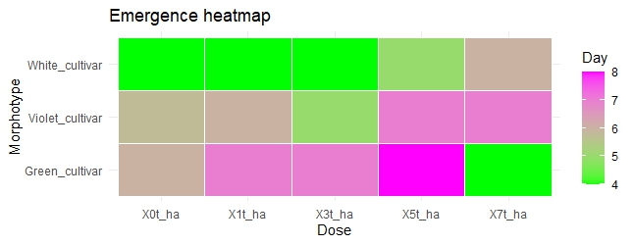

**Figure 2** : Performance of the three cultivars in terms of seedling emergence duration under the effetct of compost doses

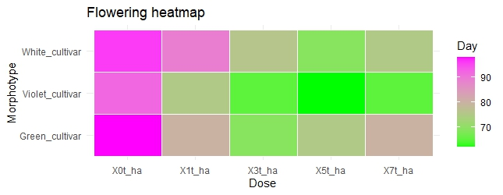

**Figure 3** : Performance of the three cultivars in terms of flowering duration and maintence under the effetct of compost doses

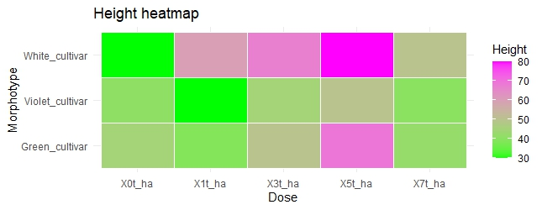

**Figure 4** : Performance of the three cultivars in terms of fruit height under the effetct of compost doses

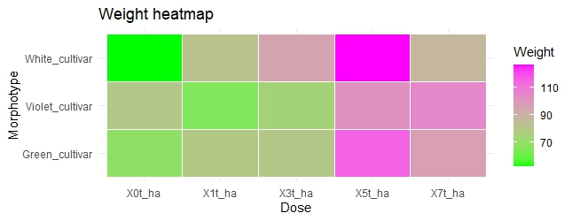

**Figure 5** : Performance of the three cultivars in terms of fruit weight under the effetct of compost doses

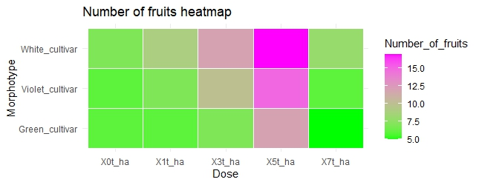

**Figure 6**: Performance of the three cultivars in terms of fruit number under the effect of compost doses

**Biochemical performance of cultivars under compost dose treatments**

Chemical analyses conducted on the fruit revealed cultivar-specific accumulation capacities that varied with compost dose. No significant differences (*p* > 0.05) were observed in the concentrations of manganese (Mn), zinc (Zn), and calcium (Ca), regardless of compost dose or cultivar.

However, ANOVA at the 5% significance level revealed significant differences in iron (Fe), sodium (Na), potassium (K), and phosphorus (P) contents. These differences were notable both across compost doses and between cultivars (Table 7).

Among the three cultivars, the dark green-fruited cultivar showed the highest capacity for nutrient accumulation, followed by the white-fruited cultivar. The purple-fruited cultivar consistently showed the lowest concentrations of Fe, Na, K, and P (Figure 7).

**Table 7**: Evaluation of the chemical elements of the three studied cultivars

|  |  |  |  |  |
| --- | --- | --- | --- | --- |
| Parameters (mg/100g) | Dart green cultivar | White cultivar | Violet cultivar | P-value |
| Zinc | 4.45 ± 0.01 | 4.51 ± 0.01 | 4.39 ± 0.01 | <0.141 |
| Manganese | 174.14 ± 0.05 | 170.84 ± 0.04 | 169.47 ± 0.06 | <0.061 |
| Calcium | 18.51 ± 0.02 | 16.38 ± 0.03 | 17.57 ± 0.02 | <0.095 |
| Iron | 360.25± 0.02 | 335.09 ± 0.02 | 290.73 ± 0.01 | <0.001 |
| Sodium | 157.35 ± 0.01 | 132.78 ± 0.02 | 119.42 ± 0.01 | <0.001 |
| Potassium | 258.54 ± 0.01 | 221.25 ± 0.01 | 205.46 ± 0.02 | <0.001 |
| Phosphorus | 1158.54 ± 0.90 | 1092.58 ± 0.72 | 984.65 ± 0.70 | <0.001 |

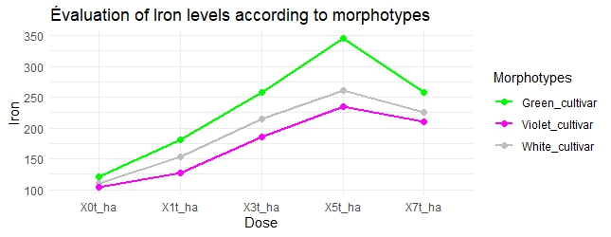

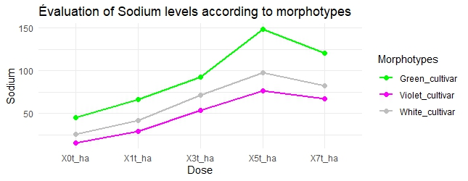

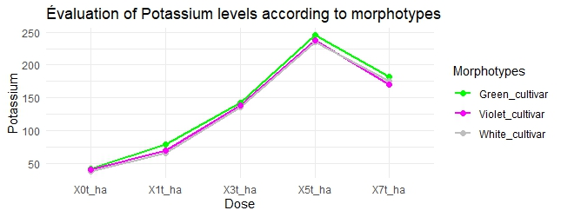

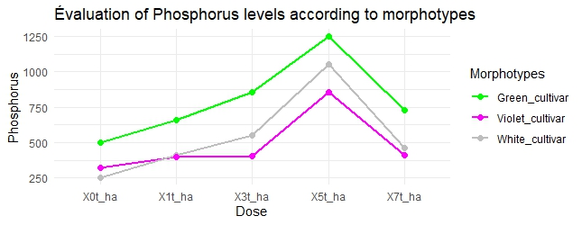

**Figure 7 :** Performance of the three cultivars in terms of chimical elements under the effetct of compost doses

**Nutrient Substance Performance of Cultivars under the Influence of Compost Doses**

Variance analysis using the Newman-Keuls test revealed significant differences at the 5% level. Indeed, the alkaloid content of the cultivars varied with compost dose and even within the same compost dose. Additionally, there was a significant difference in flavonoid performance among the three cultivars. Similarly, the saponin levels differed between cultivars and across compost doses. The cultivars treated with a 5 t/ha compost dose exemplified the highest nutrient substance performance among the three cultivars (Table 8). The dark green-fruited cultivar exhibited the highest performance in alkaloids and flavonoids (Figure 8). In contrast, the highest performances in saponins and phenols were achieved by the white-fruited cultivar (Figure 9).

Table 8: Evaluation of the nutrients of the three cultivars studied

|  |  |  |  |  |
| --- | --- | --- | --- | --- |
| Parameters (mg/100g) | Dart green cultivar | White cultivar | Violet cultivar | P-value |
| Alkaloid | 8.87 ± 0.02 | 6.52 ± 0.01 | 5.36 ± 0.02 | <0.001 |
| Flavonoid | 0.41 ± 0.01 | 0.32 ± 0.01 | 0.21 ± 0.01 | <0.001 |
| Saponin | 15.55 ± 0.02 | 18.61 ± 0.02 | 13.25 ± 0.01 | <0.001 |
| Phenol | 1.53 ± 0.03 | 2.23 ± 0.03 | 1.23 ± 0.03 | <0.031 |

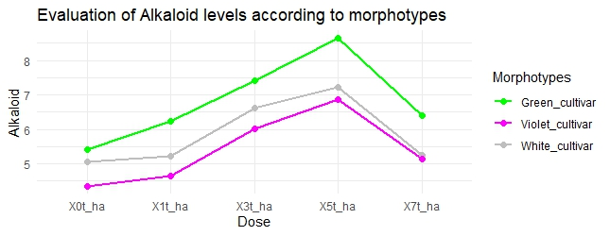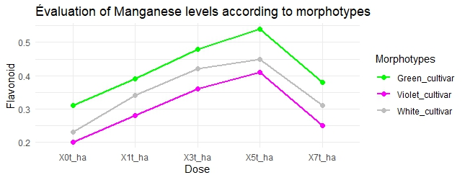

**Figure 8**: Performance of the cultivars in alkaloid and flavonoid content

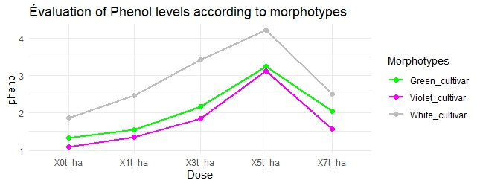

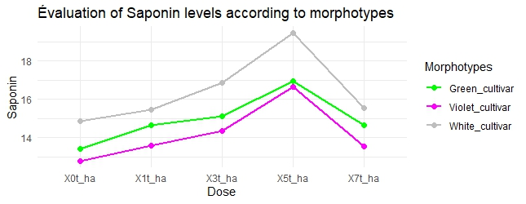

**Figure 9**: Performance of the cultivars in saponin and phenol content

**Discussions**

At the end of this experiment, several differences were observed regarding agronomical-morphological performance, chemical elements, and biochemical substances. Thus, cultivars producing purple-colored fruits performed less well compared to those with dark green and white fruits. However, other studies on edible leaves may show the opposite. Additionally, the compost model used, given its characteristics, could have an unfavourable effect on the benefits of the purple-fruited morphotype. On the other hand, the dark green and white-fruited morphotypes exhibited higher performance depending on the variation in compost doses. The white-fruited morphotype, in particular, holds the most promising qualities for generating higher monetary income for market gardeners. In fact, using this morphotype with a compost dose of 5 t/ha results in larger fruits and a higher yield of fruits compared to the other two morphotypes. This could be attributed to the genotype or the quality of the chosen compost. This agricultural practice could ensure the long-term conservation of several indigenous species, particularly the African eggplant (Gockowski et al., 2003). Regarding the chemical elements, significant differences were noted between morphotypes. Overall, due to the chemical value developed by the species, it would be beneficial to integrate the African eggplant into dietary habits (Ali & Tsou, 2000). Indeed, the morphotype producing dark green fruits could be exploited by market gardeners while applying a compost dose of 5 t/ha. This would be a benefit for consumers. For example, the significant amount of zinc in the dark green morphotype could be recommended for individuals living with HIV (Baum et al., 2003)(Traore et al., 2015). The species contains higher levels of calcium, magnesium, and zinc than species such as amaranth and vegetable purslane (Odhav et al., 2007). Regarding phosphorus, the high levels in dark green fruits would play a role in DNA and RNA synthesis. In fact, consuming these fruits could meet various hormonal needs and facilitate several biochemical reactions. Moreover, the high sodium content could help maintain nerve sensitivities and balance osmotic pressure (Fungo et al., 2015). The high iron content in this cultivar would be especially beneficial for pregnant women, breastfeeding women, and vulnerable children (García et al., 2010) ; (Ndlovu & Afolayan, 2008). Additionally, given the importance of iron in the body, consuming the dark green cultivar could be one of the most effective fruits for blood synthesis (Malakul et al., 2011). (Black et al., 2003) showed that iron deficiency in the diets of pregnant women leads to over 10% maternal mortality. Based on this study, the issue of maternal mortality could be mitigated for the well-being of families. The biochemical analysis reveals very high levels of alkaloids and flavonoids in the dark green-fruited morphotypes. Regarding tannins and saponins, the white-fruited morphotype is most prized due to its higher richness in these two substances. Both the dark green and white-fruited morphotypes would be highly beneficial for medicine due to the significant levels of substances they contain. Therefore, aqueous extractions would help meet the high demand for the compounds in this species (Nandy et al., 2020). These substances are considered to have anti-inflammatory, antimicrobial properties and could inhibit the activity of tumour agents (Malongane et al., 2018) ; (Asl & Hosseinzadeh, 2008).

**Conclusion**

The study highlighted the agronomic performance and nutritional values of the African eggplant from the Soudano-Sahelian climate zone of Burkina Faso. In this regard, it should be noted that the white-fruited morphotypes perform better in terms of yield and are very rich in phenolic compounds and saponins. Although the green-fruited morphotype does not have high yield potential, it possesses satisfactory nutritional value in terms of iron, sodium, potassium, phosphorus, flavonoids, and alkaloids. As for the purple morphotype, it closely follows the other two in terms of performance, including nutritional richness. The white-fruited morphotype is commercially useful, as its yield performance would bring higher financial gain to producers. From a health perspective, the green-fruited morphotype would be more beneficial to consumers due to its chemical and nutritional potential.

Disclaimer (Artificial intelligence)

Option 1:

Author(s) hereby declare that NO generative AI technologies such as Large Language Models (ChatGPT, COPILOT, etc.) and text-to-image generators have been used during the writing or editing of this manuscript.

Option 2:

Author(s) hereby declare that generative AI technologies such as Large Language Models, etc. have been used during the writing or editing of manuscripts. This explanation will include the name, version, model, and source of the generative AI technology and as well as all input prompts provided to the generative AI technology

Details of the AI usage are given below:

1.

2.

3.

**References**

Ali, M., & Tsou, S. (2000). The Integrated Research Approach of the Asian Vegetable Research and Development Center (AVRDC) to Enhance Micronutrient Availability. Food and Nutrition Bulletin, 21(4), 472‑481. https://doi.org/10.1177/156482650002100425

Asl, M. N., & Hosseinzadeh, H. (2008). Review of Pharmacological Effects of Glycyrrhiza sp. And its Bioactive Compounds. Phytotherapy Research, 22(6), 709‑724. https://doi.org/10.1002/ptr.2362

Baum, M. K., Campa, A., Lai, S., Lai, H., & Page, J. B. (2003). Zinc Status in Human Immunodeficiency Virus Type 1 Infection and Illicit Drug Use. Clinical Infectious Diseases, 37(s2), S117‑S123. https://doi.org/10.1086/375875

Black, R. E., Morris, S. S., & Bryce, J. (2003). Where and why are 10 million children dying every year? The Lancet, 361(9376), 2226‑2234. https://doi.org/10.1016/S0140-6736(03)13779-8

Ellong, E. N., Billard, C., Adenet, S., & Rochefort, K. (2015). Polyphenols, Carotenoids, Vitamin C Content in Tropical Fruits and Vegetables and Impact of Processing Methods. Food and Nutrition Sciences, 06(03), 299‑313. https://doi.org/10.4236/fns.2015.63030

Fungo, R., Muyonga, J., Kaaya, A., Okia, C., Tieguhong, J. C., & Baidu‐Forson, J. J. (2015). Nutrients and bioactive compounds content of Baillonella toxisperma, Trichoscypha abut and Pentaclethra macrophylla from Cameroon. Food Science & Nutrition, 3(4), 292‑301. https://doi.org/10.1002/fsn3.217

García, M., Díaz, R., Martínez, Y., & Casariego, A. (2010). Effects of chitosan coating on mass transfer during osmotic dehydration of papaya. Food Research International, 43(6), 1656‑1660. https://doi.org/10.1016/j.foodres.2010.05.002

Gockowski, J., Mbazo’o, J., Mbah, G., & Fouda Moulende, T. (2003). African traditional leafy vegetables and the urban and peri-urban poor. Food Policy, 28(3), 221‑235. https://doi.org/10.1016/s0306-9192(03)00029-0

Lassina Fondio, Mako François De Paul N’Gbesso, & Noupé Diakaria Coulibaly. (2016). Effect of Mineral Fertilization on African Eggplant (Solanum spp.) Productivity in Côte d’Ivoire. Journal of Agricultural Science and Technology B, 6(3). https://doi.org/10.17265/2161-6264/2016.03.006

Malakul, W., Thirawarapan, S., Ingkaninan, K., & Sawasdee, P. (2011). Effects of Kaempferia parviflora Wall. Ex Baker on endothelial dysfunction in streptozotocin-induced diabetic rats. Journal of Ethnopharmacology, 133(2), 371‑377. https://doi.org/10.1016/j.jep.2010.10.011

Malongane, F., McGaw, L. J., Nyoni, H., & Mudau, F. N. (2018). Metabolic profiling of four South African herbal teas using high resolution liquid chromatography-mass spectrometry and nuclear magnetic resonance. Food Chemistry, 257, 90‑100. https://doi.org/10.1016/j.foodchem.2018.02.121

Nandy, S., Mukherjee, A., Pandey, D. K., Ray, P., & Dey, A. (2020). Indian Sarsaparilla (Hemidesmus indicus) : Recent progress in research on ethnobotany, phytochemistry and pharmacology. Journal of Ethnopharmacology, 254, 112609. https://doi.org/10.1016/j.jep.2020.112609

Ndlovu, J., & Afolayan, A. J. (2008). Nutritional Analysis of the South African Wild Vegetable Corchorus olitorius L. Asian Journal of Plant Sciences, 7(6), 615‑618. https://doi.org/10.3923/ajps.2008.615.618

Odhav, B., Beekrum, S., Akula, U., & Baijnath, H. (2007). Preliminary assessment of nutritional value of traditional leafy vegetables in KwaZulu-Natal, South Africa. Journal of Food Composition and Analysis, 20(5), 430‑435. https://doi.org/10.1016/j.jfca.2006.04.015

Opabode, J. T., & Owojori, S. (2018). Response of African Eggplant (Solanum macrocarpon L.) to Foliar Application of 6-Benzylaminopurine and Gibberellic Acid. Journal of Horticultural Research, 26(2), 37‑45. https://doi.org/10.2478/johr-2018-0014

Thiombiano, A., & Kampmann, D. (2010). Atlas de la biodiversité de l’Afrique de l’Ouest (BIOTA).

Traore, I. T., Meda, N., Hema, N. M., Ouedraogo, D., Some, F., Some, R., Niessougou, J., Sanon, A., Konate, I., Van De Perre, P., Mayaud, P., & Nagot, N. (2015). HIV prevention and care services for female sex workers : Efficacy of a targeted community‐based intervention in Burkina Faso. Journal of the International AIDS Society, 18(1). <https://doi.org/10.7448/ias.18.1.20088>

Terán, F., Vives‐Peris, V., Gómez‐Cadenas, A., & Pérez‐Clemente, R. M. (2024). Facing climate change: plant stress mitigation strategies in agriculture. *Physiologia Plantarum*, *176*(4), e14484.

Han, M., Opoku, K. N., Bissah, N. A., & Su, T. (2021). Solanum aethiopicum: The nutrient-rich vegetable crop with great economic, genetic biodiversity and pharmaceutical potential. *Horticulturae*, *7*(6), 126.

Choi, S. M., & Choi, C. I. (2024). Nutritional Composition, Phytochemical Profiles, and Pharmacological Effects of Ethiopian Eggplant (Solanum aethiopicum L.). *Nutrients*, *16*(23), 4228.

Omondi, E. O., Lin, C. Y., Huang, S. M., Liao, C. A., Lin, Y. P., Oliva, R., & van Zonneveld, M. (2024). Landscape genomics reveals genetic signals of environmental adaptation of African wild eggplants. *Ecology and Evolution*, *14*(7), e11662.