# GC MS analysis of phytoconstituents from leaves of *Rhynchoglossum notonianum* (Wall.) B.L. Burtt

**Abstract**

Objectives of the present study to determine various compounds present in leaves of *Rhynchoglossum notonianum* using different solvents. *R. notonianum* belongs to Gesneriaceae family. It include medium sized plants which comes under the order Lamiales, which grows in moisture and shade areas near waterfalls. Leaves of the plant are used to cure diabetes, wounds, inflammation, asthma, fever, ulcer.Glycosides, tannins, flavonoids, saponins, and terpenoids are various phytochemicals reported in *R.notonianum*. Compounds obtained from leaves of the plants are used for treating number of diseases.In this study ethyl acetate, chloroform and methanol extract of leaves of the plant was studied phytochemically using Gas Chromatography-Mass Spectrometry. GC-MS result of ethyl acetate extract of leaves showed presence of E-15-Heptadecenal,nonadecane, neophytadiene, eicosane, tetratetracontane. Chloroform extract showed Dodecane,2,6,11-trimethyl, Tetradecane, 2,4-Ditert-Butylphenol, Eicosane, Neophytadiene, Cyclotetracosane, methanol extract of leaves showed Squalene, Tetratetracontane, Gamma-sitosterol.

**Keywords**: *Rhynchoglossum notonianum,* GCMS, Eicosane,1-Heneicosanol, Docosane.-

**1.Introduction**

*Rhynchoglossum notonianum* belongs to Gesneriaceae family. Many species of Gesneriaceae are grown as ornamentals while a few are medicinally important plants. The plants are usually small with showy flowers. Many compounds isolated from plants directly used as drugs. *R.notonianum* are succulent annual herbs found in both low and high altitudes. Their leaf blades oblique and asymmetrical between two sides. Leaf shapes varies ovate to oblong and inflorescence is terminal or axillary receme. They need abundant water content for their growth. They exhibit massive growth in banks of streams and water falls. In *R.notonianum* the calyx lobes are winged and one wing is larger than others. The epithet Rhynchoglossum comes from the Greek Rhynchos meaning beak and glossa meaning tongue. The second part of the name mention tongue like lower lip of the corolla (Weber,2004). Different works conducted on the chemical characters of the family Gesneriaceae. Harborne(1967) and Lowry(1973) studies revealed anthocyanins-a flavonoid found the whole family. Harborne also reported the presence of flavonoids like chalcones and aurones in Gesneriaceae. *R.notonianum* reduce blood pressure. Phytochemical studies revealed the plant consist of anti oxidants and alkaloids. Many phytochemicals such as glycosides, steroids, flavonoids, tannins, saponins, and terpenoids, were found in different extracts (Farzeen *et al.,* 2022). A phylogenetic analysis of Rhynchoglossum using DNA sequence data has been conducted together with other members of the tribe epithemateae (Mayer *et al.,* 2003).

**2. Materials and Methods**

**2.1 Collection and extraction of plant materials**

Fresh leaves of *R.notonianum* were collected from Kodaikanal and Wayanadu. The leaves of the sample were washed under running tap water to remove soil particles and adhered debris. The samples were chopped in to pieces, dried under shade at room temperature. The dried samples were grind in to powder and the powdered material is weighed and used for Soxhlet extraction using ethyl acetate, chloroform and methanol. After Soxhlet it was filtered and the filtrate concentrated using the rotary evaporator.

**3.GC-MS analysis**

Chemica**l** composition was determined by GC-MS (Shimadzu QP-2010 plus with Thermal Desorption System TD 20, fitted with a 60 m x 2025 mm x 0.25 m WCOT column coated with diethylene glycol (AB-Innowax 7031428, Japan). Helium was used as a carrier gas at a flow rate of 1.21 mL/min at a column pressure of 77.6 kPa. Both injector and detector temperatures were maintained at 260 0C. Samples (6 µL) were injected in to the column with a split ratio of 10:0. Component separation was achieved following a linear temperature program of 70- 260 0C at 30C/min and then held at 2600C for 6 min, with a total run time of 44.98 min. The MS parameters used were : electron ionization (EI) voltage 70 eV, peak width 2 s, mass range 40-850 *m/z*and detector voltage 1.5 V. The constituents were identified by comparison of their linear retention indices. The MS fragmentation pattern was checked with National Institute of Standards and Technology (NIST) mass spectra libraries and with those in the literature (Adams, 2001).

**4.Results**

**4.1GC - MS analysis**

Table.1 Metabolite profile of ethyl acetate extract of leaves of *R.notonianum*

|  |  |  |  |  |
| --- | --- | --- | --- | --- |
| Peaks | RT | Area % | Name of compound | Biological activity |
| 1 | 7.458 | 1.01 | 5-Ethyl-2-Methylloctane | -­­ |
| 2 | 13.268 | 1.59 | Dodecane,2,6,11-trimethyl- | antibacterial activity,susceptibility to shoot fly, attractants and/ or oviposition stimulants for the sorghum shoot fly(Rahbar *et al*.,2012) |
| 3 | 19.395 | 1.96 | 2,4-Ditert-Butylphenol | induces oxidative stress through the generation of reactive oxygen species( Chuah *et al*) |
| 4 | 193831 | 1.19 | Nonadecane | Antimicrobial activity,cytotoxic(Sunita *et al*.,2017) |
| 5 | 21.277 | 18.36 | Heneicosane,1(1-Ethylpropyl)- | Microbicide activities (Vanitha *et al*.,2020) |
| 6 | 25.488 | 2.92 | E-15-Heptadecenal | Antibacterial activity(Kumar *et al*.,2011) |
| 7 | 25.611 | 2.79 | Iron,Tricarbonyl[N-(Phenyl-2-Pyridinylmethylene)Benzenamine-N,N’] | Derivative of aniline Fungicidal activity (Sharmila *et al*.,2017) |
| 8 | 26.435 | 18.72 | Phytol,acetate | Antimicrobial, anticancer, anti-inflammatory and diuretic activity. contraction of vascular smooth muscle cells, used in treatment of such dermatitis(Padmini *et al*.,2010) |
| 9 | 27.311 | 6.21 | Neophytadiene | Antioxidants, antibacterial activity(Sharmila *et al*.,2017) |
| 10 | 29.123 | 1.20 | Dibutyl phthalate | Urinary infection, Antioxidants Silane, trichlorooctadecyl Antimicrobial, Antifouling(Arancibia *et al*.,2016) |
| 11 | 29.468 | 3.11 | Heneicosyl alcohol | antifungal and antibacterial activities. |
| 12 | 31.527 | 0.97 | 2-Methylanthraquinone | Carcinogenic to humans (Gori *et al*.,2009) |
| 13 | 32.107 | 13.20 | 9,10-Anthracenedione,2-Methyl- | Antioxidant, anticancer, anti-inflammatory, immune suppressive, diuretic, cathartic, laxative, antimicrobial, vasorelaxant, and phytoestrogen(Yao *et al.*,2020) |
| 15 | 32.817 | 0.99 | 1,2-Benzenedicarboxylic acid,Dinonyl ester | Acidifier, endocrine disruptors(Kumar*et al*.,2020) |
| 16 | 33.107 | 2.36 | 1-Tricosene | Anti-tumorcompound(Sunita *et al*.,2017) |
| 17 | 33.196 | 2.40 | Eicosane | Antibacterial, antimicrobial and cytotoxicactivity ( Sharif *et al*.,2009) |
| 18 | 36.472 | 1.19 | 1-Heneicosanol | antifungal and antibacterial activities ( Arancibia *et al* .,2016) |
| 19 | 36.543 | 2.95 | Docosane | Antibacterial activity(Gumgumjee *et al*.,2015) |
| 20 | 39.033 | 1.13 | 1,2-Benzenedicarboxylic Acid | inhibits MG-63 cells proliferation via Akt-p53-cyclin pathway( Tomar*et al.,*2017) |
| 21 | 40.594 | 1.85 | Bis-(3,5,5-trimethylhexyl)phthalate | Antimalarial activities( Imam *et al*.,2017) |
| 22 | 41.099 | 3.89 | Tetratetracontane | Anti cancer,antimicrobial(Asnaashari *et al*.,2019) |
| 23 | 43.172 | 100.00 | 1,2-Benzenedicarboxylic acid,Diisodecyl ester | Antiviral compound( Madhavan *et al.,*2021) |

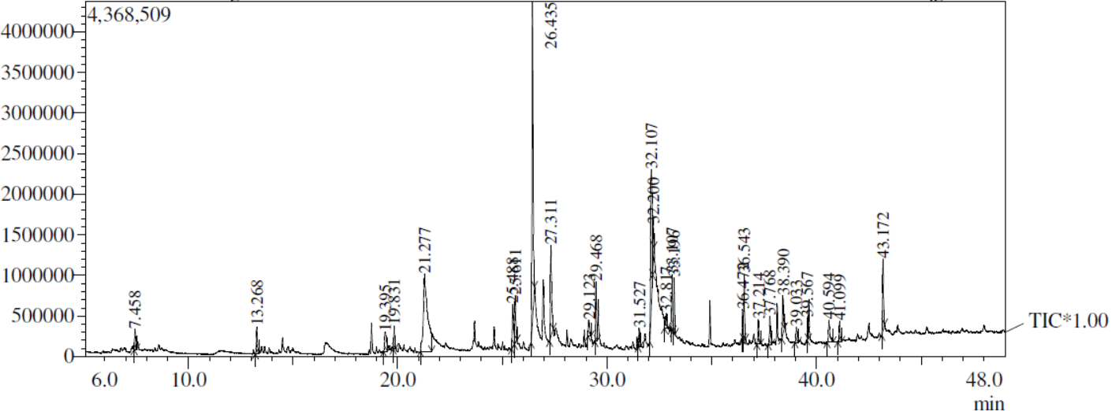

Fig.1 GC-MS chromatogram of ethyl acetate extract of leaves of *R.notonianum*

Table.2 Metabolite profile of chloroform extract of leaves of *R.notonianum*

|  |  |  |  |  |
| --- | --- | --- | --- | --- |
| Peaks | RT | Area % | Name of compound | Biological activity |
| 1 | 11.290 | 1.90 | Dodecane,2,6,11-trimethyl- | Antibacterial activity( Momodu *et al*.,2022) |
| 2 | 12.478 | 1.31 | Tetradecane | Antifungal,antibacterial(Ibrahim *et al.,*2017) |
| 3 | 16.707 | 3.14 | nonadecane | Antituberculosis, anticancer, antioxidant, antimicrobial( Rukachaisirikul,2004) |
| 4 | 17.362 | 1.14 | 2,4-Ditert-Butylphenol | Antioxidant,anticancer,antifumgal( Choi *et al*.,2009) |
| 5 | 17.783 | 3.24 | Dodecane,2,6,11-trimethyl- | Antibacterial activity,antifungalantitumor,larvicidal( Rahbar *et al.,*2012) |
| 6 | 22.553 | 3.41 | Eicosane | Antioxidant  Antitumor activity( Sharif *et al.*,2009) |
| 7 | 22.946 | 1.19 | Docosane | Antibacterial activity(Gumgumjee *et al*.,2015) |
| 8 | 23.441 | 1.71 | 1-Decanol,2-hexyl- | Antimicrobial( Krishnamoorthy *et al*.,2014) |
| 9 | 23.567 | 0.80 | Heptadecane | Antimicrobial,antioxidant activity ( Vinay Kumar *et al*.,2011) |
| 10 | 24.382 | 1.55 | Neophytadiene | Antioxidants, antibacterial activity( Gonzalez *et al*.,2023) |
| 11 | 25.259 | 0.88 | 3,7,11,15-Tetramethyl-2-hexadecen-1-ol | Provide oligosaccharide[39] |
| 12 | 26.030 | 2.25 | Hexadecane,2,6,11,15-tetramethyl- | Antibacterial activity,antifungal,antitumor,antilarvicidal(Sunita *et al*.,2011) |
| 13 | 27.110 | 5.53 | 1,2-Benzenedicarboxylic acid,butyloctyl ester | Anticancer activity( Rajesh *et al*.,2017) |
| 14 | 27.300 | 1.32 | Dodecane,2,6,11-trimethyl- | Antibacterial activity,antifungalantitumor,larvicidal( Kumar *et al*.,2011) |
| 15 | 27.587 | 2.48 | E-15-Heptadecane | Antibacterial( Kumar *et al.,*2011) |
| 16 | 27.716 | 0.63 | Heptadecane | Antioxidant activity( Kumar *et al*.,2011) |
| 17 | 30.472 | 1.09 | Tetracosane | Cytotoxic towards  gastric cancer cells by  induction of apoptosis ( Uddin *et al*.,2012) |
| 18 | 31.480 | 50.44 | Beta-Methylanthraquinone | Antifungal,anti insect activities(Thulasidas *et al*.,2006) |
| 19 | 33.668 | 2.15 | Cyclotetracosane | Antibacterial,antioxidant,anticancer activities( Mongalo *et al.,*2019) |
| 20 | 33.834 | 2.40 | Heneicosane | Antiasthmatics, urine acidifiers andantimicrobial ( Arancibia *et al.,*2019) |
| 21 | 38.860 | 1.24 | Cyclooctacosane | Antifungal activity( |
| 22 | 38.967 | 57.10 | Octacosane | Antibacterial,antitumor activity(Figueiredo *et al*.,2014) |
| 23 | 42.853 | 1.39 | Celidoniol,Deoxy- | Antibacterial,anti-inflammatory(Kose *et al*.,211) |
| 24 | 44.559 | 100.00 | Tetratetracontane | Antioxidant activity(Asnaashari.,2019) |

­

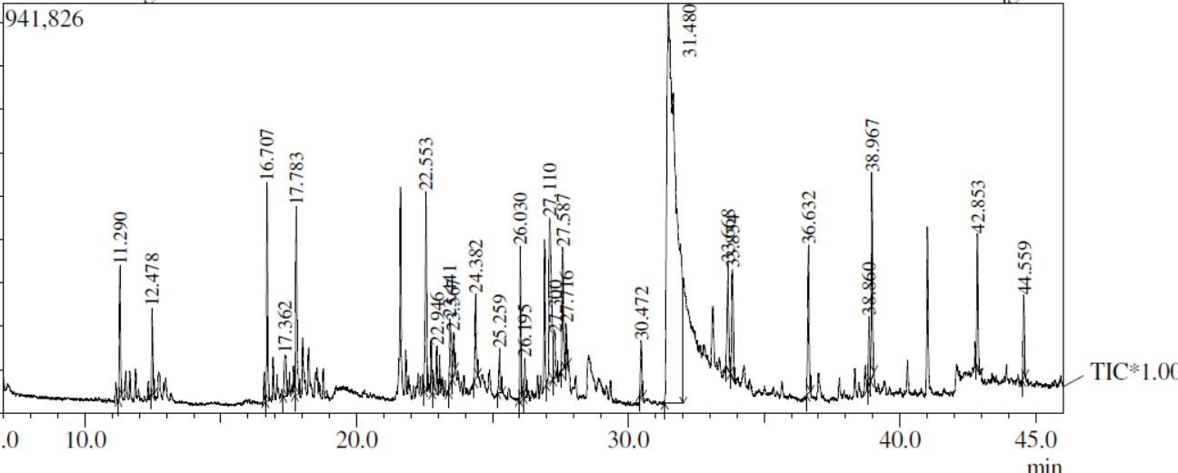

Fig.2 GC-MS chromatogram of chloroform extract of leaves of *R.notonianum*

Table.3 Metabolite profile of methanol extract of leaves of *R.notonianum*

|  |  |  |  |  |
| --- | --- | --- | --- | --- |
| Peaks | RT | Area % | Name of compound | Biological activity |
| 1 | 16.503 | 2.85 | Neophytadiene | neuropharmacological activity- anxiolytic-like and anticonvulsant actions ( Gonzalez *et al.,*2023) |
| 2 | 17.157 | 0.96 | (E)-Phytol | precursor for the manufacture of synthetic forms of vitamin E and vitamin K1(Byju *et al*.,2013)  antinociceptive, anxiolytic, cytotoxic, antioxidant, anti-inflammatory, immune-modulating, autophagy- and apoptosis-inducing, and antimicrobial ( Islam *et al*.,2015) |
| 3 | 19.193 | 0.41 | PhosphonicAcid,Dioctadecyl Ester | - |
| 4 | 22.671 | 29.78 | 9,10-Anthracenedione,2-Methyl- | Antioxidant, anticancer, anti-inflammatory, immune suppressive, diuretic, cathartic, laxative, antimicrobial, vasorelaxant, and phytoestrogen( Guang *et al*.,2020) |
| 5 | 34.768 | 5.18 | Squalene | anti-cancer properties, cholesterol-lowering property,protect humanskin ( Smith *et al*.,2000) |
| 6 | 35.173 | 1.08 | Tetratetracontane | Antioxidant activity( Mallick *et al*.,2014) |
| 7 | 38.043 | 7.98 | Ergost-5-En—3-ol | Reduce cholesterol level,inhibit growth of cancer cells ( Francis *et al*.,2021) |
| 8 | 38.910 | 29.24 | Stigmasta-5,22-Dien-3ol | Antioxidant,antibacterial activity,  anti-inflammatory,antiarthriticantiasthma,diuretic (Bakrim *et al.,*2022) |
| 9 | 40.584 | 15.30 | Gamma-sitosterol | Anti inflammatoryactivity (Naikwadi *et al.,*2022) |

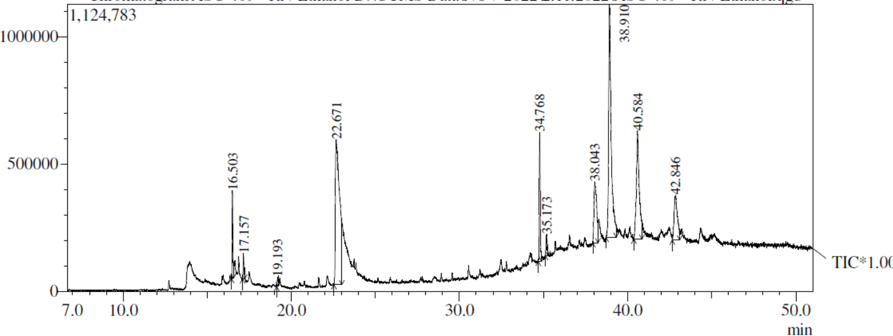

Fig.3 GC-MS chromatogram of methanol extract of leaves of *R.notonianum*

**5. Discussion**

GC MS analysis of ethyl acetate extract of leaves of *R.notonianum*were shown table.1. It revealed 27 compounds,Dodecane,2,6,11-trimethyl- shows Antimicrobial, anticancer, anti-inflammatory and diuretic activity. contraction of vascular smooth muscle cells, used in treatment of such dermatitis. Neophytadiene possess antioxidants, antibacterial activities. Heneicosyl alcohol acts as antifungal and antibacterial activities. 9,10-Anthracenedione,2-Methyl- possess Antioxidant, anticancer, anti-inflammatory, immune suppressive, diuretic, cathartic, laxative, antimicrobial, vasorelaxant, and phytoestrogen. 1-Tricosene acts as Anti-tumorcompound. Eicosane shows biologically important properties like antibacterial, antimicrobial and cytotoxicactivity. 1-Heneicosanol very important in antifungal and antibacterial activities. Bis-(3,5,5-trimethylhexyl)phthalate has antimalarial activities, Tetratetracontane has Anti cancer,antimicrobial activities. 26 bioactive compounds have been identified in the chloroform root extract of *R.notonianum*. The major bioactive compounds include Dodecane,2,6,11-trimethyl- it shows antibacterial activity. Nonadecane has antituberculosis, anticancer, antioxidant, antimicrobial activity. 2,4-Ditert-Butylphenol has Antioxidant,anticancer,antifumgal activity, Dodecane,2,6,11-trimethyl has Antibacterial activity,antifungalantitumor,larvicidal activity,Eicosane has anti oxidant ,anti tumor activity, Docosane has anti bacterial activity, E-15-Heptadecane shows anti bacterial activity, Cyclotetracosane has antibacterial,antioxidant,anticancer activities, heneicosane shows antiasthmatics, urine acidifiers andantimicrobial activities, tetratetracontane shows anti oxidant activity, 9 bioactive compounds have been identified in the methanol root extract of *R.notonianum.* The major bioactive compounds include neophytadiene shows neuropharmacological activity- anxiolytic-like and anticonvulsant actions, 9,10-Anthracenedione,2-Methyl has Antioxidant, anticancer, anti-inflammatory, immune suppressive, diuretic, cathartic, laxative, antimicrobial, vasorelaxant, and phytoestrogen activities. Squalene shows anti-cancer properties, cholesterol-lowering property,protect humanskin, tetratetracontane has anti oxidant activity, Gamma-sitosterol shows anti inflammatory activity.

**6.Conclusion**

This study revealed that ethyl aceate and chloroform extract of leaves of *R.notonianum* showed more compounds . Isolation and identification of medicinally important compounds is next investigation of this method.

**7.Competing Interests**

Authors have declared that no competing interest exist.

Disclaimer (Artificial intelligence)

Option 1:

Author(s) hereby declare that NO generative AI technologies such as Large Language Models (ChatGPT, COPILOT, etc.) and text-to-image generators have been used during the writing or editing of this manuscript.

Option 2:

Author(s) hereby declare that generative AI technologies such as Large Language Models, etc. have been used during the writing or editing of manuscripts. This explanation will include the name, version, model, and source of the generative AI technology and as well as all input prompts provided to the generative AI technology

Details of the AI usage are given below:

1.

2.

3.

**Reference**

1.Adams, R. P. (2001). Identification of essential oils by Capillary gas *Chromatography/Mass Spectroscopy* ,Allured , Carol Stream, IL,USA.

2.Azhagu Madhavan S, Vijayakumar S, Sripriya R, Rajalakshmi S. Phytochemical Screening And GC–MS Analysis OfBioactive Compounds Present In Ethanolic Leaf Extract *Murraya koenigii.* Bull. Env.Pharmacol. Life Sci., Vol10[4]March2021 : 158-164

3.Ajay Kumar, Sandeep Kaur, Sukhvinder Dhiman et al. 1,2-benzenedicarboxylic acid, bis (2-methyl propyl) ester isolated from Onosmabracteata Wall. inhibits MG-63 cells proliferation via Akt-p53-cyclin pathway, 04 June 2021.

4.Arancibia, L. A., Naspi, C. V., Cecilia, V., Pucci, G.N., Arce, M., E., Colloca, C. B., 2016. Biological activity of 1-heneicosanol isolated from Seneciocoluhuapiensis, an endemic species from Patagonia,Argentina. The Pharmaceutical and Chemical Journal, 3(4), 73-77

5.Asnaashari S, Delazar A, Safarzadeh E, Tabibi H, Mollaei S, Rajabi A, *et al*. Phytochemical Analysis and Various Biological Activities of the Aerial Parts of *Scrophularia Atropatana* Growing in Iran. Iran. J. Pharm. Res. 2019;18:1543-1555.

6.Farzeen, S., & Kumar, A. (2022). Preliminary phytochemical screening and various phytoconstituent of leaves extract of *Rhynchoglossum notonianum* wall. *International Journal of Health Sciences*, *6*(S3), 8040–8051.

7.Giampaolo Gori, Mariella Carrieri, Maria Luisa Scapellato, Giorgio Parvoli, Daniela Ferrara, Rocco Rella, Alberto Sturaro, Giovanni Battista Bartolucci, 2-Methylanthraquinone as a Marker of Occupational Exposure to Teak Wood Dust in Boatyards, The Annals of Occupational Hygiene, Volume 53, Issue 1, January 2009, Pages 27–32

8.Gumgumjee, N.M. and Hajar, S.A. (2015): Antibacterial activities and GC-MS analysis of phytocomponents of Ehretiaabyssinica R.Br. ex fresen. Int J ApplBiol Pharm Tech.,6(2): 236-241**.**

9.Harborne, J.B. 1967. Comparative biochemistry of the flavonoids-VI: flavonoid patterns in the Bignoniaceae and the Gesneriaceae. *Phytochemistry* 6(12): 1643–1651.

10.Imam, A. A. and Ezema, M. D. and Muhammad, I. U. and Atiku, M. K. and Alhassan, A. J. and Idi, A and Abdullahi, H and Mohammed, A (2017) In vivo Antimalarial Activity of Solvents Extracts of Alstoniaboonei Stem Bark and Partial Characterization of Most Active Extract(s).10.Annual Research & Review in Biology, 17 (5). pp. 1-11. ISSN 2347565X

11.Lowry, J.B. 1973. *Rhabdothamnus solandri*: some phytochemical results. *New Zealand Journal of Botany* 11(3): 555–560.

12.Mayer, V., Moller,M., Perret.M&Webber,A. 2003. Phylogenetic position and generic differentiation of Epithemateae (Gesneriaceae) inferred from plastid DNA sequence data. American J. Bot. 90:321-329.

13.Padmini, E., A. Valarmathi and M. Usha Rani, 2010.Comparative analysis of chemical composition and antibacterial activities of Mentha spicata and Camellia sinensis. Asian Journal of Experimental Biological Science, 1(4): 772-781.

14.S.Guang-Yao, C. Ming-Long & W. Kui-Wu “Natural New Bioactive An-thraquinones from Rubiaceae”, Mini-Reviews in Organic Chemistry 17(2020) 872.

15.Sharmila.S, Kalaichelvi K, Dhivya SM,20217. pharmacognostic standardisation of *cayratiapedata*(lam.) gagnep. var*.glabra*gamble–an endemic and endangered medicinal climber in shola,nilgirisVol 9, Issue 12, 2017

16.Sunita A., Ganesh K., Sonam M. Gaschromatography-mass spectroscopy analysis of root of an economically important plant,Cenchrusciliaris l. from thar desert, rajasthan(INDIA). Asian Journal of Pharmaceutical andClinical Research, 10)9(, -64-69 (2017) .doi:10.22159/ajpcr.2017.v10i9.19259.

17.T. S. Chuah, M. Z. Norhafizahand B. S. Ismail Author Affiliations *Crop and Pasture Science* 66(2) 214-223.

18.Vanitha V., Vijayakumar S., Nilavukkarasi M., Punitha V. N., Vidhya E. and Praseetha P. K. Heneicosane, A novel microbicidal bioactive alkane identified from Plugmbagozeylanica L*. Industrial Crops and Products,* 154, 112748(2020).

19.Vinay Kumar, A.K., J. Bhatnagar and J.N. Srivastava,2011. Antibacterial activity of crude extracts of Spirulina platensis and its structural elucidation of bioactive compound. Journal of Medicinal PlantsResearch, 5(32): 7043-7048

20.Weber, A.2004a. Gesneriaceae. In: Kubitzki, K.&Kaderreit, J.W. The families and Genera of Vascular plants. Vol.7. Flowering plants, dicotyledons: Lamiales (except Acanthaceae including Avicenniaceae). Springer-Verlag, Berlin. 63-158.

21.Momodu, I. B., 1Okungbowa, E. S., 1Agoreyo, B. O. and 2Maliki, M. M(2022)Gas Chromatography – Mass Spectrometry Identification of Bioactive Compounds in Methanol and Aqueous Seed Extracts of Azanzagarckeana Fruits1: 25-38 (May, 2022).

22.Ibrahim, H.O., O. Osilesi, O.O. Adebawo, F.D. Onajobi, and K.O. Karigidi (2017). Nutrients compositions and phytochemical contents of edible parts of *Chrysophyllum albidum* fruit. J.Nutr. Food Sci. 7: Article 579.

23.Rukachaisirikul T, Siriwattanakit P, Sukcharoenphol K, WongveinC,Ruttanaweang P, Wongwattanavuch P, et al(2004) Chemical constituents and bioactivity of *Piper sarmentosum*. J Ethnopharmacol2004;93:173-6.

24.Choi Y, Lee J (2009) Antioxidant and antiproliferative properties of a tocotrienol-rich fraction from grape seeds. Food Chemistry 114,1386–1390. doi:10.1016/j.foodchem.2008.11.018

25.Rahbar N., Shafagha A., Salimi F.(2012)Antimicrobial activity and constituents of thehexane extracts from leaf and stem of Origanumvulgare L. sp. Viride (Boiss.) Hayek. Growingwild in Northwest Iran. J. Med. Plants Res., 6,2681–2685(2012).

26.Sharif, M.A., A. Rahman and S.C. Kang, 2009. Chemical composition and inhibitory effect ofessential oil and organic extracts of Cestrum antibacterial activities of Mentha spicata and nocturnum L. on food-borne pathogens. InternationalJournal of Food Science and Technology, 44: 1176-1182.

27. Krishnamoorthy, K., and P. Subramaniam (2014). Phytochemical profiling of leaf, stem, and tuber parts of *Solena amplexicaulis* (Lam.) Gandhi using GC-MS. Int. Sch. Res. Notices 2014: Article 567409.

28.Gonzalez-Rivera, M.L.; Barragan-Galvez, J.C.; Gasca-Martínez, D.; Hidalgo-Figueroa, S.; Isiordia-Espinoza, M.; Alonso-Castro, A.J. In Vivo Neuropharmacological Effects of Neophytadiene. Molecules 2023, 28, 3457. <https://doi.org/10.3390/molecules28083457>

29.T. Rajesh Singh Tomar, B. Sharmistha Banerjee and K. Shuchi Kaushik (2017). Assessment of Antioxidant Activityof Leaves of *Murraya koenigii* Extracts and it’s Comparative Efficacy Analysis in Different Solvents. /J. Pharm. Sci.& Res. Vol. 9(3), 288-291

30.C. Siva Kumar 1, 2 . H. C. Sharma Peter M. Vijay and Lakshmi Narasu 2(2011)Leaf surface chemicals of sorghum seedlings influence the genotypic resistance to shoot fly, Atherigonasoccata <http://dx.doi.org/10.1007/s13562-011-0048-3>

31.Uddin, S.J., Grice, D., and Tiralongo, E. (2012): Evaluation of cytotoxic activity of patriscabratine, tetracosane and various flavonoids isolated from the Bangladeshi medicinal plant Acrostichumaureum . Pharmaceutical Biology., 50(10): 1276–1280.

32.P. K. Thulasidas K. M. Bhat(2006)Chemical extractive compounds determining the brown-rot decay resistance of teak wood 65: 121- 124

33.Mongalo, NI,Soyingbe, OS; Makhafola, TJ. Antimicrobial, cytotoxicity, anticancer and antioxidant activities of Jatropha zeyheriSond. roots (Euphorbiaceae). Asian Pacific Journal of Tropical Biomedicine 9(7):p 307-314, July 2019.

34.Arancibia, L. A., Naspi, C. V., Cecilia, V., Pucci, G.N., Arce, M., E., Colloca, C. B., 2016. Biological activity of 1-heneicosanol isolated from Seneciocoluhuapiensis, an endemic species from Patagonia,Argentina. The Pharmaceutical and Chemical Journal, 3(4), 73-77

35.Kose, Y.B., Iscan, G. and Demirci, B. (2016): Antimicrobial Activity of the Essential Oils Obtained fromFlowering Aerial Parts of CentaurealycopifoliaBoiss. et Kotschy and Centaureacheirolopha (Fenzl) Wagenitzfrom Turkey. J Essent Oil Bear Pl., 19 (3): 762 – 768

36.Gonzalez-Rivera, M.L.; Barragan-Galvez, J.C.; Gasca-Martínez, D.; Hidalgo-Figueroa, S.; Isiordia-Espinoza, M.; Alonso-Castro, A.J. In Vivo Neuro pharmacological Effects of Neophytadiene. Molecules2023,28, 3457. <https://doi.org/10.3390/molecules28083457>

37. K Byju, G Vasundhara, V Anuradha, S M Nair, N C Kumar(2013) Presence of Phytol, a Precursor of Vitamin E in ChaetomorphaAntinnina[Vol. 12 No. 2 (2013)](https://journals.christuniversity.in/index.php/mapana/issue/view/79)

38.Islam MT, Ali ES, Uddin SJ, Shaw S, Islam A, Ahmed I, *et al*. A review of biomedical activities. Food Chem. Toxicol. 2018;121:82-94

39.S. Guang-Yao, C. Ming-Long & W. Kui-Wu “Natural New Bioactive An-thraquinones from Rubiaceae”, Mini-Reviews in Organic Chemistry 17(2020) 872.

40.Smith, T. J. (2000). Squalene: potential chemopreventive agent. *Expert Opinion on Investigational Drugs*, *9*(8), 1841–1848. <https://doi.org/10.1517/13543784.9.8.1841>

41.Mallick, S.S., and V.V. Dighe (2014). Detection andestimation of alpha-amyrin, beta-sitosterol,lupeol and n-tricontane in two medicinal plantsby high performance thin layer chromatography.Adv. Chem. 2014: Article 143948

42.Steffy Francis1,V Anand Gideon2, S John Britto3 Antibacterial and GC-MS analysis of stem and leaf of Premnapaucinervis (C.B. Clarke) gamble (Lamiaceae)- An endemic and rediscoverded species Volume 6, Issue 2, 2021, Page No. 282-292

43.Bakrim S, Benkhaira N, Bourais I, Benali T, Lee LH, El Omari N, Sheikh RA, Goh KW, Ming LC, Bouyahya A. Health Benefits and Pharmacological Properties of Stigmasterol. Antioxidants (Basel). 2022 Sep 27;11(10):1912. doi: 10.3390/antiox11101912. PMID: 36290632; PMCID: PMC9598710

44.Naikwadi, Narendra D. Phatangare and Dhananjay V. ManeActive Anti-Inflammatory Potency of γ-Sitosterol from Woodfordia Floribunda SalisbPankaj H. 338 (2) 1–9 2022