Regeneration of Spent Transformer Oil Using Bentonite Clay and Palm Kernel Shell

**ABSTRACT**

The reliable operation of power transformers is critically dependent on the quality of insulating oil, which degrades over time due to thermal, electrical, and chemical stresses. This study explores an innovative, sustainable approach using bentonite clay and palm kernel shell-activated carbon (PKS-AC) for regenerating spent transformer oil. The adsorbents were chemically activated at 7N sulfuric acid concentrations and characterized using FTIR, SEM, and physico-chemical analyses. Regeneration experiments were carried out using a transformer oil-to-palm kernel shell-to-bentonite base ratio of 30:3.4:3.8 (mL/g/g), at a temperature of 77 °C, for 77 minutes, with continuous stirring at 744 rpm. Density decreased from 0.975 to 0.8342 g/cm³, kinematic viscosity from 18.3 to 10.34 mm²/s, acidity from 0.821 mg KOH/g to 0.003 mg KOH/g, and water content from 35.42 ppm to 10.254 ppm, while the breakdown voltage increased from 10 to 60 kV, flash point from 144°C to 150°C and fire point from 156°C to 160°C. The regenerated oil met standard acceptable limits, with significant improvements in the transformer oil properties. These findings indicate successful restoration of dielectric strength and thermal stability of transformer oil. Based on the result obtained, bentonite and palm kernel shell are veritable adsorbents for regeneration of used transformer oil, thus contributing to sustainable energy practices.

**Keywords:** Transformer oil, Regeneration, Bentonite Clay, Palm kernel shell, Adsorption and Oil degradation

1. **INTRODUCTION**

Power transformers are vital to electrical distribution systems, relying heavily on the quality of their insulating oil for optimal performance. Transformer oil serves critical functions, including electrical insulation, cooling, and arc suppression. However, during operation, it degrades due to thermal, electrical, and chemical stresses, accumulating acids, moisture, dissolved gases, and other contaminants. These impurities deteriorate the oil dielectric strength and cooling efficiency, jeopardizing transformer reliability and lifespan (Aliev et al., 2023; Tiwari et al., 2024). Given the global demand for a stable power supply and sustainable energy infrastructure, finding cost-effective and eco-friendly solutions for oil regeneration is imperative. Regeneration is an economically viable technique because it reduces the disposal of spent oil and minimizes the need to purchase new oil, which is unwise considering the escalating price of petroleum-derived oils. The regeneration process involves removing contaminants and degradation by-products such as polar, acidic, ketones, water or colloidal materials from spent transformer oil by using a chemical or adsorbent. The main advantage of the regeneration process is that the properties of spent transformer oil can be restored such that the properties are comparable to those of fresh transformer oil. Several studies have explored the regeneration of spent transformer oil. The methods employed include the use of dry sludge from water treatment plants (Hafez et al., 2015), microemulsion with Triton X-100 (Soares et al., 2023), activated clay-biopolymer composites and kappa cotton coated with polyaniline (Duraisamy et al., 2022), chitosan and sepiolite (Prasad et al., 2024), magnesium oxide (Durairaj et al., 2024), activated carbon (Vanitha et al., 2016).

Additionally, several approaches also rely on nanoparticles, synthetic esters, activated bauxite (Taha et al., 2020; Safiddine et al., 2017). While these methods can restore oil quality, their costs and ecological impact limit their feasibility, especially in developing regions. Recent research has explored natural adsorbents as alternatives, but many approaches still suffer from inefficiencies in effectively removing contaminants or lack scalability. There remains a need for an affordable, sustainable, and highly effective regeneration method that combines natural materials to optimize contaminant removal.

This study focused on using locally sourced bentonite clay and palm kernel shell-activated carbon (PKS-AC) for transformer oil regeneration. Bentonite clay, a naturally abundant aluminosilicate, exhibits exceptional adsorption properties due to its layered structure, effectively removing polar contaminants and metals (Jaber Ibrahim et al., 2023; Naswir et al., 2019). Palm kernel shell, an agricultural waste product, is converted into activated carbon, offering high porosity and surface area for contaminant adsorption (Permady & Mustakim, 2024; Sambo et al., 2024). The synergistic combination of these materials aims to enhance regeneration efficiency while maintaining environmental and economic sustainability. This study aims to develop an eco-friendly regeneration method for spent transformer oil using bentonite clay and palm kernel shell-based activated carbon (PKS-AC). It involves characterizing the physicochemical properties of both fresh and degraded transformer oil, as well as synthesizing and evaluating activated bentonite and PKS-AC as adsorbents. The effectiveness of these materials in removing contaminants is assessed under varying acid activation concentrations. The properties of the regenerated oil are compared against established industry standards to determine its suitability for reuse.

This research introduces a dual-adsorbent system that leverages the complementary properties of locally sourced bentonite clay and PKS-AC, offering a more comprehensive and sustainable solution. The use of palm kernel shell, a low-cost agricultural waste adds value to an otherwise discarded resource, aligning with circular economy principles, also with the use of naturally occurring bentonite clay. Furthermore, this study provides a detailed performance evaluation under varying contamination levels, ensuring practical applicability in real-world scenarios.

1. **MATERIALS AND METHODS**
   1. **Transformer Oil and Adsorbents Collection**

One liter of used transformer oil (naphthalene-based) was obtained from a faulty transformer in a company in Port Harcourt. The transformer failed during operation as a result of arcing. The spent transformer oil was labelled as sample A. Half a liter of fresh transformer oil (naphthalene-based) was also obtained from the same source through the company and labelled as control sample B.

Palm Kernel Shells (PKS) were obtained from a palm oil mill in Anambra State. The shells were washed with distilled water to remove dirt and dried in an oven at 110 OC for 24 h. The bentonite sample used in this research work was collected from the Oyi local government in Anambra State, Nigeria, and was milled in MANSID Nigeria Limited, Port Harcourt, Nigeria.

* 1. **Synthesis of the adsorbents**

A modified approach of Babayemi (2017) was used to synthesize the adsorbents. The dried Palm Kernel Shells (PKN) was carbonized in a muffle furnace at a temperature of 500 OC for 3 h, allowed to cool to room temperature, pulverized using a jaw crusher and sieved using 0.2 mm mesh. The sieved materials were weighed (50g) and impregnated with 250 mL of 7N H2SO4 for 12 h. The impregnated samples were washed with NaOH and distilled water until pH 7.0, decanted and dried in the oven at 90 OC for 3 h before being packed in airtight container.

A modified approach of Taha et. al, (2020) was used to synthesize the bentonite clay. The milled bentonite clay sample of 50 g was used and 250 mL of 7N H2SO4 acid solution was added. The mixture was homogenized in a steam bath at a temperature of 90 OC for 3 h so activation can take place. The resulting mixture was washed by neutralizing with NaOH and distilled water until pH 7.0 to reduce the acidity. It was allowed to settle, decanted, dried in the oven at a temperature of 300 OC for 3 h. The dried activated clay was crushed into fine powder and sieved through an aperture of 75μm.

**2.3 Characterization of Transformer Oil**

This characterization provides a fundamental understanding of the properties, such as water content, acidity, density, viscosity, flash point and fire point of the fresh transformer oil and spent transformer oil.

2.3.1 Acid Test:

The acid number was determined through titration with standardized potassium hydroxide (KOH), following the method described by Adekoya and Adejumobi (2017). Phenolphthalein was used as the indicator, and the acid value was calculated using Equation 1, representing the milligrams of KOH required to neutralize 1 g of oil. Results were compared to the acceptable limit specified in IEC 60296:2020. The percentage removal of acid was computed using Equation 2 (Zhang et al., 2015; Yassin et al., 2022).

Acid value (mgKOH/g) = $\frac{V*C*56.1}{m}$ (1)

where V is the consumption of titration KOH solution volume, mL; C is the concentration of KOH solution, mol/L; m is the quality of the oil, g; 56.1 is the potassium hydroxide molar mass, g/mol.

% removal of acid = $\frac{C_{O}-C_{1}}{C_{O}}$ (2)

where Co and C1 are the initial and residual concentrations of acid

2.3.2 Flash Point and Fire Point Test:

Flash and fire points were measured according to ASTM D93:2012 using a Pensky-Martens closed cup apparatus at room temperature and pressure. Approximately 60 mL of oil was heated, and a test flame was introduced to determine the flash (momentary ignition) and fire point (sustained ignition) temperatures (Bakrutheen et al., 2014; Vanitha et al., 2016).

2.3.3 Kinematic Viscosity Test:

Kinematic viscosity was measured in accordance with ASTM D445:2011 using a Redwood viscometer at room temperature. The time required for 50 mL of oil to flow through the orifice was recorded and used to calculate viscosity (Vanitha et al., 2016).

2.3.4 Density Test:

Density was determined using a clean, pre-weighed pycnometer filled with oil to a calibrated mark and re-weighed. The value was calculated using Equation 3 and the result was compared against acceptable limit specified in IEC 60296:2020 standard.

Density = $\frac{Weight of oil (W_{2}-W_{1})}{Volume of the oil}$ (3)

Where W₁ is the weight of the empty bottle and W₂ is the weight of the filled bottle.

2.3.5 Moisture Content Test:

The moisture content was estimated using gravimetric method (Zambrano et al., 2019). A modified approach of Boadu et al., 2018 was used. 10 g of oil was heated at 110°C till a constant weight was achieved, and the mass loss was recorded. The change in weight was attributed primarily to moisture evaporation. The water content (in ppm) was then calculated using Equation 4, assuming that all weight loss was due to moisture. Value was compared against the acceptable limit specified in IEC 60296:2020.

Water content(ppm) = $\frac{W_{1}- W_{2}}{W_{1}}*{10}^{6}$ (4)

Where W₁ is the initial weight and W₂ is the post-heating weight.

2.3.6 Breakdown Voltage (BDV) Test:

BDV was measured according to IEC 60156:2003 using a standard oil test kit. Oil samples were poured into the test cell with 2.5 mm electrode spacing, and voltage was ramped at 2 kV/s until breakdown occurred. The average of three tests was reported as the final BDV (Vanitha et al., 2016).

* 1. **Characterization of the** **Adsorbents**

This process provides a fundamental understanding of the adsorbent properties and their potential synergistic effects in transformer oil regeneration applications. It entails the chemical composition and physico-chemical characteristics of Activated Bentonite (AB) and Palm Kernel Shell Activated Carbon (PKS-AC) using Scanning electron microscopy (SEM), Fourier Transform Infrared (FTIR) and Brunauer, Emmett and Teller (BET).

2.4.1 Surface Morphology Determination

The Scanning Electron Microscope energy dispersive X-ray spectroscopy (SEM-EDS) Phenom model, manufactured by Phenom World, Netherlands was used to carry out the morphology analysis of the adsorbents

2.4.2 Surface Functional Groups Determination:

The Fourier Transform Infrared (FTIR) spectra of the adsorbents were measured using FTIR 8400 S in the range of 400 to 4000 cm-1 at a resolution of 4 cm-1. FTIR spectroscopy was used to analyze and identify the key functional groups present in the structure of the activated adsorbents

2.4.3 Surface Area Determination by Brunauer, Emmett, and Teller (BET):

The surface area of the adsorbents was determined using the method of Brunauer, Emmett, and Teller (BET) with Quantachrome Nova4200e equipment

2.4.4 Digital Multi-Parameter Photometer: This was used to analyze the elemental properties of the palm kernel shell-activated carbon

* 1. **Oil Regeneration Process**

The regeneration process was carried out in line with the conditions in Table 1. The base ratio 30:3.4:3.8 (mL/g/g) for spent transformer oil, PKS-AC, and AB, respectively, was maintained at a temperature of 77°C, duration of 77 minutes, and stirring at 744 rpm. The mixture was subjected to agitation on a digital hot plate magnetic stirrer set to 77 OC and 744 rpm for a contact time of 77 minutes. Afterwards, it was decanted, filtered with Whatman filter paper no. 42 using a vacuum pump. Filtrate was dehydrated by adding silica gel pellets of 0.5 g to the oil and stirring with a speed of 550 rpm for 5 h using a magnetic stirrer. This dehydration method was carried out to reduce moisture content to an acceptable level, as also carried out by Thanigaiselvan and Raja (2016). Following this, the sample was stored in an amber glass bottle, tightly sealed and labelled accordingly for testing of parameters.

The treatment was conducted using varying ratios of mass of PKS-AC, mass of activated bentonite (AB), temperature, time, and stirring speed, with percentage acidity removal and percentage moisture content removal as in Table 1.

**Table 1:** Ratios of treatment factors for spent transformer oil regeneration

|  |  |
| --- | --- |
| Factors | Conditions |
| Weight of PKS-AC | 3.4 g/30 mL |
| Weight of AB | 3.8 g/30 mL |
| Temperature | 77 OC (350k) |
| Time | 77 minutes |
| Stirring speed | 1. rpm |

1. **RESULTS AND DISCUSSION**
   1. **Characterization of Fresh and Spent Transformer Oil**

This was carried out to ascertain the quality of the oil when fresh and spent transformer oil using the method described in Section 2.3. The results obtained are presented in Table 2. The Table showed that the acid value for the fresh transformer was 0.001mgKOH/g and the moisture content was 7 ppm while the acid value for the spent transformer oil was 0.821 mgKOH/g and the moisture content was 35.42 ppm. This may indicate that the fresh transformer oil properties were of very good quality while the spent transformer oil showed degradation of its properties. The comparative analysis of fresh (FTO) and spent transformer oil (STO) reveals critical degradation markers.

3.1.1 Water content: It has been shown above that the moisture content of used transformer oil was higher than that of fresh transformer oil. The water content obtained for used transformer oil was 35.42 ppm while the acceptable limit as per standard requirement is less than 30 ppm (Atanasova‑Höhlein, 2021). This shows that water content in the used transformer oil is high and this could be because of water ingress or degradation of the oil (Hafez et al., 2019). The high moisture content value may have increased the degradation of both the insulating oil and the paper insulation, releasing more water in the process. Moist insulation contaminates the oil (Salvi and Paranjape, 2017). The presence of moisture in oil is highly undesirable as it adversely affects the dielectric properties of oil and solid insulation of transformer (Arsad et al., 2023). Thus, water quantity needs to be low in an electrical device as water content is enemy number one of electrical power equipment and can harmfully have a consequence in the functioning of the transformer.

3.1.2 Acidity: It has been shown in above that the acid of spent transformer oil was higher than that of fresh transformer oil. The acid content obtained was 0.821 mgKOH/g. The acceptable limit as per standard requirement is less than 0.01 mgKOH/g (Yu et al., 2017; Atanasova‑Höhlein, 2021). This shows that acid content in the used transformer oil is high and this could be because of oxidation of the oil (Hadjadj and Fofana, 2015). The high acid value could have caused corrosion inside the transformer (Hadjadj and Fofana, 2015). The extent of acidity is a sign of the oxidation level of the transformer oil, which was because of water, heat, oxygen, alcohols, organic acids, peroxides, ketones, and some different gases produced from oil decomposition /oxidation (Pahlavanpour and Habibollahi, 2019).

3.1.3 Kinematic Viscosity: The results in Table 2 showed the kinematic viscosity of spent transformer oil to be 18.3 mm2/s while that for fresh transformer oil was 9.44 mm2/s. The acceptable limit as per standard requirement is less than 12 mm2/s (Vanitha et al., 2016; Atanasova‑Höhlein, 2021). This shows that the spent transformer oil has high viscosity and this could be because of the presence of impurities. This high index for the kinematic viscosity could have led to the poor cooling of the transformer (Pahlavanpour and Habibollahi, 2019). Higher thermal losses and faster aging of oil and insulation are caused using high viscosity oil in high operational temperatures.

3.1.4 Density: From the results in Table 2, the density of the spent transformer oil sample was 0.975 g/cm3 while that for fresh transformer oil was 0.7801 g/cm3. The acceptable limit as per standard requirement is less than 0.9 g/cm3 (Atanasova‑Höhlein, 2021). This shows that the density of the spent transformer oil was high, and this could be a result of water and sludge in the spent transformer oil.

3.1.5 Flash point and Fire point: The flash point values as seen in Table 2 were 144OC for spent transformer oil and 155OC for fresh transformer oil and the fire point values were 156OC for spent transformer oil and 165OC for fresh transformer oil. All values were observed to be higher than 135OC (Vanitha et al., 2016) to be within the acceptable limit as per standard requirement. This test showed an indication of the presence of volatile compounds in oil (Mariprasath and Kirubakaran, 2016). Higher flash point indicates low flammability of oil (Vanitha et al., 2016). This value indicated that the transformer was safe from developing a spark of fire.

3.1.6 BreakDown Voltage: From the results in Table 2, the breakdown voltage of spent transformer oil sample was 10kV while that for fresh transformer oil was 75 kV. The acceptable limit as per standard requirement is greater than 30 kV (Bokang et al., 2021; Atanasova‑Höhlein, 2021). The breakdown voltage of spent transformer oil was observed to be low when compared to the fresh transformer oil and the acceptable limit. The spent oil was said to be highly contaminated with water, fibres, sediment and conducting particles (Pahlavanpour and Habibollahi, 2019).

**Table 2:** Characterization of Fresh and Spent Transformer Oil

|  |  |  |  |  |
| --- | --- | --- | --- | --- |
| Oil Properties | Standard | Acceptable Limit | Spent Transformer Oil (STO) | Fresh Transformer Oil (FTO) |
| Water Content(ppm) | IEC 60296:2020 | <30 (a) | 35.42 | 7 |
| Acidity(mgKOH/g) | IEC 60296:2020 | <0.01 (a) | 0.821 | 0.001 |
| Kinematic Viscosity at 40oC (mm2/s) | ASTM D445:2011 | <12 (a) | 18.3 | 9.44 |
| Density at 20oC (g/cm3) | IEC 60296:2020 | <0.9 (a) | 0.975 | 0.7801 |
| Flashpoint (oC) | ASTM D93:2012 | >135 (b) | 144 | 155 |
| Fire point (oC) | ASTM D93:2012 | >135 (b) | 156 | 165 |
| Breakdown Voltage (kV) | IEC 60156:2003 | >30 (a) | 10 | 75 |

1. Acceptable limit for transformer oil: According to Atanasova‑Höhlein, 2021
2. Acceptable limit for transformer oil: According to Vanitha et al., 2016

It can be inferred that the STO’s degradation is driven by oxidation, moisture, and particulate contamination, necessitating adsorbents with high polarity-selectivity (e.g., acid-activated bentonite for polar compounds).

* 1. **Characterization of the Adsorbents**

3.2.1 Chemical Composition of Activated Bentonite (AB) Clay

This was carried out to ascertain the efficiency of acid and moisture removal with the activated bentonite clay. The results obtained are presented in Table 3. The Table showed that for the activated bentonite clay, the SiO2 was 69.8% and Loss in ignition (LOI) was 7.29%. This may indicate that the activated bentonite clay has potential for adsorption.

**Table 3:** Chemical Composition of Activated Bentonite (AB) Clay

|  |  |  |  |
| --- | --- | --- | --- |
| Oxides | | Activated Bentonite | |
| SiO2 (%) | | 69.81 |  |
| Al2O3 (%) | | 11.67 |  |
| Fe2O3 (%) | | 1.88 |  |
| MgO (%) | | 3.24 |  |
| CaO (%) | | 2.07 |  |
| Na2O (%) | | 1.48 |  |
| K2O (%) | | 1.12 |  |
| TiO2 (%) |  | 0.85 |  |
| SO2 (%) |  | 0.75 |  |
| LOI (%) |  | 7.29 |  |

**3.2.2** Physico-Chemical Characteristics of Activated Bentonite (AB) and Palm Kernel Shell Activated Carbon (PKS-AC)

This was carried out to ascertain the efficiency of acid and moisture removal with activated palm kernel shell and bentonite clay using the methods by Boadu et al. (2018). The results obtained are presented in Table 4. The Table showed that for activated bentonite clay, the moisture content was 1.55% and the surface area was 475.10 m2/g while for the palm kernel shell- activated carbon (PKS-AC), the moisture content was 2.48% and the surface area was 711.92 m2/g. This indicated that activated adsorbents could serve as good adsorbents.

**Table 4:** Physico-Chemical Characteristics of Activated Bentonite (AB) and Palm Kernel Shell Activated Carbon (PKS-AC)

|  |  |  |
| --- | --- | --- |
| Physico-Chemical Properties | Activated Bentonite | Palm Kernel Shell-Activated Carbon |
| Ph | 8.91 | 8.14 |
| Moisture Content (%) | 1.55 | 2.48 |
| Ash Content (%) | 2.20 | 3.40 |
| Bulk Density (g/cm3) | 2.32 | 3.19 |
| Porosity (%) | 54.50 | 63.80 |
| Pore Volume (cc/g) | 0.42 | 0.63 |
| Surface Area (m2/g) | 475.10 | 711.92 |

3.2.3 Elemental/ Ultimate Analysis of Palm Kernel Shell Activated Carbon

This was carried out to ascertain the efficiency of acid and moisture removal using the method described in Section 2.4. The results obtained are presented in Table 5. The Table showed that for PKS-AC, the carbon content was 79.17 % and the nitrogen content was 1.53 %. This implied that PKS-AC could serve as good adsorbent.

**Table 5:** Elemental/ Ultimate Analysis of Palm Kernel Shell Activated Carbon

|  |  |
| --- | --- |
| Elements | Palm Kernel Shell |
| Carbon (%) | 79.17 |
| Hydrogen (%) | 4.64 |
| Oxygen (%) | 13.27 |
| Nitrogen (%) | 1.53 |

Tables (3–5) present the Adsorbent Composition and Physico-Chemical Properties. For the Activated Bentonite Clay (Tables 3 & 4) it has been shown that SiO₂ content was highly present. This could mean availability of silica-rich active sites for acid adsorption. The high silica (SiO2) content and low values in the other components of the clay, is in agreement with similar studies (Andala and Maina, 2015; Abdullahi et al., 2022; Berhe et al., 2023), and thus an indication of a partial destruction of the octahedral sheets by dissolution of exchangeable cations changing the clay structure thereby creating new pores and resultant increase in surface area (Abdullahi et al., 2022) as a result of activation. The Porosity (54.5%) and surface area (475.1 m²/g) improve significantly with activation, and this could be attributed to leaching of interlayer cations (Ca²⁺, Mg²⁺). Then, for the Palm Kernel Shell Activated Carbon (PKS-AC) (Tables 4 & 5), the activation boosts carbon content (79.17 %) and surface area (711.92 m²/g), creating a microporous structure ideal for non-polar contaminant adsorption. Boadu et al. (2018) observed similar surface area after activation. Finally, the reduced nitrogen content (1.53 %) in PKS-AC suggests enhancing physical adsorption due to increased surface area. Andas et al. (2017) and Saffidine et al. (2017) observed high carbon content and low nitrogen, oxygen and hydrogen content. This was because, at activation of the adsorbent, oxygen containing functional groups were removed from the carbon skeletal due to the released volatile matter (Andas et al., 2017). The synergy between mesoporous bentonite (polar adsorption) and microporous PKS-AC (non-polar adsorption) enables comprehensive oil regeneration.

**3.3 Surface Functional Group of Activated Bentonite clay**

To investigate the surface characteristics of the activated Bentonite clay, FTIR analyses were carried out in the range 400–4000 cm−1. Surface functional groups in the activated adsorbents were characterized by FTIR spectroscopy as shown in Figure 1.

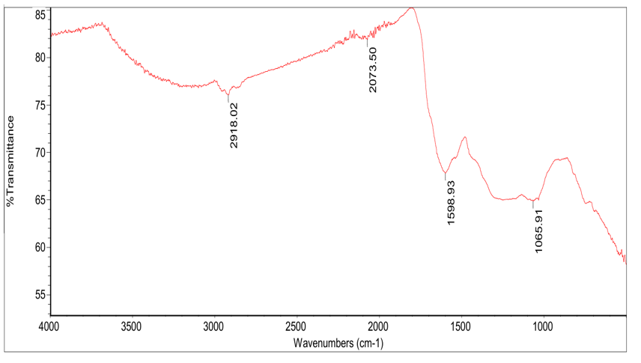

**Figure 1:** FTIR spectra of Activated Bentonite Clay

The FTIR spectra of activated bentonite clay (Figure 1) reveal critical functional groups and chemical interactions governing their adsorption efficacy in transformer oil regeneration. For the Bentonite Clay (Figure 1), Si–O Stretch (~1065.91 cm⁻¹) band corresponds to the stretching vibrations of silicate structures, indicative of the presence of Si–O–Si and Si–O–Al bonds. Zaitan et al. (2007) observed similar peak in 1200–1000 cm−1 region. These structures contribute to the high surface area and porosity of bentonite and palm kernel shell, enhancing its capacity to adsorb polar compounds such as acids and moisture from transformer oil. ​C=C–C Stretch (~1598.93 cm⁻¹) is associated with aromatic ring structures, this band suggests the presence of π-electron-rich regions. These regions can interact with unsaturated hydrocarbons and aromatic compounds in transformer oil through π–π interactions, facilitating their adsorption.​ C≡N Stretch (~2073.5 cm⁻¹) indicates presence of nitrile group, Boadu et al. (2020) observed similar peak in 2000-2300 cm-1 region. Their presence may enhance the adsorption of certain nitrogen-containing impurities through dipole–dipole interactions.​ C–H Stretch (~2918.02 cm⁻¹) is characteristic of aliphatic C–H stretching vibrations, suggesting the presence of alkane groups. Banik et al. (2015) observed peak close to 2920 cm−1. These hydrophobic regions can interact with non-polar impurities in transformer oil, aiding in their removal.​ The absence of bands corresponding to O–H stretching vibrations (3200–3700 cm⁻¹) indicates a reduction in hydroxyl groups due to acid activation as most of functional groups disappeared (Hidayu et al., 2019). This dehydroxylation process increases the surface acidity and porosity of bentonite, enhancing its adsorption capacity for polar impurities such as acids and moisture.

**3.4 Surface Morphology of Activated Bentonite and Palm Kernel Shell (PKS)**

The surface morphology of the activated PKS and bentonite was investigated by Scanning electron microscopy (SEM), and the images were shown with 534µm magnification in Figures 2-3.

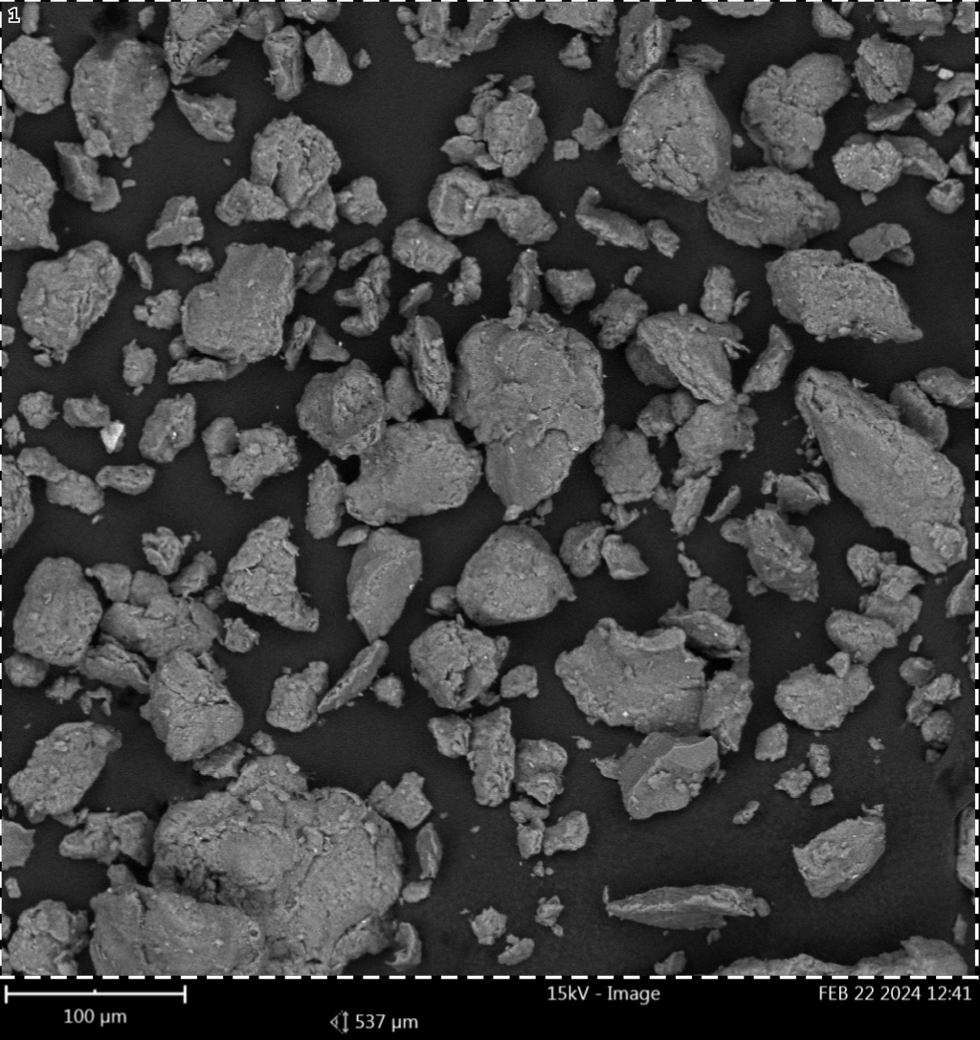

**Figure 2:** SEM Micrograph of Activated Bentonite Clay

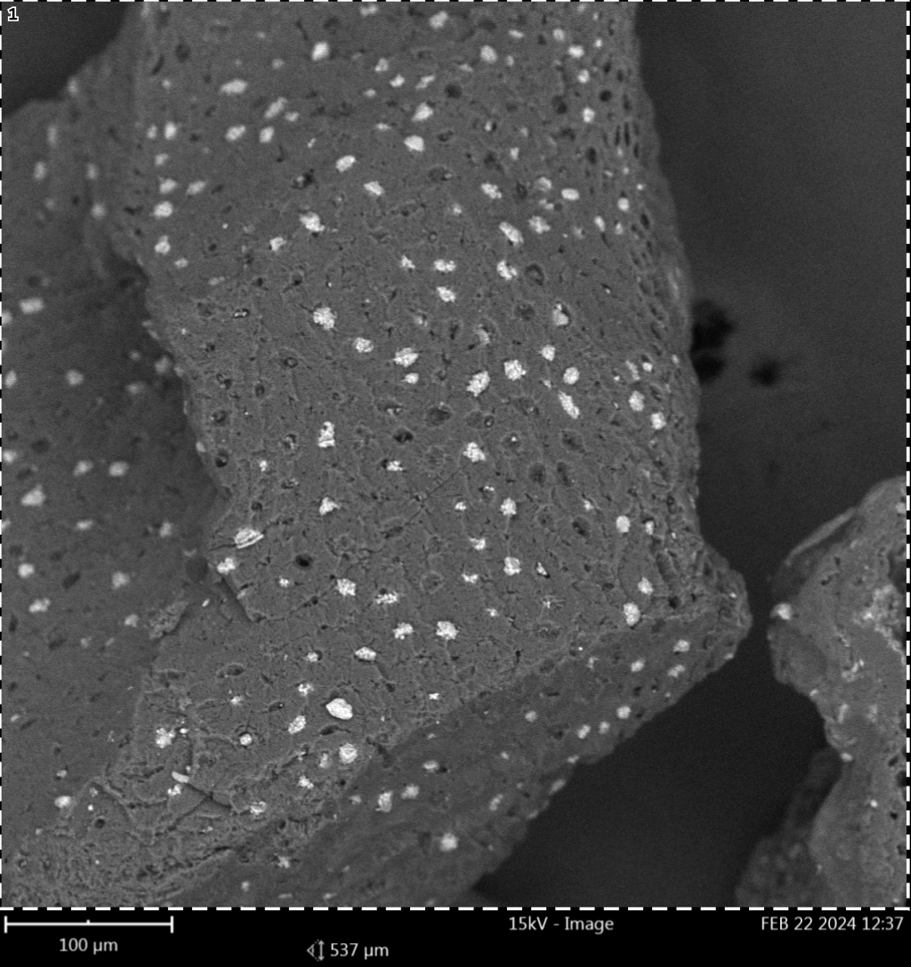

**Figure 3:** SEM Micrograph of Activated Palm Kernel Shell

SEM images (Figures 2–3) elucidate morphological changes induced by acid activation: For Bentonite Clay (Figure 2), it reveals exfoliated layers and honeycomb-like pores, corroborating FTIR-derived porosity enhancement. Then, Palm Kernel Shell (Figure 3), micrograph shows fissures and cavities, aligning with FTIR data on hemicellulose removal. The bentonite shows a layered, flaky morphology with visible mesopores formed by the leaching of interlayer cations during acid activation. Banik et al. (2015) observed massive plates and pores. These pores enhance its capacity to adsorb polar contaminants such as water and acidic degradation products. In contrast, PKS-AC exhibits a rough, fractured surface with abundant micro-fissures and cavities, resulting from the carbonization of lignocellulosic material. Its predominantly microporous structure, combined with a higher surface area (711.92 m²/g vs. 475.10 m²/g for bentonite), makes it effective for adsorbing non-polar compounds like hydrocarbons. The SEM pictures verify that PKS-AC and bentonite have complimentary adsorption properties, with PKS-AC working on non-polar impurities and bentonite on polar ones. It is important to note that the activation treatment optimize adsorbent morphology, with bentonite developing mesopores (ideal for large oil molecules) and PKS acquiring a cracked texture (increasing surface area).

* 1. **Comparative analysis of regenerated transformer oils and spent transformer oil**

The properties of the regenerated transformer oil are compared with those of spent transformer oil in Table 6.

**Table 6: Comparison of regenerated transformer oils with spent transformer oil**

|  |  |  |
| --- | --- | --- |
| Oil Properties | Spent Transformer Oil (STO) | Regenerated Transformer Oil (RTO) |
| Water Content(ppm) | 35.42 | 10.254 (71.05 %) u |
| Acidity(mgKOH/g) | 0.821 | 0.003 (99.64 %) u |
| Kinematic Viscosity at 40 oC (mm2/s) | 18.3 | 10.34 (43.50 %) u |
| Density at 20 oC (g/cm3) | 0.975 | 0.8342 (14.44 %) u |
| Flashpoint (oC) | 144 | 150 (4.17 %) u |
| Fire point (oC) | 156 | 160 (2.56 %) u |
| Breakdown Voltage (kV) | 10 | 60 (83.33 %) u |

u Values in parentheses indicate the percent removal of the used transformer oil.

This provides a comparative evaluation of key physicochemical and electrical properties between the used transformer oil (STO) and regenerated transformer oil (RTO). The regeneration process led to significant improvements across all measured parameters.​ Water Content reduced from 35.42 ppm in STO to 10.254 ppm in RTO, indicating a 71.05% decrease, which enhances the dielectric strength of the oil.​ The acid number decreased from 0.821 mg KOH/g to 0.003 mg KOH/g, representing a 99.64 % reduction, thereby mitigating the risk of corrosion and extending the service life of transformer components.​ Kinematic Viscosity was reduced from 18.3 mm²/s to 10.34 mm²/s, a 43.50 % reduction, improving the oil's cooling efficiency and flow characteristics.​ Density decreased from 0.975 g/cm³ to 0.8342 g/cm³, a 14.44 % reduction, which can contribute to better thermal conductivity and reduced energy losses.​ Flash Point increased from 144 °C to 150 °C, a 4.17 % improvement, enhancing the safety margin against fire hazards.​ Fire Point increased from 156 °C to 160 °C, a 2.56 % increase, further contributing to operational safety.​ Breakdown Voltage (BDV) significantly improved from 10 kV to 60 kV, marking an 83.33 % increase, which substantially enhances the insulating properties of the oil.

1. **CONCLUSION**

This study successfully demonstrated the effectiveness of bentonite clay and palm kernel shell-activated carbon (PKS-AC) as sustainable and potential adsorbents for regenerating spent transformer oil. The activated adsorbents exhibited good performance, achieving 99.64 % acidity removal and 71.05 % moisture reduction, while restoring key oil properties such as viscosity, density, flash point, and breakdown voltage to within acceptable industrial standards. The optimal regeneration conditions (3.4g PKS-AC/30 mL oil, 3.8 g bentonite/30 mL oil, 77 °C, 77 minutes, 744 rpm) highlight the synergistic potential of these natural materials in oil treatment processes.

Based on the result obtained, bentonite and palm kernel shell are veritable adsorbents for regeneration of used transformer oil. This research contributes to sustainable waste management by repurposing agricultural byproducts (palm kernel shells) and natural clays (bentonite), reducing environmental impact while maintaining cost efficiency. To further advance this research, multiple efficiency of bentonite and PKS-AC to determine their reusability and potential cost savings need to be investigated.

**COMPETING INTERESTS**

Authors have declared that no competing interests exist.

**AUTHORS’ CONTRIBUTIONS**

This work was carried out in collaboration among all authors. Author OSO designed the study, performed the statistical analysis, wrote the protocol and wrote the first draft of the manuscript. Authors IE and BOE supervised the literature research and analyses of the study. Author IE supervised all stages of the work. The authors read and approved the final manuscript.

Disclaimer (Artificial intelligence)

Option 1:

Author(s) hereby declare that NO generative AI technologies such as Large Language Models (ChatGPT, COPILOT, etc.) and text-to-image generators have been used during the writing or editing of this manuscript.

Option 2:

Author(s) hereby declare that generative AI technologies such as Large Language Models, etc. have been used during the writing or editing of manuscripts. This explanation will include the name, version, model, and source of the generative AI technology and as well as all input prompts provided to the generative AI technology

Details of the AI usage are given below:

1.

2.

3.

**REFERENCES**

Adekoya, D.O and Adejumobi, I.A. (2017). Analysis of Acidic Properties of Distribution Transformer Oil Insulation: A Case Study Of Jericho (Nigeria) Distribution Network. Nigerian Journal of Technology (NIJOTECH), Vol. 36, No. 2, pp. 563 – 570

Ahmetović, M., Šestan, I., Odobašić, A., Papraćanin, E., Keran, H., Đozić, A., & Junuzović, H. (2024). The Potential of Bentonite as a Low-cost Adsorbent for the Removal of Heavy Metal Ions from Multicomponent Aqueous Systems of the Galvanic Industry. International Research Journal of Pure and Applied Chemistry, 25(2), 28–39. https://doi.org/10.9734/irjpac/2024/v25i2848

Aliev, A., Ganieva, S., Smanov, B., Adizov, B., & Rakhimov, B. (2023). Environmentally friendly regeneration of used energy oils. E3S Web of Conferences, 390, 05043. https://doi.org/10.1051/e3sconf/202339005043

Ani, I.J., Okafor, J. O., Olutoye, M. A. and Akpan, U. G. (2015). Optimization of Base Oil Regeneration from Spent Engine Oil via Solvent Extraction. Advances in Research4(6): 403-411

Arsad, S.R., Ker, P.J., Jamaludin, M.Z., Choong, P.Y., Lee, H.J., Thiviyanathan, V.A., Yang Ghazali, Y.Z. (2023). Water Content in Transformer Insulation System: A Review on the Detection and Quantification Methods. Energies 16, 1920. https://doi.org/10.3390/en16041920

Atanasova‑Höhlein, I. (2021). IEC 60296 (Ed. 5): Fluids for Electrotechnical Applications – Mineral Insulating Oils for Electrical Equipment [Convenor’s overview]. Transformers Magazine, 8(1), 86–95.

Babayemi, A. K. (2017). Performance Evaluation of Palm Kernel Shell Adsorbents for the Removal of Phosphorus from Wastewater. Advances in Chemical Engineering and Science, 07(02), 215–227. https://doi.org/10.4236/aces.2017.72016

Bakrutheen, M., Raymon, A., Pakianathan, P.S. and Rajamani, M.P.E. and Karthik, R. (2014). Enhancement of Critical Characteristics of Aged Transformer Oil using Regenerative Additives. Australian Journal of Electrical and Electronics Engineering, 11:1, 77-86

Boadu, K.O, Joel, O.F, Essumang, D.K and Evbuomwan, B.O., (2018). Comparative Studies of the Physicochemical Properties and Heavy Metals adsorption Capacity of Chemical Activated Carbon from Palm Kernel, Coconut and Groundnut Shells. J. Appl. Sci. Environ. Manage. Vol. 22 (11) 1833–1839, ISSN 1119-8362, DOI: https://dx.doi.org/10.4314/jasem.v22i11.19

Bokang, A.T., Ravi S., Modisa M. (2021). Alternative liquid dielectrics in power transformer insulation: a review. Indonesian Journal of Electrical Engineering and Computer Science Vol. 23, No. 3, pp. 1761-1777

Duraisamy, S., Murugesan, S., Palanichamy, M., & Antony Raj, R. (2022). Restoration of critical dielectric properties of waste/aged transformer oil using biodegradable biopolymer-activated clay composite for power and distribution transformers. Biomass Conversion and Biorefinery, 12(10), 4817–4833. https://doi.org/10.1007/s13399-022-03065-0

Durairaj, K. P., Rengaraj, R., Perumalsamy, A., & Ananthan, B. (2024). Assessing remaining life of reclaimed transformer oil with magnesium oxide absorbent for biorefinery sustainability. Electrical Engineering. https://doi.org/10.1007/s00202-024-02812-y

Gainullina, L. R., & Tutubalina, V. P. (2020). Adsorption Dehydration of Transformer Oil of Selective Treatment. *Journal of Engineering Physics and Thermophysics*, *93*(2), 324–328. DOI: 10.1007/s10891-020-02124-5

Hadjadj, Y. and Fofana, I. (2015). Assessing Insulating Oil Degradation by Means of Turbidity and UV/Vis Spectrophotometry Measurements. IEEE Transactions on Dielectrics and Electrical Insulation Vol. 22, No. 5, pp 2653-2660

Hafez, A., Gerges, N., El-nagar, K., Mohamed, S. and Hashem, A. (2015). Treatment of aged transformer oil using dry sludge in lab-scale refining unit. Journal of Oil, Gas and Coal Engineering. Vol. 2(1), pp. 010-022

Hafez,A. I., El deeb,A. M., El behairy,M. H., Khalil, E. M. and Abd el fattah M. S. (2019). Study on the Treatment of High Voltage Used Transformer Oil by Using Natural Material. IOSR Journal of Applied Chemistry (IOSR-JAC), Volume 12, Issue 10, Ser. I, PP 19-36

Inyinbor, A.A., Adekola, F.A and G.A. Olatunji, G.A. (2016). Liquid Phase Adsorption of Rhodamine B Dye onto Acid-treated Raphia hookeri Fruit Epicarp: Isotherms, Kinetics and Thermodynamics Studies. S. Afr. J. Chem., 2016, 69, 218–226

Jaber Ibrahim, A., Abdul Wahid Dwesh, H., & R.Y. Al-Sawad, A. (2023). Adsorption of methylene blue dye onto bentonite clay: Characterization, adsorption isotherms, and thermodynamics study by using UV-Vis technique. Analytical Methods in Environmental Chemistry Journal, 6(3), 5–18. https://doi.org/10.24200/amecj.v6.i03.243

Lai, J. Y., & Ngu, L. H. (2024). Post-combustion carbon dioxide adsorption of concurrent activated and surface modified palm kernel shell-derived activated carbon. Greenhouse Gases: Science and Technology, 14(3), 492–525. https://doi.org/10.1002/ghg.2274

Mariprasath, T. and Kirubakaran, V. (2016). Thermal degradation analysis of pongamia pinnata oil as alternative liquid dielectric for distribution transformer. Indian Academy of Sciences, Sadhana Vol. 41, No. 9, pp. 933–938

Medeiros, A. D. M. D., Silva Junior, C. J. G. D., Amorim, J. D. P. D., Durval, I. J. B., Costa, A. F. D. S., & Sarubbo, L. A. (2022). Oily Wastewater Treatment: Methods, Challenges, and Trends. Processes, 10(4), 743. https://doi.org/10.3390/pr10040743

Naswir, M., Arita, S., Hartati, W., Septiarini, L., Desfaournatalia, D., & Wibowo, Y. G. (2019). Activated Bentonite: Low-Cost Adsorbent to Reduce Phosphorus in Waste Palm Oil. International Journal of Chemistry, 11(2), 67. https://doi.org/10.5539/ijc.v11n2p67

Pahlavanpour, B. and Habibollahi, H. (2019). Characterisation of Insulating Oils. 6th Distribution Networks Conference

Permady, M. W. E., & Mustakim, Z. (2024). ADSORPTION OF METHYLENE BLUE DYES USING PALM KERNEL SHELLS AS ADSORBENTS. Jurnal Integrasi Proses Dan Lingkungan, 1(2), Article 2. https://doi.org/10.30587/jipl.v1i2.7130

Prasad, R., P V ,Nisha, Khan , Huma, & and T, J. (2024). Sustainable regeneration of transformer oil through composite adsorbent of chitosan and sepiolite: A biorefinery approach. Energy Sources, Part A: Recovery, Utilization, and Environmental Effects, 46(1), 10861–10884. https://doi.org/10.1080/15567036.2024.2387827

Safiddine, L., Hadj‐Ziane Zafour, A., Fofana, I., Skender, A., Guerbas, F., & Boucherit, A. (2017). Transformer oil reclamation by combining several strategies enhanced by the use of four adsorbents. *IET Generation, Transmission & Distribution*, *11*(11), 2912–2920. https://doi.org/10.1049/iet-gtd.2016.1995

Salvi, S. and Paranjape, A.P. (2017). Study of Transformer Oil Purification, SSRG International Journal of Electrical and Electronics Engineering, vol. 4, no. 3, pp. 16-19

Sambo, G. N., Adeola, A. O., & Muhammad, S. A. (2024). Oil palm waste-derived adsorbents for the sequestration of selected polycyclic aromatic hydrocarbons in contaminated aqueous medium. Applied Water Science, 14(6), 113. https://doi.org/10.1007/s13201-024-02171-w

Soares, M. E., Araujo, A. J., Silva, F. S., Silva, M. R. A., & Barbosa, N. V. (2023). Regeneration of transformer oil using a microemulsion with Triton X-100. Brazilian Journal of Chemical Engineering, 40(3), 901–911. https://doi.org/10.1007/s43153-021-00113-6

Sun, W.-J., Tang, Q.-T., Lu, T.-H., Fan, R.-D., Sun, G.-G., & Tan, Y. (2024). Adsorption performance of bentonite and clay for Zn(II) in landfill leachate. Geoenvironmental Disasters, 11(1), 4. https://doi.org/10.1186/s40677-023-00265-2

Taha, G., Nasrat, L. and Younes, G (2020). Improvement of Some Chemical and Electrical Properties of Aged Transformer Oil using Eco-Friendly Fillers. Aswan University Journal of Environmental Studies (AUJES), Vol. 1, No. 2, pp. 137-146, DOI: 10.21608/aujes.2020.127569

Thanigaiselvan, R. and Raja, T.S. (2016). Enrichment of used Transformer Oil using Activated Bentonite and Comparison of Various Transformer Oils with Vegetable Oil. International Journal of ChemTech Research, Vol.9, No.01 pp 128-133

Tiwari, R., Agrawal, P. S., Belkhode, P. N., Ruatpuia, J. V. L., & Rokhum, S. L. (2024). Hazardous effects of waste transformer oil and its prevention: A review. Next Sustainability, 3, 100026. https://doi.org/10.1016/j.nxsust.2024.100026

Vanitha, M., Narmadhai, N. and Karthik, M. (2016). Investigation of Critical Characteristics of Transformer Oil with Activated Carbon. Circuits and Systems, 7, 2521-2529. http://dx.doi.org/10.4236/cs.2016.79218

Yassin, J.M., Shiferaw, Y. and Tedla, A. (2022). Application of acid activated natural clays for improving quality of Niger (Guizotia abyssinica Cass) oil. Heliyon 8 (2022) e09241

Yu, H., Chen, R., Hu, X., Xu, X., & Xu, Y. (2017). Dielectric and Physicochemical Properties of Mineral and Vegetable Oils Mixtures. 19th IEEE International Conference on Dielectric Liquids (ICDL), Manchester, United Kingdom, 25 – 29

Zambrano, M.V., Dutta, B., Mercer, G.D., Heather L. MacLeana, L.H. and Touchie, M.F. (2019). Assessment of moisture content measurement methods of dried food products in small-scale operations in developing countries: A review. Trends in Food Science & Technology 88 (2019) 484–496

Zhang, Q.Y., Wu, J.F., Ma, P.H., Cai, J. and Zhang, Y.T. (2015). Acid Value Determination and Pre-Esterification of Crude Euphorbia lathyris L. Oil. World Journal of Engineering and Technology, 3, 70-75. http://dx.doi.org/10.4236/wjet.2015.32007