**EVALUATION OF YEAST STRAIN DIVERSITY FROM WILD EDIBLE FRUITS FOR WINE MAKING PROCESS**

**ABSTRACT**

|  |
| --- |
| *Phyllanthous emblica* L. (popularly known as amla or Indian goose berry) is an ephemeral tree belonging to the *Euphorbiaceae* family and Woodapple, also known as *Feronia limonia* or *Limonia acidissima*, is an underutilized dry land fruit crop, also known as kitha, kaintha bel, kothbel, and monkory fruits. In current study, the fresh fruit sample of amla and wood apple were collected from their natural habitat near Harapanahalli, Davangere district. The isolation of yeast involved serial dilution followed by plating techniques, including spread plate and streak plate methods, to assess morphology and recovery. The isolated yeast strain was identified through morphological and biochemical characterization and further confirmed by genomic characterization using 16S rRNA gene sequencing. It was deposited in GenBank, NCBI, and identified as *Pichia cecembensis* strain KUMBSRNGBT-115 with the accession number PQ316097. Biochemical analysis included pH determination, which indicated an acidic condition at pH 3.5, and reducing sugar estimation using the DNS method, which showed 0.35 mg/mL for wood apple and 0.42 mg/mL for amla. Titratable acidity was measured, with values of 0.9 mg/mL for amla and 1.5 mg/mL for wood apple. The phenol (tannin) content was estimated to be 0.24 mg/mL for amla and 0.64 mg/mL for wood apple. The fermentation process was successful, characterized by carbon dioxide production and sugar reduction, indicating the yeast's ability to convert fruit sugars into alcohol. The sugar content in the fruit must significantly influence the alcohol yield and the production of secondary metabolites like phenols, which contributed to the wine's flavor and health benefits. |

***Keywords:*** *Phyllanthous emblical L, Feronia limonia, GenBank, Pichia cecembensis, reducing sugar and titrable acidity.*

**Graphical Abstract**

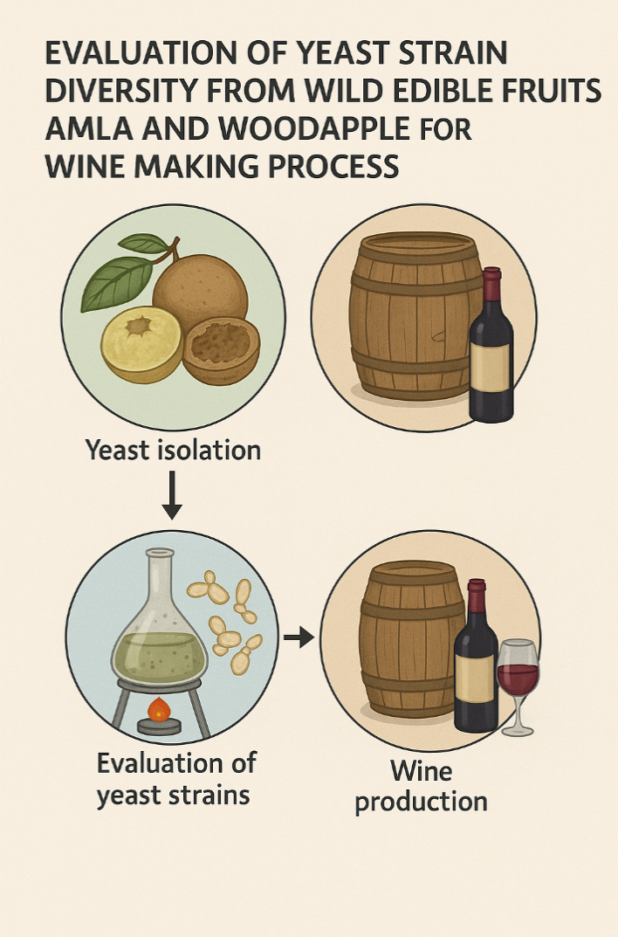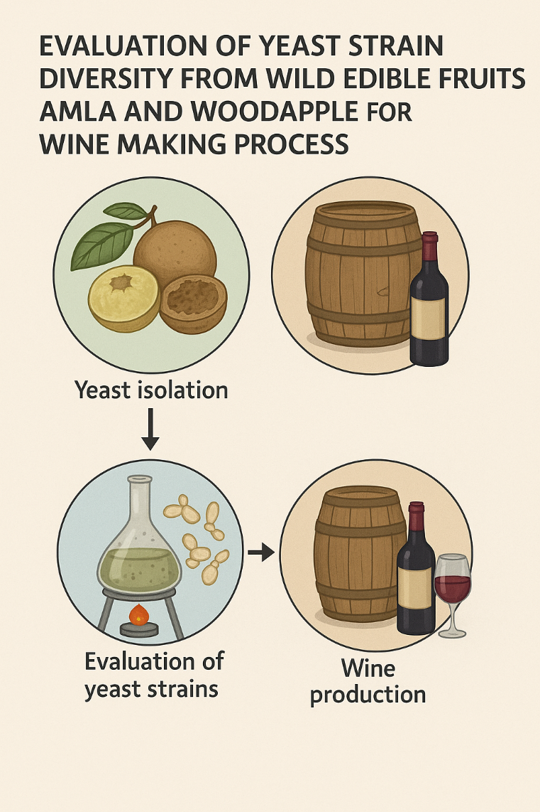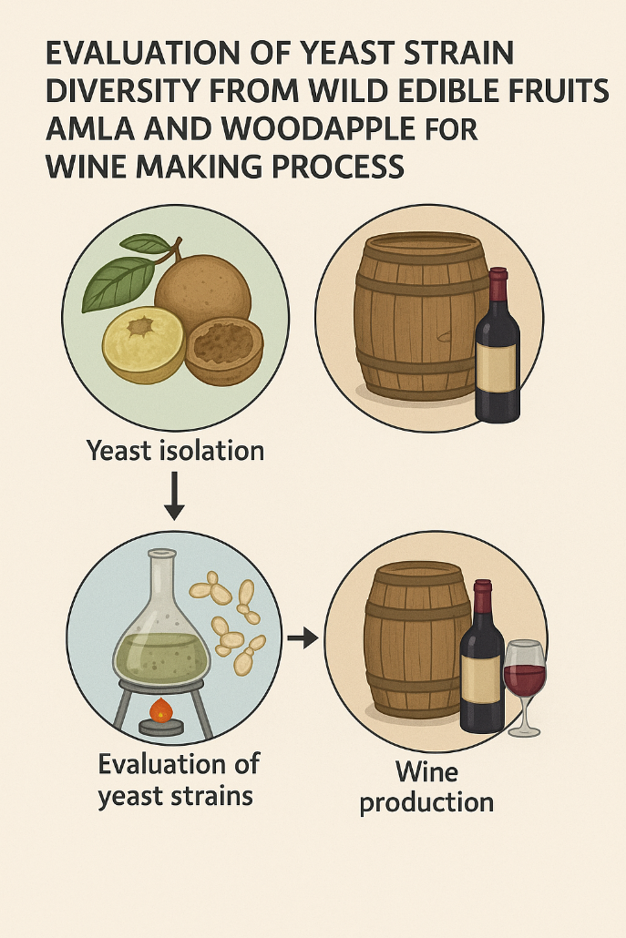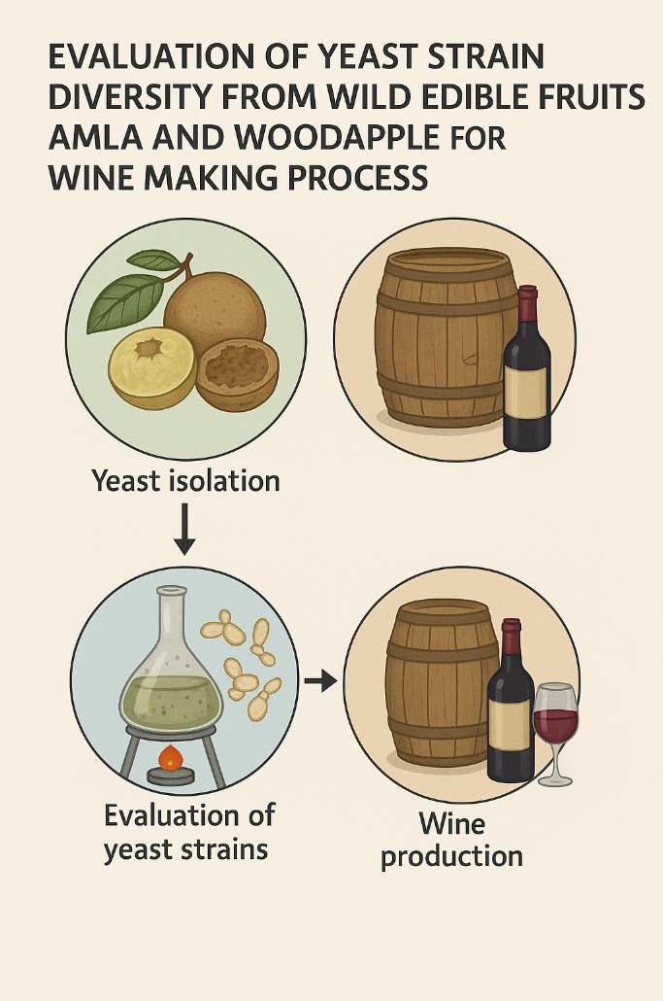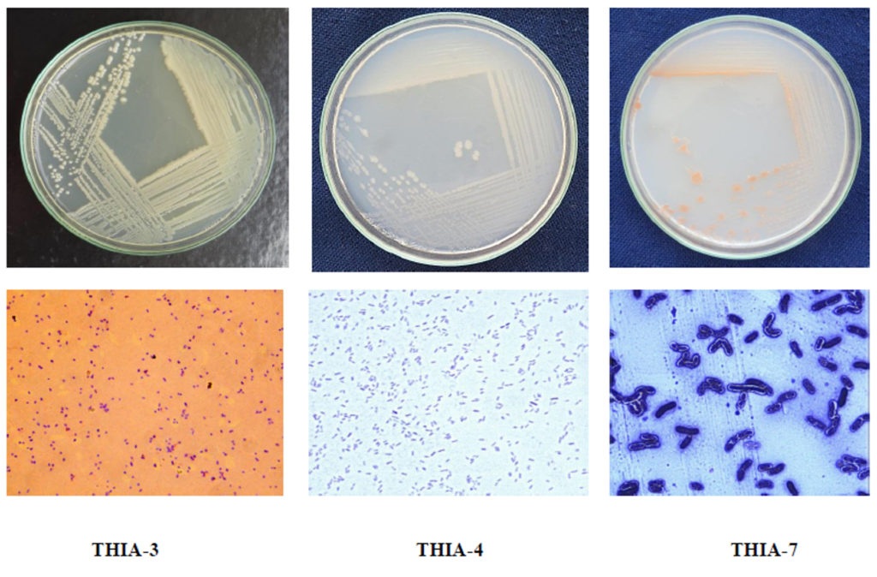

1. **INTRODUCTION**

Today’s modern world, where healthy life style is the key to achieving longevity and balanced diet, the food industry has emerged with a wide range of innovative ideas that can alter our diet and life style. Fermentation is known to mankind since time immoral and has played a significant role in industries and homes. The fermented foods and drinks are always loaded with extra nutrients that are beneficial our health and helps improve our overall body system. Fermentation is a natural process and has a wide range of benefits. Wine one of the most common drink in western countries which is prepared by using grapes and undergoes fermentation but in today’s world, the word wine can be applied to drinks which can be prepared by using a wide array of seasonal fruits and berries. Tropical and sub-tropical fruit are available in plenty during season and they can be used for other processing but at times it can be wasted if no proper processing and transportation are available in especially in small scale. Converting the fruit juice or berries in to a wine can be an added advantage not only to formers but also production and increasing economy. The wines prepared from other fruits and berries can have slight difference in the extraction and processing method due to different pulp and juice ratio including the sugar and acid content but still they can be made into wines without problems (Jarauta et al., 2005).

Compare to commercial grapes wines, fruit and berry wines are prepared mostly in traditional home made method rather than industrial method and hits a very and basic steps which is easy and fun to learn. Amelioration is usually done when comes to berries which have low sugar content and high acid in order to balance the composition but that doesn’t alter the wine characteristics. The advantage of wine making is that the longer the wine age the better it gives flavor and texture and also being fermented based it does; It get contamination if properly handled from the start of the wine preparation, exceptional cases of contamination occurs when pH is too high or too much air is goes inside or improper handling of the wine during bottling.

Wine making can reduce fruit wastage and add more increase in production. The advantage of using fruits for making wines is because fruits have a lot of vitamins and minerals and have a compound that is antioxidant which help to kill the free radicals present in our cell which can help our body fight against disease and helps to keep our body and skin free from disease. Tannins are present wine which are responsible for the taste, texture and also for the color. The minimum percentage of alcohol content in most of the wines are between 5 and 13%. Wines made from fruits often named after the fruits. No other drinks, except water and milk, have earned such universal acceptance and esteem throughout the ages as in wines (Amaley et al., 2016).

* 1. **AMLA**

**Botanical description**

The tree is small to medium in size, reaching 1–8 meters (3+1⁄2–26 feet) in height. The bark is mottled. The branches are finely pubescent (not [glabrous](https://en.m.wikipedia.org/wiki/Glabrousness)), 10–20 cm (4–8 inches) long, usually deciduous. The [leaves](https://en.m.wikipedia.org/wiki/Leaves) are simple, [subsessile](https://en.m.wikipedia.org/wiki/Subsessile) and closely set along branches, light green, resembling [pinnate](https://en.m.wikipedia.org/wiki/Pinnate) leaves. The flowers are greenish–yellow. The fruit is nearly spherical, light greenish–yellow, quite smooth and hard on appearance, with six vertical stripes or furrows. The fruit is up to 26 mm (1 in) in diameter, and, while the fruit of wild plants weigh approximately 5.5 grams, cultivated fruits average 28.4 g 1 to 56 g.

*Phyllanthous emblical* L. (popularly known as amla or Indian goose berry) is an ephemeral tree belonging to the *Euphorbiaceae* family. Amla fruits are edible and are mainly found in regions of India, Southeast Asia, China, Iran, and Pakistan. Amla has an important role in the traditional medicine of India to reduce anxiety and burning sensation in skin and eyes, improve anemic condition, favors the health of male reproductive system reproduction, facilitate digestion, improve liver health, and also exert a tonic effect in the cardio vascular system (Deshmukh and Deshmukh 2021).

The fruit of *P. emblica* L. is one of the most popular botanicals, with a wide range of uses in the medicinal, cuisine, and cosmetic industries. This is the first tree to be “produced in the universe”, according to ancient Indian mythology. It is a great nutritional supplement with several medicinal benefits. Due to abundance phenolic compounds, Emblic fruit could be regard as a plant source for natural anti-oxidants and neutraceuticals or medicinal components. Consumers like embolic fruits because of its unique flavor and pleasant smell. In various animal and human investigation, amla has been proven to have anti-hyper glycemic, hypoglycemic, anti-inflammatory, antihyper lipidemic and antioxidant activities. Amla is rich in antioxidant gallic acid, ascorbic acid and phenolic compounds and thus helps the body’s immune system and digestion. Thus, due to the increasing interest and potential if *P. eblica* L., this review aims to provide an over view of the nutritional composition, phytochemistry and potential health benefits associate with the conception of Phyto-chemical naturally found in amla (Amaley et al., 2016).

* + 1. **Nutritional Composition of Amla**

Amla fruits are a relevant source of carbohydrates that account for >70 g/100 g dry weight (DW). Fiber is another relevant component (7.2–16.5 g/100 g DW) as well as contents of protein, minerals such as (iron, calcium and phosphorous), and fat (2.0–4.5, 2.1–3.1, and 0.2–0.6 g/100 g DW, respectively). The variability in the composition of amla fruit has been attributed to the cultivar in many studies.

Another important component found in amla fruit is ascorbic acid (vitamin C). Values between 193 and 720 mg/100 g have been reported in different studies that evaluated a different variety of amla. Although the optimum recommended daily intake has not been defined yet due to the emergency of new factors from modern society, many governmental health authorities around the globe established Recommended Dietary Allowance (minimum level to meet the need for a healthy person for a day) that varies between 40 and 110 mg vitamin C/day. Moreover, the Australian and China health authorities have proposed a daily intake of 190–220 mg/day. In this sense, a serving portion of at least 100 g of fresh amla fruits (2–3 pieces) from any of the varieties indicated in should suffice the daily need for vitamin C (Argade and Pande 2015).

* 1. **WOODAPPLLE**

**Botanical description**

Woodapple scientifically known as *Feronia limonia* or *Limonia acidissima*, is an underutilizes dry land fruit crop and also known vernacular names like kitha, kaintha bel, kothbel and monkory fruits. It belongs to family *Rootaceae*. In India, it has consumed either raw or ripe. Growing habits are deciduous, erect, and spreading. It has a strong root system, making it draught resilient, and it prefers light to heavy soils. The fruits of the wood apple tree have curative characteristics making it one of India’s most beneficial medicinal plants. It contains nutritious and therapeutic value, as well as astringent characteristics and a role in the cardiovascular system.

**1.2.1. Origin and Distribution**

South India and Sri Lanka are the origins of the wood apple. It grows in a variety of tropical and subtropical climates, including India, Pakistan, Sri Lanka, and Southeast Asia. It is an extremely hardy tree that may be found throughout India's plains in the northern, central, eastern, and southern areas, particularly in the semi-arid and arid regions of Maharashtra and Madhya Pradesh.

**1.2.2. Soil and climate**

Sandy loam or deep loam with a pH of 7-7.5 and well-drained soils are required for excellent yield potential and good plant growth. It can adapt to a wide range of ecological circumstances, owing to its extensive geographical distribution, which ranges from tropical and subtropical to arid and semiarid environments. It is an excellent fruit tree for semi-arid and desert environments. It is highly suitable fruit tree for semi-arid and arid ecosystem.

**1.2.3. Nutritive value**

Wood apple seeds have a nutritional value of moisture 4.0%, protein 26.18%, fat 27%, carbohydrates 35.49%, ash 5.03%, calcium 1.58%, phosphorus 1.43%, iron 0.03% and tannins 0.08% per 100 gm of (ripe) edible pulp.

**Botanical description**

A small to medium-sized deciduous tree with thorny branches that grows up to 10 meters tall with a 0.6-1.6-meter girth and a short cylindrical trunk that grows throughout India in dry and warm climates up to 450 meters elevation. It's a polygamomonoecious tree with a spiky, rough bark. Dark green, leathery, often minutely serrated, and blunt or notched at the apex, the deciduous, alternating leaves are 7.5-12.5 cm long. When crushed, they have oil glands and have a subtle lemon fragrance. New branches on the terminal or axillary panicle produce a large number of tiny flowers. Flowering occurs from February through the first week of June. The majority of flowers are staminate and hermaphrodite. The fruit is botanically berry.

The tree is small to medium in size, reaching 1–8 meters (31⁄2–26 feet) in height. The bark is mottled. The branches are finely pubescent (not [glabrous](https://en.m.wikipedia.org/wiki/Glabrousness)), 10–20 cm (4–8 inches) long, usually deciduous. The [leaves](https://en.m.wikipedia.org/wiki/Leaves) are simple, [subsessile](https://en.m.wikipedia.org/wiki/Subsessile) and closely set along branches, light green, resembling [pinnate](https://en.m.wikipedia.org/wiki/Pinnate) leaves. The flowers are greenish–yellow. The fruit is nearly spherical, light greenish–yellow, quite smooth and hard on appearance, with six vertical stripes or furrows. The fruit is up to 26 millimetres (1 in) in diameter, and, while the fruit of wild plants weigh approximately 5.5 grams, cultivated fruits average 28.4 g to 56 g (Argade and Pande 2016).

1. **MATERIALS AND METHODS**

**2.1. Collection of samples:**

The healthy plants samples were collected aseptically with the help of secateurs. Photographs of plants were taken in their habitat and GPS (Global Positioning System) locations of the sampling site were documented and the collected samples were placed in clean paper bags and brought into the laboratory. The fresh fruit samples [*Limonia acidissima*](https://www.sciencedirect.com/topics/agricultural-and-biological-sciences/limonia-acidissima) were collected from the local market, near Chowkipet Road, Davangere. The collected fruits were placed in polythene bag and brought into the laboratory.

**2.1.1. Morphological characterization**

Amla Fruits are present in clusters along the leaf axils. Fruit surface is shiny with translucent appearance and hard in texture. Raw fruits are green in color and become greenish-yellow on ripening. Amla consists of three celled nuts. Each cell holds two triangular seeds which are round and have sharp edges.

The woo apple fruit is a [berry](https://en.wikipedia.org/wiki/Berry_(botany)) 5–9 cm diameter, and may be sweet or sour. It has a very hard rind which can be difficult to crack open, it appears greenish-brown in color from outside and contains sticky brown pulp and small white seeds. The fruit looks similar in appearance to the [bael](https://en.wikipedia.org/wiki/Aegle_marmelos" \o "Aegle marmelos) fruit *(Aegle marmelos)*. It contains considerable amount of protein, carbohydrate, iron, fat, calcium, Vit-B & C etc. 100 g of ripe fruit pulp contains up to 49 KCal (Manthena *et al*., 2014).   
**2.2. Recovery of isolates**

To isolate yeasts from wood apple fruit sample, 1 mL of rotten fruit juice was suspended into test tubes containing 9 mL distilled water.

Flow chart 1: Recovery process of isolates

**Morphological characterization**

**Collection of fruit sample**

**Isolation of Yeast**

**Identification of yeast**

**Recovery of Yeast**

**Biochemical characterization**

**Streak Plate**

**Spread plate**

**Biochemical analysis**

**pH determination**

**Determination of reducing sugar**

**Titrable acidity**

**Determination of alcohol by specific gravity**

**Determination of phenol (tannin) content**

**Molecular characterization**

**Preparation of wine**

**Preparation Starter culture**

**Must Fermentation**

**Racking and bottling**

**2.2.1. Isolation of yeast:**

One mL of samples from the test tube was transformed into 9 mL of normal saline (0.85%) blank and further dilutions were made up to 10-6 by adding 1ml from previous dilution to next dilution. Serially diluted sample was then inoculated on the Yeast extract peptone dextrose Agar media plates by plating out 0.1mL of 10-2, 10-4 and 10-6 dilutions.

**2.2.2. Spread plate method**

Using a sterile glass rod 0.1 mL of each dilution was spreaded on the yeast extract peptone dextrose agar media plates and then observed the characteristics of colonies after incubating Petri plates for 72 h at 21 ℃. Studies were done on colony morphology with naked eyes and with the help of microscope.

**2.2.3. Streak plate method**

From the colonies obtained on the Yeast extract peptone dextrose Agar media plates, single separate colony was picked and inoculated on fresh Yeast Extract peptone dextrose media plate.

**2.3. Biochemical Tests**

Urease test, Gelatine hydrolysis test, Hydrogen sulphide test, Oxidase test and Catalase test

**2.3.1. Haemolysis test**

Blood agar media is prepared and poured on to the sterile Petri plates and allowed to solidify. Using a sterile inoculating loop, pick up a well isolated colony of yeast from fresh culture and streak on blood agar plates. Incubate the plates at 35-37 °C for 24 h. Examine the agar for changes around the bacterial colonies to determine the type of hemolysis (Soni et al., 2009).

**2.4. Genomic characterization**

The identification of the isolated fungi based on morphological characteristics was complemented by means of the internal transcribed spacer (ITS) sequences. This DNA fragment included the 3' end of the 18S rDNA, ITS1, the 5.8 rDNA, ITS2, and the 5' end of the 28S rDNA. The ITS was amplified using primers ITS1 and ITS4 (White et al. 1990). Amplification reactions were performed in a 50-µl reaction volume under the following PCR cycling conditions: one cycle of denaturation at 95º C for 3 min, followed by 34 cycles of denaturation at 95º C for 1 min, annealing at 52º C for 30 sec, and elongation at 72º C for 1 min, with a final extension step of 72º C for 10 min. The PCR products of approximately 550 bp length were resolved in 1% agarose gels stained with ethidium bromide. The PCR products were sequenced by mean of the mentioned primers in an Applied Biosystem 3130 sequencer as described by Sanger et al. (1977).

**Phylogenetic analysis**

The ITS sequence of *Pichia cecembensis* strains were compared with those of 15 species of *Pichia* and its related genera available in the National Center for Biotechnology Information (NCBI) gene bank. Sequences were aligned using the clustal W BioEdit version five. Maximum parsimony analysis was performed and the branches were supported by the bootstrap method (100 replicates). A dendrogram was generated based on the rDNA sequences by means of the Mega5 Software (Tamura et al., 2011).

**2.5. Biochemical Analysis**

**2.5.1. pH determination**

10 mL of the “must” was put into a sterile beaker, and the pH of the must determine using a pH a digital pH meter.

**2.5.2. Determination of reducing sugar**

1 ml of 3, 5- Dinitrosalicyclic acid (DNS) was poured to 1 ml of supernatant of sample, in a test tube and the mixture was then heated in water bath for 10 min. The test tube was then cooled rapidly under tap water and the final volume was adjusted to 12 ml with distilled water. The optical density of the sample was read against the blank in the spectrophotometer around 540 nm absorbance.

**2.5.3. Titrable acidity**

A measured volume of the wine sample, usually 10 mL, was transferred to a conical flask. A few drops of phenolphthalein indicator were added. A burette was filled with the standardized sodium hydroxide (NaOH) solution. The sample was titrated against the NaOH, the titration continued until a color change was observed, indicating the endpoint was reached. In this case, the phenolphthalein changed from colorless to pink, signifying that the wine’s acidity had been neutralized. The titratable acidity was calculated using the formula:

$$Total titrable aciditiy= \frac{(Volume of NaOH (mL)×Normality of NaOH ×1000)}{ Volume of wine sample in mL}$$

**2.5.4. Determination of alcohol content by specific gravity:**

50 mL specific gravity bottle was thoroughly cleaned and dried. The weight of the dried bottle (W1) was recorded. It is then filled with deionized water and surface of the bottle was cleaned with a cotton wool and weighed as (W2). The bottle was empty and cleaned twice with 10ml of the must. Thereafter, the bottle was filled to the brim with the “must” and the bottle cleaned with cotton wool and weighed as (W3). The specific gravity (S.G) was calculated as follows:

**S.G = S/W**

Where, S = (W3-W1); W = (W2-W1)

**2.5.5.** **Determination of phenol (tannin) content**

The total phenol content of the fruit extract was determined by using Folin-clocalteu method 0.5 mL of wine sample was mixed with 0.5 mL Fc reagent (1:10 dilution) to the mixture. 2% sodium carbonate solution was added and vortex vigorously. Tubes were incubated for 30 min at room temperature. .and the absorbance at 765nm. Gallic acid was used as standard. Standard graph was plotted for the concentration 0-1000g/mL of gallic acid. The total phenolic content of fruit extract will be expressed as gallic acid equivalent in mg/mL.

**2.6. Preparation of Starter Culture**

200 mL of fruit juice was taken in conical flask to this 20g of sugar was added. Then the content of fruits was heated in water bath at 80c for 30 min, then the flask was cooled and yeast was added under aseptic condition then it was incubated at room temperature for 1 day (Sonawane and Arya 2013).

**2.6.1. Must Fermentation**

The amla and wood apple fruits were washed carefully with 0.1% sodium metabisulphite solution. The fruits were incised, manually deseeded; pulp was separated, blended and filtered to obtain the must. Aliquots of the must were obtained and used for pH, temperature, titrable acidity and reducing sugar analysis. The must was poured into a sterile 1000 ml glass fermenter. This was followed by the addition of 100mg/mL of Sodium metabisulphite (anti-microbial), 100g of granulated sugar. The juice was inoculated with yeast and kept for period of 21 days to ferment. Analysis of pH, temperature, reducing sugar and titrable acidity parameters (Nandagopal and Nair 2013).

**2.6.2. Racking and Bottling**

Initial racking was carried out at ambient temperature. Racking of the amla and wood apple wine was carried out when total soluble solids (TSS) reached around 3.5˚ Brix. 0.035% Bentonite was added before the final racking to remove the last remaining residues. After final racking, 100 mg/ ml of sodium metabisulphite was again added as preservative before bottling. The bottles were filled full with wine, corked and sealed (Sarkar and Singhal 2018).

**3. RESULTS**

**3.1. Collection and Identification of plant sample**

Fruit samples were collected in the local market of Davanagere district, Karnataka, India, lies between Latitude: 14.4724° N, Longitude: 75.9196° E (Fig. 1).

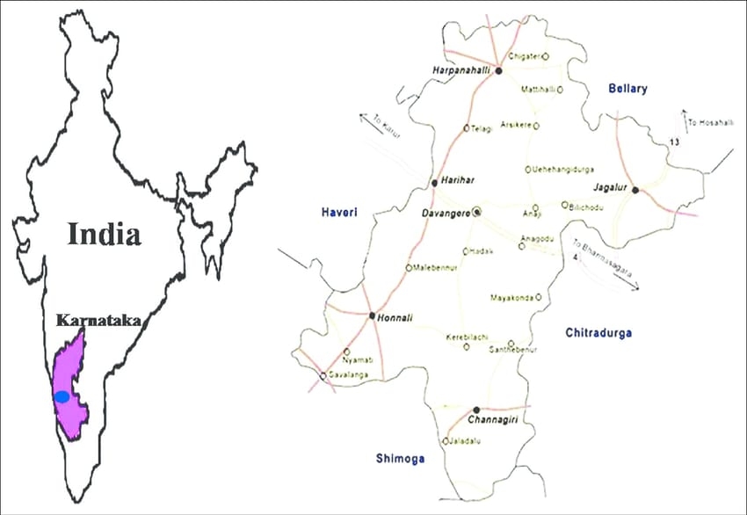

**Fig. 1.** Location of sample collection site

**Taxonomic features of** [***Limonia acidissima***](https://www.sciencedirect.com/topics/agricultural-and-biological-sciences/limonia-acidissima)**and *Emblica officinalis***

***Limonia acidissima* (Wood Apple)**

*Limonia acidissima*, commonly known as wood Apple, the tree was small deciduous type, growing up to 9 meters in height. Its leaves were pinnately compound with 5-7 lanceolate-shaped, dark green leaflets. The flowers were small, white, and aromatic, usually found in clusters or solitary. The fruit was round, woody, and had a hard shell, commonly known as wood apple (Fig. 2). The pulp inside was brownish and had a strong, sour smell. Multiple seeds were embedded in the fruit pulp. It was mainly found in South Asia, particularly in India and Sri Lanka, in dry, deciduous forests (Murthy and Dalawai, 2020), .

**Kingdom :** Plantae

**Phylum :** Angiosperms

**Class :** Eudicots

**Order :** Sapindales

**Family :** Rutaceae

**Genus :** *Limonia*

**Species :** *Limonia**acidissima*

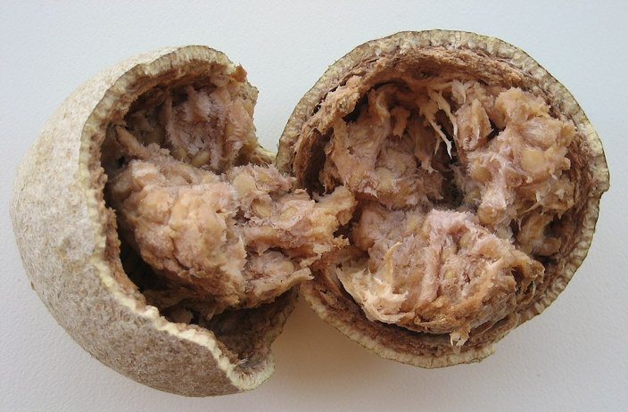

**Fig. 2.** Wood Apple

***Emblica officinalis* (Indian Gooseberry or Amla)**

Indian gooseberry, also known as amla, is a fruit tree native to Asia, with culinary and herbal medicine applications in India. It is rich in vitamin C and has potential antioxidant and heart-health benefits. The tree has yellow-green flowers and edible fruits, which are sour, bitter, and astringent (Fig. 3). The fruit is used in cooking in India, and most supplements are made from powdered, dried fruit or fruit extracts. However, the whole plant, including the fruit, leaves, and seeds, is used in traditional Indian medicine (Srinivasan, 2020)*.*

**Kingdom :** Plantae

**Phylum :** Angiosperms

**Class :** Eudicots

**Order :** Myrtales

**Family :** Phyllanthaceae

**Genus :** *Phyllanthus*

**Species :** *Phyllanthus**emblica*

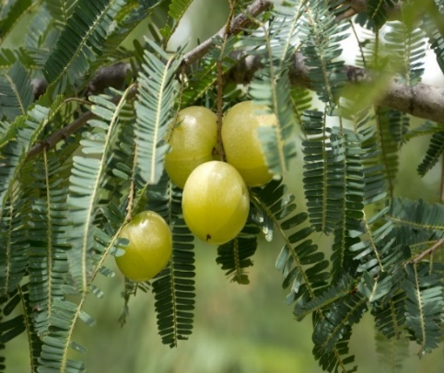

**Fig. 3.** Amla

**3.2. Recovery of isolates**

Yeast was isolated from the fruit samples by following a serial dilution method. First, 1 mL of the fruit sample was transferred into 9 mL of sterile distilled water, and further dilutions were made up to 10^-6 by transferring 1 mL of the diluted solution to the next dilution tube.

For the spread plate method, 0.1 mL of each dilution (10-2, 10-4, and 10-6) was spread evenly on Yeast Extract Peptone Dextrose Agar (YPD) plates using a sterile glass rod. The plates were incubated at 21°C for 72 h. After incubation, the colonies were observed, and their morphology was recorded (Fig. 3).

Following this, the streak plate method was employed. A single isolated colony from the spread plate was picked using a sterile inoculation loop and streaked onto fresh YPD agar plates. These plates were incubated under the same conditions, and the colony characteristics were observed.

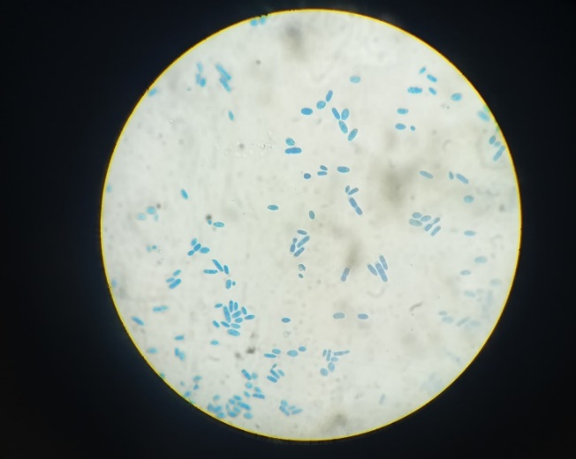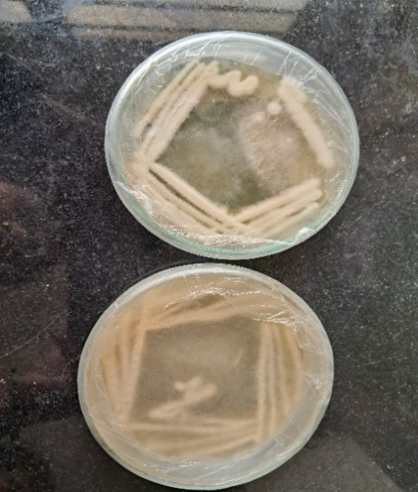

**Fig. 3.** Microscopic view of Yeast (100X)

**3.3. Biochemical tests**

**3.3.1. Urease test**

The urease test performed on the yeast isolated from wood apple produced a positive result. The test involved inoculating a urea-containing medium with yeast, which metabolized urea and released urease, an enzyme that hydrolyzed urea into ammonia and carbon dioxide. This increased pH caused an alkaline environment, as seen through a color shift in the pH indicator. This confirmed the yeast's urease activity, indicating its ability to use urea as a nitrogen source.

**3.3.2. Gelatin test**

The negative result of the gelatin test shown by the yeast isolated from wood apple indicated that the yeast did not produce gelatinase. The yeast's inability to hydrolyze gelatin into soluble forms and its lack of liquefaction in the gelatin medium indicate that it relied on other nutrients for growth, rather than using gelatin, a characteristic of many yeast species. The absence of liquid in the medium suggests that the yeast used simpler organic compounds found in its natural habitat for growth.

**3.3.3. Hydrogen sulfide test**

The yeast showed a negative result for the hydrogen sulfide (H₂S) test. After conducting the test, which involved inoculating the medium and incubating it under appropriate conditions, the researchers observed that there was no black precipitate formed in the medium. This indicated that the yeast did not produce hydrogen sulfide, confirming that it lacked the necessary enzymatic pathways to reduce sulfur compounds to H₂S.

**3.3.4. Catalase test**

In the study of yeast isolated from wood apple (*Limonia acidissima*), a positive result was observed in the catalase test. After inoculating we found that yeast culture can detoxify hydrogen peroxide by using enzyme catalase, which breaks it down into water and oxygen. This indicates the yeast's ability to manage oxidative stress, indicating its resilience in environments with reactive oxygen species. This positive result underscores the yeast's ability to survive in environments with reactive oxygen species.

**3.3.5. Oxidase test**

In the study of yeast isolated from wood apple (*Limonia acidissima*), a positive result was obtained in the oxidase test. The yeast culture was tested for the presence of the enzyme cytochrome c oxidase, which was found to be present after applying a few drops of oxidase reagent, confirming the yeast's ability to utilize oxygen in its metabolic processes.

**3.3.6. Haemolysis test**

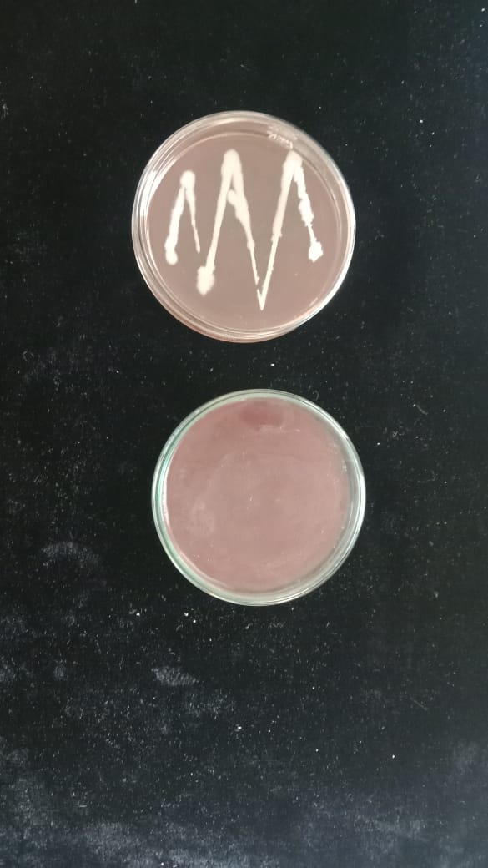The yeast isolated from wood apple (*Limonia acidissima*) shows a positive result was in the haemolysis test. After inoculating the yeast onto blood agar plates and incubating them under appropriate conditions, the researchers noted a clear zone of haemolysis surrounding the colonies. This indicated that the yeast was capable of lysing red blood cells and breaking down haemoglobin (Fig. 4).

The presence of this clear zone confirmed the yeast's ability to produce haemolytic enzymes, which could enhance its pathogenic potential or facilitate nutrient acquisition in its environment.

**Fig. 4.** Haemolysis test

**3.4. Genomic characterisation**

By employing ITS primers to molecularly characterize the 16S rRNA gene sequence, it was possible to identify the species of Yeast. Initial and final denaturation both took place at 95°C, whereas annealing took place at 50°C. The nucleotide sequence was deposited to GenBank NCBI and the organisms was assigned with the unique identifier PQ316097. The PCR amplicon size of the chosen strain was 1080 base pairs, and gene sequence was aligned using pair-wise alignment demonstrated maximum (100%) similarity with *Pichia cecembensis* strain KUMBNBNGBT-115. The Phylogenetic tree was created using neighbour-joining method using BioEdit software by selecting the sequence files from NCBI, the Bootstrap value (100) was selected using RAxML and the best tree obtained in the analysis was selected and the neighbour-joining tree of *Pichia cecembensis* was constructed using Fig-Tree shown in Fig. 5.

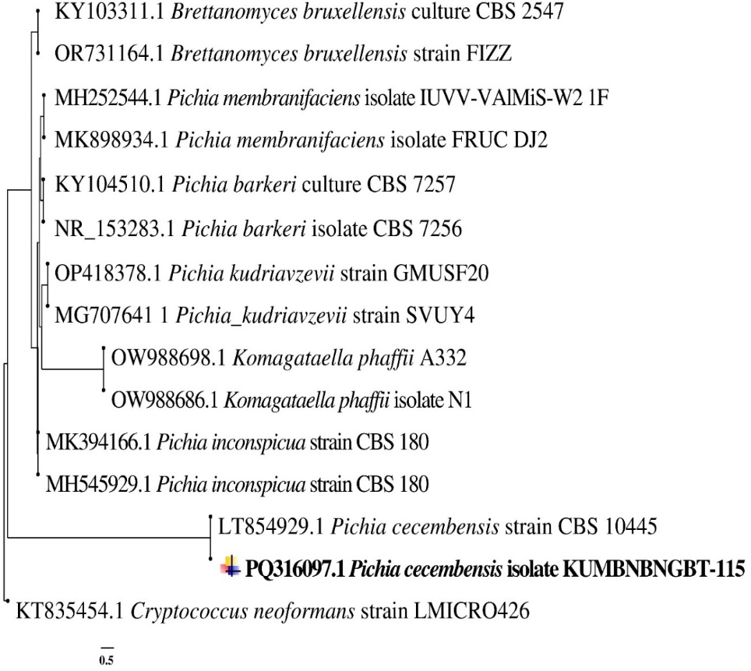

**Fig. 5.** Phylogenetic analysis of *Pichia cecembensis* isolate KUMBNBNGBT-115 using neighbour joining method with bootstrap value of 100.

**3.5. Biochemical analysis**

**3.5.1. pH determination**

In the analysis of the pH of wood apple wine, a result of 3.5 was recorded. This measurement indicated that the wine was acidic, which is typical for fruit wines. The pH level suggested that the fermentation process had produced organic acids, such as tartaric and malic acid, contributing to the wine's overall flavour profile and stability (Table 1**)**.

The slightly acidic pH of 3.5 was beneficial for the preservation of the wine, as lower pH levels can inhibit the growth of spoilage microorganisms. Additionally, the acidity played a crucial role in balancing the sweetness and enhancing the aroma of the wood apple wine, ultimately influencing its sensory characteristics (Fig. 6).

**3.5.2. Determination of reducing sugar**

**Table 1:** Determination of reducing sugar by using DNS method

|  |  |  |  |  |  |  |  |
| --- | --- | --- | --- | --- | --- | --- | --- |
| **SL NO** | **Standard maltose**  **in mL** | **Distilled water in mL** | **Volume of DNS in mL** | **Incubation** | **Distilled water** | **Concentration in µg** | **Optical density at 560nm** |
|  | 0 | 1 | 3 | Incubation  At boiling  Water bath for  5-10 minutes | 5 | 0 | 0 |
|  | 0.2 | 0.8 | 3 | 5 | 200 | 0.09 |
|  | 0.4 | 0.6 | 3 | 5 | 400 | 0.18 |
|  | 0.6 | 0.4 | 3 | 5 | 600 | 0.27 |
|  | 0.8 | 0.2 | 3 | 5 | 800 | 0.36 |
|  | 1.0 | 0.0 | 3 | 5 | 1000 | 0.45 |
|  | Wood apple | - | 3 | 5 | 790 | 0.35 |
|  | Amla | - | 3 | 5 | 960 | 0.42 |

**Fig. 6:** Determination of reducing sugar by using DNS method

**3.5.3. Determination of specific gravity**

The amount of alcohol present in the wine is estimated by specific gravity method. The specific gravity can be defined as the ratio of density of sample of the solution to the density of equal volume of reference solution. By this method we can estimate the approximately amount of alcohol present in the wine. The percentage of alcohol in the wine was calculated by or determined by AOAC chart (Table 2, 3 and Fig. 7).

**Table 2:** Determination of specific activity by using different parameters

|  |  |  |
| --- | --- | --- |
| **Parameters** | **Amla** | **Wood Apple** |
| pH | 3.5 | 3.5 |
| Specific gravity |  |  |
| Titratable acidity | 0.9 | 1.5 |
| Phenol content | 0.35 | 0.42 |

**3.5.4. Determination of Phenol content**

**Table 3:** Determination of phenol content

|  |  |
| --- | --- |
| **Concentration in µg** | **Optical density at 560nm** |
| 0 | 0.26 |
| 200 | 0.84 |
| 400 | 1.89 |
| 600 | 1.76 |
| 800 | 1.41 |
| 1000 | 1.77 |
| Amla | 0.24 |
| Wood apple | 0.64 |

**Fig. 7.** Determination of Phenol content

**3.6. Preparation of starter culture**

The starter culture exhibited a vigorous growth of yeast cells. This ensured that a sufficient population was available for inoculation into the wine must, leading to a robust fermentation process. The starter culture began to develop characteristic flavour compounds during fermentation. This included esters and phenols, which contributed to the overall aroma and taste profile of the final wine. The use of a prepared starter culture allowed for a more controlled and faster fermentation when inoculated into the primary must. This minimized the risk of spoilage and off-flavours that could occur with wild yeast fermentation. By using a starter culture, winemakers achieved more consistent fermentation outcomes, which enhanced the overall quality and stability of the wine. The desired alcohol content and acidity levels were reached more predictably. The inclusion of amla in the wine not only contributed to flavor but also enhanced the nutritional profile of the final product, offering potential health benefits due to its high vitamin C and antioxidant content.

**3.6.1. Must fermentation**

Fresh amla and wood apple fruits were selected, ensuring they were ripe and free from blemishes. After thorough washing, the fruits sample was chopped or crushed to facilitate juice extraction and enhance the fermentation process. The chopped fruit samples was mixed with water and sugar to create a mash. This combination provided both the fermentable sugars needed for yeast activity and the liquid medium necessary for fermentation, a suitable yeast strain was inoculated into the fruit sample mash. This step was conducted under sterile conditions to avoid contamination and ensure a healthy fermentation environment. The inoculated mash was placed in a fermentation vessel, which was kept at a controlled temperature conducive to yeast activity. The mixture was allowed to ferment for several days, with regular monitoring of temperature and sugar levels.

The fermentation exhibited vigorous activity, evidenced by the production of carbon dioxide bubbles and froth in the mash. This indicated that the yeast was actively converting sugars into alcohol and carbon dioxide. As fermentation progressed, the mash began to develop complex flavours. The tartness of the amla combined with the fruity notes from the fermentation created a unique and pleasant aroma, enhancing the overall sensory experience. The fermentation process successfully converted a significant portion of the sugars into alcohol. The final alcohol content was measured, and it fell within the desired range for wood apple and amla wine, contributing to its palatability. Initially, the high acidity of the amla and wood apple mash began to decrease as fermentation progressed. This reduction in acidity balanced the tartness of the fruit sample resulting in a smoother and more enjoyable flavour profile. Throughout the fermentation process, the beneficial compounds present in amla, and wood apple such as vitamin C and antioxidants, were retained in the final product. This not only contributed to the wine’s health benefits but also enhanced its appeal to health-conscious consumers. After fermentation was complete, the wine underwent a natural clarification process. Sediments settled at the bottom of the fermentation vessel, leading to a clearer final product. This clarity was visually appealing and indicative of a well-executed fermentation process (Nandagopal and Nair 2013; Joshi and Ray 2021).

**3.6.2. Racking and Bottling**

Before bottling, the wine underwent a final filtration to remove any remaining particles. This step ensured that the wine was as clear as possible, further improving its appearance and stability. The wine was carefully transferred into bottles under sanitary conditions to prevent contamination. Each bottle was filled to an appropriate level, ensuring consistency across the batch. After filling, the bottles were sealed with screw caps. This sealing process was critical for protecting the wine from oxidation and spoilage, preserving its quality over time.

**4. DISCUSSION**

The current study aimed to explore the fermentation potential of two wild edible fruits, *Phyllanthus emblica* (Indian Gooseberry or Amla) and *Limonia acidissima* (Wood Apple), for wine production. The research involved isolating yeast strains, conducting biochemical tests, fermenting fruit musts, and evaluating the final product's properties. The investigation into fruit-based wine production is critical for understanding the potential of underutilized fruits in the food and beverage industry (Liu et al., 2022). The increasing demand for functional beverages, which combine health benefits with taste, makes such studies relevant, especially given the medicinal properties of the selected fruits (Sarkar and Singhal, 2018).

Amla, rich in antioxidants, vitamin C, and other phytochemicals, is known for its therapeutic effects, such as anti-inflammatory, anti-hyperglycemic, and cardioprotective properties. Similarly, Wood Apple offers nutritional benefits, including being a rich source of vitamins and minerals, and it is resilient to harsh growing conditions, making it an excellent candidate for sustainable food systems.

In this research, yeast strains were isolated using serial dilution and spread plate techniques on Yeast Extract Peptone Dextrose Agar (YPD) media. The primary yeast identified from Wood Apple was *Pichia cecembensis*, confirmed through genetic characterization using the internal transcribed spacer (ITS) sequence, which was compared with sequences available in the National Center for Biotechnology Information (NCBI) database (Tamura et al., 2011). This yeast strain was employed in fermenting the fruit musts, which showed active fermentation over several days. The successful fermentation, evidenced by carbon dioxide production and sugar reduction, reflects the yeast's ability to convert the sugars in the fruit into alcohol.

Both fruits presented distinct characteristics, influencing the fermentation dynamics and the final wine product's sensory attributes. The sugar content in the fruit must played a pivotal role in the fermentation, impacting both the alcohol yield and the development of secondary metabolites, such as phenols, which contribute to the wine's flavor, aroma, and potential health benefits (Kumar et al., 2020).

Several biochemical tests were performed to assess the properties of the isolated yeast and the final wine product. The catalase and oxidase tests indicated the yeast's ability to manage oxidative stress, crucial for fermentation longevity. Additionally, the urease test's positive result suggested that the yeast could utilize urea as a nitrogen source, promoting yeast growth and fermentation efficiency.

Post-fermentation analysis revealed that the pH of both wines was around 3.5, a value typical for fruit wines, contributing to their stability and preservation. The titratable acidity was slightly higher in Wood Apple wine (1.5%) compared to Amla wine (0.9%), reflecting the inherent tartness of Wood Apple. This higher acidity may influence the taste, making Wood Apple wine sharper and more intense in flavor compared to the smoother, milder Amla wine. The alcohol content, estimated using the specific gravity method, fell within acceptable ranges for fruit wines, which typically contain 5–13% alcohol by volume.

The phenolic content was higher in Amla wine, likely due to the fruit's natural abundance of antioxidants, including tannins, flavonoids, and ascorbic acid. The higher phenol content enhances both the wine's sensory characteristics and its health benefits, as phenolic compounds are known for their antioxidant properties, protecting against oxidative stress and contributing to cardiovascular health (Kumaresan et al., 2024).

The sensory analysis of the wine indicated that Amla wine retained the characteristic tartness of the fruit but developed a more complex flavor profile through fermentation. The fermentation process reduced the initial acidity, resulting in a balanced wine with a pleasant aftertaste. Similarly, Wood Apple wine, though tart, exhibited a distinct fruity aroma, with the hard rind and sticky pulp contributing to a unique texture and flavor.

One of the significant findings was the retention of the bioactive compounds present in the raw fruits. Both Amla and Wood Apple are known for their high antioxidant content, and the study confirmed that these beneficial compounds were preserved post-fermentation. This is crucial for consumers seeking functional foods and beverages that not only offer enjoyment but also provide health benefits (Le et al., 2016).

The study highlights the potential for using wild fruits like Amla and Wood Apple in value-added products like wine, providing an alternative to grape-based wines and helping to reduce fruit waste. Amla, in particular, has a long history in Ayurvedic medicine, and producing wine from Amla could introduce a new functional beverage into the market, offering both traditional and modern appeal. This could also provide economic benefits to farmers in regions where these fruits are abundant but underutilized, such as in India and Sri Lanka (Moazzem et al., 2019).

The production of wine from such fruits could address several market trends, including the rising demand for organic and health-promoting foods, and aligns with the growing interest in sustainable food systems. Additionally, the shelf stability and transportability of wine make it an attractive option for fruit processing industries, particularly in regions where post-harvest losses of perishable fruits are significant. While the results are promising, further research is needed to optimize fermentation conditions to maximize the retention of bioactive compounds and improve sensory attributes. Exploring the development of wine from other underutilized fruits rich in medicinal compounds could also be beneficial. Moreover, studies on consumer acceptance and commercial scalability of fruit-based wines would be valuable to fully realize their potential in the beverage market (Moazzem et al., 2019).

**5. CONCLUSION**

In conclusion, this study successfully demonstrated the potential of wild edible fruits, Amla and Wood Apple, in wine production. The fermentation process was efficient, with yeast strains such as *Pichia cecembensis* playing a vital role in converting fruit sugars into alcohol. The wines produced from these fruits retained their natural health benefits, particularly their antioxidant properties, making them functional beverages with potential appeal in the health and wellness market.

The study underscores the importance of exploring underutilized fruits for value-added products like wine, which can provide economic and environmental benefits. By reducing fruit waste and promoting the use of medicinally valuable fruits in new forms, this research contributes to sustainable food production systems.

Further studies could focus on improving fermentation techniques to enhance the flavour and stability of these wines. Additionally, exploring the commercial scalability of Amla and Wood Apple wine production could open new markets for functional beverages, catering to the growing demand for health-promoting foods and drinks. The future of fruit-based wines looks promising, with Amla and Wood Apple leading the way as innovative alternatives to traditional grape wines.

**DISCLAIMER (ARTIFICIAL INTELLIGENCE)**

Author(s) hereby declare that no generative AI technologies such as Large Language Models (ChatGPT, COPILOT, etc.) and text-to-image generators have been used during the writing or editing of this manuscript.

**7. REFERENCE**

1. Amaley, S. H., Sapkal, R. S., Sapkal, V. S., Motghare, K. A., & Jangde, V. R. (2016). Wine from Emblica officinalis fruits. *International Journal of Advanced Research in Basic Engineering Sciences and Technology* (IJARBEST), 2(10), 1-7.
2. Argade, V. P., & Pande, V. V. (2015). Preparation and standardization of amla wine by using *Saccharomyces cerevisiae* yeast as a fermenter. *Inventi Rapid: Planta Activa*, *2*, 1-5.
3. Argade, V. P., & Pande, V. V. (2016). Influence of different fermentation conditions on the formulation and development of Amla (*Emblica officinalis* Gaertin.) wine. *Indian Journal of Traditional Knowledge*, 15(2), 254-259.
4. Deshmukh, A. W., & Deshmukh, S. A. (2021). Herbal wine production from fruits and vegetable wastes and peels. *International Journal of Engineering Applied Sciences and Technology*, *5*(9), 2455-2143.
5. Joshi, V. K., & Ray, R. C. (2021). Wine and winemaking: An introduction. In Winemaking (pp. 3-36). CRC Press.
6. Jarauta, I., Cacho, J., & Ferreira, V. (2005). Concurrent phenomena contributing to the formation of the aroma of wine during aging in oak wood: An analytical study. *Journal of agricultural and food chemistry*, *53*(10), 4166-4177.
7. Kumar, V., Joshi, V. K., Thakur, N. S., Sharma, N., & Gupta, R. K. (2020). Effect of artificial ageing using different wood chips on Physico-chemical, sensory and antimicrobial properties of apple tea wine. *Brazilian Archives of Biology and Technology*, *63*, e20180413.
8. Kumaresan, S. M., Sathasivam, R., Somanathan, H., Sivaram, S., Christopher, D., Anbalagan, A., & Park, S. U. (2024). Production, antimicrobial, antioxidant, sensory, and therapeutic properties of herbal wine–A comprehensive review. *Journal of Applied Botany and Food quality*, *97*, 1-14.
9. Le, T. M., Nguyen, T. H. T., & Nguyen, P. K. (2016). Preliminary insights into wood apple wine using consumer perceptive mapping. *Proceedings of spise 2016*, 100.
10. Liu, S., Laaksonen, O., Li, P., Gu, Q., & Yang, B. (2022). Use of non-Saccharomyces yeasts in berry wine production: Inspiration from their applications in winemaking. Journal of Agricultural and Food Chemistry, 70(3), 736-750.
11. Manthena, J. S. K., & Mythili, K. (2014). Development of wood apple pickle. *International Journal of Food Safety, Nutrition and Public Health*, *5*(1), 1-6.
12. Moazzem, M. S., Sikder, M. B. H., & Zzaman, W. (2019). Shelf-life extension of wood apple beverages maintaining consumption-safe parameters and sensory qualities. *Beverages*, *5*(1), 25.
13. Murthy, H. N., & Dalawai, D. (2020). Bioactive compounds of wood apple (Limonia acidissima L.). *Bioactive compounds in underutilized fruits and nuts*, 543-569.
14. Nandagopal, G., & Nair, P. S. (2013). Production of wine from ginger and Indian gooseberry and a comparative study of them over commercial wine. *Am. J. Eng. Res*, *2*(5), 19-38.
15. Sarkar, A., & Singhal, A. (2018). Development of health functional wine produced from Emblica officinalis and Phyllanthus niruri and a comparative study of them over commercial wine. *International Journal of Fermented Foods*, *7*(2), 119-124.
16. Sarkar, A., & Singhal, A. (2018). Effect of varied levels of sugar concentration on wines produced from Emblica officinalis. *International Journal of Food and Fermentation Technology*, *8*(1), 87-91.
17. Sonawane, S., & Arya, S. S. (2013). Antioxidant activity of jambhul, wood apple, ambadi and ambat chukka: an indigenous lesser known fruits and vegetables of India. *Adv J Food Sci Technol*, *5*(3), 270-275.
18. Soni, S. K., Bansal, N., & Soni, R. (2009). Standardization of conditions for fermentation and maturation of wine from Amla (*Emblica officinalis* Gaertn.). *Natural Product Radiance*, 8(4), 436-444
19. Srinivasan, K. (2020). Indian gooseberry. In *Nutritional Composition and Antioxidant Properties of Fruits and Vegetables* (pp. 483-496). Academic Press.
20. Tamura, K., Peterson, D., Peterson, N., Stecher, G., Nei, M., & Kumar, S. (2011). MEGA5: molecular evolutionary genetics analysis using maximum likelihood, evolutionary distance, and maximum parsimony methods. *Molecular biology and evolution*, *28*(10), 2731-2739.