**Natural Coagulants as Phytoremediation: An *in-silico* Approach to Distillery Effluent Treatment**

**ABSTRACT**

Distillery effluents are among the most challenging industrial pollutants, characterized by high organic load and toxicity, posing severe threats to environmental health. This study employs a novel in-silico strategy to evaluate the bioremediation potential of plant-derived proteins as natural coagulants for distillery wastewater treatment. Key effluent-associated ligands were identified and docked against selected proteins from Moringa oleifera, Hibiscus and Lantana camara using AutoDock Vina within the PyRx platform. Protein stability was validated via Ramachandran plot analysis, ensuring structural integrity. Among the tested candidates, Lectin (PDB ID: 5GQT) from Lantana camara exhibited the strongest binding affinities across multiple ligands, indicating its high potential for pollutant sequestration. These findings underscore the promise of plant-based proteins, particularly lectins, as effective, eco-friendly agents in phytoremediation and sustainable industrial wastewater management. Therefore phytoremediation can be recommended as a complementary treatment strategy to enhance the purification of distillery effluents.

***Keywords:*** *Molecular docking, Ramachandran plot, Distillery effluent, Water pollution, Severe treatment*

**INTRODUCTION**

Distilleries rank among the most polluting industries, with approximately 88% of their raw materials converted into waste, much of which is discharged into water bodies, thereby contributing significantly to water pollution. For every litre of alcohol produced, around 15 litres of spent wash-a highly polluting effluent-is generated (Kukreja et al., 2012). Alcohol serves as a fundamental feedstock for a wide array of chemical industries, and consequently, its demand is expected to surge in the coming years. Distilleries are playing a crucial role in meeting this growing demand.

The global interest in ethanol production from agricultural biomass as an alternative fuel is escalating due to the dwindling reserves of non-renewable energy sources and the fluctuating prices of oil and natural gas. In India, this demand is anticipated to rise, particularly considering legislation mandating the blending of 5% ethanol with petrol, with a target to increase this proportion to 10% (Kumar, 2021).

Many large-scale distilleries in India are integrated with sugar mills and typically use molasses as a raw material. On average, such distilleries produce 15 litre of spent wash per litre of alcohol (Bhardwaj et al., 2019). Molasses-based spent wash (MSW) poses significant disposal challenges due to its low pH, elevated temperature, dark brown hue, high ash content, and substantial concentrations of dissolved organic and inorganic matter (Pawar et al., 2017). The effluent’s high biochemical oxygen demand (BOD) and chemical oxygen demand (COD)-ranging from 35,000–50,000 mg L⁻¹ and 100,000–150,000 mg L⁻¹ respectively, reflect its severe environmental impact (Nandy et al., 2002).

The release of spent wash into the environment leads to widespread soil and water contamination. In response, the Central Pollution Control Board (CPCB), India’s premier environmental regulatory authority, mandated that all distilleries achieve zero liquid discharge (ZLD) of spent wash by December 2005 (CPCB, 2003).

Many developing countries face challenges in treating domestic and industrial wastewater due to limited infrastructure and financial resources. As a result, the discharge of untreated sewage contributed to the contamination of both surface and ground water. (Singh et al., 2023).

Phytoremediation is a eco-friendly technique where plants are utilized to remove , degrade or stabilize contaminants from soil and water. Textile effluents discharged into aquatic ecosystems pose significant toxicity risks to aquatic flora and fauna. Mahajan et al., 2019 reports that the phytoremediation potential of *Chara vulgaris* was assessed for the treatment of textile effluent.

Floating wetlands (FWTs) offer a sustainable alternative for the treatment of polluted surface water bodies. When terrestrial plant species such as *Ocimum tenuiflorum, Hibiscus spp., Chrysopogon zizanioides,* and *Canna indica* were employed in FWT systems using naturally buoyant bamboo rafts. Among the tested species, *Canna indica* and *Chrysopogon zizanioides* demonstrated superior performance in removing nutrients and other contaminants from municipal sewage (Arivukkarasu & Sathyanathan, 2023).

Bioremediation research involves proteins from plant extracts, which exhibit a strong affinity for pollutants in spent wash. It helps in enhancing treatment efficiency: Designing engineered enzymes or selecting microbes that target key pollutants.

While traditional treatment of distillery effluents focuses on physical, chemical, or biological methods, molecular docking offers insights into the biodegradation mechanisms at the molecular level.

Molecular docking is a widely used computational technique in structure-based drug design that predicts the optimal orientation of a ligand when bound to a target macromolecule, such as a protein, to form a stable complex. This approach provides insights into binding affinity and interaction patterns, which are crucial for understanding structure activity relationships and identifying potential drug candidates. Molecular docking also enables high throughput virtual screening, significantly accelerating the early phases of drug discovery while reducing time and cost compared to experimental methods (Morris & Lim-Wilby, 2008).

In this research article, molecular docking of distillery wastewater is done to explore how pollutants in the wastewater interact with biological molecules like proteins and play a crucial role in building up sustainable environment.

**MATERIALS AND METHODS**

Discovery Studio 3.5 Client was used for visualization, Open Babel for the format interconversion, and PyRx for the Molecular docking. Supporting web based tools include PubChem (U.S. National Library of Medicine. (n.d.) for ligand, protein (Bank, R. P. D. (n.d.-b) CASTp (CASTp 3.0: Computed atlas of surface topography of proteins. (n.d.). for active prose determination, and PROCHEK integrated with PDBSum for Ramachandran plot (Team, E. W. (n.d.).

***Ligand Preparation***

The primary material used in the study was the 3-dimensional structure of the ligands present in distillery effluent. Based on the literature survey, the structures (3-D) of different ligands present in distillery effluent were downloaded from PubChem. The ligands used in present study are shown in Table 1.

Table 1: Ligands used in the study

|  |  |  |
| --- | --- | --- |
| **Sl. No.** | **Ligand names** | **Abbreviation** |
| 1 | 1,2,4,5-tetrahydro-2-methyl-3H-2-benzazepine-3-one | Lig_1 |
| 2 | 3H-thieno[3,4-c] thiophene | Lig_2 |
| 3 | Butanoic acid | Lig_3 |
| 4 | 4-(p-cumylphenoxy) phthalonitrile | Lig _4 |
| 5 | Hexadecenoic acid | Lig _5 |
| 6 | Butyl ester | Lig _6 |
| 7 | Squalene | Lig _7 |

***Protein preparation***

Protein was optimised by downloading three-dimensional (3D) X-ray crystallographic structures in (.cif) format and later converted to pdb format using Open Babel GUI software. The Proteins were also checked for their stability using Ramachandran plot (Ramachandran et al., 1963; Laskowski et al., 1993). The proteins used for the study are shown in Table 2.

Table 2: Various proteins used for the study and their biological activities

|  |  |  |  |  |
| --- | --- | --- | --- | --- |
| **Sl.no** | **Proteins** | **PDB ID** | **Biological activity** | **References** |
| *Moringa oleifera* seed protein | | | | |
| 1 | 2S Albumin | 1GP6 | Sulphur rich seed storage protein (methionine & cysteine). Exhibit anti-microbial property. | Al-Zahrani & Ibrahim , 2018 |
| 2 | Morintides mO1 | 5WUZ | Cysteine rich peptide, it leads to exceptional stability, making mo1 resistant to thermal and enzymatic degradation, antifungal | Kini et al., 2017 |
| 3 | (Mo-CBP4) | 6VJO | Chitin binding protein, antifungal & anti-inflammatory | Leite Pereira et al., 2011 |
| 4 | Mo-CBP3-4 | 6S3F | Chitin binding protein, antifungal & anti-inflammatory | Moulin et al., 2019 |
| *Moringa oleifera* leaf protein | | | | |
| 5 | Leucin | 5ECM | Stress response and metabolism | Sadak et al., 2020 |
| 6 | Glutamic acid | 6R85 | Plant nitrogen metabolism and stress tolerance | Qui et al., 2020 |
| 7 | Albumin | 2EFD | Anti-microbial | Shewry, & Halford, 2002 |
| 8 | Prolamin | 4GG6 | Anti-microbial | Xie et al., 2011 |
| 9 | Globulins | 3KSC | Viscoelastic property, autoimmune development | Shewry & Halford 2002 |
| *Hibiscus* leaf protein | | | | |
|  |  | | |  |
| 6 | Glutamic acid | 6R85 | Plant nitrogen metabolism and stress tolerance | Forde & Lea, 2007 |
| 7 | Albumin | 2EFD | Anti-microbial | Shewry & Halford, 2002 |
| 9 | Globulins | 3KSC | Viscoelastic property, autoimmune development | Shewry & Halford, 2002 |
| 10 | Aspartic acid | 3AUP | Nitrogen metabolism, stress response | Sarkiyayi & & Ikioda 2010. |
| *Lantana camera* leaf protein | | | | |
| 11 | Lectin | 5GQT | Defence mechanism, symbiotic interaction, cell signalling, growth regulation, used for glycoprotein detection and cell typing | Hiremath et al., 2020 |

***Molecular Docking***

The ligand and the proteins were subjected for the molecular docking studies (Jain et al., 2021). Molecular docking studies was carried out using AutoDock Vina program integrated with the PyRx software. The active prose required for the protein was retrieved from webtool CASTp. This prose was used for the docking of the ligand into it. The docked ligand was saved in the pdb format and was used for the visualization for the interaction with the amino acid residues of the proteins.

**RESULTS AND DISCUSSION**

The 3-D structures of the ligands present in the distillery effluents were downloaded and the same are represented in Figure 1.In molecular visualizations, standard color conventions are used to distinguish between different elements in ligands: carbon is typically represented in grey or black, oxygen in red, nitrogen in blue, sulfur in yellow, phosphorus in orange, and various metal ions in shades of green (Garrison & Bruckner, 2022).

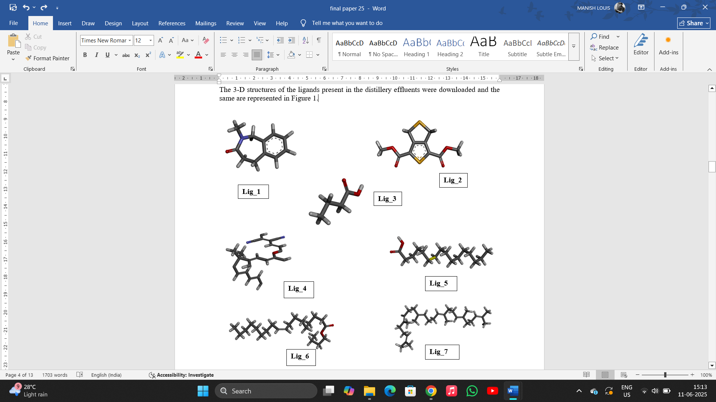

Fig. 1. 3-D structures of the Ligands mentioned in table 1.

**Protein validation**

The Ramachandran Plot is a critical tool in structural biology used to evaluate the quality and validity of protein models by analysing the backbone dihedral angles, phi (Φ) and psi (Ψ), of amino acid residues. Protein validation by a Ramachandran plot is a key method for assessing the quality of a protein structure (Ramachandran, 1963).

Residues falling within the most favoured and additionaly allowed regions are indicative of a high quality structure while those in disallowed regions may suggest modelling errors on unusual confirmation. In this study Ramachandran plot of all the proteins revealed (Fig. 2) that the around 90% of the amino acid residues of the proteins used are falling in the allowed/favourable region of the plot suggesting that the proteins are of good quality and are stable in nature.

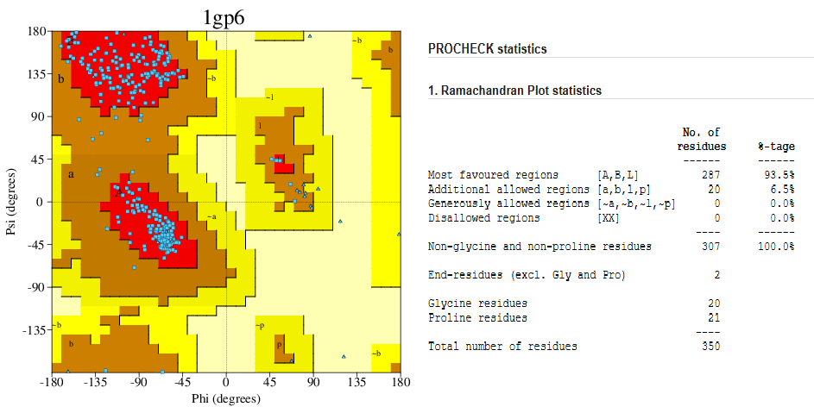

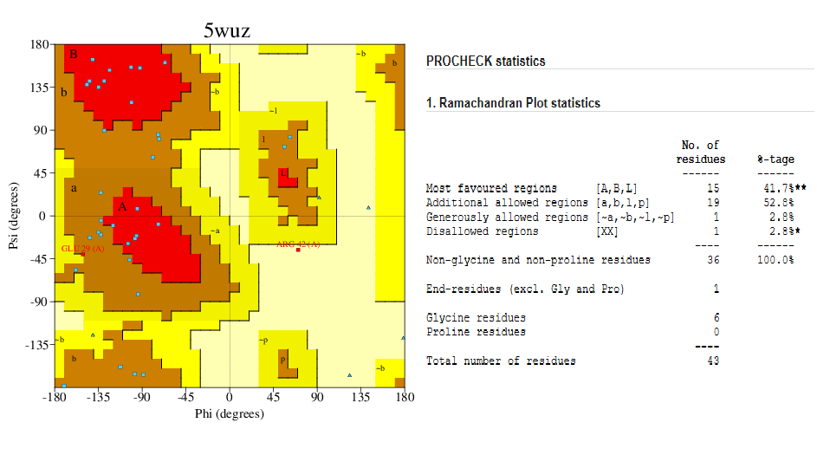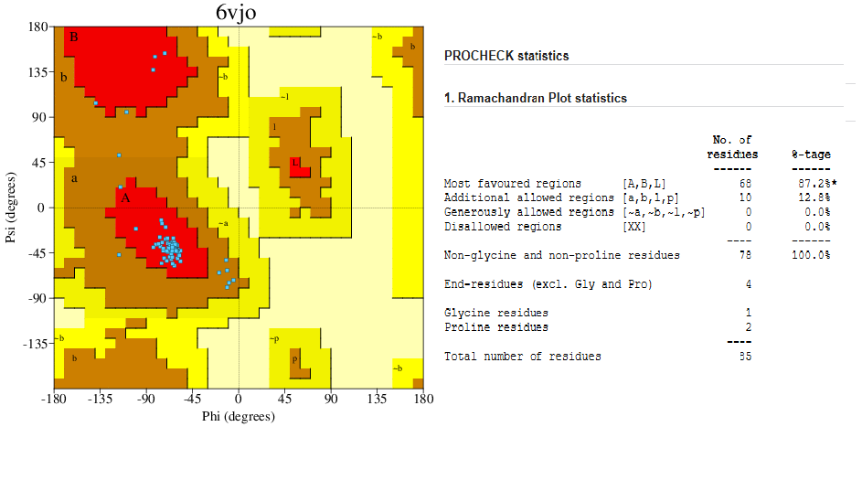

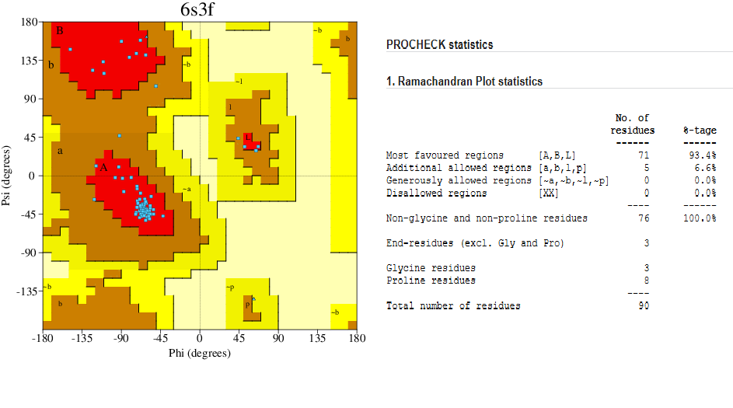

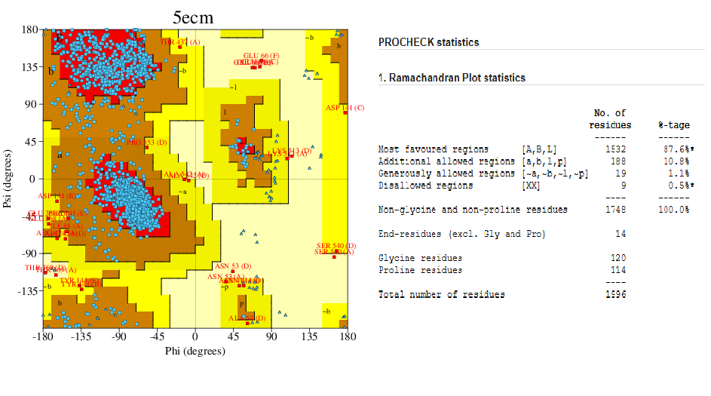

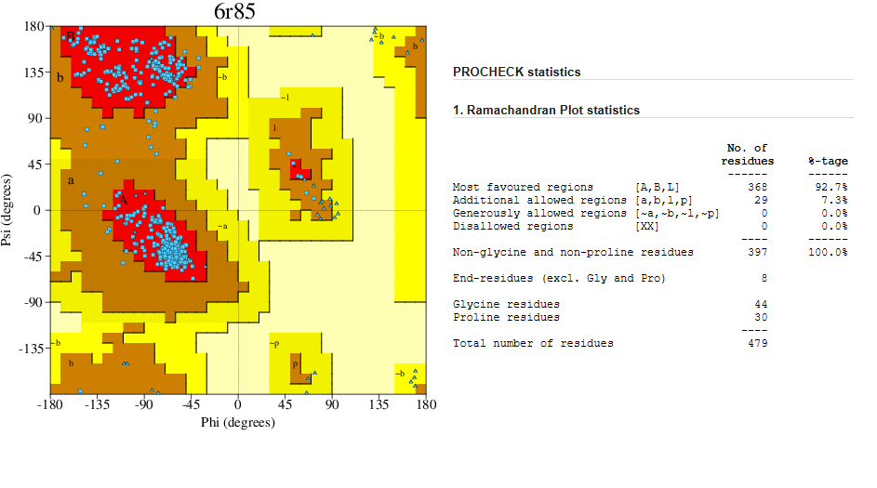

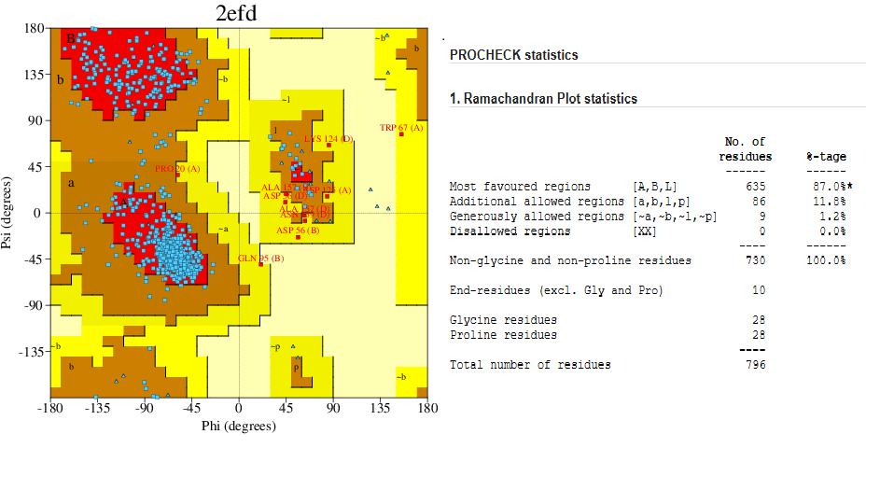

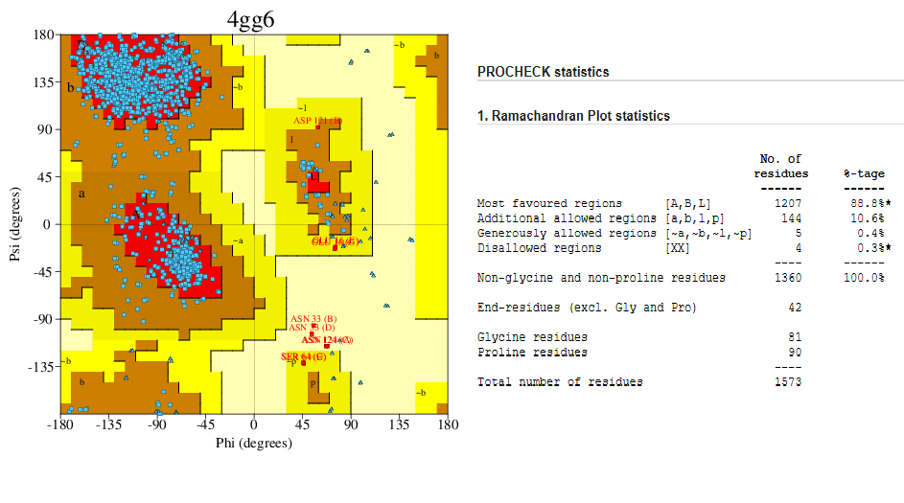

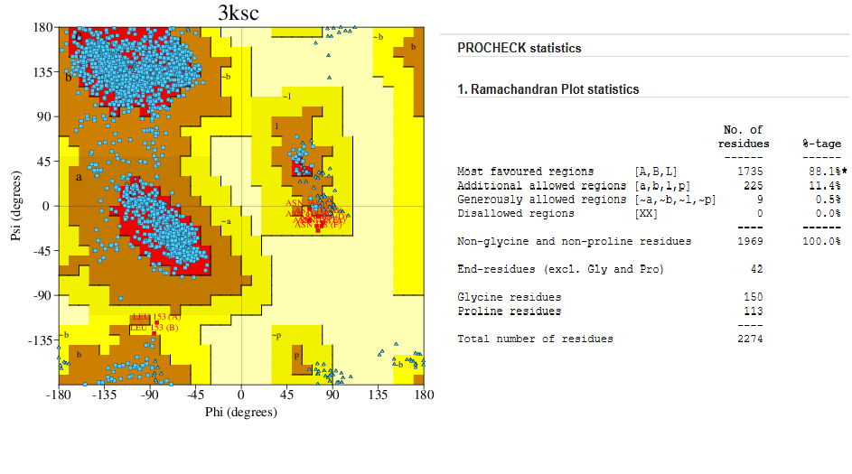

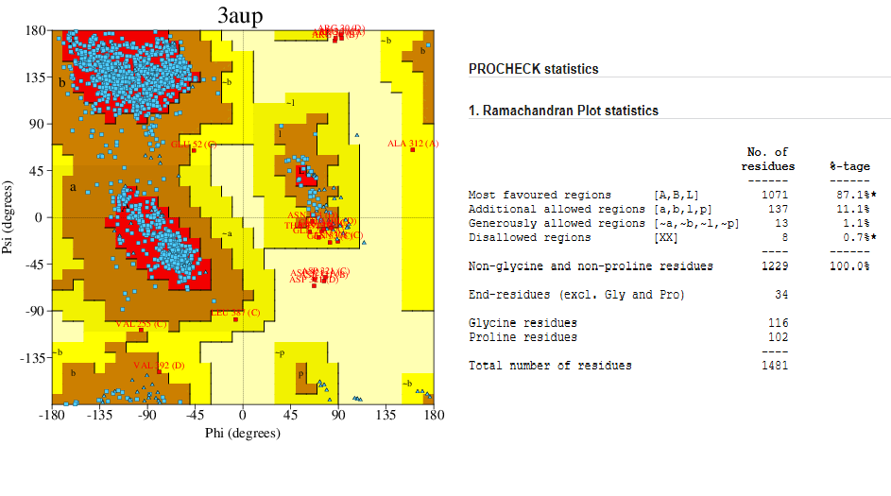

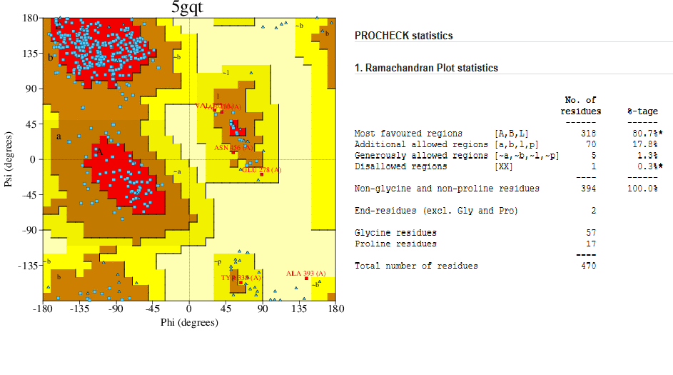

Fig. 2. Ramachandran Plot of the proteins extracted from various plants.

***Molecular docking***

To evaluate the potential binding interactions between selected ligands and target proteins, molecular docking studies were performed using AutoDock Vina, integrated within the PyRx virtual screening tool. This computational approach enabled the prediction of binding affinities (expressed in kcal/mol) by simulating the interaction of each ligand with a set of 11 distinct protein targets. The docking results, summarized in Table 3, provide insight into the strength and specificity of these interactions. Ligands demonstrating binding affinities more negative than −6.0 kcal/mol were considered to exhibit strong binding potential, as this threshold is commonly associated with biologically significant interactions in a biochemical context (Copeland et al., 2006).

Table 3: Molecular docking studies result showing the binding affinity (kcal/mol) of the ligands with the corresponding Proteins

Ligand

|  |  |  |  |  |  |  |  |  |
| --- | --- | --- | --- | --- | --- | --- | --- | --- |
| Sl. No. | Proteins | Lig_1 | Lig_ 2 | Lig_3 | Lig_4 | Lig_5 | Lig_6 | Lig_7 |
|  | 1GP6 | -7.3 | -7.2 | -3.8 | -9.3 | -6.4 | -4.3 | -6.1 |
|  | 5WUZ | -4.5 | -4.4 | -2.6 | -5.3 | -3 | -2.9 | -3.6 |
|  | 6VJO | -5.6 | -4.7 | -3.3 | -7.3 | -4.4 | -3.5 | -5.5 |
|  | 6S3F | -4.9 | -3.7 | -3.3 | -5.4 | -4.7 | -3.6 | -5.1 |
|  | 5ECM | -7 | -6.6 | -4.1 | -7.2 | -6.2 | -4.2 | -5.5 |
|  | 6R85 | -4.9 | -5.3 | -3.4 | -6.1 | -3.6 | -3.5 | -4.3 |
|  | 2EFD | -6.5 | -6.2 | -3.7 | -8.8 | -4.9 | -4.4 | -6.7 |
|  | 4GG6 | -5.8 | -6.4 | -3.5 | -7.7 | -4.2 | -3.6 | -4.8 |
|  | 3KSC | -6.4 | -6.9 | -4 | -7.4 | -4.6 | -4.4 | -6 |
|  | 3AUP | -5.9 | -6 | -3.8 | -8.1 | -5.3 | -4 | -5.2 |
|  | 5GQT | -7.7 | -7.3 | -4 | -9.8 | -5.8 | -4.5 | -6.9 |

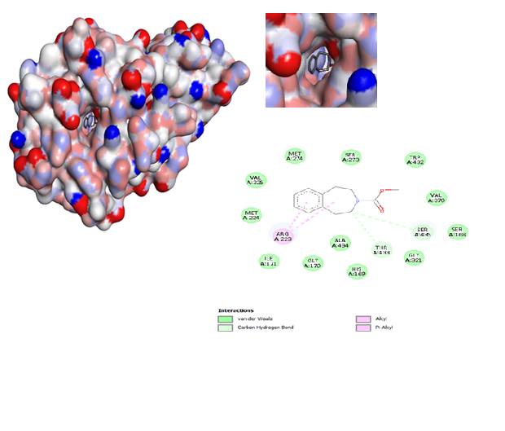

**A.**

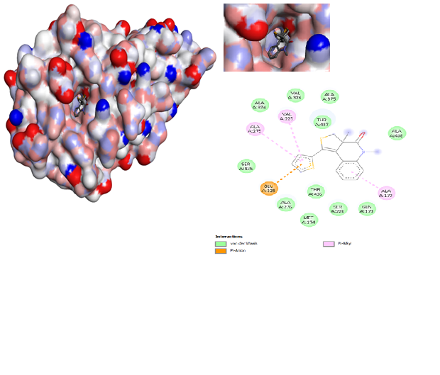

**B.**

**C.**

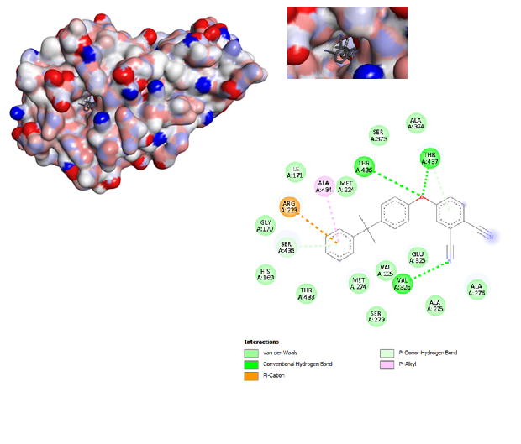

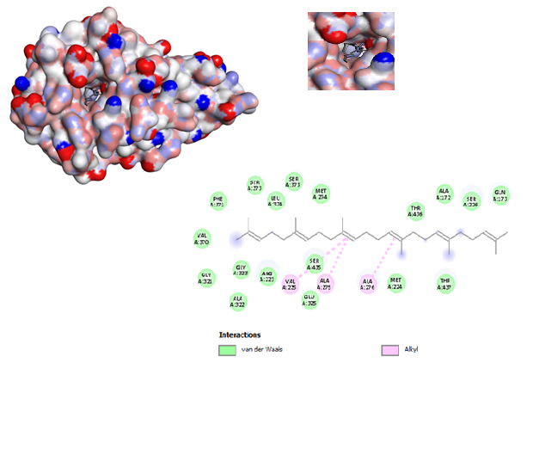

**D.**

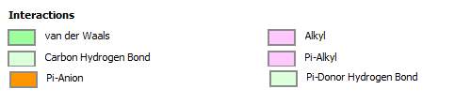

Fig. 3. The 3-D and 2-D structures of the ligands docked with Lectin (PDB ID: 5GQT), **A**. Lig_1, **B**. Lig_2, **C**. Lig_4, and **D**. Lig_7.

The increasing adoption of in silico tools—including virtual screening, molecular docking, and network pharmacology—in the exploration of traditional medicinal plants is revolutionizing drug discovery. These computational approaches facilitate the identification of lead compounds, elucidate mechanisms of action, and enhance the cost-efficiency and precision of pharmacological research, thereby supporting the scientific validation and modernization of ethnomedicinal knowledge (Yi et al., 2018).

In 2022, Hamrita et al. demonstrated through in silico analysis of *Hibiscus sabdariffa* L. calyx that docking simulations exhibited favourable binding affinities (up to -9.6 kcal/mol) with key active site residues of target proteins 1JIJ, 2QZW, and 2UVO. These results underscore the therapeutic potential of Roselle extract as a reservoir of bioactive phytoconstituents exhibiting antimicrobial, antioxidant, and anti-quorum sensing activities.

Further supporting this, Tessema et al. (2025) reported that various medicinal plants exhibited strong binding affinities to bacterial targets associated with antimicrobial and anti-swarming properties, indicating their capacity to interfere with bacterial communication and pathogenicity.

In silico methodologies have also been employed to identify bioactive molecules from traditional medicinal flora, such as *Lycium shawii*, using computational modeling techniques (Mohammed et al., 2022).

Complementing these efforts, computational docking investigations by Pruthvi and Nagendra (2015) revealed that among 14 tested ligands, arsenic, lead, mercury, and acrylamide significantly accelerated melanoidin polymerization due to their high binding affinities. Notably, the second melanoidin variant demonstrated even stronger interactions with lead, mercury, and manganese. These insights highlight the critical need for effective removal of such ligands from industrial effluents to mitigate the environmental persistence and toxicological risks posed by carcinogenic compounds.

In this research article the analysis highlights that 5GQT protein is much more efficient in forming the stable dead-end complex with most of the ligand suggesting that the protein Lectin present in the *Lantana camera* will be useful in pelleting the compounds present the industrial distillery effluent in a more efficient way as compared to the other proteins used in this study. The interaction of the amino acid residues of the of Lectin (PDB ID: 5GQT) with the ligands is shown in Fig. 3.

**CONCLUSION**

In this study, a comparative analysis of various proteins was performed to assess their binding affinity to a selected ligand, with the aim of identifying potential candidates for reducing the physical parameters of distillery effluent. Among the proteins analysed, protein 1 was identified as albumin derived from *Moringa* seed, while protein 12 was lectin obtained from *Lantana* leaf. Additionally, proteins 5 and 7 represented leaf proteins from *Moringa*, corresponding to leucin and albumin, respectively. Among all the tested leaf proteins, the lectin from *Lantana* leaf (protein 11) exhibited the highest binding affinity to the ligand. This strong interaction suggests that *Lantana* lectin has a significant potential in binding and neutralizing target molecules present in distillery effluent. Consequently, its application resulted in a marked improvement in the reduction of key physical parameters (such as turbidity, and organic load) of the effluent. These findings highlight the promise of plant-derived proteins, particularly lectins from *Lantana,* as effective bio-remediation agents in treating industrial wastewater. Future work may further optimize the use of such proteins in large-scale effluent treatment systems.

Disclaimer (Artificial intelligence)

Option 1:

Author(s) hereby declare that NO generative AI technologies such as Large Language Models (ChatGPT, COPILOT, etc.) and text-to-image generators have been used during the writing or editing of this manuscript.

Option 2:

Author(s) hereby declare that generative AI technologies such as Large Language Models, etc. have been used during the writing or editing of manuscripts. This explanation will include the name, version, model, and source of the generative AI technology and as well as all input prompts provided to the generative AI technology

Details of the AI usage are given below:

1.

2.

3.

**REFERENCES**

Al-Zahrani, A. A., & Ibrahim, A. H. (2018). Changes in 2S albumin gene expression in Moringa oleifera under drought stress and expected allergenic reactivity in silico analysis. *Theoretical and Experimental Plant Physiology*, *30*, 19-27.

Arivukkarasu, D., & Sathyanathan, R. (2023). Phytoremediation of domestic sewage using a floating wetland and assessing the pollutant removal effectiveness of four terrestrial plant species. *H2Open J*, *6*(2), 173-187.

Bank, R. P. D. (n.d.-b). *Homepage*. RCSB PDB. <https://www.rcsb.org/>

Bhardwaj, S., Ruhela, M., Bhutiani, R., Ahamad, F., & Bhardwaj, R. (2019). Distellery spent wash (DSW) treatment methodogies and challenges with special reference to incineration: An overview. *Environment Conservation Journal*, *20*(3), 135-144.

CASTp 3.0: Computed atlas of surface topography of proteins. (n.d.). http://sts.bioe.uic.edu/castp/index.html?1ycs+%29

Copeland, R.A., Pompliano, D.L., & Meek, T.D. (2006). Drug–target residence time and its implications for lead optimization. *Nature Reviews Drug Discovery*, *5*(9), 730-739.

CPCB . 2003 . *Environment management in selected industrial sectors and status and needs* , New Delhi, , India : Central Pollution Control Board . Ministry of environment and Forest. Report no. PROBES/97/2002–03

Forde, B.G., & Lea, P.J. (2007). Glutamate in plants: metabolism, regulation, and signalling. *Journal of Experimental Botany*, *58*(9), 2339-2358.

Garrison, L., & Bruckner, S. (2022). Considering best practices in color palettes for molecular visualizations. *Journal of Integrative Bioinformatics*, *19*(2), 20220016.

Hamrita, B., Emira, N., Papetti, A., Badraoui, R., Bouslama, L., Ben Tekfa, M. I., ... & Snoussi, M. (2022). Phytochemical Analysis, Antioxidant, Antimicrobial, and Anti‐Swarming Properties of *Hibiscus sabdariffa* L. Calyx Extracts: In Vitro and In Silico Modelling Approaches. *Evidence‐Based Complementary and Alternative Medicine*, *2022*(1), 1252672.

Hiremath, K.Y., Jagadeesh, N., Belur, S., Kulkarni, S.S., & Inamdar, S.R. (2020). A lectin with anti-microbial and anti proliferativeanti-proliferative activities from Lantana camara, a medicinal plant. *Protein Expression and Purification*, *170*, 105574.

Jain, A.S., Sushma, P., Dharmashekar, C., Beelagi, M.S., Prasad, S.K., Shivamallu, C., Prasad, A., Syed, A., Marraiki, N., Prasad, K.S. (2021). In silico evaluation of flavonoids as effective antiviral agents on the spike glycoprotein of SARS-CoV-2. *Saudi Journal of Biological Sciences.*1040-51

Kini, S.G., Wong, K H., Tan, W.L., Xiao, T., & Tam, J.P. (2017). Morintides: cargo-free chitin-binding peptides from *Moringa oleifera*. *BMC Plant Biology*, *17*, 1-13.

Kukreja, K., Gahlot, D. K., & Suneja, S. (2012). Distillery effluent: problems and prospects-a review. 122-134

Kumar, G. (2021). Ethanol blending program in India: An economic assessment. *Energy Sources, Part B: Economics, Planning, and Policy*, *16*(4), 371-386.

Laskowski, R.A., MacArthur, M.W., Moss, D.S., & Thornton, J.M. (1993). PROCHECK: a program to check the stereochemical quality of protein structures. *Applied Crystallography*, *26*(2), 283-291.

Leite Pereira, M., David de Oliveira, H., Tadeu Abreu de Oliveira, J., Menezes Gifoni, J., de Oliveira Rocha, R., de Oliveira Bezerra de Sousa, D., & Maria Vasconcelos, I. (2011). Purification of a chitin-binding protein from Moringa oleifera seeds with potential to relieve pain and inflammation. *Protein and Peptide Letters*, *18*(11), 1078-1085

Mahajan, P., Kaushal, J., Upmanyu, A., & Bhatti, J. (2019). Assessment of phytoremediation potential of Chara vulgaris to treat toxic pollutants of textile effluent. *Journal of toxicology*, *2019*(1), 8351272.

Mohammed, A. E., Ameen, F., Aabed, K., Suliman, R. S., Alghamdi, S. S., Safhi, F. A., ... & Rahman, I. (2022). In-silico predicting as a tool to develop plant-based biomedicines and nanoparticles: *Lycium shawii* metabolites. *Biomedicine & Pharmacotherapy*, *150*, 113008.

Morris, G. M., & Lim-Wilby, M. (2008). Molecular docking. *Molecular Modelling of Proteins*, 365-382.

Moulin, M., Mossou, E., Signor, L., Kieffer-Jaquinod, S., Kwaambwa, H.M., Nermark, F., & Rennie, A.R. (2019). Towards a molecular understanding of the water purification properties of Moringa seed proteins. *Journal of Colloid and Interface Science*, *554*, 296-304.

Nandy, T., Shastry, S., & Kaul, S.N. (2002). Wastewater management in a cane molasses distillery involving bioresource recovery. *Journal of Environmental Management*, *65*(1), 25-38.

Pawar, V. A., Bhangare, P. J., Lolage, Y. P., & Bhalekar, M. J. (2017). Characterization of molasses spent wash and its decolorization using mushroom cultivation.

Pruthvi, S. N., & Nagendra, H. G. (2015). In silico Interaction Studies of Melanoidin Pigments with ligands reveal preferential binding and their plausible roles in bioaccumulation and biomagnification.

Qiu, X.M., Sun, Y.Y., Ye, X.Y., & Li, Z.G. (2020). Signalling role of glutamate in plants. *Frontiers in Plant Science*, *10*, 1743.

Ramachandran, G. N. (1963). Protein structure and crystallography. *Science*, *141*(3577), 288-291.

Ramachandran, G.N., Ramakrishnan, C., & Sasisekharan, V. (1963). Stereochemistry of polypeptide chain configurations. *Journal of Molecular Biology*, 7(1), 95–99.

Sadak, M.S., Abdalla, A.M., Abd Elhamid, E.M., & Ezzo, M.I. (2020). Role of melatonin in improving growth, yield quantity and quality of Moringa oleifera L. plant under drought stress. *Bulletin of the National Research Centre*, *44*, 1-13.

Sarkiyayi, S., & Ikioda, H. (2010). Estimation of thiamine and ascorbic acid contents in fresh and dried Hibiscus sabdariffa (Roselle) and Lactuca sativa (Tettuce). *Advance Journal of Food Science and Technology*, *2*(1), 47-49.

Shewry, P.R., & Halford, N.G. (2002). Cereal seed storage proteins: structures, properties and role in grain utilization. *Journal of Experimental Botany*, *53*(370), 947-958.

Singh, B. J., Chakraborty, A., & Sehgal, R. (2023). A systematic review of industrial wastewater management: Evaluating challenges and enablers. *Journal of Environmental Management*, *348*, 119230.

Team, E. W. (n.d.). *PDBsum  pictorial database of 3D structures in the Protein Data Bank*. PDBsum home page. https://www.ebi.ac.uk/thornton-srv/databases/pdbsum

Tessema, F. B., Asfaw, T. B., Tadesse, M. G., Gonfa, Y. H., & Bachheti, R. K. (2025). In Silico Studies as Support for Natural Products Research. *Medinformatics*, *2*(1), 11-21.

U.S. National Library of Medicine. (n.d.). *PubChem*. National Center for Biotechnology Information. PubChem Compound Database. https://pubchem.ncbi.nlm.nih.gov/

Xie, Y., Fleming, E., Chen, J.L., & Elmore, D.E. (2011). Effect of proline position on the antimicrobial mechanism of buforin II. *Peptides*, *32*(4), 677-682.

Yi, F., Li, L., Xu, L. J., Meng, H., Dong, Y. M., Liu, H. B., & Xiao, P. G. (2018). In silico approach in reveal traditional medicine plants pharmacological material basis. *Chinese medicine*, *13*, 1-20.