# **Web Based Approach for Siwes Supervisors' Reporting**

**Abstract**

In Nigerian universities, the Student Industrial Work Experience Scheme (SIWES) is a mandatory program designed to expose undergraduate students to real-world industrial practices relevant to their field of study. Despite the technological advancements in educational systems, the process of SIWES supervision and student performance assessment remains largely manual, inefficient, and error-prone. This project focuses on designing of a web-based system to enhance the supervision and grading process for SIWES students in the Department of Information Technology. The system enables supervisors to submit structured reports during field visits, assess students based on predefined criteria, and assign grades accordingly. Additionally, the platform facilitates the integration of departmental evaluations such as student defenses by combining defense scores with supervisor assessments to compute a final SIWES grade. The system was developed using the Laravel framework with HTML, CSS, JavaScript, and PHP. Through a thorough review of existing processes, system analysis, and software development methodologies, the project delivered a solution that improves accountability, streamlines communication, and enhances transparency in SIWES performance evaluation. The deployment of this solution is expected to improve the accuracy and efficiency of SIWES supervision and grading at both the field and departmental levels.

**Keywords:** SIWES, Grading, Supervisor Reporting, Web Based Approach

**I. INTRODUCTION**

The Student Industrial Work Experience Scheme (SIWES) is a critical component of undergraduate education in Nigeria, aimed at bridging the gap between theoretical knowledge and practical industry experience (Adebakin, Kayode, & Ayeni, 2015). As part of this program, students are attached to various organizations relevant to their field of study, where they are supervised and assessed. However, reporting and grading students' performance during their industrial attachment remains largely manual, inefficient, and error-prone. Supervisors are often required to fill out paper-based forms during field visits, and these reports are later submitted physically to the department for grading. This method not only delays the evaluation process but also increases the chances of data loss, inconsistency, and lack of transparency (Olajide & Olanrewaju, 2019).

Furthermore, the final grading process typically involves combining the supervisor’s evaluation with an internal departmental defense assessment. After completing their SIWES program, students are expected to present and defend their industrial training experience before a panel of lecturers, who then assign additional marks (Industrial Training Fund [ITF], 2004). Merging these marks manually to arrive at a final grade is tedious and can lead to inaccuracies.

To address these challenges, this project proposes the design and implementation of a web-based system that streamlines the entire process of SIWES supervision, reporting, and student grading. The system enables supervisors to submit real-time assessments online, allows coordinators to monitor reporting progress, and provides a secure platform for computing final student grades by combining field evaluation scores with departmental defense results. This approach aims to enhance efficiency, accountability, and transparency in the SIWES grading process within the Department of Information Technology (Oduwaye & Adebanjo, 2020).

**II. RELATED LITERATURE**

The Student Industrial Work Experience Scheme (SIWES) is an essential component of undergraduate education in Nigeria, designed to bridge the gap between theoretical classroom learning and practical industrial application. Effective management of the SIWES process—particularly supervision, assessment, and grading has been a subject of continued research due to recurring inefficiencies in traditional approaches, several studies have highlighted the challenges associated with manual SIWES coordination, which include time-consuming supervisor allocation, inefficient student monitoring, and delays in assessment compilation. For instance, Adetiba et al. (2012) examined the inadequacies of paper-based logbooks and manual grading systems, noting that they hinder accurate performance tracking and contribute to administrative burden. Similarly, Zachariah and Yabuwat (2016) emphasized the need for automated tools to streamline student placement and improve supervisor-student interaction.

Web-based platforms have gained significant traction as potential solutions to these challenges. According to Adebayo et al. (2022), implementing a secure, electronic SIWES placement system enhances accessibility, ensures student data security, and improves the coordination of placements and supervisor assignments. The study further demonstrated that integrating recommendation features for industrial placement significantly improves students’ decision-making and satisfaction. implementing a web-based SIWES portal enhances accessibility, improves data integrity, and facilitates real-time communication between students and academic supervisors. the study further demonstrated that integrating recommendation features for industrial placement significantly improves students’ decision-making and satisfaction.

satisfaction.

Moreover, Adetiba et al. (2012) proposed a web-based SIWES portal that supports logbook entry, supervisor comments, and real-time assessment uploads. Their results showed that over 85% of users found the system efficient compared to traditional methods. Additionally, Zachariah and Yabuwat (2016) suggested that web-based logbooks reduce the risk of data loss and enable multiple users (e.g., supervisors, coordinators, and defense panels) to interact with the student records concurrently.

Despite these advancements, most existing systems are primarily student-focused, with limited attention to supervisor reporting and departmental grading workflows. Few frameworks adequately address the integration of supervisor assessments with departmental defense scores to compute final student grades. This gap reveals the need for a holistic system that supports supervisor reporting during industrial visits, departmental panel grading after student defense, and real-time computation of final SIWES grades.

The present study addresses this gap by designing and implementing a web-based application that facilitates supervisor reporting, department-level grading, and centralized performance evaluation. By focusing on the supervisory and administrative aspects of SIWES, the system improves efficiency, reduces workload, and ensures a more accurate and transparent grading process.

Despite these advancements, most existing systems are primarily student-focused, with limited attention to supervisor reporting and departmental grading workflows. Few frameworks adequately address the integration of supervisor assessments with departmental defense scores to compute final student grades. This gap reveals the need for a holistic system that supports supervisor reporting during industrial visits, departmental panel grading after student defense, and real-time computation of final SIWES grades.

The present study addresses this gap by designing and implementing a web-based application that facilitates supervisor reporting, department-level grading, and centralized performance evaluation. By focusing on the supervisory and administrative aspects of SIWES, the system improves efficiency, reduces workload, and ensures a more accurate and transparent grading process.

**III. METHODOLOGY**

This project adopted the Agile Software Development Methodology due to its flexibility, iterative nature, and ability to incorporate continuous feedback from stakeholders such as SIWES supervisors, the departmental coordinator, and the assessment panel. The Agile methodology was appropriate for this study as it enabled the development team to incrementally design, implement, and test each component of the system, ensuring that the final product aligned with the practical needs of the Faculty of Information Technology. Tools and Technologies UsedBackend Framework: Laravel (PHP)), Frontend: HTML, CSS, JavaScript, Database: MySQL Server: Shared Hosting with 250GB bandwidth and 1GB memory, Version Control.

1. **SYSTEM REQUIREMENT ANALYSIS**

System analysis and design is a careful and systematic process of studying an existing system to create a more effective and reliable solution. For the Student Industrial Work Experience Scheme (SIWES), this involves understanding how supervisors assess students, how reports are submitted, and how departmental grades are merged with supervisor evaluations to determine final results. The proposed system focuses on enabling online reporting by supervisors, streamlining grading processes, and managing student performance data centrally and securely.

1. **Functional Requirements:** Functional requirements describe what the software must do to validate the system.
   * 1. The system shall differentiate user roles (supervisors, coordinators, and department).
     2. The coordinator shall allocate supervisors to students.
     3. Coordinators shall view, approve, or flag supervisor reports.
     4. The coordinator shall allocate supervisors to students
     5. The coordinator, as admin, create an account for supervisors and department.

**B. Non-Functional Requirements:** The non-functional on the solutions that will meet the functional requirements. In essence, it is concerned with how well the system performs. The security, usability, accessibility, reliability and accuracy, flexibility, and also how user-friendly.

A non-functional requirement also deals with both hardware and software specifications of the system,

1. User friendly: The system shall be easy to use and understand.
2. Performance: The system shall respond quickly to user requests.
3. Reusability: The system will provide a means to reuse some of its features like the diagrams and code.
4. Maintainability: The system will be easy to maintain as changes can be implemented easily.
5. **SYSTEM DESIGN**

Having clearly understood the challenges associated with manual supervision and grading in the SIWES program of the case study on this work, the next step is to transform these requirements into a working solution. System design focuses on converting the "what" (requirements) into the "how", detailing how the system will function, interact with users, and meet defined objectives (Pressman, 2014). The project was developed using PHP, HTML, CSS, JavaScript and MySQL Database. This section describes the tools used in the development of the system, in terms of hardware and software. This includes designing interfaces, user roles, process flows, and data models for implementation.

1. **Use Case Diagram**

The diagram shows the functionality of the system to be developed, together with the associated user who can perform that particular role. The system user involves the student, supervisor, SIWES coordinator and the system itself. It is given in Figure1 Use case diagram below:

**Use Cases by Actor:**

**1. SIWES Coordinator**

* Assign Supervisors to Students
* Monitor Supervisor Reports
* View/Export Grading Sheets
* Generate Reports
* Manage System Settings
* Create user

**2. Supervisor**

* Log in to the System
* Submit Student Assessment Reports
* View Assigned Students
* Edit Submitted Reports

**3. Department Admin**

* Log in to the System
* Manage report
* Export Overall Results

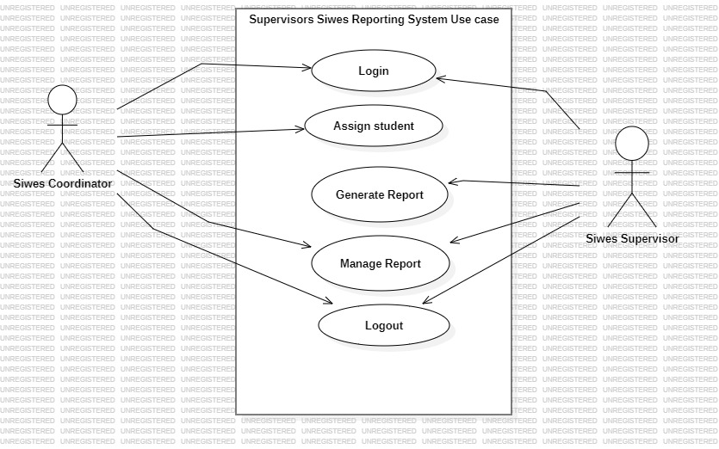

Figure 1 Use Case Diagram

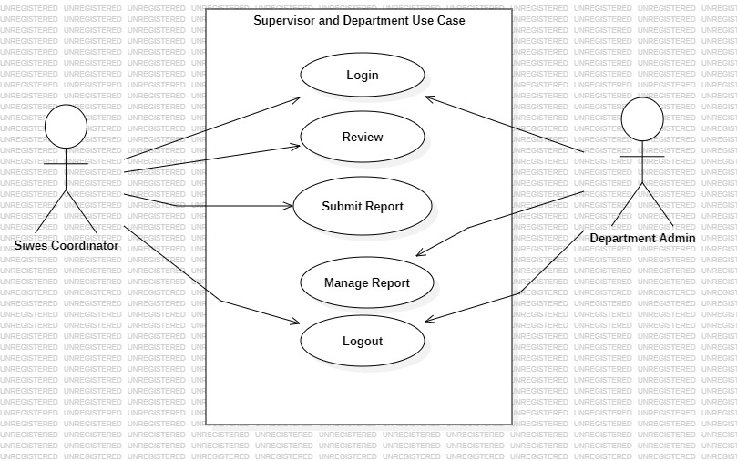

Figure 2. Use Case Diagram

1. **Sequence diagram**

Sequence diagrams are used to show it helps in designing how a system will sequentially execute a task as time passes, and also help in determining the methods needed in the class diagram, thereby giving an insight into how the system will behave. Time moves vertically while action moves horizontally on the diagram.

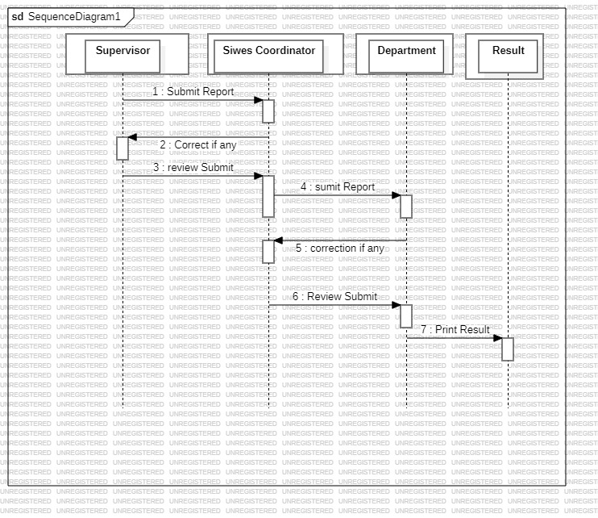

Figure 3: Sequence Diagram

1. **Hardware Specifications**

The system was developed on an HP laptop computer with the following hardware specifications:

TABLE 1

**SYSTEM DEVELOPMENT HARDWARE SPECIFICATION**

|  |  |
| --- | --- |
| Hardware | Specification |
| Memory | 4GB RAM |
| Hard drive | 500GB |
| processor | Core i7 2.68GHz |

1. **Software Specifications**

The table below gives the list of software used during the development of the system together with their specifications:

TABLE 2

**SYSTEM DEVELOPMENT SOFTWARE SPECIFICATION**

|  |  |
| --- | --- |
| Software | Specification |
| Operating System | Windows 10 |
| Front End languages | languages HTML5, CSS3, JavaScript, bootstrap |
| Web server | Apache 2.4 |
| Server-side language | PHP Version 5.6 |
| Relational Database Management System | System MySQL 5.5 |
| Browsers | Chrome recommended |

**VI. SYSTEM IMPLEMENTATION**

Implementing of the system involves integrating the designed software into a functional, usable web application. This stage focuses on configuring the server, deploying the software, and ensuring that all components work seamlessly together. The implementation specifications, including the hardware and software environment, as well as the results of the system tests, are described below.

For the deployment of this system, a shared hosting environment was utilized. The hosting service provided 250GB of monthly bandwidth, 1GB of memory, and unlimited storage capacity. This setup was selected to accommodate the anticipated number of students and supervisors within the Faculty of Computer Science and Information Technology, Modibbo Adama University, Yola, and the allocated resources are expected to be sufficient for managing the system's web traffic and data storage needs.

The implementation process included:

* **Server Configuration:** Setting up the hosting environment and configuring the necessary server-side components (e.g., Apache, MySQL, PHP).
* **System Deployment:** Uploading the application files to the server, ensuring that the application runs smoothly on the chosen platform.
* **Testing:** Conducting rigorous tests to validate the system's functionality, ensuring that it meets the defined requirements and handles expected user loads.

**System features**

Figure 4: Index page

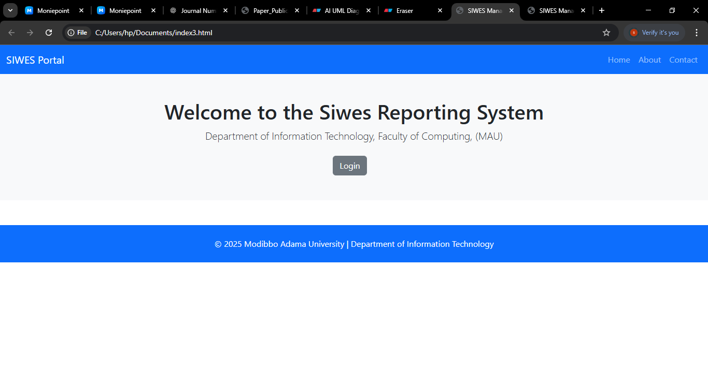

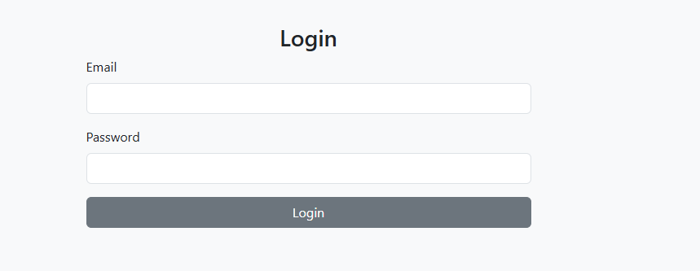

Figure 5: Login page

* 1. **RESULTS and DISCUSSION**

This review study was aimed at addressing the past related publication challenges associated with the developed system which exclude the Student Industrial Work Experience Scheme (SIWES) Supervisor reporting module and student grading by the department leveland assessment by the Siwes school coordinator Following the implementation phase, the system underwent rigorous testing involving key stakeholders, including SIWES supervisors, coordinator and departmental Admin from the Department of Information Technology, Modibbo Adama University, Yola. Functional testing employed black-box techniques to validate critical components such as supervisor visit reporting, student grading integration, and departmental panel score aggregation, Supervisors were able to submit structured assessment reports on student performance during industrial visits via a secure web interface. coordinators utilized the administrative dashboard to assign supervisors, monitor reporting activities, and export grading sheets To Departmental admin which now the department admin merges the grade with the final I.T defense

A usability evaluation was conducted with 10 I.T student users, comprising four supervisors, coordinators, department admin. The system achieved an average System Usability Scale (SUS) score of 81.2, reflecting a high level of user satisfaction. Participants highlighted the system’s ability to significantly reduce manual workload and streamline data access.

From a scalability perspective, the system is designed for adaptability across departments and institutions with minimal modifications. Its modular architecture supports the configuration of new user roles and grading rubrics, making it suitable for broader academic applications such as teaching practice, clinical internships, or engineering workshops, Additionally, the web-based design ensures remote access and cross-platform compatibility an essential feature for institutions with geographically dispersed students and supervisors. While the current implementation is hosted on a shared server, the platform is capable of being migrated to cloud infrastructure to accommodate increased demand and enhance performance in institution-wide deployments.

The deployment of this web-based SIWES supervisory and grading platform represents a substantial advancement in the management of industrial training programs. By digitizing supervisor reports and integrating them with departmental grading processes, the platform facilitates a more holistic and transparent evaluation of student performance. the system centralizes all relevant data and automates grade computation, thereby minimizing administrative errors.

**VI. CONCLUSIONS**

This review study was aimed at addressing the past related publication challenges associated with the developed system which exclude the Student Industrial Work Experience Scheme (SIWES) Supervisor reporting module and student grading by the department level. the project focused on developing a web-based application that enables supervisors to evaluate students during industrial visits, submit assessment reports, and streamline communication with the SIWES coordinator and departmental panel.

To achieve this, existing publication were studied, literature was reviewed, and requirements were gathered from the Faculty of Computer Science and Information Technology at Modibbo Adama University, Yola. The developed system supports supervisor allocation, report submission, grading automation, and the integration of defense scores by the departmental panel to generate final SIWES grades.

The system was implemented and deployed on a shared hosting platform, making it accessible via the web for all relevant stakeholders. With this solution, the process of supervisor reporting, departmental evaluation, and student grading is now more efficient, reliable, and less prone to data loss or miscommunication.

In summary, the web-based system has transformed SIWES supervision from a fragmented, paper-based workflow to a centralized digital platform that ensures accuracy, accountability, and ease of use. When fully adopted, this solution has the potential to significantly improve the quality of SIWES administration across the faculty and beyond.

Disclaimer (Artificial intelligence)

Option 1:

Author(s) hereby declare that NO generative AI technologies such as Large Language Models (ChatGPT, COPILOT, etc.) and text-to-image generators have been used during the writing or editing of this manuscript.

Option 2:

Author(s) hereby declare that generative AI technologies such as Large Language Models, etc. have been used during the writing or editing of manuscripts. This explanation will include the name, version, model, and source of the generative AI technology and as well as all input prompts provided to the generative AI technology

Details of the AI usage are given below:

1.

2.

3.

**Reference**

Adebayo, O. S., Adebayo, B. S., Abdullah, M. J., Enemona, O. S., & Abdulazeez, L. (2022). Development of an Electronic Secure Students’ Industrial Works Experience Scheme Placement System. *International Journal of Information Technology and Computer Science (IJITCS)*, 14(2), 31–44. <https://www.mecs-press.org/ijitcs/ijitcs-v14-n2/IJITCS-V14-N2-3.pdf>

Adetiba, E., Matthews, V. O., Egunjobi, V. O., & Olajide, A. T. (2012). Development of e-SIWES Portal: A Web-Based Platform for Student Industrial Work Experience Scheme (SIWES) Management. *International Journal of Applied Information Systems*, 3(8), 10–17. <https://www.ijais.org/archives/volume3/number8/250-0577/>

Akinyemi, M. O., & Akinyemi, M. O. (2024). A Web-Based Approach for Abraham Adesanya Polytechnic SIWES Management Information System. *Nightingale International Journal of Arts, Development and Scientific Research*, 8(2), 10–17. <https://nightingalepublications.com/index.php/nijadsr/article/view/135/189>

Amron, M. T., Jaafar, A. N., Rohafauzi, S., Md Enzai, N. I., Mohd Fauzi, F. D. H., & Nik Dzulkefli, N. N. S. (2017). Development of Internship Monitoring and Supervising Web-Based System. In *Proceedings of the IEEE Student Conference on Research and Development (SCOReD)* (pp. 193–197). IEEE. <https://doi.org/10.1109/SCORED.2017.8305395>

Babalola, G. O., Adeyemo, O. A., & Adewole, L. B. (2015). Leveraging on Web-based Technology for the Management of Students on SIWES Programme in Higher Educational Institutions (HEIs): A Case Study of Afe Babalola University. *International Journal of Advance Research*, 3(3), 1–13.[MECS Press+1ResearchGate+1](https://www.mecs-press.org/ijitcs/ijitcs-v14-n2/IJITCS-V14-N2-3.pdf?utm_source=chatgpt.com) <https://www.researchgate.net/publication/281968763>

Babalola, G. O., Adeyemo, O. A., & Adewole, L. B. (2015). Leveraging on Web-based Technology for the Management of Students on SIWES Programme in Higher Educational Institutions (HEIs): A Case Study of Afe Babalola University. *International Journal of Advance Research*, 3(3), 1–13.

[Https://www.academia.edu/download/109574172/leveraging-on-web-based-technology-for-the-management-of-students-on-siwes-programme-in-higher-educational-institutions.pdf](https://www.academia.edu/download/109574172/LEVERAGING-ON-WEB-BASED-TECHNOLOGY-FOR-THE-MANAGEMENT-OF-STUDENTS-ON-SIWES-PROGRAMME-IN-HIGHER-EDUCATIONAL-INSTITUTIONS.pdf)

.

Muhammad, M. S. (n.d.). *A report of SIWES undertaken at Bayero University Kano*. [https://d1wqtxts1xzle7.cloudfront.net/58483092/siwes_report_by_mansur_muhammad_sauwa-libre.pdf?1550927089=&response-content-disposition=inline%3b+filename%3da_report_of_siwes_undertaken_at_bayero_u.pdf&expires=1748257835&signature=oiho4ybrebjca7erlibfeqv5qftlbvig3o3w0vfcccpsvzpx7wpwlpvlunqrc~fp6icztvnybwakf~jkwm3mhwfjbemosofjslwiprszk1nnwq9tkbqd3shc5rdxoc1kwrdcdcyl4jlwqcp05bzey~2xzarrglofdlqz~ndtfxkro4ln6u33jxo6spdr~4gdgj~lhctgkfp3ucj-r5qkzitlb4m08beod1mvl2g9vq6b87zuhvsp~kfay9en-y-oc4uzw3jp3rqrnoa1zwjzwi2b0vkdtrl81noqvocr6zmwewuqardjcgj4ivd1tgblx-4wkwdiaj10obgsbxor5q__&key-pair-id=apkajlohf5ggslrbv4za](https://d1wqtxts1xzle7.cloudfront.net/58483092/SIWES_REPORT_by_MANSUR_MUHAMMAD_SAUWA-libre.pdf?1550927089=&response-content-disposition=inline%3B+filename%3DA_REPORT_OF_SIWES_UNDERTAKEN_AT_BAYERO_U.pdf&Expires=1748257835&Signature=OihO4yBrebjcA7erlIBFeqv5qftLbViG3o3W0vfCccPsVZpx7WPWLpVLUNqrC~fp6iCZtVnybWAKF~jKWM3mhWfJBemOSofJSlWipRSzK1nnWq9tKbqD3sHc5RDXoc1kWrdcdcyL4jLwQCp05bZeY~2xzarrGlOFdlQz~nDtfXkro4lN6U33jXo6sPdR~4GDGj~LHCTGKFP3UCj-r5QKzITlb4m08BeOD1mVl2G9vQ6b87ZuHvsp~kFAY9en-y-oC4uzW3Jp3Rqrnoa1Zwjzwi2B0vkdTrl81NOqVocR6zmWeWUqArDJcgj4IVd1tgblx-4WkwdIAJ10ObGSbxoR5Q__&Key-Pair-Id=APKAJLOHF5GGSLRBV4ZA)

Omonijo, D. O., Anyaegbunam, M. C., Adeleke, V. A., Nnatu, S. O., Ejoh, S., Oluwunmi, A. O., Olowookere, E. I., & Agubo, C. (2019). The Review of the Student Industrial Work Experience Scheme (SIWES) in Four Selected Countries. *Academic Journal of Interdisciplinary Studies*, 8(3), 158–169. <https://www.academia.edu/download/79360762/10196.pdf>

Oyeniyi, A. A. (2011). Students' Industrial Work Experience Scheme (SIWES) and the Incidence of Occupational Misfit in Nigeria. *African Journal of Educational Management*, 14(1), 163–176. <https://eric.ed.gov/?id=ED533330>

Rano, B. A., & Muhammad, S. H. (2017). SIWES Management System: Web Technology Approach. *Faculty of Computer Science and Information Technology, Bayero University, Kano*. [Https://www.academia.edu/download/62375398/paper_publication-_siwes_management_system20200315-11473-1frj6ih.pdf](https://www.academia.edu/download/62375398/Paper_Publication-_SIWES_MANAGEMENT_SYSTEM20200315-11473-1frj6ih.pdf)

Zachariah, B., & Yabuwat, P. N. (2016). A Collaborative Students' Industrial Work Experience Scheme (SIWES) Supervision and Management Platform: A Cloud-Based Solution. *International Journal of Advanced Research in Computer Science*, 7(2), 1–6. <https://www.ijarcs.info/index.php/Ijarcs/article/view/2633/2621>

Adamu, A. U., & Zubairu, M. (n.d.). *A mobile students’ industrial work experience scheme logbook application*. SciSpace. <https://scispace.com/pdf/a-mobile-students-industrial-work-experience-scheme-logbook-31cvttuarz.pdf>

Ishak, A., Ariffin, A., & Mahamod, M. (n.d.). *Web-based student internship attendance application system for effective student attendance monitoring*. SciSpace. <https://scispace.com/papers/web-based-student-internship-attendance-application-system-27rne5r3hl>