Prediction of Omega-3 Fatty Acid Desaturase in Tomato

ABSTRACT

|  |
| --- |
| **Aims:** The jasmonic acid (JA) pathway plays a core role in the plant defense response, and the omega-3 fatty acid desaturase (FAD7 protein) is closely related to the synthesis and signal transduction of JA by regulating fatty acid metabolism. However, the regulation differences of FAD7 in different plants and the correlation between the regulation of fatty acid metabolism and the dynamic balance of JA signaling remain unclear. Therefore, it has great significance to clarify the properties, structure and protein interaction network of the FAD7 protein for the study of the plant defense response mechanism.  **Study design:** In order to explore the properties, structure and protein interaction network of the FAD7 protein for the study of the plant defense response mechanism, we conducted systematic bioinformatics analyses to predict and characterize the tomato ω-3 fatty acid desaturase. The results of this study laid a solid foundation for further in-depth exploration of the regulatory mechanisms of ω-3 fatty acid desaturases and the stress response mechanisms of tomato plants to various environmental stresses.  **Place and Duration of Study:** College of Bioscience and Biotechnology, between March 2024 and April 2025.  **Methodology:** In this study, we used bioinformatics methods to analyze the open reading frame, physical and chemical properties, secondary structure, subcellular localization, signal peptide, transmembrane structure, conserved domain, 3D structure and protein-protein interaction of the omega-3 fatty acid desaturase.  **Results:** The results showed that the omega-3 fatty acid desaturase in tomato had 435 amino acids, among which the numbers of acidic and alkaline amino acids were similar. It contained 10 open reading frames, had no signal peptide but possessed 2 transmembrane domains. The subcellular localization analysis indicated that it was localized in the chloroplasts and endoplasmic reticulum. It belonged to the PLN02498 superfamily. The proteins that interacted with the omega-3 fatty acid desaturase included the DNAJ heat shock N-terminal domain protein, arginine decarboxylase, polyamine oxidase 1, acyl-CoA N-acyltransferase, fatty acid desaturase 6 and acyl carrier protein. In the secondary structure, α-helices and random coils accounted for the highest proportion. The results of this experiment laid a foundation for the further functional study of omega-3 fatty acid desaturase in tomato.  **Conclusion**: The results of this study provided a reference basis for further in-depth research on the functions and metabolic pathways of omega-3 fatty acid desaturase in tomato. They also offered new targets for molecular breeding aimed at enhancing the resistance, yield and quality of tomato in agricultural production. |

*Keywords: Tomato; SlFAD7 gene; Jasmonic acid pathway; Omega-3 fatty acid desaturase*

1. INTRODUCTION

When plants are subjected to biotic and abiotic stresses, they need to regulate their own metabolic levels and hormonal levels to respond to the stresses[1-2]. Jasmonates (JAs) are a kind of growth-regulating substances widely existing in plants[3]. They also serve as signaling molecules for plant responses to stresses. Through the regulation of the expression of downstream related genes, JAs play a very crucial role in the processes such as plant growth and development, wound responses and reproductive metabolism[4]. The detailed mechanisms and principles of the JA signaling pathway are currently a research hot topic in the study of plant wound response. A large number of studies have shown that the JA signal can effectively mediate the defense responses of plants against pathogens, herbivores[5], as well as defense responses against abiotic stresses such as ultraviolet radiation, drought, ozone and other factor[6-9]. Moreover, it plays a regulatory role in the processes of carbon allocation, growth and development, and senescence of plants[10-13].

JA and its cyclic precursors and derivatives are derived from linolenic acid through the octadecanoid pathway[14]. The omega-3 fatty acid desaturase plays an important role in the synthesis pathway of JA. It leads to the accumulation of JAs by activating the octadecanoid pathway, catalyzes the production of the precursor of JA - linolenic acid. Then, the linolenic acid is synthesized into JA through the stearic acid pathway[15-16].

Fatty acid desaturases exist in all organisms. They are a group of enzymes that catalyze the reaction of forming double bonds in the fatty acid chains. Among them, omega-3 fatty acid desaturase (FAD7 protein) is closely associated with the cold resistance and drought resistance of plants[17-22]

Tomato (*Solanum lycopersicum*) is the most widely cultivated and consumed vegetable crop globally[23]. In tomato production, it is often vulnerable to biotic and abiotic stresses, which affect its yield and quality. *SlFAD7* encodes omega-3 fatty acid desaturase, which plays an important role in the growth and development process of tomato crops. When *SlFAD7* in the plant fails to encode omega-3 fatty acid desaturase, it will affect the biosynthesis of JA. The content of JA in the mutant plants decreases, reducing the stress resistance and survival rate of the plants, and ultimately affecting the plant responses to biotic stresses and environmental stresses. As a key gene, the expression of *SlFAD7* shows obvious differences in different tissues of plants. However, the regulatory mechanism of the specific expression of *SlFAD7* in specific tissues has not been fully elucidated at present [26,27].

Therefore, in this study, through systematic bioinformatics analysis, the omega-3 fatty acid desaturase in tomatoes was predicted and analyzed, laying a solid foundation for the subsequent in-depth exploration of the regulatory mechanism of omega-3 fatty acid desaturase and the response mechanism of tomato to various stresses

2. Materials and Methods

**2.1 Target Sequence**

We obtained the sequence of omega-3 fatty acid desaturase (SlFAD7 protein) of tomato from the NCBI website (http://www.ncbi.nlm.nih.gov/).

**2.2 Bioinformatics Analysis Tools**

We mainly conducted predictive analyses on the open reading frame, physical and chemical properties, secondary structure, subcellular localization, signal peptide, transmembrane structure, conserved domain, 3D structure and protein-protein interaction relationship of the omega-3 fatty acid desaturase gene *SlFAD7* in tomato. The specific contents of bioinformatics analysis and the tools used were presented in Table 1.

**Table 1 Tools for bioinformatics analysis**

|  |  |  |
| --- | --- | --- |
| Analyze the content | Software name | Bioinformatics analysis tool website |
| Open reading frame | ORFFINDER | https://www.ncbi.nlm.nih.gov/orffinder/ |
| Physicochemical  properties | ProtParam | <http://web.expasy.org/protparam/> |
| Secondary structure | SOPMA | https://npsa-prabi.ibcp.fr/cgi-bin/secpred_sopma.pl |
| Subcellular localization | Plant-mPLoc | http://www.csbio.sjtu.edu.cn/bioinf/plant-multi/ |
| Signal peptide | SignalP 4.1 | <http://www.cbs.dtu.dk/services/SignalP/> |
| Transmembrane structure | TMHMM | <http://www.cbs.dtu.dk/services/TMHMM/> |
| Conserved domain | CD-Search | https://www.ncbi.nlm.nih.gov/Structure/cdd/wrpsb.cgi |
| 3D structure prediction | Swiss-Model | https://swissmodel.expasy.org/ |
| Protein-protein interaction | STRING | http://string-db.org/ |

3. Results and Analysis

By using the NCBI website, we found that there was only one omega-3 fatty acid desaturase protein in tomato, which was named omega-3 fatty acid desaturase (NP_001234592.1).

**3.1 Tomato *SlFAD7* Open Reading Frame Prediction**

The open reading frame, also known as the reading frame or translatable frame, is the normal nucleotide sequence of a structural gene and is a continuous set of DNA sequences containing triplet codons[24]. It starts with a start codon and ends with a stop codon. It can encode a complete polypeptide chain, and there are no stop codons within the sequence that will interrupt the translation. In this study, the online tool ORFFINDER of the NCBI database was used to analyze the number of open reading frames of *SlFAD7* in tomato. We found a total of 10 open reading frames (Table 2). Among them, the longest open reading frame was ORF1 started from the 1st base and ended at the 1308th base with a total of 1308 bases, encoding 435 amino acids, locating on the sense strand, which the reading frame was 1. The shortest open reading frame was ORF2 started from the 227th base and ended at the 334th base with a total of 108 bases, which encoded 35 amino acids. It was also located on the sense strand, but the reading frame was 2.

**Table 2 Predicted results on the open reading frame of *SlFAD7***

|  |  |  |  |  |  |
| --- | --- | --- | --- | --- | --- |
| Label | Strand | Frame | Start | Stop | Length(nt | aa） |
| ORF1 | + | 1 | <1 | 1308 | 1308 | 435 |
| ORF9 | - | 2 | 332 | >3 | 330 | 109 |
| ORF10 | - | 3 | 622 | 392 | 231 | 76 |
| ORF3 | + | 2 | 596 | 805 | 210 | 69 |
| ORF5 | - | 1 | 1116 | 931 | 186 | 61 |
| ORF7 | - | 1 | 303 | 130 | 174 | 57 |
| ORF4 | + | 3 | 24 | 185 | 162 | 53 |
| ORF6 | - | 1 | 603 | 490 | 114 | 37 |
| ORF8 | - | 2 | 866 | 753 | 114 | 37 |
| ORF2 | + | 2 | 227 | 334 | 108 | 35 |

**3.2 Physicochemical Properties Analysis of Tomato *SlFAD7***

In this study, we used the ProtParam tool to analyze the basic physicochemical properties of SlFAD7 in tomato. The analyzed contents included the molecular weight, theoretical isoelectric point (PI), amino acid composition, atomic composition, extinction coefficient, instability index, aliphatic index and grand average of hydropathicity (GRAVY) of the protein. The analysis results were shown in Table 3. The relative molecular mass of SlFAD7 was 49,659.73, and the theoretical isoelectric point was 7.78, indicating that this protein might contain a similar number of acidic amino acids (38) and basic amino acids (39), and it mainly existed in the form of cations in tomato (Fig.1). A protein with an instability index less than 40 was predicted to be stable, and a value higher than 40 indicated that the protein might be unstable. The instability index of SlFAD7 was 38.93, indicating that this protein was relatively stable. At the same time, the average hydropathy coefficient of this protein was -0.223, which was less than 0, so it was a hydrophilic protein. The aliphatic index of this protein was 83.59, indicating that omega-3 fatty acid desaturase was a protein rich in lipids.

**Table 3 Prediction of physical and chemical properties for omega-3 fatty acid desaturase**

|  |  |  |  |  |  |  |  |
| --- | --- | --- | --- | --- | --- | --- | --- |
| Name | Molecular weight | Asp+Glu | Arg+Lys | GRAVY | PI | Instability index | Aliphatic index |
| SlFAD7 | 49659.73 | 38 | 39 | - 0.223 | 7.78 | 38.93 | 83.59 |

**Fig.1 Number of amino acids (A) and percentage (B) of omega-3 fatty acid desaturase**

**3.3 Secondary Structure Analysis of Tomato *SlFAD7***

The secondary structure of a protein refers to the spatial arrangement of the main chain of a polypeptide chain, or the regular geometric directions, rotations and foldings. It only involves the conformation of the main chain of the polypeptide chain and the hydrogen bonds formed within or between the chains, without involving the conformation of the side chains. The secondary structure of proteins mainly includes n of the polypeptide cHh), , econdary structure of prEe), β-turn (Beta turn, Tt) and random coil (Random coil, Cc). The secondary structure of protein is maintained through hydrogen bonds formed by carbonyl oxygen on the main chain and hydrogen on the amide group. The α-helix is the most abundant and common secondary structure in protein. The β-sheet, also known as the β-pleated sheet structure, has two forms of parallel and antiparallel. The β-turn refers to the folded part when the main chain of the peptide chain makes a 180° turn, and it often appears on the surface of globular protein molecules. The remaining ordered non-repetitive structures that cannot be classified into the above-mentioned definite secondary structures are called random coils.

In this study, we used the SOPMA software to conduct an online analysis of the secondary structure of SlFAD7 in tomato. The results showed that the SlFAD7 of tomato contained parts such as α-helix, β-sheet, β-turn and random coil, but the proportions of each part were different. The secondary structure of SlFAD7 was mainly composed of α-helix and random coil, accounting for 35.4% and 46.9% respectively. Followed by β-sheet and β-turn, the β-turn had the lowest proportion, accounting for only 3.45%.

**3.4 Subcellular Localization and Signal Peptide Prediction of Tomato *SlFAD7***

Subcellular localization refers to the specific location within a cell where a certain protein or the product of protein expression. The regulation of gene expression is reflected in the structure and function of proteins. Only when a protein is in the correct location can it perform its normal biological functions[25]. In this study, we predicted the location of SlFAD7 in tomato cells. The results showed that SlFAD7 in tomato was localized in chloroplasts and the endoplasmic reticulum.

It was generally believed that the information about protein localization exists within the protein own structure and was expressed through interactions with specific receptors on the membrane, which formed the basis of the signal peptide hypothesis. According to this hypothesis, the signals for protein transmembrane transport were also encoded by mRNA. After the start codon, there was an RNA region encoding a hydrophobic amino acid sequence, and this amino acid sequence was the signal peptide. This sequence was usually located at the amino terminus of a secretory protein and generally consisted of 13 to 36 residues. We used the online tool SignalP-5.0 to predict the signal peptide of SlFAD7 (Fig.2), and the results showed that this protein had no signal peptide.

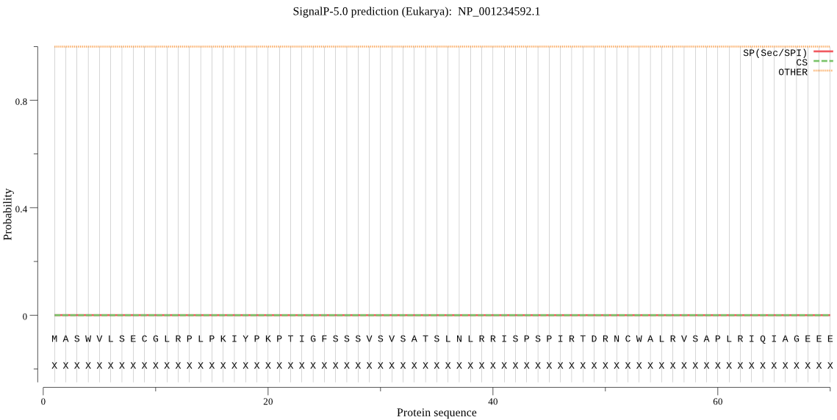

**Fig.2 Signal peptide prediction of omega-3 fatty acid desaturase by SignalP 5.0 database**

**3.5 Transmembrane Structure Prediction of Tomato *SlFAD7***

Many membrane proteins are amphipathic molecules. Their polypeptide chains can traverse the membrane one or more times. Their hydrophobic regions can span the hydrophobic region of the lipid bilayer and covalently bind to fatty acid chains, while the hydrophilic polar parts are located on the inner and outer surfaces of the membrane. In this study, the TMHMM Server 2.0 tool was used to predict the transmembrane structure of SlFAD7 in tomato. This prediction included the Number of predicted TMHs (the predicted number of transmembrane helices), Exp number of AAs in TMHs (the expected number of amino acids in the transmembrane helix structure), Exp number of first 60 AAs (the number of amino acids in the transmembrane helix among the first 60 amino acids of the protein) and Total prob of N-in (the total probability of being on the cytoplasmic side of the membrane). The prediction results (Fig.3) showed that SlFAD7 had two transmembrane helix structures (red rectangles), two structures inside the membrane (blue line segments), and one structure outside the membrane (red line segment). In addition, the two predicted transmembrane helices were located between the 119th and 141st, and the 268th and 290th amino acid residues respectively. This also verified the previously predicted result that this protein had a high aliphatic index.

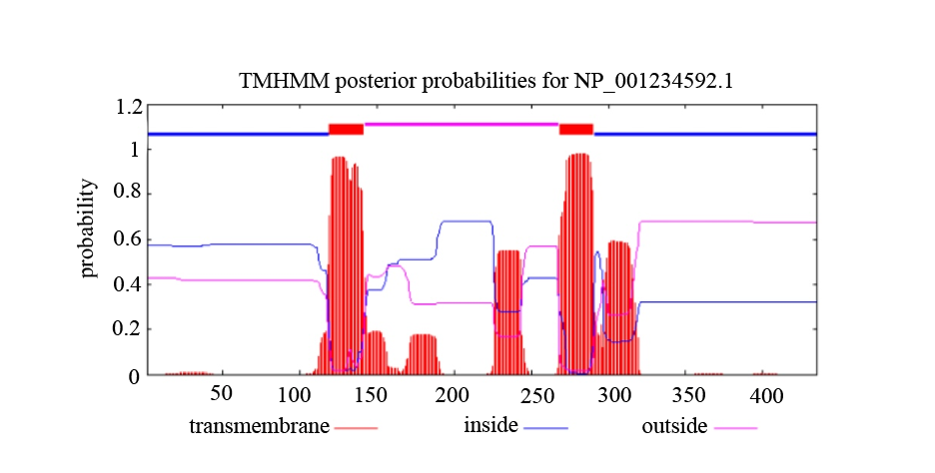

**Fig.3 Prediction of transmembrane structure of omega-3 fatty acid desaturase by TMHMM database**

**3.6 Conserved Domain Prediction of Tomato *SlFAD7***

A structural domain refers to an independent and stable structural region in a protein that is composed of different secondary structures and supersecondary structures[28], and it is also a functional unit of the protein. In proteins with multiple structural domains, different structural domains are often associated with different functions. A conserved domain refers to a structural domain that remains unchanged or identical during biological evolution or within a protein family. Conserved domains possess important functions and cannot be altered. They are the core of a gene. In this study, we analyzed SlFAD7 in tomato using the NCBI Conserved Domain Search online analysis software. The results showed that SlFAD7 belonged to the PLN02498 superfamily (Fig.4) and was the only member of this superfamily. This further illustrated the uniqueness and irreplaceable importance of the omega-3 fatty acid desaturase.



**Fig.4 Prediction of the conserved domain of omega-3 fatty acid desatur**

**3.7 3D Structure Prediction of Tomato *SlFAD7***

In this experiment, the Swiss-Model database was used to predict the 3D structure of SlFAD7 in tomato (Fig.5-7). The results showed that the model closest to SlFAD7 was 4zyo.1.A, but the similarity was only 16.44%. 4zyo.1.A was a structural model of human integral membrane stearoyl-CoA desaturase, indicating that omega-3 fatty acid desaturase had similar functions to stearoyl-CoA desaturase..

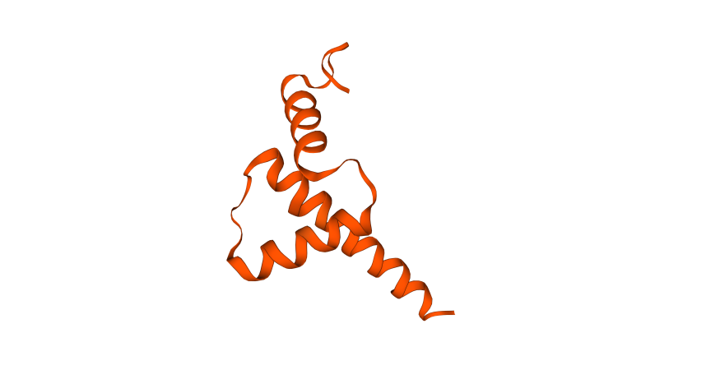

**Fig.5 Crystal structure of omega-3 fatty acid desaturase**

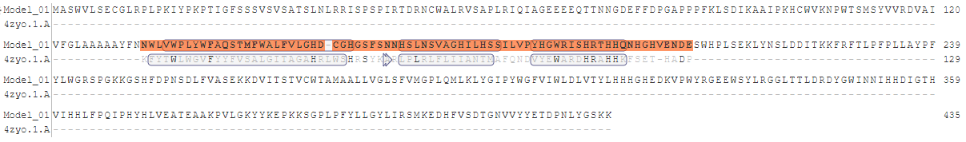

**Fig.6 Comparison of omega-3 fatty acid desaturase protein sequences with 4zyo.1.A**

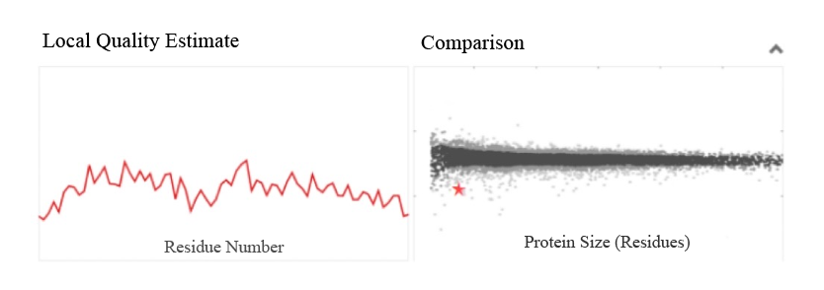

**Fig.7 Similarity analysis between omega-3 fatty acid desaturase and 4zyo.1.A**

**3.8 Prediction of Interacting Proteins of Tomato *SlFAD7***

We used the STRING database to predict the proteins that might interact with SlFAD7. The results showed that there were many proteins associated with SlFAD7 (Table 4), including the protein containing the DNAJ

heat shock N-terminal domain, arginine decarboxylase, polyamine oxidase 1, acyl-CoA N-acyltransferase, fatty acid desaturase 6 and acyl carrier protein. These enzymes exerted their respective catalytic effects and catalyzed the reactions of the upstream and downstream substances that relied on the action of SlFAD7 in tomato. It could be reasonably speculated that these proteins might work together with the omega-3 fatty acid desaturase in the synthesis pathway of JA and participated in the systemic disease resistance and defense response of tomato plants

**Table 4 Protein prediction associated with omega-3 fatty acid desaturase**

|  |  |  |  |
| --- | --- | --- | --- |
| Name | Associated protein | Specific types of associated proteins | Associated protein domain |
| omega-3  fatty acid  desaturase | Solyc12g099930.1.1 | Hop-interacting protein THI032 | Aminotran_5 |
| Solyc02g014860.2.1 | DNAJ heat shock N-terminal domain-containing protein | DnaJ、Fer_14 |
| Solyc10g054440.1.1 | Arginine decarboxylase | Orn_Arg_deC_N |
| Solyc01g110440.2.1  Solyc01g087590.2.1  Solyc01g103110.2.1  Solyc07g005510.2.1  Solyc02g038720.1.1 | Arginine decarboxylase  Polyamine oxidase 1  Acyl-CoA N-acyltransferase  Fatty acid desaturase 6  Acyl carrier protein | Orn_Arg_deC_N  DAO  Acetyltransf_6  FA_desaturase  PP_binding |

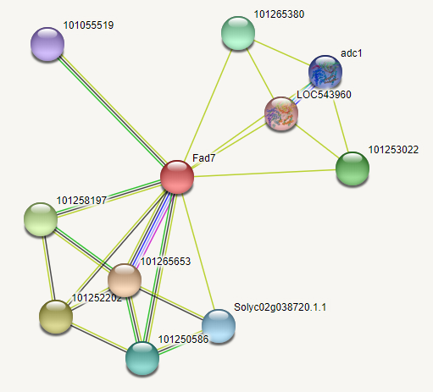

**Fig.8 Prediction of the related proteins of omega-3 fatty acid desaturase by STRING databas**

4. Discussion

During the growth process of plants, they will encounter various biotic and abiotic stresses, such as the infection of pathogens, drought and high temperature. In order to deal with these challenges, plants have evolved a set of complex regulatory mechanisms and make corresponding responses by regulating their own metabolic levels and hormonal levels[1-2].

Jasmonates play a crucial role as signaling molecules in this process. They are able to sense external stress signals and transmit them into the cells. Through precise regulation of the expression levels of downstream related genes, they play the indispensable role in many important processes such as plant growth and development, wound responses and reproductive metabolism[3]. For example, when plants are nibbled by insects or suffer from mechanical damage, the JA signaling pathway is activated, inducing the expression of a series of defense genes, synthesizing chemical substances for defense responses and enhancing the plant resistance.

The SlFAD7 gene and its encoded product, omega-3 fatty acid desaturase, occupy a central position in the synthesis pathway of JA, and they are the key components in this pathway. Omega-3 fatty acid desaturase can catalyze the production of linolenic acid, a precursor of JA. Linolenic acid is further synthesized into JA through the stearic acid pathway, thus playing an important role in the regulation of plant defense responses and growth and development.

In this study, we employed bioinformatics methods to conduct a comprehensive and in-depth analysis of the omega-3 fatty acid desaturase in tomato. By predicting its basic physical and chemical properties, we obtained information such as the molecular weight, isoelectric point and amino acid composition of the enzyme. These data provided a basis for the subsequent studies on the activity and function of the enzyme. The prediction of the open reading frame had clarified the gene structure encoding this enzyme, enabling us to have a deeper understanding of the gene expression regulatory mechanism. The prediction of the transmembrane structure and signal peptide had revealed the localization and transportation mode of the enzyme within the cell. The results of subcellular localization indicated that it mainly existed in chloroplasts and the endoplasmic reticulum, which provided important clues for further research on its action mechanism within the cell.

The analysis of the secondary structure had enabled us to clarify the spatial conformation of the enzyme. It had the structural characteristics mainly composed of α-helices and random coils, which might be closely related to its catalytic activity and function. The prediction of the conserved domain had determined that it belonged to the PLN02498 superfamily, further emphasizing the conservation and importance of this enzyme during the evolutionary process. The prediction of the 3D structure showed that the closest model of the omega-3 fatty acid desaturase was 4zyo.1.A, suggesting that it might have similar functions to stearoyl-CoA desaturase. The prediction of protein-protein interaction relationships had identified a series of proteins that interacted with the omega-3 fatty acid desaturase. These proteins might jointly participate in the synthesis and regulation of JA and work synergistically in the systemic disease resistance and defense response of tomato plants.

The results of this study provided a reference basis for further in-depth research on the functions and metabolic pathways of omega-3 fatty acid desaturase in tomato. They also offered new targets for molecular breeding aimed at enhancing the resistance, yield and quality of tomato in agricultural production.

5. Conclusion

Through the bioinformatics analysis of omega-3 fatty acid desaturase in tomato, we found that the omega-3 fatty acid desaturase in tomato was an enzymatic protein encoded by the *SlFAD7* gene. There were a total of 10 open reading frames for the omega-3 fatty acid desaturase, among which the longest open reading frame was ORF1 and the shortest open reading frame was ORF2. In terms of physical and chemical properties, the relative molecular mass of omega-3 fatty acid desaturase was 49,659.73, and its theoretical isoelectric point was 7.78. It contained a similar number of acidic amino acids (38) and basic amino acids (39). It was a stable hydrophilic protein with a relatively high lipid content. In terms of subcellular localization, omega-3 fatty acid desaturase was located in chloroplasts and the endoplasmic reticulum. It had 2 transmembrane domains and no signal peptide structure. It was speculated that this protein might be a chloroplast membrane protein and enters the chloroplast through the post-translational translocation pathway. In the secondary structure, α-helices and random coils accounted for the highest proportion. The 3D model was constructed using 4zyo.1.A as a template, but the sequence similarity between them was not high, and further experiments were needed to clarify its exact 3D structure. There were many types of interacting proteins, most of which were enzymatic proteins, such as arginine decarboxylase, polyamine oxidase 1 and fatty acid desaturase 6. Since the stress resistance of tomato plants plays a decisive role in the yield of tomato , the conclusion of this study not only enriched the information about omega-3 fatty acid desaturase in tomato, but also laid a foundation for further research on how the *SlFAD7* gene and its encoded product regulated the stress resistance response of tomato, thereby improving the yield and quality of tomato.

ACKNOWLEDGEMENT

This work was supported by the Project of Shenyang Science and Technology (24-215-2-11).

**Authors’ contributions**

*This work was carried out in collaboration among all authors. Authors CN, CX and ZYC designed the study, performed the statistical analysis, wrote the protocol and wrote the first draft of the manuscript. Authors CX, ZSY and ZYQ managed the analysis of the study. Authors ZSY and ZYQ managed the literature searches. All authors read and approved the final manuscript.*

Disclaimer (Artificial intelligence)

Option 1:

Author(s) hereby declare that NO generative AI technologies such as Large Language Models (ChatGPT, COPILOT, etc.) and text-to-image generators have been used during the writing or editing of this manuscript.

Option 2:

Author(s) hereby declare that generative AI technologies such as Large Language Models, etc. have been used during the writing or editing of manuscripts. This explanation will include the name, version, model, and source of the generative AI technology and as well as all input prompts provided to the generative AI technology

Details of the AI usage are given below:

1.

2.

3.

References

1. Song, W., Shao, H., Zheng, A., Zhao, L., & Xu, Y. (2023). Advances in roles of salicylic acid in plant tolerance responses to biotic and abiotic stresses. *Plants*, *12*(19), 3475.
2. Kumar, S., Jeevaraj, T., Yunus, M. H., Chakraborty, S., & Chakraborty, N. (2023). The plant cytoskeleton takes center stage in abiotic stress responses and resilience. *Plant, cell* *& environment*, *46*(1), 5-22.
3. Zhang, C., Wang, D., Li, Y., Wang, Z., Wu, Z., Zhang, Q., Jia, H., Dong, X., Qi, L,. Shi, J., & Shang, Z. (2024). Gibberellin positively regulates tomato resistance to tomato yellow leaf curl virus (TYLCV). *Plants*, *13*(9), 1277.
4. Huang, H., Qiao, H., Ma, X., Zhao, W., Sun, L., Yang, R., & Wang, S. (2023). Roles of jasmonates in tomato growth, development and defense. *Vegetable Research*, *3*(1).
5. Hewedy, O. A., Elsheery, N. I., Karkour, A. M., Elhamouly, N., Arafa, R. A., Mahmoud, G. A. E., Dawood, M. F.-A., Hussein, W. E., Mansour. A., Amin. D. H., Allakhverdiev. S.I., Zivcak. M., & Brestic, M. (2023). Jasmonic acid regulates plant development and orchestrates stress response during tough times. *Environmental and Experimental Botany*, 208, 105260.
6. Browse, J. (2009). Jasmonate passes muster: a receptor and targets for the defense hormone. *Annual Review of Plant Biology*, *60*(1), 183-205.
7. Conconi, A., Smerdon, M. J., Howe, G. A., & Ryan, C. A. (1996). The octadecanoid signalling pathway in plants mediates a response to ultraviolet radiation. *Nature*, *383*(6603), 826-829.
8. Glazebrook, J. (2005). Contrasting mechanisms of defense against biotrophic and necrotrophic pathogens. *Annu. Rev. Phytopathol.*, *43*(1), 205-227.
9. Howe, G. A., & Jander, G. (2008). Plant immunity to insect herbivores. *Annu. Rev. Plant Biol*., *59*(1), 41-66.
10. Buchanan‐Wollaston, V., Page, T., Harrison, E., Breeze, E., Lim, P. O., Nam, H. G. ,et al. (2005). Comparative transcriptome analysis reveals significant differences in gene expression and signalling pathways between developmental and dark/starvation‐induced senescence in Arabidopsis. *The Plant Journal*, *42*(4), 567-585.
11. Feys, B. J., Benedetti, C. E., Penfold, C. N., & Turner, J. G. (1994). Arabidopsis mutants selected for resistance to the phytotoxin coronatine are male sterile, insensitive to methyl jasmonate, and resistant to a bacterial pathogen. *The Plant Cell*, *6*(5), 751-759.
12. Huang, H., Liu, B., Liu, L., & Song, S. (2017). Jasmonate action in plant growth and development. *Journal of experimental botany*, *68*(6), 1349-1359.
13. Xu, E., Vaahtera, L., & Brosche, M. (2015). Roles of defense hormones in the regulation of ozone-induced changes in gene expression and cell death. *Molecular plan*t, *8*(12), 1776-1794.
14. Wasternack, C. (2007). Jasmonates: an update on biosynthesis, signal transduction and action in plant stress response, growth and development. *Annals of botany*, *100*(4), 681-697.
15. Li, C., Liu, G., Xu, C., Lee, G. I., Bauer, P., Ling, H. Q., Ganal, M. W ., & Howe, G. A. (2003). The tomato suppressor of prosystemin-mediated responses2 gene encodes a fatty acid desaturase required for the biosynthesis of jasmonic acid and the production of a systemic wound signal for defense gene expression. *The Plant Cell*, *15*(7), 1646-1661.
16. Shi, Y., An, L., Li, X., Huang, C., & Chen, G. (2011). The octadecanoid signaling pathway participates in the chilling-induced transcription of ω-3 fatty acid desaturases in Arabidopsis. *Plant Physiology and Biochemistry*, *49*(2), 208-215.
17. Domínguez, T., Hernández, M. L., Pennycooke, J. C., Jiménez, P., Martínez-Rivas, J. M., Sanz, C., Stockinger, E. J., SÁnchez-Serrano, J. J., & Sanmartín, M. (2010). Increasing ω-3 desaturase expression in tomato results in altered aroma profile and enhanced resistance to cold stress. *Plant Physiology*, *153*(2), 655-665.
18. Khodakovskaya, M., McAvoy, R., Peters, J., Wu, H., & Li, Y. (2006). Enhanced cold tolerance in transgenic tobacco expressing a chloroplast ω-3 fatty acid desaturase gene under the control of a cold-inducible promoter. *Planta*, 223, 1090-1100.
19. Kodama, H., Hamada, T., Horiguchi, G., Nishimura, M., & Iba, K. (1994). Genetic enhancement of cold tolerance by expression of a gene for chloroplast [omega]-3 fatty acid desaturase in transgenic tobacco. *Plant Physiology*, *105*(2), 601-605.
20. Kodama, H., Horiguchi, G., Nishiuchi, T., Nishimura, M., & Iba, K. (1995). Fatty acid desaturation during chilling acclimation is one of the factors involved in conferring low-temperature tolerance to young tobacco leaves. Plant *Physiology*, *107*(4), 1177-1185.
21. Yu, C., Wang, H. S., Yang, S., Tang, X. F., Duan, M., & Meng, Q. W. (2009). Overexpression of endoplasmic reticulum omega-3 fatty acid desaturase gene improves chilling tolerance in tomato. Plant Physiology and *Biochemistry*, *47*(11-12), 1102-1112.
22. Zhang, M., Barg, R., Yin, M., Gueta‐Dahan, Y., Leikin‐Frenkel, A., Salts, Y., Shabtai, S., & Ben‐Hayyim, G. (2005). Modulated fatty acid desaturation via overexpression of two distinct ω‐3 desaturases differentially alters tolerance to various abiotic stresses in transgenic tobacco cells and plants. *The Plant Journal, 44*(3), 361-371.
23. Roșca, M., Mihalache, G., & Stoleru, V. (2023). Tomato responses to salinity stress: From morphological traits to genetic changes. *Frontiers in plant science*, 14, 1118383.
24. Buljan, M., & Bateman, A. (2009). The evolution of protein domain families. *Biochemical Society Transactions*, *37*(4), 751-755.
25. Chen, Y., Wang, Y., Fu, H., Zeng, W., Wang, P., Zheng, X., & Yang, F. (2024). A new Bowman-Birk type protease inhibitor regulated by MeJA pathway in maize exhibits anti-feedant activity against the Ostrinia furnacalis. *Plant Molecular Biology*, *114*(5), 110.
26. Milovskaya, I. G., Varlamova, N. V., Starikov, A. Y., Demidenko, D. V., Pavlenko, O. S., Tyurin, A. A., ... & Khaliluev, M. R. (2024). Effect of Heterologous Δ9-Desaturase Expression on Fatty Acid Composition of Tomato Plants. *Russian Journal of Plant Physiology*, *71*(5), 162.
27. Lu, J., Xiaoyang, C., Li, J., Wu, H., Wang, Y., Di, P., ... & Zhang, J. (2025). Whole‐Genome Identification of the Flax Fatty Acid Desaturase Gene Family and Functional Analysis of the LuFAD2. 1 Gene Under Cold Stress Conditions. *Plant, Cell & Environment*, *48*(3), 2221-2239.