***Review Article***

**Role of Cover Crops in Mitigating Greenhouse Gas Emissions in Agricultural Systems**

**ABSTRACT**

Agriculture is a significant contributor to global greenhouse gas (GHG) emissions, particularly carbon dioxide (CO₂), methane (CH₄), and nitrous oxide (N₂O). At the same time, it offers viable pathways for climate change mitigation through sustainable land management. This systematic literature review evaluates the potential of cover crops non-harvested plant species typically grown during fallow periods to reduce GHG emissions and support climate-smart agriculture. Cover crops influence GHG dynamics through multiple mechanisms, including carbon sequestration, biological nitrogen fixation, and reduced nitrate leaching. They also improve soil health by enhancing organic matter content, stabilizing soil structure, conserving water, and supporting beneficial microbial activity. Drawing from 80 peer-reviewed studies selected from an initial pool of 250, the review categorizes cover crops into leguminous and non-leguminous types. Legumes, such as clover and vetch, fix atmospheric nitrogen, decreasing the need for synthetic fertilizers and associated N₂O emissions. Non-leguminous species like rye and radish scavenge excess nutrients and improve carbon storage. Despite strong empirical support for their environmental benefits, the effectiveness of cover crops varies by species, soil type, climate, and management practices. In some cases, cover crops can even increase N₂O emissions under poorly drained or mismanaged conditions. Adoption of cover crops remains uneven, particularly in the Global South, due to financial, technical, and institutional barriers. Constraints include limited seed access, labor shortages, and lack of policy incentives. This review identifies key research gaps in understanding long-term effects, species mixtures, and cover crop performance under future climate scenarios. To scale adoption and maximize climate benefits, future efforts should focus on improving predictive models, expanding farmer training, and enhancing policy and financial support. Overall, cover crops present a promising, nature-based strategy for reducing agricultural emissions while enhancing soil health and resilience in the face of climate change.

*Keywords: Cover crops, CO2, CH₄, constrains, N₂O, mitigation*

1. **INTRODUCTION**

Agriculture plays a pivotal yet paradoxical role in the global climate crisis. It is both a major contributor to anthropogenic greenhouse gas (GHG) emissions and a potential pathway for climate change mitigation. The three primary GHGs associated with agricultural systems are carbon dioxide (CO₂), methane (CH₄), and nitrous oxide (N₂O) (Sadra et al., 2024). These gases originate from distinct biophysical processes and differ significantly in their global warming potentials (GWP). CO₂ emissions primarily result from the loss of soil organic carbon due to practices such as tillage and land-use change. CH₄ is largely produced through enteric fermentation in ruminants and under anaerobic conditions in flooded paddy fields. N₂O, with a GWP approximately 300 times that of CO₂ over a 100-year period, is predominantly emitted as a byproduct of nitrogen fertilization and inefficient nutrient cycling in soils (Salehin et al., 2025). Collectively, the agriculture, forestry, and other land use (AFOLU) sectors account for roughly 23–24% of global anthropogenic GHG emissions, underscoring the urgent need for transformative land management practices (IPCC, 2021). In response to the challenges of agricultural emissions, sustainable agricultural strategies, particularly those aligned with the principles of climate-smart agriculture (CSA), are gaining prominence. CSA approaches aim to simultaneously improve productivity, enhance resilience, and reduce greenhouse gas emissions (Paustian et al., 2016). Among these, cover cropping has emerged as a nature-based solution offering multiple ecosystem services.

Cover crops, grown primarily to cover the soil surface between main crop cycles (Sharma et al., 2018). These are typically planted between cash crops to improve agricultural productivity and sustainability. Cover crops can be broadly categorized into leguminous and non-leguminous types. Legume cover crops, such as clover and vetch, primarily contribute to atmospheric nitrogen fixation, which benefits subsequent crops by reducing the need for synthetic nitrogen fertilizers (Smith et al., 1987; Ladha et al., 2014). In contrast, non-leguminous cover crops such as rye, mustard, and radish are primarily used to reduce soil erosion and nitrate leaching, while also enhancing soil structure and organic matter content (Meisinger et al., 1991; McCracken et al., 1994). Both leguminous and non-leguminous cover crops play critical roles in improving the physical, chemical, and biological properties of the soil, making them essential tools in the transition toward more sustainable, climate-resilient agriculture. They improve soil health, manage nutrients, reduce erosion, conserve water, and foster biodiversity (Fiorini et al., 2020; Gong et al., 2021; Salehin et al., 2025; Silva et al., 2025). Typically planted during fallow periods, these crops modulate key soil biogeochemical processes and influence GHG emissions through carbon sequestration, enhanced nitrogen cycling, and support for beneficial microbial activity (Figure 1) (Salehin et al., 2025; Silva et al., 2025).

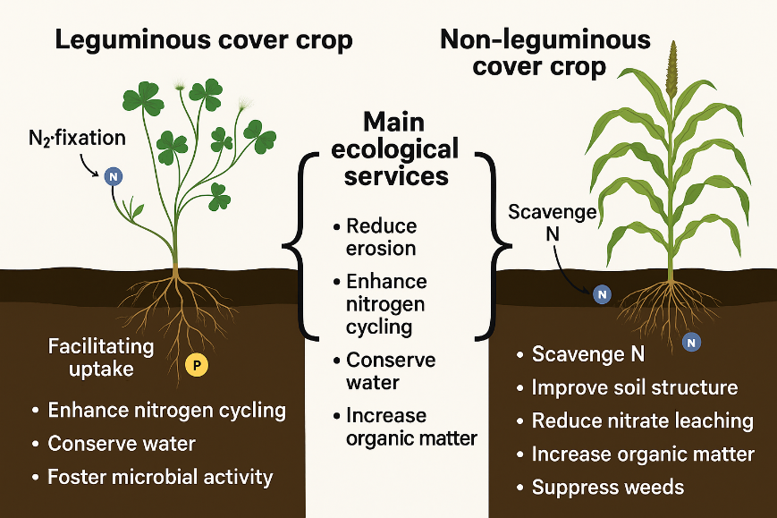

Figure 01: Schematic diagram explaining the role of different type of cover crops in the agroecosystems and their main ecological services.

Cover crops have long been recognized for their multiple benefits, both for the environment and farming communities. An ideal cover crop should establish and grow rapidly, tolerate adverse climatic conditions, fix atmospheric nitrogen, absorb nutrients through deep root systems, and produce substantial biomass within a short period. Additionally, it should be easy to manage, non-competitive with main crops, resistant to pests and diseases, effective in suppressing weeds, and cost-effective to cultivate (Deb et al., 2013; Reddy, 2016; Bayer et al., 2016; Kaye and Quemada, 2017).

The multi-functionality of cover crops aligns closely with CSA’s “triple win” objectives. Cover crops contribute to building soil organic matter, reducing dependency on synthetic fertilizers, and improving agroecosystem biodiversity, factors that support both climate mitigation and agricultural sustainability. However, the magnitude and direction of these benefits are highly context-dependent (Paustian et al., 2016). Variations in cover crop species, soil type, climate, and management practices significantly affect their performance. For instance, leguminous species such as clover and vetch can fix atmospheric nitrogen, whereas cereal cover crops like rye are effective at scavenging excess soil nitrogen, thereby reducing potential N₂O emissions (Schön et al., 2024).

Despite their promise, the adoption of cover crops is uneven globally. In regions like the United States and parts of Europe, financial incentives, extension services, and policy support have led to increased adoption. The U.S. Department of Agriculture’s Natural Resources Conservation Service (USDA-NRCS), for example, offers programs providing both technical and financial assistance to farmers implementing cover crops (Tian et al., 2024). In contrast, adoption remains limited in many parts of Africa, Asia, and Latin America due to constraints such as lack of seed access, technical knowledge, labor availability, and policy support. Additionally, smallholder farmers may face trade-offs between short-term economic gains and long-term soil health benefits (Tian et al., 2024).

Scientific evidence underscores the role of cover crops in influencing soil–plant–atmosphere interactions that determine GHG fluxes. Carbon sequestration occurs through the buildup of soil organic carbon, especially when crop residues are left to decompose naturally. Enhanced organic matter improves soil structure, water retention, and nutrient availability, key traits of resilient farming systems. Moreover, biological nitrogen fixation and nutrient recycling by cover crops can reduce the need for synthetic nitrogen inputs, mitigating associated N₂O emissions. Some cover crops may also reduce methane emissions by improving soil aeration, particularly relevant in rice-based systems.

Meta-analyses and field studies provide empirical support for these benefits. Poeplau and Don (2015) found that cover cropping can increase soil organic carbon stocks by an average of 0.32 ± 0.08 Mg ha⁻¹ yr⁻¹. Similarly, Basche et al. (2014) reported a 50% reduction in nitrate leaching due to cover crops, indirectly reducing N₂O emissions through improved nitrogen retention. However, some studies also report increased N₂O emissions under specific conditions, such as poorly drained soils or when high-biomass cover crops are terminated under wet conditions. These findings highlight the need for site-specific management.

Cover crops often interact synergistically with other sustainable practices. For instance, pairing them with conservation tillage can amplify carbon sequestration and soil erosion control. Likewise, integrating cover crops with precision nutrient management enhances nitrogen use efficiency and minimizes GHG losses. Nevertheless, trade-offs may arise in water-limited environments where cover crops may compete with cash crops for moisture and nutrients, potentially impacting yields.

Challenges to wider adoption include economic costs related to seeds, labor, and termination, as well as knowledge gaps regarding long-term and large-scale effects. There remains significant uncertainty in modeling and measuring cover cropping impacts on GHG emissions across diverse agroecological zones. Key research gaps persist around the cumulative effects of long-term cover cropping, performance of multi-species mixtures, and their behavior under projected climate change scenarios.

Future research should aim to improve predictive models of cover crop effects on GHG dynamics, develop site-specific recommendations, and incorporate remote sensing for regional monitoring. Policy instruments that offer financial incentives, support farmer training, and invest in robust seed systems will be essential for scaling up adoption. Given their potential for improving soil health, reducing GHG emissions, and enhancing system resilience, cover crops represent a compelling solution for climate-smart and sustainable agriculture.

1. **METHODOLOGY**

This systematic literature review (SLR) was conducted to assess the role of cover crops in mitigating greenhouse gas (GHG) emissions within agricultural systems. The SLR method allows for a comprehensive and structured synthesis of existing literature, offering a high degree of topic relevance and the ability to identify current knowledge gaps and future research directions (Tikito and Souissi, 2019; Burgers et al., 2019). The review was organized into two major sections: (1) types and agronomic roles of cover crops, along with mitigation of GHG Emission and (2) considerations and future perspectives of using cover crops to mitigate GHG

To ensure the rigor and relevance of the review, literature was identified using reputable scientific databases including Google Scholar, PubMed, and ResearchGate. Relevant keywords such as “cover crops,” “greenhouse gas emissions,” “agriculture,” “soil carbon,” “nitrous oxide,”sustainable agriculture” and “mitigation” were used. In total, approximately 250 articles were initially identified through these databases. A flow framework approach was applied to screen the literature, incorporating both inclusion and exclusion criteria. The inclusion criteria required that studies: (1) explicitly focus on cover crops in agricultural systems; (2) provide empirical data or a robust synthesis of field-based or modeled findings and (3) future considerations of employing cover crops in agriculture fields. Articles were excluded if they lacked relevance to GHG mitigation or focused on unrelated aspects of cover cropping (e.g., control pests and pathogens, attraction of pollinator insects) without addressing emissions.

Following the initial screening, 80 articles were selected based on their direct relevance to the research objectives and thematic focus. These included peer-reviewed journal articles, review papers, and high-quality conference proceedings. A snowballing technique was also used to identify additional literature by reviewing the reference lists of key publications (Greenhalgh and Peacock, 2005). The final set of literature was analyzed for key findings, methodologies, and thematic trends, which are discussed in the following sections. This synthesis provides an evidence-based overview of how cover crops can influence greenhouse gas dynamics, soil health, and sustainable agricultural practices.

1. **RESULT AND DISCUSSION**
   1. **Cover Crops: Types and Agronomic Roles**

Cover crops are non-harvested plant species intentionally integrated into cropping systems to enhance a range of agroecological functions rather than to produce direct economic yield. Their primary roles include improving soil fertility, reducing erosion, suppressing weeds, enhancing water infiltration, conserving biodiversity, and mitigating greenhouse gas (GHG) emissions. The selection of cover crop species depends heavily on regional climate, soil conditions, management goals, and crop rotation schedules. Broadly, cover crops are categorized into legumes, non-legumes (grasses and brassicas), and multi-species mixtures, each offering distinct functional advantages (Blanco-Canqui et al., 2015).Table 01 displays few countries from many which have conducted studies recently to evaluate the impact of cover crops for the environment and mitigation of GHG emissions.

Table 01: Countries conducted studies on effect of cover crops as documented from peer-reviewed research studies.

|  |  |  |  |
| --- | --- | --- | --- |
| Country | Main Crop | Cover Crop | Reference |
| Southern Brazil | maize | oat, vetch, cowpea, pigeon pea | Silva et al., 2025 |
| Central Europe | Pea | Phacelia Mustard Clover Oats | Scho et al., 2024 |
| Iran | Potato | hairy vetch, rye, mixed (rye + hairy vetch) | Sadra et al., 2024 |
| Ireland | rotation sugar beet, spring barley and oil seed rape | mustard cover crop | Abdalla et al., 2014 |
| USA | Cotton | Austrian winter pea, purple-top turnip, oats | Salehin et al., 2025 |
| Spain | Maize | Barley, (2) vetch, traditional winter fallow | Guardia et al., 2016 |
| Italy | soybean, winter wheat, maize | Hairy vetch | Fiorini et al., 2020 |

* + 1. **Leguminous Cover Crops**

Leguminous species such as hairy vetch (*Vicia villosa*), red clover (*Trifolium pratense*), field pea (*Pisum sativum*), alfalfa (*Medicago sativa*), and cowpea (*Vigna unguiculata*) are primarily valued for their ability to biologically fix atmospheric nitrogen (N₂) through symbiotic interactions with *Rhizobium* bacteria in root nodules. This process, known as biological nitrogen fixation (BNF), converts inert N₂ gas into plant-available ammonium (NH₄⁺), enhancing soil nitrogen status while reducing reliance on synthetic fertilizers. Depending on species, climate, and management conditions, legumes can fix between 50–200 kg N/ha annually (Quintarelli et al., 2022). For instance, hairy vetch has demonstrated nitrogen fixation rates exceeding 100 kg N/ha in temperate regions (Drinkwater et al., 1998). Further, studies confirm that the use of legume cover crops in crop rotations, such as clover and alfalfa enhance the yields of the following cash crop (Chu et al., 2017; Marcillo et al., 2017; Zhang et al., 2017; Jensen et al., 2021). Additionally, they acidify the plant rhizosphere by facilitating the uptake of insoluble phosphorous into the soil (Wang and Lambers, 2020; Mukherjee et al., 2021) (Figure 02).

Beyond nitrogen contribution, legumes support microbial biomass and soil aggregation via prolific root exudates, and flowering species (e.g., clovers) provide vital forage for pollinators, enhancing on-farm biodiversity (Schipanski et al., 2014; Storkey et al., 2015). However, their relatively low biomass production compared to grasses limits their effectiveness in erosion control and weed suppression. Additionally, their nitrogen-rich residues decompose rapidly, potentially leading to elevated nitrous oxide (N₂O) emissions if residue incorporation is poorly timed (Basche et al., 2014; Sanz-Cobena et al., 2017).

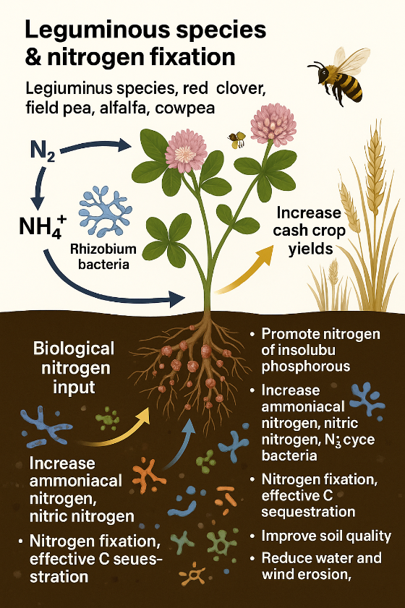

Figure 02: Schematic diagram explaining the role of different type of leguminous cover crops in the agroecosystems.

* + 1. **Grass Cover Crops**

Grasses such as cereal rye (*Secale cereale*), oats (*Avena sativa*), and barley (*Hordeum vulgare*) are favored for their rapid growth, extensive fibrous root systems, and capacity for high biomass production. These characteristics make them effective at stabilizing soil, enhancing soil organic matter, and scavenging residual soil nitrogen, thereby reducing nutrient leaching during fallow periods (Kaye & Quemada, 2017). Grasses typically exhibit high carbon-to-nitrogen (C:N) ratios, which slows decomposition, extends ground cover duration, and supports long-term carbon sequestration. These species also improve soil physical properties such as porosity and water infiltration, which in turn regulate GHG fluxes by influencing microbial habitat conditions and gas diffusivity in the soil profile. However, the high C:N ratio of grass residues may lead to temporary nitrogen immobilization, restricting nitrogen availability for subsequent crops (Table 02).

* + 1. **Brassica Cover Crops**

Brassicas, including forage radish (*Raphanus sativus*), canola (*Brassica napus*), and mustard (*Sinapis alba*), provide specialized ecosystem services. Their signature trait is the development of deep taproots capable of penetrating compacted soil layers a phenomenon termed "bio-drilling" which improves subsoil aeration, water infiltration, and nutrient accessibility for subsequent crops (Chen & Weil, 2011). Additionally, many brassicas produce glucosinolates, compounds that decompose into natural biofumigants, which help suppress soil-borne pathogens and pests (Table 02). While brassicas do not contribute to nitrogen fixation, they are efficient nutrient recyclers and can scavenge significant amounts of residual nitrogen. Their fast decomposition rates and disease-suppressive attributes make them valuable in pest management and integrated nutrient strategies.

Table 02: Agro-ecological services of Grass Cover Crops and Brassica Cover Crops

|  |  |  |  |
| --- | --- | --- | --- |
|  | Agro-ecological Function | Example/s of cover crops | Reference |
| Grass Cover Crops | Increase SOM | *Avena sativa* | Duval et al., 2016 |
| Reduce soil erosion | *Avena sativa, Secale cereal, Lolium perenne, Sorghum × drummondii* | Kaspar et al., 2001; DeBaets et al., 2011 |
| Effective C sequestration | *Secale cereal, Panicum maximum, Pennisetum glaucum* | Ding et al., 2006; Nascente et al., 2013; Gong et al., 2022 |
| Keeping N2O emissions under control and Reduce NO3 leaching | *Secale cereale* | Fiorini et al., 2020 |
| Improve soil structure | *Secale cereale, Sinapis alba* | García-González et al., 2018; Boselli et al., 2020 |
| Brassica Cover Crops | Effective against pest | *Brassica rapa, Brassica napus, Raphanus raphanistrum subsp. sativus, Brassica juncea L., Eruca sativa* | Ntalli and Caboni, 2017; Aydınlı et al., 2018; Wang and Lambers, 2020; Mukherjee and Sen, 2021; Waisen et al., 2022 |
| Enhance nitrogen fixation | *Brassica hirta* | Collins et al., 2007 |
| Increase microbial activity | *Brassica napus, Brassica rapa* | Lehman et al., 2012 |
| Reduce subsoil compaction and Reduce soil erosion | *Raphanus sativus, Brassica napus, Pennisetum glaucum* | Chen et al., 2011; Abdollahi et al., 2014; Calonego et al., 2010 |

* + 1. **Mixed-Species Cover Crops**

Multi-species mixtures, combining legumes, grasses, and brassicas, are gaining prominence due to their capacity to deliver multiple functions simultaneously. A common example is a hairy vetch–rye mixture, which leverages nitrogen fixation from the legume and high biomass and nitrate scavenging from the grass. This combination creates a more balanced C:N ratio, moderating decomposition rates and synchronizing nutrient release with crop demand (Basche & DeLonge, 2019).

Mixed cover crops often improve ecological resilience by providing functional diversity in rooting depth, growth phenology, and nutrient uptake strategies. This diversity enhances system stability under fluctuating climatic conditions (Ranaldo et al., 2019). Deep-rooted species exploit subsoil resources, while shallow-rooted companions access surface nutrients, thereby optimizing total system efficiency and reducing interspecific competition.

Nevertheless, managing mixtures is more complex than monocultures. Considerations must include species compatibility, optimal seeding rates, and termination methods tailored to each component. Aggressive grasses may outcompete slower-growing legumes, and termination via rolling, mowing, or herbicide must be matched to the physiological characteristics of all included species.

# **Ecological Functions of Cover Crops for Mitigation of Greenhouse Gas (GHG) Emission**

Cover crops are fundamental to sustainable agricultural systems, providing critical ecosystem services that enhance soil health, nutrient cycling, biodiversity, and climate resilience. Their diverse functional traits offer targeted ecological benefits (Figure 03), enabling farmers to select species or species mixtures according to specific management objectives and environmental conditions. Understanding these traits is essential for optimizing the multifunctional benefits of cover cropping, including greenhouse gas (GHG) mitigation (Tribouillois et al., 2018; Ranaldo et al., 2019; Blanco-Canqui & Ruis, 2015) which is also vary depending on the type of cover crops, management practices, and soil type. Silva et al., 2025 revealed cover crops can reduce life-cycle GHG emissions by ~40 to >100% through increased soil C sequestration from no-tillage maize cultivations in southern Brazil while resulting increased margin yield.

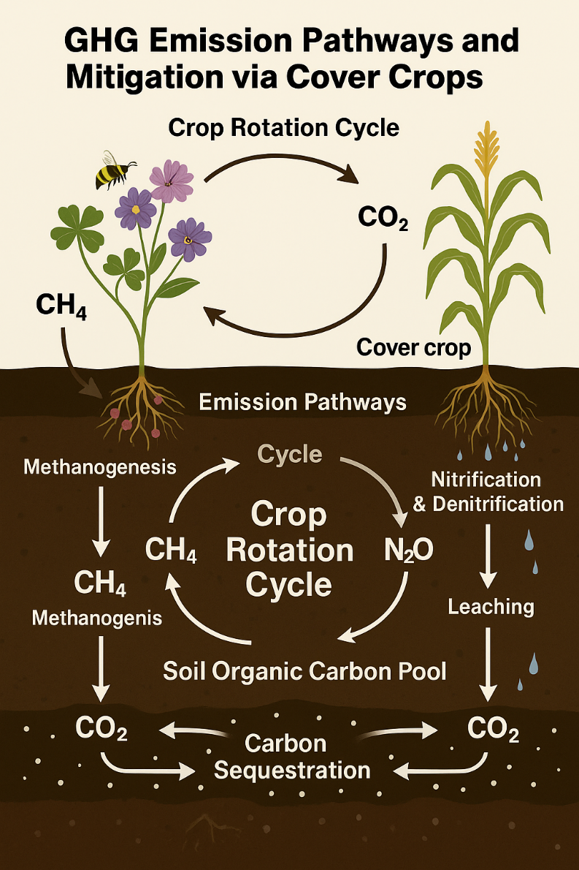

Figure 03: Schematic diagram of GHG emission pathways and mitigation via cover crops

* + 1. **Nitrogen Fixation and Soil Fertility Enhancement**

In conventional grain production systems, nitrate leaching can account for 10% to 30% of the nitrogen applied (Sharma et al., 2018). This leaching is a significant concern, as it can contaminate drinking water, contribute to the eutrophication of aquatic ecosystems, and increase atmospheric ammonia pollution. Adopting improved soil management practices, such as the use of cover crops, can help mitigate nitrate leaching in agricultural soils (Tosti et al., 2014). Cover crops reduce the need for additional nitrogen inputs for subsequent crops by capturing nitrogen through their roots. This process prevents the leaching of nitrate into groundwater and limits the downward movement of nutrients within the soil profile (Gabriel et al., 2013).

For an example leguminous cover crops, such as hairy vetch (*Vicia villosa*), red clover (*Trifolium pratense*), crimson clover (*Trifolium incarnatum*), and alfalfa (*Medicago sativa*) are especially valued for their ability to fix atmospheric nitrogen (N₂) through symbiotic relationships with *Rhizobium* bacteria. This biological nitrogen fixation (BNF) transforms inert atmospheric N₂ into bioavailable ammonium, enriching soil fertility, reducing synthetic fertilizer use, and thus lowering GHG emissions associated with fertilizer production and application (Blanco-Canqui et al., 2015; Sanz-Cobena et al., 2017; Quintarelli et al., 2022). A study conducted in Sweden (1992–1994) found that perennial ryegrass (*Lolium perenne*) as a cover crop reduced nitrate leaching in barley systems from 10–18 mg L⁻¹ to less than 5 mg L⁻¹ (Bergström et al., 2001). Another study showed that oat (*Avena sativa*) cover crops reduced nitrate concentrations by 26%, while rye (*Secale cereale*) reduced nitrate concentrations by 48% (Kaspar et al., 2012).

In another experiment conducted by Wang el al. in 2021, it was revealed that hairy vetch can contribute 100–200 kg N/ha per season, significantly enhancing soil nitrogen availability for subsequent crops. Similarly, crimson clover and alfalfa can fix 50–250 kg N/ha, depending on conditions, providing a robust nitrogen source while also improving soil structure through deep-rooting systems (William et al., 2021). By displacing fossil-fuel-intensive synthetic fertilizers, leguminous cover crops can reduce the carbon footprint of farming by up to 40% (Basche et al., 2014). However, if residues decompose too rapidly and release nitrogen when not needed by crops, they can increase nitrous oxide (N₂O) emissions, a potent GHG highlighting the importance of synchronizing cover crop termination with cash crop uptake (Hina, 2024).

* + 1. **Biomass Production and Carbon Sequestration**

The potential of cover crops to enhance soil organic carbon (SOC) has been explored in only a limited number of studies (Lal, 2004). Agricultural soils generally contain lower SOC levels compared to soils under natural vegetation. In fact, crop cultivation can lead to SOC losses of 30 to 40% relative to natural ecosystems (Don et al., 2011; Poeplau et al., 2011). The amount of SOC sequestered in soils, whether under conventional tillage or no-till systems is influenced by crop management practices, which affect both the quantity of plant carbon inputs and the rate of organic matter mineralization.

Grasses like cereal rye (*Secale cereale*), oats (*Avena sativa*), barley (*Hordeum vulgare*), and sorghum-sudangrass (*Sorghum bicolor × S. sudanense*) excel in producing substantial aboveground and belowground biomass. High biomass production contributes organic matter inputs that enhance soil structure, boost microbial activity, and build long-term soil organic carbon (SOC) stocks (Blanco-Canqui et al., 2015; Kaye & Quemada, 2017). For example, cereal rye can yield up to 10,000 kg of dry biomass per hectare (Schipanski et al., 2014), acting as a powerful soil cover that reduces erosion and suppresses weeds. Its high carbon-to-nitrogen (C:N) ratio ensures slower decomposition, leading to sustained carbon inputs and enhanced SOC sequestration over time. A meta-analysis by Poeplau and Don (2015) showed that cover cropping with species like rye increased SOC by an average of 0.32 Mg C ha⁻¹ yr⁻¹, especially in temperate and degraded soils. Numerous studies (Bayer et al., 2009; Bayer et al., 2016) have observed that management with summer cover crops in agroecosystems promotes soil C sequestration in low-fertility soils in the tropics and subtropics because of the high production of biomass by summer cover crops.

* + 1. **Weed Management**

Beyond soil building, high-biomass cover crops suppress weeds physically through shading and chemically through allelopathy. Rye, for example, releases allelochemicals such as benzoxazinoids that inhibit weed seed germination (Teasdale & Mohler, 2000), offering a natural alternative to herbicides. Similarly, sorghum-sudangrass produces bioactive compounds that suppress weed and pathogen populations (Schipanski et al., 2014; Panda et al., 2021). A field study conducted in Lithuania (2006–2012) found that white mustard, alone or mixed with buckwheat, was the most effective cover crop for suppressing weeds in organic and sustainable farming systems across soils with low and moderate humus content. In contrast, narrow-leafed lupine mixed with oil radish was less effective. The experiment demonstrated that cover crops can serve as an effective weed control strategy (Masilionyte et al., 2017).

* + 1. **Deep Rooting and Bio-Drilling Functions**

Deep-rooted cover crops such as oilseed radish (*Raphanus sativus*), alfalfa, and forage chicory (*Cichorium intybus*) are vital for alleviating soil compaction and enhancing subsurface nutrient cycling. Through "bio-drilling," these species create vertical channels that improve water infiltration, aeration, and root penetration for subsequent crops (Chen & Weil, 2011). Oilseed radish, for example, can penetrate compacted layers to depths over one meter (Snapp et al., 2022), reducing surface runoff and promoting groundwater recharge. Alfalfa, with taproots extending up to 4 meters deep, not only improves subsoil structure but also recycles deep-stored nutrients like nitrogen and potassium back to the surface, where they become accessible to shallower-rooted cash crops (William et al., 2021).

The **deep rooting ability** of cover crops plays an important role in **controlling soil erosion**. A study in Belgium found that cover crops with fibrous root systems (e.g., ryegrass (*Lolium perenne*), rye (*Phacelia tanacetifoli*), and oats (*Avena sativa*)) are more effective at controlling soil erosion than those with thicker roots (e.g., white mustard (*Sinapis alba*) and fodder radish (*Raphanus sativus subsp. oleiferus*)). Root density ranged from 1.02 kg/m³ (phacelia) to 2.95 kg/m³ (ryegrass) (De Baets et al., 2011).

* + 1. **Nutrient Scavenging and Environmental Protection**

Grasses and brassicas are particularly efficient at scavenging residual soil nutrients especially nitrogen and preventing them from leaching into groundwater. Cereal rye's dense fibrous root system efficiently captures nitrate, reducing nitrate leaching losses by up to 80% compared to bare fallow fields (Storkey et al., 2015). Similarly, brassicas like forage radish and mustard mobilize otherwise immobile nutrients like phosphorus, enhancing their bioavailability for succeeding crops (Chen & Weil, 2011).

Moreover, many brassicas produce glucosinolates, compounds that break down into biofumigants capable of suppressing soil-borne pathogens and pests (Ranaldo et al., 2019). This dual nutrient-scavenging and pest-suppressive capability makes brassicas highly valuable in integrated pest management (IPM) systems, particularly for organic farming operations where synthetic chemicals are restricted (Clark, 2007).

* + 1. **Improve Microbial Populations**

Cover crops are increasingly used as a strategy to enhance soil microbial growth in agricultural systems. A study examining conventional tillage (CT) and no-tillage (NT) systems with a ryegrass (*Lolium perenne*) cover crop in cotton (*Gossypium hirsutum*) fields found that ryegrass maintained higher microbial populations in the upper 2 cm of soil compared to plots without cover crops. Additionally, CT systems had higher bacterial and fungal colony-forming units (CFUs) in the 2–10 cm soil depth. Remarkably, cover crops under NT systems supported 100-fold higher CFUs than other treatments (Zablotowicz et al., 2007).

A field experiment in Pennsylvania evaluated the effects of individual and mixed cover crops on soil microbial community structure and biological activity. The results showed that oats (*Avena sativa*) and cereal rye (*Secale cereale*) favored the growth of arbuscular mycorrhizal (AM) fungi, while hairy vetch (*Vicia villosa*) was more associated with non-AM fungi. Mixtures of multiple cover crop species also promoted diverse cover crop–microbe associations, demonstrating a clear relationship between cover crop species and microbial communities (Finney et al., 2017).

The role of mycorrhizal fungi in improving soil quality is well established. Cover crops enhance the inoculation of mycorrhizal fungi in soils (Galvez et al., 1995), which in turn benefits crop growth by forming symbiotic relationships with plant roots, improving nutrient and water uptake (Zak et al., 1998). For instance, early growth and higher yields of cotton following a wheat (*Triticum aestivum*) cover crop were linked to early root infection by mycorrhizal fungi. This suggests that cotton roots actively engage with existing mycorrhizal networks established by the wheat cover crop (Flint et al., 2000).

# **Challenges, Limitations, and Economic Considerations for Using Cover Crops in Greenhouse Gas Mitigation**

Despite the well-documented environmental benefits of cover crops, their widespread adoption for greenhouse gas (GHG) mitigation in agriculture remains limited due to a range of economic, agronomic, knowledge-based, and institutional barriers. Understanding and addressing these challenges is essential to scaling up their deployment and realizing their full climate potential. Among the most significant impediments is the economic cost associated with establishing cover crops. Expenses for seeds, labor, specialized equipment for seeding and termination, and potential reductions in yields particularly in tight crop rotations can make adoption financially daunting (SARE & CTIC, 2016). For smallholder farmers and even larger operations with narrow profit margins, these upfront costs are prohibitive unless compensated by tangible short-term returns or subsidies. Compounding this issue is the delayed realization of benefits such as soil health improvements, carbon sequestration, and enhanced nutrient cycling, which typically accrue over multiple seasons (Poeplau & Don, 2015). Farmers operating under annual lease agreements or immediate financial pressures are thus less likely to invest in practices offering primarily long-term gains. To overcome these economic barriers, robust policy tools such as payments for ecosystem services, cost-share programs, and verifiable carbon credit systems are necessary to internalize the long-term climate value of cover cropping and improve financial viability (Abdalla et al., 2019).

Agronomic trade-offs further complicate the integration of cover crops into existing farming systems. In semi-arid and arid regions, water competition between cover crops and cash crops is a pressing concern. Cover crops can significantly deplete soil moisture, particularly if termination is delayed, thereby undermining yields and threatening farm sustainability (Eash et al., 2021). Additionally, cover crops may serve as reservoirs for pests and pathogens; for example, cereal rye can harbor wireworms and brassicas may attract flea beetles, both of which negatively impact subsequent crops (Schipanski et al., 2014). Nitrogen management also presents challenges. Leguminous cover crops like clover and hairy vetch contribute valuable nitrogen to the soil but can increase N₂O emissions of nitrogen inputs surpass the needs of subsequent crops (Wang et al., 2021). Non-leguminous species like rye, while effective at nitrogen scavenging and reducing emissions, often necessitate supplemental fertilizer inputs for optimal cash crop performance. These trade-offs highlight the need for locally adapted cover cropping strategies that align species selection and management practices with agroecological conditions.

Beyond economic and agronomic factors, knowledge gaps and infrastructural constraints hinder the effective integration of cover crops. Many farmers lack awareness of the climate mitigation benefits of cover crops or the technical expertise required for successful implementation (Basche et al., 2014). Specialized equipment such as interseeders or crimp rollers is often needed for efficient planting and termination, especially in conservation tillage systems, and access to such tools is limited in developing regions. Weak agricultural extension systems further exacerbate these challenges by restricting the dissemination of context-specific management advice. Capacity-building initiatives such as on-farm demonstrations, participatory research trials, and farmer-to-farmer learning networks are vital to fostering widespread adoption and reducing uncertainty around cover cropping (Panda et al., 2021).

Institutional and market-related barriers also significantly limit cover crop adoption for climate mitigation purposes. Many agricultural policy frameworks and subsidy structures remain misaligned with regenerative practices. In some regions, government incentives favor monoculture systems or heavy fertilizer use, indirectly disincentivizing practices like cover cropping that promote diversification and nutrient efficiency (Pramanick et al., 2021). Moreover, carbon market mechanisms often inadequately account for soil-based carbon sequestration and the indirect GHG mitigation benefits from improved nitrogen management. As a result, farmers may find it difficult to access meaningful financial rewards for adopting climate-friendly practices. Shifting towards outcome-based incentive systems that reward verified reductions in GHG emissions or measurable increases in soil carbon could create stronger motivations for cover crop adoption (Petropoulos et al., 2025).

While the challenges are considerable, there are also significant economic opportunities linked to cover cropping for GHG mitigation. One key advantage is the potential for reduced input costs. Leguminous cover crops like hairy vetch (*Vicia villosa*) and crimson clover (*Trifolium incarnatum*) can fix atmospheric nitrogen, thus reducing reliance on synthetic fertilizers (Quintarelli et al., 2022). In the U.S. Midwest, cover cropping has been shown to cut nitrogen fertilizer requirements by up to 60 kg N ha⁻¹, offering substantial savings (Clark, 2015). Additionally, cover crops improve soil structure, water retention, and nutrient cycling, leading to more stable yields, particularly during extreme weather events. A multi-state study in the U.S. Corn Belt, for instance, demonstrated that maize yields were 14-18% higher during drought years in fields with cover crops due to improved soil moisture and reduced compaction (Basche et al., 2014; Blanco‐Canqui, & Ruis, 2020).

Financial incentives from carbon markets and conservation programs further bolster the economic argument for cover crops. Programs like the USDA’s Conservation Stewardship Program (CSP) and private carbon initiatives such as Indigo Ag’s carbon program which offers up to $15 per metric ton of CO₂e sequestered, provide direct monetary returns for farmers (Indigo Ag, 2021). However, practical challenges remain. Establishing cover crops typically costs between $30 and $60 per acre, varying by species and seed costs (Snapp et al., 2022). Management complexity particularly in terms of species selection, planting timing, and termination is another hurdle. For example, improperly managed cereal rye can compete with cash crops, while species like hairy vetch may increase weed pressure if not controlled properly (Panda et al., 2021). Cover cropping can also paradoxically lead to increased GHG emissions if leguminous residues decompose under wet, anaerobic conditions (Silva et al., 2025).

The need for specialized equipment such as no-till drills, roller-crimpers, or high-residue cultivators, combined with increased labor requirements, adds another layer of cost and complexity. Successful models do exist, however. In Iowa, integrating cover crops with reduced tillage led to a 40% reduction in fuel and labor costs alongside improved drought resilience (Iowa Soybean Association, 2020). In Australia, grain growers participating in the Carbon Farming Initiative (CFI) experienced a 10-15% boost in annual farm income through carbon payments and fertilizer savings (Atallah, 2024). In California, vineyards employing mixed-species cover cropping strategies reduced irrigation needs by 30% without sacrificing grape yield or quality (Basche & DeLonge, 2019; Eash et al., 2021).

Looking forward, maximizing the economic and environmental benefits of cover cropping will require innovations in seed production, precision planting methods, and digital technologies for monitoring biomass and soil carbon changes. Machine learning and remote sensing hold promise for optimizing cover crop management at scale. Furthermore, integrating cover crops into robust carbon credit systems could provide stronger financial incentives for farmers to adopt this important climate mitigation strategy. In sum, while the theoretical and practical benefits of cover crops for GHG mitigation are significant, a coordinated effort involving research, policy reform, market development, and farmer-centered outreach is essential to overcoming current barriers and unlocking their full potential in sustainable agriculture.

* 1. **Future Perspectives**

Despite considerable advances, significant gaps remain in understanding how cover crops influence greenhouse gas (GHG) fluxes, particularly through their interactions with soil microbial communities. Research has demonstrated that microbial composition and functional gene expression—specifically processes such as denitrification and methanotrophy are central to regulating emissions. However, the precise mechanisms underlying these interactions are not yet fully understood (Basche & DeLonge, 2019; Rezgui et al., 2021). Much of the current literature focuses on broad shifts in microbial biomass and community composition but often lacks high-resolution metagenomic or transcriptomic data that could uncover the specific biochemical pathways modulated by various cover crop species.

Furthermore, the limited number of long-term studies constrains our ability to detect cumulative effects and temporal trends related to GHG emissions. Most existing studies span only a few growing seasons and may miss delayed or indirect benefits, such as gradual increases in soil organic matter or improvements in soil structure that significantly impact soil aeration and microbial habitat over time (Mazzoncini et al., 2011; Mashece et al., 2025). To establish more robust and predictive relationships between cover crop types, evolving soil conditions, and sustained GHG mitigation, a greater emphasis on longitudinal and decadal-scale research is urgently needed.

The integration of precision agriculture technologies offers promising avenues to optimize the climate benefits of cover crops. Emerging tools such as real-time soil monitoring systems, multispectral imaging, and variable-rate seeding technologies enable site-specific management strategies. These innovations can maximize biomass production and nutrient scavenging while mitigating risks like increased nitrous oxide (N₂O) emissions from poorly drained soils (Sanz-Cobena et al., 2012). Moreover, the use of digital decision-support platforms could assist farmers in optimizing cover crop species selection, planting density, and termination timing, thereby aligning management practices with specific mitigation targets.

Policy interventions will be critical to scaling up the adoption of cover crops for climate benefits. Incentive-based mechanisms, such as payments for ecosystem services (PES), could compensate farmers for the external benefits provided by GHG reductions, promoting broader implementation. Additionally, regulatory frameworks that integrate cover crops into nutrient management plans could strengthen their role in agricultural systems. However, policy design must be context-sensitive, addressing the distinct climatic, agronomic, and socioeconomic conditions across regions. While the European Union’s Common Agricultural Policy (CAP) subsidies have driven substantial uptake, the United States and regions in the Global South still face challenges in expanding cover crop adoption without stronger public sector engagement and support (Quintarelli et al., 2022).

Finally, cover crops represent a foundational element of climate-smart agriculture (CSA), contributing simultaneously to mitigation, adaptation, and productivity goals. By improving water retention, reducing soil erosion, and stabilizing yields under increasing climate variability, they offer comprehensive resilience benefits. When combined with complementary practices such as reduced tillage and precision nutrient management, cover crops can significantly lower the GHG emission intensity of cropping systems (Kaye & Quemada, 2017). Nonetheless, unlocking their full potential will demand ongoing technical innovations as well as strong institutional commitment at multiple governance levels (Figure 04).

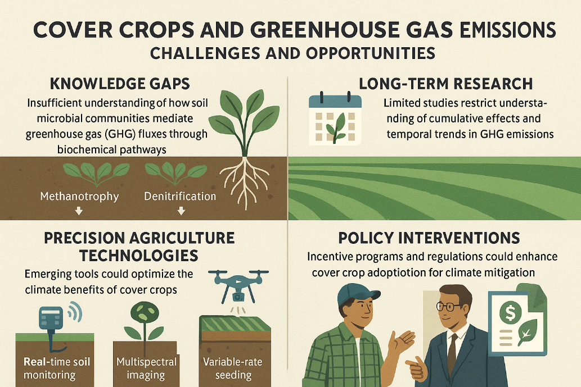

Figure 04: Schematic diagram of challenges of growing cover crops to mitigate GHG emission

1. **CONCLUSION**

Cover crops are a versatile and effective nature-based solution for mitigating greenhouse gas (GHG) emissions in agricultural systems. By enhancing soil health, increasing carbon sequestration, and improving nitrogen cycling, they offer multiple ecosystem services that align with climate-smart agriculture goals. The ability of cover crops to fix atmospheric nitrogen, scavenge residual soil nutrients, and improve soil structure makes them valuable tools for reducing emissions of carbon dioxide (CO₂), methane (CH₄), and nitrous oxide (N₂O). However, the effectiveness of cover crops in GHG mitigation is influenced by factors such as species selection, soil type, climate, and management practices. While legumes are effective in nitrogen fixation, grasses are better suited for carbon sequestration and erosion control, and brassicas offer biofumigation benefits.

Despite their proven benefits, the adoption of cover crops remains limited due to economic, agronomic, and knowledge-based barriers. High establishment costs, water competition, pest management challenges, and a lack of farmer awareness are significant obstacles. Policy support, financial incentives, and farmer education are crucial to overcoming these barriers and scaling up cover crop adoption globally. Technological innovations, such as precision agriculture and remote sensing, can further optimize their use and ensure site-specific management.

Future research should focus on long-term studies to better understand the cumulative impacts of cover crops on GHG dynamics, as well as their interactions with soil microbial communities. Developing robust carbon credit systems, promoting farmer-centered extension services, and enhancing policy support will be essential for maximizing the climate benefits of cover crops. By integrating cover crops into broader sustainable agriculture strategies, we can move closer to achieving global climate goals while maintaining agricultural productivity and resilience.

Disclaimer (Artificial intelligence)

Option 1:

Author(s) hereby declare that NO generative AI technologies such as Large Language Models (ChatGPT, COPILOT, etc.) and text-to-image generators have been used during the writing or editing of this manuscript except generating images. <https://chatgpt.com/g/g-681f259e3bf08191a84010cf30abe74d-image-generator-logo-art-photos-more>

1. **REFERENCES**

Abdalla, M., Hastings, A., Helmy, M., Prescher, A., Osborne, B., Lanigan, G. et al., (2014). Assessing the combined use of reduced tillage and cover crops for mitigating greenhouse gas emissions from arable ecosystem. *Geoderma*, 223–225(1), 9–20. https://doi.org/10.1016/j.geoderma.2014.01.030

Abdalla, M., Hastings, A., Cheng, K., Yue, Q., Chadwick, D., Espenberg, M. et al., (2019). A critical review of the impacts of cover crops on nitrogen leaching, net greenhouse gas balance and crop productivity. *Global Change Biology*, 25. 10.1111/gcb.14644.

Abdollahi, L. and Munkholm, L.J. (2014) Tillage System and Cover Crop Effects on Soil Quality: I. Chemical, Mechanical, and Biological Properties. *Soil Science Society of America Journal*, 78, 262-270. https://doi.org/10.2136/sssaj2013.07.0301

Aydınlı, G. and Mennan, S. (2018). Biofumigation Studies by Using Raphanus sativus and Eruca sativa as a Winter Cycle Crops to Control Root-knot Nematodes. *Brazilian Archives of Biology and Technology*, 61. 10.1590/1678-4324-2018180249.

Atallah, S. (2024). The economics of carbon farming. 10.1016/B978-0-323-91013-2.00051-4.

Basche, A. D. and DeLonge, M. S. (2019). The impact of continuous living cover on soil hydrologic properties: A meta-analysis. *Soil Science Society of America Journal*, 83(3), 548–560. https://doi.org/10.2136/sssaj2018.09.0331

Basche, A. D., Miguez, F. E., Kaspar, T. C. and Castellano, M. J. (2014). Do cover crops increase or decrease nitrous oxide emissions? A meta-analysis. *Journal of Soil and Water Conservation, 69*(6), 471-482. <https://doi.org/10.2489/jswc.69.6.471>

Bayer, C., Gomes, J., Zanatta, J.A., Vieira, F.C.B. and Dieckow, J. (2016). Mitigating greenhouse gas emissions from a subtropical Ultisol by using long-term no-tillage in combination with legume cover crops. *Soil and Tillage Research*. 161. 86-94. 10.1016/j.still.2016.03.011.

Bergström, L.F. and Jokela, W.E. (2001) Ryegrass Cover Crop Effects on Nitrate Leaching in Spring Barley Fertilized with 15NH4 15NO3 . *Journal of Environmental Quality*, 30, 1659-1667. https://doi.org/10.2134/jeq2001.3051659x

Blanco-Canqui, H. and Ruis, S. J. (2015). Cover crop impacts on soil physical properties: A review. *Soil Science Society of America Journal, 79*(6), 1488-1499. https://doi.org/10.2136/sssaj2015.05.0167

Boselli, R., Fiorini, A., Santelli, S., Ardenti, F., Capra, F., Maris, S.C. et al., (2020). Cover crops during transition to no-till maintain yield and enhance soil fertility in intensive agro-ecosystems. Field Crops Research. 255. 10.1016/j.fcr.2020.107871.

Calonego, J. and Rosolem, C. (2010). Soybean root growth and yield in rotation with cover crops under chiseling and no-till. *European Journal of Agronomy*. 33. 242-249. 10.1016/j.eja.2010.06.002.

Chen, G. and Weil, R. R. (2011). *Root growth and yield of maize as affected by soil compaction and cover crops*. Soil and Tillage Research, 117, 17–27. Link

Chu, M., Jagadamma, S., Walker, F.R., Eash, N.S., Buschermohle, M.J. and Duncan, L.A. (2017). Effect of Multispecies Cover Crop Mixture on Soil Properties and Crop Yield. *Agricultural & Environmental Letters,* 2. 10.2134/ael2017.09.0030.

Clark, A. (Ed.). (2007). *Managing Cover Crops Profitably* (3rd ed.). Sustainable Agriculture Research and Education (SARE). <https://www.sare.org/resources/managing-cover-crops-profitably-3rd-edition/>

Collins, H.P., Delgado, J.A., Alva, A.K. and Follett, R.E. (2007). Use of Nitrogen-15 Isotopic Techniques to Estimate Nitrogen Cycling from a Mustard Cover Crop to Potatoes. *Agronomy journal*. 99. 10.2134/agronj2005.0357.

Don, A., Schumacher, J. and Freibauer, A. (2011) Impact of Tropical Land-Use Change on Soil Organic Carbon Stocks—A Meta-Analysis. Global Change Biology, 17, 1658-1670. https://doi.org/10.1111/j.1365-2486.2010.02336.x

Deb, S.K., Shukla, M.K., Sharma, P. and Mexal, J.G. (2013) Soil Water Depletion in Irrigated Mature Pecans under Contrasting Soil Textures for Arid Southern New Mexico. Irrigation Science, 31, 69-85. https://doi.org/10.1007/s00271-011-0293-1

De Baets, S., Poesen, J., Meersmans, J. and Serlet, L. (2011) Cover Crops and Their Erosion-Reducing Effects during Concentrated Flow Erosion. Catena, 85, 237-244. American Journal of Plant Sciences DOI: 10.4236/ajps.2018.99140 1946 P. Sharma et al. https://doi.org/10.1016/j.catena.2011.01.009

Ding, G., Liu, X., Herbert, S., Novak, J., Amarasiriwardenae, D. and Xing, B. (2006). Effect of cover crop management on soil organic matter. *Geoderma*. 130. 229-239. 10.1016/j.geoderma.2005.01.019.

Drinkwater, L. E., Wagoner, P., & Sarrantonio, M. (1998). Legume-based cropping systems have reduced carbon and nitrogen losses. *Nature, 396*(6708), 262-265. <https://doi.org/10.1038/24376>

Duval, M.E., Galantini, J.A., Capurro, J.E. and Martinez, J.M. (2016). Winter cover crops in soybean monoculture: Effects on soil organic carbon and its fractions. *Soil and Tillage Research*. 161. 95-105. 10.1016/j.still.2016.04.006.

Eash, L., Berrada, A. F., Russell, K. and Fonte, S. J. (2021). Cover Crop Impacts on Water Dynamics and Yields in Dryland Wheat Systems on the Colorado Plateau. Agronomy, 11(6), 1102. <https://doi.org/10.3390/agronomy11061102>

Fiorini, A., Maris, S. C., Abalos, D., Amaducci, S. and Tabaglio, V. (2020). Combining no-till with rye (Secale cereale L.) cover crop mitigates nitrous oxide emissions without decreasing yield. *Soil and Tillage Research*, *196*(October 2018), 104442. https://doi.org/10.1016/j.still.2019.104442

Flint, E. (2000) Comparisons of No-Tillage and Conventional Cotton (Gossypium hirsutum L.) with Evaluations of Mycorrhizal Associations. Ph.D. Dissertation, Mississippi State University, Starkville, MS.

Finney, D., Buyer, J. and Kaye, J. (2017) Living Cover Crops Have Immediate Im pacts on Soil Microbial Community Structure and Function. *Journal of Soil and Water Conservation*, 72, 361-373. https://doi.org/10.2489/jswc.72.4.361

Gabriel, J.L., Garrido, A. and Quemada, M. (2013) Cover Crops Effect on Farm Benefits and Nitrate Leaching: Linking Economic and Environmental Analysis. *Agricultural Systems*, 121, 23-32. https://doi.org/10.1016/j.agsy.2013.06.00

Galvez, L., Douds, D., Wagoner, P., Longnecker, L., Drinkwater, L. and Janke, R. (1995) An Overwintering Cover Crop Increases Inoculum of VAM Fungi in Agri cultural Soil. *American Journal of Alternative Agriculture*, 10, 152-156. https://doi.org/10.1017/S0889189300006391

Gong, Y., Li, P., Sakagami, N. and Komatsuzaki, M. (2021). No-tillage with rye cover crop can reduce net global warming potential and yield-scaled global warming potential in the long-term organic soybean field. *Soil and Tillage Research*, *205*(November 2019), 104747. https://doi.org/10.1016/j.still.2020.104747

García-González, I., Hontoria, C., Gabriel, J.L., Alonso-Ayuso, M. and Quemada, M. (2018). Cover crops to mitigate soil degradation and enhance soil functionality in irrigated land. *Geoderma*. 322. 81-88. 10.1016/j.geoderma.2018.02.024.

Guardia, G., Abalos, D., García-Marco, S., Quemada, M., Alonso-Ayuso, M., Cárdenas, L. M. et al., (2016). Effect of cover crops on greenhouse gas emissions in an irrigated field under integrated soil fertility management. *Biogeosciences*, *13*(18), 5245–5257. https://doi.org/10.5194/bg-13-5245-2016

Hina, N. S. (2024). Global Meta-Analysis of Nitrate Leaching Vulnerability in Synthetic and Organic Fertilizers over the Past Four Decades. *Water*, *16*(3), 457. <https://doi.org/10.3390/w16030457>

Indigo Ag. (2021). Carbon Farming Program. https://www.indigoag.com/carbon

Kaspar, T.C., Radke, J.K. and Laflen, J.M. (2001) Small Grain Cover Crops and Wheel Traffic Effects on Infiltration, Runoff, and Erosion. *Journal of Soil and Water Conservation*, 56, 160-164. https://doi.org/10.31274/icm-180809-706

Kaspar, T., Jaynes, D., Parkin, T., Moorman, T. and Singer, J. (2012) Effectiveness of Oat and Rye Cover Crops in Reducing Nitrate Losses in Drainage Water. *Agricultural Water Management*, 110, 25-33. https://doi.org/10.1016/j.agwat.2012.03.010

Kaye, J. P. and Quemada, M. (2017). Using cover crops to mitigate and adapt to climate change. *A review. Agronomy for Sustainable Development*, 37, 4. https://doi.org/10.1007/s13593-016-0410-x

Ladha, J., Khind, C., Gupta, R., Meelu, O. and Pasuquin, E. (2004) Long-Term Ef fects of Organic Inputs on Yield and Soil Fertility in the Rice-Wheat Rotation. *Soil Science Society of America Journal*, 68, 845-853.

Lal, R. (2004) Soil Carbon Sequestration to Mitigate Climate Change. *Geoderma*, 123, 1-22. https://doi.org/10.1016/j.geoderma.2004.01.032

Lehman, R.M., Taheria, W.T., Osborne, S.L., Buyer, J.S. and Douds, D.D. (2012). Fall cover cropping can increase arbuscular mycorrhizae in soils supporting intensive agricultural production. *Applied Soil Ecology*. 61. 300–304. 10.1016/j.apsoil.2011.11.008.

Lowa Soybean Association. (2020). Cover Crops and Strip-Tillage Impact Assessment. <https://www.iasoybeans.com/>

Mashece, W., Sindesi, A., Silwana, S. and Tshuma, F. (2025). Leguminous Cover Crops Increase the Biomass and Nutritive Value of Grasses in South African Soils: A Review. *South African Journal of Agricultural Extension (SAJAE)*, *53*(1), 61-85. <https://doi.org/10.17159/2413-3221/2025/v53n1a17571>

Marcillo, G.S. and Miguez, F.E. (2017). Corn yield response to winter cover crops: An updated meta-analysis. *Journal of Soil and Water Conservation*. 72. 226-239. 10.2489/jswc.72.3.226.

Masilionyte, L., Maiksteniene, S., Kriauciuniene, Z., Jablonskyte-Rasce, D., Zou, L. and Sarauskis, E. (2017). Effect of Cover Crops in Smothering Weeds and Volunteer Plants in Alternative Farming Systems. Crop Protection, 91, 74-81. https://doi.org/10.1016/j.cropro.2016.09.016

Mazzoncini, M., Sapkota, T., Bàrberi, P., Antichi, D. and Risaliti, R. (2011). Long-term effect of tillage, nitrogen fertilization and cover crops on soil organic carbon and total nitrogen content. *Soil & Tillage Research - SOIL TILL RES*. 114. 165-174. 10.1016/j.still.2011.05.001.

McCracken, D.V., Smith, M.S., Grove, J.H., Blevins, R.L. and MacKown, C.T. (1994). Nitrate Leaching as Influenced by Cover Cropping and Nitrogen Source. *Soil Science Society of America Journal*, 58, 1476-1483. https://doi.org/10.2136/sssaj1994.03615995005800050029x

Meisinger, J., Hargrove, W., Mikkelsen, R., Williams, J. and Benson, V. (1991). Ef fects of Cover Crops on Groundwater Quality. In: *Cover Crops for Clean Water*, 57-68.

Mukherjee, R. and Sen, S. Harvest (2021). Bi-Annual Sustainable Agriculture & N agricultural sustainability through nitrogen f ixation: Approaches and techniques. Harvest 2021, 6, 48–55. 54.

Nascente, A.S., Li, Y.C. and Crusciol, C.A.C. (2013). Cover crops and no-till effects on physical fractions of soil organic matter. *Soil and Tillage Research*. 130. 52–57. 10.1016/j.still.2013.02.008.

Ntalli, N. and Caboni, P. (2017). A review of isothiocyanates biofumigation activity on plant parasitic nematodes. *Phytochemistry Reviews*. 16. 10.1007/s11101-017-9491-7.

Panda, P., Panda, Shravan K., Duary, S., Mahapatra, A. and Maitra, S. (2021). Legumes in Cropping System for Agricultural Sustainability. 12. 37363-37372.

Paustian, K., Lehmann, J., Ogle, S., Reay, D., Robertson, G. P. and Smith, P. (2016). Climate-smart soils. Nature 532, 49–57. doi: 10.1038/nature1717.

Petropoulos, T., Benos, L., Busato, P., Kyriakarakos, G., Kateris, D., Aidonis, D. et al., (2025). Soil Organic Carbon Assessment for Carbon Farming: A Review. *Agriculture*, 15(5), 567. <https://doi.org/10.3390/agriculture15050567>

Poeplau, C., Don, A., Vesterdal, L., Leifeld, J., Van Wesemael, B., Schumacher, J. et al., (2011) Temporal Dynamics of Soil Organic Carbon after Land-Use Change in the Temperate Zone-Carbon Response Functions as a Model Approach. *Global Change Biology*, 17, 2415-2427.  
https://doi.org/10.1111/j.1365-2486.2011.02408.x

Poeplau, C. and Don, A. (2015). Carbon sequestration in agricultural soils via cultivation of cover crops – A meta-analysis. *Agriculture, Ecosystems & Environment, 200*, 33-41. https://doi.org/10.1016/j.agee.2014.10.024

Pramanick, B., Kumar, M., Singh, S., Sapna, K. and Maitra, S. (2021). Soil-Centric Approaches Towards Climate-Resilient Agriculture. 10.1007/978-981-16-0917-6_17.

Ranaldo, M., Carlesi, S., Costanzo, A. and Bàrberi, P. (2019). Functional diversity of cover crop mixtures enhances biomass yield and weed suppression in a Mediterranean agroecosystem. Weed Research. 60. 10.1111/wre.12388.

Reddy, P.P. (2016) Cover/Green Manure Crops. In: Sustainable Intensification of Crop Production, Springer, Singapore, 55-67. https://doi.org/10.1007/978-981-10-2702-4_4

Rezgui, C., Trinsoutrot Gattin, I., Benoit, M., Laval, K. and Riah, W. (2021). Linking changes in the soil microbial community to C and N dynamics during crop residue decomposition. J*ournal of Integrative Agriculture.* 20. 3039-3059. 10.1016/S2095-3119(20)63567-5.

Sadra, S., Mohammadi, G. and Mondani, F. (2024). Effects of cover crops and nitrogen fertilizer on greenhouse gas emissions and net global warming potential in a potato cropping system. *Journal of Agriculture and Food Research*, *18*(June), 101256. https://doi.org/10.1016/j.jafr.2024.101256

SARE and CTIC. (2016). Cover Crop Survey Analysis. https://www.sare.org/resources/2016-cover-crop-survey-analysis/

Salehin, S. M. U., Rajan, N., Mowrer, J., Casey, K. D., Tomlinson, P., Somenahally, A. et al., (2025). Cover crops in organic cotton influence greenhouse gas emissions and soil microclimate. *Agronomy Journal*, *117*(1), 1–22. https://doi.org/10.1002/agj2.21735

Sanz-Cobena, A., Sánchez-Martín, L., García-Torres, L. and Vallejo, A. (2012). Gaseous emissions of N2O and NO and NO3− leaching from urea applied with urease and nitrification inhibitors to a maize (Zea mays) crop. *Agriculture, Ecosystems & Environment*. 149. 64–73. 10.1016/j.agee.2011.12.016.

Schipanski, M. E., Barbercheck, M., Douglas, M. R., Finney, D. M., Haider, K., Kaye, J. P. et al., (2014). A framework for evaluating ecosystem services provided by cover crops in agroecosystems. *Agricultural Systems, 125*, 12-22. https://doi.org/10.1016/j.agsy.2013.11.004

Schön, J., Gentsch, N. and Breunig, P. (2024). Cover crops support the climate change mitigation potential of agroecosystems. *PLoS ONE*, *19*(5 May), 1–20. https://doi.org/10.1371/journal.pone.0302139

Sharma, P., Singh, A., Kahlon, C. S., Brar, A. S., Grover, K. K., Dia, M. et al., (2018). The Role of Cover Crops towards Sustainable Soil Health and Agriculture—A Review Paper. *American Journal of Plant Sciences*, *09*(09), 1935–1951. https://doi.org/10.4236/ajps.2018.99140

Silva, G. R. da, Liska, A. J. and Bayer, C. (2025). Cover Crops Can Reduce Greenhouse Gas Emissions from No-Till Maize in Southern Brazil: Insights from a Long-Term Field Experiment. *Agronomy*, *15*(2), 1–14. https://doi.org/10.3390/agronomy15020267

Snapp, S., Ugarte, C., Hunter, D. and Wander, M. (2022). Cover crops for soil health. 10.19103/AS.2021.0094.11.

Smith, M.S., Frye, W.W. and Varco, J.J. (1987). Legume Winter Cover Crops. In: Stewart, B.A., Eds., Advances in Soil Science, Vol. 7, Springer, New York, 95-139. https://doi.org/10.1007/978-1-4612-4790-6_3

Storkey, J., Macdonald, A. J., Poulton, P. R., Scott, T., Köhler, I. H., Schnyder, H. et al., (2015). Grassland biodiversity bounces back from long-term nitrogen addition. *Nature, 528*(7582), 401-404. https://doi.org/10.1038/nature16444

Tian, S., Xu, Y., Wang, Q., Zhang, Y., Yuan, X., Ma, Q. et al., (2023). The effect of optimizing chemical fertilizers consumption structure to promote environmental protection, crop yield and reduce greenhouse gases emission in China. *The Science of the total environment*, *857*(Pt 1), 159349. https://doi.org/10.1016/j.scitotenv.2022.159349

Tosti, G., Benincasa, P., Farneselli, M., Tei, F. and Guiducci, M. (2014) Barley-Hairy Vetch Mixture as Cover Crop for Green Manuring and the Mitigation of N Leach ing Risk. *European Journal of Agronomy*, 54, 34-39. https://doi.org/10.1016/j.eja.2013.11.012

Tribouillois, H., Constantin, J. and Justes, E. (2018). Cover crops mitigate direct greenhouse gases balance but reduce drainage under climate change scenarios in temperate climate with dry summers. *Global Change Biology*, *24*(6), 2513–2529. https://doi.org/10.1111/gcb.14091

Quintarelli, V., Radicetti, E., Allevato, E., Stazi, S. R., Haider, G., Abideen, Z. et al., (2022). Cover Crops for Sustainable Cropping Systems: A Review. Agriculture, 12(12), 2076. <https://doi.org/10.3390/agriculture12122076>

Waisen, P., Cheng, Z., Sipes, B.S. and Wang, K.H. (2022). Biofumigation effects of brassicaceous cover crops on soil health in cucurbit agroecosystems in Hawaii, USA. *Pedosphere*. 32. 521-531. 10.1016/S1002-0160(21)60054-1.

Wang, Y. and Lambers, H. (2020). Root-released organic anions in response to low phosphorus availability: Recent progress, challenges and future perspectives. *Plant Soil*, 447, 135–156

Wang, C., Amon, B., Schulz, K. and Mehdi, B. (2021). Factors That Influence Nitrous Oxide Emissions from Agricultural Soils as Well as Their Representation in Simulation Models: A Review. Agronomy, 11(4), 770. <https://doi.org/10.3390/agronomy11040770>

Osterholz, W., Ruark, M., Renz, M. and Grabber, J. (2021). Interseeding alfalfa into corn silage increases corn N fertilizer demand and increases system yield. *Agronomy for Sustainable Development*, 41. 10.1007/s13593-021-00711-1.

Zablotowicz, R.M., Locke, M.A. and Gaston, L.A. (2007). Tillage and Cover Effects on Soil Microbial Properties and Fluometuron Degradation. *Biology and Fertility of Soils*, 44, 27-35. https://doi.org/10.1007/s00374-007-0175-0

Zak, J.C., McMichael, B., Dhillion, S. and Friese, C. (1998) .Arbuscular-Mycorrhizal Colonization Dynamics of Cotton (Gossypium hirsutum L.) Growing under Several Production Systems on the Southern High Plains, Texas. *Agriculture, Ecosystems & Environment*, 68, 245-254. https://doi.org/10.1016/S0167-8809(97)00151-5

Zhang, W.P., Liu, G.C., Sun, J.H., Fornara, D., Zhang, L.Z. et al., (2016). Temporal dynamics of nutrient uptake by neighbouring plant species: Evidence from intercropping. Functional Ecology. 31. 10.1111/1365-2435.12732.