A Critical Review on SARS-CoV-2: Nature or Nurture?
Abstract
SARS-CoV-2 belongs to the family of coronaviridae and genus coronavirus and is the causative agent of COVID-19 disease that originated in Wuhan, China, a disease characterized by shortness of breath, severe fever, and cough. Scientists continue to be divided as to the origin of the virus with some scientists proposing the emergence of the SARS-CoV-2 as a consequence of evolutionary mutation, implicating the Bat corona virus as a possible ancestor while some scientists propose a laboratory leak and a possible consequence of a laboratory creation. This is further complicated because of the unique polybasic sequence at the furin cleavage site within the S1/S2 spike protein, a characteristic not found in any close family of the SARS-CoV-2, but found in its distant relatives. While the origins of SARS-CoV-2 continue to be a subject of debate, this review is an attempt on the presentation of facts that may give clues as to the origin of the virus and a call for extensive research on the repurposing of drugs apart from Ivermectin and hydroxychloroquine which may be beneficial among low and middle income populations.
Key words: Virus, SARS-CoV-2, Coronaviruses, Cleavage, Spike protein, COVID-19.
Introduction
“The SARS-CoV-2 disease spread began in China, having Wuhan as its epicenter in December, 2019” (Zhu et al., 2020; Zhan et al., 2020). At first, international response was slow but the high rate of infectivity of the novel virus began to draw global attention. This was accompanied by quarantine of infected persons in Wuhan and other places in China but unfortunately, there was an international and intercontinental spread of the virus. “Coronavirus Disease 2019 (COVID-19) was declared a pandemic by the World Health Organization on March 11th, 2020 mainly due to the speed and scale of the transmission of the disease” (WHO, 2020). “The etiologic agent of COVID-19 was isolated and identified as a novel coronavirus, initially designated as 2019-nCoV” (Gralinski and Menachery, 2020) and was named severe acute respiratory syndrome coronavirus-2 (SARS-CoV-2) by the International Committee for Taxonomy of Viruses.
There are different schools of thought on the origin of the SARS-CoV-2. While some scientists believe in the natural origins of the SARS-CoV-2 citing genetic similarities with other corona viruses, other scientists believe that the natural origins of the virus is highly unlikely citing the unique inserts of furin cleavage site on the spike protein as one of the evidence of natural origin of SARS-CoV-2 being an unlikely fortuitous event. This review is an attempt to present an overview of the virus and presentation of facts on the SARS-CoV-2 that may provide clearer insights into its origins.
Virus
Viruses are obligate parasites that possess small genomes that can either be composed of single stranded or double stranded DNA and RNA (Koonin and Starokadomskyy, 2016). Viruses can infect a variety of living organisms, including bacteria, plants, and animals. Attempts have been made on the definition of viruses and has been complicated with regards to origin nature and role of viruses especially after the discovery of the Mimiviruses and Pandoraviruses. Raoult and Forterre (2008) classified the living world into two major realms: Capsid encoding organisms (viruses) and ribosome encoding organisms (archaea, Bacteria, Eukarya). “Viral infectious particles, or virions, are composed of a nucleic acid (DNA or RNA) surrounded by a protein shell (the capsid) and sometimes by an additional lipid envelope. The infective cycle begins when a virion injects or releases its nucleic acid in a cell, leaving its capsid and envelope outside. In eukaryotic cells, virions can be incorporated in endocytotic vesicles where their capsid is degraded before the nucleic acid gets released into the cytoplasm” (López-García, P., & Moreira, D. 2012). Viruses are classified based on the structure of their nucleic acid and its mode of replication, the type of symmetry of the virus capsid (helical vs. icosahedral) and the presence or absence of a lipid envelope.

Coronaviruses are positive-sense, enveloped RNA viruses that cause various illnesses in mammals and birds and was first discovered in 1960 (Burrell et al., 2016). “Coronaviruses belong to the family Coronaviridae in the order Nidovirales” (Zhou et al., 2021). “They are classified into four genera: Alphacoronavirus, Betacoronavirus, Gammacoronavirus, and Deltacoronavirus” (Schütze, 2024). Among them, “alpha- and betacoronaviruses infect mammals, gammacoronaviruses infect avian species, and deltacoronaviruses infect both mammalian and avian species” (Li, 2016). Structurally, “coronaviruses are characterized by an unusually large RNA genome and club-like glycoprotein spikes that project from the surface of its envelope” (Fehr, 2015). “Coronaviruses (CoVs) are emerging and re-emerging pathogens and several of them have caused serious problems in humans and animals” (Lau and Chan, 2015). “SARS-CoV-2 belongs to the beta subgrouping of the Coronaviridae family and are enveloped virus containing a positive-sense, single-stranded RNA with 29,891 bases of size” (Paraskevis et al., 2020) and like other corona viruses, are characterized by the presence of spikes on their surfaces (Schoeman and Felding, 2019).
MOLECULAR BIOLOGY OF SARS-COV-2
“SARS-CoV-2 are roughly spherical with average diameter of 80–120 nm. The surface spikes of the coronaviruses projects about 17–20 nm from the surface of the virus particle and have been described as having a club-like, pear-shaped, or petal-shaped and a thin base with a width of approximately 10 nm at the distal extremity” (Masters, 2006). The genome encodes for 29 proteins involved in the infection, replication and virion assembly process but specifically four structural proteins: the Spike(S) protein, the Nucleocapsid (N) protein, the membrane (M) protein and the envelope proteins. Like other coronaviruses, SARS-CoV-2 are characterized by the presence of crown-like spikes on their surface (Schoeman and Felding, 2019; Rabi et al., 2020). The corona virus proteins undergo post translational modification which play a role in enzymatic activity, sub cellular localization, folding (Fung and Liu, 2018).
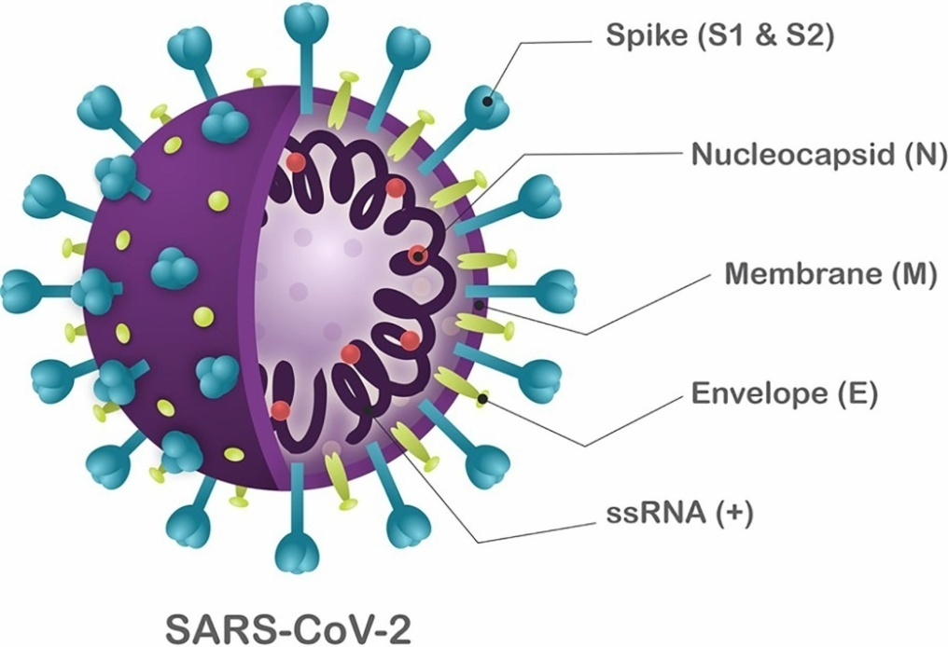
Fig 1: Schematic structure of SARS-CoV-2. (Dos Santos et al., 2020).
Antivirals Against Coronaviruses: Candidate Drugs for SARS-CoV-2 Treatment?
The entire replication process of the SARS-CoV-2 is not clear but it is known to enter host cells through binding to unique cells possessing the Angiotensin-converting enzyme 2(ACE2) hence defining cell tropism for cells that express this receptors such as intestinal, pulmonary and renal human cells are known to possess ACE2 (Hoffmann et al., 2020a). The spike protein contains the receptor binding domain (RBD) of the coronavirus which binds to the human angiotensin-converting enzyme 2 (ACE2) and leads to virion endocytosis and endosome formation (Yan et al., 2020; Rabi et al., 2020). “The recognition of the ACE2 receptor by SARS-CoV-2 followed by conformational changes in the S protein that promote viral-host cell membrane fusion are critical steps to infection” (Mittal et al., 2020).
The spike protein
The structure of the S protein has a high sequence divergence amongst various family of corona viruses and is of great importance as it has become the focus of development of vaccines (Zech et al., 2024). The S protein is a glycosylated transmembrane protein divided into three parts; ectodomain, the transmembrane domain and the endodomain with two subunits S1 and S2 made up of 1162 to 1452 residues and plays an important role in attachment to the host and fusion between the viral and host membranes (Walls et al., 2020; Artika et al., 2020). The spike protein contains the receptor binding domain of the coronavirus which binds to ACE2 and leads to virion endocytosis and endosome formation (Artika et al., 2020)

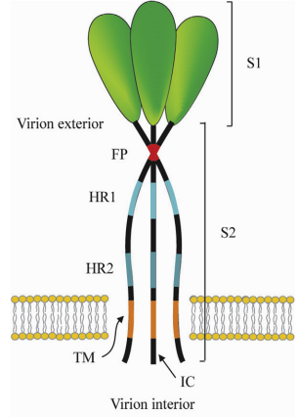
Fig 2: Corona virus spike protein (Masters, 2006; Li, 2016). Heptad repeat regions (HR 1 and 2), Transmembrane domain (TM), Intracellular tail (IC), Fusion peptide (FP)
Cleavage of spike into its component units SI and S2 can occur at different points depending on the sequence of spike protein and can either occur during trafficking in the producer cells by host furin-like enzymes or serine proteases such as Serine 2/TMPRSS2 or by cathepsin (Hoffmann et al., 2020b). “The S2 subunit therefore allows fusion of the viral envelop with endosome membrane and consequently release of the capsid into the cytoplasm” (Matsuyama et al., 2015). “In the cytoplasm, the CoV viral genome is uncoated, and the viral RNA is released. The positive-sense RNA viral genome is translated to produce nonstructural proteins (nsps) from two open reading frames (ORFs), ORF1a and ORF1b. The ORF1a encodes the polyprotein pp1a that is cleaved in 11 nsps, while the ORF1b encodes the polyprotein pp1ab, which is cleaved into 15 nsps. The proteolytic cleavage is performed by viral proteases nsp3 and nsp5” (Jo et al., 2020).
One key importance of the corona virus spike protein in infectivity is that changes in the regions that interact with entry receptors can modify or alter the host, tissue or cellular tropism of the corona viruses (Masters, 2016). Greater focus will be placed on the spike protein because it is the major antigen and induces the major immune response and also is target to neutralizing antibodies (Li, 2016). “The spike glycoproteins of coronaviruses are important determinants of tissue tropism and host range and are critical targets for vaccine development” (Hulswit et al., 2016).
Unique Furin cleavage site of SARS-CoV 2: The Holy Grail
“The majority of attention has focused on a potentially critical insertion of a furin cleavage site upstream of the S1 cleavage site in spike” (Coutard et al., 2020). “Coronaviruses enter host cells via their spike glycoprotein which is synthesized as an inactive precursor that must be cleaved to mediate membrane fusion” (Peacock et al., 2021). “Unlike its closest known relatives, the SARS-CoV-2 spike (S) protein contains a furin cleavage site at the S1/S2 junction that enhances SARS-CoV-2 replication in airway cells and contributes to virus pathogenicity and transmissibility which is lacking in the S protein of SARS-CoV-1” (Walls et al., 2020). Another distinctive molecular characteristics of the SARS-CoV-2 is the presence of a polybasic cleavage site (PRRA) at the junction of S1 and S2 of the S protein due to four amino acid residue insertion (PRRA) at SARS-CoV-2 S positions 681–684 (Andersen et al., 2020; Walls et al., 2020) and this amino acid insert has been implicated as the potential cleavage site for the protease furin (Jaimes et al., 2020; Walls et al., 2020). “Furin is an enzyme expressed by human cells that separates the spike protein subunits at the cleavage site, enabling the virus to bind more efficiently to human cells and release its genetic material into them which explains why SARS-CoV-2 is so easily transmissible” (Xia et al., 2020). To demonstrate the importance of the PPRA insert and hence a focus for future research on the origins of the virus, a ΔPPRA SARS-CoV-2 (mutant SARS-CoV-2) and WT SARS-CoV-2 (wild type) was transfected in Calu3 2B4, a human lung adenocarcinoma characterized by ACE2 expression. Results from this studies showed that there was robust replication of WT SARS-CoV-2 in contrast to the ΔPPRA mutant virus where replication was reduced (Johnson et al., 2020).
“This furin recognition motif permits effective cleavage by furin and other protease and determines viral infectivity and host range. While the functional consequences of the polybasic cleavage site of the SARS-CoV-2 are yet to be elucidated, it is found to increase the virus infectivity and have impact on transmissibility and pathogenicity of the virus” (Andersen et al., 2020; Walls et al., 2020). The Polybasic cleavage sites have not been observed in related ‘lineage B’ betacoronaviruses, although other human betacoronaviruses, including HKU1 (lineage A), have those sites and predicted O-linked glycans.
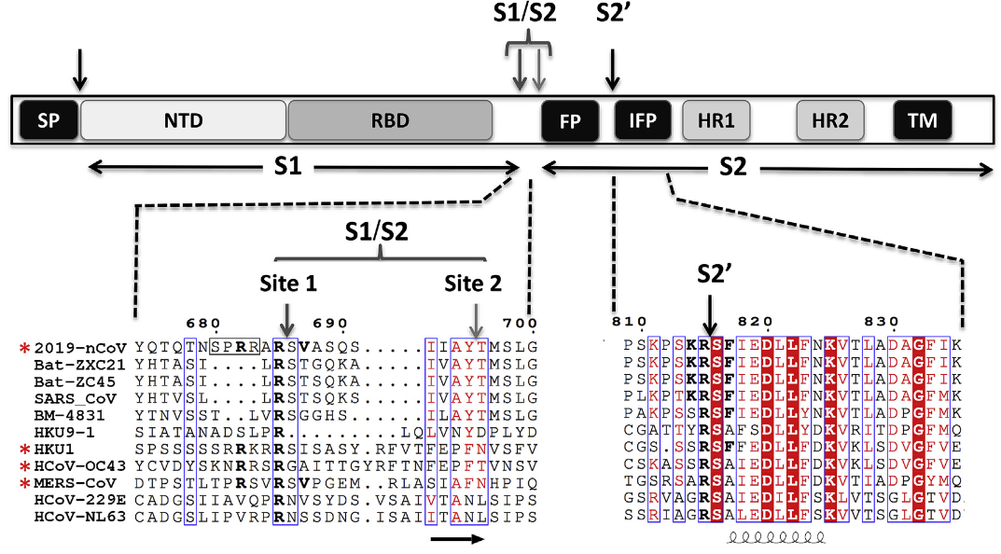

Fig 3: Schematic representation of the spike protein with comparison of its sequence with other viruses (Coutard et al., 2020).
The unique furin cleavage site on the SARS-CoV-2 has attracted the attention of eminent scientists such as the Nobel laureate David Baltimore and other researchers with obvious reasons. This is because the polybasic amino acid sequence on the furin cleavage site is found nowhere else in the entire genus of SARS-related betacoronaviruses and SARS-CoV-2 is the only one that has it (Coutard et al., 2020). In addition, while other more distant coronaviruses do have furin cleavage sites, the protein components (amino acids) in the SARS-CoV-2 furin cleavage site are coded for by a unique set of nucleotides in its RNA, not found in the other viruses which has fueled interest as to its origins. The furin cleavage sites have been observed in other virulent pathogens like HIV, avian influenza strains (H5 and H7) as well as Ebola (Braun and Sauter, 2019). In fact, furin cleavage sites are found in a number of other CoV family members including MERS-CoV, HKU1-Cov, and OC43-CoV (Kirchdoerfer et al., 2016); given the range of disease associated with these CoV strains, the furin cleavage site does not necessarily predetermine virulence. However, given its absence in other group 2B CoVs and the major differences in disease compared to SARS-CoV raises fundamental questions about its origin.
Again the mutation and diversification rates of SARS CoV-2 which were previously thought to be higher were actually much lower compared to other RNA viruses, such as human immunodeficiency virus (HIV) or hepatitis C virus (HCV) due to the improved proofreading activity of the corona virus polymaerase activity, a characteristic extremely rare in RNA viruses (Moeller et al., 2022).

Symptoms of SARS-CoV-2
Because of the overlap in the manifestation of symptoms seen in SARS-CoV-2 and other respiratory infections like MERS and SARS, patients are advised to present themselves to a doctor (Sohrabi et al., 2020). Symptoms like fever and cough are associated with other respiratory diseases such as influenza and are the most reported and reliable features of those infected with the SARS-Cov-2 (Ghayda et al., 2020). Previous studies have shown that the symptoms presented by SARS-CoV-2 varies with respect to the stage of infection; which can be mild, moderate or severe. In a study carried out by Guan et al. (2020), 67% of the patients admitted to hospitals in mainland china manifested cough, 44% fever, and 38% experienced fatigue. As high as 75% of non-admitted patients had fever and in severe cases, shortness of breath and cough (88%) were common in patients in intensive care units admitted in a hospital in Washington D.C, USA (Bhatraju et al., 2020). Loss of sense of smell or taste was also found in 64% of patients participating in an Italian study (Spinato et al., 2020). Individuals infected with SARS-CoV-2 can either be symptomatic or asymptomatic with 80% of the infected individuals found to be asymptomatic. Asymptomatic individuals may be due to improved immune system but still possess the ability to infect individuals (Dos Santos, 2020). The severity of the disease seems to be strongly associated with underlying host conditions including age, sex and overall health of the patient (Barek et al., 2020). The latter seems to play a critical role in susceptibility and contribute to the risk of infection.
TREATMENT OF SARS-COV-2
Treatment varies depending on the severity of the disease which can be mild, moderate, severe, and critical manifestations of COVID-19. It is often recommended that patients who are suspected or confirmed to be infected with the SARS-CoV-2 be isolated either by staying at home or in recommended isolation centers but the best way to prevent transmission and illness is to avoid being exposed to the virus and sanitary measures like social distancing, wearing of nose mask, washing of hands, and disinfecting surfaces that are constantly touched are measures that have proven to be effective in preventing asymptomatic transmission of Covid-19 (Aguirre-Duarte, 2020; Bafail and Bafail, 2022). It is also recommended by WHO that prompt recognition of signs and symptoms is paramount to halt the spread of the disease (Baldanti et al., 2022; Qin et al., 2022). The most common treatment approaches had a similar range of prevalence and included antiviral measures, antibiotics, immunomodulators and oxygen inhalation (Haddad et al., 2022). Initially, the focus of treatment of patients with SARS-CoV-2 was directed towards the use of known drugs like hydroxychloroquine and Ivermectin repurposed to combat the spread of the disease in low and middle income countries, new approaches are focused on developing new drugs which are in most cases expensive and so the repurposing of these old drugs for their possible role in mitigating the spread of the virus continues (Buonfrate et al., 2021)
Antivirals
“The entry of human CoVs into the host cells is mainly related to the binding of viral S protein to the ACE2 receptor” (Scialo et al., 2020). Pre-clinical and clinical trials for the treatment of COVID-19 have been ongoing in various centers across the world. Currently, there are 2271 clinical trials involving therapeutic or preventative interventions. Some of the drugs used used in the treatment of COVID-19 include: Remdesvir. Coronavirus uses an RdRp enzyme to carry out its replication and transcription of its genome (Malone et al., 2022). Remdesvir is a phosphoaramidate prodrug that is metabolized in the cell to its functional NTP referred to as Remdesvir Triphosphate (RTP). RdRp enzyme uses RTP as a substrate and incorporates its mononucletide form into the growing RNA chain. The result is a stalling of growing chain three nucleotides are added by RdRp. The stalling has been shown to be as a result of translocation barrier caused by Remdesvir incorporation (Kokic et al., 2021).

- Ribavirin: A guanosine monologue has different antiviral mechanisms of action against different viruses (Kausar et al., 2021). It can be said, therefore, that ribavirin may affect the spike protein binding to ACE2 directly. A study was carried out to determine the effect of ribavirin in TMPRSS which enable virus entry and was shpwn that Ribavirin led to a significant two-fold decrease in TMPRSS2 expression at mRNA and protein levels in Vero E6 cells after 48 hours (Unal et al., 2021).

- Lopinavir/ritonavir: SARS-CoV-2 has two proteases. a papain-like cysteine proteinase (PLpro, nsp3) and a 3C-like proteinase (3CLpro or Mpro, nsp5). Lopinavir is coadministered with ritonavir because of its low oral bioavailability and extensive metabolism by CYP3A4. This combination is used in HIV-1 treatment but its efficacy in the treatment of SARS-CoV-2 is not so clear.
Hydroxychloroquine
Hydroxychloroquine a derivative of chloroquine both belong to a class of drugs called 4-aminoquinolines. It differs from chloroquine due to the presence of hydroxyl group in its structure. Though the exact mechanism of action of Hydroxychloroquine is yet to be be known, “Chloroquine and hydroxychloroquine increase pH within intracellular vacuoles and alter processes such as protein degradation by acidic hydrolases in the lysosome, assembly of macromolecules in the endosomes, and posttranslational modification of proteins in the Golgi apparatus” (Halcrow et al., 2021). It has also been reported to suppress the immune system through inhibition of the cytokine receptor and Toll-like receptor pathways (Rainsford, 2015). “Chloroquine accumulates in lysosomes (lysosomotropism), and by increasing their pH, interrupts with the activities of cathepsin L which facilitates the entry of corona viruses interferes with the glycosylation of cellular receptor of SARS-CoV-2, thereby inhibiting the infection of virus” (Ou et al., 2020),

Azythromycin
“Azithromycin is a macrolide antibiotic with bactericidal and bacteriostatic actions. It inhibits bacterial protein synthesis by reversibly binding to the 50S ribosomal subunit of the sensitive microorganisms, thereby inhibiting the translocation step, leading to cell growth inhibition and cell death” (Heidary et al., 2022). Among outpatients with SARS-CoV-2 infection, treatment with a single dose of azithromycin compared with placebo did not result in greater likelihood of being symptom free at day 14. Preliminary results also suggest a synergistic effect of the combination of Hydroxychloroquine and azithromycin. “An open-label non-randomized trial with 36 positive COVID-19 patients found hydroxyquinoline and azithromycin significantly reduced viral load” (Gautret et al., 2020).
Ivermectin
“Ivermectin belongs to a group of avermectins, which is a group of 16 membered macrocyclic lactone compounds discovered at the Kitasato Institute of Japan in 1967 during actinomycetes cultures with Streptomyces avermitili” (Alvi et al., 2023). It is a broad spectrum anti-parasitic agent that has been found in recent times by various researchers to have anti-viral activities (Caly et al., 2020). It was initially found to inhibit the interaction between the integrase (IN) protein of HIV-1 and the importin (IMP) α/β1 heterodimer responsible for IN nuclear import, in other words, it prevents viral protein from entering the nucleus (Azam et al., 2022). It has been found to have inhibitory effects on a number of virus including west nile virus and influenza owing to the common mode of transmission employed by many viruses that use IMPα/β1during infection. Some researchers have shown that Ivermectin possesses antiviral activities in vitro at high doses (Buonfrate et al., 2022). A number of mechanisms of action has been demonstrated explaining this antiviral activity. Ivermectin has been shown to dock in the region of leucine 91 of the spike protein and histidine 378 of the ACE-2 receptor and also bind IMPα component of the IMPα/β1 heterodimer thereby preventing its nuclear transport of viral protein (Zaidi and Dehgani-Mobaraki, 2022)
Discussion
The coronavirus 2019 (COVID-19) pandemic represents the strongest global public health threat since the influenza outbreak in 1918 and has rapidly resulted in health and economic burdens worldwide (Lythgoe and Middleton, 2020) but it is quite strange that several years after the discovery of SARS-CoV-2, scientists are still divided on its true origins despite the cutting edge technology at our disposal. This is largely due to the polybasic basic cleavage site absent among SARS-CoV-2 closest relatives but present in distant relatives which raises a crucial question on its origin because the polybasic site has been found through previous studies to be a critical feature of the pathogenic avian influenza (Nao et al., 2017). The SARS-CoV-2 responsible for COVID-19 has a 96.2% genome sequence identity with the bat coronavirus RaTG13, 82.3% amino acid sequence similarity with bat coronavirus SL-CoVZC45, 77.2% identity with SARS-CoV. What has continued to mystify the scientific community is the origin of the 12 nucleotide insertion sequence (CCT CGG CGG GCA) coding for four amino acids (aa 681-684, PRRA) found exclusively in SARS-CoV 2 and not present in any of the three aforementioned viruses (Romeu, 2023). The consecutive CGG codons coding for arginine is rare in coronaviruses and even though point mutations exist between the viruses, it did not exceed three nucleotides
The outbreak of the virus has led to a polarization of the scientific community in terms of thought, treatments and ethics, unprecedented in modern history. What is even more worrisome is that there has been an open criticism of scientists who expressed divergent views on the origins of the virus and mode of treatment different from those propagated by mainstream media and big pharmaceutical companies. In recent times, scientists in universities and pharmaceutical research organizations have focused heavily on drug repurposing in order to reduce time and financial burden of developing molecules or drugs and some of the drugs mentioned in this article were found to be effective against SARS-CoV-2 through repurposing studies and have been beneficial to the patients. The low cost of some of the repurposed drug and the ease of accessibility also supports these drugs as the preferred treatment alternative among the larger population especially in the low and middle income country. And this begs the following questions: why are these treatment alternatives not promoted apart from vaccines? When has a divergent opinion in scientific circles become a crime as to warrant an ostracization in the medical and research community? Are facts no longer the basis of scientific arguments?
Conclusion
There is a growing evidence that suggest that the possibility of natural evolution of the polybasic furin cleavage site of SARS CoV-2 is highly unlikely. There is strong evidence to support the laboratory origins of the SARS-CoV as revealed in its distinctive features within its genome. The novel multibasic furin cleavage site (FCS) confers numerous pathogenically advantageous capabilities, the existence of which is difficult to explain though natural evolution. SARS-CoV-2 to human ACE2 binding is far stronger than in SARS-CoV, yet there is no indication of amount of evolutionary adaptation that SARSCoV or MERS-CoV underwent, in particular, a four amino acid insert (Pro-Arg-Arg-Ala) found within the S1/S2 site of the Spike glycoprotein. This finding has garnered interest because of the possible introduction of a furin recognition motif at the S1/S2 site especially since no known member of the genus of betacoronavirus possess this motif. More research should be carried out with a focus on the true origins of the virus which will lead to a better treatment strategy, better informed strategy on containment and prevention of another outbreak.
Disclaimer (Artificial intelligence)
Option 1:
Author(s) hereby declare that NO generative AI technologies such as Large Language Models (ChatGPT, COPILOT, etc.) and text-to-image generators have been used during the writing or editing of this manuscript.
Option 2:
Author(s) hereby declare that generative AI technologies such as Large Language Models, etc. have been used during the writing or editing of manuscripts. This explanation will include the name, version, model, and source of the generative AI technology and as well as all input prompts provided to the generative AI technology
Details of the AI usage are given below:
1.
2.
3.

References
Koonin, E. V., & Starokadomskyy, P. (2016). Are viruses alive? The replicator paradigm sheds decisive light on an old but misguided question. Studies in history and philosophy of biological and biomedical sciences, 59, 125.
Raoult, D., & Forterre, P. (2008). Redefining viruses: lessons from Mimivirus. Nature Reviews Microbiology, 6(4), 315-319
Burrell, C. J., Howard, C. R., & Murphy, F. A. (2016). Coronaviruses. Fenner and white's medical virology, 437.

Zhou, Z., Qiu, Y., & Ge, X. (2021). The taxonomy, host range and pathogenicity of coronaviruses and other viruses in the Nidovirales order. Animal Diseases, 1(1), 5.
Schütze, H. (2024). Coronaviruses in aquatic organisms. In Aquaculture Virology (pp. 465-478). Academic Press
Li, F. (2016). Structure, function, and evolution of coronavirus spike proteins. Annual review of virology, 3, 237-261.
Fehr, A. R., & Perlman, S. (2015). Coronaviruses: an overview of their replication and pathogenesis. Coronaviruses: methods and protocols, 1-23.
Lau, S. K., & Chan, J. F. (2015). Coronaviruses: emerging and re-emerging pathogens in humans and animals. Virology Journal, 12(1), 209.
Paraskevis, D., Kostaki, E. G., Magiorkinis, G., Panayiotakopoulos, G., Sourvinos, G., & Tsiodras, A. S. (2020). Full-genome evolutionary analysis of the novel corona virus (2019-nCoV) rejects the hypothesis of emergence as a result of a recent recombination event. Infection, Genetics and Evolution, 79, 104212.
Schoeman, D., & Fielding, B. C. (2019). Coronavirus envelope protein: current knowledge. Virology journal, 16, 1-22.
Masters, P. S. (2006). The molecular biology of coronaviruses. Advances in virus research, 66, 193-292.
Rabi, F. A., Al Zoubi, M. S., Kasasbeh, G. A., Salameh, D. M., & Al-Nasser, A. D. (2020). SARS-CoV-2 and coronavirus disease 2019: what we know so far. Pathogens, 9(3), 231.
Fung, T. S., & Liu, D. X. (2018). Post-translational modifications of coronavirus proteins: roles and function. Future virology, 13(6), 405-430
Dos Santos, W. G. (2020). Natural history of COVID-19 and current knowledge on treatment therapeutic options. Biomedicine & Pharmacotherapy, 129, 110493
Hoffmann, M., Kleine-Weber, H., Schroeder, S., Krüger, N., Herrler, T., Erichsen, S., ... & Pöhlmann, S. (2020a). SARS-CoV-2 cell entry depends on ACE2 and TMPRSS2 and is blocked by a clinically proven protease inhibitor. cell, 181(2), 271-280.
Yan, R., Zhang, Y., Li, Y., Xia, L., Guo, Y., & Zhou, Q. (2020). Structural basis for the recognition of SARS-CoV-2 by full-length human ACE2. Science, 367(6485), 1444-1448
Mittal, A., Manjunath, K., Ranjan, R. K., Kaushik, S., Kumar, S., & Verma, V. (2020). COVID-19 pandemic: Insights into structure, function, and hACE2 receptor recognition by SARS-CoV-2. PLoS pathogens, 16(8), e1008762.
Zech, F., Jung, C., Jacob, T., & Kirchhoff, F. (2024). Causes and Consequences of Coronavirus Spike Protein Variability. Viruses, 16(2), 177
Walls, A. C., Park, Y.-J., Tortorici, M. A., Wall, A., McGuire, A. T., and Veesler,
D. (2020). Structure, function, and antigenicity of the SARS-CoV-2 spike
glycoprotein. Cell 181, 281e6–292.e6. doi: 10.1016/j.cell.2020.02.058
Artika, I. M., Dewantari, A. K., & Wiyatno, A. (2020). Molecular biology of coronaviruses: current knowledge. Heliyon, 6(8).
Hoffmann, M., Kleine-Weber, H., & Pöhlmann, S. (2020b). A multibasic cleavage site in the spike protein of SARS-CoV-2 is essential for infection of human lung cells. Molecular cell, 78(4), 779-784
Matsuyama, M., Ohashi, Y., Tsubota, T., Yaguchi, M., Kato, S., Kobayashi, K., & Miyashita, Y. (2015). Avian sarcoma leukosis virus receptor-envelope system for simultaneous dissection of multiple neural circuits in mammalian brain. Proceedings of the National Academy of Sciences, 112(22), E2947-E2956.
Jo, S., Kim, S., Shin, D. H., & Kim, M. S. (2020). Inhibition of SARS-CoV 3CL protease by flavonoids. Journal of enzyme inhibition and medicinal chemistry, 35(1), 145-151.
Hulswit, R. J., de Haan, C. A., & Bosch, B. J. (2016). Coronavirus spike protein and tropism changes. Advances in virus research, 96, 29-57
Coutard, B., Valle, C., De Lamballerie, X., Canard, B., Seidah, N. G., & Decroly, E. (2020). The spike glycoprotein of the new coronavirus 2019-nCoV contains a furin-like cleavage site absent in CoV of the same clade. Antiviral research, 176, 104742
Peacock, T. P., Goldhill, D. H., Zhou, J., Baillon, L., Frise, R., Swann, O. C., ... & Barclay, W. S. (2021). The furin cleavage site in the SARS-CoV-2 spike protein is required for transmission in ferrets. Nature microbiology, 6(7), 899-909.
Andersen, K. G., Rambaut, A., Lipkin, W. I., Holmes, E. C., & Garry, R. F. (2020). The proximal origin of SARS-CoV-2. Nature medicine, 26(4), 450-452.
Jaimes, J. A., Millet, J. K., & Whittaker, G. R. (2020). Proteolytic cleavage of the SARS-CoV-2 spike protein and the role of the novel S1/S2 site. IScience, 23(6).

Xia, S., Lan, Q., Su, S., Wang, X., Xu, W., Liu, Z., ... & Jiang, S. (2020). The role of furin cleavage site in SARS-CoV-2 spike protein-mediated membrane fusion in the presence or absence of trypsin. Signal transduction and targeted therapy, 5(1), 92.
Johnson, B. A., Xie, X., Kalveram, B., Lokugamage, K. G., Muruato, A., Zou, J., ... & Menachery, V. D. (2020). Furin cleavage site is key to SARS-CoV-2 pathogenesis. BioRxiv.

Braun, E., & Sauter, D. (2019). Furin‐mediated protein processing in infectious diseases and cancer. Clinical & translational immunology, 8(8), e1073.
Kirchdoerfer, R. N., Cottrell, C. A., Wang, N., Pallesen, J., Yassine, H. M., Turner, H. L., ... & Ward, A. B. (2016). Pre-fusion structure of a human coronavirus spike protein. Nature, 531(7592), 118-121.
Moeller, N. H., Shi, K., Demir, Ö., Belica, C., Banerjee, S., Yin, L., ... & Aihara, H. (2022). Structure and dynamics of SARS-CoV-2 proofreading exoribonuclease ExoN. Proceedings of the National Academy of Sciences, 119(9), e2106379119.
Sohrabi, C., Alsafi, Z., O'neill, N., Khan, M., Kerwan, A., Al-Jabir, A., ... & Agha, R. (2020). World Health Organization declares global emergency: A review of the 2019 novel coronavirus (COVID-19). International journal of surgery, 76, 71-76.
Ghayda, R. A., Lee, J., Lee, J. Y., Kim, D. K., Lee, K. H., Hong, S. H., ... & Shin, J. I. (2020). Correlations of clinical and laboratory characteristics of COVID-19: a systematic review and meta-analysis. International journal of environmental research and public health, 17(14), 5026.
Guan, W. J., Ni, Z. Y., Hu, Y., Liang, W. H., Ou, C. Q., He, J. X., ... & Zhong, N. S. (2020). Clinical characteristics of coronavirus disease 2019 in China. New England journal of medicine, 382(18), 1708-1720.
Bhatraju, P. K., Morrell, E. D., Zelnick, L., Sathe, N. A., Chai, X. Y., Sakr, S. S., ... & Wurfel, M. M. (2021). Comparison of host endothelial, epithelial and inflammatory response in ICU patients with and without COVID-19: a prospective observational cohort study. Critical Care, 25, 1-12.

Spinato, G., Fabbris, C., Polesel, J., Cazzador, D., Borsetto, D., Hopkins, C., & Boscolo-Rizzo, P. (2020). Alterations in smell or taste in mildly symptomatic outpatients with SARS-CoV-2 infection. Jama, 323(20), 2089-2090
Barek, M. A., Aziz, M. A., & Islam, M. S. (2020). Impact of age, sex, comorbidities and clinical symptoms on the severity of COVID-19 cases: A meta-analysis with 55 studies and 10014 cases. Heliyon, 6(12).
Aguirre-Duarte, N. (2020). Can people with asymptomatic or pre-symptomatic COVID-19 infect others: a systematic review of primary data. medRxiv. https://doi. org/10.1101/2020.04.08.20054023
Bafail, D., & Bafail, A. (2022). Viral Load and Asymptomatic Virus Status of the SARS-CoV-2 Variants towards Influencing the Transmission. Journal of Pharmaceutical Research International, 34(53A),
Baldanti, F., Ganguly, N. K., Wang, G., Möckel, M., O’Neill, L. A., Renz, H., ... & Van Der Pol, B. (2022). Choice of SARS-CoV-2 diagnostic test: challenges and key considerations for the future. Critical Reviews in Clinical Laboratory Sciences, 59(7), 445-459.
Qin, J., You, C., Lin, Q., Hu, T., Yu, S., & Zhou, X. H. (2020). Estimation of incubation period distribution of COVID-19 using disease onset forward time: a novel cross-sectional and forward follow-up study. Science advances, 6(33), eabc1202
Haddad, F., Dokmak, G., & Karaman, R. (2022). A comprehensive review on the efficacy of several pharmacologic agents for the treatment of COVID-19. Life, 12(11), 1758.
Buonfrate, D., Chesini, F., Martini, D., Roncaglioni, M. C., Fernandez, M. L. O., Alvisi, M. F., ... & Bisoffi, Z. (2022). High-dose Ivermectin for early treatment of COVID-19 (COVER study): a randomised, double-blind, multicentre, phase II, dose-finding, proof-of-concept clinical trial. International journal of antimicrobial agents, 59(2), 106516.

Scialo, F., Daniele, A., Amato, F., Pastore, L., Matera, M. G., Cazzola, M., ... & Bianco, A. (2020). ACE2: the major cell entry receptor for SARS-CoV-2. Lung, 198, 867-877.
Malone, B., Urakova, N., Snijder, E. J., & Campbell, E. A. (2022). Structures and functions of coronavirus replication–transcription complexes and their relevance for SARS-CoV-2 drug design. Nature Reviews Molecular Cell Biology, 23(1), 21-39.

Kokic, G., Hillen, H. S., Tegunov, D., Dienemann, C., Seitz, F., Schmitzova, J., ... & Cramer, P. (2021). Mechanism of SARS-CoV-2 polymerase stalling by remdesivir. Nature communications, 12(1), 279.
Unal, M. A., Bitirim, C. V., Summak, G. Y., Bereketoglu, S., Cevher Zeytin, I., Besbinar, O., ... & Akcali, K. C. (2021). Ribavirin shows antiviral activity against SARS-CoV-2 and downregulates the activity of TMPRSS2 and the expression of ACE2 in vitro. Canadian journal of physiology and pharmacology, 99(5), 449-460.
Halcrow, P. W., Geiger, J. D., & Chen, X. (2021). Overcoming chemoresistance: Altering pH of cellular compartments by chloroquine and hydroxychloroquine. Frontiers in Cell and Developmental Biology, 9, 627639.

Rainsford, K. D., Parke, A. L., Clifford-Rashotte, M., & Kean, W. F. (2015). Therapy and pharmacological properties of hydroxychloroquine and chloroquine in treatment of systemic lupus erythematosus, rheumatoid arthritis and related diseases. Inflammopharmacology, 23, 231-269
Ou, X., Liu, Y., Lei, X., Li, P., Mi, D., Ren, L., ... & Qian, Z. (2020). Characterization of spike glycoprotein of SARS-CoV-2 on virus entry and its immune cross-reactivity with SARS-CoV. Nature communications, 11(1), 1620.
Heidary, M., Ebrahimi Samangani, A., Kargari, A., Kiani Nejad, A., Yashmi, I., Motahar, M., ... & Khoshnood, S. (2022). Mechanism of action, resistance, synergism, and clinical implications of azithromycin. Journal of clinical laboratory analysis, 36(6), e24427.
Gautret, P., Lagier, J. C., Parola, P., Hoang, V. T., Meddeb, L., Mailhe, M., ... & Raoult, D. (2020). RETRACTED: Hydroxychloroquine and azithromycin as a treatment of COVID-19: results of an open-label non-randomized clinical trial.
Alvi, S., Hussain, M. K., & Ali, R. (2023). Historical Background of and Synthetic Approaches to Ivermectin (IVM) and its Homologues. Chemistry and Biological Activities of Ivermectin, 23-46.

Caly, L., Druce, J. D., Catton, M. G., Jans, D. A., & Wagstaff, K. M. (2020). The FDA-approved drug ivermectin inhibits the replication of SARS-CoV-2 in vitro. Antiviral research, 178, 104787
Azam, F., Taban, I. M., Eid, E. E., Iqbal, M., Alam, O., Khan, S., ... & Khan, M. U. (2022). An in-silico analysis of ivermectin interaction with potential SARS-CoV-2 targets and host nuclear importin α. Journal of Biomolecular Structure and Dynamics, 40(6), 2851-2864.
Zaidi, A. K., & Dehgani-Mobaraki, P. (2022). The mechanisms of action of Ivermectin against SARS-CoV-2—an extensive review. The Journal of antibiotics, 75(2), 60-71.
Lythgoe, M. P., & Middleton, P. (2020). Ongoing clinical trials for the management of the COVID-19 pandemic. Trends in pharmacological sciences, 41(6), 363-382
Nao, N., Yamagishi, J., Miyamoto, H., Igarashi, M., Manzoor, R., Ohnuma, A., ... & Takada, A. (2017). Genetic predisposition to acquire a polybasic cleavage site for highly pathogenic avian influenza virus hemagglutinin. MBio, 8(1), 10-1128
Romeu, A. R. (2023). Probable human origin of the SARS-CoV-2 polybasic furin cleavage motif. BMC Genomic Data, 24(1), 71.
López-García, P., & Moreira, D. (2012). Viruses in biology. Evolution: Education and Outreach, 5, 389-398.

