**Comparative Evaluation of Three Mangrove Restoration Methods in Côte d’Ivoire: A Multi-Site Experimental Approach**

**Abstract:**

This study aims to identify favourable conditions for the restoration of Rhizophora racemosa. Mangroves play a major ecological role by reducing coastal erosion, capturing carbon, and supporting fisheries. In Côte d'Ivoire, they are highly threatened by urbanization, pollution, and overexploitation, resulting in the loss of more than 50% of their surface area since 1990. This study was conducted in the Grands-Ponts region, located in the south of Côte d'Ivoire. The experiments were carried out in four localities (Gboyo, Gbéhiri, Téffrédji, and Tiemien), testing three techniques: transplanting wildlings, direct sowing of propagules, and planting seedlings in nurseries. The results show that direct sowing has the best germination rate, while the nursery method offers the best survival (up to 97.5%). Seedling growth is favoured by sandy-clay soils and a moderate pH. Factors such as salinity, prolonged flooding, pests, and weed cover were major constraints. The success of reforestation also depends on the active involvement of local communities. Locations with sandy-clay and sandy-loam soils (Gbéhiri and Tiemien) recorded the best results. Finally, the physicochemical parameters of the water, notably pH and dissolved oxygen, have proven to be decisive in the success of mangrove plantations.

**Keywords** : Mangrove; Ecological restoration; Côte d’Ivoire; Replanting techniques; Coastal ecosystems

### INTRODUCTION

Mangroves are salt-tolerant groups of tropical plants that occupy the inter-tidal zones of the sheltered coasts such as estuaries and lagoons. Mangroves have the ability to grow where no other tree can, thereby making significant contributions that benefit the environment. They are variously adapted to cope with the unfavourable environmental conditions for growth and reproduction resulting from inundation with salt water, unstable soils due to tidal flow and lack of freshwater (Ngongolo et al., 2015). Mangroves are among the richest and most productive ecosystems on the planet (Giri et al., 2010; Alongi, 2012). Located at the interface between terrestrial and marine environments, they provide essential ecological functions, including protection against coastal erosion, sediment stabilization, regulation of biogeochemical cycles, and long-term carbon sequestration, giving them a major role in climate change mitigation (Donato et al., 2011; Ajonina et al., 2014; Chaudhari & Pachpande, 2015). In addition, they provide breeding, nursery, and feeding habitats for many fish species, thus contributing significantly to the sustainability of small-scale fisheries (Barbier et al., 2011; Nagelkerken et al., 2008). Globally, mangrove cover has experienced a worrying decline in recent decades. According to the FAO (2020), the annual rate of mangrove loss decreased from 470 km²/year between 1990 and 2000 to 210 km²/year between 2010 and 2020, reflecting a relative, but still alarming, slowdown. Côte d'Ivoire, although historically home to large mangrove stands, is no exception to this trend. Mangrove areas, estimated at around 20,000 hectares in 1990, have been reduced by half, now approaching 10,000 hectares, with an estimated annual loss rate of 6% (FAO, 2020; Ouattara & Cecchi, 2021). It is estimated that nearly 95% of Ivorian mangroves have disappeared, with the few remaining stands confined to protected areas. This dramatic decline is mainly attributed to anthropogenic pressures: urban expansion, conversion to agricultural or aquaculture areas, illegal logging, and coastal pollution (Spalding et al., 2011; Barbier, 2016; Thomas et al., 2017). Faced with this observation, mangrove restoration appears not only an ecological necessity but also a socio-economic requirement, particularly for the coastal communities that depend on them. Numerous reforestation initiatives have been carried out around the world, led by NGOs and community actors, aimed at replanting mangroves in degraded areas (Primavera et al., 2008; NGO Bel Avenir, 2018; Océanium, nd). Reforestation refers to expediently restoring mangroves in areas that suffered from fairly recent degradation or deforestation by anthropogenic and natural factors, while afforestation refers to establishing mangroves in areas where mangroves did not previously exist (Van et al., 2019; Soper et al., 2019; Song et al., 2023). These actions, although encouraging, often encounter difficulties linked to a lack of consideration of local ecological characteristics, in particular the physicochemical properties of the soil and water, which nevertheless determine the success of plantations (Hossain & Nuruddin, 2016; Krauss et al., 2008). In Côte d'Ivoire, restoration efforts remain limited. Among the few notable initiatives is that led by Egnankou (2007), which enabled the reforestation of approximately 100 hectares of mangrove between Fresco and Grand-Lahou. However, these projects often remain ad hoc and insufficiently documented, without any real assessment of the impact of edaphic and hydrological factors on the growth and survival of young plants. However, recent research highlights the crucial importance of these environmental parameters in the success of reforestation operations, both for species selection and for the implementation of planting techniques (Friess et al., 2019; Lewis, 2005). It is therefore becoming urgent to better understand the dynamics between local abiotic conditions and the performance of young mangroves, in order to guide restoration practices towards a more scientific, sustainable and contextually adapted approach. It is with this in mind that this study is undertaken, which aims to contribute to the sustainable management of mangrove ecosystems in Côte d'Ivoire, by providing rigorous data on the ecological conditions favourable to their reconstitution. The objective is to test, in varied ecological contexts, different replanting methods and to evaluate their performance with regard to soil and water characteristics, in order to draw up practical recommendations for large-scale restoration.

**I. METHODOLOGY**

**1.1 Presentation of the study area**

This study was conducted in the Grands-Ponts region, located in the south of Côte d'Ivoire. This region, extending over the departments of Jacqueville and Grand-Lahou, is located between latitudes 5°09' and 5°16' North and longitudes 4°48' and 4°58' West (Lauginie, 2007). It covers an area of approximately 550,000 hectares and is home to an estimated population of 29,389,150 inhabitants according to data from the General Population and Housing Census (RGPH, 2021). Four representative localities were selected for the implementation of mangrove restoration experiments: Gboyo, located in the immediate vicinity of Azagny National Park; Téffrédji and Gbéhiri, both located on Déblay Island; and finally, Tiemien, located north of the town of Addah (see Figure 1). Climatically, the study area is characterized by a humid equatorial regime, with two distinct rainy seasons. The main rainy season extends from March to July, while the short rainy season extends from September to December. These wet periods are interspersed with two dry seasons: the most pronounced from January to February, and a short drought in August. This climatic variability strongly influences the hydrological and edaphic dynamics, determining elements in the growth of mangrove species. The vegetation belongs to the ombrophile littoral sector of the Guinean domain, as defined by Guillaumet and Adjanohoun (1971). This sector is dominated by flora typical of humid coastal zones, adapted to conditions of salinity and periodic flooding. The indigenous population of the region is mainly composed of the Aladjan, Avikam and Ahizi ethnic groups. In the localities studied, the Avikam and Ahizi form the main core of the local communities. They are supplemented by various non-native populations, notably from the Dida, Baoulé, Agni, Gouros, Sénoufo and Abbey groups, as well as nationals of the West African sub-region. These communities are primarily engaged in agricultural activities, while fishing, although essential to the local economy, is more practised by non-native groups. The region's economy relies heavily on natural resources, particularly agriculture and, to a lesser extent, lagoon fishing.

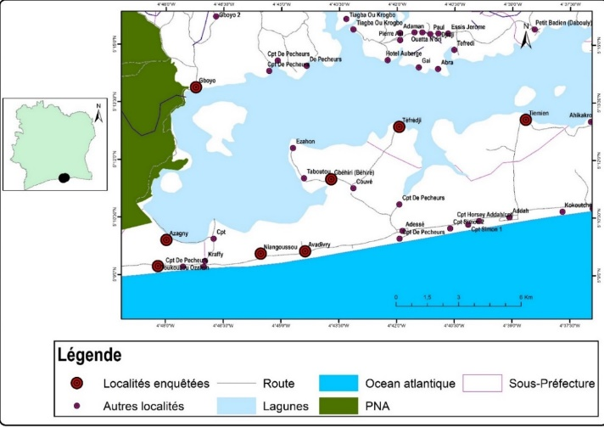

Figure 1 : Location map of the southeastern periphery of the Azagny National Park (PNA)

**1.2. Data collection**

Data collection in this study was structured into six successive steps, aimed at ensuring experimental rigor and reliability of results. These steps include: (i) selection of experimental sites, (ii) layout of the experimental device, (iii) collection of mangrove fruits (propagules) and wildings, (iv) planting of the different types of plants, (v) collection of dendrometric data in the plots, and finally, (vi) collection and analysis of water and soil samples.

**1.2.1. Selection of experimental sites**

The choice of sites was based on an ecological typology of mangroves identified in the study region, based on four degradation classes: preserved mangroves, slightly degraded, highly degraded and fragmented mangrove islands. This classification made it possible to target localities representative of the diversity of conservation states encountered in the Grands-Ponts region. Thus, the locality of **Gboyo**, located near the Azagny National Park, was chosen to represent degraded mangroves in a protected context. In parallel, three other localities **Gbéhiri** , **Téffrédji** and **Tiemien** were selected for their insular and fragmented character, corresponding to the category of mangrove islands. The choice of these sites responds to a double experimental logic: on the one hand, to assess the feasibility of restoration in an area under pressure despite its proximity to a national park (Gboyo), and on the other hand, to test the potential for the ecological transition of the islets towards more continuous and functional mangrove formations in other localities. This approach also aims to generate operational recommendations that can be transposed to other similar areas in Côte d'Ivoire.

**1.2.2. Setting up the experimental device**

The experimental protocol was implemented on a standardized area of **3600 m²** (i.e. 30 m × 30 m) per site, in order to ensure the comparability of results between localities. This main block was subdivided into **three separate plots** of **100 m² each** (10 m × 10 m), spaced 3 meters apart. Each plot corresponds to a specific experimental reforestation **treatment :**

* **MS** : planting of wild plants (natural transplanted plants),
* **MSP** : direct planting of propagules (mature mangrove fruits),
* **MPP** : planting of young plants from nurseries.

Each of the three plots was further subdivided into four 10 m² sub-plots (5 m × 2 m), also spaced 3 meters apart. This block organization allows for better control of intra-site variation factors and facilitates statistical repeatability. Plant spacing, set at 1 meter in the row and 2 meters between rows , was designed to optimize individual mangrove growth while limiting root and foliar competition. In addition, temporary shade structures were installed in the nursery areas at each site to protect young plants from heat stress and direct sunlight during the first three months of growth. This system was standardized across all sites to ensure homogeneity of initial experimental conditions.

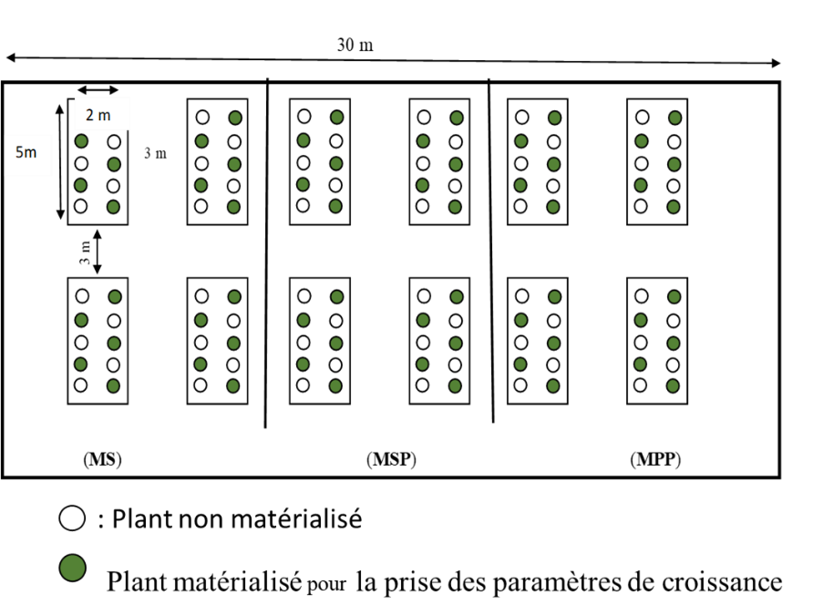

: Plant matérial for measuring growth parameters

Unmarked plant

*(* ***MS*** *): treatment of wild plants; (* ***MP*** *): treatment of propagules; (* ***MPP*** *): treatment of plants from nurseries;*

**Figure 2**: Experimental device set up for planting mangrove seedlings.

### ****1.2.3. Collection of mangrove propagules and wildlings****

Plant material was collected in the mangroves located near Gboyo, particularly around Azagny National Park and in the vicinity of Toukouzou. **Mature propagules** were harvested directly from the mangroves or taken when they had recently fallen to the ground, in order to ensure their viability. At the same time, **wildlings,** i.e. young natural plants with at least two pairs of leaves, were carefully extracted from the ground using suitable hand tools to preserve the integrity of the root system. After extraction, the wildlings were transported to a collection point by speedboat, and then transferred to the locality of Gboyo. A rigorous sorting was then carried out on the collected specimens in order to retain only the most vigorous individuals, suitable for transplantation. The selected plants and propagules were packaged in plastic containers to prevent breakage of the epicotyl, a particularly fragile part of the plant, and to protect them from drying out and excessive sunlight during transport to the experimental sites.

### ****1.2.4. Planting the plants****

Three treatments were applied in the experiment, each corresponding to a distinct reforestation method: (i) Treatment 1: Planting of wildlings (MS). This treatment consists of directly planting young natural plants (wildlings) collected from the mangrove. Only individuals with at least two pairs of leaves were selected for planting; (ii) Treatment 2: Planting of propagules (MSP). Mature propagules were directly planted in the ground, without going to the nursery. They were buried two-thirds of their length, in accordance with the recommendations in the literature (Océanium, 2010) and (iii) Treatment 3: Planting of nursery-grown plants (MPP). In this case, the propagules were germinated in the nursery in 20 cm long and 5 cm wide plastic bags filled with a substrate composed of 50% sand and 50% silt, mixed using a clean container (Primavera et al., 2014). The bags were placed under a shade structure to protect the young plants from solar radiation during their initial growth phase. Planting in the different locations took place in August 2020, at a rate of one site per day. A total of 120 seed units or plants were used per location, distributed equally between the three treatments (40 wildings, 40 direct propagules, and 40 nursery propagules).

### ****1.2.5. Monitoring and collection of dendrometric data****

### The seedlings from the nursery were watered daily for four months, although the initial maintenance period was three months. This extension of the period was made necessary by flooding in the plots, linked to an unusually high tide. Growth measurements were taken monthly over a period of twelve months from the date of planting. The parameters evaluated were: the Number of living plants (NPV) per sub-plot, the Total Height (HP) of the plant and the Diameter at the root collar (DC) (in cm). The Length (Lf) and Width (lf) of the largest leaf as well as the Number of leaves (NF) per plant were recorded. The Number of nodes (NN) and the number of branches (NBR) of the main stem were evaluated; as the Number of stilt roots (NRE) (for the species concerned). In total, sixty (60) plants were measured per site, distributed equally between the three treatments, i.e. twenty (20) plants per treatment.

### ****1.2.6. Water and soil sampling****

In each experimental plot, a **30 cm deep well** was dug to collect groundwater samples. These samples were packaged in sterile bottles and sent to the laboratory for physicochemical analysis. At the same time, **soil samples** were taken using a stratified method in the same plots, in order to analyze their edaphic properties (texture, pH, organic matter content, nitrogen, etc.). The objective of these analyses is to highlight the **possible correlations** between environmental conditions (soil and water) and growth performance observed in plants, in different locations.

### ****1.3. Analysis of reforestation trial data****

The analysis of the results of the reforestation trial was based initially on the **calculation of the averages** of the different parameters measured (NF, NBR, NRE, DC, Lf, lf, HP) by treatment and by experimental unit (sub-plot). Then, the **survival rate** of the plants was determined, as well as the **average growth rate** , using standard mathematical expressions described by Primavera (2014). These values were then subjected to statistical tests to evaluate the significance of the differences observed between the treatments. As for the statistical test, since the variables are quantitative with several factors, a parametric test was used. That of ANOVA, when the normality and homogeneity of the variances are verified by the Shapiro-Wilk test. Otherwise, a non-parametric test is applied, that of Kruskal-Wallis. The significance level chosen for these analyses is 5% (P = 0.05). Correlation tests were also carried out between water and soil parameters and some growth parameters. A principal component analysis and a factor map were carried out to see the water and soil parameters that influence the development of mangroves. 5% (P = 0.05) is the threshold level chosen for these analyses.

**II. RESULTS**

**2.1 Texture of mangrove soils in the 4 localities**

The soils of the four study sites have different textures (Table I), which significantly influences mangrove growth. Gboyo and Tiemien have mainly sandy-loam soils, with a high proportion of sand: 69.25% fine sand in Gboyo and 75.65% coarse sand in Tiemien. In contrast, Téffrédji and Gbéhiri are dominated by sandy-clay soils, with a predominance of coarse sand (89.9%) in Téffrédji, while Gbéhiri has a more balanced distribution between clay (8%) and fine silt (7.55%). These textural differences are likely to explain the disparities in performance observed between the sites, as detailed in Table I.

**Table I:** Content (%) of the granulometric composition of soils from the reforestation test plots ofmangroves

|  |  |  |  |  |  |  |
| --- | --- | --- | --- | --- | --- | --- |
| **Localities** | **Granulometric composition** | | | | |  |
| **Clay** | **Fine silt** | **Coarse silt** | **Fine sand** | **Coarse sand** | **Soil texture** |
| **Gboyo** | 8 | 3 | 16.6 | 69.25 | 3.15 | Sandy-loam |
| **Gbehiri** | 6 | 0.5 | 0.95 | 5.7 | 86.85 | Sandy-clayey |
| **Teffrédji** | 6 | 0.5 | 0.15 | 3.45 | 89.9 | Sandy-clayey |
| **Tiemien** | 8 | 4.5 | 5.1 | 6.75 | 75.65 | Sandy-loam |

### 2.2 Physicochemical and Chemical characterization of the waters with soils of mangrove plots in different locations

#### **2.2.1 Physicochemical characteristics of water**

Analysis of the **physicochemical properties of the water** at the four sites reveals very variable conditions. At **Gboyo,** the water is characterized by high acidity (pH **4.89)**, a relatively high temperature (21.05**°C)**, low salinity (0.03**/1000)** but **good oxygenation** (4.84 **mg/l)**. On the other hand, **at Gbéhiri** and **Téffrédji** has less acidic waters (pH varying from **6.53 to 6.89)**, with **high electrical conductivity** (from **1344 to 1834 µs/cm).** **Tiemien** records the **highest salinity** (0.13**/1000)**. **Significant differences** were observed between the four localities, with a value of p = **0.02. Regarding the dissolved oxygen** content, the values varied from **1.2 mg/l to 4.8 mg/l,** being relatively high in **Gboyo (4.84 mg/l)** and particularly low in **Gbéhiri (1.2 mg/l).** These significant variations (p **= 0.02)** in water characteristics appear to be an explanatory factor for the differences observed in the growth and survival of mangroves between the sites (Table II).

**Table II:** Physicochemical parameters of water in mangrove sites

|  |  |  |  |  |  |
| --- | --- | --- | --- | --- | --- |
| **Setting**  **water** | **Reforestation trial locations** | | | | **p-value** |
| **Gboyo** | **Gbehiri** | **Teffrédji** | **Tiémien** |  |
| **pH** | 4.89 | 6.89 | 6.75 | 6.53 | Ns |
| **T°C** | 21.05 | 20.97 | 19.7 | 19.64 | Ns |
| **EC (µs/cm)** | 61 | 1344 | 1834 | 267 | p=0.02 |
| **Sal (/1000)** | 0.03 | 0.67 | 0.93 | 0.13 | p=0.02 |
| **OD (mg/L)** | 4.84 | 1.2 | 2.64 | 2.03 | ns |

**2.2.2 Chemical characterization of soils from mangrove plots**

The soils studied show notable variations in terms of organic matter content and C/N ratio. Organic matter is high in Gbéhiri and Téffrédji (12.6% respectively), moderate in Tiemien (10.1%) and low in Gboyo (3.5%). Regarding the C/N ratio, it increases from 26.59 in Tiemien to 88.33 in Gboyo, with intermediate values in Gbéhiri (28.36) and Téffrédji (34.80). It is noted that the plots with the highest C/N ratios show the lowest success rates, as shown in Table III.

**Table III:** Concentrations of soil parameters from mangrove plots

|  |  |  |  |  |
| --- | --- | --- | --- | --- |
| **Soil parameters** | **Mangrove site** | | | |
|  | **Gboyo** | **Gbehiri** | **Teffrédji** | **Tiémien** |
| **Cond** (µS/cm) | 1.54 | 10.05 | 13.47 | 28.01 |
| **soil pH** | 5.3 | 4.6 | 6.6 | 3.2 |
| **C** (%) | 2.03 | 6.24 | 7.31 | 5.85 |
| **N** (%) | 0.06 | 0.22 | 0.21 | 0,22 |
| **Na** (mg/kg) | 570,1 | 416,9 | 421,7 | 361,6 |
| **K** (mg/kg) | 324,4 | 85,65 | 154,3 | 94,7 |
| **Ca** (mg/kg) | 199,7 | 132,5 | 220 | 262,2 |
| **Mg** (mg/kg) | 153 | 158,7 | 175,5 | 128,4 |
| **P** (%) | 67,2 | 56,8 | 35,4 | 62,6 |
| **MO** (%) | 3,5 | 12.6 | 12.6 | 10.1 |
| **C /N** (%) | 33.83 | 28.36 | 34.80 | 26.59 |

**2.3 Propagule germination rates according to methods and locations**

A comparative analysis of the different planting techniques highlighted the superiority of direct sowing of propagules in terms of germination rate, compared to the nursery transplanting method, in all four locations studied (Table IV). The most convincing results were observed in the location of Gboyo, where the germination rate reached 8 ± 0.4 for propagules planted directly, compared to 3.25 ± 0.47 for nursery plants. Conversely, the lowest performances were recorded in Gbéhiri for the planting of propagules (2.25 ± 0.47) and in Tiemien for the nursery treatment (0.75 ± 0.47). The results from the analysis of variance (ANOVA) reveal a statistically significant difference between the two methods in the localities of Gboyo (F = 0.518; *p* = 0.0171) and Tiemien (F = 0.1301; *p* = 0.005), thus highlighting the influence of local conditions on the effectiveness of the reforestation techniques tested.

**Table IV:** Comparison of average germination values by method and by location

|  |  |  |  |
| --- | --- | --- | --- |
| **Localities** | **Propagule Method (MSP)** | **Nursery method (MPP)** | **Statistical values** |
| **Gboyo** | 8 ± 0.4 | 3.25 ±0.47 | F=0.518; P=0.0171 |
| **Gbehiri** | 2.25 ± 0.47 | 1.25 ±0.25 | F=0.596; P=0.73 |
| **Tiemien** | 2.5 ± 0.5 | 0.75 ± 0.47 | F=0.1301; P=0.005 |
| **Teffrédji** | 4.5 ± 0.5 | 2.25 ± 0.47 | F=0.4864; P=0.22 |
|  |  |  |  |

**2.4 Height growth of plants from different types of planting in the localities**

The average heights of the plants vary depending on the type of plantation and the locality. For wild plants, the best performance was observed in Gbéhiri with an average height of 68.52 ± 11 cm, followed by Téffrédji (64.5 ± 13.15 cm). As for nursery plants, the highest results were recorded in Téffrédji (64.27 ± 13.15 cm) and Tiemien (64 ± 16.21 cm), as shown in Table V. As for propagule planting, the highest results were observed in Gbéhiri (68.52 ± 11 cm) followed by Tiemien (58.83 ± 14.97).

**Table V:** Comparison of average height values by planting type and by location

|  |  |  |  |  |
| --- | --- | --- | --- | --- |
| **Localities** | **Average plant height (cm) after one year of testing** | | |  |
| **Wildling** | **Propagule** | **Nursery** | **Statistical values** |
| **Gboyo** | 29.51 ±2.04 | 20.09 ±4.21 | 30.20 ± 5.64 | F=0.235; P=0.05 |
| **Gbehiri** | 63.68 ±14.03 | 68.52 ±11 | 54.69 ±14.7 | F=0.111; P=0.82 |
| **Tiemien** | 47.84 ±13.1 | 58.83 ±14.97 | 64 ±16.21 | F=0.073; P=0.01 |
| **Teffrédji** | 64.5 ±13.15 | 52.29 ±10.87 | 64.27 ±13.15 | F=0.532; P=0.06 |

**2.5 Survival rate of plants from different types of planting during the trial in the 4 locations**

At 12 months into the trial, survival rates reveal marked contrasts between locations and planting methods (Figures 3, 4 and 5). Gbéhiri stands out with excellent results for wildlings (77.5%) and especially propagules (85%). Tiemien particularly excels with nursery plants, achieving a remarkable rate of 97.5%. In contrast, Gboyo presents a significantly less favourable environment, with alarming survival rates: 42.5% for nursery plants, 35% for wildlings, and a worrying 10% for propagules.

Figure 3: Distribution of survival and mortality rates of wildlings by location

Figure 4: Distribution of survival and mortality rates of sown propagules according to localities

**Figure 5:** Distribution of survival and mortality rates of nurseries from nurseries by location.

**2.6 Water Parameters Influencing Mangrove Growth**

Principal component analysis (Figure 6a) reveals that water parameters exert a differentiated influence on mangrove growth, depending on the planting method used. For wildlings, pH is strongly positively correlated with height (r = 0.81) and collar diameter (r = 0.77). On the other hand, for nursery plants, dissolved oxygen shows a significant negative correlation with survival (r = -0.72) and collar diameter (r = -0.81). In addition, salinity shows a negative correlation with survival rate (r = -0.65) for all types of plants. No significant correlation was observed for propagules. The parameter scatter plot identified four distinct groups: the first group (composed of Gbéhiri and plot 3 of Teffredji) is characterized by high salinity and water conductivity. The second group (corresponding to Gboyo) is distinguished by a relatively high temperature (21.05°C) and a high dissolved oxygen level (4.84 mg/l). The third group (the Téffrédji plots) is marked by favourable plant height growth and a less acidic pH (6.75). Finally, the fourth group (represented by Tiemien) is distinguished by a lower temperature (19.64°C). Correlations with the axes indicate specific relationships between these environmental parameters and the characteristics specific to each locality (Figure 6 b).

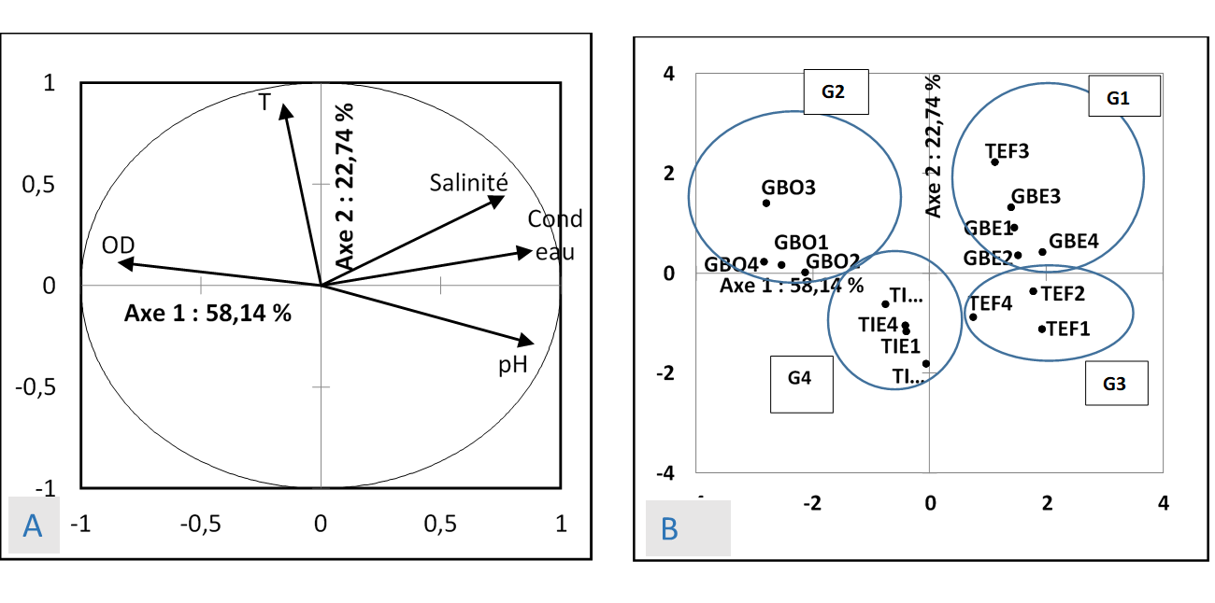

B) Factorial map of different mangrove reforestation trial plots in the four selected localities in the South-East of the PNA

**A)** Correlation circle of water parameters from the different mangrove plots used in the Principal Component Analysis

**Figure 6:** Principal component analysis of physicochemical parameters and spatial distribution of mangrove reforestation plots in the South-East of the PNA

**2.7 Influential soil parameters**

Principal component analysis revealed several significant correlations (p<0.05, r>0.70) between soil parameters and mangrove growth, according to the three planting types: wildling, propagule, and nursery planting. For wildling planting, pH was observed to promote plant height, stilt root number, and root collar diameter, while dissolved oxygen and silt had a negative impact. In addition, the presence of sand limited stilt root development. For propagule planting, conductivity improved root collar diameter, while carbon and nitrogen promoted stilt root formation, although carbon and sand reduced plant survival. Finally, for nursery planting, pH stimulated stilt root formation but decreased plant survival. These results highlight the importance of adapting planting techniques to specific edaphic conditions to optimize the success of mangrove reforestation projects.

Principal component analysis also revealed two main axes that structure the relationships between soil parameters. Axis 1 is positively correlated with conductivity, salinity, pH, potassium, sodium, and silt, and negatively with dissolved oxygen, organic matter, nitrogen, carbon, and sand content. Axis 2, on the other hand, is defined positively by temperature, magnesium concentration, and pH, and negatively by phosphorus concentration. Regarding the relationships between soil parameters and mangrove growth, for the wildling treatment, mangrove development is strongly influenced by conductivity, organic matter, nitrogen, silt, and sand. For the propagule treatment, a significant correlation was observed between conductivity and root collar diameter (r=0.70). Finally, at the nursery treatment level, pH is positively correlated with the number of stilt roots (r=0.72) but negatively with the survival rate. This structuring of edaphic variables explains the differences in efficiency observed between the different planting methods (Figure 7a). The factor map made it possible to identify three distinct groups of plots, each with specific edaphic characteristics. Group 1, consisting of the Téffrédji and Gbéhiri plots, is positively correlated with axis 1 and is distinguished by high concentrations of carbon, organic matter and nitrogen.

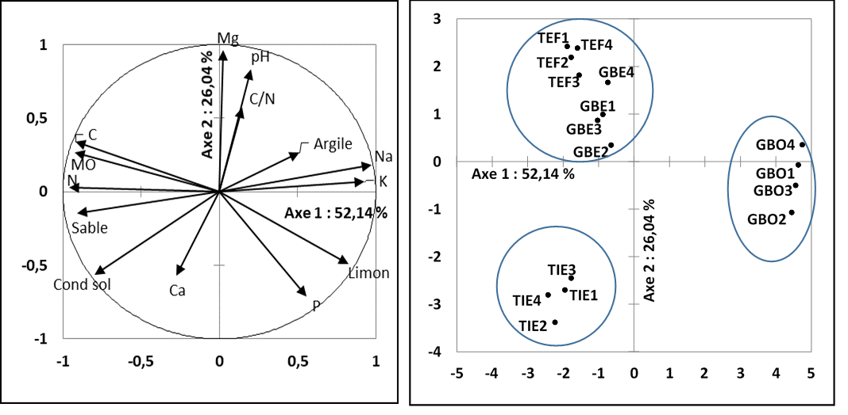

**B**

**A**

(A): Circle of correlations and projection of the plots of the different localities

(B): Factorial plan defined by axes 1 and 2 of the plots of the different locations

**Figure 7:** Factorial representation of the physicochemical parameters of water and soil from mangrove plots in the four studied locations

Cluster 2, mainly composed of Gboyo plots, shows a positive correlation with silt and phosphorus, with significant levels of both parameters. Finally, cluster 3, which includes only Tiemien plots, is positively correlated with sand, soil conductivity, and calcium, and is characterized by particularly high values for calcium and conductivity. This classification reveals the heterogeneity of soils between the studied localities and suggests that each site offers distinct potential for mangrove growth (Figure 7b).

**III. DISCUSSION**

This comparative study of mangrove reforestation methods, namely direct sowing of propagules, planting of seedlings from nurseries and transplanting wildings, has highlighted several factors influencing the growth and survival of mangroves in four distinct localities. The results obtained reveal that direct sowing of propagules offers the best germination rate in all localities, which can be explained by the direct contact of the propagules with soil nutrients, thus facilitating their initial development. However, it is the nursery method that records the highest overall survival rate (70%), attributable to the preliminary development period of the seedlings in the nursery, lasting four months, before their transplantation into the natural environment. On the other hand, the welding method displays the lowest survival rate (48.33%), mainly due to the stress related to transplantation. This finding is supported by the work of Diallo et al. (2020), who highlight the impact of ecological conditions of seeds on their development and survival after planting. The impact of the site of origin of propagules on seedling survival was also highlighted by Sinsin et al. (2022), who show that the edaphic characteristics of propagule collection sites significantly influence seedling performance after planting. Thus, the Téffrédji locality is distinguished by particularly tall plants in the wildling and nursery treatments, which could be correlated with a higher pH (6.6) and a higher carbon content (7.31%) in the soil. Soil texture also appears to be a key factor in mangrove growth. The sandy-loam soils of Gboyo and Tiemien and the sandy-clay soils of Gbéhiri and Téffrédji differ significantly in their physicochemical properties, thus influencing plant performance. Sandy-clay soils, with their spongy and elastic structure, appear more conducive to the development of mangrove plants, a finding consistent with the observations of Adriamala (2007), according to which clay soils provide the plasticity and adhesiveness necessary for maintaining moisture and good root growth. The soils of Gbéhiri and Téffrédji, rich in organic matter (12%) and carbon (6.24% to 7.31%), also promote an environment conducive to mangrove growth. However, as Andriatsiaronandroy (2017) and Bocquet (2018) point out, the excess organic matter under flooding conditions can lead to anaerobic degradation, which is potentially toxic to roots. Furthermore, the particularly high C/N ratio in Téffrédji (34.80%) suggests a slow decomposition of organic matter, promoting greater humus stability, but also conditions that could become unfavourable for root growth. Major exchangeable elements, such as potassium, calcium, magnesium, and sodium, play a determining role in the physiological processes of mangroves. These elements are essential for the regulation of intracellular osmotic potential, which helps mitigate the effects of water stress due to high soil salinity, as indicated by Farooqui et al. (2016). Conversely, excessive concentrations of nitrogen (N) and phosphorus (P) can become toxic, negatively affecting seedling density and promoting the proliferation of harmful aquatic organisms. Regarding water, physicochemical parameters, such as pH and dissolved oxygen, are identified as key factors influencing mangrove growth. Increasing water pH has a beneficial effect on the height growth and crown diameter of mangrove plants. On the other hand, soil conductivity, organic matter, and nitrogen promote the development of stilt roots, while excessively high levels of sand and carbon are detrimental to plant survival, particularly in the case of propagules. The results of this study, although partly contradictory to the findings of Wakushima et al. (1994), which highlight the impact of salinity on productivity, confirm the hypotheses put forward by UNDP et al. (2009), according to which there is an inverse relationship between salinity and mangrove productivity. Furthermore, insect predation, particularly in Tiemien, appears to be a significant factor in plant mortality, as highlighted by Kathiresan (2003) and other similar studies. Principal component analysis revealed significant differences between the four studied localities (Gbéhiri, Tiemien, Gboyo and Téffrédji) with regard to the physicochemical parameters of soils and water, thus confirming the importance of these variables in the success of mangrove reforestation projects. In summary, this study demonstrates that the success of mangrove reforestation depends on the complex interaction between planting techniques, soil characteristics and water parameters. The most effective method for reforestation appears to be the planting of seedlings from nurseries, which achieved a survival rate of 70%, thus highlighting the importance of adapting planting techniques to specific local conditions to optimize the growth and survival of mangroves.

**Conclusion and Perspectives**

This study evaluated the effectiveness of three mangrove reforestation methods (direct sowing of propagules, planting of nursery seedlings, and transplanting wildlings) in four different locations. The results showed that the most successful method, in terms of success rate and seedling survival, was that of nursery seedlings, with a survival rate of 70%. The propagule method also had a high recovery rate, but the wildling method revealed a lower survival rate due to transplantation stress. Soil edaphic characteristics, such as texture, organic matter content, pH, and salinity, also showed a significant influence on mangrove growth. Locations with sandy-clay and sandy-loam soils (Gbéhiri and Tiemien) recorded the best results. Finally, the physicochemical parameters of the water, notably pH and dissolved oxygen, have proven to be decisive in the success of mangrove plantations.

Disclaimer (Artificial intelligence)

Option 1:

Author(s) hereby declare that NO generative AI technologies such as Large Language Models (ChatGPT, COPILOT, etc.) and text-to-image generators have been used during the writing or editing of this manuscript.

Option 2:

Author(s) hereby declare that generative AI technologies such as Large Language Models, etc. have been used during the writing or editing of manuscripts. This explanation will include the name, version, model, and source of the generative AI technology and as well as all input prompts provided to the generative AI technology

Details of the AI usage are given below:

1.

2.

3.

**REFERENCES**

**ADG, 2013** . Project of restoration and conservation of the mangrove ecosystem in the Biosphere Reserve of the Delta of the Saloum - PRECEMA

**Ajonina G., Kairo J., Grimsditch G., Sembres T.3., Chǔi G., Mibog DE & FitzGerald C. 2013** . Assessment of carbon pools and multiple benefits of mangroves in Central Africa for REDD+. UNEP, WCMC, CWCS, KMFRI Report. 85pp.

**Ajonina GN, Kairo J, Grimsditch G, Sembres T, Chuyong G, Diyouke E. 2014** . Assessment of Mangrove Carbon Stocks in Cameroon, Gabon, the Republic of Congo (RoC) and the Democratic Republic of Congo (DRC) Including their Potential for Reducing Emissions from Deforestation and Forest Degradation (REDD+). In The Land/Ocean Interactions in the Coastal Zone of West and Central Africa Estuaries of the World, Diop S, Barusseau JP, Descamps CYR (eds). Springer: Germany; 177-189.

**Andriamalala CAK 2007.** Etude écologique pour la gestion des mangroves Madagascar Thèse de Doctorat de l’Université d’Antananarivo, Antannarivo, Madagascar, 283p.

**Andriatsiaronandroy ORR, Taïbi AN, Davranche A., Ballouche A. & Rejo-Fienena F. 2017** . Dynamics of the mangrove in the southwest region of Madagascar in the face of anthropogenic actions and climate change. The example of mangrove formations. Territoires d’Afrique, n° 9, pp. 41-52.

**Barbier, EB, 2016** . The protective service of mangrove ecosystems: A review of valuation methods. Marine Pollution Bulletin

**Boquet. E. 2018.** Mangrove reforestation in the Saloum Delta, Senegal: Ecological and social assessment. Master's thesis in bioengineering: forest and natural area management, specialized focus, University of Thiès, Thiès, Senegal, 86 p.

**Chaudhari S, Pachpande MP. 2015** . Natural carbon sequestration by dominant mangrove species Avicennia marina Var. Accutissima Ex Staf and Moldenke Ex Moldenke found across Thane Creek, Maharashtra, India. International Journal of Scientific and Engineering Research, 6(2): 1162-1165. http://www.ijser.org

**Chevalier, J., 2014.** Creation of an ecological benchmark for evaluating the success of wetland rehabilitation operations. In: Agricultural Sciences.

**CRAAQ** ( **Quebec Reference Center for Aquaculture and Agrifood** ). **2006.** Phosphorus mobility: literature review. CRAAQ, Quebec

**Diallo FA, Sandwidi A., Dao MEC, BationoKando P. & Diallo BO 2020** . Phenotypic characterization of seedlings from four populations of Sclerocarya birrea (A. Rich.) Hochst. in Burkina Faso. *Bois et Forêts des Tropiques* , **344** : 33-46.

**Dikobè S., 2018.** Cameroon: Reforestation of mangroves in coastal regions. https://www.africa-info.org/environnement/1479-cameroun-reboisement-desmangroves-dans-les-regions-cotieres.html, (2/8/2018).

**Diop E. S., Gordon G., Semesi A. K., Soumaré A., Diallo N., Guissé A., Diouf M. & Ayivor J.S**. **2001**. Mangrove of Africa. In Mangrove ecosystems. Function and management. *Springer 2001* *Ed. Lacerda*. Berlin Heidelberg, Springer2001.

**FAO 2020.** The state of the world's forests 2020. FAO and UNEP. https://doi.org/ 10.4060/CA8642EN

**Farooqui A., Ranjana. & Joshi Y. 2016**. Low Na/K ratio in the leaves of mangroves mitigates salinity stress in estuarine ecosystem. *Tropical Plant Research*, **3**(1): 78–86.

**Giri C., Long J. & Tieszen L**. **2011a**. Mapping and Monitoring Louisiana’s Mangroves in the Aftermath of the 2010 Gulf of Mexico Oil Spill. *Journal of Coastal Research* 1059– 1064.

**Giri C., Ochieng E., Tieszen L. L., Zhu Z., Singh A., Loveland T., Masek J. & Duke N. 2011b**. Status and distribution of mangrove forests of the world using earth observation satellite data: Status and distributions of global mangroves. Global Ecology and Biogeography 20, 154–159.

**Giri, C. et al., 2011**. Status and distribution of mangrove forests of the world using earth observation satellite data. Global Ecology and Biogeography, pp. 154 - 159

**Guillaumet JL & Adjanohoun E. 1971.** The vegetation of the Ivory Coast. In Avenard JM, Eldin E., Girard G., Sircoulon J., Touchebeuf P., Guillaumet JL, Adjanohoun E. & Perraud A. (eds.) 1971. The natural environment of the Ivory Coast. *ORSTOM* n°50, Paris, pp. 157-263.

**Hossain MD, Nuruddin AA. 2016** . Soil and Mangrove: A review. J. Approx. Sci. Technol., 9: 198-207. DOI: 10.3923/jest.2016.198.20

**Kathiresan K. 2003.** Insect foliage in mangroves. *Indian J. Mar. Sci* , **32** (3), 237–239 **.**

**Lauginie F.** 2007. **Conservation** of nature and protected areas in Ivory Coast. NEI/Hachette and Afrique Nature, Abidjan (Ivory Coast), 668 p.

**Ndour N. 2005.** Characterization and study of the dynamics of mangrove populations in the Saloum Delta (Republic of Senegal), Postgraduate thesis, Faculty of Science and Technology, Cheikh Anta Diop University, Dakar, Senegal, 180 p.

**Oceanium** , Reforestation of rhizophora: plant your tree! http://www.oceaniumdakar.org/Le-reboisement-du-rhizophora.html, (2/8/2018).

**Oceanium. 2010** . Project design document form v.02 - Oceanium mangrove restoration project.

**NGO Bel Avenir, 2018.** Reforestation of the forest and mangrove - NGO Bel Avenir. [http://ongbelavenir.org/ambiental/projets/recuperation-de-l'environnement/reboisement-de-la-forêt-et-de-la-mangrove/](http://ongbelavenir.org/ambiental/projets/recuperation-de) , (2/8/2018).

**Ouattara A. Cecchi P. 2021.** Status and conservation of mangroves in Ivory Coast. Proceedings of the LMI-PATEO – UASZ International Conference, Assane Seck University of Ziguinchor (Senegal), November 19-22, 2019, p.112.

**Primavera JH & Esteban JMA 2014** . A review of mangrove rehabilitation in the Philippines: Successes, failures and future prospects. *Wetl. Ecol. Manag* , **16** (5), 345–358.

**Ranaivoson J.** 2001. **Study** of the shrimp aquaculture development plan in Madagascar. Phase I: Cases of zones 1, 4. Madagascar, Ministry of Fisheries and Fisheries Resources. European Union, 42 p.

**RGPH 2021.** Sociodemographic and economic data of Côte d'Ivoire. Source: National Institute of Statistics Côte d'Ivoire. <http://www.ins.ci/n/templates/docss/RGPH2014D.pdf>.

**Sinsin B., Assogbadjo AE, Tente B., Yo T., Adanguidi J., Lougbegnon T., Ahouansou S., Sogbohossou E., Padonou EA & Agbani P. 2022.** Floristic and faunal inventory of mangrove ecosystems and coastal wetlands of Benin. FAO & Laboratory of Applied Ecology, Benin, *ISBN* 978-92-5-103148-7 (FAO-Benin).

**Spalding, M., Kainuma, M., Collins, L. & Harris, E., 2011**. Atlas Mondial des Mangroves. OIBT, ISME.

**UNDP., GEF., UNESCO. & IOC. 2009**. Atelier régional de formation sur les techniques de restauration de la mangrove. UNDP, Rapport final, 20 p.

**Wakushima S., Kuraishi S. & Sakurai N., 1994**. Soil salinity and pH in Japanese mangrove forests and growth of cultivated mangrove plants in different soil conditions. *J. Plant Res*., **107**(1), 39–46.

Ngongolo, K., Mtoka, S., & Mahulu, A. (2015). Challenges and Opportunities for Restoring the Threatened Mangroves. Journal of Scientific Research and Reports, 5(5), 352–360. <https://doi.org/10.9734/JSRR/2015/8922>

Soper, F. M., MacKenzie, R. A., Sharma, S., Cole, T. G., Litton, C. M., & Sparks, J. P. (2019). Non‐native mangroves support carbon storage, sediment carbon burial, and accretion of coastal ecosystems. Global Change Biology, 25(12), 4315-4326.

Song, S., Ding, Y., Li, W., Meng, Y., Zhou, J., Gou, R., ... & Lin, G. (2023). Mangrove reforestation provides greater blue carbon benefit than afforestation for mitigating global climate change. Nature Communications, 14(1), 756.

Van Vinh, T., Marchand, C., Linh, T. V. K., Vinh, D. D., & Allenbach, M. (2019). Allometric models to estimate above-ground biomass and carbon stocks in Rhizophora apiculata tropical managed mangrove forests (Southern Viet Nam). Forest Ecology and Management, 434, 131-141.