**Mathematical Modeling and Equilibrium**

**Analysis of Early Life Stress Using a**

**Modified SEIR Framework**

**Abstract**

Early life stress (ELS) are adverse childhood exposures and exerts profound effects on brain development in children and mental health in later life. We formulated and solved a deterministic SEIR type model to describe the effects of ELS on child populations in urban areas in Kenya. The model involved environmental, genetic, neurobiological, and resilience factors with crucial dynamics and relapse. Equilibrium states were derived, and the local and global stability of the equilibriums were rigorously investigated by Mathematical analysis. The model identified significant patterns of progression of stress and provides a foundation for evaluating intervention approaches. Sensitivity of Stress Propagation Index *R*0  shows that resilience and environmental exposure are key determinants of the dynamics of mental health. The findings are of relevance to mental health professionals, public health policy makers, educational and social services, and the general public.

**Keywords:** SEIR Model, Early Life Stress, Mental Health, Stability Analysis, Stress Propagation Index.

# 1 Introduction

Early life stress (ELS) is a major risk factor for adverse mental health outcomes. The timing and accumulation of stress during critical developmental periods can alter neurobiological systems, increasing vulnerability to psychiatric disorders such as anxiety disorders, depression, Post Traumatic Stress Disorder (PTSD) and drug abuse [2].

Over 60% Studies in Kenya have highlighted the high prevalence of adverse childhood experiences (ACEs) among Kenyan children and adolescents, with significant associations to mental health issues[1]. Additionally, maternal mental health has been shown to mediate the relationship between maternal ACEs and child mental health problems, emphasizing the intergenerational impact of early life stress. Most of urban populations live in informal settlements where children are routinely exposed to chronic stressors such as food insecurity, poor housing conditions, exposure to violence and lack of access to mental health care. The Nairobi Urban Health and Demographic Surveillance System (NUHDSS) has consistently reported high levels of psychosocial stress and limited mental health support structures in informal settlements [1,4].

Mathematical modeling provides a structured framework for understanding the transmission and persistence of stress effects within a population, integrating neuroimaging studies, longitudinal cohort data and psychological assessments [4]. However, there remains a gap in comprehensive models that holistically integrate genetic predispositions, environmental influences and psychosocial factors. This paper developed a modified SEIR model for ELS and analyzed its equilibrium behavior and stability. It contributes to the identification of thresholds and provides intervention strategies to reduce the burden of mental health in children.

# 2 Literature Review

In this chapter existing research is reviewed on the effects of early life stress (ELS) on brain development and mental health trajectories.

Impact of ELS on brain development and behavior by [7] used zebrafish as a model organism to study the impact of ELS on brain development and behavior. The model leverages the genetic and neuroanatomical similarities between zebrafish and humans to examine stress responses. A common formulation used in this type of model involved modeling stress-induced changes in gene expression using a system of differential equations:

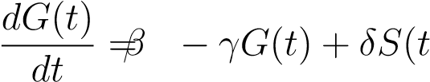) (1)

Where: *G*(*t*) represents the level of a specific gene expression at time *t*. *β* is the baseline gene expression rate. *γ* is the decay rate of gene expression. *δ* represents the effect of stress *S*(*t*) on gene expression.

This equation helped to understand how ELS influences gene expression patterns related to stress and developmental outcomes. Translating findings from zebrafish to human neurodevelopment requires careful consideration of species-specific differences in stress responses.

Backward bifurcation in a two strain model of Heroine Addiction by [11], they introduced and analyzed a two-strain epidemic model with the superinfection for modeling the effect of prescribed opioids abuse on heroin addiction. The total population of the community is divided into the following groups, susceptible individuals S, individuals infected with strain one, i.e., individuals who abuse prescription opioids I1, individuals infected with strain two, i.e., individuals addicted to heroin I2, and individuals under treatment/rehabilitation R. The number of individuals in this compartments is denoted by S,I1,I2 and R respectively. The numbers 12 show the rate of infection in strains one and two, respectively. Among the various causes of heroin addiction, the use of prescription opioids is one of the main reasons. The model contains the impact of relapse of individuals under treatment/rehabilitation to drug abuse in each strain and was formulated as follows;

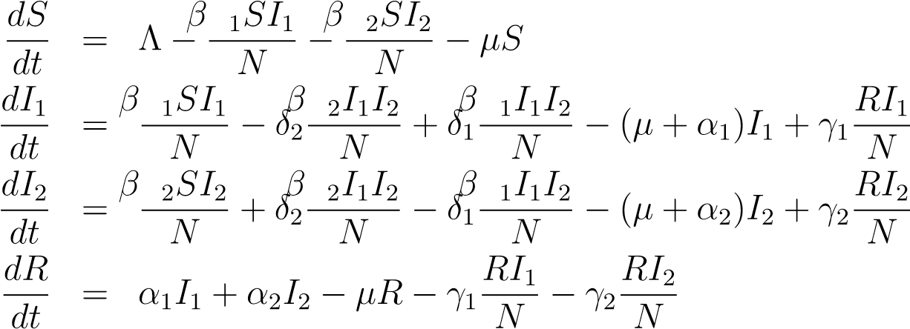 (2)

Modeling of substance abuse and its progression stages by [8] , a model was developed on Substance-Abuse and Its Progression Stages. Substance-abuse. Mathematical model was used to study the dynamism of substance abuse and its various stages of progression from the justification that substance abuse leads to substance addiction with the development of tolerance and dependence.

The model was formulated under the following assumptions that, total population comprises Susceptible (*S*), Substance Abusers (*A*), Substance Addicts (*Q*), substance Tolerants (*T*), substance Dependents (*D*) and Rehabilitants (*R*) with the assumptions that new recruitment into the system are in the susceptible class, rehabilitation does not provide permanent recovery therefore rehabilitated persons could become susceptible again and that the rehabilitation center is strictly inpatient so as to avoid relapsing. The model equations were formulated as follows:

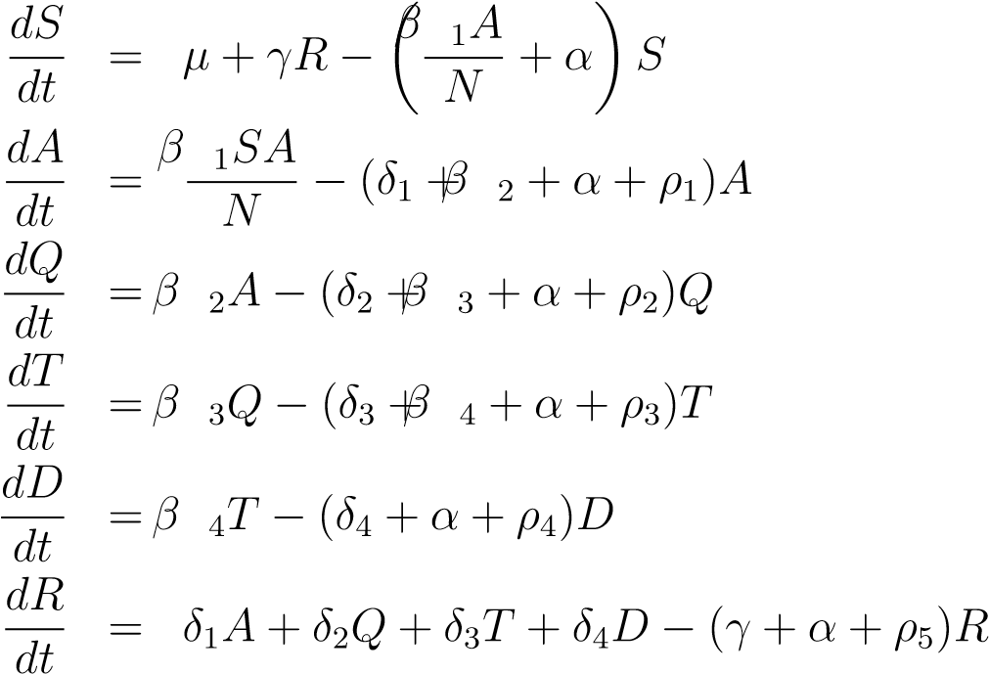 (3)

where *N* = *S* + *A* + *Q* + *T* + *D* + *R*,

subject to the initial conditions;

*t* = 0*, S*(0) = *S*0*, A*(0) = *A*0*, Q*(0) = *Q*0*, T*(0) = *T*0*, D*(0) = *D*0*, R*(0) = *R*0 with *µ,γ,α,β,δ,ρ* as parameters.

In this research, epidemiological approach was adopted in the mathematical model which enabled scientists to study the dynamism of substance-abuse and its various stages of progression. With this in mind, a comprehensive mathematical model was crucial for understanding the mechanisms underlying the effects of early life stress on brain development and mental health trajectories using epidemiological approach in the model development.

# 3 Model Development

This SEIR model is designed to study how early life stress (ELS) impacts brain development and mental health. It categorizes individuals into four groups: susceptible ( S), exposed (E), impaired (I), recovered (R), and models how individuals transition between these states based on the population changes over time. The dynamics are influenced by vital demographic processes (births and deaths) and modulated by biological, genetic, and psychological factors.

We define four compartments:

*S*(*t*): Susceptible children (not yet exposed to ELS)

*E*(*t*): Exposed children (experienced ELS, no symptoms)

*I*(*t*): Impacted children (symptomatic mental health burden)

*R*(*t*): Recovered children (temporary resolution of symptoms)

The model equations incorporating birth-death dynamics and relapse are:

$$\frac{dS}{dt}=Λp_{1}-βSE_{f} \left(1-R_{f}\right)-μS$$

$$\frac{dE}{dt}=Λp_{2}+βSE_{f} \left(1-R_{f}\right)- αE\left(N_{f}+G_{f}\right)-μE$$

$$\frac{dI}{dt}= Λp_{3}+ αE\left(N_{f}+G_{f}\right)-σI+γR_{f}-μI$$

$$\frac{dR}{dt}=σI-γR_{f}-μR$$

(4)

From the above definitions and descriptions, the resulting diagram for the model is given

as;

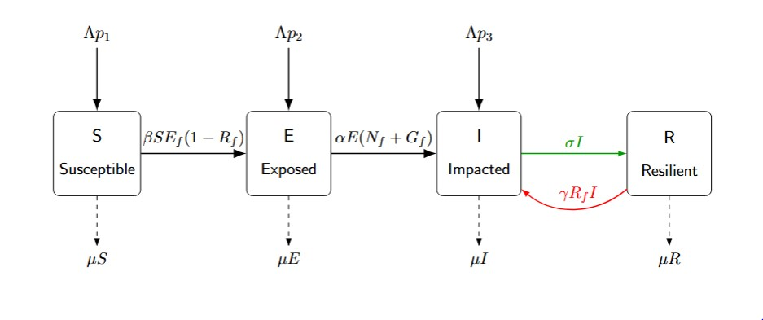

### Figure 1: Schematic diagram of the SEIR model for Early Life Stress ( ELS )

Model Parameters:

*β* = 0*.*28: Stress exposure rate

*Ef* = 0*.*65: Environmental factor index

*Rf* = 0*.*35: Resilience factor

*Nf* = 0*.*52, *Gf* = 0*.*40: Neurobiological and genetic factors

*α* = 0*.*18: Incubation rate

*σ* = 0*.*12: Recovery rate

*γ* = 0*.*06: Relapse rate

Λ = 0*.*025, *µ* = 0*.*015: Birth and death rates

*p*1 = 0*.*70, *p*2 = 0*.*25, *p*3 = 0*.*05: Birth distribution proportions

# 4 Model Analysis.

The well-posedness of the differential equations for the model formulated in this study was demonstrated by proving several theorems on the feasibility, boundedness, equilibria , local and global stabilities.

## 4.1 Positivity

From the model equations, we establish that the model is biologically meaningful by showing that the state variables (representing population sizes) remain non-negative and bounded for all time, given non-negative initial conditions. Positivity ensures that the population sizes are non negative, for it to be realistic due to resource limitations or other constraints.

If *S* = 0 at some time *t*0, then

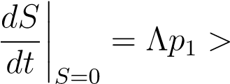0 (4)

assuming Λ *>* 0 and *p*1 *>* 0. This ensures *S* cannot become negative.

If *E* = 0 at some time *t*0, then

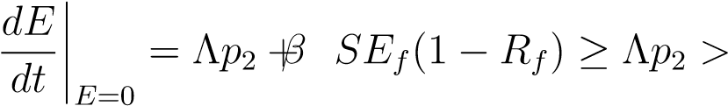0 (5)

assuming Λ *>* 0 and *p*2 *>* 0. This ensures *E* remains non-negative.

If *I* = 0 at some time *t*0, then

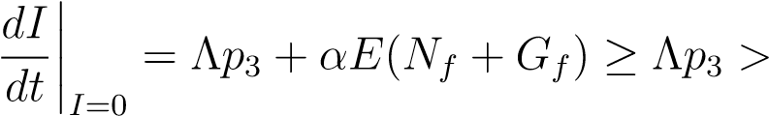0 (6)

assuming Λ *>* 0 and *p*3 *>* 0. This ensures *I* remains non-negative.

If *R* = 0 at some time *t*0, then

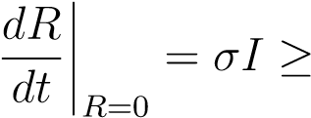0 (7)

since *I* ≥ 0 and *σ >* 0. This ensures *R* remains non-negative.

Therefore, the system preserves positivity of all state variables, making it biologically meaningful. The solution trajectories that start in the non-negative orthant remain in for all *t* ≥ 0.

## 4.2 Boundedness

For a biologically realistic model, we need to show that the total population remains bounded over time. Let *N* = *S* + *E* + *I* + *R* be the total population in the system.

By adding all equations in our system, we obtain:

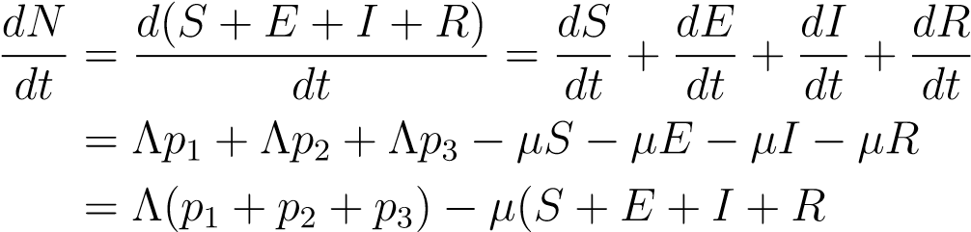 (8)

(9)

Assuming that *p*1 + *p*2 + *p*3 = 1 (i.e., the birth rates into different compartments sum to 1), we have:

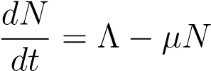 (10)

This is a linear first-order ordinary differential equation which can be solved using standard techniques. Therefore, the total population *N*(*t*) is bounded above by , regardless of the initial conditions. This constant  represents the carrying capacity of the population in this model. We define a positively invariant region:

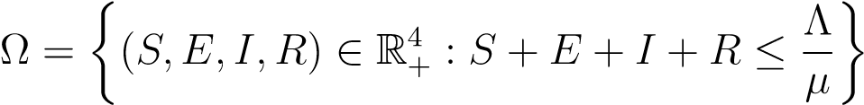 (11)

If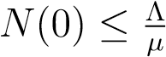, then 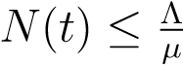 for all *t* ≥ 0.

If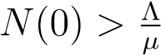, then *N*(*t*) will eventually be less than or equal to 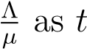increases.

This boundedness property ensures that the solutions of the system are Well-posedness and biologically meaningful. Positivity and boundedness of the SEIR-ELS model has been established thus making it biologically meaningful.

## 4.3 Stress Propagation Index *R*0

We define the infected state vector:

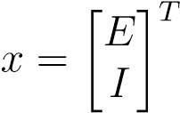

We separate the system into:

F(*x*): the rate of new infections

V(*x*): the rate of transfer in/out of infected compartments (not due to new infections)

New Infection Terms

$$F=\left[\begin{matrix}βSE_{f} \left(1-R_{f}\right) \\ 0\end{matrix}\right]$$

$$V=\left[\begin{matrix}αE\left(N_{f}+G_{f}\right)+μE \\ -αE\left(N_{f}+G_{f}\right)+\left(σ-γR_{f}+μ\right)I\end{matrix}\right]$$

$$F=\frac{∂F}{∂x}|_{DFE}=\left[\begin{matrix}β\frac{Λp_{1}}{μ}E_{f} \left(1-R_{f}\right) & 0 \\ 0 & 0\end{matrix}\right]$$

$$V=\frac{∂V}{∂x}|_{DFE}=\left[\begin{matrix}α\left(N_{f}+G_{f}\right)+μ & 0 \\ -α\left(N_{f}+G_{f}\right) & σ-γR_{f}+μ\end{matrix}\right]$$

$$V^{-1}=\left[\begin{matrix}\frac{1}{α\left(N_{f}+G_{f}\right)+μ} & 0 \\ μ\left(γR_{f}+α+σ+μ\right) & \frac{1}{σ-γR_{f}+μ}\end{matrix}\right]$$

Next Generation Matrix (*FV* −1)

Substituting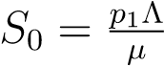

$$R_{0}=\frac{βE_{f} \left(1-R_{f}\right).Λp_{1}}{μ\left(α\left(N_{f}+G_{f}\right)+μ\right)}$$

This represents the expected number of new symptomatic cases caused by stressors in a fully susceptible population.

## 4.4 Sensitivity Analysis of the Stress Propagation Index *R*0

Sensitivity analysis is performed to evaluate the impact of model parameters on the transmission dynamics of early life stress (ELS). The normalized forward sensitivity index for each parameter *x* is defined as:

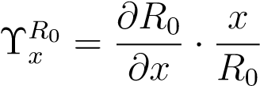

## 4.5 Disease-Free Equilibrium ( DFE )

The Disease-Free Equilibrium represents a state of mental health system where no active progression of stress-related mental health issues occurs. Its stability is crucial in understanding how early life stress can potentially trigger or prevent long-term mental health trajectories.

At the DFE, *E* = *I* = *R* = 0, and

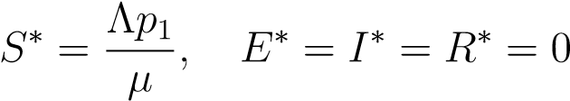

**4.6 Local Stability of Disease-Free Equilibrium** We compute the Jacobian matrix of the system at the DFE:

$$J=\left[\begin{matrix}-βE_{f }\left(1-R_{f}\right)-μ & 0 & 0 & 0 \\ βE_{f }\left(1-R_{f}\right) & -α\left(N_{f}+G_{f}\right)-μ & 0 & 0 \\ 0 & α\left(N_{f}+G_{f}\right) & -σ-γR_{f}+μ & 0 \\ 0 & 0 & σ+γR_{f} & -μ\end{matrix}\right]$$

so its eigenvalues are the diagonal entries:

*λ*1 = −*βEf*(1 − *Rf*) − *µ <* 0

*λ*2 = −*α*(*Nf* + *Gf*) − *µ <* 0

*λ*3 = −(*σ* − *γRf* + *µ*) *<* 0

*λ*4 = −*µ <* 0

By Routh-Hurwitz Stability Criterion, all eigenvalues of the Jacobian have negative real parts thus when

*R*0 *<* 1, we have:

### Tr(*J*) *<* 0*,* det(*J*) *>* 0

This ensures that the recovery-driven feedback (relapse loop) is not stronger than the combined forces of recovery and natural death. Thus, when *R*0 *<* 1, the disease-free equilibrium is locally asymptotically stable, and this means that small perturbations from the DFE will decay over time, leading the system back to the disease-free state.

## 4.7 Global Stability of Disease-Free Equilibrium

To establish the global stability of DFE, we apply the Castillo-Chavez and Song theorem [3]. Consider the subsystem with *E* = *I* = 0:

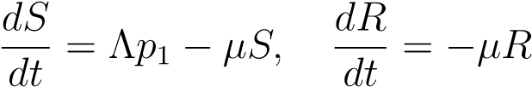

:

### 0 as *t* → ∞

$$fx=\left[\begin{matrix}E \\ I\end{matrix}\right]$$

$$F=\left[\begin{matrix}βSE_{f} \left(1-R_{f}\right) \\ 0\end{matrix}\right]$$

$$V=\left[\begin{matrix}αE\left(N_{f}+G_{f}\right)+μE \\ -αE\left(N_{f}+G_{f}\right)+\left(σ-γR_{f}+μ\right)I\end{matrix}\right]$$

$$D_{fx}V=\left[\begin{matrix}α\left(N_{f}+G_{f}\right)+μ & 0 \\ -α\left(N_{f}+G_{f}\right) & σ-γR_{f}+μ\end{matrix}\right]$$

Using the Castillo-Chavez approach [3], if *R*0 *<* 1, then the disease-free equilibrium is globally asymptotically stable.

## 4.8 Endemic Equilibrium ( EE )

At the endemic equilibrium:

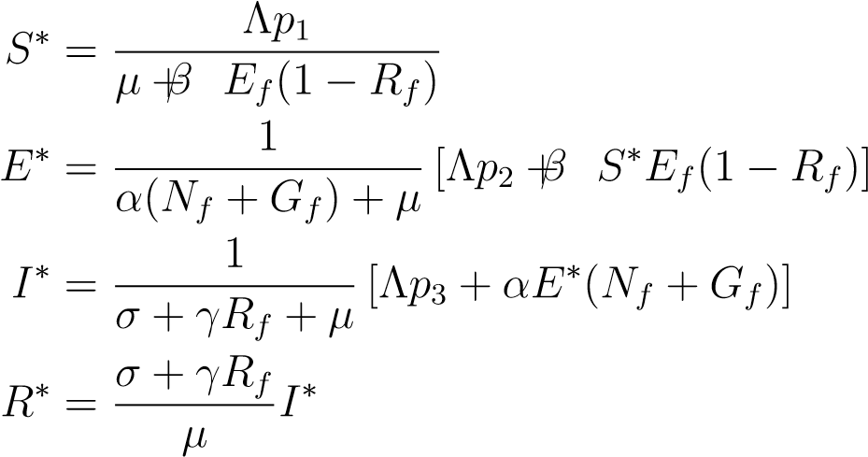

## 4.9 Local Stability of Endemic Equilibrium

The eigenvalues are the diagonal entries of the Jacobian matrix.

*λ*1 = −*βEf*(1 − *Rf*)*,*

*λ*2 = −*α*(*Nf* + *Gf*) − *µ,*

*λ*3 = −*σ* + *γRf* − *µ,*

*λ*4 = −*µ*

Tr(*J*) = −*βEf*(1 − *Rf*) − *α*(*Nf* + *Gf*) − *σ* + *µ* − *γRf* − *µ*

The stability of the endemic equilibrium depends on the value of *R*0 and the biological parameters.

When

### *R*0 *>* 1*,* Tr(*J*) *<* 0*,* det(*J*) *>* 0*,*

all eigenvalues have negative real parts when

*σ* + *µ > γRf,R*0 *>* 1

then

*Tr*(*J*) *<* 0*,*det(*J*) *>* 0

so the endemic equilibrium is locally asymptotically stable.

## 4.10 Global Stability of Endemic Equilibrium

Let a Lyapunov function be:

*V* (*E,I*) = *a*(*E* − *E*∗)2 + *b*(*I* − *I*∗)2

where *a,b >* 0 are constants. Then *V*˙ ≤ 0 when *R*0 *>* 1. Hence, the endemic equilibrium is globally stable when stress is endemic in the population.

# 5 Discussion

This study developed a compartmental SEIR model to understand the effects of early life stress on childhood and adolescent mental health, incorporating key biological, environmental, and resilience-related parameters. Key findings showed that Stress Propagation Index *R*0 is highly sensitive to Environmental factor index *Ef*, Resilience factor *Rf*, and Incubation rate *α*.

A positive index indicates that an increase in the parameter increases *R*0, while a negative index suggests that increasing the parameter decreases *R*0.

|  |  |  |
| --- | --- | --- |
| **Parameter** | **Symbol** | **Sensitivity Index** |
| Stress transmission rate | *β* | +1*.*000 |
| Environmental factor | *Ef* | +1*.*000 |
| Resilience factor | *Rf* | −0*.*538 |
| Incubation rate | *α* | −0*.*917 |
| Neurobiological factor | *Nf* | −0*.*518 |
| Genetic factor | *Gf* | −0*.*399 |
| Natural death rate | *µ* | −0*.*083 |

### Table 1: Normalized sensitivity indices of *R*0 with respect to model parameters.

Increasing resilience factors significantly reduce the size and duration of the impacted population, while reducing environmental stressors delays symptom onset and flattened the progression curve. In contrast, increasing the incubation rate accelerated transitions from exposure to impact, underscoring the importance of early intervention.

The model also demonstrated how births, deaths, and background stress levels influence population flow through the compartments over time.

# 6 Conclusion

A structured SEIR model of early life stress was developed and rigorously analyzed. Both local and global stability conditions were derived, offering insights into how resilience and environmental quality affect stress dynamics. The model is particularly suited for forecasting mental health outcomes in response to early adversity, making it a useful tool for public health and policy interventions in settings where large-scale interventions are needed. Overall, the results emphasizes on the critical role of resilience-building, environmental improvement, and early intervention in mitigating long-term psychological impacts of early life stress.

By incorporating both biological and social factors, the ELS model presents a holistic view of early life stress dynamics, offering important insights for future research and practical applications in mental health.

Disclaimer (Artificial intelligence)

Option 1:

Author(s) hereby declare that NO generative AI technologies such as Large Language Models (ChatGPT, COPILOT, etc.) and text-to-image generators have been used during the writing or editing of this manuscript.

Option 2:

Author(s) hereby declare that generative AI technologies such as Large Language Models, etc. have been used during the writing or editing of manuscripts. This explanation will include the name, version, model, and source of the generative AI technology and as well as all input prompts provided to the generative AI technology

Details of the AI usage are given below:

1.

2.

3.

# References

1. Beguy, D., Elung’ata, P., Mberu, B., Oduor, C., Wamukoya, M., Nganyi, B., & Ezeh, A. C. (2015). Health & Demographic Surveillance System Profile: The Nairobi Urban Health and Demographic Surveillance Sys tem (NUHDSS). International Journal of Epidemiology, 44(2), 462–471. https://doi.org/10.1093/ije/dyu
2. C. Castillo-Chavez and Y. Song, Dynamical models of tuberculosis and their applications, *Mathematical Biosciences and Engineering*, vol. 1, no. 2, pp. 361–404, 2004.
3. C Runyenje,H Ragen . African Population and Health Research Center. Annual Performance Review Report (2021).
4. Danese A, Moffitt TE, Harrington H, et al. Adverse childhood experiences and adult risk factors for age-related disease: depression, inflammation, and clustering of metabolic risk markers. Arch Pediatr Adolesc Med. 2009;163(12): 1135–1143
5. Dubowitz H, Finkelhor D, Zolotor A, et al. Addressing Adverse Childhood Experiences in Primary Care: Challenges and Considerations. Pediatrics. 2022;149(4):e2021052641
6. Eachus H, Choi M-K & Ryu S(2021) The Effects of Early Life Stresson the Brain and Behaviour: Insights From Zebrafish Models. Front. Cell Dev. Biol. 9:657591. doi:7.3389 /fcell. 2021.657591
7. Kalabu S. A., Usamatu U., Abdul A. I and Ibrahim Y. I., (2020). Modelling of Substance-Abuse and Its Progression Stages.North American Academic Research. Volume 3, Issue 12; 3(12) 12-29. http://twasp.info/journal/home
8. Kumar, M., Huang, K. Y., Othieno, C., Wamalwa, D., Madeghe, B., Osok, J., ... & McKay, M. M. (2018). Adolescent pregnancy and challenges in Kenyan context:perspectives from multiple community stakeholders. *Global Social Welfare 5,11-27,2018*. <https://doi.org/10.1007/s40609-017-0102-8>
9. Ndetei DM, Mutiso V, Musyimi C, Jeremiah E, Nyamai P, Walusaka S, Onyango V, Bhui K and Mamah D (2025). Resilience and its association with hopelessness, depression, loneliness, posttraumatic stress disorder (PTSD) and suicidal ideations and behavior in a cohort in the Nairobi Metropolitan. Cambridge Prisms: Global Mental Health, 12, e38, 1–10 https://doi.org/10.1017/gmh.2025.27
10. Reza Memarbashi1,Atena Ghasemabadi and Zahra Ebadi.(2022). Backward bifurcation in a two strain model of heroin addiction. Computational Methods for Differential Equations. Vol. 10, No. 3, 2022, pp. 656-673. <http://cmde.tabrizu.ac.ir>
11. Shonkoff JP, Garner AS, Siegel BS, et al. Committee on Psychosocial Aspects of Child and Family Health; Committee on Early Childhood, Adoption, and Dependent Care. Section on Developmental and Behavioral Pediatrics. The lifelong effects of early childhood adversity and toxic stress. Pediatrics. 2012;129(1): e232–e246
12. World Health Organization (WHO). (2021). Global Health Observatory: Mortality rate estimates for urban populations. World Health Organization.

https://www.who.int/data/gho