**Original Research Article**

**Teaching Where Numbers Don’t Add Up: Lived Realities of Educators Teaching Students with Math Difficulties**

**Abstract**

Many elementary educators face the daily challenge of teaching students who struggle with basic addition, a difficulty compounded by math anxiety, limited resources, and diverse learning needs. This qualitative study explores the lived realities of seven teachers at Tagawisan Elementary School as they support students with addition difficulties. Through in-depth interviews and thematic analysis grounded in constructivist learning theory, four key themes emerged: persistent instructional challenges, adaptive and creative strategies, significant personal and professional growth, and forward-looking recommendations for practice. The findings reveal that teachers must continually adapt their approaches, drawing on empathy, patience, and resourcefulness to foster student engagement and understanding. These insights underscore the importance of supporting teachers with targeted professional development and accessible resources to enhance mathematics instruction. While the small, context-specific sample limits generalizability, the study offers valuable recommendations for policy and practice, including institutionalizing adaptive teaching strategies and prioritizing foundational math skills. Further research is recommended to explore diverse educational settings and to examine the long-term impact of these strategies on student outcomes.

***Keywords:****adaptive teaching strategies, addition difficulties, constructivist learning theory, elementary education, qualitative research, teacher experiences*

**Introduction**

Mathematics education in early schooling is vital for developing students’ logical reasoning and problem-solving skills; however, many learners face challenges and anxiety with basic concepts such as addition, which complicates teaching and learning (Research Group for Mathematics Learning and Instruction, 2021; Future Directions for Mathematics Education Research, Policy, and Practice, 2023). Recent research highlights that students’ perceptions and attitudes toward mathematics significantly influence their academic performance and engagement in the subject (Hagan, Amoaddai, Lawer, & Atteh, 2020). In particular, negative perceptions can exacerbate math anxiety and hinder the acquisition of foundational skills, underscoring the importance of fostering positive mathematical identities from an early age. Furthermore, the effectiveness of diverse, evidence-based teaching strategies—including cooperative learning and technology integration—combined with culturally responsive pedagogy, has been shown to enhance student engagement and equity in mathematics education (Cardino & Ortega-Dela Cruz, 2020; OECD, 2025).

Globally, mathematics learning difficulties remain a persistent issue across diverse educational systems (OECD, 2019; Theron, 2025). The latest PISA results from 2022 reveal an unprecedented drop in mathematics performance, with the OECD average score falling by nearly 15 points compared to 2018, highlighting widespread struggles with basic arithmetic and the impact of factors such as math anxiety and disruptions caused by the COVID-19 pandemic (OECD, 2023; World Economic Forum, 2023). Recent systematic reviews and global analyses emphasize that challenges such as insufficiently trained teachers, inadequate resources, and negative socio-cultural attitudes toward mathematics continue to hinder student achievement, underscoring the urgent need for effective instructional strategies and robust support systems for both students and educators worldwide (Theron, 2025).

Locally, challenges with basic addition among elementary learners are well-documented. Cabrestante and Lopez (2023) found that various mathematics intervention strategies—including Think-Pair-Share, Individualized Student Activity, Drill and Practice, Peer Mentoring, Games, Learners Activity Sheets, ICT-Based Mentoring, and Home Visitation—were significantly related to their extent of implementation and were effective in improving students’ mathematics performance. The study recommends institutionalizing these strategies into the curriculum to better support learners facing difficulties in mathematics. Similarly, Sabando (2022) identified that intervention strategies such as repetition, timed-testing, and problem-solving techniques were perceived by elementary mathematics teachers as effective in enhancing learners’ fundamental, computational, and word problem-solving skills. Collectively, these findings highlight persistent difficulties with basic addition that require teachers to continuously innovate and seek appropriate resources to improve learning outcomes.

If the challenges faced by students with mathematics learning difficulties and the experiences of their teachers remain unaddressed, the consequences could be far-reaching. Students may continue to struggle with foundational skills like addition, leading to persistent gaps in mathematical understanding that hinder academic progress and limit future educational and career opportunities. Moreover, math anxiety disrupts working memory and reduces the use of effective problem-solving strategies, particularly in children with high cognitive capacity, further impeding achievement (Scheibe et al., 2023; Cuder et al., 2023). Teachers, without adequate support and resources, may experience increased stress, burnout, and reduced effectiveness, which can exacerbate student learning difficulties and widen achievement gaps (Colorado Department of Education, 2025; Education Week, 2025). This underscores an urgent need to explore and understand the lived experiences of teachers who support these learners, as their insights are critical for developing adaptive instructional strategies, guiding targeted professional development, and informing policies that foster inclusive, equitable, and supportive learning environments.

This study aimed to explore the lived experiences of educators teaching students who have difficulties in addition. This study was anchored on Piaget’s Constructivist Learning Theory, which posits that learners actively construct knowledge through experience and interaction (Piaget, 1972). We believe that understanding grows from hands-on engagement and that teaching strategies must be tailored to each learner’s developmental stage. This perspective shapes our interpretation of both the challenges and the successes described by teachers. It also informs our belief that adaptive, student-centered instruction is essential for supporting learners with math difficulties.

This study assumed that the lived experiences of teachers can be authentically captured and analyzed through qualitative interviews (ontological). We assumed that knowledge about effective strategies and challenges can be constructed collaboratively between researchers and participants (epistemological). The research process is iterative and reflexive, with meaning emerging through dialogue and thematic analysis (methodological). The study was grounded in constructivist theory (theoretical lens), and values patience, empathy, and adaptability as cultural norms within the teaching profession.

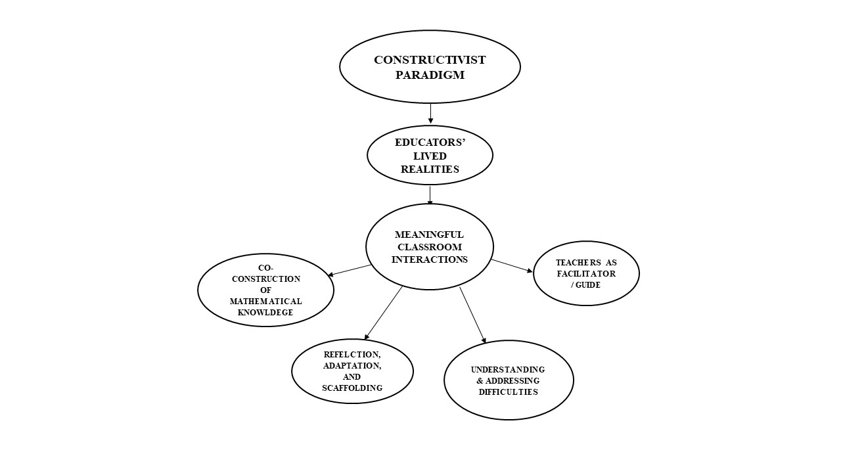

*Figure 1 Paradigm of Educators’ Lived Realities*

**Methodology**

In this study, we adopted a qualitative phenomenological research design, using in-depth, semi-structured interviews to capture the nuanced experiences of elementary teachers. We believe that a qualitative approach is best suited to uncovering the rich, subjective realities of educators as they navigate the challenges of teaching students with addition difficulties. By engaging directly with teachers, we aimed to gain authentic insights into their strategies, emotions, and professional growth (Creswell & Poth, 2018).

The research was conducted at Tagawisan Elementary School, a public institution where teachers regularly work with students exhibiting a range of mathematical abilities. Using purposive sampling, seven teachers with at least two years of teaching experience were selected based on their direct involvement with students facing addition difficulties. The students taught ranged from grades 4 to 6, aged 10 to 14, with a majority being female. The teachers were chosen for their willingness to share insights and represented varying levels of experience, ensuring diverse perspectives from both relatively new and more seasoned educators. This purposive sampling approach aligns with recommended practices for selecting information-rich cases relevant to the research phenomenon (Palinkas et al., 2015).

We conducted one-on-one interviews with each participant, allowing for open-ended responses and the opportunity to probe deeper into their experiences. The small, focused sample size enabled a detailed exploration of each teacher’s unique journey.

The interview guide was designed to elicit detailed narratives about the teachers’ experiences through semi-structured, in-depth conversations with selected knowledgeable participants. Each interview was audio-recorded and transcribed verbatim to ensure accuracy, with interview durations ranging from 45 to 60 minutes. Data collection continued until the point of data saturation was reached, defined as the stage when no new themes or insights emerged from additional interviews, ensuring comprehensive coverage of the educators’ lived experiences (Qualtrics, 2023; Dovetail, 2023). Thematic analysis was conducted following Braun and Clarke’s (2006) approach, involving repeated readings of transcripts to immerse in the data, initial coding, and grouping codes into broader themes and sub-themes. To enhance coding reliability, multiple researchers independently coded the data and then discussed discrepancies to reach consensus, thereby improving the trustworthiness and validity of the findings. This iterative process allowed themes to emerge organically, reflecting the complexity of teachers’ experiences.

To ensure trustworthiness, we employed several strategies: member checking (participants reviewed their transcripts for accuracy), and reflexivity (acknowledging our own biases as researchers). Confidentiality was maintained throughout, and participants were assured that their insights would be used solely for research purposes. These measures helped to mitigate potential harm and ensure that the findings authentically represented the participants’ voices (Lincoln & Guba, 1985).

**Results**

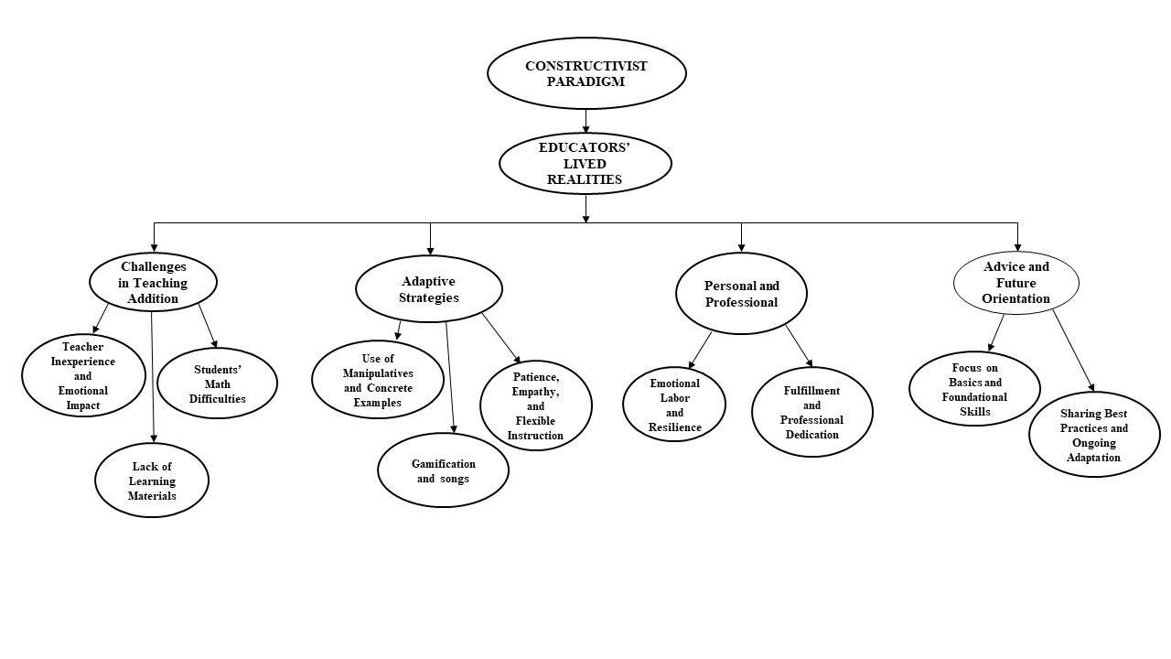The modified paradigm that emerged from this study centers on the dynamic, reciprocal relationship between teacher and learner. Teachers construct meaning through their daily interactions with students, adapting their strategies in response to learners’ needs and emotional states. The process is iterative and collaborative, with both teacher and student contributing to the learning journey.

*Figure 2 Modified Paradigm of Educators’ Lived Realities*

Figure 2 presents the four emergent themes and corresponding sub-themes derived from the lived experiences of teachers instructing students with difficulties in addition. This thematic map provides a structured representation of the challenges, strategies, growth, and advice shared by participants, offering valuable insights into effective teaching practices in early mathematics instruction. Themes and sub-themes were identified based on common responses from 4 to 5 teachers, ensuring that each theme reflected shared experiences rather than isolated opinions.

**Challenges in Teaching Addition**

**Student Difficulties.** Students often struggle with recalling basic addition concepts and experience math anxiety, which impedes learning and engagement. Four respondents

*“May problema sila sa pag-recall ng mga dating discussion. Nahihirapan silang intindihin ang math concepts. May mga estudyante na may math anxiety, kaya iniiwasan nila ang math-related na mga sitwasyon.” (IDI-3)*

(“They have trouble recalling information from previous discussions. They are having trouble understanding mathematical concepts. Some of them have mathematics anxiety, which leads them to avoid math-related situations.”)

**Teacher Inexperience and Emotional Impact**. Teachers expressed feelings of impatience and self-doubt, highlighting the emotional toll of supporting struggling learners.

*“Sa personal, para sa akin, ito ay hamon. Sa propesyonal, bilang guro, kailangan ng maraming pasensya, dedikasyon, at passion sa pagtuturo.” (IDI-1)*

(“Personally, for me, it is a challenge. Professionally, as a teacher, it needs a lot of patience, dedication, and passion in teaching.”)

**Lack of Learning Materials.** Limited access to appropriate learning materials and resources further complicates teaching addition effectively.

*“Mag lisod ko produce og learning materials kay daghan pako gi gastohan.” (IDI-7)*

(“I find it difficult to produce learning materials because I have many other expenses.”)

**Adaptive Strategies**

**Use of Manipulatives and Concrete Examples**. Educators emphasized hands-on learning with manipulatives and real-life examples to make abstract concepts tangible.

“Ang ginagamit ko ay mga concrete manipulatives o physical objects tulad ng counters o blocks. Nakakatulong ito para makita ng mga estudyante ang addition bilang pagsasama-sama.” (IDI 4)

(“What I usually use is setting an example by the use of concrete manipulatives or using physical objects like counters or blocks. It will help the learners visualize addition as a combining process.”)

**Patience, Empathy, and Flexible Instruction**  
Teachers highlighted the importance of patience and empathy, adapting instruction to meet individual student needs and emotional states.

Bawat estudyante ay may kanya-kanyang uniqueness. Bilang guro, gagamit ako ng iba’t ibang methods at strategies para matulungan sila.” (IDI 7)

(“Every student is unique in their own ways. As a teacher, I will use different methods and strategies to migrate those learners.”)

**Gamification and songs** Educators used educational games and songs to make learning more engaging and enjoyable, helping students retain mathematical concepts through interactive and musical experiences.

“Magpatukar mi ug kanta para malingaw sila, para motivated.” (IDI 5)

(We play songs so they enjoy and stay motivated.)

**Personal and Professional Growth**

**Emotional Labor and Resilience**. The emotional labor involved in supporting struggling students was significant, requiring resilience and self-care.

“Personally, for me, it exhibits challenge. And professionally, being a teacher, it needs a lot of patience, dedication, and passion in teaching.” (IDI 2)

**Fulfillment and Professional Dedication**. Despite challenges, teachers found fulfillment in small victories and remained dedicated to their students’ growth.

“Kapag nakikita ko na naiintindihan na ng estudyante, sulit ang lahat ng effort.” (IDI 1)

(“When I see a student finally get it, it makes all the effort worthwhile.”)

**Advice and Future Orientation**

**Focus on Basics and Foundational Skills**. Teachers advised prioritizing foundational skills and scaffolding instruction to build confidence.

“Kapag ine-expect natin na alam na nila ang addition, pero wala silang basic skills. Kailangang tutukan ang basics.” (IDI 4)

(“When we expect students to know addition but they lack basic skills, we need to focus on the basics.”)

**Sharing Best Practices and Ongoing Adaptation**. Educators recommended regular sharing of strategies and ongoing professional development to foster adaptive teaching practices.

“As a teacher, I will use different methods and strategies to migrate those learners.” (IDI 6)

**Discussions**

Students’ difficulties in recalling basic addition concepts are deeply intertwined with math anxiety, which impairs cognitive functions such as working memory and problem-solving, leading to avoidance behaviors that perpetuate learning gaps (Suárez-Pellicioni, Núñez-Peña, & Colomé, 2020; Namkung, Peng, & Lin, 2022). This finding aligns with Hagan et al. (2020), who emphasized that students’ perceptions of mathematics directly affect their academic outcomes. When learners view mathematics as intimidating or irrelevant, their motivation and performance decline, making it crucial for educators to adopt strategies that not only address cognitive barriers but also reshape students’ attitudes toward the subject. Integrating interventions that build confidence and positive perceptions, as recommended by Hagan et al. (2020), may help reduce math anxiety and improve foundational skill acquisition.

Teachers’ emotional labor in supporting students with addition challenges reveals a critical dimension often overlooked in educational research—the impact of educator well-being on instructional quality and student outcomes. Feelings of impatience, self-doubt, and stress among teachers not only threaten their professional sustainability but may also inadvertently transmit anxiety to students, reinforcing negative math attitudes (Polacco, Zsoldos-Marchiș, & Dekel, 2023; Education Week, 2025). This underscores the necessity for systemic supports, such as targeted professional development and mental health resources, to foster teacher resilience and efficacy (Mihăescu et al., 2025).

Resource scarcity remains a persistent barrier, yet the adaptive strategies employed by teachers—manipulatives, gamification, and concrete examples—demonstrate pedagogical creativity and responsiveness. These approaches resonate with constructivist learning theories that advocate for active, contextualized learning experiences to deepen conceptual understanding and reduce anxiety (Polacco, Zsoldos-Marchiș, & Dekel, 2023). However, without adequate systemic investment, such innovations risk being inconsistent or unsustainable.

Finally, the teachers’ resilience and professional fulfillment derived from student progress point to the importance of fostering professional learning communities that encourage sharing best practices and continuous growth. This aligns with adult learning theories emphasizing collaboration and reflective practice as keys to effective teaching adaptation (Polacco, Zsoldos-Marchiș, & Dekel, 2023; Mihăescu et al., 2025). Overall, these findings call for integrated educational policies that address cognitive, emotional, and systemic factors to improve mathematics learning outcomes.

Limitations of this study include its small sample size and focus on a single school, which may limit the generalizability of findings. Additionally, the study relied solely on teacher perspectives without including student voices, which could provide a more comprehensive understanding of math difficulties.

Recommendations for future research include expanding the sample across multiple schools and regions to capture diverse experiences, incorporating student perspectives to enrich data, and exploring the long-term impact of specific instructional strategies on both math anxiety and achievement. Further studies could also investigate the effectiveness of targeted professional development programs aimed at reducing math anxiety for both teachers and students.

**Conclusion**

This study highlighted the real-world challenges and successes of teachers helping students with addition difficulties at Tagawisan Elementary School. Teachers consistently faced obstacles such as limited resources and student anxiety but responded with creative and adaptive teaching strategies. Their experiences fostered greater patience, empathy, and professional growth. Despite the demands, teachers found reward in their students’ progress. Overall, the findings emphasize the importance of flexible, supportive, and student-centered approaches in helping all learners succeed in mathematics.

Disclaimer (Artificial intelligence)

Option 1:

Author(s) hereby declare that NO generative AI technologies such as Large Language Models (ChatGPT, COPILOT, etc.) and text-to-image generators have been used during the writing or editing of this manuscript.

Option 2:

Author(s) hereby declare that generative AI technologies such as Large Language Models, etc. have been used during the writing or editing of manuscripts. This explanation will include the name, version, model, and source of the generative AI technology and as well as all input prompts provided to the generative AI technology

Details of the AI usage are given below:

1. grammarly

2.

3.

**References**

Braun, V., & Clarke, V. (2006). Using thematic analysis in psychology. *Qualitative Research in Psychology, 3*(2), 77–101. <https://doi.org/10.1191/1478088706qp063oa>

Cardino, J. M., Jr., & Ortega-Dela Cruz, R. A. (2020). Understanding learning styles and teaching strategies towards improving mathematics teaching and learning. *LUMAT: International Journal on Math, Science and Technology Education.* <http://dx.doi.org/10.31129/LUMAT.8.1.1348>

Colorado Department of Education. (2025, April 29). *Supporting struggling learners in mathematics.* <https://www.cde.state.co.us>

Cabrestante, J., & Lopez, E. (2023). Extent and effectiveness of mathematics intervention strategies: Their relationship to the academic performance of students. *Psychology and Education: A Multidisciplinary Journal*, 8, 1176–1200. <https://ejournals.ph/article.php?id=20693>

Clarke, V., & Braun, V. (2013). Teaching thematic analysis: Overcoming challenges and developing strategies for effective learning. *The Psychologist, 26*(2), 120–123. <https://resources.nu.edu/c.php?g=1013606&p=8395539>)

Creswell, J. W., & Poth, C. N. (2018). *Qualitative inquiry and research design: Choosing among five approaches* (4th ed.). SAGE Publications. <https://www.worldcat.org/title/983779110>

Cuder, A., Živković, M., Doz, E., Pellizzoni, S., & Passolunghi, M. C. (2023). The relationship between math anxiety and math performance: The moderating role of visuospatial working memory. *Journal of Experimental Child Psychology.* https://arts.units.it/retrieve/7dae14fe-92c5-45d0-b9d8- e7a16ca281f1/1-s2.0- S0022096523000644-main.pdf

Education Week. (2025, May 5). *5 ways teachers can support students with math anxiety.* <https://www.edweek.org>

Hagan, J. E., Amoaddai, S., Lawer, V. T., & Atteh, E. (2020). Students’ Perception towards Mathematics and Its Effects on Academic Performance. Asian Journal of Education and Social Studies, 8(1), 8– 14. <https://doi.org/10.9734/ajess/2020/v8i130210>

Kilpatrick, J., Swafford, J., & Findell, B. (Eds.). (2001). *Adding it up: Helping children learn mathematics.* National Academy Press. <https://doi.org/10.17226/9822>

Lincoln, Y. S., & Guba, E. G. (1985). *Naturalistic inquiry.* <https://books.google.com/books?id=2oA9aWlNeooC>

Mihăescu, D., Bologa, L., & Bîclea, D. (2025). Breaking the cycle of math anxiety: Empowering pre- service teachers with evidence-based strategies. *INTED2025 Proceedings.* <https://library.iated.org/view/MIHAESCU2025BRE>

Namkung, J. M., Peng, P., & Lin, X. (2022). The mediating role of working memory in the relationship between math anxiety and math performance: A meta-analysis. *Frontiers in Psychology, 12*, 798090. <https://www.frontiersin.org/articles/10.3389/fpsyg.2021.798090/full>

OECD. (2019). *PISA 2018 results (Volume I): What students know and can do.* OECD Publishing. <https://doi.org/10.1787/5f07c754-en>

OECD. (2023). *PISA 2022 results: First results since the pandemic show unprecedented drop in maths and reading performance.* <https://www.oecd.org/pisa/publications>

OECD. (2025). *Future-focused mathematics curricula: Empowering learners for the 21st century* (Policy brief). <https://www.oecd.org/education>

Palinkas, L. A., Horwitz, S. M., Green, C. A., Wisdom, J. P., Duan, N., & Hoagwood, K. (2015). Purposeful sampling for qualitative data collection and analysis in mixed method implementation research. *Administration and Policy in Mental Health and Mental Health Services Research, 42*(5), 533– 544. <https://doi.org/10.1007/s10488-013-0528-y>

Piaget, J. (1972). *The psychology of the child* (H. Weaver, Trans.). Basic Books. (Original work published 1969)

Polacco, D., Zsoldos-Marchiș, I., & Dekel, R. (2023). Perspectives of teachers on the signs and causes of mathematics anxiety. *Acta Didactica Napocensia, 16*(2), 129–143. <https://adn.reviste.ubbcluj.ro/papers/article_16_2_10.pdf>

Research Group for Mathematics Learning and Instruction. (2021). *Cultivating future mathematical minds: Investigating learning and teaching processes from early childhood to adulthood.* [https://ppw.kuleuven.be/onderwijskunde/en/wog-2024/snr2024-rg-math-instruction-and- learningin.pdf](https://ppw.kuleuven.be/onderwijskunde/en/wog-2024/snr2024-rg-math-instruction-and-%09learningin.pdf)

Sabando, N. A. (2022). Intervention strategies utilized by elementary mathematics teachers and their perceived effectiveness in enhancing learners’ performance. *Psychology and Education: A Multidisciplinary Journal*, 5(1), 281–292. <https://scimatic.org/storage/journals/11/pdfs/704.pdf>

Scheibe, D. A., Was, C. A., Dunlosky, J., & Thompson, C. A. (2023). Metacognitive cues, working memory, and math anxiety: The regulated attention in mathematical problem solving (RAMPS) framework. *Journal of Intelligence, 11*(6), 117. <https://doi.org/10.3390/jintelligence11060117>

Suárez-Pellicioni, M., Núñez-Peña, M. I., & Colomé, À. (2020). Math anxiety and working memory updating. *Frontiers in Psychology, 11*, 669. <https://www.frontiersin.org/articles/10.3389/fpsyg.2020.00669/full>

Theron, H. (2025). Global trends in contributing factors to mathematics performance in secondary schools: Lessons for South Africa 2015–2024. *International Journal of Learning, Teaching and Educational Research, 24*(1), Article 14. <https://doi.org/10.26803/ijlter.24.1.14>

The Royal Society. (2023). *Maths education must integrate quality EdTech faster to thrive in a data-centric future* [Report]. UCL Institute of Education. [https://www.ucl.ac.uk/ioe/news/2023/sep/maths- education-must-integrate-quality-edtech-faster-thrive-data-centric-future](https://www.ucl.ac.uk/ioe/news/2023/sep/maths-%09education-must-integrate-quality-edtech-faster-thrive-data-centric-future)

World Economic Forum. (2023, December 10). *OECD PISA results: Maths and reading skills in ‘unprecedented drop’.*