**Assessment of Compatibility of *Trichoderma asperellum* with Different Fungicides**

**ABSTRACT**

|  |
| --- |
| An *in vitro* study was conducted at the Department of Plant Pathology, Dr. Sharadchandra Pawar College of Agriculture, Baramati, during 2024–2025, using Completely Randomized Design (CRD) to assess the compatibility of *Trichoderma asperellum* with seven fungicides at full and half recommended doses via the poison food technique. Fluxapyroxad 333 g/L FS and Kresoxim-methyl 44.3% SC were found to be highly compatible, allowing over 90% radial growth of *T. asperellum* at both concentrations. Fosetyl-Al 80% WP showed moderate compatibility (65–75% growth), while Tebuconazole 25.9% EC, Difenoconazole 25% EC, Propiconazole 25% EC, and Hexaconazole 5% EC were incompatible, significantly inhibiting fungal growth. The findings indicate that Fluxapyroxad and Kresoxim-methyl can be safely integrated with *T. asperellum* in disease management, whereas caution is needed with Fosetyl-Al, and the remaining fungicides should be avoided. This study supports the selection of compatible chemical partners in integrated plant disease management programs involving biological control agents. |

**Key words:** Biological control, Fungicide compatibility, Integrated disease management, Poison food

technique, *Trichoderma asperellum.*

1. **INTRODUCTION**

Sustainable agriculture increasingly depends on eco-friendly approaches to managing plant diseases. Among biological control agents, fungi from the genus *Trichoderma* have earned recognition for their ability to fight against a wide range of plant pathogens. They do this through several mechanisms such as mycoparasitism where, *Trichoderma* species wrapped around the hyphae of *Rhizoctonia solani*, leading to the depletion of cell contents and collapse (Chu and Wu, 1981), production of antifungal compounds such as harzianolide and viridin and competition for space and nutrients. *Trichoderma* species are inherently competitors. Application of *Trichoderma* to grape flowers allows the fungus to colonize senescing tissue before *Botrytis,* thereby reducing disease level in the fruit (Harman *et al*.,1996; Harman *et al.*, 2004; Vinale *et al.*, 2008). Among various *Trichoderma* spp. *Trichoderma asperellum* belongs to the Hypocreaceae family and is a distinct species of fungus. It can be differentiated from *T. viride* based on molecular and phenotypic traits. *Trichoderma asperellum* produces secondary metabolites that help trigger the plant's natural defense mechanisms. One of these compounds, known as Epl1-Tas, has been shown to activate genes involved in the salicylic acid (SA) defense pathway, which plays a key role in protecting plants against disease (Prashanth Kumar *et al*., 2023). Itstands out for its effectiveness against both soilborne *viz.,* *Pythium* spp., *Rhizoctonia* spp., *Fusarium* spp., and foliar plant pathogens *viz.,* *Botrytis cinerea*, *Sclerotinia sclerotiorum* and is commonly used in commercial biocontrol formulations.

Fungicides have long been a cornerstone of crop protection, helping farmers tackle diseases that could otherwise cause serious yield losses. Among them, systemic fungicides are particularly valued for their ability to move within plant tissues and protect them. Fungicides belong to various chemical groups, including triazoles, strobilurins, phosphonates and SDHIs, each functioning through distinct biochemical pathways to inhibit fungal growth or reproduction (FRAC, 2023). When applied judiciously, they provide rapid and broad-spectrum control against a variety of plant pathogens. However, the extensive use of these compounds has sparked worries about their effects on the environment and human health as well as the emergence of fungicide-resistant bacteria. Despite growing awareness of the drawbacks these chemicals remain central to crop protection because of their quick action and broad efficacy (Monte, 2001). To strike a balance between sustainability and efficiency, integrated approaches are gaining importance. One such strategy involves combining biological agents with fungicides under the Integrated Disease Management (IDM) program.

Chemical fungicides work well in environmental conditions where biological antagonists are less effective. Meanwhile, an active biological control agent can preventively establish itself on wounds or senescing plant tissue. (Hjeljord and Tronosmo, 1998) However, biocontrol agents and fungicides may not always be in harmony. Some fungicides can interfere with the growth or activity of *Trichoderma* species, limiting their success in the field (Papavizas, 1985; Mukhopadhyay, 2012). For this reason, compatibility studies are crucial to determine which fungicides can be used alongside biocontrol agents without reducing their performance and it also provides an opportunity to incorporate bioagents into integrated disease management strategies. Therefore, it is crucial to evaluate the compatibility of the widely utilized biocontrol agent *Trichoderma* *asperellum* with various systemic fungicides employed for plant protection in modern farming.

**2. MATERIAL AND METHODS**

**Source of *Trichoderma* culture**

Rhizospheric soil samples were collected from the farm of the College of Agriculture, Baramati to isolate *Trichoderma asperellum*. The samples were processed using the serial dilution method and cultured on Potato Dextrose Agar (PDA) and Trichoderma Selective Medium (TSM), following the procedure outlined by Johnson and Curl (1972). Identification of *T. asperellum* was based on colony morphology, growth pattern, and microscopic features, including the structure of mycelium, conidiophores, phialides, and conidia, as described by Kubicek and Harman (2002). To ensure viability and purity, the fungal cultures were regularly sub-cultured and maintained on PDA and TSM slants under sterile conditions throughout the study.

**Fungicides**

The current research utilized seven systemic fungicides Fosetyl AI 80% WP, Tebuconazole 25.9% EC, Fluxapyroxad 333g/I FS, Difenaconazole 25% EC, Kresoxim methyl 44.3% SC, Propiconazole 25%EC and Hexaconazole 5% EC were obtained from the Plant Pathology Division of Dr. Sharadchandra Pawar College of Agriculture, Baramati and used in this study.

***In vitro* compatibility of *Trichoderma asperellum* with fungicides**

The Standard Poisoned Food Technique was used to assess the compatibility of *Trichoderma* spp. with various fungicides, following the method described by Nene and Thapliyal (1993). The required quantities of each fungicide were calculated based on their active ingredient content and then individually mixed into autoclaved and cooled Potato Dextrose Agar (PDA) to achieve the desired concentrations. The fungicide-amended PDA was aseptically poured into 90 mm Petri plates (20 ml per plate) and allowed to solidify at room temperature.

For each fungicide and its respective concentrations, three replicates were maintained. Once the medium solidified, the plates were inoculated aseptically by placing a 5 mm mycelial disc at the center. The disc was taken from a 7-day-old actively growing culture of *Trichoderma asperellum*, using a flame-sterilized cork borer. All plates were then incubated at 28 ± 1 °C. Petri dishes containing plain PDA without fungicide, inoculated similarly with *T. asperellum*, served as untreated controls.

**Treatment details**

* Design : Completely Randomized Design (CRD)
* Replication : Three
* Treatment : Eight
* Technique : Poison Food technique (Nene and Thapliyal, 1993)

**List 1: Details of fungicides used for *Trichoderma asperellum* compatibility test.**

|  |  |  |  |  |
| --- | --- | --- | --- | --- |
| **Tr.**  **No.** | **Treatments** | **Concentration (ppm)** | | **Trade**  **name** |
| **Half of the recommended concentration** | **Recommended concentration** |
| T1 | Fosetyl Al 80% WP | 1000 | 2000 | Bayer Aliette |
| T2 | Tebuconazole 25.9% EC | 750 | 1500 | Bayer Folicur |
| T3 | Fluxapyroxad 333g/I FS | 500 | 1000 | BASF Systiva |
| T4 | Difenaconazole 25% EC | 250 | 500 | Score |
| T5 | Kresoxim methyl 44.3% SC | 250 | 500 | Ergon |
| T6 | Propiconazole 25% EC | 250 | 500 | Tilt |
| T7 | Hexaconazole 5% EC | 250 | 500 | Contaf |
| T8 | Control | - | - | - |

Observations on the mycelial growth of *Trichoderma asperellum* were taken when control plates showed full growth of the fungus. Growth of *Trichoderma* asperellum for each fungicide was determined by measuring mycelial growth diameters. The average data from the replicated plates was taken and the result was expressed as percent inhibition of mycelial growth over the control. The percentage growth inhibition of *Trichoderma asperellum* expressed by using the following formula given by Vincent (1947):

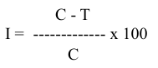

Where,

I = Percent growth inhibition

C = Radial growth of fungus in control plate

T = Radial growth of fungus in treated plate

**List 2:** The range for compatibility based on inhibition percentage (Saha *et al*. 2023)

|  |  |
| --- | --- |
| **Inhibition** | **Nature of compatibility** |
| 0-30% | Highly compatible |
| 31-60% | Moderately compatible |
| 61-90% | Slightly compatible |
| 91-100% | Non-compatible |

**Statistical analysis**

The experimental data were statistically analysed using computer programs designed for Completely Randomized Block Design (CRD). The standard error (SE) and critical difference (C.D.) at a significance level of P=0.05 *(In vitro)* were calculated, and the results were statistically compared. (Panse and Sukhatme, 1967)

**3. RESULTS AND DISCUSSION**

As shown in Table 1**,** among the systemic fungicides tested at half of the recommended dose, *Trichoderma asperellum* showed high compatibility with Fluxapyroxad 333 g/L FS and Kresoxim-methyl 44.3% SC, which recorded the lowest levels of mycelial growth inhibition at (8.52% and 19.81%), respectively. In contrast, Fosetyl-Al 80% WP was found to be moderately compatible, causing (47.78%) inhibition of mycelial growth.

On the other hand, as also presented in Table 1 and illustrated in Figure 1, the rest of three fungicides tested at half of the recommended concentration *viz.,* Tebuconazole 25.9% EC, Propiconazole 25% EC and Hexaconazole 5% EC were recorded completely incompatible by causing maximum mycelial growth inhibition (94.44%) of *T. asperellum.* The fungicide Difenaconazole 25% EC also resulted incompatible with *Trichoderma asperellum* as its percent mycelial growth inhibition was (91.48%).

At recommended concentration of systemic fungicides, the results (see Table 1) indicated that Fluxapyroxad 333g/I FS and Kresoxim methyl 44.3% SC were found moderately compatible with less average mycelial growth inhibition (34.08% and 39.53%, respectively) of *T. asperellum.* fungicideFosetyl Al 80% WP resulted slightly compatible with (86.30%) mycelial growth inhibition.

In contrast, remaining three fungicides *viz.,* Tebuconazole 25.9% EC, Difenaconazole 25% EC, Propiconazole 25% EC and Hexaconazole 5% EC appeared to be completely incompatible by causing maximum mycelial growth inhibition of *T. asperellum,* as highlighted in both Table 1 and Plate 1 of recommended concentration.

The results of this study align closely with the observations made by Dinkwar *et al.* (2023), who found that Fluxapyroxad 333 g/L FS worked well in combination with *Trichoderma* isolates, showing high compatibility. In contrast, Tebuconazole 25.9% EC was noted to be strongly incompatible. These findings are further supported by Maheshwary *et al.* (2020), who reported that both Tebuconazole 25.9% EC and Propiconazole 25% EC had adverse effects on the growth of *Trichoderma asperellum*. Bagwan (2010) and Bindu *et al*. (2011), where also reported the incompatibility of Tebuconazole with *Trichoderma*. Results of Kumar *et al*. (2017) are also in agreement with result obtained in present study *i.e.,* propiconazole 25% EC and Hexaconazole are completely incompatible with *T. asperellum.* Saha *et al. (*2023),proved thatKresoxim methyl 44.3% SC is highly compatible with *T. asperelloides.* Dwivedi and Vishunavat (2018) reported incompatibility of Tebuconazole 25.9% EC with *Trichoderma asperellum*.

Some other scientists also reported similar results such as Gunda *et al*. (2018), Meena Ravindra *et al*. (2018), Kumar *et al*. (2019), Singh *et al*. (2021) and Bai *et al*. (2022).

**Table 1*. In Vitro* Effect of Systemic Fungicides on *Trichoderma asperellum***

|  |  |  |  |  |  |
| --- | --- | --- | --- | --- | --- |
| **Tr. No.** | **Treatments** | **Radial mycelial growth (mm)\*** | | **% Growth Inhibition** | |
| **Half of the recommended concentration** | **Recommended concentration** | **Half of the recommended concentration** | **Recommended concentration** |
| T1 | Fosetyl Al 80% WP | 47.00 | 12.33 | 47.78 | 86.30 |
| T2 | Tebuconazole 25.9% EC | 5.00 | 5.00 | 94.44 | 94.44 |
| T3 | Fluxapyroxad 333g/I FS | 82.33 | 59.33 | 8.52 | 34.08 |
| T4 | Difenaconazole 25% EC | 7.67 | 5.00 | 91.48 | 94.44 |
| T5 | Kresoxim methyl 44.3% SC | 72.17 | 54.42 | 19.81 | 39.53 |
| T6 | Propiconazole 25% EC | 5.00 | 5.00 | 94.44 | 94.44 |
| T7 | Hexaconazole 5% EC | 5.00 | 5.00 | 94. 44 | 94.44 |
| T8 | Control | 90.00 | 90.00 | 00.00 | 00.00 |
|  | **S.E.(m)±** | **0.83** | **0.63** | **-** | **-** |
|  | **C.D. (0.05)** | **2.50** | **1.90** | **-** | **--** |

*Mean of three replications

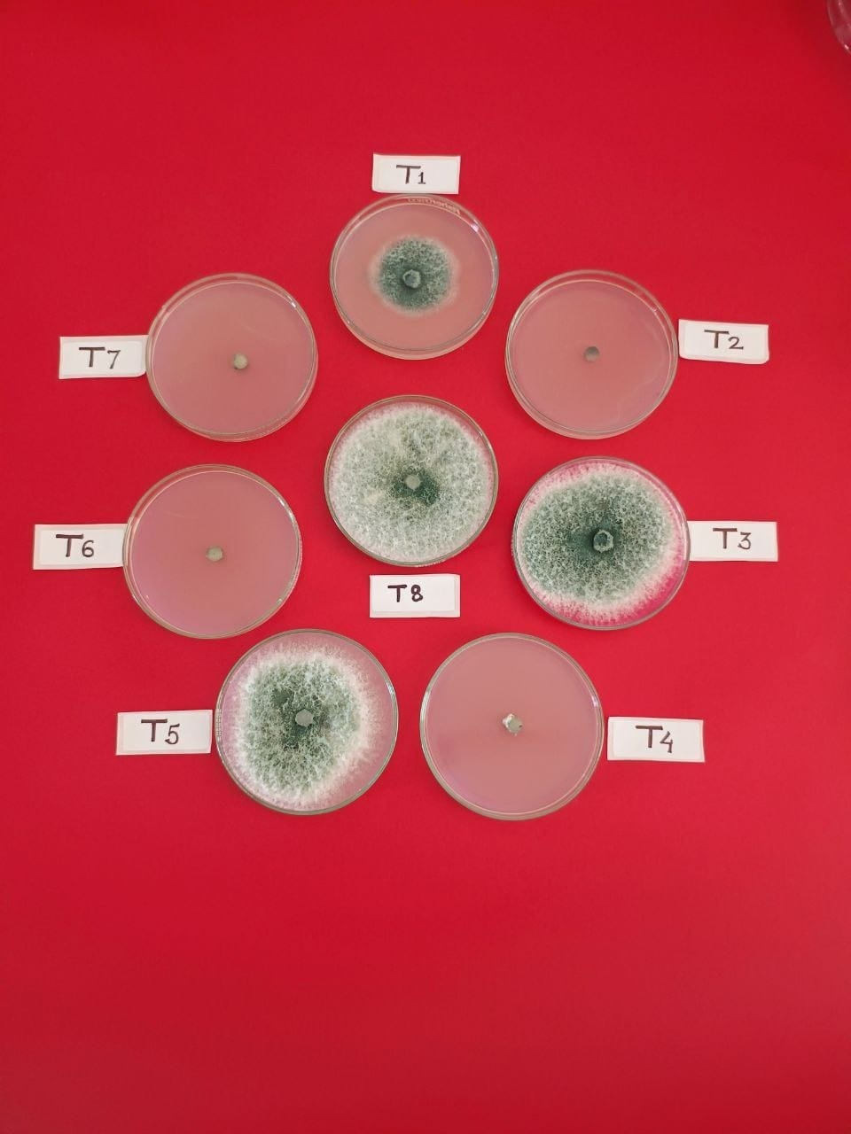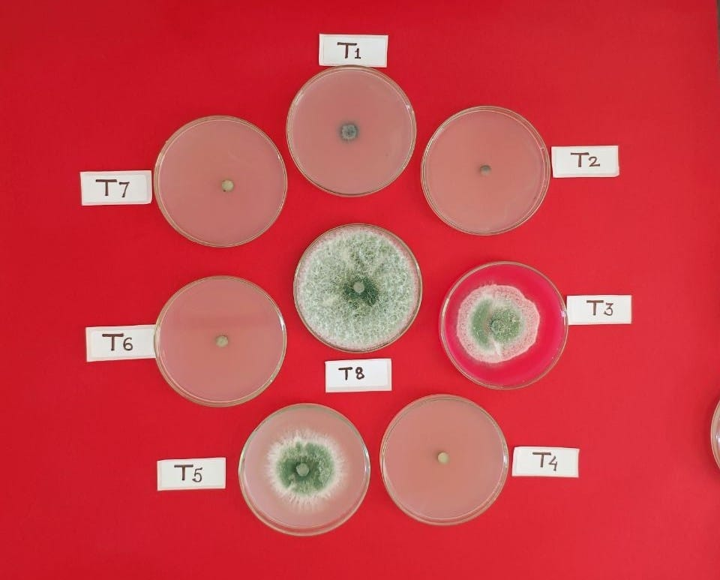

Half of the recommended concentration

Recommended concentration

**Plate 1. *In vitro* assessment of *T. asperellum* with systemic fungicides at half of the**

**recommended and recommended concentration.**

**Fig. 1 Colony diameter of *T. asperellum* under *in vitro* conditions at half of the recommended and recommended concentration**

**Fig.1. Colony diameter of *Trichoderma asperellum* under *in vitro* conditions**

**4. CONCLUSIONS**

The *in vitro* evaluation of the compatibility of *Trichoderma asperellum* with seven systemic fungicides showed varying degrees of interaction. Among the tested fungicides, Fluxapyroxad 333 g/L FS and Kresoxim-methyl 44.3% SC were found to be highly compatible, showing low percent growth inhibition of *T. asperellum* ranging between 8.52% and 19.81% at half of the recommended concentrations. These two fungicides also showed moderate compatibility at recommended concentration, with growth inhibition between 31% and 60% respectively. In contrast, Fosetyl-Al 80% WP exhibited moderate compatibility at half of recommended concentration and slight compatibility at full concentration. On the other hand, the remaining fungicides Tebuconazole 25.9% EC, Difenoconazole 25% EC, Propiconazole 25% EC and Hexaconazole 5% EC were found to be completely incompatible, with percent growth inhibition ranging from 91% to 100% at both concentrations. These results show the importance of careful selection of fungicides in integrated disease management programs to ensure they do not inhibit the beneficial activity of *Trichoderma* *asperellum.*

**DISCLAIMER**

Author(s) hereby declares that NO generative AI technologies such as Large Language Models (ChatGPT, COPILOT, etc.) and text-to-image generators have been used during the writing or editing of this manuscript.

**REFERENCES**

1. Bagwan N. B. (2010) Evaluation of *Trichoderma* compatibility with fungicides, pesticides, organic cakes and botanicals for integrated management of soilborne diseases of soybean [*Glycine max* (L.) Merril]. *International Journal of Plant Protection*., **3**(2): 206-209.
2. Bai, A. T., Vibha, J. B., Nair, R. and Upadhyay, A. (2022). Compatibility of *Trichoderma viride* with commonly used fungicides in management of early blight pathogen of tomato. *The Pharma Innovation Journal,* **11**: 1734-1736.
3. Bharadwaz, P., Nath, B. C., Chetia, R., Saikia, S., Bora, P. and Bhattacharyya, P. N. (2023). *In vitro* studies on the compatibility of Trichoderma viride with commonly used agrochemicals in the vegetable cropping system. *Pest Management in Horticultural Ecosystems,* **29**(1): 136-143.
4. Bindu M. G., Bhattiprolu S. L. and Balireddy V. (2011) Compatibility of biocontrol agent *Trichoderma viride* with various pesticides. *Journal Horticulture Science*., **6**(1):71-73.
5. Chu, F.F. and Wu, W.S. (1981). Biological and chemical control of *Rhizoctonia solani* by pea seed treatment. Memoris of the college of Agriculture. National Taiwan University, **21**:19-28.
6. Dinkwar, G. T., Yadav, V. K., Kumar, A., Nema, S. and Mishra, S. (2023). Compatibility of fungicides with potent *Trichoderma* isolates. *International Journal of Plant and Soil Science*., **35**(18): 1934-1948.
7. Fungicide Resistance Action Committee (FRAC). (2023). *FRAC mode of action classification 2023*.
8. Gunda, V. N. S., Kiran, M., Thara, S. S. and Jyothi, K. R. (2018). Studies on compatibility of biocontrol agents with chemical fungicides for integrated management of *Alternaria* leaf spot of cabbage. *Journal of Pharmacognosy and Phytochemistry*. **7**(5): 2974-2977.
9. Harman, G. E., Howell, C. R., Viterbo, A., Chet, I. and Lorito, M. (2004). *Trichoderma* species—opportunistic, avirulent plant symbionts. *Nature Reviews Microbiology.***, 2**(1): 43–56.
10. Harman, G. E., Latorre, B., Agosin, E., San Martin, R., Riegel, D. G., Nielsen, P. A., ... and Pearson, R. C. (1996). Biological and Integrated Control of *Botrytis* Bunch Rot of Grape Using *Trichoderma* spp. Biological Control, **7**(3): 259-266.
11. Hjeljord, L., Tronsmo, A., Harman, G. E. and Kubicek, C. P. (1998). *Trichoderma* and *gliocladium* Biological control: an overview. In: *Trichoderma* and *Gliocladium*: Enzymes, biological control and commercial applications. Harman GE, Kubice CP.(Eds), **2**:131-151.
12. Johnson L. F. and Crul E. A. (1972) Methods of research on ecology of soil borne pathogens. Minneapolis U.S. Burgess Publ., :247.
13. Kubicek, C. P. and Harman, G. E. (Eds.). (2002). *Trichoderma and Gliocladium: Volume 1. Basic biology, taxonomy and genetics*. London, UK: Taylor and Francis.
14. Kumar, A., Bansal, R. D. and Chelak, Y. K. (2019). Compatibility of *Trichoderma viride* with fungicides for plant disease management. *International Journal of Pure and Applied Bioscience*, **7**(3): 44-51.
15. Kumar, N. and Singh, S. K. (2017). Screening of tolerance and compatibility of *Trichoderma viride* against common fertilizers and fungicides. *International Journal of Chemical Studies.,* **5**(4): 1871-1874.
16. Maheshwary, N., Gangadhara Naik, B., Amoghavarsha Chittaragi, M., Naik, S. K. and Nandish, M. (2020). Compatibility of *Trichoderma asperellum* with fungicides. *The Pharma Innovation Journal*., **9**(8): 136-140.
17. Meena Ravindra, Arsia S. K., Jain, Y. K. and Dongre, M. (2018). Compatibility of fungicides with *Trichoderma viride* against *Fusarium* wilt caused by *Fusarium udum*. *International Journal of Agriculture Sciences,* **10**(5): 5268-5271.
18. Monte, E. (2001). Understanding *Trichoderma*: Between biotechnology and microbial ecology. *International Microbiology***, 4**(1): 1–4.
19. Mukhopadhyay, A. N. (2012). Biological control of plant diseases: Status in India. In M. S. Reddy (Ed.), *Biological Control of Crop Diseases* (pp. 1–20). Scientific Publishers.
20. Nene, Y.L. and Thapliyal, P.N. (1993). Fungicides in plant disease control, 3rd edition, Oxford, IBH Publishing Company, New Delhi, 531-532.
21. Papavizas, G. C. (1985). *Trichoderma* and *Gliocladium*: Biology, ecology, and potential for biocontrol. *Annual Review of Phytopathology.***, 23**: 23–54.
22. Prashanth Kumar A., Sathish G., Srinivas J. and Chandrasekhar B. (2023) *Trichoderma* Species and Their Biological Mechanisms. *International Journal of Environment and Climate Change,* **13**(10): 1637–1651.
23. Saha, S., Pharate, S., Thosar, R. U. and Chavan, V. (2023). Compatibility of *Trichoderma asperelloides* with Fungicides Controlling Downy Mildew and Powdery Mildew in Grapes. *Grape Insight.*, **1**(1): 32-36.
24. Singh, M., Singh, R., Mishra, P., Sengar, R. S. and Shahi, U. P. (2021). *In vitro* compatibility of *Trichoderma harzianum* with systemic fungicides. *International Journal of Chemical Studies*, **9**(1): 2884-2888.
25. Vinale, F., Sivasithamparam, K., Ghisalberti, E. L., Marra, R., Woo, S. L. and Lorito, M. (2008). *Trichoderma*-plant-pathogen interactions. *Soil Biology and Biochemistry.***, 40**(1): 1–10.
26. Vincent J (1947). Distortion of fungal hyphae in the presence of certain inhibitors. *Nature.,***159**(4051): 850-850.