**Biological Control of Sweet Potato Weevil Using Metarhizium Anisopliae: A Step Toward Eco-Friendly Pest Management**

**ABSTRACT**

This study aims to evaluate the potential of the entomopathogenic fungus *Metarhizium anisopliae* as a biological control agent against sweet potato weevil. Sweet potato weevil (*Cylas formicarius*) is a major pest of sweet potato crops, causing severe economic losses due to its ability to infest both storage roots and vines. Concerns regarding the ecological health risks posed by chemical insecticides in sweet potato farming, a natural approach were tested as an alternative method for controlling this pest. This study evaluates the potential of the entomopathogenic fungus *Metarhizium anisopliae* as a biological control agent against sweet potato weevil. Laboratory experiments were conducted to compare the effectiveness of different strains of *M. anisopliae* and other entomopathogens, using two application techniques: "dipping" and "ingestion." Results demonstrated that *M. anisopliae* significantly increased Sweet potato weevil (SPW) mortality, with the "ingestion" method rather than "dipping" method across all treatments. Among the tested strains, *M. anisopliae* (MR) showed the highest mortality rate (62.47%) when applied through ingestion. The findings highlight that both the choice of fungal strain and application technique are critical for optimizing pest control outcomes. The study also underscores the advantages of *M. anisopliae* as an eco-friendly alternative to chemical pesticides, with potential to reduce environmental impact while maintaining effective pest management. Furthermore, the results emphasize the importance of integrating biological control agents with precise application methods to enhance pest control efficacy. This research contributes to sustainable agriculture by promoting the use of entomopathogenic fungi as part of integrated pest management strategies. Further research is suggested to assess the field-level use of M. anisopliae under varying environmental conditions, aiming to establish its effectiveness in large-scale sweet potato cultivation in order to reduce reliance on chemical pesticides. However, field studies are needed to reach a good conclusions and practical applications.

**KEY WORDS:** *Metarhizium anisopliae, sweet potato weevil, biological control, entomopathogenic fungi*, *Cylas formicarius*

1. **INTRODUCTION**

In any crop, pests and diseases generally hamper growth, yield, and productivity. Particularly in sweet potatoes, the sweet potato weevil (*Cylas formicarius*) is known as a major devasting pest (Hejjegar et al., 2023; Chen et al., 2019). The duration of SPW cycle is as follow: egg stage (5-14 days), larvae (10-35 days), pupae (7-35 days), adult (20-94 days). The adult weevils feed on the tender buds, leaves, vines and storage roots while the larvae, the most destructive stage, feed and tunnel into mature stems and storage roots. SPW are known to cause significant harm to the entire sweet potato plant at every stage of their life cycle, ranging from the egg stage to adulthood (Hejjegar et al., 2023). As the adult weevil can survive up to 94 days or almost more than three months, this preliminary experiment is focusing on eradication of SPW at adult stage. Several strategies have been used to manage SPW infestation, including insecticides, pheromone traps, and biological control using parasitoids, nematodes and fungi. Korada et al. (2010) reported *Beauveria bassiana* (Bals.) as one of the most effective entomopathogenic fungi (EPF) infecting SPW through spraying *B. bassiana* solution at a concentration of 1.6 x 104 during planting and rootstock formation. Entomopathogenic fungi of the genus Metarhizium Sorokin (Hypocreales; Clavicipitaceae) are used globally for biological insect control and act as regulators of insect populations in nature (Li et al. 2010). They are pathogenic to a wide range of arthropod pests and can occupy a great diversity of ecological niches (Baró et al. 2022). In 2014, Gadi et al. (2014) also reported on *B. bassiana* in combination with *Metarhizium brunneum* as the most successful treatment to combat SPW under laboratory and also field conditions. In this study, we found *M. anisopliae*, a strain which is widely used as bioinsecticides in agriculture but not yet being tested on SPW. Hajek et al. (1994) reported *M. anisopliae* is recognized as one of the most known and significant entomopathogen. Besides, this species can infect universal host of insect pest that leads to plant health improvement, and easily produce in mass especially for agriculture use. The response of SPW towards with experiment consisted of ten different treatments (T1 to T10); T1 – S8 (*Trichoderma asperellum*), T2 – S10 (*M. anisopliae*), T3 – S4 (*Beauveria sp.*), T4 – MG (*M. anisopliae*), T5 – MP (*M. anisopliae*), T6 – MR (*M. anisopliae*), T7 – Commercial product (*M. anisopliae*), T8 – M1 (*M. anisopliae*), T9 - positive control, T10 - negative control. The objective of this study is to evaluate the potential of the entomopathogenic fungus Metarhizium anisopliae as a biological control agent against sweet potato weevil.

1. **MATERIALS AND METHODS**

**2.1 Collection and rearing of SPW**

The SPW colony was reared at temperature 25 ± 2ºC, 85 ± 5% relative humidity and 6:18 h L:D photoperiod (Janson et al. 1991) in Entomology Laboratory in MARDI Bachok. Approximately 5-6 generations were completed before using the offspring for experiments. Each of the SPW used in the experiment was at the similar age.

**2.2 Fungi isolation and purification**

Fungi-infected SPW adults cadavers were sterilized and a small part of it was then dried on filter paper prior transferring onto potato dextrose agar (PDA) to grow at 25 ± 2ºC. A hyphen tip technique was used for fungi purification (Devi et al. 2005).

**2.3 Culture of fungi isolates on PDA medium**

Purification of fungi isolates on PDA was followed by screening of the isolates that germinated rapidly. The produced conidia were harvested by method. The concentration of the conidia was measured by haemocytometer (Improved Neubauer, Germany) and the final concentration was adjusted to 1.0 x 108 conidia/ml (Inglis et al. 2001).

**2.4 Molecular characterization**

The DNA extraction of *Metarhizium* and *Trichoderma spp.* were carried out from the mycelium cultured 7 days after incubated at 280 C using wizard genomic DNA purification kit. The extracted DNA was then used for polymerase chain reaction (PCR) using ITS universal primer. A band size 700bp was excised out and sent for sequencing. The DNA sequence obtained was blast to identify for the highest similarity in NCBI GenBank (White et al. 1990).

**2.5 Bioassay procedures**

Fungi isolates (1.0 x 108 conidia/ml) were applied to the SPW adult by ingestion dipping method (Inglis et al. 2001). 50 of SPW were used per treatment/box and experimental design was conduct using RCBD with three replications. Based on the preliminary study, the concentration was selected sufficiently for killing the SPW adults. The mortality rates were calculated for statistical analysis in order to determine the relative efficacy of different isolates. Observations were taken daily until day fourteen.

**2.6 Experimental design**

The bioassay was laid out according to RCBD with three replications.

**2.7 Statistical analysis**

Dead individuals of each SPW with unique symptoms such as fungi growth on their bodies were considered infected by the fungi. Fungi were considered as main effects and the dead SPW individuals as a variance response (Zimmerman, 2007). The results were analysed by one-way analysis of variance (ANOVA). The means were tested for significant difference using SAS (Statistical Analysis System) with a threshold of P <0.05 (Montgomery, 2020).

1. **RESULT AND DISCUSSION**

A pure culture of *T. asperellum* (S8) and *M. anisopliae* (S10) were obtained from adult’s cadaver and the isolates were characterized by its morphology and microscopic examination (Figure 1); The conidia of *T. asperellum* are typically oval to oblong in shape, measuring approximately 3 – 4 µm in length, and are borne on greenish-yellow pigmentation and branched conidiophores (**Chaverri, 2013**). The conidia of *M. anisopliae* are cylindrical in shape and the size was in the range of 5 – 8 µm long (**Rangel et al. 2015**).

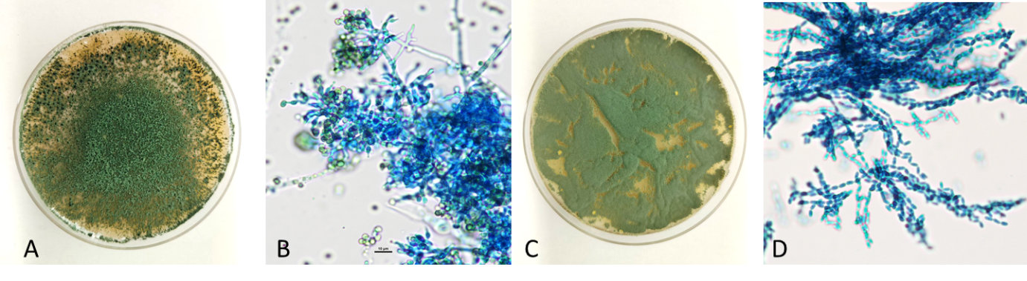**Figure 1.** (A) Colony of *T. asperellum* in PDA medium. (B) Microscopic structure of *Tricoderma sp*. (C) Colony of *Metarhizium sp.* in PDA medium. (D) Microscopic structure of *M. anisopliae*.

Identification of *Metarhizium spp.* was done using molecular approach. A fragment of 700 bp was visualized after DNA extraction and PCR amplification of *Metarhizium sp*. (S10). The result showed that this isolate has 95% similarity to the *M. anisopliae* isolate TMBMAVTL (accession number MT229077.1), thus confirming that the isolate corresponds to *M. anisopliae*.

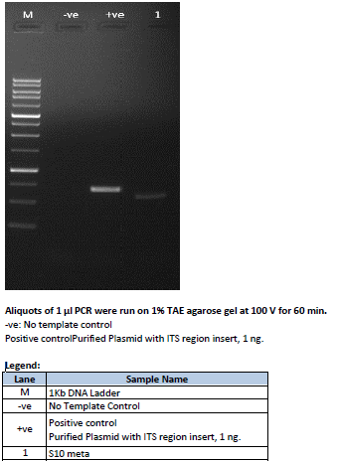

700bp

**Figure 2:** Aliquots of 1 ul PCR were run on 1% TAE agarose gel at 100 V for 60 min. Lane M, 1 kb DNA ladder; Lane –ve, no template control; Lane +ve, positive control (purified plasmid with ITS region inserts 1 ng; Lane 1, S10.

The population dynamics and infestation rates of the SPW can vary significantly depending on environmental conditions, agricultural practices, and the variety of sweet potato being cultivated. Generally, SPW thrive in warm, humid climates and can cause severe damage to both the vines and tubers of sweet potatoes. Figure 3 shows SPW attack on sweet potato accessions planted in bris soil. Out of the six sweet potato assession, five assession exceeded 30% infestation, (Tanjung Sepat, B1, Jepun Manis, and Sabah B). while popular varieties such as Vitato, on the other hand, are relatively less infested by SPW with an incident value is below 20%. This data shows the importance of management and control of SPW to reduce the loss of potato yield in the field.

**Figure 3.** Incidence of Sweet Potato Weevil (*Cylas formicarius*) on selected sweet potato accessions cultivated in bris soil

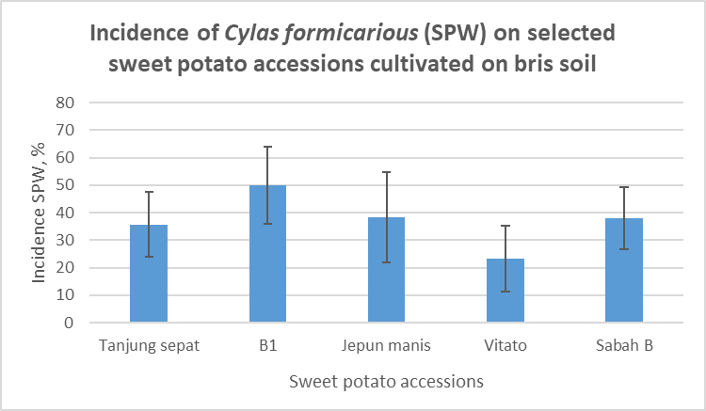

Figure 4 illustrates the mortality percentage of SPW using selected entomopathogens that were applied through two techniques: "dipping" and "ingestion." The analysis is based on the average of three experimental cycles. All treatments show significant differences in effectiveness between the two techniques, with the "ingestion" method consistently resulting in higher mortality rates compared to the "dipping" method for most treatments. From the figure 4, treatment T6 (MR - *M. anisopliae*) using the "ingestion" method recorded the highest mortality rate at 62.47%, whereas treatment T1 (S8 - *T. asperellum*) using the "dipping" method showed the lowest mortality rate at 12.90%. This indicates that the efficacy of the entomopathogens strongly depends on the application technique. The "ingestion" method appears to be more effective, likely due to the direct intake of pathogens by the pests, enhancing absorption and impact. Other treatments, such as T4 (MG - *M. anisopliae*), T5 (MP - *M. anisopliae*), and T3 (S4 - *Beauveria sp.*), also show significant differences between the two application methods, with "ingestion" being consistently more effective. In contrast, the positive control (T9) and negative control (T10) recorded much lower mortality rates, confirming that the use of entomopathogens significantly influences SPW mortality.

**Figure 4.** An average of mortality percentage of SPW using selected entomopathogens with two techniques "dipping" and "ingestion" method.

d

de

de

cd

cd

cd

bc

de

a

bc

a

a

a

ab

a

ab

ab

ab

cd

e

*The values indicated by the different alphabets in the graph were significantly different at p <0.05 by the LSD test

List of treatments:

T1: S8 (*T. asperellum*)

T2: S10 (*M. anisopliae*)

T3: S4 (*Beauveria sp.*)

T4: MG (*M. anisopliae*)

T5: MP (*M. anisopliae*)

T6: MR (*M. anisopliae*)

T7: *M. anisopliae – product from China*

T8: M1 (*M. anisopliae*)

T9: +ve control

T10: -ve control

Figure 5 shows tuber infected by SPW and infection of SPW with *M. anisopliae.* Many studies have been carried out by other researcher to evaluate the efficacy of metarhizium against sweet potato weevil. B. bassiana and M. anisopliae have given promising results to control C. formicarius in India [[Tarafdar and Sarkar, 2006](https://www.sciencedirect.com/science/article/pii/S0022201114001128" \l "b0150)], Kenya [[Ondiaka et al., 2008](https://www.sciencedirect.com/science/article/pii/S0022201114001128" \l "b0090)], Taiwan [[Su et al., 1988](https://www.sciencedirect.com/science/article/pii/S0022201114001128" \l "b0135)], and the Philippines [[Burdeos and Villacarlos, 1989](https://www.sciencedirect.com/science/article/pii/S0022201114001128" \l "b0025)].

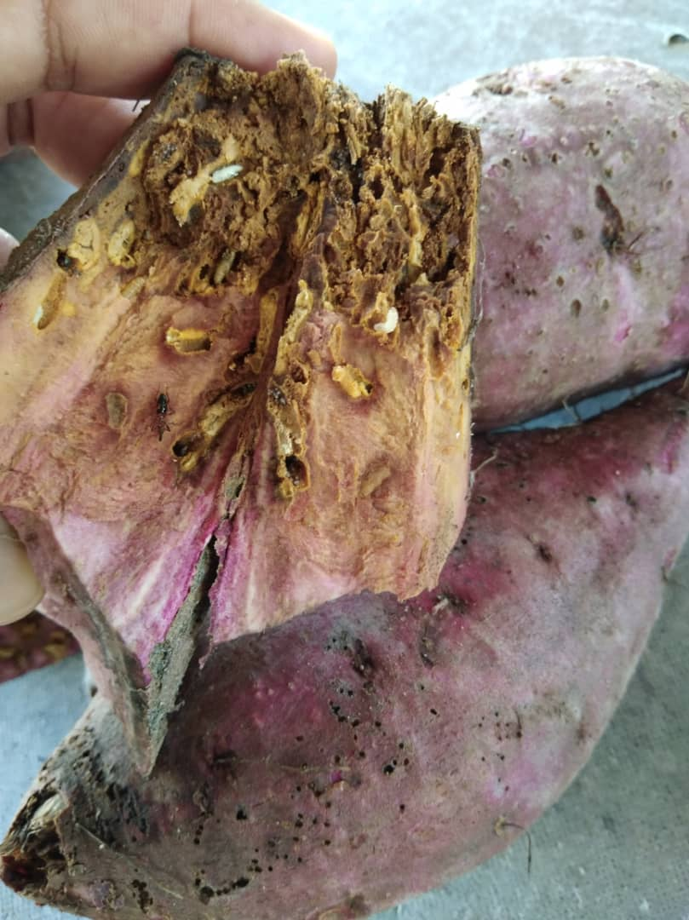 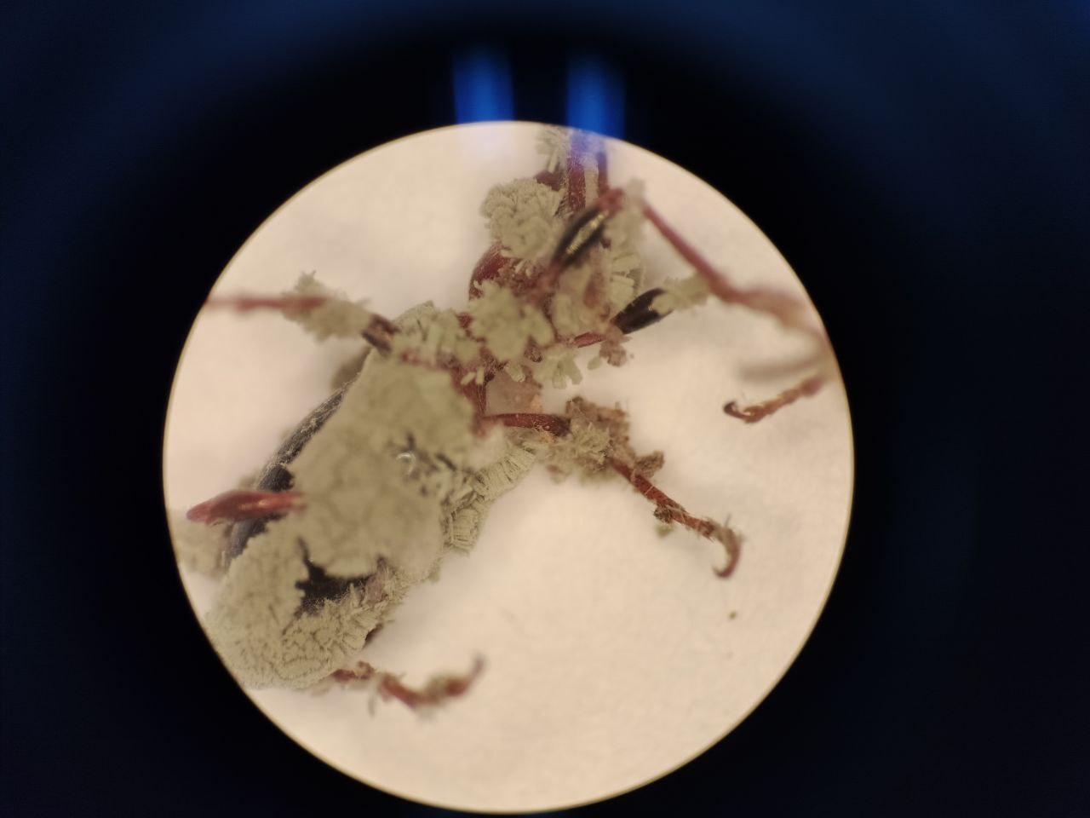

B

A

**Figure 5 (A-B):** (A) The effected of tuber by sweet potato weevil (SPW) infestation; and (B) infected weevil exposed to fungi *M.* *anisopliae* (1.0 x 108 conidia/ml) under laboratory conditions.

1. **CONCLUSION**

This study highlights the significant impact of application techniques based on the effectiveness of entomopathogens in controlling SPW. The "ingestion" method showed the best efficacy compared to the "dipping" method in nearly all treatments. Direct ingestion enhances pathogen efficacy, likely due to improved internal activation and absorption, leading to increased pest mortality. For example, treatment T6 (MR - *M. anisopliae*) showed a remarkable mortality rate of 62.47% using the "ingestion" technique, reinforcing its effectiveness. The variability in mortality rates across treatments also underscores the importance of selecting the appropriate strain of entomopathogen. Among the tested strains, *M. anisopliae* consistently performed better across multiple treatments, particularly when applied through ingestion. This suggests that this entomopathogen may be well-suited for controlling SPW, especially when integrated with a targeted application technique. Meanwhile, lower mortality rates in some treatments, such as T1 (*T. asperellum*), indicate that not all entomopathogens are equally effective against SPW, and their use should be tailored based on the pest's specific vulnerabilities. Overall, the findings emphasize the need for a strategic approach in pest management, combining effective entomopathogens like *M. anisopliae* with the most appropriate application method, such as "ingestion." This approach can maximize the control efficacy while minimizing environmental and economic costs associated with pest outbreaks. Further studies could be explored to optimize the application rates and techniques in order to enhance the applicability of these findings.

**Disclaimer (Artificial intelligence)**

Option 1:

Author(s) hereby declare that NO generative AI technologies such as Large Language Models (ChatGPT, COPILOT, etc.) and text-to-image generators have been used during the writing or editing of this manuscript.

Option 2:

Author(s) hereby declare that generative AI technologies such as Large Language Models, etc. have been used during the writing or editing of manuscripts. This explanation will include the name, version, model, and source of the generative AI technology and as well as all input prompts provided to the generative AI technology

Details of the AI usage are given below:

1.

2.

3.

1. **REFERENCES**
2. Baró, Y., Schuster, C., Gato, Y., Márquez, M. E., & Leclerque, A. (2022). Characterization, identification and virulence of Metarhizium species from Cuba to control the sweet potato weevil, Cylas formicarius Fabricius (Coleoptera: Brentidae). Journal of Applied Microbiology, 132(5), 3705-3716.
3. [Burdeos and Villacarlos, 1989](https://www.sciencedirect.com/science/article/pii/S0022201114001128#bb0025). A.T. Burdeos, L.T. Villacarlos. Comparative pathogenicity of *Metarhizium anisopliae*, *Beauveria bassiana* and *Paecilomyces lilacinus* to adult sweet potato weevil, *Cylas formicarius* (F.) (Coleoptera: Curculionidae). Philipp. Entomol., 7 (1989), pp. 561-571
4. C.Y. Su., S.S. Tzean., W.H. Ko, 1988. *Beauveria bassiana* as the lethal factor in a Taiwanese soil pernicious to sweet potato weevil, *Cylas formicarius*. J. Invertebr. Pathol., 52 (1988), pp. 195-197
5. **Chaverri, P., and Samuels, G.J. (2013).** Evolution of habitat preference and nutrition mode in Trichoderma (Hypocreales, Ascomycota): A phylogenetic perspective. Mycological Research, **117(6–7)**, 466–479. DOI: <https://doi.org/10.1016/j.funbio.2013.04.002>.
6. Chen, J., Stout, M. J., Beuzelin, J., Smith, T. P., LaBonte, D., Murray, J. M., & Davis, J. A. (2019). Host preference of sweetpotato weevil, Cylas formicarius elegantulus (Summers): an example of Hopkins’ host-selection principle. Arthropod-Plant Interactions, 13, 779-786.
7. Devi, P.S., Reddy, N.R., and Subhash, Y. (2005). Molecular characterization of entomopathogenic fungi using ITS primers. Indian Journal of Microbiology, **45(3)**, 241–246. Available at: <https://doi.org/10.1007/BF02948893>.
8. Gadi V.P. Reddy, Zihua Zhao, Richard A. Humber, 2014. Laboratory and field efficacy of entomopathogenic fungi for the management of the sweetpotato weevil, Cylas formicarius (Coleoptera: Brentidae), Journal of Invertebrate Pathology, Volume 122, Pages 10-15, ISSN 0022-2011, <https://doi.org/10.1016/j.jip.2014.07.009>
9. Hajek, A.E., and St. Leger, R.J. (1994). Interactions between fungal pathogens and insect hosts. Annual Review of Entomology, **39**, 293–322. DOI: 10.1146/annurev.en.39.010194.001453.
10. Hejjegar , I., Hiremath , S. M., Naik , K. R., Shekharappa, & Patil , V. S. (2023). Screening of Sweet Potato Genotypes against Sweet Potato Weevil (Cylas formicarius). International Journal of Plant & Soil Science, 35(18), 2225–2229. https://doi.org/10.9734/ijpss/2023/v35i183514
11. **Inglis, G.D., Goettel, M.S., Butt, T.M., and Strasser, H. (2001).** Use of hyphomycetous fungi for managing insect pests. In: Butt, T.M., Jackson, C., and Magan, N. (Eds.), Fungi as Biocontrol Agents. CABI Publishing, Wallingford, UK, pp. 23–69. Available at: <https://doi.org/10.1079/9780851993560.0023>.
12. Jansson, R.K., and Lecrone, S.H. (1991). Field efficacy of Beauveria bassiana against the sweet potato weevil (Cylas formicarius). Florida Entomologist, **74(3)**, 469–472. Available at: <https://doi.org/10.2307/3495347>.
13. Korada, R.R., Naskar, S.K., Palaniswami, M.S., and Ray, R.C. (2010). Management of sweet potato weevil (Cylas formicarius Fab.): An overview. Journal of Root Crops, **36(1)**, 14–26. Available at: <https://www.researchgate.net/publication/228478747>.
14. Li, Z., Alves, S. B., Roberts, D. W., Fan, M., Delalibera Jr, I., Tang, J., & Rangel, D. E. (2010). Biological control of insects in Brazil and China: history, current programs and reasons for their successes using entomopathogenic fungi. Biocontrol Science and Technology, 20(2), 117-136.
15. Montgomery, D.C., 2020. Design and Analysis of Experiments. 10th Edition. Wiley, New York, USA, pp. 1–752. DOI: <https://doi.org/10.1002/9781119818625>.
16. **Rangel, D.E.N., Braga, G.U.L., Fernandes, É.K.K., Keyser, C.A., Hallsworth, J.E., and Roberts, D.W. (2015).** Physiological and morphological characterization of Metarhizium anisopliae exposed to environmental stress. Fungal Biology, **119(5)**, 392–402. DOI: https://doi.org/10.1016/j.funbio.2015.01.006.
17. S. Ondiaka, N.K. Maniania, G.H.N. Nyamasyo, J.H. Nderitu. 2008. Virulence of the entomopathogenic fungi *Beauveria bassiana* and *Metarhizium anisopliae* to sweet potato weevil *Cylas punctiocollis* and effects on fecundity and egg viability. Ann. Appl. Biol., 153 (2008), pp. 41-48
18. [Tarafdar and Sarkar, 2006](https://www.sciencedirect.com/science/article/pii/S0022201114001128#bb0150). J. Tarafdar, M.A. Sarkar. Managing sweet potato weevil (*Cylas formicarius fabricius*) in West Bengal, India, by some chemicals, bioproducts and sex pheromone traps. Acta Hort., 703 (2006), pp. 189-196
19. **White, T.J., Bruns, T., Lee, S., and Taylor, J. (1990).** Amplification and direct sequencing of fungal ribosomal RNA genes for phylogenetics. In: Innis, M.A., Gelfand, D.H., Sninsky, J.J., and White, T.J. (Eds.), PCR Protocols: A Guide to Methods and Applications. Academic Press, New York, pp. 315–322. Available at: <https://doi.org/10.1016/B978-0-12-372180-8.50042-1>.
20. **Zimmermann, G. (2007).** Review on safety of the entomopathogenic fungi Beauveria bassiana and Metarhizium anisopliae. Biocontrol Science and Technology, **17(9)**, 879–920. Available at: <https://doi.org/10.1080/09583150701593963>.