Accreditation Document Management System of Apayao State College, Conner Campus, Philippines

.

ABSTRACT

|  |
| --- |
| The study focuses on the development and implementation of an *Accreditation Document Management System* (ADMS) for Apayao State College – Conner Campus to address inefficiencies in the existing manual accreditation records process. Currently, the college manually manages accreditation documents, leading to problems such as delayed access and unavailability of records when needed. The ADMS was designed to digitize and streamline the storage, retrieval, access, and monitoring of accreditation-related documents. Its goal is to support stakeholders such as faculty, program heads, the accreditation task force, and administrators in easily accessing and managing documents critical to accreditation processes. The system enables the electronic storage of files, including image formats, and improves information tracking and analysis while enhancing preservation and submission workflows. According to data collected on the manual process challenges, the new system effectively addresses identified issues, such as document misplacement and inefficient access. Evaluation based on ISO/IEC 25010 quality standards revealed that the system met user needs to a *“very great extent,”* particularly in terms of usability, reliability, and functionality. The conclusion highlights the system’s effectiveness in reducing challenges faced by the Quality Assurance Unit. Recommendations include full implementation across the college, ongoing testing and documentation to refine the system, regular monitoring to ensure consistent performance, and scheduled maintenance and upgrades in response to evolving user demands. Additionally, proper training for all involved personnel is emphasized to ensure optimal use of the system’s capabilities and long-term sustainability. This development represents a significant step toward modernizing the college’s accreditation management practices. |

*Keywords: Accreditation, Document Management System, ISO, Apayao State College*

1. INTRODUCTION

The world is marked by rapid changes taking into account the pace of scientific and technological advances. These advances have created great effects in the different systems in our society. In this era of information age, we are facing new challenges and approaches in file management systems (Audrin, 2019). One of the challenges is the digitization of accreditation documents using the new technology. Hence, the need for a dynamic transformation of technology education is necessary in order to provide better management of files (Benavides et. al, 2020).

The Document management is a technology and discipline that manages a computerized file system. By allowing users to characterize documents generally stored in files, document management systems allow users to store, retrieve and use these documents more easily and more powerful (Ngohayon et. al, 2012; Rocamora & Hernandez, 2017).

Accreditation Document Management System aims to manage and track accreditation paper electronically, store a second copy of accreditation papers electronically in image file, have an easy access to accreditation paper and help personnel such as accreditation task force, faculty, program heads, accreditors or even the director itself to locate immediately the papers needed in the accreditation (Conchada & Tiongco, 2015; Hwang et al., 2013).

**To keep track in ensuring quality education in the State Universities and Colleges (SUCs) in the country, the A**ccrediting Agency of Chartered Colleges and Universities in the Philippines (AACCUP), Inc. **adapted online platforms to continue its evaluation and assessment function to commence with the virtual transition conforming the limitations of the physical contact (**Ching, 2013)**. AACCUP Online Accreditation is** to evaluate and assess the level of compliance of the academic programs offered by the college and to ensure that the minimum requirements set by the Commission on Higher Education (CHED) and other governing body is complied by institutions (Cambel et. al, 2012; Papassavas et al., 2015).

The Quality Assurance Unit of Apayao State College (ASC) being a member institution of the State Universities and Colleges (SUCs) in the Philippines hopes to innovate its document management by way of developing a system that will digitize all its accreditation documents. At present, ASC keeps its accreditation records manually, thus problem arises such as records are sometimes unavailable when needed. Hence, the school needs to digitize accreditation documents to provide information on anything the institution needs to track and analyze about accreditation records, improve access to information sources, preservation, easy submission and consolidation of accreditation documents (Gilbert, 2020; Mokhtar et al., 2014).

This prompted the researcher to develop a project titled “Accreditation Document Management System of Apayao State College Conner Campus”. The proposed system will be utilized by the Quality Assurance Unit to systematize and digitize accreditation documents of the college.

2. objectives of the study

This study aimed to design and develop an Accreditation Document Management System of Apayao State College (ASC), Conner Campus.

Specifically, it aimed to answer the following questions:

1. To determine the current practices in the management of accreditation documents of the Quality Assurance Unit in terms of:
   1. retrieval;
   2. submission;
   3. shared access; and
   4. security
2. To design and develop an accreditation document management system that will facilitate the unit’s processes in terms of:
   1. retrieval;
   2. submission;
   3. shared access; and
   4. security
3. To determine the compliance of the developed system to ISO 25010 in terms of the following;
   1. Functional Stability;
   2. Performance Efficiency;
   3. Compatibility;
   4. Usability;
   5. Reliability;
   6. Security;
   7. Maintainability, and
   8. Portability

3. FRAMEWORK OF THE STUDY

The researcher realizes the possible improvements on the services provided by the Quality Assurance office through the development and implementation of the Accreditation Document Management System for Apayao State College Conner Campus to improve the quality of document management system in terms of tracking and analyzing accreditation records, improving access to information sources, preservation, easy submission and consolidation of accreditation documents.

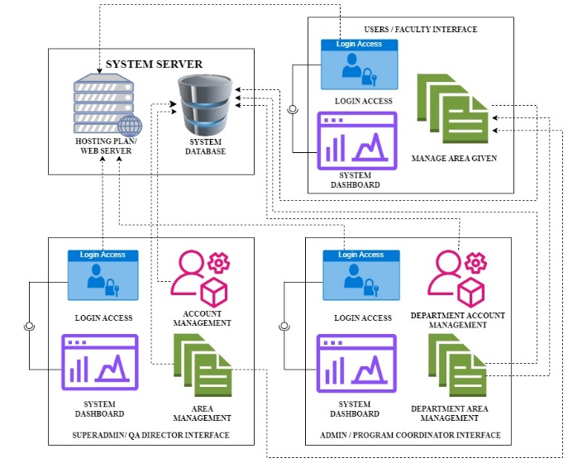

***Figure 1. Conceptual Framework***

***of the Accreditation Document Management***

***System***

The figure shows the system's functions and procedures. It shows how all user data and information are stored in the system database. The system requires a web server to allow online access, enabling users to log into their accounts using their respective credentials.

4. METHOLODOLOGY

**4.1. Research Design**

The study utilized the descriptive and development type of research designs to describe the software characteristics of the proposed Accreditation Document Management System in order to enhance the Quality Assurance Unit processes and services in Apayao State College.

For the descriptive design, the researcher used this method to gather data on the problems and issues encountered in the existing system. While the developmental design, the researcher utilized the concept of System Development Life Cycle model utilizing the Agile methodology for the development of the system.

**4.2. The Agile Model**

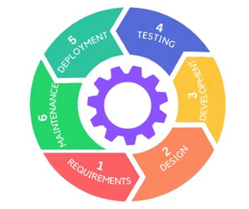The study employed the Agile Model as a process model of the Accreditation Document Management System for the Quality Assurance Unit of Apayao State College, Conner Campus.

***Figure 2. The Agile Model***

Figure 2 shows the cycle of how to design and develop the accreditation document management system for its stated deliverables and simplicity of understanding when developing a system.

The Agile model’s multiple phases assist proponents through various tasks, and the model’s extensive explanations for each stage aid in the design of a precise system that functions properly. The requirements gathering phase seeks to develop an accreditation document management system by collecting essential, well-organized data, information, and a variety of other items. The requirements are gathered through several methods, including interviews with program coordinators and faculty and a review of the organization’s prior system. Throughout the system design process, diagrams such as the conceptual framework, the entity-relationship diagram, and the data flow diagram are created to help understand and design the system. All of them were built to satisfy the demands of accreditation document management system based on the specifications obtained and the system’s objectives. The system interface is built during the development phase, when the forms and objects necessary to build the system are combined with ease of usage or convenience after development. It is critical that the system meet the expectations of both the developer and the user. After the system has been produced, it will be tested using ISO 25010 evaluation to ensure that it is built precisely as it should be based on the requirements collected, system design, and development phases. During the deployment phase, the system will be installed, and users will be instructed and trained to better understand the system’s functionality. Finally, after the system is integrated, the developer will check for any minor flaws or difficulties, and if any are discovered, the system will go through maintenance to remedy the problems and resolve the issues.

5. results and discussion

**5.1. The Current Practices of the Present System of Document Management**

***Table 1. The current practices and problems of the current system***

|  |  |
| --- | --- |
| **Current Practices** | **Existing Problems** |
| Accreditation task force will prepare and attach all the pertinent and needed documents according to the benchmark statements of the AACCUP Survey instruments from Area 1 to Area 10. | Possible loss of data and delays in locating accreditation records.  Redundancy or duplication of document.  Inability of the accreditation task force to generate timely reports due to manual filing and retrieval of records.  Documents are often misplaced. |
| Uses folders and filing cabinets to store document files |

**5.2. The Existing System**

The existing system of the Quality Assurance of Apayao State College currently utilizes a manual system in the management of its accreditation records. It uses folders and filing cabinets to store document files. All documents are done manually, the program accreditation task force attached hardcopy files or photocopies of the the required or needed documents per benchmark statement of the AACCUP Accrediation Survey Instrument during the preparation of documents before the scheduled Accreditaion survey. The Quality Assurance Officer is responsible in keeping, consolidation, retrieval and updating the records of all the programs.

**5.3. Information Requirements of the Existing System**

The following are the information requirements of the existing system:

Before a program is subjected for accreditation, each program accreditation task force will prepare and attach all the pertinent and needed documents according to the benchmark statements of the AACCUP Survey instruments from Area 1 to Area 10. These documents will be use by the AACCUP Accreditors to evaluate and assess the level of compliance of the academic programs offered by the college and to ensure that the minimum requirements set by the Commission on Higher Education (CHED) and other governing body is complied by the institution.

After the evaluation of these documents, the Quality Assurance Officer keeps these records for later reference. Cabinets are used as storage for the records thus problems arise such as possible loss of data and delays in locating accreditation records.

Update of records is done whenever it is needed. Specifically update of records is done every schedule of accreditaion. When an update is required, the Quality Assurance Officer requires the program acrreditation task force to fill-up the self rating form of the AACCUP accreditation survey instruments in order to validate or evaluate the documents prior to scheduled accreditation.

**5.4. Problems Encountered in the Existing System**

In the existing system, accreditation records of the programs are contained in individual file folder per area. These records are kept in a filing cabinet together with the other exhibit documents. When these documents are needed for decision making purposes, the Quality Assurance Officer has to look for the folder of each program per area in the filing cabinet thus problems such as delay in retrieval of information occurs. Redundancy or duplication of data is also one possible problem in the manual system. Worst of all, is when these documents are lost and the Quality Assurance Officer has to require the concerned accreditation task force to submit all the documents needed.

Problem also arises due to improper storage and exhaustive retrieval of files due to bulky accreditation records; inability of the accreditation task force to generate timely reports due to manual filing and retrieval of records.

Preparation and retrieval of accreditation documents is quite time consuming. Loss of information also is a problem because sometimes documents are misplaced.

**5.5. Developed System to Address the Problems/Issues of the Existing System**

Based on the result of the problems/issues experienced by the participants, the Accreditation Document Management System was developed to address the different problems identified to easily update the accreditation documents and to easily monitor the complete attachment per benchmark statement in every area of evaluation.

The following screenshots show the interface of the developed system. Each photo indicates the use of the system.

**SUPERADMIN:** The SUPERADMIN holds overarching responsibility for all functionalities and transactions within the system. They have administrative privileges allowing them to manage user accounts, system configurations, and ensure smooth operation of the entire system. Additionally, the SUPERADMIN oversees system security, updates, and implements necessary changes to optimize performance.

**ADMIN:** The ADMIN role entails monitoring and supervising a specific department or set of functions within the system. They are responsible for ensuring that tasks are completed efficiently and according to established protocols. ADMINs may also handle user permissions and provide support to users within their designated area.

**USERS:** USERS are tasked with uploading, adding, and editing documents within the system. They are responsible for maintaining the accuracy and integrity of the documents assigned to them. Additionally, USERS track the progress of their designated areas, collaborate with other users, and communicate any issues or updates to the ADMIN or SUPERADMIN as necessary.

**SUPERADMIN/DIRECTOR DASHBOARD**

***Figure 3. LOGIN PAGE***

This page serves as the login access point where users can access their accounts, provided by the SUPERADMIN. Upon receiving their account details via email, users can log in and are prompted to change their password for security purposes.

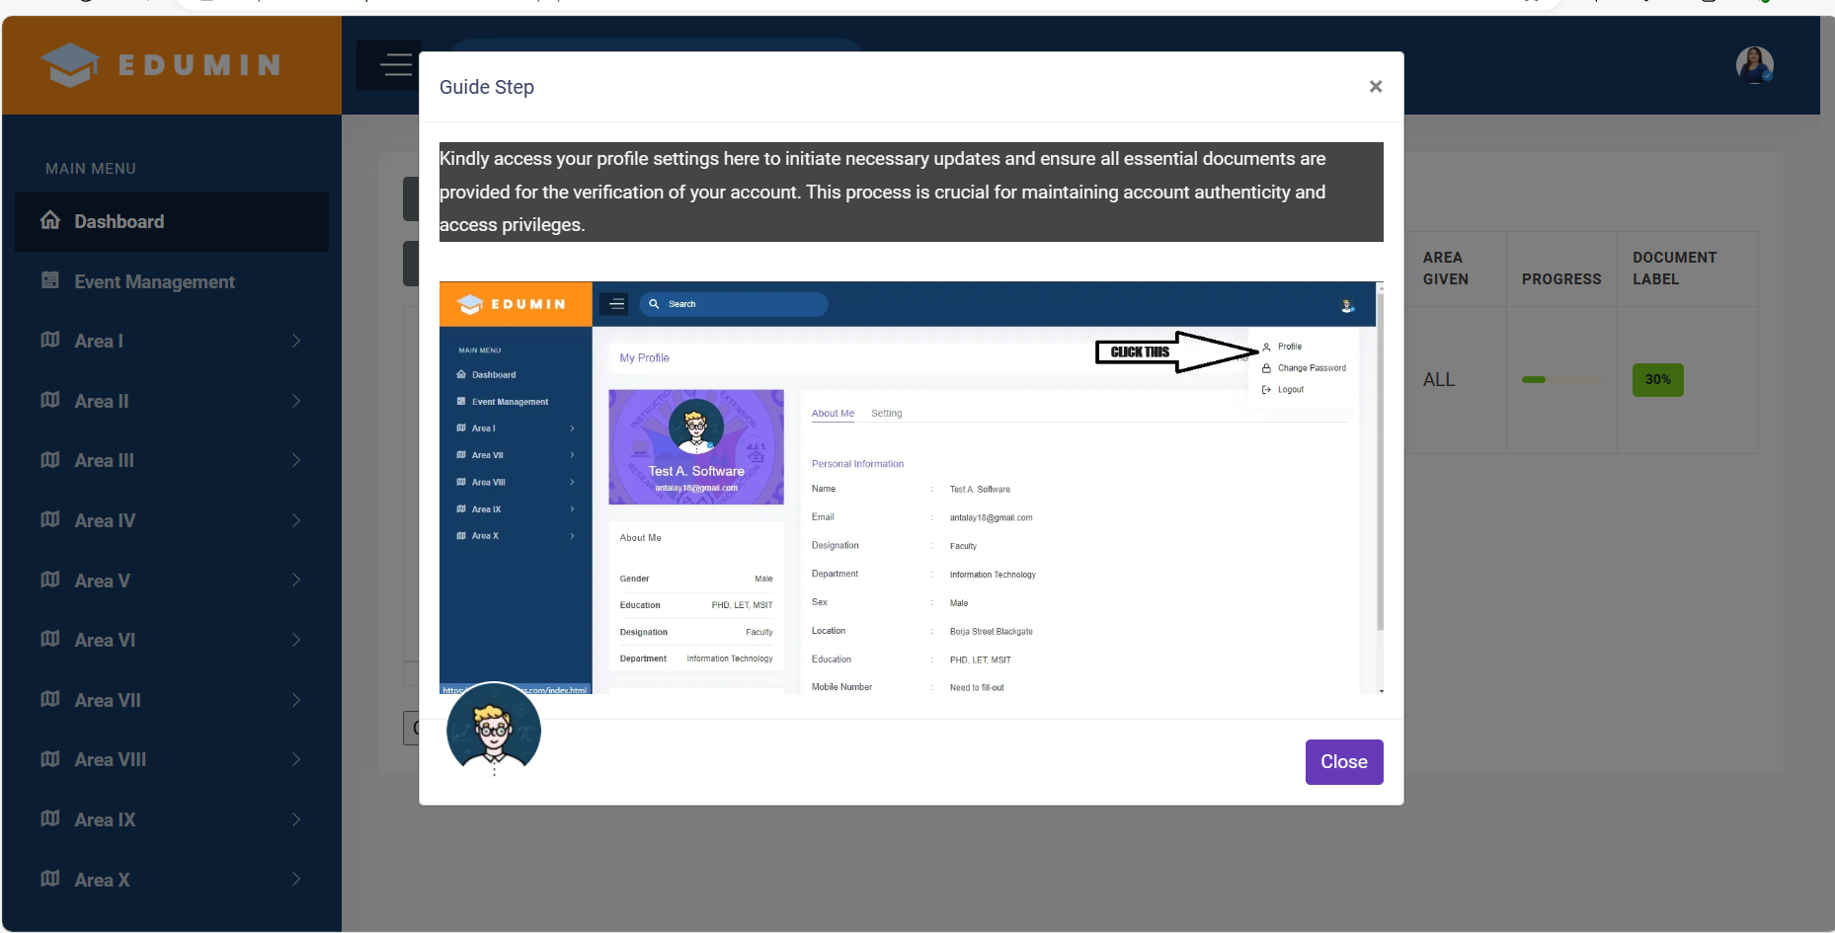 ***Figure 4. STEP GUIDE***

After logging in and accessing the dashboard, you will find a system guide providing instructions on how the system operates. This guide will be displayed only once upon each account login on a particular device.

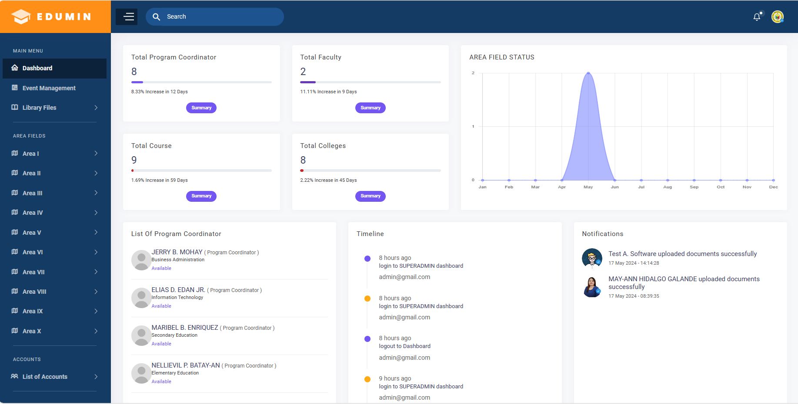

***Figure 5. SUPERADMIN DASHBOARD***

This page functions as the SUPERADMIN dashboard, providing a summary of the total number of program coordinators, faculty members, courses, departments, and the status of documents uploaded within the area of study. Additionally, it displays notifications and timelines for all users.

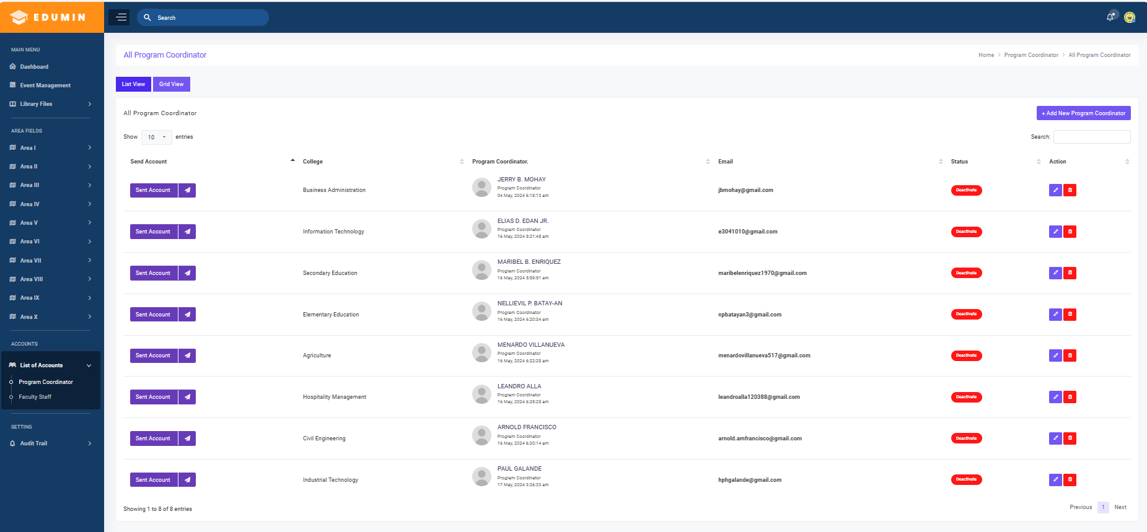

***Figure 6. Program Coordinator List***

This page displays all program coordinator accounts, where you are responsible for adding, modifying, and sending account details to users via Gmail, based on the registered email addresses provided.

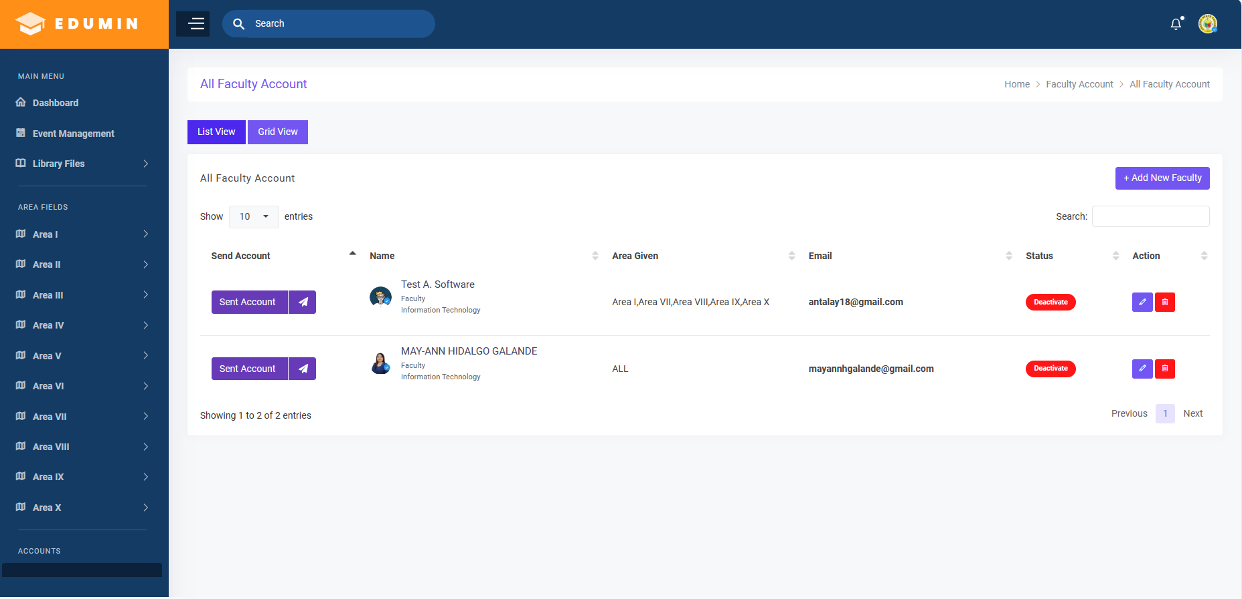

***Figure 7. Faculty List***

This page displays all faculty accounts, where you are responsible for adding, modifying, and sending account details to users via Gmail, based on the registered email addresses provided and also you also responsible for giving the area for the faculty to be monitored.

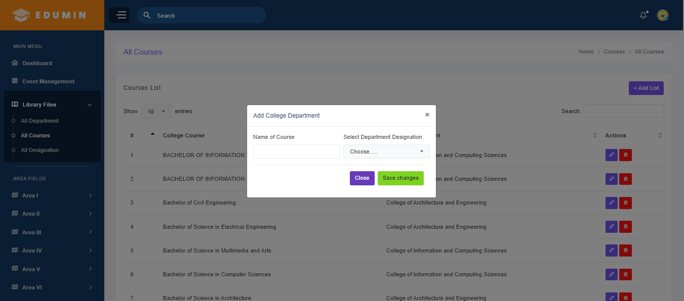

***Figure 8. Courses***

This function comprises a list of all college courses for which you are responsible for adding, editing, and deleting. Additionally, college deans have the capability to add courses based on the assigned department; however, ultimate responsibility for all college courses rests with you.

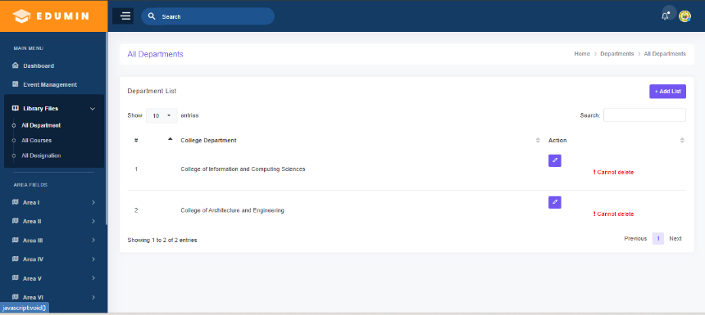  
***Figure 9. Departments***

This function is the list of all college departments you are responsible of adding, editing and deleting it.

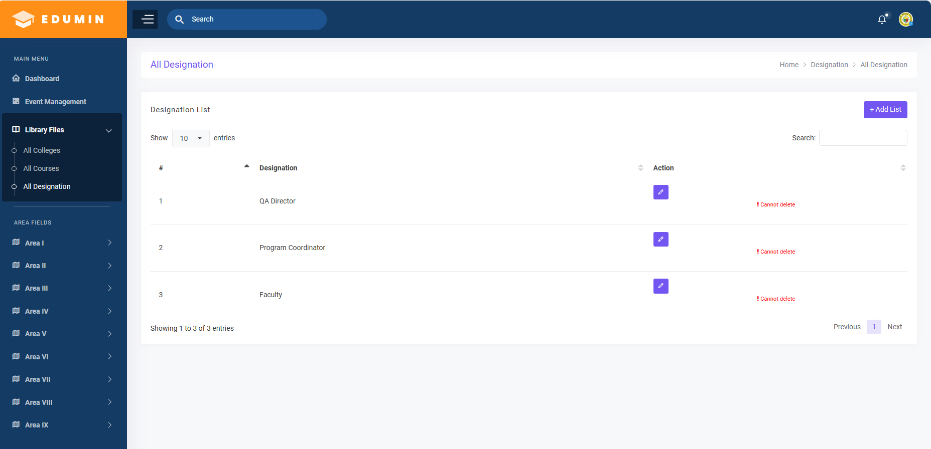

***Figure 10. Designation***

This function is the list of all designation of accounts which you are responsible of adding, editing, and deleting it.

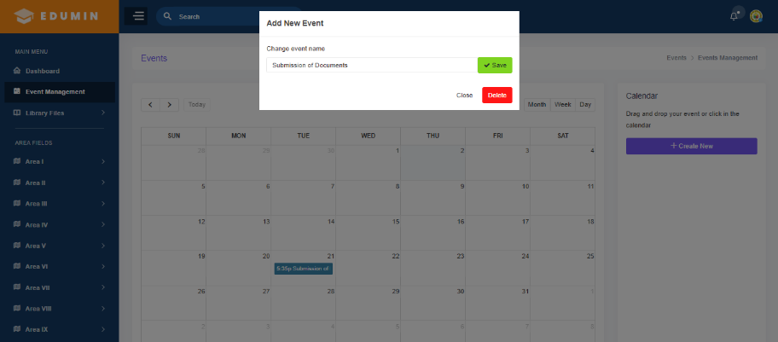

***Figure 11. Events Monitoring***

This function serves as an event monitoring, enabling you to add events that will notify all users based on the set date you provide. This feature aids in tracking the progress of users and monitoring their completion of assigned tasks.

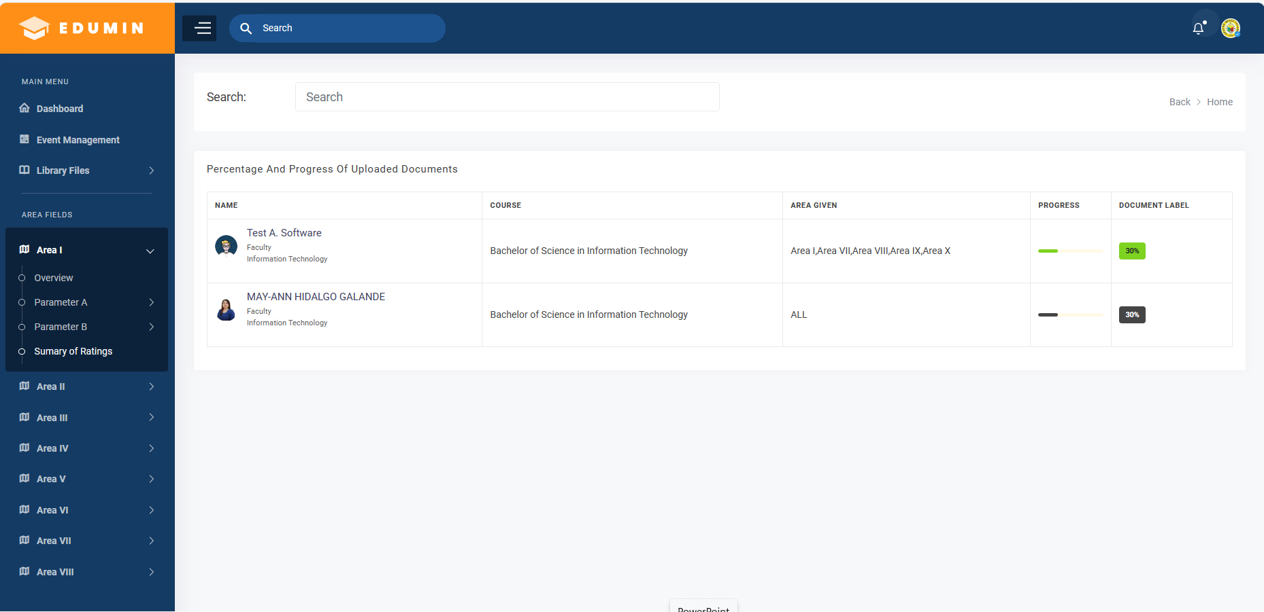

***Figure 12. Summary Ratings***

This page serves as a summary of uploaded documents in the areas designated by users. It displays the progress and percentage completion of each user, with filtering functions available for managing large numbers of users displayed in the table.

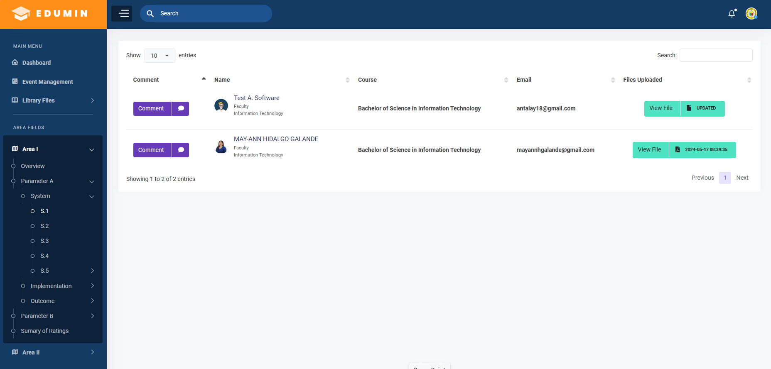

***Figure 13. Parameters***

This function is responsible for check and track the uploaded documents of the user where you can view it and comment if there’s a modification of the documents.

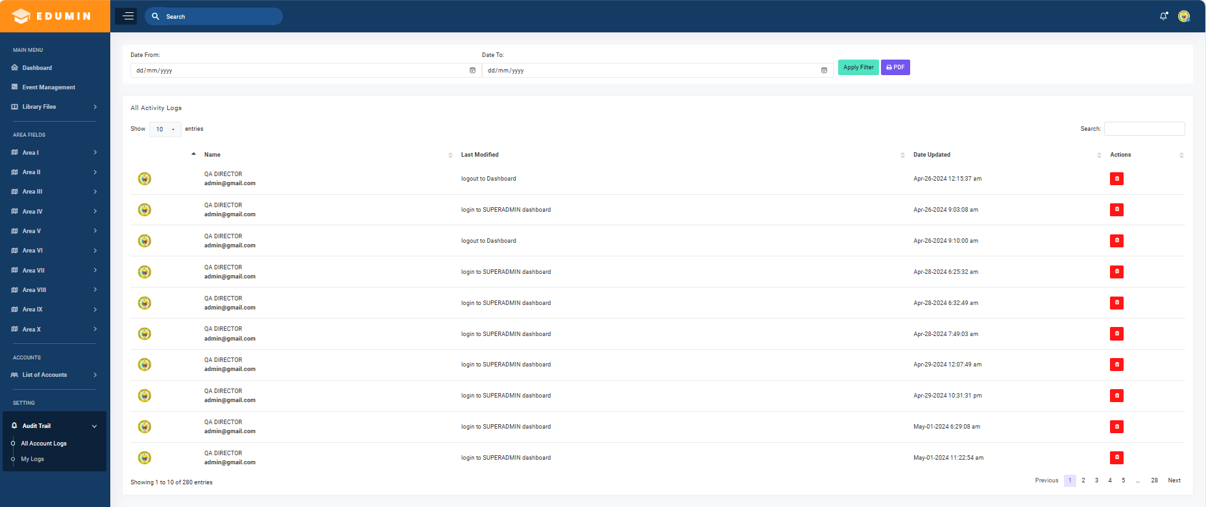

***Figure 14. Audit Trail/Activity Log***

This function is the activity log for all users, for which you are responsible for tracking all account activities within the system. You can filter the logs and generate audit trail reports for printing.

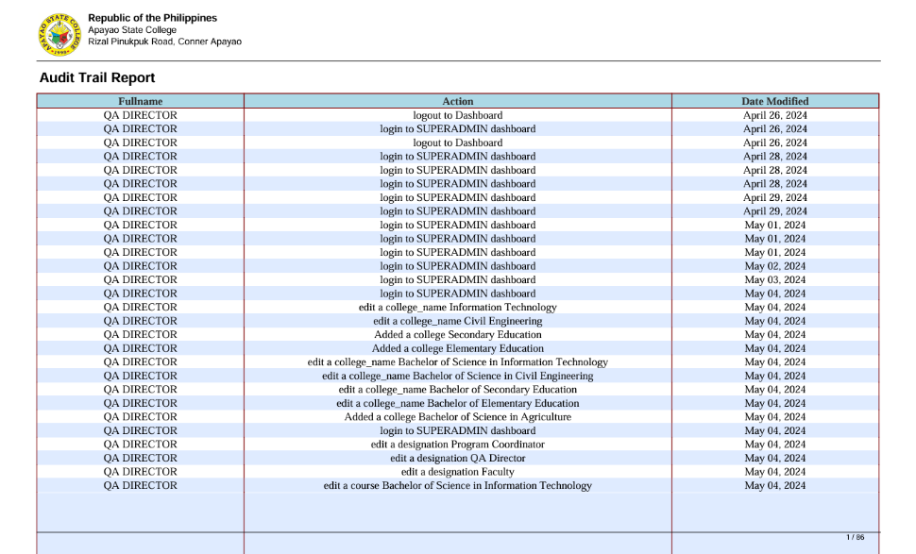

***Figure 15. Activity Log Report***

This sample report of all activities of the users base set date filtered.

***Figure 16. Overview Area***

This page serves as an overview of every area, containing detailed information that you can modify. This allows everyone to view it on their accounts, providing them with information on the areas they are monitoring.

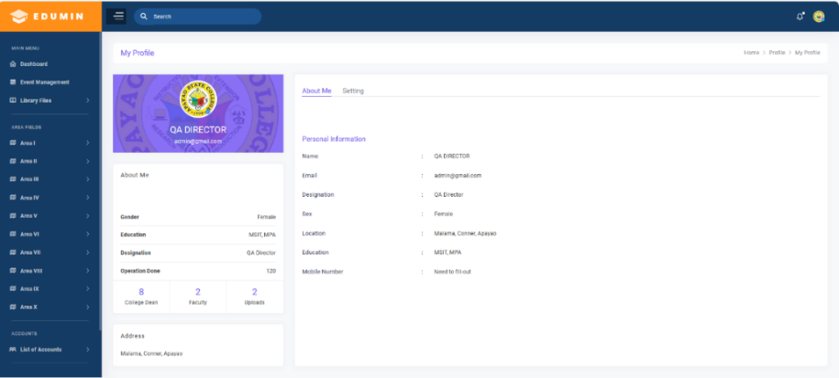

***Figure 17. My profile***

This page serves as your profile settings here to initiate necessary updates and ensure all essential information are provided for the verification of your account. This process is crucial for maintaining account authenticity and access privileges.

**ADMIN DASHBOARD/ PROGRAM COORDINATOR**

***Figure 18. ADMIN DASHBOARD***

This page serves as the ADMIN dashboard, offering a summary of the total number of faculty members of the department, courses, and the status of documents uploaded within the area of study. Additionally, it displays notifications and timelines for all users, which are only monitored based on the department provided by the SUPERADMIN.

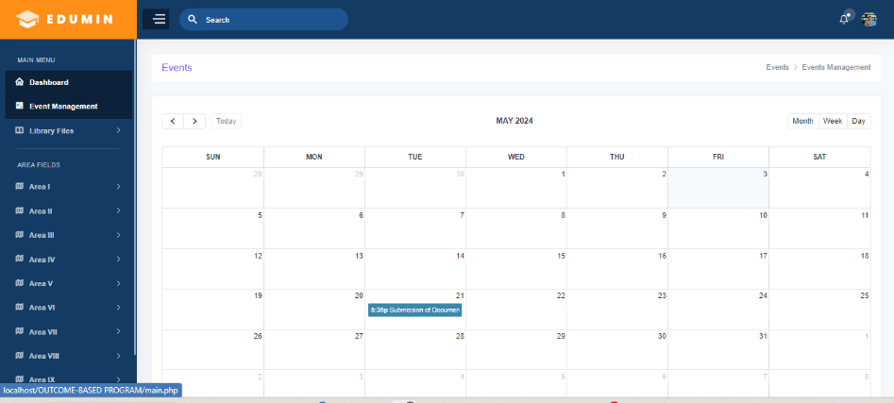

***Figure 19. Event***

This page serves as your notification hub for any events set by the SUPERADMIN, such as dates for guideline meetings, deadlines, and other schedules.

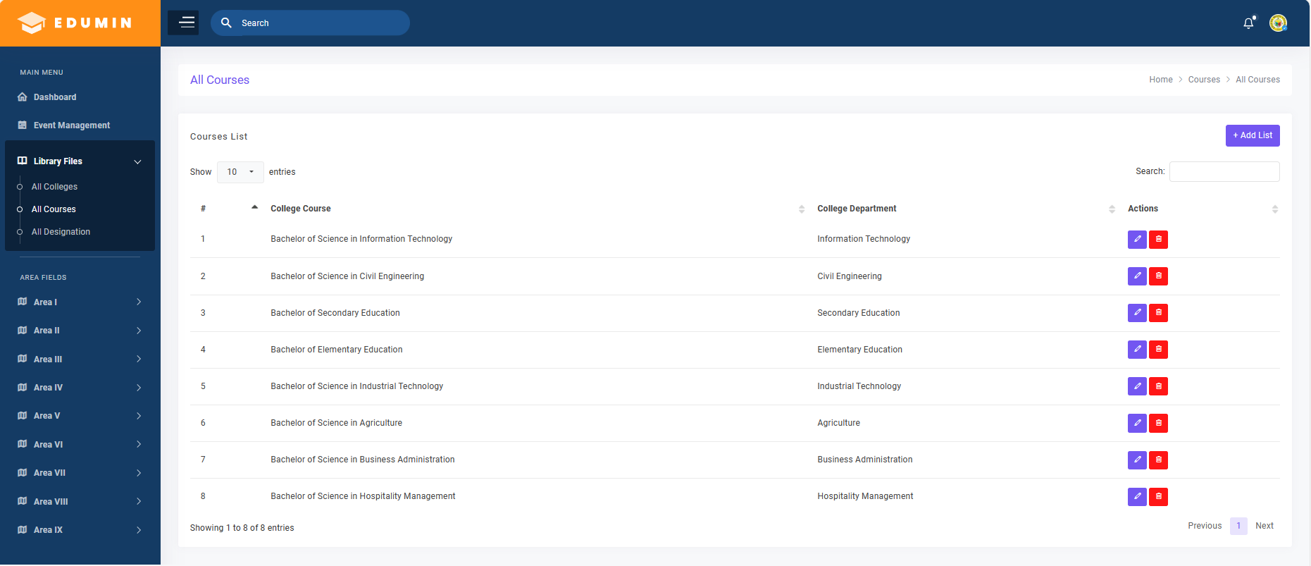

***Figure 20. Courses***

This page functions are responsible for adding and modifying courses base on the department specified by the ADMIN/Program Coordinator.

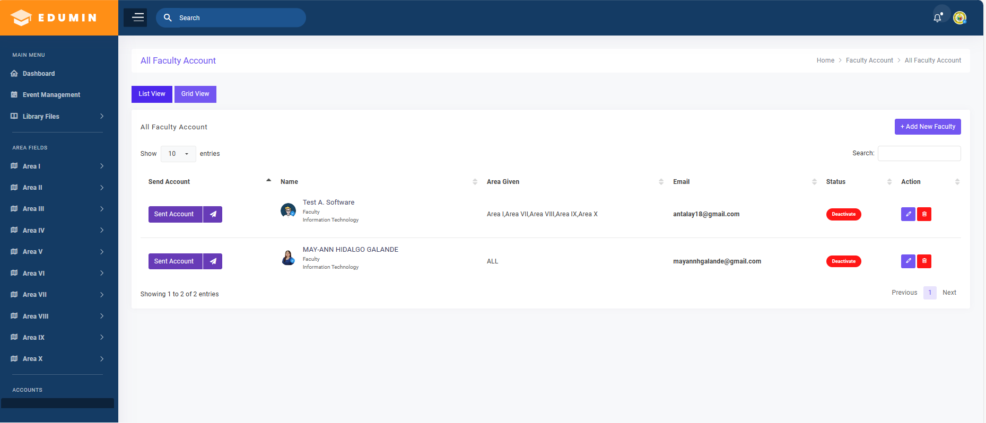

***Figure 21. Faculty***

This serves as the ADMIN's platform to add, modify, and assign staff accounts based on their respective departments. This functionality allows the admin to designate areas to be monitored by the faculty.

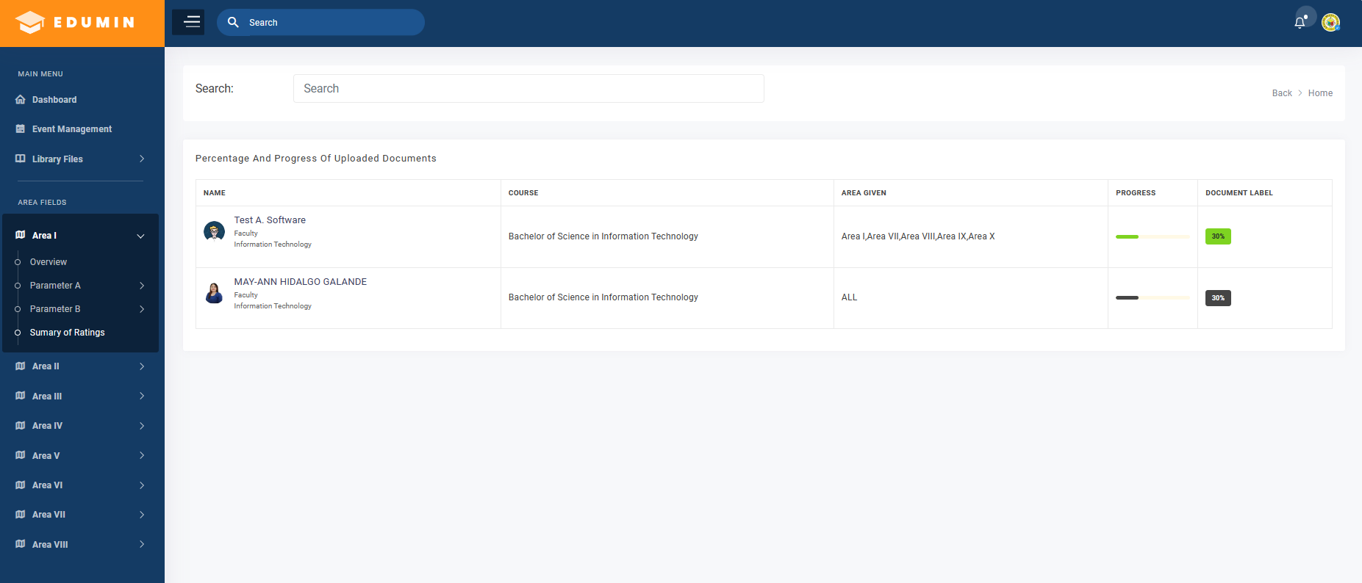

***Figure 22. Summary of Ratings***

This page serves as the admin's tool to check the progress of faculty-uploaded documents within their designated areas.

***Figure 23. Overview Area***

This page serves as an overview of the selected area, providing detailed information for easy access to necessary data within the area.

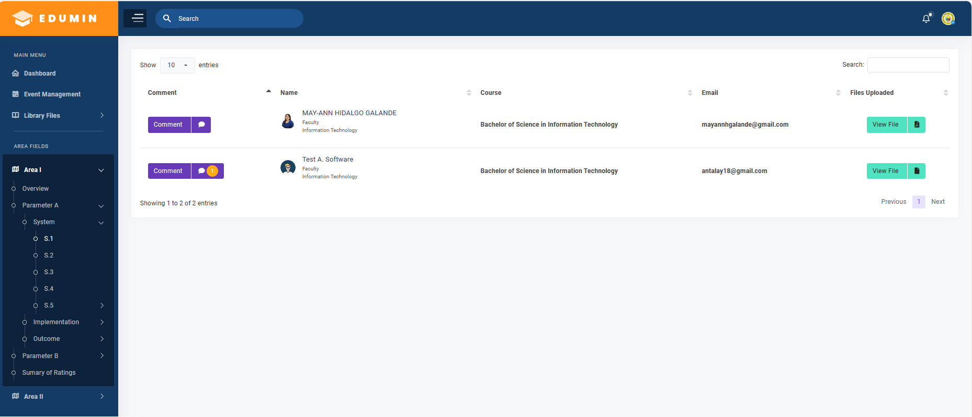

***Figure 24. Parameters***

This function is responsible for tracking and monitoring the uploaded documents of your faculty, allowing you to comment on and view them.

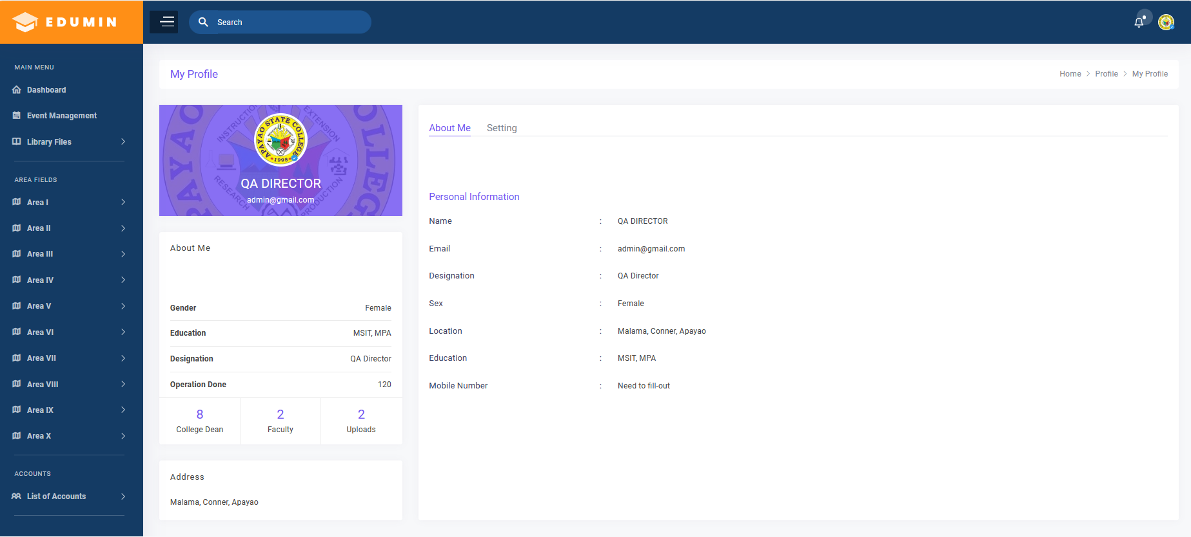

***Figure 25. My profile***

This page serves as your profile settings here to initiate necessary updates and ensure all essential information are provided for the verification of your account. This process is crucial for maintaining account authenticity and access privileges.

**USERS/ FACULTY DASHBOARD**

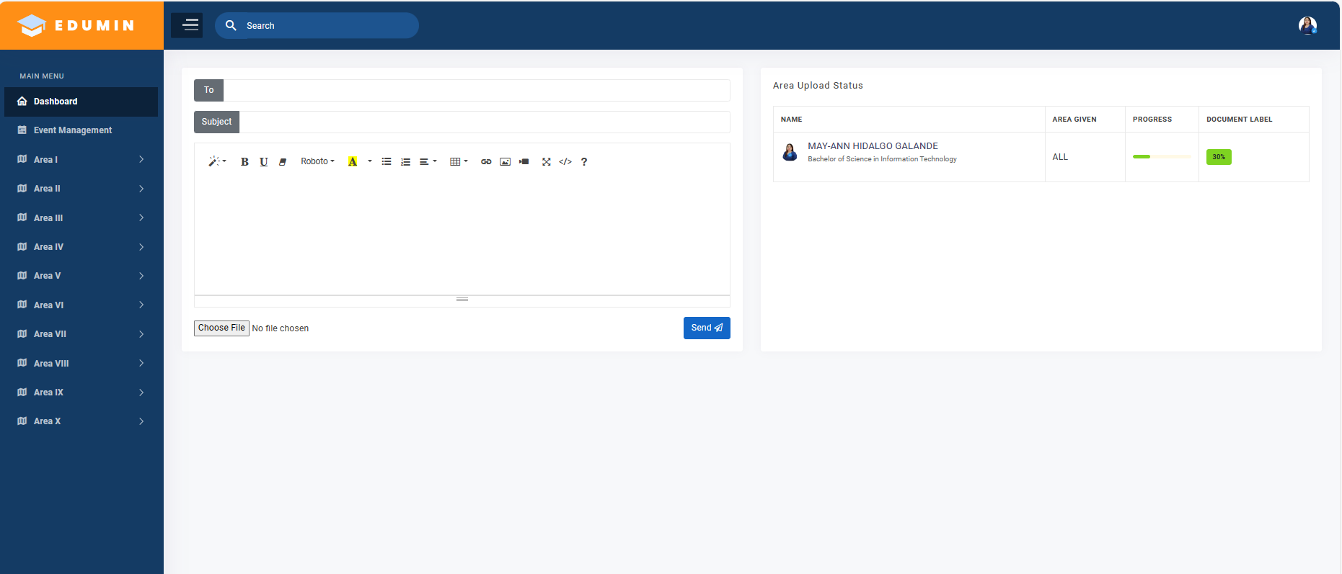

***Figure 26. FACULTY DASHBOARD***

This page serves as the dashboard of the faculty which it shows here the progress of the uploaded documents on the area designated.

***Figure 27. Overview Area***

This page serves as an overview of the selected area, providing detailed information for easy access to necessary data within the area.

***Figure 28. Parameters***

This page serves as the primary interface for faculty transactions, allowing them to upload, modify, and delete documents. It also enables them to review comments and address any queries related to the documents.

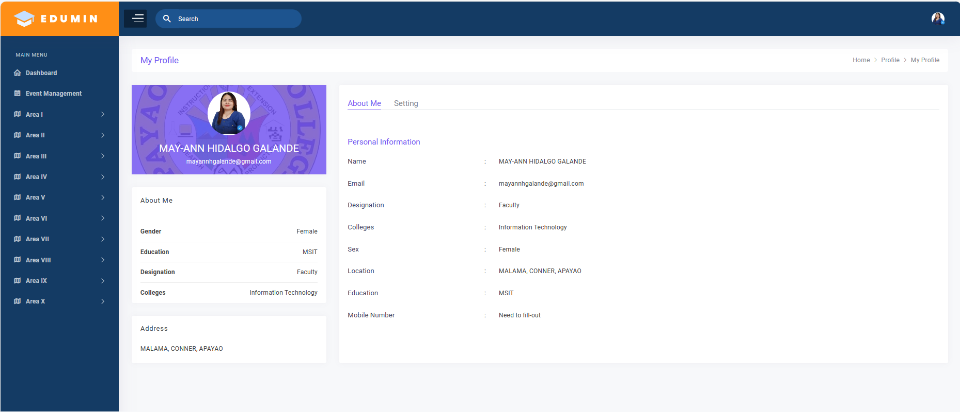

***Figure 29. My profile***

This page serves as your profile settings here to initiate necessary updates and ensure all essential information are provided for the verification of your account. This process is crucial for maintaining account authenticity and access privileges

6. Conclusion

Based on the results and findings of this study, the researcher concludes that the implementation of the developed system provides solution to reduce the various problems and issues encountered in the manual system with regard to management of accreditation documents of the Quality Assurance Unit.

AcknowledgEments

The researcher humbly expresses her profound gratitude and appreciation to the following who has generously shared assistance and sacrifices in making this study possible. To the Administration of the Apayao State College: Dr. John N. Cabansag, the College President. Her respondents for their willingness to answer the questionnaires in terms of assessing the developed system. Her Loving and supportive husband, Mr. Danpaul T. Galande, and children, Bryan Paul H. Galande, John Paul H. Galande and HP H. Galande, relatives and friends for their unending love, motivation, encouragement, moral support, prayers and unending love; Above all, to the most powerful God for His unending love and care. To God be the glory.

Authors’ Contributions

As the sole author of this study, I contributed to all aspects of its development and completion, including the identification of the research topic, design of the methodology, data collection, analysis, and interpretation. I conducted the interviews, ensured the confidentiality of the respondents, and synthesized their responses into meaningful insights. Additionally, I wrote and revised the entire manuscript and sought guidance from mentors and reviewers to improve the quality and accuracy of the work.

**DISCLAIMER (ARTIFICIAL INTELLIGENCE)**

I acknowledge that I have not used ChatGPT or Copilot for refining some of the sections in the document.

Consent (WHEREVER applicable)

I affirm that the respondents voluntarily agreed to participate after being fully informed about the purpose, nature, and potential implications of the study. Their responses have been collected with utmost respect for their privacy and confidentiality, in accordance with ethical research guidelines.

Ethical approval (where ever applicable)

The study was conducted with approval and in accordance with the standards of the college. No ethical approval was required, as the research followed all applicable ethical guidelines, ensuring respect for the respondents' privacy and confidentiality

References

Audrin, B. (2019). *Making sense of digitization: Three studies on the digitization concept and its implementation in organizations* (Doctoral dissertation, éditeur non identifié).

Benavides, L. M. C., Tamayo Arias, J. A., Arango Serna, M. D., Branch Bedoya, J. W., & Burgos, D. (2020). Digital transformation in higher education institutions: A systematic literature review. *Sensors*, *20*(11), 3291.

Cambel, T. L., Tabares, M. N. C. L., & Barraca, L. (2012). The role of accreditation in the conversion of a college to a university: The SKSU Experience. *Quality Assurance: Concepts, Structures, and Practices. AACCUP, Quezon City*.

Ching, G. S. (2013). Higher education accreditation in the Philippines: A. *International Journal of Research*, *2*(1), 63-74.

Conchada, M. I. P., & Tiongco, M. M. (2015). A review of the accreditation system for Philippine higher education institutions.

Gilbert, D. D. (2020). ISO Alongside, Instead, or Inside? The potential of ISO 21001: 2018 to change and challenge higher education accreditation. *International Journal of Business and Applied Social Science*, *6*(10), 45-52.

Ngohayon, S. L., Guimpatan, J. A., & Basilio, F. (2012). The impact of accreditation to IFSU’s quest for quality and excellence. *Quality Assurance: Concepts, Structures, and Practices. AACCUP, Quezon City*.

Rocamora, N. C., & Hernandez, A. (2017). Workflow-based Document Management System for Higher Education Programmatic Accreditation Agency. In iIternational Conf. Adv. Sci. Eng. Technol (p. 5).

Papassavas, A., Chatzistamatiou, T. K., Michalopoulos, E., Serafetinidi, M., Gkioka, V., Markogianni, E., & Stavropoulos-Giokas, C. (2015). Quality management systems including accreditation standards. In Cord blood stem cells and regenerative medicine (pp. 229-248). Academic Press.

Mokhtar, R., Jaafar, N. H., Tahar, N. F., Sukiman, S. A., Aris, A., & Bakar, N. F. A. (2014, May). An integrated document management system for managing self programme accreditation using scrum approach. In 2014 International Symposium on Technology Management and Emerging Technologies (pp. 102-106). IEEE.

Hwang, S. H., Jung, S. K., Kang, S. J., Cha, H. S., Chung, S. H., & Lee, D. H. (2013). Development of a document management system for the standardization of clinical laboratory documents. Annals of laboratory medicine, 33(6), 441.