Original Research Article

Symbolism of Lute Instruments in Borobudur's Karmawibhangga Reliefs: A Semiotic Analysis

.

ABSTRACT

|  |
| --- |
| This study aims to explore the social, symbolic, and spiritual meanings of lute-type musical instruments depicted in the Karmawibhangga reliefs of 9th-century Borobudur Temple in Central Java, Indonesia. These instruments are shown in detailed visual narratives that reflect ancient Javanese cultural and religious values, yet their specific functions and meanings remain underexplored. This research adopts a qualitative visual semiotic methodology. The study was conducted at Borobudur Temple between January and April 2025. The research focuses on three Karmawibhangga relief panels numbered 102, 125, and 151 that feature representations of lute instruments. Using Charles Sanders Peirce’s triadic semiotic theory (icon, index, and symbol), the study analyzes the visual elements of the reliefs to interpret layers of meaning embedded in the depiction of these instruments. The analysis is supported by a literature review of historical texts, Southeast Asian ethnomusicology, and musical iconography. The depicted lute instruments have two to five strings and appear within sacred musical ensembles. These instruments are consistently featured in scenes associated with celestial realms, religious rituals, and elite social contexts. The lute is not portrayed as an entertainment device, but rather as a medium of spiritual communication. This reflects the significance of music in cosmological and religious expressions of ancient Javanese society. The lute instruments in the Karmawibhangga reliefs function not merely as artistic or musical elements but as symbolic conduits that integrate spirituality, visual culture, and social hierarchy. Their representation underscores the vital role of music in religious life and its position within the broader cosmological worldview of 9th-century Java. The study contributes to a deeper understanding of the cultural role of music in ancient Southeast Asia and opens new pathways in archaeological music research. |

*Keywords: ancient Javanese music, lute, Peircean semiotics, Karmawibhangga relief, Borobudur, spiritual symbolism, sacred ensemble*

1. INTRODUCTION

Borobudur, a 9th-century Buddhist temple located in Central Java, Indonesia, is renowned for its intricate and detailed reliefs that depict various aspects of ancient Javanese life and Buddhist teachings. Among these reliefs is the Karmawibhangga, located on the base of the monument. Currently, this relief has been buried for structural preservation purposes. The Karmawibhangga illustrates the law of karma through scenes of daily life, moral conduct, and their consequences. This relief was covered by an additional encasement built during the final stage of the temple's construction, around the 9th century CE. The covering is believed to have been motivated by structural considerations to reinforce the monument, and ideological reasons, as several panels depict vulgar or morally deviant scenes according to the standards of that era (Santiko, 2016). The rediscovery of this relief was made by J.W. Ijzerman in 1885, and the entire series of panels was documented by Kassian Cephas between 1890 and 1891, before being reburied for conservation purposes. The values conveyed by these panels deserve continuous exploration, as the reliefs function not only as religious didactic tools or ornamental carvings but also as windows into the social and cultural structures of the time. One of the significant aspects of the Karmawibhangga relief is the depiction of musical instruments, particularly stringed instruments that can be categorized within the *tata vadyā* (string instruments) of the lute type. These instruments appear in various contexts, indicating their importance in both secular and spiritual life. However, the specific functions and symbolic meanings of the lute instruments in these reliefs remain underexplored.

This study aims to analyze the symbolic function of lute instruments depicted in the Karmawibhangga reliefs using Charles Sanders Peirce’s triadic semiotic framework. By applying this model, the research seeks to uncover the layers of meaning embedded in the visual representations of lute instruments and their roles in conveying moral and spiritual messages. Previous studies have addressed the presence of musical instruments in the Borobudur reliefs. Kunst conducted foundational research on the iconography of music in Javanese temples, noting the variety of string instruments and their possible origins (Kunst, 2013). Lakusa examined the reconstruction of musical instruments in the Sound of Borobudur project, interpreting their symbolic meaning within the context of Buddhist teachings (Lakusa & Pradoko, 2021). Setiawan applied Peirce’s semiotics to analyze plant imagery in Borobudur’s reliefs, demonstrating the relevance of this approach for visual elements on the monument (Setiawan, 2024). Additionally, prior research on gestures and narratives within the reliefs has provided insights into the cultural and aesthetic values of ancient Javanese society (Hertiasa et al., 2021).

Despite these contributions, there is still a lack of semiotic analysis specifically focused on the lute instruments in the Karmawibhangga relief. This study fills that gap by analyzing the relief panels that feature lute instruments, interpreting their representamen, identifying the objects they signify, and explaining the interpretants within the cultural and religious context of 9th-century Java. The scope of the study includes in-depth visual analysis of the reliefs, contextual interpretation based on historical and religious texts, and comparative insights from related musical traditions. By revealing the symbolic function of the lute instruments in the Karmawibhangga reliefs, this research contributes to a deeper understanding of the interconnectedness between music, art, and spirituality in ancient Javanese Buddhism.

2. material and methods

**2.1. Visual Data Sources**

This study utilizes visual data from official photographic documentation of the Karmawibhangga reliefs at Borobudur Temple, specifically focusing on panels that depict stringed musical instruments resembling lutes. The primary sources of images are the documentation provided by the Borobudur Conservation Office as well as digital archives published in previous studies (Santiko & Nugrahani, 2012). The selected panels were chosen based on visual clarity, the presence of figures playing string instruments, and the narrative context within each panel.

**2.2 Semiotic Analysis Procedure**

This study employs a qualitative-descriptive approach utilizing Charles Sanders Peirce's triadic semiotic method. Semiotics is applied to interpret the symbolic meanings of lute representations within the context of ancient Javanese culture. The representamen pertains to the physical form or visual signs in the reliefs, such as lutes, figures, attire, objects, and inscriptions. The object refers to what the representamen signifies, while the interpretant relates to the mental or cultural interpretations arising from the relationship between the representamen and the object within the context of ancient Javanese society. The analysis begins with the identification of panels 102, 125, and 151, which explicitly depict lute-type instruments, focusing on the clarity of visual structures such as the resonator and neck of the instrument, as well as the performative gestures of the players. These panels were selected due to their accompanying narrative contexts. The next stage involves an in-depth visual description, systematically documenting the instrument forms, player positions, and the socio-religious narrative contexts within the panels. Subsequently, Peirce's triadic construction is applied by dissecting the representamen, object, and interpretant, allowing for a profound understanding of the symbolic role of music within the cosmological and spiritual structures of 9th-century society. The final stage involves historical validation by examining the connections between the visual interpretations and written as well as archaeological sources, such as the Karmawibhangga texts that served as references for the relief carvings, to obtain strong academic justification for the proposed symbolic interpretations (Krom, 1927). This method not only enables the tracing of the historical trajectory of the lute instrument but also reveals its cultural significance as a symbol of spiritual harmony within Borobudur's visual world.

**2.3 Literature and Comparative Sources**

The study of musical instrument representations in the Karmawibhangga reliefs at Borobudur Temple necessitates a multidisciplinary approach involving iconography, philology, semiotics, and Southeast Asian music studies. A significant starting point for understanding classical Javanese music iconography stems from Kunst's work (1968), which comprehensively analyzes the forms, playing techniques, and similarities of instruments depicted in the reliefs with those from various other cultures worldwide. Kunst's comparative approach underscores that these instruments are not isolated local entities but part of cross-cultural dynamics that have occurred since the early centuries AD.

Iconographic interpretation alone is insufficient to comprehend the narrative and spiritual contexts of these instruments. Santiko's study (2016) complements this by offering an archaeological-historical approach linking the Karmawibhangga reliefs with two Buddhist texts translated into Chinese, namely T80 and T81. Through comparing the episodes in the reliefs with these texts, it was found that T80 more closely aligns with the narrative structure depicted in the reliefs. This finding provides a basis for assuming that the visualization of instruments in the Karmawibhangga context is influenced by textual teachings, indicating that the instruments serve not only aesthetic functions but also embody Buddhist doctrinal values. The connection between visual forms and ancient texts is further emphasized by Hendra, who focuses his research on the relationship between musical instruments in Java and Bali with Old Javanese literary texts (Hendra, 2020). There is a continuity between the visual contexts discussed by Kunst and Santiko and the literary and functional readings offered.

Furthermore, to understand the symbolic meanings of these instruments, Lakusa's study (2021) through the Sound of Borobudur project provides significant contributions using Peirce's semiotic approach. In this study, instruments are treated not merely as material objects but as signs possessing representamen, object, and interpretant, positioning archaeological artifacts as sign constructions that must be understood within complex cultural meaning networks. Additionally, Setiawan's symbolic study (2024) on plant elements in Borobudur's reliefs highlights how visual elements in the reliefs carry religious and philosophical meanings. This reinforces the assumption that representations of musical instruments should also be viewed within the same symbolic interpretive framework, not merely as narrative illustrations but as media conveying spiritual values. Ferdinandus's (2001) study, integrating visual data (reliefs), textual sources (ancient manuscripts), and material artifacts (statues and physical instruments), presents a holistic approach. This research positions musical instruments as cross-media entities, whose meanings are formed through the interaction between texts, images, and tangible objects. In this context, the entire body of literature forms a theoretical and methodological foundation that mutually reinforces, enabling a comprehensive, contextual, and multi-perspective semiotic analysis of lute-like instruments in the Karmawibhangga reliefs.

**2.4 Gap in Literature**

The Karmawibhangga reliefs of Borobudur depict two primary types of plucked string instruments: bar-zither and lute. Bar-zither is represented as a horizontal, fretless instrument with an elongated flat body, typically played while resting on the lap or a surface.This study specifically focuses on the visual representations of lute-type stringed musical instruments found in the Karmawibhangga reliefs at Borobudur Temple. This focus is chosen to maintain analytical depth and avoid diluting attention across various other instrument types also present in the Borobudur relief complex. Therefore, stringed instruments such as harps, horizontal zithers, or other zithers lacking the distinctive morphological features of lutes (neck, resonator, and tuning pegs aligned in one direction) are excluded from the main discussion.

Although musical instruments like lutes frequently appear in Borobudur's reliefs, in-depth studies on their symbolic meanings and spiritual significance within the context of 9th-century Javanese life remain scarce. Most existing literature discusses these musical instruments in a descriptive manner, focusing on typology, iconography, or historical classification. While general works such as those by Kunst (2013) and Haryono (2008) provide valuable overviews of musical instruments in ancient Indonesia, specific analyses of the lute are limited. When addressed, the lute is typically described in terms of its physical characteristics or musical function, with little emphasis on its symbolic or spiritual dimensions. To date, scholarly inquiry into the lute’s role as a religious symbol or its function in ritual contexts remains scarce, highlighting a significant gap that this study seeks to address. A semiotic approach to the representation of lutes can unveil their roles in shaping spiritual experiences and cultural identities, an avenue of inquiry that has yet to be extensively explored.

3. results and discussion

The Karmawibhangga relief consists of 160 narrative panels, of which 16 panels depict scenes involving musical instruments. Among these, 3 panels are identified as illustrating lute-type instruments. An analysis of the Karmawibhangga relief panels reveals the presence of stringed musical instrument representations that resemble lutes. The visual identification of lute instruments in these reliefs serves as a crucial initial step in tracing the representation of musical elements within the visual context of ancient Javanese culture. Several panels depict figures holding objects resembling stringed instruments characterized by elongated, convex bodies and short necks, features that closely align with the morphological traits of the lute family. This identification considers not only the physical form and playing posture but also the surrounding narrative context. Thus, the visual analysis of these reliefs provides a foundational basis for deeper semiotic and historical readings regarding the presence and significance of these instruments within the cultural landscape of the past.

**3.1 Visual Identification of Lute Instruments in Karmawibhangga Relief Panel Number 102**

Panel series O 102 presents a complex scene imbued with a sacred atmosphere and rich religious symbolism. On the right side of the panel, three priests are depicted sitting calmly on a roofed platform (an architectural element that signifies their elevated status and spiritual authority). In front of these priests stands a figure who appears to be offering or distributing something to two other individuals positioned directly before them, suggesting a ritualistic interaction or offering related to religious practice.

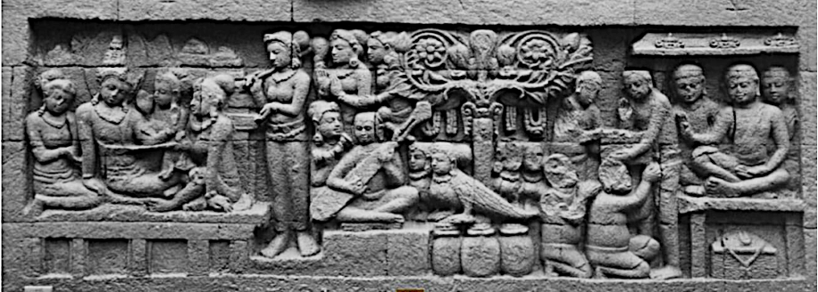

**Fig. 1. Relief Karmawibhangga Panel Number 102 (Santiko & Nugrahani, 2012)**

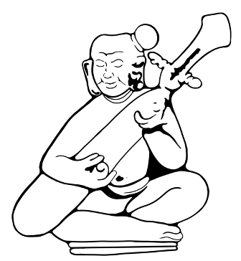

**Fig. 2. Sketch of the Two-Stringed Instrument from Karmawibhangga Relief Panel Number 102 (Sketch by the author)**

In the central part of the panel, a majestic *kalpataru* tree appears, symbolizing abundance and immortality, surrounded by four semi-divine beings (kinnara) standing gracefully atop a large vessel filled with jewelry. Further to the left, two musicians are seen sitting near the tree. One of them plays a two-stringed plucked lute-like instrument with a slender body and no neck. This instrument may have been played using a plectrum, indicating a fairly advanced playing technique for that time. The music they produce accompanies three dancers performing in front of them, creating harmony between movement and sound in the context of an offering or worship ritual. On the far left, there is a prominent figure adorned with a prabha (a sacred halo-like radiance), signifying divine status or spiritual enlightenment. This figure is surrounded by four seated women, forming a visual composition that emphasizes peace and celestial grandeur. The music being played can thus be assumed to possess a sacred nature, intended as part of a worship ritual or spiritual offering. Although the main deed or action serving as the background to the scene is not explicitly depicted, the panel may represent an act of generosity. Another interpretation suggests that the central figure might be teaching spiritual discipline, guiding followers toward the path of enlightenment and virtue.

Below is the triadic semiotic analysis table for Karmawibhangga Relief Panel Number 102.

**Table 1. Triadic Semiotic Analysis of Karmawibhangga Relief Panel Number 102**

|  |  |  |  |
| --- | --- | --- | --- |
| No | Representamen | Object | Interpretant |
| 1 | Three priests seated on a roofed bench | Spiritual leaders or teachers | A symbol of religious authority and the center of Dharma transmission |
| 2 | Jar-shaped container and chest with triangular lid in the lower right part of the relief | Storage for valuables or ritual equipment | Symbolizes prosperity, sacred offerings, or spiritual hierarchy |
| 3 | A small-bodied figure squatting with head tilted upward, receiving something from the priest | A priest performing a good deed for a commoner | Represents vertical social structure: commoners or servants present as devotees or supporters in major ceremonies |
| 4 | A figure raising a hand in a gesture of giving or presenting something to another | Social interaction, giving instructions or blessings | Representation of mutual respect and a hierarchy of knowledge or authority |
| 5 | A male figure sitting cross-legged playing a lute (similar to a two-stringed *sape*) (Kunst, 2013) | Musical practice in a ritual or sacred context | Music is positioned as a vital element in sacred events; the instrument symbolizes emotional or spiritual expression |
| 6 | A large tree adorned with leaves and flowers rising in the center of the relief composition | Sacred nature, the Bodhi tree or *kalpataru* (wish-fulfilling tree) | The tree as a cosmic center and symbol of fertility and spirituality, representing the connection between the earthly and divine realms |
| 7 | A large bird sitting on a jar, facing the musician | *Kinnara* as a spiritual being | Representation of the connection between the lower and upper worlds; a symbol of beauty or musical rhythm |
| 8 | Female accessories: hair bun, bangles, large earrings, and head ornaments (*makuta*) (Hertiasa et al., 2021) | Status marker in the narrative (nobility, high rank) | Indicates social stratification in Javanese society and a distinct gender representation where women are dressed lavishly for important events |
| 9 | Several women dancing in standing poses and one accompanying the musician | Ritual or devotional dance | A symbol of spiritual offering through movement |
| 10 | A figure sitting cross-legged on a stage with a halo-like light (*prabha*) around the head, surrounded by standing and seated figures (Ānandajoti, 2023) | An enlightened being or sacred figure | A symbol of high spirituality and divine birth in the heavenly realm (Heaven of sensual pleasures) |
| 11 | The posture and gaze direction of the figures on the left side of the relief surrounding the central figure | Narrative focus on the central figure or key event | This dramatic emphasis shows Borobudur’s visual narrative technique to guide interpretation toward the scene’s core meaning |
| 12 | Lack of significant facial expressions | A culture of calmness, self-control, and sacred atmosphere | Represents Buddhist ethical values such as inner peace and compassion |

**3.2 Visual Identification of Lute Instruments in Karmawibhangga Relief Panel Number 125**

Panel series number O 125 presents a scene that portrays a majestic and elegant atmosphere, in which a male figure appears as the central character. This figure is dressed in luxurious clothing and adorned with a crown, a symbol of high status, possibly representing a noble or divine character. He sits gracefully on a roofed bench (an element often associated with honor or a place of distinction) and surrounded by four women also seated nearby, creating a composition that emphasizes both grandeur and intimacy among the figures.

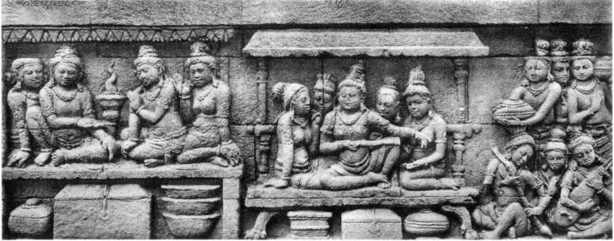

**Fig. 3. Relief Karmawibhangga Panel Number 125 (Santiko & Nugrahani, 2012)**

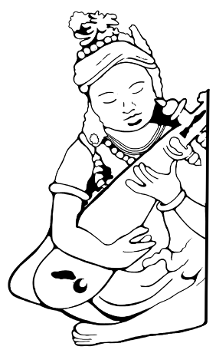

**Fig. 4. Sketch of Lute Player from Karmawibhangga Relief Panel Number 125**

**(Sketch by the author)**

To the right of the central group, three additional seated figures are depicted. Two of them are engaged in playing musical instruments, while the third, who holds no instrument, is presumably functioning as a vocalist or vocal accompanist within the ensemble. One musician is seen playing a three-stringed plucked lute characterized by a slender body and an elongated neck. On the left side of this arrangement, another individual is depicted performing on a barzither, a type of chordophone commonly employed for melodic purposes in ancient musical ensembles. The musical performance illustrated in this relief likely served functions of entertainment or ritual offering, imbued with symbolic significance. Notably, the panel includes two short inscriptions: the first, susvara, translates as “beautiful sound,” and the second, Mahojaskasamavadhana, can be interpreted as “a group of exalted individuals” or “a class of noble authority”.

The following section presents a triadic semiotic analysis of Karmawibhangga relief panel number 125.

**Table 2. Triadic Semiotic Analysis of Karmawibhangga Relief No. 125**

|  |  |  |  |
| --- | --- | --- | --- |
| No | Representamen | Object | Interpretant |
| 1 | Two figures seated cross-legged in the lower right playing plucked string instruments (Kunst, 2013) | Musicians and their instruments: lute and bar-zither | Music as a vital element in ritual or spiritual communication; symbolizes harmony and accompaniment in religious contexts |
| 2 | Simpler clothing worn by individuals in the lower section (Santiko & Nugrahani, 2012) | Common people | Denotes social distinction between elites and the general populace |
| 3 | A figure carrying a large round container with a lid | Bearer of offerings or food | A symbol of service or reverence toward the central figure |
| 4 | A group of women seated beside the central figure, adorned with headdresses and jewelry | Disciples, followers, or community members | Indicates hierarchical social structure; their interaction reflects respect or submission to the central figure |
| 5 | Two central and left-positioned figures with the right leg folded upward and the left leg folded sideways | Central figure, father, husband, king, or leader | Represents the highest authority |
| 6 | Boxes, containers, and bowls in the lower section | Ritual implements or storage for sacred objects | Signifies a ritualistic or spiritual context; denotes acts of offering or spiritual instruction |
| 7 | A central figure seated on a long bench, body turned sideways, hand pointing toward the musical performance | Leader, priest, or spiritual authority | Embodies authority, center of knowledge, and symbol of wisdom; seated posture emphasizes central status in a scene concerning the appreciation of beautiful music |
| 8 | Roofed and columned architectural structure above the central figure | Sacred space or hall for a significant individual | Highlights the setting as a distinguished and sacred space |
| 9 | Cross-legged seated posture and folded hands on several figures | Gesture of respect, listening, or submission | Reflects proper conduct in the socio-religious system of ancient Javanese society |
| 10 | Absence of flora or natural landscape | Indoor spatial focus | Emphasizes a formal, ceremonial, or spiritual interior setting rather than an outdoor or natural one |
| 11 | Calm and non-caricatured facial expressions | Buddhist self-restraint | Represents Buddhist values such as patience and compassion |
| 12 | Absence of decorative flora or fauna | Narrative focus on human action | Suggests that the relief emphasizes ethical-social relationships over cosmological themes |
| 13 | Inscription above the central part of the panel  (Ānandajoti, 2023) | susvara | “Beautiful sound” referring to the quality of the music performed |
| 14 | Inscription above the left part of the panel  (Ānandajoti, 2023) | Mahāujaska-samavadhāna | having the society of distinguished people, |

**3.3 Visual Identification of Lute Instruments in Karmawibhangga Relief Panel Number 151**

On panel O 151, the inscription svarga is carved, explicitly indicating that the scene depicted represents a heavenly realm. The central figure in the composition is a male character, most likely a deity or divine being, as suggested by his elevated status and central positioning. He is seated on a bench, accompanied by two women. One of the women is seen holding the male figure’s hand, possibly signifying an emotional bond or an act of devotion, while the other appears to be grooming her hair and holding a mirror.

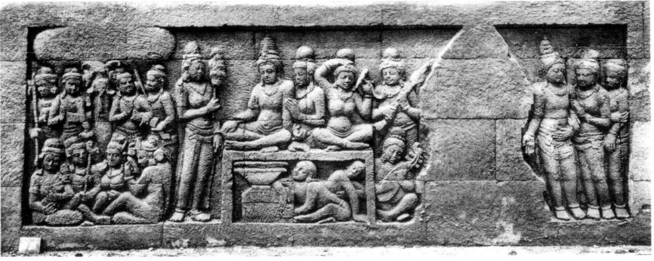

**Fig. 5. Relief Karmawibhangga Panel Number 151 (Santiko & Nugrahani, 2012)**

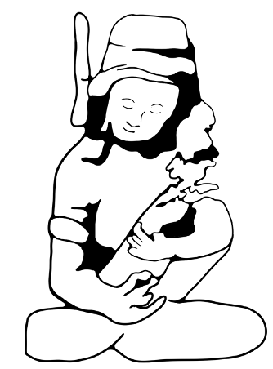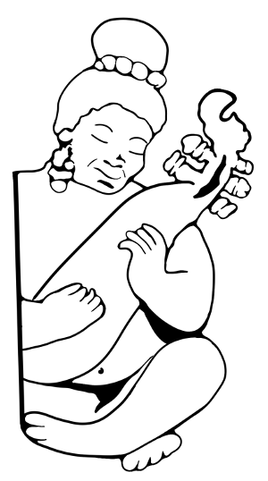

**Fig. 6. Sketch of Lute Player from Karmawibhangga Relief Panel Number 151**

**(Sketch by the author)**

In front of the three central figures, two individuals are seated directly on the ground, gazing toward the central character. The performance depicted consists of two musical ensemble groups. The first group features a figure playing a five-stringed lute and another playing a bar-zither. This group is situated beneath a tree presumed to be a *kalpataru*, although the carving details appear to be unfinished. The second ensemble group includes musicians shown both standing and sitting. The first member holds a bar-zither as a melodic instrument; two others play the damaru, a small rhythmic instrument commonly used in ritual contexts; and another holds an additional bar-zither also used for melodic accompaniment.

Additionally, there is a group of seated musicians. One is seen holding a bow, most likely used to play a melodic bowed instrument. Another figure does not carry an instrument and may serve as a vocalist. The remaining two musicians each play a bar-zither and a lute. In front of the main figure, a standing woman is depicted fanning him with a gesture, representing service or devotion to a sacred figure. Continuing the scene, a man accompanied by two women is shown walking toward a sacred building, which may indicate a religious procession or transition to a site of worship.

The following is a triadic semiotic analysis table for Karmawibhangga relief panel number 151.

**Table 3. Triadic Semiotic Analysis of Karmawibhangga Relief No. 151**

|  |  |  |  |
| --- | --- | --- | --- |
| No | Representamen | Objek | Interpretant |
| 1 | Three figures walking toward a building | Pilgrimage or journey to a temple | Closure of the visual narrative: indicates devotion directed toward a sacred place |
| 2 | Two figures beside the central character holding a fan and stringed instrument | Attendants or musicians accompanying the main figure | Sign of reverence, entertainment, or devotion to the central figure |
| 3 | Oval-shaped plucked instrument played by a seated figure in the bottom right corner.  (Ferdinandus, 2001) | A lute resembling the sape | Suggests a sacred or courtly entertainment setting |
| 4 | A cross-legged figure on an elevated platform adorned with jewelry and a crown, surrounded by seated and standing figures | Central figure in an honored position, presumed to be a king or spiritual leader | Symbol of authority or sanctity; the spiritual focal point of the community |
| 5 | Two women beside the male figure, depicted with gestures of touch and beautification | Divine attendants or celestial maidens | Symbol of heavenly beauty and the aesthetic role of women in the spiritual realm |
| 6 | Two small figures beneath the platform, looking up at the central figure | Servants, guardians, or representations of the lower stratum | Indicates a hierarchy in relation to the spiritually elevated figure |
| 7 | Group of standing figures on the left side of the relief with various gestures | Audience, followers, or community members | Indicates interaction, communal life, and the value system surrounding the central figure |
| 8 | Elaborate head ornaments and luxurious clothing on certain figures | Indicators of status and authority | Interpretation of social stratification; symbols of honor and elite roles in society |
| 9 | Musicians on the left side of the relief facing each other rather than the central figure | Musical ensemble | Emphasizes the importance of inter-musician communication in producing harmonious music |
| 10 | Inscription above the relief panel  (Santiko & Nugrahani, 2012) | Heaven/svargga | Indicates the scene is set in a spiritual realm, providing a transcendental context for the entire panel |
| 11 | Large tree in the background | Kalpataru (Tree of Wish Fulfillment) | Cosmic symbol of abundance and the link between the spiritual and material worlds |
| 12 | Small drum  (Kunst, 2013) | Rhythmic instrument (damaru) | Rhythm in ritual music; commonly used in Southeast Asian religious contexts |
| 13 | One bar-zither player standing, holding the melodic instrument vertically | Vertical bar-zither | Indicator of technical variation and complexity within the celestial ensemble |
| 14 | Bow stick | Bowed instrument (similar to a rebab) | The presence of a bowed instrument suggests deep melodic expression |
| 15 | One ensemble member without an instrument | Vocalist | The role of the voice in spiritual music; enhances the devotional atmosphere through singing |

**3.3. Discussion**

The depiction of the lute instrument in various contexts within the Karmawibhangga reliefs highlights the significance of music in multiple aspects of ancient Javanese life. The lute is notably absent in scenes portraying the activities of common people. The Borobudur sculptors employed other instruments to illustrate musical practices among the general populace, such as flutes, drums, mouth organs, cymbals, and other idiophonic instruments. This can be observed from street musicians depicted in Reliefs 39, 52, and 53, who are shown performing music in the context of popular entertainment for the common people. The lutes depicted in panels O 102, O 125, and O 151 of Borobudur represent more than mere musical instruments; they are cultural artifacts reflecting the social structure, spiritual values, and aesthetic expressions of 9th-century Javanese society. The presence of the lute in both religious and courtly settings suggests that this instrument held a prominent role in spiritual realms, ceremonial life, and noble entertainment.

Panel O 102 narrates teachings on the "Ten Deeds Leading to Rebirth in the Sensuous Heaven" which is associated with divine splendor and spiritual abundance. Elements such as the kalpataru tree and the presence of kinnara figures serve as indicators that the actions depicted in this scene culminate in the merit of rebirth within one of the sensuous heavenly realms. Kalpataru originates from the Sanskrit terms "kalp," meaning desire or wish, and "taru," meaning tree. As such, Kalpataru is regarded as a mythical tree believed to grant all human desires and necessities (Soekmono, 1973). Furthermore, it also serves as a symbol of the heavenly realm, wealth, and prosperity (Halim & Herwindo, 2017). The kinnara figure frequently appears in the reliefs as a symbolic indicator of a heavenly atmosphere. Several panels specifically reliefs no. 101, 102, 126, 130, 134, 137, 143, 147, 149, 155, and 160 depict kinnaras to illustrate scenes of celestial realms (Ānandajoti, 2023). Likewise, the presence of a radiant halo behind certain figures, as seen in reliefs 85, 106, and 129, serves to emphasize the sanctity or spiritual prominence of the central characters portrayed. Virtuous deeds are illustrated in the right section of the relief, while their spiritual rewards are depicted on the left.

In a social context, the lute is associated with the learned class, priests, nobility, and court musicians. In panel O 125, the lute is played in a royal setting by a musician accompanying a majestic figure adorned with a crown and luxurious garments, seated among four noblewomen. This suggests that the lute was part of musical performances reserved for the elite, functioning as both entertainment and a marker of social status. Lakusa (2021) asserts that the representation of music in the Borobudur reliefs reflects social stratification and the role of music across various layers of society. At the top of the panel, there are approximately 50 short inscriptions written in Old Javanese script using Sanskrit words (santika), serving as guides for the sculptors (Santiko & Nugrahani, 2012). The analysis of this panel is greatly supported by the presence of two inscriptions above the relief. One of the carvings reads *susvara*, meaning “melodious sound.” The scene depicts a figure seated on a pavilion, surrounded by consorts and listening to music. The inscription on the left reads *mahaujaska-samavadhāna* (meeting with a truly great one), which closely parallels *maheśākhyaiḥ samāgamo* (gathering with noble persons). These texts add interpretive depth to the scene, reinforcing the idea that the male central figure and his entourage are exalted (possibly divine) figures, and affirming the close relationship between music, social status, and the representation of authority within the spiritual-cultural framework of ancient Java.

Nevertheless, in panel O 151, the lute appears in a more religious and sacred context. Music is performed in the presence of a divine or celestial figure seated among female attendants. In this relief, the lute forms part of a devotional ensemble that reinforces a heavenly atmosphere, illustrating how sound was regarded as a spiritual offering. The presence of the inscription *svargga* (heaven) in this panel further affirms that the lute was not merely played for entertainment, but held ritualistic and religious symbolic functions (Santiko & Nugrahani, 2012).

The overall visual composition of this relief suggests a celestial life filled with music, reverence, and spiritual service. This semiotic indicator underscores that all the visual events depicted in the relief are closely related to heavenly realms. Hence, the musical elements portrayed therein can be strongly interpreted as sacred music, performed within contexts of worship or spiritual offerings. Panel O 102 even features a musician playing a two-stringed lute in front of a figure adorned with a prabha (a halo symbolizing holiness or celestial status). The presence of the kalpataru tree and kinnara figures further reinforces the interpretation that the lute contributes to an idealized celestial ambiance, embodying harmony, virtue, and devotion (Iswahyudi, 2021). Within the Mahayana Buddhist religious framework that influenced Borobudur, rebirth in Indra's heaven is envisioned through celestial music, where the lute serves as an icon of sound guiding the soul toward a higher realm. In addition to its spiritual symbolism, the presence of the lute may also reflect social stratification within ancient Javanese society, where musical performance and specific instruments could denote elite cultural practices or status markers. Considering the broader narrative of the Karmawibhangga Relief the lute might simultaneously function as a symbol of both sacred aspiration and worldly privilege. Its representation alongside figures of high status or divine association suggests that the instrument held layered meanings, bridging the human and celestial domains.

The lute represents the sound of the universe channeled by humans in their quest to connect with noble values. In the 9th-century Javanese religious and cultural context, the lute held a spiritual position, accompanying not only bodily movement (dance) and speech (chanting), but also the motion of the soul toward heightened consciousness. The lute is the sound that unites human beings with gods, celestial beings, and the eternal beauty of the cosmos. These findings align with earlier studies that emphasize the importance of music in Southeast Asian religious traditions, where sound is not merely an aesthetic form but also a medium with spiritual power (Becker, 2004).

When examining instruments similar to the lute in relief 102, ethnoarchaeological research may provide deeper insights, as in Kalimantan, there exists a two-stringed plucked instrument used in sacred ceremonies. This instrument, called Sape, originates from the Dayak Kayaan people and is played during the *dange*, a ritual thanksgiving ceremony following the harvest (Prastiwi & Wulandari, 2022). The Sape shares remarkable similarities in form and technique with the instrument depicted in the relief. This interpretation is further supported by Hindu traditions, in which the goddess Saraswati is commonly portrayed alongside a lute instrument. Such comparisons allow us to situate the Borobudur lute within the broader cultural ecology of Southeast Asia (Kartomi, 1993). The idea of cross-cultural exchange and musical knowledge transfer is further supported by mappings of early Southeast Asian musical development, particularly how interregional influences occurred through trade routes, religious migration, and royal patronage (Nicolas, 2011). Therefore, Kunst's claim regarding the resemblance between the Borobudur instrument and those from other regions gains a broader historical foundation.

**4. CONCLUSION**

This study reveals that the depiction of the lute in the Karmawibhangga reliefs of Borobudur Temple is not merely a representation of a musical instrument, but carries profound symbolic meanings within the socio-spiritual context of 9th-century Java. Through a Peirce semiotic analysis of relief panels 102, 125, and 151, it was found that the lute appears in various contexts, accompanying celestial dance, forming part of sacred ensembles, and symbolizing luxury and power within elite circles. The presence of two- to four-stringed lutes, often played alongside bar zithers and accompanied by singers, indicates the musical complexity of the time. These findings demonstrate that music was inseparable from the religious, social, and political practices of ancient Javanese society, serving as a medium for conveying profound meanings between the human and the transcendent realms.

Disclaimer (Artificial intelligence)

Author(s) hereby declare that NO generative AI technologies such as Large Language Models (ChatGPT, COPILOT, etc.) and text-to-image generators have been used during the writing or editing of this manuscript.

REFERENCES

Ānandajoti. (2023). Karmavibanga Sūtra. Ehipassiko Foundation.

Becker, J. (2004). Deep listeners: Music, emotion, and trancing (Vol. 2). Indiana University Press.

Ferdinandus, P. E. J. (2001). Alat musik Jawa kuno. Yayasan Mahardhika. <https://books.google.co.id/books?id=hzuKnQAACAAJ>

Halim A, Herwindo Rp. 2017. The Meaning Of Ornaments The Hindu And Buddhist Temples On The Island Of Java (Ancient-Middle-Late Classical Eras). Jurnal Riset Arsitektur 1 (2): 170-191

Haryono, T. (2008). Seni pertunjukan dan seni rupa dalam perspektif arkeologi seni. ISI Press Solo.

Hendra, S. (2020). EVOLUSI GAMELAN BALI: Dari Banjuran Menuju Adi Merdangga. In: Pusat Penerbitan LP2MPP Institut Seni Indonesia Denpasar.

Hertiasa, H., Santosa, I., Irfansyah, I., & Setiawan, P. (2021). Gesture in Visual Narrative Reliefs of Karmawibhangga Borobudur as An Ancient Javanese Locality Value. ICON ARCCADE 2021: The 2nd International Conference on Art, Craft, Culture and Design (ICON-ARCCADE 2021),

Iswahyudi, I. (2021). The Depiction of Heaven and Hell in the Karmawibangga Reliefs of Borobudur Temple: An Overview of Character Education. Randwick International of Education and Linguistics Science Journal, 2(4), 568-579. <https://doi.org/10.47175/rielsj.v2i4.344>

Kartomi, M. J. (1993). A Javanese Gamelan: Traditional Orchestra of Indonesia. By JENNIFER LINDSAY. New York: Oxford University Press, 1992. vi, 76 pp. $14.95. The Journal of Asian Studies, 52(3), 793-794.

Krom, N. J. (1927). Barabudur archaeological description. MARTINUS NIJHDFF.

Kunst, J. (2013). Music in Java: Its history, its theory and its technique. Springer.

Lakusa, N. F., & Pradoko, A. S. (2021). Representation of Buddhism Teachings in the Show Sound of Borobudur: The Reconstruction of Karmawibhangga Relief in the Age of Hyperreality. 4th International Conference on Arts and Arts Education (ICAAE 2020),

Nicolas, A. (2011). Early musical exchange between India and Southeast Asia. Early interactions between South and Southeast Asia: Reflections on cross-cultural exchange, 347-369.

Prastiwi, S. D., & Wulandari, B. J. W. (2022). Penutur tradisi lisan kayaan mendalam: mereka yang berjuang melintasi zaman. CV Media Jaya Abadi.

Santiko, H. (2016). Identification Of Karmawibhangga Reliefs At Candi Borobudur.

Santiko, H., & Nugrahani, D. (2012). Adegan dan ajaran hukum karma pada relief Karmawibhangga. Balai konservasi borobudur.

Setiawan, H. (2024). Pemaknaan tumbuhan pada relief karmawibhangga candi Borobudur : perspektif semiotika peirce Universitas Gadjah Mada]. Yogyakarta : Universitas Gadjah Mada., 2024.

Soekmono R. 1973. Introduction to The History of Indonesian Culture. Kanisius, Yogyakarta