CASE REPORT

A Case of Renal Medullary Carcinoma in a young male with sickle cell trait : Case Report and Review of Literature

Abstract
Renal medullary carcinoma is an uncommon malignancy that occurs predominantly in young males with sickle cell trait. This cancer is driven by the loss of a tumor suppressor gene called SMARCB1 which is mutated in a variety of rare childhood cancers. Due to its aggressive nature, most cases are metastatic at the time of diagnosis. Prognosis is poor with a usual survival of less than 1 year as per current available data. Treatment options are sparse mainly due to the limited knowledge on the biology of the disease. Here we present a case of metastatic renal medullary carcinoma in a 30-year-old Asian male. He underwent nephrectomy and was on chemo immunotherapy. He had very good response to treatment but progressed rapidly while on maintenance therapy after around 1 year. Enrolment in clinical trials is the best option where available for treatment of renal medullary carcinoma. More recently, with the development of genomics, newer targets and avenues of treatment are in the pipeline.

Keywords: Renal medullary carcinoma; Sickle cell trait; Clinical Trials; Young males; Aggressive

Introduction
Renal medullary carcinoma (RMC) is an aggressive malignancy of the kidneys. It usually diagnosed in young adults and adolescents. It arises centrally, in the renal medulla, grows rapidly in an infiltrative pattern and invades the renal sinuses. It is closely associated with individuals who have a sickle cell trait and more prevalent among African population. In several studies, around 80% to 90% have been associated with this trait. Males have higher risk than females.The origin and pathogenesis of renal medullary carcinoma are not completely understood. Isolated hematuria or in combination with abdominal or flank pain was the presenting sign in 66% cases. The prognosis is usually dismal. Here we report a case of a young male who was diagnosed with this rare malignancy and was treated with systemic therapy.

Case presentation
A 36-year-old male presented to us in January 2023 with a history of loin pain and hematuria for one month. He was evaluated elsewhere and found to have a renal lesion with enlarged lymph nodes and bilateral pulmonary consolidation. Biopsy done from another hospital was reported as urothelial carcinoma. A Positron emission Tomography – Computed Tomography (PET CT) scan done at our institute confirmed the above findings and also identified bone metastasis. Slide and block review at our institute did not reveal any signs of malignancy (due to depletion of material in block). In view of severity of pain and new onset massive hematuria, it was decided by our multidisciplinary team to perform a palliative right radical nephrectomy. The histopathology reportafter surgery was reported as renal medullary carcinoma with loss of INI 1 expression (Figure 1). Since it was a rare variant of renal cell carcinoma, we reviewed the literature. We found an association of it with sickle cell hemoglobinopathies. Hence, we decided to carry out hemoglobin electrophoresis and it revealed a sickle cell trait. Foundation 1 CDx testing was done which showed abnormality in SMARCB1 as quoted in previous literature and the tumor proportion score was 95%. He was initiated on chemo-immunotherapy with Gemcitabine, Carboplatin, and Pembrolizumab. Bone metastasis was given palliative radiation before start of chemo-immunotherapy at the site of maximum pain. His response evaluation with PET CT scans after 3 cycles showed a complete metabolic response (Figure 2A and Figure 2B). On further follow up, he was continued on chemo immunotherapy and completed 6 cycles. He was continued on immunotherapy maintenance and completed almost 1 year of the same. Subsequently, developed clinical and radiological progression on maintenance immunotherapy. His general condition deteriorated and succumbed to his illness.
Discussion
RMC is an uncommon tumor; it comprises around 0.5% of the diagnosed renal malignancy (1). As a matter of fact, the prevalence of RMC may be underestimated because it is difficult to differentiate it from other rare and aggressive renal cancers such as collecting duct carcinomas (2). Moreover, due to the close association of sickle cell trait with RMC, the exact prevalence cannot be established in areas where the former is endemic. Some cases have also been reported in association with sickle cell anemia and beta-thalassemia (3, 4). Male gender is affected more disproportionately (2:1) and there is a higher predilection to affect the right-sidedrenal system (1,3).Due to all these reasons, the availability of data on RMC is scarce.
The pathogenesis of RMC has not been clearly elucidated. In individuals with sickle cell trait, it is believed that the trigger is chronic hypoxia affecting the renal medullary system as a result of sickled red blood cells. In the molecular level, loss of SMARCB1/INI1 in the switch/sucrose nonfermentable (SWI/SNF) complex, is a salient finding in RMC (5). This complex is a key mediator in cellular transcriptional modulation. The cell of origin of RMC is unknown but it has close resemblance with collecting duct carcinomas. Pathologically, it is identified as an infiltrative tumor extending beyond the renal pelvis with associated sickled red blood cells in certain cases (where sickle cell trait is associated). Evidences from radiographic and pathologic findings suggests that renal medullary carcinoma probably originates in the calyceal epithelium in or near the renal papillae (6). In a series of 7 cases from Brazil (where sickle cell trait may be endemic), they noted one child survived 8 years after diagnosis. They suggested that periodic search for renal medullary carcinoma in young patients who have known abnormalities of the hemoglobin gene and hematuria could result in an early diagnosis and a better survival (7).The loss of SMARCB1/INI1, which results in the loss of protein expression, is identifiable by immunohistochemistry and is almost sine qua non to the diagnosis.
The usual presentation is with hematuria and flank painin a young adultidentical to other renal tumors. Imaging in these patients commonly reveals a kidney mass and associated satellite lesions with intra-tumoral necrosis.
At the time of diagnosis, the majority of patients have a metastatic disease.Typical computed tomography features include a central renal location, often with involvement of the renal cortex and renal sinus, an infiltrative and heterogeneous appearance. The prognosis is dismal and the treatment intent is usually palliative. A caseseries by Davis et al (8) showed a median survival of around 4 months. Even with chemotherapy and surgery, outcomes remain dismal, with a median survival of approximately1 year. The RMC working panel has suggested that debulking nephrectomy is still a standard of care and should be considered before or after systemic chemotherapy (1). In a multicenter collaborative study that collected data from 56 patients with RMC, nephrectomy and systemic chemotherapy had superior overall survival than systemic chemotherapy alone (16.4 versus 7.0 months) (P < .001) (9).
Our patient also had a similar history of disease as reported in prior literature. The disease had a good control for around 1 year after which there was sudden progression.
Every newly diagnosed patient of RMC is a candidate for clinical trial. . Cytotoxic chemotherapy with platinum-based regimens has demonstrated partial to complete responses with marginal clinical benefits; but these responses are usually short lived. Systemic therapy regimens commonly used to treat metastatic urothelial carcinoma, such as gemcitabine and platinum agents, are utilized in management of RMC.A case series by Shah et al of 52 patients reported a response rate of 29 % to chemotherapy (10). In the era of immunotherapy, checkpoint inhibitors have also been tried in clinical trials and selected cases.PD-L1 is responsible for T cell activation, proliferation, and cytotoxic secretion, PDL-1 inhibitor nivolumab is potential target for RMC (11). One case report of patient with metastatic RMC who was treated with nivolumab after recurrence following initial nephrectomy and six adjuvant cycles of cisplatin-based chemotherapy showed a progression free survival (PFS) of 15 months(11). In another report, the patient had PFS of 9 months (12). Another study of advanced rare cancers with pembrolizumab included 4 cases of RMC. Responses were noted but further follow up was not available (13, 14). All these reports suggest the potential role of immuno-oncology drugs in RMC.Moreover, pathologic evaluation of RMC has shown presence of abundant amount of tumor-infiltrating lymphocytes, which are predictive of response to immunotherapy in several other tumor types (3). Our patient also had a good response to immunotherapy as available with scarce literature but it was short lived suggesting the aggressive nature of the RMC.SMARCB1/INI1-deficient tumors demonstrate increased EZH2 activity; in view of this, the efficacy of the EZH2 inhibitor, tazemetostat, against SMARCB1/INI1-negative tumors is being tested (as a tumor agnostic therapy), including RMC (15). Vascular endothelial growth factor–directed treatment and mammalian target of rapamycin inhibitor have yielded minimal benefit in patients with RMC (1).The high level of VEGF is a bad predictive marker, and considered as one of peptides with angiogenic properties (16). Some trials are trying proteasome inhibitors like bortezomib and ixazomib in the treatment (6).Unfortunately, as evident from the discussion, the scarcity of RMC patients precludes their enrollment in clinical trials and is an obstacle for formulating larger clinical trials. Hence, it is paramount that these cases be included in clinical trials of rare tumors or renal cancers of other histological subtypes.
Conclusion
RMC is a rare but devastating malignancy that most often presents in young adults with sickle cell traits. It is characterized by loss of SMARCB1/INI1 expression and the true incidence is unknown. The mainstay of treatment of metastatic RMC is surgery and consideration for enrollment in a clinical trial if available or for systemic platinum-based chemotherapy with or without immunotherapy (as with other urothelial cancers). Newer avenues of treatment including targeted therapies and immunotherapy are in the pipeline for improving the prognosis of RMC.

Disclaimer (Artificial intelligence)
Option 1:
Author(s) hereby declare that NO generative AI technologies such as Large Language Models (ChatGPT, COPILOT, etc.) and text-to-image generators have been used during the writing or editing of this manuscript.

Consent
As per international standards or university standards, patient(s) written consent has been collected and preserved by the author(s).

Footnotes - Informed consent for publication has been obtained
Reference
- Beckermann KE, Sharma D, Chaturvedi S, et al. Renal Medullary Carcinoma: Establishing Standards in Practice. J OncolPract. 2017;13(7):414-421. doi:10.1200/JOP.2017.020909
- Amin MB, Smith SC, Agaimy A, et al: Collecting duct carcinoma versus renal medullary carcinoma: An appeal for nosologic and biological clarity. Am J SurgPathol 38:871-874, 2014
- Alvarez O, Rodriguez MM, Jordan L, et al: Renal medullary carcinoma and sickle cell trait: A systematic review. Pediatr Blood Cancer 62:1694-1699, 2015
- Hakimi AA, Koi PT, Milhoua PM, et al: Renal medullary carcinoma: The Bronx experience. Urology 70:878-882, 2007
- Calderaro J, Masliah-Planchon J, Richer W, et al: Balanced translocations disrupting SMARCB1 are hallmark recurrent genetic alterations in renal medullary carcinomas. EurUrol 69:1055-1061, 2016
- Holland P, Merrimen J, Pringle C, Wood LA. Renal medullary carcinoma and its association with sickle cell trait: a case report and literature review. CurrOncol. 2020;27(1):e53-e56.
- Watanabe IC, Billis A, Guimarães MS, Alvarenga M, de Matos AC, Cardinalli IA, Filippi RZ, de Castro MG, Suzigan S. Renal medullary carcinoma: report of seven cases from Brazil. Mod Pathol. 2007 Sep;20(9):914-20.
- Su Y, Hong AL. Recent Advances in Renal Medullary Carcinoma. Int J Mol Sci. 2022 Jun 26;23(13):7097.
- Iacovelli R, Modica D, Palazzo A, et al: Clinical outcome and prognostic factors in renal medullary carcinoma: A pooled analysis from 18 years of medical literature. Can UrolAssoc J 9:E172-E177, 2015
- Shah AY, Karam JA, Malouf GG, et al: Management and outcomes of patients with renal medullary carcinoma: A multi-center collaborative study. BJU Int 10.1111/bju.13705
- Sodji Q, Klein K, Sravan K, Parikh J. Predictive Role of PD-L1 Expression in the Response of Renal Medullary Carcinoma to PD-1 Inhibition. J Immunother Cancer (2017) 5(1):62.
- Beckermann KE, Jolly PC, Kim JY, Bordeaux J, Puzanov I, Rathmell WK, et al. Clinical and Immunologic Correlates of Response to PD-1 Blockade in a Patient With Metastatic Renal Medullary Carcinoma. J Immunother Cancer (2017) 5:1.
- Naing A, Meric-Bernstam F, Stephen B, et al. Phase 2 study of pembrolizumab in patients with advanced rare cancers [published correction appears in J Immunother Cancer. 2020 Apr;8(1):e000347corr1. doi: 10.1136/jitc-2019-000347corr1.]. J Immunother Cancer. 2020;8(1):e000347.
- Bhardwaj, T., Hiwale, K. M., &Vagha, S. (2021). Renal Cell Carcinoma Clear Cell Variant with Chromophobe Differentiation -A Rare Case Presentation. Journal of Pharmaceutical Research International, 33(62B), 479–485.
- Haupt T, Akinyemi O, Raju RA, et al. Renal Medullary Carcinoma: A Surveillance, Epidemiology, and End Results (SEER) Analysis. J Surg Res. 2023;292:1-6.
- Ferrara N. VEGF as a therapeutic target in cancer. Oncology 2005; 69(Suppl):11–16.

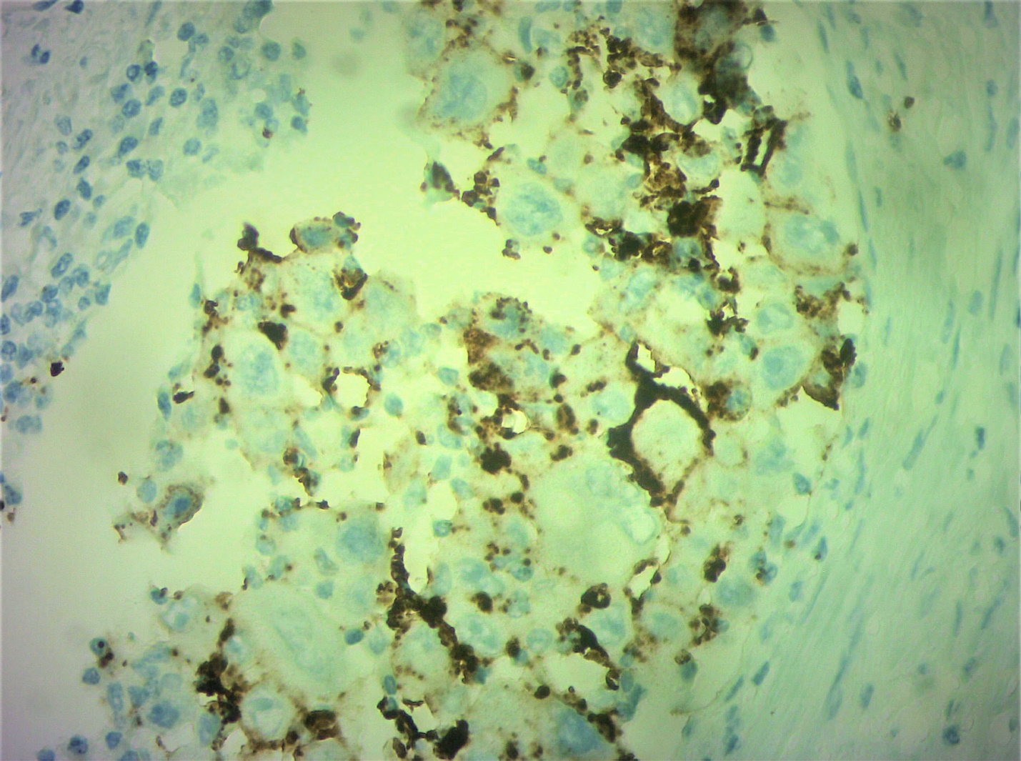
Fig 1-Histopathology slide of Renal medullary carcinoma showing loss of INI 1 expression

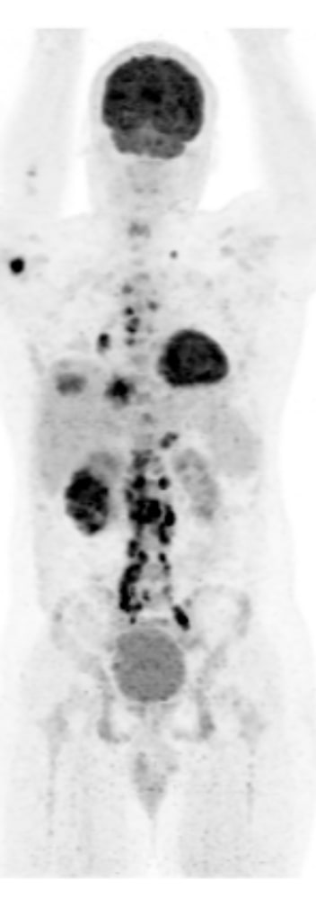
Fig 2A-PET CT scan of the patient prior to treatment showing the disease burden
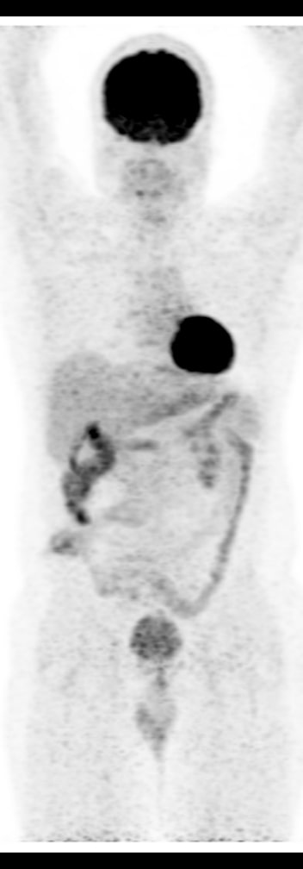
Fig 2B-PET CT scan=taken after 3 cycles of chemo-immunotherapy

