***In-vitro* Analysis of Antifungal Plant Extracts Against Late Blight Disease Causing *Phytophthora infestans***

**Abstract**

Late blight, caused by *Phytophthora infestans*, is a devastating disease affecting solanaceous crops *viz.,* potato and tomato, leading to significant economic losses globally. The increasing resistance of *P. infestans* to synthetic fungicides and the associated environmental concerns have necessitated the search for eco-friendly alternatives. In this study, an *in vitro* evaluation was conducted to assess the antifungal efficacy of selected plant extracts against *P. infestans*, employing five different formulations. The present *in-vitro* study evaluated the antifungal efficacy of aqueous leaf extracts from three plants *viz., Carica papaya*, *Syzygium cumini*, and *Lantana camara* which had formulated into five different treatments (T1 to T5). The combination of the used plant extract in each treatment in the order of *Carica papaya*, *Lantana camara*, *Syzygium cumini* is as follows, T1 (6:3:4), T2 (3:5:6), T3 (2:6:8), T4 (4:4:4) and T5 (4:8:2) and 10% W/V of chemical fungicide (Carbendazim) is served as control. The antifungal activity was assessed using the agar well diffusion method, with the zone of inhibition serving as an indicator of efficacy. The control showed a mean inhibition zone of 1.15 ± 0.17 cm. Among the treatments, T5 exhibited the highest antifungal activity with a zone of inhibition of 1.925 ± 0.70 cm, followed by T2 (1.700 ± 0.24 cm), T4 (1.200 ± 0.53 cm), T3 (1.125 ± 0.09 cm), and T1 (1.075 ± 0.32 cm). The enhanced performance of T5 and T2 indicates that certain combinations or concentrations of these aqueous extracts may contain bioactive phytochemicals capable of inhibiting the mycelial growth of *P. infestans*. These findings demonstrate the potential of water-extracted botanicals as effective, eco-friendly, and affordable biocontrol agents. The use of such natural products can significantly contribute to sustainable plant disease management. Further phytochemical characterization and field-based trials are warranted to validate the efficacy and scalability of these formulations for practical agricultural applications.

**Key words**: Antifungal Plant extracts, Antifungal activity, *Phytophthora infestans*, *Solanum lycopersicum.*

**Introduction**

Late blight, caused by the oomycete *Phytophthora infestans*, severely affects solanaceous crops like potato and tomato, causing major yield losses worldwide. Its rapid disease cycle, capacity to reproduce both sexually and asexually, and ability to develop resistance to fungicides make it a major threat to global food security (Fry *et al.* 2015). In particular, *P. infestans* was responsible for the infamous Irish Potato Famine in the 1840s and continues to cause significant crop damage today, especially in developing nations with limited access to resistant cultivars and effective fungicides (Haverkort *et al.* 2008).

While synthetic fungicides remain a major control strategy, their intensive and prolonged usage has resulted in several problems including environmental pollution, toxicity to non-target organisms, and the emergence of resistant strains of pathogens. Hence, there is an urgent need to explore alternative approaches that are safer, cost-effective, and eco-friendly. Among such strategies, the use of plant-based extracts has gained renewed interest due to their richness in secondary metabolites *viz.,* alkaloids, flavonoids, terpenoids, and phenolics, which are known to possess antifungal and antimicrobial properties (Bukar *et al.* 2010). It had been reported that *Azadirachta indica* extracts have anti-fungal property which helps in controlling the growth of *Phytophthora infestans* growth in Pigeon Pea (*Cajanus cajan* L. Hugh) (Nwokeji *et al.* 2023). In this context, the present study investigates the antifungal potential of aqueous crude extracts from three plants *viz., Carica papaya* (papaya), *Syzygium cumini* (jamun) and *Lantana camara* against *Phytophthora infestans* under *in vitro* conditions. *Carica papaya* is rich in bioactive compounds *viz.,* papain, chymopapain, and phenolic acids, which have been shown to possess antifungal properties (Akinpelu and Aiyegoro 2004). *Syzygium cumini* contains powerful phytochemicals like ellagic acid, flavonoids, and anthocyanins, known for their broad-spectrum antimicrobial activity (Chaudhary and Mukhopadhyay 2012). *Lantana camara*, often labelled an invasive species, has also been reported to possess significant antifungal properties due to its triterpenoids and flavonoids (Deena and Thoppil 2000). Despite the reported antimicrobial potential of these plants, limited studies have addressed their efficacy specifically against *P. infestans*, particularly using aqueous extracts. Aqueous extracts are preferable in sustainable agricultural practices as they are safe, environmentally benign, and do not rely on harmful organic solvents (Rai and Carpinella 2006). In this article, we present an *in vitro* evaluation of the antifungal efficacy of aqueous extracts of *Carica papaya*, *Syzygium cumini*, and *Lantana camara* against *Phytophthora infestans*. The study comprises the preparation of plant extracts, assessment of antifungal activity based on the zone of inhibition, and statistical analysis of the data. This research contributes to the identification of potent plant-based antifungal agents that may supplement or replace synthetic fungicides in managing late blight disease. Ultimately, the findings aim to promote the adoption of natural, cost-effective, and sustainable plant protection strategies in crop production systems.

**MATERIALS AND METHODS**

**Selection and Collection of plant materials:**

The present work was designed to prepare a non-toxic, cost efficient and eco-friendly herbal consortia for controlling the late blight disease in tomato plants. For that, the plants are selected which are commonly available and have high anti-fungal activity. The selected plants are:

List 1 : **Selection and Collection of plant materials**

|  |  |  |
| --- | --- | --- |
| **S.No.** | **NAME OF THE PLANT USED** | **PLANT PARTS USED** |
| **1** | *Carica papaya* | Leaves |
| **2** | *Lantana camara* | Leaves |
| **3** | *Syzygium cumini* | Leaves |

Based on the literature the above-mentioned plants and its parts have been selected and used for the preparation of the anti-fungal herbal consortia to inhibit the growth of *Phytophthora infestans* which cause late blight disease in tomato plant. From the selected plant material which is mentioned above, mature and healthy leaves have been collected.

**Preparation of Herbal Consortia:** (Bhupendra, 1999)

The collected plant materials (leaves) were washed with running tap water inorder to remove the dirt and the prominent mid veins in the leaves has been removed using the scissors. Then the leaves are chopped into small pieces by using the knife and dropped into the mixer jar. To that chopped leaves, 30 ml of water and 2 ice cubes (to prevent from denaturing of phytochemicals or secondary metabolites) was added and finely grounded using the mixer. Then the homogenate was filtered by using the 3 to 4 layers of muslin cloth. Then the aqueous extract or the filtrate was stored in glass bottle and refrigerated at 40C till have to be used.

**Culturing of Pathogen from Diseased Plant Material:** (Basharat, 2022)

To obtain a pure culture of *Phytophthora infestans*, tomato leaves exhibiting characteristic symptoms of late blight infection *viz.,* water-soaked lesions, chlorosis, and sporulation—were carefully collected from infected plants in the field. The collected leaf samples were initially rinsed under running tap water to remove soil, debris, and other surface contaminants. Subsequently, surface sterilization was performed using 0.1% sodium hypochlorite (NaOCl) solution for exactly one minute to eliminate epiphytic microorganisms while retaining internal fungal pathogens. Following sterilization, the leaf samples were thoroughly rinsed three times with sterile distilled water to remove any residual chlorine that might interfere with fungal growth.

After surface sterilization, small leaf segments (approximately 5 mm × 5 mm) were excised from the lesion margins using a sterile scalpel under aseptic conditions. These segments were then aseptically transferred into 100 mL of Potato Dextrose Broth (PDB) medium contained in sterilized Erlenmeyer flasks. The inoculated flasks were incubated at a controlled temperature of 25 ± 2 °C for a period of 48 hours without agitation to promote the establishment and growth of *P. infestans*.

After the incubation period, visible fungal mycelial mats were observed forming within the broth, indicating successful proliferation of the pathogen. These mycelial cultures were carefully harvested and used as inoculum for subsequent *in vitro* antifungal assays to evaluate the efficacy of selected aqueous plant extracts. The entire culturing process was conducted under sterile conditions to prevent contamination and ensure the purity of the fungal culture.

**Antifungal activity:** (Bidaud *et.al.,* 2021)

To evaluate the antifungal efficacy of aqueous plant extracts, an *in vitro* assay was conducted using the agar well diffusion method. Initially, a pure culture of *Phytophthora infestans* was maintained in Potato Dextrose Broth (PDB) under optimal conditions to ensure active mycelial growth. For the assay, 250 mL of Potato Dextrose Agar (PDA) medium was prepared by mixing dehydrated PDA powder in distilled water, and the solution was sterilized in an autoclave at 121 °C for 15 minutes. The sterilized medium was then allowed to cool slightly before being aseptically poured into pre-sterilized glass Petri dishes inside a laminar air flow chamber to avoid contamination. The plates were left undisturbed for 5 to 10 minutes until the agar solidified completely.

Once the medium was set, two uniform wells were carefully created on opposite sides of the PDA plate using a sterile corkborer. One well served as the treatment site for the plant extract formulation, while the other acted as the positive control using a commercial fungicide. A sterile cotton swab was used to evenly inoculate the surface of the PDA medium with the prepared fungal suspension, ensuring consistent and uniform distribution of the pathogen across the agar surface.

Into one of the wells, 250 µL of the aqueous plant extract formulation was introduced, and into the other well, 250 µL of 10% w/v Carbendazim solution was added as the standard control. The inoculated plates were then incubated at room temperature (approximately 25 ± 2 °C) for 24 hours without any disturbance to allow proper diffusion of the antifungal agents and fungal growth.

After the incubation period, the zone of inhibition around each well was observed and measured using a digital caliper. The diameters of the inhibition zones were recorded in centimeters, and the results were systematically tabulated in Table 2 to compare the antifungal activity of different plant extracts against *P. infestans*. The results of the five formulations have been tabulated and the images are displayed in the Figure 1.

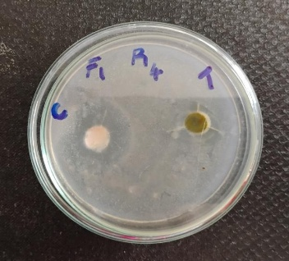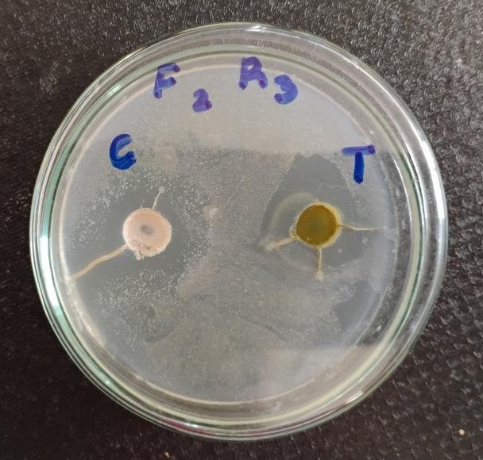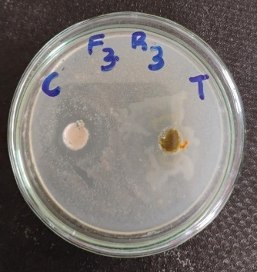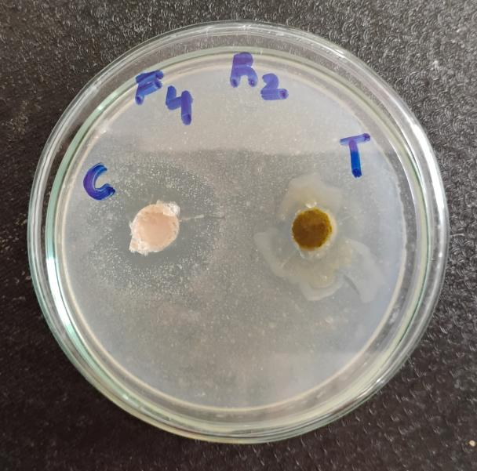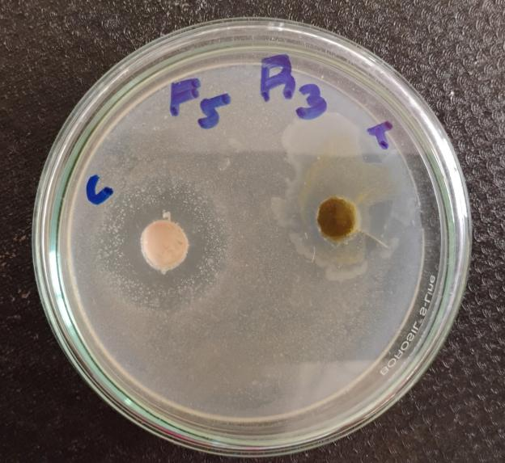

**Figure 1:** Antifungal activity of formulations used for different treatments

**RESULTS AND DISCUSSION**

The antifungal activity of various formulations against *Phytophthora infestans* was assessed using the agar well diffusion method, and the efficacy was determined based on the zone of inhibition measured in centimeters (cm). The study revealed significant differences in the antifungal potential of the tested formulations, indicating that some treatments exhibited strong inhibitory effects, while others were relatively ineffective. The ingredients and quantities used for preparation of the formulation is shown in the Table 1.

The control group, which did not receive any active treatment, showed a zone of inhibition of 1.15 ± 0.17 cm. This serves as the baseline for comparing the efficacy of the different formulations. Any formulation with a zone of inhibition exceeding this value is considered to have some degree of antifungal activity.

Among the treatments, as shown in the table 2, formulation T5 exhibited the maximum antifungal activity, recording a zone of inhibition of 1.925 ± 0.70 cm. This value is significantly higher than the control and all other treatments, suggesting that T5 contains potent antifungal compounds capable of effectively suppressing the growth of *P. infestans*. The broader inhibition zone and relatively high standard deviation also imply strong activity, possibly with some variability depending on the concentration or mode of application.

The second most effective treatment was T2, with a zone of inhibition of 1.700 ± 0.24 cm. This result also indicates considerable antifungal efficacy and is markedly greater than the control. The low standard deviation observed with T2 implies a consistent antifungal response, suggesting that the formulation may have a well-defined and uniform mode of action.

Formulations T3 and T4 showed moderate antifungal effects, with zones of 1.125 ± 0.09 cm and 1.200 ± 0.53 cm, respectively. These values are only slightly higher than the control, and their marginal increase suggests limited antifungal potency. T3, in particular, showed a very narrow standard deviation, indicating consistent but minimal inhibition. T4, while having a slightly better zone, had higher variability, which may reflect inconsistency in the performance or a weaker concentration of active ingredients.

On the other hand, formulation T1 exhibited the lowest antifungal activity, with a zone of 1.075 ± 0.32 cm, which is even slightly lower than the control. This result suggests that T1 was ineffective in inhibiting *P. infestans* or possibly interfered with the natural suppression seen in the control, rendering it unsuitable as an antifungal treatment.

These findings clearly demonstrate the superior performance of formulations T5 and T2, indicating their strong antifungal potential. The substantial difference in the zones of inhibition between these and the control group supports their further evaluation for possible use in the biological control of *Phytophthora infestans*, a notorious pathogen responsible for late blight disease in several crops. Additional studies involving concentration gradients, phytotoxicity analysis, and field-level validation are necessary to confirm the practical applicability and safety of these formulations under real agricultural conditions.

**Table 1:** Ingredients and quantities used for preparation of foliar spray

|  |  |  |  |  |  |
| --- | --- | --- | --- | --- | --- |
| **Plant name** | **Treatments (ml/L)**  **T1 T2 T3 T4 T5** | | | | |
| ***Carica papaya*** | 300 | 150 | 100 | 200 | 200 |
| ***Lantana camara*** | 150 | 250 | 300 | 200 | 400 |
| ***Syzygium cumini*** | 200 | 300 | 400 | 200 | 100 |
| **Control** | 10% W/V of chemical fungicide (Carbendazim) | | | | |

**Table 2:** Anti-fungal activity against *Phytophythora infestans* with different formulations represented by Zone of Inhibition

|  |  |
| --- | --- |
| **Formulation** | **Zone of Inhibition (cm)** |
| Control | 1.15 $±$ 0.17 |
| T1 | 1.075 $±$ 0.32 |
| T2 | 1.700 $±$ 0.24 |
| T3 | 1.125 $±$ 0.09 |
| T4 | 1.200 $±$ 0.53 |
| T5 | 1.925 $±$ 0.70 |

**Conclusion**

The present study highlights the promising antifungal efficacy of aqueous plant extract formulations against *Phytophthora infestans*, the notorious oomycete responsible for late blight in tomato crops. The *in vitro* antifungal assay clearly indicated differential inhibitory effects among the tested formulations. Among the five treatment formulations evaluated, T5 exhibited the highest zone of inhibition, measuring 1.925 ± 0.70 cm, which was followed by T2 (1.700 ± 0.24 cm). These findings suggest that certain combinations or concentrations of aqueous extracts derived from *Carica papaya*, *Syzygium cumini*, and *Lantana camara*  possess significant antifungal activity capable of suppressing the growth and proliferation of *P. infestans*. The superior performance of specific formulations can be attributed to the synergistic effects of diverse phytochemicals present in the plant materials used. Compounds *viz.,* flavonoids, alkaloids, phenolics, terpenoids, tannins, and saponins are well-documented for their antifungal properties. These bioactive constituents are believed to exert their effects by disrupting fungal cell wall integrity, altering membrane permeability, inhibiting spore germination, and suppressing hyphal elongation and metabolic activities. In particular, phenolic compounds and terpenoids may interfere with the enzymatic systems of the pathogen, leading to impaired growth and eventual cell death. Another significant observation from this study is the efficacy of water-based (aqueous) extracts in controlling late blight pathogen growth. Aqueous extracts are especially desirable for agricultural use due to their non-toxic nature, environmental safety, cost-effectiveness, and ease of preparation. Unlike synthetic fungicides, which often pose risks of environmental contamination, phytotoxicity, and fungicide resistance development, plant-based aqueous formulations offer a natural and sustainable alternative compatible with organic farming systems and eco-agriculture models. These findings reinforce prior research highlighting the antimicrobial potential of *C. papaya*, *S. cumini*, and *L. camara*, but also extend their applicability specifically to oomycete pathogens like *Phytophthora infestans*. While the *in vitro* results are encouraging, additional studies are warranted. Future research should focus on phytochemical characterization of the most effective extracts to identify the key active principles. Furthermore, mechanistic studies at cellular and molecular levels would help elucidate how these compounds interfere with pathogen physiology. Finally, field trials and formulation standardization under real agricultural conditions will be essential to validate the practical utility of these extracts in integrated disease management (IDM) frameworks for tomato and other susceptible crops.

In conclusion, the present work provides a strong foundation for developing safe, natural, and sustainable antifungal solutions from locally available medicinal plants to combat late blight disease effectively.

**Disclaimer (Artificial intelligence)**

Option 1:

Author(s) hereby declare that NO generative AI technologies such as Large Language Models (ChatGPT, COPILOT, etc.) and text-to-image generators have been used during the writing or editing of this manuscript.

**References**

1. Achore D.S., Nemec S. and Baker R.A. 1993. Effects of *Fusarium Soloni* nanphthazarin toxins on the cytology and ultra structure of rough lemon seedlings. Mycopathologia, 123: 117-126.
2. Adomako, J., Kwoseh, C. K., Emmanuel, M., & Stephen, L.-K. (2016). Prevalence of Phytophthora Leaf Blight of Taro (Colocasia esculenta (L.) Schott) in the Semi Deciduous Forest Zone of Ghana. Journal of Experimental Agriculture International, 11(4), 1–7.
3. Akinpelu, D. A. and Aiyegoro O. A. 2004. Antibacterial and antifungal activities of *Carica papaya* (fruit) juice extract against some pathogenic microorganisms. Ethnobotanical Leaflets, 1: 105-112.
4. Anne-Laure Bidaud, Patrick Schwarz, Guillaume Herbreteau and Eric Dannaoui 2021. Techniques for the Assessment of *In vitro* and In Vivo Antifungal Combinations. Journal of Fungi, 7(2):113.
5. Arpita Chatterjee, Subrata K. Ghosh 2008. Alterations in biochemical components in mesta plants infected with yellow vein mosaic disease. Brazilian Journal of Plant Physiology, 20(4): 267 - 275.
6. Basharat Mahmood, Muhammad Tariq-Khan, Aneela Azad, Nasir Rahim, Shameem Arif, Muhammad Riaz Khan, Abid Hussain, Muhammad T. Younis, Asma Bashir, Sohail Ahmed, Javed R. Khan, Sahira Tariq and Muhammad Jamil 2022. Management of late blight of potato caused by *Phytophthora infestans* through Botanical Aqueous Extracts. International Journal of Phytopathology,11(1): 35-42.
7. Bhupendra K., Rana V. and Taneja and Singh U.P. 1999. Antifungal Activity of an Aqueous Extract of Leaves of Garlic Creeper (*Adenocilymma alliaceum* Miers.). Pharmaceutical Biology, 37(1): 13-16.
8. Bidaud, A. L., A. Bottero, O. Lemaitre, J. D. Dagens, and S. Fernandez. 2021. Evaluation of the disk diffusion method for antifungal susceptibility testing of dermatophytes. Journal of Clinical Microbiology, 59 (1).
9. Bukar A., Uba A. and Oyeyi T.I. 2010. Antimicrobial profile of *Moringa oleifera* Lam. extracts against some food–borne microorganisms. Bayero Journal of Pure and Applied Sciences, 3(1): 43-48.
10. Chaudhary, B. and Mukhopadhyay S. 2012. *Syzygium cumini* (L.) Skeels: A potential source of nutraceuticals. International Journal of Pharmacy and Biological Sciences, 2(1): 46-53.
11. Deena M. J. and Thoppil J. E. 2000. Antimicrobial activity of the essential oil *of Lantana camara* Fitoterapia, 71: 453-455.
12. Dubey, N. K., Ravindra Shukla, Ashok Kumar, Priyanka Singh and Bhanu Prakash. 2011. Prospects of botanical pesticides in sustainable agriculture. Current Science, 101(4): 479-480.
13. Fry W. E., GodwFn S. B., Koh Y. J., Dyer A. T., Matusral J. M., Drenth A., Cohen B. A., Splelman L. J, Tooley P. W., Deahl K. L., Sujkowski L. S., lnglls D. A., Sandlan K. P. 2015. Historical and Recent Migrations of Phytophthora infestans: Chronology, Pathways, and Implications. Plant Disease, 99(1): 4-13.
14. [Haverkort](https://link.springer.com/article/10.1007/s11540-008-9089-y?utm_source=chatgpt.com#auth-A__J_-Haverkort-Aff1) A. J., [Boonekamp](https://link.springer.com/article/10.1007/s11540-008-9089-y?utm_source=chatgpt.com" \l "auth-P__M_-Boonekamp-Aff1) P. M., [Hutten](https://link.springer.com/article/10.1007/s11540-008-9089-y?utm_source=chatgpt.com#auth-R_-Hutten-Aff1) R., [Jacobsen](https://link.springer.com/article/10.1007/s11540-008-9089-y?utm_source=chatgpt.com#auth-E_-Jacobsen-Aff1) E., [Lotz](https://link.springer.com/article/10.1007/s11540-008-9089-y?utm_source=chatgpt.com#auth-L__A__P_-Lotz-Aff1) L. A. P., [Kessel](https://link.springer.com/article/10.1007/s11540-008-9089-y?utm_source=chatgpt.com#auth-G__J__T_-Kessel-Aff1) G. J. T., [Visser](https://link.springer.com/article/10.1007/s11540-008-9089-y?utm_source=chatgpt.com#auth-R__G__F_-Visser-Aff1) R. G. F. and [van der Vossen](https://link.springer.com/article/10.1007/s11540-008-9089-y?utm_source=chatgpt.com#auth-E__A__G_-Vossen-Aff1) E. A. G. 2008. Societal costs of late blight in potato and prospects of durable resistance through cisgenic modification. Potato Research, 51(1): 47-57.
15. Iridiam Hernández-Soto, Yolanda González-García, Antonio Juárez-Maldonado and Alma Delia Hernández-Fuentes. 2024. Impact of *Argemone mexicana* L. on tomato plants infected with *Phytophthora infestans*. PeerJ, 12:
16. Kagbo H. and Ejebe D. 2009. Phytochemistry and Preliminary Toxicity Studies of the Methanol Extract of the Stem Bark of Garcinia kola (Heckel). International Journal of Toxicology, 7(2).
17. Kordali S., Cakir A, Zengin H. and Duru ME 2003. Antifungal activities of the leaves of three Pistacia species grown in Turkey,Fitoterapia74: 164-167.
18. Nandhini, R. and Subramanian K. S. 2020. Evaluation of antifungal efficacy of *Carica papaya* leaf extract against major phytopathogenic fungi. Journal of Pharmacognosy and Phytochemistry, 9(1): 1535-1539.
19. Nwokeji, E. M., Ibeh, M. C., Nnaji, N. W., Ogwudire, V. E., Keyagha , E. R., Cookey, C. O., Alagba, R. A., & Ihejirika, G. O. (2023). Management of Phytophthora Blight of Pigeon Pea (*Cajanus cajan* L. Hugh) Through the Use of Neem (*Azadirachta indica*) Plant Parts Aqueous Extracts. Asian Journal of Research in Crop Science, 8(3), 36–43.
20. Pradeep A., Dinesh M., Govindaraj A., Vinothkumar D. and Ramesh B. N. G. 2014. Phytochemical Analysis of Some Important Medicinal Plants. International Journal of Biological & Pharmaceutical Research, 5(1): 48–50.
21. Prashant T., Bimlesh K., Mandeep K., Gurprect K. and Harleen K. 2011. Phytochemical Screening and Extration: A Review. Internationale Pharmaceutica Sciencia, 1(1): 98-106.
22. Rai M. K. and Carpinella M. C. 2006. Naturally Occurring Bioactive Compounds: A New and Safe Alternative for Control of Pests and Diseases. Elsevier.
23. Sathiyabama M. and Manikandan A. 2011. Application of plant extracts in the management of phytopathogenic fungi. Journal of Biopesticides, 4(2): 168-172.
24. Saxena R. and Mathur N. 2018. Antifungal properties of essential oils extracted from *Lantana camara* L. Journal of Essential Oil-Bearing Plants, 21(2): 530-536.