Ameliorating Effect of GA₃ Priming on Seed Germination and Seedling Growth of Rice Genotypes Under Salinity Stress

.
ABSTRACT

Aims:
Salinity is a major abiotic stress limiting crop productivity, particularly in arid and semi-arid regions. Rice (Oryza sativa L.) is highly sensitive to salinity, especially during the germination stage. This study aimed to evaluate the effect of gibberellic acid (GA₃) seed priming on mitigating salinity stress and improving seed germination and early seedling growth in different rice genotypes.
Study Design:
The experiment followed a factorial block design under laboratory conditions, testing the interaction of four rice genotypes and varying salinity levels, with and without GA₃ priming.
Place and Duration of Study:
The lab experiment was conducted in department Plant physiology laboratory in GBPUAT Pantnagar over a period of four weeks.
Methodology:
Four rice genotypes Pant Basmati 1, Pant Basmati 2, Pant Sugandh 21, and CSR 36were evaluated under four NaCl concentrations (0, 50, 100, and 150 mM). Seeds were primed with 20 and 30 µM GA₃ and compared to untreated controls. Key germination and seedling parameters including germination percentage, shoot and root length, dry weight, seedling vigour index, and seedling tolerance index were measured and statistically analysed.
Results:
Increased salinity significantly reduced all measured parameters across genotypes. Pant Basmati 1 was most sensitive, while CSR 36 showed the highest tolerance. At 150 mM NaCl, germination occurred only in CSR 36. GA₃ priming significantly improved germination and seedling growth, particularly in sensitive genotypes. Pant Sugandh 21 and Pant Basmati 1 showed 30% and 23% increased germination, respectively, with GA₃ at high salinity. More than 15% improvement in shoot and root length was observed in all GA₃-treated genotypes at 100 and 150 mM NaCl.
Conclusion:
Seed priming with 30 µM GA₃ effectively mitigates salinity stress during rice germination, enhancing seedling growth and tolerance, especially in salt-sensitive cultivars. This approach holds promise for improving rice cultivation in salt-affected areas.

Key words: Rice,priming, germination, Gibbrellic acid, salinity

1 INTRODUCTION
Salinity, is one of the pernicious abiotic stress that adversely affects the physiological functioning of the plants and restricts the productivity in most of crop plants (Bazakos et al., 2015). Approximately 45 million hectares of land, which is almost 20% of irrigated land and provides one-third of the world's food needs, is affected by salinity (Abdel et al., 2018). It is estimated that by 2050, fifty per cent of the world's arable land will be affected by salinity (Machado and Serralheiro, 2017). All the agricultural land contains some amount of salt whereas, the amount of salt depends on the types of soil and quality of irrigation water. Soil is considered saline when the salt content in the root zone is high enough to prevent optimum growth and yield of the plant (FAO, 2013). A high concentration of salt in the soil reduces the osmotic ability of the soil and further affects the uptake of water and nutrients by the roots, thereby affecting the germination and metabolism of the plants, resulting in significant crop damage and poor productivity (Tester and Davenport, 2003).
Rice is the most critical food crop worldwide, cultivated in wide regions of the world with expanded crop production. However, Salinity has a harmful effect on rice over entire growth phases as reduced germination and seedling growth, biomass accumulation, decrease in tillering, spikelet per panicle, panicle weight, and a finally significant reduction in grain yield (Zhao et al., 2006).Seed germination is a vital phase of plant life. Successful germination depends on the ability of the plant embryo metabolism, which depends upon strict regulation of plant hormones including Gibberellic acid, Abscisic acid, auxin and ethylene (Savvides et al., 2016,Mohammed and Nulit,2019).
Salinity leads to reduced germination and seedling growth is often the result of increased concentrations of salt in the root zone due to the upward rise of the soil solution and resulting evaporation on the soil surface but the magnitude of reduction is genotypes dependent (Hakim et al., 2014). α-amylase plays an integral part in the hydrolyzation of the endosperm starches into metabolic sugars during cereal seed germination, which provides energy to the developing seedling. Under salinity stress, enzyme activity declines due to the downregulation of alpha-amylase gene expression. (Liu et al., 2018). However, Seeds can be primed to increase their resistance against NaCl stress using a range of chemical compounds and plant growth regulators which provide physiological conditions to mount a more rapid resistance response upon exposure to stress. Priming confers long-lasting low-cost cost and long-lasting effectiveness to plant and environment-friendly (Savvides et al., 2016).
Among all the priming compounds, Gibberellic acid plays an important role in the adaptive response of the plant to various abiotic stresses. During germination, the endosperm is mobilized to provide the energy to developing seedlings. Bioactive GA₃ is also synthesised in the embryo during seed germination and moved to the aleurone layer to induce alpha-amylase gene expression for starch hydrolysis in the endosperm. Under salinity, inhibited germination and growth could be induced by decreased GA₃ content. It seems that the exogenous application of GA₃ rescued this decline (Liu et al., 2018). This study aims to evaluate salt tolerance through germination and seedling characterizations among rice genotypes under 20 and 30µM GA₃ concentration.

2. material and methods
The seeds of rice genotypes i.e., Pant Basmati1, Pant Basmati2 and Pant Sugandh21 were obtained from Govind Ballabh Pant University of Agriculture and Technology, Pantnagar (Uttarakhand) however CSR36 from Central Soil Salinity Research Institute (CSSRI), Karnal, Haryana.
The experiment was performed with three variables as rice genotypes (Pant Basmati1, Pant Basmati 2, Pant Sugandh 21 and CSR 36), salinity (50, 100 and 150 NaCl) and 20 and 30μM of GA₃ in Petri plate lined by moist germination paper. The seeds were disinfected with 1 % sodium hypochlorite solution followed by several washings with pure water and pre-soaked in 30μM GA₃ solution for 24 hours. In each treatment, 10 seeds for each genotype were allowed to germinate with a solution of 5 ml of varying concentrations of NaCl
2.1 Germination and Seedling Growth:
Final germination percentage: The final germination percentage (FGP) was recorded on the 11th day by using the following equation provided by Ellis and Robert, 1981.
Final germination percentage (%) = (No.of germinated seeds)/(Total no.of seeds taken) ×100
2.2 Root and shoot length (cm)
At the 11th day seedlings were collected and the following observations were taken, Root and shoot length of the 5 seedlings were determined by using a scale at random from each replication.
2.3 Dry weight of seedling (mg)
Randomly collected 5 seedlings from each Petri plate were overdried at 80˚C for 24 hours and used for dry weight.
Seedling vigour index
Seedling vigour index (SVI) was calculated by following formula given by Abdulbaki and Anderson, 1970.
2.4 SVI= (Average shoot length+ Average root length) ×Germination percentage)
Salt tolerance index: It is determined using the following formula given by Carpýcýet al., 2009
Salt tolerance index = (Total dry weight at salt concentration)/(Total dry weight at control) ×100
2.5 Alpha amylase activity
One unit of amylase activity was defined as the amount required for liberating 1mg of maltose in 1min at 37˚C.Amylase activity was estimated by Jayaraman, (1981) method.
2.6 Data analysis
Analysis of variance was analyzed by using SPSS software (SPSS for WINDOW, Standard version 26.0), Mean values of all parameters including germination percentage, shoot and root length, dry weight, seedling vigour index and salt tolerance index were compared by Duncan’s test.
.
3 results and discussion
3.1 Germination percentage
The results showed that seed germination in all the rice genotypes decreased with increasing salinity from 50mM to 150mM NaCl (Figure 1). However, at lower salinity (50mM NaCl), it was least affected for all the genotypes. In salt tolerant genotype i.e., CSR36, higher germination (90%) was recorded while Pant Basmati 1 showed minimum (73%) germination. As the salinity level increases up to 100mM NaCl germination was reduced by 40% in all genotypes except CSR36(less than 30%), While Pant Basmati1(16%) showed the lowest germination followed by Sugandh 21 (20%) respectively. Germination was completely inhibited for all the genotypes at high salinity (150mM NaCl) except CSR36(43.3%). Among all the salinity levels, CSR36 showed less reduction in germination as compared to the others.
On the other hand,both the concentrations (20 and 30µM) of GA₃ showed improvement in germination in all the genotypes at higher salinity levels of 100 & 150 NaCl. At lower salinity (50mM NaCl), above 80% germination was achieved in all the genotypes with both the concentrations of GA₃ while maximum (100%) germination was recorded in CSR36 with 30µM GA₃ and above 90% germination was found in Pant Basmati1.Similarly at higher salinity (100 and 150 mM NaCl), an increase in germination was significant with both the conc. While maximum (above 40 and 30%) germination was found with 30µM GA₃ at 100 and 150mM NaCl in all the genotypes. Among all the genotypes,CSR36 showed superior germination under all the salinity levels (Figure 1).

3.2 Root and Shoot length
The shoot and root length decreased with increased salinity (Figure 2 and figure3). At lower salinity (50mM NaCl), Pant Basmati1 showed a maximum (33%) reduction in shoot length followed by Pant Basmati 2 (31%) while a minimum was recorded in CSR36(6%). At 100mM NaCl,above 50% reduction found in Pant Basmati1(55%) and Pant Basmati 2(56%) while minimum i.e 21% in CSR36. Further rise in salinity up to 150mM NaCl, only CSR36 showed seedling growth with a 73% reduction as compared to control(figure 2). However, both concentrations of GA₃ treated seedlings showed significant improvement in shoot length. Under 50 and 100 mM NaCl, genotype Pant Basmati1 treated with 30µM GA₃ showed a maximum (33 and 27%) increase in shoot length followed by Pant Basmati2 (29 and 25 %). As there was no germination of seeds was observed in 150mM, data on shoot and root length was not taken.
With all the salinity levels, CSR36 developed the longest root lengths relative to other genotypes. Results showed that, at 50mM NaCl, the highest reduction in root length was recorded in Pant Basmati1 (50%) followed by Pant Sugandh21(39%) and Pant Basmati2(34%). However, at 100mM NaCl, it enhanced by 76%,63 %and 62% respectively. In the present study root length in seedlings was more noticeable as compared to the shoot length. (Figure 3). Under lower salinity (50mM NaCl), all the genotypes with 30µM GA₃ exhibit the above 10% recovery of root length as compared to 50mM NaCl.While maximum(30%) recorded in Pant Basmati1(30%).While at 100 NaCl, pre-treated seeds of CSR36 with 30µM GA₃ showed the highest increase (30%) followed by Pant Sugandh21(18%) as compared to the 100 NaCl. However, both the concentrations (20 and 30µM GA3) pre-treated at high salinity(150mM) showed more than 20% increase in all the genotypes, while the maximum increase (25%) was recorded in Pant Sugandh21. Among all the GA₃, treated genotypes, Pant sugandh21 showed higher root length in 50 and 150 NaCl while CSR36 showed higher root length at 100mM NaCl. In the present study, salinity stress affects seedling growth by decreasing shoot and root length. salinity decreased shoot and root length as salinity levels increased; nevertheless, the maximum reduction in shoot length under all salinity levels was found in Pant Basmati1(figure 2 and Figure 3).

3.3 Dry weight
Increased salinity negatively influenced the dry weight in all the rice genotypes (Figure 4). At 50mM NaCl the highest dry weight reduction was recorded in Pant Sugandh21 (21.2%) followed by Pant Basmati 2(17.8%) as compared to control. Similarly, at 100 mM NaCl, a maximum (57.90%) reduction was found in Pant Basmati1 followed by Pant Basmati 2 (54.47%). While less than 30% reduction was reported in CSR36(25.2%). Similarly, at higher salinity (150mM), dry weight was only encountered in CSR36 with a 53.67% reduction.
Dry weight was positively influenced in GA₃ treatment rice genotypes (Figure 4). In our study results revealed that maximum dry weight reduction was reported in Pant Basmati1 under all salinity levels. These results indicate that NaCl inhibits the growth of rice seedlings and leads to a decrease in biomass. Under lower salinity (50mM NaCl) both the GA₃ concentrations (20 and 30 µM ) treated seedlings showed a 5% increase in dry weight in all the genotypes. At 100mM NaCl, less than a 10% increase was reported in all the genotypes. Under higher salinity (150), both 20 and 30µM GA₃-treated seedlings showed dry weight in all the genotypes.

3.4 Seedling vigour index
Results showed that increased salinity negatively affects the seedling vigour index in all genotypes (Figure 5).
The highest vigour index has been recorded in Pant Basmati 1(529 cm) followed by CSR36(497cm), Pant Basmati2(459cm) and Pant Sugaandh21(378cm). At the lowest salinity level (50 mM), Pant Basmai1 showed a maximum (55%) reduction in SVI followed by Pant Basmati 2 (44.7%). Over 90% reduction in SVI was reported in Pant Basmati1 and Pant Basmati2 at 100mM. While above 80% and 50% reduction were recorded in Pant Sugandh21 and CSR36 respectively. In the present study, results showed that Pant Basmati1 had the lowest vigour index in all the salinity levels (Figure 5).
At 50 NaCl, both the concentrations of 20 and 30 µM GA₃ improved the seedling vigour index in all the genotypes. However, Pant Basmatii1 showed the highest increase (42.7%) in SVI with 30µM GA₃. Similarly, at100mM NaCl, improved SVI was recorded in all the genotypes with both the GA3 concentrations. The maximum increase (49%) was recorded in Pant Sugandh21 followed by Pant Basmati2(46%). While GA₃ treated seedlings of CSR36 showed SVI of 26cm. With both the GA₃ concentrations SVI improved at high salinity but more positive results were observed with the conc. 30µM GA₃.

3.5 Salt Tolerance Index
STI was reduced with increased salinity levels in all genotypes. (Figure 5).CSR36 had the highest STI in all the salinity levels. At 50mM NaCl, over 80% STI was reported in all the genotypes while the highest tolerance (94.26%) was recorded in CSR36 followed by Pant Sugandh21(90%). At 100mM NaCl, Pant Basmati1 showed lowest (44.1%) tolerance index followed by Pant Basmati2 (50%). While a maximum (78.85%) STI was reported in CSR36.At high salinity (150mM NaCl), the tolerance index was only observed in CSR36(38.46%).
According to the present study, at lower salinity level (50mM NaCl) salt tolerance index was least affected in all the genotypes as compare to other salinity levels. however, Pant Basmati 1 showed lowest STI in all the salinity levels as compare to other genotypes (Figure 5). Under all the salinity levels, pretreated seedlings with 20 and 30µM GA₃ significantly improved the STI in all the genotypes. At 100mM NaCl, an above 60% increase in STI was recorded in Pant Basmati 1 and Pant Basmati 2. However, CSR36 obtained a maximum (77%) increase in STI. At high salinity (150mM NaCl), all genotypes showed above 20% increase in STI with respect to 150mM NaCl while the maximum increase was reported in CSR36(71%).

3.6 Alpha amylase content
The table shows alpha-amylase content in rice seedlings under different treatments under 24 hour incubation. The result showed that amylase content was decreased with increased salinity levels. Maximum amylase activity was observed in 30µM GA₃ treated seedlings in all the genotypes. However, in the control condition, the highest amylase activity was recorded in CSR36(34ug/ml) followed by Pant Basmati2 (26ug/ml). At 50mM NaCl, activity starts to decrease in all the genotypes while the highest (above 30%) decrease was recorded in Pant Basmati2, Pant Sugandh21, and Pant Basmati1, respectively, while less than 10% reduction was recorded in CSR36. Pre-treatment of 20µM GA₃ and 30 µM GA₃ improved the amylase content in all the seedlings. The highest increase was recorded in Pant Basmati2 (7%) followed by Pant Sugandh21(6%) compared to the 50mM NaCl. Similarly, at 100mM NaCl, an above 50% reduction in alpha-amylase content was recorded in Pant basmati1 (54.99%) and Pant Sugandh21(55.96%) while the lowest reduction (19.45%) was recorded in CSR36. Further pre-treatment with 30µM GA₃ improved the alpha-amylase content in all the genotypes as compared to the 100mM NaCl. However, the highest increased (5%) was reported in Pant Basmati1. At 150mM NaCl, and above 85% reduction in alpha-amylase content was recorded in all the genotypes CSR36. The highest value of alpha-amylase content was recorded in CSR36(12.56ug/g) followed by CSR23(11.56ug/g), respectively. However, pre-treatment with GA₃ improved the amylase content in all the genotypes. While 30 µM GA₃ treatment showed maximum amylase content in all the genotypes as compared to the 150mM NaCl.

3.7 Principal Component Analysis:
Principle component analysis (PCA) for Seedling vigour index and salt tolerant index revealed that treatments viz 150mM NaCl+20µM GA₃, 150 NaCl,150NaCl+30µM GA₃ and 100mM NaCl lies opposite quadrate in biplot. In treatments, PCA for SVI revealed that the first two principal components explained the total variation of 98.1% (PC1=90.16%, PC2=7.94%). While, PCA for the Salt tolerance index revealed that the first two principal component explained total of 98.97% variation (PC1=91.09, PC2=7.88).The magnitude of each quantitative trait in different treatments is shown in Figure 5. and the treatment on same side of the quantitative trait has a higher value for the quantitative trait and vice versa.

4 Discussion
Rice is a salt susceptible crop and highly sensitive to the germination stage. Healthy seedling growth and high germination are essential for crop establishment, which is necessary for reaching economical yield, if there is good germination and seedling growth than there would be adequate seedlings which will lead to proper plant density. In the present experiment four genotypes (Pant Basmati1, PantBasmati2, PantSugandh21 and CSR36), showed genotypic variation to different salinity levels. Moreover, there was variation in the germination percentage and seedling growth characteristics. However, with increased salinity germination is reduced in all the genotypes. A significant reduction was observed in all the genotypes above 100mM NaCl, although CSR36 showed less reduction as compare to the others.
Inhibition in germination during stress condition is due to the reduction of bioactive GAs which down regulate the Alpha amylase activity responsible for starch hydrolysis and devoid the seedling of energy and osmotic support necessary to initiate germination.Under normal condition bioactive GA triggers α-amylase production in aleurone layer which diffuses from the embryo, activates GID1-DELLA signaling pathways , and promotes α-amylase gene expression I.e Amy1, Amy2, Amy3 )(Miyuki Kaneko,2002)
Present findings are in agreement with previous studies in rice, which concluded that seed germination and early seedling growth of rice is highly sensitive to salt stress because of the marked effects of osmotic stress and specific ion toxicity on the growth stages, their results showed that on increasing salinity from 4 to 20 dS m⁻¹, germination in all the rice genotypes reduced significantly. While at 20 dS m-1 germination was completely inhibited for all the genotypes. Overall genotypes, MR211, MR232 and IR20 showed better tolerance up to 12 dS m-1. The weakness of seeds to germinate under salt stress may be due to embryo damage by Na⁺/Cl⁻ ions or inhibition of seed water imbibition (Hakim et al., 2010). Further pre-treatment with 30µM GA₃ significantly improved the germination up to higher salinity (100 and150mM NaCl). The pre-soaked wheat seedlings with 0.58mM GA₃ alleviates the toxic effect of salinity by improving amylase activity in seedlings which hydrolysed storage material i.e., starch and transform into simple sugars that ultimately leads to better germination and seedling growth (Ibrahim et al., 2019).
With increasing salinity, seedling growth, root and shoot length, and dry weight of seedlings are negatively affected, rate of reduction was more prominent at higher salinity levels (100 and 150mM NaCl). Whereas with increased salinity, reduction in root length was more prominent as compare to the shoot length. Overall CSR36 had a lower rate of reduction among all the genotypes. Salinity screening of 30 rice genotypes revealed that growth was adversely affected by increased salt concentration but sensitive genotypes were more adversely affected by an increased salt concentration while certain genotypes, including CSR36, were less affected (Rima et al., 2018). Similarly, the reduction in the ratio of the root shoot was less than 5% at a concentration of 5 dsm⁻¹ for sensitive cultivars (Olugundudu et al., 2014). Results agree with another researcher who revealed that root growth under salinity stress was more adversely affected in wheat cultivars as compared to shoot length (Ibrahim et al., 2019). Shoot and root length, dry weight reduced with increased salt concentration from 50 to 150mM in all the rice genotypes however reduction was more pronounced in salt-sensitive Shaheen Basmati while reduction rate was significant at higher salinity i.e.,100 &150mM NaCl (Jamil et al., 2012). Tolerant cultivars have the ability to avoid Na⁺ accumulation and absorb K⁺ to maintain low Na⁺ /K⁺ ratios, which could be a good tolerance determinant for NaCl stress. While sensitive cultivars accumulated a larger amount of Na⁺ and absorbed a smaller amount of K⁺ in roots and shoots than the tolerant cultivars. This fact shows that the noticeable variation in sensitivity at different growth stages is due to the difference in Na⁺ and K⁺ aggregation and not to the difference in the physiological adaptation process (Ferdose et al., 2009). At high salinity root length of the sensitive cultivar has been adversely affected, root growth is most critical for the survival of the plant at high concentration, while pre-soaking of sensitive and tolerant oat cultivar at 100ppm GA₃ promotes root and shoot length under salinity stress (Chauhan et al., 2019). Primed seedling of rice genotypes showed an increase in dry weight under salinity stress. Pre-soaking of a wheat cultivar with 0.58mM GA₃ increased the dry weight up to 76 % under high salinity levels from 100 to 300mM NaCl (Ibrahim et al., 2019).
Seedlings with higher vigour can yield strong seedlings that become vigorous and uniform plants. On the other hand, seeds shown to be low in vigour, would create weakened seedlings that will be more prone to attack, damage, and other environmental issues. Seedling vigour index was significantly reduced in all the genotypes with increased salt concentrations while at high salinity (100mM NaCl), above 50% reduction was recorded in all genotypes. Similar findings also agreed with our results, they concluded that with increasing salt concentration in maize from 20 to 40mM NaCl, the vigour index decreases from 4.53 and 9.98 % respectively while the highest reduction (94.2 %) was reported at 320mM NaCl (Ahmed at al., 2017). Primed seedings with GA₃ showed significant increase in vigour index as compared to the untreated seedlings. Similarly, pre-soaking of 150ppm GA3 has been shown to increase the vigour index of tolerant oat cultivars at high salinity levels (100 and 150mM), whereas 100ppm GA₃ was more effective for sensitive cultivars (Chauhan et al., 2019).
The salt tolerance index is a heritable measure of plant salt tolerance. Higher value of STI indicates that plants have higher ability to survive in salt-stress conditions lower than the value of STI results in poor tolerance toward salinity stress. The salt tolerance index was also reduced in all genotypes while CSR36 exhibits a higher Salt tolerance index in all salinity levels as compared to other cultivars. Results also agreed with the previous findings, which revealed that salt tolerance indices in maize decreased with the increased salinity while the lowest STI was recorded in a high salinity level (250mM) in all maize cultivars (Carpıcı et al., 2009). In the present study, results indicate that CSR36 had higher STI among all whereas priming with 30µM GA₃ significantly improved the tolerance index in all the genotypes. Pre-soaking of wheat seeds in 0.58mM GA₃ greatly increases STI at all salinity levels, GA₃ increased STI by 67.12 % relative to control in wheat cultivars at high salinity (Ibrahim et al., 2019). Salt accumulation leads to ion toxicity that enhance ABA and decline GA activity leads to reduces alpha amylase activity.The decreased amylase activity in cotyledons of stressed seedlings could result in a reduced formation of glucose from starch, thereby leading to a decreased synthesis of sucrose and its restricted supply to the embryonic axis, resulting in reduced germination and seedling growth under water-stressed conditions. This process seems to be partially reversed by the exogenous application of GA₃ (Kaur et al., 2000). Lipid profiling in rice revealed that salt stress substantially reduced levels of all lipids such as monogalactosyldiacylglycerol (MGDG), digalactosyldiacylglycerol (DGDG), and combined phospholipids plus diacyglycerol.While,priming with GA3 before salt treatment ,ration of these lipid remains high (Liu et al.,2018). All GA₃ primed seedlings significantly improved the seedling growth in all genotypes. Seedling growth in GA₃ primed oat seedlings enhanced significantly under salinity stress and mitigates the negative effect of salinity. The increased growth of seedlings is due to an increase in invertase production, which improves sucrose transport in the shoot, which has been decreased due to an increase in salinity stress (Chauhan et al., 2019).

Figure 1. Effect GA₃ concentrations on germination of rice genotypes under different salinity levels. Vertical bars indicate ±standard error.

Figure 2. Effect GA₃ concentrations on root length of rice genotypes under different salinity levels. Vertical bars indicate ± standard error.

Figure 3. Effect GA₃ concentrations on shoot length of rice genotypes under different salinity levels. Vertical bars indicate ±standard error.

Figure 4. Effect GA₃ concentrations on dry weight of rice genotypes under different salinity levels. Vertical bars indicate ±standard error.

Figure 5. Effect GA3 concentrations on vigour index of rice genotypes under different salinity levels. Vertical bars indicate ±standard error.

Figure 6. Effect GA₃ concentrations on Salt Tolerance Index of rice genotypes under different salinity levels. Vertical bars indicate ±standard error.

Figure 7. Effect GA₃ concentrations on alpha amylase content of rice genotypes under different salinity levels. Vertical bars indicate ± standard error.
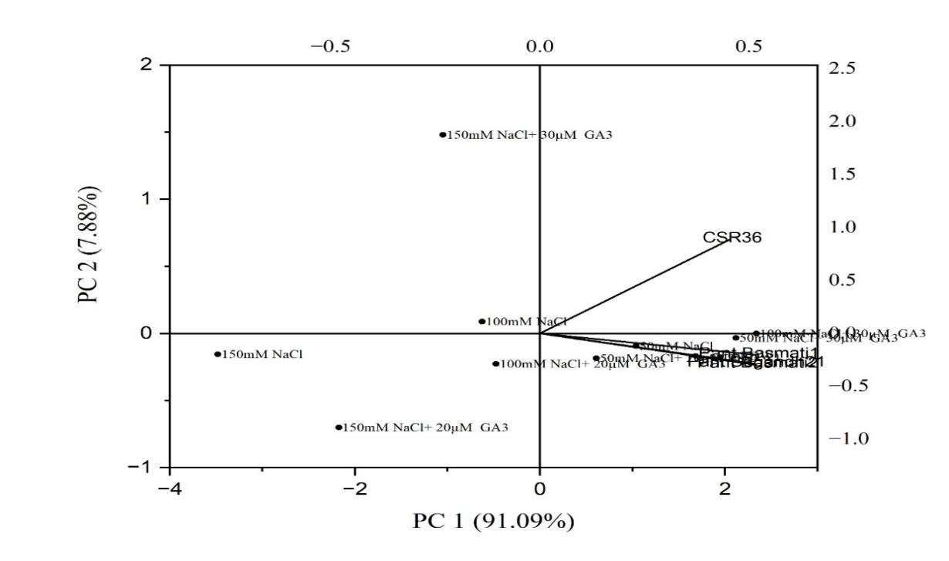
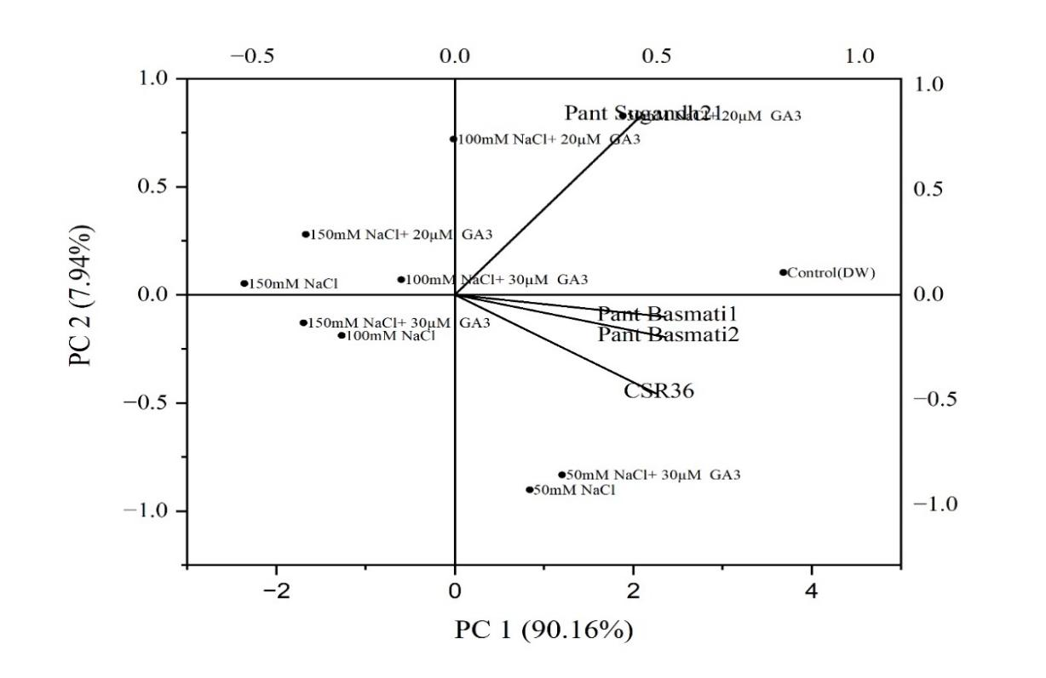
Figure 8. Principal Component Analysis (PCA) biplot illustrating the response of rice genotypes under various NaCl and GA₃ treatments based on Seedling Vigour Index and Salt Tolerance Index during germination.

Conclusion
It could be concluded from the present study that under control conditions all four genotype of rice had good germination with better seedling growth, but they showed a different response to increased levels of salt concentration from 50mM to 150mM NaCl. However, salinity reduced all germination properties of rice cultivars, mainly seed vigour. Based on the above results CSR36 was the most tolerant genotype whereas Pant Basmati 1 was considered more sensitive to salinity stress as compared to other cultivars. Further 24 hour pre-soaked rice genotypes with 30µM GA₃ mitigate the toxic effect of salinity and improved the germination and seedling growth in all the genotypes at higher salinity (150mM). Pant Basmati1 proved to have better germination, shoot and root length under GA₃ treatment up to 100 NaCl. Whereas GA₃ treatment in Pant Sugandh 21 showed better improvement in the dry weight of seedlings as compared to another cultivar. Pant basmati2 showed maximum SVI with GA₃ treated seedlings under 100 mM NaCl. GA₃ treated seedlings of Pant Basmati1 and Pant Basmati2 showed up to 60% salt tolerance index whereas, at high salinity (150mM NaCl), highest tolerance was found in CSR36. These results indicate that genetic variation exists among rice genotypes in terms of early seedling growth rate under salt stress conditions.

DISCLAMER
Option 2:
Author(s) hereby declare that generative AI technologies such as Large Language Models, etc. have been used during the writing or editing of manuscripts. This explanation will include the name, version, model, and source of the generative AI technology and as well as all input prompts provided to the generative AI technology
Details of the AI usage are given below:
Author(s) hereby declare that AI technologies Chat GPT has been used for grammar correction

References
Abdel Latef AAH, Srivastava AK, El-sadek MSA, Kordrostami M, Tran LSP 2018: Titanium dioxide nanoparticles improve growth and enhance tolerance of broad bean plants under saline soil conditions. Land Degrad. Dev., 29, 1065–1073. https://doi.org/10.1002/ldr.2780
Asgharipour MR, Rafiei M 2011: Effect of salinity on germination and seedling growth of lentils. Aust. J. Basic Appl. Sci., 5, 2002–2004.
Bazakos C, Manioudaki ME, Sarropoulou E, Spano T, Kalaitzis P 2015: 454 pyrosequencing of olive (Olea europaea L.) transcriptome in response to salinity. PLoS One, 10(11), e0143000.
Chauhan A, AbuAmarah BA, Kumar A, Verma JS, Ghramh HA, Khan KA, Ansari MJ 2019: Influence of gibberellic acid and different salt concentrations on germination percentage and physiological parameters of oat cultivars. Saudi J. Biol. Sci., 26, 1298–1304. https://doi.org/10.1016/j.sjbs.2019.04.014
Ellis RH, Roberts EH 1980: Improved equations for the prediction of seed longevity. Ann. Bot., 45, 13–30. https://doi.org/10.1093/oxfordjournals.aob.a085797
FAO 2013: Global cereals forecast to increase by 7 percent in 2013. http://www.fao.org/asiapacific/rap/home/news/detail/en/?news_uid=180032 (Accessed June 2, 2025).
Ferdose J, Kawasaki M, Taniguchi M, Miyake H 2009: Differential sensitivity of rice cultivars to salinity and its relation to ion accumulation and root tip structure. Plant Prod. Sci., 12, 453–461. https://doi.org/10.1626/pps.12.453
Hakim MA, Juraimi AS, Begum M, Hanafi MM, Ismail MR, Selamat A 2010: Effect of salt stress on germination and early seedling growth of rice. Afr. J. Biotechnol., 9, 1911–1918.
Hakim MA, Juraimi AS, Hanafi MM, Ismail MR, Selamat A, Rafii MY, Latif MA 2014: Biochemical and anatomical changes and yield reduction in rice (Oryza sativa L.) under varied salinity regimes. Biomed Res. Int., 2014, 1–10. https://doi.org/10.1155/2014/208584
Hussien Ibrahim ME, Zhu X, Zhou G, Adam Ali AY, Ibrahim Elsiddig AM, Farah GA 2019: Response of some wheat varieties to gibberellic acid under saline conditions. Agrosyst. Geosci. Environ., 2, 1–7. https://doi.org/10.2134/age2019.01.0003
Jamil M, Bashir S, Anwar S, Bibi S, Bangash A, Ullah F, Rha ES 2012: Effect of salinity on physiological and biochemical characteristics of different varieties of rice. Pak. J. Bot., 44(1), 7–13.
Kaneko, M., Itoh, H., Ueguchi-Tanaka, M., Ashikari, M., & Matsuoka, M. (2002). The α-amylase induction in endosperm during rice seed germination is caused by gibberellin synthesized in epithelium. Plant Physiology, 128(4), 1264-1270.
Kaur S, Gupta AK, Kaur N 2000: Effect of GA3, kinetin and indole acetic acid on carbohydrate metabolism in chickpea seedlings germinating under water stress. Plant Growth Regul., 30, 61–70. https://doi.org/10.1023/A:1006371219048
Kumari R, Kumar P, Sharma VK, Kumar H 2018: Evaluation of salinity tolerance of rice varieties through in vitro seed germination and seedling growth. Int. J. Curr. Microbiol. App. Sci., 7(3), 2648–2659.
Liu L, Xia W, Li H, Zeng H, Wei B, Han S, Yin C 2018: Salinity inhibits rice seed germination by reducing α-amylase activity via decreased bioactive gibberellin content. Front. Plant Sci., 9, 275. https://doi.org/10.3389/fpls.2018.00275
Liu, X., Wang, X., Yin, L., Deng, X., & Wang, S. (2018). Exogenous application of gibberellic acid participates in up-regulation of lipid biosynthesis under salt stress in rice. Theoretical and Experimental Plant Physiology, 30, 335-345.
Machado RMA, Serralheiro RP 2017: Soil salinity: effect on vegetable crop growth. Management practices to prevent and mitigate soil salinization. Horticulturae, 3(2), 30.
Mohammed, S. J., & Nulit, R. (2019). Impact of NACL, KCI, MCL2, MGSO4 and CACL2 on the seed germination and seedling growth of cucumber (Cucumis sativus cv. MTi2). Plant Archives (09725210), 19(2).
Mohammed, S. J., & Nulit, R. (2019). Impact of NaCl, MgCl2 and CaCl2 on seed germination and seedling growth on turnip (Brassica rapa rapa).
Ologundudu AF, Adelusi AA, Akinwale RO 2014: Effect of salt stress on germination and growth parameters of rice (Oryza sativa L.). Int. J. Sci. Res. Publ., 6, 237–243.
Savvides A, Ali S, Tester M, Fotopoulos V 2016: Chemical priming of plants against multiple abiotic stresses: mission possible? Trends Plant Sci., 21, 329–340. https://doi.org/10.1016/j.tplants.2015.11.003
Tester M, Davenport R 2003: Na+ tolerance and Na+ transport in higher plants. Ann. Bot., 91, 503–527. https://doi.org/10.1093/aob/mcg058
Zhao F, Wang Z, Zhang Q, Zhao Y, Zhang H 2006: Analysis of the physiological mechanism of salt-tolerant transgenic rice carrying a vacuolar Na+/H+ antiporter gene from Suaeda salsa. J. Plant Res., 119, 95–104. https://doi.org/10.1007/s10265-005-0250-2

