**Studies on Sugarcane Wilt Caused by *Fusarium sacchari* under Sub-tropical India**

**ABSTRACT**

Wilt disease of sugarcane is a complex and serious disease known to cause significant loss. In India, Sugarcane wilt disease was recorded almost 100 years ago and is one of the major fungal diseases affecting sugarcane production and productivity. First reported from Bihar in 1906 by Butler and detailed studies were made few years later in 1913 by Butler and Khan. The present study includes genotypes/varieties evaluation against wilt disease (*Fusarium sacchari*) of sugarcane in sub-tropical region of India. Total 35 genotypes, maintained at ICAR-IISR, Lucknow and were tested against wilt of sugarcane. Out of 35 genotypes, 25 genotypes were rated as resistant (R) genotypes to wilt disease and 10 genotypes were rated as susceptible (S) against wilt disease of sugarcane. The genotypes rated susceptible can be exploited as susceptible check for screening against wilt of sugarcane whereas genotypes rated resistant against sugarcane wilt disease can be exploited for development of wilt resistant variety of sugarcane. The aim of the study is to help the researcher to get an idea about the impact and importance of wilt disease in sugarcane.

**Keywords:** Wilt, Sugarcane, *Fusarium sacchari*, Pathogen variability.

**INTRODUCTION**

Sugarcane *(Saccharum officinarum)*occupies a commanding position as an agro-industrial crop in the country. The crop is cultivated in 5 million ha area in tropical and sub-tropical [1]. The crop engages 123.4 lakh farmers and farm workers [1]. “Sugarcane contributes nearly 70% of world sugar production and provides raw materials for many other by-products. Covering about 26.34 million hectares, it produces around 1,859.39 million tons annually” [2]. “India being the second-largest sugarcane producer and sugarcane cultivated on 5.15 million hectares of land, yielding 405.39 million tons per year” [3].

“Sugarcane is long duration crop and is being attacked by a number of pathogens like Bacteria, Fungi, Viruses and Phytoplasma. The fungal diseases are comparatively more damaging than others. On an average the loss caused in sugarcane by fungal diseases alone ranges from 15 to 30” % [4,5]. But in case of epiphytotic conditions the losses in yield and sugar goes up to 100 % [6].

Among the sugarcane disease, wilt disease has also received the attention recently by the researchers working on sugarcane. Butler and Khan [7] for the first time described “the disease in India in sugarcane under the term ‘wilt’ and noted *Cephalosporium sacchari* as the causal agent” . In India wilt epidemics during the past century have led in elimination of numerous commercial cultivars from cultivation [8,9]. Numerous researchers worldwide have performed serological characterisation, however there is little molecular-level information available. In India limited reported has been made by the workers [10]. The wilt disease is currently regarded as the second largest sugarcane disease in India and is still spreading throughout the world's sugarcane-producing regions [11]. Internationally, the disease has been reported from several countries including Bangladesh, Philippines, South Africa, West Indies, USA, Pakistan and Mexico [12].According to Viswanathan [13], any field under harvest displayed 10-15% of dried canes and approximately 50% of them were affected due to wilt.

“Country-wide disease assessment revealed that wilt of 5-10% in CoS 767, CoJ 64, CoJ 79 and 60% on Co 7717 in Uttar Pradesh, severe wilt incidence in combination with red rot disease noticed on major varieties in Bihar, severe wilt incidence on Co 89003 and moderate wilt on CoS 88230, CoS 8436 and Co 7717 in Punjab, varying levels of wilt in most of the varieties in cultivation in South Gujarat, mild wilt on popular varieties in Madhya Pradesh and Maharashtra” [14]. Previous studies of Viswanathan et al. [15] revealed that “the disease intensity varies from trace to 75% in different states of India”. “An elite variety in coastal Andhra Pradesh Co 7805, caused enormous loss to sugarcane production due to wilt in the two decades” [16].

**MATERIALS AND METHODS**

**Isolation of wilt Pathogen**

Wilt samples were collected from experimental farm of ICAR-Indian Institute of Sugarcane Research, Lucknow. Diseased canes were collected and the infected parts of the tissues were cut into small pieces, and washed in sterile distilled water followed by 70 % ethanol. The bits were then surface sterilized in 0.1 % HgCl2 for 10 s and then rewashed with sterile distilled water to remove HgCl2. The bits were transferred to Potato Dextrose Agar/ oat meal agar media petri plates. These petri plates were incubated in sterilized condition at 27̊C for 6-7 days. [17].

**Evaluation of Different Genotypes/ Varieties**

To assess the pathogenic variability, the fungal isolates of wilt disease were multiplied on potato dextrose agar medium till seven-days. From seven-day old cultures, spore suspension of *F. sacchari* was prepared and utilized for inoculation onto 35 sugarcane genotypes by plug method [18].

**Plug inoculation method**- The spore suspension of concentration 3x105 spores per ml inoculum was prepared. 1 ml of conidial suspension was placed in the bore hole node and sealed with parafilm to avoid aerial contamination. Canes were inoculated at the third internode from the base of the stalks beside the land and the control was treated with sterile distilled water. Observation of the disease development was started after two weeks up to six months of inoculation. The inoculated and un-inoculated (control) canes were cut and split open for final observation

**Table 1: Disease rating scale for wilt disease of sugarcane**

|  |  |
| --- | --- |
| **Grade** | **Characteristics of key wilt associated parameters in sugarcane** |
| **Pith cavities in the internodes above the point of inoculation (0,1,2,3)** | |
| 0 | No apparent pith cavities |
| 1 | Moderate pith cavities occupying entire pith region |
| 2 | Cavities along with tissue discoloration covering 2/3rdof the internode width |
| 3 | Entire internodes are converted into deep pith cavities |
| **Nodal transgression above inoculated internode (0,1,2,3)** | |
| 0 | No disease progress in the internodes above the inoculated internode |
| 1 | Moderate pith cavities in at least 2 internodes above with moderate tissue discoloration or vascular streaks |
| 2 | Moderate to severe cavity formation along with tissue discolorations at least in 4 internodes above |
| 3 | Severe cavity formation along with tissue discolorations in more than 4 internodes |
| **Nodal transgression below inoculated internode (0,1)** | |
| 0 | No disease progress below the inoculated internodes |
| 1 | Moderate to severe cavity formation along with tissue discoloration |
| **Top dried / green (0,1)** | |
| 0 | Spindle leaves remain green at the time of examination |
| 1 | The spindle leaves show paleness, yellowing, drying or complete death |
| **Stalk external appearance (0,1)** | |
| 0 | Appears healthy |
| 1 | Rind discoloration, total shrinkage of cane/ drying or death of the inoculated canes |

**Source:** ICAR-Indian Institute of Sugarcane Research, Lucknow

**Radial growth of isolates**

Wilt isolates were cultured on oat meal agar plates to study the radial growth of isolates. Ten isolates of wilt pathogen were used for the study. 5 mm disc of 7 days old culture of wilt pathogen were placed in the centre of the media plate and incubated at 27ºC. The fungal colony diameter was recorded after 24 h, 48 h, 72h, 96h, 120h, and 144h of time interval.

**Morphological Characterization of *Fusarium sacchari***

Morphological study of the isolates of wilt pathogen was conducted to find out the size and shape of the spore. The wilt pathogen of sugarcane *Fusarium sacchari* was characterized through lacto phenol cotton blue wet mount and examined under compound microscope at 40x. The morphological characters of fungus like spore shape, spore size (width and length) were also studied [17].

**RESULTS AND DISCUSSION**

**Evaluation of Different Genotypes/ Varieties**

The result revealed that out of 35genotypes tested against wilt of sugarcane, 25genotype *viz.,* LG19006, LG19100, LG19097, LG19136, LG19105, LG19104, LG19049, LG19096, LG19171, LG19005, LG19063, LG19109, LG19103, LG19025, LG19039, LG19033, LG19158, LG19017, LG19107, LG19066, LG19087, LG19142, LG19037, LG19101, CoLk17204 were rated as resistant (R) genotypes against the wilt disease. Whereas, ten (10)genotypes *viz.,* LG 19043, LG 19015, LG 19003, LG 19123, LG 19165, LG 19036,Co 17018, CoPb17215, CoS17236, and Co19016 were rated as susceptible (S) against wilt disease of sugarcane. The genotypes rated highly susceptible genotypes can be exploited as susceptible check for screening of wilt disease of sugarcane whereas genotypes rated resistant against wilt disease of sugarcane can be exploited for development of resistant variety wilt of sugarcane. Viswanthan et al., [19] clearly established that the plug method of inoculation is ideal in inducing wilt compared to the soil inoculum in endemic soils. Thus in the present investigation, plug method of inoculation was used for the disease production. Similar kinds of studies were conducted by Viswanathan et al., [20] and Sekhar, [18].

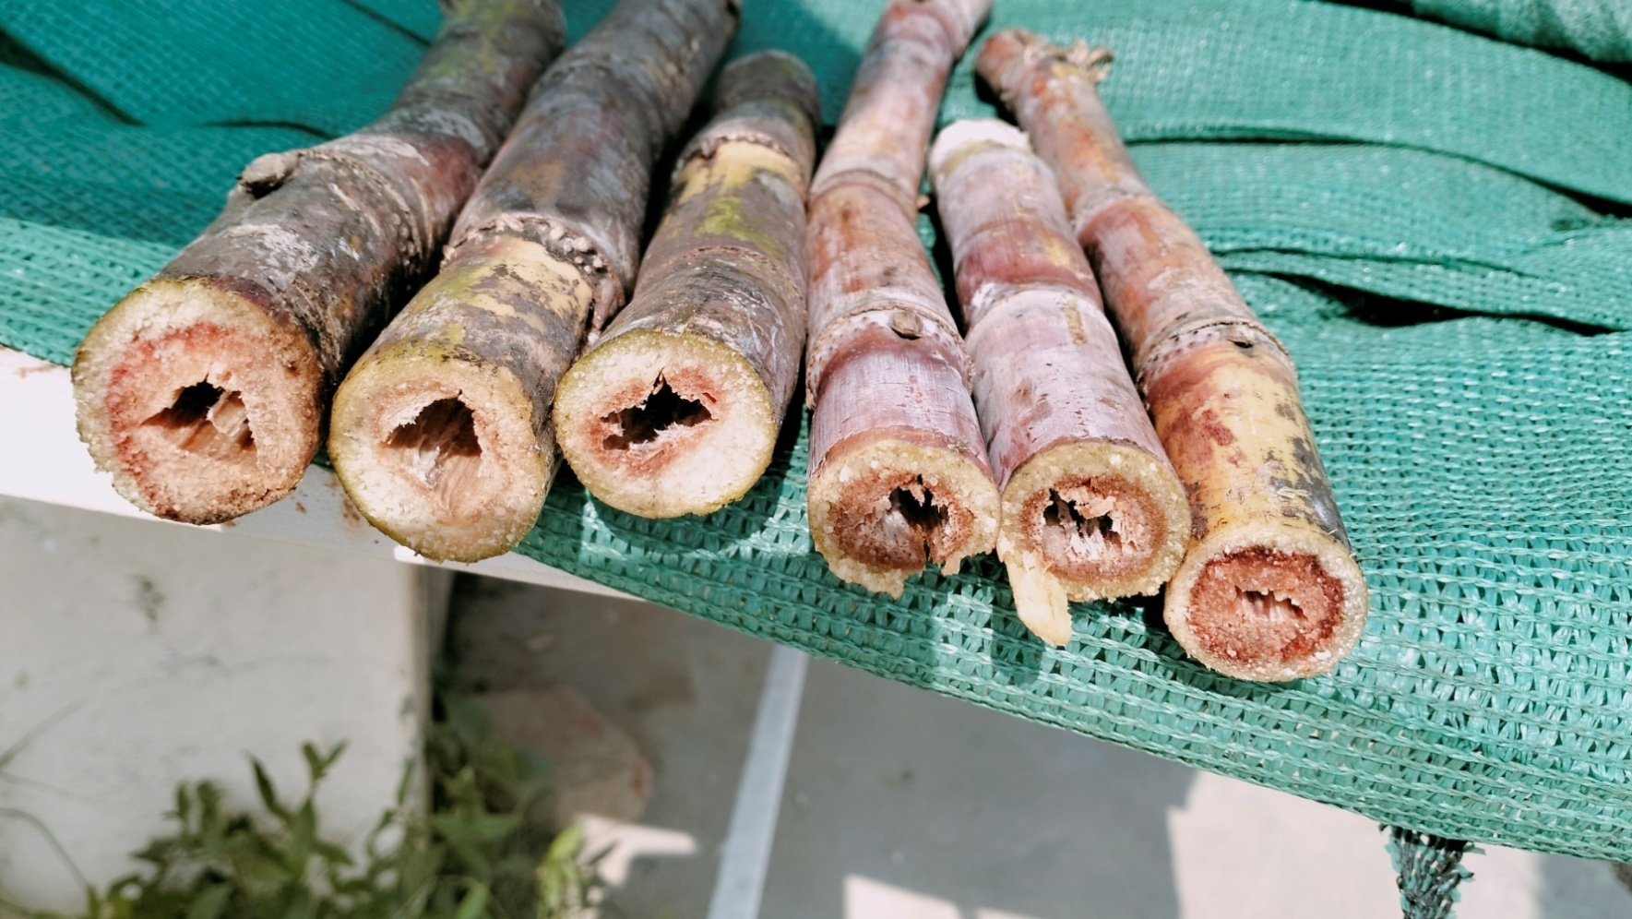

**Figure 1: Cane showing wilt disease symptoms.**

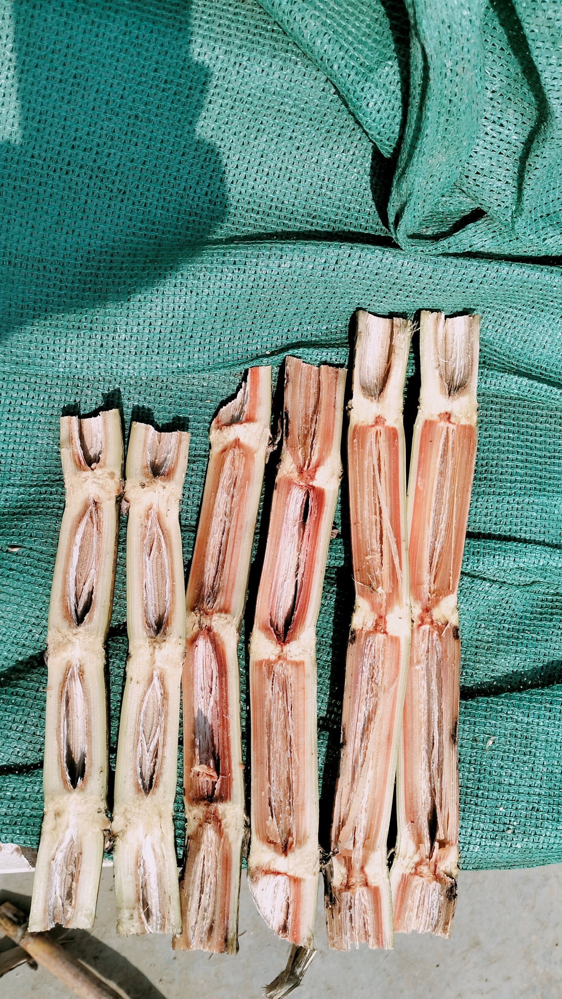

**Figure 2: Vertically spitted canes showing cavity formation due wilt disease.**

**Radial growth rate of *Fusarium sacchari* isolates**

Out of ten isolates tested against *Fusarium sacchari* (wilt pathogen of sugarcane), LG 19043 was recorded the fastest growth rate at 24 hours attaining 1.2 cm diameter. Whereas, Co 19016 recorded the slowest growing isolate attaining 0.6 cm colony diameter at same time duration. The results of the experimental revealed that there is variability within the isolates. Overall CoS 17236 isolate of *Fusarium sacchari* rates the fastest growth rate attaining 1.1 cm, 2.3 cm, 3.2 cm, 4.1 cm and 4.5 cm redial growth at 24h, 48h, 72h, 96h and 120h, respectively. The isolate LG 19043 also noted the fast growth rate recorded 1.2 cm, 2.3 cm, 3.3 cm, 4.1 cm and 4.5 cm redial growth at 24h, 48h, 72h, 96h and 120h time intervals, respectively. Viswanathan et al.,[21] have “clustered *Fusarium sacchari* isolates into seven groups based on variability observed against growth rate of the wilt pathogen”. “The cultural character such as average growth rate was considered to assess the variability of 12 isolates and the results depicted an average growth rate of the fungus ranging from 6.2 to 7.3 cm on seventh day” [18].

**Table 2: Radial growth rate of different *Fusarium sacchari* isolates**

|  |  |  |  |  |  |  |  |
| --- | --- | --- | --- | --- | --- | --- | --- |
| **S. No.** | **Isolates Variety** | **Radial growth (cm)** | | | | | |
| **24 h** | **48 h** | **72 h** | **96 h** | **120 h** | **144 h** |
| 1. | Co 19016 | 0.6 | 1.2 | 2.2 | 3.5 | 4.0 | 4.5(F) |
| 2. | CoS 17236 | 1.1 | 2.3 | 3.2 | 4.1 | 4.5(F) | - |
| 3. | CoPb 17215 | 0.9 | 1.5 | 2.4 | 3.6 | 4.4(F) | - |
| 4. | Co 17018 | 1.0 | 2.5 | 3.1 | 3.9 | 4.5(F) | - |
| 5. | LG 19123 | 0.9 | 2.2 | 3.0 | 3.8 | 4.4(F) | - |
| 6. | LG 19165 | 1.0 | 2.3 | 3.0 | 3.9 | 4.5(F) | - |
| 7. | LG 19036 | 1.1 | 2.2 | 3.1 | 3.9 | 4.3(F) | - |
| 8. | LG 19003 | 0.9 | 1.7 | 2.8 | 3.7 | 4.1 | 4.5(F) |
| 9. | LG 19043 | 1.2 | 2.3 | 3.3 | 4.1 | 4.5(F) | - |
| 10. | LG 19015 | 0.8 | 1.7 | 2.8 | 3.6 | 4.1 | 4.5(F) |

**Morphological Characterization of *Fusarium sacchari***

Maximum spore length of 18.58μm was recorded with Co19016 isolate of wilt followed by 17.38μm with CoS 17236, 16.33µm with LG 19015, 15.38μm with CoPb 17215, 15.41µm with LG 19036, 14.37µm with LG 19003,14.35µm LG 19165, 13.22μm with LG 19123, 13.31μm with Co17018, and 12.18μm with LG 19043. Whereas, *Fusarium sacchari* spore width measurement studies resulted that maximum spore width of 7.45 μm was recorded with two isolates Co19016 and LG19036, followed by 7.42µm with LG19015, 6.43µm with CoS 17236, 5.44μm with CoPb 17215, 5.43µm with LG19165, 5.40µm with LG19003, 4.42 µm with isolates Co17018 and LG19123, and minimum spore width of 3.38μm was recorded with LG 19043. In 2013 Viswanahtan et al., [21] performed “an extensive morphological study of the wilt pathogen”. Similar kind of study was conducted by Sekhar, [18] for the of study morphological characters the isolates like shape, size, colour and septation.

**Table 3: Morphological Characterization of *Fusarium sacchari* of wilt conidiospore**

|  |  |  |  |  |
| --- | --- | --- | --- | --- |
| **S. No.** | **Isolate Variety** | **Shape** | **Spore length (μm)** | **Spore width (μm)** |
| 1. | Co 19016 | Sickle | 18.58 | 7.45 |
| 2. | CoS 17236 | Sickle | 17.38 | 6.43 |
| 3. | CoPb 17215 | Sickle | 15.38 | 5.44 |
| 4. | Co 17018 | Sickle | 13.31 | 4.42 |
| 5. | LG 19123 | Sickle | 13.22 | 4.42 |
| 6. | LG 19165 | Sickle | 14.35 | 5.43 |
| 7. | LG 19036 | Sickle | 15.41 | 7.45 |
| 8. | LG 19003 | Sickle | 14.37 | 5.40 |
| 9. | LG 19043 | Sickle | 12.18 | 3.38 |
| 10. | LG 19015 | Sickle | 16.33 | 7.42 |

|  |  |
| --- | --- |
|  |  |

**Figure 3: Photographs depicting cultural characters of wilt pathogen**

**CONCLUSION**

The genotypes/varieties rated resistant against sugarcane wilt disease can be exploited for the development of wilt resistant variety of sugarcane whereas genotypes/varieties rated susceptible genotypes can be exploited as susceptible check for screening against wilt disease of sugarcane. And the development of resistant varieties is the eco-friendly way to control the wilt disease of sugarcane.

**Disclaimer (Artificial intelligence)**

Option 1:

Author(s) hereby declare that NO generative AI technologies such as Large Language Models (ChatGPT, COPILOT, etc.) and text-to-image generators have been used during the writing or editing of this manuscript.

Option 2:

Author(s) hereby declare that generative AI technologies such as Large Language Models, etc. have been used during the writing or editing of manuscripts. This explanation will include the name, version, model, and source of the generative AI technology and as well as all input prompts provided to the generative AI technology

Details of the AI usage are given below:

1.

2.

3.

**REFERENCES**

1. Ram B, Hemaprabha G. The sugarcane variety Co 0238-a reward to farmers and elixir to India’s sugarsector. Curr Sci. 2020;118(11): 1643-46.
2. Vamsi Krishna G, Manoj Kumar V, Kishore Varma P, Bhavani B, Vijaya Kumar G. Identification of resistance to Sugarcane mosaic virus, Sugarcane streak mosaic virus, and Sugarcane bacilliform virus in new elite sugarcane accessions in India. Frontiers in Microbiology. 2023;14: 1276932.
3. FAO. Production: Crops and livestock products. In FAOSTAT. Rome. [Cited October 2023].
4. Tiwari AK, Bharti YP, Tripathi S, Mishra N, Lal M, Rao GP, Sharma PK, Sharma ML. Biotechnological approaches to improve sugarcane crop with special reference to disease resistance. Acta Phytopathol Entomol Hungric. 2010; 45(2):235-49.
5. Vandana P, Singh D, Srivastava S, Guru, GD. Suppression of Sugarcane Red Rot Disease through Its Rhizospheric Mycoflora. Journal of Experimental Agriculture International*.* 2024;46(5): 98-109.
6. Viswanathan R, Rao GP. Disease scenario and management of major sugarcane diseases in India. Sugar Tech. 2011;13(4):336-53.
7. Butler EJ, Khan AH. Some new sugarcane diseases. Part I, Wilt. Memoirs of the Department of Agriculture, India*,* Botany series. 6th ed. 1913. p. 180-90.
8. Kirtikar, Singh GP, Shukla R. Role of seed material in carryover of wilt disease of sugarcane. Indian Sugar.1972;22: 89-90.
9. Singh K, Singh RP. Involvement and pathogenicity of Acremonium in wilt syndrome of sugarcane. Sugarcane Pathol. Newsl. 1974;11/12: 24-25.
10. Viswanathan R, Karuppaiah R, Balamuralikrishnan M. Detection of three major RNA viruses infecting sugarcane by multiplex reverse transcription-polymerase chain reaction (multiplexRT-PCR). Australas Plant Pathol. 2010;39:1-6.
11. Tiwari AK, Singh A, Singh SP, Dagar A, Kumari K, Kumar D, Pandey N, Kumar P. An Overview of Major Fungal Diseases of Sugarcane in India: Detection and Management Strategies, © Springer International Publishing Switzerland. 2017; pp:275-276.
12. Rao GP, Agnihotri VP. Wilt. In: A guide to sugarcane diseases, Rott P, Bailey R, Comstock JC, Croft B, Saumtally S) (Eds.). Montpellier, CIRAD/ISSCT, France. 2000:pp. 193-97.
13. Viswanathan R. Changing scenario of sugarcane diseases in India since introduction of hybrid cane varieties: path travelled for a century. J Sugarcane Res. 2018;8:177–211.
14. Agnihotri VP, Rao GP. A century status of sugarcane wilt in India. In: Sugarcane Crop Management (ed. S.B. Singh, G. P. Rao and S. Eswaramoorthy), SciTech Publishing LLC, Houston, USA. 2002:145-160.
15. Viswanathan R, Malathi P, Ramesh Sundar A, Poongothai M, Singh N. Current status of sugarcane wilt in India. Sugar Cane Intern.2006;24: 1-7.
16. Viswanathan R. Status of sugarcane wilt: one hundred years after its occurrence in India. J. Sugarcane Res. 2013;3(2): 86-106.
17. Poongothai M, Viswanathan R, Malathi P, Sundar AR. Sugarcane Wilt: Pathogen Recovery from Different Tissues and Variation in Cultural Characters. Sugar Tech. 2013;DOI 10.1007/s12355-013-0249-2.
18. Chandra Sekhar V, Kishore Varma P, Swapna B, Suresh M, Bharathalakhsmi M. Variability of Sugarcane Wilt Pathogen in North Coastal Zone of Andhra Pradesh. International Journal of Current Microbiology and Applied Science. 2021;10(02): 3161-3174.
19. Viswanathan R, Poongothai M, Malathi P, Prasanth N. Sugarcane wilt: Simulation of pathogenicity through different methods and environments. [International Sugar Journal](https://www.researchgate.net/journal/International-Sugar-Journal-0020-8841?_tp=eyJjb250ZXh0Ijp7ImZpcnN0UGFnZSI6InB1YmxpY2F0aW9uIiwicGFnZSI6InB1YmxpY2F0aW9uIiwicG9zaXRpb24iOiJwYWdlSGVhZGVyIn19). 2015;117(1396).
20. Viswanathan R, Malathi P, Ramesh Sundar A. Final Report of the Network Project on Wilt of crops with special reference to cultural, morphological, molecular characterization and pathogenic variability of isolates in India, Sugarcane breeding Institute, Coimbatore, 2009;46 pp.
21. Viswanathan R. Status of Sugarcane Wilt: One Hundred Years after Its Occurrence in India. Journal of Sugarcane Research. 2013;3:86-106.