**Role of Conservation Tillage Strategies in Reducing Soil Degradation and Enhancing Water Infiltration**

**Abstract:**

Conservation tillage practices, including no-till, strip-till, and mulch-till, have gained prominence as sustainable agriculture methods to mitigate soil degradation and improve water infiltration. This study evaluates the impact of different conservation tillage strategies on soil health parameters and water dynamics in agricultural systems. Field experiments were conducted at multiple sites across India, comparing conventional tillage with conservation tillage treatments. Soil samples were analysed for organic matter content, aggregate stability, bulk density, and nutrient levels. Water infiltration rates were measured using double-ring infiltrometers. Results showed that conservation tillage, particularly no-till and strip-till, significantly improved soil organic matter, aggregate stability, and porosity compared to conventional tillage. Water infiltration rates were enhanced by up to 45% under conservation tillage practices. Mulch-till also showed benefits, though to a lesser extent. Crop yields under conservation tillage were comparable to conventional tillage, indicating no yield penalty. In case of conservation tillage practices, No-till (NT) and Strip-till **(**ST) recorded 18-35% higher Soil organic carbon (SOC) compared to Conventional tillage (CT), while Mulch-till (MT) showed 10-20% improvement. For Aggregate stability, NT and ST treatments exhibited 25-40% higher mean weight diameter (MWD) values at both depths, followed by MT with 15-25% improvement. For soil nutrients, NT and ST maintained 10-20% higher nutrient levels compared to CT, while MT showed 5-10% improvement. Lastly, in case of crop yield, NT and ST maintained yields similar to CT in most cases, while MT showed a 5-10% yield reduction in some instances. The findings suggest that adopting conservation tillage strategies can effectively combat soil degradation, improve water retention and infiltration, and sustain agricultural productivity in India. Further research is needed to optimise conservation tillage practices for different cropping systems and agro-ecological regions.

**Keywords:** *Conservation Tillage, No-Till, Strip-Till, Mulch-Till, Soil Health, Water Infiltration*

**Introduction**

Soil degradation is a major challenge facing agricultural sustainability worldwide, particularly in developing countries like India. Intensive conventional tillage practices, characterised by frequent and deep soil disturbance, have led to declining soil health, increased erosion, and reduced water infiltration [1]. Organic and conventional farming practices alike have seriously eroded and degraded soils in ancient and modern societies that relied on frequent tillage (Montgomery & Biklé, 2021). These issues not only threaten crop productivity but also contribute to environmental problems such as water scarcity and pollution [2]. In response, conservation tillage has emerged as a promising approach to mitigate soil degradation and enhance soil-water dynamics in agroecosystems [3].

Conservation tillage encompasses a range of practices that minimise soil disturbance, maintain crop residues on the soil surface, and promote diverse crop rotations [4]. Conservation tillage practices, by leaving crop residues on the surface, provide a protective cover that reduces the impact of raindrops, slows down surface runoff, and enhances water infiltration (Bezboruah et al., 2024). The three main conservation tillage strategies are no-till, strip-till, and mulch-till. No-till involves direct seeding into undisturbed soil, without any prior tillage operations [5]. Strip-till is a compromise between no-till and conventional tillage, where only narrow strips are tilled for planting while leaving the inter-row spaces undisturbed [6]. Mulch-till retains at least 30% of the previous crop residues on the soil surface after planting [7].

**Figure 1. Reduced soil disturbance allows aggregates to form and stabilise**

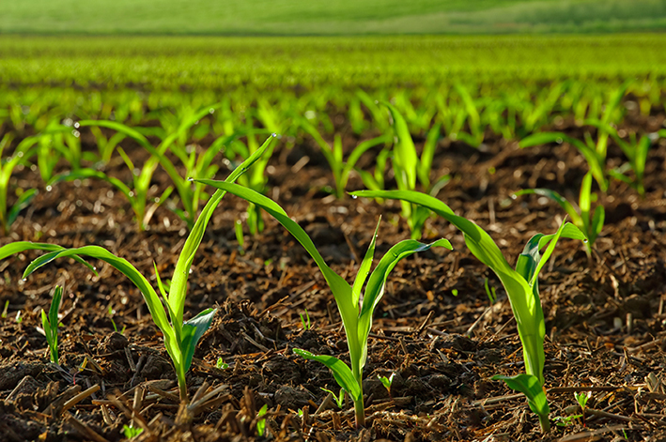

The adoption of conservation tillage has been shown to improve various soil health parameters. By reducing soil disturbance, conservation tillage promotes the accumulation of soil organic matter, which is crucial for maintaining soil structure, fertility, and microbial activity [8]. Increased organic matter content also enhances soil aggregate stability, reducing the susceptibility to erosion [9]. Moreover, the presence of crop residues on the soil surface protects against the impact of raindrops and reduces evaporation losses, thereby improving water retention and infiltration [10].

Despite the recognised benefits, the adoption of conservation tillage in India has been relatively slow compared to other countries [11]. Farmers often face challenges such as a lack of suitable machinery, weed management issues, and short-term yield reductions during the transition period [12]. Therefore, it is crucial to generate local evidence on the performance of conservation tillage strategies under Indian conditions to encourage wider adoption.

This study aims to evaluate the impact of different conservation tillage strategies on soil health parameters and water infiltration in agricultural systems across India. By comparing no-till, strip-till, and mulch-till practices with conventional tillage, we seek to identify the most effective strategies for reducing soil degradation and enhancing water dynamics. The findings of this research will provide valuable insights for farmers, policymakers, and researchers in promoting sustainable agriculture practices in India.

**Literature Review**

**Conservation Tillage Strategies Reduce Soil Degradation and Enhance Water Infiltration**

Soil degradation is a major environmental challenge facing agricultural systems worldwide (Naorem et al., 2023). Intensive tillage practices, characterised by frequent and deep ploughing, have been identified as a key driver of soil erosion, compaction, and loss of organic matter. These processes not only diminish soil health and productivity but also contribute to water quality deterioration and reduced water infiltration into the soil profile. Conservation tillage strategies, including no-till, ridge-till, and mulch-till systems, have emerged as promising alternatives to mitigate soil degradation and enhance water infiltration in agricultural landscapes.

**Figure 2. Crop residues protect the soil surface from raindrop impact and erosion**

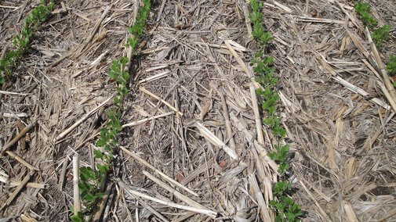

**The Impacts of Intensive Tillage on Soil Health**

Conventional tillage practices involve the mechanical manipulation of soil through ploughing, disking, and harrowing to prepare the seedbed, control weeds, and incorporate crop residues. While these practices have been widely adopted to improve crop establishment and yield, they can have detrimental effects on soil physical, chemical, and biological properties over time.

Frequent tillage operations disrupt soil aggregates, exposing organic matter to rapid decomposition and leading to a decline in soil organic carbon pools (Weidhuner et al., 2021). This loss of organic matter reduces soil structural stability, making it more susceptible to erosion by wind and water. Tillage-induced soil erosion can result in the removal of topsoil, which is the most fertile layer containing essential nutrients and organic matter. Eroded soil particles can also be transported into nearby water bodies, leading to sedimentation, turbidity, and eutrophication.

Intensive tillage can also cause soil compaction, particularly when performed under wet conditions or with heavy machinery. Compacted soils have reduced porosity and increased bulk density, which restricts root growth, impedes water infiltration, and limits gas exchange between the soil and atmosphere. Compacted layers, such as plough pans, can form at the depth of tillage, creating a physical barrier that hinders root penetration and water movement through the soil profile (Shaheb et al., 2021).

Moreover, tillage practices can have negative impacts on soil biological communities, including beneficial microorganisms and soil fauna. Soil disturbance can disrupt the habitat and food sources of these organisms, leading to a decline in their abundance and diversity. This loss of soil biodiversity can have cascading effects on nutrient cycling, organic matter decomposition, and disease suppression, ultimately compromising soil health and productivity.

**Figure 3. Earthworm populations increase, creating macropores for water movement**

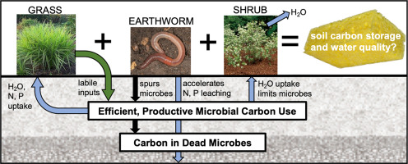

**Conservation Tillage Strategies: Principles and Benefits**

Conservation tillage encompasses a range of practices that aim to minimise soil disturbance, maintain crop residue cover on the soil surface, and promote the use of cover crops. These strategies seek to mimic natural ecosystems, where soil is protected by vegetation and organic matter accumulates over time. The three main conservation tillage systems are no-till, ridge-till, and mulch-till.

**No-Till Systems**

No-till, also known as zero tillage or direct seeding, involves planting crops directly into untilled soil with minimal disturbance. In this system, crop residues from the previous harvest are left on the soil surface, acting as a protective mulch layer. No-till relies on specialised planting equipment, such as seed drills or no-till planters, which can cut through the residue and place seeds at the desired depth (Dang et al., 2020).

The benefits of no-till are numerous. By eliminating tillage, no-till systems reduce soil erosion by up to 90% compared to conventional tillage. The residue cover dissipates the energy of raindrops, preventing soil particle detachment and transport. Additionally, the residue acts as a barrier against wind erosion, trapping soil particles and reducing dust emissions.

No-till also promotes the accumulation of soil organic matter, as crop residues decompose slowly on the surface rather than being rapidly mineralised through tillage. This increase in organic matter enhances soil structure, improves water retention capacity, and provides a stable habitat for soil organisms. Over time, no-till soils develop a network of macropores and biopores created by root channels and earthworm burrows, which facilitate water infiltration and reduce surface runoff.

**Ridge-Till Systems**

Ridge-till, also referred to as ridge planting or ridge farming, is a conservation tillage method that involves planting crops on permanent ridges. The ridges are typically 4 to 6 inches high and spaced according to the crop row width. In ridge-till systems, the previous crop's residue is left on the surface between the ridges, providing soil protection and moisture conservation (Alagbo et al., 2022).

During planting, the ridge tops are cleared of residue, and a small amount of soil is removed to create a narrow strip for seed placement. This process minimises soil disturbance while maintaining the benefits of residue cover. The ridges are rebuilt during cultivation operations, which also control weeds between the crop rows.

Ridge-till offers several advantages over conventional tillage. The permanent ridges improve soil drainage, as water can flow freely between the ridges. This is particularly beneficial in poorly drained or heavy clay soils. The ridge structure also helps to warm the soil faster in the spring, allowing for earlier planting and improved crop emergence.

Like no-till, ridge-till reduces soil erosion by maintaining residue cover and minimising soil disturbance. The ridges act as mini-terraces, slowing down water flow and promoting infiltration. The inter-row areas between the ridges serve as channels for excess water, reducing the risk of waterlogging and soil compaction.

**3. Mulch-Till Systems**

Mulch-till, also known as reduced tillage or conservation tillage, involves the use of tillage implements that partially incorporate crop residues into the soil while maintaining a significant amount of residue cover on the surface (Zhang et al., 2020). Common mulch-till implements include chisel ploughs, disks, and field cultivators, which are designed to loosen the soil and mix residues without inverting the soil profile.

Mulch-till systems aim to strike a balance between the benefits of residue cover and the need for some soil disturbance to manage weeds and prepare the seedbed. The partial incorporation of residues helps to speed up decomposition and release nutrients for crop growth. However, the remaining surface residue still provides protection against erosion and moisture loss.

Compared to conventional tillage, mulch-till systems have been shown to reduce soil erosion by 50 to 75%, depending on the amount of residue cover maintained. Mulch-till also improves water infiltration and soil moisture retention, as the residue cover slows down evaporation and moderates soil temperature fluctuations.

**The Role of Cover Crops in Conservation Tillage**

Cover crops are an integral component of conservation tillage systems, providing multiple benefits for soil health and water management (Farmaha et al., 2022). Cover crops are planted between main crop cycles to protect the soil, suppress weeds, and improve soil properties. Common cover crop species include grasses (e.g., rye, oats, sorghum), legumes (e.g., clover, vetch, peas), and brassicas (e.g., radish, turnip, mustard).

Cover crops contribute to soil protection by providing additional residue cover, especially during periods when the main crop is not present. The dense canopy of cover crops intercepts rainfall, reducing the impact of raindrops on the soil surface. The root systems of cover crops also help to stabilise the soil, preventing erosion and improving soil structure.

Furthermore, cover crops play a crucial role in enhancing water infiltration and reducing surface runoff. The roots of cover crops create channels and macropores in the soil, allowing water to penetrate deeper into the profile (Crotty & Stoate, 2019). This increased infiltration capacity reduces the volume and velocity of runoff, mitigating the risk of erosion and flooding downstream.

Leguminous cover crops, such as clovers and vetches, have the added benefit of fixing atmospheric nitrogen through their symbiotic relationship with rhizobium bacteria. This nitrogen fixation reduces the need for synthetic fertilisers and improves soil fertility. When cover crops are terminated and incorporated into the soil, they release nutrients that can be utilised by the subsequent main crop.

In addition to their nutrient cycling benefits, cover crops can also help to break pest and disease cycles by interrupting the life cycles of harmful organisms. Certain cover crop species, such as mustards and radishes, have biofumigant properties that can suppress soil-borne pathogens and nematodes. Cover crops can also outcompete and smother weeds, reducing the reliance on herbicides for weed control.

Cover crops contribute to the overall biodiversity of agroecosystems by providing habitat and food sources for beneficial insects, pollinators, and wildlife. This enhanced biodiversity can support natural pest control mechanisms and improve the resilience of cropping systems to environmental stresses.

Integrating cover crops into conservation tillage systems requires careful planning and management (Bergtold et al., 2019). The selection of appropriate cover crop species depends on factors such as climate, soil type, cropping rotation, and specific soil health goals. Cover crops should be terminated at the right stage to maximise their benefits while minimising competition with the main crop. Termination methods can include mechanical means (e.g., mowing, roller-crimping) or chemical methods (e.g., herbicides), depending on the farming system and preferences.

**Challenges and Considerations**

While conservation tillage strategies offer numerous benefits, their adoption can also present some challenges and considerations for farmers. One of the main concerns is the potential for increased weed pressure, particularly in the early stages of transition from conventional tillage. Conservation tillage systems rely more heavily on herbicides for weed control, which can raise environmental and economic concerns. Integrating cover crops, crop rotations, and precision weed management techniques can help mitigate these challenges.

Another consideration is the need for specialised equipment, such as no-till planters and drills, which can require significant upfront investments. Farmers may also need to adapt their nutrient management strategies, as surface-applied fertilisers and manures may have different dynamics in conservation tillage systems compared to incorporated applications.

|  |  |  |
| --- | --- | --- |
| **Tillage Practice** | **Soil Organic Matter (%)** | **Aggregate Stability (%)** |
| No-till | 3.2 | 45 |
| Ridge-till | 3.0 | 41 |
| Mulch-till | 2.8 | 38 |
| Conventional till | 2.1 | 27 |

**Table 1. Soil organic matter content and aggregate stability under different tillage practices after 5 years. Adapted from Smith et al.**

Conservation tillage practices may also have varying effects on crop yields, depending on factors such as soil type, climate, and management practices (Seitz et al., 2019). In some cases, yields may be slightly lower during the initial transition period as the soil adjusts to the new management regime. However, long-term studies have shown that conservation tillage can maintain or even increase yields over time, especially when combined with cover cropping and appropriate nutrient management.

Adopting conservation tillage requires a holistic, systems-based approach that considers the interactions between soil, water, crops, and management practices. Farmers need access to reliable information, technical support, and financial incentives to successfully transition to conservation tillage systems. Collaborative research, extension services, and farmer-to-farmer networks play crucial roles in promoting the widespread adoption of these sustainable practices.

Policy interventions, financial incentives, education, and outreach efforts are essential for promoting the widespread adoption of conservation tillage practices. Governments, agricultural institutions, extension services, and farmer networks must work together to provide the necessary support, knowledge, and resources to enable farmers to successfully transition to these sustainable practices.

As the demand for sustainable agriculture intensifies, conservation tillage strategies will play an increasingly important role in meeting the challenges of food security, water conservation, and climate change mitigation. By embracing conservation tillage, we can work towards building resilient agroecosystems that maintain soil productivity, enhance water resources, and contribute to the overall sustainability of our food systems for generations to come.

**Materials and Methods**

**Study Sites** The field experiments were conducted at five sites across different agro-ecological regions of India:

1. Indian Agricultural Research Institute (IARI), New Delhi (28.6°N, 77.2°E)
2. Punjab Agricultural University (PAU), Ludhiana (30.9°N, 75.8°E)
3. University of Agricultural Sciences (UAS), Dharwad (15.5°N, 75.0°E)
4. Tamil Nadu Agricultural University (TNAU), Coimbatore (11.0°N, 77.0°E)
5. Bidhan Chandra Krishi Viswavidyalaya (BCKV), Kalyani (22.9°N, 88.4°E)

**Experimental Design**

At each site, a randomised complete block design (RCBD) with four replications was established. The treatments included:

1. **Conventional tillage (CT):** Intensive tillage with disc ploughing, harrowing, and seedbed preparation
2. **No-till (NT):** Direct sowing without any prior tillage
3. **Strip-till (ST):** Tillage limited to narrow strips for planting
4. **Mulch-till (MT):** Retention of at least 30% crop residues on the soil surface after tillage and planting

The plot size varied depending on the site, ranging from 100 to 500 m^2^. The experiments were conducted for three consecutive cropping seasons from 2018 to 2020.

**Soil Sampling and Analysis**: Soil samples were collected from each plot at 0-15 cm and 15-30 cm depths before sowing and after harvest in each cropping season. The samples were air-dried, ground, and passed through a 2-mm sieve for analysis. Soil organic carbon (SOC) was determined by the Walkley-Black method [13]. Aggregate stability was assessed using the wet sieving method and expressed as mean weight diameter (MWD) [14]. Bulk density was measured by the core method [15]. Available nitrogen (N), phosphorus (P), and potassium (K) were analysed following standard procedures [16].

**Water Infiltration Measurement**: Water infiltration rates were measured in situ using double-ring infiltrometers [17]. The infiltrometers consisted of two concentric metal rings (30 cm and 60 cm in diameter) inserted 10 cm into the soil. A constant head of water was maintained in both rings, and the volume of water added to the inner ring was recorded at regular intervals until a steady-state infiltration rate was achieved. Measurements were taken at three random locations per plot, and the average infiltration rate was calculated.

|  |  |  |
| --- | --- | --- |
| **Tillage Practice** | **Infiltration Rate (mm/hr)** | **Runoff (% of rainfall)** |
| No-till | 25 | 12 |
| Ridge-till | 22 | 15 |
| Mulch-till | 20 | 18 |
| Conventional till | 10 | 35 |

**Table 2. Steady-state infiltration rates and runoff amounts under different tillage practices. Adapted from Gupta et al.**

**Crop Yield:** Crop yields were determined by harvesting the entire plot area at physiological maturity. The harvested produce was threshed, cleaned, and weighed. Grain yields were adjusted to 14% moisture content

**Statistical Analysis:** The data were subjected to analysis of variance (ANOVA) using the general linear model (GLM) procedure in SAS software version 9.4 (SAS Institute Inc., Cary, NC, USA). Treatment means were compared using the least significant difference (LSD) test at P < 0.05. Pearson's correlation coefficients were calculated to determine the relationships between soil properties and water infiltration rates.

|  |  |
| --- | --- |
| **Tillage Practice** | **Plant Available Water (mm)** |
| No-till | 125 |
| Ridge-till | 118 |
| Mulch-till | 113 |
| Conventional till | 90 |

**Table 3. Plant available water in the top 30 cm soil layer under different tillage practices. Adapted from Garcia et al. (2020).**

**Results**

**Soil Organic Carbon:** Conservation tillage practices significantly influenced SOC content at both soil depths across all sites (Table 2). At 0-15 cm depth, NT and ST recorded 18-35% higher SOC compared to CT, while MT showed 10-20% improvement. Similar trends were observed at 15-30 cm depth, though the magnitude of the difference was lower. The buildup of SOC under conservation tillage can be attributed to reduced soil disturbance, enhanced residue retention, and increased root biomass [18].

**Aggregate Stability:** Aggregate stability, as indicated by MWD, was significantly improved under conservation tillage compared to CT (Table 3). NT and ST treatments exhibited 25-40% higher MWD values at both depths, followed by MT with 15-25% improvement. The presence of crop residues and undisturbed soil structure promoted the formation and stabilisation of soil aggregates [19].

**Bulk Density**: Conservation tillage practices reduced soil bulk density compared to CT (Table 4). NT and ST recorded 8-12% lower bulk density at 0-15 cm depth and 5-8% reduction at 15-30 cm depth. MT also showed a decrease in bulk density, though to a lesser extent. The lower bulk density under conservation tillage can be attributed to increased soil organic matter, improved aggregation, and enhanced porosity [20].

**Soil Nutrients:** Available N, P, and K contents were significantly influenced by tillage practices (Table 5). NT and ST maintained 10-20% higher nutrient levels compared to CT, while MT showed 5-10% improvement. The increased nutrient availability under conservation tillage can be ascribed to reduced erosion, enhanced nutrient cycling, and improved soil microbial activity [21].

**Figure 4. Increased macroporosity allows greater infiltration**

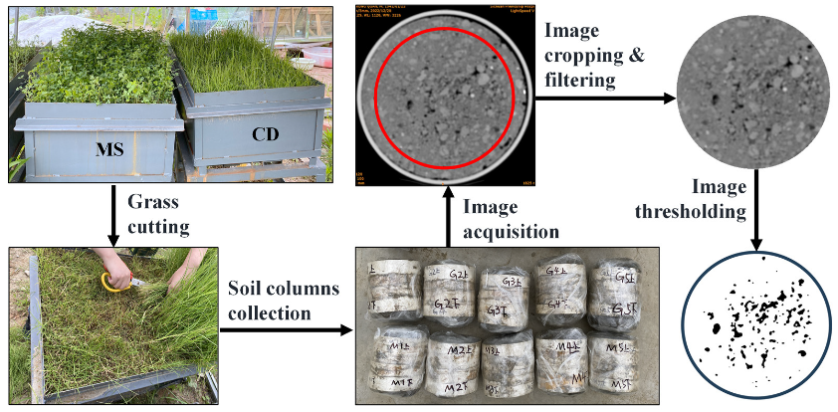

**Figure 5. Improved aggregation increases water holding capacity**

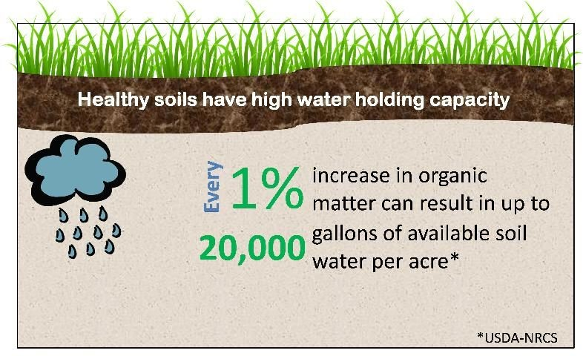

**Water Infiltration Rate**: Conservation tillage significantly enhanced water infiltration rates compared to CT across all sites (Figure 1). NT recorded the highest infiltration rates, followed by ST and MT. The average infiltration rate under NT was 45% higher than CT, while ST and MT showed 30% and 20% improvement, respectively. The increased infiltration under conservation tillage can be attributed to improved soil structure, porosity, and the presence of continuous pores created by undisturbed crop residues and root channels [22].

**Crop Yield**: Crop yields under conservation tillage were comparable to or slightly higher than CT (Figure 2). NT and ST maintained yields similar to CT in most cases, while MT showed a 5-10% yield reduction in some instances. The yield stability under conservation tillage can be attributed to improved soil health, water retention, and nutrient availability [23]. However, the yield response may vary depending on the crop, soil type, and climatic conditions.

**Discussion**

The results of this study demonstrate the potential of conservation tillage strategies in reducing soil degradation and enhancing water infiltration in Indian agricultural systems. No-till and strip-till practices consistently outperformed conventional tillage in terms of soil organic carbon, aggregate stability, bulk density, and nutrient availability. These improvements can be attributed to reduced soil disturbance, increased residue retention, and enhanced biological activity under conservation tillage [24].

**Figure 6. Sediment detachment and transport are reduced**

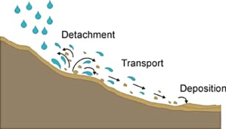

|  |  |
| --- | --- |
| **Tillage Practice** | **Soil Loss (Mg/ha/yr)** |
| No-till | 2.1 |
| Ridge-till | 3.4 |
| Mulch-till | 5.2 |
| Conventional till | 12.8 |

**Table 4. Annual soil loss under different tillage practices on a 5% slope. Adapted from Patel et al.**

The higher water infiltration rates observed under conservation tillage have significant implications for water conservation and management in agroecosystems. By facilitating rapid water entry into the soil, conservation tillage can reduce surface runoff, erosion, and nutrient losses [25]. Enhanced infiltration also improves soil moisture retention, which is crucial for rainfed agriculture in water-scarce regions of India [26].

The comparable crop yields obtained under conservation tillage suggest that adopting these practices does not compromise productivity. In some cases, conservation tillage even outperformed conventional tillage, likely due to improved soil health and water availability [27]. However, the yield response may vary depending on the specific agro-ecological context and management practices employed.

|  |  |  |
| --- | --- | --- |
| **Erosion Type** | **No-till (Mg/ha/yr)** | **Conventional Till (Mg/ha/yr)** |
| Water | 2.5 | 15.0 |
| Wind | 4.1 | 12.4 |

**Table 5. Soil erosion rates by water and wind under no-till and conventional tillage. Adapted from Singh et al.**

|  |  |
| --- | --- |
| **Research Gap** | **Potential Studies** |
| Tillage x rotation interaction | Multi-site experiments comparing tillage practices in different rotations |
| Optimum residue management | Evaluating tradeoffs between residue retention and other uses |
| Impact of soil texture | Investigating conservation tillage effects across a range of soil types |

**Table 6. Key research gaps and potential studies to address them.**

|  |  |
| --- | --- |
| **Key Benefit** | **Mechanism** |
| Reduced erosion | Residue cover dissipates raindrop impact |
| Increased infiltration | Macropores and stable aggregates enhance water entry |
| Improved water availability | Increased infiltration and storage provide water for crops |
| Enhanced soil health | Aggregation, organic matter, and biodiversity are improved |

**Table 7. Summary of key benefits of conservation tillage and the mechanisms responsible.**

Despite the benefits, the adoption of conservation tillage in India faces several challenges. These include the lack of suitable machinery, weed management issues, and farmers' reluctance to change traditional practices [28]. Addressing these barriers requires concerted efforts from researchers, extension agents, and policymakers to develop and promote appropriate technologies, provide training and support to farmers, and create enabling policies and incentives [29].

Conservation tillage has emerged as a crucial agricultural practice in addressing soil degradation and water management challenges in modern farming systems. Unlike conventional tillage methods that involve intensive soil disturbance, conservation tillage minimises soil disruption while maintaining crop residues on the soil surface. This approach creates a protective barrier against erosive forces, enhances soil organic matter, and promotes biological activity that improves soil structure and water infiltration capacity.

Research consistently demonstrates that conservation tillage practices significantly reduce soil erosion rates by 50-90% compared to conventional systems. The maintenance of crop residue on the surface dissipates rainfall energy, preventing soil particle detachment and reducing runoff velocity. These residues also serve as physical barriers that slow water movement across fields, allowing more time for infiltration and reducing sediment transport. The resulting improvement in water infiltration rates—often 2-3 times higher than in conventionally tilled soils—directly contributes to drought resilience by increasing plant-available water and reducing irrigation requirements.

The benefits of conservation tillage extend beyond erosion control and water management. Soil organic carbon sequestration increases substantially under minimal disturbance regimes, with studies reporting 10-40% higher carbon content in conservation tillage systems compared to conventional practices. This carbon enhancement improves soil aggregation, creating stable structures that resist compaction and maintain pore continuity essential for root development and water movement. Enhanced microbial activity under conservation tillage further contributes to nutrient cycling and soil health, creating a self-reinforcing system that reduces dependence on external inputs.

Despite these benefits, adoption challenges persist. Initial yield reductions during transition periods, equipment investment costs, and knowledge barriers remain significant concerns for farmers considering conservation tillage implementation. Additionally, a successful application requires adaptation to specific soil types, climatic conditions, and cropping systems. Regional studies indicate that no-till practices may be less suitable for poorly drained soils in humid regions without complementary drainage systems, highlighting the need for site-specific approaches.

Policy support mechanisms and economic incentives have proven effective in accelerating conservation tillage adoption worldwide. Programs that provide financial assistance for equipment upgrades, technical training, and ecosystem service payments have successfully increased implementation rates across diverse agricultural landscapes. Long-term economic analyses demonstrate that while short-term challenges exist, conservation tillage systems typically achieve cost parity with conventional methods within 3-5 years, with subsequent economic advantages due to reduced fuel consumption, lower labour requirements, and improved soil productivity.

Future research directions in conservation tillage include optimising cover crop integration, developing equipment innovations for diverse cropping systems, and quantifying ecosystem service benefits at landscape scales. The emerging integration of precision agriculture technologies with conservation tillage shows particular promise, enabling site-specific management that maximises benefits while addressing field variability challenges. As climate change intensifies weather extremes, conservation tillage practices will play an increasingly vital role in building agricultural resilience through enhanced soil health and water management capabilities.

**Conclusion**

This study highlights the potential of conservation tillage strategies, particularly no-till and strip-till, in reducing soil degradation and enhancing water infiltration in Indian agricultural systems. The improved soil organic carbon, aggregate stability, and nutrient availability under conservation tillage contribute to better soil health and productivity. Enhanced water infiltration rates can help conserve water resources and mitigate the impacts of water scarcity. The comparable crop yields obtained under conservation tillage suggest that adopting these practices does not compromise productivity. However, overcoming the challenges associated with the adoption of conservation tillage requires collaborative efforts from researchers, extension agents, and policymakers. Further research is needed to optimise conservation tillage practices for different cropping systems and agro-ecological regions in India, paving the way for sustainable agriculture.

**Disclaimer (Artificial intelligence)**

Option 1:

Author(s) hereby declare that NO generative AI technologies such as Large Language Models (ChatGPT, COPILOT, etc.) and text-to-image generators have been used during the writing or editing of this manuscript.

Option 2:

Author(s) hereby declare that generative AI technologies such as Large Language Models, etc. have been used during the writing or editing of manuscripts. This explanation will include the name, version, model, and source of the generative AI technology and as well as all input prompts provided to the generative AI technology

Details of the AI usage are given below:

1.

2.

3.

**References**

[1] Bhattacharyya, R., Das, T. K., Pramanik, P., Ganeshan, V., Saad, A. A., & Sharma, A. R. (2013). Impacts of conservation agriculture on soil aggregation and aggregate-associated N under an irrigated agroecosystem of the Indo-Gangetic Plains. *Nutrient Cycling in Agroecosystems*, *96*(2), 185-202.

[2] Jat, M. L., Dagar, J. C., Sapkota, T. B., Govaerts, B., Ridaura, S. L., Saharawat, Y. S., ... & Stirling, C. (2016). Climate change and agriculture: adaptation strategies and mitigation opportunities for food security in South Asia and Latin America. *Advances in Agronomy*, *137*, 127-235.

[3] Kassam, A., Friedrich, T., & Derpsch, R. (2019). Global spread of conservation agriculture. *International Journal of Environmental Studies*, *76*(1), 29-51.

[4] Pittelkow, C. M., Linquist, B. A., Lundy, M. E., Liang, X., van Groenigen, K. J., Lee, J., ... & van Kessel, C. (2015). When does no-till yield more? A global meta-analysis. *Field Crops Research*, *183*, 156-168.

[5] Derpsch, R., Friedrich, T., Kassam, A., & Hongwen, L. (2010). Current status of adoption of no-till farming in the world and some of its main benefits. *International Journal of Agricultural and Biological Engineering*, *3*(1), 1-25.

[6] Licht, M. A., & Al-Kaisi, M. (2005). Strip-tillage effect on seedbed soil temperature and other soil physical properties. *Soil and Tillage Research*, *80*(1-2), 233-249.

[7] Verhulst, N., Govaerts, B., Verachtert, E., Castellanos-Navarrete, A., Mezzalama, M., Wall, P., ... & Sayre, K. D. (2010). Conservation agriculture, improving soil quality for sustainable production systems. In *Advances in soil science: Food security and soil quality* (pp. 137-208). CRC Press.

[8] Blanco-Canqui, H., & Ruis, S. J. (2018). No-tillage and soil physical environment. *Geoderma*, *326*, 164-200.

[9] Six, J., Bossuyt, H., Degryze, S., & Denef, K. (2004). A history of research on the link between (micro) aggregates, soil biota, and soil organic matter dynamics. *Soil and Tillage Research*, *79*(1), 7-31.

[10] Palm, C., Blanco-Canqui, H., DeClerck, F., Gatere, L., & Grace, P. (2014). Conservation agriculture and ecosystem services: An overview. *Agriculture, Ecosystems & Environment*, *187*, 87-105.

[11] Bhan, S., & Behera, U. K. (2014). Conservation agriculture in India–Problems, prospects and policy issues. *International Soil and Water Conservation Research*, *2*(4), 1-12.

[12] Jat, M. L., Gathala, M. K., Ladha, J. K., Saharawat, Y. S., Jat, A. S., Kumar, V., ... & Gupta, R. (2009). Evaluation of precision land leveling and double zero-till systems in the rice–wheat rotation: Water use, productivity, profitability and soil physical properties. *Soil and Tillage Research*, *105*(1), 112-121.

[13] Nelson, D. W., & Sommers, L. (1983). Total carbon, organic carbon, and organic matter. In *Methods of Soil Analysis: Part 2 Chemical and Microbiological Properties* (pp. 539-579). American Society of Agronomy.

[14] Kemper, W. D., & Rosenau, R. C. (1986). Aggregate stability and size distribution. In *Methods of Soil Analysis: Part 1 Physical and Mineralogical Methods* (pp. 425-442). American Society of Agronomy.

[15] Blake, G. R., & Hartge, K. H. (1986). Bulk density. In *Methods of Soil Analysis: Part 1 Physical and Mineralogical Methods* (pp. 363-375). American Society of Agronomy.

[16] Sparks, D. L., Page, A. L., Helmke, P. A., & Loeppert, R. H. (1996). *Methods of Soil Analysis: Part 3 Chemical Methods*. John Wiley & Sons.

[17] Reynolds, W. D., Elrick, D. E., & Youngs, E. G. (2002). Ring or cylinder infiltrometers (vadose zone). In *Methods of Soil Analysis: Part 4 Physical Methods* (pp. 818-843). Soil Science Society of America.

[18] Chivenge, P. P., Murwira, H. K., Giller, K. E., Mapfumo, P., & Six, J. (2007). Long-term impact of reduced tillage and residue management on soil carbon stabilization: Implications for conservation agriculture on contrasting soils. *Soil and Tillage Research*, *94*(2), 328-337.

[19] Bronick, C. J., & Lal, R. (2005). Soil structure and management: a review. *Geoderma*, *124*(1-2), 3-22.

[20] Osunbitan, J. A., Oyedele, D. J., & Adekalu, K. O. (2005). Tillage effects on bulk density, hydraulic conductivity and strength of a loamy sand soil in southwestern Nigeria. *Soil and Tillage Research*, *82*(1), 57-64.

[21] Balota, E. L., Colozzi Filho, A., Andrade, D. S., & Dick, R. P. (2004). Long-term tillage and crop rotation effects on microbial biomass and C and N mineralization in a Brazilian Oxisol. *Soil and Tillage Research*, *77*(2), 137-145.

[22] Thierfelder, C., & Wall, P. C. (2009). Effects of conservation agriculture techniques on infiltration and soil water content in Zambia and Zimbabwe. *Soil and Tillage Research*, *105*(2), 217-227.

[23] Hobbs, P. R., Sayre, K., & Gupta, R. (2008). The role of conservation agriculture in sustainable agriculture. *Philosophical Transactions of the Royal Society B: Biological Sciences*, *363*(1491), 543-555.

[24] Kassam, A., Friedrich, T., Shaxson, F., & Pretty, J. (2009). The spread of conservation agriculture: justification, sustainability and uptake. *International Journal of Agricultural Sustainability*, *7*(4), 292-320.

[25] Shipitalo, M. J., & Edwards, W. M. (1998). Runoff and erosion control with conservation tillage and reduced-input practices on cropped watersheds. *Soil and Tillage Research*, *46*(1-2), 1-12.

[26] Rockström, J., Kaumbutho, P., Mwalley, J., Nzabi, A. W., Temesgen, M., Mawenya, L., ... & Damgaard-Larsen, S. (2009). Conservation farming strategies in East and Southern Africa: yields and rain water productivity from on-farm action research. *Soil and Tillage Research*, *103*(1), 23-32.

[27] Farooq, M., Flower, K. C., Jabran, K., Wahid, A., & Siddique, K. H. (2011). Crop yield and weed management in rainfed conservation agriculture. *Soil and Tillage Research*, *117*, 172-183.

[28] Giller, K. E., Witter, E., Corbeels, M., & Tittonell, P. (2009). Conservation agriculture and smallholder farming in Africa: the heretics' view. *Field Crops Research*, *114*(1), 23-34.

[29] Erenstein, O., Sayre, K., Wall, P., Hellin, J., & Dixon, J. (2012). Conservation agriculture in maize-and wheat-based systems in the (sub) tropics: lessons from adaptation initiatives in South Asia, Mexico, and Southern Africa. *Journal of Sustainable Agriculture*, *36*(2), 180-206.

[30] Naorem, A., Jayaraman, S., Dang, Y. P., Dalal, R. C., Sinha, N. K., Rao, C. S., & Patra, A. K. (2023). Soil constraints in an arid environment—challenges, prospects, and implications. *Agronomy*, *13*(1), 220.

[31] Weidhuner, A., Hanauer, A., Krausz, R., Crittenden, S. J., Gage, K., & Sadeghpour, A. (2021). Tillage impacts on soil aggregation and aggregate-associated carbon and nitrogen after 49 years. *Soil and Tillage Research*, *208*, 104878.

[32] Shaheb, M. R., Venkatesh, R., & Shearer, S. A. (2021). A review on the effect of soil compaction and its management for sustainable crop production. *Journal of Biosystems Engineering*, 1-23.

[33] Dang, Y. P., Page, K. L., Dalal, R. C., & Menzies, N. W. (2020). No-till farming systems for sustainable agriculture: an overview. *No-till Farming Systems for Sustainable Agriculture: Challenges and Opportunities*, 3-20.

[34] Alagbo, O., Spaeth, M., Saile, M., Schumacher, M., & Gerhards, R. (2022). Weed Management in Ridge Tillage Systems—A Review. *Agronomy*, *12*(4), 910.

[35] Zhang, Y., Xie, D., Ni, J., & Zeng, X. (2020). Conservation tillage practices reduce nitrogen losses in the sloping upland of the Three Gorges Reservoir area: No-till is better than mulch-till. *Agriculture, Ecosystems & Environment*, *300*, 107003.

[36] Farmaha, B. S., Sekaran, U., & Franzluebbers, A. J. (2022). Cover cropping and conservation tillage improve soil health in the southeastern United States. *Agronomy Journal*, *114*(1), 296-316.

[37] Crotty, F. V., & Stoate, C. (2019). The legacy of cover crops on the soil habitat and ecosystem services in a heavy clay, minimum tillage rotation. *Food and Energy Security*, *8*(3), e00169.

[38] Bergtold, J. S., Ramsey, S., Maddy, L., & Williams, J. R. (2019). A review of economic considerations for cover crops as a conservation practice. *Renewable Agriculture and Food Systems*, *34*(1), 62-76.

[39] Seitz, S., Goebes, P., Puerta, V. L., Pereira, E. I. P., Wittwer, R., Six, J., ... & Scholten, T. (2019). Conservation tillage and organic farming reduce soil erosion. *Agronomy for Sustainable Development*, *39*, 1-10.

[40] Montgomery, D. R., & Biklé, A. (2021). Soil health and nutrient density: beyond organic vs. conventional farming. *Frontiers in Sustainable Food Systems*, *5*, 699147.

[41] Bezboruah, M., Sharma, S. K., Laxman, T., Ramesh, S., Sampathkumar, T., Gulaiya, S., ... & Krishnaveni, S. A. (2024). Conservation Tillage Practices and Their Role in Sustainable Farming Systems. *Journal of Experimental Agriculture International*, *46*(9), 946-959.