**Soil insect-pests of potato in rainfed upland situation of biswanath, assam, india**

**ABSTRACT**

# A field experiment was conducted at the experimental farm for PG research, Biswanath College of Agriculture, Biswanath, Assam Agricultural University, to investigate the various soil insect pests of potato. During this experiment, four insect pests from three different orders and four families were recorded as soil insect pests of potato.

# .

# Key words: Potato, soil insect-pests, haulm cut, damaged tubers.

**Introduction**

Potato (*Solanum tuberosum* L.) is the most important cash crop that belongs to the family Solanaceae. In addition to rice, wheat and maize, potatoes are the fourth most significant food crop in the world (Singh *et al*., 2018). It is nutritionally rich in vitamin C and B1 and minerals. It is also a good source of carbohydrates (20.6%), protein (2.1%), fat (0.3%), crude fibre (1.1%) and ash (0.9%). It has also industrial value for potato starch (Farina) in textile mills and alcohol industry (Singh *et al*., 2018). Potato has been identified as the food for future by Food and Agricultural Organization of the united nations (*Twenty steps towards hidden treasure, CPRI, Shimla*, Dec.2008). It is a low calorie food and its protein has a biological value almost equal to eggs or milk (Ezekiel *et al*., 1999).

More than 100 species of insect pests attack potato plants that lowers yields and prevent~~s~~ potato crops from producing to their full potential (Chandel*et al*., 2013). The soil dwelling insect-pests can seriously reduce plant establishment, plant populations and subsequent yield potential. Insect pests account for 16% of the crop losses of potato worldwide (Oerke*et al*., 1994), and reductions in tuber yield and quality can be between 30 and 70% for various insect pests (Raman and Radcliffe, 1992). Insect pests that attack the potato crop during the growing phase are especially cut worm, red ant, termite, white grub, mole cricket and potato tuber moth, which generally damage the leaves, stems, roots, tubers, etc. (Kishore and Misra, 1988).

**Materials and methods**

The field experiments were carried out at the Post Graduate (PG) experimental plot, Biswanath College of Agriculture, BiswanathChariali, Assam, during *rabi* season of 2022-23. The experiment was carried out in three plots of 3.0 m × 3.0 m by maintaining a distance of 1.5 m by following all recommended agronomic package and practices with variety Kufripokhraj, which was sown on first fortnight of October, 2022. The soil borne insect/ infestation was taken at active growing / vegetative stage and at the harvesting of the crop.

**Results and discussion**

**Soil insect pests of potato during 2022-2023**

During the investigation, four number of soil insect pests were observed on the experimental plot of potato crop from seedling stage to harvesting. The soil insect pests recorded on the potato are described in Table~~s~~ 1.

**Cutworm*, Agrotis ipsilon*Hufnagel (Lepidoptera: Noctuidae)**

The forewing of the cut worm moth is pale brown to dark purplish brown towards costal end and the hind wing is whitish brown. Antenna of male moth is bipectinate and filliform in female. The full-grown larva is dark brown with a plump and greasy body (Fig.1a).The pupa is dark brown in colour (Fig.1b). The damage symptoms of caterpillars observed on newly transplanted crop on 17th December, 2022 and remained active throughout the period. A similar trend of results was also reported by Butani and Jotwari (1984). The young caterpillars feed on foliage of plants and the larvae came out at night and cut down the young plants or seedlings at ground level which is called haulm cut and fed on tender parts of plants (Fig.1c).The cut worm larvae caused damage by making deep irregular holes on potato tubers (Fig.1d).

**Whitegrub, *Holotrichia*spp. Fab. (Coleoptera :Scarbaeidae)**

White grubs larvae were observed at the time of harvesting and their symptoms were visible only after harvesting of the underground tubers. Previously, Singh (1987) also observed the damaged tubers caused by white grubs in the soil, which is white and almost round in shape. The young grubs are ‘C’ shaped and whitish yellow in colour with an orange head and were found undersurface of soil during harvesting of the crops (Fig.2a and b). The white grub larvae damaged potato tubers by making circular and irregular cavities by third instars grubs in potatoes (Fig.2c). Similar trend of results was also reported by Chandel *et al.,* 2003.

**Red ant, *Dorylusorientalis* westwood (Hymenoptera: Formicidae)**

Red ants are social insects with queen, female workers and males. The queen is brown and wingless. Males are reddish-brown to dark brown and have two membranous wings (Fig. 3a and b). They live in a nest, usually built 1.5–2 m under the ground. Adults have winged forms.

Red ants were observed during the crop growth period on 24th January, 2023. The damage symptoms caused by red ants as distinct minute holes on the surface of the potato skin (Fig. 3c). Appearance of red ant on potato crops after tuber formation stage from the first week of January and remained active up to February. Same trend of activity was also recorded by Kishore *et al.* (1989, 1990) who observed that the red ant appeared during December and remained active up to April. The damaging symptoms were generally observed in the tuber development stage and continued till harvesting stage.

**Wire worm, *Agriotes obscures*** L**.** (**Coleoptera: Elateridae**).

Wire worms are the soil-dwelling larvae of click beetles. Potato wire worms look~~s~~ like thin earthworms and are about 25 mm long, consisting of three pairs of forward facing tiny and very short legs at the front, which are more like mouthparts than legs (Fig. 4a-b). They feed on root system~~,~~ damaged plants showed wilting leaves. Larvae feed the potato tubers by creating tunnels (Fig. 4c).

Wire worm was first recorded on 20th January, 2023 and were identified by wilting of plants in the field, which is the typical symptom of attack by this pest. Generally, wire worm incidence in potato was severe when the crop was followed by cereals, fallow grass land in cropping sequences,Chandel and Chandla~~,~~ (2003).

**CONCLUSION**

From the present investigation, it can be concluded that out of four recorded soil pests the cut worm was recorded as the most serious pest that infested the crop from seedling to maturity stage of potato crop.

**Disclaimer (Artificial intelligence)**

Option 1:

Author(s) hereby declare that NO generative AI technologies such as Large Language Models (ChatGPT, COPILOT, etc.) and text-to-image generators have been used during the writing or editing of this manuscript.

Option 2:

Author(s) hereby declare that generative AI technologies such as Large Language Models, etc. have been used during the writing or editing of manuscripts. This explanation will include the name, version, model, and source of the generative AI technology and as well as all input prompts provided to the generative AI technology

Details of the AI usage are given below:

1.

2.

3.

**REFERENCES**

Butani, D. K. and Jotwari, M. G. (1984). Insects in Vegetables. Colour Publications, Mumbai, India.

Chandel, R.S. and Chandla, V.K. (2003). Managing tuber damaging pests of potato. *Ind. Hort.,***48**: 15–17.

Chandel, R. S.; Chandla .V. K.; Verma K. S., and Pathania. M., (2013). Insect Pests of Potato in India: Biology and Management. *J Orient ins.,* **56** (2) 245-270.

Chandel, R. S.; Chandla, V.K. and Sharma,A. (2003). Population dynamics of potato white grub in Shimla hills, *J. Ind. Potato Ass*., **30** (1-2):151-152.

Chandel, R. S.; Chandla .V. K.;Verma K.S. and Pathania. M. (2013). Insect Pests of Potato in

Ezekiel, R.; Verma S. C.; SukumarN. P. and ShekhawatG.S.(1999). A gudie book to potato

Kishore, R. and Misra , S.S. (1988). Impact of different planting dates on the incidence of cut worm on potato crop. Bull*. Entomol*., **29:**223–225.

Kishore, R.; Ram G. and Misra S. S. (1990) . Red ant, *Dorylusorientalis* Westwood an insect pest of potatoes in Bihar. *J. Entom. Res.,* **14**(1)87-88.

Kishore, R.; Ram, G. and Mishra, S.S. (1989). Red ant, *Dorylusorientalis* Westwood- an insect pest of potatoes in Bihar. National Seminar on Current Facets in Potato Research. 13th-15th December, 1989. At Central Potato Research Station, Modipuram, Meerut, UP, India.

Oerke, E. C.; Dehne , H. W.; Schonbeck, F. and Weber, A. (1994). Crop Production and Crop Protection-Estimated Losses in Major Food and Cash Crops. Elsevier Science, Amsterdam, pp 808.

Raman. K. and Raddiffe, E. B. (1992). Pest aspects of potato production part 2. Insect pests. In: Harris PM (Ed). The potato crop: The scientific basis for Improvement (2ndEdn). Chapman and Hall, Londan, UK, PP-476-506.

Singh, S.P. (1987). Studies on some aspects of biology – ecology of potato cutworms in India*. J. Soil Biol. Ecol*.,**7:**135–143.

Singh. S., Singh. P., Singh. R., (2018). Modern techniques of raising field crops: *Book chapter (Second edition), ISBN-*13 978-81-204-

**Table 1. Soil insect pests recorded on potato (var. kufripokhraj) crop during 2022 -2023**

|  |  |  |  |  |  |
| --- | --- | --- | --- | --- | --- |
| Common name | Scientific name | Order : Family | Feeding site | |  |
| Cut worm | *Agrotisipsilon* (Hafnagel) | Lepidoptera:  Noctuidae | Leaf, tender shoot, tuber | |  |
| White grub | *Holotrichia*spp*.* | Coleoptera:  Scarabaeidae | Rootlets, root, tuber | |  |
| Red ant | *Dorylusorientalis*  (Westwood) | Hymenoptera:  Formicidae | Tuber | |  |
| Wire worm | *Agriotes obscures* L | Coleoptera: Elateridae | Root, tuber | |  |

|  |  |
| --- | --- |
| **D:\MSc\Msc 3rd semester\Research activiies\photos\photo from Nirmali maam mob\21 feb,2023\potato cut worm.jpg** |  |
| 1. **Cutworm larvae** | **b. Cutworm pupa** |
|  |  |
| **c. Haulm cut** | **d. Tuber damaged by cutworm larvae** |

**Fig. 1 a-d: Cutworm and their damage symptom**

|  |  |
| --- | --- |
| **C:\Users\91957\Desktop\thesis work JKD\PPT photo\White grub\w grub.jpg** |  |
| **a. White grub larve** | **b. White grub in field during harvesting** |

**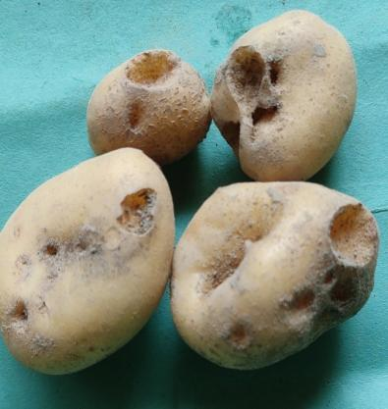**

**c. Damaged potato tuber by white grub**

**Fig. 2 a-c: White grub and their damage symptom**

|  |  |
| --- | --- |
| **C:\Users\91957\Desktop\thesis work JKD\PPT photo\Red ant\20230221_124915.jpg** |  |
| **a Red ant in potato field** | **b. Red ant infested potato field** |
|  | |

**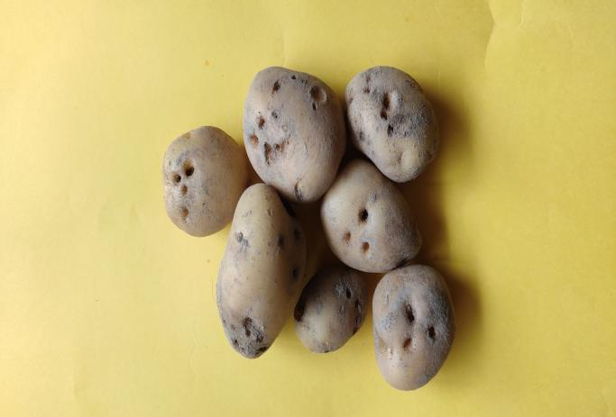**

1. **Red ant damaged potato**

**Fig.3 a-c: Red ant and their damage symptom**

|  |  |
| --- | --- |
|  |  |
| **a. wire worm in potato** | **b. wire worm in experimental field** | |
|  |  | |

**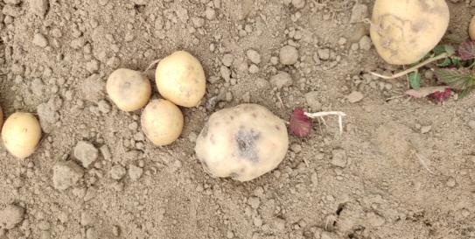**

**c.Wire worm damaged potato**

**Fig.4 a-c: wire worm and their damage symptom**