Sigmoid Volvulus Revealing Peritoneal Tuberculosis: A Rare Case Report

Abstract :
The sigmoid volvulus is a rare cause of intestinal occlusion, most cases being found in Asia and Africa. The case we report is of a patient with pulmonary tuberculosis undergoing treatment, who was admitted in our structure for an intestinal occlusion due to sigmoid volvulus, the surgical exploration found the sigmoid volvulus associated to multiple nodules which the anatomopathological biopsies confirmed the diagnostic of peritoneal tuberculosis
The aim of this article is to draw the attention of the medical community to the possibility of this association and the silent spread of tuberculosis infection from one localization to another.
Key words: sigmoid volvulus, Case Report, intestinal occlusion, Tuberculosis

Introduction :
The sigmoid volvulus is a rare pathology due a anatomic disposition of the colon to rotation, we report here the case of a 52 year-old man who was undergoing an antibiotic treatment of his pulmonary tuberculosis treatment.

Case presentation:
We report the case of a 52 years-old male patient with a known history of pulmonary tuberculosis currently on antitubercular therapy. The patient consulted for an abdominal distension and symptoms of an occlusive syndrome that had been evolving over the past three days.
The clinical examination noted a conscious patient with low BMI at 15 kg/m², the abdominal examination found an asymmetric abdominal distension highly tympanic (figure 1) with a normal rectal examination.
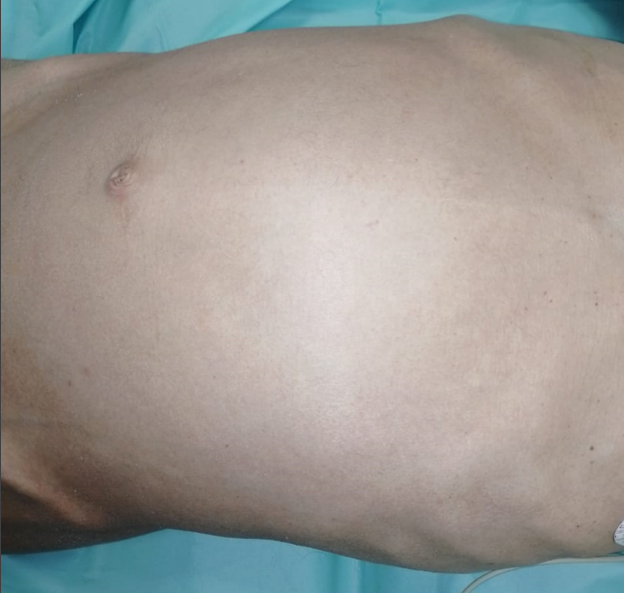
Figure 1 : Asymmetrical abdominal distension
Laboratory tests showed leukocytosis with a white blood cell count of 11,860/mm³ and an elevated C-reactive protein level of 254 mg/L.
Abdominal X-RAY showed an incomplete coffee bean sign (figure 2), a CT scan revealed an aerial colonic distension with whirl sign associated with an important abdominal effusion, suggesting a colonic ischemia where endoscopic detorsion is not recommended.
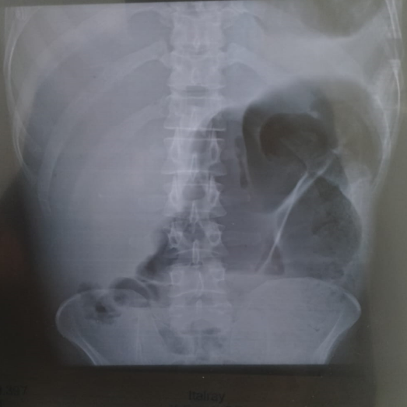
Figure 2 : Abdominal X-RAY showing an incomplete coffee bean sign
A laparotomy intervention was performed which revealed a sigmoid volvulus with a colonic distension and disseminated peritoneal nodules suggesting a peritoneal tuberculosis (figure 3 and 4).Biopsies were taken, and a sigmoid colectomy was carried out with the creation of a double-barrel colostomy. Histopathological examination of the biopsy revealed caseous necrosis within a granuloma, consistent with tuberculosis. The postoperative course was uneventful, and the patient was discharged home on the third postoperative day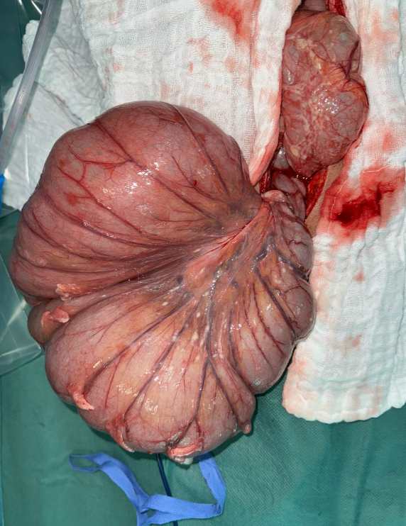
Figure 3 : Showing the sigmoid volvulus in his mesenterico-axial form

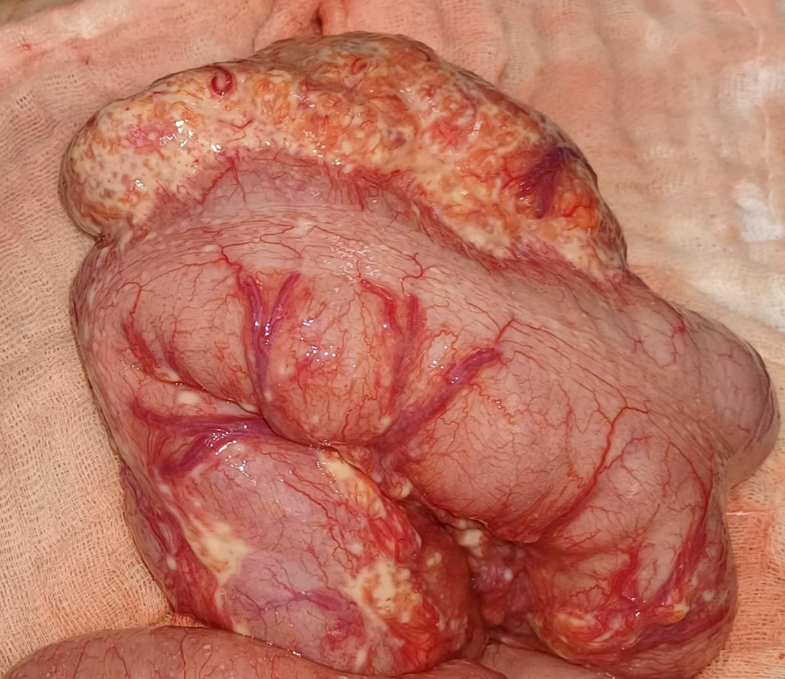
Figure 4 : Image showing the nodules

Discussion :
Sigmoid volvulus is a rare cause of intestinal obstruction, due to the torsion of the colon around his corpse or arround the mesentery, it is responsible of 5% of the occlusion in Europe and North America and between 10 to 40 % in Middle East, Eastern Europe, North America and Africa.It occurs generally on adult men with a ratio men/women of 2:1 to 8:1, and it’s most seen from the 4Th to the 8Th decade. The condition predominantly affects Black males, which may be attributed to a greater tendency for sigmoid colon elongation in this population [1–3].
There are two forms of sigmoid volvulus: the mesentero-axial and the organo-axial types. For reasons that remain unclear, the torsion is counterclockwise in approximately 70% of cases. In sigmoid volvulus, colonic distension increases intraluminal pressure, which compromises capillary perfusion of the bowel wall. This is further aggravated by mechanical compression and axial rotation (“twisting”) of the mesosigmoid vessels. The resulting mucosal ischemia facilitates bacterial translocation, which in turn exacerbates colonic distension and promotes toxic effects. This creates a vicious cycle that can progress to colonic necrosis and ischemia-reperfusion injury [4–5].
The clinical presentation of sigmoid volvulus manifests as an obstructive syndrome, with acute abdominal pain in the left iliac fossa. The clinical examination reveals the classic triad of Von Wahl which includes immobile and asymmetric abdominal distension, tympany, and elastic resistance. Abdominal X-ray and CT scan are crucial in the management of sigmoid volvulus. X-ray may show the coffee bean sign and a pneumoperitoneum in the case of perforation. CT scan demonstrates the whirl sign, the volvulus with distended and collapsed bowel, and signs of peritonitis.
The management of sigmoid volvulus can be categorized into endoscopic and surgical treatments. Endoscopy is used in the absence of peritonitis or perforation and plays a dual role in diagnosing and treating sigmoid volvulus. Surgery is required in approximately 25% of SV cases, either when endoscopic detorsion fails or when bowel necrosis and/or peritonitis are present. Surgical options include sigmoid colectomy with primary anastomosis, a colostomy with delayed anastomosis, or a Hartmann’s procedure.
Peritoneal tuberculosis is the second extra-pulmonary localization of tuberculosis after ganglionnary form, it affects patients between the ages of 35–45 with equal a 1:1 sex-ratio and has a correlation with lower socioeconomic status and promiscuity.[6]
There are three mechanism of development of peritoneal tuberculosis : hematogenous infection from active tuberculosis, direct or intraabdominal spread from affected organs such bowel, uterus and rupture of a tuberculous abdominal lymph node, lymphatic through lymph channels from infected abdominal lymph nodes. In our case the patient had a double localization pulmonary and peritoneal [7]
The infection can be silent. clinical features of the infection are wide it manifests by an abdominal distension with or without pain, vomiting, fever, nocturnal sewing and sever weight loss . The main complication is the peritonitis.
Multiple tests are attended to make the diagnostic of peritoneal tuberculosis such as quantiferon dosage in blood ,CA-125 and ADA in ascite fluid have low specificity. On the other hand PCR tuberculosis have a high specificity but a variable sensitivity relative to the tissue. The gold standard for diagnosing peritoneal tuberculosis is surgical exploration with biopsy for anatomical, pathological,and bacteriological confirmationThe treatment of peritoneal tuberculosis is codified by the WHO which consist of antibacillary treatment for 6 months based on

Conclusion :

Sigmoid volvulus is a rare cause of intestinal obstruction, in our case it revealed a peritoneal spread of a known pulmonary tuberculosis.The association with a peritoneal tuberculosis make our observation unique in the literature; through our article we detailed the characteristics of each pathology and showed that the two entities have different physiopathology and require different treatment.
Ethical Approval:
As per international standards or university standards written ethical approval has been collected and preserved by the author(s).
Consent
As per international standards or university standards, patient(s) written consent has been collected and preserved by the author(s).
Disclaimer (Artificial intelligence)
Option 1:
Author(s) hereby declare that NO generative AI technologies such as Large Language Models (ChatGPT, COPILOT, etc.) and text-to-image generators have been used during the writing or editing of this manuscript.
Option 2:
Author(s) hereby declare that generative AI technologies such as Large Language Models, etc. have been used during the writing or editing of manuscripts. This explanation will include the name, version, model, and source of the generative AI technology and as well as all input prompts provided to the generative AI technology
Details of the AI usage are given below:
1.
2.
3.

Références :
1.KEITA, Sidiki, KEITA, Koniba, SISSOKO, Moussa, et al. Volvulus of the sigmoid colon—Management in the surgery “A” department of the Teaching Hospital of Point G. Surgical Science, 2020, vol. 11, no 12, p. 469-478
2. MADIBA, T. E., ALDOUS, C., et HAFFAJEE, M. R. The morphology of the foetal sigmoid colon in the African population: a possible predisposition to sigmoid volvulus. Colorectal Disease, 2015, vol. 17, no 12, p. 1114-1120.
3.ATAMANALP, Sabri Selcuk, DISCI, Esra, PEKSOZ, Rifat, et al. Management of sigmoid volvulus: a literature review. Ibnosina Journal of Medicine and Biomedical Sciences, 2023
4. Moloney, B.M., Mc Carthy, C.E., Bhayana, R. et al. Sigmoid volvulus—Can CT features predict outcomes and recurrence?. Eur Radiol 35, 897–905 (2025). https://doi.org/10.1007/s00330-024-10979-y
5. Lubrano J, Paquette B, Delabrousse E, Koch S, Mantion G. Volvulus du sigmoïde. EMC - Gastro-entérologie 2012;7(3):1-6 [Article 9-044-A-12].
6. WU, David C., AVERBUKH, Leon D., et WU, George Y. Diagnostic and therapeutic strategies for peritoneal tuberculosis: a review. Journal of clinical and translational hepatology, 2019, vol. 7, no 2, p. 140.
7. Ahmed Khan, Fahmi Yousef. Peritoneal Tuberculosis: Advances and Controversies. Libyan Journal of Medical Sciences 2(1):p 3-7, Jan–Mar 2018. | DOI: 10.4103/LJMS.LJMS_35_17

