Case Report

Misdiagnosed Recurrent Nodular Lesions of the Hand: A Case of Neurofibroma

.
ABSTRACT

Aims: Describe the diagnostic evolution of a rare, recurrent soft tissue tumor of the hand, initially diagnosed as nodular fibromatosis and ultimately confirmed as neurofibroma.
Case presentation: A 22-year-old female presented with multiple recurrences of a soft tissue mass in the right index finger over six years. Initial biopsies showed fibromatosis; final diagnosis was neurofibroma confirmed histologically in 2024.
Discussion: Neurofibroma, though benign, may mimic other fibroblastic lesions and can lead to delayed diagnosis, particularly in the absence of immunohistochemical analysis. Their localization in the hand is exceptional, representing only 0.8% of all neurofibromas in the general population and 10–15% among patients with neurofibromatosis type 1. Clinical features such as pseudo-Tinel’s sign and multifocal presentation should raise early suspicion for nerve sheath tumors.
Conclusion: Recurrent digital fibromatosis must prompt reevaluation, including immunohistochemistry. Early consideration of neurogenic tumors may prevent diagnostic delays and functional morbidity.

Keywords: Nodular fibromatosis; Neurofibroma; Finger tumor; Soft tissue mass; Case report; Hand surgery

1. INTRODUCTION

Soft tissue tumors of the hand are uncommon and can present diagnostic and therapeutic challenges, particularly in young adults. Neurofibromas (NFs) are rare benign peripheral nerve sheath tumors arising from the proliferation of Schwann cells and fibroblasts. Approximately 90% occur sporadically, while only 10% are associated with neurofibromatosis type 1 (NF1). Their localization in the hand is exceptional, representing only 0.8% of all NFs in the general population and 10–15% among NF1 patients(1). Nodular fibromatosis and NFs, while benign, when located in the hand and can mimic other more common conditions differential diagnosis is crucial, particularly in the absence of pathognomonic signs or family history, and may require immunohistochemical profiling(2,3). Recurrent cases necessitate a thorough re-evaluation, especially in the context of multifocal involvement and atypical progression(4,5).

2. case presentation

In December 2018, a 22-year-old right-handed female university student presented with a firm, non-inflammatory, mildly painful nodule measuring approximately 1 cm on the dorsal aspect of the right index finger at the level of the distal interphalangeal (DIP) joint. The patient reported no significant past medical or surgical history. Standard radiography revealed no osseous abnormalities. Ultrasonography demonstrated a hyperechoic lesion, leading to complete surgical excision (Figure 1). Histopathological analysis identified a cicatricial nodule consistent with tendon rupture, without evidence of malignancy.
In June 2019, the patient experienced a recurrence of the mass, now accompanied by signs of complex regional pain syndrome (algodystrophy) (Figure 2). A second biopsy indicated nodular fibromatosis. Despite post-operative orthotic treatment, a mallet finger deformity developed.
In 2020, a third recurrence was documented, with the emergence of two additional nodules along the extensor pathway of the right index finger. Magnetic resonance imaging(MRI) confirmed the presence of multifocal nodular fibromatosis (Figure 3). Surgical excision was performed, and histopathological findings were consistent with fibromatosis.
By 2022, the patient had developed three new masses along the index finger. Following partial resection, she exhibited joint stiffness and a recurrent mallet finger deformity. Histology was not available.
In 2024, a fourth recurrence involved a 2 cm lesion on the index finger and a 5 cm mass over the dorsal aspect of the hand with a positive Tinel sign (Figure 4). Surgical biopsy of seven tissue fragments finally revealed histological features consistent with neurofibroma(NF). Immunohistochemical staining, including S100 protein, was used and confirmed the diagnosis.
The diagnosis evolved over time through several recurrences. Initial imaging (X-rays and ultrasounds) showed soft tissue masses without bone involvement . MRI in 2020 suggested multifocal nodular fibromatosis. Histopathological findings initially showed cicatricial nodule and fibromatosis , but the final recurrence in 2024 revealed NF

Each recurrence was managed surgically via excisional biopsies . Surgical challenges included preservation of the extensor tendon system. Rehabilitation was implemented post-operatively, particularly after tendon involvement caused mallet deformity.

Throughout the multiple recurrences, the patient underwent five surgeries. Outcomes included joint stiffness and mallet deformities . (Figure 5) After the final excision in 2024, histopathology confirmed NF and the recurrence has not reappeared to date.

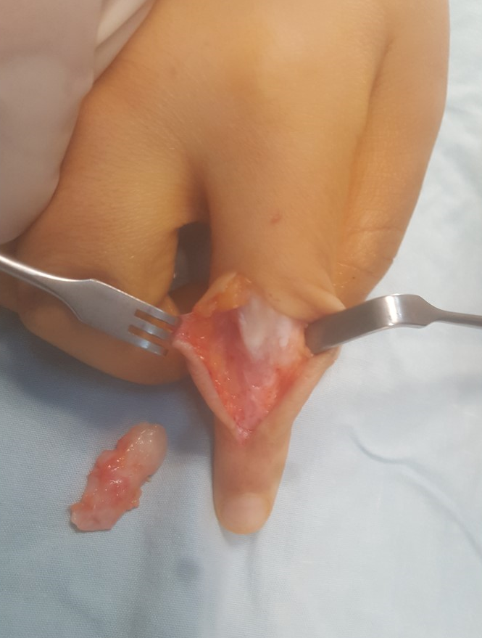

Fig. 1. Intraoperative view : Complete excision of the tumor
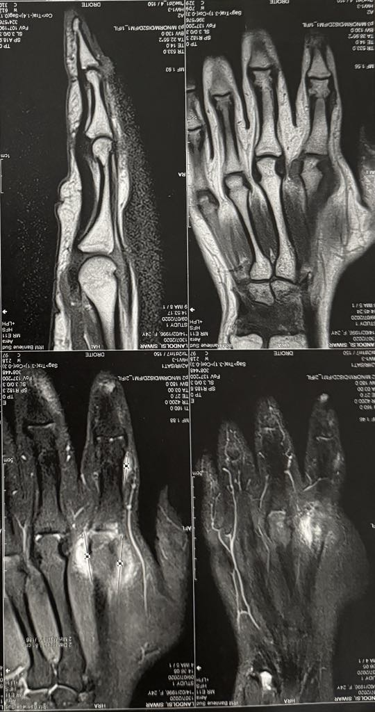

Fig. 2. MRI of the Right Hand: Multifocal Soft Tissue Lesions

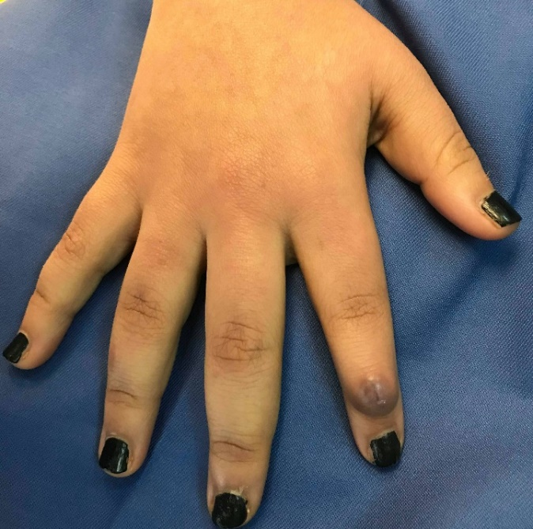

Fig. 3. Clinical appearance at first recurrence : A firm mass

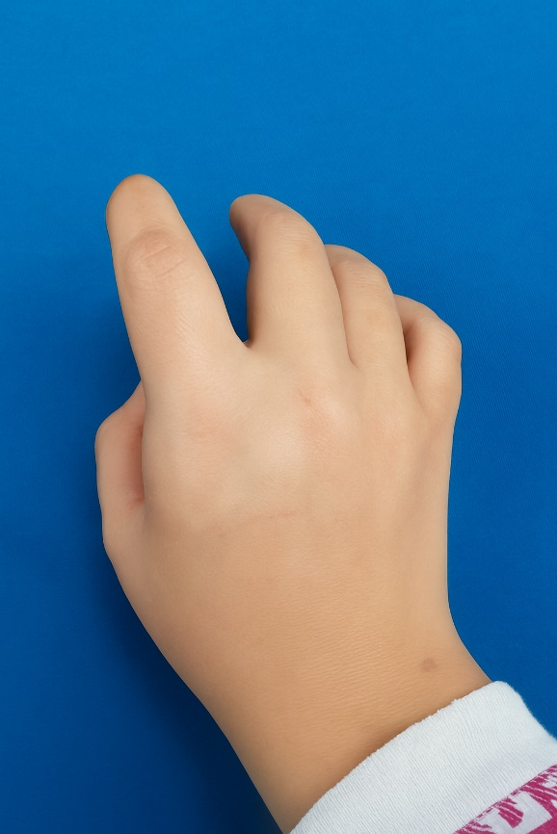

Fig. 4. Clinical appearance in 2024 : A dorsal hand mass and récurrent index finger lesion
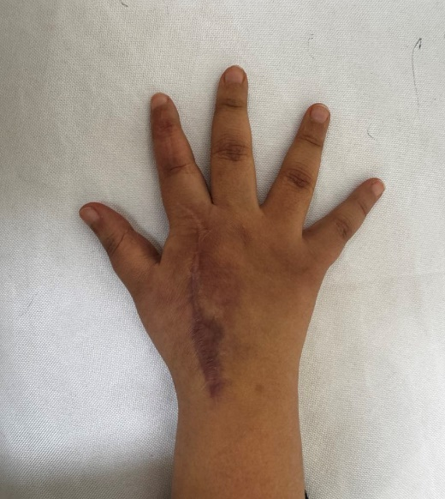

Fig. 5. Six-month postoperative view : Dorsal scar and no recurrence

3. discussion

Soft tissue tumors of the hand present a significant diagnostic challenge due to the wide differential diagnosis and the rarity of certain entities in this anatomical region(2,3). In this case, the progression from an initially benign-appearing lesion to a recurrent, multifocal disease with a final diagnosis of NF demonstrates the importance of maintaining a broad differential and revisiting initial histological interpretations when faced with atypical recurrence patterns.
Nodular fibromatosis, often considered a localized and benign proliferation of fibroblastic tissue, can mimic other lesions both clinically and histologically(5). Its recurrence is rare but has been documented, particularly when excision is incomplete or when the lesion is deeply adherent to adjacent structures, as was the case here with involvement of the extensor tendon slips. In this patient, the recurrence after the first surgery—combined with increasing size, multifocal presentation, and functional impairment—should have raised suspicion for a more aggressive or misdiagnosed pathology. Recurrent NFs may result from incomplete resection or multifocal proliferation inherent to the pathology. While NFs are generally non-encapsulated and infiltrative, making margin assessment difficult, recurrence can be minimized by ensuring adequate peripheral resection and identifying fascicular boundaries. A safety margin of at least 5 mm is often advocated in nerve sheath tumors where feasible(6).
Importantly, the diagnosis of NF—confirmed only after multiple recurrences and extensive histopathological sampling—suggests that the initial biopsies may have been insufficient in scope or depth(4). NFs, benign peripheral nerve sheath tumors composed of Schwann cells, fibroblasts, and perineurial-like cells, can sometimes present with a misleading histological pattern, especially in the presence of fibrotic or cicatricial changes post-surgery(7). Immunohistochemical analysis, particularly with markers like S100 protein, is critical in differentiating NFs from fibromatosis and other soft tissue tumors(4). The absence of such analyses in earlier stages may explain the delayed definitive diagnosis.
The multifocal nature of the lesions observed in this patient also raises the question of a syndromic association, most notably NF1, although the clinical vignette does not report any additional systemic manifestations or family history suggestive of NF1(6). The diagnosis of the disease is based on the presence of at least two of the following criteria: At least six café au lait spots larger than 5mm before puberty and larger than 15mm after puberty; Two or more neurofibromas, one or more plexiform neuromas; Lentiginous spots of the axillary or inguinal region; Two or more iris hamartomas (Lisch nodules),one optic tract glioma; A characteristic bone lesion (pseudarthrosis of a long bone, spheno-orbital dysplasia, cervical kyphosis)(8). In sporadic (non-syndromic) neurofibromas, the presentation is usually solitary; multifocal cases, particularly in the hand, are rare and warrant further genetic and dermatologic evaluation.

From a surgical standpoint, the repeated involvement of the extensor system and the development of mallet finger deformities following excisions highlight the balance required between achieving clear margins and preserving tendon integrity(9). Postoperative immobilization and rehabilitation were essential, but the recurrence rate suggests a need for multidisciplinary management, potentially including neurology and oncology input for systemic evaluation(6,10).
Finally, the positive pseudo-Tinel’s sign observed in the final recurrence is an important clinical clue, suggestive of a lesion with neural involvement, which aligns with the eventual diagnosis of neurofibroma(10,11). This physical finding, in the setting of recurrent masses, should prompt earlier consideration of nerve sheath tumors(5,6).
This case emphasizes the importance of a stepwise, evolving diagnostic approach when managing recurrent soft tissue tumors, especially in atypical locations such as the hand(3,10). It also advocates for the early use of MRI and histo-immunohistochemical studies to achieve accurate diagnosis and avoid unnecessary morbidity due to repeated surgeries(4,7). Recent French recommendations also emphasize early genetic counseling and multidisciplinary assessment in suspected NF1 cases. Recurrent or deep-seated NFs warrant rigorous clinical and radiological monitoring due to the recognized risk of malignant transformation into malignant peripheral nerve sheath tumors (MPNSTs). Although neurofibromas are benign by nature, the potential for malignant progression—particularly in plexiform or multifocal lesions—is well-documented in the literature. MRI, often complemented by metabolic imaging such as PET-CT, is advised to detect early signs of transformation, including rapid growth, heterogeneity, or increased metabolic activity. In this case, the recurrent, multifocal nature of the digital lesions—along with their progressive enlargement and involvement of critical anatomical structures—may justify prolonged and systematic surveillance(12).

4. Conclusion

This case underscores the necessity for careful long-term monitoring and repeated histopathological assessment in recurrent soft tissue tumors of the hand(3,5). Early consideration of neurogenic tumors such as neurofibroma may improve diagnostic accuracy and patient outcomes(4,6,10). It also highlights the diagnostic complexity of such cases, particularly when clinical and histological features overlap with benign fibroblastic lesions. Signs such as pseudo-Tinel’s sign and multifocality should prompt early suspicion for nerve sheath tumors. Incorporating MRI and immunohistochemical markers like S100 early in the diagnostic pathway can significantly reduce diagnostic delays. This case adds to the growing body of evidence by illustrating an unusual localization and progression of a sporadic neurofibroma, reinforcing the importance of maintaining a broad differential and ensuring adequate surgical margins to avoid functional morbidity.

Consent

Written informed consent was obtained from the patient for publication of this case report and any accompanying images.

Ethical approval

All authors hereby declare that all experiments have been examined and approved by the appropriate ethics committee and have therefore been performed in accordance with the ethical standards laid down in the 1964 Declaration of Helsinki
Author(s) hereby declare that NO generative AI technologies such as Large Language Models (ChatGPT, COPILOT, etc.) and text-to-image generators have been used during the writing or editing of this manuscript.

Disclaimer (Artificial intelligence)
Option 1:
Author(s) hereby declare that NO generative AI technologies such as Large Language Models (ChatGPT, COPILOT, etc.) and text-to-image generators have been used during the writing or editing of this manuscript.
Option 2:
Author(s) hereby declare that generative AI technologies such as Large Language Models, etc. have been used during the writing or editing of manuscripts. This explanation will include the name, version, model, and source of the generative AI technology and as well as all input prompts provided to the generative AI technology
Details of the AI usage are given below:
1.
2.
3.

References

1. Carvalho DR, Branco PM, Afonso PD, Gerardo G, Baptista C. Atypically Located Solitary Neurofibroma of the Ulnar Nerve as Inaugural Presentation of a New Genetic Variant of Neurofibromatosis Type 1: A Case Report. J Hand Surg Glob Online. 20 mai 2022;4(5):283‑7.
2. Fletcher CDM, et al. WHO Classification of Tumours of Soft Tissue and Bone. 4th ed. IARC Press; 2013
3. Sherman CE, Murray PM. Tumor-Like Conditions of the Hand and Upper Extremity. J Hand Surg. déc 2017;42(12):1009‑17.
4. Rodriguez FJ, Folpe AL, Giannini C, Perry A. Pathology of peripheral nerve sheath tumors: diagnostic overview and update on selected diagnostic problems. Acta Neuropathol (Berl). mars 2012;123(3):295‑319.
5. Weiss SW, Goldblum JR, Folpe AL. Enzinger and Weiss’s Soft Tissue Tumors. Elsevier Health Sciences; 2007. 2815 p.
6. Gupta G, Mammis A, Maniker A. Malignant peripheral nerve sheath tumors. Neurosurg Clin N Am. oct 2008;19(4):533‑43, v.
7. Rosai J. Rosai and Ackerman's Surgical Pathology. 10th ed. Elsevier; 2011.
8. Hamdaoui OR, Kardi O, Tabakh H, Siwane A, Touil N, Kacimi O, et al. Plexiform Neurofibroma of Arm: A Case Report. Int J Med Pharm Case Rep. 8 août 2022;25‑9.
9. Alla SR, Deal ND, Dempsey IJ. Current concepts: mallet finger. Hand N Y N. juin 2014;9(2):138‑44.
10. Pearl RA, O’Toole G. A case of large sporadic neurofibroma of the hand. J Plast Reconstr Aesthetic Surg JPRAS. juill 2010;63(7):e573-575.
11. Lauri G, Santucci M, Ceruso M, Innocenti M. Recurrent digital fibromatosis of childhood. J Hand Surg. janv 1990;15(1):106‑9.
12. Haute Autorité de Santé. Protocole National de Diagnostic et de Soins (PNDS) Neurofibromatose 1. HAS ; Août 2021

