Liver Injuries in Children Caused by Bullock Cart Run-Over: About Two Case Reports

Abstract
The severity of injuries is influenced by the weight and speed of the bullock cart wheels, which can cause serious trauma to both solid and hollow abdominal organs. We report two cases involving boys aged 8 years, who sustained blunt abdominal trauma after falling from and being run over by bullock carts while accompanying their fathers. Two of the children sustained liver injuries that required open surgical intervention. Blunt abdominal trauma (BAT) caused by bullock carts is a serious yet often overlooked issue in rural India. In rural India, bullock carts are widely used for agricultural and domestic purposes, making children particularly vulnerable to such injuries. These injuries can result in significant internal damage and are associated with high rates of morbidity and mortality. The most commonly affected organs include the spleen, liver, mesentery, and small intestine. Prompt diagnosis and management, including surgical intervention when needed, are crucial for improving outcomes and reducing mortality.

Keywords: Blunt abdominal trauma, Bullock card Injuries, Damage control surgery, Liver trauma

Introduction

Bull horn injuries are very frequent, especially in areas with a strong bullfighting tradition - professional oramateur all over the world and especially in countries like Spain and Latin countries. In India especially in rural areas bulls, buffaloes and cows are used for domestic and farming purposes (Garay et al., 2022). The incidents often occur during routine farming activities or during traditional festivals such as Muttu Pongal in southern India, and Bail Pola in Maharashtra, where bullock cart races are organized. During such events, children frequently accompany adults, increasing their exposure to potential accidents. Blunt abdominal trauma (BAT) refers to abdominal injury resulting from a forceful impact that does not penetrate the skin. In adults, the most common causes include motor vehicle accidents and falls. In children, BAT is primarily caused by motor vehicle or bicycle accidents. [1,2,3]. Children are more vulnerable to injuries caused by these animals due to their tender age and also maybe as children may not be able to recognize the restless behaviour of bovine animals which can signal danger and potential of being attacked. Moreover, most of the bull attacks are unprovoked which is all the more risky for children (Rao et al., 2018).

Classification of Abdominal Trauma:

Abdominal trauma is broadly classified into two types:

1. Blunt Abdominal Trauma (BAT)

2. Penetrating Abdominal Trauma (PAT)

o Low-energy penetrating wounds: Stab injuries

o High-energy penetrating wounds: Gunshot injuries
Commonly Injured Organs: Spleen: 40–50%, Liver: 35–45%, Intestines: 5–10%, Retroperitoneum:
15% Other involved organs may include the kidneys, pancreas, and major blood vessels. [1,2,3]

Common Symptoms of Blunt Abdominal Trauma: Abdominal pain and swelling, Visible bruising on the abdomen, Tenderness and pain upon palpation Guarding and abdominal rigidity, Nausea and vomiting, Signs of hypovolemia (low blood volume), Clinical signs of peritonitis (especially in cases of bowel perforation) [4,5,6]

Diagnostic Investigations:

• Hemogram (complete blood count).

• X-ray of the chest and abdomen

• Diagnostic Peritoneal Lavage (DPL) – less commonly used today

• Ultrasonography: EFAST (Extended Focused Assessment with Sonography for Trauma) EFAST may miss retroperitoneal and hollow organ injuries, making CT imaging vital for comprehensive evaluation.

• CT scan – the gold standard for evaluating abdominal organ injuries, particularly in hemodynamically stable patients. CT scans provide detailed imaging of solid organ and retroperitoneal injuries. [1,2,4,5]

EFAST Examination Views:

1. Right Upper Quadrant: Assesses for free fluid in Morrison’s pouch (hepatorenal space), around the lower pole of the right kidney, and under the diaphragm and liver trauma.

2. Left Upper Quadrant: Evaluate the spleen, diaphragm, and left hemothorax.

3. Pelvis: Check for free fluid in the pouch of Douglas or signs of bladder injury.

4. Cardiac View: Assesses for pericardial fluid and visualizes all four cardiac chambers. [7,8,9]

Liver Injury Grading:

Liver injuries are graded to determine severity and guide treatment. The American Association for the Surgery of Trauma (AAST) introduced a widely used classification system in 1994, grading liver injuries from Grade I (minor) to Grade V (severe). [5,6,7]
TABLE 1. Different grades of liver injuries and their descriptions

Grade Type Injury description
I | Hematoma Subcapsular, nonexpanding, <10 cm surface area  Laceration Capsular tear, nonbleeding, <1 cm parenchymal depth
II | Hematoma Subcapsular, nonexpanding, 10–50% surface area; intraparenchymal nonexpanding <10 cm diameter  Laceration Capsular tear, active bleeding, 1–3 cm parenchymal depth <10 cm in length
III | Hematoma Hematoma Subcapsular, >50% surface area or expanding; ruptured subcapsular hematoma with active bleeding; intraparenchymal hematoma >10 cm or expanding  Laceration >3 cm parenchymal depth

IV | Hematoma Ruptured intraparenchymal hematoma with active bleeding  Laceration Parenchymal disruption involving 25–75% of hepatic lobe or one to three  Couinaud’s segments within a single lobe
V | Laceration Parenchymal disruption involving >75% of hepatic lobe or >3 Couinaud’s segments within a single lobe  Vascula Juxtahepatic venous injuries (i.e., retrohepatic vena cava/central major hepatic veins)
VI | Vascular Hepatic avulsion

Case Reports

Case I - 8-year-old boy was brought to our center on 12/10/2020 by his grandfather, following a bullock cart run-over injury to the abdomen. The child had been sitting in front of his grandfather on the cart, with the bull's reins held by the grandfather. During the journey, the boy accidentally fell off the cart and was run over by one of the cart wheels, resulting in blunt abdominal trauma (BAT).

On physical examination, the child presented with pain in the right hypochondrium and visible signs of run-over injury to the upper abdomen. Vital signs showed a pulse rate of 110 bpm (tachycardia) and a blood pressure of 90/60 mmHg. Laboratory investigation showed hemoglobin was 8 g/dL and other investigations were normal.

An EFAST (Extended Focused Assessment with Sonography for Trauma) was immediately performed, which revealed free fluid in Morrison’s pouch and a suspected Grade IV liver laceration. As the child was hemodynamically unstable, a CT scan of the abdomen was performed, which confirmed a Grade V liver injury measuring 15x4x5 cm and free fluid in the abdomen (Hemoperitoneum).

Resuscitation was initiated with intravenous fluids and broad-spectrum antibiotics. Two units of blood were arranged for transfusion. After initial stabilization, the child was transferred to the operating theater for emergency exploratory laparotomy under general anesthesia.

Intraoperatively, a severe laceration was identified on the right lobe of the liver, involving segments.
V and VIII. The laceration measured approximately 15 x 4 x 5 cm, and a fractured liver segment weighing around 200 grams was removed in toto. Active bleeders within the lacerated liver parenchyma were carefully ligated. Direct manual compression was applied to both lobes of the liver for 10 minutes, resulting in complete hemostasis.

The liver laceration was sutured using Vicryl sutures, and Geofoam was applied to both anterior and inferior surfaces for hemostatic support and Hepatorrhaphy. After ensuring that there was no active bleeding, a drainage tube was placed under the right lobe of the liver in the hypochondrium. The remaining abdominal cavity was irrigated with warm saline. The spleen, small bowel, and other hollow organs were found to be intact. The abdomen was closed in layers.

On postoperative day 5, the drainage tube was removed after confirming there was no biliary leakage. The child had an uneventful recovery and was discharged on the 10th postoperative day. On follow-up after 4 years, the patient was found to be in good health and attending school regularly with no residual complications. (Fig 1-9)
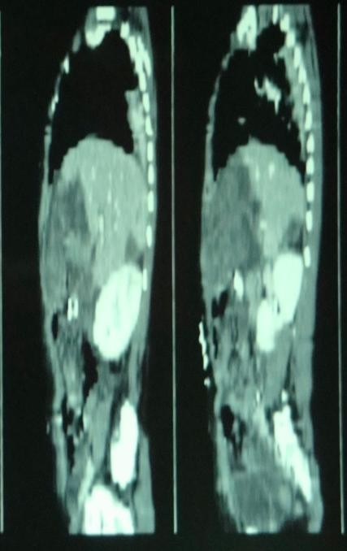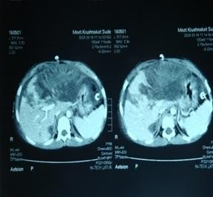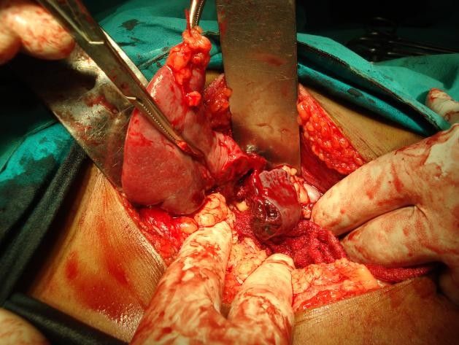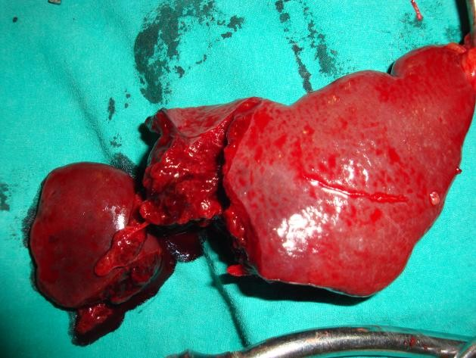

Fig-1 CT Scan Photograph showing grade IV Liver injury with hemoperitoneum
Fig-2 CT Scan Photograph showing grade IV
laceration measuring 15x4x5 cm

Fig-3 Intra operative photograph showing active bleeding into Morrison's pouch caused by grade IV liver injury

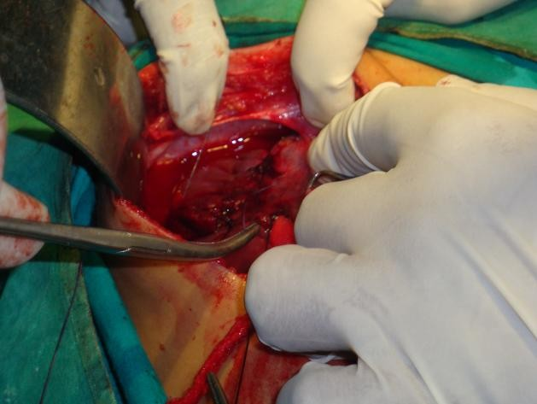Fig-4 Intra operative photograph showing severe laceration on the right lobe of the liver

Fig-5 Intra operative photograph showing severe laceration on the right lobe of the liver, involving segments V and VIII
Fig-6 Photograph showing fractured liver segment weighing around 200 grams was removed in toto
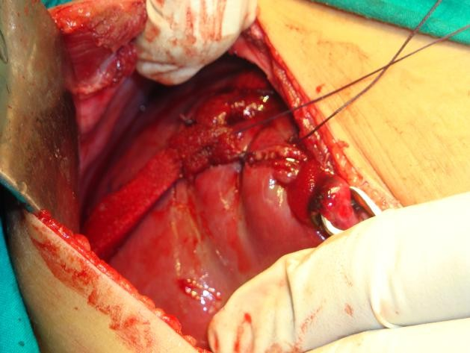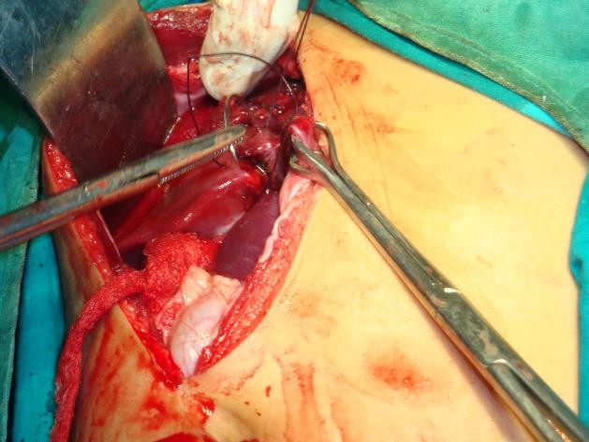

Fig-7 Intraoperative Photograph showing liver laceration sutured using Vicryl sutures
Fig-8 Intraoperative Photograph showing Hepatorrhaphy done with Vicryl sutures, and Geofoam was applied for hemostatic support

Fig-9 Post operative Photograph showing child had an uneventful recovery

Case II

8-year-old boy was admitted to our center on 10/08/2025 with a history of blunt abdominal trauma resulting from a bullock cart run-over incident. He had been accompanying his father on a bullock cart when he slipped, fell off, and was run over by a cart wheel on the abdomen.

On physical examination, the boy presented with: Visible bruising over the abdomen, severe tenderness and guarding in the upper abdomen pulse rate of 110 bpm (tachycardia) and blood pressure 90/60 mmHg, Pallor and Hemoglobin level of 9 g/dL

An extended focused assessment with sonography for trauma (EFAST) revealed free fluid in Morrison’s pouch and the pelvic cavity, suggesting intra-abdominal bleeding. The scan also indicated a liver injury involving the left lobe

Two units of blood were arranged for transfusion, and the patient was prepared for emergency exploratory laparotomy under general anesthesia. Intraoperative findings included a large laceration on
the left lobe of the liver measuring 10 x 4 x 6 cm. Active bleeding from the liver parenchyma. All four quadrants of the peritoneal cavity were filled with blood. The bleeding vessels were controlled by ligation using 2-0 Vicryl sutures. The liver laceration on the anterior surface was sutured, and Gelfoam was
applied for hemostasis and Hepatorrhaphy was done. Manual compression was applied to both liver lobes for
10 minutes, successfully stopping the bleeding. A drainage tube was placed beneath the left lobe of the liver, and the abdominal cavity was irrigated with normal saline before being closed in layers.

The drainage tube was removed on postoperative day 4, with no evidence of bile leakage. The patient had an uneventful recovery and was discharged on the 10th postoperative day. On follow-up after 3 years, the boy was in good health and regularly attended school. (Fig 10-16)
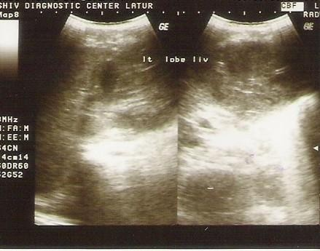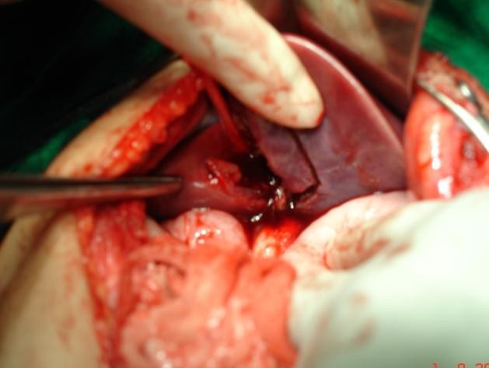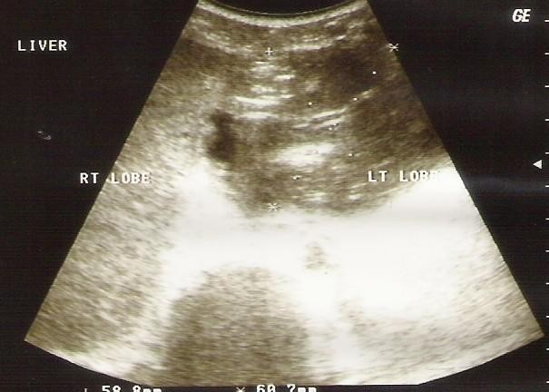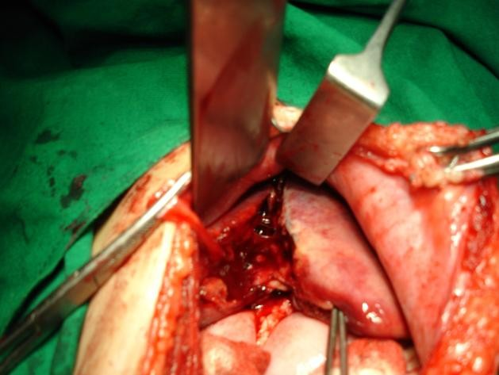

Fig-10 An ultrasonography (EFAST) grade III left Lobe of liver injury with indicating intra-abdominal bleeding
Fig-11 An ultrasonography (EFAST) revealed free fluid in Morrison’s pouch and the pelvic cavity

Fig-12 Intra operative photograph showing a large laceration on the left lobe of the liver measuring 10 x 4 x 6 cm
Fig-13 Intra operative photograph showing a large laceration on the left liver segment IV A and IV B.
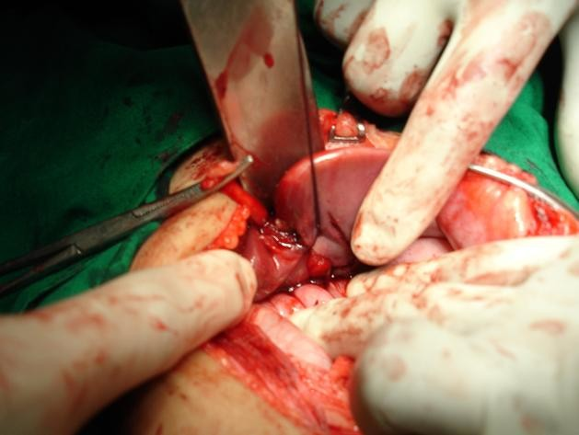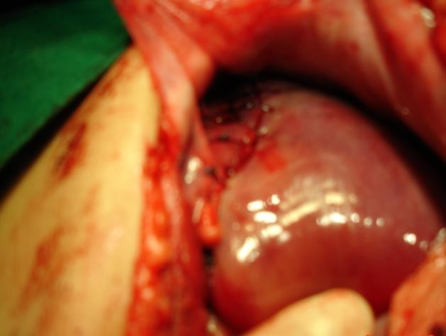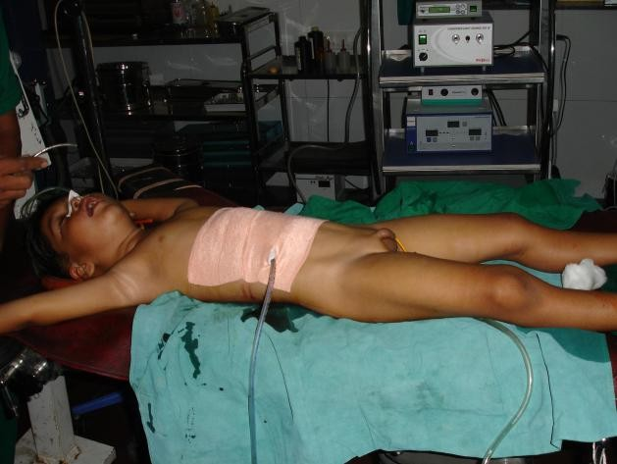

Fig-14 Intra operative photograph showing the bleeding vessels were controlled by ligation using 2-0 Vicryl sutures
Fig-15 Intra operative photograph showing the liver laceration on the anterior surface was sutured with Gelfoam and Hepatorrhaphy done

Fig-16 Post-operative photograph showing a drainage tube was placed

Discussion

Management of Liver Trauma

Liver trauma is a common and potentially life-threatening injury, particularly in blunt abdominal trauma. Management strategies are broadly categorized into non-operative and operative approaches, depending on the patient's hemodynamic status and the severity of the injury. [1,2,3]

1. Non-Operative (Conservative) Management

Non-operative management (NOM) is the first-line treatment for hemodynamically stable patients, especially those with Grade I–III liver injuries. This approach includes Observation in ICU, Supportive care, Blood transfusions as needed and Transarterial embolization (TAE) to control haemorrhage

Continuous clinical monitoring, Serial hemoglobin evaluations, 24/7 availability of: CT scan, Angiography, Blood and blood products, ICU care. Currently, NOM is used in 60–80% of blunt liver
trauma cases with a success rate of 82–100%. Reported mortality rates are 9–18%, while morbidity ranges from 14–18%. [4,5,6]

CT scan is the gold standard for diagnosing and grading liver injuries in stable patients, with a sensitivity of 92–97% and specificity of 98.7%. Follow-up CT is recommended for Grade IV–V injuries within 7–10 days to evaluate healing and detect complications like biloma or abscess. CT-guided percutaneous drainage may be used to manage bilomas and intra-abdominal fluid collections. [7,8,9]

Angiography and Angioembolization

Angiography plays a crucial role in conservative liver trauma management: Indicated for ongoing arterial bleeding, Postoperative angioembolization may be used after damage control surgery if rebleeding is suspected. Success rate: 68–93%, with benefits including Reduced transfusion requirements, Faster recovery, Shorter ICU stays, Lower mortality. Once stable, patients can be shifted from ICU to the general ward. Continued monitoring includes: Serial hemoglobin levels, Bedside ultrasonography Maintenance of systolic BP >110 mmHg and adequate cerebral oxygenation. [5,6]

2. Operative Management

Indicated when: The patient is hemodynamically unstable, there’s evidence of rebleeding, hemoglobin levels continue to drop, transfusion needs increase and failure of angioembolization. [5,6,7]

Surgical Techniques:

• Direct suture ligation of bleeding vessels (using 3-0 or 4-0 absorbable sutures)

• Packing and compression

• Repair of venous injuries

• Pringle maneuver to control hepatic inflow

• Damage control surgery (DCS) when necessary

Operative Procedure

Pack all four abdominal quadrants with laparotomy pads. Apply manual compression to the liver for
15–20 minutes. Sequentially remove packs: lower quadrants first, then left upper, followed by right upper quadrant. Assess the liver laceration and identify bleeding vessels. If bleeding continues: Use Gelfoam or omentoplasty to fill the laceration. Perform the Pringle maneuver: temporarily clamp the portal triad (safe up to 1 hour).

Hepatic Vein or Retrohepatic Caval Injuries: Pringle maneuver + clamping of the inferior vena cava (IVC) above and below the injury. Direct vascular repair is performed. Aortic clamping is not recommended. Anatomical lobectomy is rarely indicated [5,6,7

3. Damage Control Surgery (DCS)

Originally described by Rotondo et al., DCS significantly improves outcomes in severe liver trauma. Technique: Rapid mobilization of the liver, Placement of eight laparotomy pads around the liver:
Posterior paracaval surface (without compressing the IVC), Lateral right side, Anterior and posterior visceral surfaces. Avoid intrahepatic packing and leave diaphragmatic surface free to prevent respiratory compromise. Indications: Blood loss > 4 liters, 10 units of red blood cell transfusion, Systolic BP <90
mmHg and Severe liver laceration. Re-exploration: After 12–24 hours, following stabilization in ICU to remove packing and perform definitive repair. [5,6,7

4. Role of Hemostatic Agents
Common agents used in liver trauma include: Gelatin sponges (Gelfoam), Oxidized cellulose, Microfibrillar collagen, Topical thrombin, Thrombin-gelatin matrix, Fibrin sealants. These agents aid in local hemostasis and reduce the need for extensive suturing or anatomical resection. [1,2,3]

5. Liver Transplantation in Liver Trauma
Indicated in rare, catastrophic liver injuries where standard surgical measures fail, such as: Uncontrolled hemorrhage after DCS, Extensive, irreparable liver lacerations, Vascular injuries to portal or hepatic veins or bile ducts, Progressive liver failure or hepatic necrosis. [5,6,8]
Two types of liver transplant:
1. Immediate transplantation, native liver is removed and donor liver is implanted directly.
2.Staged approach: native liver removed; temporary portosystemic shunting used while awaiting
Transplant [9,10,11,12]
Conclusion
The management of liver trauma requires a multidisciplinary approach, particularly in rural India where bullock cart run-over injuries are a common cause of blunt abdominal trauma in children. The lack of tertiary pediatric care centers at the district level often leads to delayed management and increased mortality rates. Early referral to higher centers is essential and can be life-saving.
Non-operative management (NOM) should always be considered the first-line treatment in both adults
and children with hemodynamically stable liver injuries, particularly for Grade I to III trauma.

Operative management is reserved for patients who are hemodynamically unstable, experiencing rebleeding, or have failed angioembolization. Grade IV and V injuries often require surgical intervention. An integrated and timely approach involving both surgical and supportive care teams is crucial for improving outcomes and reducing mortality in pediatric liver trauma, especially in resource-limited rural settings.

COMPETING INTERESTS DISCLAIMER:
Authors have declared that they have no known competing financial interests OR non-financial interests OR personal relationships that could have appeared to influence the work reported in this paper.
Disclaimer (Artificial intelligence)
Option 1:
Author(s) hereby declare that NO generative AI technologies such as Large Language Models (ChatGPT, COPILOT, etc.) and text-to-image generators have been used during the writing or editing of this manuscript.
Option 2:
Author(s) hereby declare that generative AI technologies such as Large Language Models, etc. have been used during the writing or editing of manuscripts. This explanation will include the name, version, model, and source of the generative AI technology and as well as all input prompts provided to the generative AI technology
Details of the AI usage are given below:
1.
2.
3.

References

1. Ahmed, M. H. S., Tamgadge, L. V., Gurav, P. D., Dalavi, S. B., Bankar, S., & Parmar, R. (2019). Blunt abdominal trauma: the experience in rural India and review of
literature. International Journal of Research in Medical Sciences, 8(1), 322–326.
ht t ps:/ / doi .org/ 10.18203/ 2320 - 6012.ij rm s20195930

2. Sude, Dr. Nandkishor & Suryawanshi, P. (2014). Blunt Abdominal Trauma in RTA Patient -A State of Industrial Anarchy. International Journal of Science and Research (IJSR). VOLUME 3. 806-812.

3. Garside G, Khan O, Mukhtar Z, Sinha C. Paediatric duodenal injury complicated by common bile duct rupture due to blunt trauma: a multispecialist approach. BMJ Case Rep. 2018 Aug 29;2018 [PMC free article] [PubMed]

4. Pabithadevi B. Mehanathan, Subash Metha, Athisayamani Jeyapaul and Reesha Pa, Blunt
Abdominal Injury, Trauma and Emergency Surgery, DOI: 10.5772/intechopen.98568
5. Coccolini, F., Coimbra, R., Ordonez, C. et al. Liver trauma: WSES 2020
guidelines. World J Emerg Surg 15, 24 (2020). ht t ps:/ /doi .org/ 10.1186/ s13017- 020 -
00302- 7

6. Ahmed N, Vernick JJ. Management of liver trauma in adults. J Emerg Trauma Shock.
2011 Jan;4(1):114-9. doi: 10.4103/0974-2700.76846. PMID: 21633579; PMCID: PMC3097559.

7. Saviano, A.; Ojetti, V.; Zanza, C.; Franceschi, F.; Longhitano, Y.; Martuscelli, E.; Maiese, A.; Volonnino, G.; Bertozzi, G.; Ferrara, M.; et al. Liver Trauma: Management in the Emergency Setting and Medico-Legal Implications. Diagnostics 2022, 12, 1456. https://doi.org/10.3390/diagnostics12061456

8. Alanezi, T.; Altoijry, A.; Alanazi, A.; Aljofan, Z.; Altuwaijri, T.; Iqbal, K.; AlSheikh, S.; Molla, N.; Altuwaijri, M.; Aloraini, A.; et al. Management and Outcomes of Traumatic Liver Injury: A Retrospective Analysis from a Tertiary Care Center
Experience. Healthcare 2024, 12, 131. htt ps: // doi .org/10.3390/ heal thcar e12020131

9. Badger, S.A., Barclay, R., Campbell, P., Mole, D.J. and Diamond, T. (2009), Management of Liver Trauma. World J Surg, 33: 2522-2537 2014. ht t ps:/ / doi .org/ 10.1007/ s00268 - 009-
0215- z

10. Alghamdi HM. Management of Liver Trauma. Saudi J Med Med Sci. 2017 May- Aug;5(2):104-109. doi: 10.4103/1658-631X.204868. Epub 2017 Apr 20. PMID:
30787766; PMCID: PMC6298374

11. A.-F. Bouras, S. Truant, F.-R. Pruvot, Management of blunt hepatic trauma, Journal of
Visceral Surgery, Volume 147, Issue 6, htt ps: // doi .org/10.1016/ j .j visc surg.2010.10.004 .

12. Morales Uribe CH, Arenas Lo´ pez C, Correa Cote JC, Tobo´ n Franco S, Saldarriaga MF, Mosquera J, et al. Tratamiento del traumatismo cerrado de hı´gado, indicaciones de cirugı´a y desenlaces. Cir Esp. 2014;92:23–29.
13. Garay, M., Silver, J., Reynolds, A. W., Hess, J., Armstrong, D., & Hennrikus, W. (2022). Golf cart injuries in children: the experience of trauma centers in a single state in the USA. Journal of Pediatric Orthopaedics B, 31(1), e44-e48.
14. Changala Babu Rao et al. Institutional experience of bullock cart and bull gore injuries in children. MedPulse International Journal of Pediatrics. November 2018; 8(2): 44-47. http://medpulse.in/Pediatrics/index.php

