Case report

A case report on Synovial sarcoma of the foot: Diagnosis and treatment

.

ABSTRACT

|  |
| --- |
| **Aims:** To present a rare case of synovial sarcoma (SS) arising in the foot of a young adult male and highlight the diagnostic challenges, treatment approach, and prognosis associated with this aggressive malignancy.  **Presentation of case:** A 23-year-old Caucasian male with a history of polydactyly presented with a progressively painful mass in the third toe of the left foot. MRI revealed a 4 cm multilobulated soft tissue mass encasing the first phalanx. Biopsy with pathological examination confirmed synovial sarcoma, and the patient underwent metatarsal-level amputation with clear margins. Two years postoperatively, the patient experienced a regional relapse in the gluteal area and developed pulmonary metastases. Despite initiation of chemotherapy, the disease rapidly progressed, and the patient died within a month of relapse.  **Discussion:** Synovial sarcoma is a rare soft tissue sarcoma, typically affecting young adults and often arising in the extremities. It frequently presents with nonspecific symptoms and can mimic benign conditions, delaying diagnosis. MRI is the imaging modality of choice, and definitive diagnosis relies on histopathological analysis. While surgery with negative margins remains the cornerstone of treatment, recurrence and metastasis are common, particularly in larger tumors.  **Conclusion:** This case illustrates the aggressive nature of synovial sarcoma despite adequate initial management. Clinicians should maintain a high index of suspicion for SS in persistent foot masses, and ongoing research is vital to improve outcomes through better systemic therapies and relapse prevention strategies. |

*Keywords: Synovial sarcoma, Lower limb, Prognosis, Survival.*

1. INTRODUCTION

Synovial sarcoma (SS) is a relatively rare soft tissue sarcoma (STS). It accounts for 5 to 10% of all STS diagnoses [1,2]. It is a unique subtype of STS as it occurs in young patients with a median age of 39 years and affects both sexes equally [3]. SS can develop anywhere in the body with the extremities being the most common site. The lower extremity is the most involved site, followed by the upper extremity and the head and neck region [4,5]. The clinical presentation of synovial sarcomas differs from the typical large and rapidly growing painless mass of other soft tissue sarcomas. It usually presents as a slow growing mass with possible pain and swelling [6,7]. The disease is localized in the majority of cases, but up to 13% of patients have distant metastases at the time of diagnosis [3]. Survival rates are variable according to the current literature, affected mainly by local and metastatic relapses. Synovial sarcoma is unique in this matter with relapses that occur much later than other subtypes of STS [6].

2. CASE PRESENTATION

A 23-year-old Caucasian male with past medical history of polydactyly of the left hand and foot presented with a mass of the third toe of the left foot. The mass had been growing slowly over the previous 2 years. The patient stated that the mass had become progressively more painful with a recent rapid increase in volume over the last seven months. The patient also reported important discomfort when wearing shoes due to the size and tenderness of the mass. The patient denied any trauma, systemic symptoms, or constitutional complaints such as fever or weight loss. On physical exam, the skin was normal on the dorsal aspect of the foot and presented a small, ulcerated lesion on the plantar side. Inspection revealed a firm, non-mobile, tender mass of the third toe at the level of the first and second phalanges extending to the metatarsal region, measuring approximately 4 x 3 cm. Distal pulses and neurological examination of the foot were normal (Figure 1). Standard foot X-ray showed normal bone structure. MRI of the left foot demonstrated a well-defined, multilobulated soft tissue mass of 4 cm, encasing the first phalanx of the third toe displacing the second and fourth toes. There were no cortical bone lesions of the phalanx and cancellous bone signal was normal. The mass showed iso-intensity compared to muscle on T1-weighted images and hyperintensity on T2 with an intense and heterogenous enhancement after gadolinium injection. The flexor and extensor tendons of the third toe were simply displaced by the tumor and showed normal MRI signals (Figure 2). Open incisional biopsy was performed. Histology examination revealed a neoplasm composed of spindle cells moderately atypical with an abnormal mitotic activity.

Amputation at the level of the metatarsal bones was performed. Local flaps from the lateral and medial aspects of the foot were used to close the skin (Figure 3 and 4). The histopathologic exam confirmed the prior diagnosis and showed clear surgical margins. Two years following the initial treatment, the patient developed a regional relapse, characterized by a soft tissue mass in the left gluteal region. Further investigation with CT scans identified bilateral lung nodules, indicative of distant metastasis. Despite commencing chemotherapy, the patient's condition rapidly deteriorated, and they died within the subsequent month.

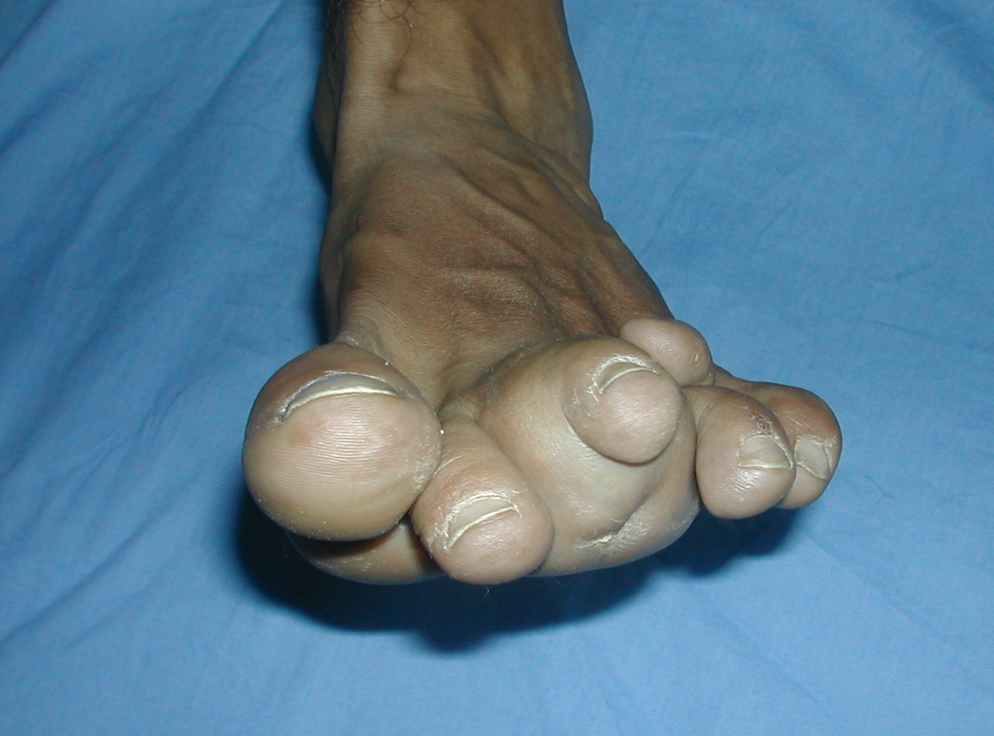

**Figure 1:** Clinical aspect of the mass of the third toe of the foot displacing the second and fourth toes.

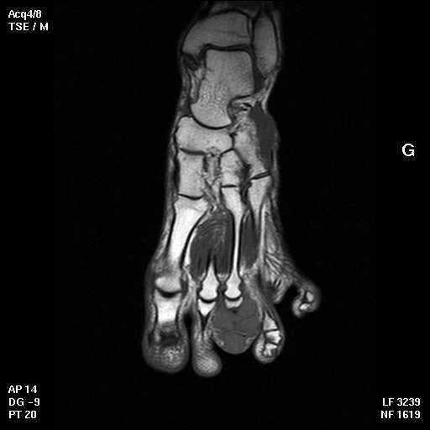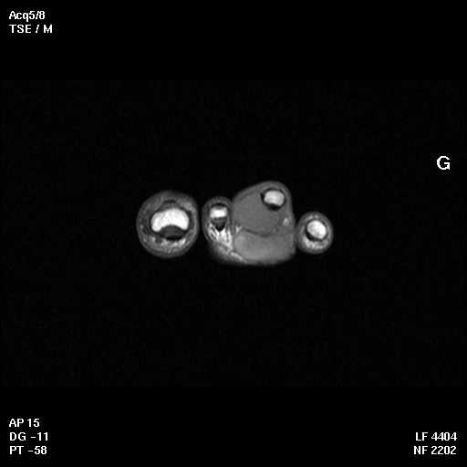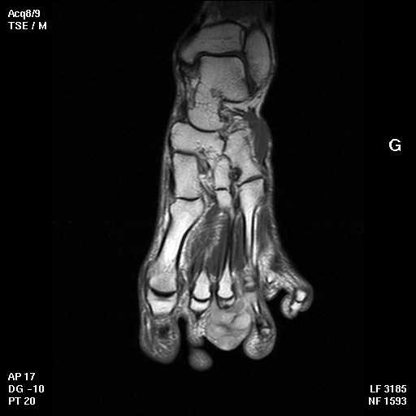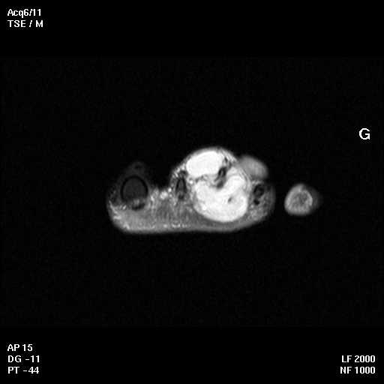

**Figure 2:** MRI images of the foot showing a well-defined, multilobulated soft tissue mass of 4 cm, encasing the first phalanx of the third toe displacing the second and fourth toes.

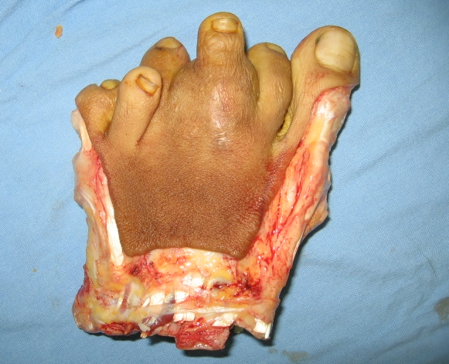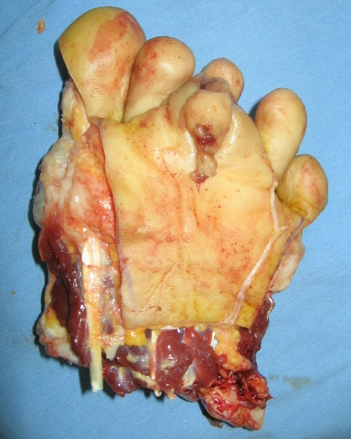

**Figure 3:** Resected piece of the amputation of the five toes to the metatarsal level with macroscopically intact margins.

**Figure 4:** Skin closure was performed by two plantar flaps; medial and lateral covering the bone completely with good soft tissue padding.

3. discussion

Synovial sarcoma is a rare subtype of Soft tissue sarcomas [8]. STSs are a heterogeneous group of rare cancers originating from mesenchymal tissues [9,10]. While the term 'synovial sarcoma' suggests a connection to the synovium, this is a misnomer. The true cellular origin of SS remains unclear, and these tumors do not arise from synovial tissue. While SS can occur across all ages, it characteristically affects young adults, with peak incidence in the 30s and a median age of diagnosis around 30 [11].

Synovial sarcoma predominantly arises in the soft tissues of the extremities, particularly near joint capsules and tendon sheaths of the foot, knee, or ankle. However, it can also manifest in other locations, including the trunk, head and neck, abdomen, pelvis, mediastinum, pleura, lungs, and, rarely, bone [11–14]. SS is considered to be the most common STS of the foot [15–17].

Similar to other STSs, SS often presents with nonspecific symptoms like swelling or pain due to tissue compression [6]. These symptoms can mimic benign conditions such as trauma, myositis, bursitis, or tendonitis, leading to potential misdiagnosis. Notably, patients may experience prolonged pain at the tumor site before swelling becomes evident [6].

Magnetic resonance imaging (MRI) is the gold standard for diagnosing synovial sarcomas, similarly to other STSs. It defines the local extent of the soft tissue mass with excellent visualization of surrounding tissue [6]. SSs are typically a heterogenous mass with low intensity on T1-weighted images and high intensity on T2 sequences with enhancement after contrast [18].

Diagnosis relies on biopsy and pathological evaluation. Open incisional biopsies have been considered to be the gold standard for STSs to define the sarcoma subtype and tumor grade [19]. SS presents as one of three histological subtypes: monophasic, biphasic and poorly differentiated [20]. Monophasic is the most frequent histological variant composed of monomorphic spindle cells with moderate cytologic atypia organized in fascicles [20,21].

Most patients present with localized disease at the time of diagnosis. The rates of initial metastatic disease in the literature range from 6 to 18% [3,6,22,23]. The most common metastatic site being the lungs [3,24].

The cornerstone of SS treatment continues to be surgical excision ensuring negative margins, supplemented by radiotherapy with or without chemotherapy based on patient and tumor-specific factors. In the absence of specific guidelines defining ideal negative margins for SS, the surgical approach mirrors that employed for other STSs [6]. Historically, amputation was frequently performed; however, advancements in adjuvant therapy and cross-sectional imaging have enabled limb-salvage surgery for most patients. While primary amputation is seldom needed for localized limb SS, it is the right initial treatment for a few cases due to specific medical factors and patient wishes [25]. In the lower limbs amputation is usually indicated when inadequate function of the limb would result from complete tumor clearance or when composite tissue is involved in the sarcoma [25].

Radiation therapy is recommended in the neoadjuvant or adjuvant setting for tumors larger than 5 cm or when a close surgical margin is anticipated to preserve major neurovascular structures or bone [26]. It has been demonstrated that radiotherapy helps to improve local control and may have overall survival benefits [27].

Five-year survival rates are variable in the literature, ranging from 59 to 75% [6]. Several prognostic factors have been thoroughly evaluated including: patient age, tumor size, grade, location and negative surgical margins [11,28,29]. Deshmukh et al. demonstrated that tumor size was a main prognostic factor and predicted worse overall survival when exceeding 5 cm [15]. Patient age at the time of diagnosis is also considered a main prognostic factor and survival rates are better among children. Studies using registry data (Sultan et al. [30] ; Smolle et al. [31] ) consistently demonstrate superior five-year survival rates in children and adolescents (83% and 89%, respectively) compared to adults (62% and 75%, respectively). Vlenterie et al. [11] further support this trend, showing a clear inverse relationship between age and survival, regardless of other factors.

4. Conclusion

In summary, this case report details the initial presentation of synovial sarcoma in the foot of a young adult male, which often presents as a gradually growing mass. The diagnostic process, aided by MRI, led to surgical resection with limb salvage as the primary treatment. However, the regional and distant relapse underscores the aggressive potential of synovial sarcoma and the challenges in achieving long-term control even with initial local treatment. This case emphasizes the importance of considering synovial sarcoma in the differential diagnosis of foot masses and highlights the critical need for continued research into more effective systemic therapies and strategies to prevent both local and distant recurrence in this challenging malignancy, regardless of the primary tumor location. Given the aggressive nature of synovial sarcoma, for newly diagnosed patients, cytogenetic with molecular profiling is important. Genetic specific alterations may inform oncologist decision-making around adjuvant therapy options. Tailoring treatment based on these findings holds the potential to improve patient prognosis and optimize therapeutic outcomes.

Consent

All authors declare that ‘written informed consent was obtained from the patient’s next of kin for publication of this case report and accompanying images.

Ethical approval

All authors hereby declare that all experiments have been examined and approved by the appropriate ethics committee and have therefore been performed in accordance with the ethical standards laid down in the 1964 Declaration of Helsinki.

Disclaimer (Artificial intelligence)

Author(s) hereby declare that NO generative AI technologies such as Large Language Models (ChatGPT, COPILOT, etc.) and text-to-image generators have been used during the writing or editing of this manuscript.

References

1. Mastrangelo G, Coindre JM, Ducimetière F, Dei Tos AP, Fadda E, Blay JY, et al. Incidence of soft tissue sarcoma and beyond: a population-based prospective study in 3 European regions. *Cancer*. 2012 Nov 1;*118*(21):5339–48. doi:10.1002/cncr.27532 PMID:22535560
2. Toro JR, Travis LB, Wu HJ, Zhu K, Fletcher CDM, Devesa SS. Incidence patterns of soft tissue sarcomas, regardless of primary site, in the surveillance, epidemiology and end results program, 1978-2001: An analysis of 26,758 cases. *Int J Cancer*. 2006 Dec 15;*119*(12):2922–30. doi:10.1002/ijc.22237 PMID:16960782
3. Aytekin MN, Öztürk R, Amer K, Yapar A. Epidemiology, incidence, and survival of synovial sarcoma subtypes: SEER database analysis. *J Orthop Surg (Hong Kong)*. 2020;*28*(2):2309499020936009. doi:10.1177/2309499020936009 PMID:32767784
4. Fisher C. Synovial sarcoma. *Ann Diagn Pathol*. 1998 Dec;*2*(6):401–21. doi:10.1016/s1092-9134(98)80020-0 PMID:10712711
5. Okcu MF, Munsell M, Treuner J, Mattke A, Pappo A, Cain A, et al. Synovial sarcoma of childhood and adolescence: a multicenter, multivariate analysis of outcome. *J Clin Oncol*. 2003 Apr 15;*21*(8):1602–11. doi:10.1200/JCO.2003.04.148 PMID:12704177
6. Gazendam AM, Popovic S, Munir S, Parasu N, Wilson D, Ghert M. Synovial Sarcoma: A Clinical Review. *Curr Oncol*. 2021 May 19;*28*(3):1909–20. doi:10.3390/curroncol28030190 PMID:34069830
7. De Silva MVC, Barrett A, Reid R. Premonitory Pain Preceding Swelling: A Distinctive Clinical Presentation of Synovial Sarcoma which may Prompt Early Detection. *Sarcoma*. 2003;*7*(3–4):131–5. doi:10.1080/13577140310001659728 PMID:18521360
8. Rajwanshi A, Srinivas R, Upasana G. Malignant small round cell tumors. *J Cytol*. 2009 Jan;*26*(1):1–10. doi:10.4103/0970-9371.51785 PMID:19881180
9. Hoang NT, Acevedo LA, Mann MJ, Tolani B. A review of soft-tissue sarcomas: translation of biological advances into treatment measures. *Cancer Manag Res*. 2018;*10*:1089–114. doi:10.2147/CMAR.S154378 PMID:29765275
10. Eliason L, Grant L, Francis A, Cardellino A, Culver K, Chawla SP, et al. Qualitative study to characterize patient experience and relevance of patient-reported outcome measures for patients with metastatic synovial sarcoma. *J Patient Rep Outcomes*. 2022 May 4;*6*(1):43. doi:10.1186/s41687-022-00455-7 PMID:35508821
11. Vlenterie M, Ho VKY, Kaal SEJ, Vlenterie R, Haas R, van der Graaf WTA. Age as an independent prognostic factor for survival of localised synovial sarcoma patients. *Br J Cancer*. 2015 Dec 1;*113*(11):1602–6. doi:10.1038/bjc.2015.385 PMID:26529326
12. Wang S, Song R, Sun T, Hou B, Hong G, Mallampati S, et al. Survival changes in Patients with Synovial Sarcoma, 1983-2012. *J Cancer*. 2017;*8*(10):1759–68. doi:10.7150/jca.19832 PMID:28824707
13. Ichikawa J, Kawasaki T, Imada H, Kanno S, Ookita G, Taniguchi N, et al. Primary Synovial Sarcoma of the Bone: A Case Report and Literature Review. *Anticancer Res*. 2023 Sep;*43*(9):4241–7. doi:10.21873/anticanres.16631 PMID:37648347
14. Caracciolo JT, Henderson-Jackson E, Binitie O. Synovial sarcoma of bone: Sarcoma typically of soft tissues presenting as a primary bone tumor. *Radiol Case Rep*. 2019 Feb;*14*(2):204–7. doi:10.1016/j.radcr.2018.11.002 PMID:30671190
15. Deshmukh R, Mankin HJ, Singer S. Synovial sarcoma: the importance of size and location for survival. *Clin Orthop Relat Res*. 2004 Feb;(419):155–61. doi:10.1097/00003086-200402000-00021 PMID:14970712
16. McGrory JE, Pritchard DJ, Arndt CA, Nascimento AG, Remstein ED, Rowland CM. Nonrhabdomyosarcoma soft tissue sarcomas in children. The Mayo Clinic experience. *Clin Orthop Relat Res*. 2000 May;(374):247–58. doi:10.1097/00003086-200005000-00030 PMID:10810787
17. Latt LD, Turcotte RE, Isler MH, Wong C. Soft-tissue sarcoma of the foot. *Can J Surg*. 2010 Dec;*53*(6):424–31. PMID:21189033
18. O’Sullivan PJ, Harris AC, Munk PL. Radiological features of synovial cell sarcoma. *Br J Radiol*. 2008 Apr;*81*(964):346–56. doi:10.1259/bjr/67448375 PMID:18426998
19. Kasraeian S, Allison DC, Ahlmann ER, Fedenko AN, Menendez LR. A comparison of fine-needle aspiration, core biopsy, and surgical biopsy in the diagnosis of extremity soft tissue masses. *Clin Orthop Relat Res*. 2010 Nov;*468*(11):2992–3002. doi:10.1007/s11999-010-1430-y PMID:20577747
20. RAJGOPAL G. DIAGNOSIS AND MANAGEMENT OF SOFT-TISSUE SARCOMAS. *Med J Armed Forces India*. 1994 Jan;*50*(1):49–55. doi:10.1016/S0377-1237(17)30607-0 PMID:28800980
21. Stacchiotti S, Van Tine BA. Synovial Sarcoma: Current Concepts and Future Perspectives. *J Clin Oncol*. 2018 Jan 10;*36*(2):180–7. doi:10.1200/JCO.2017.74.8390 PMID:29211603
22. Ferrari A, Gronchi A, Casanova M, Meazza C, Gandola L, Collini P, et al. Synovial sarcoma: a retrospective analysis of 271 patients of all ages treated at a single institution. *Cancer*. 2004 Aug 1;*101*(3):627–34. doi:10.1002/cncr.20404 PMID:15274070
23. Palmerini E, Staals EL, Alberghini M, Zanella L, Ferrari C, Benassi MS, et al. Synovial sarcoma: retrospective analysis of 250 patients treated at a single institution. *Cancer*. 2009 Jul 1;*115*(13):2988–98. doi:10.1002/cncr.24354 PMID:19437500
24. Babar, Q., Obeagu, E. I., Udenze, C. L., Ifionu, B. I., Vincent, C. C. N., Okafor, C. J. et al. Metastasis Relapse in Synovial Sarcoma of Parotid Gland Followed by Neuropathies and Tissue Damage: A Case Report. Journal of Pharmaceutical Research International, (2021). 33(54A), 125–131. doi: 10.9734/jpri/2021/v33i54A33726
25. Ghert MA, Abudu A, Driver N, Davis AM, Griffin AM, Pearce D, et al. The indications for and the prognostic significance of amputation as the primary surgical procedure for localized soft tissue sarcoma of the extremity. *Ann Surg Oncol*. 2005 Jan;*12*(1):10–7. doi:10.1245/aso.2005.02.001 PMID:15627244
26. von Mehren M, Randall RL, Benjamin RS, Boles S, Bui MM, Conrad EU, et al. Soft Tissue Sarcoma, Version 2.2016, NCCN Clinical Practice Guidelines in Oncology. *J Natl Compr Canc Netw*. 2016 Jun;*14*(6):758–86. doi:10.6004/jnccn.2016.0078 PMID:27298317
27. Song S, Park J, Kim HJ, Kim IH, Han I, Kim HS, et al. Effects of Adjuvant Radiotherapy in Patients With Synovial Sarcoma. *Am J Clin Oncol*. 2017 Jun;*40*(3):306–11. doi:10.1097/COC.0000000000000155 PMID:25985062
28. Singer S, Baldini EH, Demetri GD, Fletcher JA, Corson JM. Synovial sarcoma: prognostic significance of tumor size, margin of resection, and mitotic activity for survival. *J Clin Oncol*. 1996 Apr;*14*(4):1201–8. doi:10.1200/JCO.1996.14.4.1201 PMID:8622143
29. Spillane AJ, A’Hern R, Judson IR, Fisher C, Thomas JM. Synovial sarcoma: a clinicopathologic, staging, and prognostic assessment. *J Clin Oncol*. 2000 Nov 15;*18*(22):3794–803. doi:10.1200/JCO.2000.18.22.3794 PMID:11082163
30. Sultan I, Rodriguez-Galindo C, Saab R, Yasir S, Casanova M, Ferrari A. Comparing children and adults with synovial sarcoma in the Surveillance, Epidemiology, and End Results program, 1983 to 2005: an analysis of 1268 patients. *Cancer*. 2009 Aug 1;*115*(15):3537–47. doi:10.1002/cncr.24403 PMID:19536868
31. Dantonello TM, Int-Veen C, Leuschner I, Schuck A, Rübe C, Koscielniak E, et al. Synovial sarcoma: do children do better? *J Clin Oncol*. 2018 Sep 1;*36*(25):2606–14. doi:10.1200/JCO.2018.78.2936 PMID:30077520