Case report
Carpal tunnel syndrome caused by a lipoma

.
ABSTRACT

Aims: This report highlights the importance of considering rare local etiologies, such as lipomas, in carpal tunnel syndrome (CTS), even in bilateral presentations where systemic causes are initially presumed, emphasizing the diagnostic value of thorough surgical exploration.
Presentation of case: A 65-year-old woman on hemodialysis presented with bilateral CTS confirmed by electrodiagnostic studies. Following successful left-hand release (attributed to amyloid deposition), a right-hand carpal tunnel release one year later unexpectedly revealed per-operatively a 1 x 1.5 cm lipoma compressing the median nerve. Histopathology confirmed the diagnosis. Post-operatively, she achieved complete symptom resolution on both sides.
Discussion: While CTS is frequently idiopathic or associated with systemic conditions like chronic renal failure, rare local causes like space-occupying lesions (SOLs) can compress the median nerve. Although typically suspected in unilateral cases (5.5-12.5% incidence), SOLs can be present in bilateral CTS, complicating pre-operative diagnosis when other systemic etiologies exist, and no imaging has been performed. The lipoma was only discovered due to a systematic, extensive surgical approach, highlighting that symptoms may persist if an underlying local issue is not addressed.
Conclusion: Clinicians should consider uncommon local etiologies, including lipomas, in CTS, especially in atypical or unresponsive cases. Thorough surgical exploration is crucial for identifying and treating these rare space-occupying lesions, leading to complete symptom resolution and improved patient outcomes in unusual circumstances.

Keywords: Carpal tunnel, Lipoma, entrapment neuropathy.

1. INTRODUCTION

Carpal tunnel syndrome (CTS) is the most frequent entrapment neuropathy worldwide [1]. The etiology of CTS can be linked to various conditions such as work, injury, or genetic predisposition. Diabetes mellitus and hypothyroidism have also been linked to CTS, among other hormonal imbalances such as obesity, menopause and pregnancy [2]. The pathophysiology is multifactorial, and the syndrome is often defined as idiopathic [3]. Local causes are rarer, anomalies within the carpal tunnel such as bone structures, tumors, hematomas and anatomic variations of muscles can compress the median nerve [4]. Other regional causes include osteoarthritis, rheumatoid arthritis, gout and other specific tenosynovitis of systemic diseases [4]. Non-surgical measures such as anti-inflammatory drugs and casts can relieve symptoms of CTS in some cases. However, surgery has proven to be the most effective line of treatment with complete resolution of symptoms [2].

2. CASE PRESENTATION

A 65-year-old right-handed woman presented with a bilateral carpal tunnel syndrome. She had a history of chronic renal failure undergoing hemodialysis three times a week. The patient reported nocturnal paresthesia that have become more frequent over the previous months and present during the day. On clinical examination, the patient had full range of motion of the wrist and fingers. Tinel’s and Phalen’s test were positive at the carpal tunnel. Thenar eminence bulk was normal and thumb opposition was normal on both sides. Median nerve was given S3M5 on the right side and S3M4 on the left hand according to the British Medical Research Council (BMRC) scale. Electrodiagnostic studies demonstrated bilateral median neuropathy at the wrist, consistent with CTS, showing impaired conduction across the carpal tunnel that was more pronounced on the right. Standard wrist X-rays using the carpal tunnel view (axial projection) were normal. The patient was operated on the left side, where the arteriovenous fistula was. Post-operatively, no complications were noted, and the patient reported a full resolution of the paresthesia. After one year, the patient was admitted for a carpal tunnel release on the right hand. Classic incision over the carpal tunnel was performed (Figure 1). Exploration after release of the transverse carpal ligament showed compression of the median nerve, from the volar side, by a small soft tissue tumor (Figure 2 and 3). It measured 1 x 1,5 cm and was a polylobulated soft round yellow mass resembling a lipoma. Histopathological examination showed a well-circumscribed yellow encapsulated tumor comprised of mature adipocytes surrounded by a fibrous capsule confirming the mass was a lipoma. Post-operative period was uneventful, apart from a slightly hypertrophic scar treated with silicone gels. Patient reported complete resolution of symptoms and was satisfied (Figure 4).

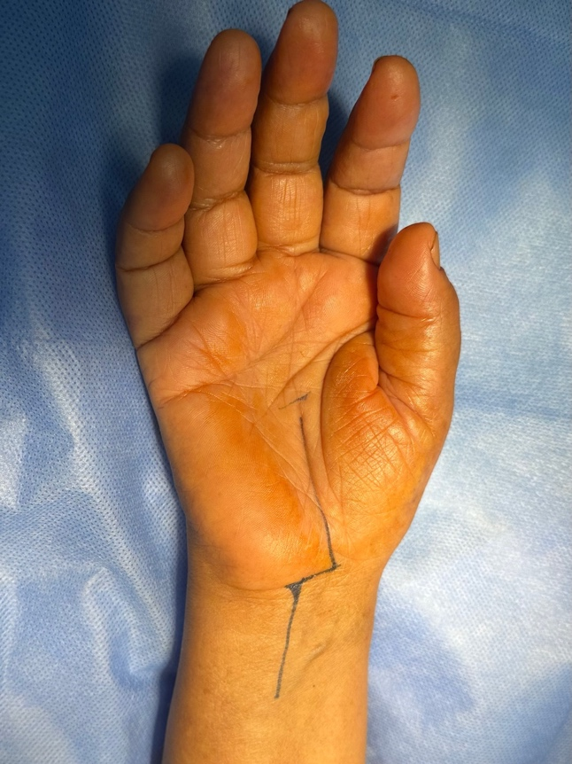

Figure 1: Classic incision for a carpal tunnel release; begins at the level of the carpal tunnel, curves across the distal wrist flexion crease, and extends into the distal third of the forearm.
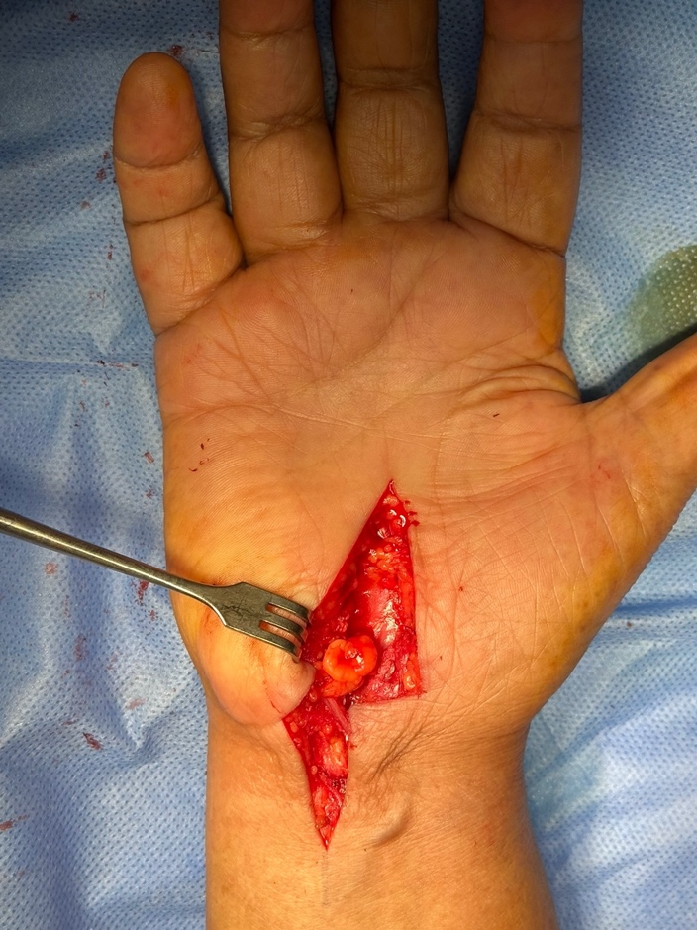

Figure 2: Compression of the median by a round small soft tissue mass from the volar side.

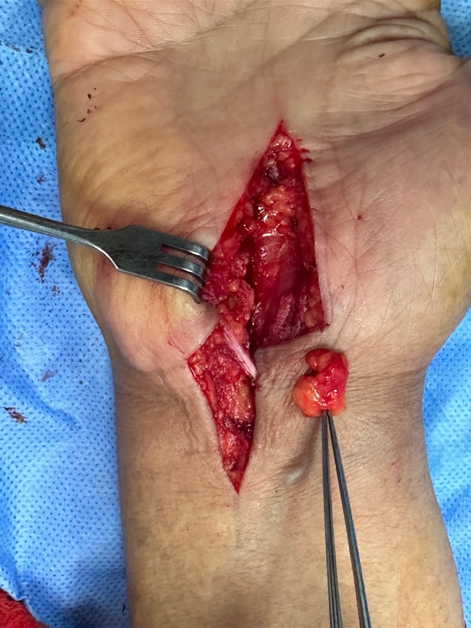
Figure 3: Resected piece of the soft tissue mass with complete release and decompression of the carpal tunnel.

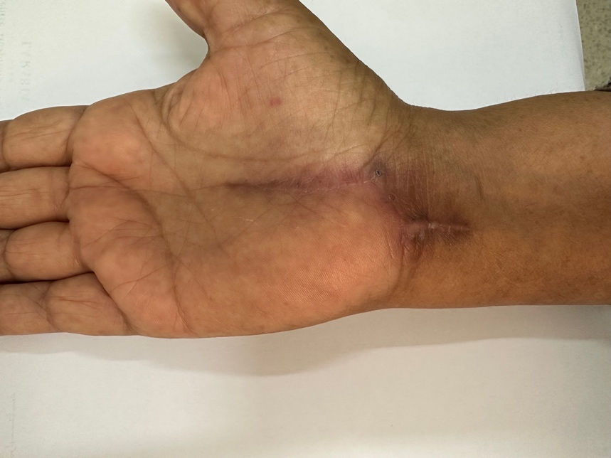

Figure 4: Aspect of the scar at 1 month post-operatively.

3. discussion

Carpal tunnel syndrome is the most frequent compression neuropathy. The median nerve is compressed in the carpal tunnel between the carpal transverse ligament on the volar side and the carpal bones dorsally. Paresthesia is the predominant symptom, occurring mostly at night. Thenar muscles atrophy happens at late stages of denervation with the loss of thumb opposition. Most cases of CTS are idiopathic; however, it is frequently associated with multiple systemic conditions such as obesity, diabetes mellitus, hypothyroidism, pregnancy, and rheumatoid arthritis. Local causes of CTS are rare and can be responsible for unilateral manifestations [5]. If the local issue is not discovered pre-operatively, symptoms will not improve after carpal tunnel release. Nine tendons and the median nerve pass through the carpal tunnel and SOLs can develop out of any one of these structures including the carpal bones. Nakamichi et al. found an overall incidence of space-occupying lesions (SOLs) of 5,5% and had exclusively unilateral symptoms [6]. Causes included ganglions, calcified masses, tuberculous tenosynovitis, and non-specific synovitis. Kang et al. found an incidence of SOLs of 12,5% in unilateral cases of CTS [5]. Other studies of SOL within the carpal tunnel reported findings of lipoma [7], giant cell tumors [8], hemangioma of the median nerve [9] and synovial sarcoma [10]. SOLs are mainly suspected in unilateral CTS cases and should be ruled out with proper imaging (X-rays, ultrasound, and magnetic resonance imaging). In cases of bilateral symptoms SOLs are not usually suspected. In our case, the lipoma was only discovered during the carpal tunnel release. We routinely only perform an axial carpal tunnel view X-ray as part of the initial diagnosis to rule out any bone abnormalities. The patient was operated on the contralateral side and no SOL was discovered. The etiology was presumed secondary to amyloid deposition related to the chronic renal dialysis as reported in the literature [11,12]. In this specific category of patients, we systematically use a classic approach to the carpal tunnel. The incision begins at the carpal tunnel, curves across the distal wrist flexion crease, and extends into the distal third of the forearm, allowing for complete visualization of the median nerve and surrounding structures (Figure n°1). This systematic approach was the only reason the lipoma was discovered. Preoperative diagnosis of SOLs is mainly confirmed with imagery. Ultrasound imaging has not only been implicated in the diagnosis of CTS but also in the screening for structural abnormalities of the wrist and SOLs within the carpal tunnel [3,13]. MRI (Magnetic resonance imaging) also serves for the assessment of SOLs with good predictive value for the type of the lesion [14].

4. Conclusion

While the majority of CTS cases are attributed to idiopathic factors or well-established associations, it is crucial for clinicians to consider less common underlying etiologies, particularly in cases with atypical presentations or a lack of response to conventional management. Space-occupying lesions within the carpal tunnel, though infrequent, represent an important differential diagnosis. Lipomas, benign fatty tumors, are rarely encountered in this anatomical location, and their presence can lead to progressive median nerve compression. This case report details the importance of thorough investigation and the potential for surgical intervention to alleviate symptoms and restore function in such unusual circumstances.

Consent

All authors declare that ‘written informed consent was obtained from the patient for publication of this case report and accompanying images. A copy of the written consent is available for review by the Editorial office/Chief Editor/Editorial Board members of this journal.

Ethical approval

All authors hereby declare that all experiments have been examined and approved by the appropriate ethics committee and have therefore been performed in accordance with the ethical standards laid down in the 1964 Declaration of Helsinki.

DISCLAIMER

Author(s) hereby declare that NO generative AI technologies such as Large Language Models (ChatGPT, COPILOT, etc.) and text-to-image generators have been used during the writing or editing of this manuscript.

References

- Pritsch T, Rosenblatt Y, Carmel A. [Carpal tunnel syndrome]. Harefuah. 2004 Oct;143(10):743–8, 765, 764. PMID:15597750
- Padua L, Coraci D, Erra C, Pazzaglia C, Paolasso I, Loreti C, et al. Carpal tunnel syndrome: clinical features, diagnosis, and management. Lancet Neurol. 2016 Nov;15(12):1273–84. doi:10.1016/S1474-4422(16)30101-7 PMID:27745722
- Bianchi S, Hoffman DF, Tamborrini G, Poletti PA. Ultrasound Findings in Less Frequent Causes of Carpal Tunnel Syndrome. J Ultrasound Med. 2020 Dec;39(12):2469–82. doi:10.1002/jum.15340 PMID:32356554
- Fournier E. [Carpal tunnel syndrome: Rare causes and associated forms behind a common and stereotyped affection]. Rev Med Interne. 2020 Jul;41(7):451–8. doi:10.1016/j.revmed.2020.03.012 PMID:32253018
- Kang HJ, Jung SH, Yoon HK, Hahn SB, Kim SJ. Carpal tunnel syndrome caused by space occupying lesions. Yonsei Med J. 2009 Apr 30;50(2):257–61. doi:10.3349/ymj.2009.50.2.257 PMID:19424883
- Nakamichi K, Tachibana S. Unilateral carpal tunnel syndrome and space-occupying lesions. J Hand Surg Br. 1993 Dec;18(6):748–9. doi:10.1016/0266-7681(93)90249-M PMID:8132962
- Kremchek TE, Kremchek EJ. Carpal tunnel syndrome caused by flexor tendon sheath lipoma. Orthop Rev. 1988 Nov;17(11):1083–5. PMID:3211516
- Meek MF, Sheikh ZA, Quinton DN. Carpal tunnel syndrome caused by a giant cell tumour of the flexor tendon sheath. J Plast Surg Hand Surg. 2014 Feb;48(1):84–5. doi:10.3109/2000656X.2013.791552 PMID:23668388
- Coessens B, De Mey A, Lacotte B, Vandenbroeck D. Carpal tunnel syndrome due to an haemangioma of the median nerve in a 12-year-old child. Ann Chir Main Memb Super. 1991;10(3):255–7. doi:10.1016/S0753-9052(05)80053-1 PMID:1722889
- Weiss AP, Steichen JB. Synovial sarcoma causing carpal tunnel syndrome. J Hand Surg Am. 1992 Nov;17(6):1024–5. doi:10.1016/0363-5023(92)90374-O PMID:1491039
- Spencer JD. Amyloidosis as a cause of carpal tunnel syndrome in haemodialysis patients. J Hand Surg Br. 1988 Nov;13(4):402–5. doi:10.1016/0266-7681(88)90184-7 PMID:3210080
- Naito M, Ogata K, Goya T. Carpal tunnel syndrome in chronic renal dialysis patients: clinical evaluation of 62 hands and results of operative treatment. J Hand Surg Br. 1987 Oct;12(3):366–74. doi:10.1016/0266-7681(87)90045-8 PMID:3680953
- Osiak K, Elnazir P, Walocha JA, Pasternak A. Carpal tunnel syndrome: state-of-the-art review. Folia Morphol (Warsz). 2022;81(4): 851-862. doi: 10.5603/FM.a2021.0121.
- Kumari A, Singh S, Garg A, Prakash A, Sural S. Tingling hand: magnetic resonance imaging of median nerve pathologies within the carpal tunnel. Pol J Radiol. 2019 Nov 22;84:e484-e490. doi: 10.5114/pjr.2019.90354. PMID: 32082444

