|  |
| --- |
| **A retrospective study on AIDS related Ocular complications particularly cytomegalovirus retinitis in 100 AIDS Patients** |

**Abstract :** The aim of this work is to investigate the ocular complications of AIDS and especially cytomegalovirus retinites. This is a retrospective descriptive study of 100 patients (diagnosed with HIV according to WHO diagnostic criteria for all stages) for a duration of 02 years (January 2019 to January 2021) and follow-up at the adult ophthalmology department at the University Hospital 20 August in Casablanca. Out of 100 patients examined: 60 patients have an ophthalmological involvement of the posterior segment, Sex ratio: 0.73(41.66% Men, 58.33% women), Average age: 40 years with extremes of 25 and 60 years, the average rate of CD4 was 233 cells/mm.

Key words: AIDS, Patients, CMV retinitis, antiretroviral treatment, ophthalmology

**Introduction**

HIV infection affects 38 million people worldwide, and 50% of HIV-infected patients develop eye disease during the course of their illness. Cytomegalovirus (CMV) retinitis is a multisystemic infection with devastating ocular consequences in patients with acquired immunodeficiency syndrome. According to HOLLAND (1), its incidence is 20-34% in adult AIDS patients, making it the leading cause of blindness. Survival of patients with CMV retinitis is relatively short. Prolonged survival is linked to the various therapies available and to early diagnosis. The visual prognosis of CMV retinitis is relatively poor, with acuity reduced to or equal to the perception of hand movements in the best cases. Several retinal lesions have been described in CMV retinitis. These include retinal detachment, chorioretinal toxoplasmosis, papillitis or retrobulbar optic neuropathy. CMV retinitis may be unilateral or, in some patients, bilateral. Untreated, it progresses to progressive extension or bilateralization: in some cases, cytomegalovirus leads to extra-ocular localization, notably encephalitis.During HIV infection, severe ocular manifestations may be seen at the stage of severe immunodepression.

CMV infection is the most frequent and most serious opportunistic infection in HIV-positive subjects on trithérapie antirétrovirale. It occurs in the late stage of the disease, when the CD4+ count is below 50 cells/mm3. Retinal involvement is by far the most frequent (80% of localizations), followed by digestive involvement (10-15% of localizations) and neurological involvement (5to 10%).

CMV retinitis is the only ocular disease included in the diagnostic criteria for AIDS stage disease. It poses numerous diagnostic and therapeutic difficulties, mainly due to frequent recurrences.In this paper, the authors report epidemiological, clinical and therapeutic data from a descriptive study of a series of cases, together with a literature review of recently adopted therapeutic protocols.

Importance of the study:

## CMV complications are more frequent in developing countries, where access to antiretroviral treatment and ophthalmological follow-up is limited.

An article can therefore also highlight issues of health equity and the strengthening of healthcare systems**.**

**Materials and methods**

1. Type of study

The study we carried out was descriptive and retrospective, a methodological approach often chosen to explore existing clinical data over a given period. This type of study enables a better understanding of patients' epidemiological and clinical characteristics, without direct intervention on exposure or outcome variables. In the hospital setting, and particularly in the field of ophthalmology applied to patients living with HIV, the retrospective study has the advantage of using data already available, which facilitates faster analysis of trends and enables the generation of clinical hypotheses useful for daily practice.

2. Study setting

The study took place in the adult ophthalmology department of the Centre Hospitalier Universitaire (CHU) du 20 Août in Casablanca, a reference institution for the multidisciplinary management of infectious and ophthalmological pathologies. The center caters for a heterogeneous population and provides access to specialized examinations such as biomicroscopy, fundus and retinal imaging, as well as ophthalmological follow-up for immunocompromised patients.

3. Duration of the study

Data collection was spread over two calendar years, between January 2019 and January 2021. This duration was chosen to ensure representative sampling and allow sufficient analysis of ophthalmological events occurring in the context of HIV, including taking into account the effects of starting or following long-term antiretroviral therapy.

4. Study population

**a. Inclusion criteria**

The study included 100 patients diagnosed as HIV-positive according to the diagnostic criteria established by the World Health Organization (WHO). The patients included were followed up in consultation or hospitalized in the ophthalmology department, whatever the initial reason for consultation, provided that ophthalmological examinations had been carried out systematically. All clinical stages were included, enabling analysis of the full range of HIV-related ophthalmological forms, from the asymptomatic to the AIDS stage.

**b. Exclusion criteria**

Patients with incomplete records (lack of documented eye examinations, absence of CD4 count at time of examination) or with eye pathologies independent of infectious or inflammatory etiology, with no established link to HIV infection, were excluded from the analysis.

5. Data collected

**a. Demographic data**

Age: age at first ophthalmological consultation

Sex: male or female

**b. General clinical data**

HIV status: WHO stage if known

Reported visual symptoms (decreased visual acuity, pain, photophobia, scotomas)

Duration of evolution of ocular signs

**c. Biological data**

CD4 count (in cells/mm³), at time of ophthalmological diagnosis

HIV viral load, if available (log copies/ml)

Associated serologies: CMV, toxoplasmosis, HBV, HCV, latent tuberculosis

**d. Ophthalmological data**

Examinations performed included:

Slit-lamp examination of the anterior segment

mydriatic fundus examination

OCT (optical coherence tomography) to study retinal and choroidal structuresRetinal fluorangiography in selected cases.

**Results**

1. General data on the study population

Of the 100 patients included in the study :

41 were male (41.66%) and 59 female (58.33%), giving a male/female sex ratio of 0.73.

The mean age was 40 years, ranging from 25 to 60 years.

The majority of patients (65%) lived in urban areas, with the remainder in semi-urban or rural areas.

2. Immunological status

The mean CD4+ count was 233 cells/mm³, indicating moderate to severe immunosuppression:

37% of patients had a CD4 count below 100 cells/mm³.

28% had between 100 and 200 cells/mm³.

35% had more than 200 cells/mm³.

Viral load was documented in 70 patients:

48 patients (68.5%) had a detectable viral load (>1000 copies/mL).

22 patients (31.5%) had an undetectable viral load, indicating a good response to ART.

3. Ophthalmological effects observed

3.1 General distribution

Among the 100 patients :

60 patients (60%) had posterior segment involvement.

20% had anterior segment involvement (keratitis, uveitis).

10% had adnexal involvement (conjunctivitis, stye, etc.).

10% had no detectable ophthalmological abnormalities.

3.2 Manifestations of the posterior segment

The 60 patients with posterior segment disease presented :

CMV retinitis: 18 cases (30%)

Toxoplasma retinitis: 15 cases (25%)

Tuberculous choroiditis: 9 cases (15%)

Necrotizing herpetic retinopathy: 6 cases (10%)

HIV-associated papillitis or optic neuritis: 5 cases (8.3%)

Other (ocular lymphoma, ocular syphilis): 7 cases (11.6%)

3.3 Relationship between CD4 count and type of lesion

Cases of CMV retinitis mainly concerned patients with CD4 < 100 cells/mm³.

Toxoplasmic lesions were observed in patients with CD4 counts between 100-200 cells/mm³.

Cases of ocular tuberculosis occurred in a broader spectrum, often in patients with CD4 > 200.

4. Functional symptomatology

The most frequently reported symptoms were:

Decreased visual acuity: 70%.

Visual blur: 45

Ocular pain: 30

Photophobia: 20%.

Myodesopsias (floating bodies): 12%.

5. Treatment received

All patients were on antiretroviral therapy, with a good compliance rate in 60% of cases.

Specific treatments included:

Intraocular or IV ganciclovir for CMV.

Pyrimethamine-sulfadiazine + folinic acid for toxoplasmosis.

**Quadrith anti-tuberculosis treatment

**Curative:**

Ganciclovir : 10mg/kg/ 2 infusions/day IV (2 - 3 weeks)

Foscarnet :180mg/kg/d 2 inf. IVL/d (2 - 3 weeks)

**Weekly intravitreal injections of ganciclovir**

**(Severe forms)**

**Preventive:**

Valaganciclovir: 900mg per os 1 x/d

Intravitreal injections of ganciclovir / 15 days.

Table 1: Number and percentage of patients with different types of eye damages

|  |  |  |
| --- | --- | --- |
| Eye damage | **Number of patients (n=60)** | Percentage |
| Cottony nodules | 24 | 40 |
| CMV retinitis | 12 | 20 |
| Retinal Hemorrhages | 5 | 8.33 |
| Papillary edema | 5 | 8.33 |
| choriorétinites toxoplasmiques | 3 | 5 |
| retinal perivascularitis | 2 | 3.33 |
| ophthalmic shingles | 1 | 1.66 |
|  |  |  |

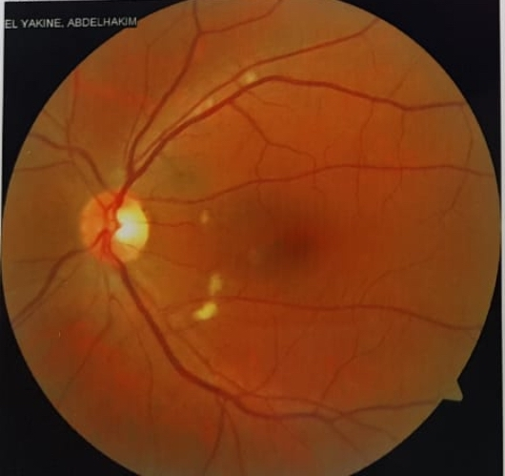

**Fig.1 Radiography: HIV-related microangiopathy: Cottony nodules**

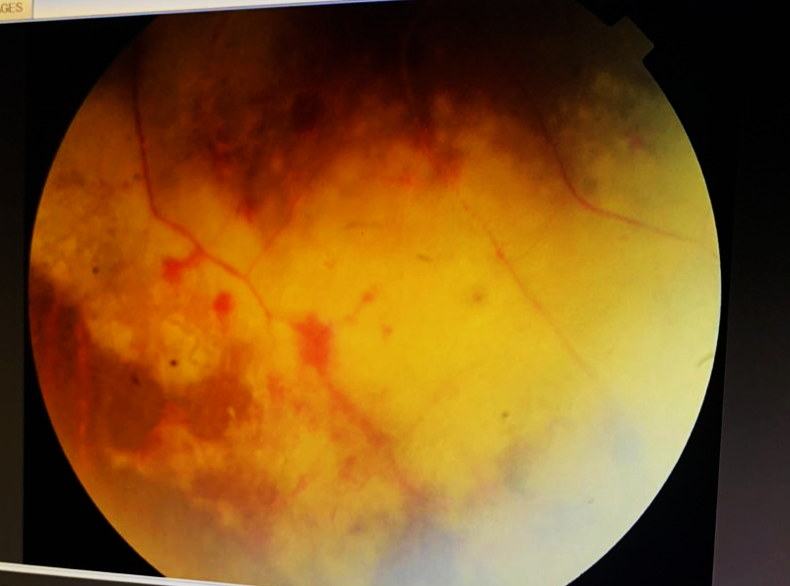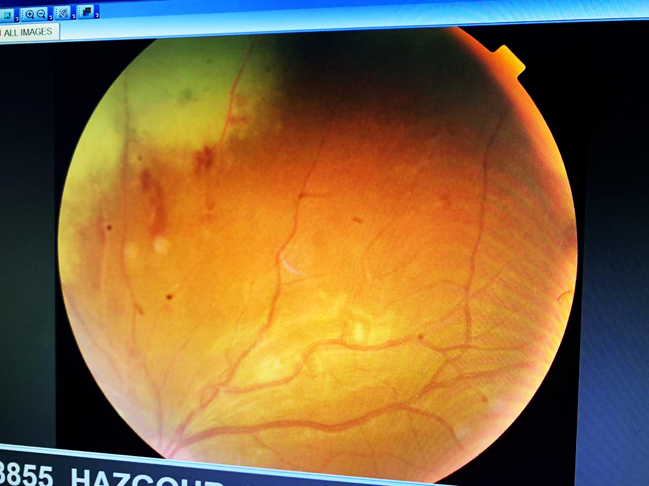

**Fig .2 Radiography: Cytomegalovirus retinitis**



**Fig .3 Radiography: Papilledema/Retinal Vasculitis**

**Discussion**

Rarely described in the African literature, an infection attacks the photoreceptor cells of the retina representing a serious disease that must be diagnosed and treated immediately

Among infectious retinal diseases, CMV retinitis remains the most common cause of blindness. The most recent epidemiological data, published before the use of antiretroviral drugs, indicated that 15-35% of HIV-infected subjects develop CMV retinitis during the course of their illness (2, 3).

However, KESTELYN reported no cases of CMV retinitis in Rwandan patients and LEWALLEN, in Malawi, found only one case (4). In our series, we collected only 12 cases at the university hospital. Our patients presented with typical aspects of retinitis, i.e. the appearance of a white, edematous, hemorrhagic paravascular patch with centrifugal progression, a scarred center and an edematous crown with sometimes vascular engorgement PCR in the aqueous humor: Diagnosis of certainty. Thus, this disparity is explained not only by the high early mortality in sub-Saharan Africa, but also by a variable susceptibility to develop CMV retinitis between different populations (5).

The treatment that had been instituted was :

CMV retinitis is the most common opportunistic infection of HIV-positive individuals (6). This strictly human virus is transmitted by close contact with the tears, saliva, urine, breast milk, semen or genital secretions of people actively replicating the virus (7). 90% of HIV carriers will develop symptoms of an active CMV infection during their illness, and up to 25% of them will suffer from life-threatening CMV infection or blindness (7, 8, 9). The severity of CMV infection and its clinical manifestations depend on the extent of the immune deficiency.

CMV retinitis occurs firstly when the CD4+ lymphocyte count Is below 50 cells/mm3, secondly during the first 3 months of antiretroviral treatment, and thirdly in the event of escape from antiretroviral therapy.

It typically affects the retinal periphery, with

retinal hemorrhages that can extend as far as the posterior pole, thus jeopardizing the visual prognosis. The macula is rarely affected first or exclusively in CMV retinitis.

During the immune reconstitution phase, hyalitis may appear in patients responding to

antiretroviral HAART (11).

Often asymptomatic, routine fundus examination is regularly recommended in stages of profound immunodepression The lesions of CMV retinitis can present different clinical aspects. The typical focus comprises a whitish scar center, an active whitish intermediate corona with hemorrhages and a peripheral corona of healthy retina containing white satellite microfocuses: this is the viral proliferation front. The edges of the focus are irregular, white or grayish and lumpy. The

relapse of retinitis is marked by an advance of the edges of the focus.

There may also be other, less typical forms, such as fulminant retinitis, indolent retinitis and perivascular retinitis. In case of doubt, retinal angiography can show signs of CMV retinitis. Hyperfluorescence begins in the center of the lesion, then spreads centrifugally.

CMV serology is usually positive in HIV-positive patients. Diagnosis can be confirmed by PCR amplification of viral DNA in aqueous humor, with a sensitivity close to 100% (12).

The introduction of antiviral treatments including antiprotease has profoundly changed the natural history of CMV infection. Two molecules are currently on the market: Ganciclovir (Cymevan®) and Foscarnet (Fos- cavir®). The systemic route is the most recommended, while the intravitreal route can be considered whenever general treatment is impossible or insufficient, but it has the disadvantage of treating only the injected eye, without protecting the other eye or preventing other localizations of CMV infection.

Ganciclovir

Ganciclovir is the reference treatment. It is a deoxyguanosine ana- logue that competitively inhibits viral DNA polymerase. Its structure is similar to that of acy- clovir, but it is 50 times more effective against CMV in vitro. The usual dosage is 5mg/kg, twice a day for 14 to 21 days by intravenous injection for the induction phase, and 5 mg/kg/D or 6 mg/kg, 5 days a week, for the maintenance phase.

As a rule, the virostatic action of the treatment precedes improvement in clinical signs. The main side effects are neutropenia (40% of cases) and thrombocytopenia (20% of cases). Intravitreal injection of Ganciclovir is recommended in cases of intolerance or contraindication to the systemic route.

It delivers higher tissue concentrations than the systemic route to the injected eye.

The dose of Ganciclovir injected intravitreally is 2 mg, twice times a week for 2 weeks, followed by one IVT per week for 8 weeks. To limit the number of iterative IVTs and their complications, it is preferable to use an intravitreal implant of Ganciclovir (Vitrasert®). The latter, dosed at 4.5 mg, releases 1 µg per hour of Ganciclovir for a duration of over 6 months, which allows better control of retinitis.

The oral route is administered at a maximum dose of 3 g/day and its only indication remains the prevention of the risk of damage to the contralateral eye and the prevention of extraocular damage, due to its insufficient bioavailability for the induction phase.

Foscarnet Foscarnet is a pyrophosphate analog that inhibits viral DNA polymerase and reverse transcriptase. Its nephro-toxicity limits its use as a first-line treatment, and it should be reserved for cases of CMV resistance to ganciclovir, or for cases of neutropenia. The initial dose is 90 mg/kg by intravenous injection twice a day for 14 to 21 days, followed by maintenance treatment at a dose of 90 to 120 mg/kg/day.

Course and complications Recurrence of CMV

retinitis after treatment is very frequent, around 50% . Maintenance treatment must therefore be continued to maintain remission. In the absence of treatment, CMV retinitis progresses and destroys the entire retina. Retinal detachment, the incidence of which has fallen considerably since the advent of HAART, remains a frequent complication (20 to 40% of cases) when the CD4+ count is below 50 cells/ml, which worsens the prognosis visual.

**Conclusion**

CMV infection is the most frequent and most serious opportunistic infection in HIV-positive subjects on trithérapie antirétrovirale. It occurs in the late stage of the disease, when the CD4+ count is below 50 cells/mm3. Retinal involvement is by far the most frequent (80% of localizations), followed by digestive involvement (10-15% of localizations) and neurological involvement (5 to 10%). CMV retinitis is the only ocular disease included in the diagnostic criteria for AIDS stage disease. It poses numerous diagnostic and therapeutic difficulties, mainly due to frequent recurrences. In this paper, the authors report epidemiological, clinical and therapeutic data from a descriptive study of a series of cases, together with a literature review of recently adopted therapeutic protocols.

Cytomegalovirus infection of the eye results in unilateral or bilateral vision loss. Its visual and vital prognosis is always poor, hence the importance of early management of patients and the initiation of antiretroviral therapy (ART). Routine eye examinations should be performed if the HIV serology test is positive. To date, there is no consensus on the importance of routine screening for ophthalmologic disease in HIV-infected patients with FO examination. However, the major drawback of CMV infection management in Morocco remains the lack of therapeutic alternatives (intravitreal injection of Ganciclovir, unavailability of oral treatment...) and the lack of specialized human resources.

CMV retinitis, the main cause of severe decline in visual acuity in AIDS-stage subjects, has seen its inci- dence considerably reduced since the introduction of

highly active antiretroviral therapy (HAART). Gan- ciclovir is currently the reference treatment, and the new Ganciclovir-based intravitreal implants offer improved management and prognosis.

Ethical Approval:

As per international standards or university standards written ethical approval has been collected and preserved by the author(s).

Disclaimer (Artificial intelligence)

Option 1:

Author(s) hereby declare that NO generative AI technologies such as Large Language Models (ChatGPT, manuscript.

Option 2:

Author(s) hereby declare that generative AI technologies such as Large Language Models, etc. have been used during the writing or editing of manuscripts. This explanation will include the name, version, model, and source of the generative AI technology and as well as all input prompts provided to the generative AI technology

Details of the AI usage are given below:

1.

2.

3.

**References**

1. Holland G.N., Pepose J.S,et AL. Acquired immune deficiency syndrome : ocular manifestations. Ophthalmology, 1983, 90 : 859-73.

2. Cochereau I - Have new antiviral treatments modified ocular damage linked to HIV? Real Ophtalmol, 1997, 56, 285-287.

3. Cunningham & Margolis TP - Ocular manifestations of HIV infection. N Engl J Med, 1998, 339, 236-244.

4. Lewallens & Courtright P - HIV, AIDS, and the eye in developping countries: a review. Arch Ophthalmol, 1997, 115, 1291-1295. 6. LIN SA, HENG WJ, LI

5. Balo KP, Fany A, Amoussou Y, Mihluedo H, Djignikpo PA et al. - Retinal complications in AIDS patients at the Lomé University Hospital (Togo). J Fr Ophtalmol, 1998, 21, 435-439.

6.Linda Visser Managing CMV Retinitis in the Developing World Community Eye Health. 2003; 16(47): 38–39.

7. Mazeron M C, Alain S. Cytomegalovirus infections. In “Medico-Surgical Encyclopedia, Infectious Diseases”. Elsevier Editions, Paris, 2001, 8-052-C-10, 18p.

8. Ranger-Rogez S, Venot C, Aubard Y, Denis F, Freymuth F. Cytomegalovirus. In “Viruses transmissible from mother to child”, Denis Fed. John Libbey Eurotext, Paris, 1999, p 191-194.

9. Colimon R, Minjolle S. Cytomegalovirus. Medical Molecular Virology, Seigneurin J

10.Lisa L. Sun, Todd Goodwin, and Joseph J. Park Optical coherence tomography changes in macular CMV retinitis Digit J Ophthalmol. 2012;

11. Ying Shi, Hongzhou Lu, Taiwen He et al Prevalence and clinical management of cytomegalovirus retinitis in AIDS patients in shanghai, china BMC Infect Dis. 2011; 11: 326

12. A Carmichael Cytomegalovirus and the eye Eye (Lond) 2012 February; 26(2): 237–240 14- Biron KK. Antiviral drugs for cytomegalovirus diseases. Antiviral Res. 2006;71:154–163.

The type of article: Case Report / Case Study (Mainly for bio-medical journals)