Case Report

Rare Occurrence of Gastric and Gallbladder Metastasis in Non-Small Cell Lung Carcinoma (NSCLC): A Case Report

.

ABSTRACT

|  |
| --- |
| **Aim:** Gastrointestinal metastasis from lung cancer (GMLC), particularly to the stomach and gallbladder, is a rare clinical entity, occurring in 0.5% to 14% of cases. These metastases often present with non-specific gastrointestinal symptoms or are incidentally detected, making early diagnosis a clinical challenge. This report highlights the diagnostic complexity and importance of histopathological confirmation in such rare cases.  **Presentation of Case:** An 80-year-old female with Stage IVB non-small cell lung carcinoma (NSCLC) on Osimertinib therapy presented with new abdominal symptoms. PET-CT revealed a hypermetabolic lesion in the gastric lesser curvature and a distended gallbladder. Endoscopy identified a gastric ulcer, while elective cholecystectomy revealed chronic inflammation. Histopathology and immunohistochemistry (CK7, CK20, TTF-1, Napsin A) confirmed gastric and gallbladder metastases from primary lung adenocarcinoma.  **Discussion:** Gastric and gallbladder metastases from NSCLC are exceedingly rare and may mimic benign lesions such as peptic ulcers or cholecystitis. While the stomach is an uncommon site of metastasis, the gallbladder is even more infrequently involved, typically identified through imaging or histologic analysis during unrelated surgery. Immunohistochemical staining, particularly TTF-1 and Napsin A, is pivotal in establishing pulmonary origin. Awareness of these unusual metastatic sites is critical for accurate staging and management. Treatment remains largely palliative, with systemic therapy being the cornerstone. This case reinforces the value of comprehensive diagnostic evaluation in advanced NSCLC with new gastrointestinal symptoms.  **Conclusion:** Heightened clinical awareness and comprehensive diagnostic evaluation are crucial for patients with lung cancer presenting with new gastrointestinal symptoms. Enhanced understanding of the clinical presentation, diagnostic challenges, and management strategies GMLC is essential for improving patient outcomes and guiding future research in this area. |

*Keywords: GMLC, lung cancer, gastric ulcer, cholecystitis, cancer, metastasis*

1. INTRODUCTION

Gastrointestinal metastasis from lung cancer (GMLC) is an uncommon clinical occurrence, with incidence rates reported between 0.5% and 14% depending on whether the data are derived from clinical or autopsy studies (Yoshimoto et al., 2006; Hu et al., 2018). Lung cancer, particularly non-small cell lung carcinoma (NSCLC), typically spreads to the brain, bone, adrenal glands, and liver. Involvement of the gastrointestinal tract is rare but likely underdiagnosed due to its often asymptomatic or nonspecific presentation (Antler et al., 1982; Rossi et al., 2007). Among these, the small intestine is the most frequently affected, followed by the stomach and colon, while gallbladder involvement remains exceedingly rare (McNeill et al., 1987).

The stomach accounts for less than 2% of all gastrointestinal metastases in living patients; however, autopsy studies suggest higher rates, with metastasis detected in up to 5.4% of patients with primary lung cancer (Kim et al., 2000; Green, 1990). Gastric involvement often mimics benign lesions such as peptic ulcers or presents as subepithelial masses, leading to misdiagnosis or delays in management (Kadakia & Parker, 1992; Menuck & Amberg, 1975). The most commonly reported histologic subtype of lung cancer associated with gastric metastasis is adenocarcinoma, although squamous cell carcinoma and large-cell carcinoma have also been implicated (Al-Daraji et al., 2007; Hu et al., 2018).

Even more rarely reported is gallbladder metastasis from NSCLC. The gallbladder is an atypical site of secondary involvement and is often overlooked unless symptoms such as acute cholecystitis or biliary colic prompt imaging or surgical intervention (Reddy et al., 2020; Mori et al., 1991). The diagnosis of gallbladder metastasis is typically incidental and confirmed only after cholecystectomy and histopathologic analysis. Several case reports describe lung adenocarcinoma metastasizing to the gallbladder, sometimes masquerading as primary gallbladder carcinoma or cholecystitis (Yoshida et al., 2013; Kim et al., 2009).

Recognition of these atypical metastatic sites is important not only for accurate staging but also for appropriate symptom management and prognostication. Given that gastrointestinal and gallbladder metastases generally occur in the context of widespread disease, their presence often portends a poor prognosis (Antler et al., 1982; Hu et al., 2018). Management is primarily palliative and centered on systemic treatment of the primary malignancy, although surgical or endoscopic intervention may be warranted in select cases involving obstruction, hemorrhage, or severe inflammation.

In this report, we present a rare case of synchronous gastric and gallbladder metastases from NSCLC in an elderly female on targeted therapy. This case highlights the critical importance of multimodal evaluation—including PET imaging, endoscopy, and immunohistochemistry—in recognizing and confirming rare metastatic presentations in lung cancer patients with new or unexplained abdominal symptoms.

**2. CASE PRESENTATION**

An 80-year-old female with a known diagnosis of Stage IVB non-small cell lung carcinoma (NSCLC), harboring an EGFR Exon 19 deletion mutation, was undergoing targeted therapy with Osimertinib. She had a history of metastases to the bone, liver, and regional lymph nodes, and had responded well to systemic therapy for over one year, maintaining stable disease status.

During a routine follow-up, positron emission tomography-computed tomography (PET-CT) revealed a new ill-defined hypermetabolic soft tissue lesion along the lesser curvature of the stomach, as well as a distended gallbladder with increased uptake suggestive of inflammation or neoplastic involvement (Figure 1). At the time, the patient was asymptomatic. Two weeks later, she reported new-onset intermittent epigastric pain, heartburn, early satiety, anorexia, and a 5-kg unintentional weight loss. She denied vomiting, hematemesis, melena, or jaundice. Physical examination was unremarkable, with no palpable abdominal masses or tenderness. Laboratory studies showed no leukocytosis or anemia. Liver enzymes and bilirubin levels were within normal limits.

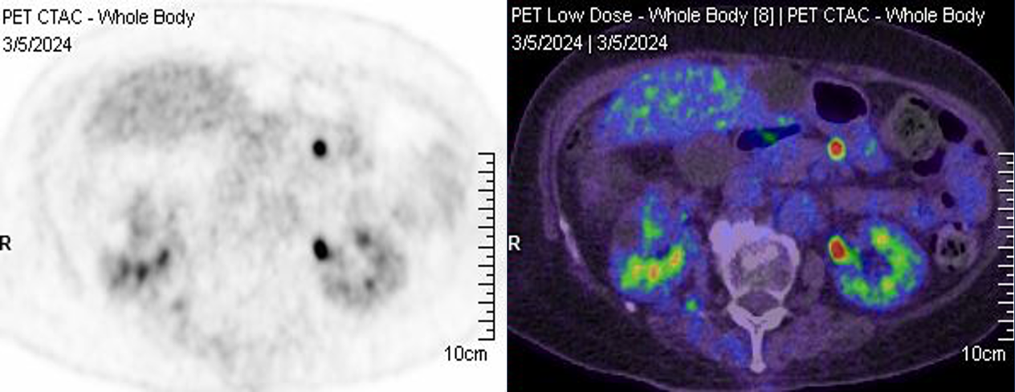

Figure 1.  New, ill-defined hypermetabolic soft tissue lesion at the lesser curvature of the stomach as seen on positron emission tomography (PET) scan.

Esophagogastroduodenoscopy (EGD) was performed, which demonstrated a solitary, irregularly bordered ulcer with a central depression and heaped-up margins located at the gastric lesser curvature (Figure 2A). Narrow band imaging (NBI) revealed disrupted microvascular and mucosal patterns, raising suspicion for malignancy (Figure 2B). Biopsies were obtained from the ulcer base and margins.

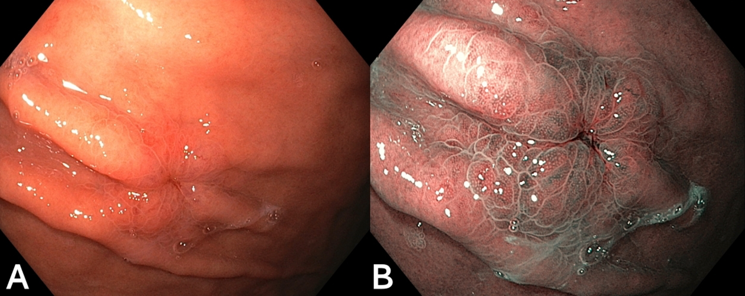

Figure 2.  Endoscopic images of a metastatic gastric ulcer. White light endoscopy shows an irregular, elevated lesion with a central depression and heaped-up margins, suggestive of a malignant ulcer (A). Narrow band imaging (NBI) reveals an irregular microvascular and mucosal pattern (B).

Given the PET findings of gallbladder distention and metabolic activity, the patient subsequently underwent elective laparoscopic cholecystectomy. Intraoperatively, the gallbladder appeared thickened and inflamed, without evidence of gross tumor. The surgery was uneventful, and the patient was discharged in stable condition.

Histopathologic analysis of the gastric biopsies revealed well-formed neoplastic glands composed of pleomorphic columnar cells with nuclear atypia and mitotic activity, consistent with adenocarcinoma arising in a background of chronic active gastritis (Figure 3). Immunohistochemical staining was positive for cytokeratin 7 (CK7), thyroid transcription factor-1 (TTF-1), and Napsin A, and negative for cytokeratin 20 (CK20), consistent with metastasis from pulmonary adenocarcinoma.

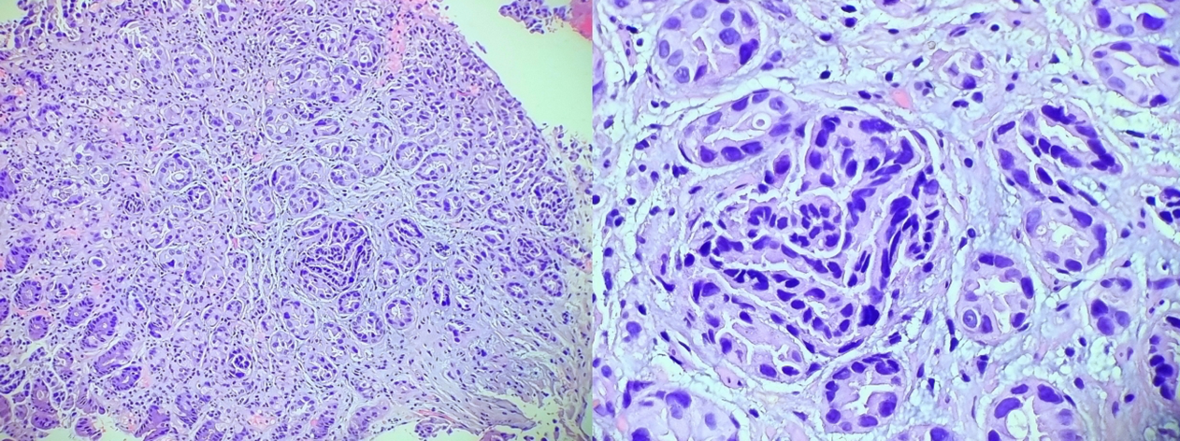

Figure 3. Histopathology showing gastric and gallbladder mucosal tissues infiltrated by well-formed neoplastic glands lined by malignant cells with features of an adenocarcinoma

The cholecystectomy specimen similarly showed metastatic infiltration of the gallbladder mucosa by malignant glands, histologically similar to the gastric lesion. Immunoprofiles matched those of the gastric tissue and prior lung biopsy, confirming gallbladder metastasis of NSCLC origin.

This case represents a rare instance of synchronous gastric and gallbladder metastases from lung adenocarcinoma in an elderly female under targeted therapy. The patient continued Osimertinib and received supportive care, with resolution of gastrointestinal symptoms at short-term follow-up.

3. discussion

Although lung cancer commonly metastasizes to the brain, bone, liver, and adrenal glands, gastrointestinal involvement remains a rare and often underrecognized entity. Small bowel metastasis is the most frequently reported gastrointestinal manifestation, followed by the stomach and colon (McNeill et al., 1987; Hu et al., 2018). Gastric metastases, though rare, are increasingly detected due to advanced imaging and extended survival from targeted therapies (Yoshimoto et al., 2006).

The clinical diagnosis of GMLC poses a significant challenge. Patients may present with abdominal pain, anorexia, gastrointestinal bleeding, or may remain completely asymptomatic until lesions are found through endoscopy, cross-sectional imaging modalities and histopathology.

Endoscopically, gastric metastases from NSCLC may appear as ulcerated or raised lesions and are commonly mistaken for primary gastric cancer or peptic ulcer disease (Kim et al., 2000; Kadakia & Parker, 1992). Endoscopic biopsy and histopathological evaluation are crucial for accurate diagnosis. Histologically, these lesions most frequently appear as adenocarcinomas or large cell carcinomas with features similar to the primary lung tumor (Rossi et al., 2007). In one study, the majority of gastric metastases from NSCLC presented as solitary ulcers or nodular lesions (Al-Daraji et al., 2007).

In contrast, gallbladder metastasis is exceedingly rare. It typically presents with nonspecific symptoms or is incidentally found on imaging or post-cholecystectomy pathology, often in the setting of presumed benign gallbladder disease (Mori et al., 1991; Yoshida et al., 2013; Reddy et al., 2020). The gallbladder's relative lack of lymphatic and vascular connections may partly explain the rarity of metastatic involvement. When symptoms do occur, they often mimic acute cholecystitis, leading to a clinical impression of primary gallbladder pathology (Yoshida et al., 2013).

PET-CT plays a crucial role in detecting hypermetabolic activity suggestive of metastasis, while histologic confirmation remains the gold standard. Immunohistochemical markers such as TTF-1 and Napsin A are critical in identifying pulmonary origin and excluding primary gastrointestinal or biliary tumors (Al-Daraji et al., 2007). These markers have high sensitivity and specificity for pulmonary adenocarcinoma, particularly when morphology overlaps with primary gastric or biliary malignancies.

The present case demonstrates the importance of comprehensive diagnostic evaluation in patients with NSCLC who develop new or unexplained gastrointestinal symptoms. Although the stomach and gallbladder are rarely involved, awareness of these potential metastatic sites is crucial. As diagnostic imaging improves and patient survival increases due to effective therapies such as tyrosine kinase inhibitors, clinicians may encounter more unusual patterns of metastasis.

Management of gastrointestinal and biliary metastases is largely palliative, often dictated by symptomatology. Systemic therapy remains the cornerstone of treatment, but endoscopic resection or surgical intervention may be warranted in cases of bleeding, obstruction, or inflammation (Antler et al., 1982). While prognosis in such settings is generally poor, accurate staging and symptom control can improve quality of life and inform treatment planning.

Ultimately, this case underscores the importance of multidisciplinary evaluation, including radiologists, gastroenterologists, pathologists, and oncologists, in managing patients with advanced NSCLC and gastrointestinal complaints. Clinicians must maintain a high index of suspicion for metastatic disease even in atypical locations to ensure timely diagnosis and appropriate management.

4. Conclusion

Gastric and gallbladder metastases from NSCLC are rare but important diagnostic considerations in advanced lung cancer. While gastric involvement may present with ulcers or mimic primary gastric tumors, gallbladder metastasis may go unnoticed or mimic benign gallbladder disease. Awareness of these atypical metastatic sites, coupled with appropriate diagnostic workup and histopathological confirmation, is vital in guiding effective palliative care. Early recognition of these entities contributes to more accurate staging and improved symptom management in NSCLC patients.

Consent

Informed consent for publication could not be obtained as the patient is deceased and no next of kin or legal representative could be identified despite reasonable efforts. The authors have ensured that all potentially identifiable information has been anonymized to protect the patient’s privacy, and the publication of this case report is justified by its educational and scientific value.

DISCLAIMER (ARTIFICIAL INTELLIGENCE)

Authors hereby declare that no generative AI technologies and text-to-image generators have been used during the writing or editing of this manuscript.

References

1. Yoshimoto, A., Kasahara, K., & Kawashima, A. (2006). Gastrointestinal metastases from primary lung cancer. European Journal of Cancer, 42(18), 3157–3160. DOI: 10.1016/j.ejca.2006.08.030
2. Hu, Y., Feit, N., Huang, Y., Xu, W., Zheng, S., & Li, X. (2018). Gastrointestinal metastasis of primary lung cancer: An analysis of 366 cases. Oncology Letters, 15(6), 9766–9776. DOI: 10.3892/ol.2018.8575
3. Antler, A. S., Ough, Y., Pitchumoni, C. S., Davidian, M., & Thelmo, W. (1982). Gastrointestinal metastases from malignant tumors of the lung. Cancer, 49(1), 170–172. DOI: 10.1002/1097-0142(19820101)49:1<170::AID-CNCR2820490134>3.0.CO;2-A
4. Rossi, G., Marchioni, A., Romagnani, E., Bertolini, F., Longo, L., Cavazza, A., & Barbieri, F. (2007). Primary lung cancer presenting with gastrointestinal tract involvement: Clinicopathologic and immunohistochemical features. Journal of Thoracic Oncology, 2(2), 115–120. DOI: 10.1097/01243894-200702000-00004
5. Kim, J. H., Ha, H. K., Park, C. M., Lee, J. M., & Choi, B. I. (2000). Gastric metastases from lung cancer: CT findings and clinicopathologic correlation. Journal of Computer Assisted Tomography, 24(3), 395–399. DOI: 10.1097/00004728-200005000-00005
6. Green, L. K. (1990). Hematogenous metastases to the stomach: A review of 67 cases. Cancer, 65(7), 1596–1600. DOI: 10.1002/1097-0142(19900401)65:7<1596::AID-CNCR2820650735>3.0.CO;2-5
7. Kadakia, S. C., & Parker, A. (1992). Metastatic tumors to the upper gastrointestinal tract: Endoscopic experience. American Journal of Gastroenterology, 87(10), 1418–1423.
8. Menuck, L. S., & Amberg, J. R. (1975). Metastatic disease involving the stomach. American Journal of Digestive Diseases, 20(10), 903–913. DOI: 10.1007/BF01070882
9. Al-Daraji, W., Lasota, J., Foss, R., & Miettinen, M. (2007). Metastatic carcinomas to the stomach: Analysis of 64 cases and review of the literature. American Journal of Surgical Pathology, 31(10), 1465–1471. DOI: 10.1097/PAS.0b013e3180306e4b
10. Reddy, S., Lankala, R., Chava, S. P., & Arora, A. (2020). Gallbladder metastasis from primary lung carcinoma: A case report and review of literature. Case Reports in Gastroenterology, 14(1), 128–133. DOI: 10.1159/000505756
11. Mori, M., Adachi, Y., Matsushima, T., Matsuda, H., & Mishima, Y. (1991). Metastatic tumors of the gallbladder: Report of four cases and review of the literature. Journal of Surgical Oncology, 48(3), 151–154. DOI: 10.1002/jso.2930480311
12. Yoshida, T., Ishikawa, H., & Goto, K. (2013). Cholecystitis as an initial manifestation of metastatic lung adenocarcinoma. Annals of Thoracic Medicine, 8(2), 114–116. DOI: 10.4103/1817-1737.109819
13. McNeill, P. M., Wagman, L. D., & Neifeld, J. P. (1987). Small bowel metastases from primary carcinoma of the lung. Cancer, 59(8), 1486–1489. DOI: 10.1002/1097-0142(19870415)59:8<1486::AID-CNCR2820590824>3.0.CO;2-T